Guideline | Canberra Health Services
Neonatal Death, Bereavement, Palliative Care and Borderline of Viability
CHS24/453

Contents
Guideline Statement 3
Scope 3
Section 1 – End of Life Care in the Department of Neonatology 3
1.1 - Background and definitions 3
1.2 - Discussion/Care Planning 5
1.3 - Documentation 5
1.4 - Pain and Symptom Management 6
1.5 - Family Support 6
1.6 - Creating Memories and Mementos 7
1.7 - Palliative Care at Home 8
Section 2 – Neonatal Death 8
2.1 - Confirmation of Death and Documentation 9
2.2 - Organ Donation 10
2.3 - Post-Mortem 10
2.4 - Care After Death 10
2.5 - Transfer of Infant to Angel Room and Mortuary 11
2.6 - Taking a Deceased Infant Home 12
2.7 - Discharge and Follow-up 12
Section 3 – Perinatal Care and Borderline of Viability 13
3.1 - Borderline of Viability: 23⁺⁰ - 25⁺⁶ Weeks Gestation Management 13
3.2 - Prior to Birth: Palliative Care Planning 16
3.3 - Immediate Postnatal Management of Neonate in Birthing Suite - Comfort Care Pathway. 17
3.4 - Management of Neonates in Department of Neonatology 17
Section 4 – Staff Support 17
Evaluation 18
Related policies, procedures, guidelines and legislation 19
References 20
Definition of terms 21
Search terms 21
Attachments 21
Attachment 1 – Setting up the Cold Cot 23
Attachment 2 – Borderline of Viability 26

Guideline Statement

Background
Death is used to describe the ‘cessation of life’ and may have a devastating impact on all involved including parents, family, friends, and staff. The death of a patient and the bereavement process is specific to each family's individual needs and this guideline should be used according to these needs.

Key Objectives
To provide a guideline for the clinical management of infants who die in the Department of Neonatology at Canberra Health Services (CHS). This includes infants nursed in the Neonatal Intensive Care Unit (NICU) or Special Care Nursery (SCN). To provide staff with information in relation to supporting family members through the bereavement process. To help to provide wellbeing support for staff.
Back to Contents

Scope
This guideline applies to the CHS Network, which includes the Canberra Hospital and North Canberra Hospital. This includes the following clinical staff working within their scope of practice:
- medical officers
- registered nurses (RN) and registered midwives (RM)
- allied heath staff
- students working under direct supervision.
This guideline applies to infants being cared for by the Department of Neonatology. This includes infants nursed in the NICU or SCN.
Back to Contents

Section 1 – End of Life Care in the Department of Neonatology

1.1 - Background and definitions
This section outlines the clinical management of the infant and family in the period leading up to the infant’s death.

End Of Life Care
- End of life care refers to the treatment delivered by health professionals and ancillary staff when an infant is dying which includes physical and psychological assessment. It incorporates families support networks and carers as well as caring for the body after death.
- End of life care includes infants who are actively dying despite full intensive care as well as infants who are undergoing palliative care according to the agreed goals of care.

Goals of Care
- Goals of care define the aims of the infant's medical treatment as determined by the parents, family, and healthcare team.
- Goals of care are adaptable to meet the needs of the infant’s condition.
- Medical goals could include treatment options to manage symptoms whereas infant or family goals may include returning home or reaching a milestone.

Palliative Care
Palliative care is an approach that improves the quality of life for the infant and family. This is an individual treatment.
The aim of palliative care is to provide an active and total approach to care, from the point of diagnosis or recognition, throughout the child's life, death, and beyond. It embraces physical, emotional, social, and spiritual elements, and focuses on the enhancement of the quality of life for the child or young person, and support for the family. The focus in end-of-life care is to keep the infant as comfortable as possible while dying, and to support the parents in caring for their infant according to their wishes and beliefs. Despite advances in neonatal medicine and intensive care there are some situations where, after discussion with their parents, it is decided that the use of intensive or 'extraordinary' care to maintain life is not appropriate. This may involve the withdrawal or limitation of intensive/life prolonging treatments in favour of a palliative care approach.
Infants considered for palliative care include, but are not limited to:
- Infants born extremely premature, <25 weeks gestational age (GA)
- Infants with known Trisomy 18 or 13 and other life-limiting congenital anomalies
- Infants with severe perinatal asphyxia
- Infants with bilateral grade 3 or 4, intra-ventricular haemorrhage (IVH), or severe parenchymal infarction.
- Infants with a severe congenital anomaly
Note:
Where the diagnosis of a life limiting foetal anomaly or extreme prematurity has been made antenatally, discussions may take place with parents before the infant is born.

1.2 - Discussion/Care Planning
The importance of involving parents is paramount in providing end of life care. Discussion with parents and families is essential in developing goals of care, which will allow support when implementing treatment options in providing individualised care.
Note:
The Neonatal High Risk Clinical Pathway form (form number 65571 on the Clinical Forms register) can be used to plan/document conversations with parents when there is a high risk of death, and a palliative approach is being considered.
Discussion with parents should take place with the Neonatologist and bedside nurse and ideally in a quiet and private space (e.g. the Quiet Room, Interview Room, etc.). The discussion should include:
- prognosis and how long their infant is expected to survive
- available treatment options and likely outcomes
- treatments to keep their infant comfortable
- discussion regarding goals of care including:
  - the role of treatments that are aimed at prolonging life
  - palliative care/comfort or symptom-based care
  - resuscitation plan/options in the event of clinical deterioration
- how the infant may die (though predictions of how long it will take for an infant to die are difficult to make)
- descriptions of what the infant will look like and what changes are expected as the infant deteriorates, e.g., colour changes, gasping etc
- care that will be provided if the infant does not die (if clinically appropriate).
Parents should be encouraged and assisted to plan for:
- the birth, care, and death of their infant
- presence of friends and family members
- any rituals that are important to them, e.g., religious, or naming ceremony
- the place of death (e.g., clinical area, Quiet Room, outdoors, at home).

1.3 - Documentation
- All treatments should be individualised and follow a goal of care plan.
- Documentation of any change to goals of care is done via the Goals of Patient Care (GOPC) Order in DHR and are to be completed by the Neonatologist.
  - DHR Goals of Patient Care Categories:
    - All Life Sustaining Treatment
    - Life Extending Intensive Treatment - With Treatment Ceiling
    - Active Ward Based Treatment - With Symptom and Comfort Care
    - Optimal Comfort Treatment - Comfort Care Pathway
- Documentation should include:
  - discussions with parents and prognosis
  - treatment plan
  - resuscitation plan in the event of clinical deterioration (e.g., whether intubation, CPR, ventilation will be provided).

1.4 - Pain and Symptom Management
Infant comfort is a priority when considering treatment options in end of life and goals of care. This can often be achieved through nursing care measures, including:
- keeping the infant swaddled and warm
- ensuring the nappy is clean and dry
- cuddling the infant
- feeding the infant if hungry and able to suck
  - most infants who are dying do not experience hunger
  - fluid requirements can be reduced to approximately 30% of usual
Note:
When an infant is expected to die within a short period of time tube feeding may not be appropriate, but with prolonged life this should be considered as a comfort measure.
- pain relief medications and anti-anxiolytics should be prescribed for the infant as per the treating medical officer
  - if pain relief medication is currently being administered this should continue unless otherwise ordered by the Neonatologist.
Staff can also refer to ‘Section 4: Pain Assessment and Management’ in the Neonatal Routine Care guideline, available on the Policy and Guidance Document Register.

1.5 - Family Support
- Parents may wish to have their infant stay with them on the ward and should be given a private room wherever possible (e.g., Quiet Room).
- It is important to have regular updates with parents to discuss their infant's care, answer questions and address any issues that may arise.
- Provide parents with the Comfort Care In The NICU/SCN Health Information Sheet (available on the Policy and Guidance Documents Register).
- Support for families may be provided by extended family, close friends, general practitioner, allied health team (e.g., social work, Aboriginal Liaison Officer (ALO), pastoral care, palliative care nurse), Newborn and Parental Support Service (NAPSS) and Maternal and Child Health (MACH) nurses.
- Encourage siblings to be present. Donated books from the “Stories with the Stars” program are available for the infant’s siblings and can be requested from the NICU Team Leader, Clinical Nurse Managers, or Neonatologist.

1.6 - Creating Memories and Mementos
Creating memories and mementos are important for families and their grieving process.

Creating Memories
Encourage parents to name, feed and spend time with their infant where appropriate. Some parents may not wish to do so and should not be forced.
Things that can help create memories include:
- dressing the infant
- music
- bathing
- skin-to-skin or Kangaroo Cuddles
- reading
- time away from ward, such as visiting the reflective garden
- rituals and blessings
  - ask families if there are any religious and cultural customs that they would like to have for their infant
  - request or order Inpatient consult to Pastoral/ Spiritual Care with parental consent via DHR Order or the family may prefer to contact their own representative. See Neonatal Death Resource folder in the NICU workroom, or for further advice contact the hospital chaplaincy (Spiritual Support Services, ph:5124 3849 or email: SpiritualSupportServices@act.gov.au).

Creating Mementos
Mementoes can include:
- photos, plaster casts, handprints, and locks of hair
- cot cards
- measuring tapes
- nametags
- clothes the infant has worn
- quilts and other mementoes that the family find significant
  - for Aboriginal and Torres Strait Islander families, the ALO can provide Dreaming Quilts and Coolamons (if family wishes to take photos) for the infant and their family
- memory boxes and objects can be found in the Quiet Room in NICU
Offer to take photos with parental consent and organise professional photos by a photographer (e.g., Heartfelt Photography). Contact the NICU Team Leader to assist in arranging this.
Some families may have uncommon requests e.g. a small container of the hand washing solution used in the nursery as the smell reminded the family of their infant. Try to accommodate requests where possible. Parents may not want these mementos at the time, but they should be retained with the patient’s belongings at the bedspace until discharge, as parents may want them later. Photographs can be uploaded to digital medical records.

1.7 - Palliative Care at Home
Note:
Some families may wish to care for their infant at home with the support of the NAPPS team, Paediatric Palliative Care Service, and other relevant services such as:
- Palliative Care Specialist (Sydney Children’s Hospitals Network)
- Local Paediatrician
- Claire Holland House Clinical Nurse Consultant
When families care for the infant at home:
- Parents will be taught how to care for their infant, particularly if tube feeding or suctioning is required.
- Parents will be provided with a contact person if they are concerned or need help after discharge (usually paediatric palliative care nurse and/or NAPSS).
- Parents need to know who to contact if the infant dies at home and be provided with contacts for emotional and practical support when the infant dies.
- Parents need to be reassured that they can bring their infant back to the hospital at any time if they feel they need to.
  - Plans should be made regarding potential readmission location and all relevant clinicians and departments to be informed of this.
  - The Emergency Department should be informed by the Neonatologist and an alert documented in DHR.
- The infant should be referred to a Paediatrician for ongoing follow up.
Back to Contents

Section 2 – Neonatal Death
This section outlines the clinical management of the infant and family immediately after death. Neonatal death refers to the death of any neonate born with signs of life at any gestational age. For deaths that occur prior to viability refer to the Termination of Pregnancy (TOP), Miscarriage or Fetal Death Management guideline, available on the Policy and Guidance Documents Register.
Note:
- Document neonatal death in records in DHR
- Follow the Neonatal High Risk Clinical Pathway (form number 65571 on the Clinical Forms register) for guidance and to aid management and care of family in neonatal end of life care
- If after hours, notify the After-Hours Nursing Coordinator (ph: 5124 2560)

2.1 - Confirmation of Death and Documentation
Note:
The following forms can be found in the Neonatal Death Resource Folder in the NICU workroom:
- ACT Government Medical Certificate of Cause of Perinatal Death
- Medical Certificate of Cause of Death
- Application for Burial or Cremation of Foetal Remains
- Certificate of Medical Attendance- Part A Cremation
- Cremation Safety Checklist.

- Medical officer to confirm neonatal death and document in the medical records
- Medical officer to complete:
  - documentation in notes including confirmation of death
  - date/time of death
  - deceased Patient Checklist DHR (Deceased Navigator on DHR)
  - cause of death
    - if ≤ 28 days of age, ACT Government Medical Certificate of Cause of Perinatal Death form
    - if > 28 days of age, Medical Certificate of Cause of Death
  - Request and Permission for Post-Mortem Examination form (form 51360 on the Clinical Forms register)
    - note order post-mortem through DHR (see section 2.3)
  - Application for Burial or Cremation of Foetal Remains form
  - Certificate of Medical Attendance – Part A Cremation form
  - Cremation Safety Checklist
  - notify General Practitioner (GP) and any treating specialists/multidisciplinary team members.
  - notification of death to the ACT perinatal mortality committee
  - discharge summary
    - copy to GP, obstetrician, and for outborn infants the referring paediatrician
    - usually not posted to families, can be printed and provided to parents at the time of death or at the follow up appointment.

2.2 - Organ Donation
There are limited opportunities for neonatal organ donation after death. If appropriate, then the Neonatologist should discuss with family prior to death. Refer to the Organ and Tissue Donation procedure, available on the Policy and Guidance Documents Register.

2.3 - Post-Mortem
Note:
A post-mortem examination should be discussed with all parents. Refer to the Perinatal and Paediatric Post-Mortem Examinations and Retention of Body Tissue procedure, available on the Policy and Guidance Documents Register.
- The aim of a post-mortem is not only to confirm a diagnosis but to also have objective evidence of the reason for palliative care and may alleviate concerns and doubt for years to come.
- The discussion with parents about a post-mortem should be done by a Neonatologist (ideally before death occurs).
- Parents should be provided with the Post-Mortem (Autopsy) Examination for Baby Health Information Sheet, available on the Policy and Guidance Documents Register, and consent signed with detailed explanation.
- The Neonatologist is to complete the Request and Permission for Post-Mortem Examination Form (form 51360 on the Clinical Forms Register) and order the post-mortem examination through DHR.
- Muscle and nerve biopsies may be required to confirm a diagnosis. Refer to the Pathology Specimen Management procedure.
- Results of the post-mortem (macroscopy) will be given to the parents soon after the post-mortem. Detailed results take 6-8 weeks.

2.4 - Care After Death
Families may choose to spend time with their infant after death. This varies from family to family. The family should be encouraged and supported to spend as much time as they would like with their infant after death. A cold cot can be used if the families would like to spend a long period of time with their infant and this can be taken to their private space (e.g., the Quiet Room or reflective garden) (refer to Attachment 1 - Setting up the Cold Cot). Gather mementos for families (refer to Creating Memories and Creating Mementos in Section 1).
It is always worth inquiring about the importance of blessing, baptism, or other rituals including cultural practices for the family after death. Some families will desire religious or cultural ceremonies which can be provided by hospital pastoral/spiritual care workers, or the appropriate representatives of the family's religion or culture. Some religions require a funeral to be held as soon as possible; ideally this needs to be discussed with the family before death occurs.
Provide resources to families on grief and loss via the RedNose organisation (available at https://rednosegriefandloss.org.au/). Refer families to relevant allied health teams for support e.g., social work, paediatric palliative care, and pastoral/spiritual care.
Note:
In addition to Red Nose, inform parents of community support groups or programs that may be helpful in their grieving process such as:
- SMS4Dads – text-based messaging services for bereaved fathers
- Bears for Hope – support group for grieving fathers
- Miracle Babies Foundation – 24/7 helpline
- Centre of Perinatal Excellence – online directory for perinatal mental health services
- Stella Bella Foundation – financial support & mementos
- StillbirthCRE
- Gidget Foundation Australia
- The Compassionate Friends Australia
- The Pink Elephants Support Network – Early pregnancy loss
- Australian Centre for Grief and Bereavement
- Griefline
- Lifeline
- 13YARN

2.5 - Transfer of Infant to Angel Room and Mortuary
Note:
The Angel Baby Workflow can be found in the Maternity Learning Home in the Help (F1) Dashboard in DHR.
The Angel Room can be found in the Birthing Suite. It contains a mortuary fridge for deceased infants from the Department of Neonatology or Maternity Services. It is intended for families who would like to spend more time with their infants in the NICU or maternity wards before being transferred to the mortuary. The infant can be transferred to a designated private and quiet space with their families (e.g. the Quiet Room in NICU) and be placed in the Angel Room fridge in the interim when the parents are not present. The transfer and management process are as follows:
- Let parents know to contact the NICU Team Leader or bedside nurse when they would like to see their infant and nursing staff will organise for the infant to return to the designated private room.
- All relevant paperwork is to be completed including a provisional discharge summary.
- An Angel Baby Record of Location Order is to be placed in the DHR. Two of the generated labels are to be attached to the infant before transfer.
- Deceased infants are taken to the Angel Room by nursery staff and signed in by the Birthing Suite Team Leader.
- Funeral Directors usually collect the infant from the mortuary, however if the parents choose, the infant can remain with them until transfer. This can be arranged following discussion with the mortuary staff.

2.6 - Taking a Deceased Infant Home
If the family request to take the infant home after death, the infant must be transported in a leak proof vessel (coffin) and transported by the family to the funeral home.
All relevant paperwork including the death certificate (See Section 2.1) needs to remain with the infant during transport. A letter is provided to the family by the medical officer and a template can be found in the Neonatal Death resource folder in NICU.
Contact mortuary staff via telephone (ph: 5124 2116) or email: tchmortuary@act.gov.au or refer to the Neonatal Death Resource Folder in the NICU workroom for state/territory legislation, particularly rules around transportation.

2.7 - Discharge and Follow-up
- Follow-up with the team who have cared for the infant should always be arranged with families after the death of an infant:
  - Usually follow up is in the Perinatal Loss clinic (obstetrician, midwife, and neonatologist) at 6 weeks after infant’s death for review by Obstetricians and Neonatologists.
  - If a postmortem has been held this should be scheduled at a time when autopsy results will be available.
- The GP and MACH Nurse should be notified of the death of the infant and the circumstances surrounding it, so that they can support the family in the community.
- Refer parents/guardian/family to the Red Nose Grief and Loss website for support resources.
- Organise grief counselling or genetic counselling, if appropriate.
- Community care for the person who gave birth should be arranged and they should be given advice on breast/lactation care by a Lactation Consultant.
Notes:
The Australian Breastfeeding Association has information on lactation after infant death, which includes lactation suppression information (available at https://www.breastfeeding.asn.au/resources/lactation-after-your-baby-dies).
Refer to the Breastfeeding Clinical Guideline, available on the Policy and Guidance Documents Register, for further information about suppressing lactation.
Back to Contents

Section 3 – Perinatal Care and Borderline of Viability
Where the diagnosis of a lethal foetal anomaly or extreme prematurity has been made antenatally, discussions should take place with parents before the infant is born. These discussions should include the likely course for the infant after birth and allow planning of Birthing Room management.

3.1 - Borderline of Viability: 23⁺⁰ - 25⁺⁶ Weeks Gestation Management
Note:
The following recommendations apply to the otherwise normal fetus. If congenital malformations or other perinatal complications exist, then an individual plan will be made between the family and perinatal/neonatal staff.
- Obstetric staff will request antenatal consult through DHR.
  - In the case of an urgent consult, phone the Neonatologist/Advanced Trainee (Fellow) on duty for consults (daytime) or the on-call Neonatologist/Advanced Trainee.
- Confirm gestational age as reported from obstetric staff. Accurate gestational age (if known) is the key determinant as to whether treatment should be provided. (Refer to Attachment 2 – Borderline of Viability).
- Additional risk factors to take into consideration are:
  - non-modifiable:
    - sex (male)
    - parity (multiple births)
    - estimated fetal weight (fetal growth restriction, weight <500g)
  - modifiable:
    - antenatal steroid cover
    - magnesium sulphate
    - location of birth (inborn vs outborn, refer to Definition of terms section).
- Where time allows an antenatal consult will occur with the Neonatologist or Advanced Trainee to allow the parents to be fully informed and will discuss:
  - mortality
  - morbidity
  - resuscitation
  - palliative care
  - later withdrawal of intensive care, if appropriate.
- If there is no time for a resuscitation plan to be made, then the ‘presumption of treatment’ plan should be followed. Refer to the Care of the Extremely Preterm and Low Birth Weight Neonate Clinical Guideline available on the Policy and Guidance Document Register.

Gestational Age-Based approach
Refer to Attachment 2 – Borderline of Viability.
- At < 22+6 weeks unless exceptional circumstances resuscitation will not be offered or attempted.
- Between 23+0 and 23+6 weeks careful consideration is given to the parent’s wishes and clinical condition to ascertain whether resuscitation is offered, if the parents request this after appropriate counselling.
- In an otherwise normal infant between 24+0 and 25+6 weeks gestation there is an increasing obligation to treat. After 25+0 weeks in usual circumstances active treatment will be provided (neonatologist to attend birth). However, it is acceptable medical practice not to initiate intensive care if parents do not want this, following appropriate counselling.
- A full discussion between two neonatologists is recommended if non-resuscitation is being considered at greater than or equal to 25+0 weeks gestation and a consensus should be reached.
- In an otherwise normal infant at greater than or equal to 26+0 weeks gestation, the obligation to treat is very high and treatment will be initiated unless there are exceptional circumstances.
- The use of adrenaline during cardiopulmonary resuscitation is generally not recommended below 26+0 weeks and is at the discretion of the medical team given the clinical situation at the time.
- Parents should be informed that active treatment usually consists of respiratory support, including:
  - lung inflation
  - intubation
  - ventilation
  - surfactant.
- Parents should be told that the duration of survival is variable. They should know what comfort care will look like for their baby.
Risk Based approach (see Figure 1)
As gestation increases risk decreases and there is increasing obligation to treat.
- Extremely high risk: For babies with an extremely high risk of death or of survival with unacceptably severe impairment despite treatment, palliative (comfort-focused) care would be in the best interests of the baby and life-sustaining treatment should not be offered.
- High risk: For babies with a greater than 50% risk of death or of surviving with unacceptably severe impairment despite treatment, it is uncertain whether active (survival focused) management is in the best interests of the baby and their family. Parents should be counselled carefully, and parental wishes should inform a joint decision to provide either active or palliative treatment.
- Moderate risk: For babies with a less than 50% risk of death or of survival with unacceptably severe impairment, active management would usually be in the best interests of the baby.
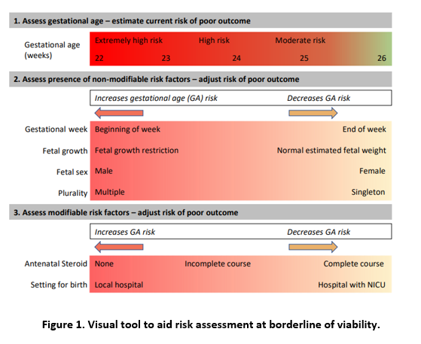
- Use of the antenatal calculator NIC-PREDICT (available at www.nic-predict.com.au) can help to predict outcomes and aid decision making (includes GA, sex, inborn and steroid coverage)
- Medical staff must record the antenatal consult in the women’s medical record in DHR including the agreed resuscitation plan. In the event a decision differs from the usual recommendations this should clearly be documented in the notes and communicated to all staff.
- Delivery attendance:
  - When active treatment is planned, a Neonatologist (Neonatologist in addition to Neonatal Advanced Trainee/Registrar) should be present at the delivery.
  - When active treatment is not planned a Neonatologist/Neonatal Registrar will not usually attend the birth but may be involved in making an appropriate palliative care plan and be available to provide support and advice to the family and perinatal team where necessary.
- When an infant dies the parents should be offered bereavement counselling including a discussion about post-mortem examination. A referral to social work and chaplaincy for bereavement support should be offered, and consent obtained before referral. For Aboriginal and Torres Strait Islander infants and family, contact the ALO team if parents consent.
- If gestational age is uncertain then fetal ultrasound and fetal weight will be markers of viability. A neonatologist should attend the birth and a decision be made in the best interests of the infant whether to initiate active treatment.

3.2 - Prior to Birth: Palliative Care Planning
Infants considered for palliative care prior to birth include, but are not limited to:
- infants born extremely prematurely <25 weeks
- infants with known Trisomy 18 or 13
- infants with a life-limiting congenital anomaly
  - severe cardiac abnormality
  - anhydramios/Absent kidneys
  - anencephaly
- infants with extreme growth restriction, expected fetal weight <500g.

Discussion with Parents:
Where time permits a consult should occur prior to labour. Parents must be part of the decision-making process and should be:
- given information in simple language regarding their infant’s condition
- told how long their infant is expected to survive and available treatment
- informed of the likely outcome if treatment is continued and how this will impact on their infant
- told that all efforts will be undertaken to keep their infant comfortable
- given treatment options including skin to skin, respiratory support, CPR, feeding, analgesia
- informed how the infant may die, though predictions of how long it will take for an infant to die are difficult to make
- given descriptions of what the infant will look like and what changes are expected as the infant deteriorates (e.g., colour changes, gasping etc.).
Parent’s anxiety and fear should be acknowledged, for many parents this may be their first encounter with death.
Parents should be encouraged and assisted to plan for:
- the birth, care, and death of their infant
- presence of friends and family members
- any rituals that are important to them, e.g., naming ceremony or baptism
- the place of death (e.g., clinical area, Quiet Room, outdoors, at home).
If time permits it is advantageous to introduce parents to the team who will be caring for them. This should include nurses, doctors, social workers, and religious support. Parents should be reassured that they will be well supported emotionally and in caring for their infant.

3.3 - Immediate Postnatal Management of Neonate in Birthing Suite - Comfort Care Pathway.
- In the delivery room, the infant should be offered skin to skin care, dried, warmed, and wrapped in warm blankets.
- The infant should be kept with the parents where possible.
- Follow the Comfort Care Plan made during antenatal consult (Parent(s), Neonatologist, Midwife) in conjunction with family and midwives.
- Assessment of infant and further pathology may be necessary to confirm diagnosis. Refer to Section 2.3 – Post-mortem.

3.4 - Management of Neonates in Department of Neonatology
- The neonate may be managed in the Birthing Suite. If survival is longer than predicted then involvement of the neonatal team should occur to allow appropriate analgesia, support, and if the parents wish for neonatal transfer. Refer to the Care of the Extremely Preterm and Low Birth Weight Neonate guideline.
- The discussion with parents about the withdrawal of active treatment must include the multi-disciplinary team while factoring in the above information. Parental requests need to be discussed.
Back to Contents

Section 4 – Staff Support
- The experience of caring for an infant receiving palliative care can be rewarding for some clinical staff and distressing and challenging for others.
- Communication and continuity of care among the multidisciplinary team is essential and supportive for both the family and the team.
- Families benefit greatly from a coordinated approach with as few carers involved as possible. For these reasons, continuity of nursing and medical team members needs to be planned for.
- It is valuable to have a multidisciplinary care team meeting as part of the decision-making process so that a care plan can be developed, and a care team arranged. It gives opportunity to answer questions and to offer support
- The paediatric palliative care nursing staff, Social Work, and Pastoral Care teams can provide support and advice to staff even if they are not directly involved with the family.
- All staff should have the opportunity to access peer and professional support and formal debriefings should be arranged as required. Support can include:
  - a Hot Debrief (a type of Operational Debrief session, refer to the Operational Debrief factsheet, available on the HealthHub) organised on the day of a death or immediately after a death/critical incident. Led by the Hot Debrief team, consultant on service or team leader.
  - a Formal Debrief (refer to Operational Debrief factsheet) during the following week, usually involving the CHS Emotional Assistance Program or a member of the Pastoral Care Team. Contact the nurse manager/Neonatal Clinical Care Coordinator (NCCC) or staff specialist to arrange.
  - individual support from senior medical or nursing supervisors
  - individual support from the CHS Emotional Assistance Program
  - a Neonatal Morbidity and Mortality meeting coordinated by the Morbidity and Mortality medical lead.
- Education and support for staff includes the CHS Neonatal Palliative Care or End of Life Program, which is a full day course for clinical staff.
- If caring for a patient who is dying, staff should be supported by the neonatal team leader and encouraged to take regular breaks and time out if required.
- After a neonatal death, the medical and nursing management team (i.e., Clinical Nurse Manager/NCCC) are to notify clinical staff.
- To remind all staff of a death of a twin or sibling, a purple butterfly place card is attached to the bed of the surviving twin/sibling.
- As a reminder to staff regarding a neonate/infant who is undergoing palliation, a caterpillar place card is to be placed outside the patient room.
Back to Contents

Evaluation

Outcome
- Infants who die while in the care of Department of Neonatology are managed as per this guideline.
- Infants that have a goal of care treatment change are documented in DHR.

Measures
- 100% of deaths reviewed in the Neonatal Morbidity and Mortality Meeting.
- Annual review of consumer feedback relating to care provided to an infant by parent or family by the Family Centre Care committee.
- 100% of deaths should have a referral for post-mortem or a documented note regarding discussion with parents for monitoring via Neonatal Morbidity and Mortality meeting.
Back to Contents

Related policies, procedures, guidelines and legislation

Policies
- Nursing and Midwifery Board of Australia (NMBA) Requirements for Practice
- Clinical Records Management

Procedures
- Clinical Records Management
- Infection Prevention and Control
- Patient Identification and Procedure Matching
- Photo, Video and Audio Capture, Storage, Disposal and Use
- Providing Care after Death
- Organ and Tissue Donation
- Pathology Specimen Management
- Perinatal and Paediatric Postmortem Examinations and Retention of Body Tissue
- North Canberra Hospital – Care of Families Experiencing Perinatal Loss at Greater than 20 weeks

Guidelines
- Consent for Healthcare Treatment
- Birth Requiring the Presence of a Neonatal Team Member
- Preterm Labour Clinical Guideline
- Care of the Extremely Preterm and Low Birth Weight Neonate
- Preterm Pre-labour Ruptured Membrane (PPROM)
- Neonatal Resuscitation and Airway Management Guideline
- Respiratory Support -Invasive and Non-Invasive (Neonates and Infants)
- Perinatal Mental Health Wellbeing
- Termination of Pregnancy (TOP) Miscarriage or Fetal Death
- Neonatal Routine Care
- Psychological Support for Staff - A Manager’s Guide
- Healthcare Associated Infection Surveillance Guideline

Legislation
- Health Records (Privacy and Access) Act 1997
- Human Rights Act 2004
- Work Health and Safety Act 2011
- Carers Recognition Act 2021

Other
- Australian Charter of Healthcare Rights
Back to Contents

References
- Australian Commission on Safety and Quality Health Care. Essential elements for safe and high-quality paediatric end-of-life care [Internet]. Australian Commission on Safety and Quality Health Care; 2016 [cited 2024 Apr 29]. Available from: https://www.safetyandquality.gov.au/sites/default/files/migrated/Consensus-statement-essential-elements-for-safe-and-high-quality-paediatric-end-of-life-care-Dec-2016.pdf
- Bolisetty S, Bajuk B, Abdel-Latif ME, Vincent T, Sutton L, Lui K. Preterm outcome table (POT): a simple tool to aid counselling parents of very preterm infants. Aust N Z J Obstet Gynaecol. 2006 Jun;46(3):189-92.
- Critical care decisions in fetal and neonatal medicine: ethical issues, Nuffield council on bioethics 2006
- CuddleCot. CuddleCot and CuddleBlanket Manuals. CuddleCot. Roftek Ltd. Gloucester, United Kingdom [Accessed 28 April 2024]. Available from https://cuddlecot.com/manuals/
- Håkansson S, Farooqi A, Holmgren PA, Serenius F, Högberg U. Proactive management promotes outcome in extremely preterm infants: a population-based comparison of two perinatal management strategies. Pediatrics. 2004 Jul;114(1):58-64
- Jankov RP, Asztalos EV, Skidmore MB. Favourable neurological outcomes following delivery room cardiopulmonary resuscitation of infants < or = 750 g at birth. J Paediatr Child Health. 2000 Feb;36(1):19-22.
- Janvier A, Barrington KJ. The ethics of neonatal resuscitation at the margins of viability: informed consent and outcomes. J Pediatr. 2005 Nov;147(5):579-85.
- Kent AL, Casey A, Lui K; NSW and ACT Perinatal Care at the Borderlines of Viability Consensus Workshop Committee. Collaborative decision-making for extreme premature delivery. J Paediatr Child Health. 2007 Jun;43(6):489-91.
- Keogh J, Sinn J, Hollebone K, Bajuk B, Fischer W, Lui K; Consensus Workshop Organising Committee. Delivery in the 'grey zone': collaborative approach to extremely preterm birth. Aust N Z J Obstet Gynaecol. 2007 Aug;47(4):273-8
- Lui K, Bajuk B, Foster K, Gaston A, Kent A, Sinn J, Spence K, Fischer W, Henderson-Smart D. Perinatal care at the borderlines of viability: a consensus statement based on a NSW and ACT consensus workshop. Med J Aust. 2006 Nov 6;185(9):495-500.
- Merenstein GB, & Gardner SL (2011). Handbook of Neonatal Intensive Care 6th Ed. Mosby. Missouri.
- Perinatal Management of Extreme Preterm Birth before 27 weeks of gestation A Framework for Practice October 2019; British Association of Perinatal Medicine.
- Perinatal Society of Australia & New Zealand. Perinatal Mortality Audit Guidelines: Section 3, Psychological and Social Aspects of Perinatal Bereavement.
- Perinatal Society of Australia and New Zealand - Clinical Practice Guideline for Perinatal Mortality https://psanz.com.au/guidelines/
- Red Nose Grief andLoss [Internet]. Red Nose; 2024 [cited 2024 May 1]. Available from: https://rednosegriefandloss.org.au/
- SIDS Western Australia. (2001). Support for Parents and Families of infants Who Have Died.
- Wilkinson AR, Ahluwalia J, Cole A, Crawford D, Fyle J, Gordon A, Moorcraft J, Pollard T, Roberts T. Management of infants born extremely preterm at less than 26 weeks of gestation: a framework for clinical practice at the time of birth. Arch Dis Child Fetal Neonatal Ed. 2009 Jan;94(1):F2-5. Epub 2008 Oct 6. PubMed PMID:
Back to Contents

Definition of terms
Inborn – neonates born in tertiary neonatal intensive care centres
Outborn – neonates born outside tertiary neonatal intensive care centres

Search terms
Death, bereavement, birth, premature, postnatal, infant, neonatal, neonate, baby, loss, perinatal, images, photograph, photo, post-mortem, palliative care, end of life, borderline, viability.
Back to Contents

Attachments
Attachment 1- Setting up the Cold Cot
Attachment 2- Borderline of Viability
Back to Contents

For Policy Team to complete:
Date amended | Section amended | Divisional approval | Final approval
11/10/2024 | New Document Added | Sarah Watson, ED, WY&C | Policy Document Review Panel
This document supersedes the following:
Document number | Document name
CHHS18/065 | Neonatal Death, Bereavement, Palliative Care and Borderline of Viability

Disclaimer
This document has been developed by Canberra Health Services specifically for its own use. Use of this document and any reliance on the information contained therein by any third party is at his or her own risk and Canberra Health Services assumes no responsibility whatsoever.
Back to Contents
Acknowledgement of Country  Canberra Health Services acknowledges the Ngunnawal people as traditional custodians of the ACT and recognises any other people or families with connection to the lands of the ACT and region. We acknowledge and respect their continuing culture and contribution to the life of this region.  © Australian Capital Territory, Canberra 2024 | Accessibility  call (02) 5124 0000   Interpreter call 131 450  canberrahealthservices.act.gov.au/accessibility  

Attachment 1 – Setting up the Cold Cot
The current cold cot used in the Department of Neonatology and North Canberra Hospital is the CuddleCot. The CuddleCot can be found in the Quiet Room in NICU.
The Instruction Manual below can found via the CuddleCot website (available at https://cuddlecot.com/manuals/ ). Other helpful resources on this site are:
- CuddleCot Quickstart Guide
- Helping families to hold baby using the CuddleCot
- ‘How to set up the CuddleCot’ presentation.

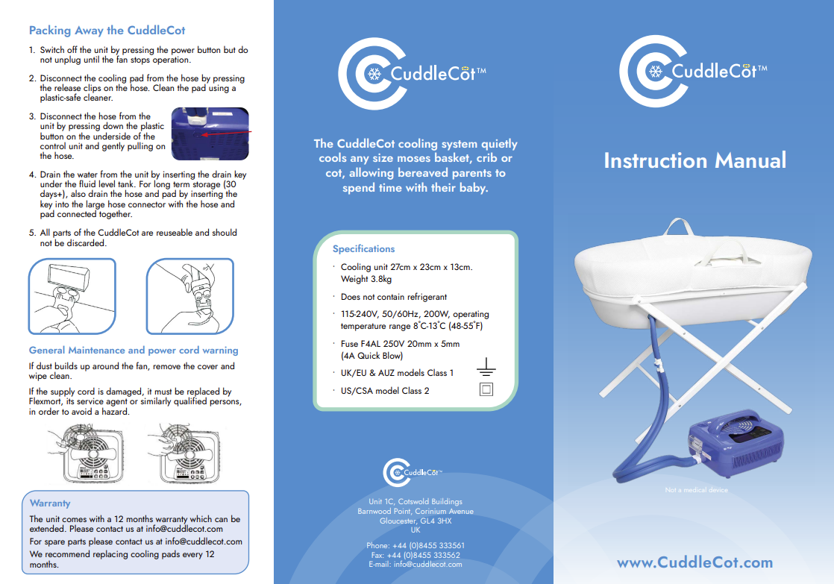
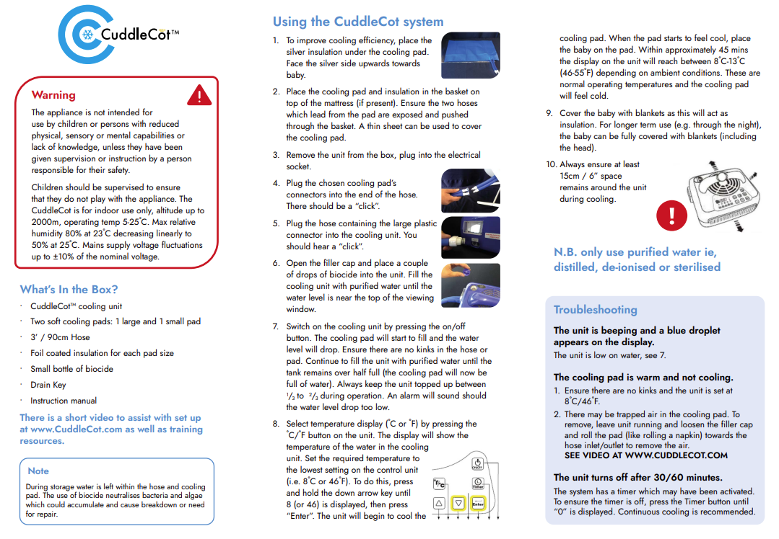

Attachment 2 – Borderline of Viability
Gestation weeks | Presumption of treatment if no discussion | Usual Recommendation to parents | Antenatal Consult | Action plan comments
26⁰+ | Active treatment provided. | Active treatment will be provided in the otherwise normal fetus. | Antenatal consult by neonatal team. | Parents will be made aware of obligation to treat. Unless exceptional circumstances active treatment will be provided. (neonatologist to attend birth).
25⁰-25⁶ | Active treatment provided. | Active treatment recommended in usual circumstances. | Antenatal consult by neonatal team. Must be neonatologist if non-treatment being considered. | In usual circumstances active treatment will be provided (neonatologist to attend birth).  If parents request palliation, then neonatologist will consult with neonatal team before agreeing a management plan. If non-resuscitation agreed neonatal team will usually be involved to provide support.
24⁰-24⁶ | Active treatment. | Full discussion of mortality/morbidity. Recommendations guided by parent’s wishes. | Antenatal consult by neonatologist/fellow. | If Active treatment plan: neonatologist to attend birth.  If Palliative care plan: neonatal staff will not usually attend birth, but neonatologist may provide support and advice as necessary.
23⁰-24⁰ | Possible resuscitation after intensive counselling. | Active treatment only after intensive counselling. | Antenatal consult neonatologist recommendations. | If active treatment is agreed following intensive counselling: Neonatologist to be present at birth to assess response to lung inflation and respiratory support.
<23 | No active treatment. | Active treatment will not be provided. | Neonatology team not usually involved in discussions. | Neonatal input not required.

