Canberra Health Services
Guideline
Employer Nominated Permanent Residency – Medical Practitioners

Contents

Contents 1
Guideline Statement 2
Scope 2
Section 1 – Pathway to Permanent Residency 2
Section 2 – Recommended Eligibility Criteria 3
Section 3 – Application and Approval Process 3
Section 4 – Cost Allocation 4
Evaluation 5
Related Policies, Procedures, Guidelines and Legislation 6
Definition of Terms 6
Search Terms 7
Attachments 7

Guideline Statement

Background
Offering a clear pathway to Australian Permanent Residency for new international Medical Practitioner hires along with existing Medical Practitioners on temporary working visas is an important strategy for both talent acquisition and retention.

This guideline will provide Delegates with a framework and process for Employer Nominated Permanent Residency visa application requests from staff or managers for existing staff on temporary working visas.

Key Objective
This guideline will ensure a consistent approach to approving and processing Employer Nominated Permanent Residency visas for Medical Practitioners across Canberra Health Services (CHS).

Back to Table of Contents

Scope

This guideline applies to Medical Practitioners including both Junior Medical Officers and Senior Medical Practitioners currently employed by CHS holding a temporary working visa who are eligible for an Employer Nominated Permanent Residency visa.

Back to Table of Contents

Section 1 – Pathway to Permanent Residency

International Medical Graduates (IMGs) who are merit selected for a Medical Practitioner position at CHS who do not have working rights in Australia (i.e. those who are not Australian Citizens, Australian Permanent Residents or New Zealand Citizens/Permanent Residents) will be provided support by CHS to obtain the appropriate temporary working visa. In most cases, this will be a Temporary Skill Shortage (Subclass 482) visa under either the Short-Term or Medium-Term Stream depending on the nominated ANZSCO occupation.

Medical Practitioners employed under a subclass 482 visa on the Medium-Term Stream may be eligible for an Employer Nomination Scheme (Subclass 186) Permanent Visa under the following streams:

Stream | Key Eligibility
Temporary Residence Transition stream | - Completed three years of full-time (1FTE) employment with the same employer who nominated the applicants subclass 482 visa  - Usually under 45 years of age (exemptions apply)
Direct Entry Stream | - Occupation must be on the relevant list of eligible skilled occupations – Medium and Long-term Strategic Skills List (MLTSSL)  - At least 3 years of relevant work experience in their occupation  - Usually under 45 years of age (exemptions apply)

Back to Table of Contents

Section 2 – Recommended Eligibility Criteria

People and Culture recommends that requests for Employer Nominated Permanent Residency nominations by existing staff or their managers be considered if they meet the following criteria, however, approval may be obtained with justification if some or all the criteria are not yet met.

- The Medical Practitioner has served a minimum of 3 years of full-time (1FTE) continuous service with CHS at the time the visa nomination is lodged by CHS with the Department of Home Affairs
- The Medical Practitioner works within an area of acute workforce shortage approved by the Executive Director of Medical Services
- The Medical Practitioner will continue to work at least 0.6 FTE within CHS for a minimum of twenty-four (24) months following approval of Permanent Residency

For Senior Medical Practitioners
- The Medical Practitioner has obtained Fellowship with the relevant specialist medical college and has or is eligible for specialist registration with the Australian Health Practitioner Regulation Agency (AHPRA)

Back to Table of Contents

Section 3 – Application and Approval Process

Step 1 | Medical Practitioner’s Clinical Director/Manager makes a request to the relevant Executive Director
Step 2 | Executive Director submits a request to:  - MOSCETU (chstchmosu@act.gov.au) for Junior Medical Officers  - Senior Medical Talent Acquisition Team (SMRO@act.gov.au) for Senior Medical Practitioners
Step 3 | For Junior Medical Officers – Director of International Coordination provides a recommendation to the Senior Director, MOSCETU for approval.  For Senior Medical Practitioners - Senior Medical Talent Acquisition Team provides a recommendation to the Executive Director of Medical Services for approval.
Step 4 | Visa nomination is lodged by Senior Medical Talent Acquisition Team/MOSCETU or a Licensed Migration Agent (if applicable)

Back to Table of Contents

Section 4 – Cost Allocation

All costs associated with a Subclass 186 visa application are listed below and as per standard recruitment expenses the CHS expenses would be paid by the hiring Division.

Subclass 186 visa costs

Item | Cost | Responsibility
Visa application fee (primary applicant) | $4,240 | Applicant
Visa application fee (dependent – over 18) | $2,120 | Applicant
Visa application fee (dependent – under 18) | $1,060 | Applicant
Miscellaneous costs in support of application (e.g. Police checks, medical checks, translations etc) | Variable | Applicant
Nomination fee* | $540 ** | CHS
Skilling Australia Fund levy (one off payment per applicant) * | $5,000 | CHS
Professional fee (Registered Migration Agent) estimated cost | $3,000 | Applicant

*Must be covered by the CHS as the nominating employer and cannot be passed on or recouped from the visa applicant.

** The Nomination Fee may be waived where the position is in a “designated regional area”

Note: Government fees shown apply to the 2022/23 Financial Year and are subject to change.

Funding Clawback

To encourage retention, the Division may choose to include a clawback clause in permanent contracts upon approval of a Subclass 186 visa. However, while clawback clauses are often included in employment contracts, there are risks in relying on such clauses as they are often unenforceable and of no effect.

If a clawback is included in employment contracts, the terms should be as follows:

- Repayment of the 100% relevant cost incurrent by CHS in the event the appointed staff terminates their employment with the Directorate within twenty-four months of the date of engagement.

The Division must ensure People and Culture/MOSCETU is made aware when permanent employment is being issued as the result of a staff member successfully receiving a permanent visa as a result of an Employer Nominated Permanent Residency visa application to ensure alignment between employment and visa categories.

Contact Details:
- MOSCETU (chstchmosu@act.gov.au) for Junior Medical Officers
- Senior Medical Talent Acquisition Team (SMRO@act.gov.au) for Senior Medical Practitioners

Back to Table of Contents

Evaluation

Outcome
The application of this guideline will:
- Ensure a consistent approach to Employer Nominated Permanent Residency visas for Medical Practitioners across Canberra Health Services
- Improve the attraction and retention of International Medical Graduates into vacant positions which are unsuccessfully filled with a suitably qualified Australian Citizen or Permanent Resident
- Reduce the number of requests for advice on Employer Nominated Permanent Residency from Medical Practitioners and managers.

Measures
- People and Culture/MOSCETU will annually review the process and outcomes of Employer Nominated Permanent Residency requests. The review will include:
  - Number of IMGs granted permanent residency through an Employer Nominated Permanent Residency visa.
  - Requests approved versus not approved including reasons for refusal.

Back to Table of Contents

Related Policies, Procedures, Guidelines and Legislation

Policy
- Annual renewal of health Practitioner Registration
- Recruitment Policy

Procedures
- Credentialling and Defining the Scope of Clinical Practice for Senior Medical and Dental Practitioners
- Recruitment Procedure
- AHPRA Medical Practitioner Registration Conditions Notations

Legislation
- Public Sector Management Act 1994 (PSM Act)
- Health Practitioner Regulation National Law Act 2009
- Human Rights Act 2004
- Information Privacy Act 2014
- Carers Recognition Act 2021

Enterprise Agreements
- ACT Public Sector Medical Practitioners Enterprise Agreement 2017-2021.

Other
- Australian Charter of Health Care Rights

Back to Table of Contents

Definition of Terms

Junior Medical Officer means Intern, Resident Medical Officer, Junior Registrar, Registrar, Senior Registrar and Senior Resident Medical Officer.

Medical Practitioner means Junior Medical Officer and Senior Medical Practitioner

Post Graduate Fellow, to be eligible for employment as a Post Graduate Fellow, a medical practitioner must:
- be a registered medical practitioner; and
- must be at least PGY7+ or equivalent; and
- be employed in a position classified as Post Graduate Fellow

Specialist means a person who:
- is a medical practitioner registered with AHPRA under the Health Practitioner Regulation National Law Act 2009 as a Specialist.
- is a medical practitioner registered with AHPRA under the Health Practitioner Regulation National Law Act 2009 who has equivalent qualifications and experience required by AHPRA as a Specialist.

Senior Specialist means a Specialist who has been employed by a hospital on the maximum pay for a Specialist for a period of at least three years (full time equivalent) and has gained such experience and attained such ability in his or her speciality as is deemed by the employer to justify appointment to the classification.

Senior Medical Practitioner means a Specialist, Senior Specialist or Post Graduate Fellow

Back to Table of Contents

Search Terms

Employer Nominated Permanent Residency Visas, Visa, Medical Practitioner, Australian Permanent Residency

Back to Table of Contents

Attachments

Attachment 1 - Employer Nominated Permanent Residency visa request process

Disclaimer: This document has been developed by Canberra Health Services specifically for its own use. Use of this document and any reliance on the information contained therein by any third party is at his or her own risk and Canberra Health Services assumes no responsibility whatsoever.

Policy Team ONLY to complete the following:
Date Amended | Section Amended | Divisional Approval | Final Approval
26/06/2023 | Complete Review | Kalena Smitham, EGM People and Culture | CHS Policy Committee

This document supersedes the following:
Document Number | Document Name

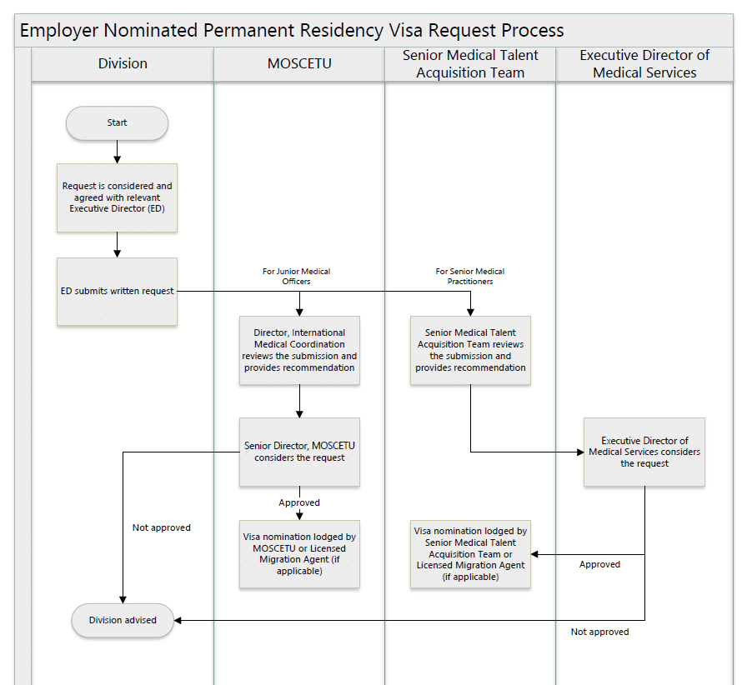
Attachment 1 - Employer Nominated Permanent Residency visa request process

