Procedure | Canberra Health Services

Voluntary Assisted Dying (VAD) (adults only)
CHS25/309
Contents
Purpose 4
Alerts 4
Scope 5
Section 1 – Overview of VAD 6
Background 6
Supporting an individual through the VAD request and assessment process 7
Mandatory VAD documentation 8
End of life planning 8
Providing culturally and spiritually safe care 9
Section 2 – Expectations for all staff and managing conscientious objection 11
Staff expectations 11
CHS VAD training 12
VAD authorised practitioner training 12
Conscientious objection 13
Section 3 – VAD communication 14
Clinical communication 14
Criminal Code considerations 14
Interpreters 15
VAD authorised practitioner requesting information 15
Individual requesting to view CHS facility operator policy information 16
Section 4 – Responding to general VAD queries and VAD information requests 16
Section 5 – Raising VAD as an end of life choice 17
Section 6 – Responding to VAD requests 18
Responding to a first request 18
Subsequent requests 20
Section 7 – VAD witness considerations 20
Second request – witness of written declaration 20
Witnessing (or being present for) VAD substance administration 20
Section 8 – CHS VAD Support Service 21
VAD Care Navigator Service (VAD CNS) 21
VAD Pharmacy Service 22
VAD Inpatient Support Service 22
Home visiting 22
Clinical Escalation 23
Out of Hours VAD support 23
Section 9 – CHS facility admission process for an individual accessing VAD 23
Non-VAD related admission 23
VAD related admission process 23
Ward staff 24
Section 10 – VAD substance storage and administration in a CHS facility 25
Storage requirements 26
Self-administration of a VAD substance in a CHS facility 27
Contact person returning self-administration VAD kit (once used) 27
Practitioner administration of a VAD substance in a CHS facility 28
Administering practitioner returning VAD kit 28
Section 11 – Providing care after death following VAD substance administration 28
Within a CHS facility 29
Outside a CHS facility 29
Section 12 – Specific VAD considerations 30
Supporting people ineligible for VAD 30
Emergency Department presentation 30
Mental health emergency & individuals in distress – staff response 30
Mental health emergency & individuals in distress – VAD CNS response 30
Organ and tissue donation 31
VAD in NSW 31
Residency exemption to access VAD in NSW 32
Residency exemption to access VAD in ACT 32
Section 13 – Individual and support network – grief and bereavement support 32
Section 14 – Supporting staff self-care, health and wellbeing 33
CHS staff supports 33
VAD Support Service staff 33
External resources 34
Section 15 – VAD Community of Practice 34
Evaluation 35
Related policies, procedures, guidelines and legislation 36
Policies 36
Procedures 36
Guidelines 36
Legislation 36
Other 37
Acknowledgements 37
Definition of terms 38
Search terms 39
Attachments 39
Attachment 1: VAD mandatory documentation requirements 42
Attachment 2: CHS facility operator policy information 43
Information about voluntary assisted dying 43
Access to voluntary assisted dying 43
Where can I find out more? 43
Attachment 3: CHS facility admission process for an individual accessing VAD 44
Attachment 4: VAD inpatient checklists 45
VAD Task List – Ward Medical Officer 45
VAD Task List – Ward CNC 46
VAD Task List – Nursing- Practitioner Administration 47
VAD Task List – Nursing – Self-Administration 48

Purpose
The purpose of this procedure is to describe the roles, responsibilities and expectations for Canberra Health Services (CHS) staff when providing care to an individual who may be seeking information about or accessing Voluntary Assisted Dying (VAD). This procedure also describes the VAD Support Services delivered by CHS (i.e. VAD Care Navigator Service (CNS), VAD Pharmacy Service and VAD Inpatient Support Service), and how conscientious objection is managed in line with the VAD legislative requirements.
Back to Contents

Alerts
Voluntary assisted dying (VAD) is a legal end of life option in the ACT since 3rd November 2025.
If staff have any concerns or queries in relation to VAD, they are strongly encouraged to contact the VAD CNS and where appropriate speak with their line manager.
An individual’s request for information about VAD or access to VAD must not impact any aspect of treatment and care that they receive from CHS staff.
Individuals are to be provided with the VAD general information brochure available in the voluntary assisted dying explained section of the ACT Government VAD website (available at: https://www.act.gov.au/health/end-of-life-and-palliative-care/voluntary-assisted-dying-in-the-act) within two business days when:
- CHS registered health professionals, social workers and speech pathologists conscientiously object to VAD and refuse to participate in certain parts of the VAD process (be a VAD authorised practitioner, provide eligibility requirement advice, supply or be present during VAD substance administration)
- any member of the individual’s treating team does not feel confident or comfortable answering an individual’s general VAD queries and requests for information.
If CHS registered health professionals, counsellors, social workers or speech pathologists are unsure if they should raise VAD as an end of life choice, or do not feel confident or comfortable doing so, they should consider giving the individual the VAD general information brochure available in the voluntary assisted dying explained section from the ACT Government VAD website.
Staff should provide hard copy VAD resources to individuals face-to-face wherever possible.
If an individual asks to view the CHS VAD facility operator policy, staff must provide them with a copy this procedure within two business days of the request. Staff must provide either a hard copy of this procedure or a link to the CHS open access information website where this procedure is publicly published (available at: https://www.canberrahealthservices.act.gov.au/about-us/policies-and-guidelines).
In the ACT, only VAD authorised practitioners can accept a first request for VAD.
If staff are asked to witness a written declaration or witness (or be present for) VAD substance administration and do not feel confident or comfortable doing so, they should let the individual know as soon as practicable that they cannot act as a witness (or be present). They should also give the individual the VAD CNS contact details and/or give the VAD general information brochure available in the voluntary assisted dying explained section from the ACT Government VAD website
All VAD authorised practitioners need to be appropriately credentialed through their relevant discipline’s CHS credentialling process before they are permitted to provide any VAD services to an inpatient in a CHS facility. For further details, please refer to the Credentialing and Defining Scope of Clinical Practice for Senior Medical and Dental Practitioners, Credentialing and Defining Scope of Clinical Practice for Senior Medical and Dental Practitioners – North Canberra Hospital (NCH) and Credentialing and Defining Scope of Clinical Practice for Nurse Practitioners and Endorsed Midwives procedures, available from the Policy and Guidance Documents Register.
An individual has the option to choose to apply for VAD in NSW and/or the ACT. However, it is important for individuals and health professionals to be aware that each VAD process is specific to each jurisdiction i.e. if an individual is found eligible for VAD in NSW, all NSW VAD steps must be completed in NSW and if an individual is found eligible for VAD in ACT, all ACT VAD steps must be completed in the ACT.
Back to Contents

Scope
This procedure applies to CHS Network staff providing care for people who may be accessing VAD as an end of life option in the community and/or as inpatients in a CHS facility. This includes nursing, medical and allied health staff working within their scope of practice. The CHS Network includes the inpatient and outpatient facilities at the Canberra Hospital, Clare Holland House, North Canberra Hospital (NCH), University of Canberra Hospital (UCH) and community-based services.
The Voluntary Assisted Dying Act 2024 (the VAD Act) refers to ‘health practitioners’ i.e. a person registered under the Health Practitioner Regulation National Law (ACT) 2024 to practise as a health professional. In this procedure the term ‘registered health professional’ is used to describe a person registered under the Health Practitioner Regulation National Law (ACT) and the term ‘self-regulated health professional’ to describe a person regulated through professional association membership (see Definition of Terms for further details). The overarching term ‘health professional’ refers to both registered health professionals and self-regulated health professionals.
Back to Contents

Section 1 – Overview of VAD

Background
Care Statement: CHS acknowledges that talking about voluntary assisted dying can be hard and cause a range of emotions. We respect that many people have personal views about this topic. If this topic raises issues for you, you can contact Lifeline on 13 11 14 or Griefline on 1800 845 745.
From the 3rd of November 2025, eligible individuals can access Voluntary Assisted Dying (VAD) as a legal end of life option in the ACT.
The Voluntary Assisted Dying Act 2024 (the VAD Act) sets out strict eligibility criteria which an individual must meet to access VAD. The individual must:
- be an adult (aged 18 years or older)
- have a diagnosed condition that is advanced, progressive and expected to cause death, either on its own or in combination with other diagnosed conditions
- be suffering intolerably because of their condition/s
- have decision-making capacity in relation to voluntary assisted dying
- be acting voluntarily and without coercion
- have been a resident of the ACT for at least the last 12 months or have been granted an exemption by the Director-General of the Health and Community Services Directorate (HCSD).
Note: ‘Voluntary’ means the choice must be the individual’s own. Only the individual seeking VAD can request it, with the use of extra assistance to exercise their decision-making capacity e.g. assistive technologies or devices as needed. It is against the law to pressure someone to request VAD and no individual can request it on another’s behalf. The VAD Act has safeguards in place to make sure the individual is protected.
If an individual is found eligible to access VAD, they may choose to self-administer the VAD substance or have a practitioner administer the VAD substance to them. This administration will be at a time and location of the individual’s choosing in the ACT (e.g. in a private home, a CHS facility, a Residential Aged Care Facility [RACF], disability housing, private hospital, other health facility or on-country). Further details on VAD eligibility and related considerations can be accessed from the ACT Voluntary Assisted Dying Clinical Guidelines available from the ACT Government VAD website (available at: https://www.act.gov.au/health/end-of-life-and-palliative-care/supporting-voluntary-assisted-dying-for-people-in-your-care).
Only certain medical practitioners, nurse practitioners and registered nurses can become VAD authorised practitioners and they must follow the legislated VAD request and assessment process. HCSD oversees authorisation of VAD practitioners. Further details on VAD authorised practitioner eligibility and authorisation can be accessed from the ACT Voluntary Assisted Dying Clinical Guidelines available from the ACT Government VAD website .

Supporting an individual through the VAD request and assessment process
The high-level steps in the VAD process are shown in Figure 1. The ten steps outline the mandated request and assessment steps with two independent VAD authorised practitioners assessing the individual’s eligibility to access VAD. Following the final request and final assessment, the individual in consultation with their coordinating practitioner, decides how they want the VAD substance to be administered (self-administration or practitioner administration). Following this administration decision, the coordinating practitioner prescribes the VAD substance and any necessary adjuvant medication. Once supplied by the VAD Pharmacy Service, the individual chooses the time and ACT location for administration of the VAD substance. Following VAD substance administration, after death care and paperwork needs to be completed.
Each step of this process is person-centred and initiated by an individual themselves. The individual requesting VAD must have decision-making capacity throughout all steps of the VAD process. Further details on each step of the VAD process, including a flowchart of a more detailed overview of this process, can be accessed from the ACT Voluntary Assisted Dying Clinical Guidelines available from the ACT Government VAD website.
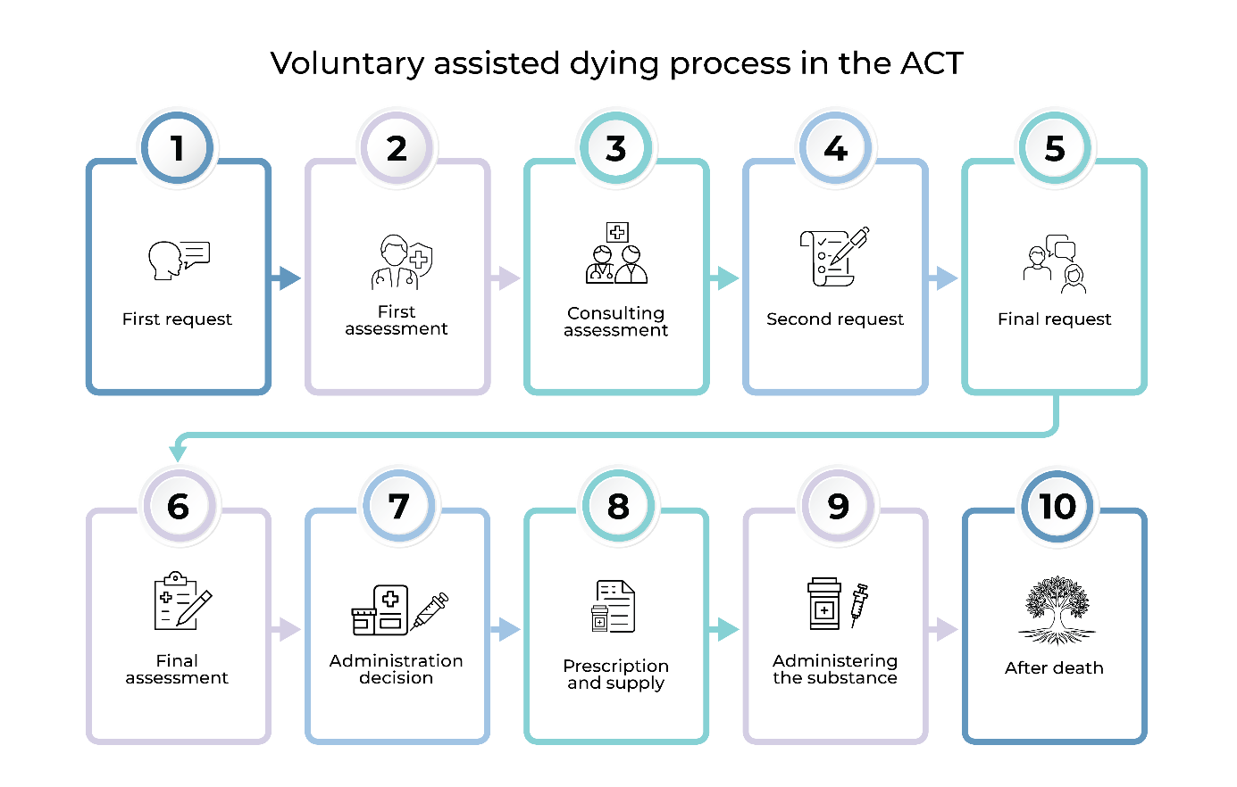
Figure 1: Overview of VAD process
If an individual has commenced the VAD process, there is no obligation for them to complete it, and they can decide to stop or re-commence the process at any time. The individual does not need to re-start a new process if they decide to take a break and then later decide to continue the VAD process.
VAD is not emergency care and the entire ACT VAD request and assessment process takes time. The exact timeframe is dependent upon the individual’s circumstances and VAD service demand. Access to some VAD services may be impacted by the availability of the individual’s coordinating, consulting or administering practitioner.
The CHS VAD Support Service (which consists of the VAD Care Navigator Service, VAD Inpatient Support Service and VAD Pharmacy Service) supports individuals and their support network (e.g. carers, family, friends and loved ones) accessing voluntary assisted dying. They also support VAD authorised practitioners in the ACT as well as staff and others. For more information on the VAD Support Service, please refer to Section 8 of this procedure.
Individuals accessing VAD may be using a private provider and some individuals accessing VAD services will be known to palliative care services.

Mandatory VAD documentation
Under the VAD Act, steps 1 to 9 of the VAD request and assessment process require mandatory information to be documented in the individual’s health record (see Attachment 1). Staff must ensure that this mandatory information is documented in line with usual CHS health record requirements (refer to the Clinical Records Management Procedure, available on the Policy and Guidance Documents Register).
Staff must also document the following in the individual’s health record:
- when responding to general VAD queries (refer to Section 4 for further details)
- when conscientiously objecting to VAD and refusing to participate as a VAD authorised practitioner, provide eligibility requirement advice, supply or be present during VAD substance administration (refer to Section 2 for further details).
All VAD authorised practitioners, the VAD Support Service and other key stakeholders such as the VAD Oversight Board Secretariat have access to the ACT VAD online portal. The VAD online portal is a secure online platform to facilitate necessary notifications, submission of required documentation and recording of VAD activities undertaken. Further details on the VAD Oversight Board are available from the ACT Government VAD website (available at: https://www.act.gov.au/directorates-and-agencies/health-and-community-services-directorate/act-voluntary-assisted-dying-oversight-board).

End of life planning
All people seeking access to VAD should have an opportunity to continue ongoing treatment with their treating team, be offered a referral to palliative care services and have end of life planning discussions. These conversations may include the involvement of carers and others in their support network where appropriate. The individual should also be supported to plan for what may occur if they were to die before completing the VAD process, or if they were to lose decision-making capacity during the VAD process.
Planning for end of life discussions can occur with the individual’s treating team, their VAD coordinating practitioner and/or the VAD Care Navigator Service (CNS). This end of life planning may include:
- Completing Advance care planning (ACP) documents
Note: An individual cannot request VAD in an ACP document. Further details on ACP in relation to VAD can be accessed from the ACT Voluntary Assisted Dying Clinical Guidelines available from the ACT Government VAD website (available at: https://www.act.gov.au/health/end-of-life-and-palliative-care/supporting-voluntary-assisted-dying-for-people-in-your-carehttps://www.act.gov.au/health/end-of-life-and-palliative-care/providing-voluntary-assisted-dying-services-in-the-act). For further ACP considerations, please refer to the Advance Care Planning (for adults) Guideline available from the Policy and Guidance Documents Register.
- Completing a will
- Appointing an Enduring Guardian and/or Power of Attorney
- Choosing a preferred place of care
- People they may want or not want present during administration
- Consideration of the end of life options available to the individual
Note: As part of this consideration, the individual’s treating team should consider whether the individual requires referral to other services e.g. palliative care.
- Any concerns or family conflict over the decision to access VAD
- Values and wishes of the individual
- Deactivation of cardiac-defibrillation devices (when appropriate)
- Symptom management
- Consideration of funeral arrangements
- Spiritual, religious, or cultural needs of the individual
- Planning who will complete the after-death documentation.
Further details on end of life planning can be accessed from the ACT Voluntary Assisted Dying Clinical Guidelines available from the ACT Government VAD website.

Providing culturally and spiritually safe care
Staff need to make every effort to provide culturally and spiritually safe care for individuals whom they are caring for. This requires considering and respecting a person’s personal, cultural, spiritual and religious beliefs and practices.
End of life care may be influenced by factors relating to the individual’s social determinants of health, culture and community. In some instances, this may require end of life decisions being made collectively by the individual’s family and their community. There can be significant diversity within all communities, such as culturally and linguistically diverse and Aboriginal and Torres Strait Islander communities – each individual needs to be supported in a way that best suits them.
Translated resources can be accessed from the ACT Government VAD website to support staff when providing care to individuals navigating the VAD process. For interpreter considerations, please refer to Section 3 of this procedure.
If an individual who identifies as Aboriginal and Torres Strait Islander is accessing VAD and the individual has not previously been referred to a CHS Aboriginal and Torres Strait Islander Liaison Service, with the individual’s consent, their treating team or the VAD CNS can arrange referral to:
- Aboriginal and Torres Strait Islander Service by calling 02 5124 5527 or emailing ALOService@act.gov.au
- North Canberra Hospital Aboriginal Liaison Team by calling 02 6201 6111 or emailing NCH.ALOS@act.gov.au
If the individual does not wish to be supported by the above service/s, staff are encouraged to consider contacting the relevant service so that they can discuss de-identified individual details to support them to provide culturally safe care.
If an individual is accessing VAD, their treating team or the VAD CNS can arrange referral to:
- Spiritual Support Services (Canberra Hospital, UCH) by calling 5124 3849 or emailing spiritualsupportservices@act.gov.au
- Pastoral and Spiritual Care (NCH) by calling 5103 6665 or emailing CHSNCH.PastoralCare@act.gov.au
Further pastoral and spiritual support details are available from the HealthHub.
Other cultural safety considerations:
- The LGBTIQ+ community – CHS aims to provide a safe space for all in our community, and this requires non-judgemental and respectful staff who are welcoming and supportive for all gender and sexually diverse individuals. This includes correct use of pronouns, preferences and providing a safe environment for individuals in line with their preferred support network
- People experiencing homelessness – should an individual experiencing homelessness request VAD, it may be possible for the VAD CNS to help identify resources and support such as homeless or other services (e.g. Onelink, ACT Housing) to potentially provide concurrent assistance through the VAD process
- People with a disability, dementia, or mental health impairment – Under the VAD Act, people with a disability, dementia, or mental health impairments may request access to VAD and may be eligible provided they have decision-making capacity and meet the other VAD eligibility criteria. They may need extra assistance to exercise their decision-making capacity e.g. assistive technologies or devices.
Further details on VAD for diverse populations (including Aboriginal and Torres Islander people) can be accessed from the ACT Voluntary Assisted Dying Clinical Guidelines available from the ACT Government VAD website.
Back to Contents

Section 2 – Expectations for all staff and managing conscientious objection
CHS understands that it may be challenging for staff if an individual receiving care from CHS seeks to access VAD as an end of life option.
Alert: If staff have any concerns or queries in relation to VAD, they are strongly encouraged to contact the VAD CNS and where appropriate speak with their line manager.

Staff expectations
There is an expectation that all staff treat individuals seeking information about VAD or accessing VAD with respect, and act professionally and with sensitivity in a manner in line with their CHS role, scope of practice and professional obligations (where applicable).
All staff should provide person-centred, high quality and safe care to individuals, irrespective of whether the individual is seeking information about VAD or accessing VAD. There is also an expectation that all staff interact respectfully with colleagues who may have differing views on VAD.
Alert: An individual’s request for information about VAD or access to VAD must not impact any aspect of treatment and care that they receive from CHS staff.
To assist staff in meeting their obligations in line with the VAD legislative requirements and CHS requirements, a high-level overview of staff expectations is provided below.

Treating team can:
- Respond to general VAD enquiries or requests for information
- Be asked to witness a written declaration or witness (or be present) for VAD substance administration

CHS registered health professionals can:
- Respond to general VAD enquiries or requests for information
- Be asked to witness a written declaration or witness (or be present) for VAD substance administration
- Conscientiously object to VAD as per VAD legislative requirements
- Raise VAD as an end of life choice as per VAD legislative requirements
- Consider a first request for VAD, but can only accept a first request if they are a VAD authorised practitioner.

CHS self-regulated health professionals can:
- Respond to general VAD enquiries or requests for information
- Be asked to witness a written declaration or witness (or be present) for VAD substance administration
- Social workers and speech pathologists: Conscientiously object to VAD as per VAD legislative requirements.
- Counsellors, social workers and speech pathologists: Raise VAD as an end of life choice as per VAD legislative requirements.

CHS VAD training
Health professionals and those who are part of the treating team, are strongly encouraged to:
- Attend a VAD education session delivered by the VAD CNS. Managers should contact the VAD CNS to arrange an education session for their staff, including refresher sessions as needed
- Complete the CHS VAD General Awareness training available from the CHS Learning Management System (LMS). This training aligns with HCSD VAD general awareness training and ACT Voluntary Assisted Dying Clinical Guidelines available from the ACT Government VAD website (available at: https://www.act.gov.au/health/end-of-life-and-palliative-care/supporting-voluntary-assisted-dying-for-people-in-your-care)
- Complete the CHS VAD Declaration from the CHS LMS confirming that you understand your responsibilities under the Act and whom to contact when you have VAD queries or concerns.
VAD CNS staff must also complete the training requirements outlined in the VAD Care Navigator Service Education Program available from the CHS LMS.
VAD Pharmacy Service staff must also complete the training requirements outlined in the approved VAD pharmacist training package, including the VAD Pharmacy Service Education Program available from the CHS LMS.

VAD authorised practitioner training
All VAD authorised practitioners must successfully complete the HCSD VAD authorised practitioner training course. HCSD oversees authorisation of VAD practitioners, including their training. Further details on VAD authorised practitioner training is available from the ACT Government VAD website (available at: https://www.act.gov.au/health/end-of-life-and-palliative-care/becoming-a-voluntary-assisted-dying-practitioner).
Upon training completion, all VAD authorised practitioners need to be appropriately credentialed through their relevant discipline’s CHS credentialling process before they are permitted to provide any VAD services to an inpatient in a CHS facility. For further details, please refer to the Credentialing and Defining Scope of Clinical Practice for Senior Medical and Dental Practitioners Procedure, Credentialing and Defining Scope of Clinical Practice for Senior Medical and Dental Practitioners – North Canberra Hospital (NCH) Procedure and Credentialing and Defining Scope of Clinical Practice for Nurse Practitioners and Endorsed Midwives Procedure available from the Policy and Guidance Documents Register.

Conscientious objection
Alert: The Voluntary Assisted Dying Act 2024 (the VAD Act) refers to ‘health practitioners’ i.e. a person registered under the Health Practitioner Regulation National Law (ACT) 2024 to practise as a health professional. In this procedure the term ‘registered health professional’ is used to describe a person registered under the Health Practitioner Regulation National Law (ACT) and the term ‘self-regulated health professional’ to describe a person regulated through professional association membership (see Definition of Terms for further details). The overarching term ‘health professional’ refers to both registered health professionals and self-regulated health professionals.
Health professionals have the right to conscientiously object to participating in VAD.
The VAD Act states that registered health professionals who have a conscientious objection to VAD may refuse to do any of the following:
- act as a coordinating practitioner, consulting practitioner or administering practitioner
- provide advice about eligibility requirements if a coordinating practitioner or consulting practitioner has made a referral for this.
Note: Providing eligibility requirement advice is not the same as providing a letter stating the individual’s current heath condition/s and any other relevant health information.
- supply a VAD substance
- be present during VAD substance administration.
The VAD Act also states that social workers and speech pathologists who have a conscientious objection to VAD may refuse to do any of the following:
- participate in a request and assessment process
- participate in an administration decision
- be present during VAD substance administration.
The VAD Act requires that if the above health professionals conscientiously object to VAD and refuse to participate in those parts of the VAD process, they must within two business days of this refusal give the individual, in writing, the contact details of the approved care navigator service i.e. the VAD CNS.
Alert: If CHS registered health professionals, social workers and speech pathologists conscientiously object to VAD and refuse to act in certain parts of the VAD process (be a VAD authorised practitioner, provide eligibility requirement advice, supply or be present during VAD substance administration), they must within two business days of this refusal give the individual the VAD general information brochure available in the voluntary assisted dying explained section from the ACT Government VAD website (available at: https://www.act.gov.au/health/end-of-life-and-palliative-care/voluntary-assisted-dying-in-the-act).
When CHS registered health professionals, social workers and speech pathologists conscientiously object to VAD and refuse to act in certain parts of the VAD process (be a VAD authorised practitioner, provide eligibility requirement advice, supply or be present during VAD substance administration), this interaction and action taken should be documented in the individual’s health record in line with usual CHS health record requirements.
Further details on VAD conscientious objection can be accessed from the ACT Voluntary Assisted Dying Clinical Guidelines available from the ACT Government VAD website.
Back to Contents

Section 3 – VAD communication

Clinical communication
All discussions with individuals, including conversations about VAD, should be treated with clinical discretion to protect privacy and confidentiality. For further details on how to protect consumer privacy and personal health information, please refer to the Consumer Privacy Policy available from the Policy and Guidance Documents Register.
Note: Staff should avoid using euphemisms when talking about VAD and end of life and use plain language wherever possible (e.g. “die” instead of “pass on”).
When supporting an individual accessing VAD, clinical handover in relation to an individual accessing VAD should occur in line with the Clinical Handover Procedure, available from the Policy and Guidance Documents Register. Staff can also contact the VAD CNS for general guidance on clinical communication considerations in relation to VAD.

Criminal Code considerations
The Commonwealth Criminal Code Act 1995 (Criminal Code) has two provisions which prohibit the use of a ‘carriage service’ i.e. telephone, videoconference, email, internet or fax to access and transmit ‘suicide-related material’. In late 2023, the Federal Court ruled that VAD is considered suicide under the Criminal Code.
Alert: Staff should provide VAD resources to individuals face-to-face, in hard copy, wherever possible.
CHS staff should ideally have VAD discussions face-to-face with an individual, particularly for VAD requests and assessments. Where this is not possible, staff should contact the VAD CNS for further specific guidance.
The VAD CNS takes referrals from any source, in any format from any stakeholder – including referrals provided via email and telephone. This approach takes into consideration the risks associated with breaching the Criminal Code and the importance of providing person-centred and high quality and safe care.
Further details of Criminal Code considerations can be accessed from the ACT Voluntary Assisted Dying Clinical Guidelines available from ACT Government VAD website (available at: https://www.act.gov.au/health/end-of-life-and-palliative-care/supporting-voluntary-assisted-dying-for-people-in-your-care).
Staff are encouraged to contact the VAD CNS if any further general guidance on Criminal Code considerations is needed.

Interpreters
The VAD Act requires that the interpreter for an individual who is accessing VAD or requesting VAD access must not:
- be a family member
- be a beneficiary of the individual’s will
- receive benefit from assisting the individual to access VAD or from the individual’s death in any way (exemption for interpreting service fees)
- own or be responsible for facility management where the individual is a resident
- be directly involved in providing health, personal or aged care services to the individual.
Further details regarding interpreter considerations relating to VAD, including interpreter exemptions (i.e. when the only interpreter available meets any of the above criteria), can be accessed in the ACT Voluntary Assisted Dying Clinical Guidelines available from the ACT Government VAD website.
Staff must ensure that individuals are given the opportunity to access an interpreter if required. The individual must consent to and have a choice about the use of an interpreter. Staff should refer to the Language Services – Interpreters and Translated Materials for Adults and Children Procedure available from the Policy and Guidance Documents Register and the Translating and Interpreting Services HealthHub site for details on how to access an interpreter.

VAD authorised practitioner requesting information
If staff are asked to provide personal health information to assist a VAD authorised practitioner assessing an individual’s eligibility for VAD (for example providing a letter stating the individual’s current heath condition/s and any other relevant health information) they should do so as part of usual care.
Staff should also seek the individual’s consent to share this personal health information. Patient consent should be documented in the individual’s health record or on the Consent to Release and/or Share Personal Information form (form no.15274 on the CHS Clinical Forms Register). For further details, please refer to the Clinical Records Management Policy and Clinical Records Management Procedure available from the Policy and Guidance Documents Register. Staff are encouraged to contact the VAD CNS if any further general guidance is needed.

Individual requesting to view CHS facility operator policy information
In the ACT, facilities such as hospitals, hospices and residential aged care facilities have facility operator obligations under the VAD Act. Detailed information outlining how CHS meets its obligations as a facility operator is outlined in Attachment 2 of this procedure.
Alert: If an individual asks to view the CHS VAD facility operator policy, staff must provide them with a copy this procedure within two business days of the request. Staff must provide either a hard copy of this procedure or a link to the CHS open access information website where this procedure is publicly published (available at: https://www.canberrahealthservices.act.gov.au/about-us/policies-and-guidelines).
Staff can contact the VAD CNS for further guidance on how to respond to an individual requesting to view the CHS facility operator policy information.
Back to Contents

Section 4 – Responding to general VAD queries and VAD information requests
The individual’s treating team can answer an individual’s general queries about VAD (e.g. answering the question “What is voluntary assisted dying?”) and provide general information about voluntary assisted dying. The individual’s treating team must respond to these queries and requests for information within two business days and they must also give the individual the VAD general information brochure available in the voluntary assisted dying explained section from the ACT Government VAD website (available at: https://www.act.gov.au/health/end-of-life-and-palliative-care/voluntary-assisted-dying-in-the-act).
When members of the individual’s treating team are asked general queries about VAD, this interaction and action taken should be documented in the individual’s health record in line with usual CHS health record requirements.
Alert: If any member of the individual’s treating team does not feel confident or comfortable answering an individual’s general VAD queries and requests for information, they must within two business days give the individual the VAD general information brochure available in the voluntary assisted dying explained section from the ACT Government VAD website.
Staff can contact the VAD CNS for guidance on how to respond to general VAD queries and requests for information.
Back to Contents

Section 5 – Raising VAD as an end of life choice
The VAD Act enables registered health professionals, counsellors, social workers and speech pathologists to initiate a discussion about VAD as an end of life choice with an individual in the following circumstances.
A doctor or nurse practitioner (with relevant expertise to discuss the full range of treatment and palliative care options) may raise VAD as an end of life choice provided that they:
- know or reasonably believe that the individual has been diagnosed with a condition or conditions which meets the VAD eligibility criteria, and
- are satisfied that they have the expertise to appropriately discuss treatment and palliative care options with the individual, and
- take reasonable steps to ensure that the individual knows of the treatment options available for the condition or conditions, the likely outcome of the treatment options, palliative care options available to the individual and the likely outcome of the palliative care options.
Doctors or nurse practitioners (without relevant expertise to discuss the full range of treatment and palliative care options), other registered health professionals, counsellors, social workers and speech pathologists may raise VAD as an end of life choice provided that they:
- know or reasonably believe that the individual has been diagnosed with a condition or conditions which meets the VAD eligibility criteria, and
- take reasonable steps to ensure that the individual knows that treatment and palliative care options are available to the individual and that the individual should discuss the options with their treating doctor.
CHS registered health professionals, counsellors, social workers or speech pathologists who raise VAD as an end of life choice must document this discussion in the individual’s health record in line with usual CHS health record keeping requirements.
Alert: If CHS registered health professionals, counsellors, social workers or speech pathologists are unsure if they should raise VAD as an end of life choice, or do not feel confident or comfortable doing so, they should consider giving the individual the VAD general information brochure available in the voluntary assisted dying explained section from the ACT Government VAD website .
CHS health professionals need to apply their clinical discretion when considering whether they should raise VAD as an end of life choice. At a minimum, health professionals must ensure that they adhere to the raising VAD as an end of life choice legislative requirements set out for doctors or nurse practitioners (without relevant expertise to discuss the full range of treatment and palliative care options), other registered health professionals (e.g. registered nurses), counsellors, social workers and speech pathologists.
Further details on raising VAD as an end of life choice can be accessed in the ACT Voluntary Assisted Dying Clinical Guidelines available from ACT Government VAD website (available at: https://www.act.gov.au/health/end-of-life-and-palliative-care/supporting-voluntary-assisted-dying-for-people-in-your-care). Staff can also contact the VAD CNS for general guidance on raising VAD as an end of choice.
Back to Contents

Section 6 – Responding to VAD requests

Responding to a first request
As set out in the VAD Act, the first step of the VAD process is where an individual makes a first request for access to VAD to a registered health professional. This first request must be clear, unambiguous, and made personally by the individual. The individual can communicate this first request in writing, using spoken language, sign language, with the assistance of an interpreter or through using assistive technologies or devices.
Examples of a first request:
- “I want to access voluntary assisted dying”
- “I want euthanasia”
- “I would like to die on my own terms. How can I access voluntary assisted dying?”
- “Can you help me die?”
- “I don’t want to go on like this. I am in too much pain. Can I get a medicine to die?”
Note: Clinical discretion is needed when considering how a registered health professional responds to an individual expressing the above.
Examples of what is not a first request:
- An individual expressing interest in VAD or seeking more information such as “Can you tell me more about voluntary assisted dying?”
- A request made on someone else’s behalf
- A health professional raising VAD as an end of life choice with an individual in certain circumstances.
If a registered health professional is not a VAD authorised practitioner, they are unable to accept a first request. Within four business days, they must tell the individual that they cannot accept first requests for VAD and that other registered health professionals may be able to assist them, and they must provide the individual with either of the following:
- information about the VAD CNS e.g. by providing the VAD general information brochure available in the voluntary assisted dying explained section from the ACT Government VAD website (available at: https://www.act.gov.au/health/end-of-life-and-palliative-care/voluntary-assisted-dying-in-the-act) or
- information about another registered health professional whom they believe may be able to assist them i.e. a VAD authorised practitioner.
Alert: In the ACT, only VAD authorised practitioners can accept a first request for VAD.
If a registered health professional is a VAD authorised practitioner, they may decide to accept a first request. Further details, including the information which must be provided if an individual’s first request is accepted, can be accessed in the ACT Voluntary Assisted Dying Clinical Guidelines available from ACT Government VAD website (available at: https://www.act.gov.au/health/end-of-life-and-palliative-care/supporting-voluntary-assisted-dying-for-people-in-your-care).
Registered health professionals must document the details of any first requests made to them and action taken in the individual’s health record.
An overview of the process for CHS registered health professionals responding to a first request is shown in Figure 2. 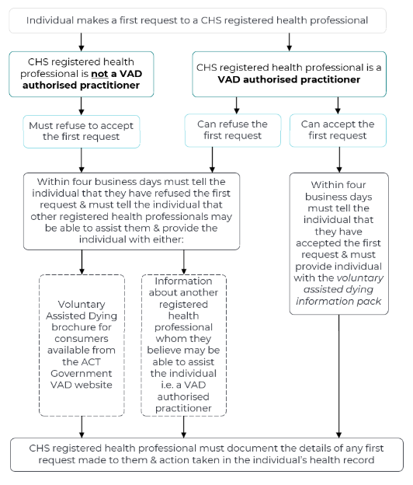
Figure 2: Overview of CHS registered health professionals responding to a first request process.
Further details on first requests and how to document a first request can be accessed from the ACT Voluntary Assisted Dying Clinical Guidelines available from ACT Government VAD website .
Staff can contact the VAD CNS for general guidance on first requests for VAD.

Subsequent requests
Subsequent VAD requests can only be considered by VAD authorised practitioners. Further details can be accessed from HCSD developed resources available from the ACT Government VAD website.
Back to Contents

Section 7 – VAD witness considerations

Second request – witness of written declaration
If a staff member is asked to witness a written declaration (as part of a VAD second request), they are encouraged to contact the VAD CNS for any necessary support.
In the ACT, an eligible witness to a written declaration means someone who is:
- an adult
- not a beneficiary of the individual’s will
- not going to benefit from assisting the individual to access VAD or from the individual’s death in any way (exemption for witness service fees)
- not an owner or responsible for facility management where the individual is a resident
- not the individual’s coordinating practitioner or consulting practitioner.
If there are any difficulties obtaining eligible witnesses for a written declaration, the VAD CNS can help facilitate this to occur.

Witnessing (or being present for) VAD substance administration
If a staff member is asked to witness (or be present for) VAD substance administration for an individual whom they have been providing care for, they are encouraged to speak with the VAD CNS. This is intended to ensure that the staff member’s consideration of this request is fully informed. The VAD CNS can provide prebrief and debrief support to any staff member who agrees to witness (or be present for) VAD substance administration.
The VAD CNS will also be available to witness (or be present for) VAD substance administration.

Alert: If staff are asked to witness a written declaration or witness (or be present for) VAD substance administration and do not feel confident or comfortable doing so, they should let the individual know as soon as practicable that they cannot act as a witness (or be present). They should also give the individual the VAD CNS contact details and/or give the VAD general information brochure available in the voluntary assisted dying explained section from the ACT Government VAD website (available at: https://www.act.gov.au/health/end-of-life-and-palliative-care/voluntary-assisted-dying-in-the-act).
Back to Contents

Section 8 – CHS VAD Support Service
The CHS VAD Support Service consists of the VAD CNS, which is managed within the Division of Cancer and Ambulatory Support, the VAD Pharmacy Service (VAD PS), which is managed through the Division of Medical Services, and the VAD Inpatient Support Service which is available in all inpatient CHS facilities and supported by the VAD CNS. The VAD Support Service is located at Canberra Hospital.
The overall goal of the VAD Support Service is to provide person-centred and sustainable VAD services to individuals, their support networks, health professionals and VAD authorised practitioners in the ACT.
The VAD Support Service does not work in isolation but exists within the context of other end of life services. This service provides cohesive integrated care through collaborating with an individual’s current health and/or service providers and local resources to support coordinated service delivery (where consent is provided to do so). For further details on the VAD Support Service, please refer to the VAD Support Service Model of Care available from HealthHub.
The VAD Support Service is available during normal working hours, Monday – Friday, 8.30am to 5pm by calling 02 5124 1888 or emailing vad.carenavigators@act.gov.au.

VAD Care Navigator Service (VAD CNS)
The VAD CNS provides:
- A single point of contact in the health system for individuals and their support network
- A single point of contact for colleagues providing care
- Accessible support, with no cost to individuals, including a home visiting service
- A multidisciplinary care approach
- The right care in the right place by the right health professional
- Person-centred care, including collaborating and working with General Practitioners (GPs), CHS services (acute and community) and Non-Government Organisations, to meet the needs of the individual, including communicating information back to the individual’s usual care team (subject to the individual’s consent)
- Witnesses for VAD substance administration when needed
- Support to individuals, their support network (e.g. carers, family, friends and loved ones) where appropriate
- Registered Nurses Only: Provides verification of death when needed
- VAD Medical Lead Only: Undertakes VAD eligibility assessment when needed.

VAD CNS referral process
The VAD CNS takes referrals from any source, in any format from any stakeholder – this includes self-referrals. A written referral is encouraged from health professionals to support timely care delivery but is not essential and telephone referrals are also accepted.
The VAD CNS accepts referrals for an individual, at any stage of the VAD process. On receipt of an initial referral, the VAD CNS will directly contact the individual.

VAD Pharmacy Service
The VAD Pharmacy Service provides:
- Information about the VAD substance to people accessing VAD and their support network, and VAD practitioners
- Information on collection, preparation, administration and disposal of the VAD substance
- Witnesses for VAD substance administration when needed
- Support to individuals when accessing the VAD substance.

VAD Inpatient Support Service
Individuals eligible to access VAD may include existing ward inpatients at a CHS facility under the care of their CHS treating team, as well as individuals requiring admission to a CHS facility for VAD substance administration (self-administration or practitioner administration). If the individual does not have a CHS treating team, the VAD CNS will arrange for an appropriate CHS team to be identified.
CHS will only accept an individual for transfer (including transfer from a RACF) for VAD when there has been prior discussion and agreement with the VAD CNS that the individual will be transferred to a CHS facility during normal working hours. The VAD CNS supports ward staff caring for individuals accessing VAD, as well as individuals, their support networks and VAD practitioners. For more information, please refer to Section 9 of this procedure.

Home visiting
VAD Support Service staff will comply with the Community Duress Device Procedure and Home Visiting Procedure, (available on the Policy and Guidance Documents Register). This includes completing the Home Visit Risk Assessment tool, using the Dot phrase note writing tool and taking reasonable steps to maintain their personal safety during home visits in line with any specific VAD Support Service work area requirements.

Clinical Escalation
Any individual accessing VAD who experiences acute escalation of symptoms should access care from their treating team. This care should include consideration of end of life care options available to the individual, which may include palliative care.

Out of Hours VAD support
The VAD Support Service does not provide emergency or after-hours care. The urgency of VAD requests are considered during normal working hours.
Back to Contents

Section 9 – CHS facility admission process for an individual accessing VAD
An individual may be admitted to a CHS facility for non-VAD or VAD care.

Non-VAD related admission
Individuals accessing VAD may be admitted to a CHS facility for non-VAD care reasons. The VAD CNS will regularly monitor inpatient admissions and will support individuals accessing VAD as needed. An overview of this process is outlined in Attachment 3.

VAD related admission process
An individual may require admission to a CHS facility for VAD, generally for VAD substance administration, due to a range of factors. Admissions must be pre-planned through the VAD CNS to ensure that the individual has access to a single private room in an appropriate timeframe, ideally Monday to Friday during normal working hours.
The coordinating practitioner, VAD CNS team and admitting team will need to manage the individual’s expectations regarding the pre-planned admission date and room availability.
Individuals requiring admission to a CHS facility should have a Request for Admission (RFA) Form completed in their electronic health record, with the required date of admission. The RFA should reflect that the individual is being admitted under their primary condition and/or treating team. This will be organised by the VAD CNS in conjunction with the coordinating practitioner and their admitting team (e.g. individual’s usual CHS treating team).
The VAD CNS will also liaise with the admitting team should the patient (once admitted to a CHS facility) require any symptom management medication prior to VAD substance administration. If the Goals of Patient Care conversation has not occurred prior to admission, the VAD CNS will liaise with the admitting team regarding this matter.
Further details of the VAD related admission process to a CHS facility are outlined in Attachment 3. Specific guidance on VAD inpatient tasks for the ward doctor, Ward CNC and nursing staff are outlined in Attachment 4. For further general admission guidance, please refer to the Admission to Discharge Procedure (adults and children) and the Admission to Discharge – Adults, Children, and Infants - North Canberra Hospital Procedure available from the Policy and Guidance Documents Register.

Ward staff
The VAD CNS will liaise with the admitting ward to ensure that ward staff can be prepared for this direct admission, including coordinating patient allocations as appropriate.
Note: Ward staff will only be expected to provide usual care before VAD substance administration. Ward staff will have no involvement in VAD substance administration.

Ward staff prebrief
Prior to VAD substance administration, a confidential prebrief may be held in the clinical area. The prebrief may be conducted by a CHS VAD authorised practitioner or VAD CNS team member to ensure that:
- staff who conscientiously participate and staff who conscientiously object are supported
- staff can raise any concerns, including acknowledgement and normalisation of different feelings about the administration of a VAD substance to an individual.
Note: Where possible, staff who provide these briefings are encouraged to utilise relevant information from the Psychological Support for Staff – A Manager’s Guide available from the Policy and Guidance Documents Register.

Ward staff debrief
After the death of a patient following VAD substance administration, staff working in the clinical area or providing usual care to the patient may want to participate in a debrief session. The debrief may be conducted by a CHS VAD authorised practitioner or VAD CNS team member. As VAD becomes more familiar, debriefing may only need to occur on a case-by-case basis.
The purpose of the debrief may include:
- Where necessary, providing psychological first aid for staff that were involved in usual care of the patient, including acknowledgement and normalisation of different feelings about the administration of a VAD substance to an individual
- Advise staff of well-being resources and the range of local support services available to them such as Employee Assistance Program (EAP). The VAD CNS can assist with arranging EAP onsite support for ward staff as needed
- Address any concerns about the administration process
- Identify continuing professional development needs of staff and linking them in with existing education material.
Note: Where possible, staff who provide these briefings are encouraged to utilise relevant information the Psychological Support for Staff – A Manager’s Guide available from the Policy and Guidance Documents Register.
Back to Contents

Section 10 – VAD substance storage and administration in a CHS facility
An individual who presents to a CHS facility with the VAD kit for self-administration must disclose if they are in possession of the VAD substance to ensure safe storage and accountability of the VAD substance.
Note:
- The VAD Act requires that every individual who chooses VAD substance self-administration nominate a contact person.
- There are no special handling requirements and usual standard precautions should be applied to the VAD kit and its contents.
If an existing inpatient in a CHS facility is supplied the VAD kit for self-administration during their inpatient stay, CHS is responsible for the safe storage and accountability of the VAD substance until the patient is discharged.
To assist with planning for VAD kit storage, the VAD kit box for self-administration has the following (estimated) dimensions: 225mm wide, 360mm long, 105mm high. The kit box includes the locked box containing the VAD substance and adjuvant medications (including lorazepam). When storing the VAD kit, the locked box should not be opened. The estimated dimensions of the locked box are: 115 mm wide, 155mm long, 85mm high.
Sample images of the locked box and lorazepam box are provided below.
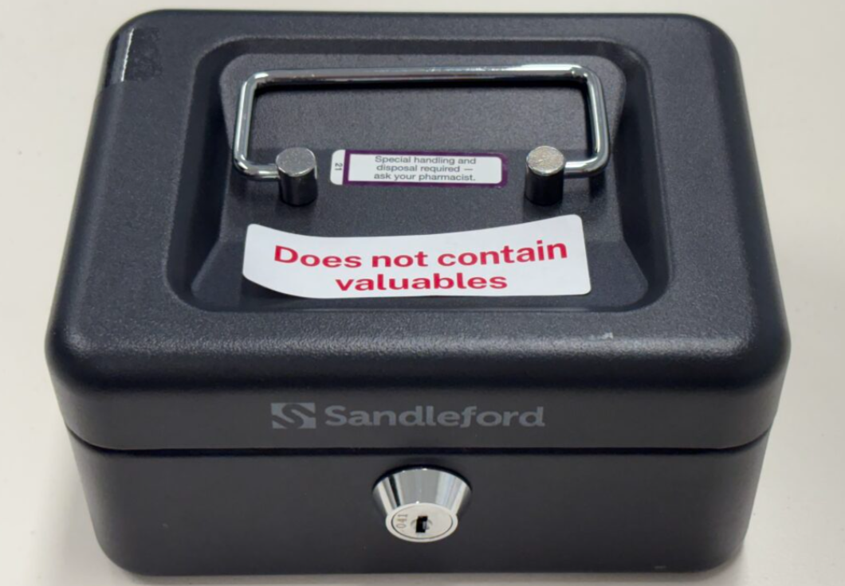
Image 1: Locked box which contains the oral VAD substance (sample image of box with no patient labelling).

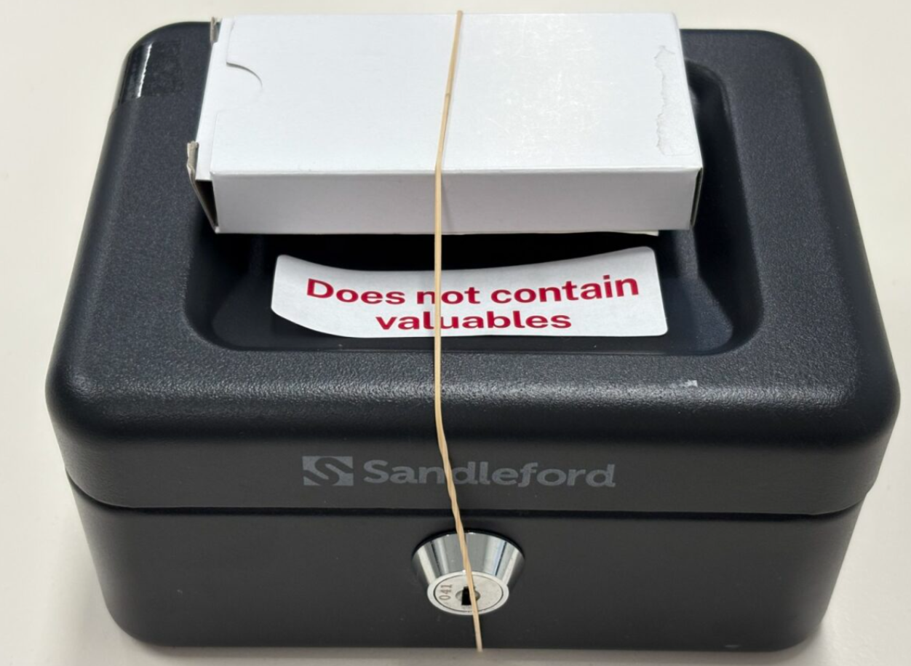
Image 2: Locked box which contains the oral VAD substance and lorazepam box (sample image with no patient labelling).

Storage requirements
The VAD kit must be stored in accordance with the requirements of the Medication Handling Policy and Medication Handling Procedure – North Canberra Hospital available from the Policy and Guidance Documents Register. Should the self-administration VAD kit not be immediately required, or if there is unused or remaining VAD substance which cannot be returned to the VAD Pharmacy Service during normal business hours, and storage at a CHS facility is necessary, the following steps must be taken by a registered nurse, pharmacist or medical officer:
- Confirm the contents of the VAD kit box (do not open the locked box containing the VAD substance) with the patient or their contact person and an authorised person (e.g. registered nurse/registered midwife or authorised prescriber assigned to the patient care area or a registered pharmacist).
- In the presence of the authorised person, the VAD kit box must be placed in the CHS facility’s agreed medication room/s when not in immediate use.
- In the presence of the authorised person, the locked box (which contains the oral VAD substance) and lorazepam box must be stored together (e.g. using a rubber/elastic band) and must be placed in the facility’s agreed medication room/s in the dedicated cupboard or safe that is locked and fixed to the wall when not in immediate use. The medication room may be on an agreed ward or in a central location for the facility.
- Ward staff must record the locked box and lorazepam box in accordance with the requirements for entries in the Schedule 8 Drug Register (refer to the Medication Handling Policy and Medication Handling Procedure – North Canberra Hospital).
- The authorised person must counter sign the entry in the register.
- A daily balance check must be conducted with authorised member of staff and a witness
- Document in the patient’s health record that the VAD kit has been stored as per this procedure.
- Staff should contact the VAD CNS before returning the VAD kit to confirm contact person details and provide support for VAD legislative compliance.
- When returning the VAD kit to the patient or contact person usual processes are to occur i.e. two authorised persons to sign out substance and return to patient or contact person.
- When unused or remaining VAD substance is provided to the contact person, please ensure that the name of the contact person and date and time of collection is recorded.
- Once the VAD kit has been returned to the patient or contact person, this return needs to be documented in the patient’s health record.
Note: The locked box key should ideally be kept by the patient.
Ward staff can contact the VAD Pharmacy Service by calling 02 5124 1888 or emailing vadps@act.gov.au for guidance regarding VAD kit storage and Controlled Medicines Register documentation requirements.

Self-administration of a VAD substance in a CHS facility
Ward staff must be able to access the VAD kit from the storage area with an authorised person present and return it to the patient or the contact person in a timely manner. Ideally, the patient will self-administer the VAD substance with a member of the VAD CNS in attendance to provide support as needed.
If a patient requests, another adult person (the assisting person) can help to prepare the VAD substance for self-administration as per the VAD patient information booklet provided by the VAD PS. In a CHS facility, this assisting person would generally be either the patient’s contact person or a member of the VAD CNS. However, the patient eligible to access VAD must be able to take the VAD substance without assistance.
In some circumstances, a patient may no longer be able to self-administer the VAD substance. If this occurs, or if there are any concerns, the VAD CNS can help the patient liaise with their coordinating practitioner and facilitate return of the self-administration VAD kit to the VAD PS.
Notes:
- Ward staff must not remove or dispose of anything used by the patient during self-administration.
- If needed and if they feel comfortable doing so, ward medical officers, ward CNCs or ward nursing staff can assist with putting everything used by the patient during self-administration back into the VAD kit and support the VAD CNS and the contact person (where applicable).

Contact person returning self-administration VAD kit (once used)
The contact person is legally responsible for returning the VAD kit (along with anything else used by patient during self-administration e.g. cup which contained any VAD substance) to the VAD PS within 14 days.
The VAD CNS can assist the contact person with facilitating return of the VAD kit from the ward to the VAD PS.

Practitioner administration of a VAD substance in a CHS facility
Practitioner administered kits are supplied directly to the authorised administering practitioner from VAD PS, close to the agreed date and time the patient has chosen for administration. The administering practitioner can elect to collect the VAD kit from the VAD PS or have the VAD kit delivered to the patient.
The VAD CNS will assist with scheduling practitioner administration to an inpatient in a CHS facility. The VAD CNS will also be available to witness the practitioner administration and support the individual, their support network, ward staff and the administering practitioner as needed e.g. facilitating cannula insertion.

Administering practitioner returning VAD kit
The administering practitioner is legally responsible for returning the VAD kit (along with anything else used during practitioner administration) to the VAD Pharmacy Service within 14 days.
The VAD CNS can assist the administering practitioner with facilitating return of the VAD kit from the ward to the VAD PS.
Back to Contents

Section 11 – Providing care after death following VAD substance administration
Staff are encouraged to contact the VAD CNS to support them with fulfilling their legal obligations after death of an individual following VAD substance administration. Further details, including how to complete the certification of death documentation can be accessed from the ACT Voluntary Assisted Dying Clinical Guidelines available from the ACT Government VAD website (available at: https://www.act.gov.au/health/end-of-life-and-palliative-care/supporting-voluntary-assisted-dying-for-people-in-your-carehttps://www.act.gov.au/health/end-of-life-and-palliative-care/providing-voluntary-assisted-dying-services-in-the-act).
Note: The usual after-death documentation will need to be completed for an individual who has died following VAD substance administration, refer to Providing Care After Death Procedure.
Note: Provided that the death of an eligible individual from VAD substance administration is in accordance with the VAD Act, there is no need to report the eligible individual's ‘death in care’ or ‘death in custody’ (as defined in the Coroners Act 1997) i.e. the ACT Policing Coroner’s team does not need to be notified.

Within a CHS facility
The ward staff are responsible for providing care after death in line with the Providing Care After Death Procedure available from the Policy and Guidance Documents Register.
The VAD CNS will liaise with ward staff to support completion of all after-death documentation required. The VAD CNS will also assist the GP Liaison Unit (Canberra Hospital), Health Information Services and ward staff with any other after-death notifications needed in line with whom the patient consented to have their personal health information shared with. For further details, refer to the Discharge Summary Completion – Inpatients Procedure and the Providing Care After Death Procedure, available from the Policy and Guidance Documents Register.
Ward staff, with assistance from the VAD CNS where necessary, should also provide appropriate support to the patient’s support network if present.
The VAD Support Service will liaise with either the patient’s contact person (in the event of VAD self-administration) or their administering practitioner (in the event of VAD practitioner administration) to support them to comply with the requirements of the VAD Act as needed.
Further details relating to VAD after-death documentation, including how to complete the Medical Certificate of Cause of Death, can be accessed from the ACT Voluntary Assisted Dying Clinical Guidelines available from ACT Government VAD website.

Outside a CHS facility
As with any expected death in the community, there should be a plan for who will verify death and certify death wherever possible after the death of an individual following VAD substance administration. Depending on the individual’s circumstances, this plan could potentially include the individual’s treating team, General Practitioner, health professionals, VAD authorised practitioners and the VAD CNS.
Registered nurses working within the VAD CNS may be asked to provide verification of death after VAD substance self-administration outside a CHS facility. If this occurs, the registered nurse will liaise with the individual’s coordinating practitioner to ensure that a medical officer certifies the death as soon as practicable. For further care after death guidance please refer to the Providing Care After Death Procedure.
The VAD Support Service will liaise with either the individual’s contact person (in the event of VAD self-administration) or their administering practitioner (in the event of VAD practitioner administration) to support them to comply with the requirements of the VAD Act as needed.
Further details relating to VAD after-death documentation, including how to complete the Medical Certificate of Cause of Death, can be accessed from the ACT Voluntary Assisted Dying Clinical Guidelines available from ACT Government VAD website.
Back to Contents

Section 12 – Specific VAD considerations

Supporting people ineligible for VAD
In some instances, an individual who might want to access VAD may be assessed by a VAD authorised practitioner as not meeting the VAD eligibility requirements. When this occurs, there may be a need for the individual to be referred to support services e.g. for psychosocial support – this can be facilitated by the individual’s treating team and/or the VAD CNS.
Note: Irrespective of an individual’s VAD eligibility, wherever possible, the individual’s treating team should ensure that an individual has received any necessary referrals to other services e.g. palliative care.
For patients who are currently under 18 years old, they and their support network will be offered additional emotional support through the usual process i.e. referral to treating team social worker or liaising with their treating team to support external referral/s as required. They should also be advised to maintain contact with their treating doctor for ongoing care, monitoring and potential future VAD eligibility.

Emergency Department presentation
Staff providing care to individuals presenting at Emergency Departments are encouraged to contact the VAD CNS for any VAD queries – these individuals may or may not be known to the VAD CNS.

Mental health emergency & individuals in distress – staff response
The VAD Act states that VAD is not suicide. Where appropriate, staff providing care to individuals experiencing a mental health emergency or distress should refer to the Initial management, assessment and intervention for people vulnerable to suicide procedure available from the Policy and Guidance Documents Register. Clinical discretion is needed when considering how to respond to individuals in distress. Staff are encouraged to contact Access Mental Health 1800 629 354 (Free Call) (02) 62051065 or the Mental Health Liaison Service for any further guidance on mental health concerns. The VAD CNS can be contacted if any further guidance relating to VAD is required.

Mental health emergency & individuals in distress – VAD CNS response
Individuals experiencing a mental health emergency or in distress may contact the VAD CNS – these individuals may or may not be known to the VAD CNS.
The VAD CNS is not a counselling service or mental health counselling service and CNS staff may need to exercise a duty of care and disclose some details (without the individual’s consent) to others such as Access Mental Health 1800 629 354 (Free Call) (02) 62051065 to help ensure that they receive appropriate treatment and care or ACT Police by calling 000 if there are immediate concerns for the individual’s personal safety.
If identifiable information is provided by the individual, the VAD CNS should document available information and action taken in the individual’s health record in line with usual CHS health record requirements.

Organ and tissue donation
Individuals accessing VAD may want to explore the possibility of donating their organs or tissue, though it may not always be possible for this donation to occur subject to the individual’s medical condition/s. Organ donation is only possible if an individual dies in a hospital while tissue donation can occur if an individual dies outside of a hospital.
If the person seeking access to VAD also requests information on organ or tissue donation, they should be referred to DonateLife ACT for more information by calling 02 5124 5625 or emailing organ.donation@act.gov.au. This may occur before assessment for suitability to access VAD.
The possibility of organ or tissue donation can only be raised by the person’s coordinating practitioner after the person has been assessed as being eligible for VAD. When organ or tissue donation is raised by the coordinating practitioner, and the individual wishes to explore the possibility of donating their organs or tissue, it is the responsibility of the coordinating practitioner to notify DonateLife ACT, the VAD CNS and the VAD PS. Alongside the coordinating practitioner, these teams will work together with the individual to facilitate the organ or tissue donation process. For further details on organ and tissue donation after VAD administration, staff should contact DonateLife ACT.

VAD in NSW
The New South Wales (NSW) Voluntary Assisted Dying Act 2022 came into effect on 28 November 2023 giving eligible people in NSW the choice to access voluntary assisted dying.
To access VAD in NSW, individuals need to complete each step of the voluntary assisted dying process within NSW (including VAD administration). The NSW VAD authorised practitioners must also be registered by the NSW Voluntary Assisted Dying Board and be physically located within NSW for each step of the voluntary assisted dying process. Further details on this process can be accessed from the NSW Voluntary Assisted Dying Clinical Practice Handbook available from the NSW VAD website (https://www.health.nsw.gov.au/voluntary-assisted-dying/Pages/default.aspx).
CHS staff can only supply individuals with information from the following websites and agencies or direct the individual to their NSW treating team:
- NSW Government voluntary assisted dying website
- the NSW Voluntary Assisted Dying Care Navigator Service:
  - phone: 1300 802 133, open Monday to Friday, 8:30am to 4:30pm (excluding public holidays)
  - email: NSLHD-VADCareNavigator@health.nsw.gov.au
- the Southern NSW Local Health District Voluntary Assisted Dying Coordinator:
  - phone: 0460 874 453
  - email: SNSWLHD-VAD@health.nsw.gov.au
CHS staff cannot discuss any content or general information about the NSW VAD process or legislation.
Alert: An individual has the option to choose to apply for VAD in NSW and/or the ACT. However, it is important for individuals and health professionals to be aware that each VAD process is specific to each jurisdiction i.e. if an individual is found eligible for VAD in NSW, all NSW VAD steps must be completed in NSW and if an individual is found eligible for VAD in ACT, all ACT VAD steps must be completed in the ACT.

Residency exemption to access VAD in NSW
While eligibility for voluntary assisted dying in NSW is limited to NSW residents of 12 months or longer, there is an exemption process available to people who can show a substantial connection to NSW. Further details on this process can be accessed from NSW Government voluntary assisted dying website.

Residency exemption to access VAD in ACT
A residency exemption process also exists for individuals to be able to access VAD in the ACT. HCSD oversees ACT residency exemptions. Further details on ACT VAD residency exemption can be accessed from the ACT Voluntary Assisted Dying Clinical Guidelines available from the ACT Government VAD website (available at: https://www.act.gov.au/health/end-of-life-and-palliative-care/supporting-voluntary-assisted-dying-for-people-in-your-care).
Back to Contents

Section 13 – Individual and support network – grief and bereavement support
The VAD CNS will offer tailored psychosocial support to the individual and the individual’s support network, if required. The length of time psychosocial support is provided by the VAD CNS will be assessed on a case-by-case basis.
In some instances, the VAD CNS may refer the individual and their support network to CHS services (e.g. pastoral and spiritual support, Aboriginal and Torres Strait Islander Liaison Service, social work, psychology where applicable) and/or liaise with their usual health care provider (with their consent) to facilitate referral to private counselling services if further ongoing support is needed.
Where palliative care services have already been involved in the care of the individual, they can also offer bereavement support or referral to other services as needed.
CHS staff can also refer the individual and their support network to grief and bereavement resources available from the ACT Government website (available at: https://www.act.gov.au/health/end-of-life-and-palliative-care/grief-and-bereavement).
Additional resources which may be useful include:
- Lifeline can provide crisis support to anyone who needs immediate help to deal with emotional distress, 13 11 14 (24 hours), www.lifeline.org.au
- Griefline is a free phone service that supports anyone experiencing grief, 1300 845 745 (Mon – Fri, 8am – 8pm), www.griefline.org.au
Griefline with the support of Dying with Dignity Victoria have pre-VAD and post-VAD supports in place for individuals and their support networks respectively https://griefline.org.au/get-help/vad-support-groups/
- 13YARN can provide crisis support for Aboriginal and Torres Strait Islander people, 13 92 76 (24 hours), https://www.13yarn.org.au/
- Grief Australia can help family, friends and carers deal with the death of a loved one and put them in touch with support groups, 1800 642 066 (Mon – Fri, 9am – 5pm), www.grief.org.au
- Canberra Grief Centre provides grief counselling and support for people who have lost a friend or family member. This is a private service who charge fees for their services, 0409 966 515 (Mon, Tues, Thurs, Fri 9am – 5pm), www.canberragriefcentre.com.au
- Solace ACT run a peer-based group that provides mutual grief and loss support after the death of a partner or spouse, 02 6297 1052, www.partner-loss-support-canberra.com
Back to Contents

Section 14 – Supporting staff self-care, health and wellbeing

CHS staff supports
Staff can access internal or external supports to support their self-care and wellbeing when providing care to individuals accessing VAD. Staff may be impacted by VAD in several ways, including their own distress associated with caring for an individual who wants to access VAD and witnessing distress from the individual’s support network.
Internal supports include opportunities for debriefing and education offered by the VAD CNS and access to self-care resources and supports available from the Support for staff HealthHub site (such as Team CHS’ Wellbeing Champions Network, Wellbeing Peer Support Officers, Respect Equity Diversity Contact Officers, Wellbeing Index App, B4home checklist and the EAP). Managers are also encouraged to support their staff using the Psychological Support for Staff – A Manager’s Guide available from the Policy and Guidance Documents Register. External supports are outlined in the resources sub-section below.

VAD Support Service staff
In addition to the supports mentioned above, the service has formal and informal avenues to support and maintain staff wellbeing. This involves opportunities for debriefing, education, as well as weekly review and debrief meetings each week to share learnings. Staff not able to attend these meetings are required to provide updates on any contacts or learnings for discussion prior to the meeting and are updated on items discussed at the meeting via routine communication channels and ad hoc meetings as required.

External resources
External resources which may be useful to staff (including VAD Support Service staff) include:
- DRS4DRS ACT, 1300 374 377, Home | drs4drs
- Nurse & Midwife Support national service, 1800 667 877, https://www.nmsupport.org.au/
- Nurse Midwife Health Program Australia, 1800 001 060, https://nursemidwifehpa.org.au/
- Pharmacists’ Support Service, 1300 244 910,https://supportforpharmacists.org.au/about-us/
Written and education resources which may also be useful include:
- End-of-life Essentials (https://www.endoflifeessentials.com.au/)
- Palliative Care Australia (https://palliativecare.org.au/)
- Grief Australia (https://www.grief.org.au/)
- CareSearch palliative care knowledge network (https://www.caresearch.com.au/)
- End of Life Directions for Aged Care – ELDAC (https://www.eldac.com.au/)
- End of Life Law for Clinicians training program (https://palliativecareeducation.com.au/course/index.php?categoryid=5&utm_source=HomeBanner&utm_medium=HomeBanner&utm_campaign=Online_Module)
Further external resources are outlined in the ACT Voluntary Assisted Dying Clinical Guidelines available from the ACT Government VAD website (available at: https://www.act.gov.au/health/end-of-life-and-palliative-care/supporting-voluntary-assisted-dying-for-people-in-your-care).
Back to Contents

Section 15 – VAD Community of Practice
A Community of Practice (CoP) is a group of people who share a concern or a passion for something they do and learn how to do it better as they interact regularly.
The VAD CoP provides an environment in which health professionals and support services can share their practice experiences, develop and discuss areas of interests, offer practical and emotional support and build a sense of community.
This CoP is overseen by the VAD CNS. All VAD authorised practitioners are automatically enrolled in the CoP once they have successfully completed the HCSD VAD authorised practitioner training course. Others involved in supporting individuals accessing VAD can also join.
The CoP is a quarterly virtual/face to face forum for health professionals and others who deliver VAD services to continually improve their practice and grow their understanding of the voluntary assisted dying process through:
- Interactions with peers
- Structured education on specialised topics relevant to VAD
- Interactive case-based discussions
- Webinars
- Mentoring
- Sharing knowledge, current resources and updates
- Psychosocial support.
Back to Contents

Evaluation
Outcome
- Responding to general VAD queries and requests for information is managed in line with VAD legislative requirements and this procedure.
- Conscientious objection is managed in line with VAD legislative requirements and this procedure.
- Raising VAD as an end of life choice is managed in line with VAD legislative requirements and this procedure.
Measures
Outcomes will be evaluated through:
- patient, support network and staff experience questionnaires, culture surveys and consumer feedback data
- monthly review and reporting by the VAD Support Service to the CAS Clinical Governance Committee on:
  - Total number of enquiries (e.g. phone calls, emails) received by the VAD CNS
  - Total number of enquiries (e.g. phone calls, emails) received by the VAD PS
  - Total number of enquiries and/or referrals received by the VAD Psychosocial Lead
  - Total number of individuals referred to the VAD CNS
  - Total number and details of substances (e.g. name, quantity) supplied and returned (including reason/s for return) to the VAD PS
  - Total number of education sessions undertaken by the VAD CNS and/or VAD PS
  - Number of CHS VAD authorised practitioners
  - Total number of VAD quality improvement activities.
Back to Contents

Related policies, procedures, guidelines and legislation

Policies
- Clinical Records Management
- Consumer Privacy
- Medication Handling

Procedures
- Admission to Discharge (Adults and Children)
- Admission to Discharge - Adults and Children and Infants – North Canberra Hospital (NCH)
- Clinical Records Management
- Clinical Handover
- Clinical Handover - North Canberra Hospital (NCH)
- Community Duress Device
- Credentialing and Defining Scope of Clinical Practice for Nurse Practitioners and Endorsed Midwives
- Credentialing and Defining Scope of Clinical Practice for Senior Medical and Dental Practitioners
- Credentialing and Defining Scope of Clinical Practice for Senior Medical and Dental Practitioners – North Canberra Hospital (NCH)
- Discharge Summary Completion – Inpatients
- Home Visiting
- Initial management, assessment and intervention for people vulnerable to suicide
- Language Services – Interpreters and Translated Materials for adults and children
- Medication Handling - North Canberra Hospital (NCH)
- Patient Identification and Health Care Activity Matching
- Providing Care After Death

Guidelines
- Advance Care Planning (for adults)
- Consent for Healthcare Treatment
- Psychological Support for Staff – A Manager’s Guide
- End of Life Palliative Care and Voluntary Assisted Dying for Detainees at Alexander Maconochie Centre

Legislation
- Carers Recognition Act 2021 (ACT)
- Crimes Act 1900 (ACT)
- Criminal Code Act 1995 (Commonwealth)
- Coroners Act 1997 (ACT)
- Health Practitioner Regulation National Law 2010 (ACT)
- Health Records Health Records (Privacy and Access) Act 1997 (ACT)
- Human Rights Act 2004 (ACT)
- Work Health and Safety Act 2011 (ACT)
- Medicines, Poisons and Therapeutic Goods Act 2008 (ACT)
- Mental Health Act 2015 (ACT)
- Voluntary Assisted Dying Act 2024 (ACT)
- Voluntary Assisted Dying Regulations 2025 (ACT) - under development

Other
- CHS VAD Support Service Model of Care
- ACT Voluntary Assisted Dying Clinical Guidelines
- ACT Voluntary Assisted Dying Prescription and Administration Manual
- Australian Charter of Healthcare Rights
- Clinical Governance Standard
- Partnering with Consumers Standard
- Medication Safety Standard
- Comprehensive Care Standard
- Communicating for Safety Standard
- Australian Commission on Safety and Quality in Health Care, 2023, National Consensus Statement: Essential elements for safe high-quality end-of-life care
- Palliative Care Australia, 2019, Voluntary Assisted Dying in Australia: Guiding principles for those providing care to people living with a life-limiting illness.
Back to Contents

Acknowledgements
This procedure was developed noting policy documents and resources which the following organisations kindly shared with us:
- Queensland Voluntary Assisted Dying Support and Pharmacy Service
- Gold Coast Hospital and Health Service
- Sydney Local Health District
- Chris O’Brien LifeHouse
- South Metropolitan Health Service
- Southern Adelaide Local Health Network
- Health and Community Services Directorate
- Healthscope (NSW)

Back to Contents

Definition of terms
Administering practitioner: A medical practitioner, nurse practitioner or registered nurse who is authorised to administer the voluntary assisted dying substance to a person if the person chooses practitioner administration
Assisting person: When an individual decides to self-administer a substance, they may ask an adult to assist them to prepare the approved substance
Authorised voluntary assisted dying practitioner: A medical practitioner, nurse practitioner or registered nurse who meets the eligibility requirements and has successfully completed the mandatory training. Medical and nurse practitioners are authorised to perform the role of coordinating or consulting practitioner and/or administering practitioner. Registered nurses can only be authorised as administering practitioners
Carriage service: Electronic method of communication, including telephone, videoconference, email, internet or fax
Conscientious objection: The refusal by a person or organisation to perform a role or participate in the provision of voluntary assisted dying because it conflicts with their religious or personal beliefs, values, or moral concerns
Consulting practitioner: The authorised voluntary assisted dying practitioner responsible for undertaking the consulting assessment
Contact person: An individual appointed by a person who has made a self-administration decision. A contact person has specific responsibilities they must fulfill to support an individual undergoing voluntary assisted dying
Coordinating practitioner: The authorised voluntary assisted dying practitioner who accepts a person’s first request and coordinates their voluntary assisted dying process
Eligible person: A person who has met all requirements to access voluntary assisted dying
First request: A clear and unambiguous request to access voluntary assisted dying made by a person during a consultation with a coordinating practitioner. This is the first of three formal requests an eligible person is required to make to access voluntary assisted dying
Health practitioner: A person registered under the Health Practitioner Regulation National Law (ACT) to practise as a health professional i.e. a registered health professional.
Health professional: Includes a health practitioner i.e. registered health professional, and a self-regulated health professional.
Practitioner administration: Administration of a voluntary assisted dying substance by an administering practitioner
Registered Health Professional: A person registered under the Health Practitioner Regulation National Law (ACT) to practise as a health professional (also known as a health practitioner).
Self-administration: Administration of a voluntary assisted dying substance by the person
Self-regulated health professional: A person regulated through professional association membership to practise in their health profession. The VAD legislation enables counsellors, social workers and speech pathologists eligible for professional association membership to practise in their health profession to initiate a discussion about VAD as an end of life choice with an individual in certain circumstances.
Support network: Includes carers, family, friends and loved ones.
Treating team: In relation to a patient, means health service providers involved in diagnosis, care or treatment for the purpose of improving or maintaining the consumer/patient’s health for a particular episode of care. For example, registered health professionals, self-regulated health professionals, allied health assistants, spiritual care practitioners.
Voluntary Assisted Dying Care Navigator Service (VAD CNS): The Voluntary Assisted Dying Care Navigator Service provides support and information relating to voluntary assisted dying to people accessing voluntary assisted dying, their family and loved ones, health professionals and private care facilities
Voluntary assisted dying substance (approved substance): A medicine approved under section 56 of the Voluntary Assisted Dying Act 2024 for the purpose of causing a person’s death
Voluntary Assisted Dying Oversight Board (the Board): The Voluntary Assisted Dying Oversight Board established under the VAD legislation
Voluntary Assisted Dying Pharmacy Service (VAD PS): The Voluntary Assisted Dying Pharmacy Service is responsible for coordinating safe access to voluntary assisted dying substances in the ACT
Back to Contents

Search terms
VAD, voluntary assisted dying, euthanasia, dying, conscientious objection, medical assistance in dying, palliative care, end of life, end-of-life, EOL, death, VAD substance, north
Back to Contents

Attachments

Attachment 1: VAD mandatory documentation requirements

Attachment 2: CHS facility operator policy information

Attachment 3: CHS facility admission process for an individual accessing VAD

Attachment 4: VAD Inpatient checklists

Back to Contents

For Policy Team to complete:
Date amended | Section amended | Divisional approval | Final approval
5 August 2025 | New document | Mel O’Brien, Executive Director Cancer and Ambulatory Services | Jacqui Clissold, Director of Policy and Consumer Handouts Team
22 September 2025 | Complete review | Mel O’Brien, Executive Director Cancer and Ambulatory Services | CHS Policy Document Review Panel
This document supersedes the following:
Document number | Document name
Disclaimer
This document has been developed by Canberra Health Services specifically for its own use. Use of this document and any reliance on the information contained therein by any third party is at his or her own risk and Canberra Health Services assumes no responsibility whatsoever.
Back to Contents

Acknowledgement of Country  Canberra Health Services acknowledges the Ngunnawal people as traditional custodians of the ACT and recognises any other people or families with connection to the lands of the ACT and region. We acknowledge and respect their continuing culture and contribution to the life of this region.  © Australian Capital Territory, Canberra 2025 | Accessibility  call (02) 5124 0000   Interpreter call 131 450  canberrahealthservices.act.gov.au/accessibility  

Attachment 1: VAD mandatory documentation requirements
The VAD Act requires mandatory documentation in the individual’s health record for each of these VAD steps:
- Section 15 Recording first request in individual’s health record
- Section 21 Recording referral in individual’s health record
- Section 29 Recording second request in individual’s health record
- Section 33 Recording final request in individual’s health record
- Section 37 Transfer request made by coordinating practitioner
- Section 42 Making administration decision
- Section 43 Changing administration decision
- Section 44 Administering practitioner
- Section 45 Revocation of administration decision
- Section 46 Transfer of administering practitioner functions—transfer request made by administering practitioner.
CHS staff must also document the following in the individual’s health record in line with usual CHS health record requirements:
- when they are responding to general VAD queries – please refer to Section 4 of this procedure for further details
- when conscientiously objecting to VAD and refusing to participate as a VAD authorised practitioner, provide eligibility requirement advice, supply or be present during VAD substance administration – please refer to Section 2 of this procedure for further details.

Back to Contents

Attachment 2: CHS facility operator policy information

Information about voluntary assisted dying
If an individual receiving treatment and care from CHS wants information about voluntary assisted dying, they can either:
- ask their treating team
- contact the Voluntary Assisted Dying (VAD) Care Navigator Service.
CHS staff will respond to general VAD queries and requests for information within two business days of the individual asking. They will also give the individual the VAD general information brochure available in the voluntary assisted dying explained section from the ACT Government VAD website – which includes the contact details of VAD Care Navigator Service.
The VAD Care Navigator Service can be contacted by phoning (02) 5124 1888 or emailing vad.carenavigators@act.gov.au. The VAD Care Navigator Service is open Monday – Friday, 8.30am – 5pm.
An individual’s request for information about voluntary assisted dying will not impact any aspect of treatment and care that they receive from CHS staff.

Access to voluntary assisted dying
Health professionals providing voluntary assisted dying services, especially VAD authorised practitioners, need to be appropriately credentialed through their relevant discipline’s CHS credentialling process before they are permitted to provide any voluntary assisted dying services in a CHS facility.
The VAD Care Navigator Service provides individualised and tailored support to people accessing voluntary assisted dying in CHS facilities. This includes inpatients and people admitted to a CHS facility for voluntary assisted dying substance administration.
The VAD Care Navigator Service assists with facilitating transfer of an individual who wants to access voluntary assisted dying and assists CHS credentialled VAD authorised practitioners to reasonably access CHS facilities.
An individual’s request to access voluntary assisted dying will not impact any aspect of treatment and care that they receive from CHS staff.

Where can I find out more?
For further CHS information, please contact the VAD Care Navigator Service by calling (02) 5124 1888 or emailing vad.carenavigators@act.gov.au.
Further voluntary assisted dying information developed by the Health and Community Services Directorate is available by searching ‘voluntary assisted dying’ from the website act.gov.au

Attachment 3: CHS facility admission process for an individual accessing VAD
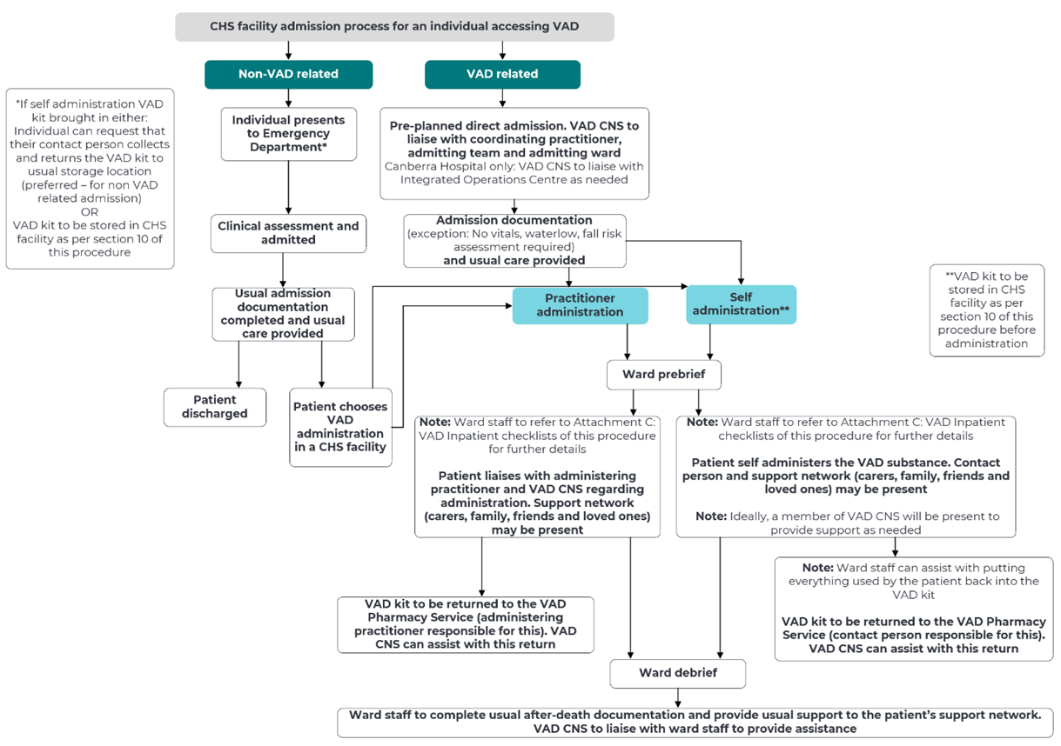
Back to Contents

Attachment 4: VAD inpatient checklists

VAD Task List – Ward Medical Officer

Prior to admission
- Request for Admission (RFA) will be attended prior to admission
- Review Voluntary Assisted Dying (VAD) Procedure.

Care before substance administration
- Complete standard admission documentation
- Complete resuscitation directive as appropriate
- Consider ceasing laxatives 24 hours prior to administration
- Ensure that any implantable cardioverter defibrillator (ICD) and pacemakers are turned off (discuss with coordinating practitioner)

Care after substance administration
- Perform verification of death (if required)
  - VAD practitioner (if administering practitioner) will likely verify death, but any medical officer is able to do this
- Do not remove or dispose of anything used by the individual for self-administration
- Ensure that the VAD CNS and the coordinating practitioner is aware
- Routine VAD deaths do not require notification to the coroner. All care of the deceased as per usual practices and in line with the Providing Care After Death Procedure
- Complete all other death documentation and care as per usual, including discharge summary.

Care for yourself
- Speak with the ward CNC, VAD CNS, Spiritual Care Coordinator, your line manager or Employee Assistance Program (EAP) for debriefing and support as you need.

VAD Task List – Ward CNC

Prior to admission
- Liaise with VAD CNS, Operations Centre, admitting specialist as needed
- Review Voluntary Assisted Dying (VAD) Procedure
- Ensure nursing staff roster is considerate of conscientious objectors
- Attempt to allocate a single room.

Care before substance administration
- Discuss staff capacity, including with the ward nurse assigned to the patient
- Review Task List with ward staff involved – nurses/medical officers/allied health/administration staff
- At planned time of administration – ensure senior nurse/nurse in charge is aware and supporting remaining staff and patients.

Care after substance administration
- Support staff through care of the Providing Care After Death Procedure
- Ensure staff do not remove or dispose of anything used by the individual for self-administration
- Provide care and support to family/carers
- Support involved ward staff following administration and organise debrief with VAD CNS.

Care for yourself
- Speak with the VAD CNS, Spiritual Care Coordinator, your line manager or Employee Assistance Program (EAP) for debriefing and support as you need.

VAD Task List – Nursing- Practitioner Administration

Prior to admission
- Review Voluntary Assisted Dying (VAD) Procedure
- Speak to your CNC if not comfortable providing VAD care

Care before substance administration
- Complete standard admission documentation
- VAD substance will be delivered directly to the authorised administering practitioner.
- Accommodate personal preferences such as music, clothing, meals, customs and bedside rituals
- Ensure the room is decluttered with a minimal clinical appearance e.g. patient belongings, favourite items, family photographs
- Bedside table should be cleared as it can be used to help when preparing the substance
- Ensure tissues, chairs, fresh water are available for family
- Put sign on door stating “Please see nursing staff before entering” to minimise disruptions
- 4 hours prior to administration limit diet and only have a light meal or snack
- 1 hour prior to administration ensure any prescribed premedications are given (e.g. antiemetics).

Care after substance administration
- Routine VAD deaths do not require notification to the coroner. All care of the deceased as per usual practices and in line with the Providing Care After Death Procedure
- Complete all other death documentation and care as per usual

Care for yourself
- Speak with the ward CNC, VAD CNS, Spiritual Care Coordinator, your line manager or Employee Assistance Program (EAP) for debriefing and support as you need.

VAD Task List – Nursing – Self-Administration

Prior to admission
- Review Voluntary Assisted Dying (VAD) Procedure
- Speak to your CNC if not comfortable providing VAD care.

Care before substance administration
- Complete standard admission documentation
- Review VAD patient information booklet with patient as needed
- If patient brings substance kit and not in immediate use, place the VAD kit box in the agreed medication room/s. The locked box and lorazepam box must be stored together e.g. using a rubber/elastic band and must be placed in the agreed medication/s rooms in the dedicated cupboard or safe that is locked and fixed to the wall when not in immediate use. Do not open the locked box. In the presence of the authorised person, record the locked box and lorazepam box in accordance with the Schedule 8 Drug register requirements for entry (as per the Medication Handling Policy and Medication Handling Procedure – North Canberra Hospital (NCH))
- Accommodate personal preferences such as music, clothing, meals, customs and bedside rituals
- Ensure the room is decluttered with a minimal clinical appearance e.g. patient belongings, favourite items, family photographs
- Bedside table should be cleared as it can be used to help when preparing the substance
- Ensure tissues, chairs, fresh water are available for family
- Put sign on door stating “Please see nursing staff before entering” to minimise disruptions
- Discuss with the patient what they would like to drink after taking the VAD substance (it is bitter)
- 4 hours prior to administration stop all food and dairy
- 1 hour prior to administration ensure any prescribed premedications are given (e.g. antiemetics).

Care after substance administration
- Keep patient 20 degrees upright for 20 minutes to reduce the risk of regurgitation (even when unconscious) after taking the substance
- During the dying process, if the family have questions, reassure and support as needed
- Do not remove or dispose of anything used by the individual. If comfortable doing so, assist with putting everything used by the individual back into the VAD kit
- The VAD CNS will be able to assist with communicating the death of the patient to the coordinating practitioner, treating team and any other people as required. Notify ward doctor and request certification of death
- All care of the deceased as per usual practices and in line with the Providing Care After Death Procedure
- Complete all other death documentation and care as per usual

Care for yourself
- Speak with the ward CNC, VAD CNS, Spiritual Care Coordinator, your line manager or Employee Assistance Program (EAP) for debriefing and support as you need.
Back to Contents

