Canberra Health Services
Clinical Guideline
Comfort Care Pathway Guideline (Adults only)

Contents

Contents 1
Guideline Statement 3
Background 3
Key Objective 3
Alerts 3
Scope 3
Section 1 – Completing the Comfort Care Pathway 4
Medical officer to complete 4
Section 2 – Comfort Care Observations 4
Phases in Palliative Care 5
Section 3 – Daily Symptom Assessment Scale for Acute Settings (SAS-AC) 6
Response to Symptom Assessment Scores 7
Section 4 – Resource Utilisation Group – Activities of Daily Living (RUG-ADL) 7
Section 5 – Australia modified Karnofsky Performance Status (AMKPS) 9
Section 6 – Symptom Management 10
Anticipatory Medications 10
The Dying Patient 11
Section 7 – After Death Care 12
Maintaining Dignity after death 12
Section 8 – Transferring Patients 14
Evaluation 14
Related Policies, Procedures, Guidelines and Legislation 15
Search Terms 15
References 15
Attachments 16
Attachment 1: Palliative Care Problem Severity Score (PCPSS) and Symptom Assessment Scale (SAS) 17
Attachment 2: Non-medical symptom management for patients at end of life care 18
Attachment 3: Comfort Care Anticipatory Medication and Symptom Management Parenteral Algorithm 20
Attachment 4: Intensive Care Unit Pain, Delirium and Agitation Guideline 22
Attachment 5: Medication Guidelines for Management of common symptoms in the dying patient 26
Attachment 6: RESTLESSNESS / AGITATION FLOWCHART FOR THE DYING PATIENT 31
Attachment 7: Numeric Pain Rating Scale (NPRS) 32
Attachment 8: Critical Care Pain Observation Tool (CPOT) 33
Attachment 9: Respiratory Distress Observation Scale (RDOS) 37
Attachment 10: Confusion Assessment Method for the ICU (CAM-ICU) scale 38
Attachment 11: Richmond Agitation-Sedation Scale (RASS) 39
Attachment 12: Daily Symptom Assessment Scale in Acute Care Settings (SAS – AC) 40

Guideline Statement

The implementation of the Comfort Care Pathway is supported in Canberra Health Services (CHS) to provide quality end of life and palliative care. The Comfort Care Pathway is an essential part of delivering Comprehensive Care to all patients in Canberra Health Services.

Background
Approximately 700 people per year die in Canberra Health Service. There are many others who may be identified at end of life and receive care until they are transferred to an aged care facility, hospice, or interstate. The care provided to these people before they die or transfer takes place across Canberra Health Service in acute wards, sub-acute wards, the Intensive Care Unit, and the Emergency Department. It is important for people who are at end of life and have goals of comfort care to receive quality end of life care no matter what ward or how long they have to live. The Comfort Care Pathway and this clinical guideline provides guidance on the delivery of quality end of life care to all those at end of life in Canberra Health Services.

Key Objective
The comfort care pathway is a consensus based, best practice guide to providing care for patients during the last days of their lives. The entire document forms part of the client’s medical record.

Alerts
- A patient may be identified as being at end of life and a family discussion is held and determined that comfort care measures are appropriate and placed on a comfort care pathway, or
- A patient may be imminently dying and placed on a comfort care pathway
- As patient care can change, the criteria for commencing a person on a comfort care plan should be revised every 72 hours to ensure comfort care measures are still appropriate.
Back to Table of Contents

Scope

The Comfort Care Pathway Guideline (Adults only) applies to all nursing medical and allied health staff caring for an adult at end of life or with goals of comfort care under the clinical governance of the Canberra Health Services.

Section 1 – Completing the Comfort Care Pathway

The Comfort Care Plan is available on the Clinical Records Forms Register and is separated into four sections as outlined below.
1.1 Commencing a Patient on the Comfort Care Pathway
Recognition of end of life and a family discussion about goals of care planning should be documented through either the Goals of Patient Care Plan prior to commencing a patient on a comfort care plan. The Comfort Care Pathway is to be initiated at the time the Goals of Patient Care Plan; note a Comfort Care Pathway should be commenced , and no later than 4 hours after a change in the Goals of Patient Care.

This section outlines a summary of outcomes from the above to inform the comfort care plan.

Who completes this section?

Medical officer to complete

1.2 Management Planning
This section provides a checklist to ensure appropriate interventions are provided or ceased. Part A: Management Planning MEDICAL to be completed by a Medical Officer on starting the comfort care plan.
Part B: Supportive Care Planning to be completed by Nursing or Allied Health Professionals.

1.3 Care Management
Part A: Comfort Care Observations
The top part of this form is to be completed once per shift by ward-based Nursing and/or Allied health Professionals. The bottom part of this form may be completed by any health professional but must be completed by the Specialist Palliative Care team / Supportive care team or like when rounding.

Part B: CHS Comprehensive Care Plan – Comfort Care
To be completed by attending Nursing and Allied health professionals using the Patient Symptom Assessment Scale. Minimum documentation is once per shift.

1.4 After Death Care Checklist
The After Death Care Checklist is to be completed by nursing or allied health staff at the time of death. Medical Officers complete a separate After Death Checklist as outlined in the Providing Care After Death procedure
Back to Table of Contents

Section 2 – Comfort Care Observations

Key Message
- If there are absent to mild range of symptom and problems scores, a monitoring and review of care plans should be done.
- If there are moderate to severe range of symptom and problems scores, interventions and actions to respond to needs should be done.

Section 3 requires nursing and allied health staff to assess the patient according to validated palliative care measures. These take the place of observations that are used for patients receiving active treatment.

The information provided in Section 2 - 5 is taken from a more detailed description available from the Palliative Care Outcome Collaborative.

Phases in Palliative Care
The phase in palliative care identifies a clinically meaningful period in a patient’s condition. The palliative care phase is determined by a holistic clinical assessment, which considers the needs of the patients and their family and carers. A change in palliative care phase represents a change in the person’s clinical condition and/or a change in the patient’s carers or family. These changes lead to a change in the patient’s care plan. Five palliative care phases are possible. Different phases may apply to the patient at different times. A structured phase algorithm can help guide healthcare professionals to determine the correct phase.

Palliative Care Problem Severity Score (PCPSS) and Symptom Assessment Scale (SAS) (see Attachment 1)
The Comfort Care Pathway utilises PCPSS and SAS assessments to measure symptoms and problems experienced by the patient and family / carer.

The symptom assessment scales in the Comfort Care Pathway are used:
- In clinical handover to prioritise care and standardise response.
- To determine frequency of review or frequency of contact with the patient and family/carer.
- As a common language to communicate patient needs across the whole multidisciplinary team.
- To trigger referral to allied health, specialist palliative care and/or for medical review.

How to use the symptom assessment scales?
- Where possible, base the assessment on the patient’s verbal response using visual of symptom assessment scale. Where this is not possible staff or family members may giver proxy rating of symptom.
- For non-verbal/semi-conscious patient look for visual cues, and use assessment tools
- Always look for reversible causes and consider non-pharmacological measures
- Discuss all changes to the plan of care with the patient and their substitute decision-maker(s)/family/carer(s), as appropriate
- Involve family/carer(s) in providing care (e.g., mouth care, comfort care), as appropriate

Frequency of symptom assessment
On admission to the unit, by nursing staff within 4 hrs of admission.
- Routine shift assessment, by nursing morning, afternoon, and night staff
- Routine review of assessments for completion and correct phase, by night duty nursing staff.
- At any change in the patient’s or family’s care needs, multidisciplinary approach.

Back to Table of Contents

Section 3 – Daily Symptom Assessment Scale for Acute Settings (SAS-AC)

The SAS- AC is patient rated (where possible) and assesses the patient’s level of distress relating to seven common symptoms (difficulty sleeping, appetite problems, nausea, bowel problems, breathing problems, fatigue, and pain). Additional items are also included with an option of other too. SAS is an 11 point numerical rating scale (0-10).

- The SAS – AC is to be used to assess patients at each assessment occasion. (see appendix 12)
- Assessments are documented in the Comfort Care Pathway.
- Audit tools are used to ensure the accuracy and reliability of assessments.
- The full assessment definitions are available for clinicians to refer to for patient assessment.
- The SAS brochure is available for patients and family / carers (including translated versions).
- Assessments drive care planning processes.
- Patient assessments are a standard item at all handovers.
- Patient referrals are triggered by assessment scores.
- Multidisciplinary meetings incorporate palliative care outcome collaboration (PCOC) assessments into patient review (standard agenda item).
- All staff may use the SAS tool or the Modified Symptom Assessment Scale to assess and respond to patient needs.

How to ask a patient about their distress?
- Using the SAS – AC or the SAS brochure for patients/families, staff ask the patient or family/carer:
  - How much do symptoms bother, worry or distress you on this scale from 0 to 10’? or
  - How much does your pain worry you on this scale from 0 – 10?
- When asking a patient about any emotional / spiritual distress, the question can be
  - Do you have any fears or concerns that are worrying you at this time?
  - Discuss any fears or concerns and ask then ‘How much does this fear / concern (put in what the patient states is the fear or concern) bother, worry or distress you on this scale from 0 to 10’, and how can we help you?

Response to Symptom Assessment Scores
Patients with assessment scores of mild and above should be actioned as per page3 of the Comfort Care Pathway. Symptom management guidelines are provided in Section 5 Symptom Management.

Back to Table of Contents

Section 4 – Resource Utilisation Group – Activities of Daily Living (RUG-ADL)

The RUG-ADL assesses the level of functional dependence, based on what a patient actually does, rather than what they are capable of doing. The RUG-ADL is used to:
- Determine patient needs and resource requirements.
- Indicate equipment needs.
- Assess potential impact on carer.
- Discharge planning as an indicator of care requirements.

Bed Mobility
- Independent or supervision only.
Able to readjust position in bed, and perform own pressure area relief, through spontaneous movement around bed or with prompting from carer. No hands-on assistance required/may be independent with use of a device.
- Limited physical assistance.
Able to readjust position in bed, and perform own pressure area relief, with the assistance of one person.
- Other than two-person physical assist
Requires the use of a hoist or other assistive device to readjust position in bed and provide pressure relief. Still requires the assistance of one person for task.
- Two or more-person physical assist.

Toileting
- Includes mobilising to the toilet, adjustment of clothing before and after toileting and maintaining perineal hygiene without the incidence of incontinence or soiling of clothes. If level of assistance differs between voiding and bowel movement, record the lower performance.
- Able to mobilise to toilet, adjusts clothing, cleans self, has no incontinence or soiling of clothing. All tasks are performed independently or with prompting from carer. No hands-on assistance required. May be independent with the use of a device.
- Requires hands-on assistance of one person for one or more of the tasks.
- Requires the use of a catheter/uridome/urinal and/or colostomy/bedpan/commode chair and/or insertion of enema/ suppository. Requires assistance of one person for management of the device.
- Requires two or more assistants to perform any step of the task.

Transfer
- Includes the transfer in and out of bed, bed to chair, in and out of shower/tub. Record the lowest performance of the day/night.
- Able to perform all transfers independently or with prompting of carer. No hands-on assistance required. May be independent with the use of a device.
- Requires hands-on assistance of one person to perform any transfer of the day/night.
- Requires use of a device for any of the transfers performed in the day/night. Requires only one person plus a device to perform the task.
- Requires 2 or more assistants to perform any transfer of the day/night.

Eating
Includes the tasks of cutting food, bringing food to mouth, and chewing and swallowing food. This does not include preparation of the meal.
- Independent or supervision only.
- Able to cut, chew and swallow food, independently or with supervision once meal has been presented in the customary fashion. No hands-on assistance required. If individual relies on parenteral or gastrostomy feeding that he/she administers him/herself then Score 1.
- Limited assistance.
- Requires hands on assistance of one person to set up or assist in bringing food to the mouth and/or requires food to be modified (soft or staged diet).
- Extensive assistance / total dependence / tube fed.
- Person needs to be fed meal by assistant, or the individual does not eat or drink full meals by mouth but relies on parenteral/gastrostomy feeding and does not administer feeds by him/herself.

Based on the RUG-ADL score, actions should be taken as per the below table.

RUG-ADL
Score | Action
4 - 5 | Monitor
6 - 10 | Assist x 1
10+ | Assist x 1, consider equipment, staff requirements, falls risk, referral
15+ | As above, pressure area risk, consider carer burden and MDT review
18 | As above, full care assistance
Table 1RUG-ADL score

Back to Table of Contents

Section 5 – Australia modified Karnofsky Performance Status (AMKPS)

This is a clinician rated assessment of performance relating to work, activity, and self-care over a 24hr period. The AKPS is a measure of the patient’s performance across the dimensions of activity, work, and self-care. The AKPS is used for:
- Planning for placement in Residential Aged Care.
- An indication of the impact on carer.
- Triggering referral to allied health and for medical review

Patients are to be assessed by the AMKPS scale below.

100. Normal, no complaints or evidence of disease
90. Able to carry on normal activity, minor signs, or symptoms of disease
80. Normal activity with effort, some signs, or symptoms of disease
70. Care for self, unable to carry on normal activity or to do active work
60. Occasional assistance but can care for most needs
50. Requires considerable assistance and frequent medical care
40. In bed more that 50% of the time
30. Almost completely bedfast
20. Totally bedfast & requiring nursing care by professionals and/or family
10. Comatose or barely rousable

Actions for AMKPS results are outlined in the AMKPS Intervention Guidelines box below.
AMKPS Intervention guidelines
Score 10-100
<50 Consider MDT review
30 – 40 Consider pressure care
10 – 20 Change to terminal phase

Back to Table of Contents

Section 6 – Symptom Management

It is important that holistic care be provided for patients at the end of life. An overview of holistic symptom management interventions that may be appropriate for patients at end of life is found in Attachment 3.

Anticipatory Medications
Comfort Care is best provided where symptoms are anticipated, and medication are charted prior to a patient being distressed. This allows symptoms to be managed in a timely manner.

An anticipatory algorithm has been developed to support the Comfort Care Pathway and includes anticipatory mediation for pain and dyspnoea, nausea, agitation, and secretions. The Anticipatory algorithm is located in Attachment 2.

Medication Standing Orders
Palliative Care Medication Standing Orders are endorsed for the below medications and can be accessed on the Electronic Medication Management System.

Medication standing orders for the below are also located on the CHS Policy register
Morphine - Terminal Phase
Midazolam – Dying in distress
Midazolam – Terminal seizures or distress
Metoclopramide – Terminal Phase

Medication Standing Orders are to be used in accordance with the guidelines and criteria for each Medication Standing Order.

The Dying Patient
An overview of Medication Guidelines for Management of common symptoms in the dying patient is found in Attachment 4:

Restlessness and /or agitation is often present in the dying patient, and staff need to be intentional to manage these symptoms for quality care for both the patient and the family. A flow chart for management of restlessness and agitation is located in Attachment 5.

Palliative Sedation
Palliative Sedation Therapy (PST) is the monitored use of medications to provides relief of symptoms that are refractory to usual measures, are distressing, and result in considerable suffering if unrelieved by lowering a patient’s awareness through sedation. Palliative sedation is used only when patients are determined by the treating physician to be terminally and is in the end of life period where death is foreseeable and near; and should be used for patients who are predicted to have a very limited expected survival. A decision to use PST is not dependent on nor does it influence other end of life decisions i.e., nutrition support.

Where any symptom distress, (physical or psychological/existential) cannot be managed, consideration should be given to the use of Palliative Sedation. Refer to the Clinical Guidelines on the Use of Palliative Care Sedation Therapy (Adults) available on the Policy Register.

Intensive Care Unit
In the Intensive Care Unit (ICU) patients’ symptoms are routinely managed with intravenous infusions of analgesic, neuroleptic, and sedative medications, titrated by nurses according to pain, delirium and sedation scale targets set by the medical team (Attachment 6). The transition from treatment of disease to care during the terminal stage and treatment of symptoms may not require a change in medications, but these may be continued with an increased focus on managing pain and terminal agitation.

Pain management is titrated to a Numeric Pain Rating Scale (NPRS) if the patient is conscious (Attachment 7), or Critical Care Pain Observation Tool (CPOT) if the patient is patient (Attachment 8). Analgesic drug infusions commonly used in ICU are fentanyl and morphine. Respiratory distress is assessed using the Respiratory Distress Observation Scale (RDOS) (Attachment 9). Delirium is assessed using the Confusion Assessment Method for the ICU (CAM-ICU) scale (Attachment 10). Pharmacological and non-pharmacological treatments are commonly used. Sedation is titrated to the Richmond Agitation-Sedation Scale (RASS) (Attachment 11). Agitation is managed by sedation which is titrated to the Richmond Agitation-Sedation Scale (RASS). Sedative drug infusions commonly used in ICU are propofol and midazolam. Propofol may be considered for sedation in the terminal stage of a patient as an alternative or in addition to benzodiazepines, especially in treatment resistant agitation.

Non-pharmacological management of delirium include reorientation, timely removal of medical devices and physical restraints, optimising communication, and sensory aids (e.g., eyeglasses and hearing aids) and promoting sleep/wake cycles including addressing nocturnal light/noise pollution.
The cessation of life-sustaining therapy may be indicated in patients with terminal disease in the dying stage, and a dose increase in analgesic/sedative medications may be required to minimise discomfort during this process. Neuromuscular blockers are NOT indicated in palliative treatment and must be ceased well before terminal weaning of supports. Most patients should receive both analgesic and sedative medications to provide effective palliation of terminal symptoms.

If a patient is receiving analgesia and sedation as above, who is anticipated to be discharged to a ward, the medications should be changed to medications appropriate for a ward setting, as documented in Attachment 3.

Back to Table of Contents

Section 7 – After Death Care

It is important that families and carers are supported with information and access to psychological support following the death of a patient.

An After Death Care Checklist is included in the Comfort Care Pathway for nursing professionals to complete.

Discussions with the family either before or immediately after death should include questions about the family’s knowledge of or plans after death (i.e., funerals, coroner, donation of body to science)

The Cancer and Ambulatory Service Volunteer Manager will send a bereavement card to the next of kin two weeks post death, and a follow up letter with a list of bereavement services will be sent 3 months post death.

Where a staff member i.e., social worker has an ongoing relationship with a family/carer a call may be made to the family member/carer after death. Where there has been no relationship, it is not recommended that this is done unless requested by the family/carer.

Maintaining Dignity after death
Maintaining the dignity of a person is important, including after the person has died. A clinician or staff member’s approach and care is integral

Ways that dignity of a person after death can be maintained include:
- Continuing to use caring and gentle touch when handling and transporting the patient
- Seeking permission from the next of kin prior to taking fingerprints, locks of hair etc.
- Inform the family /carer that they may bring into the hospital the person’s clothing prior to the person dying; for the family and / or staff to dress the deceased person in once they have died for transfer through the mortuary and to the funeral home. If the family/carer have not provided clothing, the patient should be dressed in a clean hospital gown (do not use a paper gown). The use of continence pants can be used to minimise urinal and faecal leakage also.

Please Note: Paper gowns are no longer used in dressing deceased patients.

- Respecting the patient’s clothing and personal items by giving them to families in the palliative care paper bags (characterised by a purple tree). Each ward will have a supply of these bags. Additional supplies can be sourced from on top of the End of Life and Palliative Care Storage cupboard in the 11A meeting room.
- Asking the family if they have any family, cultural or spiritual rituals, or if they have any other requests, at that time. It is important to consider the patient’s wishes in advance care planning and comfort care planning to ensure the patient’s wishes are met. At times family members and carers may want something that goes against the patient’s wishes outlined before they died. It is important to respect the patient’s wishes even after death and to sensitively advice family members / carers of this if required.
- Having a gentle and sensitive conversation with the family to say you are sorry for their loss and where appropriate, what you appreciated about the person and/or their family whilst you provided care to them.
- When it is time for the person to be moved to the morgue, the family might see and hear the nurse say goodbye to the patient in the room. The nurse might include a thank you, a gratitude, taken from some aspect of care. i.e. 'Goodbye Joe, you will be missed, you are loved by so many.'
- Family members / carers can be encouraged to say their goodbyes before the person leaves the room. Some family members/carers may wish to go with the person to the lift on the ward floor and say goodbye there. Although not common, there are times when a family member/carer may wish to go with the body to the mortuary. This is an option and parents may even carry a child down to the mortuary. If staff and family members are transporting the person to the mortuary, please use the internal (within the hospital) entrance to the mortuary near paediatric outpatients. If staff are bringing family members down through this access way, the Mortuary must be advised prior as this hallway also has a roller door to a car park which is used by Funeral Directors and may have deceased persons or funeral directors present. Where family /carers may wish to go with their loved one to the mortuary please consider any emotional preparation of the family member for this i.e., environment and smell of the mortuary. Family members/carers must also be informed they are welcome to view their loved one at any time by contacting the Mortuary.

Staff attitude and manner are key to maintaining dignity for a person at end of life. On occasions there may be family members / carers who are struggling with the death or impending death of a person and may be angry or behave in a challenging manner. This may pose difficulties for staff to continue to conduct themselves in a manner that demonstrate our values of kindness and respect. Skills in de-escalation can be helpful at these times. Seeking support from senior staff may also be beneficial.
For further information about care after death, please see the CHS Providing Care after Death procedure

Back to Table of Contents

Section 8 – Transferring Patients

Where a Comfort Care Pathway is used for a patient and the patient is transferred to an aged care facility, hospice or another health facility, the Comfort Care Pathway documentation and last day of documentation of the CHS Comprehensive Care Plan – Comfort Care is to be copied and sent with the discharge documents to the facility. It is also to be faxed to the patient’s GP. If the patient is referred to the Palliative Aged Care Service (PEACE) Geriatric Rapid Acute Care Evaluation (GRACE)or other health team, these documents are to be faxed to these teams too.

Back to Table of Contents

Evaluation

Outcome
All patients who die while being cared for by Canberra Health Services receive quality end of life care in line with the Comfort Care Pathway Guidelines

Measures
- All Bedside files have a completed comfort care pathway including comprehensive care plan for any patient who is identified to have goals of comfort care
- Annual Quality of Death File audit identifies all retrospective death files audited have a completed comfort care pathway including comprehensive care plan for any patient who is identified to have goals of comfort care
- All Consumer and Carer feedback received is considered and any concerns are included in the review of the comfort care pathway
- Annual review of Medication Standing Orders show that they are used according to this guideline
- Annual review of Palliative Care Sedation use show that this has been implemented only where a Comfort Care Pathway has been in place, and according to the Guidelines for the Use of Palliative Sedation.
Back to Table of Contents

Related Policies, Procedures, Guidelines and Legislation

Policies
- Nursing and Midwifery Continuing Competence Policy
- Informed Consent Clinical- Policy

Procedures
- Infection Prevention and Control-Healthcare Associated Infections Procedure
- Patient Identification and Procedure Matching Policy

Guidelines
- Use of Palliative Care Sedation Therapy (Adults)

Legislation
- Health Records (Privacy and Access) Act 1997
- Human Rights Act 2004
- Work Health and Safety Act 2011
Other
- Charter of Healthcare Rights
Back to Table of Contents

Search Terms

Comfort Care, End of Life, Care, Palliative Care, Dying, anticipatory prescribing,

Back to Table of Contents

References

Campbell, M. L. (2008b). Psychometric testing of a respiratory distress observation scale. Journal of Palliative Care Medicine, 11(1), 48.

Palliative Care Outcomes Collaboration (2018) PCOC Clinical Manual, Australian Health Services Research Institute (AHSRI), University of Wollongong, NSW 2522 Australia.

Sessler CN, Gosnell M, Grap MJ, Brophy GT, O'Neal PV, Keane KA et al(2002). The Richmond Agitation Sedation Scale: validity and reliability in adult intensive care patients. Am J Respir Crit Care Med; 166:1338-1344.

The Pain Scale Chart: What It Really Means - Prohealth

Wesley E, and Vanderbilt University (2002) Monitoring delirium in the ICU setting

Journal of Palliative Care Medicine 2008, 11(1), Pg.48.

Campbell L.M, Templin. T, Walch J (2010) A Respiratory Distress Observation Scale for Patient Unable To Self-Report Dyspnoea. Journal of Palliative Medicine Volume 13 Number 3, DOI 10.1089/jpm.2009.0229
Back to Table of Contents

Attachments

Attachment 1: Palliative Care Problem Severity Score (PCPSS) and Symptom Assessment Scale
Attachment 2: Non-medical symptom management of patients at end of life
Attachment 3: Anticipatory Medication Algorithms
Attachment 4: Medication Guidelines for the management of common symptoms in the dying patient
Attachment 5: The dying patient – care in the last hours/days. Restlessness/Agitation Flowchart for the dying patient
Attachment 6: Restlessness / Agitation Flowchart for the dying patient
Attachment 7: Numeric Pain Rating Scale (NPRS)
Attachment 8: Critical Care Pain Observation Tool (CPOT)
Attachment 9: Respiratory Distress Observation Scale (RDOS)
Attachment 10: Confusion Assessment Method for the ICU (CAM-ICU) scale
Attachment 11: Richmond Agitation-Sedation Scale (RASS)
Attachment 12: Daily Symptom Assessment Scale in Acute Care Settings (SAS – AC)

Disclaimer: This document has been developed by Canberra Health Services specifically for its own use. Use of this document and any reliance on the information contained therein by any third party is at his or her own risk and Canberra Health Services assumes no responsibility whatsoever.

Policy Team ONLY to complete the following:
Date Amended | Section Amended | Divisional Approval | Final Approval
06/05/2022 | Complete Review | Kath Wakefield- A/g Executive Director- CAS | CHS Policy Committee

This document supersedes the following:
Document Number | Document Name
CHS21/448 | Comfort Care Pathway Guideline

Attachment 1: Palliative Care Problem Severity Score (PCPSS) and Symptom Assessment Scale (SAS)

The PCPSS is clinician rated and supports the global screening for the overall degree of problems within four key palliative care domains (pain problems, other symptom problems, psychological / spiritual problems, and family / carer problems). PCPSS is a four point numerical rating scale (0-3).

The table below lists potential actions following PCPSS and SAS assessment. Table 5 lists potential actions specifically for the family / carer problem domain (PCPSS).

Potential actions following PCPSS and SAS assessments PCPSS & SAS | Potential actions
Absent  PCPSS = 0  SAS = 0 | - Problem/symptom distress absent. Continue with current care.  - Routine assessment.  - Phase may be Stable or Terminal.
Mild  PCPSS = 1  SAS = 1-3 | - Problem/symptom distress managed by existing plan of care and routine care.  - Treat problem/symptom according to service protocols.  - Monitor and record any relevant information.  - Phase may be Stable, Deteriorating or Terminal.
Moderate  PCPSS = 2  SAS = 4-7 | - Problem/symptom distress requires change in plan of care, referral, and escalation.  - Document review and implement any new interventions as per care plan.  - Phase may be Deteriorating or Terminal.
Severe  PCPSS = 3  SAS = 8-10 | - Problem/symptom distress requires immediate action.  - Plan of care is ineffective.  - Urgent intervention, referral and escalation required.  - Change of care plan indicated.  - Review within 24 hours.  - Phase Unstable or Terminal.

Attachment 2: Non-medical symptom management for patients at end of life care
Food and fluids:  - The patient should be supported to eat and drink for as long as tolerated and consider the use of thickened fluids.  - Monitor for signs of aspiration and / or distress  - If appropriate, consider clinically assisted (artificial) hydration.  - Swallowing difficulties – ensure patient provided with appropriate diet and fluids, taking patient’s wishes and requests into consideration. Refer to speech pathology if there are concerns about patients swallowing safety and/or for comfort and if guidance required for food/fluid choices.  Skin care:  - The frequency of assessment, repositioning, and special aids (e.g., pressure relieving mattress) should be determined by skin inspection and the patient’s individual needs.  Mouth care:  - Frequency of mouth care depends on individual need.  - Aim is to keep the patient’s mouth clean and moist  - Mouth care – consider removal of dentures if ill- fitting or causing pain. Monitor oral cavity or dryness, ulcers, thrush, mucositis, consider use of artificial saliva, lip care.  - Consider sub-cutaneous fluids.  Restlessness and / or agitation:  - Assess the patient for reversible causes including pain, incontinence, fever, breathlessness, urinary retention, faecal impaction.  - Consider position change.  Bladder care:  - Assess for pain due to bladder distension/retention.  - Use of pads, urinary catheter or penile sheath as required.  Bowel care:  - Monitor for constipation and diarrhoea.  - Bowel movements documented.  Urine output:  - If no urine output for >8 hours consider a bladder scan.  Nausea and/or vomiting:  - Consider anti-emetics.  Pain:  - Consider position change.  - Consider PRN analgesia for incident pain.  Febrile:  - Consider cool sponges and use of fans.  - Consider antipyretics PO or PR.  Family/Carer(s) distress:  - Consider the severity of the problem the family/ carer(s) is experiencing (e.g., anger, family conflict):  - If score is mild, reassure the family/carer(s) with explanation and support as required.  - If score is severe, escalate to senior staff and consider referral to Social Worker, Palliative Care Service, Aboriginal Liaison Officer, Spiritual Carer. | Eye care:  - Eyes are clean and moist.  - Swab with normal saline PRN.  Environment:  - Single room; curtains/screens; clean environment; sufficient space at the bedside, outside.  - Comfort care case items consider fragrance; silence; music; lighting; pictures; photographs; nurse call bell accessible.  Spiritual/cultural needs:  - Staff just being at the bedside can be a sign of support and caring. Respectful verbal and nonverbal communication; use of listening skills; information and explanation of plan of care given.  - Use of touch if appropriate.  - Spiritual/cultural/emotional needs supported  Psychosocial support:  - Listen and respond to worries and fears.  - Provide age appropriate information on procedures.  - Check understanding of all visitors re natural process of dying, what to expect, and any changes.  - Use clear language; avoid euphemisms or jargon.  - Allow the opportunity to reminisce.  - Assess bereavement risk and refer as needed.  - Allow opportunity to stay over (chair, cuddle bed).  - Offer food/drink/rest/parking permit.  Tissue viability, pressure injury prevention and  management:  - Regular pressure area care and repositioning.  - Ensure evidence-based skin care protocol applied.  - Protect bony prominences from pressure, shear, friction, and moisture.  - Document 8 hourly skin inspection as per Skin Integrity Assessment Form.  - Consider cessation of compression stockings for VTE-P.  - If required, remove at least daily to clean, and inspect skin.  - Review and reconsider the frequency of the dressing change plan associated with managing a palliative wound.  - Be aware of skin changes at end of life, focusing on patient-centred holistic strategies as part of ongoing care, focusing on comfort and quality of life.  Respiratory tract secretions:  - Consider position change (use semi-prone position).  - Anticholinergic medication more effective if given as soon as symptom occurs.  Breathlessness:  - Consider position change and use of fan for early breathlessness.

Attachment 3: Comfort Care Anticipatory Medication and Symptom Management Parenteral Algorithm

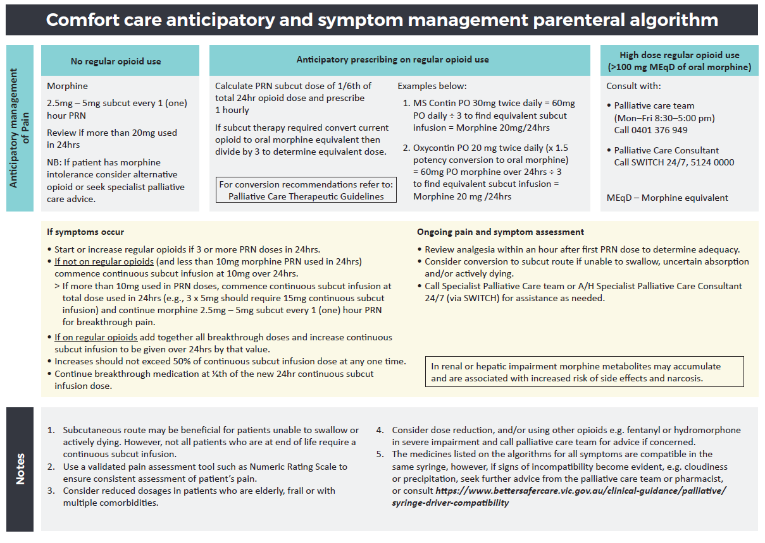

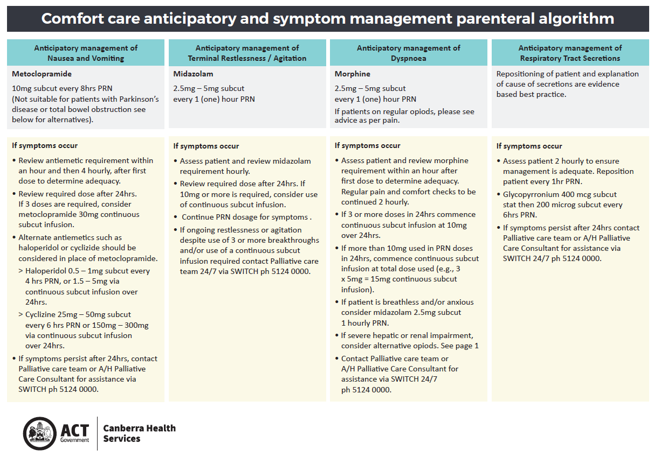

Attachment 4: Intensive Care Unit Pain, Delirium and Agitation Guideline

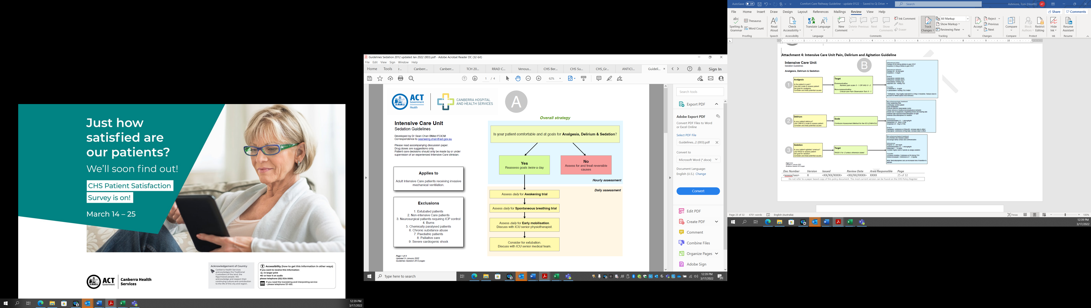

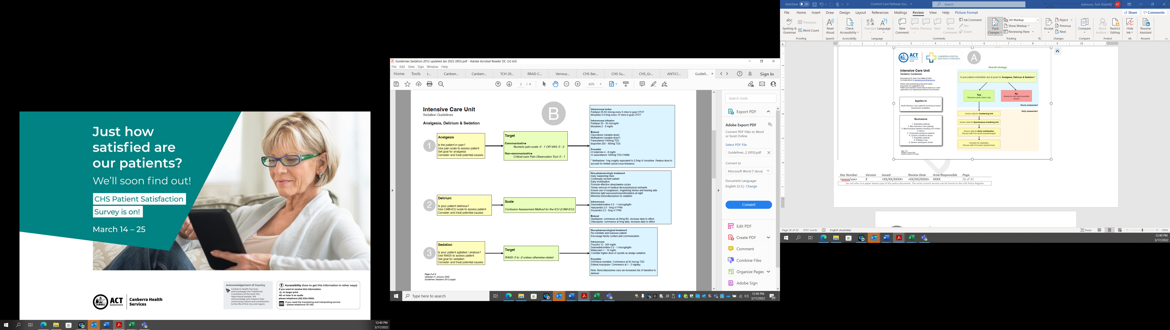

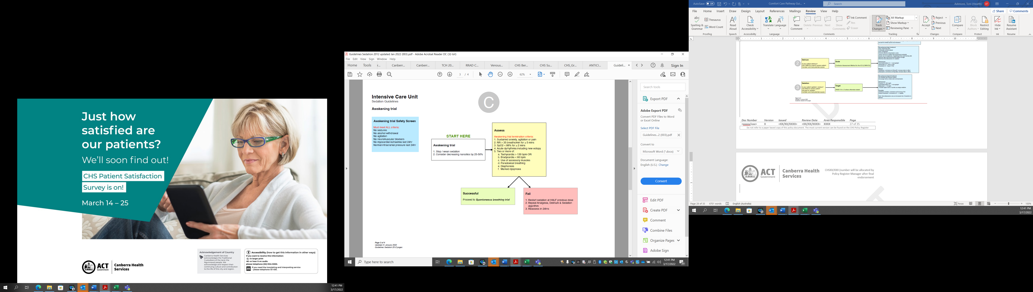



Attachment 5: Medication Guidelines for Management of common symptoms in the dying patient

These guidelines apply to patients who are expected to die in the next few hours to a few days and are unable or unlikely to take medications orally. Dosing guides are provided for some of the most commonly encountered problems seen in dying patients, where particular medications may provide relief. It is up to an individual clinician to decide on which medications a patient requires following their assessment.

Unless otherwise specified, all of the following doses can be administered by subcutaneous injection. If considering alternative routes, review dosing against an appropriate reference such as the Therapeutic Guidelines for Palliative Care. Regular medications should only be written when there is definitely an indication
e.g., patients do not have to receive opioids and benzodiazepines just because they are dying. It is always recommended to provide a range of PRN orders for problems that may occur as death approaches, such as those outlined below.

Even if it is decided that a regular medication is required, it is still important to provide PRN orders to allow the patient to receive additional doses if required to maximise their comfort.
Please note that it is essential that all PRN orders clearly state the indications for which the drug is being prescribed.
Nursing staff cannot provide a PRN dose for a symptom unless it is written with the prescription.
If a patient continues to be distressed despite the use of prescribed medications, they should be managed as an urgent problem requiring a direct physical review. In hospital there is access to medical staff 24hrs a day, and junior doctors should feel comfortable escalating concerns to senior medical staff.
Clinicians are strongly urged to call the Specialist Palliative Care Consultant and Liaison Service for advice any time they have management concerns – via switch 24 hours/day.

Pain
- If patient is opioid naïve (has not used recently) or has only been sporadically using opioids:
  - Prescribe morphine 2.5 mg subcutaneously every hour as required. Lower doses can be commenced if there are clinical reasons to do so
  - If discomfort is not responding to 3 doses in 3 hours, the patient needs further medical review.
  - If more than 3 doses in 24 hours, consider commencement of a continuous subcutaneous infusion. Start with 10 mg over 24 hours and continue same prn dose.
- If patient is already taking a stable dose of oral morphine.
  - Consider commencing a continuous subcutaneous infusion; calculate the total oral daily dose of morphine and divide by 3 (i.e., If total daily oral morphine dose is 30mg, commence the infusion at <10mg/24hours).
  - Provide an order for additional as required doses of morphine at an initial dose of 2.5mg subcutaneous every 1 hour. Higher doses may be required if the patient was already taking more than 30mg of oral morphine per day. Review if more than 4 doses are needed during 24 hours
- If morphine dose is not stable or has been ineffective, if the patient is using other opioids (e.g., Oxycodone, Hydromorphone, Fentanyl etc) or you have any concerns about safe prescribing for the patient.
  - Call the Palliative Care Service for advice 24 hrs a day as above.
  - Note that it is advisable to use guidelines for opioid conversions, but adjustments and assumptions vary widely.
- ADVANCED KIDNEY DISEASE: Fentanyl or hydromorphone are preferred in patients with advanced kidney disease GFR <30ml/min and morphine should be avoided. Use of subcutaneous midazolam to control agitation in the setting of pain while dying is appropriate. Consider Midazolam for use in this situation.
  - Prescribe 2.5mg subcutaneously every hour as required. If 3 doses have not resulted in benefit, please review.
  - Consider adding midazolam to a syringe driver if > 3 doses required in 24hrs at 10 (-20) mg / 24 hr. Plus continue PRN doses

Nausea/vomiting
- Metoclopramide 10mg subcutaneously every 4hours as required to maximum 40mg/24 hours.
  - Do not use if possibility of gastric outlet/upper gastrointestinal obstruction.
  - If not effective or safe, stop metoclopramide and use haloperidol as follows:
- Haloperidol 0.5mg subcutaneously every 12 hrs regularly
  - Additional 0.5mg every 2hours prn up to another 4 doses per day.
  - If not responding to an additional 2 doses in 4 hours, or if all 4 prn doses used within 24 hours, seek medical review.
  - If not effective, contact Palliative Care Service for advice 24 hours/day
WARNING: Risk of extra pyramidal side effects with metoclopramide and haloperidol and should not be
used concurrently.
- Cyclizine
  - For use with refractory nausea/vomiting and patients for whom other first and second-line treatments are proven to be ineffective or are contraindicated.
  - Use where known contraindications or risk of drug interaction.
  - Dose is 25-50mg every 8 hrs oral, subcutaneously, or intravenous (equivalence).
- Ondansetron may be effective but high risk of constipation
  - Tablets wafers and injections are available for inpatient use without restriction.
  - Dose is 4-8mg every eight hours intravenous or orally.
Dyspnoea and tachypnoea
- If hypoxic, provide oxygen via standard hospital prescription guidelines.
  - If oxygen and rest not sufficient, consider using opioids as 1st line and benzodiazepines as 2nd line medications.
- Fans – may be useful as a non-pharmaceutical approach
- Morphine–as per advice for pain as above. The dosing guidelines for pain or dyspnoea are the same. It is reasonable to list both indications of “pain” and “dyspnoea” when prescribing PRN morphine for dying patients.
- Consider Midazolam for agitation and distress associated with dyspnoea.
  - Prescribe 2.5mg subcutaneously every hour as required. If 3 doses have not resulted in benefit, please review. Lower doses can be used if there are clinical reasons to do so.
  - Consider adding midazolam to a syringe driver if > 3 doses required in 24hrs at 10 (-20) mg over 24 hrs. Plus continue as required doses.
- If the above measures are ineffective, or the patient is already on benzodiazepines, contact the Specialist Palliative Care Service for advice 24 hours/day.
Myoclonus
- Transient involuntary twitching of muscles that are more frequent at the end of life and can be exacerbated by electrolyte disturbances and opioids.
- Assess for drug toxicity e.g., opioid accumulation and extra pyramidal involuntary movement. These are frequent in
- End Stage Renal Disease (ESRD) - Only treat if distressing.
- Consider Midazolam at doses recommended above if treatment required.
- If further seizure activity beyond myoclonus prescribe midazolam at 5mg SC PRN given during seizures to arrest them and contact pall care.
Secretions
- In most situations, these noisy sounds represent either saliva pooling in the upper airway and/or respiratory secretions that a weak, dying patient can no longer clear. Often, these do not cause the patient distress, but can be alarming to family and staff. Position changes and a good explanation as to the cause can be helpful. Only use medication if it is felt the secretions are causing the patient distress; they are often either ineffective or only partially effective.
  - BuscopanTM (hyoscine butylbromide) – 20mg subcutaneously every 2hours as required up to 4 doses per 24 hours.
  - Glycopyrrolate – 400micrograms subcutaneously every 2 hours as required up to 4 doses per 24 hours
  - Other well - known anti - secretory agents include hyoscine hydrobromide and atropine – these agents can more readily cross the blood brain barrier and, with their natural anticholinergic properties, are more likely to induce/worsen delirium; therefore, their routine use is not recommended.

Bowels
- If someone is dying, it is usually not possible to continue routine oral aperients and it is unlikely they would even be effective as the gastro-intestinal tract starts to shut down along with all body organs in the dying patient. These should be stopped.
- If it is felt the patient has faecal loading or impaction causing discomfort, then a PR examination should be performed to determine if rectal interventions are required. If they are, consider:
  - Glycerol and Dulcolax® (bisacodyl) suppositories
  - Microlax enemas
Anxiety/fear
- Actively involve social work/psychology.
- Actively exclude reversible causes of delirium. If delirium is unlikely to be the cause, using benzodiazepines is appropriate.
  - If benzodiazepine naive, consider Midazolam at 2.5 mg subcutaneously every hour as required subcutaneously. Lower doses can be used if there are clinical reasons to do so.
  - If multiple doses required, consider commencing a syringe driver with midazolam 10mg (-20mg)/24 hrs subcutaneously.
  - If already taking other benzodiazepines, it may not be possible to continue the same tablets. For advice on alternatives, or if the above measures are not working, contact the Palliative Care Service for advice 24hours/ day.
Delirium
- Optimal therapy of delirium remains unclear in the palliative setting. Use of antipsychotics and benzodiazepines are appropriate if significant distress, agitation, or risk of harm that is not otherwise manageable.
- If required, consider Haloperidol 0.5mg subcutaneously twice daily regularly to manage these issues.
- Additional doses as required for ongoing delirium 0.5mg subcutaneously every 2 hours, up to another 4 doses per 24 hours.
- If features of anxiety with delirium refer to the above guidelines for midazolam which may be required in addition to haloperidol.
- If these measures are not successful, please contact the Palliative Care Service for advice via switch 24 hours/day.

Attachment 6: RESTLESSNESS / AGITATION FLOWCHART FOR THE DYING PATIENT
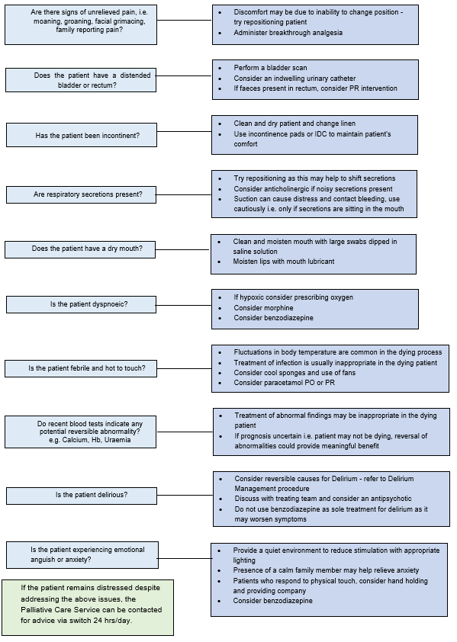

Attachment 7: Numeric Pain Rating Scale (NPRS)

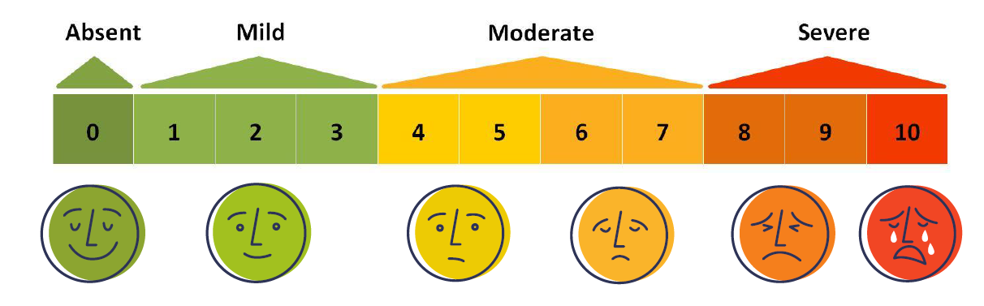

Attachment 8: Critical Care Pain Observation Tool (CPOT)

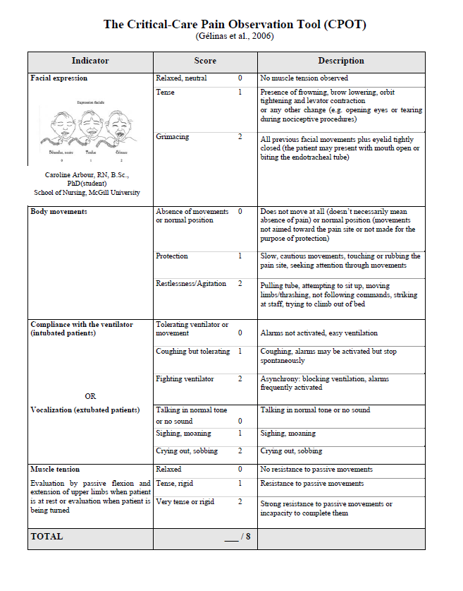

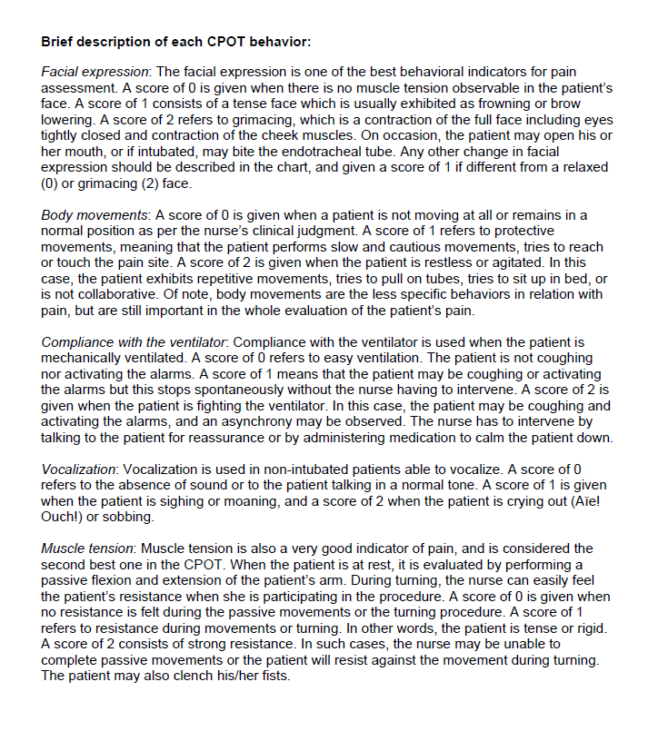

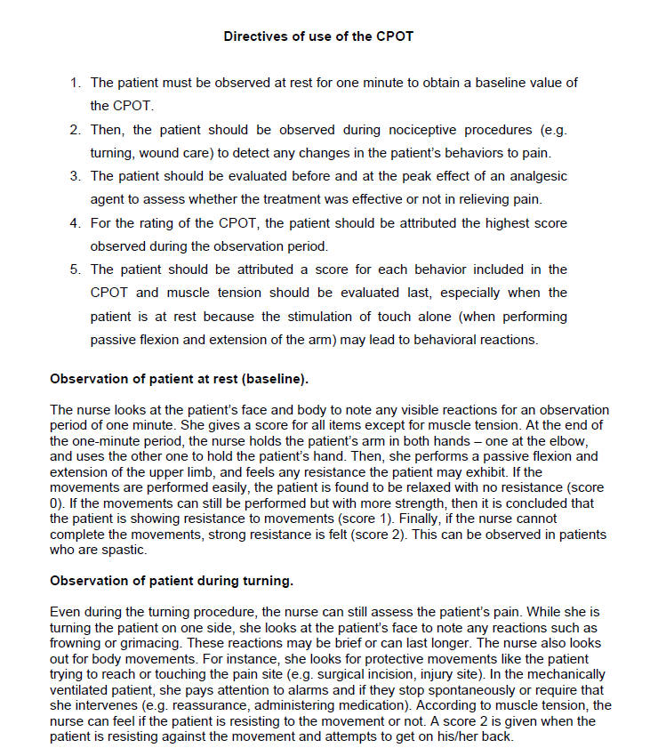

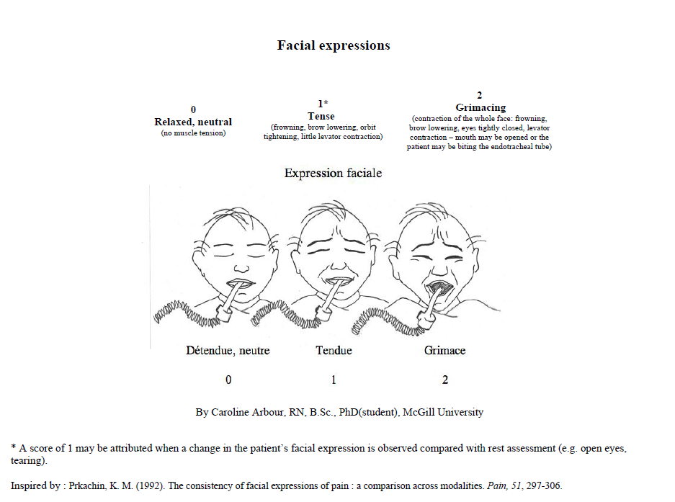

Attachment 9: Respiratory Distress Observation Scale (RDOS)

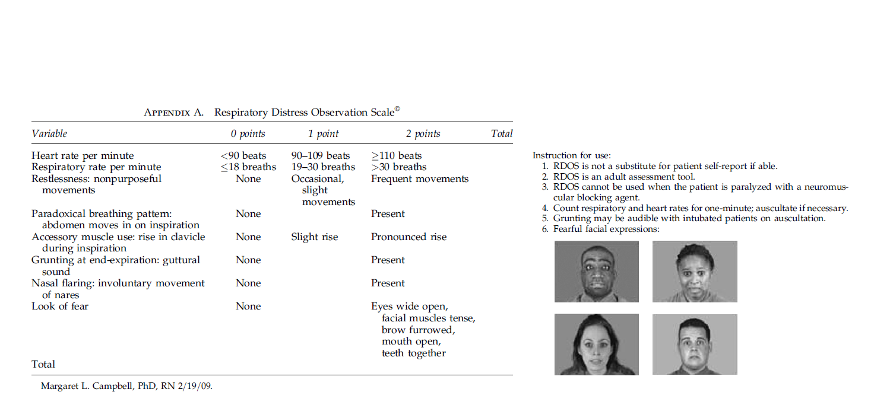

Attachment 10: Confusion Assessment Method for the ICU (CAM-ICU) scale

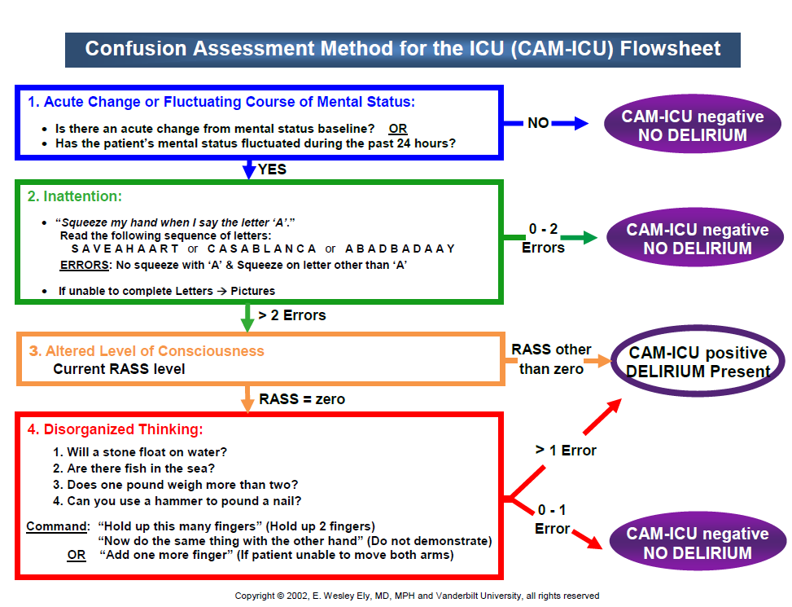

Attachment 11: Richmond Agitation-Sedation Scale (RASS)
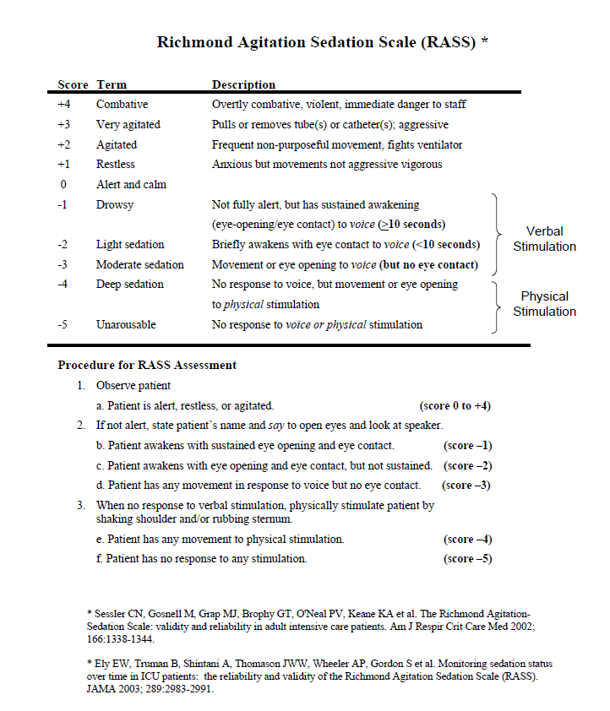

Attachment 12: Daily Symptom Assessment Scale in Acute Care Settings (SAS – AC)

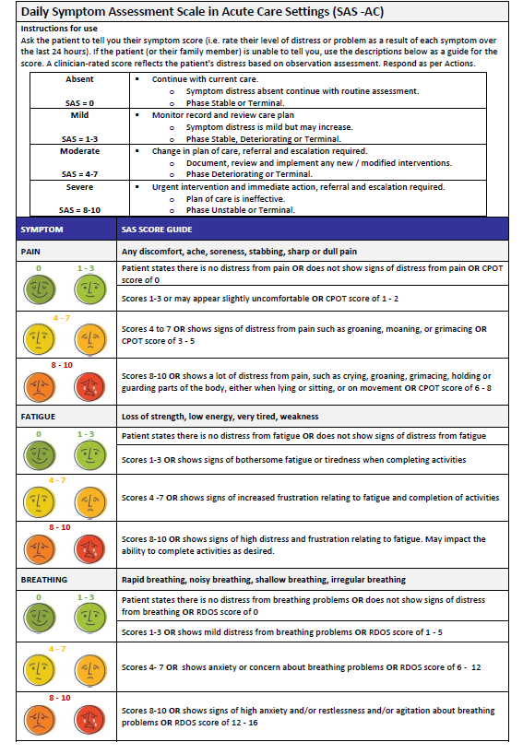

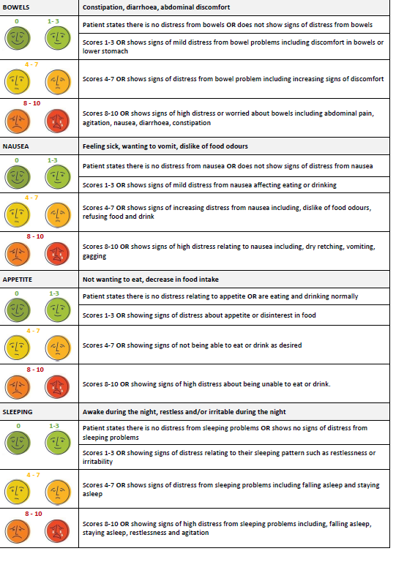

Palliative Care Outcomes Collaboration (2018) PCOC Clinical Manual, Australian Health Services Research Institute (AHSRI), University of Wollongong, NSW 2522 Australia.
Palliative Care Outcomes Collaboration (2018) PCOC Clinical Manual, Australian Health Services Research Institute (AHSRI), University of Wollongong, NSW 2522 Australia.
Palliative Care Outcomes Collaboration (2018) PCOC Clinical Manual, Australian Health Services Research Institute (AHSRI), University of Wollongong, NSW 2522 Australia.
Palliative Care Outcomes Collaboration (2018) PCOC Clinical Manual, Australian Health Services Research Institute (AHSRI), University of Wollongong, NSW 2522 Australia.
Adapted from Palliative Care Outcomes Collaboration (2018) PCOC Clinical Manual, Australian Health Services Research Institute (AHSRI), University of Wollongong, NSW 2522 Australia.

