Procedure | Canberra Health Services

MHJHADS Intramuscular Medication Administration Procedure
CHS25/344
Contents
Purpose 2
Alerts 2
Scope 2
Section 1 - Background 3
Section 2 – Guiding Principles 3
Section 3 – Site Selection 5
Section 4 – Preparation, Site Selection, Process and Documentation 8
Evaluation 12
Related policies, procedures, guidelines and legislation 12
References 13
Definition of terms 14
Search terms 14

Purpose
The purpose of this procedure is to ensure consistent best practice for the administration of medications by intramuscular injection (IMI) for Mental Health, Justice Health, and Alcohol and Drug Services (MHJHADS), including North Canberra Hospital (NCH) mental health services. It addresses appropriate circumstances in which to utilise IMIs, injection sites, needle selection and injection techniques.
This procedure supports the implementation of the following National Safety and Quality Health Service (NSQHS) Standards:
- Partnering with Consumers
- Medication Safety
- Comprehensive Care.
Back to Contents

Alerts
Nurses/Medical Officers (MO)/Nurse Practitioners (NP) should use the recommended needle sizes, medication preparation processes and administration sites outlined in the drug manufacturer guidelines. For some medications, needles are included with the medication packaging.
Prone restraint poses a risk of sudden death, particularly if parenteral medication is administered in this position. It should be a last resort and limited to no longer than three minutes.
Back to Contents

Scope
This document applies to all MHJHADS, including NCH, inpatient and outpatient mental health consumers aged over 12 years, who receive intramuscular (IM) medication.
This document applies to the following staff working within their scope of practice:
- Medical Officers (MO)
- Nurse Practitioners (NP)
- Registered Nurses (RN)
- Enrolled Nurses (EN) qualified to administer medications
- Student nurses (within their scope of practice) under direct supervision.
- Medical Students (within their scope of practice).
Back to Contents

Section 1 - Background
Intramuscular injections (IMIs) involve administering prescribed medication into muscle tissue using a needle and syringe. This technique is essential in mental health settings, particularly for Long Acting Injectable (LAI) antipsychotics, often referred to as ‘depot injections’.
Evidence-based technique is critical to avoid complications. The dorsogluteal site poses risks due to proximity to the sciatic nerve, blood vessels, and thick subcutaneous fat, which can lead to poor absorption and ineffective treatment.
Using the ventrogluteal site reduces risks such as pain, nerve damage, and abscesses, and ensures proper medication delivery into muscle tissue for optimal therapeutic effect. In acute behavioural situations requiring restraint, the ventrogluteal or vastus lateralis sites can be safer alternatives, as they avoid the need for prone positioning.
Back to Contents

Section 2 – Guiding Principles
Decisions regarding the preferred site for IMIs may be based on clinical judgement of the nurse/MO/NP, in alignment with this procedure. The consumer’s body make up and body mass index (BMI), needle length available, and types of medication must be considered during clinical care. The IMI administration site may vary for rapid tranquilisation and depot medications.
Staff must always adhere to the Medication Handling Policy and Medication Handling – North Canberra Hospital (NCH) Procedure located on the CHS Policy and Guidance Documents Register. For further medication related information, such as consumer information, potential side-effects and contraindications, staff can refer to The Australian Injectable Drugs Handbook, Australian Medicines Handbook (AMH) Online, and MIMS (eMIMs Elite) available through Clinical Apps on the CHS intranet.

Use of IMIs During Rapid Tranquilisation and Restraint
Rapid tranquilisation using IMIs may be necessary as a last resort in cases where de-escalation efforts are unsuccessful, and a consumer poses a risk of harm to themselves or others. This is to ensure the safety of both consumers and staff.
Whenever possible, IMIs should be administered with consumer collaboration. However, if restraint is required, great care must be taken during administration to minimise the risk of damage to nerves and blood vessels. This is regardless of injection site.
The use of prone restraint should be a last resort and limited to no longer than three minutes due to the risk of sudden death, particularly when parenteral medication is administered in this position. Prone restraint can compress the chest and torso, restrict breathing and potentially lead to respiratory arrest. It may also cause circulatory issues due to pressure on the torso and limbs. Alternative physical restraint techniques and injection sites other than the dorsogluteal should be used wherever possible.
If the medication is a LAI, staff should consider whether administration can be delayed until collaboration with the consumer is possible. If this is deemed clinically appropriate, guidance should be sought from the treating team.
Further guidance can be found in the Restraint and or Forcible Giving of Medication to a person Detained under the Mental Health Act 2015 Procedure, available on the Policy and Guidance Document Register.

Z-track Administration Technique
The Z-track technique is the preferred method for administering IMIs because it prevents leakage (tracking) of medication into the subcutaneous tissue. During the procedure, skin and tissue are pulled and held firmly while a long needle is inserted into the muscle. After the medication is injected, the skin and tissue are released. When a needle is inserted into the tissues, it leaves a very small hole, or track. Small amounts of medication can sometimes leak backwards through this track and be absorbed into other tissues. Pulling the skin and tissue before the injection causes the needle track to take the shape of the letter ’Z,’ which gives the procedure its name. This zigzag track line is what prevents medication from leaking from the muscle into surrounding tissue. The technique procedure is detailed in Section 3.
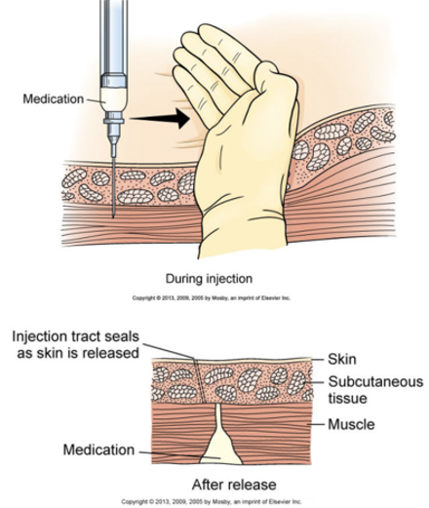
Figure 1 – Z-track administration technique (Image Source – quizlet.com)
Back to Contents

Section 3 – Site Selection

Ventrogluteal (the Gluteus Medius and Minimus)
- This is the preferred site for IMIs. It is relatively free from major nerves and blood vessels; the muscles are large and well-defined and the landmarks for administration are easy to locate.
- There may be some modesty issues associated with using this site.
Alert: The ventrogluteal injection site is the preferred injection site when the medication is to be administered in the gluteal muscle.
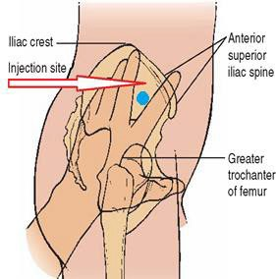
Figure 2 – Ventrogluteal site (Image Source: Whyte, 2016)

Deltoid (the Deltoid muscle)
- Injections into the mid deltoid muscle produce a quick uptake of medication.
- This site is easily accessible.
- There are no anticipated modesty concerns as the consumer only has to expose their arm.
- This site is commonly used for small volume injections up to 2mL (like vaccines).
- This site is not commonly used for IMIs due to the small size of the deltoid muscle.
- However, some medications, like Paliperidone, require the first two initiation doses of the LAI to be given in the deltoid. It is important to always refer to the manufacturer approved product information for correct administration processes.
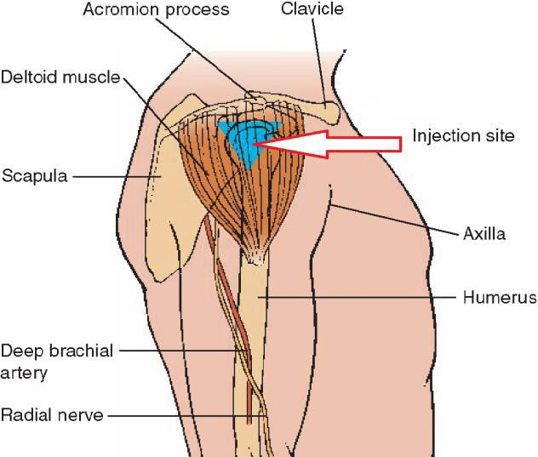
Figure 3 – Deltoid site (Image Source: Whyte, 2016)

Lateral Thigh (Vastus Lateralis)
- This site is on the lateral (side) aspect of the thigh.
- The muscle is usually thick, well developed and easy to access.
- There are no major blood vessels in this area.
- This site is easy to access and femoral nerve injury due to inaccurate landmarking is rare.
- There may be some modesty issues associated with using this site.
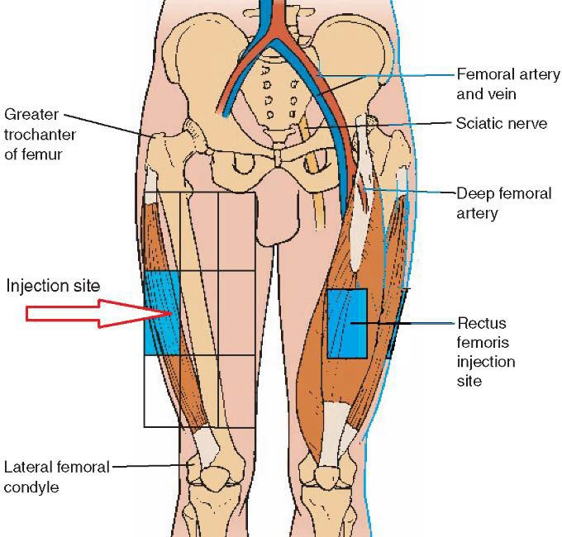
Figure 4 – Lateral Thigh site (Image Source: Whyte, 2016)

Dorsogluteal (Gluteus Maximus)
Alert: The dorsogluteal site should only be used as a last resort.
- The dorsogluteal site (often referred to as the ‘upper outer quadrant’) targets the gluteus maximus muscle and is used for high volume injections.
- Adverse effects of IMI administration in the dorsogluteal site are well recognised due to the location of the sciatic nerve, blood vessels and thickness of subcutaneous fat.
- Injections given at the dorsogluteal site can be inadvertently administered into subcutaneous adipose tissue leading to delayed/ineffective absorption and to an increase in required dose due to the failure to obtain the expected treatment outcomes.
Back to Contents

Section 4 – Preparation, Site Selection, Process and Documentation

Equipment
- antimicrobial hand sanitiser or access to hand washing facilities
- 2 – 5 millilitre (mL) syringe
- 21-gauge 38-millimetre (mm) needle (or 50mm needle if BMI is over 30)
- 21 or 23-gauge 38mm needle (or 50mm needle if BMI is over 30) retractable needle – in the instance of high aggression or during a situation in which a restraint is necessary due to significant risk for consumers and staff
- 18-gauge 40mm blunt needle for drawing up injection
- non-sterile gloves
- alcohol swab
- non-woven gauze swab or cotton ball
- small plaster or adhesive strip
- prescribed medication
- valid medication order
- dish for equipment
- sharps container.
Alert: Nurses/MOs/NPs should use the recommended needle sizes and administration site outlined in the drug manufacturer recommendations.

Procedure
Note: All staff are responsible for correct identification of a consumer’s identity using a minimum of three approved identifiers to correctly match the consumer to the procedure.
Barcode scanning processes for both the product and the consumer prior to medication administration may vary across sites. Staff must refer to their local operating procedures for specific guidance or the Patient Identification and Health Care Activity Matching Procedure located on the Policy and Guidance Documents Register.
- Ensure access to the consumers Digital Health Record (DHR) including the Medication Administration Record (MAR).
- Wash hands according to the five moments of hand hygiene.
- Put on disposable gloves and any other required Personal Protective Equipment (PPE).
- Ask the consumer if their physical or mental health has changed since the last contact with the service, including the health of the injection site.
- Ask the consumer about any side effects experienced since the last injection (if not the first time).
- Confirm in the consumer’s clinical record which side (right or left) into which the medication was last administered. Rotate sides where possible. For example, if the medication was given on the left side last time, ideally it should be given on the right side for the next injection. This can help reduce the risk of lipohypertrophy.
- Check the five rights of medication administration:
  - Right Person
  - Right Drug
  - Right Dose
  - Right Route
  - Right Time
- Confirm that the consumer has capacity to consent and provides consent to the procedure (noting there may be instances where consent cannot be provided, e.g. during restraint). See Consent for Healthcare Treatment Guideline on the Policy and Guidance Documents Register.
- Ask a second practitioner to double check the medication and follow local procedures for barcode scanning processes. An authorised second person is:
  - EN where the person administering the injection is an RN or MO
  - MO
  - Registered Pharmacist
  - RN
  - Registered Midwife
  - NP.
In community settings, medication can be double checked prior to leaving the health facility. The person administering the injection must re-check the medication against the prescription/order at the time of administration. If it is not practicable to obtain an authorised second person check in the community then it may be appropriate to ask the consumer or carer to check the medication prior to administration. Refer to the Medication Handling Policy and Medication Handling – NCH Procedure, located on the Policy and Guidance Documents Register, for more information.
- See Table 1 for site specific guidance:
Table 1 – Preparation guidance specific to IMI site
Site | Preparation
Ventrogluteal | Ask the consumer to lie down on their side and expose their hip. Note they are not required to expose more than the injection site. A blanket can be used to protect modesty.  Palpate the greater trochanter. Place the palm of the opposite hand to the consumer’s leg on the greater trochanter (e.g. staff member’s left hand on their right leg).  Locate and place index finger on the anterior superior iliac spine.  Extend middle finger towards the iliac crest to form a ‘V’ between index and middle fingers. Thumb should be pointing towards the front of the leg.  The Injection site is in the ‘V’ formed by index and middle fingers.
Deltoid | Ask the consumer to sit down and loosen their clothes so that their arm and shoulder are exposed. If the consumer is comfortable doing so, removing the arm fully from the clothing can reduce the likelihood of the tensing the shoulder. Ask them to position their arm across their body to relax the muscles.  Palpate the upper arm and find the landmarks of the acromion process and the axillary crease.  The target injection site can be located by visualising an inverted triangle which extends from the base of the acromion process and extends down to a point level with the axillary crease.  Place three fingers below the acromion process. Lift the third finger to identify the site which extends no lower than an imaginary line drawn across the arm from the axillary crease.
Lateral thigh | Ask the consumer to either sit or lie down and expose their upper leg/s. A blanket can be used to protect modesty.  Place the little finger of one hand on the lateral femoral condyle of the knee and the little finger of the other hand on the greater trochanter of the femur.  Try and align both thumbs together.  Both hands are then spanning the distance, and the injection site is at the midpoint on the lateral aspect of the thigh.
Dorsogluteal | Site not recommended unless no other options are available. See Sections 2 and 3.  If administration is required in this site as a last resort:  - Ask the consumer to lie down and loosen their clothes so one buttock is exposed. Ask the consumer to either lie on their front or side with the femur internally rotated to minimise pain on administration.  - Palpate the greater trochanter and place a finger on the site. Find the posterior superior iliac spine and place a finger on the site.  - Visualise a straight line between these two points and find the middle point of the line. The injection site is 2.5 cm above (towards the torso) of this point.

- Administer the injection using the Z-track technique.
  - Pull the skin at the administration site taut and to one side with the side of the non-dominant hand.
  - Maintain firm traction of the skin throughout the procedure.
  - Insert the needle at a 90-degree angle to the surface of the skin to an adequate depth to allow the needle to penetrate the muscle.
  - Aspirating the syringe – due to the potential presence of major blood vessels steady the barrel of the syringe with the remaining fingers of the non-dominant hand and pull back on the plunger with the dominant hand to aspirate. If blood appears in the syringe all the equipment must be discarded and the whole procedure must start again. If no blood appears, it is safe to continue.
  - Depress the plunger slowly at a rate of 1ml per ten seconds to allow the muscle fibres to expand to accommodate the medication.
  - Wait ten seconds before removing the needle. Traction on the skin can be released only when it has been removed.
Note: Priming of needles prior to injection is not recommended due to risk of losing full dosage, stinging sensation at injections site and medication solidifying in the needle causing pain on administration.
- Dispose of all equipment immediately and safely dispose of sharps in a sharps container.
- Document the administration in the MAR, including the injection site and side (right or left).
- Provide information and education to the consumer and their carer/s, family or supporters. This should include things to look out for after the injection, how to manage any common side effects and what to do if the consumer experiences any change to their mental or physical health status before their next visit.
Note: If a consumer declines injection into the ventrogluteal site and requests the dorsogluteal site instead, this must be clearly documented in their DHR. The consumer is to be informed of the risks associated with using the dorsogluteal site. This discussion is to be recorded in clinical documentation.

Documentation
The clinical record should reflect the administering staff member’s full, chronological account of assessment, planning and care and provide information relevant to the procedure at the time of the administration of the injection.
The following information should be included:
- completed MAR which will outline:
  - medication type
  - medication dose
  - time and date of administration
  - administration site (e.g. ventrogluteal)
  - administration side (e.g. left or right side)
  - signature of second person/person double checking medication.
- a record in the progress notes of any discussions around decisions made and education provided to the consumer, their family and/or support person
- any deviation from normal practice, including use of/reason for dorsogluteal site
- any clinical incidents must be recorded in the clinical incident register (RiskMan) and reported to the relevant Team Leader.
Back to Contents

Evaluation

Outcome
- Staff consistently use best practice IM medication administration techniques, including 90% of IMIs administered to the gluteal muscle use the ventrogluteal site
- 85% of MHJHADS nursing staff receive IM administration training
- 95% compliance with barcode scanning of the medication and the consumer

Measures
- Review of HRIMS completion rates of online learning module and face to face training over 12 months
- Review of percentage of IMIs administered to the gluteal muscle use the ventrogluteal site, over 12 months
- Compliance with barcode scanning measured through the DHR by The Canberra Hospital (TCH) Pharmacy Medication Safety Team
Back to Contents

Related policies, procedures, guidelines and legislation

Policies
- Medication Handling
- Nursing and Midwifery Board of Australia (NMBA) Requirements for Practice

Procedures
- Infection Prevention and Control
- Patient Identification and Health Care Activity Matching
- Medication Handling – North Canberra Hospital (NCH)
- Restraint and or Forcible Giving of Medication to a person Detained under the Mental Health Act 2015
- Olanzapine Long-Acting Injection (LAI) – Administration and Observation

Guidelines
- Consent for Healthcare Treatment

Legislation
- Health Records (Privacy and Access) Act 1997
- Human Rights Act 2004
- Work Health and Safety Act 2011
- Carers Recognition Act 2021
- Mental Health Act 2015
- Medicines, Poisons and Therapeutic Goods Regulation 2008
- Medicines, Poisons and Therapeutic Goods Act 2008

Other
- Australian Charter of Healthcare Rights
- The Australian Injectable Drug Handbook
- Australian Medicine’s Handbook (AMH) Online
- MIMS (eMIMs elite)
- Choice and Medication for Canberra Health Service
Back to Contents

References
Canterbury District Health Board. (2019). Intramuscular Injection. Protocol. Intramuscular Injections
Department of Health and Aged Care. (2022). Medication management in the community. Guiding Principles. Guiding Principles for Medication Management in the Community
Elgellaie, A., Ashcroft, E., & Larkin, T. A. (2018). Effects of thickness of muscle and subcutaneous fat on efficacy of gluteal intramuscular injection sites. British Journal of Nursing (Mark Allen Publishing), 27(6), 300–305. https://doi.org/10.12968/bjon.2018.27.6.300
Legrand, G., Guiguet‐Auclair, C., Viennet, H., Aumeran, C., Reynaud, D., Badrikian, L., & Debost‐Legrand, A. (2019). Nurses’ practices in the preparation and administration of intramuscular injections in mental health: A cross‐sectional study. Journal of Clinical Nursing, 28(17–18), 3310–3317. https://doi.org/10.1111/jocn.14909
Oxford Health NHS Foundation Trust. (2024). Guidance on The Administration of Intramuscular Injections in In-patient Settings. Guidance on the administration of intra-muscular injections in Inpatient Settings V2 FINAL 02.24.pdf
Roldán‐Chicano, M. T., Rodríguez‐Tello, J., Cebrián‐López, R., Moore, J. R., & Mar García‐López, M. (2023). Adverse effects of dorsogluteal intramuscular injection versus ventrogluteal intramuscular injection: A systematic review and meta‐analysis. Nursing Open, 10(9), 5975–5988. https://doi.org/10.1002/nop2.1902
South Eastern Sydney Local Health District. (2022). Intramuscular Injection in Mental Health. Procedure. SESLHDGL/076 - Intramuscular Injection in Mental Health
Turan, N., Acı, Ö. S., Irmak, H., Kaya, H., & Kutlu, F. Y. (2022). Knowledge and practices of nurses working in psychiatry clinics on ventrogluteal injection. Perspectives in Psychiatric Care, 58(4), 1388–1398. https://doi.org/10.1111/ppc.12942
Weber, H. (2023). Deciding on a safe site for intramuscular injections in an acute mental health setting. Kai Tiaki Nursing Research, 14(1), 58–61.
White, J. (2022). Guidance on the Administration to Adults of Oil-based Depot and other Long-Acting Intramuscular Antipsychotic Injections 7th Edition. guidance-on-im-administration-of-oil-based-depots-and-other-long-acting-antipsychotic-injections-7th-edition.pdf
Whyte, A., & Parker, C. (2016). A review of the efficacy and tolerability of antipsychotic long‐acting injections. Progress in Neurology and Psychiatry, 20(4), 20–26. Retrieved from https://wileymicrositebuilder.com/trends/wp-content/uploads/sites/28/2016/08/A-review-of-the-efficacy-and-tolerability-of-antipsychotic-long-acting-injections.pdf
South Australia Health. (n.d). Changes to your long acting injection. Brochure. Long Acting Intramuscular Injections Brochure
Quizlet. (n.d.). Medication administration test bank review [Flashcards]. Quizlet. https://quizlet.com/726976317/medication-administration-test-bank-review-flash-cards/
Back to Contents

Definition of terms
Lipohypertrophy: a condition characterised by abnormal build-up of fatty tissue under the skin, often a result from repeated injections in the same area.
Long Acting Injectable: a type of medication formulated to be administered via injection, where the drug is slowly released into the body over an extended period—typically weeks to months
Parenteral: refers to the administration of substances—such as medications or nutrients—by routes other than the digestive tract. This typically involves injection directly into the body through various methods, bypassing the gastrointestinal system.
Prone restraint: refers to the act of physically restraining an individual while they are in the prone position—that is, lying face down with the front of the body against the ground
Subcutaneous adipose tissue: a type of body fat located directly beneath the skin and above the muscles
Back to Contents

Search terms
Intramuscular injection, IMI, depot, long acting injectable, LAI, injection, antipsychotic, ventrogluteal, deltoid, dorsogluteal, ztrack
Back to Contents
For Policy Team to complete:
Date amended | Section amended | Divisional approval | Final approval
2 October 2025 | New document | Bruno Aloisi, GM MHJHADS | Jacqui Clissold, Director of Policy and Consumer Handouts
22 December 2025 | Complete review | Bruno Aloisi, GM MHJHADS | CHS Policy Document Review Panel
This document supersedes the following:
Document number | Document name
Disclaimer
This document has been developed by Canberra Health Services specifically for its own use. Use of this document and any reliance on the information contained therein by any third party is at his or her own risk and Canberra Health Services assumes no responsibility whatsoever.
Back to Contents

Acknowledgement of Country  Canberra Health Services acknowledges the Ngunnawal people as traditional custodians of the ACT and recognises any other people or families with connection to the lands of the ACT and region. We acknowledge and respect their continuing culture and contribution to the life of this region.  © Australian Capital Territory, Canberra 2024 | Accessibility  call (02) 5124 0000   Interpreter call 131 450  canberrahealthservices.act.gov.au/accessibility  

