Canberra Health Services
Procedure
North Canberra Hospital (NCH) – Antimicrobial Stewardship

Contents

Contents 1
Purpose 2
Scope 2
Alerts 2
Section 1 – Responsibilities 3
Section 2 – Prescribing Restricted Antimicrobials 5
Section 3 – Approval description 5
Section 4 – Antimicrobial Classifications and Restrictions 6
Section 5 – Process for Requesting Antimicrobial Approval and Supply Monday – Friday 7
Section 6 – Process for Requesting Antimicrobials and Supply on Weekends 8
Section 7 – Requesting an Extension of Approval 8
Section 8 – Exemptions to Seeking Approval for Restricted Antimicrobials 9
Section 9 – Antimicrobial Shortages 9
Section 10 – After-hours Supply Service 9
Section 11 – AMS Review 9
Section 12 – IV to Oral Switch 10
Related Policies, Procedures, Guidelines and Legislation 12
References 13
Definition of Terms 13
Search Terms 13
Attachments 13

Purpose

The purpose of this procedure is:
- Promote the judicious use of antimicrobial agents via formulary restriction, education, decision support, feedback and evidenced-based protocol development
- Assist and support clinicians with decisions regarding the optimal selection, dose and duration of antimicrobial agents
- To outline how to prescribe restricted antimicrobials based on the ‘traffic light’ system, BLACK, RED, ORANGE and GREEN
- Minimise antimicrobial-related adverse effects
- Reduce the selection pressure driving the development of multi-resistant organisms (MROs) and Clostridium difficile
- Streamline the process of obtaining approvals for restricted antimicrobials and define the roles and responsibilities of all staff involved with the Antimicrobial Stewardship (AMS) process
- To facilitate adherence to the National Antimicrobial Stewardship Clinical Care Standard (ASCCS)
Back to Table of Contents

Scope

This document applies to all North Canberra Hospital team members involved in the prescribing, preparation, administration, and dispensing of antimicrobials.

This procedure aligns with the National Antimicrobial Stewardship Clinical Care Standard (ASCCS). The ASCCS consists of eight nationally agreed quality statements developed by the Australian Commission for Safety and Quality in Health Care (ACSQHC) about the care that a patient should be offered in line with current best evidence. It describes key aspects of care when antimicrobials are being considered for treatment of a bacterial infection or for prophylaxis.

The quality statements relate to high-priority areas for improvement regarding antimicrobial prescribing and it complements the National Safety and Quality Health Service Standards (NSQHS) and other national efforts that support AMS.

Back to Table of Contents

Alerts

This process applies to all antimicrobials prescribed as per the Therapeutic Guidelines: Antibiotic, NCH policies, the clinical condition of the patient, and/or results from microbiological testing

Executive, AMS team, Prescribers, Pharmacists and Nursing Staff must at all times adhere to the eight eight Antimicrobial Stewardship Clinical Care Standards of the Australian Commission for Safety and Quality in Health Care (Attachment 1)

Back to Table of Contents

Section 1 – Responsibilities

Executive staff:
- To ensure resources are available to facilitate a sustainable, efficient AMS program
- To promote prescribing within their division and departments that is concordant with this procedure
- To collaborate with the AMS team to encourage the optimal use of antimicrobials
- Must adhere to the eight Antimicrobial Stewardship Clinical Care Standards of the Australian Commission for Safety and Quality in Health Care.

Antimicrobial stewardship team:
- Respond to and review antimicrobial approval requests during weekdays in a timely manner and provide antimicrobial advice and recommendations (ie, decision support) to clinical staff
- The role of the AMS team is distinct to the Infectious Diseases (ID) consult service. It is not within the scope of an AMS review to clinically examine patients or provide definitive diagnostic advice. If the prescribing team require ID consultation, contact NCH switchboard and request the ID registrar
- Must adhere to the eight Antimicrobial Stewardship Clinical Care Standards of the Australian Commission for Safety and Quality in Health Care.
- AMS Pharmacist:
- Assists in orientation and education of clinical team members of AMS practices at NCH
- Educates and upskills clinical team members in antimicrobial knowledge
- Routinely evaluates and reviews the effectiveness of the AMS program, including:
- Compliance with Antimicrobial Stewardship from National Safety and Quality Health Service Standards (NSQHS) Preventing and Controlling Healthcare-Associated Infection Standard 3
- Monitoring and auditing antibiotic usage data and benchmarking against similar hospitals
- Reviews NCH antibiogram and multi-resistant organism data from microbiology laboratory
- Adheres to any other key performance indicators required from Infection Preventing and Controlling Infcetrions Standard Committee, Drug and Therapeutics (DTC) committee or from NCH executive.

Prescribing staff:
- Responsible for prescribing antimicrobials in accordance with the Therapeutic Guidelines: Antibiotic, NCH policies and procedures, the clinical condition of the patient, and/or the results of microbiological testing
- Must be familiar with how to place a AMS consult in the Digital Health Record (DHR)
- Responsible for seeking prompt approval of restricted antimicrobials within specified timeframes
- Responsible for engaging with clinical pharmacists and/or the AMS team to clarify the rationale of recommended antimicrobials, as required
- Must adhere to the eight Antimicrobial Stewardship Clinical Care Standards of the Australian Commission for Safety and Quality in Health Care.

Pharmacists:
- Responsible for clinical review of antimicrobial prescriptions and must dispense antimicrobials in accordance with this procedure
- Will alert prescribing teams when AMS approval is required for restricted antimicrobials
- Will notify the AMS team if approval is not sought for restricted antimicrobials
- Must adhere to the eight Antimicrobial Stewardship Clinical Care Standards of the Australian Commission for Safety and Quality in Health Care.

Nursing staff:
- Responsible for arranging supply from pharmacy or after-hours cupboard for antimicrobials which are not ward stock and administering antimicrobials at the correct time, as prescribed.
- Should advocate for patient care by promoting adherence to this policy, including documentation of antimicrobial indications and expiring or missing AMS approvals
- Should alert the clinical pharmacist and prescribing team with concerns of non-compliance, if necessary
- Must adhere to the eight Antimicrobial Stewardship Clinical Care Standards of the Australian Commission for Safety and Quality in Health Care.

Back to Table of Contents

Section 2 – Prescribing Restricted Antimicrobials

To ensure judicious management of broad-spectrum antimicrobial prescribing, the North Canberra Hospital (NCH) ‘traffic light system’ (colours of BLACK, RED, ORANGE and GREEN) whether approval is required to prescribe and in the required time frame.

COLOUR | BLACK | RED | ORANGE | GREEN
Restriction | Highly Restricted | Restricted | Restricted | Not restricted
Approval Process | Infectious diseases (ID) approval required PRIOR to prescribing | Approval is required within 24 hours of prescribing | Approval is required within 72 hours of prescribing | Antimicrobial agent should be prescribed in accordance with the latest version of Therapeutic Guidelines: Antibiotic, and/or NCH policy document
Approval Process | The approval code must be documented in an appropriate section in DHR to be a valid approval

Prescribing via an Antimicrobial Panel
When using DHR Antimicrobial Panels, increased dispensing amounts can occur from the first dose without consult or approval. There is an approved initial duration of supply built into the panel. Once this supply expires, AMS/ID consult is required for ongoing supply.

Back to Table of Contents

Section 3 – Approval description
AMS approval codes will appear in the following format:
e.g. CBDDMM03(R/S)
CB = example of AMS approver initials DDMM = Day and Month
03 = example of duration (in days) of approval from date of review.
R = REVIEW indicates that duration will need re-approval after the specified number of days. A new AMS approval code will need to be obtained if the antimicrobial is to continue.
S = STOP indicates that the approval is intended to lapse (eg, cessation or stepdown to oral antimicrobials) after the specified number of days.
Approval is not valid if the code is not documented in DHR
Code expiry: Codes will expire on the last day indicated in the approval code. e.g. CB251203S expires on the 28th of December at 2pm

Procedure

Back to Table of Contents

Section 4 – Antimicrobial Classifications and Restrictions

Colour | Restriction | Antimicrobial
BLACK | Infectious Diseases (ID) approval required to be documented PRIOR to prescribing | Colistin  Foscarnet  Ceftolozane/tazobactam  Ceftazidime/avibactam  Levofloxacin  Fidaxomicin
RED | Approval required to be documented in DHR within 24 hours of prescribing | Amikacin  Amoxicillin/Clavulanate IV Amphotericin IV  Anidulafungin  Cefepime  Cefotaxime  Ceftazidime  Daptomycin  Ertapenem  Flucytosine  Fosfomycin  Ganciclovir | Linezolid  Meropenem  Moxifloxacin  Pentamidine  Piperacillin/Tazobactam  Rifampicin  Sodium fusidate  Teicoplanin  Tigecycline  Valganciclovir  Vancomycin  Voriconazole
ORANGE | Approval required to be documented in DHR within 72 hours of prescribing | Azithromycin  Ceftriaxone  Ciprofloxacin  Clindamycin | Fluconazole  Gentamicin > 3 days  Norfloxacin  Tobramycin
GREEN | No approval required | Aciclovir  Amoxicillin  Amoxicillin/Clavulanic acid PO  Ampicillin  Benzylpenicillin  Cefalexin  Cefazolin  Cefuroxime  Clarithromycin  Dicloxacillin  Doxycycline  Erythromycin | Flucloxacillin  Ivermectin  Metronidazole  Minocycline  Nitrofurantoin  Phenoxymethylpenicllin  Roxithromycin  Trimethoprim/Sulfamethoxazole  Tinidazole  Trimethopim  Valaciclovir

Back to Table of Contents

Section 5 – Process for Requesting Antimicrobial Approval and Supply Monday – Friday

 | Monday-Friday process for approval |  |  |  | Monday-Friday process for supply
 | AMS approval request process |  | Clinician responsible  for review | Code Requirements | Prior to  approval | Post  approval | Expired approval
BLACK | Infectious diseases (ID) approval required PRIOR to prescribing |  | Working hours:  Team to contact the ID/AMS registrar at NCH via switchboard  After hours:  Prescribing team to contact the on-call ID physician at CHS | AMS team must document approval code in consult/ review note. | Pharmacy is unable to supply until approval code is documented in DHR | Pharmacy will supply until 2pm on the day that the approval is due to be reviewed or ceased. | Pharmacy is unable to supply. Prescribing team must review and request an extension from ID/AMS registrar (see Section 9)
RED | Request AMS consult in DHR on day of prescription |  | ID/AMS registrar or pharmacist to contact prescriber with an approval code or request for information |  | Pharmacy will supply for 24 hours. Approval is required by 2pm the following day
ORANGE | Request AMS consult in DHR within 24 hours of prescription |  |  |  | Pharmacy will supply 72 hours. Approval is required by 2pm on the 3rd day | Pharmacy will supply until 2pm on Monday only if the code expires on a weekend
GREEN |  | No restriction. Antimicrobials should be guided by Therapeutic Guidelines: Antibiotic, NCH policies, the clinical condition of the patient and/or the results of microbiological testing

Back to Table of Contents

Section 6 – Process for Requesting Antimicrobials and Supply on Weekend and Public Holidays

On Saturday/Sunday, there is no ID/AMS registrar or consultant service at NCH
 | Weekend process for approval |  |  | Weekend and Public Holiday process for supply
 | AMS approval request process |  | Code Requirements | Prior to approval | Post approval | Expired approval
BLACK | Contact the on-call Infectious Diseases (ID) physician CHS via the switchboard PRIOR to prescribing |  | Prescriber must document the approval code in the progress note. | Pharmacy is unable to supply until approval code is documented in DHR | Pharmacy will supply until 2pm on the day that the approval is due to be reviewed or ceased. | Pharmacy is unable to supply. The team must review the antimicrobial and request an extension from the on-call ID physician at CHS via the switchboard
RED | Contact the on-call ID physician at CHS via switchboard on day of prescription and request AMS consult in DHR |  |  | Pharmacy will supply 24 hours. Approval is required by 2pm the following day
ORANGE | Request AMS consult in DHR within 24 hours of prescription |  |  | Pharmacy will supply until 2pm on Monday | Pharmacy will supply until 2pm on Monday only if the code expires on a weekend
GREEN |  | No restriction. Antimicrobials should be guided by Therapeutic Guidelines: Antibiotic, NCH policies, the clinical condition of the patient and/or the results of microbiological testing

Back to Table of Contents

Section 7 – Requesting an Extension of Approval

- Once an initial antimicrobial request has been submitted, the AMS team will continue to review the patients’ progress. If, however the team wishes to escalate antimicrobial therapy, (i.e. to another restricted antimicrobial) the prescribing team should request approval in the specified timeframe.
Back to Table of Contents

Section 8 – Exemptions to Seeking Approval for Restricted Antimicrobials

- Exemptions include antimicrobials previously approved by Infectious Diseases for indefinite therapy (eg, suppression of prosthetic hip infection) or prophylaxis against opportunistic organisms. The prescriber must document that indication in DHR.
- Prescribing for patients in the Intensive Care Unit (ICU) and High Dependency Unit (HDU) is exempt from requiring approval due to the level of AMS team and ID service involved; however, discussion with the ID team is recommended if patients have infectious diseases issues and have not been discussed in the twice weekly AMS meetings.

Back to Table of Contents

Section 9 – Antimicrobial Shortages

- There can be interruptions with the supply of antimicrobial drugs in Australia that necessitate modifications to the restriction policies. When this occurs, please refer to the NCH Formulary for the most up to date information and follow guidance from the AMS/ID team.

Back to Table of Contents

Section 10 – After-hours Supply Service

- Antimicrobials obtained from the after-hours service are subject to the approval process outlined above and will be followed up by pharmacists with the prescribing team. Antimicrobial dispensing through this route will be routinely monitored.

Back to Table of Contents

Section 11 – AMS Review

In line with the Clinical Care Standards, an AMS review may involve:
- Reviewing antimicrobial prescribing in situations where the ID consultation service is not usually involved
- Reviewing medication charts, progress notes, investigations, pathology, microbiology and radiology
- Discussing patient progress with the prescribing team
- Requesting review of antimicrobial therapy of indication for use
- Recommending documentation of the indication, drug name, route of administration, intended duration and review plan
- Requesting to document the justification for deviation from Therapeutic Guidelines: Antibiotic, NCH policies, the clinical condition of the patient and/or the results of microbiological testing
- Recommending dosage adjustment, therapeutic drug monitoring, consideration of alternative therapy (eg, oral step-down), or consideration of cessation of treatment
- Recommending additional investigations, eg, microbiological tests
- Referring antimicrobial prescribing practices that are not in line with the AMS policy or procedure to the ID registrar and/or consultant for review
- Recommending ID consultation for assistance with complex therapeutic situations beyond the scope of an AMS review.
Back to Table of Contents

Section 12 – IV to Oral Switch

IV to oral switch/stop
Unnecessarily prolonged IV antimicrobial therapy is associated with: prolonged hospital stays; increased costs of staff time for preparation of medicines, administration of medicines, and maintenance of IV lines; and increased morbidity and mortality related to IV line infections. Switching IV to oral therapy as soon as feasible mitigates against this.
Oral stepdown options are pre-programmed in the DHR prescribing panels and are provided for all appropriate indications in the Therapeutic Guidelines: Antibiotic³.

When to switch?
An assessment of clinical response and microbiology results should be performed every day after prescription of antimicrobials in hospital. Most transitions to oral therapy can be made within 48-72 hours of admission; some may even be able to be ceased. Inability to switch within this time period often suggest alternative diagnoses including those where IV switch may not be appropriate such as fixed focus infections, non-infective diagnoses or less commonly inappropriate antimicrobial coverage.

The following criteria should be fulfilled when switching to oral therapy from guidelines based intravenous therapy (see figure below)
- The condition does not require a pre-specified period of IV treatment
- Those that do include endocarditis, meningitis, necrotising fasciitis, Staphylococcus aureus bacteraemia, and most cases of bone and joint infection
- Signs of clinical improvement (including resolution of fever)
- No persistent features of severe sepsis
- An oral antimicrobial with a suitable spectrum of activity is available if ongoing therapy is still required
- Oral administration is tolerated and is possible
- Gastrointestinal absorption is not significantly reduced (e.g., vomiting, GI pathology)

Conditions particularly suited for an early switch to oral therapy:
- Pneumonia
- Skin and soft tissue infection
- Urinary tract infection
- Uncomplicated Gram-negative bacteraemia
- Intra-abdominal infection without deep-seated collections

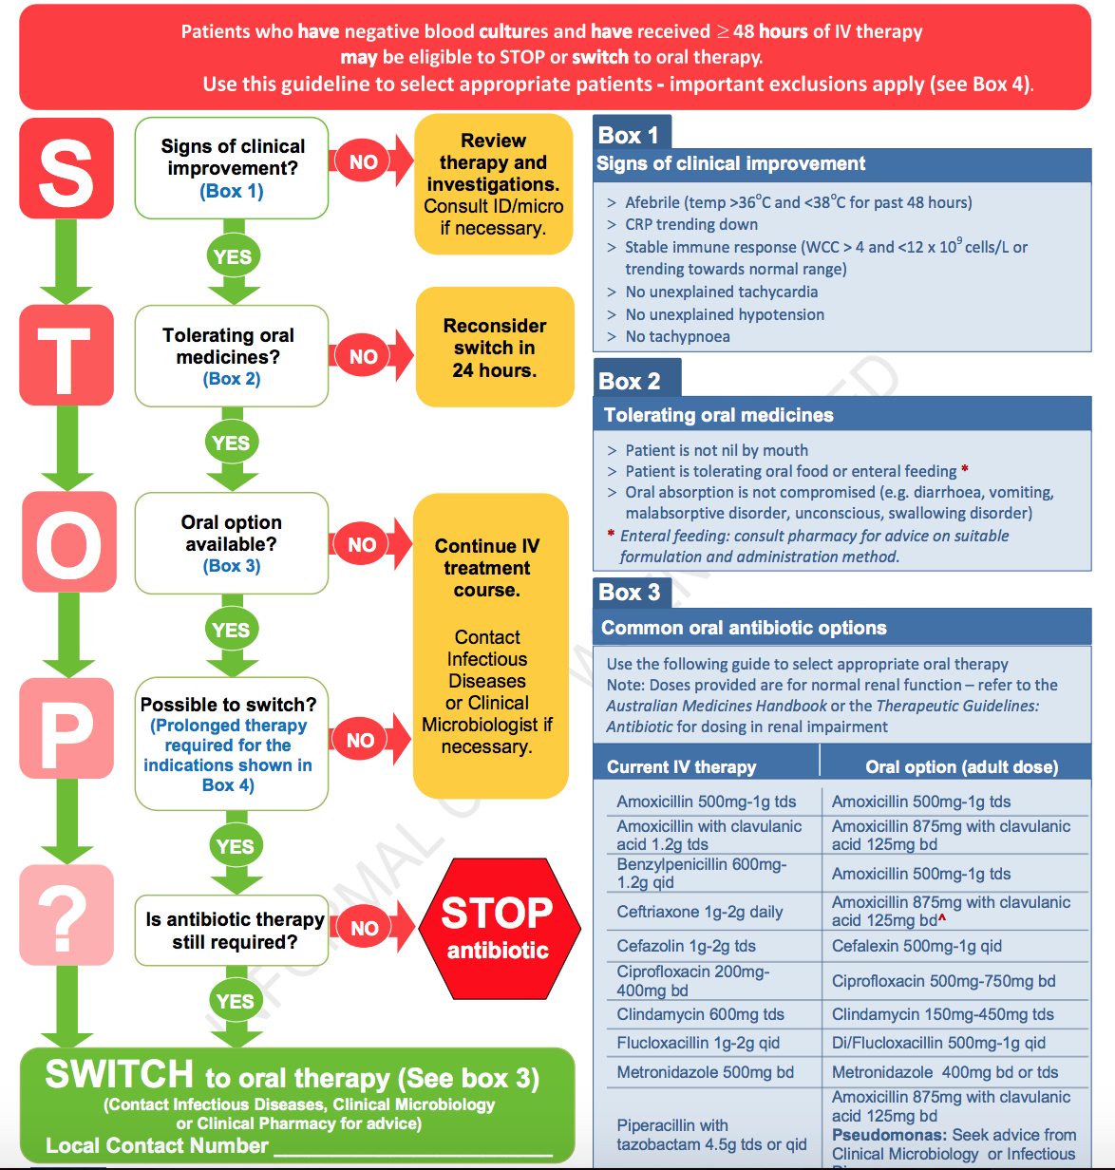
Figure 1: IV to oral switch/stop
Box 4: Endocarditis, meningitis, necrotising fasciitis, Staphylococcus aureus bacteraemia, and most cases of bone and joint infection
*Adapted with consent from SA Health

Antimicrobials considered to be bioequivalent (IV vs. oral)
Several antimicrobials have equivalent efficacy when given IV or orally because of excellent bioavailability and/or high concentrations at the target site (see Table below). They should be administered orally assuming enteral intake is feasible and oral absorption is not impaired.

Antimicrobial | Approximate bioavailability | IV dose | PO dose
Amoxicillin  *(Ampicillin is IV equivalent) | 80% | 2000mg Q4-6H* | 500-1000mg TDS
Ciprofloxacin | 70-80% | 400mg Q8-12H | 500mg BD for cystitis 750mg BD for most other conditions
Clindamycin | ~90% | 600mg Q8H | 450mg TDS
Fluconazole | >90% | IV and oral dose are equivalent
Linezolid | ~100% | IV and oral dose are equivalent
Metronidazole | 100% | 500mg BD | 400mg BD for common infections (except C. difficile therapy)
Moxifloxacin | ~90% | IV and oral dose are equivalent
Trimethoprim/sulfamethoxazole | 90-100% | IV and oral dose are equivalent
Voriconazole | ~96% | IV and oral dose are equivalent

Back to Table of Contents

Related Policies, Procedures, Guidelines and Legislation

Policies
- Informed Consent – Clinical

Procedures
- NCH Infection Prevention and Control
- Patient Identification and Procedure Matching
- NCH Medication Handling

Legislation
- Health Records (Privacy and Access) Act 1997
- Human Rights Act 2004
- Work Health and Safety Act 2011

Other
• Australian Charter of Healthcare Rights
- Antimicrobial Stewardship Clinical Care Standard

Back to Table of Contents

References

- TGA: Antibiotic Expert Group. Therapeutic Guidelines: Antibiotic. Version 16. Melbourne: Therapeutic Guidelines Limited; 2019
- Australian Commission on Safety and Quality in Health Care. Antimicrobial Stewardship in Australian Health Care 2018. Sydney: ACSQHC; 2018 [Available online: https://www.safetyandquality.gov.au/resource-library/antimicrobial-stewardship-australian-health-care-2018 ]

Back to Table of Contents

Definition of Terms
AMS: Antimicrobial Stewardship
DHR: Digital Health Record
Back to Table of Contents

Search Terms

Anitmicrobial, AMS, Prescribing, antibiotics, Antimicrobial stewardship, AMS, Antibiotic, Restricted, Antimicrobial, Approval, Antimicrobial Approval, DHR, Antimicrobial Order Panels, Infectious, Diseases, Prescribing, Antibiotics.

Back to Table of Contents

Attachments

Attachment 1 – Antimicrobial Stewardship Clinical Care Standard

Disclaimer: This document has been developed by Canberra Health Services specifically for its own use. Use of this document and any reliance on the information contained therein by any third party is at his or her own risk and Canberra Health Services assumes no responsibility whatsoever.

Policy Team ONLY to complete the following:
Date Amended | Section Amended | Divisional Approval | Final Approval
23/02/2024 | NCH Tranistion | Emily Diprose, NCH ED of Allied Health & Pharmacy | CHS Policy Team

This document supersedes the following:
Document Number | Document Name
 | Antimicrobial Stewardship (AMS) Procedure
 | Antimicrobial Stewardship (AMS) Policy

Attachment 1 – Antimicrobial Stewardship Clinical Care Standard

1 Life-threatening conditions A patient with a life-threatening condition due to a suspected infection receives an appropriate antimicrobial immediately, without waiting for the results of investigations.
2 Use of guidelines When a patient is prescribed an antimicrobial, this is done in accordance with the current Therapeutic Guidelines or evidence-based, locally endorsed guidelines and the antimicrobial formulary.
3 Adverse reactions to antimicrobials When an adverse reaction (including an allergy) to an antimicrobial is reported by a patient or recorded in their healthcare record, the active ingredient(s), date, nature and severity of the reaction are assessed and documented. This enables the most appropriate antimicrobial to be used when required.
4 Microbiological testing A patient with a suspected infection has appropriate samples taken for microbiology testing as clinically indicated, preferably before starting antimicrobial therapy.
5 Patient information and shared decision making A patient with an infection, or at risk of an infection, is provided with information about their condition and treatment options in a way that they can understand. If antimicrobials are prescribed, information on how to use them, when to stop, potential side effects and a review plan is discussed with the patient.
6 Documentation When a patient is prescribed an antimicrobial, the indication, active ingredient, dose, frequency and route of administration, and the intended duration or review plan are documented in the patient’s healthcare record.
7 Review of therapy A patient prescribed an antimicrobial has regular clinical review of their therapy, with the frequency of review dependent on patient acuity and risk factors. The need for ongoing antimicrobial use, appropriate microbial spectrum of activity, dose, frequency and route of administration are assessed and adjusted accordingly. Investigation results are reviewed promptly when they are reported.
8 Surgical and procedural prophylaxis A patient having surgery or a procedure is prescribed antimicrobial prophylaxis in accordance with the current Therapeutic Guidelines or evidence-based, locally endorsed guidelines. This includes recommendations about the need for prophylaxis, choice of antimicrobial, dose, route and timing of administration, and duration.

