Canberra Health Services
Perinatal Substance Use: Queensland Health Clinical Guideline (Neonates)

Purpose

Neonatal Abstinence Syndrome (NAS) is a syndrome of substance withdrawal with non-specific signs in a neonate following chronic in-utero exposure to a variety of substances. Canberra Health Services (CHS) endorses the use of Queensland Health’s Clinical Guideline: Perinatal substance use: neonatal to assist medical, nursing and midwifery staff in the management and treatment of neonates diagnosed with NAS.

This document provides information on:
- clinical signs and symptoms of NAS and the use of Finnigan’s Scoring
- supportive care and treatment of neonates with NAS
- pharmacological therapy.

Scope

This document applies to all neonates who require supportive care and opiate treatment for NAS.

This document applies to the following staff working within their scope of practice:
- medical officers
- nurses and midwives
- students working under direct supervision.

Alerts

This document is endorsed with the following amendments to the sections stated below, to align with specific policies, protocols and processes relevant to CHS (all referenced documents can be found on the Policy and Guidance Documents Register).

Section | CHS Amendment
Section 1.3- Routine/standard care and Section 4- Communicating with parent/carer | Refer to the Neonatal Routine Care Guideline and Developmental Care in the Neonatal Intensive Care Unit and Special Care Nursery Guideline.
Section 2- Table 3: Aspect: Resuscitation | Refer to the Neonatal Resuscitation and Airway Management Guideline.
Section 2.1- Table 4: Any Substance | Refer patient to On-Shift Neonatologist or Advanced Trainee.
Section 3.2- Table 6: Substance Testing | Consult with ACT pathology regarding recommendations.
Section 4.1.1- Table 12: If Breastfeeding  Section 4.1.2- Table 13, Importance | Refer to the Breastfeeding Clinical Guideline.
Section 5.1 -Table 15: Morphine Hydrochloride Schedule and Weaning | Refer to the Neonatal Intensive Care Drug Manual.
Section 5.2- Table 16: Clinical Surveillance | Request the on-shift neonatologist or advanced trainee.
Section 6- Table 17: Child Protection/Safety Assessment | Staff have a duty of care to report to Child and Youth Protection Services for ACT and Family & Community Services refer to Child Protection Policy and Child Protection and Prenatal Concern Reporting Guideline.
Section 6.1-Table 18: Home Medications  Criteria | Outpatient treatment can be considered if dose of morphine is less than 0.5mg/kg/day.  Frequency of wean is usually reduced to weekly after discharge depending on symptoms.
Section 6.1-Table 18: Home Medications  Support Services | Individual syringe preparations are not available.  CHS staff to prescribe morphine on an outpatient prescription to include dose, frequency and total prescribed amount in mg and mL (total weekly dose plus an extra 0.1-0.2mL/dose for losses in the drawing up syringe).
Appendix A- Finnigan Neonatal Abstinence Severity Score | Use Finnigan Chart (Modified) Term Infant Clinical Form 60650 (Attachment 1) and Neonatal Drug Withdrawal Chart for Preterm Infants Modified Finnigan Chart (Below 37 Weeks Gestation) Clinical Form 60640 (Attachment 2).
NeoMedQ Medication Information | Refer to Neonatal Intensive Care Drug Manual.

Which area in Canberra Health Services can I contact for more information?

Clinical Support Nurse, Department of Neonatology.
Ph: 61426360

How can I access the document?

The Queensland Clinical Guideline: Perinatal substance use: neonatal can be accessed on the Queensland Health website at: https://www.health.qld.gov.au/__data/assets/pdf_file/0018/140814/g-psuneo.pdf?msclkid=cc37094ebb9e11ecb53aae2213634f55

Search Terms

Neonatal Abstinence Syndrome, NAS, perinatal substance use, neonate, neonatal, neonatal withdrawal, withdrawing, Finnigans, Finnegans, Finnigans Scoring

Attachments

Attachment 1: Finnigan Chart (Modified) Term Infant.
Attachment 2: Neonatal Drug Withdrawal Chart for Preterm Infants Modified Finnigan Chart (Below 37 Weeks Gestation).

Policy Team ONLY to complete the following:
Date Amended | Section Amended | Divisional Approval | Final Approval
27/01/2023 | New document | Susan Freiberg, ED WY&C | CHS Policy Committee

This document supersedes the following:
Document Number | Document Name

Attachment 1 - Finnigan Chart (Modified) Term Infant
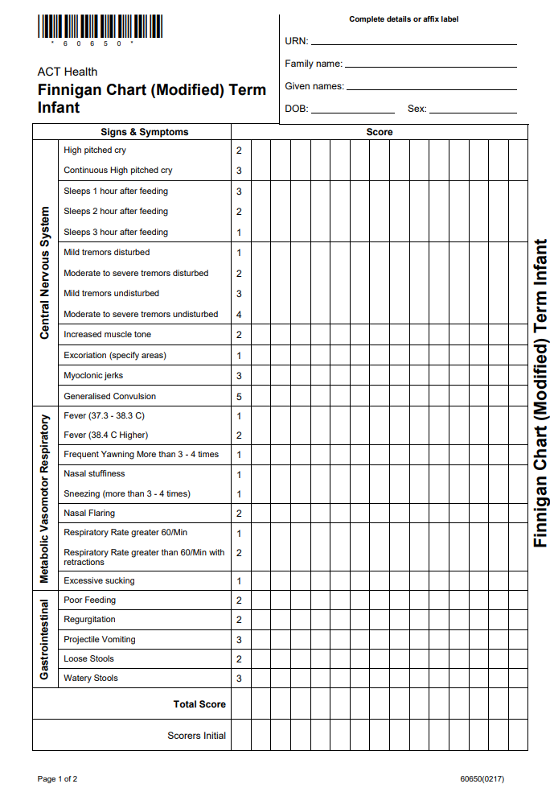
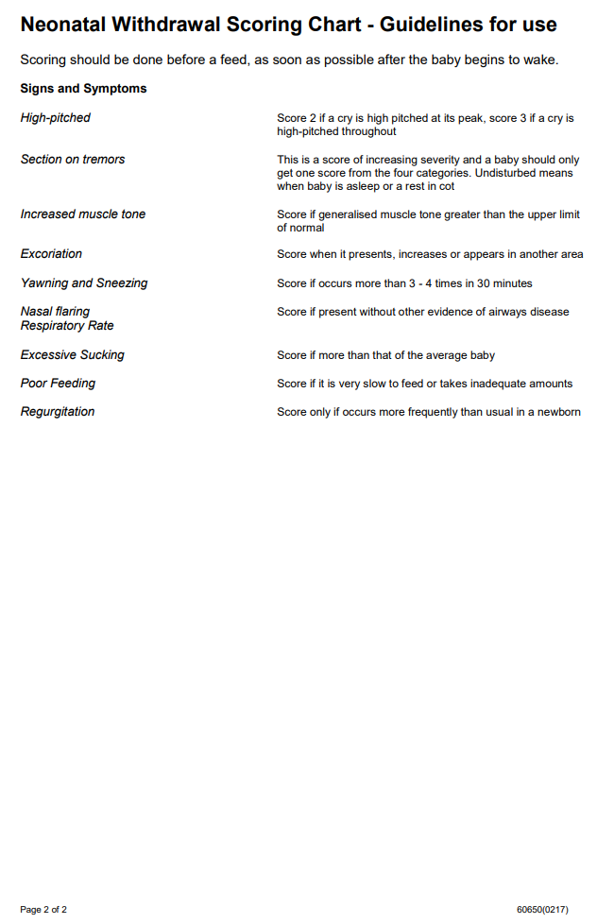

Attachment 2 - Neonatal Drug Withdrawal Chart for Preterm Infants Modified Finnigan Chart (Below 37 Weeks Gestation)
