Canberra Health Services
Procedure
Prohibited Substances Management

Contents

Contents 1
Purpose 2
Alerts 2
Scope 3
Section 1 – CHS staff authorised to deal with prohibited substances within Canberra Hospital 3
Section 2 – CHS staff authorised to deal with prohibited substances within the University of Canberra Hospital 4
Section 3 – Process to follow when suspected prohibited substances are found in patient care areas at Canberra Hospital or the University of Canberra Hospital 5
Section 4 – Process to follow when suspected prohibited substances are found by Security Officers in public areas of Canberra Hospital or the University of Canberra Hospital 7
Section 5 – Process to follow when suspected prohibited substances are transferred to Canberra Hospital pharmacy or the University of Canberra Hospital pharmacy from patient care areas 7
Section 6 – Process to follow when suspected prohibited substances are surrendered to ACT Police 8
Evaluation 8
Related Policies, Procedures, Guidelines and Legislation 8
Definition of Terms 9
Search Terms 10

Purpose

This procedure describes the process that must be followed when:
- a suspected prohibited substance is found by Canberra Health Services (CHS) staff at Canberra Hospital or the University of Canberra Hospital
- a suspected prohibited substance is willingly surrendered to CHS staff by a consumer attending Canberra Hospital or the University of Canberra Hospital

Continued use of a suspected prohibited substance by a consumer whilst under clinical treatment:
- Has a risk of significant injury or complication (e.g. interaction with prescribed medicines, serious deterioration in mental state) and possibly death
- Presents a risk to other consumers and visitors if found and used by them.

Once taken from consumers these substances may not be returned to the consumer as the return of prohibited substances constitutes supply and is contrary to criminal law.

For these reasons, suspected prohibited substances must be managed in accordance with this procedure.

Back to Table of Contents

Alerts

The Medicines, Poisons and Therapeutic Goods Act 2008 describes a prohibited substance as a substance to which the Medicines and Poisons Standard Schedule 9 applies. Schedule 9 substances are generally illegal substances that are subject to abuse such as heroin, cannabis (including seeds, extracts and resins) and MDMA (ecstasy). For the purpose of this Operational Procedure substances included in schedule 10 of the Commonwealth Poison Standard (SUSMP) such as Cardarine are also included.

The decriminalisation of cannabis in certain circumstances has not resulted in a reclassification of its scheduling in accordance with the SUSMP. It remains a prohibited substance and should be handled in accordance with this procedure.

Medicinal cannabis products are classified as either Schedule 4 or Schedule 8 controlled substances and should be handled in accordance with the Medication Handling Policy. For advice on the scheduling of a substance please contact the Pharmacy department on extension 42421

CHS staff are not under any obligation to remove a suspected prohibited substance if this action would place them at risk. Please see CHS Occupational Violence Policy and Procedure and Identification, Mitigation and Management of Aggression and Violence for MHJHADS.

CHS staff are not obliged to inform ACT Policing if a person is using, or in possession of, a suspected prohibited substance. The treating team and/or Security Manager must be involved in the discussion to inform ACT Policing and the decision will be dependent on several variables such as the circumstances surrounding the patient’s presentation and the quantity and type of suspected prohibited substance involved.

CHS staff (including those employed in the Pharmacy department) are not permitted to destroy or discard suspected prohibited substances. Only a Medicines and Poisons Inspector as defined in Medcines, Poisons and Therapeutic Goods Act 2008 (which includes Police Officers) and approved analysts are permitted to discard prohibited substances and they must be contacted to arrange for disposal. The suspected prohibited substance will usually be surrendered to the Medicines and Poisons Inspector for removal and destruction but in certain situations the destruction of the prohibited substances by a Medicines and Poisons Inspector may occur at Canberra Hospital.
Back to Table of Contents

Scope

This document applies to all CHS staff working at Canberra Hospital or the University of Canberra Hospital.
Back to Table of Contents

Section 1 – CHS staff authorised to deal with prohibited substances within Canberra Hospital

Under a permit issued by the Chief Health Officer under section 861 of the Medicines, Poisons and Therapeutic Goods Regulation 2008, the Canberra Health Services Executive Director of Nursing and Midwifery, the Director of Pharmacy and the Deputy Director of Pharmacy (Operations) are authorised to deal with suspected prohibited substances in accordance with this procedure.

Through their delegation in accordance with this procedure the following staff may assist in the removal of prohibited substances by performing the following actions:

Delegated Staff | Actions Allowed
Nursing Staff:  Executive Director of Nursing and Midwifery  Directors of Nursing (DONs)  Assistant Directors of Nursing (ADONs)  Clinical Nurse Consultants (CNCs) including After Hours CNCs | - Receive a suspected prohibited substance from a consumer with their consent and store the substance in a drug safe in the patient care area  - Surrender a suspected prohibited substance to a pharmacist listed in this table - this surrender must occur in the patient care area where the substance was stored  - Surrender a suspected prohibited substance to ACT Policing or a Medicines and Poisons Inspector – this surrender must occur in the patient care area where the substance is stored
Pharmacy Staff:  Director of Pharmacy  Deputy Director of Pharmacy (Operations)  Pharmacist in charge of shift | - Receive a suspected prohibited substance or remove the suspected prohibited substance from a drug safe in the patient care area and transfer the substance to the pharmacy drug safe  - Surrender a suspected prohibited substance to ACT Policing or a Medicines and Poisons Inspector – this surrender must occur in the area where the substance is stored

The following staff are authorised to witness the delegated staff member take receipt of a suspected prohibited substance and countersign the consequent entry in the prohibited drug register:
- a doctor
- dentist
- registered midwife
- registered nurse
- nurse practitioner
- pharmacist
- an ambulance officer employed by the Commonwealth, the Territory, or a State
- a medicines and poisons inspector.

Back to Table of Contents

Section 2 – CHS staff authorised to deal with prohibited substances within the University of Canberra Hospital

Under a permit issued by the Chief Health Officer under section 861 of the Medicines, Poisons and Therapeutic Goods Regulation 2008, the Canberra Health Services Director of Pharmacy and the University of Canberra Hospital Assistant Director of Nursing are authorised to deal with suspected prohibited substances in accordance with this procedure.

Through their delegation in accordance with this procedure the following staff may assist in the removal of prohibited substances by performing the following actions:

Delegated Staff | Actions Allowed
Nursing Staff:  University of Canberra Hospital Assistant Director of Nursing (ADON)  Clinical Nurse Consultants (CNCs) including After Hours CNCs | - Receive a suspected prohibited substance from a consumer with their consent and store the substance in a drug safe in the patient care area  - Surrender a suspected prohibited substance to a pharmacist listed in this table - this surrender must occur in the patient care area where the substance was stored  - Surrender a suspected prohibited substance to ACT Policing or a Medicines and Poisons Inspector – this surrender must occur in the patient care area where the substance is stored
Pharmacy Staff:  Director of Pharmacy  Pharmacist in charge of the  University of Canberra Hospital pharmacy | - Receive a suspected prohibited substance or remove the suspected prohibited substance from a drug safe in the patient care area and transfer the substance to the pharmacy drug safe  - Surrender a suspected prohibited substance to ACT Policing or a Medicines and Poisons Inspector – this surrender must occur in the area where the substance is stored

See section 1 for details staff authorised to witness the delegated staff member take receipt of a suspected prohibited substance and countersign the consequent entry in the prohibited drug register.
Back to Table of Contents

Section 3 – Process to follow when suspected prohibited substances are found in patient care areas at Canberra Hospital or the University of Canberra Hospital

- When a CHS staff member identifies that a consumer is in possession of a suspected prohibited substance or a suspected prohibited substance is found, a Delegated Staff member must be contacted.

If this occurs After Hours (1700 – 0800 on Monday – Friday, Saturday all day, Sunday all day and public holidays) and there are no suitable staff with delegation available the After-Hours CNC should be contacted.

- The Delegated Staff member will take receipt of the suspected prohibited substance in the presence of an authorised witness.

CHS staff should not attempt to remove a person’s suspected prohibited substance if:
- the person does not consent to this removal, and/or
- staff feel that there is a risk of violence or aggression by the person
If a patient declines to surrender a suspected prohibited substance the Delegated Staff member in consultation with the Security Manager and the patient’s consultant will decide whether the police should be informed of the situation.

- In the presence of an authorised witness the Delegated Staff member should place the suspected prohibited substance in a tamper evident bag* and label the bag with:
- the date and time
- location
- by whom it was found/received, and
- where it was found.

The bag must then be sealed in the presence of the authorised witness to prevent tampering.
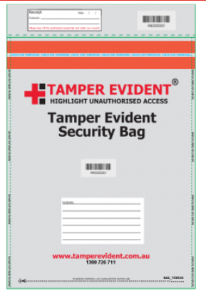
* Tamper evident bags can be obtained from pharmacy, AMHU, ED and Drugs and Alcohol patient care areas.

- The Delegated Staff members should place an entry into the Prohibited Substances Register and store the suspected prohibited substance in the Schedule 8 ward safe. This must be witnessed and co-signed by an authorised witness.
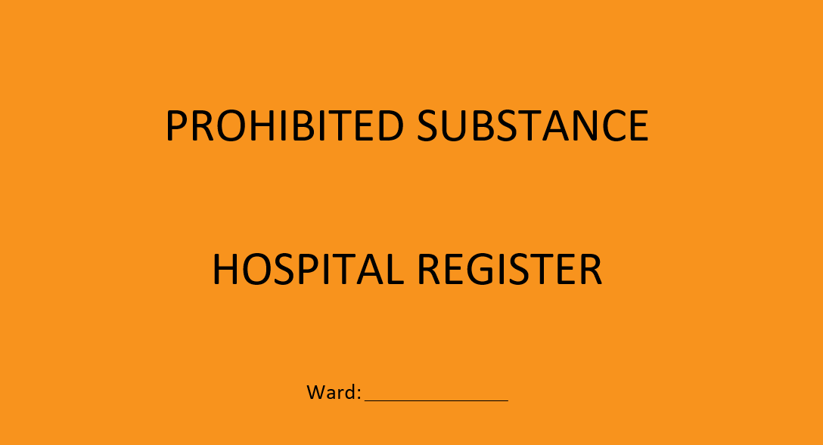
Prohibited Substance registers are in all areas with a Schedule 8 medication safe.

- The Delegated Staff member receiving the substance must notify the Director of Pharmacy or the appropriate Delegated Pharmacy Staff member as soon as possible. If this is outside of the normal Pharmacy operating hours of 8.30am – 4.30pm notification should be made the following business day.

Back to Table of Contents

Section 4 – Process to follow when suspected prohibited substances are found by Security Officers in public areas of Canberra Hospital or the University of Canberra Hospital

If an unattended prohibited substance is found by a Security Officer, the Security Officer must immediately arrange for the substance to be taken either to the nearest suitable ward/clinic/unit or to pharmacy for safe storage. Security Officers must minimally handle the substance and must surrender the prohibited substance to a Delegated Staff member as soon as practical.

Back to Table of Contents

Section 5 – Process to follow when suspected prohibited substances are transferred to Canberra Hospital pharmacy or the University of Canberra Hospital pharmacy from patient care areas

The Delegated Pharmacy Staff member, accompanied by an authorised witness, must complete the following steps when transferring a suspected prohibited substance from a patient care area’s drug safe to the pharmacy:

- Entries must be made in the Prohibited Substances registers in both the patient care area and pharmacy reflecting this transfer. These entries must be co-signed by an authorised witness.

- A requisition form must be completed by the Delegated Nursing Staff member signing the controlled medication out of the safe in the patient care area. This requisition number must be included in both the patient care area and pharmacy’s Prohibited Substances Register entries to ensure traceability of the movement of Prohibited Substances within Canberra Health Services. The white copy of the requisition should be returned with the suspected prohibited substances to the respective pharmacy department.

- The Delegated Pharmacy Staff member receiving the substance must notify ACT Police as soon as possible, to arrange for transfer of custody to ACT Police and destruction. Under no circumstances should the suspected prohibited substance be destroyed by CHS staff.

Back to Table of Contents

Section 6 – Process to follow when suspected prohibited substances are surrendered to ACT Police

Surrender of a suspected prohibited substance to police must occur in the area in which the substance is stored. This will usually occur in the Pharmacy department after completion of the steps described in Section 5. However, in certain situations it may be appropriate to surrender the suspected prohibited substance directly from the patient care area to ACT Police after completing the necessary steps described in Section 3. An entry must be made in the Prohibited Substance Register to reflect the surrender to ACT Police and co-signed by the collecting police officer.

Evaluation

Outcome
Compliance with the Medicines, Poisons and Therapeutic Goods Act 2008 and its associated Regulations

Measures
Annual review of Pharmacy prohibited substance register to ensure compliance with prohibited substances documentation and management of prohibited substances in accordance with this procedure.

Back to Table of Contents

Related Policies, Procedures, Guidelines and Legislation

Policies
- Occupational Violence
- Consumer and Carer participation
- Consumer Privacy
- Searching of a Consumer’s Person or Property
- Dhulwa Mental Health Unit Searching
- Medication Handling
- Waste Management

Procedures
- Occupational Violence
- Alerts Management
- Adult Mental Health Unit
- Blood Borne Virus: Occupational Risk Exposure Management
- Clinical Handover
- Responding to Consumer Use of Alcohol and/or Drugs (AOD)
- Dhulwa Mental Health Unit: Prohibited and restricted items and items requiring approval
- Dhulwa Mental Health Units Searching Procedure
- Identification, Mitigation and Management of Aggression and Violence for MHJHADS

Legislation
- Australian Charter of Healthcare Rights
- Civil Law (Wrongs) Act 2002
- Crimes Act 1900
- Criminal Code 2002
- Drugs of Dependence Act 1989
- Guardianship and Management of Property Act 1991
- Health Practitioner Regulation National Law (ACT) Act 2010
- Health Records (Privacy and Access) Act 1997
- Human Rights Act 2004
- Human Rights Commission Act 2005
- Medical Treatment (Health Directions) Act 2006
- Medicines, Poisons and Therapeutic Goods Act 2008
- Medicines, Poisons and Therapeutic Goods Regulation 2008 (the Regulation), Section 861
- Mental Health Act 2015
- Powers of Attorney Act 2006
- Privacy Act 1988
- Public Sector Management Act 1988
Back to Table of Contents

Definition of Terms

AOD: Alcohol and/or other drugs

Consumer: In this document the term ‘consumer’ refers to any person accessing Canberra Health Services and is interchangeable with the terms ‘patients’ and ‘clients’.

Patient care area: Any area, clinic or unit in a hospital, health facility, health institution, health centre, health service or health support service where patient treatment or care may be carried out. Includes a hospital ward, operating theatre, specialised treatment unit (for example haemodialysis, oncology, radiology, dental), day surgery unit, domiciliary service, day centre, and facilities at which Justice Health & Forensic Mental Health Network provides health services

Possession: knowingly having AOD under one’s custody or control or establishing ownership.

Prohibited substance: Includes Schedule 9 and Schedule 10 substances from the Commonwealth Poisons Standard (SUSMP). Schedule 9 substances are generally illegal substances that are subject to abuse, for example, cannabis or heroin whilst Schedule 10 substances are of such danger to health as to warrant prohibition of sale, supply and use

Scheduled medication: A medication containing a substance in the SUSMP as:
- Schedule 2 ‘Pharmacy Medicine’ (pharmacy ‘over the counter’ medication)
- Schedule 3 ‘Pharmacist Only Medicine’ (pharmacist controlled ‘over the counter medication)
- Schedule 4 ‘Prescription Only Medicine’ (also known as a ‘restricted substance’)
- Schedule 8 ‘Controlled Drug’ (also known as a ‘drug of addiction’)
- Schedule 9 ‘Prohibited Substances’
- Schedule 10 Substances.

Supply: includes the preparation, manufacture, sale, exchange, agreement to sell or possession for sale of AOD

Use: ‘using’ refers to introducing the AOD into the body
Back to Table of Contents

Search Terms

Prohibited Substances, Schedule 9, Schedule 10, illicit drugs, illegal substances, disposal, destruction, heroin, cannabis, MDMA , ecstasy, marijuana.

Disclaimer: This document has been developed by Canberra Health Services specifically for its own use. Use of this document and any reliance on the information contained therein by any third party is at his or her own risk and Canberra Health Services assumes no responsibility whatsoever.

Policy Team ONLY to complete the following:
Date Amended | Section Amended | Divisional Approval | Final Approval
14/04/2021 | New Document | Daniel Lalor, A/g ED MSG | CHS Policy Committee

This document supersedes the following:
Document Number | Document Name

