Guideline | Canberra Health Services

Oxygen Therapy and/or Bubble CPAP (Paediatrics
0-16 years)
CHS25/005
Contents
Guideline statement 2
Scope 2
Section 1 - Overview 2
Section 2 – Nasal cannula 3
Section 3 – Simple face mask 4
Section 4 – Non-rebreather mask 4
Section 5 – Oxygen delivery via a tracheostomy 4
Section 6 – Humidified High Flow Nasal Cannula (HHFNC) 5
Section 7 – Continuous Positive Airway Pressure (CPAP) 6
Section 8 – Transporting a child receiving oxygen therapy or Bubble CPAP 7
Section 9 – Ongoing care for all forms of therapy 8
Section 10 – Weaning therapy 9
Evaluation 10
Related policies, procedures, guidelines and legislation 10
References 11
Search terms 11
Attachments 11
Attachment A - HHFNC system setup (Optiflow - up to 25L/min) 13
Attachment B - HHFNC system setup (Airvo 2 – 2L/min to 50L/min) 15
Attachment C – Aerogen Solo nebuliser setup 17
Attachment D – Bubble CPAP setup 20
Attachment E – Transport oxygen tubing for HHFNC 24

Guideline statement
The purpose of this document is to guide the safe and effective care, delivery and management of oxygen therapy and/or Bubble CPAP (Continuous Positive Airway Pressure) to paediatric patients including infants, children and adolescents from 0 to 16 years at Canberra Hospital.
Back to Contents

Scope
This document is applicable to the management and care of paediatric patients. It excludes infants under the care of the Department of Neonatology.
This document applies to the following CHS Network staff working within their scope of practice:
- Medical Officers
- Nurses and Midwives
- Allied Health Professionals
- Students under direct supervision.
This document does not cover or provide direction for staff caring for children with their own personal Non-Invasive Ventilation (NIV) equipment. This equipment is the responsibility of the patient and/or their carer.
Back to Contents

Section 1 - Overview

Key points
- The goal of oxygen therapy is to correct or prevent hypoxaemia or hypoxia.
- Commencement of oxygen therapy requires documentation in the clinical record by a medical officer, except in an emergency. In the Digital Health Record (DHR), oxygen may be ordered via the ‘Paediatric Oxygen Therapy’ order set, or the ‘Respiratory Support (NICU)’ order set for Continuous Positive Airway Pressure (CPAP) (discussed in section 7).
- The oxygen therapy order must include:
  - target oxygen saturation range – minimum and maximum (where clinically applicable)
  - oxygen delivery device, flow rate and FiO₂ (where relevant).
- Supplemental oxygen improves oxygenation but DOES NOT improve ventilation or treat the underlying cause of hypoxaemia.
- Although the wall oxygen supply provides a concentration of 100% oxygen, the actual concentration of oxygen the child receives will vary according to the apparatus used, the flow, and the child’s minute volume.
- When considering the application of oxygen therapy it is essential to perform a thorough clinical assessment of the child.
- Transient, self-correcting desaturations without other signs of deterioration (e.g. tachycardia, cyanosis) do not routinely require oxygen therapy.
- The threshold for oxygen therapy can vary with the child’s general state and point in the illness.
- There is no physiological basis for the application of low flow oxygen therapy to a child with normal SpO₂ and increased work of breathing.¹
- There are some indications for oxygen therapy in the absence of hypoxia (e.g. pneumothorax).

Oxygen saturation targets
- Normal oxygen saturation in a child with no underlying cardiac abnormalities is greater than 95% on room air.
- During an acute illness, oxygen therapy is initiated with consistently low oxygen saturations below 90% on room air, targeting saturations 90-94%.²
- Children with cyanotic heart disease may have baseline oxygen saturations of 75-85%. Administration of supplemental oxygen to these children may compromise homeostasis. Oxygen therapy for these children should be discussed with a senior medical officer.
- Children with broncho-pulmonary dysplasia or chronic respiratory disease may have lower than usual oxygen saturations and may chronically retain CO_{2.} Their oxygen saturation targets will be individualised.
- Children with known pulmonary hypertension typically have higher target SpO₂ (usually ≥95%) and oxygen saturation targets will be individualised.
- Concurrent use with some drugs (i.e. certain cytotoxic medications) may increase the pulmonary toxicity of the drugs.
Back to Contents

Section 2 – Nasal cannula
- Nasal cannula size is approximately half the diameter of the nares.
- Maximum flow rates using simple nasal cannula are:
  - 2 L/min for children less than 2 years
  - 4 L/min for children over 2 years
- Consider switching to Humidified High Flow Nasal Cannula (HHFNC) oxygen if the child requires greater than 2 L/min of oxygen via simple nasal cannula.
- Low flow oxygen of 2-4L/min can be delivered via a humidified circuit at FiO₂ of 100% for those children who poorly tolerate dry O₂
- There are three types of oxygen flow meter:
  - Micro low flow meter for ≤ 0.2L/min
  - Low flow meter for ≤ 1L/min
  - Regular flow meter for 1-15L/min
- If micro/low flow meters are used, there must be a regular (15L/min) flow meter available for use in an emergency.
- Nasal cannula may be secured to the child’s face if required, using a hydrocolloid dressing (such as Duoderm™) and zinc oxide or Mefix™ tape.
- Nasal cannula and tubing are changed every 7 days, unless required more frequently.
Back to Contents

Section 3 – Simple face mask
- Minimum flow rates using simple face masks are:
  - 4 L/min for paediatric face mask
  - 6 L/min for adult face mask
- A minimum gas flow of 4 L/min (for paediatric mask and 6L/min for an adult mask) must be maintained in order to prevent accumulation of carbon dioxide with subsequent re-breathing.
Back to Contents

Section 4 – Non-rebreather mask
- A non-rebreather face mask includes an oxygen reservoir bag to reduce rebreathing of exhaled gas. These masks may be used in an emergency or clinical deterioration.
- The reservoir bag should be inflated prior to placing on the child’s face.
- The mask should fit snugly to the child’s face.
- Flow rate must be sufficient to maintain a fully inflated reservoir bag during the whole respiratory cycle (i.e. inspiration and expiration), generally 10-15L/min.
Back to Contents

Section 5 – Oxygen delivery via a tracheostomy
- For spontaneously breathing children with a tracheostomy, oxygen may be delivered via several devices, including a Heat Moisture Exchanger (HME) with oxygen port, and the HHFNC and Bubble CPAP systems (with specific tracheostomy circuits).
- Equipment may be sourced through WYC Technical Officer 0466 474 423 (Monday-Friday, business hours), or Paediatric Nursing Team Leader outside of business hours.

Back to Contents

Section 6 – Humidified High Flow Nasal Cannula (HHFNC)
Alert
The Optiflow and Airvo 2 systems can each be used for humidified low or high flow oxygen delivery, however HHFNC oxygen therapy refers to flow rates of 2L/kg/minute.
- Refer to Attachment A and B for system setup information.
- Commence flow at:
  - 2L/kg/min for weight up to 12 kg
  - 30 L/min for 13 kg to 15 kg
  - 35 L/min for 16 kg to 30 kg
  - 40 L/min for 31 kg to 50 kg.³
- Commence at FiO₂ 21% and titrate to maintain SpO₂ 90-94%.³
- Children requiring 2L/kg/min (or weight-based parameters above) and Fi0₂ > 50% should be reviewed, with consideration to escalation of care to Bubble CPAP (for children less than 10 kg or 12 months of age), or to the appropriate critical care environment i.e. ICU, NICU, or NETS.
- Children commencing HHFNC therapy will be cared for in the Paediatric Close Observation Unit (COU) for the first 4 hours (Refer to Guideline ‘Acutely Unwell and Deteriorating Paediatric Patient’ on the policy register). They should then be reviewed by the medical team and, if clinically appropriate, may be stepped down to a general paediatric bed. All children receiving HHFNC therapy should be reviewed by a Registrar every shift, at minimum.
- HHFNC therapy provides some un-measured positive airway pressure, hence should be used with caution, and following review by a Paediatric Registrar in consultation with a Paediatrician.
- HHFNC therapy may cause gastric distension. To decompress the stomach, a nasogastric tube (minimum size 8Fr) should be placed prior to initiation of HHFNC therapy, and left open to vent.
- Feeds should be stopped for a short period (up to 4 hours), then restarted (either orally or enterally) after medical review for stabilisation.
- Nursing staff must review the HHFNC system settings at clinical handover by confirming the prescribed order, settings and patient response to therapy.
- Clinical indicators of stabilisation include:
  - reduction in heart rate and respiratory rate by 20%, or to within normal range for age
  - improvement in signs of respiratory distress
  - FiO₂ <40% to maintain Sp0₂ > 90%.
- Children who do not exhibit signs of clinical stabilisation within 2 hours of commencement of HHFNC therapy should be reviewed by paediatrics and, if necessary, escalated to ICU/NICU. Consider the need for blood gas analysis, chest x-ray, insertion or aspiration of a nasogastric tube (if not already done), and fluid management review.
- Children requiring inhaled medication such as salbutamol should continue with Metered-Dose Inhalers (MDI) via a spacer while receiving HHFNC therapy, in preference to nebulised medications (including in-line nebulisers, e.g. Aerogen Solo). MDI via spacer delivers significantly more medication to the child than nebulisers, however the HHFNC gas flow should be temporarily ceased during MDI administration, or reduced to 3 L/min or less, as tolerated by the child.^{4,5} Should nebuliser therapy be required, refer to the Aerogen Solo set up in Attachment C, and reduce gas flow to 3 L/min during therapy, as tolerated by the child.⁵
- HHFNC circuits may be used for 14 days.

Contraindications to HHFNC therapy:
- Children requiring intubation for airway protection e.g. with decreased level of consciousness
- Maxillofacial trauma
- Nasal obstruction i.e. choanal atresia, large nasal polyps
- Present or suspected base of skull fracture
- Foreign body aspiration
- Chest wound/chest trauma.

Special consideration required:
- Pneumothorax
- Chronic respiratory insufficiency
- Diaphragmatic hernia
- Congenital heart disease.
Back to Contents

Section 7 – Continuous Positive Airway Pressure (CPAP)
- CPAP is a form of non-invasive ventilation (NIV) and is a means of providing ventilatory support to children with either upper airway obstruction or respiratory failure.
- Children < 10kg will typically be managed with Bubble CPAP in Paediatric COU, and children > 10kg will typically be managed with CPAP via ventilator in ICU.
- Children treated with CPAP should be regularly reassessed for the appropriateness of treatment. At minimum these children should be reviewed by a Registrar every shift.
- CPAP therapy may cause gastric distension to a greater extent than with HHFNC therapy. Decompress the stomach with a nasogastric tube (minimum size 8Fr) prior to initiation, and leave open to vent.
- Feeds should be stopped for a short period (up to 4 hours), then restarted (either orally or enterally) after medical review for stabilisation.

Indications
- Respiratory distress and/or respiratory failure caused by:
  - Respiratory tract infections
  - Atelectasis
  - Pulmonary oedema (with caution in cardiac conditions)
- Upper airway obstruction – non acute e.g. Laryngomalacia or other abnormalities of the airways, predisposing to airway obstruction or collapse
- Chronic Lung Disease (CLD)
- Obstructive Sleep Apnea (OSA)

Contraindications
Consider intubation and ventilation and transfer to a critical care area (NICU/ICU) for children with:
- Persistent respiratory failure despite CPAP (pCO₂ > 55mmHg, persisting hypoxaemia)
- Respiratory arrest
- Apnoea or inadequate spontaneous respiratory effort/rate
- Inability to maintain own airway/need for secure airway
- Upper airway abnormalities precluding adequate system seal (cleft palate, choanal atresia).
- Tracheoesophageal fistula
- Pneumothorax
- Moderate to severe cardiovascular instability

Bubble CPAP
- Bubble CPAP may be used for children up to 10kg. The system may be used on an individual patient greater than 10kgs (with appropriately fitting prongs/nasal mask), at the discretion of the treating consultant.
- Refer to Attachment D for system setup information.
- Suggested starting parameters include flow at 10L/min, Positive End Expiratory Pressure (PEEP) 5cm, FiO₂ 21% and titrate to maintain SpO2 90-94%.
- Bubble CPAP circuits may be used for 14 days.
Back to Contents

Section 8 – Transporting a child receiving oxygen therapy or Bubble CPAP
- All children receiving oxygen therapy must be escorted by a RN or EN when being transported.
- Clinical condition must be assessed when considering whether the child should be transported, what type of monitoring will be used, and whether emergency equipment will be necessary for the transfer.
- As per the Paediatric Early Warning Score (PEWS) escalation flow chart, a child with a PEWS >6 require an RN and RMO escort. If a patient has a PEWS >8 they require an RN and a Registrar escort between wards or departments.
- Children receiving simple oxygen therapy via nasal cannula, face mask or requiring a non-rebreather mask may be transported using a portable oxygen cylinder and appropriate flow meter.
- The HHFNC and Bubble CPAP Optiflow humidifier bases are not transportable. There are three options for transporting children using these systems:
  - switch to the transport Airvo 2 HHFNC system (with 30-minute battery pack power supply). This is the preferred option for transport of unstable/flow-dependent children and for those who will be out of the ward for a significant amount of time.
  - if the transport Airvo 2 is unavailable for transfer to ICU, request to bring ICU Airvo 3 to patient for transfer.
  - switch to portable oxygen cylinder and transport tubing for standard nasal cannula oxygen therapy (no humidification/warming, refer Attachment E for picture) at up to 2L/min for ‘Junior 2’ prongs or 4L/min for small adult prongs. This is appropriate for short term use only (e.g. transfer between bed spaces).
Back to Contents

Section 9 – Ongoing care for all forms of therapy
All children receiving oxygen therapy require:
- Hourly vital signs documented in DHR, including respiratory rate, effort of breathing, SpO₂, oxygen delivery, FiO₂, oxygen flow rate, heart rate and level of consciousness.
- Four hourly respiratory assessment and documentation in DHR ‘basic assessment’ tab including effort of breathing, respiratory pattern, respiratory depth/rhythm, apnoea, chest assessment, bilateral or Right/Left breath sounds and cough.
- Continuous pulse oximetry.
- Four hourly assessment of skin and oro-nasopharynx mucous membrane integrity (pressure areas or hot spots from oxygen delivery devices, effect of gases on skin and mucous membranes).
In addition, children receiving HHFNC therapy also require:
- Hourly documentation of total flow and humidifier temperature.
- Continuous cardiorespiratory monitoring and accurate fluid balance.
- Hourly assessment of circuit for patency, condensation, position (the patient’s head must be higher than the circuit and humidifier base) and water bag volume.
In addition, children receiving Bubble CPAP also require:
- Hourly documentation of PEEP and presence of bubbles in system.
- Four hourly assessment and documentation of blood pressure for the first 24 hours of CPAP therapy.
- Four to six hourly removal of the CPAP apparatus for skin, mucous membrane and eye assessment and care.
Children on long term oxygen therapy (i.e. home oxygen therapy) or for palliation may have individualised management plans documented in their clinical record.
Back to Contents

Section 10 – Weaning therapy
This section provides a guide to weaning oxygen therapy in an acute respiratory illness episode, rather than the child on long-term oxygen therapy. Weaning, or titration of oxygen therapy should occur to provide the lowest possible oxygen percentage to maintain an SpO₂ in the range⁶ of 90-94%.² Nursing staff may wean oxygen therapy according to the following protocol, without a new order from a medical officer.
For children on simple oxygen therapy (nasal cannula, face mask, humidified oxygen at low flows):
- reduce oxygen flow by 50% (e.g. from 1L/min to 0.5L/min) every 2 hours, maintaining Sp0₂ above 90%. Cease when 0.2L/min is reached. Note: face mask oxygen therapy has a minimum flow rate of 4L/min, and non-rebreather mask has a minimum flow rate of 10L/min.
For children on HHFNC oxygen therapy:
- Wean FiO₂ by 5% increments (e.g. from 30% to 25%) every 2 hours until 21% is reached,^{6,7} maintaining Sp0₂ above 90%.
- Once the child has been on FiO₂ 21% for 4 hours^{6,7} and maintained SpO₂ above 90%, HHFNC can be ceased.
For children on Bubble CPAP:
- Wean FiO₂ by 5% increments (e.g. from 30% to 25%) every 2 hours until 21% is reached, maintaining Sp0₂ above 90%.
- The nursing and medical team will then collaboratively decide how to wean PEEP.
- From a respiratory perspective, children can generally be discharged if they have been off oxygen therapy for 4 hours.⁸
Back to Contents

Evaluation

Outcome
- Oxygen therapy and Bubble CPAP is provided to paediatric patients in a safe manner.
- The use of oxygen delivery and Bubble CPAP equipment in paediatric patients is guided by evidence.

Measures
- Regular discussion of oxygen therapy and Bubble CPAP at unit meetings.
- Monitoring for adverse events related to oxygen therapy and Bubble CPAP through RiskMan reporting and at Quality and Safety Committee meetings.
Back to Contents

Related policies, procedures, guidelines and legislation

Procedures
- Infection Prevention and Control Procedure
- Patient Identification and Healthcare Activity Matching
- Vital Signs and Early Warning Scores – The Canberra Hospital Inpatients
- Patient Escort and Transport within Canberra Hospital Campus

Guidelines
- Tracheostomy Care and Management – infants, children and adolescents
- Acutely Unwell and Deteriorating Paediatric Patient excluding Acute Psychiatric or Behaviour Deterioration
- Non-invasive Ventilation (NIV) in Children over 10kg in the Emergency Department
- Respiratory Support – Invasive and Non-Invasive (Neonates and Infants)
- Consent for Healthcare Treatment

Legislation
- Health Records (Privacy and Access) Act 1997
- Work Health and Safety Act 2011
- Human Rights Act 2004

Other
- Australian Charter of Healthcare Rights
Back to Contents

References
- The Royal Children’s Hospital Melbourne. Oxygen delivery. Nursing Guidelines. 2017. Available at https://www.rch.org.au/rchcpg/hospital_clinical_guideline_index/Oxygen_delivery/
- Nagakura A, Morikawa Y, Takasugi N, Funakoshi H, Miura Y, Ota T, Shimizu A, Shimizu K, Shirane S, Hataya H. Oxygen saturation targets in pediatric respiratory disease. Pediatr Int. 2022 Jan;64(1):e15129. doi: 10.1111/ped.15129.
- Franklin D, Babl FE, George S, et al. Effect of early high-flow nasal oxygen vs standard oxygen therapy on length of hospital stay in hospitalized children With acute hypoxemic respiratory failure: The PARIS-2 randomized clinical trial. JAMA. 2023;329(3):224–234. doi:10.1001/jama.2022.21805.
- Alalwan MA, Fink JB, Ari A. In vitro evaluation of aerosol drug delivery with and without high flow nasal cannula in children. Pediatr Pulmonol. 2019;54(12):1968-1973. doi:10.1002/ppul.24501.
- Berlinkski, A. Pediatric aerosol therapy. Respir Care. 2017 Jun;62(6). doi: 10.4187/respcare.05298.
- Franklin, D., Babl, F., Schlapbach, L., Oakley, E., Craig, S., Neutze, J., Furyk, J., Fraser, J., Jones, M., Whitty, J., Dlaziel, S., & Schibler, A. A randomized trial of high-flow oxygen therapy in infants with bronchiolitis. N Engl J Med. 2018;378(12), 1121-1131. doi: 10.1056/NEJMoa1714855.
- Elks M, Young J, Kearney L, Bernard A. The impact of an autonomous nurse-led high-flow nasal cannula oxygen protocol on clinical outcomes of infants with bronchiolitis. J Clin Nurs. 2023;32(15-16):4719-4729. doi: 10.1111/jocn.16525.
- Gilbert Y, Shrapnel J, Lau C, Dalbey-Payne J. Duration of monitoring after cessation of oxygen therapy in infants with bronchiolitis. J Paed Child Health. 2023;59, 1223-1229. doi:10.1111/jpc.16485.
Back to Contents

Search terms
Paediatric, paed, child, respiratory, oxygen, O2, HHFNC, HFNP, high flow, CPAP, NIV, bubble, Airvo, Optiflow, Aerogen.
Back to Contents

Attachments
Attachment A – HHFNC system setup (Optiflow - up to 25L/min)
Attachment B – HHFNC system setup (Airvo 2 – 2L/min to 50L/min)
Attachment C – Aerogen Solo nebuliser setup
Attachment D – Bubble CPAP setup
Attachment E – Transport oxygen tubing for HHFNC
Back to Contents
For Policy Team to complete:
Date amended | Section amended | Divisional approval | Final approval
07/01/2025 | New Document Added | Sarah Watson, A/g, ED, WY&C | Policy Document Review Panel
This document supersedes the following:
Document number | Document name
CHS21/287 | Oxygen Therapy and Non-Invasive Ventilation (Paediatrics 0-16yrs) guideline
Disclaimer
This document has been developed by Canberra Health Services specifically for its own use. Use of this document and any reliance on the information contained therein by any third party is at his or her own risk and Canberra Health Services assumes no responsibility whatsoever.
Back to Contents

Acknowledgement of Country  Canberra Health Services acknowledges the Ngunnawal people as traditional custodians of the ACT and recognises any other people or families with connection to the lands of the ACT and region. We acknowledge and respect their continuing culture and contribution to the life of this region.  © Australian Capital Territory, Canberra 2024 | Accessibility  call (02) 5124 0000   Interpreter call 131 450  canberrahealthservices.act.gov.au/accessibility  

Attachment A - HHFNC system setup (Optiflow - up to 25L/min)
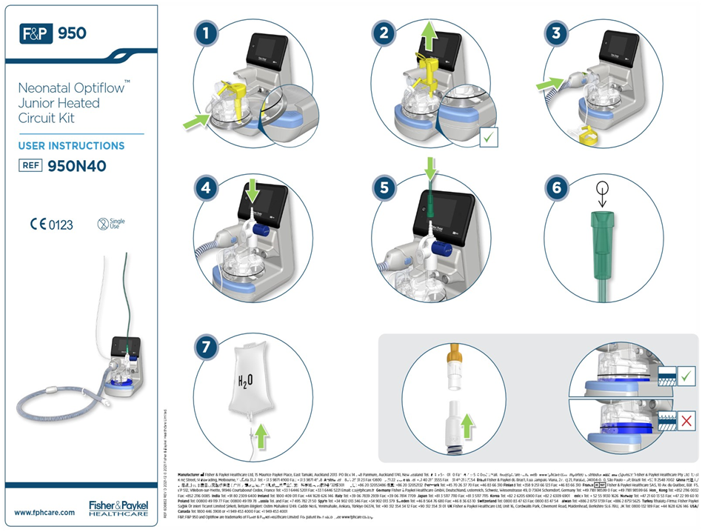
Figure 1: Optiflow circuit setup - for use with total flow rate up to 25L/min
In step 6 in Figure 1, connect the oxygen tubing to an oxygen blender with 2 x 15L/min flow meters. A Y-connecter will be required for flows above 15L/min, to a maximum of 30L/min.
- Ensure clear connector for nasal cannula is firmly attached.
- Select appropriate size Optiflow nasal cannula (see Table 1) and ‘Wiggle Pads’ to secure nasal cannula to the child (see Figure 2).
- Nasal cannula for Neonatal Optiflow Junior Heated Circuit kit
Product -  Optiflow Junior 2 Nasal Cannula | Item code | Approximate weight range | Maximum flow (L/min)
Medium (yellow) | OJR414 | 1.5-8 kg | 1-10
Large (Purple) | OJR416 | 3.5-18kg | 1-23
XLarge (Green) | OJR418 | 3-15kg | 1-25
XXLarge (Grey) | OJR520 | 12-30Kg | 10-50  (Airvo 2 only)

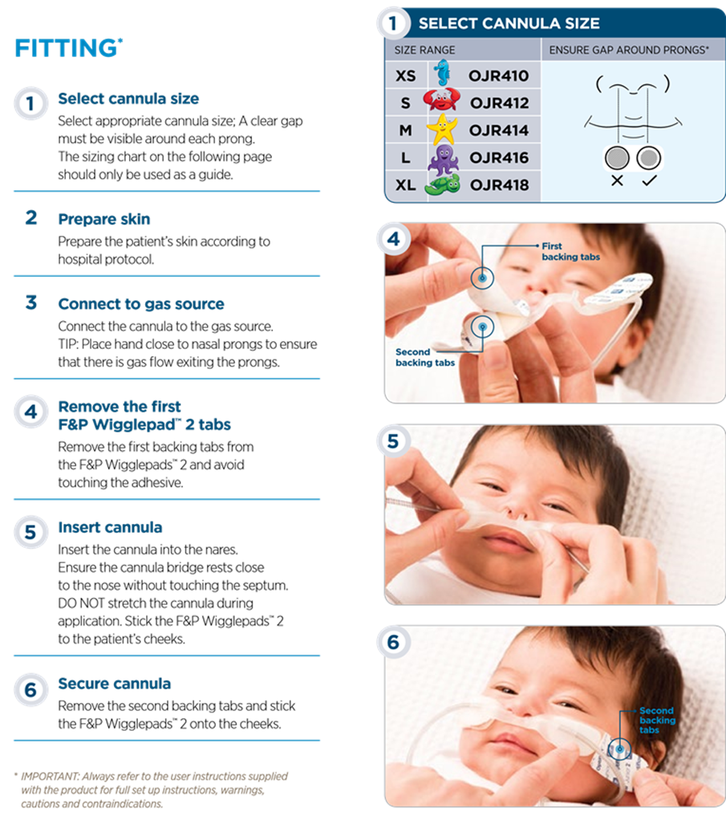
Figure 2: Fitting Wiggle Pads and nasal cannulae
Back to Contents

Attachment B - HHFNC system setup (Airvo 2 – 2L/min to 50L/min)
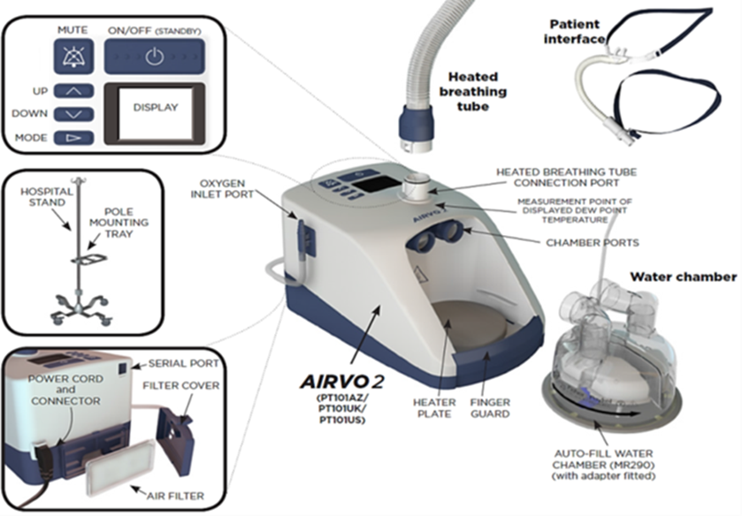
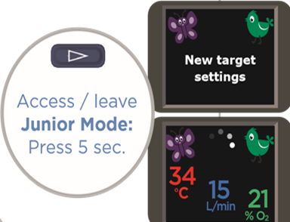
Figure 3: Airvo 2 system setup
- The Airvo2 has two modes: Junior (2-25L flow) or Adult (25-60L flow).
- If an FiO2 greater than 21% is required, attach O2 tubing to the oxygen inlet port, via a 15L/min flow meter.
- The Airvo2 system does not require piped air supply.
- Select appropriate sized nasal cannula (refer to Table 2).
- After use on a patient, the Airvo2 requires disinfection. This is achieved by attaching the red disinfection tubing, connecting to power, and turning on the Airvo2 system. The display will count down the time remaining of the disinfection cycle (60 minutes). The filter is required to be replaced every 3 months or 1000 hours.

- Nasal Cannula for RT202 Circuit
Item code | Description | Maximum flow (L/min)
OPT542 | Small adult size – may be suitable for children greater than 5 years | 50*
OPT544 | Medium adult size – may be suitable for children greater than 10 years | 50*
*Manufacturer recommendation for adult patients
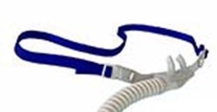
Nasal cannula for older children (RT202 Circuit)
Back to Contents

Attachment C – Aerogen Solo nebuliser setup
- Set up as shown in Figure 4 for Optiflow system, or Figure 5 for Airvo2 system
- HHFNC gas flow should be temporarily reduced to 3 L/min or less, as tolerated by the child, during nebulisation.^{4,5}
- The Aerogen nebuliser can be left in-line when not in use
- The controller has a ‘30min’ and a ‘continuous’ mode
- In the 30min mode - If dose is finished (usually about 8 mins) the controller will continue to vibrate and will turn off after 30 mins, or can be turned off manually
- The Aerogen nebuliser is a gravity feed system, hence must be in an upright position
- Medications do NOT need to be diluted. Salbutamol and Ipratropium may be mixed in the chamber
- Maximum of 6 mLs can be held by the nebuliser chamber
- Flush the nebuliser with 2 drops of 0.9% Sodium Chloride after each dose to prevent any crusting of medication on the mesh plate. This flush is performed whilst the nebuliser is still vibrating
- Nebuliser can be used for 28 days for intermittent use or 7 days for continuous use
- Single patient use
- Pro-X Controller should be plugged in during use, however has the ability to run on battery for up to 45 minutes
- Further information can be found www.aerogen.com
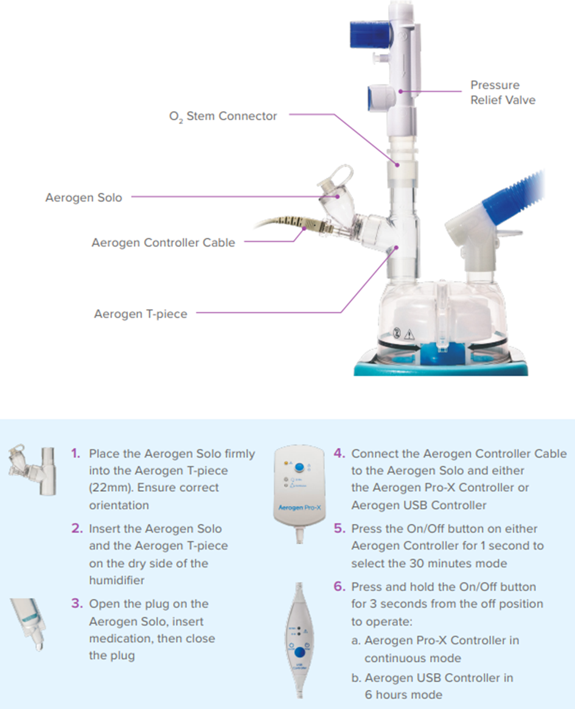
Figure 4: Aerogen setup for Optiflow system

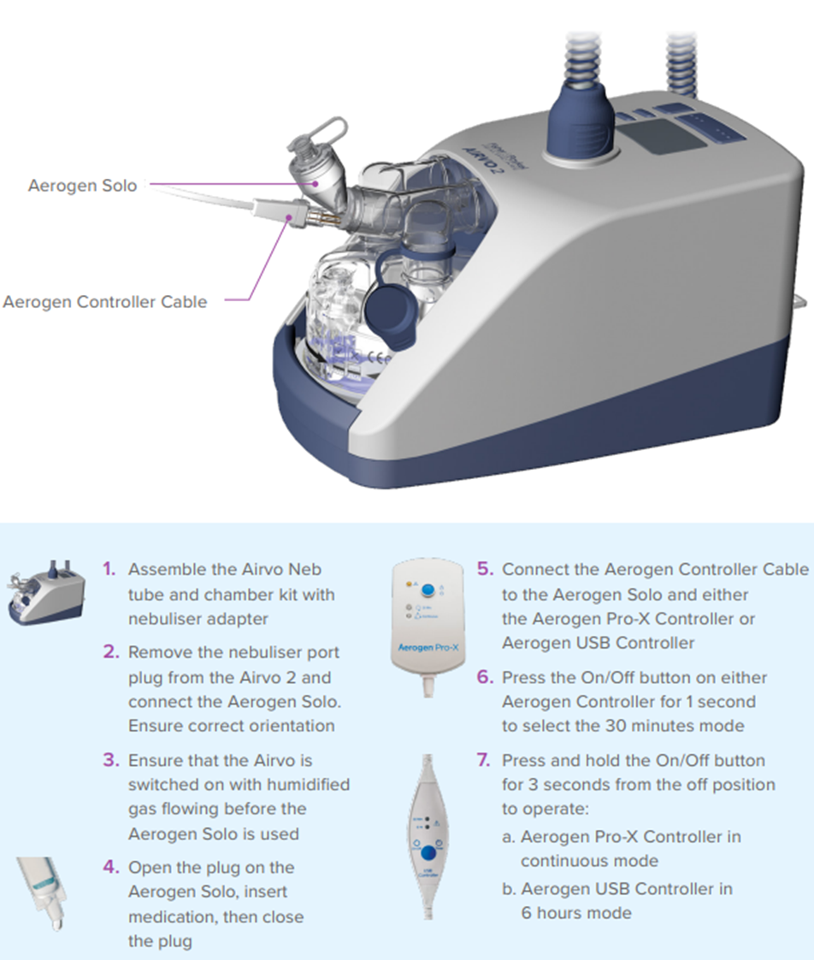
Figure 5: Aerogen setup for Airvo 2 system
Back to Contents

Attachment D – Bubble CPAP setup

Equipment
- Fisher & Paykel CPAP circuit (950N60) and ‘snorkel’ Nasal Tubing 100mm (BC 182)
- CPAP cap/head gear and accessories
- Nasal cannula/prongs appropriate for the size of the infant – sizing chart included in ‘snorkel’ packaging
- Humidifier base (MR950), oxygen blender, flow meters and tubing
- 1L bag of water for injection
- Bottle of sterile water for irrigation

Procedure
- Set up (step 1-10 Figure 6) and test (step 11-14 Figure 6) Bubble CPAP circuit.
- For children ≤5kg, set flow meter to 8L (or Consultant discretion)
- For children between 6-10Kg set flow meter to a minimum flow of 10L/min and a maximum flow of 15L/min (or Consultant discretion)
- Suggested starting parameters include flow at 10L/min, PEEP 5cm, FiO2 21% and titrate to maintain SpO2 90-94%.
- Fit headgear and nasal cannula/prongs (Figure 7a and 7b)
Alert
To prevent injury to the infant, nasal cannula must be occlusive, without stretching the nares. Cannula must not rest on the nasal septum. One third of the cannula should be visible outside the nares.

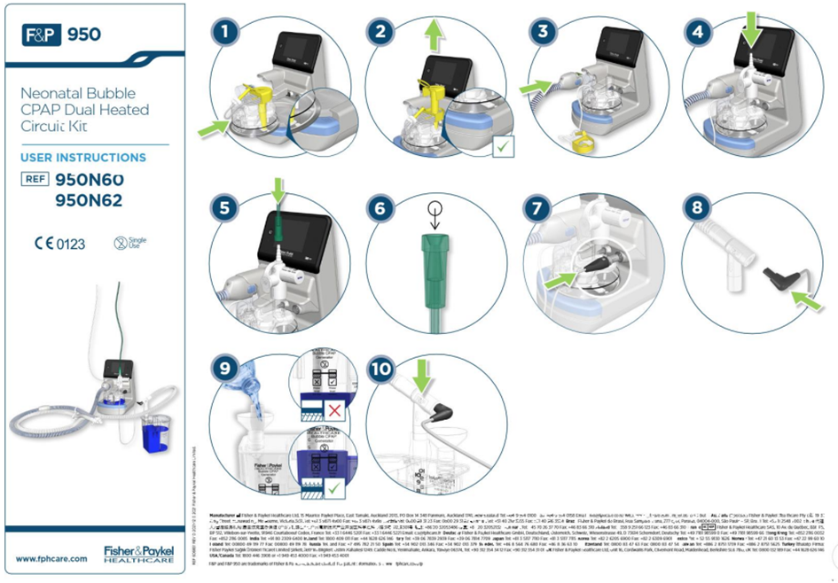
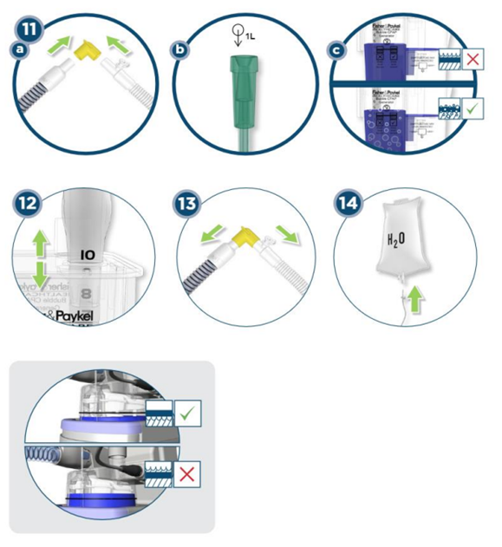
Figure 6: Bubble CPAP circuit setup

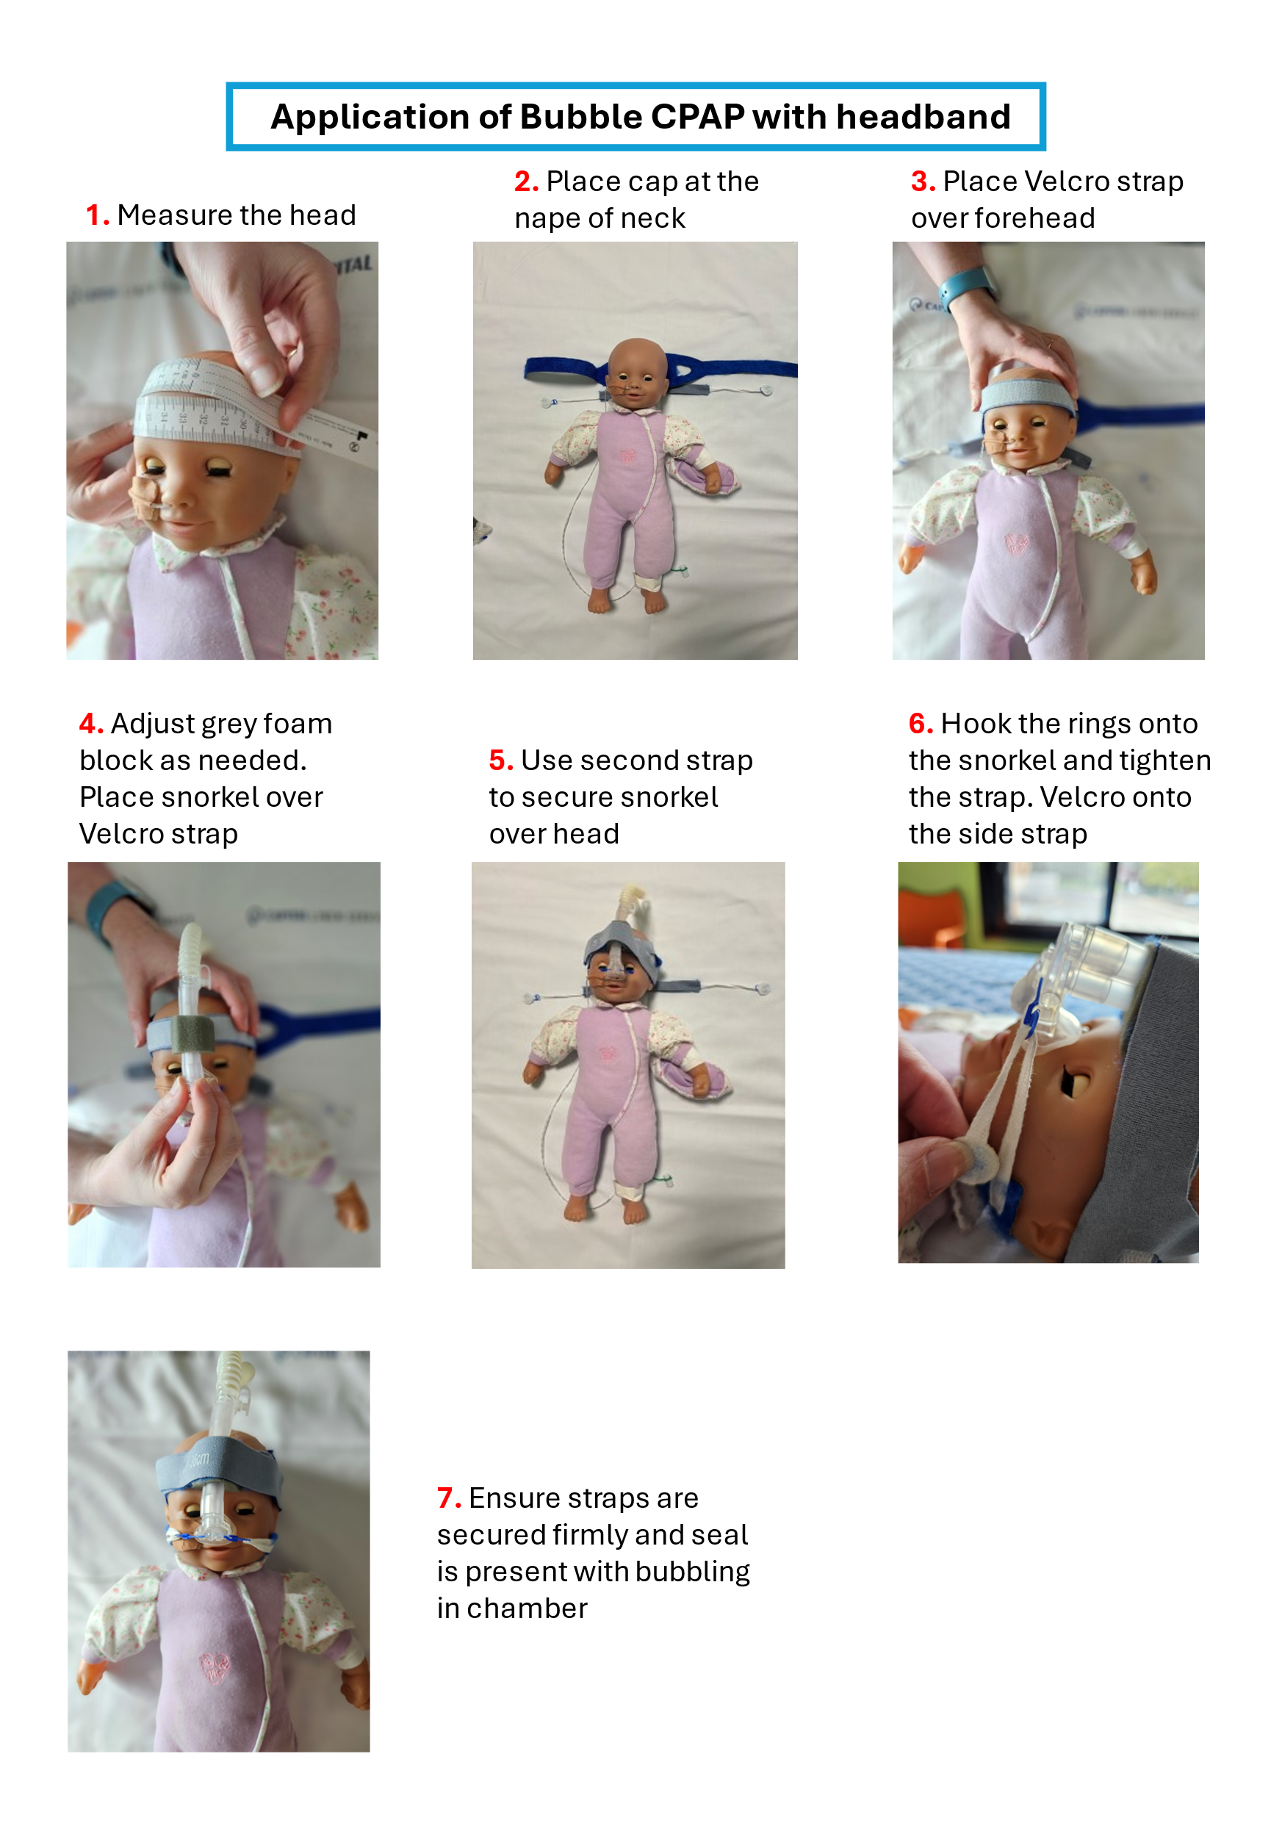
Figure 7a: Bubble CPAP with headband
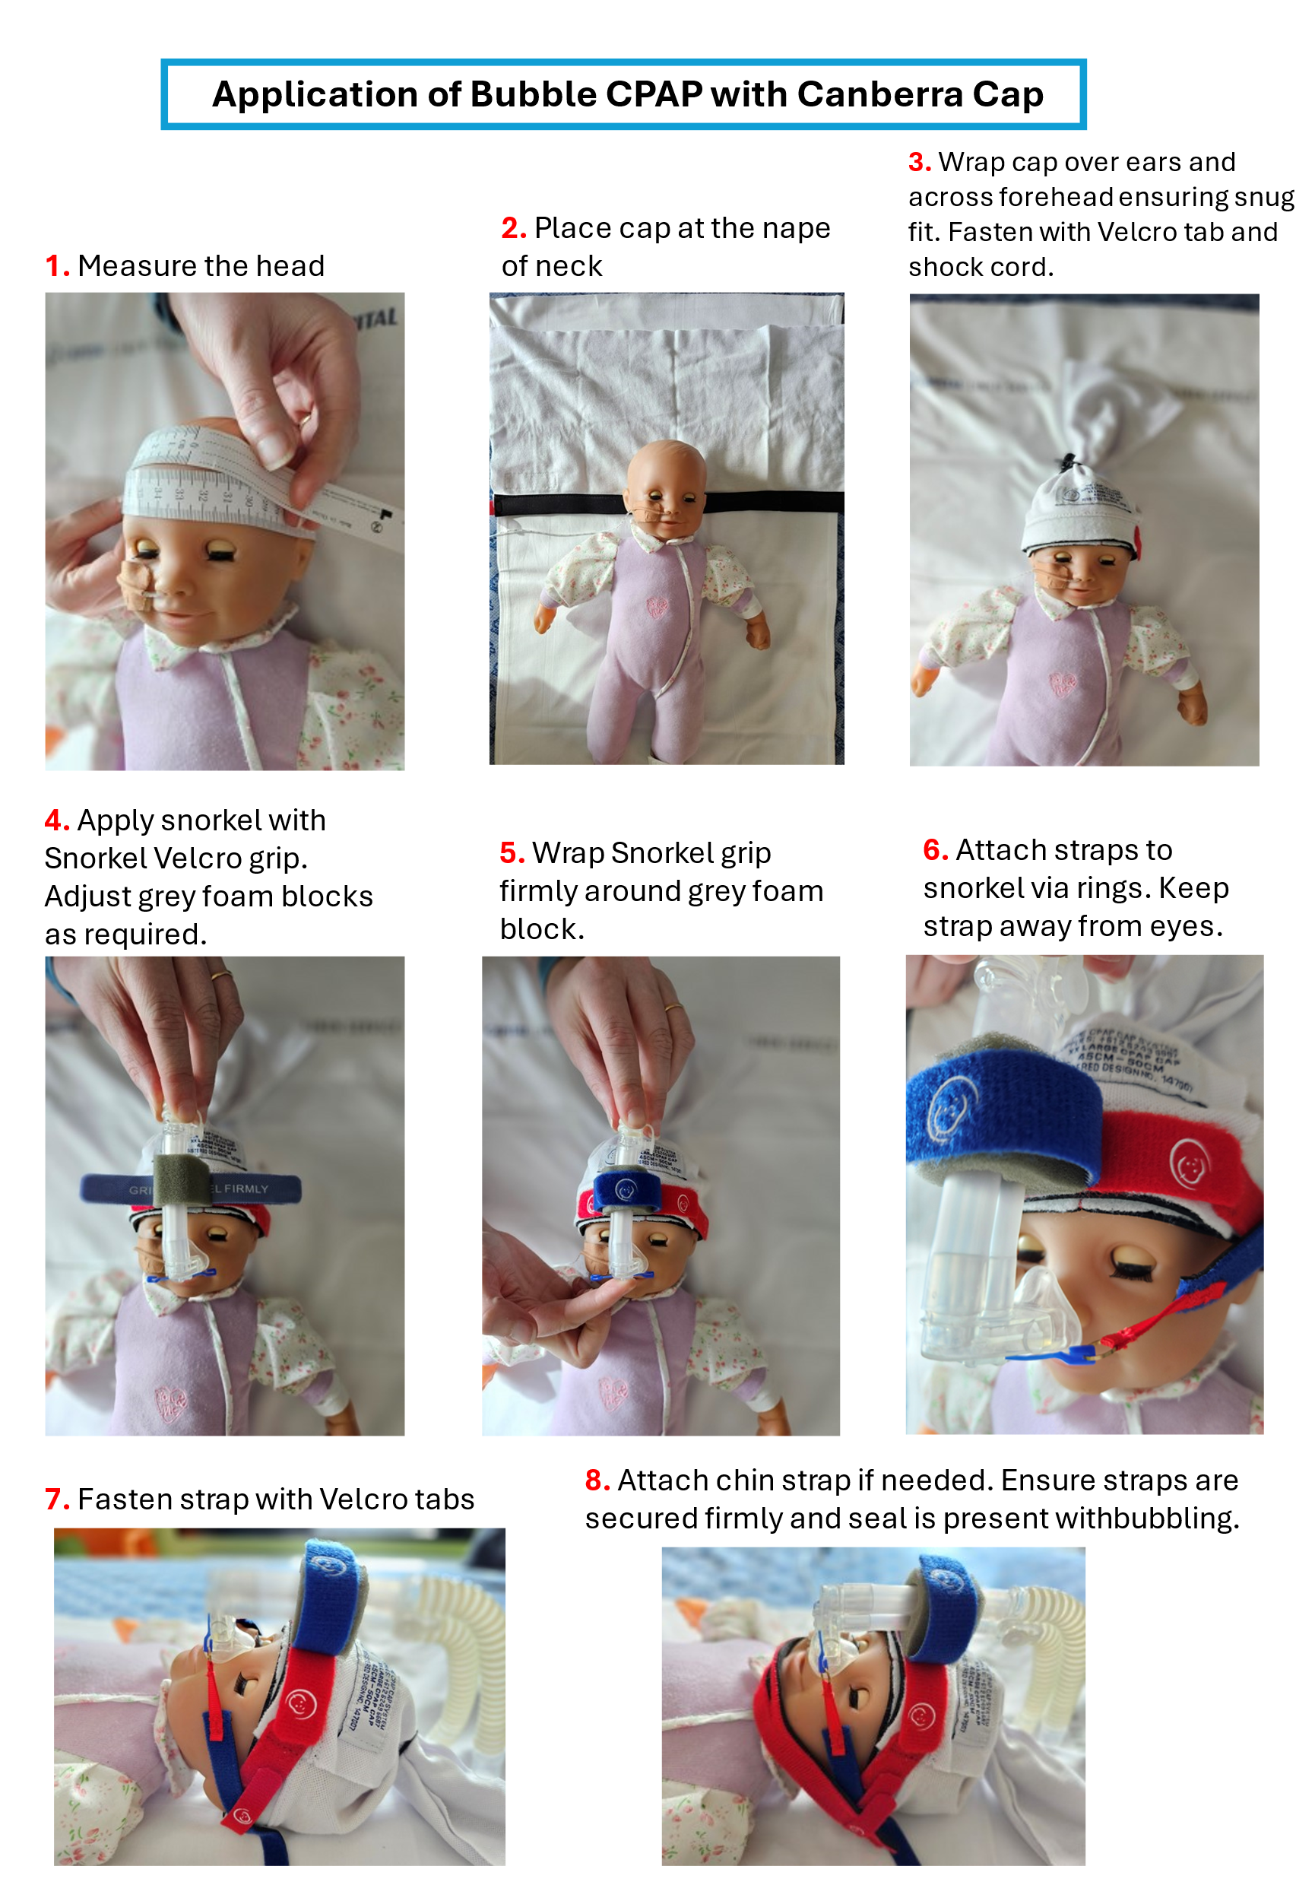
Figure 7b: Bubble CPAP with Canberra Cap
Back to Contents

Attachment E – Transport oxygen tubing for HHFNC
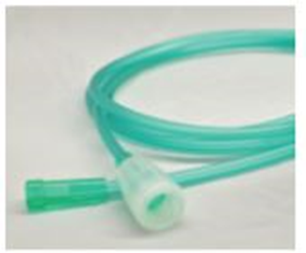
Figure 8: Transport oxygen tubing for Optiflow HHFNC.
Figure 8 shows the oxygen tubing required to attach a portable oxygen cylinder to Optiflow nasal cannulae.
Back to Contents

