Canberra Health Services
Operational Guideline
Oral Health Services – Infection Prevention and Control

Contents
Contents 1
Guideline Statement 1
Scope 2
Section 1 – Oral Health Services 3
Section 2 – Standard Precautions of Infection Control 4
Section 3 – Environment 11
Section 4– Transportation of contaminated reusable medical devices 15
Section 5- Reprocessing Reusable Medical Devices (RMD’s) 18
Section 6 – Documentation 30
Implementation 32
Evaluation 32
Related Policies, Procedures, Guidelines and Legislation 32
References 33
Definition of Terms (if applicable) 33
Search Terms 35
Attachments 35

Guideline Statement

Background
The Oral Health Services (OHS) Guidelines for Infection Prevention and Control outlines the work practices dental staff are to follow while delivering dental services.

These practices are designed to:
- Reduce the number of infectious agents in the dental practice environment
- Prevent or reduce the likelihood of transmission of these infectious agents from one person or item/location to another and
- Make items and areas as free as possible from infectious agents.

Each member of the dental team is responsible for implementation and compliance with these guidelines.

The guidelines are based on current national infection prevention and control best practice and are aligned with the following organisational, professional, and national documents:
- Canberra Health Services (CHS) Infection Prevention and Control – Healthcare Associated Infections
- Australian Dental Association (ADA) Guidelines for Infection Control, Dental Board of Australia’s Guidelines on Infection Control 3rd edition.
- National Health Medical Research Council (NHMRC) Australian Guidelines for the Prevention and Control of Infection in Healthcare 2019 (CD34).
- AS/NZS 4815:2006 Office-based health care facilities – Reprocessing of reusable medical and surgical instruments and equipment, and maintenance of the associated environment
- AS/NZS 4187:2014/Amdt 2:2019 Reprocessing of reusable medical devices in health service organizations
- National Safety and Quality Health Services Standards – Second Edition 2021(NSQHS)

Key Objective
The aim of infection prevention and control practices is to limit or control factors influencing the spread of microorganisms and thereby the transmission of infection. The spread of microorganisms can be reduced by:
- Limiting surface contamination by microorganisms
- Adhering to good personal hygiene practices, particularly efficient hand hygiene
- Using personal protective equipment
- Using disposable products where appropriate (e.g. paper towels) and
- Following risk minimisation techniques such as using rubber dam and pre-procedural mouth rinsing.

Back to Table of Contents

Scope
The OHS Infection and Prevention Guidelines relate to all patients/clients accessing Canberra Health Services (CHS) Oral Health Service.

This document applies to the following CHS OHS staff working within their scope of practice:
- Dentists
- Dental Therapists
- Oral Health Therapists
- Dental Assistants
- Prosthetists
- Laboratory technicians
- Dental specialists
- Students on placement
Back to Table of Contents

Section 1 – Oral Health Services
The Oral Health Service is committed to:
- Developing and implementing work practices that comply with infection control standards
- Ensuring documented infection prevention and control protocols are easily accessible to dental staff and are regularly reviewed and updated, including ADA Infection Control Guidelines, the NHMRC Guidelines, and AS/NZS 4815:2006 or AS/NZS 4187:2014/Amdt 2:2019.
- Ensuring all dental staff are appropriately trained in contemporary infection control practices
- Providing a system of reporting, monitoring, and rectifying breaches of infection control protocols
- Ensuring dental staff are aware of and comply with the immunisation and management of occupational exposure to blood-borne viruses’ policies in Canberra Health Services.
- Ensuring dental staff are trained in and comply with the recording of workplace incidents and accidents (including sharps injuries) through RiskMan
- Auditing and reporting Infection Prevention and Control (IP&C) practices
- IP & C Meetings
- Implementing a hand hygiene programme consistent with the national hand hygiene initiative from Hand Hygiene Australia (HHA) which promotes the use of alcohol-based hand rubs in situations where hands are not visibly contaminated
- Implement systems for the safe handling and disposal of sharps
- Implement systems to prevent and manage occupational exposure to blood borne viruses
- Implement systems for environmental cleaning
- Implement systems for processing of reusable medical devices.

Oral Health Service Staff

Dental Practitioners
Registered dental practitioners are legally required to comply with the Dental Board of Australia’s policies and guidelines and must ensure they fulfil their obligations. Their common law legal duty of care requires compliance with infection control measures. They must practice in a way that maintains and enhances public health and safety by ensuring that the risk of the spread of infectious diseases is prevented or minimised. This includes themselves, those people with whom they work, and their clients. They shall comply with infection control measures that apply to their particular field of work and follow the specific infection control policies contained in this guideline.

Dental Support Staff
All dental support staff have a duty of care to themselves, those with whom they work, and the clients of OHS. Dental support staff shall comply with infection control measures that apply to their particular field of work and follow the specific infection control policies contained in this guideline.

Immunisation
All people employed, or seeking employment in OHS, must comply with the Canberra Hospital and Health Services, Occupational Assessment, Screening and Vaccination policy (CHS17/233).

Infected Health Care Workers
Infected workers shall be assessed according to the Canberra Hospital and Health Services, Occupational Assessment, Screening and Vaccination policy (CHS17/233).

Staff demonstrating poor compliance with infection prevention and control measures will be subject to the disciplinary process.

Back to Table of Contents

Section 2 – Standard Precautions of Infection Control

Minimising the risk of transmission of infection

Standard precautions
Standard precautions are the basic processes of infection control to minimise the risk of transmission of infection irrespective whether the client has an infectious disease and include:
- Undertaking regular hand hygiene before gloving and after glove removal
- Using personal protective barriers such as gloves, masks, eye protection and gowns
- Wearing appropriate protective equipment during clinical procedures and when cleaning and reprocessing instruments
- Correctly handling contaminated waste
- Appropriately handling sharps
- Appropriately reprocessing reusable instruments
- Effectively undertaking environmental cleaning
- Respiratory hygiene and cough etiquette
- Using aseptic non-touch techniques where indicated
- Appropriately handling used linen and clinical gowns
- Where appropriate, use environmental barriers such as plastic coverings on surfaces and items that may become contaminated and are difficult to clean.

When to use Standard Precautions
- Whenever dental practitioners or their clinical support staff touch the mucous membranes or non-intact skin of a dental client
- Cleaning the dental surgery environment
- When handling items contaminated with saliva (e.g., radiographs, dentures, orthodontic appliances, wax rims, and other prosthetic work that have been in a client’s mouth)
- When handling blood (including dried blood), saliva and other body fluids (excluding sweat) whether containing visible blood or not
- When cleaning and processing reusable medical devices.

Additional information on standard precautions
Practitioner Responsibilities
Reusable Medical Devices (RMDs) must remain intact in their sterile packaging/sterile barrier system (SBS) until use. The Dental Practitioner is responsible for checking the integrity of the SBS at point of use and must ensure:
- The affixed sterilisation label is valid showing expiry date, Universal Cycle 134 and that the cycle has passed
- The Class 1 indicator on pouch has made the required colour change
- The pouch integrity is not compromised. Pouch must be sealed correctly and be intact, free from tears, perforations, damage, or watermarks
- Bar codes on autoclave pouch must be recorded in the client’s Titanium record.

If the sterile packaging fails to reach these parameters, it must not be used on clients and must be returned to the dirty utility room for reprocessing.
See Table 5.2
Also see Clinical Breach Table 6.1

Hand Hygiene
- Regular use of skin moisturisers both at work and at home is encouraged.
- Hands must always be washed at the start of a working session, after toilet breaks, and when leaving the surgery.
- Hands must be washed with soap and water when visibly dirty.
- Washing hands with soap and water immediately before or after using an alcohol-based hand rub (ABHR) is not only unnecessary but may lead to dermatitis.
- Hand washing should be undertaken in dedicated (clean) sinks preferably fitted with non-touch taps (or carried out using a non-touch technique) and not in the (contaminated) sinks used for reusable medical device cleaning.
- ABHR dispensers must be located close to the clinical working area (but away from contamination by splash and aerosols).
- Use an alcohol-based hand rub for all clinical situations where hands are visibly clean.
- Any cuts or open wounds need to be covered with a waterproof dressing.
- All hand, wrist or nail jewellery, (e.g., rings, wrist watches and bracelets) must be removed prior to putting on gloves. A plain band ring such as a wedding ring may be left on for non-surgical procedures.
- Artificial fingernails must not be worn as they can harbour microorganisms.
- Nail polish, if worn, should be clear, but preferably dental staff should not wear nail polish. All fingernails must be kept short.
- Follow the hand hygiene steps in Attachment 1 – Five Moments of Hand Hygiene, Attachment 2 – How to Hand Rub, Attachment 3 – How to Handwash

Personal Protective Equipment
Wearing personal protective clothing and equipment where aerosols are likely to be generated is an important way to reduce the risk of transmission of infectious agents.

Barrier protection, including gloves, mask, eyewear, and gown must be removed before leaving the work area (e.g., dental surgery, instrument processing or laboratory areas).

Gloves
- Dental staff must wear gloves for all clinical procedures. Gloves should not be worn where direct clinical procedures are not being undertaken e.g. data entry by DA, processing radiographs.
- Wearing gloves does not replace the need for hand hygiene.
- Disposable gloves must be used for each client and changed as soon as they are cut, torn, or punctured.
- Gloves must be removed before touching any environmental surface without a barrier or before accessing clean areas.
- Gloves must be removed as soon as clinical treatment is complete and hand hygiene undertaken immediately to avoid the transfer of microorganisms to other clients or environments.

Non-sterile examination gloves may be worn for non-surgical general dental procedures. Gloves supplied for use in dental practice are required to conform to AS/NZS 4011.1:2014

- Sterile gloves must be worn when a sterile field is necessary for procedures such as oral, periodontal, or endodontic surgery.
- Both opened and unopened boxes of gloves must be stored away from aerosol contamination where they will not be exposed to droplets generated by client care.
- Gloves must be worn when cleaning instruments and environmental surfaces. The type of glove worn must be appropriate to the task. Disposable latex free gloves are appropriate for cleaning the dental surgery during changeover between client’s appointments.
- Heavy-duty utility, puncture-resistant gloves must be used during manual reusable medical device cleaning, rather than disposable latex free gloves. These utility gloves can be reused, but must be washed in detergent after each use, stored dry and replaced if torn, cracked, peeling, or showing signs of deterioration.

Masks
Masks do’s:
- Tie string/ear loop masks should be worn where aerosols are likely to be generated.
- Fit and wear tie string/ ear loop masks according to the manufacturer’s instructions. i.e., use both tie strings and adapt the mask to the bridge of the nose.
- Cover both the nose and mouth, and where possible the mask be extended out fully to cover the chin and upper neck.
- Remove and dispose of immediately after treatment by touching the strings and loops only.

Masks Don’ts:
- Masks must not be touched by the hands while being worn.
- Are not to be worn around the neck or chin.

Eye wear
- Eyewear must be optically clear, anti-fog, distortion-free, close-fitting, and should be shielded at the sides.
- Prescription lenses are not a substitute for protective eyewear unless they are inserted in frames designed to provide a suitable level of protection to the orbital region. Face shields are available for use over prescription glasses or loupes.
- Clients must be provided with protective eyewear to minimise the risk of possible injury from materials or chemicals used during treatment. Tinted lenses may protect clients from the glare of the operating light.
- Eyewear may be either single-use or can be reused after cleaning with detergent and water.
- In cases where the client has sustained facial trauma and it is likely blood contamination of the client’s protective eyewear occurs, use of disposable eyewear would be prudent as it removes the need for complex decontamination.

Protective Clothing

Gowns
- Gowns should be worn when there is close contact with the client, materials or equipment which may lead to contamination of skin, uniforms or other clothing with infectious agents or there is a risk of contamination with blood, body substances or secretions.
- Single use disposable gowns should be worn for each single procedure or episode of client care and removed/disposed in the area where the episode of care takes place (surgery & utility).
- When removing a gown do so by turning the outer ‘contaminated’ side of the gown inward, then roll gown into a bundle and discard in an appropriate waste bin.
- Gowns must be removed before entering non clinical areas e.g. offices, reception.
- Gowns do not need to be worn when undertaking procedures with low risk of contamination e.g. examinations, consults, radiographs.
- A dental jacket or scrubs is appropriate attire. Details of appropriate attire are outlined in:
Canberra Hospital Health Services (CHHS)- Healthcare Associated Infections Procedure CHHS17/164.
- Ensure uniforms are washed separately using laundry detergent using hot (>65 degrees) wash or in a cooler wash with laundry detergent and an added sanitiser. Examples of sanitisers include Napisan, Canestan hygiene rinse, or Dettol sanitising laundry rinse (available in supermarkets).

See Attachment 4 - Donning and doffing personal protective equipment

Footwear
Dental clinical staff should wear non-porous enclosed footwear that will protect them from injury or contact with sharp objects or spills.

Sharps Management
The practitioner using a disposable sharp item must be responsible for its safe management and disposal after use. This must be at the point of use in the surgery.
- Sharp instruments such as scalpels and scalers must never be passed by hand between dental staff members.
- Reusable medical devices and sharp items must be carried from the surgery to the sterilising area in a lidded puncture-resistant sharps transport container.

Handling of needles
- Needles must not be re-capped once used.
- The practitioner must dispose of the needle immediately after use.
- Needles must never be bent.
- Needles must be removed from a syringe by use of artery forceps.
- Once the needle is removed from the syringe with artery forceps it must be immediately placed in a sharps container.

Disposal of sharps
The dental practitioner must
- Discard all used disposable sharps into a sharps container
- Remove bur/s from handpieces
- Remove matrix bands from retainers
- Dental Assistants must check that sharps have been removed by the operator before commencing environmental cleaning

Sharps containers
Sharps containers must conform to AS 4031 or AS/NZS 4261. They must be placed in a safe position within the surgery to avoid accidental tipping over and must be out of the reach of small children. Sharps containers must be sealed when they reach the indicator line to avoid the risk of over filling.

Collection point for used sharps containers
- Alexander Maconochie Centre – Dirty Utility Room
- Belconnen - Health Centre External Caged Waste Bay
- Gungahlin - Health Centre External Caged Waste Bay
- Mobile Dental Clinic - Waste Bay at Nursing Home Facility
- Phillip – Waste Bay in Basement
- Tuggeranong - Health Centre External Caged Waste Bay
- Civic - Infectious Waste Room in Basement

Management of clinical waste and other sharps
Clinical waste comprises those disposable items contaminated with blood or body products.
General waste comprises those disposable items contaminated with general secretions e.g. saliva.
- Contaminated waste should be held in the provided leak-proof thick yellow bags labelled with the biohazard symbol and removed by a licensed contractor. These clinical waste bags must conform to AS/NZS 3816.
- Waste in the dental practice should be separated according to its category (medical or non-medical) at the point of generation.
- Personal Protective Equipment (PPE) must be used when handling clinical waste bags and containers.
- Clinical waste bags and containers must not be overfilled and must not be compacted by hand.
- Extracted deciduous teeth once cleaned of visible blood, debris, adherent soft tissues, and saliva may be cleaned with a disinfectant and placed in a sealed bag or container before being given to the child/parent. Permanent teeth should be wrapped in paper towel before disposal in the general waste.
- Single use items must be discarded after use.

Barriers
Items where barrier protections are required include:
- Triplex syringe
- The polymerising light, intraoral camera, and fibre optic illuminator

Any surface barriers used should be disposed of after each client treatment and surfaces must be cleaned.
- Where a practitioner deems that there may be a risk of contamination (e.g. blood) to a surface, they may elect to barrier the object. (e.g. Instrument Tray, Overhead light handle)

Transmission-based (risk-based) precautions
Transmission-based (risk-based) precautions are applied to clients suspected or confirmed to be infected with agents transmitted by the contact, droplet, or airborne routes. The agents of most concern to dental practice are respiratory viruses. e.g. active tuberculosis, viral influenza as well as measles, chickenpox. In these cases, non-urgent treatment should be delayed or postponed. If clients require urgent care, transmission-based precautions must be followed. These precautions include:
- All standard precautions
- Wearing P2 (N95) surgical respirators
- Clients being seen as the last clients of the day
- Request that client phone ahead prior to arrival to check that other clients have left the premises
- Use of pre-procedural mouth rinses
- Rubber dam must be used where possible
- Minimising the use of aerosol-generating techniques
- Two cycles of cleaning for environmental surfaces

See Attachment 4 - Donning and doffing personal protective equipment- for droplet and airborne precautions.

Minimum Exclusion Periods for Infectious Conditions
The National Health and Medical Research Council (NHMRC) Recommended Minimum Exclusion Periods for Infectious Conditions may provide a guide for practitioners that may need to consider delaying non-urgent dental treatment for clients, particularly children, affected by infectious conditions.
See Canberra Hospital Health Services (CHHS)- Healthcare Associated Infections Procedure CHHS17/164.

Summary of Standard Precautions
Based on the categorisation of Exposure Prone Procedures (EPP) the following package of precautions should be taken:
- EPP Category 1 e.g. examinations, radiographs, denture services, topical fluorides,
- Appropriate clinical attire (gowns not required)
- Eye wear
- Masks – tie/ear loop
- Protective footwear
- Single use examination gloves
- Barriers not essential

- EPP Category 2 e.g. restorations, simple extractions, endodontics, scaling
- Single use disposable gowns
- Eye wear
- Tie/ear loop masks correctly fitted
- Protective footwear
- Single use examination gloves
- Protective barriers essential
- EPP Category 3 e.g. surgical extractions, oral surgery, endodontic surgery, periodontal surgery
- Sterile gowns
- Client drapes
- Eye wear
- Tie/ear loop masks correctly fitted
- Protective footwear
- Sterile gloves
- Protective barriers essential

Back to Table of Contents

Section 3 – Environment

General design and presentation of premises
- Work areas should be well lit and ventilated with sufficient uncluttered and easily cleaned bench space to accommodate necessary equipment. Portable fans should not be located in treatment areas or the utility areas.
- Work surfaces and bench tops in surgeries and utility must be nonporous, impervious to water, smooth without crevices and have sealed joins.
- Damaged or worn work surfaces must be reported to a supervisor for assessment.
- No toys, magazines, brochures, photo frames or books are to be displayed in the surgery. Educational props must be kept to a minimum and cleaned after use and on a weekly basis.
- All Oral Health Services approved signage and client information on walls and cabinetry must be laminated or have a plastic covering to allow cleaning.
- No notes or paper documents should be pre-set in the contaminated zone unless they are to be destroyed immediately after the client’s appointment.

Identification of contaminated and clean zones
The dental surgery and instrument reprocessing rooms must have clearly defined clean and contaminated zones.

Contaminated zone
Definition: the contaminated zone is the area which becomes contaminated by splashes and droplets originating from the client’s mouth (typically within a distance of one metre) although, it is important to note that aerosols generated from client’s care may extend further than splashed material (up to approximately 1.8 metres). The contaminated zone is the area contaminated with material from client’s care, as well as the instrument cleaning area.

Clean zone
Definition: the clean zones of the dental practice include office areas, staff room, waiting and reception areas as well as those areas used for storage of supplies and sterilised instruments and equipment. Clinical records, forms and brochures should be placed in this zone. Clean areas include those surfaces and drawers where clean, disinfected, or sterilised instruments are stored and never come in contact with contaminated instruments or equipment.

Workflow between clean and contaminated zones
- Reusable Medical Devices (RMDs) and materials must be moved from the clean zone to the contaminated zone.
- Care must be taken to avoid contaminated RMDs or equipment or wastes re-entering clean areas.
- RMDs placed into the contaminated zone for a treatment session, but not used during the session, must be regarded as contaminated and removed at the end of the session.
- When moving from the contaminated zone to a clean zone to touch non-clinical items without a barrier, gloves must be removed and hands washed or decontaminated with ABHR before touching the item. The person must then perform hand hygiene (e.g. with ABHR) and re-glove before re-entering the contaminated zone. Alternatively transfer tweezers can be used to retrieve the item within the surgery and reprocessed after each use.

Other general areas
Eating and common room areas for dental staff must be separate from client’s treatment areas, the dental laboratory, and conform to work health and safety regulations. Eating or drinking is NOT permitted in client treatment areas even when clients are not present. This includes the dental laboratory and sterilisation areas. Lunchroom crockery must not be washed in the hand wash sinks or in instrument wash basins. Food must not be stored in a refrigerator with dental materials, sealed clinical specimens, or medical products such as drugs or blood, because of the risks of cross-contamination.

See Safe Work Australia: Managing the work environment and facilities

Dental prostheses, impressions, and materials
It is mandatory that any materials which have contacted oral tissue are cleaned and disinfected (impressions, bites, try-ins etc) before being dispatched to the laboratory. Thorough rinsing with cold running water, followed by the application of a neutral detergent and/or immersion in Cavex Impresafe, followed by further rinsing until all visible contamination is removed.

Note:
Impressions, repairs, relines etcetera should be immersed in a neutral detergent solution (e.g. Cavex Impresafe 30ml-1L for 3 minutes) and then thoroughly rinsed under cold running water before being sealed in a leak proof airtight container (plastic bag etc).

Prosthetic work area in the clinic
Items including dentures and orthodontic appliances removed from a client’s mouth can be considered biologically contaminated and must be handled in a safe manner to ensure cross contamination does not occur.

The clinic lathe area should be prepared and maintained for single client use procedures:
Before use
- Correct PPE must be worn when operating the lathe. Ie. goggles, gloves, mask, splash gown or heavy-duty apron
- Place new bib inside lathe bucket with the plastic surface facing upwards.
- Fresh pumice must be dispensed for individual use and is not to be re-used.
- New arbor bands, clean mops, clean brushes, and sterilized burs must be used for each client’s work.

After Use
- Place the used mop/brush in a container designated for used equipment.
- Discard used pumice and bib from the lathe bucket and wipe out the lathe bucket after each client.
- Rinse polishing mops thoroughly to ensure removal of pumice.
- Soak mops in disinfectant, squeeze out excess moisture and leave to dry.
- Burs and polishers are to be cleaned and sterilized after each client’s work is completed.
- Laboratory motor and handpiece, and benches, are to be wiped with neutral detergent wipes.

Sending work to the laboratory
- All work going to the laboratory must be rinsed to remove visible blood and saliva, treated with neutral detergent (follow manufacturer’s instructions), and
- Rinsed with clean water before being inspected to ensure it is free of blood or visible foreign matter e.g. denture adhesives.
- The decontaminated item should be placed in a laboratory transport bag, sealed, and labelled as per laboratory process.
- Laboratory boxes should be wiped with neutral detergent and water prior to being reused to transfer sealed items.

Dental Laboratory
All materials transported to the dental laboratory should already be pre-cleaned and disinfected. However, laboratory staff should be aware that incoming work can present a biological hazard; therefore, for their own safety, laboratory staff should practice the necessary precautions in handling biological material. Standard infection control precautions should be applied when handling dental materials i.e. appropriate personal protective equipment (e.g. disposable gloves, apron, eye protection or a face-shield) should be worn when the sealed container is opened. All packing materials and waste should be disposed of accordingly.

Impressions, Repairs, Relines
As a precautionary measure and before commencing laboratory work, impressions, repairs and relines should be immersed in a solution (30ml-1L) of Cavex Impresafe for three minutes and then thoroughly rinsed under cold running water.

Disinfection of other Materials or Instruments
All prostheses, inter-treatment prosthodontic materials e.g. occlusal registrations (bite rims), interim prostheses (try-ins) etcetera, and non-sterilisable equipment should already be cleaned and disinfected before being transported to the laboratory. However, as a precautionary measure these can be cleaned and/or disinfected again by immersing in diluted neutral detergent or immersed in Cavex Impresafe and rinsed under cold running water.

Work area
The items and materials in the production area should already be disinfected and therefore no special handling is required. Correct hand washing procedures/protocols should always be followed before leaving the laboratory work area.

Outgoing prostheses/appliances
On completion of the laboratory work, all items should be cleaned by immersed with neutral detergent, rinsed under cold running water, and placed in a sealed airtight container for dispatch. Reusable containers such as the red lab boxes should be cleaned with neutral detergent after the completion of each case.

Cleaning

General principles
Routine cleaning of the contaminated zone within the dental operatory is necessary to maintain a safe environment because deposits of dust, soil and microbes on environmental surfaces can transmit infection. Working surfaces in the contaminated zone must be cleaned after every client by wiping the surface with a neutral detergent starting from least contaminated and finishing at the most contaminated. Standard precautions (including wearing of personal protective equipment (PPE) as applicable) must be implemented when cleaning these surfaces.

Brooms must not be used in clinical areas as these disperse dust and bacteria into the air.

General work surfaces in the dental operatory outside the contaminated zone must be cleaned after each session or when they become visibly soiled. Sinks and wash basins must be cleaned at least daily, or more frequently as appropriate.
See Attachment 5 - Environmental Cleaning

Environmental Cleaning

Waterlines and water quality
All waterlines must be fitted with non-return (anti-retraction) valves to help prevent retrograde contamination of the lines by fluids from the oral cavity.

Water used for surgical procedures should be sterile; water used for mouth rinsing should be of potable standard. Water required for irrigation for tooth preparation and ultrasonic scaling should be of no less than potable standard.

Air and water lines should be flushed for a minimum of two minutes at the start of the day and for 30 seconds between clients i.e. triplex syringe, high speed handpieces.
Water bottles on A-Dec chairs must be treated with ICX tablets at each refill as per manufacturer’s instructions.

Management of Burs in OHS
Slow speed stainless steel burs are single use only and discarded into a sharps container after use by the practitioner. These burs can remain in the manufacturer's packet and dispensed at time of use using hand hygiene procedures.

Slow speed tungsten carbide burs e.g. surgical burs, burs for vital pulpotomy, must be packaged and autoclaved before each use and can be reprocessed through the normal sterilisation process.

High speed/surgical/prosthetic burs can be reprocessed after each use. If showing signs of wear the practitioner should dispose in a sharps container. These burs are reprocessed in autoclave bags and stored in closed drawers.

Back to Table of Contents

Section 4– Transportation of contaminated reusable medical devices

Transportation of contaminated reusable medical devices (RMDs) within the dental clinic

Process for Belconnen, Gungahlin & Tuggeranong:
- Contaminated RMDs must be placed into the red contaminated cupboard in the surgery at point of use.
- Dental Assistant (DA) will sort RMDs into two green perforated trays:
- Tray 1 will contain hand RMDs.
- Tray 2 will contain handpieces, ketac applicator gun and suction tubes
- RMDs must be in a single layer
- RMDs must be facing in the same direction
- RMDs must not protrude out of the tray
- RMDs from the surgery will be collected by reprocessing staff and transported to the reprocessing room in the red contaminated trolley.
- Sorted green perforated trays will be placed into the washer disinfector by reprocessing staff.
- Handpieces are not to be placed in the washer, the handpiece head should be scrubbed using neutral detergent and water in a downward motion to remove debris and placed in the Assistina.

Process for Civic:
- DA must walk RMDs in? and ? the designated contaminated sealed container to the reprocessing room.
- DA will sort RMDs into two green perforated trays:
- Tray 1 will contain hand RMDs
- Tray 2 will contain handpieces, ketac applicator gun and suction tubes
- RMDs must be in a single layer
- RMDs must be facing in the same direction
- RMDs devices must not protrude out of the tray
- Sorted green perforated trays will be place into the washer disinfector by utility staff.
- Handpieces are not to be placed in the washer, the handpiece head should be scrubbed using neutral detergent and water in a downward motion to remove debris and placed in the Assistina.

Process for Phillip:
- The Dental assistant must place the contaminated RMDs into the green perforated trays contained in the designated instrument chute. Where the chute is difficult to access, the DA may walk RMDs to the reprocessing area in a sealed “contaminated” container.
- DA will sort RMDs into two green perforated trays:
- Tray 1 will contain hand RMDs
- Tray 2 will contain handpieces, ketac applicator gun and suction tubes
- RMDs must be in a single layer
- RMDs must be facing in the same direction
- RMDs must not protrude out of the tray
- Reprocessing staff will retrieve the contaminated RMDs from the chute.
- Sorted green perforated trays will be placed into the washer disinfector by reprocessing staff.
- Handpieces are not to be placed in the washer, the handpiece head should be scrubbed using neutral detergent and water in a downward motion to remove debris and placed in the Assistina.

Transporting reusable medical devices from outside facilities to Dental for reprocessing

Podiatry Procedure:
- Podiatry to provide sealed labelled lockable containers and green baskets to facilitate the reprocessing of their RMDs.
- All bulky debris need to be removed from the RMDs prior to transport.
- All disposable sharps are to be removed at the site of use by the practitioner.
- All RMDs are to face the same direction in a single layer in the green basket for reprocessing.
- When couriered, Podiatry RMDs must be placed in duck bags and in a secured container marked as contaminated for transport.
- Podiatry RMDs that are reprocessed at the Civic Dental Clinic will be delivered and picked up by courier.
- Podiatry clinics co-located with OHS reprocessing rooms are to deliver the contaminated RMDs at regular intervals during the day.
- The green baskets will be returned to Podiatry in the contaminated container.
- Podiatry’s clean container will be large enough to transport the RMDs that have been reprocessed so that the packs cannot be damaged or pierced.
- OHS will keep records of reprocessed Podiatry RMDs. This will record how many loads, autoclave number and load number.
- Podiatry surgical RMD’s packs are to be double bagged and packed as per photographs provided by Podiatry.

If the above is not complied with, the contaminated RMDs will be returned to Podiatry.

See Attachment 6 – Podiatry

AMC offsite RMD reprocessing
See attachment 7 - AMC offsite RMD reprocessing
Link to Intranet copy of AMC offsite RMD reprocessing
Link to Intranet copy of Attachment F AMC RMD transport check list
Link to Intranet copy of Attachment A AMC Daily RMD count

School MDC
There are no reprocessing facilities in the School Mobile Dental Clinic (MDC).
- Predominately disposable medical devices will be used.
- The packaging can be scanned, however if the scanner does not work the tracking number is to be entered manually into Titanium in the steri log icon.
- Dental hand pieces and any RMDs that are used are placed inside a duck bag and transported to a local OHS Clinic for reprocessing.
- Duck bags are designed to keep soiled RMDs moist
- Once the liquid sachet is open it has 5 days before the RMDs must be processed.
- After each appointment that uses RMDs, they are placed in duck bags and then into the designated contaminated transport container which is then sealed. The Interagency Co-ordinators (IAC) is then contacted to collect the RMDs to be transported to Civic Health Centre for reprocessing.
- The contaminated transport container is to be thoroughly cleaned with neutral detergent.
- It is the IAC’s responsibility to transport the reprocessed RMDs in a designated ‘clean’ container, back to the MDC.

Contaminated waste produced is to be disposed of in the appropriate yellow contaminated waste bag. The bag should be clearly labelled “LEAVE FOR DENTAL”. This waste will be removed by the IAC.

See Attachment 8 – Duck Bags

Targeted Access Program (TAP) MDC

See Attachment 9 – TAP MDC reusable medical device process

General Anaesthetic (GA) Carts
OHS will supply a small number of additional RMDs within the GA carts to be used at the hospitals. They are to be kept in the top section of the Stanley Cart for transportation to the hospitals.

Contaminated RMDs must be put into duck bags and then a designated clear, sealable, puncture proof container clearly labelled ‘contaminated’. The container is then placed in the bottom of the Stanley Cart for transport to OHS for reprocessing.

On call dental kit/dental screening program
At the end of the session, contaminated RMDs are placed in a duck bag in a designated clear, sealable, puncture proof container marked ‘contaminated’ and delivered to the reprocessing room at the local OHS dental clinic for reprocessing. The contaminated transport container is to be thoroughly cleaned with detergent ready for collection to reuse and returned to the on-call kit.

Back to Table of Contents

Section 5- Reprocessing Reusable Medical Devices (RMD’s)

Reprocessing of RMDs must be in accordance with AS/NZS 4815 and/or AS/NZS 4187:2014/Amdt 2:2019.

- All critical and semi-critical reusable medical devices must be packaged in a sterile barrier system and traceable in OHS.
- Reprocessed RMDs must not be stored in an area where contaminated RMDs are held, cleaned, or where there is a possibility of contamination from organisms carried in droplets or aerosols. RMDs should also not be stored with consumables.
- All RMDs must be kept stored and packaged within sterile barrier systems until point of use or date of expiry, or if the integrity of the packaging has been perforated.

Workflow
The reprocessing room is the designated area for the reprocessing of RMDs, this includes the cleaning, packaging, and sterilising of RMDs and must not be used for any other purpose/s.
The reprocessing process should flow in one direction, from contaminated to clean to sterile.

The reprocessing area must be divided into distinct areas for:
- Receiving, cleaning and decontamination
- Preparation and packaging
- Sterilisation, and
- Storage.

Reprocessing of RMDs
When collecting contaminated RMDs from the surgeries and handling the RMDs in the contaminated reprocessing room, dental staff must use heavy-duty utility (puncture and chemical-resistant) gloves, gown, wear eye protection/face shield, and a mask.

Instruments must be completely cleaned before being sterilised as the presence of organic material left on instruments/equipment may prevent steam penetration during sterilisation. Gross soil is to be removed from RMDs. This is to be done by wiping them at the chair side onto an adhesive-backed sponge or dampened gauze on the bracket table, using a one-handed method.
Splashes of cleaning agents on a person’s skin must be washed immediately with clean water, and then treated in accordance with the manufacturer’s instructions.

Table 5.1 Spaulding Classification

Item | Definition |  | Example |  | Key information
Critical | Where there is entry or penetration into sterile tissue, cavity, or bloodstream (e.g. surgical procedures, tooth extraction and endodontic procedures on vital pulp tissue). |  | Forceps and elevators; flap retractors and surgical bur; and surgical dental handpieces |  | These RMDs must be sterile at the time of use and must be either ‘single-use disposable’ or capable of being steam sterilised  Batch control identification is mandatory for these RMDs.
Semi-critical |  | Where there is contact with intact non-sterile mucosa or non-intact skin |  | Mouth mirrors; restorative instruments; dental tweezers and probes; metal impression trays |  | RMDs must be sterilised where possible and when not physically possible, a barrier must be placed (e.g. curing light tip, intra-oral camera and Mirrorlite handle).  RMDs should be ‘single-use disposable’ or sterilised after use.  After processing, semi-critical RMDs should be kept bagged in a central reusable medical devices storage area.
Non- Critical |  | Contact with intact skin |  | Hand mirror, |  | Cleaned with neutral detergent wipe  Stored in a clean, dry place

Mechanical cleaning
Mechanical cleaning of instruments can be carried out in instrument washer disinfectors or ultrasonic cleaners. These systems must comply with AS 2945 or AS 3836.

Washer disinfector
The washer disinfector must be well maintained and cleaned regularly to prevent formation of biofilms that could contaminate the instruments being processed.

Key point to remember when using the washer disinfector:
- Protein residue test to be performed weekly
- PH test to be performed daily
- De scale to be performed monthly
- Check tray arm spins freely
- Check filters

Instructions to start a cycle for Miele washer disinfector - Gungahlin
- Load the washer with green baskets making sure that each basket just has a single layer of RMDs or
- Place a single layer of RMDs in large silver basket on the lower rack
- Place suction tips on holder to stand upright on the upper rack
- Do not place handpieces in washer/disinfector
- Place bur holders, chucks for ultrasonic tips in lockable basket.
- Do not leave bib chains in the washer disinfector overnight as they rust
- Place a wash monitor test in each load with the holder attached to green basket
- Ensure that the program is set to Vario TD
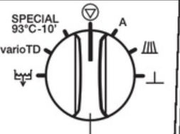
- Select drying cycle on touch pad
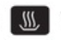

- Press start


- Please refer to manual for any further instructions or contact the Principle Dental Assistant (PDA)

Monthly Washer disinfector maintenance
The maintenance procedure that is required to be performed monthly of the washer disinfector

- Descale

See Attachment 11- Washer disinfector checklist maintenance

Ultrasonic cleaner
In Oral Health Services, an ultrasonic cleaner is only used when a washer/disinfector is not available. The ultrasonic cleaners must comply with AS 2773.

Key points to remember when using an ultrasonic cleaner:
- Lids, tank, gaskets, and strainers must be cleaned daily.
- Water must be de-gassed before use.
- Cleaning fluid must be changed when it appears heavily contaminated or cloudy.
- The detergent used in the ultrasonic cleaner must state that it is suitable for use in an ultrasonic cleaner.
- A Hendricks test must be performed daily, and the result recorded on the Ultrasonic Record Sheet (Attachment 13).
- Lids must be closed during operation (to avoid dispersal of aerosols).
- Items must be free of visible soil before being placed in an ultrasonic cleaner.
- RMDs must be completely submerged in fluid, and no part of the operator’s fingers or hands is permitted to be immersed in the fluid during operation of the cleaner.
- Once RMDs are removed from the ultrasonic cleaner they are rinsed in warm water.
- At the end of each day, the ultrasonic cleaner tank must be emptied, cleaned, and left dry.

See Attachment 13 Ultrasonic Record Sheet for the Nursing Home Mobile Dental Clinic

Reprocessing Handpieces
- Handpieces are not to be processed in the washer/disinfector
- The handpiece head is to be scrubbed using a neutral detergent solution and in a downward motion to remove all debris and then wiped with a neutral detergent wipe before placing in the Assistina.
- Once the handpiece has been processed in the Assistina it is wiped with a neutral detergent wipe before being placed in an autoclave pouch for sterilising.
- PPE is to be worn when completing this task
- The ratio for the neutral detergent cleaning solution is 5mls of Sonident to 1litre of cold water.
- This solution is to be replaced daily.
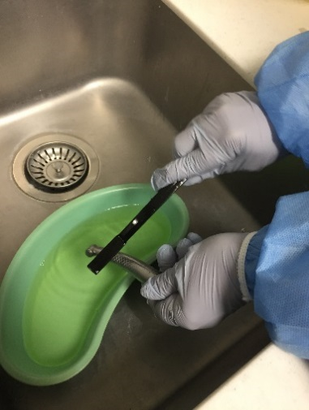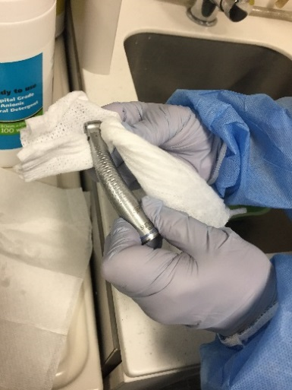

Manual cleaning
In the event of the washer disinfector not being available, manual cleaning or where a Reusable Medical Device’s (RMD) instruction for use states that manual cleaning is required then Manual Cleaning will be conducted.
- Manual cleaning is performed in a sink not used for hand washing.
- The RMDs should be immersed in warm water with neutral detergent and a downward brushing motion used.
- Abrasive cleaners and steel wool should not be used as this may leave a residue.
- Instruments are to be rinsed thoroughly with warm water to remove all traces of detergent.
- Soiled RMDs stained with blood and tissue should be soaked in an enzymatic solution for 5 minutes, rinsed in warm water, before placing in ultrasonic cleaner.

Duck bags
- Duck bags should be used when reprocessing services are not available or when transportation of RMDs is required.
- RMDs should be placed in the duck bag in the same direction
- Duck bags should not be overloaded with RMDs.

See Attachment 8 – Duck Bag Instructions

Zip lock Bags with Optipro Instrument Pre cleaner
Zip lock bags may be used as an alternative to duck bags however must be used with the Optipro Instrument Precleaner. RMDs should be placed in the same direction within a zip lock bag and zip lock bags should not be overloaded. RMDs can remain within a zip lock bag for 5 days.

Drying RMDs
RMDs that are to be sterilised by steam should be dry as residual moisture following cleaning may impede the sterilisation process. Suitable methods include using lint-free cloth or drying cabinets. Towels must not be used.

Washer disinfectors have an inbuilt drying cycle which should eliminate the need for a separate drying step.

If RMDs require additional drying after being removed from the washer disinfector care must be exercised to avoid a sharps injury.

Inspection of reusable medical devices
Prior to bagging, all RMDs must be inspected for damage, rust or debris. If damage or rust is detected the RMDs must be discarded in the sharps bin and those with visible residue soil/contamination must be re-cleaned.

Packaging prior to steam sterilisation
All RMDs must be placed in a Steel Barrier Sleeve (SBS) (autoclave pouch) prior to sterilisation. Pouches must conform to AS 1079.2.

A SBS must only be used once and then discarded, RMDs must be packed aseptically to permit the removal of air, the penetration of steam into the pack, and the removal of steam and water vapour after sterilisation.

RMDs with hinges or ratchets must remain open and unlocked. Sharp RMDs must be double pouched and packaged in such a way as to prevent perforation of the pack.

Pouches must be sealed on the perforated line prior to processing by removing the protective tape on the end of the self-sealing pouch. The pouch must be completely sealed with no creases at the taped sealed end.
Identification colour-coded tapes or silicone rubber rings must not be used on RMDs. At the end of the cycle, the staff member completes the autoclave record indicating the load is sterile, the chemical indicators have changed colour and the parameters have been met before signing off that the load is suitable for use.

See Attachment 10- Autoclave record

Sterilisation of RMDs
All sterilisers must be approved by the Therapeutic Goods Australia (TGA), validated and operated according to AS/NZS 4187:2014/Amdt 2: 2019.and/or AS/NZS 4815 and the manufacturer’s instructions.

In Oral Health Services, the B class sterilisation cycle must be used.

Maintenance and Testing
All autoclaves must be commissioned on installation.

Validation steps
- Commissioning (installation qualification and operational qualification)
- A commissioning report includes installation documents and operation verification. This is performed by the service technician when new or repaired sterilisers are installed in the practice.

Performance qualification
- Physical qualification (by a qualified instrument technician or manufacturer’s technician):
- Calibration report (annually)
- The Validation report summarises satisfactory completion of commissioning, operational and performance qualification.
- The hard copy must be filed in utility and an electronic copy saved on site specific folder in G drive e.g. G/: Dental/Site Specific/

Table 5.2 Monitoring performance for autoclaves with a B Class cycle

Type of test | Frequency | Other information – where to record
Processed chemical indicator (Class 1) | Every load | Chemical indicator is on the SBS
Processed chemical indicator (Class 6) | Every load | Chemical indicator is placed on the tray with the RMDs. A correct colour change indicates the sterilising parameters of temperature, pressure and time have been achieved. When kept in record books, acid released from the paper of the record book can permeate into the indicator and cause colour changes.
Helix test | Daily | Cycle – before sterilising RMDs  Label to be printed, documented, and signed on the autoclave record (Attachment 10)
Vacuum test | Weekly  (first clinical working day of the week) | Label to be printed, documented, and signed on the autoclave record (Attachment 10)
Physical check of completed load | After every load | - Check the parameters – pressure (2 bar), temperature (134 degrees), time (4 mins) - on the steam steriliser’s RMDs and compare them to the recommended values.  - For readings outside its specified limits, the sterilisation cycle must be regarded as failed (regardless of results obtained from chemical indicators) and the sterilising cycle repeated.  - If the second cycle fails, the steam steriliser must not be used until the problem has been rectified by a technician.
Biological or spore test – Attest validation test | Yearly after calibration or when Autoclave has returned onsite from major service | - Plug in unit – Allow 30mins to warm up. The C1 caution code will disappear when temperature is reached.  - Wearing correct PPE place labelled RRBI in challenge pack (date, steriliser, and load number). Place with full load in autoclave and process as usual.  - Place one non-processed vial on bench and mark “C” for CONTROL.  - At the end of cycle remove RRBI from challenge pack and allow to cool.  - CLOSE RRBI cap by pressing down.  - CRUSH vial in crushing well.  - Hold RRBI by cap and TAP bottom of vial on bench until spore strip at bottom of vial is wet.  - Repeat procedures for all RRBI including CONTROL.  - Open cover and PLACE RRBI into corresponding number well and place CONTROL in available well. A record of the control well should be recorded.  - After approx. 1hr alarm will sound as incubator will read a positive (+) RED from CONTROL. Press “alarm off”.  - After 3 hrs processed RRBI should show a negative (-) green result.  - Record results  - Must be repeated 3 times per machine.  WARNING  Do not remove or change placement of RRBI once placed in well. Doing so may result in loss of results and the RRBI test may be invalid.

Table 5.3 Monitoring performance for Washer Disinfector
Wash monitor test | Every load | Wearing PPE  - Place the wash monitor strip into the holder.  - Clip the holder onto the RMD basket.  - Ensure that the wash test is performed with a full load.  - Select wash program and press start.  - At the end of the cycle the coloured splat on the indicator strip should be removed.  - Record test results with the word PASS/ FAIL on the record sheet.  - Dispose of used test in general waste.  - In the event of a failed test notify the PDA immediately.  - For any further questions please refer to the PDA or manufactures instructions.
Protein Test | Every 3rd day | This test is completed once every 3 days to ensure that there is no protein residue remaining on RMDs and that the washer disinfector is working effectively.  Instructions:  - Wearing PPE  - Remove device from foil pouch  - Remove swab from tube using a twist and pulling motion  - Swab all surfaces of a hinged RMD.  - Provide sufficient pressure to see flex in the swabbing wand. Keep the swabbing technique consistent. Do this for 30 seconds  - Place the swab back into the tube and click into place  - Once secured using you thumb, and forefinger squeeze the bulb twice to release the solution down onto the swab  - Move the testing tube from side to side for 5-10 seconds to ensure that the swab is covered by the solution.  - The testing vial must remain upright during reaction time.  - After 60 seconds the results can be recorded  The solution should turn green for a positive result of no protein residue in the washer/disinfector  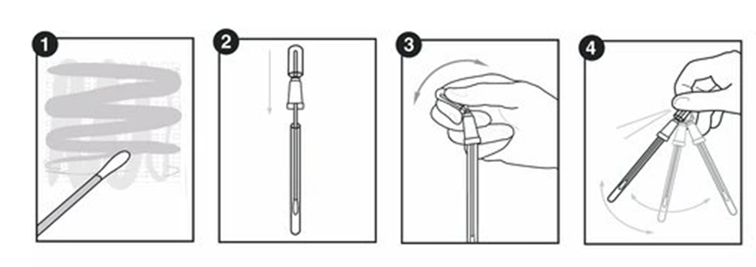  - Record results on the washer/disinfector record sheet.  In the event of a failed test please notify the PDA immediately for action.
pH Test (Gungahlin) | Daily | - Ensure washer is empty  - Conduct daily maintenance check filters  - Place a silver bowl in a green tray on the washer rack to collect water  - Start a load as normal making note of the time, after 15minutes stop the cycle and open the door  - Remove the silver bowl and green tray and dip a pH test strip into the collected water and record the results  - Close the door and turn the dial to select the drain on the washer to remove the water  Drain Icon  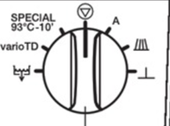  - After the washer has fully drained from the washer disinfector move the dial back to Vario TD the washer is now ready  - Please see your PDA if there are any issues
pH Test | Start of each day | - Conduct daily maintenance checks on washer disinfector first  - Check the filters  - Check the washer disinfector spray arms spin freely  - Place small bowl on the middle rack (at GHC only place bowl on bottom rack) of the washer disinfector so the water can be collected for testing.  - Run the washer disinfector on the pH cycle  - Remove the bowl from the washer disinfector and dip the test strip in the bowl for 10-15 seconds  - Check the strip against the colour indicator on the box  - The test strip should read:  - between 10-12 in Belconnen, Civic, Phillip and Tuggeranong  - between 7-9 in Gungahlin (different brand of washer disinfector)  - Record the results.  The washer disinfector is ready to use.  In the event of a failed result:  - Check the chemical bottles are not empty  - Check that the tubing is not kinked  - Repeat the test  - If the pH test still fails, contact the PDA or Manager  - Use disposable instruments where possible, and duck bag reusable medical devices for offsite reprocessing  - Set up the ultrasonic until a service technician can come and assess the situation.  - Fill in a maintenance request.

See Attachment 11 – Washer Disinfector Record Sheet

Sterilisation of RMDs
- Place perforated autoclave trays with pouched RMDs paper side up ensuring that the RMDs pouches do not overlap or hang over the edge or touch the side of the autoclave chamber.
- To ensure air removal, hollow items should be loaded according to the manufacturer’s instructions.
- Items awaiting sterilisation must be stored in a dedicated ‘pre-sterilisation’ area, not in the steam steriliser.

After completion of sterilisation cycle
- Trays of RMDs, when removed from the steam steriliser, should be placed on racks and not directly on the bench to prevent damage from water condensation under the cooling packages.
- Visually check that bags and their contents are dry.
- Check that the external chemical indicator on the bag (Class 1) and chemical indicators (Class 6) placed in the sterilisation load have made the required colour change. If one pack has not changed colour the whole load must be regarded as failed, the entire load will need to be re-packaged and resterilised.
- Check each pouch to ensure it is undamaged and sealed properly. RMDs packs must not be used if mechanical or chemical indicators indicate any flaws in the sterilising process.
- If the packaging is compressed, torn, unsealed, wet, dropped on the floor or placed on contaminated surfaces, the affected reusable medical devices must be considered contaminated and must be repackaged and reprocessed.
- At the end of the cycle, the staff member fills in the information for the instrument count and that the status of the chemical indicators are passed, before signing off the load is sterile.

See Attachment 12 – Failed Autoclave Report

Labelling the pouches after sterilisation
A label must be applied to the sterilised pouch stating:
- Steriliser identification number or code (serial number of autoclave)
- Date of sterilisation
- Cycle type (Universal 134)
- Batch or cycle number (load number)
- Person who released the load

This label is printed from the label printer. The label must be carefully secured to the laminated side of the pouch immediately, without creases or over hangs. The label will only print out after the cycle has been successfully signed off as passing the parameter checks and the load is sterile.

Storage of processed reusable medical devices
- RMD packs must be kept in the designated RMD storage area.
- Only RMDs required for a session may be kept in the surgery.
- Packages of sterilised RMDs must be examined before opening to ensure the SBS has not been compromised during storage.
- RMDs should be re-cleaned, re-packed and re-sterilised if the RMD pack has been compromised, or there is any doubt that sterility has been achieved.
- Storage areas for sterilised RMDs in packs must be dedicated for that purpose only and be free of dust, insects, and vermin.
- For open shelving, all items must be stored above floor level by at least 250 mm, from ceiling fixtures by at least 400 mm, and protected from direct sunlight, and from winds from open windows.

During storage, packs must not:
- Be over-handled – This can happen through excessive transferring from one place to another, or during rotation of RMDs, from over-stocking storage areas or containers: or from bundling packs together using rubber bands.
- Come in contact with moisture – if the pack is placed on a wet bench top, is splashed with water, other liquids or aerosols.
- Be opened or penetrated – if RMDs break through the surface of the pack
- When storing packs ensure most recently processed packs are placed at the back of the storage container and oldest packs are moved to the front of the container ensuring rotation of stock.

Logs and printouts must be retained for inspection and monitoring.

Back to Table of Contents

Section 6 – Documentation

Maintaining sterilisation records

Sterilising records
OHS must maintain records relating to the sterilisation process. These sterilisation records include maintenance records, performance tests on the sterilising equipment (such as biological or spore tests - attest, air leakage - vacuum and air removal tests - helix), records of validation, calibration, and daily steriliser cycle records.
For each sterilising cycle (even those that do not include any packs of critical reusable medical devices) the results of the cycle must be recorded as follows:
- Steam steriliser serial number or code (to identify the machine the item was sterilised in).
- date
- cycle or load number
- contents of load cycle parameters used (time and temperature) - ensuring these are appropriate for the load type being processed – whether wrapped or unwrapped
- RMD count packs included in the load (if any)
- result of the steam steriliser physical readouts or printout for the cycle
- result of the chemical indicator used in the cycle, this checking should include all external and internal chemical indicators, and
- identification (signature or initials) of the person who has checked the steam steriliser readouts and chemical indicator result, and who authorises release of the load for use

Ultrasonic records
Records are maintained for daily tests on ultrasonic cleaners (such as the Hendricks test).

Retention of hard copy printouts from steam sterilisers
A requirement of AS/NZS 4815 is that records are maintained of RMDs reprocessing and steriliser cycles. OHS must retain printouts from autoclaves for a minimum of 3 months. Data must be downloaded from flash memory cards at least every fortnight to dedicated storage location (eg site specific folder on Q Drive) and regularly backed up. Hardcopy documents to be uploaded every fortnight.

In addition to steriliser cycle records, other records to be retained include:
- results of performance tests of equipment (Site specific)
- employee training records (ask RM)
- incident reports e.g. Riskman non-conforming products or workplace health and safety incidents (ask RM)
- quality and procedure/operational manuals (see intranet)
- steriliser maintenance records, and (site specific)
- validation and calibration certificates (site specific)

Clinical Breach
Table 6.1 Approach to an infection control breach with potential risk of blood borne pathogen
Identification, information gathering and notification of infection control breach
Clinical Staff:
- Identify the nature of the breach, type of procedure, and biologic substances involved and remove any other items that may be implicated in the breach, and
- Notify Clinical and Regional Manager.
- Determine the time frame of the breach.
Clinical Manager:
- Review the recommended reprocessing methods or aseptic technique & institute corrective action as early as possible in consultation with Regional manager.
- Identify exposed clients through Titanium.
Notify and involve key stakeholders
- Clinical Managers, in consultation with RMs will involve key stakeholders as appropriate such as:
- CHHS Infection, Prevention & Control
- ACT Health, Health Protection Service
- Occupational Medicine Unit, TCH
- Request that staff member who identifies the breech complete and submit Riskman
Qualitative assessment of breach
Clinical Managers:
- If possible, classify breach as major or minor:
- Major, involves a gross error or demonstrated high-risk practice.
- Minor, involves a breach with lower likelihood of blood exposure.
Decision regarding client notification and testing
Clinical Team assessing and reviewing the incident or breach:
- If major, client notification and testing is warranted.
- If minor, Consider the following factors in the decision:
- Potential risk of transmission
- Public concern
- Duty to warn vs. harm of notification (Refer to CHS Incident Management – Clinical Procedure (CHS21/446)
Communications & logistical issues
Clinical Managers and Director:
- Develop communication materials.
- Consider post-exposure prophylaxis if appropriate.
- Determine who will conduct testing, obtain consent, and/or perform counselling, if appropriate.
- Determine if follow-up testing is required.
- Facilitate public inquiry and communication.
- Address media and legal issues.
Back to Table of Contents

Implementation

This guideline will be communicated to staff and incorporated into existing orientation plans, training programs, and staff meetings.

Back to Table of Contents

Evaluation

- Scope of document: In line with NSQHSS Standard 4 – Preventing and Controlling Infections. Applies to all OHS staff to improve patient safety and bring infection prevention and control in line with relevant standards.
- What sort of evaluation is required to answer agreed evaluation questions – quantitative data on number of infection control related incidents over the time the document has been in use (compared to prior to implementation). Qualitative data from several community health centres and/or outreach locations as to local use and awareness of document.
- Document performance to date including problems and/or opportunities for improvement: Review of data (qualitative and quantitative) relating to the use and appropriateness of the document and whether it responds to key issues and outcomes for which it was developed
- Identifying key stakeholders of the document, and who would benefit from outcomes of an evaluation: OHS Clinical Governance Committee, Sterilising Services, Justice Health and Podiatry.
- Who should evaluate: Evaluation by all key stakeholders above.

Outcome: High risk, formal report evaluation to be included with policy update

Back to Table of Contents

Related Policies, Procedures, Guidelines and Legislation

Policies
- Occupational Assessment, Screening and Vaccination Procedure
- Blood Borne Virus – Occupational Risk Exposure Management
- Blood Borne Virus in Health Care Workers
- Antimicrobial Stewardship Procedure
- Waste Management Plan

National Guidelines
- National Safety and Quality Health Service Standard 3: - Preventing and Controlling Healthcare Associated Infections
- National Health Medical Research Council, Australian Guidelines for the Prevention and Control of Infection in Healthcare. Commonwealth of Australia
- Australian/New Zealand Standard AS/NZS 4187 Reprocessing of reusable medical devices in health service organisations
- Australian/New Zealand Standard 4815 :2006 Office-based health care facilities – Reprocessing of reusable medical and surgical instruments and equipment, and maintenance of the associated environment
- Charter of Healthcare Rights

Legislation
- Public Health Act 1997
- Health Practitioners Regulation National Law (ACT) Act 2010
- Work Health and Safety Act 2011
- Public Sector Management Act 1994
- Waste Management and Resource Recovery Act 2016
- Medicines, Poisons and Therapeutic Goods Regulation 2008
- Human Rights Act 2004
Back to Table of Contents

References

ADA. Guidelines for Infection Control Third Edition [internet]. 2015[cited 2016 Sept 08]. Available from:
http://www.ada.org.au/Dental-Professionals/Publications/Infection-Control/Guidelines-for-Infection-Control/1ADA_GuidelinesforInfectionControl_3

Australian/New Zealand Standard 4815 Office-based health care facilities—
Reprocessing of reusable medical and surgical instruments and equipment, and maintenance of the associated environment. (Copy available at each DHP clinic) AS/NZS 4815:2006

Australian Dental Prosthetist Association (ADPA) https://www.adpa.com.au/

Back to Table of Contents

Definition of Terms (if applicable)

Blood-borne viruses (BBVs) include hepatitis B (HBV), hepatitis C (HCV) and human immunodeficiency (HIV). These viruses are transmitted primarily by blood-to-blood contact.

Contaminated zone is that area of work in which contamination by client fluids (blood and saliva) may occur by transfer, splashing or splatter of material. It includes the operating field in the dental operatory, as well as the instrument cleaning area within the sterilising room. Contamination must be confined and contained to this area.

Disinfection is the destruction of pathogenic and other kinds of microorganisms by physical or chemical means.

Sterilisation involves the complete destruction of all forms of microbial life, including bacteria, viruses, and spores.

Exposure Prone Procedures (EPPs) are procedures where there is a risk of injury to dental staff resulting in exposure of the client’s open tissues to the blood of the staff member. These procedures include those where the dental staff’s hands (whether gloved or not) may be in contact with sharp instruments, needle tips or sharp tissues (spicules of bone or teeth) inside a client’s open body cavity, wound or confined anatomical space where the hands or fingertips may not be always completely visible.

Here are three different categories of EPPs:

Category 1 | A procedure where the hands and fingertips of the healthcare worker are usually visible and outside the body most of the time and the possibility of injury to the worker’s gloved hands from sharp instruments and/or tissues is slight.
Category 2 | A procedure where the fingertips may not be visible at all times but injury to the healthcare worker’s gloved hands from sharp instruments and/or tissues is unlikely. If injury occurs it is likely to be noticed and acted upon quickly to avoid the healthcare worker’s blood contaminating a client’s open tissues
Category 3 | A procedure where the fingertips are out of sight for a significant part of the procedure, or during certain critical stages and in which there is a distinct risk of injury to the healthcare worker’s gloved hands from sharp instruments and/or tissues. In such circumstances it is possible that exposure of the client’s open tissues to the healthcare worker’s blood may go unnoticed or would not be noticed immediately

Category 1
Most procedures in dentistry are Category 1 EPPs because they are undertaken with the hands and fingertips of the dental practitioner visible and outside the mouth.
The possibility of injury to the practitioner’s gloved hands from sharp RMDs and/or tissues is slight, and the risk of the practitioner bleeding into a client’s open tissues is remote.

Category 2
In a smaller group of procedures, designated as Category 2 EPPs, the fingertips may not be always visible; however, injury is unlikely to occur to the practitioner’s gloved hands from sharp RMDs and/or tissues. If injury occurs it is likely to be noticed and acted upon quickly to avoid the dental practitioner’s blood contaminating a client’s open tissues.

Category 3
Category 3 EPPs in dentistry are surgical procedures where the fingertips are out of sight for a significant part of the procedure, or during certain critical stages in which there is a distinct risk of injury to the dental practitioner’s gloved hands from sharp RMDs and/or tissues. In such circumstances, it is possible exposure of the client’s open tissues to the practitioner’s blood may go unnoticed or would not be noticed immediately. Such procedures include maxillofacial surgery; oral surgical procedures including surgical removal of teeth and dento-alveolar surgery; periodontal surgical procedures; endodontic surgical procedures; and implant surgical procedures (such as implant placement and recovery). The definition of Category 3 EPPs excludes forceps extraction of highly mobile or exfoliating teeth.

Back to Table of Contents

Search Terms

Dental, Dentist, Dental Assistant, Infection Control, Autoclave, Washer, Reusable Medical Device, Duck Bag, Mobile Dental Clinic.

Back to Table of Contents

Attachments

Attachment 1 – Five Moments of Hand Hygiene
Attachment 2 – How to Handrub
Attachment 3 – How to Handwash
Attachment 4 – Donning and doffing personal protective equipment
Attachment 5 – Environmental Cleaning
Attachment 6 – Podiatry
Attachment 7 – AMC offsite RMD reprocessing
Attachment 8 – Duck Bag Information
Attachment 9 – TAP MDC reusable medical device process
Attachment 10- Autoclave Record
Attachment 11 – Washer Disinfector Record Sheet
Attachment 12 – Failed Autoclave Report
Attachment 13 – Ultrasonic Record Sheet

Back to Table of Contents

Disclaimer: This document has been developed by Health Directorate, Canberra Hospital and Health Services specifically for its own use. Use of this document and any reliance on the information contained therein by any third party is at his or her own risk and Health Directorate assumes no responsibility whatsoever.

Policy Team ONLY to complete the following:
Date Amended | Section Amended | Divisional Approval | Final Approval
17/09/2021 | Complete Review | Jo Morris, A/g Executive Director RACS | CHS Policy Committee

This document supersedes the following:
Document Number | Document Name
CHHS17/048 | Oral Health Services Infection Prevention and Control

– Five Moments of Hand Hygiene

Attachment One: Five Moments of Hand Hygiene

Attachment Two: How to Handrub?

Attachment Three: How to Handwash?

Attachment Four: Donning and doffing personal protective equipment
Attachment 4 – Donning and doffing personal protective equipment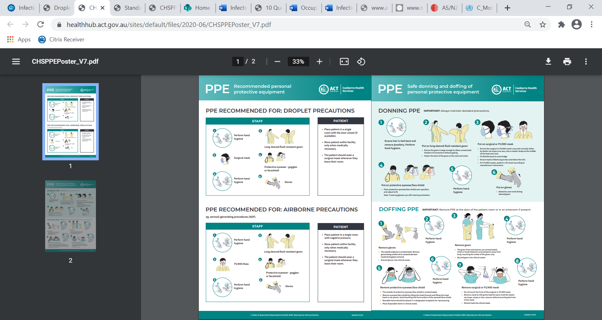

Attachment Five: Environmental Cleaning

Attachment Six: Podiatry
6 – Podiatry
Reusable medical devices to be packed individually
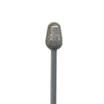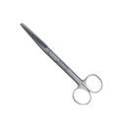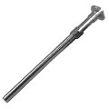

How reusable medical devices are to be placed in green tray
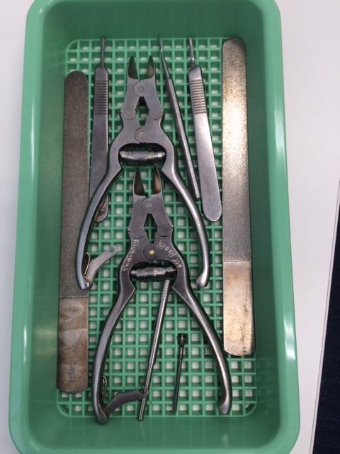

Standard Podiatry reusable medical device t pack
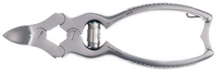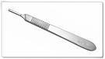
Clippers Scalpel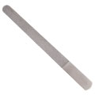 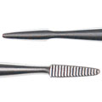
File Blacks file

Podiatry Surgical Pack – please pack together and double bag

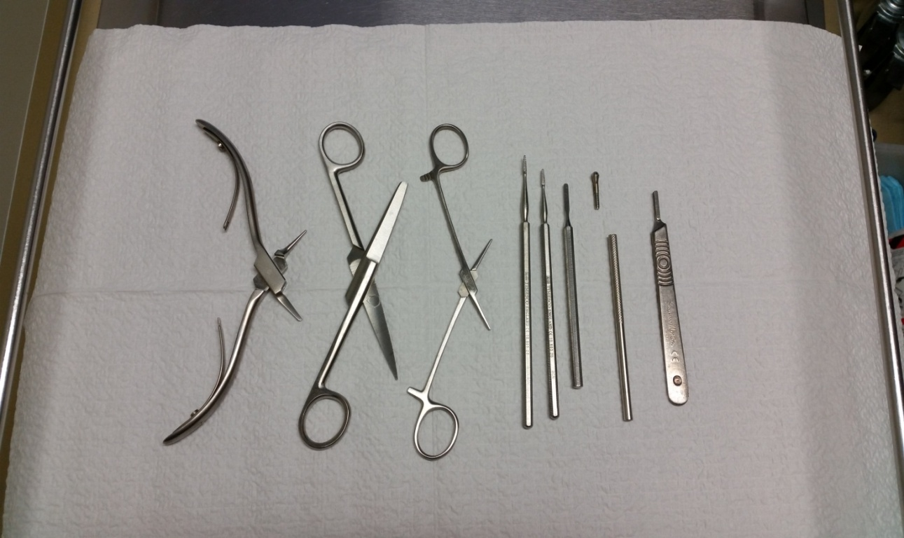

Podiatry Surgery Pack – individual items – to be packed individually

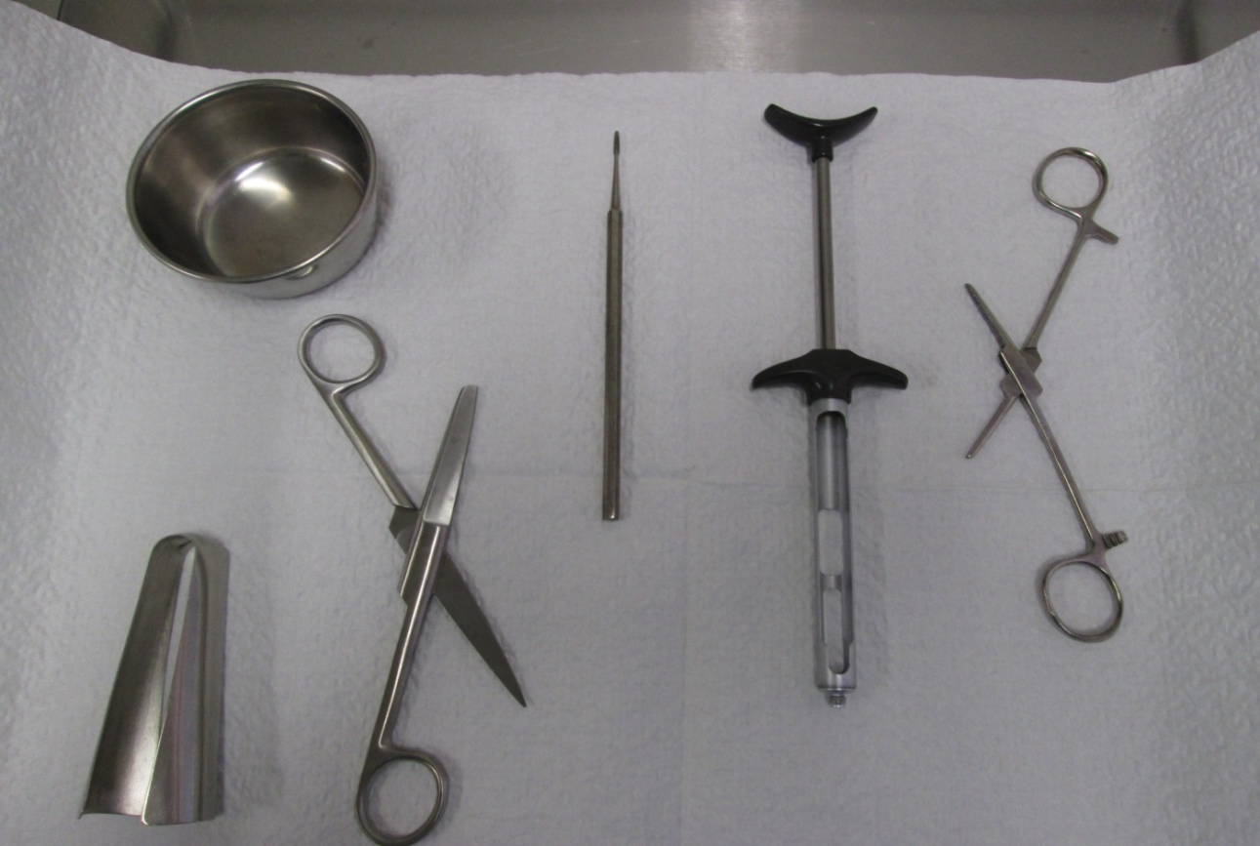

Attachment Seven: Process for Offsite RMD Reprocessing - AMC

Attachment 7 – AMC offsite RMD reprocessing
Process for Offsite RMD Reprocessing – AMC

- Count and pre-treat the Reusable Medical Devices (RMD’s):
- Handpieces are separated from the pack; they are re processed on site at AMC.
- Using a downward motion clean/scrub the handpiece head with a nylon brush using a solution of neutral detergent and water, then rinse.
- Lubricate in the Assistina.
- Wipe the handpiece using a damp lint free cloth and pack into an autoclave pouch ready to be sterilised on site (AMC).
- The contaminated RMD’s being taken offsite for reprocessing are to be recorded on the count which is signed and dated (located on the intranet under FORMS – AMC Attachment F Daily Instrument Check).
- The contaminated RMD’s are placed into a cassette and covered with a Pre-Cleaner - OPTIPRO gel which has a strong performance including:
- Advanced gel technology which clings to heavy soils and keeps them from drying on RMD’s.
- Dissolves blood and fat, making the removal from RMD’s fast and effective.
- Neutral pH allows for safe use with most RMD material.
- Fragrance-free formula provides better staff acceptance.
- Gel form avoids splashing of liquid during transport.
- DO NOT place bib chains in the cassette.
- Burs need to be placed into a metal mesh holder, sprayed with Pre-Cleaner OPTIPRO gel and placed in the zip-lock bag.
- The cassette is then closed and fastened, the RMD’s are placed into a disposable zip-lock bag.
- The sink is wiped clean to remove any residual Optipro gel.
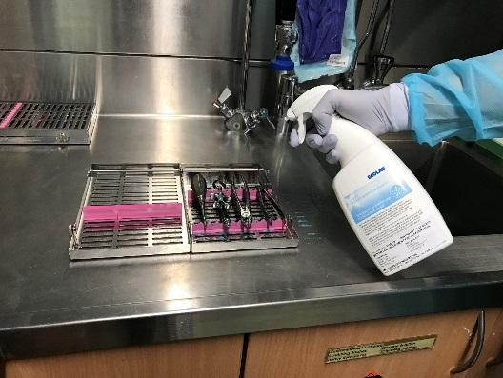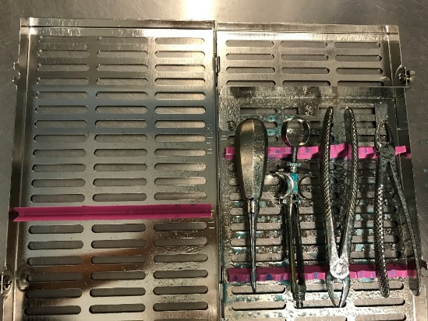
- Prepare the RMD’s for transport
- The zip-lock bags containing the contaminated RMD cassettes are placed into a hard lidded RED container which is marked contaminated
- The sheet with the count is placed into a plastic sleeve and placed onto the outside of the contaminated RMD container.
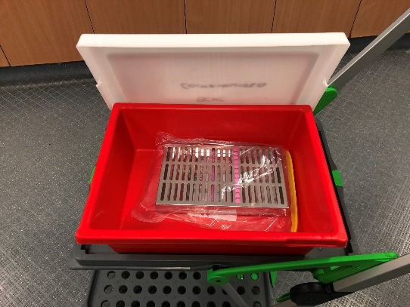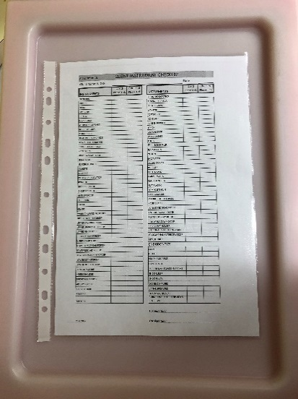
- RMD’s and clean transport box delivered to AMC stores
- Contaminated RMD’s and the BLUE sterile instrument transport container are left in the AMC dental reprocessing room on a trolley at the end of the working day. Stores will collect the trolley before 10 am on Wednesday, Thursday and Friday. AMC Stores is open from 7.30am - 3pm.

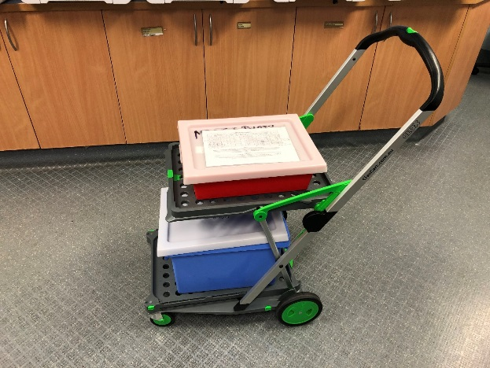

- Re-processing at community health centre
- Cassettes are removed from the zip-lock bag. The bag is disposed of in contaminated waste. The cassettes are placed into the washer undisturbed. Only AMC RMD’s are to be placed into the washer during re-processing so that the count is maintained.

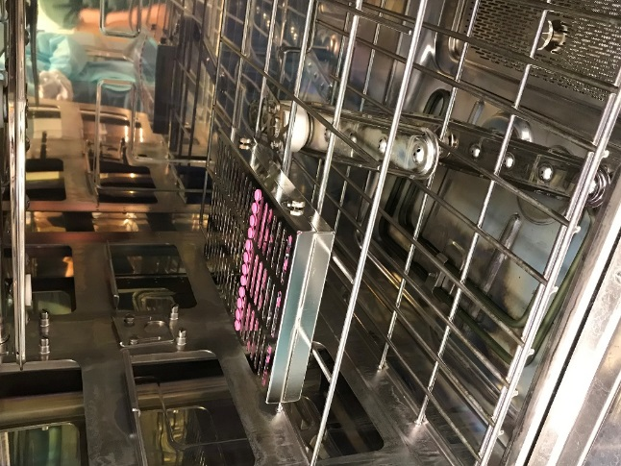
- Disinfect the hard contaminated container with wipes.
- Counting and Bagging of RMD’s
- RMD’s are removed from the cassette and bagged into autoclave pouches. “AMC” should be written on each pouch to indicate instruments are from AMC. Luxator and Elevator size should be written on the bottom of the autoclave pouch to assist with easy identification during the count.

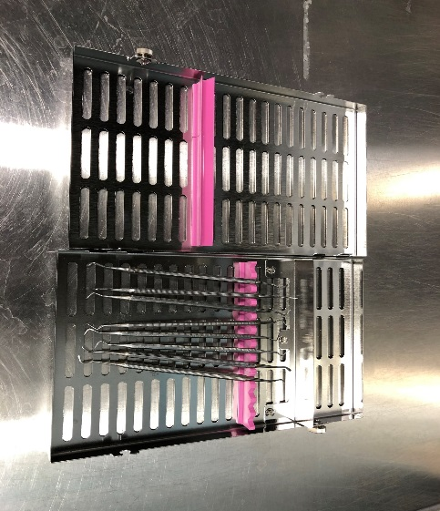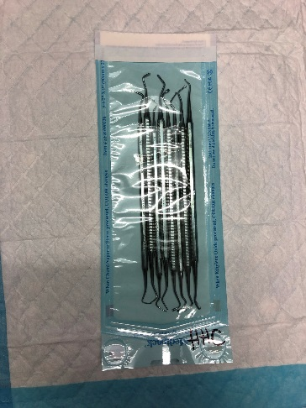
AMC

- RMD’s are then autoclaved. Only AMC RMD’s are to be placed into the autoclave during re-processing so that the count is maintained. AMC RMD’s should not be mixed with CHC RMD’s. The count is checked, signed and dated (comparing the count on the AMC Attachment F Daily Instrument Check which accompanied the instruments) and RMD’s are placed into clean BLUE clean transport container.
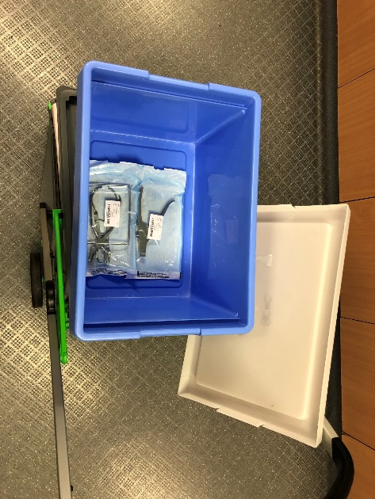
- RMD’s are returned to AMC stores by OHS transport (AMC Stores is open from 7.30am - 3pm)

- The sterile RMD’s in the BLUE clean transport container and the empty RED contaminated instrument container are returned to the back room of the dental surgery at AMC by AMC stores staff.

- The AMC Dental staff count the sterile RMD’s in.

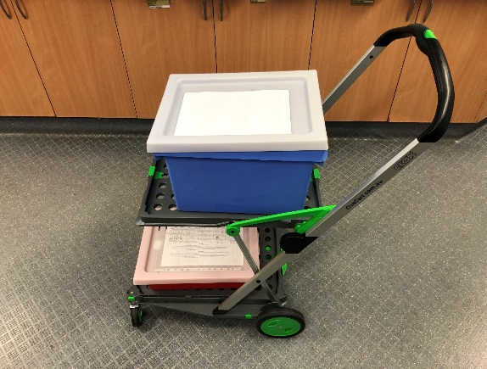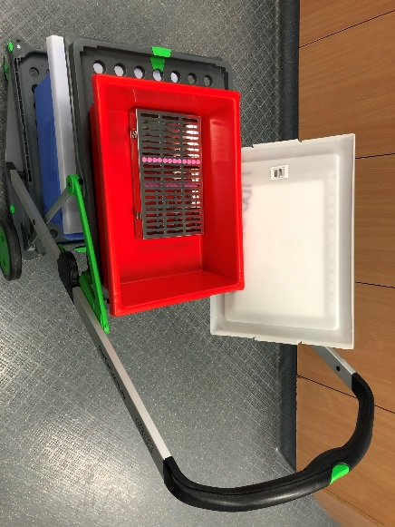

Attachment Eight: Duck bag information

– Duck Bag Instructions
Duck Bag
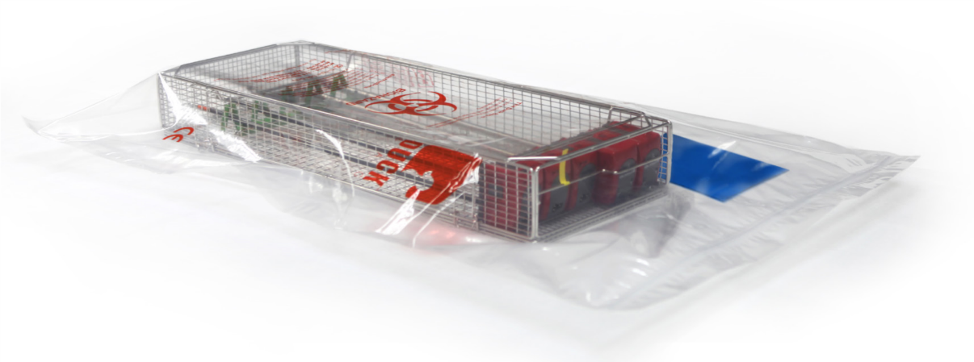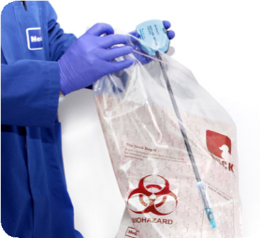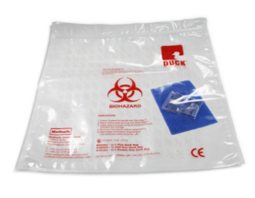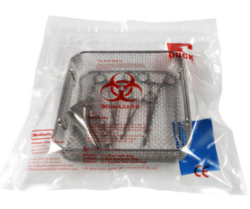

▪
Instrument humidity pack

▪
For transport and storage prior to instrument reprocessing

▪
Pre moistened – ready for immediate use

▪
4-
Zyme sachet included- works at room temperature

▪
Heat sealed bag is easy to use & single use

▪
Available in 3 sizes:

-
Half DIN 420mm (16.5”) wide x 470mm (18.5”) deep

-
Full DIN 400mm (15.7”) wide x 780mm (30.7”) deep

-
Super Size 600mm (23.6”) wide x 1000mm (39.3”) deep
The pre moistened Medisafe Duck Bag prevents soiled instruments from drying during transportation from point of use to CSSD. Place your soiled instruments and tray inside the see-through Duck Bag and seal to maintain a humid environment.
National/International guidelines and instrument manufacturers recommend that the reprocessing of soiled instruments begin within 30 minutes of end of use to ensure that soil, especially blood, does not dry on the surface of used instruments.
The CFPP highlights the importance of keeping instruments moist between use and reprocessing:
“Prions are hydrophobic proteins. The attachment of hydrophobic proteins to surfaces becomes less reversible if they are allowed to dry fully onto a surface. Keeping the environment around soiled instruments at or near saturation humidities
(moist) prevents full attachment of hydrophobic proteins such that they are more efficiently removed by cleaning.” DOH, CFPP 01-01, Page 20, March 2013
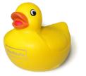
Order details:

M20350 - Half Din
M20358 - Full Din
M20359 - Super-Size

Name: | Duck Bag
Classification: | CE marked Class 1
Ingredients | pH neutral aqueous solution of protease HT and protease LT, lipase and amylase enzymes with corrosion inhibitor and surfactants
Storage condition | between 2°C and 38°C (35.6°F -  100.40°F )
pH | 7.5-8.2
Shelf life | Up to 2 years - applies only to detergent
Packaging: | bags per box

Duck Bag
Keeping soiled instruments moist

Instruction for use Medisafe Duck Bag™
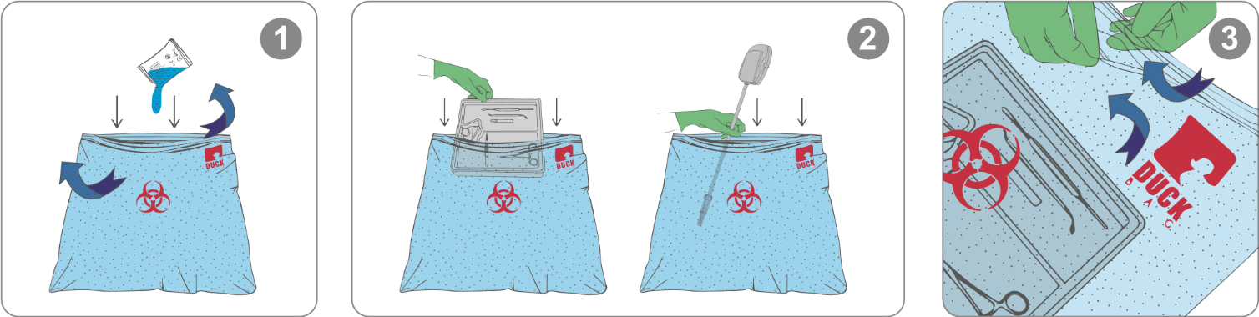
1. Empty contents of 4-Zyme sachet into 2. Place instruments and tray into Duck Bag™ 3. Close seal to ensure humid environment
Duck Bag™ during transport and storage
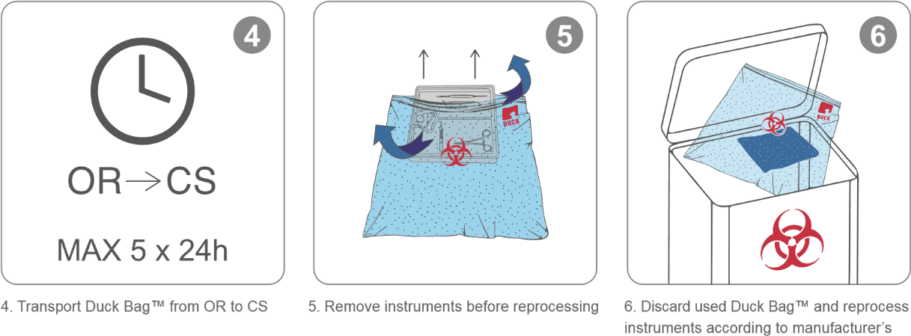
instructions for use

Attachment Nine: TAP MDC reusable medical device process
Storage, Transport and Reprocessing
Of Contaminated RMDs on the TAP MDC
Please find below the process for what to do with the reusable instruments from use to sterilisation.

- Location of contaminated container behind the sink/ tap.
- This is where the contaminated container is to go BEFORE you commence treatment.

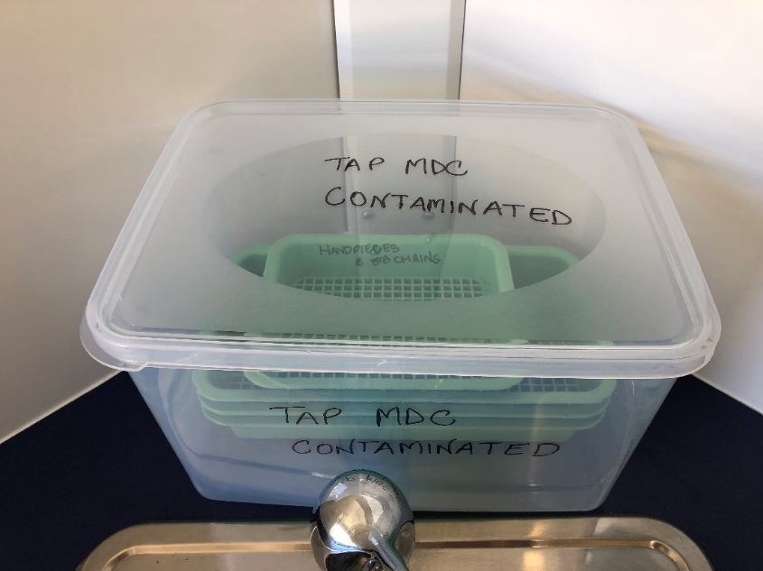

- Contaminated RMDs on the dental tray.

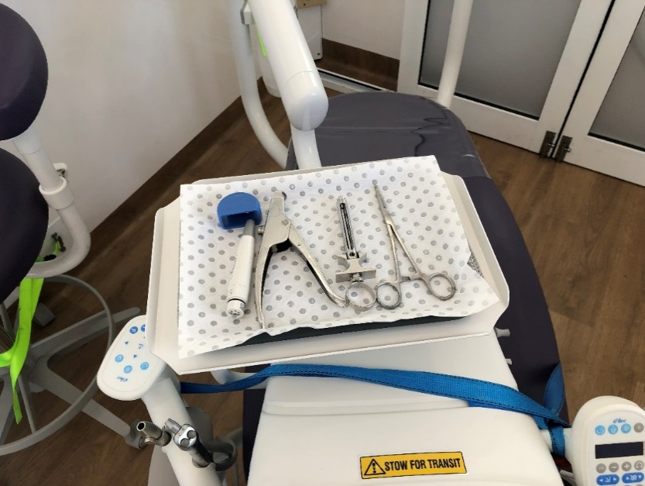

- Transfer the tray with contaminated RMDs on the right bench.

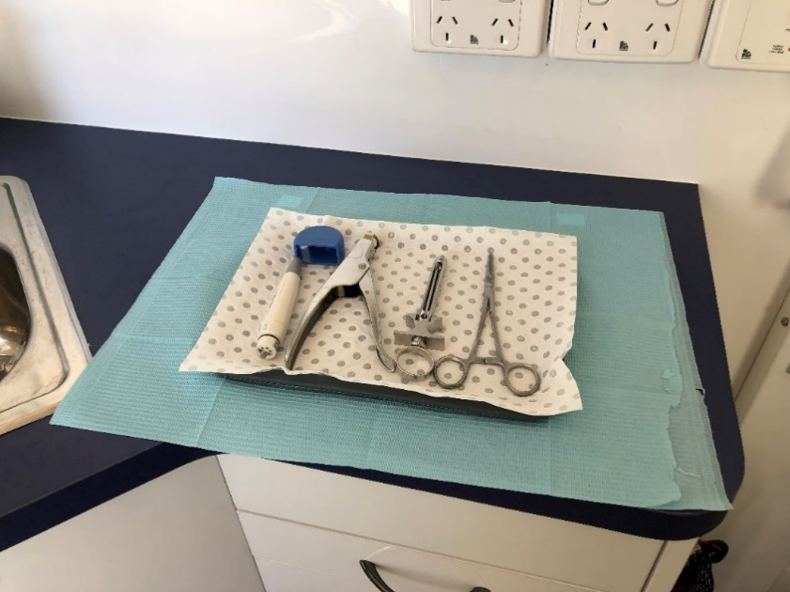

- Place contaminated RMDs into green trays, DO NOT overload.

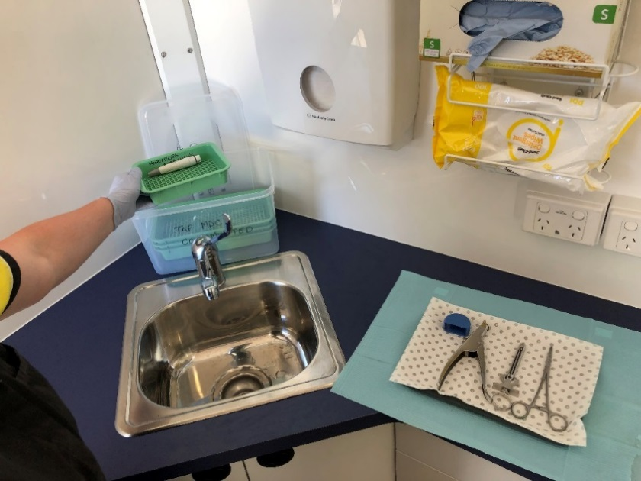
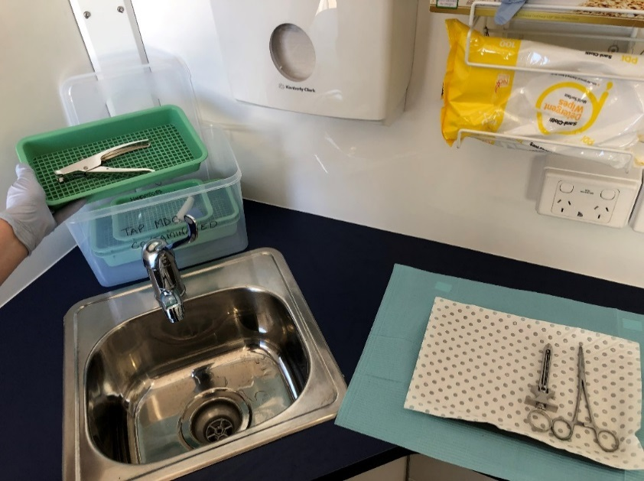
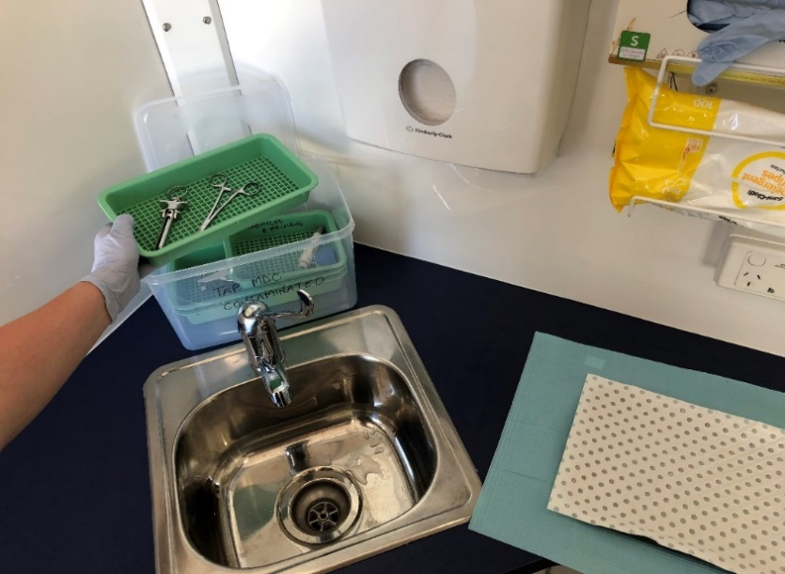

5. Before closing the container with the lid, spray on top of the contaminated RMDs with ECOLAB spray.
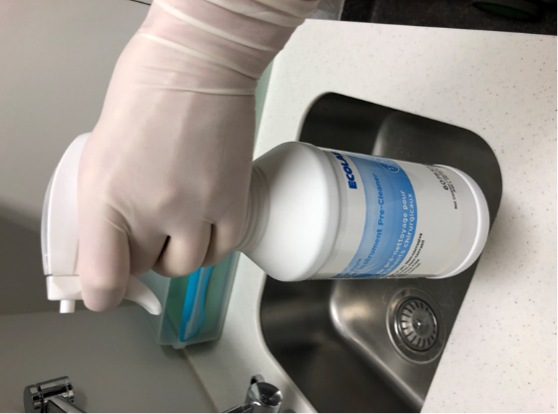

- Replace the lid on the container and stored behind the sink during the treatments.

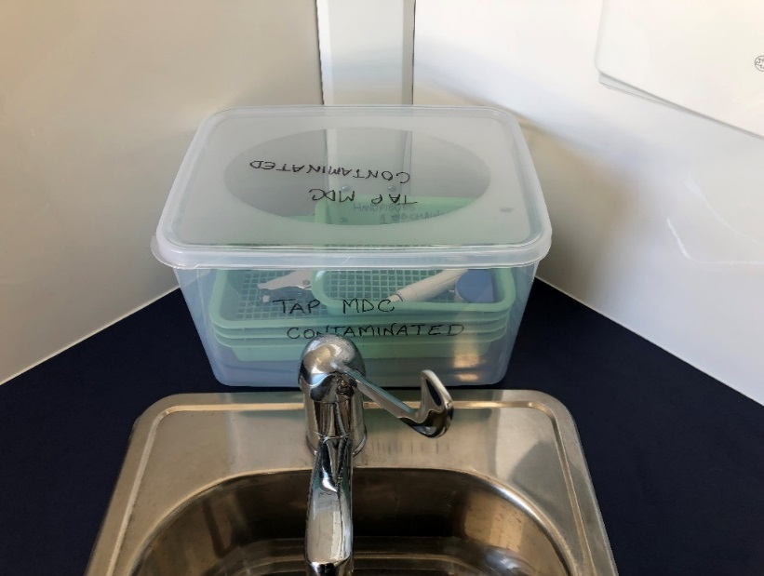

- During transport, container with contaminated RMDs need to be placed into the sink.

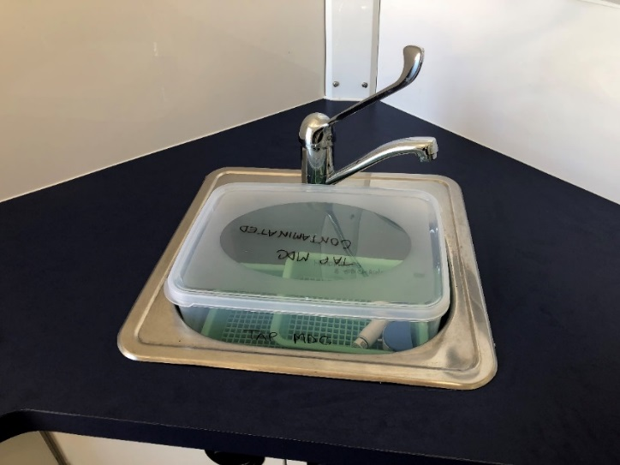

- At the end of the day, place contaminated container into trolley for transport to GHC – Dental clinic – dirty utility.

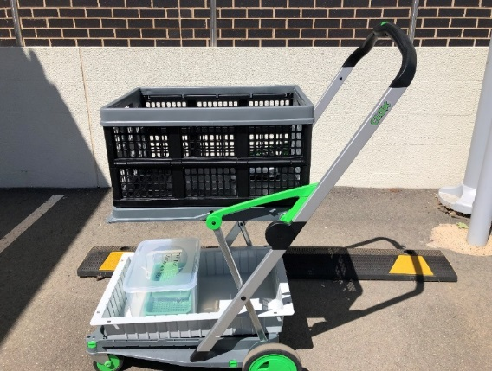

- Contaminated container place into dirty utility for re processing on the bench between to sinks.

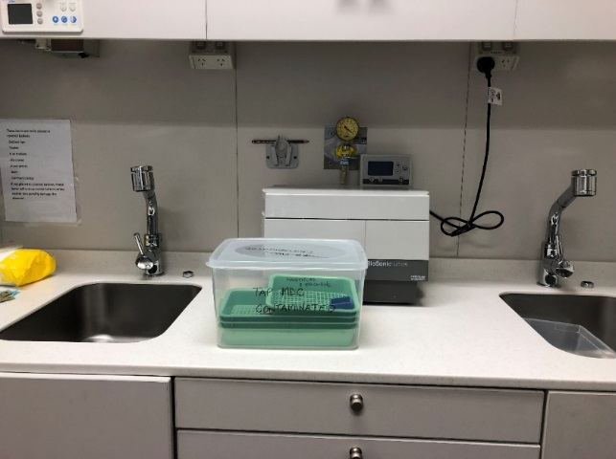

- Reprocessing DA will open and take green trays with contaminated RMDs for reprocessing through the washer machine. When they have been washed/ disinfected and ready for autoclave they have to be placed in autoclave pouches SBS and marked MDC with marker on right corner of the pouch.

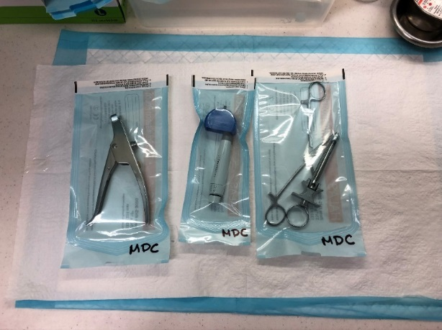

- Sterile RMDs will be place into the clean utility in MDC Basket on the lower shelf in the sterile RMD cupboard.
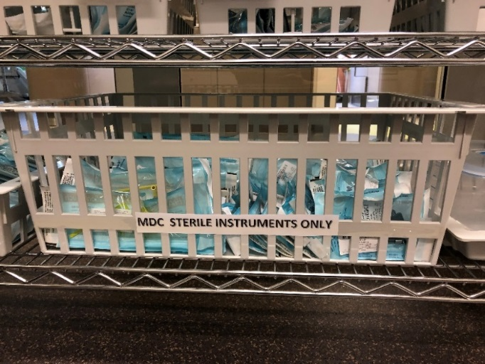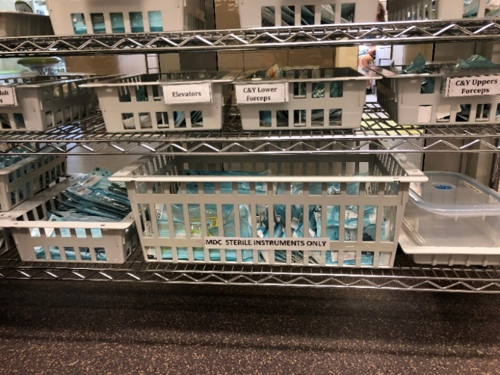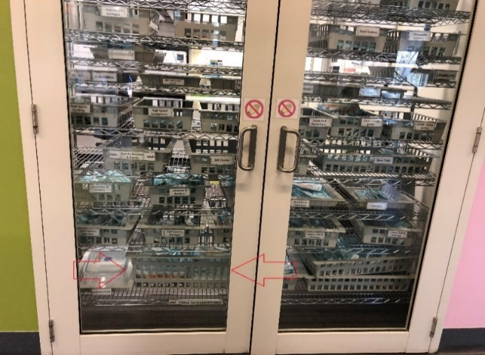

Attachment Ten: Autoclave Record

Attachment 10 - Autoclave record
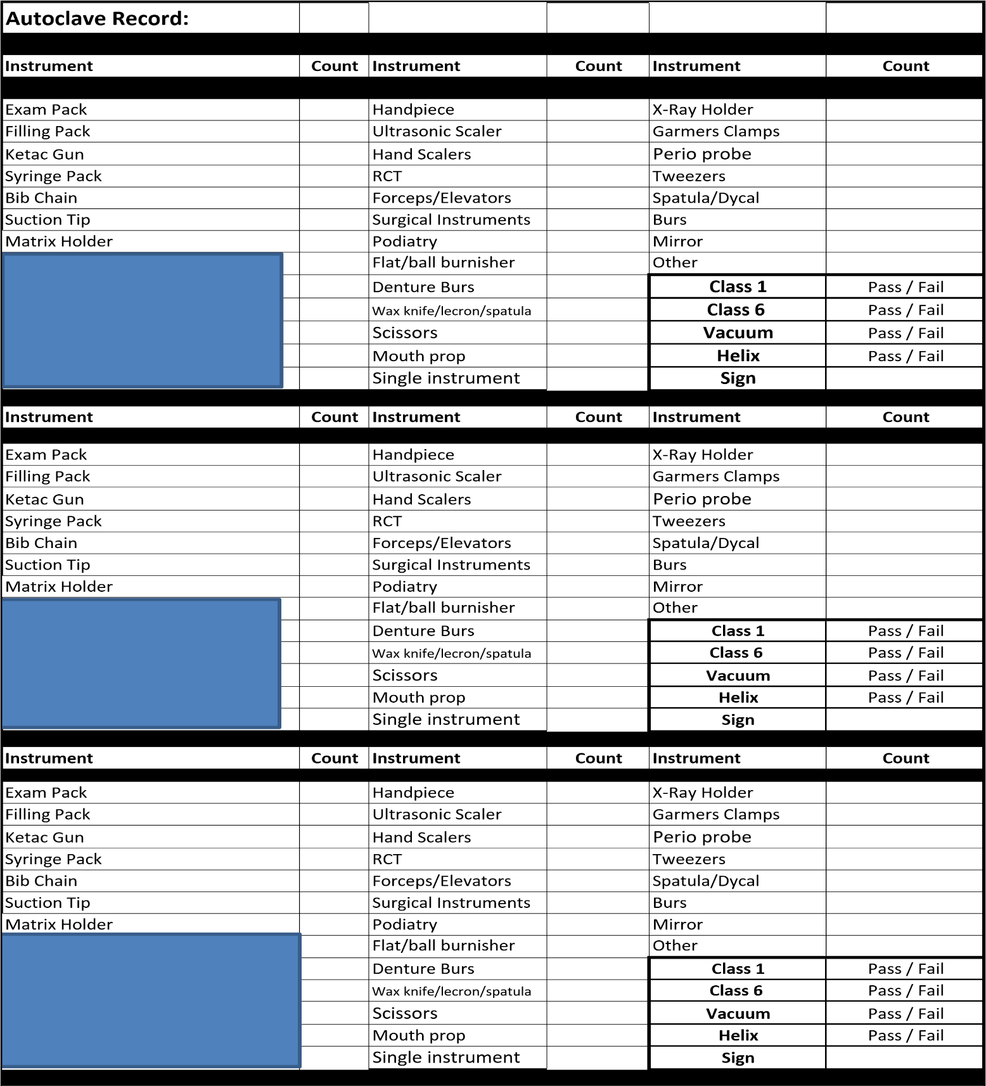
Attachment Eleven: Washer Disinfector Record  Washer Disinfector Record |  |  |  |  |  |  |  | Clinic:
 | Date
 | Daily Maintenance | Spin Arms |  |  |  | Check Filters |  |  | PH TEST |  | PASS / FAIL
 |  |  |  |  |  |  |  |  | Signature :
 | Washer Cycle Number | Wash Monitor |  |  |  |  |  |  | Name |  | Signature
 |  | Pass |  |  |  |  | Fail
 |  | Pass |  |  |  |  | Fail
 |  | Pass |  |  |  |  | Fail
 |  | Pass |  |  |  |  | Fail
 |  | Pass |  |  |  |  | Fail
 |  | Pass |  |  |  |  | Fail

Date
Daily Maintenance | Spin Arms |  | Check Filters |  | PH TEST | PASS / FAIL
 |  |  |  |  | Signature :
Washer Cycle Number | Wash Monitor |  |  |  | Name | Signature
 | Pass |  |  | Fail
 | Pass |  |  | Fail
 | Pass |  |  | Fail
 | Pass |  |  | Fail
 | Pass |  |  | Fail
 | Pass |  |  | Fail

Date
Daily Maintenance | Spin Arms |  |  |  | Check Filters |  |  |  |  |  | PH TEST |  |  | PASS / FAIL
 |  |  |  |  |  |  |  |  |  |  | Signature :
Washer Cycle Number | Wash Monitor |  |  |  |  |  |  |  |  |  | Name |  |  | Signature
 | Pass |  |  |  |  |  | Fail
 | Pass |  |  |  |  |  | Fail
 | Pass |  |  |  |  |  | Fail
 | Pass |  |  |  |  |  | Fail
 | Pass |  |  |  |  |  | Fail
 | Pass |  |  |  |  |  | Fail
Protein Test results
Date: |  | Cycle number |  |  |  |  |  | Batch |  |  |  | RMD |  |  |  | Pass/Fail
 |  |  |  |  |  |  |  |  |  |  |  | Signature :
Date
Daily Maintenance | Spin Arms |  |  |  | Check Filters |  |  |  |  |  | PH TEST |  |  | PASS / FAIL
 |  |  |  |  |  |  |  |  |  |  | Signature :
Washer Cycle Number | Wash Monitor |  |  |  |  |  |  |  |  |  | Name |  |  | Signature
 | Pass |  |  |  |  |  | Fail
 | Pass |  |  |  |  |  | Fail
 | Pass |  |  |  |  |  | Fail
 | Pass |  |  |  |  |  | Fail
 | Pass |  |  |  |  |  | Fail
 | Pass |  |  |  |  |  | Fail

Date
Daily Maintenance | Spin Arms |  | Check Filters |  | PH TEST | PASS / FAIL

Attachment Twelve: Failed Autoclave Report
FAILED AUTOCLAVE REPORT

CLINIC LOCATION:__________________YOUR NAME:______________________

DATE: ______/______/_____ TIME:____________________

AUTOCLAVE SERIAL NUMBER:_________________________

LOAD NUMBER:________________________________

TYPE OF LOAD VACUUM HELIX UNIVERSAL 134
(PLEASE CIRCLE)

ALARM CODE:_____________________________________________

BRIEF DESCRIPTION OF PROBLEM:_______________________________________________________________________________________________________________________________________________________________________________________________________________________

ATTACH FAILED TEST STRIP/BARCODE LABEL

WAS THE PROBLEM CORRECTED BY STAFF: YES NO

LOAD RE-AUTOCLAVED: YES NO

AUTOCLAVE RUN ON EMPTY CYCLE: YES NO

AUTOCLAVE RETEST COMPLETED: VACUUM HELIX UNIVERSAL 134

DID THE AUTOCLAVE RETEST PASS: YES NO

REPORTED TO PDA/MANAGER YES NO

SERVICE TECHNICIAN NOTIFIED: YES NO

SERVICE REPORT__________________________________________________________

Attachment Thirteen : Ultrasonic Record Sheet
Ultrasonic Record Sheet |  |  |  |  | Clinic: MDC NH
Date
Daily Maintenance | De Gas |  | Hendrix Test |  | Name | Signature
Load time | Sign | Time |  |  | Sign

Date
Daily Maintenance | De Gas |  | Hendrix Test |  | Name | Signature
Load time | Sign | Time |  |  | Sign

Date
Daily Maintenance | De Gas |  |  |  | Hendrix Test |  |  |  |  |  | Name |  |  |  | Signature
Load Time | Sign |  |  | Time |  |  |  |  |  |  | Sign
Protein Test results
Date: |  | Load Time |  |  |  |  |  | Batch |  |  |  |  | RMD |  |  |  | Pass/Fail
 |  |  |  |  |  |  |  |  |  |  |  |  | Signature :

