Canberra Health Services
Procedure
Non-invasive Electrocardiography (ECG) in Adults and Newborn Infants

Contents

Contents 1
Purpose 2
Scope 2
Section 1 – Classification for ECG monitoring 2
Section 2 – ECG Monitoring of Adults 4
Section 3 – Standard 12 lead ECG diagnostic test for Adults 6
Section 4 – Guidelines for patients who require Pre-operative ECGs 10
Section 5 – ECG Procedure for Infants 11
Evaluation 14
Related Policies, Procedures, Guidelines and Legislation 14
References 15
Definition of Terms 16
Search Terms 16
Attachments 16

Purpose

The purpose of this document is to provide Canberra Health Services (CHS) Network staff the procedure on how to perform Electrocardiographic (EG) monitoring and 12 lead ECG.

ECG monitoring is used for the diagnosis of heart rhythms/arrhythmias. 12 lead ECGs diagnose myocardial ischaemia/injury and assist in differentiation of arrhythmias.

Scope
This procedure applies to continuous ECG monitoring of adults and 12 lead ECG diagnostic test for newborn infant and adult patients at CHS network, not including paediatric patients.

This procedure applies to the CHS Network that includes inpatient facilities at Canberra Hospital, Clare Holland House, Centenary Hospital for Women and Children, North Canebrra Hospital and University fo Canberra Hospital.

This procedure applies to the following staff at CHS network working within their scope of practice:
- Medical Officers
- Registered Nurses and Registered Midwives
- Enrolled Nurses
- Cardiac Physiologists
- Respiratory Physiologists
- Students working under direct supervision.

Back to Table of Contents

Section 1 – Classification for ECG monitoring

Class I
Class I ECG monitoring is recommended for all patients at significant risk of an immediate, life-threatening arrhythmia. If a patient in this situation is required to leave the monitored unit for diagnostic or therapeutic procedures, then ECG monitoring should be continued with a portable, battery-operated monitor-defibrillator used by a healthcare provider who is skilled in ECG interpretation and defibrillation.

This includes patients who:
- are undergoing cardiac arrest or post resuscitation
- have acute coronary syndromes (ST-elevation or non–ST-elevation Myocardial Infarction, unstable angina) for 48-72 hours
- have unstable coronary syndromes and newly diagnosed high-risk coronary lesions
- are immediately post cardiac surgery until four hours post pacing wire removal
- have undergone non-urgent percutaneous coronary intervention
- post insertion of cardiac implantable device for 24 hours
- have a temporary pacemaker or transcutaneous pacing pads
- have symptomatic Atrial Ventricular (AV) block
- bradycardic or tachycardic arrhythmias causing hemodynamic compromise
- have long QT syndrome and associated ventricular arrhythmias
- have intra-aortic balloon counter pulsation in place
- have acute heart failure/pulmonary oedema
- Infants at risk of arrhythmias (refer to Section 5 - Procedure for Infants).

Class II
ECG monitoring may be beneficial in some of the following patients, but it is not considered essential for all. ECG monitoring is helpful in the clinical management of Class II patients, but it is not expected to save lives. ECG monitoring often takes place in an intermediate care (telemetry) unit.

Patients who have:
- chest pain syndromes
- undergone uncomplicated, non-urgent Percutaneous Coronary Interventions
- been administered an antiarrhythmic drug or who require adjustment of drugs for rate control with chronic atrial tachyarrhythmia
- undergone implantation of a pacemaker lead
- undergone uncomplicated ablation of an arrhythmia
- undergone routine coronary angiography
- sub-acute heart failure
- been admitted for investigation for syncope
- Not for Resuscitation (NFR) orders with arrhythmias that cause discomfort
- have had sedation or anaesthesia for diagnostic/therapeutic procedures

Class III
ECG monitoring is not indicated in Class III patients. These include:
- Postoperative patients who are at low risk for cardiac arrhythmias (e.g., young patients, over 16 and below 65 years, without heart disease who undergo uncomplicated surgical procedures)
- obstetric patients, unless heart disease is present
- patients with permanent, rate-controlled atrial fibrillation
- Patients undergoing haemodialysis.

Indications for ECG monitoring for non-cardiac patients
ECG monitoring is recommended for non-cardiac patients with:
- major trauma
- acute respiratory failure
- sepsis
- shock
- acute pulmonary embolus
- major non-cardiac surgery (especially in older adult patients with a history of coronary artery disease or coronary risk factors)
- renal failure with electrolyte abnormalities (e.g., hyperkalaemia)
- Drug overdose (especially from known arrhythmogenics, e.g., digoxin, tricyclic antidepressants, phenothiazines, antiarrhythmic), and other illnesses.

Back to Table of Contents

Section 2 – ECG Monitoring of Adults

ECG monitoring can be by five or three lead monitoring, as guided by the treating team.

Equipment
Mandatory:
- cardiac monitor including leads
- ECG electrodes
- abrasive paper and/or water wipes for skin preparation
- NOTE: For patients with excessive body hair a razor may be required to remove hair from the chest area during the skin preparation

Procedure
- Ensure patient privacy and obtain patient consent.
- Ask patient if they have any allergies to dressing or tape.
- Enter patient details into monitor after checking the patient’s identity as per the Patient Identification and Procedure Matching procedure, ensuring date of birth and gender are entered into ECG machine.
- Attend hand hygiene.
- Prepare the skin for the ECG electrodes, e.g., gently abrade the skin to remove dry skin cells, shave excess chest hair and remove excess oils or sweat with water.
- Attach the ECG electrodes and corresponding leads to patient.

To prevent skin irritation and ensure optimum electrode conduction change the skin electrodes if poor contact or if the patient complains of skin discomfort in the electrode area. Hypoallergenic electrodes are available.

To remove an electrode, it should be gently lifted, the underlying skin supported and counter stretched against the pull of the electrode. The ideal angle for removal from the skin is that the section being removed is at 120 degrees from the counter stretched skin.
This should be done in a slow and controlled manner to prevent a skin reaction or damage to fragile or thin skin.

Five lead monitoring, see Image 1 below
- black lead on left shoulder
- red lead on left flank
- brown lead in fourth intercostal space right side of chest close to sternum (V1)
- white lead on right shoulder
- Green lead on right flank.
Image 1 – 5 Lead Electrode system
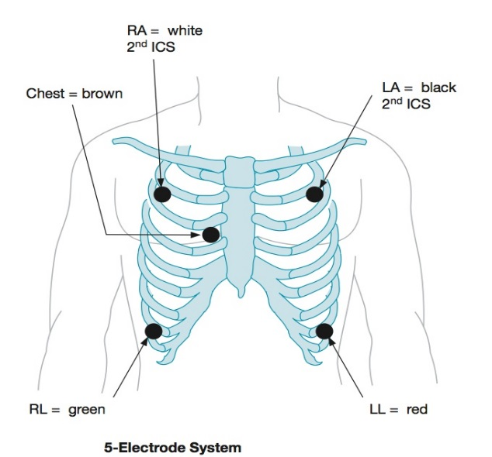
2017 M. Cadogen lifeinthefastlane.com

Three lead monitoring, see Image 2 below
- black lead on left shoulder
- red lead on left flank
- white lead on right shoulder
Image 2 – 3 Electrode System
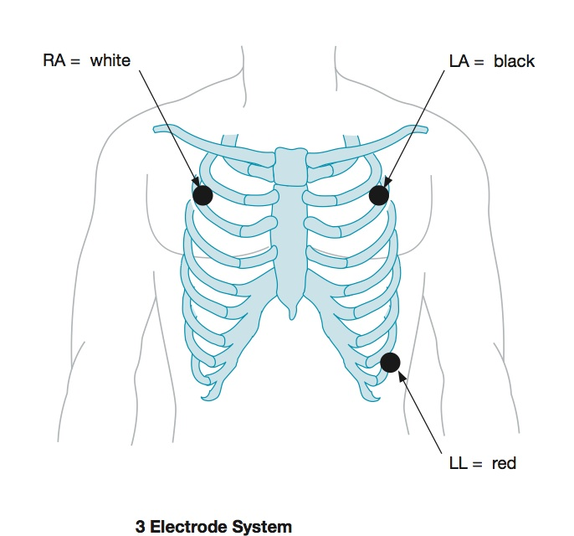
2017 M. Cadogen lifeinthefastlane.com
Any abnormal rhythms should be printed and reviewed by the ward team leader and/or medical officer. Vital signs should be taken and escalated as per the Vital Signs and Early Warning Scores procedure. A 12-lead ECG should also be completed if possible.

Medical Emergency Team (MET) should be activated if the patient’s rhythm is
life-threatening or advanced life support (ALS) is required. In some clinical units remote to a CHS campus, a Code Blue Response is activated through the ACT Ambulance Service on 000.

Back to Table of Contents

Section 3 – Standard 12 lead ECG diagnostic test for Adults

Equipment
- ECG machine
- ECG tab or foam electrodes (10 electrodes give 12 “Leads” or views across the heart)
- Hair clippers (if required)
- Towel or cloth (if skin is moist)
- Alcohol swabs.

Patient Positioning
- Ensure patient privacy and obtain patient consent
- Place the patient in a supine or semi-Fowler’s position as indicated in Image 3 below.

Image 3 – Semi-Fowler’s position
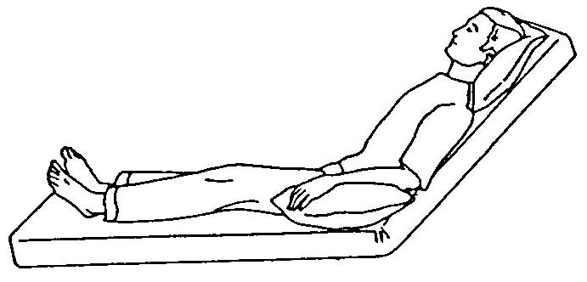
2015 Brookside Associates https://brooksidepress.org/basic_patient_care/lessons/lesson-2-positioning-the-patient/2-03-positioning-the-patient/

- If the patient cannot tolerate being semi recumbent, you can do the ECG in a more upright position.
- Instruct the patient to place their arms down by their side and to relax their shoulders.
- Make sure the patient’s legs are uncrossed.
- Move any electrical devices, such as mobile phones, away from the patient as they may interfere with the ECG machine.

Skin Preparation
- Ensure the patient’s skin is dry.
- If required shave any hair that interferes with electrode placement to ensure good electrode contact with the skin.
- Gently abrade the skin surface to remove dry skin cells and show a pink colour.
- Rub an alcohol swab on the skin if excessive skin oils are present to ensure electrode adhesion.

Procedure

Before connecting electrodes identify patient in the ECG machine.

To obtain a tracing of a 12 lead ECG, place the gel tabs or foam electrodes as follows (see Image 4 below):
- V1 - 4th intercostal space to the right of the sternum
- V2 - 4th intercostal space to the left of the sternum
- V3 - midway between V2 and V4
- V4 - 5th intercostal space at the midclavicular line left side of chest
- V5 - anterior axillary line at the same level as V4 left side of chest
- V6 - mid-axillary line at the same level as V4 and V5 left side of chest
- RL - Right lower leg, proximal to the ankle
- RA - Right forearm, proximal to the wrist
- LL - Left lower leg, proximal to the ankle
- LA - Left forearm, proximal to the wrist
Image 4 – 12 lead ECG placement
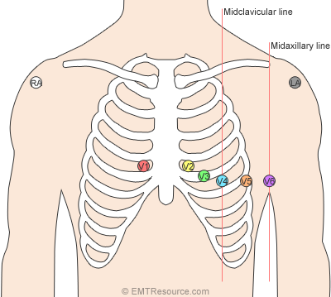
April 27, 2014 by EMTResource.com

Electrode Application
- When placing the electrode on the skin check to make sure the gel pad is still moist.
- Do not place the electrode on the skin directly over bones.
- For patients with large breasts, lift the breast and place the electrode on the skin under the breast tissue.
- Do not place the electrodes over areas where there is a lot of muscle movement.

Once the leads are in the required positions on the patient the ECG machine screen should be viewed for assessment of electrode contact with the patient’s skin and presence of any electrical interference. Missing leads from the ECG recording can signify poor electrode contact or that the lead has become detached from the electrode.

Excessive interference may be present:
- if the patient is moving, advise them to lie still during the procedure
- Electrical devices are plugged into the bed space close to the patient - these will need to be switched off for the recording of the ECG.

Excessive baseline movement
- If the patient is moving, advise them to lie still during the procedure.

Recording, storing and printing the ECG
- Once the ECG reading is ready to be recorded, record the ECG and press the ‘Transmit’ button to send directly to Digital Health Record (DHR). Using this method, the ECG does not need to be printed.
- If preferred for clinical reasons, the ECG can be printed in addition to transmitting directly to DHR, or instead of transmitting directly into DHR. If the ECG is printed without transmitting directly to DHR, ensure that the printed ECG has the patient’s three core identifiers and it is filed in the patient clinical record so it can be scanned to their digital record.

Print, review and store the ECG
- To print the ECG press the print button. If you are unfamiliar with the machine, ask a staff member or check the machine manual.
- Once the ECG has been printed it must be interpreted by a member of the nursing or medical staff who is proficient in ECG interpretation. Their review should be documented, and the ECG is then stored in the patient’s medical record.

Interpretation of the ECG
- Once the ECG has been completed it must be interpreted by a member of the nursing or medical staff who is proficient in ECG interpretation. Their review should be documented in the patient’s clinical record.

Once the ECG has been obtained the ECG electrodes can be left in position for 24hrs if they are required to be used again, otherwise they should be removed to prevent skin irritation. To remove an electrode the electrode should be gently lifted in a slow controlled manner, the underlying skin supported and counter stretched against the pull of the electrode to prevent a skin reaction or damage to fragile or thin skin.

Right ventricular 12 lead ECG
Placement of right ventricular (RV) leads
A complete RV ECG is obtained by placing leads V1-6 in a mirror-image position on the right side of the chest, refer to Image 5 below. The procedure is otherwise the same as for a standard 12 lead ECG.

Ensure to document on the ECG that it is an RV ECG.

Image 5 – Right Ventricular 12 Lead ECG
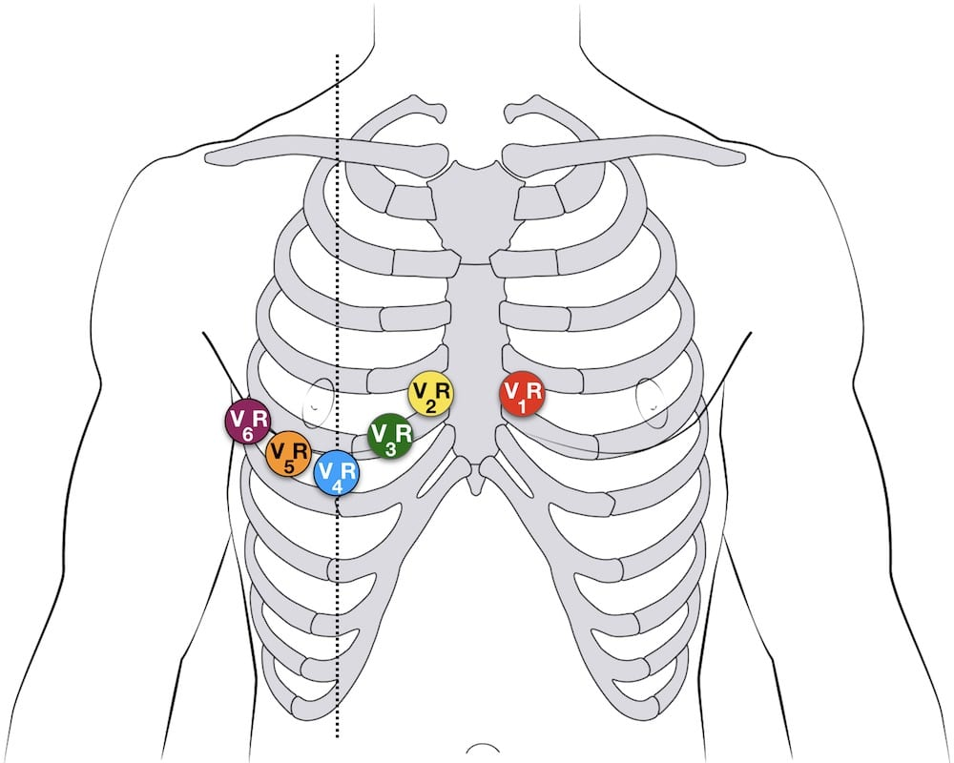
2021 E. Burns & R Buttner lifeinthefastlane.com

Posterior 12 lead ECG
Placement of posterior leads
To obtain a tracing of a posterior 12 lead ECG, place the gel tab or foam electrodes as follow:
- V7 is located at the same horizontal line as V4R (i.e. 5th ICS) on the posterior axillary line, (use the V4 electrode).
- V8 same horizontal line as V4R, mid subscapular line (use V5 electrode).
- V9 same horizontal line as V4R, left para-spinal border (use V6 electrode).
See Image 6 below.

When documenting on the ECG the normal V4, V5 and V6 positions, now get labelled V7, V8 and V9.
The procedure is otherwise the same as for a standard 12 lead ECG.

Image 6 – Posterior Lead Placement
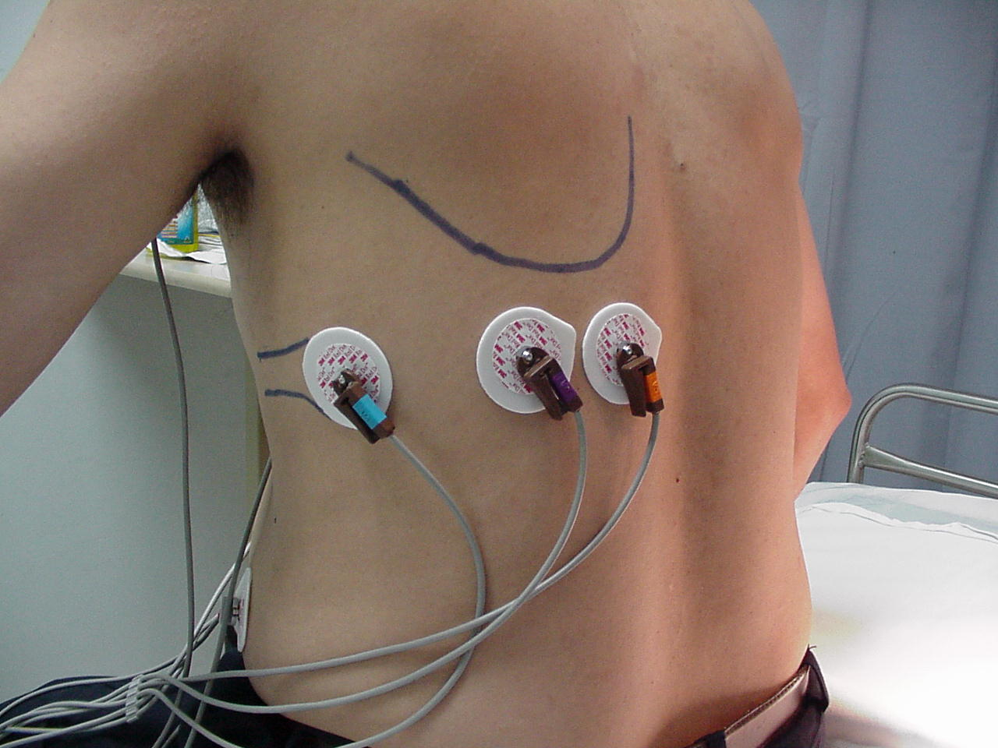
Posterior Ventricular leads V7, V8, V9
Photos provided by B. Redley Clinical Nurse Educator, MMC November 2000
Back to Table of Contents

Section 4 – Guidelines for patients who require Pre-operative ECGs

Rationale: to detect evidence of ischaemic heart and cardiac conduction abnormalities, and to provide a baseline for comparison in the event of problems in the post-operative period.

- Clinical: An ECG is required pre-operatively for the following patients. If the below conditions are stable and an ECG has been performed in the previous 3 months, it does not need to be repeated:
- BMI≥40
- If aged ≥65 and no ECG for past 12 months with ASA grade 1-2
- Everyone with ASA grade 3-4 having minor, intermediate or major surgery
- Cardiovascular disease including:
- Hypertension
- Ischaemic heart disease
- Congestive cardiac failure
- Arrhythmias
- Valvular heart disease.
- Diabetes- if ≥40 years old (GDM do not need an ECG)
- Chronic renal disease
- Cerebrovascular disease
- Chronic pulmonary disease including:
- Chronic obstructive airway disease
- Obstructive sleep apnoea.
- Symptoms of dyspnoea, chest pain or poor exercise tolerance
- Those undergoing intermediate and major surgery:
- Cardiothoracic
- Vascular
- Major orthopaedic
- Major general
- Major Neurosurgery
- Major ENT
- Major OMF.
For more information refer to NICE Guidelines. Visit Routine preoperative tests for elective surgery: summary of updated NICE guidance | The BMJ

Back to Table of Contents

Section 5 – ECG Procedure for Infants

Indications
- For clinical reasons such as arrhythmias, a formal ECG is sometimes required to be attended on a newborn infant.
- The aim is for the ECG to be carried out at a timeframe that is suitable for the infant.
- Urgent ECGs are to be attended immediately.
- Non-urgent ECGs to be attended when the infant is due to have cares or a feed attended – this is to avoid disturbing the infant’s sleep.
Clinical Process
- Positioning of electrodes is the same as that demonstrated above for an adult
- Cut electrode discs in half, (may need to use whole electrode if the infant is active).
- Locating the correct anatomical position for ECG electrodes in an infant can be difficult due to the ribs being hard to feel, narrow intercostal spaces, and adult finger pad being larger than the spaces
- Infants positioning follows that of an adult except for the V4 lead which is placed on the right side. See Images 7 and 8 below.

Alert: In paediatric electrocardiography, lead V4R is often used to the exclusion of lead V4. This is because of the normal right ventricular preponderance in early infancy.

- V4R is located on the right hand side of the chest. V4R must be placed first and is located in the fifth intercostal space on the right midclavicular line.

Note: in Neonatal Cardiac monitoring it is advised to use small electrodes, rather than cutting electrodes to size.
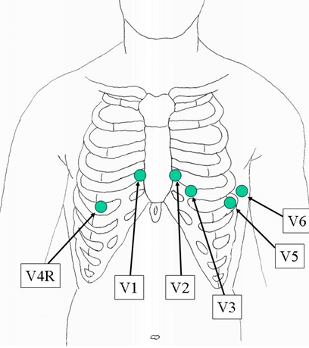
Image 7: Precordial lead placement with the V4 electrode in the position of V4R

- The limb leads are placed with the lower limb leads heading as demonstrated in Images 8 and 9 below.
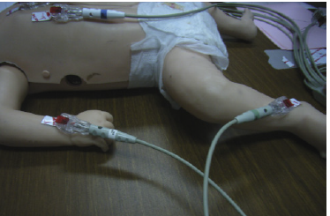

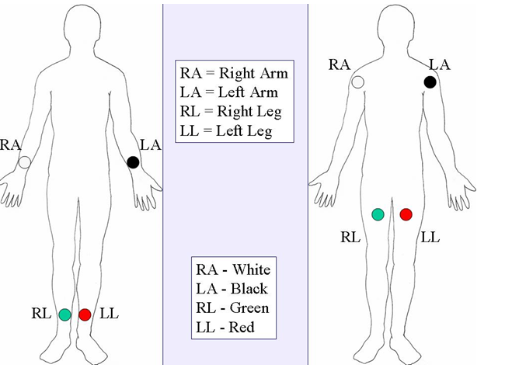

Image 8: Limb Lead placement

- Leads and Colour Codes
V1 (Red)  Fourth intercostal space at the right sternal border | Limb Leads – wrist and ankle inner aspect preferred  (These are longer than the other leads.)
V2 (Yellow)  Fourth intercostal space at the left sternal border | Right arm (white)  right deltoid or wrist
V 3 (Green)  Mid way between V2 – V4 | Right Leg (green)  right thigh or ankle
V 4 (Blue)  Fifth intercostal space at right midclavicular line | Left arm (black)  Left deltoid or wrist
V 5 (Orange)  Anterior axillary line on same horizontal level as V4 | Left Leg (red)  left thigh or ankle
V6 (Maroon)
Mid axillary line on same horizontal level as V4 + V5
- Image 9 below should be used as a guide
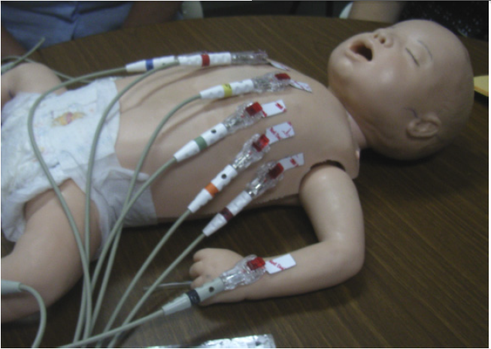
Image 9
Process
- Discuss procedure with parent(s)
- Attend moments of hand hygiene as appropriate
- Place infant in a warm environment
- Attach the electrodes to the infant
- Attach the cable lead wires to the electrodes on the infant
- Arrange the lead cable such that it is neat and not dangling or looped. Ensure that the cable is not pulling on individual electrodes.
- Minimise electrical interference
- Turn on the machine
- Wait until the infant is settled
- Print
- Turn machine off
- Remove all dots and leads
- Dress and settle the infant
- Clean the cable lead wires with disinfectant wipes
- Document in the infant’s DHR that the procedure has been attended
- Consult the infant’s neonatal team/paediatrician on the ECG.
Trouble Shooting
- Artifacts (disturbances) can have many causes.
- Common causes are:
- Monitor
- Skin
- Environment
- Electrodes
- Lead Wire.
Refer to Attchment 1 for more troubleshooting guide.
Back to Table of Contents

Evaluation

Outcome
CHS patients assessed as requiring an ECG or ECG monitoring are managed as per this procedure.

Measure
There will be monitoring of any clinical incidents involving ECG monitoring and 12 lead ECGs.

Back to Table of Contents

Related Policies, Procedures, Guidelines and Legislation

Policies
- Informed Consent - Clinical
- Partnering with Consumers
- Patient Identification and Procedure matching Policy
- Consumer and Carer Participation Policy
- Clinical Records Management

Procedures
- Admission to Discharge
- Infection Prevention and Control
- Healthcare Associated Infections Procedure
- Emergency Management Plans - Code Blue
- Clinical Records Management
- Vital Signs and Early Warning Scores – Canberra Hospital
- Vital Signs and Early Warning Scores – North Canberra Hospital
- Patient Identification and Procedure Matching

Legislation
- Human Rights Act 2004
- Health Records (Privacy and Access) Act 1997
- Work Health and Safety Act 2011

Other
- Australian Charter of Healthcare Rights

Back to Table of Contents

References

- Drew BJ, Califf RM, Funk M, Et Al. AHA scientific Statement: practice standards for electrocardiographic monitoring in hospital setting: an American Heart Association Scientific Statement from the Councils on Cardiovascular Nursing, Clinical Cardiology, and Cardiovascular Disease in the Young; endorsed by the International Society of Computerized electro cardiology and the American Association of Critical Care Nurses. Journal of Cardiovascular Nursing. 2005; 20(2): 76-106.
- Cadogen, M. 2017. lifeinthefastlane.com/ecg-library/basics/lead-positioning/, viewed 8 November 2017
- Burns, E. and Buttner, R. 2021 Right Ventricular Infarction • LITFL • ECG Library Diagnosis
- Emergency Medical Technician 2017 http://www.emtresource.com/resources/ecg/12-lead-ecg-placement/, viewed 8 November 2017
- Brookside Associates 2015, Basic Patient Care Procedures: distance learning for medical and nursing professionals https://brooksidepress.org/basic_patient_care/lessons/lesson-2-positioning-the-patient/2-03-positioning-the-patient/ viewed 18 October 2018
- Walvin. T, 2018 Ausmed 12 Lead ECG Placement/Viewed 8 May 2019
- 3M Health Care Limited www.healthcare.co.uk / Viewed 8 May 2019
- Campbell B, Richley D, Ross C, Eggett CJ. Clinical Guidelines by Consensus: Recording a standard 12-lead electrocardiogram. An approved method by the Society for Cardiological Science and Technology (SCST) 2017. Available at: http://www.scst.org.uk/resources/SCST_ECG_Recording_Guidelines_2017
- Crawford, J. Doherty, L., 2012, Practical Aspects of ECG Recording, M & K Publishing, Keswick.
- Graham S. & Buchan J. (2013), JNE Kids Health: ECG investigation in NICU, online access 12 May 2019, http://www.hnekidshealth.nsw.gov.au/site/content.cfm?page_id=351320&current_category_code=15920
- Harrigan R. Chan T. Electrocardiographic Electrode Misplacement, Misconnection, and Artifact, The Journal of Emergency Medicine, 2012;43(6):1038-1044
- Kligfield, P., Recommendations for the Standardization and Interpretation of the Electrocardiogram, Journal of the American College of Cardiology, 2007, Vol. 49, No. 10
- 3M Health Care, Factors Affecting ECG Trace Quality, online access 12 May 2019, http://multimedia.3m.com/mws/media/128344O/factors-affecting-ecg-trace-quality.pdf
Back to Table of Contents

Definition of Terms

AV Atrial Ventricular block

Electrocardiogram (ECG) - An ECG is a test that checks for problems with the electrical activity of your heart. An ECG shows the heart's electrical activity as line tracings on paper. The spikes and dips in the tracings are called waves.

MET Medical emergency team
Back to Table of Contents

Search Terms

Cardiac Monitoring, ECG, electrocardiographic monitoring, 5 lead,3 lead, 12 lead, heart, right ventricular leads, monitoring, diagnostic test, electrocardiograph

Attachments
Attachment 1 - Trouble shooting ECG Traces

Disclaimer: This document has been developed by Canberra Health Services specifically for its own use. Use of this document and any reliance on the information contained therein by any third party is at his or her own risk and Canberra Health Services assumes no responsibility whatsoever.

Policy Team ONLY to complete the following:
Date Amended | Section Amended | Divisional Approval | Final Approval
20/05/2024 | New Document | CHS Policy Team | CHS Policy Team

Attachment 1 - Trouble shooting ECG Traces – Trouble shoot each artefact in order starting with
Artefacts | Skin  Impedance | Muscle  Movement | Electrical  Continuity | Electrodes | Cabling | Interference | Equipment
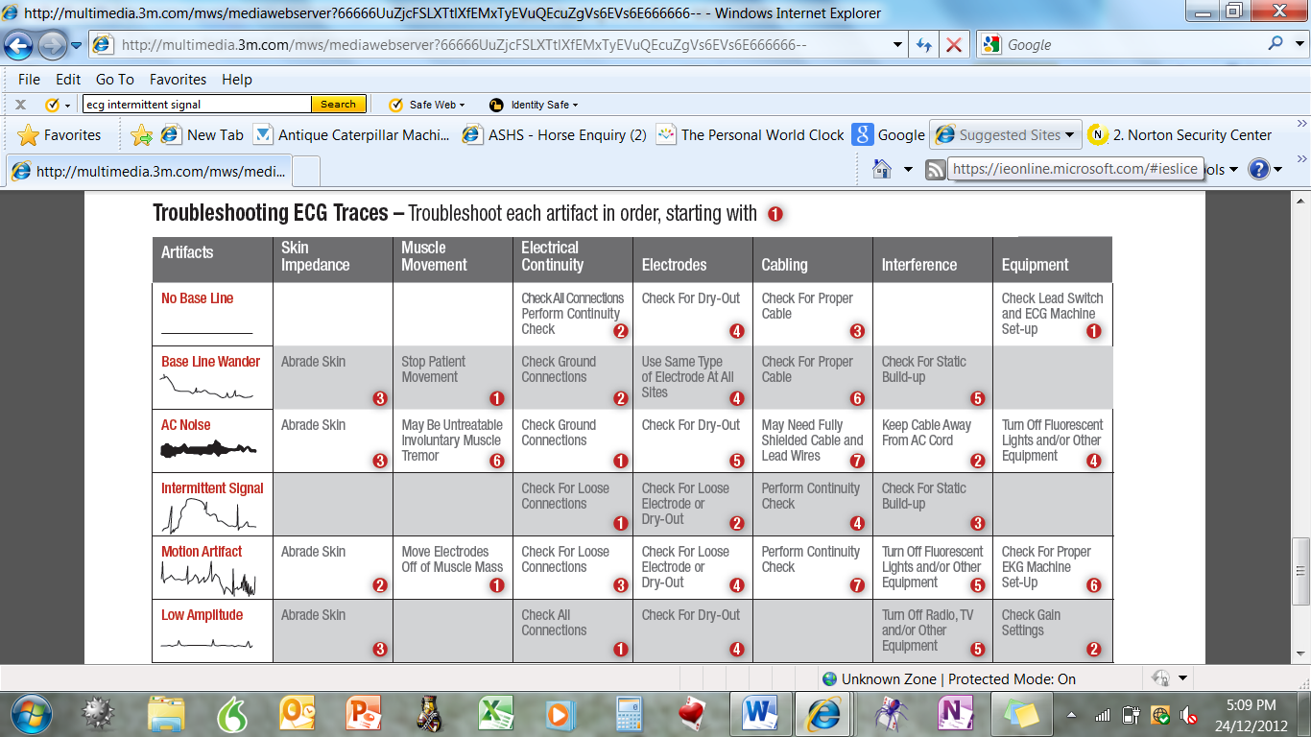 |  |  | Check all connections  Perform continuity check | Check for dry out | Check for proper cable |  | Check lead switch and ECG machine set up
 | Clean and dry skin | Settle infant to stop movement | Check ground connections | Use same type of electrodes at all sites | Check for proper cable | Check for static build up
 | Clean and dry skin | May be untreatable involuntary muscle mass tremor | Check ground connections | Check for dry out | May need fully shielded cable and lead wires | Keep cable away from AC cord | Turn off fluorescent lights and / or other equipment
 |  |  | Check for loose connections | Check for loose electrodes or dry out | Perform continuity check | Check for static build up
 | Clean and dry skin | Move electrodes off muscle mass | Check for loose connections | Check for loose electrodes or dry out | Perform continuity check | Turn off fluorescent lights and / or other equipment | Check for proper ECG machine set up
 | Clean and dry skin |  | Check all connections | Check for dry out |  | Turn off Radio, TV and / or other equipment | Check Gain settings
(Adapted from 3M Health Care: Factors Affecting ECG Trace Quality)
Back to Table of Contents

