Guideline | Canberra Health Services
Neonatal Surgery
CHS26/016

Contents
Guideline Statement 2
Scope 3
Section 1 – Oesophageal Atresia (OA) and Tracheoesophageal Fistula (TOF) 3
Section 2 – Gastroschisis 11
Section 3 – Exomphalos or Omphalocele 15
Section 4 – Congenital Diaphragmatic Hernia (CDH) 18
Section 5 – Bowel Washout Procedure (Neonates and Infants) 22
Evaluation 24
Related policies, procedures, guidelines and legislation 25
References 26
Definition of terms 28
Search terms 30
Attachments 30

Guideline Statement
Background
The purpose of this document is to outline the safe and effective management of infants born with Oesophageal Atresia (OA), Tracheoesophageal Fistula (TOF), Gastrochisis, Omphalocele, and Congenital Diaphragmatic Hernia (CDH).
Key Objective
- To inform staff of the diagnosis and management of infants born with OA, TOF, Gastrochisis, Omphalocele, and CDH.
- To assist staff in the pre-operative, immediate management, post-operative, and discharge management of infants born with OA, TOF, Gastroschisis, and Omphalocele.
- To guide staff in undertaking the following procedures:
  - Bowel Washout
  - Intra-abdominal or Bladder Pressure Monitoring Procedure
  - Replogle Tube Insertion and Management.

Alerts
- Do not place gauze or saline on the bowel as gauze will adhere to the bowel and saline will increase heat loss.
- Infants with Gastroschisis or Omphalocele, if the bowel remains dusky alert the surgical team immediately.
- Do not advance the replogle tube. Do not suction beyond the length of the replogle tube as this could damage the anastomosis.
- When attending to a bowel washout, the recommended solution is sodium chloride 0.9%. The use of other solutions or concentrations in infants may be dangerous. The solution must be lukewarm to prevent colonic spasm.
- If there are any signs of Abdominal Compartment Syndrome inform medical staff immediately. These may include:
  - intra-abdominal pressure greater than 12mmHg
  - tense and distended abdomen
  - abdominal discoloration
  - respiratory compromise
  - worsening metabolic acidosis
  - hypotension
  - poor urine output
  - increasing pain.
- Inform the neonatal consultant and/or advanced trainee, and surgical team on call of imminent delivery when OA/TOF/gastroschisis/omphalocele/CDH are suspected/confirmed.
- Discussion to be held between Neonatologist and surgical team regarding location of surgery:
  - Elective or complex cases: Must be discussed with surgical team, anaesthetics team, and NICU consultant
  - Emergency surgery for unstable infants: To occur in the NICU theatre. Consider ventilation equipment and space availability
  - Gestation-based default location: Neonates less than 32 weeks gestation and/or less than 1500g to have surgery in NICU theatre by default due to thermoregulation considerations, unless specific requirements dictate otherwise.
Back to Contents

Scope
This document pertains to all neonates and infants nursed in the Neonatal Intensive Care Unit (NICU) at Canberra Hospital and other CHS Network facilities including Centenary Hospital for Women and Children and North Canberra Hospital (NCH), with the following conditions:
- OA
- TOF
- Gastroschisis
- Omphalocele
- CDH.
This document applies to all staff working within their scope of practice including:
- Medical Officers
- Nurses
- Midwives
- Students under direct supervision.
Back to Contents

Section 1 – Oesophageal Atresia (OA) and Tracheoesophageal Fistula (TOF)

Background
OA and TOF are congenital abnormalities of the respiratory tract. The incidence of OA/TOF is 1 in 2500-4500 livebirths ⁽¹⁾. This congenital abnormality usually occurs sporadically and in 60 percent of cases is associated with other congenital abnormalities ⁽²⁾. The most common is VACTERL association (vertebral abnormalities, anorectal malformations, cardiac abnormalities, tracheo-oesophageal fistula, renal abnormalities and limb defects). Other associations include trisomy 13, CHARGE association, duodenal atresia, malrotation or other skeletal abnormalities. Associated anomalies are more common in isolated OA ⁽²⁾.
There are five types of OA/TOF. The most common variant is Type C accounting for around 85 percent of cases (See Figure 1 below).
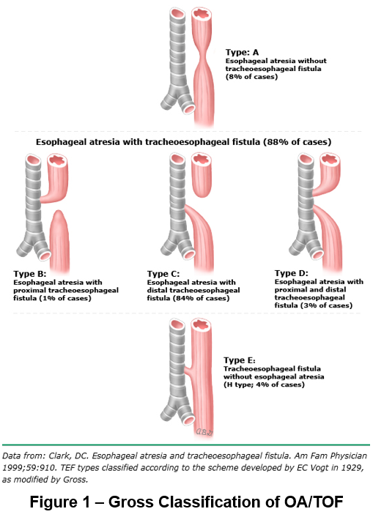
Figure 1 – Classification of OA/TOF (3)

Prenatal Diagnosis
The presence of polyhydramnios and a small stomach conveys a positive predictive value of 44 and 56 percent respectively for diagnosing OA ⁽¹⁾. Sometimes the presence of anomalies associated with VACTERL can increase the risk of a subsequent diagnosis of OA or TOF, however the majority of cases are not detected antenatally.

Management of a Neonate with a Suspected OA/TOF at Delivery
- Provide neonatal resuscitation at birth as per Neonatal Resuscitation and Airway Management Guideline found on the Policy and Guidance Documents Register.
- When there is a suspicion of OA/TOF antenatally (small stomach and/or significant polyhydramnios) a nasogastric tube (NGT) should be passed prior to the first feed. In a term neonate, the inability to advance a size 10 Fr NGT more than 10 centimetres (cm) from the lips is suspicious of OA ⁽²⁾. As some NGTs (particularly those that are smaller than a size 10 Fr) can coil in the upper pouch or go through an upper pouch fistula, an X-ray should be performed to ensure that the NGT has passed into the stomach.
- The most common variant of OA/TOF is Type C. On the Chest X-ray this appears as an NGT that is either terminating high or coiling in the oesophagus with air present in the stomach (see Figure 2).
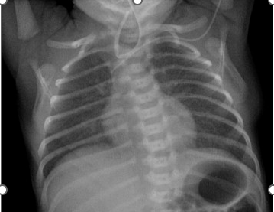
Figure 2 – Chest X-ray demonstrating a coiled NGT in the oesophageal pouch and air in the stomach suggestive of a Type C OA/TOF (4)

Postnatal Diagnosis
- The majority of neonates are diagnosed postnatally.
- Signs and symptoms of OA/TOF include:
  - a large amount of oral secretions requiring frequent suctioning
  - choking episodes or cyanosis associated with feeding attempts
  - mild or moderate respiratory distress.
- If an OA/TOF is suspected do not delay attempting to pass a NGT and performing an X-ray.
- It can be difficult to diagnose Type E (otherwise known as H-type) TOF as these are not associated with OA. Symptoms of these include coughing during feeds, recurrent pneumonia or cyanotic spells. The diagnosis of an H-type TOF requires imaging including a combination of a contrast study/ video-fluoroscopic swallow study (VFSS)/endoscopy or laryngeal-bronchoscopy, however none of these imaging studies has a 100 percent sensitivity ⁽⁵⁾. This is rarely diagnosed in the neonatal period.

Pre-surgical Management
Note: Please refer to Attachment 1 – Checklist for Oesophageal Atresia with/without Tracheoesophageal Fistula.
Once a diagnosis of OA has been made the goals of treatment are ⁽²⁾.

Stabilisation
- Avoid frequent aspiration by placing a replogle tube in the upper pouch of the oesophagus on continuous suction (see Attachment 2).
- Avoid reflux of gastric contents into the lungs by positioning the infant 30-40 degrees head up.
- Avoid gastric overdistention by avoiding non-invasive or mechanical ventilation where able. When mechanical ventilation is required, keep the endotracheal tube (ETT) low with the goal of keeping it beyond a proximal fistula and use minimal pressures to assist in avoiding over-distention of the stomach ⁽¹⁾. Selective intubation of a bronchus is another potential short-term ventilation strategy if gastric over-distension is a problem ⁽²⁾.
- If gastric overdistention has occurred and is leading to diaphragm splinting/respiratory deterioration, a surgical ligation of the fistula and decompression of the stomach may be required to avoid a tension pneumoperitoneum. Rarely babies with OA/TOF may have a bowel atresia (as a second congenital anomaly) and these babies are at greatest risk of gastric/bowel overdistention and pneumoperitoneum. Consult the paediatric surgical team urgently if this is suspected.

Planning
- Refer any newly diagnosed OA/TOF to the surgical team promptly to plan for surgical repair.
- Where possible a clinician performed cardiac ultrasound (CCPU) will be performed prior to surgery (paying attention to any obvious structural cardiac abnormalities and sidedness of the aortic arch). This is within the limitations and dependent upon the availability of CCPU.

Surgical management
- The surgical approach to management depends on whether there is a short or long gap between the proximal and distal oesophageal pouches.
- The operation is performed either via thoracotomy (extra pleural intervention) or thoracoscopically. Bronchoscopy is sometimes done to exclude the rare variants, including a proximal fistula. The primary goal of surgery is the identification and ligation of any tracheoesophageal fistula. Following TOF repair, if the infant is stable, then primary repair of the OA is attempted. This is more likely if the gap between proximal and distal pouches is short.
- The infant will often have an intercostal catheter – this may be in the extra- or intra-pleural space.
- If the gap is long there are several different approaches to the management. The definition of a long gap varies between surgeons; however, any OA that cannot undergo primary anastomosis is considered to be a long gap. The best surgical strategy will be decided upon by the surgical team in consultation with the infant’s family and the NICU team. This may include ^{(6, 7)}:
  - Delayed primary anastomosis: Proximal oesophageal pouch decompression and gastrostomy feeding until the gap is amenable to repair. Sham feeds may be given to support suck development. Sham feed is a feed given to an infant with a replogle tube in the upper oesophageal pouch connected to suction, which drains the milk to prevent aspiration. This is used to enable the infant to learn to feed orally prior to the surgical repair.
  - Other strategies include extra- or intra- thoracic oesophageal traction, circular myotomy, or delayed oesophageal replacement (using stomach, small bowel or large bowel).

Post-surgical Management
Note: Please refer to Attachment 1 – Checklist for Oesophageal Atresia with/without Tracheoesophageal Fistula.

Ventilation
- The majority of infants require a period of post-operative ventilation. If there is a concern that the anastomosis is under tension, some surgeons will advise keeping the infant well sedated and muscle relaxed with their head in a flexed position to avoid putting further tension on the surgical repair site ⁽²⁾.
- There have been concerns about the use of continuous positive airway pressure (CPAP) after extubation in this group of patients (in relation to putting additional pressure on the anastomosis). A small retrospective review recently documented no increased adverse outcome in infants extubated to CPAP post OA/TOF surgery compared to those extubated to room air suggesting this may be safe practice when needed ⁽⁸⁾.

Analgesia
- Ensure that pain scoring is regularly performed and reviewed.
- Analgesia will be required until removal of the inter-costal catheter.
- Most infants will be on a morphine infusion in addition to regular intravenous paracetamol.

Nutrition
- Enteral feeds can usually be started day 1-2 post-surgery via the trans-anastomotic tube. These are graded up slowly to avoid reflux affecting the anastomosis. If there are concerns about the anastomosis this may be delayed.
- Suck feeds should not be introduced unless recommended by the surgical team. Babies with OA or TOF have an increased risk of dysphagia and feeding difficulties. Consider referral to speech pathology to commence or progress suck feed.
- Continue TPN (Total Parenteral Nutrition) until infants are tolerating enteral feeds. Consider dietitian referral for babies with growth faltering, delayed progress in enteral feeds or long-term proton pump inhibitor (PPI).

Acid suppression
- Given the high incidence of gastro-oesophageal reflux and its association with oesophageal strictures, infants should be started on a PPI post operatively generally for the first year of life ⁽⁹⁾. Acid suppression has been shown to reduce respiratory and gastrointestinal symptoms as well as improve weight gain ⁽¹⁰⁾.
- The long-term safety of PPI in this population has not been extensively studied and there are concerns about the effects of acid suppression on intestinal microbiota (and gastrointestinal/respiratory infection).

Complications
- Complications of OA and TOF
Complication | Description/Information
Anastomotic leak | This is reported to occur in up to 17 to 20 percent of cases ^{(1,2)}.  Major leaks usually present in the first 48 hours with tension pneumothorax or signs of sepsis ⁽¹¹⁾.  Minor leaks often present on contrast study 5-7 days post-surgery.  These are usually managed conservatively with antibiotics and a period of nil by mouth (NBM).  Anastomotic leaks are associated with mediastinitis and have higher rates of complications such as later stricture or re-occurrence of the fistula ⁽²⁾.
Oesophageal stricture | This is reported to occur in up to 40 percent of cases ⁽²⁾.  It is more common in any oesophageal repair under tension, in infants with gastro-oesophageal reflux and in those with a previous anastomotic leak ⁽¹¹⁾.  Serial dilatation may be required.
Recurrence of fistula | This is uncommon but may present with recurrent episodes of aspiration or acute life-threatening events ⁽¹¹⁾.  This can be difficult to diagnose and requires surgical management.
Gastro-oesophageal reflux (GORD) | This is thought to affect 40 percent of cases.  It can usually be managed with medical therapy but may, in some cases, require a trial of trans-pyloric feeds with the longer-term consideration of a fundoplication.  Fundoplication has a high rate of morbidity early in infancy, particularly in this group of patients.
Vocal cord palsy | This occurs in 3 to 4 percent of patients post OA repair ⁽¹¹⁾ either due to intraoperative injury to the recurrent laryngeal nerve or secondary to congenital vocal cord palsy which is more common in this population.  Suspected vocal cord palsy requires review by the ears, nose, and throat (ENT) team.
Feeding difficulties | Feeding difficulties are common and affect up to 52 percent of patients ⁽¹²⁾.  Oesophageal dysphagia and oropharyngeal dysphagia are common. Speech pathology should be involved in the care of patients with difficulties establishing oral feeding or in those in whom there are clinical aspiration events. Dietician referral for feeding difficulties that impact or are likely to impact on growth.  Longer term follow-up should identify children struggling to wean onto solids in infancy.
Tracheo-bronchomalacia (TBM) | TBM is a structural and functional weakness of the tracheal and bronchial walls that leads to partial and sometimes complete obstruction of the upper airways ⁽¹⁾.  Most infants with OA/TOF have a degree of TBM however this is clinically significant around 10-20 percent of the time. Many patients have a brassy “TOF cough”. The natural history of this condition is that it improves as the child grows.  Severe TBM associated with Brief Resolved Unexplained Events (BRUEs) (previously known as ALTE - Apparent Life-Threatening Event) may require surgical intervention. If an infant has BRUEs associated with airway obstruction they should be discussed with the multidisciplinary team in the Sydney Children’s Hospital Network (initially Neonatology, ENT, respiratory, and surgery as advised).  Preterm infants who continue to need CPAP at term corrected age (or from 34-36 weeks if there is no other explanation for the CPAP requirement) may require further investigation for TBM in consultation with the CHS paediatric surgeons and/or discussion with the multidisciplinary team in Sydney Children’s Hospital Network.
Cyanotic spells | These often occur after 2-3 months of age and may be precipitated by coughing or crying.  They are associated with vascular rings (such as from an innominate artery compression of the trachea) or severe TBM. Infants with repeated cyanotic spells should be investigated for vascular rings, recurrent fistulae and TBM. Depending on the findings of these investigations they could be referred to the Sydney Childrens’ Hospital Network for consideration of surgical intervention.

Prognosis

Medical ⁽¹³⁾
- Survival is reported to be more than 90 percent.
- Generic quality of life appears to be similar to that of the general population; however, health related quality of life is reported to be impaired ⁽¹³⁾.
- There is a very significant risk of long-term medical morbidity. The risks are higher in patients with a long gap OA.
  - Oesophageal dysmotility, GORD and dysphagia affect children, adolescents and adults who have had an OA/TOF repair.
  - Recurrent respiratory infections continue to be common into adulthood, as are recurrent wheeze and cough.
  - Poor weight gain and feeding difficulties are common in childhood.
- Long term medical and multidisciplinary follow up is required into adulthood.

Neurodevelopmental Outcome
- The majority of low-risk infants with OA/TOF have been reported to have normal outcomes ^{(14,15)}.
- A proportion of children have been reported to have delays in language development and may require speech pathology support ⁽¹⁴⁾.
- Preterm infants and those with comorbid congenital abnormalities have higher risks depending on their comorbidity and gestational age.
- In addition to surgical follow up, all infants who have undergone an OA/TOF repair should be seen in the neurodevelopmental follow up clinic on discharge, undertake a general movements assessment and have a paediatrician follow up.

Antenatal counselling
- Whilst it is reassuring that more than 90 percent of infants survive and most simple cases will have a positive long-term neurodevelopmental outcome; the long-term medical morbidity associated with this condition is significant and should not be underestimated. It remains reassuring that many studies report that general quality of life is not significantly affected by this diagnosis.

Considerations for special groups
- Very low birthweight infants (less than 1500g) with proximal TOF are at a higher risk of gastric overdistention due to decreased lung compliance. A number of procedures have been described in this population (including catheter occlusion of the fistula or sialastic banding of the oesophagus), however more recent series suggest that an early thoracotomy and fistula ligation is preferable ⁽¹⁶⁾. A staged approach to surgery may be required in some cases (i.e., OA repair after fistula ligation).
Back to Contents

Section 2 – Gastroschisis

Background
Gastroschisis is a congenital defect in the ventral wall of the abdomen. It is paraumbilical, usually occurs at the right of the umbilicus and allows evisceration of the bowel and sometimes organs from the abdomen. The incidence of gastroschisis is increasing worldwide and is currently around 4.5-5.13 per 10000 pregnancies ⁽¹⁷⁾. Risk factors for gastroschisis include younger maternal age and smoking ⁽¹⁷⁾. There is not thought to be a genetic association with this condition.
Over 90 percent of cases of gastroschisis are detected via antenatal ultrasound screening, usually in the second trimester of pregnancy ⁽¹⁸⁾. A high maternal serum alpha-fetoprotein is also associated with gastroschisis ⁽¹⁸⁾. It is a risk factor for intra-uterine growth restriction and stillbirth.
- Simple gastroschisis: The majority of infants with gastroschisis do not have any apparent intestinal complications.
- Complex gastroschisis:
- This accounts for up to 28 percent of the cases and it is associated with a higher risk of morbidity and mortality ⁽¹⁸⁾, including prolonged hospital stay, short gut syndrome and necrotising enterocolitis.

Antenatal Predictors of Complex Gastroschisis or Poorer Outcome
- Intra-abdominal bowel dilatation: This has been associated with bowel atresia, perforation, necrosis and volvulus. A meta-analysis reported an odds ratio of 5.48 (95% confidence interval 3.1-9.8) of bowel atresia associated with intra-abdominal bowel dilatation ⁽¹⁹⁾.
- Extra-abdominal bowel dilatation (EABD): This has not been consistently associated with bowel atresia or adverse outcome ⁽¹⁸⁾. When EABD is greater than 25 millimetres (mm) one retrospective review found that this conferred a lower rate of successful primary closure, longer time to full enteral feeds and a longer stay in hospital ⁽²⁰⁾.
- The timing of bowel dilatation has been found to be predictive of complex gastroschisis. If the small bowel is greater than or equal to 10mm dilated at less than 30 weeks this is predictive of complex gastroschisis with a sensitivity of 89 percent and specificity of 79 percent) ⁽¹⁸⁾.
- Bowel dilatation (in any location) can be found in simple gastroschisis and is associated with a longer need for TPN and a longer hospital stay.
- Polyhydramnios: This is thought to occur partly due to exposed bowel having a reduced ability to resorb amniotic fluid. It is not a reliable predictor of complex gastroschisis.

Timing and Mode of Delivery ⁽¹⁸⁾
- Although there are mixed reports in the literature, delivery less than 37 weeks has not been shown to improve outcome, and it is associated with adverse effects of preterm birth.
- Delivery between 37 and 38 weeks and 6 days of gestational age has been associated with less neonatal bowel injury and sepsis when compared to expectant management and birth nearer to 39 or 40 weeks.
- The risk of death has been shown to increase from weeks 37 to 39 with a number needed to delivery of 17 to prevent one death at 39 weeks ⁽¹⁸⁾.
- Delivery between 37 and 38 weeks of gestation seems optimal from the current available evidence. The timing of this will be decided by the fetal medicine and obstetric teams.
- The mode of delivery should not be guided by the presence of a gastroschisis.
- When an induction of labour is planned the neonatal and surgical teams should both be informed prior to the induction commencing.

Delivery Room Management
Alert: Do not place gauze or saline on the bowel as gauze will adhere to the bowel and saline will increase heat loss.
- Perform neonatal resuscitation as per Neonatal Resuscitation and Airway Management Guideline found on the Policy and Guidance Documents Register.
- Try to leave at least 10 centimetres (cm) of umbilical cord. Umbilical catheters should not be inserted.
- Avoid using prolonged non-invasive positive pressure ventilation as this may worsen gut distention and make it harder to reduce bowel into the abdominal cavity. Consider early intubation and ventilation.
- Once the infant has transitioned and is stable, wrap the abdominal wall defect in polyethylene wrap taking care to avoid putting pressure on exposed bowel:
  - Place the infant on a piece of polyethylene wrap large enough to wrap around their abdomen.
  - Wearing sterile gloves place the bowel on the abdomen.
  - Wrap the polyethylene wrap over the abdomen making sure the bowel is not compressed and remains pink.
- Nurse the infant on their right side as this improves gut perfusion. Support defect with bedding or roiled towel to prevent skin and bowel traction.
- Monitor the bowel every 15 minutes to ensure it is not getting dusky. If the bowel becomes dusky unwrap the wrap and ensure there is no kinking, twisting or compression and place the infant on their right side. If the bowel remains dusky alert the surgical team immediately.
- Insert a NGT and aspirate the gastric contents. Record the volume of gastric aspirate.
- Note that the lack of external presence of a previously diagnosed gastroschisis at birth suggests that there may have been a loss of bowel antenatally.

Pre-operative Management
Note: Refer to Attachment 5 – Checklist for Gastroschisis or Ruptured Exomphalos
The goals of pre-operative management are to:
- Avoid distention of the herniated bowel: Place the NGT on free drainage, aspirate the gastric contents and avoid using non-invasive ventilation where able (if respiratory support is required consider intubation and ventilation).
- Avoid hypovolaemia: Obtain intravenous access. Start the infant on 80ml/kg of 10% dextrose and replace gastric losses ml/ml with 0.9% sodium chloride and 10mmol/500ml potassium chloride fluids. Keep the bowel wrapped in polyethylene wrap to avoid insensible losses.
- Avoid hypothermia: Keep the bowel covered with polyethylene wrap and monitor temperature.
- Protect the bowel: Monitor the bowel for evidence of poor perfusion every 15 minutes. If there are concerns about bowel perfusion, ensure the wrap isn’t causing the bowel to be under pressure. If the bowel remains poorly perfused urgently contact the surgical team.
- Alert the surgical team about the infant: There is some evidence that reduction as soon as practical after delivery (once the infant is stable) is beneficial ⁽²¹⁾.

Closure of the Defect
- The surgical team will assess the infant once stabilised and decide whether the defect is amenable to a primary closure or not. They will then also decide whether this should be a beside reduction with sutureless closure or whether the infant will need to go to theatre for operative management.
- A bedside non-surgical reduction can occur in the NICU with the neonatologist or an advanced trainee in attendance. The bowel is replaced in the abdominal cavity, and the defect is closed using a sutureless technique.
- This strategy has been associated with less ventilation, anaesthesia and pain medication requirement but an increased risk of umbilical hernia.
- Intravenous (IV) paracetamol should be administered at least 10 minutes prior to the procedure and pain scores should be documented. A low dose morphine infusion can be commenced. Discuss with the neonatal registrar if a bolus of morphine is required.
- A staged closure requires the bowel to be placed in a silo (See Figure 3):
- The bowel is usually reduced back into the abdomen gradually over a number of days.
- Once the bowel is fully reduced the abdomen is closed
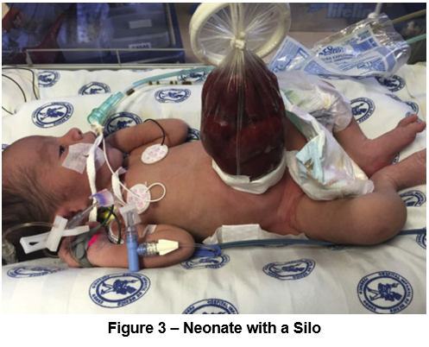
Figure 3 Newborn with a silo ⁽²²⁾

Post-Surgical Management

Nutrition
- Infants will require central access for TPN. This may be a peripherally inserted central catheter or a central venous catheter.
- Feeds are usually started in consultation with the surgeons once the gastric aspirates reduce to less than 40ml/kg/day.
- Feeds should be graded up carefully, paying attention to changes in volume of gastric aspirates (initially by 20ml/kg/day until well tolerated).
- Ideally infants receive the immunity benefit of small oral amounts of expressed breast milk even while nil by mouth.
- Expressed breast milk should be the preferred type of milk provided post operatively. If this is not available, consider using donor breastmilk whilst maternal lactation is being supported.
- Gastroschisis babies have significantly delay to feeding compared to normal babies. While the majority of cases will start feeds within 2 weeks, some can take much longer (even months), and may take a prolonged period to reach full oral feeds. Consider referral to speech pathology to support feeding development and a dietician referral to help optimise growth.

Probiotics
There is no evidence to support that probiotics are beneficial for infants with gastroschisis. There is evidence that they are well tolerated and there are randomised controlled trials that are ongoing with a view to answering this question ⁽²⁴⁾. Individual consultants may decide to start probiotics if they feel they may benefit specific infants.

Complications
- Abdominal compartment syndrome: This occurs when there is raised intra-abdominal pressure following bowel reduction. It presents as worsening respiratory distress, pain, decreased urine output and a distended abdomen. This may require further surgical management. Refer to Attachment 3 for bladder pressure monitoring.
- Prolonged gut dysmotility: Some infants can take a long period of time to tolerate enteral feeding.
- Short gut syndrome: Infants with complex gastroschisis may have gut atresia (these may not be diagnosed antenatally).
- Necrotising enterocolitis: This is more common in infants with surgical conditions. Prioritise the use of maternal expressed breast milk and consider using donor breastmilk when this is unavailable.

Prognosis
- The long-term prognosis for simple gastroschisis is excellent. In some cases of complex gastroschisis (particularly those complicated by short gut syndrome) there is significant long-term morbidity ⁽²⁵⁾.
Back to Contents

Section 3 – Exomphalos or Omphalocele

Background
Exomphalos or omphalocele is an abdominal wall defect at the base of the umbilical cord that is covered by a 3-layered sac (amnion, Wharton’s jelly and peritoneum). The vast majority are diagnosed antenatally on ultrasound after 12 weeks of gestation. The definition of a giant omphalocele varies ⁽²⁶⁾ but is usually defined as a defect greater than or equal to 5cm containing liver. Sometimes this is defined as an extra-abdominal liver volume greater than 50%. These are harder to manage operatively.
Omphalocele is associated with genetic abnormalities. Those that contain liver are less likely to be associated with aneuploidy, whereas those that only contain bowel are associated with aneuploidy 60 percent of the time ⁽²⁷⁾. Small defects are commonly associated with genetic abnormalities. Associations include:
- additional gastrointestinal abnormalities
- cardiac defects
- genitourinary abnormalities
- orofacial clefts
- neural tube defects
- diaphragmatic defects
- trisomy 13 or 18
- trisomy 21
- Turner’s syndrome
- triploidy
- Beckwith Wiedemann syndrome (15% liveborn cases) ⁽²⁶⁾.

Differential Diagnosis
- Gastroschisis - Some omphaloceles rupture in utero. The presence of an umbilical defect site and an extracorporeal liver suggest that it is an omphalocele. The presence of an intracorporeal liver and a paraumbilical defect suggest a gastroschisis.
- Umbilical cord hernia - An umbilical cord hernia inserts into the umbilical ring. An omphalocele inserts into a membranous sac.

Prenatal Management
Delivery route and timing are not usually altered by the presence of a small omphalocele. Large omphaloceles containing the liver may need to be delivered by caesarean section to avoid the risk of liver injury or rupture ⁽²⁶⁾. This will be decided by the fetal medicine and obstetric teams.

Delivery Room Management
Alert: Do not place gauze or saline on the bowel as gauze will adhere to the bowel and saline will increase heat loss.
- Perform neonatal resuscitation as per the Neonatal Resuscitation and Airway Management Guideline found on the Policy and Guidance Documents Register..
- Try to leave at least 10cm of umbilical cord. Umbilical catheters should not be inserted.
- Avoid using prolonged non-invasive positive pressure ventilation as this may worsen gut distention and make it harder to reduce bowel into the abdominal cavity. If prolonged positive pressure is required, consider early intubation and ventilation.
- Once the infant has transitioned and is stable, wrap the abdominal wall defect in polyethylene wrap:
  - Place the infant on a piece of polyethylene wrap large enough to wrap around the abdomen.
  - Wearing sterile gloves, wrap the polyethylene wrap around the abdomen, making sure the defect is not compressed and the bowel inside the defect remains pink.
- Monitor the bowel in the wall defect every 15 minutes to ensure it isn’t getting dusky. If the bowel becomes dusky unwrap the wrap and ensure there is no kinking or compression. If the bowel remains dusky alert the surgical team.
- Insert a NGT and aspirate the gastric contents. Record the volume of gastric aspirate.
- Support defect with bedding or roiled towel to prevent skin and bowel traction.

Pre-operative Management
Note: Refer to Attachment 4 – Checklist for Non-Ruptured Exomphalos and Attachment 5 – Checklist for Gastroschisis or Ruptured Exomphalos
The goals of treatment are to:
- Maintain a normal temperature.
- Protect the bowel and amnion. Keep the defect wrapped in polyethylene wrap until directed otherwise by the surgical team. Remain nil by mouth (NBM) (oral immune therapy with expressed breast milk is still allowed). Keep the bowel decompressed by inserting a NGT which should be aspirated 4 hourly and left on free drainage
- Careful fluid management - unless the omphalocele sac has ruptured start on the fluid intake required as per gestational age. Measure gastric aspirates and start replacing losses with 0.9% sodium chloride if greater than 20ml/kg/day of gastric aspirate. Measure and document urine output.
- Carefully examine the infant for other congenital abnormalities and monitor blood glucose levels regularly given the association with Beckwith Wiedemann syndrome.

Operative Repair
The type of operative repair is determined by the paediatric surgical team. It may be either ⁽²⁶⁾:
- Immediate surgical repair.
- Staged repair with delayed primary closure (usually as for gastroschisis involving the use of a silo).
- Delayed repair (paint and wait). This is a technique where the amnion is painted with an escharotic agent (Betadine® or Acticoat®) until the sac epithelializes. Closure is attempted when it is deemed that there is space within the abdomen for the contents of the omphalocele, sometimes years later. This is useful for infants with comorbidities who may not tolerate surgery, or for very large defects ⁽²⁸⁾.

Post-Operative Repair
This is much the same as that of a gastroschisis repair aside from the following:
- These infants can generally feed much quicker than those with gastroschisis as the bowel has not been exposed to the amniotic fluid. This will be guided by the infant’s feed tolerance and the surgical team.
- Infants need to be investigated for associated conditions and genetic defects including Beckwith Wiedemann syndrome. All infants with an omphalocele should have:
- A cardiac echocardiogram
  - Comparative Genomic Hybridization microarray analysis (CGH microarray) and methylation studies for Beckwith Wiedemann syndrome
- Renal ultrasound
- Careful physical examination including the palate and spine.

Prognosis
This is variable and depends on the size of the defect and associated syndromes/diagnoses.
Back to Contents

Section 4 – Congenital Diaphragmatic Hernia (CDH)

Background
CDH is a congenital malformation affecting approximately 1 in 3500 liveborn infants which consists of a defect allowing herniation of the abdominal contents into the thorax ^{(29,30)}. The majority are left sided (70-90 percent) ⁽³⁰⁾. Bilateral defects are rare and are associated with a poor prognosis ⁽³⁰⁾.

Antenatal Predictors
The degree of lung hypoplasia, the position of the liver and other co-existing anomalies determines the prognosis in CDH. The lung to head ration (LHR) is a marker of the degree of lung volume. A LHR less than 0.6 is often predictive of a poorer outcome and a LHR greater than 1.4 is predictive of survival ⁽³⁰⁾.

Timing of Delivery
- Encouragement to deliver at full term.
- Routine caesarean section is not recommended.

Delivery Room Management
- Perform neonatal resuscitation as per Neonatal Resuscitation and Airway Management Guideline found on the Policy and Guidance Documents Register.
- Early intubation and avoid bag-mask ventilation.
- Insert orogastric tube.
- Target preductal oxygen saturations greater than 85 percent.
- Aim for low pressure ventilation with Peak Inspiratory Pressure (PIP) less than 25 cmH20 and Positive End-Expiratory Pressure (PEEP) 3-5 cmH20.

On Admission
- Insert double lumen umbilical venous catheter (UVC) and umbilical arterial catheter (UAC). If unable to insert UAC to insert a right radial peripheral arterial line.
- Arterial blood gas, FBC (full blood count), NICP (neonatal intensive care profile), Coagulation profile, CGH array, cortisol.
- Aim for conventional ventilation with PIP less than 25 cmH20 and PEEP 3-5 cmH20 with tidal volumes of 4-5ml/kg.
- Consider High Frequency Oscillator Ventilation (HFOV) if PIP greater than 25 cmH20, pCO2 greater than 70 mmHg. Aim for Mean Airway Pressure (MAP) less than 15 cmH20, Hertz (Hz) 10 and Amplitude 30-50
- Pre and post ductal saturations and target preductal oxygen saturations greater than 85 percent.
- Target pH greater than 7.2, pCO2 50-70 mmHg, lactate less than 3
- Transcutaneous Carbon Dioxide Monitoring (TCM)
- Aim for urine output of greater than 1ml/kg/hr
- Correct any electrolyte or coagulation abnormalities.
- Sedate with morphine/fentanyl with/without Midazolam. Boluses may be required with handling.
- Chest and abdominal X-ray
- Perform an early Cardiac Clinician Performed Ultrasound (CCPU). See Figure 4 for management based on phenotype

Timing of Surgical Repair
- Surgical repair is performed following stabilisation of the pulmonary hypertension (PH), cardiac function, systemic circulation and ventilation.
- Mean Arterial Pressure (MAP) normal for gestation and off inotropes
- Pre ductal saturations greater than 85 percent with fraction of inspired oxygen (FiO₂) less than 50 percent and off inhaled nitric oxide
- Lactate less than 3
- Urine output greater than 2ml/kg/hr.

Complications
Infants with CDH can have a number of long-term complications. Respiratory complications include chronic lung disease, home oxygen, pulmonary hypertension and aspiration pneumonia. Gastrointestinal complications can include oral aversion, reflux and poor growth. Consider referral to dietician. Neurocognitive delays and behavioural disorders have also been noted, and all infants will require growth and development follow up on discharge. Hernia recurrence may also occur.

Follow-Up
- Referral to physiotherapists for hands on assessment as well as general movement assessment.
- Growth and development follow up at 3 months, 12 months and 24 months.
- Paediatric surgical follow up as requested.
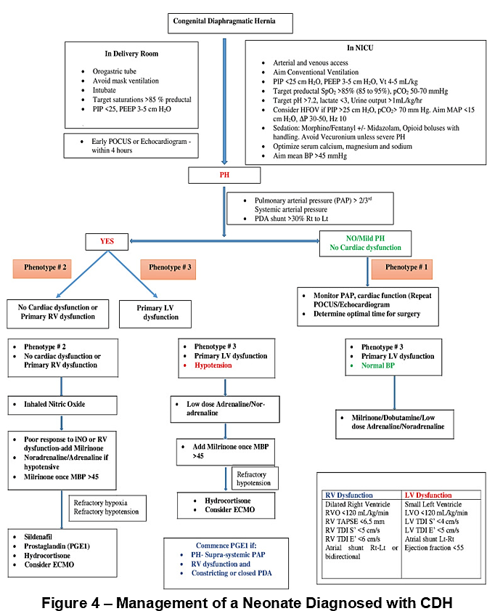
Figure 4 – Management of a neonate diagnosed with CDH (29)
Back to Contents

Section 5 – Bowel Washout Procedure (Neonates and Infants)
Note: This section is a guideline only and procedures may vary slightly from case to case, depending on the surgical and clinical variations of the patient.
Bowel washouts are performed to decompress the intestine and deflate the abdomen by removing gas and faeces through the action of flushing small amounts of fluids into the intestinal lumen. This procedure is used for rectal or distal stoma washouts.

Indications:
- To relieve low intestinal obstruction due to meconium plug, meconium ileus or intestinal dysmotility.
- To clean the distal portion of the bowel in cases of Hirschsprung disease. Bowel washouts are used as a mode of temporary management in proven cases of Hirschsprung disease until definitive surgery is performed, which may be performed in 4 to 12 weeks depending on each case.
- Preoperatively in some babies undergoing closure of stoma procedures.

Assessment
Alert: Green (bile) staining of vomit or nasogastric aspirate is indicative of bowel obstruction. If present notify the medical team immediately.
Assess and record any signs of bowel obstruction in the patient’s medical records. These include:
- vomiting or nasogastric aspirate. Note the frequency, colour, and amount. Is it bile stained?
- abdominal distension
  - is the abdomen tight or shiny?
  - describe degree of distension of the abdomen prior to performing bowel washout
- bowel movement
  - time since last bowel movement
  - note frequency, consistency, colour and presence of blood.

Equipment
- Personal Protective Equipment (PPE) (e.g., eye protection, gloves, gown)
- 60mL catheter tip syringe
- Sodium chloride 0.9% or other solution as prescribed
  - solution should be warmed prior to use
- Nelaton catheters (See Table 2 for catheter size guide)
  - soft catheters are less likely to damage mucosa (do not use NGT’s with weighted tips)
- Disposable tape measure
- Lubricating gel
- Kidney dish
- Disposable wipes
- Disposable absorbent pad “Blueys” or diaper
- Clinical waste receptacle.

Procedure
Alert: The solution most commonly used is sodium chloride 0.9%. The use of other solutions or concentrations in infants may be dangerous. The solution must be lukewarm to prevent colonic spasm. The infant may need regular monitoring of serum sodium as there is a risk of reabsorption, especially if most of the solution is not expelled, and especially in preterm infants.
- Medical orders for the bowel washout must be clearly documented on the patient’s care plan by the surgical team or neonatal team.
- Orders should be clearly documented and should include:
  - frequency
  - type, size, and length of catheter to be inserted (see Table 2 below)
  - type and volume of warmed solution to be used (sodium chloride 0.9% or other solution). Maximum per procedure is 20ml/kg
  - if N-acetylcysteine is required and what dose.
- Length of Catheter Insertion by Weight
Weight | Size (guide only- please refer to Paediatric surgeon notes) | Length to be inserted
Less than 2 kg | Size 8 FG Feeding tube or Nelaton | 2 – 3 cm
Greater than 2 kg | Size 8 FG Feeding tube or Nelaton | 5 cm

- Explain procedure and obtain parental consent prior to the procedure. Ensure that the consent is obtained before commencement.
- Observe ‘5 moments of Hand Hygiene’ throughout procedure as per Infection Prevention and Control Procedure.
- Provide comfort to the infant. Consider swaddling infant’s arms, consider giving oral sucrose or breastmilk, and consider pacifier for patient’s comfort.
- Don PPE as per Infection Prevention and Control Procedure.
- Position the infant on his/her back with legs in a frog-leg position on a clean nappy and disposable under-pad.
- Prime the catheter with warmed sodium chloride 0.9% or other solution as prescribed.
- Lubricate the tip of the catheter with lubricating gel.
- Take note of insertion depth of catheter using disposable tape measure as a guide.
- Gently insert catheter into rectum or distal stoma (See Table 2).
- Do not use excessive force if resistance is felt.
- Instil warmed solution in 10 –20 mL aliquots over 1-2 minutes. There should be no resistance while gently injecting the sodium chloride 0.9%.
- Do not pull back on syringe to aspirate. Allow the fluid and bowel contents to flow out naturally.
- Remove syringe and let fluid and bowel contents to flow into nappy or kidney dish.
- Repeat procedure until fluid return is clear of all faeces or all the bowel washout solution is used.
- Gently remove catheter and provide hygiene. Ensure the infant is left clean and comfortable.
- Discard all waste in appropriate receptacle.
- Document the results of bowel washout accurately on fluid balance chart and in the patient’s notes.
- Report and document any washout fluid retention and/or any other abnormal findings immediately to neonatal or surgical team.
- Watch for signs of increasing abdominal distension, tenderness, and any features suggestive of bowel perforation.
Back to Contents

Evaluation

Outcome
Infants born with either one or more of the following conditions will be cared according to best practice:
- OA
- TOF
- Gastroschisis
- Omphalocele.
- CDH

Measures
- Cases of infants with OA, TOF, gastroschisis, omphalocele and CDH admitted in the NICU will be audited yearly.
- Complex cases of infants with OA, TOF, gastroschisis, omphalocele and CDH will be reviewed through the Neonatal Morbidity and Mortality Meeting as required.
- Survival and morbidity statistics of infants with OA, TOF, gastroschisis, omphalocele and CDH admitted in the NICU will be reviewed annually
- Clinical Incident Reporting System (Riskman®) reports related to the management of infants with OA, TOF, gastroschisis, omphalocele and CDH will be reviewed yearly.
Back to Contents

Related policies, procedures, guidelines and legislation

Policies
- Nursing and Midwifery Board of Australia (NMBA) Requirements for Practice

Procedures
- Infection Prevention and Control
- Infection Prevention and Control – North Canberra Hospital (NCH)
- Stoma Management – Adults, Adolescents, Children, Infants, and Neonates
- Venous and Arterial Access Management in the Department of Neonatology
- Urine Collection in Neonates
- Ultrasounds and Echocardiograms in the Department of Neonatology - Neonates

Placeholder
- Neonatal Intensive Care Medication Guidance: Australian Neonatal Medicines Formulary (ANMF)

Guidelines
- Consent for Healthcare Treatment
- Patient Identification and Health Care Activity Matching
- Neonatal Nutrition Guide
- Total Parenteral Nutrition and Lipids (Neonates)
- Neonatal Routine Care
- Neonatal Resuscitation and Airway Management Guideline
- Respiratory Support – Invasive and Non-Invasive (Neonates and Infants)
- Birth Requiring the Presence of a Neonatal Team Member
- Neonatal Bacterial Sepsis
- Neonatal Jaundice
- Neonatal Hypoglycaemia
- Developmental Care for patients admitted to the Neonatal Intensive Care and Special Care Nursery
- Management of Neonatal Pneumothorax
- Neonatal Death, Bereavement, Palliative Care, and Borderline of Viability
- Persistent Pulmonary Hypertension of the Newborn and Inhaled Nitric Oxide Therapy (Neonates and Infants)
- Admission Guideline – Department of Neonatology
- MRI Preparation and Procedure (Neonates and Infants)
- Breastfeeding Guideline

Legislation
- Health Records (Privacy and Access) Act 1997
- Human Rights Act 2004
- Work Health and Safety Act 2011
- Carers Recognition Act 2021

Other
- Australian Charter of Healthcare Rights
Back to Contents

References
- Holland AJ, Fitzgerald DA. Oesophageal atresia and tracheo-oesophageal fistula: current management strategies and complications. Paediatr Respir Rev. 2010;11(2):100-106; quiz 106-107
- Hunt RW, Perkins EJ, King S. Peri-operative management of neonates with oesophageal atresia and tracheo-oesophageal fistula. Paediatr Respir Rev. 2016;19:3-9
- Oermann C RG, Hoppin A. Congential anomalies of the intrathoracic airways and tracheosophageal fistula. Waltham MA2020.
- Gauvin, Gabrielle et al. A unique presentation of a standard type C esophageal atresia in a very low-birth-weight neonate. Journal of Pediatr Surg. 2012;47(7):1460-1462
- Cuestas G, Rodriguez V, Millan C, Bellia Munzon P, Bellia Munzon G. H-type tracheoesophageal fistula in the neonatal period: Difficulties in diagnosis and different treatment approaches. A case series. Arch Argent Pediatr. 2020;118(1):56-60
- Shieh HF, Jennings RW. Long-gap esophageal atresia. Semin Pediatr Surg. 2017;26(2):72-77
- Baird R, Lal DR, Ricca RL, Diefenbach KA, Downard CD, Shelton J, et al. Management of long gap esophageal atresia: A systematic review and evidence-based guidelines from the APSA Outcomes and Evidence Based Practice Committee. J Pediatr Surg. 2019;54(4):675-687
- Shah PS, Gera P, Gollow IJ, Rao SC. Does continuous positive airway pressure for extubation in congenital tracheoesophageal fistula increase the risk of anastomotic leak? A retrospective cohort study. J Paediatr Child Health. 2016;52(7):710-714
- Mousa H, Krishnan U, Hassan M, Dall'Oglio L, Rosen R, Gottrand F, et al. How to Care for Patients with EA-TEF: The Known and the Unknown. Curr Gastroenterol Rep. 2017;19(12):65
- Shawyer AC, D'Souza J, Pemberton J, Flageole H. The management of postoperative reflux in congenital esophageal atresia-tracheoesophageal fistula: a systematic review. Pediatr Surg Int. 2014;30(10):987-996
- Teague WJ, Karpelowsky J. Surgical management of oesophageal atresia. Paediatr Respir Rev. 2016;19:10-15
- Mahoney L, Rosen R. Feeding Difficulties in Children with Esophageal Atresia. Paediatr Respir Rev. 2016;19:21-27
- Roberts K, Karpelowsky J, Fitzgerald DA, Soundappan SS. Outcomes of oesophageal atresia and tracheo-oesophageal fistula repair. J Paediatr Child Health. 2016;52(7):694-698
- Mawlana W, Zamiara P, Lane H, Marcon M, Lapidus-Krol E, Chiu PP, et al. Neurodevelopmental outcomes of infants with esophageal atresia and tracheoesophageal fistula. J Pediatr Surg. 2018;53(9):1651-1654
- Walker K, Loughran-Fowlds A, Halliday R, Badawi N, Stewart J, Holland AJ, et al. Developmental outcomes at three years of age of infants with esophageal atresia. J Pediatr Surg. 2016;51(2):249-251
- Conforti A, Morini F, Bagolan P. Difficult esophageal atresia: trick and treat. Semin Pediatr Surg. 2014;23(5):261-269
- Melov SJ, Tsang I, Cohen R, Badawi N, Walker K, Soundappan SSV, et al. Complexity of gastroschisis predicts outcome: epidemiology and experience in an Australian tertiary centre. BMC Pregnancy Childbirth. 2018;18(1):222
- Oakes MC, Porto M, Chung JH. Advances in prenatal and perinatal diagnosis and management of gastroschisis. Semin Pediatr Surg. 2018;27(5):289-299
- D'Antonio F, Virgone C, Rizzo G, Khalil A, Baud D, Cohen-Overbeek TE, et al. Prenatal Risk Factors and Outcomes in Gastroschisis: A Meta-Analysis. Pediatrics. 2015;136(1):e159-169
- Garcia L, Brizot M, Liao A, Silva MM, Tannuri AC, Zugaib M. Bowel dilation as a predictor of adverse outcome in isolated fetal gastroschisis. Prenat Diagn. 2010;30(10):964-969
- Alali JS, Tander B, Malleis J, Klein MD. Factors affecting the outcome in patients with gastroschisis: how important is immediate repair? Eur J Pediatr Surg. 2011;21(2):99-102
- Zalles-Vidal C, Penarrieta-Daher A, Bracho-Blanchet E, Ibarra-Rios D, Davila-Perez R, Villegas-Silva R, et al. A Gastroschisis bundle: effects of a quality improvement protocol on morbidity and mortality. J Pediatr Surg. 2018;53(11):2117-2122
- Witt RG, Zobel M, Padilla B, Lee H, MacKenzie TC, Vu L. Evaluation of Clinical Outcomes of Sutureless vs Sutured Closure Techniques in Gastroschisis Repair. JAMA Surg. 2019;154(1):33-39
- Rao S, Simmer K, Patole S. Probiotic supplementation in neonates with major gastrointestinal surgical conditions: a systematic review. J Matern Fetal Neonatal Med. 2018;31(11):1517-1523
- Amin R, Knezevich M, Lingongo M, Szabo A, Yin Z, Oldham KT, et al. Long-term Quality of Life in Neonatal Surgical Disease. Ann Surg. 2018;268(3):497-505
- Skarsgard ED. Immediate versus staged repair of omphaloceles. Semin Pediatr Surg. 2019;28(2):89-94
- Van Zalen-Sprock RM, Vugt JM, van Geijn HP. First-trimester sonography of physiological midgut herniation and early diagnosis of omphalocele. Prenat Diagn. 1997;17(6):511-518
- Wagner JP, Cusick RA. Paint and wait management of giant omphaloceles. Semin Pediatr Surg. 2019;28(2):95-100
- Chaudhari T, Schmidt Sotomayor N and Maheshwari R. Diagnosis, management and long-term cardiovascular outcomes of phenotypic profiles in pulmonary hypertension associated with congenital diaphragmatic hernia. Front. Pediatr. 2024;2:1356157
- Congenital Diaphragmatic Hernia - StatPearls - NCBI Bookshelf
- Ahamed N, Patchiannan K. Intra-Abdominal Pressure Monitoring. International Journal of Recent Surgical and Medical Sciences. 2023;9(1):S5-S10. doi:10.1055/s-0042-1743452
Back to Contents

Definition of terms
Acronym | Definition
ACS | Abdominal Compartment Syndrome
ALTE | Apparent Life‑Threatening Event (now termed BRUE)
BWS | Beckwith–Wiedemann Syndrome
BRUE | Brief Resolved Unexplained Event
CCPU | Clinician‑Performed Cardiac Ultrasound
CDH | Congenital Diaphragmatic Hernia
CHARGE | Coloboma, Heart defects, Atresia choanae, Retarded growth, Genital anomalies, Ear anomalies
CHS | Canberra Health Services
CPAP | Continuous Positive Airway Pressure
ΔP (Delta P) | Pressure amplitude used in HFOV
EABD | Extra‑Abdominal Bowel Dilatation
ECMO | Extracorporeal Membrane Oxygenation
EF | Ejection Fraction
ENT | Ear, Nose and Throat
ETT | Endotracheal Tube
GORD | Gastro‑Oesophageal Reflux Disease
HFOV | High‑Frequency Oscillatory Ventilation
Hz | Hertz (frequency of oscillation in HFOV)
IAP | Intra‑Abdominal Pressure
IDC | Indwelling Catheter
iNO | Inhaled Nitric Oxide
IV | Intravenous
LHR | Lung‑to‑Head Ratio
LVO | Left Ventricular Output
Lt–Rt | Left‑to‑right shunt
LV | Left Ventricle
MAP | Mean Airway Pressure / Mean Arterial Pressure
MBP | Mean Blood Pressure
NBM | Nil By Mouth
NCH | North Canberra Hospital
NGT | Nasogastric Tube
NICU | Neonatal Intensive Care Unit
OA | Oesophageal Atresia
OGT | Orogastric Tube
PAP | Pulmonary Arterial Pressure
PDA | Patent Ductus Arteriosus
PEEP | Positive End‑Expiratory Pressure
PGE1 | Prostaglandin E1
PH | Pulmonary Hypertension
PIP | Peak Inspiratory Pressure
pCO₂ | Partial Pressure of Carbon Dioxide
POCUS | Point‑of‑Care Ultrasound
pH | Measure of blood acidity/alkalinity
PPI | Proton Pump Inhibitor
RV | Right Ventricle
RVO | Right Ventricular Output
Rt–Lt | Right‑to‑left shunt
S’ (TDI S’) | Systolic velocity (Tissue Doppler Imaging)
SCN | Special Care Nursery
SpO₂ | Peripheral Oxygen Saturation
TAPSE | Tricuspid Annular Plane Systolic Excursion
TAT | Trans‑Anastomotic Tube
TBM | Tracheo‑Bronchomalacia
TDI | Tissue Doppler Imaging
TOF | Tracheo‑Oesophageal Fistula
TPN | Total Parenteral Nutrition
UAC | Umbilical Arterial Catheter
UVC | Umbilical Venous Catheter
VFSS | Video‑Fluoroscopic Swallow Study
Vt | Tidal Volume
Back to Contents

Search terms
NICU, TOF, Tracheoesophageal fistula, Oesophageal atresia, Gastroschisis, Omphalocele, Surgery, Congenital Diaphragmatic Hernia, CDH, Bowel Washout, Intra-abdominal Pressure, IAP, Bladder Pressure Monitoring, Neonate, Neonates, Newborn, Infant, Replogle Tube, Exomphalos, Neonatal Surgery, Surgery Neonates, north
Back to Contents

Attachments
Attachment 1 – Checklist for Oesophageal Atresia with/without Tracheoesophageal Fistula Management and Care
Attachment 2 – Replogle Tube Insertion and Management Procedure
Attachment 3 – Intra-abdominal or Bladder Pressure Monitoring Procedure
Attachment 4 – Checklist for Non-Ruptured Omphalocele
Attachment 5 – Checklist for Gastroschisis or ruptured Omphalocele

For Policy Team to complete:
Date amended | Section amended | Divisional approval | Final approval
19 January 2026 | Complete review | Katherine Wakefield, ED WY&C | CHS Policy Document Review Panel
This document supersedes the following:
Document number | Document name
CHS21/146 | Neonatal Surgery

Disclaimer
This document has been developed by Canberra Health Services specifically for its own use. Use of this document and any reliance on the information contained therein by any third party is at his or her own risk and Canberra Health Services assumes no responsibility whatsoever.
Back to Contents

Acknowledgement of Country  Canberra Health Services acknowledges the Ngunnawal people as traditional custodians of the ACT and recognises any other people or families with connection to the lands of the ACT and region. We acknowledge and respect their continuing culture and contribution to the life of this region.  © Australian Capital Territory, Canberra 2024 | Accessibility  call (02) 5124 0000   Interpreter call 131 450  canberrahealthservices.act.gov.au/accessibility  

Attachment 1 – Checklist for Oesophageal Atresia with/without Tracheoesophageal Fistula Management and Care
Pre-Operative Care
Management and Care Task | Attended (√)
Insert and management Replogle Tube as per Attachment 2 – Replogle Tube Insertion and Management Procedure
Nurse infant with head of the bed at 30-40 degrees
Observe for abdominal distension (there may be excessive abdominal distension from ventilation of the stomach through the distal fistula).
Maintain nil by mouth and fully monitored (can receive sucrose/expressed breast milk orally for analgesia).
Insert a cannula and send bloods for FBC, Coagulation Screen, Group and Hold, NICP, Blood Culture and a gas.
Start intravenous fluids depending on age at diagnosis and gestation (as per nutrition guideline).
Start IV antibiotics (penicillin and gentamicin).
Perform clinician performed ultrasound if able.
Immediate Post-Operative Care
Management and Care Task | Attended (√)
Receive handover from the surgical and anaesthetic teams and clarify post-operative instructions.
Perform a chest X-ray and check position of endotracheal tube, intercostal catheter and trans-anastomotic tube (TAT). Document these in the patient’s medical records.
Place replogle tube on continuous suction and check intended insertion depth with surgical team. Document this in the notes.
Alert: Do not advance the replogle tube. Do not suction beyond the length of the replogle tube as this could damage the anastomosis. Post-surgery, flush replogle tube with air only.
Perform post-operative pathology blood tests (i.e., blood gas, FBC and NICP) once stabilised on the ventilator for 1 hour.
Ensure the extra-pleural drain is secured and leave on free drainage.
Start Total Parenteral Nutrition as per Neonatal Nutrition and Total Parenteral Nutrition and Lipids (Neonates) Guidelines found in the Policy Register
Ensure adequate analgesia is prescribed and perform routine pain scoring.
Alert: Do not replace a transanastomotic tube (TAT) or NG tube post-operatively without discussion with the surgical team. If the TAT is accidentally dislodged, notify the surgeon immediately and do not replace a TAT or NG tube post-operatively without discussion with the surgical team.
Document in the notes:
Any concerns about the oesophageal anastomosis – does this infant need to be nursed with a flexed neck or muscle relaxed/deeply sedated?
Duration of NBM
Duration of antibiotics
Planned timing of starting feeds via the TAT

Ongoing Post-Operative Care
Management and Care Task | Attended (√)
Start feeds via the TAT as guided by the surgical team.
Start a proton pump inhibitor once on feeds.
Clarify timing of contrast study with the surgical team.
Ensure ongoing adequate analgesia.
Complete VACTERL screen including:
Spine X-ray
CCPU and referral for formal ECHO with cardiology
Renal/Spine ultrasound
Discharge Planning
Management and Care Task | Attended (√)
Refer to the physiotherapy team for general movements assessment.
Arrange growth and development follow up on discharge.
Surgical follow up on discharge.
Paediatric follow up on discharge.
Back to Contents

Attachment 2 – Replogle Tube Insertion and Management Procedure

Equipment
- Hand Hygiene Equipment
- Personal Protective Equipment (e.g., gloves, google, and gown)
- Appropriately sized Replogle Tube
- Replogle tube size based on weight
Weight | Replogle Tube Size (Fr)
Less than 2.5 kg | 8 Fr
Greater than or equal to 2.5 kg | 10 Fr
- Duoderm
- Luekoplast Brown Tape
- 2-3 ml Slip Tip Syringe
- 10ml 0.9% Sodium Chloride Ampoule
- Suction Tubing
- Wall Suction with Regulator
- Non-pharmacological pain relief (i.e., dummy, sucrose, swaddling)

Procedure
- Attend to Hand Hygiene.
- Identify correct patient and inform parent/guardian of procedure.
- Prepare equipment.
- Provide appropriate non-pharmacological pain relief.
- Apply appropriately sized duoderm onto infant’s chin.
- Gently insert the replogle tube over the tongue until resistance is felt in the upper pouch of the oesophagus.
- Withdraw the tube 0.5cm so the tip of the tube is not in contact with the end of oesophageal pouch. This is important to prevent trauma during aspiration and suction.
- Connect a syringe to the tube and gently aspirate pouch contents.
- Secure the replogle tube with tapes. Skin must be free of undue pressure.
- Document the tube size and insertion depth in the patient’s medical record.
- Connect tubing to the wall suction and gently increase the suction to achieve a flow of secretions through the tube, suction pressure should not exceed 5Kpa.
  - Inform the medical team if higher pressure is required to achieve the flow of secretions. There must be a continuous flickering movement of fluid within the tube.
- Keep the replogle tube on continuous suction.
- Flush with 0.5 ml of 0.9% sodium chloride every 15 minutes and observe the tube.
  - The 0.9% sodium chloride should be drained back up the replogle tube.
  - If not, check tube patency. Remove syringe after each flush as leaving syringe attached will block the air vent.
  - Extra flushes may be needed if the replogle tube shows signs of blockage. If the replogle tube appears blocked or the infant requires oral suctioning, flush the replogle tube with 1ml of air followed by 1ml of 0.9% sodium chloride if the 1ml of air does not unblock the tube.
  - If a replogle tube is still blocked, remove the tube and flush with 0.9% sodium chloride until it is patent. Reinsert the tube.
- Ensure that an additional replogle tube of the same size is kept at the patient’s bedside as the tube may have to be replaced in case of severe blockage.
- Check replogle tube position and suction pressure hourly.

DHR Documentation
- Attach Replogle tube to patient’s Avatar and complete insertion details. Select the ordered flush frequency and volume.
- In the Fluid Balance (SCN/NICU) Flowsheet, the replogle tube should now appear with an input and output row. Document all flushes in these rows.
Back to Contents

Attachment 3 – Intra-abdominal or Bladder Pressure Monitoring Procedure

Background
Abdominal Compartment Syndrome (ACS) is a pathological condition where intra-abdominal pressure (IAP) is consistently greater than 20mmHg for a prolonged period of time leading to multiorgan dysfunction and/or failure. IAP is the pressure within the abdominal cavity. ACS can be caused by:
- major fluid resuscitation
- severe gut oedema
- intra or retro-peritoneal bleeding
- post-abdominal surgery.
Untreated elevated IAP can cause significant cardiac, pulmonary, renal, gastrointestinal, and hepatic impairments.
Intra-abdominal or Bladder Pressure Monitoring is a reliable method of measuring IAP and can assist clinical staff in monitoring, preventing, and managing ACS. It requires an indwelling urinary catheter (IDC) to be inserted into the bladder and connected to a pressure transducer and monitoring system.

Indications
- Post-abdominal Surgery
- Congenital Diaphragmatic Hernia
- Gastroschisis
- Omphalocele
- Abdominal Perforation related to Necrotising Enterocolitis

Management
- IAP should be kept less than 12mmHg. See table below for management of IAP in the post-operative period based on the measured pressure.
- Measured Intra-abdominal Pressure and Management
Intra-abdominal Pressure | Management
Greater than 20mmHg | Requires muscle relaxant and surgical consult
15 – 20mmHg | Increase muscle relaxant and sedation
Less than 15mmHg | Heavy sedation
Less than 10mmHg | Cease pressure monitoring but keep sedation
- Renal Function must be assessed in conjunction with IAP monitoring and urine output must be closely monitored
  - IAP greater than 15mmHg may impair renal function and raised IAP with reduced urine output requires appropriate and timely intervention. For the medical management of IAP greater than or equal to 12mmHg, see Figure 5 below.
- IAP monitoring is required for short period of time and removed 5 days post-operation or as per Medical Officer order.

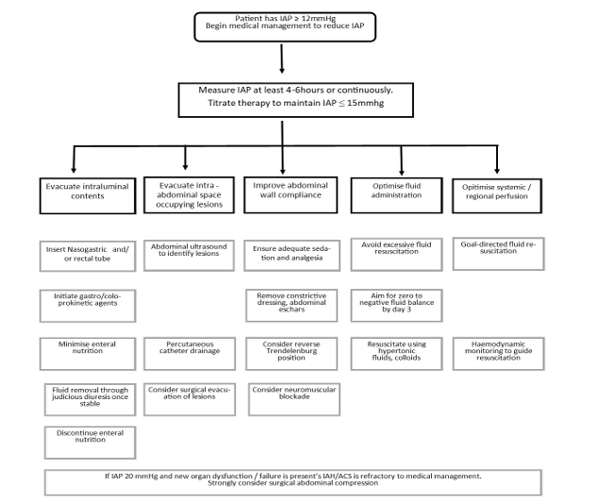
Figure 5 – Management for raised Intra-abdominal Pressure ⁽³¹⁾

Equipment
- Sterile gloves
- Monitoring Device with invasive pressure (IBP) monitoring capabilities (e.g., Phillips Monitor with IBP cable)
- IV trolley
- Sterile Dressing Pack
- Disposable Transducer Monitoring Kit
- Size 6F Foleys Catheter
- Three-Way Tap
- 50ml IV syringe
- Drawing Up Needle
- IV Extension Line
- 50mls of 0.9% sodium chloride solution
- Syringe Driver
- IV infusion label
- Indwelling Catheter Line Label
- Duoderm
- Mefix Tape
- Steri-Strips
- Sterile Scissors
- Gel Lubricant
- Chlorhexidine 0.1% Antiseptic Solution
- Gauze Squares
- Sterile Drape
- Paediatric Urine Meter
- Chest drain clamp

Procedure

Set Up
- Prime Transducer Monitoring Kit.
- Draw up 50mls of 0.9% sodium chloride solution with drawing up needle into a 50ml IV Syringe and connect to IV extension line.
  - Connect extension line to Transducer Monitoring Kit via distal port (closest to transducer). See figure 6.
Note: If using the arterial line transducer monitoring kit make sure to remove the sampling syringe with port (red) to distinguish IAP transducer from arterial blood pressure transducer. Ensure to label lines clearly.
- Attach three-way tap to end of transducer extension line.
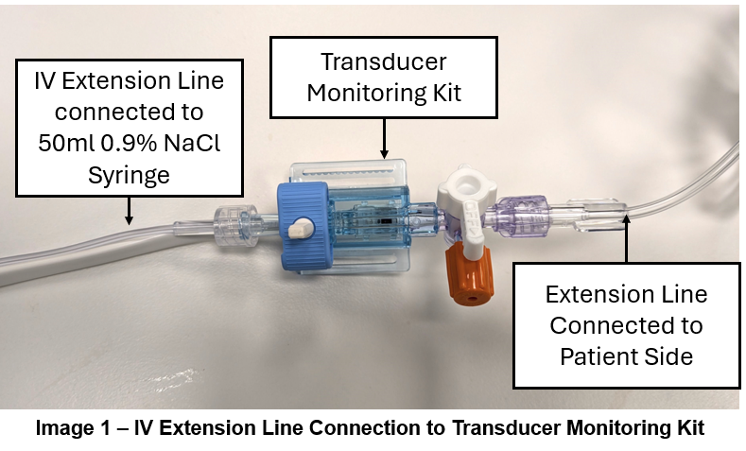
- Prime transducer monitoring kit and three-way tap with 0.9% sodium chloride.
Figure 6 – IV extension line connection to transducer monitoring kit
- Attach three-way tap to urine bag sample port. See figure 7. Turn three-way tap OFF from transducer to patient.
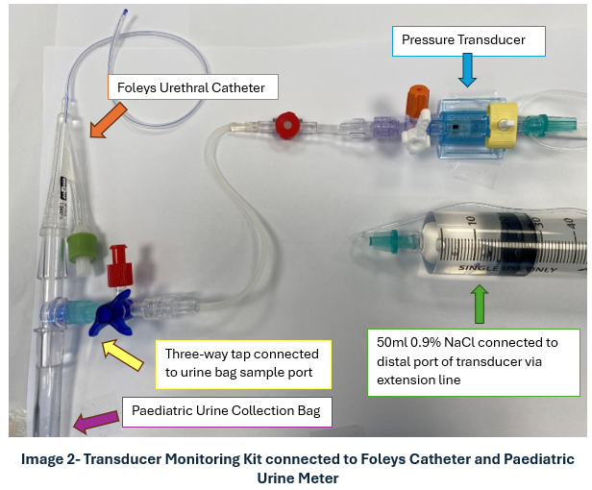
Figure 7 – Transducer Monitoring Kit connected to Foleys Catheter and Paediatric Urine Meter
- Attach Foleys catheter to paediatric urine collection bag.
- Insert and secure Foley catheter as per Urine Collection in Neonates Procedure.
- Connect transducer monitoring kit to IBP monitoring cable and monitoring device.
  - Label pressure measured as IAP to distinguish from blood pressure on monitoring device.
- Align transducer to the level of the symphysis pubis and zero for calibration.
- Document procedure and IDC in patient digital medical records.
- Label lines clearly.
- 0.9% NaCl and Syringe should be changed 24 hourly. The transducer should be changed every 72 hours.

Measurement of IAP
- IAP monitoring to be done every 4 hours or as per Medical Officer order
- Ensure transducer is aligned with symphysis pubis and zero for calibration
- Turn three-way tap ON from transducer kit to patient
- Clamp urine meter tubing below urine bag sample port. See figure 8.
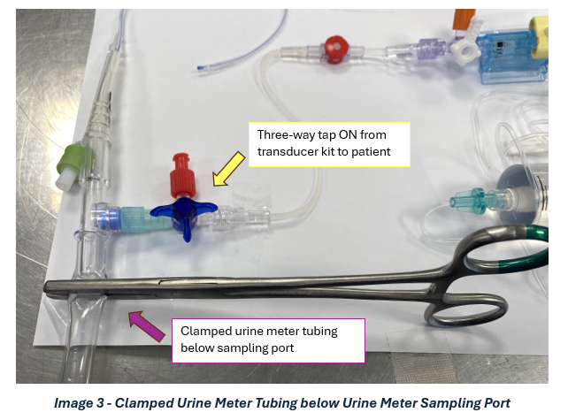
Figure 8 – Clamped Urine Meter Tubing below Urine Meter Sampling Port
- Slowly fill bladder with 1ml/kg (Volume to be Infused (VTBI)) of 0.9% sodium chloride using syringe pump set to an infusion rate of 20ml/hr.
- Once VTBI administered and bladder is filled, change infusion rate to 1ml/hr.
- Allow 1 minute for reading to stabilise on monitoring device.
- Read and document pressure displayed as mmHg.
- Turn off syringe pump.
- Turn three-way tap OFF from transducer to patient. Remove clamp from urine meter tubing. Allow fluid to free flow to urine meter.

Digital Health Record (DHR) Documentation
Intra-abdominal Pressure Measurement
- Attach IDC or urethral catheter to Avatar.
- In NICU/SCN Comprehensive Care Flowsheet, add Bladder/Intra-abdominal Pressure row. This should now appear under OTHER.
- Document IAP measured in generated Bladder/Intra-Abdominal Pressure Row.
Input and Output when monitoring IAP
- When attending to an IAP measurement, document the VTBI required to fill bladder in Intake Row in Other and specifically documenting in the comments as “IAP measurement”.
- Document Output as per volume collected from IDC as per MO.
Back to Contents

Attachment 4 – Checklist for Non-Ruptured Omphalocele
Pre-Operative Care
Management and Care Task | Attended (√)
Ensure continuous cardio-respiratory monitoring and normothermia.
Aspirate the NGT as required at least 4-hourly leaving it on free drainage between aspiration.
Document the volume of gastric aspirate and urine output on the fluid chart.
Insert a PIVC and start the newborn on 60ml/kg of 10% dextrose or TPN or gestation specific total fluid intake. See Neonatal Nutrition and Total Parenteral Nutrition and Lipids (Neonates) Guidelines found in the Policy Register.
If greater than 20ml/kg/day of gastric aspirate is obtained from the stomach, replace ongoing gastric losses with 0.9% sodium chloride aiming to keep the newborn euvolemic.
Send pathology request and obtain blood for Full Blood Count, Coagulation screen, blood cultures, blood gas and blood group and hold.
Monitor blood glucose levels given the association with Beckwith Wiedemann syndrome.
Inspect the bowel through the polyethylene wrap every 15 minutes.
Alert: If there are concerns about bowel perfusion check the wrap is not putting pressure on the bowel. If the poor perfusion persists alert the surgical team.
Post-Operative NICU Management
Management and Care Task | Attended (√)
Receive handover from the surgical and anaesthetic team and clarify the surgical teams’ post-operative recommendations.
If the newborn is ventilated confirm the position of the ETT with a chest Xray. Perform a gas 1 hour after they have been stabilised on our ventilator.
Continue to aspirate the NGT regularly as per the surgical team.
Maintain NBM (newborns may receive immune benefit from small amounts of expressed breast milk).
Record the NGT aspirate volume, urine output and fluid balance.
Start TPN either via a peripheral intravenous cannula or central venous line.
Replace gastric losses of more than 20ml/kg/day with 0.9% sodium chloride over 4 hours
Perform a gas and NICP 4 hours following the procedure
Monitor for signs or symptoms of abdominal compartment syndrome. This includes:
- Intra-abdominal Pressure greater than 12mmHg. Inform Medical Officer immediately. See Attachment 3.
- Tense and distended abdomen
- Abdominal discoloration
- Respiratory compromise
- Worsening metabolic acidosis
- Hypotension
- Poor urine output
- Increasing pain
Alert: If these occur, the infant needs to be medically reviewed urgently and discussed with the fellow/consultant on call.
Provide analgesia as required.
Infants with a silo who are ventilated will require an intravenous opiate infusion and ensure that regular pain scoring is taking place.
Support maternal lactation.
Once the bowel is reduced and gastric aspirates are less than 40ml/kg/day consider starting enteral feeds (EBM or donor breast milk) in consultation with the surgical team.
Screening for associated genetic conditions and syndromes including:
Cardiac echocardiogram
CGH microarray
Methylation studies for Beckwith Wiedemann
Careful physical examination including the palate and spine looking for associated congenital and genetic abnormalities.
Discharge Planning
Management and Care Task | Attended (√)
Refer to the physiotherapy team for general movements assessment.
Arrange growth and development follow up on discharge.
Surgical follow up on discharge.
Cardiology follow up if not arranged during in-patient stay
Paediatric follow up on discharge.
Back to Contents

Attachment 5 - Checklist for Gastroschisis or Ruptured Omphalocele
Pre-Operative Care
Management and Care Task | Attended (√)
Ensure continuous monitoring and normothermia, and regular blood pressure measurement.
Aspirate the NGT every 15 minutes leaving it on free drainage between aspirations.
Document the volume of gastric aspirate and urine output on the fluid chart.
Insert a peripheral intravenous cannula (PIVC) and start the infant on 80ml/kg of 10% dextrose or TPN
Consider a higher volume if preterm i.e. 20ml/kg more than the usual starting total fluid intake as per the Neonatal Nutrition guideline).
Replace gastric losses mililitres (ml) by ml with 0.9% sodium chloride
Send pathology request and obtain blood for Full Blood Count, Coagulation screen, NICP, blood cultures, gas and group and hold.
Start IV antibiotics.
Inspect the bowel through the polyethylene wrap every 15 minutes.
Alert: If there are concerns about bowel perfusion check that the wrap is not putting pressure on the bowel. If the poor perfusion persists alert the surgical team.
NICU Management of Ward Reduction for Gastrochisis
Management and Care Task | Attended (√)
If using the NICU theatre room warm it to 25 degrees.
This procedure may be performed at the infant’s bedside.
Place the infant on an open care system, fully monitored and check their temperature.
Perform a ‘time out’ and ensure the surgical team have parental consent for the procedure.
Place the infant on a large absorbent sheet to absorb losses and irrigation fluid.
Continue to aspirate the NGT 15 minutely.
Administer IV paracetamol prior to starting the procedure.
Ensure that intubation equipment, suction and a Neopuff® are available and in working order prior to starting the procedure.
Prepare IV morphine boluses for analgesia during the procedure as required.
Confirm that the equipment required is available for the surgical team.
Immediate Post-Operative NICU Management
Management and Care Task | Attended (√)
If the infant returns from operating theatre, receive handover from the surgical and anaesthetic team and clarify the teams’ post-operative recommendations.
If the infant is ventilated confirm the position of the ETT with a chest X ray and perform a blood gas 1 hour after they have been stabilised on the ventilator.
Continue to aspirate the NGT regularly as per the surgical team.
Maintain Nil by Mouth.
Note: Infants may receive immune benefit from small amounts of expressed breast milk for mouth care
Record the NGT aspirate volume, urine output and fluid balance in the patient’s medical record
Start TPN either via a PIVC or central venous line.
Replace gastric losses greater than 20ml/kg/day with 0.9% sodium chloride over 4 hours.
Perform blood gas and NICP 4 hours following the procedure.
Monitor for signs or symptoms of abdominal compartment syndrome. This includes:
- Intra-abdominal Pressure greater than 12mmHg. Inform Medical Officer immediately. See Attachment 3.
- Tense and distended abdomen
- Abdominal discoloration
- Respiratory compromise
- Worsening metabolic acidosis
- Hypotension
- Poor urine output
- Increasing pain
Alert: If these occur the infant needs to be medically reviewed urgently and discussed with the fellow/consultant on call.
Provide analgesia as required.
Infants with a silo who are ventilated will require an intravenous opiate infusion and ensure that regular pain scoring is taking place.
Support maternal lactation.
Once the bowel is reduced and gastric aspirates are less than 40ml/kg/day consider starting enteral feeds (EBM or donor breast milk) in consultation with the surgical team.
Note: Infants with gastroschisis have significant delay to feeding compared to normal infants. While many cases will start feeds within 2 weeks, some can take much longer, even months, and may take a prolonged period to reach full oral feeds
Discharge Planning
Management and Care Task | Attended (√)
Refer all infants with gastroschisis to the physiotherapy team for general movements assessment.
Arrange growth and development follow up on discharge.
Surgical follow up on discharge.
Paediatric follow up on discharge.
Back to Contents

