Canberra Health Services
Clinical Guideline
Neonatal Bacterial Sepsis

Contents

Contents 1
Guideline Statement 2
Scope 2
Section 1 – Introduction 3
Section 2 – Early Onset Sepsis (EOS) 4
Section 3 – Late Onset Sepsis (LOS) in the NICU 8
Section 4 – Late onset sepsis in term newborns/term corrected newborns presenting via the Emergency Department (ED) or via the Mid-call midwives 10
Evaluation 10
Related Policies, Procedures, Guidelines and Legislation 11
References 11
Definition of Terms 13
Search Terms 13
Attachments 13
Attachment 1: Flow chart for management of suspected early onset sepsis in term and late preterm (≥34 weeks gestation) newborns in NICU/SCN/PNW/ANW/Birth Suite/Birth Centre/OT 15
Attachment 2: Flow chart for newborns at risk of early onset sepsis <34 weeks in the NICU 16
Attachment 3: Newborns attending ED or via the community midwives with suspected late onset sepsis (<28 days of age or ex-premature infants 44 weeks corrected gestational age) 17

Guideline Statement

Background
Neonates and young infants are at high risk of severe bacterial infections with significant associated morbidity and mortality. Symptoms of early onset bacterial sepsis are often non-specific; therefore, a high index of suspicion is warranted. Due to the non-specific presentation of severe bacterial infection in neonates, initial treatment is empiric (i.e., covering a range of likely bacteria). There is a lower threshold for intervention in preterm neonates than in term infants (see attachments).

Key Objective
This document provides information and algorithms (please see attachments) to support the timely diagnosis and treatment of sepsis in newborn infants. Other objectives are to rationalise the use of antibiotics in suspected early onset sepsis and encourage the cessation of antibiotics in well infants at 36 hours post blood culture being taken, when there is a low clinical suspicion of infection.

Alerts
- Antibiotics should be given within an hour of birth or diagnosis of suspected sepsis.
- Ensure when prescribing antimicrobials that the Antimicrobial Stewardship Procedure is considered and followed.

Back to Table of Contents

Scope

This clinical guideline applies to newborns (<28 days or 44 weeks corrected gestational age if preterm) at risk of sepsis or presenting with suspected sepsis in:
- Neonatal Intensive Care (NICU) or Special Care Nursery (SCN)
- Birth Suite, Birth Centre, or Operating Theatre (OT)
- Postnatal and antenatal wards
- Via the emergency department/community midwives.

This document also applies to the following Canberra Health Services (CHS) staff working within their scope of practice:
- Medical Officers.
- Registered Nurses and Midwifes.
- Student Nurses and Midwifes working under supervision.

Back to Table of Contents

Section 1 – Introduction

Neonatal sepsis is classified according to the infant's age at the onset of symptoms. For the purposes of this guideline early and late onset sepsis are defined as:
- Early-onset sepsis is defined as the onset of symptoms occurring within the first 72 hours of life.
- Late-onset sepsis is defined as the onset of symptoms at ≥72 hours of life.

At CHS, there are four clinical scenarios for suspected sepsis that present in the newborn period, each requiring a slightly different approach (See Attachments 1-3):
- Newborns ≥34 weeks gestation with suspected early onset sepsis (Attachment 1).
- Newborns <34 weeks gestation with suspected early onset sepsis (Attachment 2).
- Preterm/Term newborns with suspected late onset sepsis in the NICU/SCN.
- Term or ex-preterm newborns with suspected late onset sepsis presenting via the emergency department or via the community midwives (Attachment 3).

Blood investigations for sepsis

Blood cultures:
Blood cultures should be taken prior to starting antibiotics. However, if intravenous access is difficult to obtain in the setting of septic shock, antibiotics should not be delayed for a blood culture to be taken.

At least 1 ml of blood should be collected (even for extremely low birth weight infants) as this improves the diagnostic yield of the test 2 fold⁽¹⁾.

Full Blood Count (FBC):
Neutrophilia, neutropenia, thrombocytopenia, and abnormal immature/total neutrophil ratio (I/T ratio) are all associated with bacterial infection but are not individually sensitive or specific enough to prove or exclude an infection. An I/T ratio is the ratio of immature to mature neutrophils and is calculated as follows: immature neutrophils (promyelocytes + myelocytes+ metamyelocytes + bands)/total number of neutrophils (mature + immature). The I/T ratio is a measure of the immature neutrophil count and it is suggestive of neonatal sepsis when the value is ≥0.2 (with a sensitivity of 70-75% and positive predictive value of 55%). ⁽²⁻³⁾. An I/T ratio <0.2 has a high negative predictive value (93.4%) for sepsis⁽²⁻³⁾.

Acute phase reactants:
There are several acute phase reactants that are being studied to assist in better diagnosing and monitoring neonatal sepsis. C-reactive protein (CRP) has been shown to have a low sensitivity early in the course of infection, which improves 24-48 hours after the onset of symptoms⁽⁴⁾. In the Department of Neonatology, it is recommended to send a CRP at the onset of infective symptoms and a repeat CRP again 12 -24 hours later. Two normal CRP levels taken initially 8-24 hours after birth (first CRP level) and again 24 hours later (second CRP level) have a negative predictive value of 99.7% for culture proven sepsis⁽⁵⁾. There are reference ranges for a normal CRP in both term and preterm newborns that depend on age ⁽⁶⁾. In general, a CRP of <10 mg/L is <95th percentile in a population of term and preterm infants ⁽⁶⁾.

Administration of antibiotics
Antibiotics should be given as soon as possible, and definitely within 1 hour of birth or 1 hour from when the decision to treat the newborn for suspected sepsis is made. The duration of treatment depends on the clinical picture and blood culture results and is at the discretion of the treating neonatologist. There is evidence to support that blood cultures positive for pathogens are positive by 36 hours ⁽¹²⁾. Whenever possible, antibiotics should be ceased after 36 hours if blood cultures remain negative, the baby is clinically well, the clinical suspicion of infection is low and inflammatory markers are reassuring ⁽⁸⁾.

Back to Table of Contents

Section 2 – Early Onset Sepsis (EOS)

Early-onset infection is usually due to vertical transmission^{(17, 18)}. Only around half of infants who develop EOS are symptomatic at birth ⁽⁷⁾. Well newborns ≥34 weeks gestation who have risk factors for sepsis require 4-hourly monitoring of physiologic parameters (heart rate, temperature, blood pressure, oxygen saturation and clinical status), in the 12 hours following birth (see Attachment 1). Preterm newborns (<34 weeks) or clinically unwell newborns with suspected sepsis require pre-emptive treatment (see Attachment 2).
The goal is to start antibiotics within an hour of delivery or from when the decision to treat is made.

Common Causative Organisms of EOS
- Group B streptococcus (GBS, Streptococcus agalactiae)
- Escherichia coli
- Haemophilus influenzae
- Listeria monocytogenes
- Other organisms are Staphylococcus aureus, Klebsiella sp, other enteric gram-negative bacteria

Figure 1: Causative bacteria for early onset sepsis at Canberra Health Services (CHS) between July 2017 and June 2021 (organisms detected in a total of 13 positive blood cultures)

Risk Factors for EOS
An infant is considered at risk for early onset neonatal sepsis if any of the following apply: ^{(7,16)}
- Evidence of clinical chorioamnionitis (abnormal maternal observations: temperature ≥38⁰C, HR > 100/min, uterine tenderness, foul smelling vaginal discharge, rising CRP or white blood cell count, and fetal heart rate >160 bpm).
- Preterm labour at <37 weeks’ gestation.
- Preterm prelabour rupture of membranes (PPROM).
- Prolonged rupture of membranes ≥18 hours at term (PROM).
- Mother carries Group B Streptococcus (GBS): GBS bacteriuria at any stage during pregnancy; previous GBS infected baby; known GBS carriage as per antenatal swab who has not received adequate antibiotic cover in labour (defined as antibiotics given >4 hours prior to birth).
- Evidence of infection in sibling in case of multiple pregnancy.
- Maternal sepsis during labour or within 24 hours of delivery.

Term and late preterm newborns at risk of early onset sepsis need close monitoring of physiological and physical parameters for the first 24-48 hours of age even if asymptomatic. Please refer to “Early Onset GBS Disease” guideline, Neonatal Early Warning Score (NEWS) charts and “Prelabour Rupture of Membranes (PROM)” guidelines for duration of in-patient observation.

Sepsis Calculator (https://neonatalsepsiscalculator.kaiserpermanente.org)
A multivariate risk prediction tool has been developed that allows clinicians to estimate the risk of EOS taking clinical risk factors into account ⁽⁹⁾. This tool has been validated in clinical practice ⁽⁷⁾ and has been shown to reduce antibiotic use and blood tests in infants 34 weeks gestation and older without increasing morbidity or mortality. It can be used in newborns from 34 weeks gestation (see Attachment 1). Our local incidence of EOS for the purpose of calculator used is 0.6/1000 live births. The criteria used for assessing clinical signs for the calculator are outlined below. Please refer to Attachment 1.

Well appearing | Normal vital signs, well appearing newborn.  No persistent physiologic abnormalities.
Equivocal | Persistent (≥4 hours) abnormal vital signs:  - HR≥160/min  - RR≥60/min  - temperature instability (≥38⁰C or ≤36.4⁰C)  - increased work of breathing (grunting, flaring, or retracting) not requiring supplemental oxygen  Or  Two or more of the above abnormal vital signs lasting ≥2 hours  Note: abnormality can be intermittent
Clinical illness | Persistent abnormalities:  - persistent need for continuous positive airway pressure (CPAP) /High flow nasal cannula (HFNC)/mechanical ventilation (outside of the delivery room)  - hemodynamic instability requiring vasoactive drugs  - Neonatal encephalopathy/Perinatal depression (Seizures or Apgar <5 at 5 minutes)  - Need for supplemental oxygen >2 hours to maintain oxygen saturations > 90% (outside of the delivery room)

Interpretation of the sepsis calculator
The sepsis calculator is a tool that calculates a risk of infection according to risk factors at birth and clinical signs at the moment of assessment. This tool generates an EOS risk (probability of infection per 1000 live births), for each of the three clinical scenarios above (well appearing, equivocal and clinical illness).
Each EOS risk factor has a designated colour that gives a clinical recommendation. The three colours with the respective clinical recommendation are:

Colour | Clinical recommendation
Green | To observe (no bloods, no antibiotics)
Yellow/Amber | To collect blood tests (Blood Culture, CRP and FBC)
Red | To start empiric antibiotics (and collect blood tests: Blood culture, CRP and FBC)
Note:
In the specific case of a term neonate admitted in the NICU on CPAP with non-oxygen requirements; OR when there is quickly weaning to air within the first hour of commencing CPAP; AND without risk factors for EOS (see risk factors listed above) AND when the most likely diagnosis (after clinical assessment +/- Chest X Ray or lung ultrasound) is transient tachypnoea of the newborn, the fellow/consultant on service may decide not to start empiric antibiotics or may delay this decision and observe the baby, despite the recommendation provided by the sepsis calculator.
Note:
In the Department of Neonatology, the interpretation of the “Yellow/Amber” recommendation includes collecting blood culture and CRP and FBC. The aim is to check these results as soon they are available and make the decision to either start antibiotics or continue to observe/monitor the baby. In the case that antibiotics are not started, the results of the blood culture must be chased before the baby is discharged.

The interpretation of the “Red” recommendation includes taking and sending blood culture, FBC and CRP and then starting antibiotic treatment.

Empiric antibiotic choice for early onset sepsis

First line | IV Benzylpenicillin and IV Gentamicin  (If a mother is known to be colonised with or infected by a pathogen that is not sensitive to this regimen an alternative may need to be used/discussed with infectious diseases/microbiology)
First line if risk factors AND high suspicion of infection | IV Benzylpenicillin and IV Amikacin  Risk factors: Travel to a developing country/hospitalisation in a developing country in the past year. Known maternal colonisation with multi-resistant Gram-negative organisms (if Amikacin sensitive)
Severe sepsis/septic shock | IV Meropenem and IV Vancomycin

Please note that if it is known that a mother is colonised with a specific pathogen, empiric therapy for her newborn may need to be modified to cover for that organism in addition to usual pathogens. Please refer to Attachments 1 and 2 for suggested antibiotics.

Back to Table of Contents

Section 3 – Late Onset Sepsis (LOS) in the NICU

Late onset sepsis occurs in 4.3% of newborns admitted to level III Neonatal Intensive Care Units in Australia and New Zealand in 2019⁽¹⁰⁾ and is more common with decreasing gestational age. In the 2019 Australia and New Zealand Neonatal Network dataset, 34.4% of babies born <24 weeks, 26.7% of babies born at 24-25 weeks and 13% of babies born at 26-27 weeks developed late onset sepsis (defined as a sepsis at ≥48 hours after birth) ⁽¹⁰⁾. By far the most common organism associated with LOS in premature infants is Coagulase-Negative Staphylococci (CoNS).

Common Causative Organisms

Figure 2: Causative organisms for late onset sepsis at Canberra Health Services (CHS) between July 2017 and June 2021 (organisms detected in a total of 62 positive blood cultures)

Risk factors
- Prolonged hospitalisation due to any reason (e.g., prematurity, very low birth weight (VLBW), etc.).
- Delayed enteral feeding/prolonged central line usage.
- Mechanical ventilation.
- Presence of foreign bodies (e.g., intravenous catheter, central lines, drains-urinary/chest).
- Multiple invasive procedures.
- Malformations (e.g., urinary tract anomalies).
- Mother colonised with GBS.

Signs and symptoms
The signs and symptoms of late onset sepsis are often very non-specific. It is important to consider sepsis whenever there is a change in the clinical status of a vulnerable newborn infant in the NICU.

Investigations
- Blood tests: FBC, CRP, blood gas, blood glucose, blood culture.
- Also consider (if clinically indicated) chest X-ray; abdominal X-ray; urine microscopy and culture; endotracheal aspirate culture and skin swabs.
- Lumbar puncture should be performed at the discretion of the treating neonatologist ⁽¹¹⁾. This should be considered:
- When there is a pathogen isolated on blood culture (23% of bacteraemic newborns may have meningitis).
- When there are clinical signs or symptoms of meningitis or encephalitis (37% of newborns with meningitis have sterile blood cultures).
- When there is a strong clinical suspicion of sepsis with raised inflammatory markers despite a negative blood culture.
- When there is a newborn with positive surface swab for Herpes Simplex Virus (HSV); or a newborn of a mother with primary (genital or systemic) HSV infection close to delivery; or a newborn born through birth canal with active HSV disease to a mother without previous history of genital HSV; or a newborn with clinical signs of neonatal HSV disease (regardless of maternal history).
- When a patient is worsening despite antibiotic treatment.

Antibiotics in LOS in the NICU (source unknown)
This antibiotic recommendation is for empiric therapy when the source of the infection is unknown. If the source is known it may be appropriate to use a different antibiotic regimen (i.e., if treating pneumonia, meningitis, a Urinary Tract Infection (UTI) or Necrotising enterocolitis (NEC). Consider what organisms the infant/mother are colonised with, when making decisions about empiric therapy. This should be discussed with the treating neonatologist.

The duration of treatment depends on the clinical picture and blood culture results and is at the discretion of the treating neonatologist. There is evidence to support that blood cultures positive for pathogens are positive by 36 hours ⁽¹²⁾. Whenever possible antibiotics should be ceased after 36 hours if blood cultures remain negative, the infant is well, the clinical suspicion of infection is low and inflammatory markers are reassuring⁽⁸⁾.

Empiric antibiotic choice for late onset sepsis

First line | IV Flucloxacillin and IV Gentamicin  Consider alternatives based on previous blood culture results or sensitivity patterns for the patient or mother
First line if risk factors AND high suspicion of infection | IV Flucloxacillin and IV Amikacin  Risk factors: Travel to a developing country /hospitalisation in a developing country in the past year. Known maternal colonisation with multi-resistant Gram-negative organisms (if Amikacin sensitive)
Severe sepsis/septic shock | IV Meropenem and IV Vancomycin

Back to Table of Contents

Section 4 – Late onset sepsis in term newborns/term corrected newborns presenting via the Emergency Department (ED) or via the Mid-call midwives

Newborns presenting from the community via the ED, the Mid-call midwives, or community nurses, who are unwell with suspected sepsis should be readmitted to paediatrics or NICU depending on their age and on the severity of their symptoms. These infants should not routinely be readmitted to the postnatal ward (unless this has been discussed with the neonatologist on call) as the postnatal ward is not able to provide the necessary monitoring for a newborn with suspected sepsis. If a neonate presents directly to the ward with suspected sepsis the neonatology registrar is responsible for making a timely assessment of their condition, discussing them with the neonatologist on call and referring them to paediatrics/NICU or ED depending on their clinical condition. Please refer to Attachment 3 for a suggested approach to assessment and management of this patient group.

Back to Table of Contents

Evaluation

Outcome
- Neonates and infants, who present with symptoms of sepsis get timely diagnosis
- Patients receive appropriate treatment and management in relation to EOS and LOS
- Staff are aware of the differences between EOS and LOS and are informed and educated on the management and treatment of septic patients
- Use and interpretation of the sepsis calculator is initiated correctly and that governance systems are followed for effective and rapid treatment of patients

Measures
- Yearly audit and monitoring of percentage of antibiotic use in neonates after applying neonatal sepsis calculator tool.
- Audit of all cases of central line associated blood stream infections (CLABSI) causing late onset sepsis in neonates, every 6 months via Neonatal Morbidity and Mortality Meetings.
- Audit of data of all cases of early and late onset sepsis in neonates in the neonatology department, every 3 months via Neonatal Morbidity and Mortality Meetings.
- Audit and review of all cases of neonatal death associated with early or late onset sepsis via monthly Neonatal Morbidity and Mortality Meetings.
- Audit of neonatal mortality associated with early and late onset sepsis in the Department of Neonatology via monthly via monthly Neonatal Morbidity and Mortality Meetings.

Back to Table of Contents

Related Policies, Procedures, Guidelines and Legislation

Policies
- Nursing and Midwifery Continuing Competence Policy
- Informed Consent-Clinical

Guidelines
- Pre-labour Rupture of Membranes (PROM) Management at Term
- Preterm Pre-labour Rupture Membranes (PPROM)
- Early Onset Group B Streptococcus Disease (EOGBSD) (Maternity)

Procedure
- Venepuncture Blood Specimen Collection
- Venous and Arterial Access: Management in the Department of Neonatology

Legislation
- Health Records (Privacy and Access) Act 1997
- Human Rights Act 2004
- Work and Safety Act 2011

Back to Table of Contents

References

1. Connell TG, Rele M, Cowley D, Buttery JP, Curtis N. How reliable is a negative blood culture result? Volume of blood submitted for culture in routine practice in a children's hospital. Pediatrics. 2007;119(5):891-6.
2. Lloyd BW, Oto A. Normal values for mature and immature neutrophils in very preterm babies. Arch Dis Child. 1982;57(3):233-5.
3. Schelonka RL, Yoder BA, desJardins SE, Hall RB, Butler J. Peripheral leukocyte count and leukocyte indexes in healthy newborn term infants. J Pediatr. 1994;125(4):603-6.
4. Hofer N, Zacharias E, Muller W, Resch B. An update on the use of C-reactive protein in early-onset neonatal sepsis: current insights and new tasks. Neonatology. 2012;102(1):25-36.
5. Benitz WE, Han MY, Madan A, Ramachandra P. Serial serum C-reactive protein levels in the diagnosis of neonatal infection. Pediatrics. 1998;102(4):E41.
6. Chiesa C, Natale F, Pascone R et al, C-reactive protein and procalcitonin: Reference intervals for preterm and term newborns during the early neonatal period, Clinica Chimica Acta 412 (2011) 1053–1059
7. Kuzniewicz MW, Puopolo KM, Fischer A, Walsh EM, Li S, Newman TB, et al. A Quantitative, Risk-Based Approach to the Management of Neonatal Early-Onset Sepsis. JAMA Pediatr. 2017;171(4):365-71.
8. National Institute of Clinical Excellence, Neonatal infection (early onset): antibiotics for prevention and treatment, August 2012 accessed https://www.nice.org.uk/guidance/cg149/chapter/1-Guidance#risk-factors-for-infection-and-clinical-indicators-of-possible-infection-2 on 01/08/2017..
9. Puopolo KM, Draper D, Wi S, Newman TB, Zupancic J, Lieberman E, et al. Estimating the probability of neonatal early-onset infection on the basis of maternal risk factors. Pediatrics. 2011;128(5):e1155-63.
10. Chow S.S.W, Creighton P, Chambers G, Lui K. Report of the Australian and New Zealand Neonatal Network 2019, accessed from:
https://anznn.net/annualreports
11. Polin RA, Committee on F, Newborn. Management of neonates with suspected or proven early-onset bacterial sepsis. Pediatrics. 2012;129(5):1006-15.
12. Janjindamai W, Phetpisal S. Time to positivity of blood culture in newborn infants. Southeast Asian J Trop Med Public Health. 2006;37(1):171-6.
13. Goldstein B, Giroir B, Randolph A, International Consensus Conference on Pediatrics. International pediatric sepsis consensus conference: definitions for sepsis and organ dysfunction in pediatrics. Pediatr Crit Care Med. 2005;6(1):2-8.
14. NSW Clinical Excellence Commission, Sepsis kills Newborn Sepsis Pathway accessed from http://www.cec.health.nsw.gov.au/__data/assets/pdf_file/0009/292194/Newborn-Sepsis-Pathway-December-2016.pdf on the 06/09/2017.
15. NSW health guideline: Maternity - Maternal Group B Streptococcus (GBS) and the Minimisation of Neonatal Early - Onset GBS Sepsis, January 2017, accessed from:
https://www1.health.nsw.gov.au/pds/ActivePDSDocuments/GL2017_002.pdf
16. Puopolo K, Lynfield R, Cummings J. Management of Infants at risk for Grroup B Streptococcal Disease. Pediatrics 2019, Aug; 144 (2): e20191881.
17. Puopolo K, Benitz W, Zaoutis T. Management of Noenates Born at ≥35 0/7 weeks’ Gestation with Suspected or Proven Early- Onset Bacterial Sepsis. Pediatrics 2018, Dec; 142; (6): e20182894.
18. Puopolo K, Benitz W, Zaoutis T. Management of Noenates Born at ≤ 34 6/7 weeks’ Gestation with Suspected or Proven Early- Onset Bacterial Sepsis. Pediatrics 2018, Dec; 142; (6): e20182896.
19. Kuzniewicz MW, Walsh EM, Li S, Fischer A, Escobar GJ. Development and Implementation of an Early-Onset Sepsis Calculator to Guide Antibiotic Management in Late Preterm and Term Neonates. Jt Comm J Qual Patient Saf. 2016 May;42(5):232-9.
20. Escobar GJ, Puopolo KM, Wi S, Turk BJ, Kuzniewicz MW, Walsh EM, Newman TB, Zupancic J, Lieberman E, Draper D. Stratification of risk of early-onset sepsis in newborns > 34 weeks' gestation. Pediatrics. 2014 Jan;133(1):30-6. doi: 10.1542/peds.2013-1689.

Back to Table of Contents

Definition of Terms

These definitions have been adapted from the International paediatric sepsis consensus conference: Definitions for sepsis and organ dysfunction in paediatrics.⁽¹³⁾

Systemic inflammatory response syndrome (SIRS):
Two of following abnormalities (need either temperature instability or WCC to be one criteria):
- Abnormal white cell count or immature/total neutrophil ratio (I/T)
- Temperature >38.5⁰C of <36⁰C
- Tachycardia/bradycardia
- Tachypnoea.

Infection: Positive culture from a sterile site or clinical symptoms of infection.

Sepsis: Systemic Inflammatory Response Syndrome (SIRS) and proven or suspected infection.

Severe sepsis: Sepsis and evidence of organ dysfunction.

Septic shock: Sepsis with cardiovascular organ dysfunction leading to inadequate tissue perfusion.

Back to Table of Contents

Search Terms

Neonatology, Sepsis, Infection, Neonate, GBS, PROM, PPROM, Fever, Sepsis calculator, Neonatal, Early Onset Sepsis, EOS, Late Onset Sepsis, LOS, Prolonged Rupture of Membranes, Febrile neonate, Febrile, Infant, Septic infant.

Back to Table of Contents

Attachments

Attachment 1. Flow chart for management of suspected early onset sepsis in term and late preterm (From 34 weeks gestation) newborns in Postnatal Ward (/NICU/SCN
Attachment 2. Flow chart for management of preterm infants at risk of EOS in the NICU

Attachment 3. Newborns attending ED or via the community midwives with suspected late onset sepsis (<28 days of age or ex-premature infants <28 days corrected gestational age) – adapted from the NSW Clinical Excellence Commission sepsis kills pathway⁽¹³⁾

Back to Table of Contents

Disclaimer: This document has been developed by Canberra Health Services specifically for its own use. Use of this document and any reliance on the information contained therein by any third party is at his or her own risk and Canberra Health Services assumes no responsibility whatsoever.

Policy Team ONLY to complete the following:
Date Amended | Section Amended | Divisional Approval | Final Approval
17 December 2021 | Complete Review | Boon Lim, A/g ED-WY&C | CHS Policy Committee

This document supersedes the following:
Document Number | Document Name
CHHS18/056 | Neonatal Bacterial Sepsis

Attachment 1: Flow chart for management of suspected early onset sepsis in term and late preterm (≥34 weeks gestation) newborns in NICU/SCN/PNW/ANW/Birth Suite/Birth Centre/OT
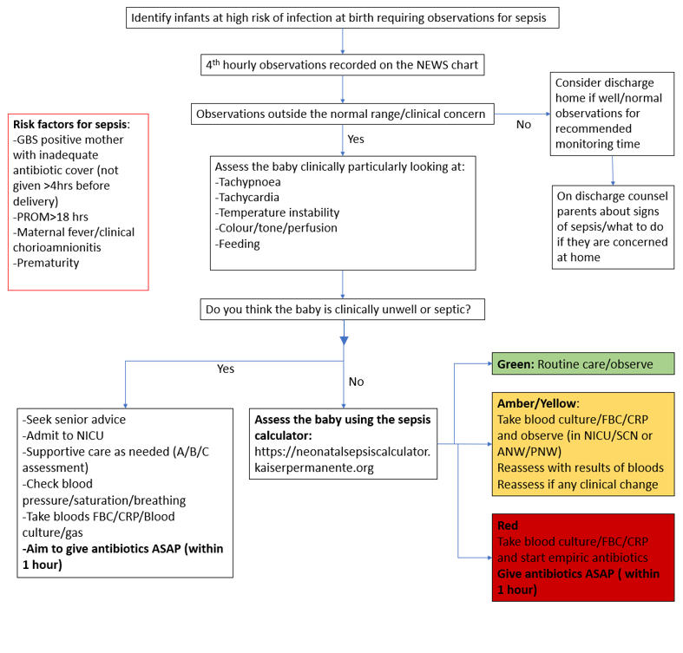
Empiric antibiotic treatment
First line | IV Benzylpenicillin AND IV Gentamicin  (If a mother is known to be colonised with or infected by a pathogen that is not sensitive to this regimen an alternative may need to be used/discussed with infectious diseases/microbiology)
First line IF risk factors AND high suspicion of infection | IV Benzylpenicillin AND IV Amikacin  Risk factors: Travel to a developing country/hospitalisation in a developing country in the past year. Known maternal colonisation with multi-resistant Gram-negative organisms (if Amikacin sensitive)
Severe sepsis/septic shock | IV Meropenem and IV Vancomycin

Attachment 2: Flow chart for newborns at risk of early onset sepsis <34 weeks in the NICU

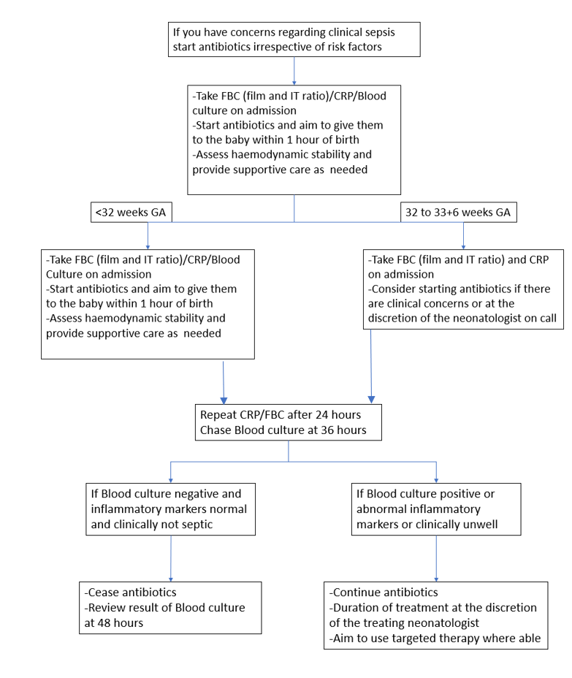
Empiric antibiotic treatment
First line | IV Benzylpenicillin AND IV Gentamicin  (If a mother is known to be colonised with or infected by a pathogen that is not sensitive to this regimen an alternative may need to be used/discussed with infectious diseases/microbiology)
First line IF risk factors AND high suspicion of infection | IV Benzylpenicillin AND IV Amikacin  Risk factors: Travel to a developing country/hospitalisation in a developing country in the past year. Known maternal colonisation with multi-resistant Gram-negative organisms (if Amikacin sensitive)
Severe sepsis/septic shock | IV Meropenem and IV Vancomycin

Attachment 3: Newborns attending ED or via the community midwives with suspected late onset sepsis (<28 days of age or ex-premature infants 44 weeks corrected gestational age)

Adapted from the NSW Clinical Excellence Commission sepsis kills pathway
