Canberra Health Services
Procedure
Medication Fridge Temperature Monitoring

Contents

Contents 1
Purpose 2
Alerts 2
Scope 2
Section 1 – Importance of Maintaining Cold Chain 3
Section 2 - Procurement and Maintenance of Medication Fridges 3
Section 3 – Transportation of Refrigerated Medicines 5
Section 4 – Storing Refrigerated Medicines in Patient Care Areas 6
Section 5 – Wi-Fi Monitoring of Medication Fridges 7
Section 6 – Manual Medication Fridge Monitoring 16
Section 7 – Health Protection Service Vaccines 20
Section 8 – Useful Contacts 21
Evaluation 22
Related Policies, Procedures, Guidelines and Legislation 22
Definition of Terms 23
Search Terms 23
Attachments 23

Purpose

This document outlines the procedure to be followed for:
- monitoring the temperature of medication fridges across Canberra Health Services (CHS)
- monitoring the temperature of medication freezers in the Pharmacy Department of CHS
- recording the temperature of medication fridges which are not currently Wi-Fi temperature monitored
- identifying and managing a temperature excursion to prevent harm caused to patients and to minimise economic losses for the organisation, and
- procuring a new medication fridge for a patient care area.

Back to Table of Contents

Alerts

- Most medication fridges in CHS are monitored centrally via Wi-Fi connection. Information is stored on a server and accessed via a software program called Vision.
- In patient care areas where Wi-Fi monitoring is in place, there is no need for staff to manually monitor medication fridges or reset the temperature display of the fridge using the buttons on the controller at the front of the fridge. Note that special requirements apply where vaccinations provided by Health Protection Services are stored in the fridge - see Vaccine Cold Chain Management Procedure.
- If Wi-Fi monitoring is interrupted, patient care areas will be notified by the Pharmacy Department or the Canberra Hospital After Hours Hospital Managers. In this instance manual monitoring is to resume using the Medication Fridge Manual Monitoring Recording Form – Appendix 1.
- There are some areas of Canberra Health Service that are not covered by Wi-Fi internet connection. These areas are required to manually document the temperature of medication fridges twice a day by recording these temperatures on the Medication Fridge Manual Monitoring Recording Form – Appendix 1.
- In the event of a temperature excursion, a Riskman is to be completed by the Clinical Nurse Consultant (CNC), Clinical Midwife Consultant (CMC) or other team leader of the patient care area.
- Medication Fridge Temperature Excursion Pack replacement kits can be obtained from the Medication Safety Team by emailing medicationsafetypharmacist@act.gov.au or ext. 47204 during 8.30am to 4.30pm Monday to Friday.

Back to Table of Contents

Scope

This document relates to temperature monitoring of medicines in medication fridges and freezers across CHS.

This document applies to all staff involved in:
- supply, storage and administration of medicines which need to be stored under refrigerated conditions (e.g., pharmacists, pharmacy staff, nursing and midwifery staff)
- transportation of refrigerated medicines from pharmacy to patient care areas (e.g., central equipment courier service)
- maintenance of medication fridges and freezers (e.g., Facilities and Asset Management)
- maintaining the technical features of Wi-Fi monitoring of medication fridges.

Back to Table of Contents

Section 1 – Importance of Maintaining Cold Chain

A significant proportion of medicines need to be stored between 2 and 8 degrees Celsius to ensure they maintain clinical efficacy, to preserve shelf life, or to prevent degradation into potentially toxic breakdown products.

To guarantee the integrity of these refrigerated items and ensure patient safety, storage temperatures must be monitored at all stages of the cold chain. When storage conditions fall outside of the recommended range, it is important that appropriate action is taken to confirm the viability of the stock and dispose of non-viable stock to prevent it from being administered to a patient. Maintaining the cold chain supports CHS to provide safe and effective treatment to patients.

Acknowledging the importance of maintaining cold chain in the provision of safe and effective treatment to patients, the Medication Safety Committee has oversight of the monitoring of medication fridges across CHS.

Back to Table of Contents

Section 2 - Procurement and Maintenance of Medication Fridges

Section 2.1 - Procurement of Medication Fridges
Purpose built medication grade fridges of a suitable size to accommodate the anticipated volume of stock should be used across CHS. Wherever possible, a medication fridge with a glass, self-closing door and illumination is preferred to allow for easier stock selection prior to opening the medication fridge door. Consultation with a Canberra Hospital Facilities refrigeration mechanic regarding selection of an appropriate fridge is suggested. The cost of procuring a medication fridge is to be sourced from the division’s budget.

To ensure that new medication fridges are accounted for and monitored via Wi-Fi connection, new medication fridges must:
- be purchased via CHS Procurement Services
- be asset tagged
  - Contact Facilities Management, Asset Management section: FMassetmanagement@act.gov.au or
CHS.FM@act.gov.au ext. 48033.
  - They will provide you with the FM Asset Register Template to complete and forward through to the email address above.
  - Note if the cost of the medication fridge is greater than $5,000, an additional asset tag will also be affixed to the fridge to ensure the fridge is captured on the financial asset register for depreciation purposes.

Section 2.2 - Procurement of Wi-Fi temperature monitoring tags
To ensure that new medication fridges are accounted for and their temperature monitored via Wi-Fi connection, new medication fridges must:
- have Wi-Fi temperature monitoring installed and
- have a Medication Fridge Temperature Excursion Pack (Appendix 2) place on the front or side of the fridge.

Contact the Medication Safety Team to arrange purchase of a Wi-Fi temperature monitoring tag 02 5124 3835 or ext. 43835 or email Medicationsafetypharmacist@act.gov.au

Section 2.3 - Maintenance of Medication Fridges
Requesting a refrigeration mechanic to service your medication fridge can be done through MyFM. The Facilities Management (FM) technician will respond to the work order request during business hours.

Out of business hours, the FM technician will respond to alarms of fridge fault generated by the Building Management System (BMS) - a computer generated alert delivered via Switchboard 24 hours a day. The alarm from the BMS is independent of alerts generated by Wi-Fi temperature monitoring tags.

Not all medication fridges are linked to the BMS. Medication fridges on Canberra Hospital Campus that are on the BMS contain high-cost and/or high-risk medicines, these fridges include:
- Emergency Department Clinical Forensic Medicine Unit Medication Fridge B12 L2
- Emergency Department Fast Track Medication Fridge B12 L2 Fridge 1
- Immunology Medication Fridge B19 L2 Rm69
- Medical Oncology Clean Utility Medication Fridge B19 L4 Rm104
- Occupational Medicine Unit Vaccine Fridge B15 L1 Rm41
- Oncology Pharmacy Cool Room B19 L3
- Pharmacy Cool Room B1 L2
- Forensic Medicine Unit B12 L2
- Intensive Care Unit B12 L3
- Ward 9A Neurology Medication Fridge B1 L9
- Ward 14A Medication fridge B3 L2

Medication Fridges connected to the BMS at University of Canberra Hospital include
- Inpatient Unit
- Adult Mental Health Rehabilitation Unit
- Clinical Education Research Centre
- Brindabella
- Pharmacy Medication Fridge and Freezer

Section 2.4 - Maintenance of Wi-Fi temperature monitoring tags
The Wi-Fi tags, associated temperature monitoring probes and software that receives and stores information from the tags is maintained by the Medication Safety Team.

The Medication Safety Team:
- ensure accurate data within Vision for reporting and alerting functions
- monitor battery levels of Wi-Fi tags and replace them when they reach 20% capacity or earlier if needed
- ensure that new and existing Wi-Fi tags and probes are matched and calibrated against a reference thermometer certified by the National Association of Testing Authorities (NATA)
- Calibrate, maintain Wi-Fi tags and maintain propylene glycol bottles.

For queries relating to Wi-Fi tag and temperature probes contact the Medication Safety Team: 02 5124 7204, Fridge Lab on 02 5124 3835, or medicationsafetypharmacist@act.gov.au Monday to Friday (8:30 am to 4:30 pm).

Back to Table of Contents

Section 3 – Transportation of Refrigerated Medicines

Cold chain must be maintained for medicines that are transported from the Pharmacy Departments (based at Canberra Hospital and University of Canberra Hospital) to patient care areas.

Section 3.1 - Dispensed medicines
Refrigerated medicines that have been dispensed to individual patients will have a blue alert sticker (see image below for sample) placed on the product near the dispensing label to alert staff that the medicine is to be stored in the fridge.

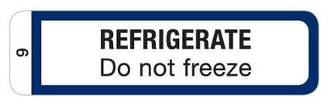

When the dispensed medicine is released by the pharmacist in the dispensary, it will be placed in a silver foil bag to create a visual alert that the medicine is a fridge line (see image below for sample). Note that these bags are not insulating, and the medicine must be stored inside a fridge.

All bags containing refrigerated medicines will be stored in a fridge within pharmacy until delivery rounds. At delivery rounds the central equipment and courier service will accept the refrigerated medicines and place them into an esky containing an ice brick. The medicines will be transported to the patient care area and placed in the medication fridge in the medication room within 90 minutes of leaving the pharmacy to ensure cold chain is maintained.

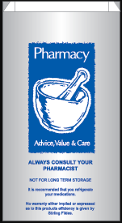

Section 3.2 - Imprest medicines
Imprest medicines are delivered from the pharmacy to the patient care area by pharmacy technicians. To maintain the cold chain, these medicines will be transported from the pharmacy to patient care areas in an esky containing an ice brick and unpacked into the medication fridge in the medication room. Empty eskies and ice bricks are then returned to the pharmacy by the technician.

Back to Table of Contents

Section 4 – Storing Refrigerated Medicines in Patient Care Areas

To reduce the risk of selection error, medicines are to be stored inside the fridge in manufacturers’ packaging or the packaging provided by the Pharmacy Department. Loose strips of tablets or individual ampoules or vials are not to be stored.
Food, nutritional supplements, and blood products must not be stored in medication fridges. They are to be stored in a separate fridge.

Note that blood and blood products can only be stored in a NATA (AS 364.2-2012) accredited fridge. Refer to ‘Fresh Blood Administration Procedure’ for more detail.

Back to Table of Contents

Section 5 – Wi-Fi Monitoring of Medication Fridges

Section 5.1 - Scope of Wi-Fi
All medication fridges in CHS that are covered by Wi-Fi connection will be monitored in real time via a centralised process. In patient care areas where Wi-Fi monitoring is in place there is no need for staff to manually monitor medication fridges or reset the maximum/minimum values on the fridge controller/display.

Note that medication fridges that contain vaccines belonging to the Health Protection Service must have the temperature checked and recorded manually twice daily – refer to Section 7.1 - Monitoring the temperature of Health Protections Service Stock.

If the Wi-Fi monitoring of a fridge is interrupted, the pharmacist and After-Hours Hospital Managers (AHHMs) are notified through a text message alert. In this instance, the patient care area will be contacted and asked to revert to manual monitoring of their medication fridge until it is rectified. Refer to Section 6 for details on manual monitoring.

Section 5.2 – Monitoring Medication Fridges via Wi-Fi
Wi-Fi temperature monitoring tags enable central, real-time, and consistent monitoring of medication fridge temperatures via the Vision database (known from here as ‘Vision’). This monitoring system measures product temperature (by a temperature probe immersed in a bottle of propylene glycol) and is a better reflection of medicine temperature than air temperature (which is reported on the front of the fridge).

With the central monitoring of most CHS medication fridges via Vision, real-time remediation of potential (or actual) temperature excursions is possible. Vision provides a dashboard of data from all active temperature tags, generates alerts sent to a mobile phone of impending and actual temperature excursions and has a log of all events (see Section ‘Definition of terms’ for definitions of ‘alert’ and ‘event’).

Section 5.3 – Responsibilities for responding to alerts and events from Vision
The Pharmacy Department and the After-Hours Hospital Managers (AHHMs) at the Canberra Hospital share responsibility for monitoring medication fridges and ensuring that alerts generated by Vision are appropriately responded to.

- The Canberra Hospital Pharmacy Department (From 8.30am to 4.30pm each day including weekends and public holidays) and
- The Canberra Hospital After Hours Hospital Managers (From 4.30pm to 8.00am each day including weekends and public holidays)

Section 5.4 - Reporting Requirements
Acknowledging the importance of maintaining cold chain in the provision of safe and effective treatment to patients, the Medication Safety Committee has oversight of the monitoring of medication fridges across CHS.

The Medication Safety Team will provide a monthly report to the Medication Safety Committee for their consideration. This report will:
- summarise all temperature excursions that have been notified through Vision
- provide details of the action taken in response to the temperature excursion (as comments entered into Vision by Pharmacy staff or AHHMs)
- provide the number of near misses where an alert regarding an impending temperature excursion had been generated, but temperature excursion was avoided

Section 5.5 - Process for Wi-Fi Monitoring of Medication Fridges by Pharmacy Department/AHHMs

Section 5.5.1 - Materials required
- Vision Database (http://10.254.100.12:8660/index.html) and log on credentials (note: Pharmacy, AHHM and Facilities Management have log on capabilities)
- Pharmacy Fridge Mobile Phone (0466 810 594) or After-Hours Hospital Manager Mobile Phone (available via Switchboard)
- Medication Fridge Temperature Excursion Pack attached to medication fridge, containing:
  - CNC Flow Chart for Responding to a medication fridge alert
  - “Medication Fridge Out of Order” signage
  - stickers to mark stock affected by temperature excursion
  - quarantine signage to segregate affected stock
  - Medication Fridge Temperature Excursions Standard Recording Form to record details of medicines affected by a temperature excursion so that pharmacy can investigate if the medicines are safe to be used
  - useful contact numbers and contact people
  - Medication Fridge Manual Monitoring Recording Form to use if Wi-Fi monitoring is not available (Appendix 1).

Medication Fridge Temperature Excursion Pack replacement kits can be obtained from the Medication Safety Team by emailing medicationsafetypharmacist@act.gov.au or phoning the Fridge Lab ext. 43835 during business hours.

Section 5.5.2 - Procedure
The monitoring of medication fridge temperatures and documentation of the response to alerts and events is shared between:
- the Canberra Hospital Pharmacy Department (From 8.30am to 4.30pm each day including weekends and public holidays) and
- the Canberra Hospital After Hours Hospital Managers (From 4.30pm to 8.00am each day including weekends and public holidays)

Section 5.5.3 - SMS Alerts of impending temperature excursions identified via Wi-Fi monitoring
- When a medication fridge temperature reaches 2.5 or 7 degrees Celsius (before it is out of range) an SMS is sent to both the Pharmacy Fridge Mobile Phone and the AHHM’s Mobile Phone. The time of day (see above) will dictate who responds to the SMS message. An example of the SMS message is as follows:
Fridge Temperature Alert Temp Breach

Temperature Event
Thu Sep 10 14:36:29 EST 2020

TEMPERATURE IS TOO HIGH

Current Temperature: 7.1 °C
Allowed Range: From 2.5 to 7.0 °C

Event Originator

Asset Type: Medication Fridge
: NICU Med Fridge- B11/L3- 11.3.418

- When an SMS is received, the pharmacist or AHHM contacts the patient care area to see if the situation can be rectified to prevent a temperature excursion (for example, closing the door of the fridge and leaving it closed for half an hour)
  - Out of business hours, if there are no staff or patients in a patient care area (Community Health Centres for example), no action is required as a temperature excursion has not occurred and there are no staff there to action the alert.
  - After speaking with staff of the patient care area, the pharmacist or AHHMs will monitor the temperature of the fridge to ensure that it does trend down and does not continue to move out of range.
- The pharmacist or AHHM logs into the Vision database, clicks ‘Accept’ on the alert pop up (the colour of the alert will turn from red to amber).
- The Pharmacist or AHHM monitors the data in Vision to ensure that the temperature is trending back to being in range. (Note that while the alert is amber, if the temperature remains between 7 and 8 degrees, no further alert will be generated. If the temperature continues to move out of range, an excursion alert will be generated when the temperature is measured in excess of 8 or below 2 degrees Celsius.)
- Once the Pharmacist or AHHM is satisfied that a temperature excursion has been avoided, they document their activities in the comments box, including:
  - the maximum or minimum temperature reached
  - the words ‘near miss’
  - their initials
  - click ‘Comment and Close’. The alert will turn green and will be closed off.
- Once the alert is green and closed off, any new temperatures measured above 7 degrees Celsius will generated a new alert.
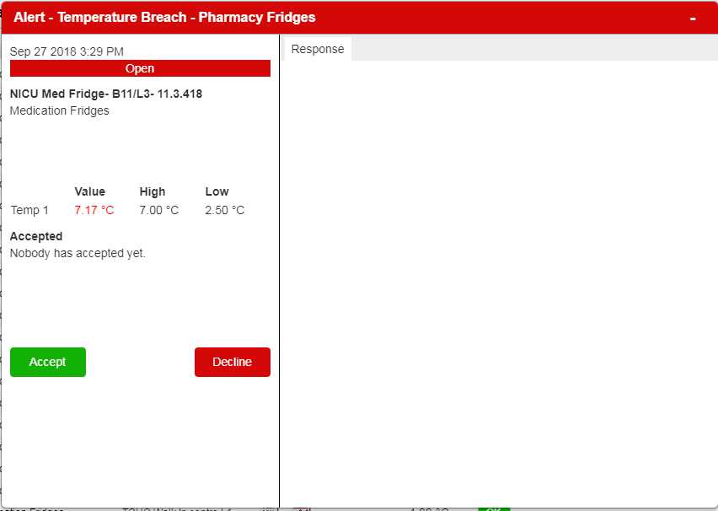
Click Accept
The alert will change from red to amber

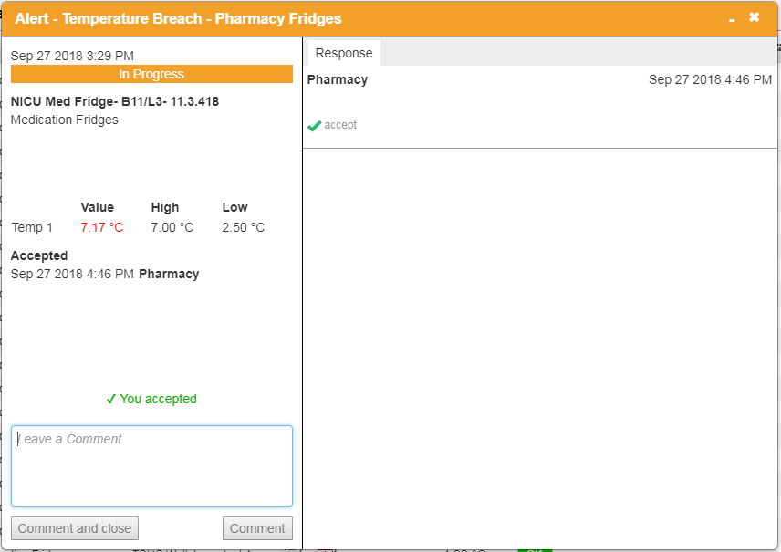
Enter detail here including your initials

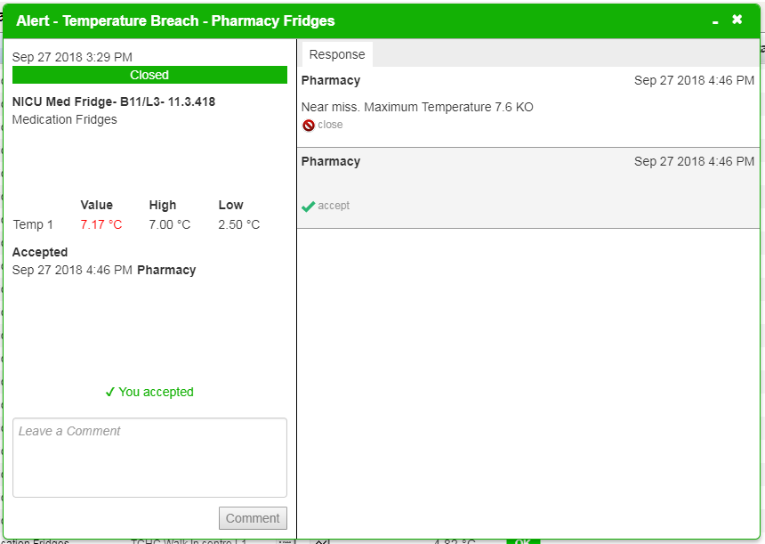

- All alerts are to be closed off (and green) at the end of the shift, and handover to occur between Pharmacy and AHHM if anything needs to be followed up.
- Note that a RiskMan entry is not required in this instance, as a temperature excursion has not occurred (i.e. did not exceed 8 degrees C).

Section 5.5.4 - SMS Alerts of actual temperature excursions identified via Wi-Fi monitoring
- When a medication fridge temperature reaches less than 2 degrees or greater than 8 degrees Celsius the cold chain has been breached. An SMS is sent to the Pharmacy Fridge Mobile Phone and the AHHM Mobile Phone. An example of the SMS message is as follows:
ALLOWABLE TEMPERATURE EXCEEDED. Please QUARANTINE Fridge – stock damaged

Temperature Event
Wed Aug 29 09:49:48 EST 2020

TEMPERATURE IS TOO LOW

Current Temperature: 1.9 °C
Allowed Range: From 2.0 to 8.0 °C

Event Originator

Asset Type: Medication Fridges
: GCHC Walk-in Centre

- When this SMS is received, the pharmacist or AHHM contacts the CNC, CMC or other team leader of the patient care area to advise of the temperature excursion. Should the CNC, CMC, or other person-in-charge of the area be unavailable, the Pharmacy will escalate to the relevant Assistant Director of Nursing (ADON) or Director of Nursing (DON) until a responsible officer is identified.
  - Note: Out of business hours, if there are no staff or patients in a patient care area (Community Health Centres for example) the Pharmacy Department will follow up with the patient care area the following business day to advise of the temperature excursion. The Pharmacy Department can see that this has happened overnight as the Pharmacy Fridge Phone receives the same SMS messages as the AHHM.
  - The exception to this are five unstaffed patient care areas of the hospital that contain high risk or high-cost medicines that staff may access overnight in emergency situations (Appendix 6).
- The pharmacist or AHHM will ask the team leader to quarantine the medicines so that they are not administered to patients. This is an important action to protect patients from receiving potentially damaged and unsafe medicines. Use signage found in the Medication Fridge Temperature Excursion Pack located on the front or side of the medication fridge.
  - Refer to CNC Flow Chart for responding to the Medication Fridge Alert found in the Medication Fridge Temperature Excursion Pack (Appendix 4)
  - If an obvious cause for the medication fridge malfunction can be identified (e.g., fridge door was not fully closed) and it is likely that the medicines will not be exposed to further temperature fluctuations, the medicines can be safely quarantined there.
  - If an obvious cause for the medication fridge malfunction cannot be identified and the medicines are at risk of being exposed to further temperature fluctuations, the medicines can be transferred using an esky and ice brick to the Pharmacy Cool Room or other monitored medication fridge (such as a neighbouring ward) for safe keeping. Note that the medicines must be placed in a monitored medication grade fridge. A fridge containing food is not suitable. These medicines need to be clearly identified with the location of where they originated and that they are quarantined due to being exposed to a temperature breach. Following this, a maintenance request should be placed in MyFM for a refrigeration mechanic to service the fridge. The medication fridge should not be used until a refrigeration mechanic deems it fit for use
  - The CNC/CMC or other team leader is responsible for making an entry into Riskman documenting the details of the temperature excursion.
- The pharmacist or AHHM logs in to Vision and records activities against the alert pop up that relate to this event.
  - Click ‘Accept’ on the alert pop up - the colour of the alert will turn from red to amber. Note that while the alert is amber, for the time that the temperature remains above 8 degrees, no further alert will be generated.
- Once the Pharmacist or AHHM is satisfied that the temperature of the fridge has settled, they document their activities in the comments box, including:
  - the maximum or minimum temperature reached - this information is important to determine the extent of damage to the affected stock
  - a conservative estimate of how many minutes the fridge has been above 8 degrees or below 2 degrees
  - where the medicines are quarantined (in the same fridge or elsewhere)
  - their initials
  - click ‘Comment and Close’. The alert will turn green and will be closed off.
- All alerts are to be closed off (and green) at the end of the shift, and handover to occur between Pharmacy and AHHM if needed.

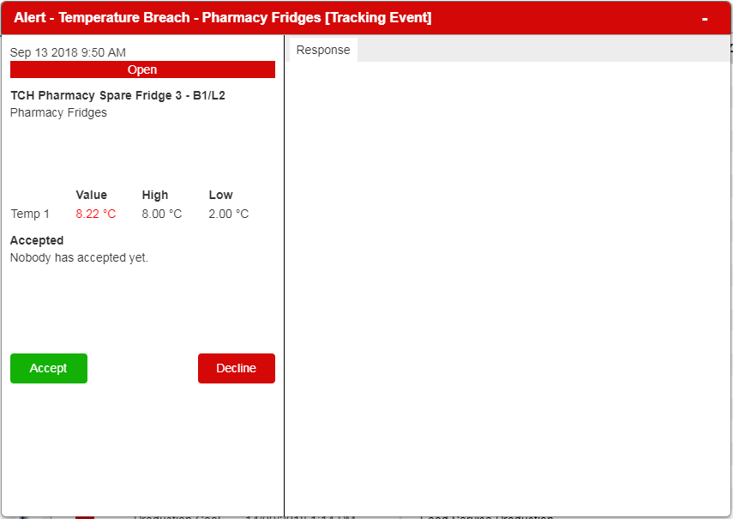
Click Accept
The alert will change from red to amber

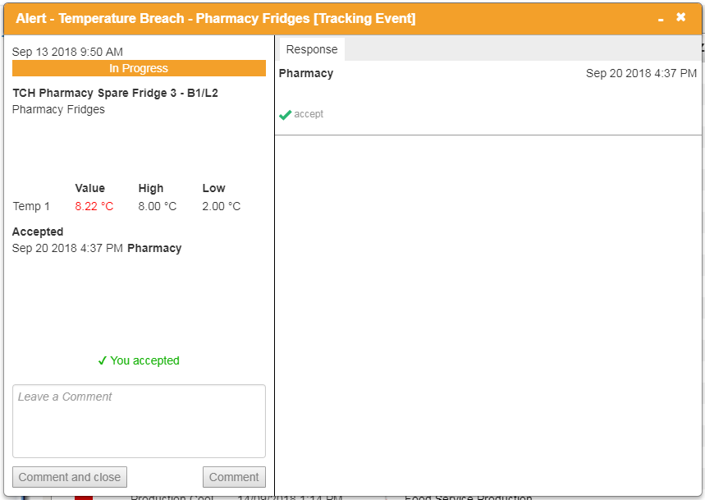
Enter detail here including your initials

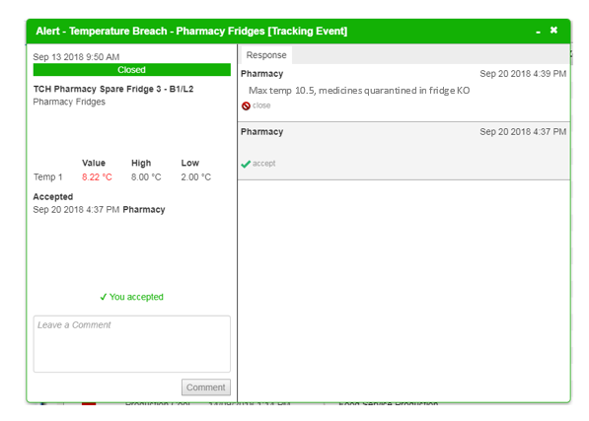

Section 5.6 – Professional judgment and temperature excursions
Depending on the nature of the temperature excursion, the medicines in the fridge and professional judgment of the pharmacist assessing the situation, the pharmacist monitoring the fridge may be able to provide advice to the team leader on date adjustment of stock which still may be safe to use. This is dependent on the medicines affected, how extreme the excursion is, information available in the medicines’ product information, extended stability data, advice provided from the relevant pharmaceutical manufacturer(s) and the clinical judgment of the pharmacist.

Section 5.7 – Nurse in Charge Process to follow when advised of temperature excursion
When the Nurse in charge of the Patient Care Area is advised by Pharmacy or the AHHM that there has been a temperature excursion, the most important action is to protect patients from receiving potentially damaged and unsafe medicines.

Section 5.7.1 - After hours from 4.30pm to 8.00am every day
The CNC, CMC or other team leader of the patient care area is responsible for communicating the temperature excursion to their staff following these steps:
- Use the signage found in the Medication Fridge Temperature Excursion Pack to alert staff that the fridge is out of order and that the medicines should not be used.
- Ensure medicines needed for ongoing patient care are available:
  - Source supply from alternate ward (refer to CHS Imprest Stock Locations).
  - If not available elsewhere in the hospital and a dose is needed, contact the After-Hours CNC who will liaise with the on-call pharmacist.
- At the start of the next day, contact pharmacy via the pharmacy fridge phone 0466 810 594 to obtain advice on next steps.

Section 5.7.2 - In Business Hours between 8.30am and 4.30pm every day
- Use the signage found in the Medication Fridge Temperature Excursion Pack to alert staff that the fridge is out of order and that the medicines should not be used.
- Ensure medicines needed for ongoing patient care are available:
  - All medicines required for immediate patient treatment must be ordered from the Pharmacy as a matter of urgency. All other items should be reordered prior to the next required dose.
  - Where the patient care area does not have a functioning fridge, these replacement medicines must be stored in an alternative, functioning medication refrigerator being monitored via Wi-Fi connection.
- Complete the Medication Fridge Temperature Excursion Standard Recording Form (Appendix 6) to document which medicines are in the fridge and email through to medicationsafetypharmacist@act.gov.au. Some medicines have data that show that they are still safe to be used after an exposure to temperatures above 8 or below 2 degrees Celsius and with time, pharmacy can provide this information.

Section 6 – Manual Medication Fridge Monitoring

Not all areas of CHS are enabled with Wi-Fi temperature monitoring technology.
These patient care areas are required to have a data logger installed in the fridge and to manually check and record the temperature of their medication fridge twice a day using Medication Fridge Manual Monitoring Recording Form – Appendix 1.
If a Medication Fridge is usually covered by Wi-Fi monitoring and the monitoring has dropped out as notified by the pharmacist or AHHM, patient care areas will be required to temporarily monitor their fridge manually.

Section 6.1 - Reporting Requirements
Acknowledging the importance of maintaining cold chain in the provision of safe and effective treatment to patients, the Medication Safety Committee has oversight of the monitoring of medication fridges across CHS.

A new Medication Fridge Manual Monitoring Recording Form is to be started every month.
Medication Fridge Manual Monitoring Recording Forms are to be collated and used to inform a quarterly Manual Medication Fridge Audit Report (Appendix 5) and submitted to the Medication Safety Committee vis CHS.MedicationSafety@act.gov.au

Section 6.2 - Materials
Data logger installed inside fridge
Medication Fridge Manual Monitoring Recording Form (Appendix 1)
- Medication Fridge Temperature Excursion Pack which contains:
  - CNC Flow Chart for Responding to a Medication Fridge Alert
  - “Medication Fridge Out of Order” Signage
  - stickers to mark stock affected by temperature excursion
  - quarantine signage to segregate affected stock
  - Medication Fridge Temperature Excursions Standard Recording Form to record details of medicines affected by a temperature excursion so that pharmacy can investigate if the medicines are safe to be used
  - useful contact numbers and contact people
  - Medication Fridge Manual Monitoring Recording Form to use if Wi-Fi monitoring is not available (Appendix 1).
Medication Fridge Temperature Excursion Pack replacement kits can be obtained from the Medication Safety Team by emailing medicationsafetypharmacist@act.gov.au or 02 5124 3835 or Fridge Lab ext. 43835 during business hours.

Section 6.3 - Procedure for Routine Monitoring and Recording of Fridge Temperatures
- The medication fridge temperature is to be checked twice daily at approximately the same time each day and the details recorded on the Medication Fridge Manual Monitoring Recording Form (Appendix 1).
- To complete manual temperature monitoring of a medication fridge:
  - In the box corresponding to today’s date, document the current temperature displayed on the front panel of the medication fridge using a ● to indicate the current temperature
  - Using the buttons on the front of the fridge, check the minimum and maximum temperature recorded by the fridge’s temperature display and document using an X to indicate the temperatures the fridge has experienced over the last 24 hours (or since last check):
    - If the maximum temperature was greater than 8 degrees Celsius or the minimum temperature was below 2 degrees Celsius, report this immediately to the nurse in charge of the area and refer to procedure documented in Section 6.4.
    - If the values are within 2 and 8 degrees Celsius, reset the fridge thermometer. No further action is required.

Section 6.4 - When the Medication Fridge Temperature has been outside of 2 and 8 degrees Celsius
If upon routine monitoring and recording of the medication fridge temperature it is
detected that a temperature excursion has occurred, the CNC, CMC or other team leader is
responsible for the following actions:

Immediate Actions

- Medicines must not be used for patient care as they may have been damaged by the temperature excursion. They should be clearly identified as being quarantined using signage in the Medication Fridge Temperature Excursion Pack.
- If the medication fridge is currently within temperature range, the medicines can be quarantined inside the fridge. Place the ‘Out of Order’ sign found in the Medication Fridge Temperature Excursion Pack on the front of the fridge.
- If the medication fridge is out of accepted temperature range (less than 2 degrees Celsius or more than 8 degrees Celsius) and an obvious cause for the medication fridge malfunction cannot be identified, the medicines are at risk of being exposed to further temperature excursions. Medicines are to be transferred using an esky and ice brick to the cool room in Pharmacy or other monitored medication fridge (such as a neighbouring ward) for safe keeping. These medicines need to be clearly identified with the location of where they originated and that they are to be quarantined due to being exposed to a temperature excursion. If practical, to protect stock from further exposure to temperature excursions, consider using eskies and ice bricks and moving the stock to another medication grade fridge that is monitored manually or by Wi-Fi.
- The clinical area must ensure that they are able to continue therapy for their patients. All medicines required for immediate patient treatment must be ordered from the Pharmacy as a matter of urgency. All other items should be reordered prior to the next required dose. Where the patient care area does not have a functioning fridge, replacement medicines must be stored in an alternative, functioning medication fridge monitored manually or by Wi-Fi.
- Submit a maintenance request via MyFM to request a refrigeration mechanic to service the medication fridge. The medication fridge should not be used and out of order signage must be in place until a refrigeration mechanic deems it fit for use.

Secondary Actions

- Using the data recorded on the Medication Fridge Manual Monitoring Recording Form, determine what date and time the medication fridge was last known to be within range.
- Download data from the data logger in the fridge. The process for doing this is dependent on the type of data logger installed in the fridge. If this is not possible, provide a conservative estimate of the maximum or minimum temperature reached and the length of time the fridge has been out of range.
- Determine which medicines have been administered to patients between the time the medication fridge was known to have been in range and the time of identifying the breach.
- Stability data related to the products administered should be sought from the Medicines Information Service available during business hours (02 5124 3333 email medicinesinformation@act.gov.au). On weekends contact the pharmacy department, and after hours if it is clinically urgent contact the on-call pharmacist via the After-Hours CNC. Clinical and professional judgement and stability data (if available) should be used to determine the potential risk to the patient. The treating consultant of these patients should be notified as soon as is practicable.

When Immediate and Secondary Actions Completed
- Complete the Medication Fridge Temperature Excursion Standard Recording Form (Appendix 6) and forward to medicationsafetypharmacist@act.gov.au with the data logger download. The Medicines Information service will work to retrieve stability data on whether medicines exposed to temperature breach are safe to be used or to be discarded. This can take several business days to obtain data from manufacturers.
- The CNC, CMC or other team leader is responsible for completing a Riskman report that includes all details of the temperature excursion.
- Once pharmacy has obtained stability data from manufacturers, it will be communicated to the CNC, CMC or other team leader. Medicines exposed to a temperature excursion must be marked as such, including where relevant expiry dates adjusted or stock destroyed. The CNC, CMC or team leader is responsible for ensuring this occurs using the pre-printed labels found in the Medication Fridge Temperature Excursion Pack.

Fill in the label with the details when they are provided by pharmacy and place a label on each medicine (including on each insulin pen) affected by the temperature excursion. If the product’s expiry date is not altered, cross out ‘New expiry is’ and write ‘use same expiry’.

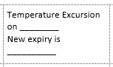

Section 6.5 - Responding to an Audible Medication Fridge Alarm
If the medication fridge (which is not Wi-Fi monitored) is alarming or the temperature on the fridge display panel is outside the acceptable range (+2 to +8°C):
- Identify and correct any obvious cause for the alarm (e.g., close door, confirm fridge plugged in).
- Reset the alarm.
- Recheck temperature in 15 minutes (Strive for 5)
- If, after 15 minutes the temperature is within the acceptable range, no further action is required.
- If during this 15-minute period the fridge is malfunctioning, immediately quarantine the medicines following the procedure outlined in Section 6.4.
- If, after 15 minutes the temperature is still outside the acceptable range (+2 to +8°C) follow procedure outlined in Section 6.4.

Back to Table of Contents

Section 7 – Health Protection Service Vaccines

Vaccines supplied by the Health Protection Service (HPS), ACT Health for immunisation in
accordance with the National Immunisation Schedule are to be monitored according to
Strive for 5 monitoring and recording requirements.

Section 7.1 - Monitoring the temperature of Health Protections Service Stock
Health Protection Service requires medication fridges holding vaccinations be monitored
according to Strive for 5; that is, the temperature of the fridge is monitored and recorded
twice a day manually on a specific HPS fridge temperature monitoring sheet.

The Medication Safety Pharmacists will notify HPS as soon as possible within business hours
if the real time Wi-Fi monitoring system detects an excursion in a fridge containing HPS
vaccines that would not be detected in real time by the current monitoring system.

Section 7.2 – Reporting Requirements
Acknowledging the importance of maintaining cold chain in the provision of safe and effective treatment to patients, the Medication Safety Committee has oversight of the monitoring of medication fridges across CHS including monitoring of medication fridges containing vaccines provided by HPS that are administered to CHS patients.

If HPS detect a cold chain breach, details of this must be sent through to the Medication Safety Committee CHS.MedicationSafety@act.gov.au. Also refer to the detail in the CHHS Procedure Vaccine Cold Chain Management.

Manual monitoring of medication fridges according to Strive for 5 is governed by the
Medication Safety Committee. As a result, The Health Protection Service Vaccines are to collate their manual monitoring forms on a quarterly basis and use them to inform a quarterly Manual Medication Fridge Audit Report (Appendix 5). These Quarterly reports are to be provided to the Medication Safety Committee.

Section 7.3 – Managing a temperature excursion that involves Health Protection stock
If Health Protection Service Vaccines are affected by a temperature excursion, quarantine
the stock using the signage in the Medication Fridge Temperature Excursion Kit and contact
the immunisation section of the Health Protection Service Vaccine Management Unit on (02) 5124 9800 for advice on management of the temperature excursion.

Section 7.4 – Locations of Health Protection stock
Patient care areas that hold HPS vaccines include:
- Alexander Maconochie Centre (AMC) Justice Health Centre
- Bimberi Youth Justice Centre
- Centenary Hospital for Women and Children (CHWC) Ante Natal/Gynaecology
- CHWC Birthing Suite
- CHWC Birthing Centre
- Canberra Hospital (CH) Drug & Alcohol
- CHWC Maternity Assessment Unit
- CHWC Paediatric Day Stay
- CH Pharmacy
- CHWC Post Natal
- CH Sexual Health
- CH Sleep & Respiratory (Thoracic)
- CHWC Special Care Nursery
- School Health Team
- Belconnen Clinic
- CC Cares at Canberra College
- Dickson Clinic
- Florey Clinic
- Gungahlin Clinic
- Lanyon Clinic
- West Belconnen (Kippax)
- Phillip Clinic
- Ngunnawal Clinic
- Tuggeranong Clinic
- Walk-in Centre Belconnen
- Walk-in Centre Weston Creek
- Walk-in Centre Tuggeranong
- Walk-in Centre Gungahlin
- Women’s Health Services

Back to Table of Contents

Section 8 – Useful Contacts

After Hours Hospital Manager
- For advice or specific details of temperature excursions that occur overnight between the hours of 4.30pm and 8.00am each day:
Contact the After-Hours Hospital Manager via Switchboard
Facilities Management
- To organise fridge repair or service:
Contact Facilities Management through MyFM or 02 5124 2115 or via email at CHS.FM@act.gov.au
Pharmacy
- For replacement of medicines affected by a temperature excursion between hours of 8:30am and 4:30pm each day:
Imprest medicines: scan an imprest request form to the pharmacy
Medicines dispensed to individual patients: request resupply via EMM (MedChart) or scan paper-based medication chart to the pharmacy

- For assessment of whether medicines are safe to use following a temperature excursion:
Scan and e-mail a completed Medication Fridge Temperature Excursion Standard Recording form (Appendix 6) to Medicationsafetypharmacist@act.gov.au – Please note that this service takes time, and research will need to be conducted to determine if medicines are safe to use

- For advice or specific details of temperature excursions that occur between the hours of 8.30am and 4:30pm each day
Contact the Medication Fridge Monitoring Team on 0466 810 594

- For queries about Wi-Fi tags including maintenance and replacement or,
for replacement of items in Medication Fridge Temperature Excursion Packs (Date adjustment stickers, quarantine sign etc.):
Contact the Medication Safety Team on ext. 43835 (02 512 43835) or via email Medicationsafetypharmacist@act.gov.au

Back to Table of Contents

Evaluation
Outcome
Medication fridges and freezers at CHS are monitored as per this procedure and overseen by the CHS Medication Safety Committee

Measures
- Rate of temperature excursions per month.
- Number of temperature excursion appropriately documented and closed on the temperature monitoring software program (Vision).

Back to Table of Contents

Related Policies, Procedures, Guidelines and Legislation

Policies
- Medication Handling

Procedures
- Vaccine Cold Chain Management
- Fresh Blood Administration Procedure

Legislation
- Medicines, Poisons and Therapeutic Goods Act 2008
- Medicines, Poisons and Therapeutic Goods Regulation 2008
- Therapeutic Goods Act 1989
- Therapeutic Goods Regulation 1990

Back to Table of Contents

Definition of Terms

Alert: An alert is an SMS text message advising of an impending temperature excursion. At this point the medication fridge temperature has reached either 2.5 or 7 degrees. An alert box is also generated in the Vision database.

Cold Chain: The 'cold chain' is a system of storing and transporting vaccines at recommended temperatures from the point of manufacture to the point of use.

Event: An event is an SMS text message advising of a breach of cold chain and a temperature excursion has occurred. At this point the medication fridge temperature has reached either less than 2 degrees Celsius or greater than 8 degrees Celsius. An event box is also generated in the Vision database.

Temperature excursion: When the temperature of a medication fridge exceeds 8 degrees Celsius or less than 2 degrees Celsius.

Vision: Database that holds data from temperature probes sent via Wi-Fi connection.

Back to Table of Contents

Search Terms

Medication Fridges, fridges, refrigerator, manual monitoring, Wi-Fi, wi fi, Wi-Fi monitoring, wifi, temperature excursion, fridge reporting, cold chain, vaccines, temperature monitoring, fridge, cold chain breach, refrigeration, temperature-sensitive medicine, cold chain management, cool room, temperature alarm, fridge alarm, Vision.

Back to Table of Contents

Attachments

Appendix 1 - Medication Fridge Manual Monitoring Recording Form
Appendix 2 - Medication Fridge Temperature Excursion Pack Contents Page
Appendix 3 - CNC Flow Chart for responding to Medication Fridge Alert
Appendix 4 - Quarterly Manual Medication Fridge Audit Report template
Appendix 5 - Medication Fridge Temperature Excursion Standard Recording Form
Appendix 6 - Vision Alerts

Disclaimer: This document has been developed by Canberra Health Services specifically for its own use. Use of this document and any reliance on the information contained therein by any third party is at his or her own risk and Canberra Health Services assumes no responsibility whatsoever.

Policy Team ONLY to complete the following:
Date Amended | Section Amended | Divisional Approval | Final Approval
07 July 2021 | Complete Review | Dr N Coatsworth, ED, MSG | CHS Policy Committee

This document supersedes the following:
Document Number | Document Name
CHS19/097 | Medication Fridge Temperature Monitoring

Appendix 1 – Minimum/maximum vaccine refrigerator temperature chart

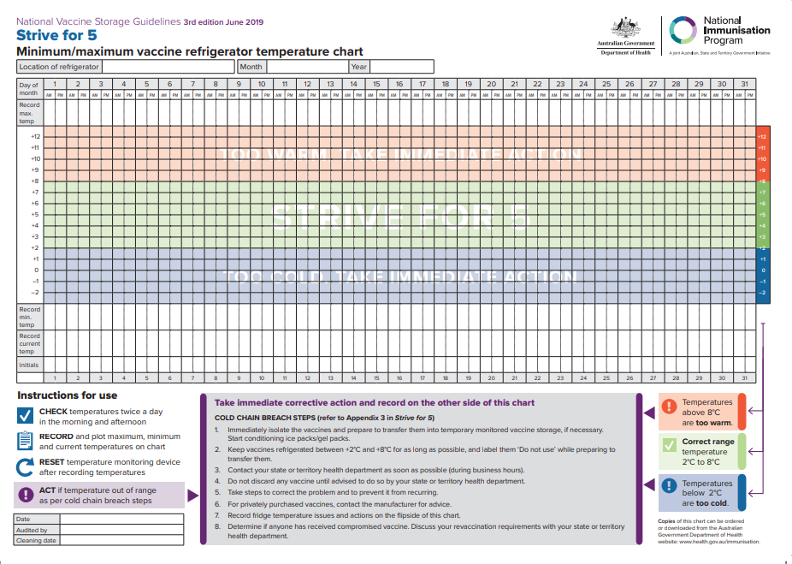

Appendix 2
Appendix 3

Appendix 4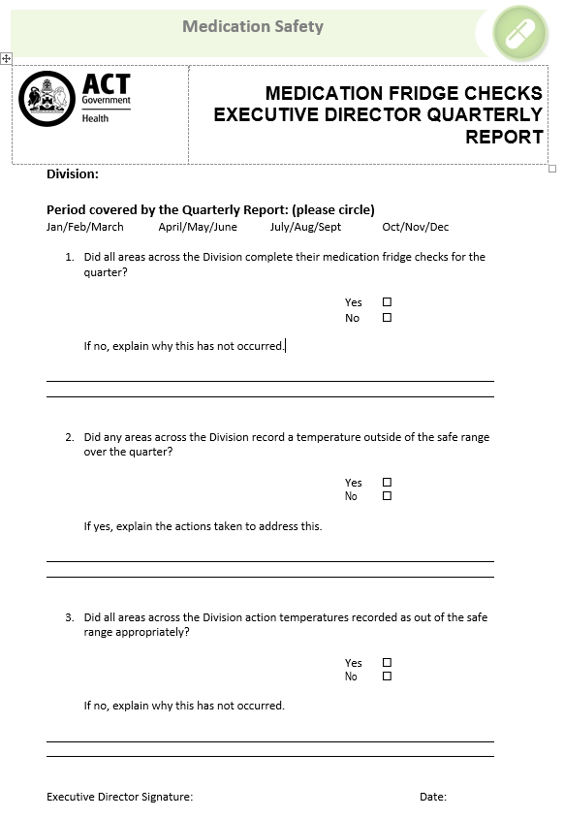
Appendix 5
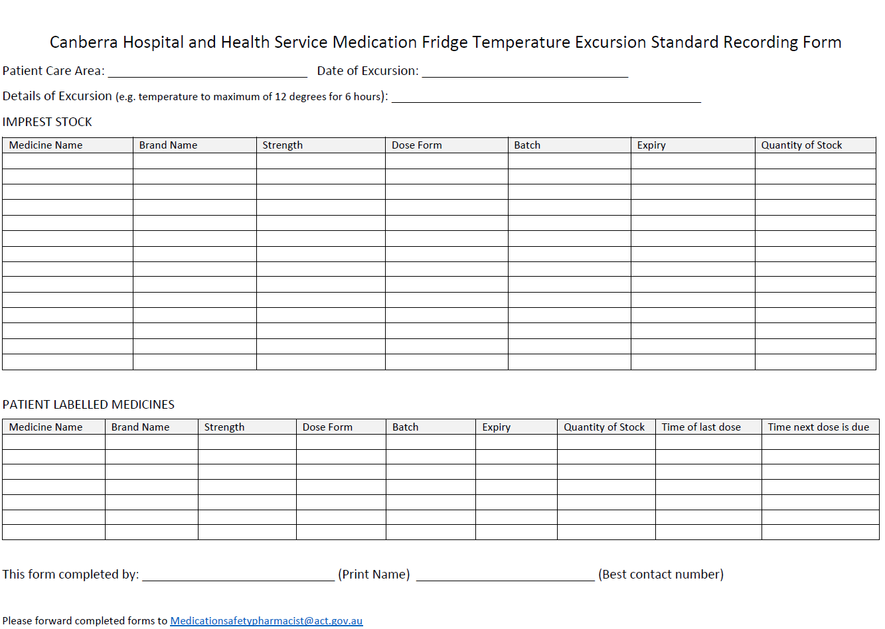

Appendix 6 – Vision Alerts

If an alert is generated in Vision for any of these fridges overnight, (areas without staff) intervention needs to be taken to prevent a temperature excursion. This is due to the cost or high-risk nature of medicines in the fridge. Note this is in addition to every fridge in areas that are staffed overnight.
Patient Care Area | Name as listed in Vision | Physical Location | Relocation Fridge
Cardiac Catheter Lab (CCL) | TCH Cardiac catheter lab 1.3.13 | Building 1 Level 3 Catheter Lab  - obtain key from CCU or Security to access Catheter lab after hours.  - Medication fridge is in ‘Workroom’ room number 1.3.13 which is also the CNC’s office. | - CCU medication fridge or  - Pharmacy Cool Room  Please ensure glyceryl trinitrate syringe is available on CCU.
Eye Clinic | TCH Eye Clinic Medication Fridge 3.1 83 | Building 3 Level 1 in Medication room - signage on the door is ‘Store 1.07’ access via swipe card  *Ask security to attend with you to disarm alarm and ensure you have access* | Pharmacy Cool Room
Nuclear Medicine hot lab | Nuclear medicine hot lab 2.12.17 98 | Building 12, Level 2, room 17.  If this fridge is going out of range call the Nuclear Medicine Technician on call via switchboard.  Note that swipe access to the ‘radioactive hot lab’ is very restricted. | Pharmacy Cool Room.  Note that the diagnostics in the fridge are not radioactive and are safe to be stored in a medication fridge overnight if needed.
Medical Imaging | TCH Medical Imaging - Angio Control room 12.2 | Building 12, Level 2  In Angio control room (between two angiography suites)  - Contact ‘CT nurse’ who are available 24 hours a day.  - The CT nurse will be able to take you to the location of the medication fridge. | Pharmacy Cool Room
Occupational Medicine Unit | TCH OMU vaccine fridge 15.1.41 14 | Building 15, Level 1 Occupational Medicine Unit.  Medication fridge is located through the glass doors into OMU immediately on your right.  *Ask security to attend with you to disarm alarm and ensure you have access* | Pharmacy Cool Room

