Canberra Health Services
Guideline
Management of Anaphylaxis in Adults and Children

Contents

Contents 1
Guideline Statement 2
Scope 2
Section 1 – Reducing the Risk of Anaphylaxis 3
Section 2 – Symptoms and Signs of Acute Allergic reaction 3
Section 3 – Access to Personal Adrenaline Injector 4
Section 4 – Emergency Management of Allergy and Anaphylaxis 5
Section 5 – Different Diagnosis 7
Section 6 – Hospital in the Home (HITH) 8
Section 7 – Community Care Program (Community Nurses) 9
Section 8 – Weston Creek Medical Imaging service 10
Section 9 – Immunisations 11
Section 10 – Justice Health Services – Custodial Health 13
Section 11 – Podiatry Services 14
Evaluation 15
Related Policies, Procedures, Guidelines and Legislation 15
References 16
Definition of Terms (if applicable) 17
Search Terms 17
Attachments 18

Guideline Statement

Background
Anaphylaxis is an abnormally vigorous immune response, which can cause physiological changes, including bronchospasm, haemodynamic instability, vascular leak, rash, and itchiness. This is usually triggered by exposure to an exogenous antigen such as venom, food, or a drug.

This clinical guideline is informed by the Acute Anaphylaxis Clinical Care Standard (November 21) published by the Australian Commission on Safety and Quality in Healthcare: Acute Anaphylaxis Clinical Care Standard | Australian Commission on Safety and Quality in Health Care

This guidance is based on the Australian Society of Clinical Immunology and Allergy (ASCIA) guidelines for the Acute Management of Anaphylaxis: https://www.allergy.org.au/hp/anaphylaxis

Please note the following online training resources which clinicians may want to access:
https://allergy.org.au/hp/hp-e-training
https://alm.ascia.org.au/

Key Objective
This guideline outlines the emergency management of anaphylaxis in children and adults and aims to ensure:
- Identification of patients with anaphylaxis
- Safe and effective management of patients with anaphylaxis

Alerts
- Anaphylaxis is a severe allergic reaction with manifestations in more than one organ system. Anaphylaxis is a medical emergency and therefore requires immediate medical management
- Not all drug reactions are anaphylaxis or even allergic in origin. In addition, some features of anaphylaxis can result from other mechanisms. Important examples to note:
- Vancomycin can cause erythema
- ACE inhibitors such as ramipril can cause angioedema
- Monoclonal antibodies can cause immune activation and cardiovascular collapse.

Back to Table of Contents

Scope

This document applies to the management of anaphylaxis across the CHS Network including the inpatient facilities at Canberra Hospital, Clare Holland House, North Canberra Hospital, and University of Canberra and community based services.
The Clinical Care Standard (CCS) does not apply to anaesthetic anaphylaxis however, this guideline addresses this issue.

This clinical guideline applies to the following staff working within their scope of practice within CHS:
- Medical Officers
- Registered nurses (RN) and midwives working within their scope of practice
- Other authorised prescribers
- Podiatry Services: this pertains to podiatrists who administer local anaesthetic agents. The podiatrist must have current training in CPR and anaphylaxis management as per the Podiatry Board of Australia requirements
- Justice Health Services (JHS): this applies to all anaphylactic events at the Alexander Maconochie Centre (AMC) and Bimberi Youth Justice Centre (BYJC) while Justice Health Services Custodial Health Registered Nursing and/or Medical staff are on site. Note JHS medical and nursing staff only are in scope while JHS allied health staff are out of scope (with the exception of Podiatry)
- Community Nursing: this pertains to community nurses who administer intravenous (IV) and intramuscular (IM) antibiotics in patients’ homes and health centre clinics.
- HITH nurses – this pertains to HITH nurses who administer medications in patients’ homes
- Walk in Centres (WiC) Advanced Practice Nurses (APN) and Nurse Practitioners (NP) - This pertains to all presentations for anaphylaxis and anaphylaxis post medication administration and includes children under 2 years.

Back to Table of Contents

Section 1 – Reducing the Risk of Anaphylaxis

All patients presenting to the CHS Network should be asked if they have any alerts or allergies. These are to be documented on the patient’s Comprehensive Care Plan – Part 1 – Risk Screening. Before commencing a new treatment, staff prescribing and administering the medication should ask the patient if they have any allergies. Consult health records in the DHR.

Back to Table of Contents

Section 2 – Symptoms and Signs of Acute Allergic reaction

Prompt Recognition of Anaphylaxis
A patient with acute-onset clinical deterioration with signs or symptoms of an allergic response is to be rapidly assessed for anaphylaxis, especially in the presence of an allergic trigger or a history of allergy.

Mild to Moderate Allergies
Signs or symptoms that might be observed with any form of allergic reaction:
- swelling of lips or eyelids (angioedema)
- rash, hives, or welts (urticaria)
- tingling in the mouth
- cough or wheeze
- skin or mucosal changes.

Severe Acute Allergic Reaction and Anaphylaxis
Signs and symptoms of mild allergy can also occur concurrently in patients with severe allergic reactions. Signs and symptoms that might indicate anaphylaxis:
- shortness of breath
- tightness in the throat
- sensation of swollen tongue
- light headedness
- sweatiness
- abdominal pain, nausea, diarrhoea
- severe anxiety
- swelling of the tongue, pharynx, larynx
- widespread wheeze
- hypoxia
- tachypnoea
- hypotension
- tachycardia
- collapse, loss of consciousness.
- cardiac arrest
- pale and floppy (young infants).

Back to Table of Contents

Section 3 – Access to Personal Adrenaline Injector

If a patient is known to have a personal adrenalin injector, their capacity to safely use it during the healthcare encounter should be assessed as soon as feasible using the In hospital checklist for patients own use of adrenaline (epinephrine) autoinjector at Attachment B. This includes:
- Checking their capacity, physical capability and willingness to use their personal adrenaline injector and their ability to recognise the symptoms of anaphylaxis
- Considering medicines administered during the healthcare visit that may impair the patient’s usual ability to recognise and treat anaphylaxis. Involving a family member or carer in the assessment, if appropriate, when a patient is cognitively impaired or lives with a disability
- Involving a parent, guardian or carer in the assessment when in the paediatric setting
- Patients admitted to mental health units will not have access to their autoinjectors.

Except for mental health patients, any patient owning a personal adrenalin injector should have access to it during all healthcare encounters in case self-administration is required. This includes patients keeping their adrenaline injector safely at their bedside during a hospital admission. The medications are to be entered into the Patient’s clinical records.

Patients should be advised that when they recognise the signs of anaphylaxis, they should notify nursing staff and get immediate medical attention. Should there be a delay in administering IM adrenalin on the ward, the patient should use their injector immediately and call for help.

Back to Table of Contents

Section 4 – Emergency Management of Allergy and Anaphylaxis

See Schematic Flowchart – Attachment C:

For Anaphylaxis:
- Call for help - Call Medical Emergency Team (MET)
- Canberra Hospital and North Canberra Hospital: dial 2222, emergency Code Blue
- University of Canberra Hospital dial: 2222, emergency Code Blue and if ambulance assistance is required call 0-000)
- In other settings follow specific guidelines in sections below.
- Stop any intravenous treatment immediately. Remove any other obvious trigger or cause
- Basic life support – DRSABCD
- Ensure correct patient positioning – Lie the patient flat or in the recovery (left lateral position) if they are pregnant or vomiting
- Administer injection of intramuscular adrenaline (Medication Standing Order CHS21/112) immediately as per Table 1 (below). This should occur before any other treatment including asthma medicines. Corticosteroids and antihistamines are not first-line treatments for anaphylaxis.

Table 1
Adrenaline 1:1000 (1mg/mL)
Age (years) | Weight (kg) | Adrenaline volume (mL) | Adrenaline Injector
<1 | <7.5 | 0.1 mL | Not available
1-2 | 10 | 0.1 mL | 7.5-20 kg (<5 years)  150 microgram device
2-3 | 15 | 0.15 mL | 7.5-20 kg (<5 years)  150 microgram device
4-6 | 20 | 0.2 mL | 7.5-20 kg (<5 years)  150 microgram device
7-10 | 30 | 0.3 mL | >20kg (>5 years)  300 microgram device
10-12 | 40 | 0.4 mL | >20kg (>5 years)  300 microgram device
>12 and adult | >50 | 0.5 mL | >50kg (>12 years)  300 or 500 microgram  device.

Alert: Treatment can be repeated after five minutes if there is no response to the first dose. It can be repeated every 5 min as necessary after this, but alternative diagnoses and other factors (section 4) should be considered after two doses if there has been no improvement.

- Administer oxygen by mask
- Establish intravenous access if able, noting that some CHS Network sites may require ACT Ambulance Service assistance
- Notify the treating team trainee via your Facility switchboard
- For anaesthetic anaphylaxis, follow the ANZAAG guidelines available in the operating theatres in the Anaphylaxis Box.

Observation time following anaphylaxis - A patient treated for anaphylaxis remains under clinical observation for at least 4 hours after their last dose of adrenaline, or overnight as appropriate ASCIA Acute Management of Anaphylaxis guidelines.

Observation timeframes are determined based on assessment and risk appraisal after initial treatment.

For Anaphylaxis Treated in the Canberra Hospital, North Canberra Hospital and University of Canberra Hospital (including Emergency Department, Wards and Outpatient Areas) in addition to the above steps the following is recommended:
- If appropriate (i.e., allergen cannot be easily avoided in the future – i.e., food, venom), patient should be discharged with a script for an appropriate adrenaline autoinjector and one autoinjector.
- Patients who have received adrenaline in hospital for anaphylaxis are eligible for a Pharmaceutical Benefits Scheme (PBS) supported adrenaline autoinjector without the need for consultation (however consultation with an immunologist is recommended).
- The patient or parents should be educated on the administration of an autoinjector prior to discharge. Patient should also be given an Anaphylaxis Action plan (Attachment A).

An adrenaline autoinjector is not required for an easily avoidable allergy, (e.g. prescribed medications).
- Follow up should be arranged in the Immunology clinic, Allergy clinic or Anaesthetic Allergy clinic as appropriate. Please fax to 5124 5543. Contact Registrar or Consultant on call to ensure referral.
- Immediately modify the patient’s health record and alerts in the DHR to reflect the likely cause(s) of the anaphylaxis. If the anaphylaxis was caused by a medication, ensure that a notification is made to the ACT Adverse Drug Reaction Committee.

Discharge Management and Documentation
Before a patient leaves a healthcare facility (either as an inpatient or outpatient) after having anaphylaxis, they are to be advised of the suspected allergen, allergen avoidance strategies and post-discharge care.

The discharge care plan is tailored to the allergen and includes details of the suspected allergen, the appropriate ASCIA Action Plan, and the need for prompt follow-up with a general practitioner within one week and clinical immunology/anaesthetic allergy specialist review. Provide and discuss with patient the Anaphylaxis discharge checklist and discussion guide (Attachment H).

Where there is a risk of re-exposure, the patient will be discharged with a workable autoinjector and a prescription for a personal adrenaline injector. The patient must be trained in its use.

Details of the allergen, the anaphylactic reaction and discharge care arrangements are documented in the patient’s healthcare record.

Reporting and documentation should be completed as per the requirements in the Medication Handling Policy/Procedure and Clinical Handover Procedure for your facility and individual area requirements.

Back to Table of Contents

Section 5 – Different Diagnosis

In cases where the patient does not respond to adrenaline (i.e., two doses are given without improvement in condition), anaphylaxis may not be the correct diagnosis, or the patient might be on another treatment that prevents adrenaline from working.

Examples of such treatments include:
- ACE inhibitors such as ramipril can cause angioedema
- Monoclonal antibodies can cause immune activation that result in cardiovascular collapse
- Beta blockers inhibit some actions of adrenaline.

In these cases, in addition to steps already taken (e.g., contacting MET or ACTAS) seek urgent medical advice about patient management from Immunology, via the Facility Switchboard.

Back to Table of Contents

Section 6A – Hospital in the Home (HITH) – Canberra Hospital and University of Canberra Hospital

This section applies to HITH nurses and the HITH hospital-based clinics. HITH nurses will carry and supply adrenaline in the Anaphylaxis kit.

Prior to administering IV Antibiotics the HITH nurse will:
- Ensure that the patient has received the first dose of the antibiotic at the HITH clinic (except in the case of a patient in a Residential Aged Care Facility)

Note
HITH nurses do not administer the first dose of any parenteral medication in the patients’ home, but may do so in a Residential Aged Care Facility

- Ensure a medical order for the administration of Adrenaline is documented on the PRN section of the medication chart (for UCH and Canberra Hospital only).
- Ensure that the following is available in the HITH Anaphylaxis Kit:
- Two vials of Adrenaline 1:1000 (1mL each vial)
- 1mL syringes, drawing up needles and 23-gauge needles.

Management of Mild to Moderate Signs and Symptoms (see Section 2 for definition):
- Cease administration of IV Antibiotic
- Monitor patient for at least 20 minutes for improvement or progression of signs and symptoms
- Report to the patient’s Team Registrar and arrange same day patient review in the HITH clinic. Advise the patient to call an ambulance if symptoms worsen. Advise the patient not to drive
- Document all interventions in the patient’s health record
- Enter an alert in the DHR.

Management of Severe Signs and Symptoms (see Section 2 for definition):
- Cease administration of IV Antibiotic
- Assess airway, breathing, circulation and commence basic life support algorithm (DRSABCD)if required
- Lay patient flat, do not stand or walk. If breathing is difficult, allow the patient to sit
- If unconscious, lie the patient on the left side and position to keep the airway clear
- Call for ACT Ambulance Service:
- Dial 000
- Dial 112 on a mobile phone - this is the GSM international standard emergency access number
- Administer adrenaline (as per doctor’s order on medication chart), IM injection into the mid-lateral thigh. Note the time of administration. If there is no improvement in the patient’s condition the dose can be repeated after 5 minutes
- Never leave the patient alone
- Continue emergency care until ambulance arrives
- Contact and advise the patient’s Treating Team Registrar if time allows
- Document all interventions in the patient’s clinical record
- Enter an alert in the DHR
- Advise the CHS Drugs and Therapeutics Committee.

Back to Table of Contents

Section 6B – Hospital in the Home (HITH) – North Canberra Hospital

- The HITH nurse who administers a medication must have annual training in Basic Life Support (BLS).
- A Standing Order for Adrenaline is used for NCH HITH patients.
- HITH staff administering medication will ensure that adequate supplies of adrenaline 1:1000 ampoules, needles and syringes are readily available at the time of, and directly after administration.
- The Nurse who administers a medication must be able to recognise and effectively manage anaphylaxis. Attachment I describes the clinical procedure to be followed in the event of an anaphylactic reaction.
- HITH nurses must report to the HITH Unit Medical Director or delegate and the HITH Clinical Manager or delegate any incidents of anaphylaxis or other adverse reactions related to administration of medication as soon as possible.
- An Adverse Drug Reaction Reporting Form must be completed by the HITH pharmacist and submitted to the ACT Adverse Drug Reaction Reporting Committee.
- When adrenaline is administered for suspected anaphylaxis the patient must be transported to hospital via ambulance and a full set of observations recorded every 5 minutes whilst awaiting ambulance transport. Basic Life Support should be undertaken if indicated.
- Complete Riskman as per Attachment J Flow chart.
- Before the patient leaves hospital after having anaphylaxis, they should be advised about the suspected allergen, allergen avoidance strategies and post-discharge care.
- Details of the allergen, anaphylactic reaction and the need for prompt follow-up with GP and immunology/allergy specialist should be communicated to the patient and documented in the patient’s record and discharge summary
- The HITH Medical Director or delegate and the HITH Clinical Manager or delegate will be responsible for auditing clinical records of patients with episodes of anaphylaxis. This data will be reported as an identified component at the HITH Morbidity and Mortality review process and will therefore be reported to Clinical Governance Committee.

Back to Table of Contents

Section 7 – Community Care Program (Community Nurses)

This section applies to community nurses who administer IV or IM antibiotics in patients’ homes or in health centre clinics.

Community nurses do not carry or supply adrenaline. Prior to administering IV or IM antibiotics the community nurse will:
- Ensure that the patient has received an initial dose of the antibiotic

Note
Community nurses do not administer the first dose of any parenteral medication.

- Ensure a medical order for the administration of Adrenaline is documented on the ‘Medical Officers Orders for Medication Administration’ form located on the Clinical Forms Register, Barcode 75243
- Ensure that the following is available in the patient’s home or health centre clinic:
- Two vials of Adrenaline 1:1000 (supplied by the patient)
- 1 mL syringes, drawing up needles and 23-gauge needles (supplied by the Community Care Program).

Management of Mild to Moderate Signs and Symptoms (see Section 2 for definition):
- Cease administration of IV or IM antibiotic
- Monitor patient for at least 20 minutes for improvement or progression of signs and symptoms
- Report to the patient’s General Practitioner and arrange same day patient review.
- Advise the patient to call an ambulance (or attend ED if safe to do so) if symptoms worsen.
- Advise the patient not to drive
- Document all interventions in the patient’s health record.
- Add to DHR alerts.

Management of Severe Signs and Symptoms (see Section 2 for definition):
- Cease administration of IV or IM antibiotic
- Commence basic life support algorithm- DRSABC
- Lay patient flat, do not stand or walk. If breathing is difficult, allow the patient to sit
- If unconscious, lie the patient on the left side and position to keep the airway clear
- Call for ACT Ambulance Service:
  - Dial 000
  - Dial 112 on a mobile phone – this is the GSM international standard emergency access number
- Assess airway, breathing, circulation and commence basic life support if required
- Administer adrenaline (as per doctor’s order), by IM injection into the mid-lateral thigh. Note time of administration. If there is no improvement in the patient’s condition the dose can be repeated after 5 minutes
- Never leave the patient alone
- Continue emergency care until ambulance arrives
- Document all interventions in the patient’s health record
- Enter an alert in the DHR.

Back to Table of Contents

Section 8 – Weston Creek Medical Imaging service

This section applies to medical imaging nurses working in the Weston Creek Medical Imaging Service for the management of anaphylactic iodinated contrast reaction.

All nursing staff must have read the Standing Medical Order for the Administration of Adrenaline CHS23/010.

Management of Mild to Moderate Signs and Symptoms (see Section 2 for definition):
- Cease administration of IV contrast
- Provide treatment under the direction of the medical officer as per the RANZCR guidelines for the Management of Anaphylactic Iodinated contrast reaction.
- Advise the patient to call an ambulance (or attend ED if safe to do so) if symptoms worsen.
- Document all interventions in the patient’s clinical record.
- Add to patient’s health record in DHR.

Management of Severe Signs and Symptoms (see Section 2 for definition):
- Cease administration of IV
- Commence basic life support algorithm- DRSABC
- Lay patient flat, do not stand or walk. If breathing is difficult, allow the patient to sit.
- If unconscious, lie the patient on the left side and position to keep the airway clear.
- Call for ACT Ambulance Service:
  - Dial 000
  - Dial 112 on a mobile phone – this is the GSM international standard emergency access number
- Assess airway, breathing, circulation and commence basic life support if required.
- Administer adrenaline (as per SMO CHS23/012), by IM injection into the mid-lateral thigh. Note time of administration. If there is no improvement in the patient’s condition the dose can be repeated after 5 minutes
- Never leave the patient alone
- Continue emergency care until ambulance arrives.
- Document all interventions in the patient’s health record.
- Enter an alert in the patient’s clinical record in DHR.

Back to Table of Contents

Section 9 – Immunisations

To minimise the risk of an adverse event following immunisation, prior to vaccination all persons are screened using the pre-vaccination checklist from the Australian Immunisation Guidelines available online at:
https://immunisationhandbook.health.gov.au/resources/handbook-tables/table-pre- vaccination-screening-checklist

Alert
Recipients of vaccines must remain under direct observation by a nurse for at least 15 minutes following immunisation.

A protocol for the management of anaphylaxis and adrenaline must always be immediately at hand wherever vaccines are given. For management of anaphylaxis and adrenaline dosages in an emergency, see Section 4.

Prior to administering a vaccine, staff are to ensure the following emergency equipment is available:
- Telephone
- Laerdal resuscitator age appropriate and (excluding for community health centres and regional sites) pocket face mask
- Adrenaline 1:1000 (2 vials and 1mL syringes, 23g needles, drawing up needles).

Clinical features which may assist differentiation between a vasovagal episode and anaphylaxis:

Table 3
 | Vasovagal episode | Anaphylaxis
Onset | Immediate, usually within minutes of or during vaccine  administration. | Usually within 15 minutes, but can occur within hours, of vaccine administration.
Skin | Generalised pallor, cool, clammy skin. | Skin itchiness, generalised skin erythema (redness), urticaria (wheals) or angioedema (localised oedema of the deeper layers of the  skin or subcutaneous tissues).
Respiratory | Normal respiration; may be shallow, but not  laboured. | Cough, wheeze, stridor, or signs of respiratory distress (tachypnoea, cyanosis, rib recession).
Cardiovascular | Bradycardia, weak/ absent peripheral pulse, strong carotid pulse.  Hypotension – usually transient and corrects in  supine position. | Tachycardia, weak/absent peripheral and carotid pulse.  Hypotension – sustained and no improvement without specific treatment.
Neurological | Feels faint, light-headed. | Sense of severe anxiety and distress.  Loss of consciousness – no improvement once  supine or head down position.
Loss of consciousness – improves once supine or
head down position.

Note
For Adrenaline dosages used for the treatment of anaphylaxis see table in Section 4.

Documentation
- All adverse events are reported on Report of Adverse Event Following Immunisation (AEFI) form, located at: Clinical Apps - Adverse Event Following Immunisation (AEFI) form (sharepoint.com)
- (Attachment G). This is faxed within 48 hours to Health Protection Service on 5124 5554 or scanned and emailed to immunisation@act.gov.au. The Health Protection Service can also be contacted on 5124 9700 and email hps@act.gov.au
- Any adverse reaction to an immunisation needs to be recorded in the patient’s health record in the DHR.

Back to Table of Contents

Section 10 – Justice Health Services – Custodial Health

In addition to Emergency Management (see Section 4) the following should be performed:

Adults at the Alexander Maconochie Centre (AMC)
- In the emergency management of an anaphylaxis and allergic response, Justice Health Services Custodial Health team will generally be notified via Code Pink over the radio and the RN/MO will attend the specified area with the Emergency Bags
- Initially, the RN/MO will assess the patient including attempting to ascertain the cause of the anaphylaxis
- If the patient is having difficulty breathing or is unconscious Basic Life Support should be commenced as per Australian Resuscitation Council (ARC) and CHS Vital Signs & Early Warning Scores Procedure
- If the patient is conscious, they should self-administer an autoinjector if they have one prescribed to be in their possession
- After assessment, the responding RN/MO will consider the use of adrenaline 1:1000 in accordance with Adrenaline Medication Standing Order CHS21/112
- Consideration should be given for transfer to hospital
- If an Ambulance should be requested to attend, the RN/MO should seek assistance from another staff member present and request for them to call 0-000 for ACT Ambulance Service and to notify the Master Control Room at AMC and the Officer in Charge if not already present
- Prepare patient and any relevant information for transport to the Canberra Hospital.
- This event must be documented in the Mental Health Alcohol Justice Health Integrated Care Electronic Record (MAJICeR) in accordance with the CHS Clinical Handover Procedure
- If anaphylaxis is an adverse reaction to a medical intervention, an incident report should be completed via Riskman per the CHS Incident Management Policy
- Enter an alert for the patient in the DHR.

Young People at the Bimberi Youth Justice Centre
- When Justice Health Services Nursing or Medical staff are on site at Bimberi Youth Justice Centre they will be notified either via a Code Blue over the radio or by telephone.
- The RN/MO on duty will attend the location with the emergency bags to assess the patient and attempt to ascertain the cause of the anaphylaxis.
- The RN/MO may ask the Youth Workers to call 000 and ask for ACT Ambulance service to attend.
- Once the cause of anaphylaxis is known, the responding RN/MO will consider the use of Adrenaline 1:1000 in accordance with the Adrenaline Medication Standing Order CHS21/112.
- Prepare patient and any relevant information for transport to the Canberra Hospital.
- This event must be documented in the MAJICER in accordance with the CHS Clinical Handover Procedure.
- Clinical Incident report in Riskman should also be completed as per the CHS Incident Management Policy.
- Once the cause of anaphylaxis is known, enter an alert for the patient in the DHR.

Back to Table of Contents

Section 11 – Podiatry Services

Prior to Administering Local Anaesthetic Agents, Podiatrists must:
- Ensure adequate dosages of adrenaline (via autoinjector) will be readily available at the time of, and directly after administration.
- The Podiatry Manager needs to be notified at least 2 weeks prior to administering local anaesthetic to persons between 10-20kg, so that the appropriate adrenaline can be ordered. Patients who weigh <10 kg would not be deemed suitable for local anaesthetic administration by podiatrists.
- Be able to recognise and effectively manage anaphylaxis.
- Check the Podiatry Nail Surgery Report located on the Clinical Forms. Register and confirm with the patient their allergies or previous reactions to antigens.
- Ensure there is a duress alarm facility in the health centre clinic.

Note: Podiatrists must report to the Podiatry Manager, any incidents of anaphylaxis, or other adverse reactions related to administration of local anaesthetic agent within 24 hours of the event.

Management of Mild Signs and Symptoms (see Section 2 for definition):
- Cease administration of local anaesthetic.
- Place patient in a supine position whilst remaining in the Podiatry chair.
- Never leave the patient alone.
- Monitor patient for at least 20 minutes for improvement or progression of signs and symptoms.
- Contact patient’s General Practitioner and arrange same day patient review.
- Document all interventions in the patient’s health record.
- Enter Alert into the DHR.
- Report to the Podiatry Manager within 24 hours.

Management of Anaphylaxis (see Section 2 for definition):
Basic life support should be commenced as per Australian Resuscitation Council (ARC), see Attachment D
- Administer adrenaline via autoinjector (see Attachment E or F).
- Never leave patient alone.
- Call for additional assistance – press duress alarm.
- Call for ACT Ambulance Service or advise others to request an ambulance:
- Dial 0 to obtain a dial tone, then 000 or
- Dial 112 on a mobile phone - this is the GSM international standard emergency access number
- Continue emergency care until ambulance arrives.
- Document all interventions in the patient’s clinical record.
- Complete incident report via Riskman.
- Enter Alert into DHR.
- Report to the Podiatry Manager within 24 hours.

Back to Table of Contents

Evaluation

Outcome
No adverse events or near misses arising from management of anaphylaxis, and staff are aware of their responsibilities.

Measures
This document is evaluated through review of clinical incident Riskman report and audits of anaphylaxis management in various clinical locations.

Back to Table of Contents

Related Policies, Procedures, Guidelines and Legislation

Medication Standing Order
- Adrenaline Medication Standing Order

Strategies
CHS Work Health Safety Strategy 2018-2022 https://healthhub.act.gov.au/news/chs-work- health-safety-strategy-2018-2022

Policies
- Medication Handling
- Nursing & Midwifery Board of Australia (NMBA) Requirements for Practice
- Work Health and Safety
- Incident Management - clinical

Procedures
- Immunisation Service Delivery in Schools and Child Health Clinics
- Oral Food Challenge Testing (Infant, Child, Adolescent and Adult)
- Clinical Handover
- Patient Identification and Procedure Matching
- Vital Signs & Early Warning Scores – The Canberra Hospital Inpatient
- Vital Signs & Early Warning Scores – North Canberra Hospital
- Vital Signs & Early Warning Scores – University of Canberra Hospital
- NCH Medication Handling Procedure
- Open Food Challenges, CHS Nutrition Department internal procedure, August 2009.

Legislation
- Health Practitioner Regulation National Law (ACT) Act 2010
- Medicines, Poisons and Therapeutic Goods Act 2008 and Regulations 2008
- Corrections Management Act 2007
- Health Records (Privacy and Access) Act 1997
- Health Act 1993
- Human Rights Act 2004
- Privacy Act 1988
- Public Health Act 1997
- Public Sector Management Act 1994
- Work Health and Safety Act 2011
- ACT Children and Young People Act 2008

Standards
- National Medicines Policy and Quality Use of Medicines Framework
- Australian Commission on Safety and Quality in Healthcare (Medication Safety Standard)
- Code of conduct for registered health practitioners, Podiatry Board of Australia, March 2014
- Podiatry Competency Standards for Australia and New Zealand August 2009
- ACT Standards for Adult Correctional Services, Canberra.

Competency
- Registration with the Podiatry Board of Australia
- Current First Aid Certificate as per the Podiatry Board of Australia requirements
- AHPRA registration with appropriate regulatory authorities.

Other
- Australian Charter of Healthcare Rights

Back to Table of Contents

References

- Ellis AK and Day JH. Diagnosis and management of anaphylaxis. CMAJ 2003;169(4):307- 312. www.cmaj.ca/cgi/content/full/169/4/307
- http://www.nps.org.au/health_professionals/publications/nps_radar/2006/august_200 6/epipen
- Australasian Society of Clinical Immunology and Allergy national guidelines (www.allergy.org.au)
- The Australian Immunisation Handbook 10th Edition p 85-97.
- http://www.allergy.org.au/images/stories/anaphylaxis/multinew/ENG.How_to_give_Epi Pen_2011.pdf
- http://www.allergy.org.au/images/stories/anaphylaxis/2015/ASCIA_Action_Plan_Anaph ylaxis_EpiPen_Personal_2015.pdf

Back to Table of Contents

Definition of Terms

DET | Department of Education
AMC | Alexander Maconochie Centre
Centre PDC | Periodic Detention
Centre BYJC | Bimberi Youth
Justice Centre EWS | Early Warning Signs
MEWS | Modified Early Warning Signs
RN | Registered Nurse

Back to Table of Contents

Search Terms

Acute, Adrenaline, Adverse, Allergy, Anaphylaxis, Epipen, Hypersensitivity, Immunisation, Podiatry, Reaction, Vaccine, Vasovagal

Back to Table of Contents

Attachments

Attachment A: Anaphylaxis Action Plan
Attachment B: In hospital checklist for patients own use of adrenaline (epinephrine) autoinjectors
Attachment C: Schematic Flow Chart
Attachment D: Basic Life Support Chart
Attachment E: How to Use an EpiPen
Attachment F: How to Use an Anapen
Attachment G: Adverse Event Following Immunisation (AEFI) Form
Attachment H: Anaphylaxis discharge checklist and discussion guide
Attachment I: Clinical procedure for management of anaphylaxis in HITH Services – 2022 Australian Prescriber
Attachment J: Flowchart for Management of Anaphylaxis in the Community

Disclaimer: This document has been developed by Canberra Health Services specifically for its own use. Use of this document and any reliance on the information contained therein by any third party is at his or her own risk and Canberra Health Services assumes no responsibility whatsoever.

Policy Team ONLY to complete the following:
Date Amended | Section Amended | Divisional Approval | Final Approval
24 June 2022 | Complete Review | Melissa O’Brien, ED-CAS | CHS Policy Committee
16 November 2023 | Amendment to Section 8 | Dr Katrina Randall Staff Specialist CAS | CHS Policy Team

This document supersedes the following:
Document Number | Document Name
CHS21/281 | Management of Anaphylaxis in Adults and Children

Attachment A: Anaphylaxis Action Plan
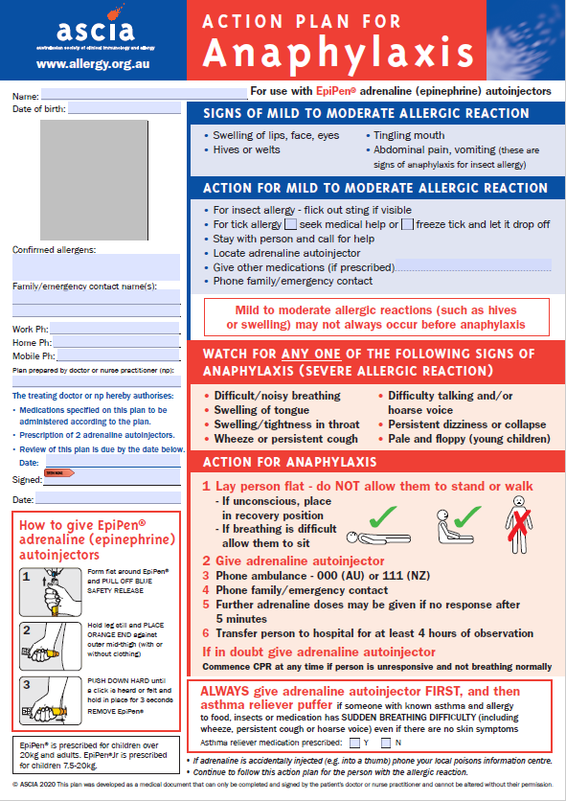
Accessed from https://www.allergy.org.au/images/stories/anaphylaxis/2020/ASCIA_Action_Plan_Anaphylaxis_EpiP en_Red_2020.pdf

Attachment B: In hospital checklist for patients own use of adrenaline (epinephrine) autoinjectors
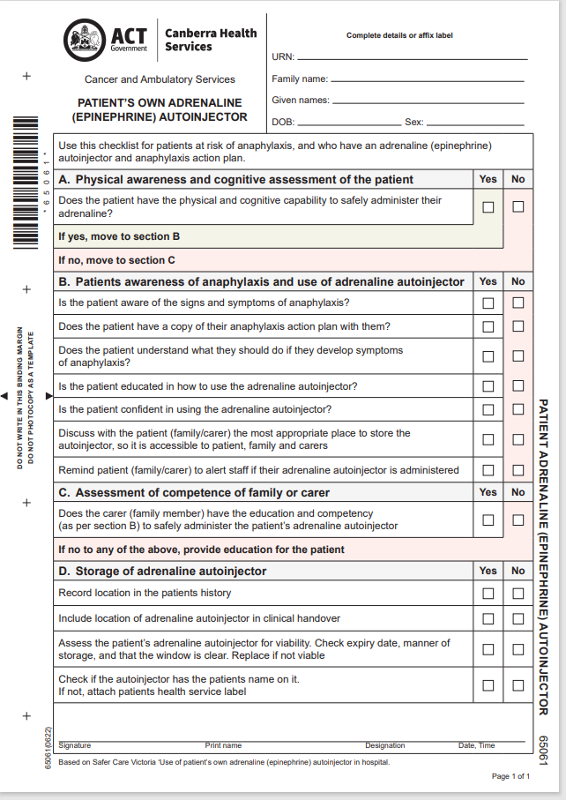

Attachment C: Schematic Flow Chart
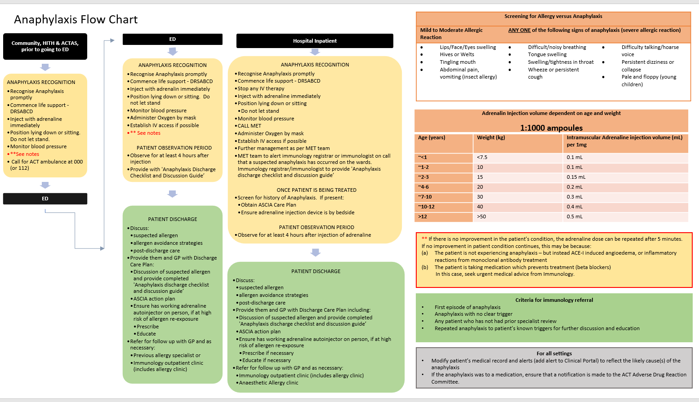

Attachment D: Basic Life Support Chart
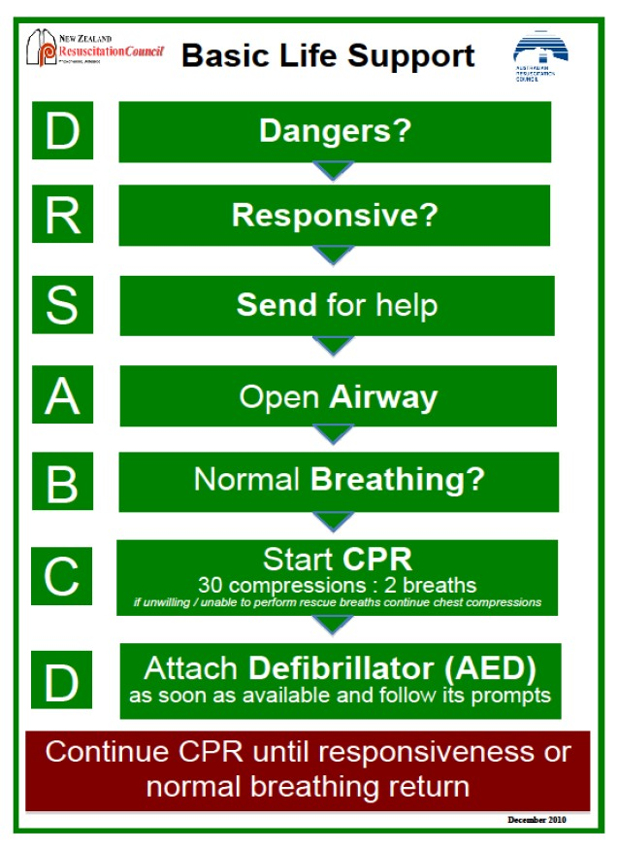

Attachment E: How to use an Epipen
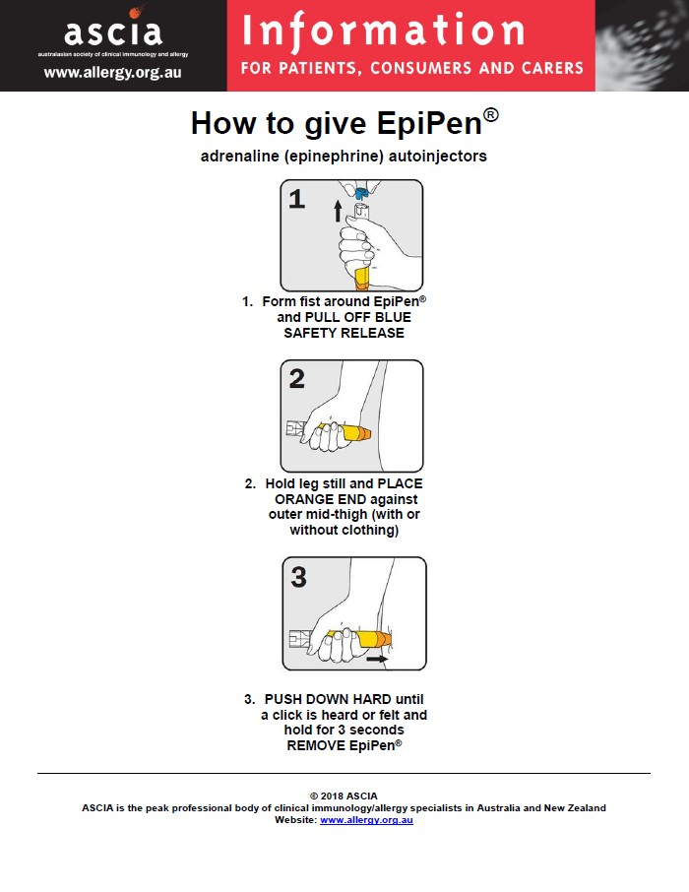
Accessed from: https://www.allergy.org.au/images/stories/anaphylaxis/2018/ASCIA_PCC_How_to_give_EpiPen_201 8.pdf

Attachment F: How to use an Anapen

Anapen® is administered via a simple, 4 step process³






      - Remove grey safety cap from red button

      - Pull of black needle shield

      - Place needle firmly against out mid-thigh at 90° angle, with or without clothing

      - Press red button so it clicks. Hold for 10 seconds. Remove Anapen®.

In more detail
Step 1
Pull off the black needle shield by pulling hard in the direction of the arrow.

When the black needle shield is removed, a small internal grey needle shield will come loose. This is supposed to happen. The Anapen® needle is double capped for safety and sterility.

Step 2
Remove the grey safety cap from the red firing button.

Step 3
Position the needle end of the Anapen® device against the outer part of the thigh. Anapen® can be used through light clothing, such as denim, cotton or polyester.
Note: Anapen® is intended only for intramuscular use. Administer to the outer part of the thigh only, nowhere else.
Step 4

WHITE END ON LEG | PRESS THUMB ON RED

Press the red firing button so that it clicks.

Hold the Anapen® device against the outer thigh for 10 seconds, then slowly remove it from the thigh.
© 2021 Allergy Concept
Accessed from : How to Use — Anapen

Attachment G: Adverse Event Following Immunisation (AEI) Form
Clinical Apps - Adverse Event Following Immunisation (AEFI) form (sharepoint.com)

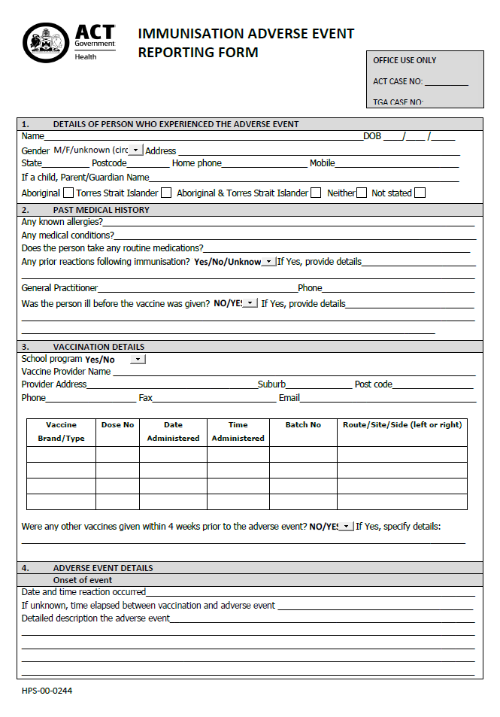
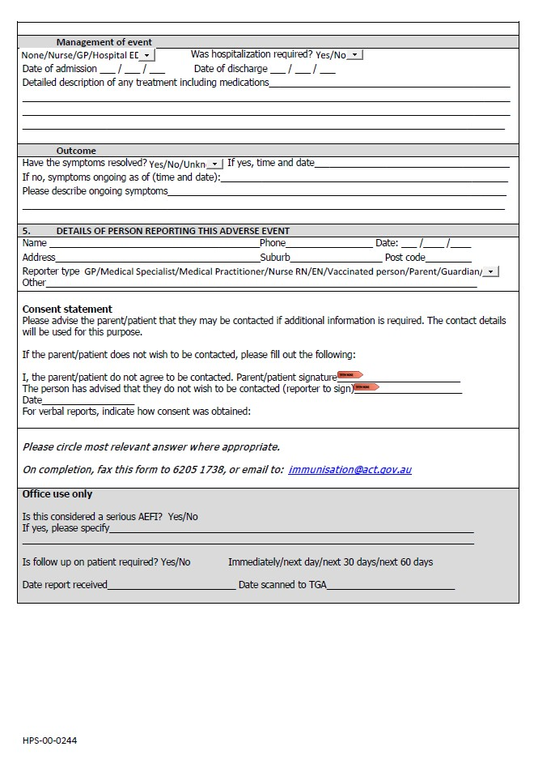

Attachment H: Anaphylaxis discharge Checklist and Discussion Guide
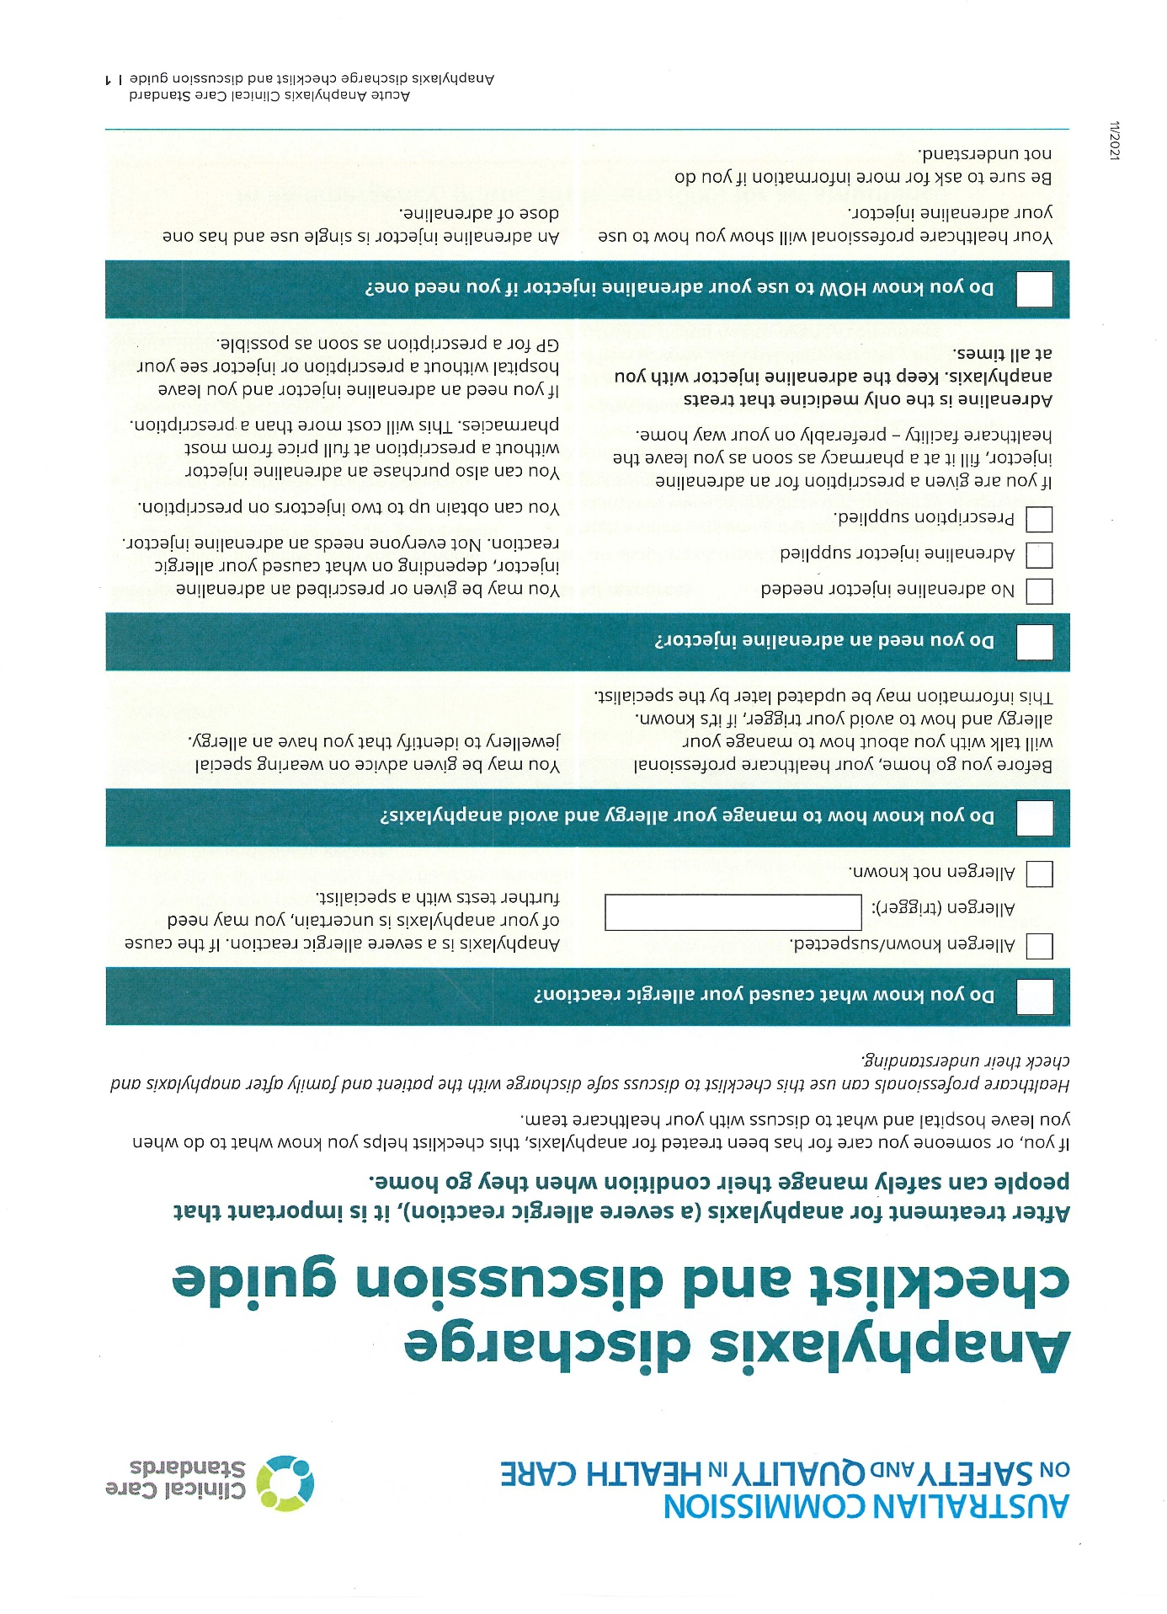
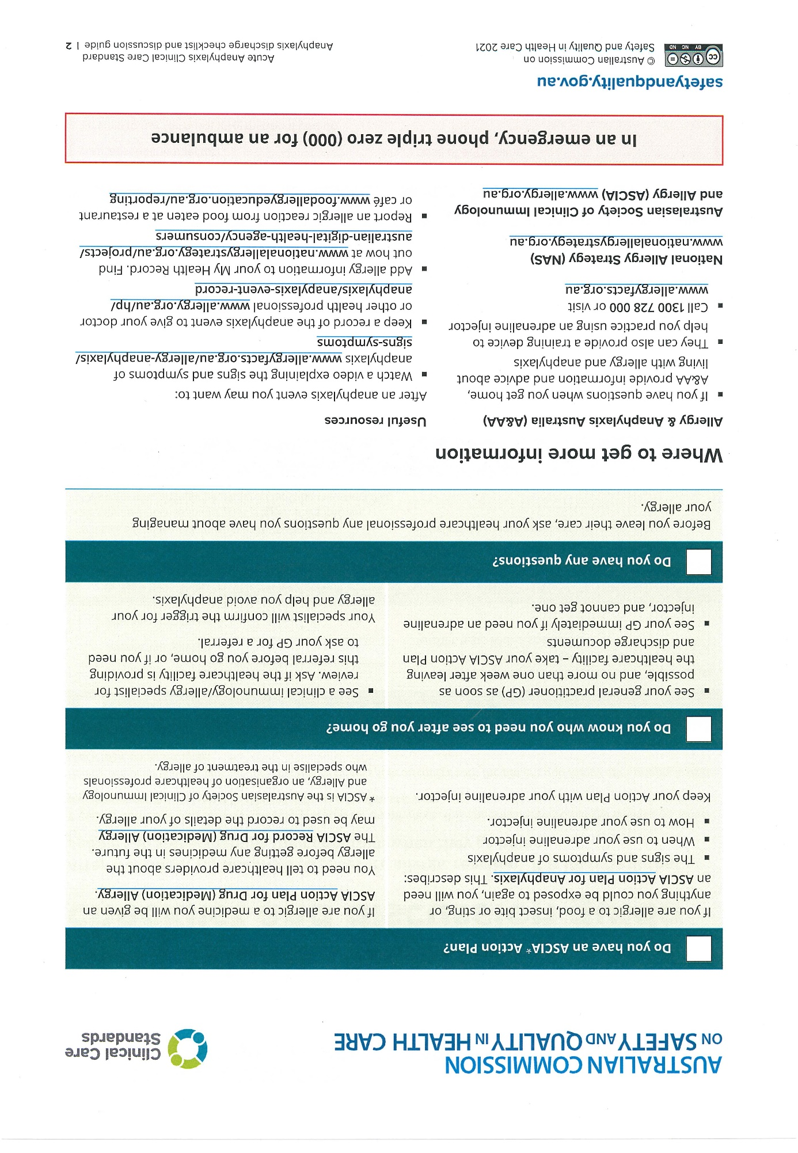
Attachment I - Clinical procedure for management of anaphylaxis in HITH Services – 2022 Australian Prescriber

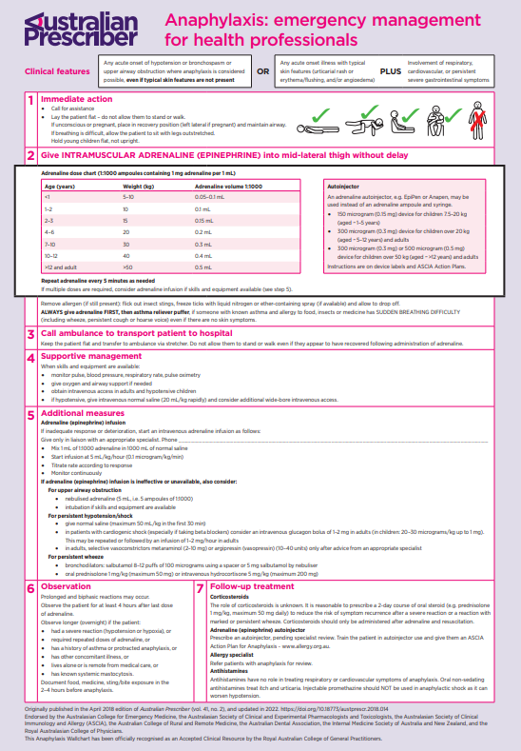
Attachment J - Flowchart for Management of Anaphylaxis in the Community

