Canberra Health Services
Clinical Procedure
Iron Infusions – Adult Only

Contents

Contents 1
Purpose 2
Alerts 2
Scope 2
Section 1 - Intravenous Iron Infusion 3
Section 2 - Iron Polymaltose Infusion 4
Section 3 - Ferric Carboxymaltose Infusion 7
Section 4 - Iron Sucrose Infusion 8
Section 5 - Adverse Effects 10
Evaluation 12
Related Policies, Procedures, Guidelines and Legislation 12
References 13
Search Terms 14
Attachments 14

Purpose

To ensure the safe prescribing and administration of intravenous (IV) iron (including either iron polymaltose, iron sucrose or ferric carboxymaltose) by infusion, to adult patients, at Canberra Health Services (CHS).

Back to Table of Contents

Alerts

- Subcutaneous leakage of iron - iron infusions that leak under the skin result in permanent discolouration of the skin and can happen in the absence of patient reports of discomfort. Refer to Section 4 for management.
- Infusion rates, maximum doses and dilutions are not interchangeable between intravenous iron preparations.
- Oral iron supplements should not be given together with parenteral iron.
- Anaphylactoid reactions may occur with intravenous iron so an emergency trolley, and facilities for cardiopulmonary resuscitation must be readily accessible should a hypersensitivity reaction occur.
- Red cell transfusion is inappropriate therapy for Iron deficiency anaemia unless an immediate increase in oxygen delivery is required, such as when the patient is experiencing end-organ compromise (e.g., angina pectoris or cardiac failure), or if iron deficiency anaemia is complicated by serious, acute ongoing bleeding.

Back to Table of Contents

Scope

This procedure applies to all CHS staff working within their scope of practice that prescribe, administer, supply, monitor or advise on the use of iron infusions.

This procedure applies to patients receiving iron infusions in both inpatient and outpatient settings.

This procedure does not apply to patients receiving iron infusions through dialysis as part of treatment for end stage renal failure. Refer to Haemodialysis and Plasma Exchange in Adults Procedure for information about iron infusions for patients receiving haemodialysis.

Back to Table of Contents

Section 1 - Intravenous Iron Infusion

Management of Iron deficiency Anaemia is an important part of the Patient Blood Management (PBM) Strategy . PBM is a coordinated, patient-centred approach to manage and conserve a patient’s own blood to improve health outcomes. For more information on PBM see: https://www.blood.gov.au/pbm-guidelines

Indication
For the treatment of iron deficiency anaemia:
- When oral therapy is contraindicated, or inappropriate or enteric absorption of iron is defective
- Non-compliance with, or gastrointestinal upset from, oral iron preparations
- Second or third trimester of pregnancy, for the above reasons, or to avoid blood transfusion
- Post-partum or post-surgical anaemia following acute large volume blood loss
- Pre-operative patients identified as iron deficient prior to surgery and if oral iron preparations are unlikely to replace iron stores in the required time – Refer to Attachment A
- With erythropoietin therapy in patients with chronic renal impairment – Refer to Haemodialysis and Plasma Exchange for Adults Procedure for information about iron in patients receiving haemodialysis.
- It is important to note that iron deficiency may occur without anaemia, and suboptimal iron stores will impact on the patient’s ability to respond to the increase in erythropoiesis associated with blood loss.

Contraindications
- Previous hypersensitivity to a form of parenteral iron – alternative formulations, including iron sucrose (Venofer®) may be an alternative (see Section 4)
- Anaemia not caused by simple iron deficiency (e.g., haemolytic anaemia, megaloblastic anaemia caused by vitamin B₁₂ deficiency, disturbances in erythropoiesis, hypoplasia of the marrow)
- Iron overload (e.g., haemochromatosis, haemosiderosis)
- Acute infectious renal complaints
- Decompensated hepatic cirrhosis
- Patients with severe inflammation or infection
- Uncontrolled hyperparathyroidism

Precautions
- Use with caution after consulting treating Medical Officer (MO) for patients with:
- Low iron binding capacity (increased chance of hypersensitivity)
- Folic acid deficiency (increased chance of hypersensitivity)
- Bronchial asthma (increased chance of hypersensitivity)
- Chronic polyarthritis
- Infectious hepatitis

Infusion set-up¹
To minimise risk of iron staining the following procedures are recommended:
- Distal veins of the forearm are preferred site for cannulation and administration of iron infusion (avoid the back of the hand, and sites of flexion e.g., antecubital fossa and wrist)
- Use appropriate cannula size (20 to 24 gauge)
- Secure the cannula and use an extension set to minimise catheter movement
- Leave injection site uncovered, a bandage is not necessary.
- Minimise the number of cannulation attempts
- IV iron should be commenced only once the patency of the cannula has been confirmed
- Do not administer infusions at nighttime or to patients who are unable to report symptoms (e.g., anaesthetised patients)
- Nursing staff should be always alert to extravasation as parenteral iron can cause permanent staining of the skin. Refer to Section 5 for management.

Back to Table of Contents

Section 2 - Iron Polymaltose Infusion

Indication
- Iron Polymaltose is the first line option for parenteral iron for inpatients. Refer to Canberra Hospital Formulary for further information on availability of other forms of parenteral iron.

Availability
- Standard ready-made iron polymaltose infusion bags are available from the pharmacy department and in some ward areas, for the following standard doses:
- Iron polymaltose 1000mg in 250mL sodium chloride 0.9% (final volume 285mL)
- Iron polymaltose 1500mg in 500mL sodium chloride 0.9% (final volume 575mL)
- Iron polymaltose 2000mg in 500mL sodium chloride 0.9% (final volume 585mL)
- For compounding of alternative doses or fluid options please contact your ward pharmacist, or the Pharmacy IV Room, on x42633 or 02 5124 2633

Prescribing
- Dose is based on body weight and haemoglobin of the patient – refer to table below
- If the patient has been given a blood transfusion to correct the low haemoglobin, use the POST-transfusion haemoglobin to calculate dose
- Only 1000mg iron polymaltose infusions can be given by rapid infusion (total infusion time 81 minutes)

Dose of Elemental Iron Required - Simplified dosing ^{2,14}
- Dose is based on body weight and haemoglobin of the patient

 | Body Weight < 70kg | Body Weight ≥70kg
Haemoglobin (g/L)  pre-blood transfusion | Dose of elemental iron (mg)
≥ 100 | 1000mg | 1500mg
70 to 99 | 1500mg | 2000mg
< 70 | 2000mg | 2000mg
* Rapid infusion rates only available for 1000mg iron polymaltose
Note: Renal physicians may request iron polymaltose at a dose of 500mg

- If haemoglobin level is not available a suggested dose based on body weight is:
- < 70kg body weight = 1000mg elemental iron
- ≥ 70kg body weight = 1500mg elemental iron
- If Body Mass Index (BMI) ≥ 30, base the dose calculation on ideal (not actual) body weight
- In pregnant women, the pre-pregnancy weight should be used. (If the pre-pregnancy weight is not known then the dose should be based on the current weight less 10%)

Line Requirements
- Iron polymaltose should be infused intravenously through a peripheral line. See ‘Infusion Set Up’ in Section 1.

Administration³
- Anaphylactoid reactions may occur with intravenous iron – see alerts
- An emergency trolley and facilities for cardiopulmonary resuscitation must be readily accessible should a hypersensitivity reaction occur
- Each infusion will be run at a ‘test dose rate’ for the first 15 minutes, though reaction can occur at any stage through the infusion
- If an infusion-related reaction occurs temporarily stop the infusion and restart at the same rate or a reduced rate of 60 mL/hour
- Only 1000mg iron polymaltose infusions can be given by rapid infusion protocol
- Doses of 1500mg and 2000mg must be given by slow infusion protocol
- Refer to table below for information on infusion rates

 | Rapid Infusion iron polymaltose |  |  |  | Slow Infusion iron polymaltose
Total iron dose presented as iron polymaltose | Initial Infusion Rate | If tolerated increase to | Monitoring | Total infusion time including test dose | Rate | If tolerated increase to | Monitoring | Total infusion time including test dose
1000mg in 250mL sodium chloride 0.9%  (final volume 285mL) | 40mL/hour for 15 minutes | 250mL/hour | Vital signs every 5 minutes for 15 minutes, then every 15 minutes until 30 minutes post infusion | 1 hour 21 minutes  (81 minutes) | 40mL/hour for 15 minutes | 120mL/hour | Vital signs every 5 minutes for 15 minutes, then every 30 minutes until 30 minutes post infusion | 2 hours 33 minutes  (153 minutes)
1500mg in 500mL sodium chloride 0.9%  (final volume 575mL) | Not available for administration as rapid infusion |  |  |  | 40mL/hour for 15 minutes | 120mL/hour | Vital signs every 5 minutes for 15 minutes, then every 30 minutes until 30 minutes post infusion | 4 hours 58 minutes  (283 minutes)
2000mg in 500mL sodium chloride 0.9%  (final volume 585mL) | Not available for administration as rapid infusion |  |  |  | 40mL/hour for 15 minutes | 120mL/hour | Vital signs every 5 minutes for 15 minutes, then every 30 minutes until 30 minutes post infusion | 5 hours 3 minutes  (303 minutes)

Monitoring ^{2,3}

A full set of vital signs as per Vital Signs and Early Warning Scores procedure at:
- Baseline (prior to infusion administration), then
- Every 5 minutes for 15 minutes during administration of test dose, then
- Every 15 minutes for rapid infusion rates until 30 minutes post infusion, or
- Every 30 minutes for slow infusion rates until 30 minutes post infusion.
- If an infusion-related reaction occurs temporarily stop the infusion and then restart at the same rate or a reduced rate of 60 mL/hour

Back to Table of Contents

Section 3 - Ferric Carboxymaltose Infusion

Note: A maximum of 1000mg ferric carboxymaltose may be given as a single dose per week.
Outpatients should access ferric carboxymaltose on external PBS prescriptions

Indication
- Iron Polymaltose is the first line option for parenteral iron for inpatients. Refer to the Canberra Hospital Formulary for further information to determine if your patient is eligible for ferric carboxymaltose.

Availability
- Ferric carboxymaltose vials are dispensed by the hospital pharmacy department upon receipt and medication review of the prescription.

Dosing ¹⁵
Haemoglobin g/L | Body Weight 35 to <70 kg | Body Weight ≥ 70 kg
< 100 | 1500mg* | 2000mg*
≥ 100 | 1000mg | 1500mg*
Max dose per week of ferric carboxymaltose is 1000mg. In patients who need more than 1000mg, the dose must be divided and given at least one week apart

Presentation
- 100mg/2mL solution in a glass vial
- 500mg/10mL solution in a glass vial

Prescribing
- Dose is based on body weight and haemoglobin of the patient
- If patient has been given a blood transfusion to correct the low haemoglobin, use the post-transfusion haemoglobin to calculate dose. Max dose per week of ferric carboxymaltose is 1000mg. In patients who need more than 1000mg, the dose must be divided and given at least one week apart

Line Requirements
- Ferric carboxymaltose should be infused intravenously through a peripheral line. See ‘Infusion Set Up’ in Section 1.

Administration
- Anaphylactoid reactions may occur with intravenous iron – see alerts
- An emergency trolley and facilities for cardiopulmonary resuscitation must be readily accessible should a hypersensitivity reaction occur

IV infusion:
- Doses up to 500mg can be added to 100mL sodium chloride 0.9% and infused over 6 minutes
- Doses > 500mg to a maximum of 1000mg can be added to 250mL of sodium chloride 0.9% and infused over 15 minutes

IV injection:
- Doses up to 500mg can be administered as an intravenous injection, undiluted at maximum rate of 100mg/minute. Use a spring fuser with flow control tubing of 10mL over 5 minutes.
- Doses > 500mg to maximum of 1000mg can be administered as an intravenous injection, undiluted over 15 minutes. Use a spring fuser with flow control tubing of 10mL over 15 minutes.

Monitoring
- A full set of vital signs as per Vital Signs and Early Warning Scores procedure at:
- Baseline (prior to infusion administration), then
- At completion of infusion
- Patients should be monitored closely for signs of hypersensitivity during and for at least 30 minutes after administration

Preparation
Stability:
- Solutions prepared for infusion or injection should be used immediately

Back to Table of Contents

Section 4 - Iron Sucrose Infusion

Indication
- Iron Polymaltose is the first line option for parenteral iron for inpatients. Refer to the Canberra Hospital Formulary for further information to determine if your patient is eligible for Iron Sucrose. Usually, Iron Sucrose is indicated if the patient has had a reaction to iron polymaltose.

Presentation
- Iron as iron sucrose (Venofer®) 100mg/5mL ampoule

Availability
- Iron sucrose ampoules are dispensed by the hospital pharmacy department upon receipt and medication review of the prescription

Prescribing in patients with adequate kidney function (i.e., patients not receiving haemodialysis)
- A total dose of 1000mg of iron sucrose is given in 5 x 200mg doses over a 14-day period. 200mg diluted in 50 to 100mL sodium chloride 0.9% is administered intravenously over 15 minutes. Repeat this on 4 different occasions across a 14-day period to administer total required iron dose of 1000mg (i.e., 5 x 200mg = 1000mg)
- Patients who are at increased risk of allergic reactions may require premedication 20 minutes prior to infusion (see Section 4 adverse effects)

Alert:. For patients receiving haemodialysis refer to Haemodialysis and Plasma Exchange for Adults Procedure)

Test Dose
- For iron sucrose infusion in a new patient, a test dose of 20mg given intravenously over 15 minutes should be given.
- Give iron sucrose 20mg (1mL) in 20mL sodium chloride 0.9% infused IV over 15 minutes.
- The 20mg test dose comes out of the prescribed dose. (e.g., if prescribed dose is 200mg, give 20mg as slow infusion test dose, then give remaining 180mg in 50 to 100mL sodium chloride 0.9% over 15 minutes).

Line Requirements
- Iron sucrose should be infused intravenously through a peripheral line. See ‘Infusion Set Up’ see Section 1.

Administration
- 200mg iron sucrose diluted in 50 to 100mL sodium chloride 0.9% administered intravenously over 15 minutes
- An emergency trolley and facilities for cardiopulmonary resuscitation must be readily accessible should a hypersensitivity reaction occur
- Patients who are at increased risk of allergic reactions may require premedication 20 minutes prior to infusion (see Section 5 for managing adverse effects)

Monitoring
- Take a full set of vital signs as per Vital Signs and Early Warning Scores Procedure at:
- baseline (prior to infusion administration).
- Patients should be monitored for signs of hypersensitivity during and for at least 30 minutes after administration.

Back to Table of Contents

Section 5 - Adverse Effects

Incompatibilities³
- Iron infusions must have their own intravenous line because they are incompatible with other drugs
- Iron is only compatible with sodium chloride 0.9%
- Refer to the Australian Injectable Drugs Handbook for up-to-date information

Interactions
- Oral iron supplements should not be given concomitantly with parenteral iron. Stop oral iron supplements before iron infusion and do not restart for one week
- Concomitant administration of Angiotensin Converting Enzyme (ACE) inhibitors may increase the incidence of adverse effects associated with parenteral iron preparations e.g., erythema, abdominal cramps, nausea, vomiting and hypotension
- Refer to an up-to-date interactions resource for comprehensive information.

Subcutaneous leakage of iron
Iron infusions that leak under the skin result in permanent discolouration. While the risk of this occurring is low, patients should be warned of this possibility during the consent process.

To minimise risk of iron staining the following procedures are recommended¹:
- Distal veins of the forearm are preferred site for cannulation and administration of iron infusion (avoid the back of the hand, and sites of flexion e.g., antecubital fossa and wrist)
- Use appropriate cannula size (20 to 24 gauge)
- Secure the cannula and use an extension set to minimise catheter movement
- Leave injection site uncovered, a bandage is not necessary.
- Minimise the number of cannulation attempts
- IV iron should be commenced only once the patency of the cannula has been confirmed
- Do not administer infusions at nighttime or to patients who are unable to report symptoms (e.g., anaesthetised patients)
- The infusion site should be regularly monitored during infusion
- Pain or infusion site discomfort should prompt immediate cessation of the infusion and it be recommenced only once patency has been confirmed
- The IV cannula must be thoroughly flushed at the end of the infusion to ensure that residual iron within the cannula does not deposit as the cannula is withdrawn
- Extravasation of iron can cause permanent staining and is not limited to long infusions. Extravasation has been reported with infusions of 15 minutes and in the absence of patient reports of discomfort. Informing the patient of the potential for skin staining is recommended³.

Management of subcutaneous leakage of iron¹
Stop infusion immediately if patient reports pain, swelling, soreness at injection site.

- Disconnect giving set
- Aspirate any residual drug from cannula
- Remove the cannula
- Apply cold pack for swelling or soreness, though this does not prevent spread of stain
- Take clinical photograph to capture extent of extravasation and to monitor success of treatments
The options for reversing iron staining are limited, with the most evidence for laser therapy. Prompt referral of the patient to a Dermatologist is suggested.

Adverse Effects of iron infusions
Note: Patients who are at increased risk of allergic reactions (see Precautions above) may require premedication 20 minutes prior to infusion:
- 100mg IV hydrocortisone
- 180mg oral fexofenadine
- Anaphylactic reactions occur most frequently within the first several minutes of administration.
- If signs of allergic reaction or intolerance occur at any time during the infusion, the infusion must be stopped, and a medical officer contacted immediately

Immediate adverse effects may include:
- Anaphylactoid reactions
- Bronchospasm with dyspnoea
- Faintness, syncope, tachycardia, hypotension, circulatory collapse
- Loss of consciousness

Alert: If any adverse reactions fall into the Medical Emergency Team (MET) criteria, a Code Blue must be called (dial 2222)

Mild allergic reactions (mild rash, itching, no respiratory symptoms, no facial swelling) can be treated with an antihistamine such as fexofenadine.

Delayed Adverse Effects:
- Patients with rheumatoid arthritis and other inflammatory diseases (e.g., ankylosing spondylitis, lupus erythematosus) may be at particular risk of delayed reactions, including fever and exacerbation or reactivation of joint pain. They may include:
- Central Nervous System: dizziness
- Musculoskeletal: arthralgia, myalgia, sensation of stiffening of arms, legs or face
- Haematological: generalised lymphadenopathy
- Dermatological: angioneurotic oedema, rash, urticaria
- General: chills, fever, chest & back pain

Side Effects of iron infusions
General infusion side effects may include:
- Cardiovascular: hypotension, collapse, tachycardia and palpitations
- Central Nervous System: headache and dizziness
- Gastrointestinal: nausea & vomiting (may indicate excessive infusion rate), abdominal pain and diarrhoea
- Musculoskeletal: joint and muscle pain
- Dermatological: rash, urticaria
- General: flushing, sweating, fever, shivering, chest tightness

Reporting
When a patient experiences an adverse effect from an iron infusion it is reported in the adverse drug reaction form located in the pharmacy page on the intranet.

Other incidents related to iron infusions are reported in the clinical incident reporting system.

Back to Table of Contents

Evaluation

Outcome
Patients will safely receive the appropriate intravenous iron infusion in the correct dose and administered in the safest way possible.

Measures
- Review of adverse effects due to iron infusions reported in adverse drug reaction system.
- Review of clinical incidents relating to administration of iron infusions reported in the incident management system Riskman.
- Drug Usage Review to ascertain the clinical indications for the different iron preparations to observe if hospital formulary restrictions are reserved.

Back to Table of Contents

Related Policies, Procedures, Guidelines and Legislation

Policies
- Nursing and Midwifery Continuing Competence
- Informed Consent (Clinical)
- Medication Handling

Procedures
- Infection Prevention and Control - Healthcare Associated Infections
- Peritoneal Dialysis
- Haemodialysis and Plasma Echange for Adults
- Vital Signs and Early Warning Scores
- University of Canberra Hospital (UCH) – Vital Signs and Early Warning Scores
- Patient Identification and Procedure Matching
- Peripheral Intravenous Cannula Adults and Children (not neonates)
- Venous and Arterial Access Management in the Department of Neonatology

Guidelines
- Intermittent Haemodialysis
- Renal Vascular Access for Renal Replacement Therapy in Adults

Legislation
- Health Records (Privacy and Access) Act 1997
- Human Rights Act 2004
- Work Health and Safety Act 2011
- Medicines, Poisons and Therapeutic Goods Act 2008
- Medicines, Poisons and Therapeutic Goods Regulation 2008

Other
- Australian Charter in Healthcare Rights

Back to Table of Contents

References

- Canning M, Grannell L. A stain on iron therapy. Aust Prescr 2020;43:160-3. Available from DOI: 10.18773/austprescr.2020.051
- Ferrosig (Iron Polymaltose Injection Product Information: Sigma Pharmaceutical (Australia) Pty Ltd. Available at MIMS Online.
- Ermer J & Symons K (ed). Australian Injectable Drug Handbook Eight Edition. Content last updated 31/8/21. The Society of Hospital Pharmacists of Australia, 2020.
- Newnham, E., Ahmad, I., Thornton, A., and Gibson, P.R. (2006) ‘Safety of iron polymaltose given as a total dose iron infusion’. Internal Medicine Journal. 36: 672-674.
- NSW Therapeutic Advisory Group (2008) ‘Iron Polymaltose Infusions Discussion Paper’. New South Wales Therapeutic Advisory Group Inc.
- Iron Polymaltose Compound Infusion (2010) Ballarat Health Services.
- Drug Protocol: Iron polymaltose infusion (2007) Sydney West Area Health Service.
- Iron Infusion (Iron Polymaltose) Guideline (2007) North Coast Area Health Service.
- Venofer (Iron Sucrose) Injection Product Information: Sigma Pharmaceutical (Australia) Pty Ltd. Available at MIMS Online.
- Venofer Practice Guidelines. Drug Information Unit Westmead Hospital Pharmacy Department, Sydney.
- Policies and procedures: Iron Sucrose (Venofer) (2002) Royal Melbourne Hospital.
- DrugDex Evaluation: Iron. (2018). Available at Micromedex Online.
- Iron Sucrose: Drug Information (2018). Available at UpToDate Online.
- Evstatiev, R, Marteau, P, Iqbal, T, Khalif, I, Stein, J et.al (2011) FERGIcor, a randomized controlled trial on ferric carboxymaltose for iron deficiency anaemia in inflammatory bowel disease. Gastroenterology, 141:846-853.
- Ferinject (Iron Carboxymaltose Injection Product Information: Vifor Pharma Pty Ltd (Australia) Pty Ltd. Available at MIMS Online.
- Iron; Dosing/Administration Iron Sucrose. Micromedex (2021) Available at IBM Micromedex.
- Drug Guideline, Parenteral Iron Infusion (2010). Alfred Health.

Back to Table of Contents

Search Terms

Iron, iron infusion, intravenous iron, iv iron, iron sucrose, iron polymaltose, ferric carboxymaltose, iron (Fe), anaemia, ferritin, intravenous, ferrinject, iron deficiency.

Back to Table of Contents

Attachments

Attachment A: Preoperative haemoglobin assessment and optimisation template

Back to Table of Contents

Disclaimer: This document has been developed by Canberra Health Services specifically for its own use. Use of this document and any reliance on the information contained therein by any third party is at his or her own risk and Canberra Health Services assumes no responsibility whatsoever.

Policy Team ONLY to complete the following:
Date Amended | Section Amended | Divisional Approval | Final Approval
08 October 2021 | Complete Review | Dr Nick Coatsworth, ED-MSG | CHS Policy Committee

This document supersedes the following:
Document Number | Document Name
CHHS18/138 | Iron Infusions – Adults Only

Attachment A: Preoperative haemoglobin assessment and optimisation template.
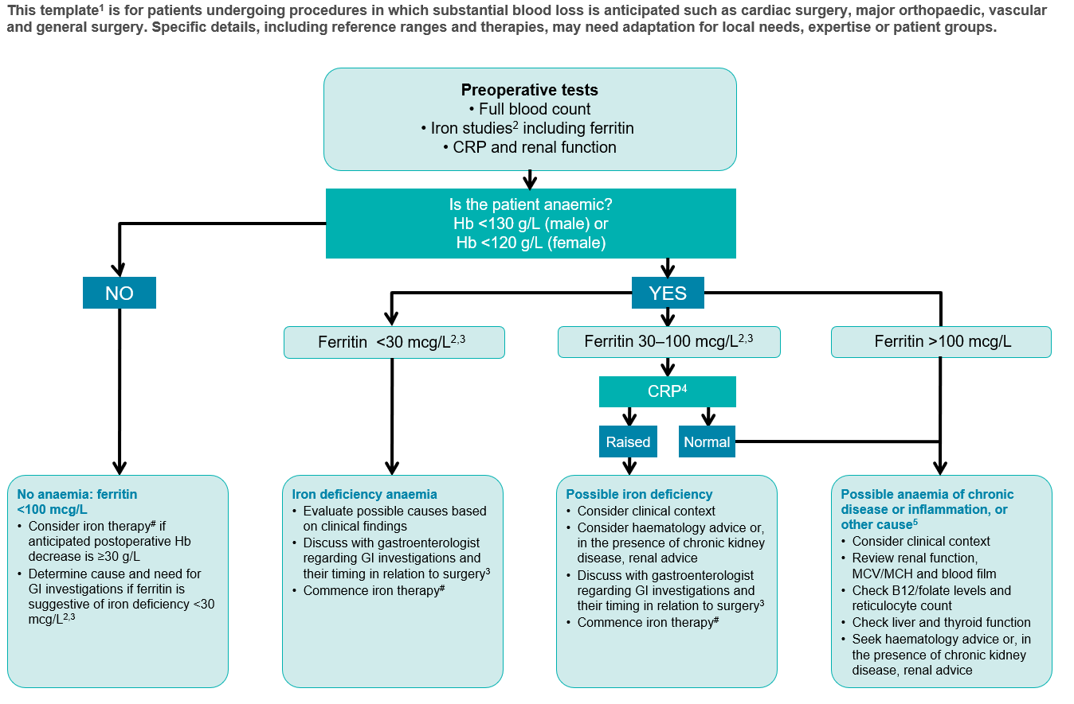
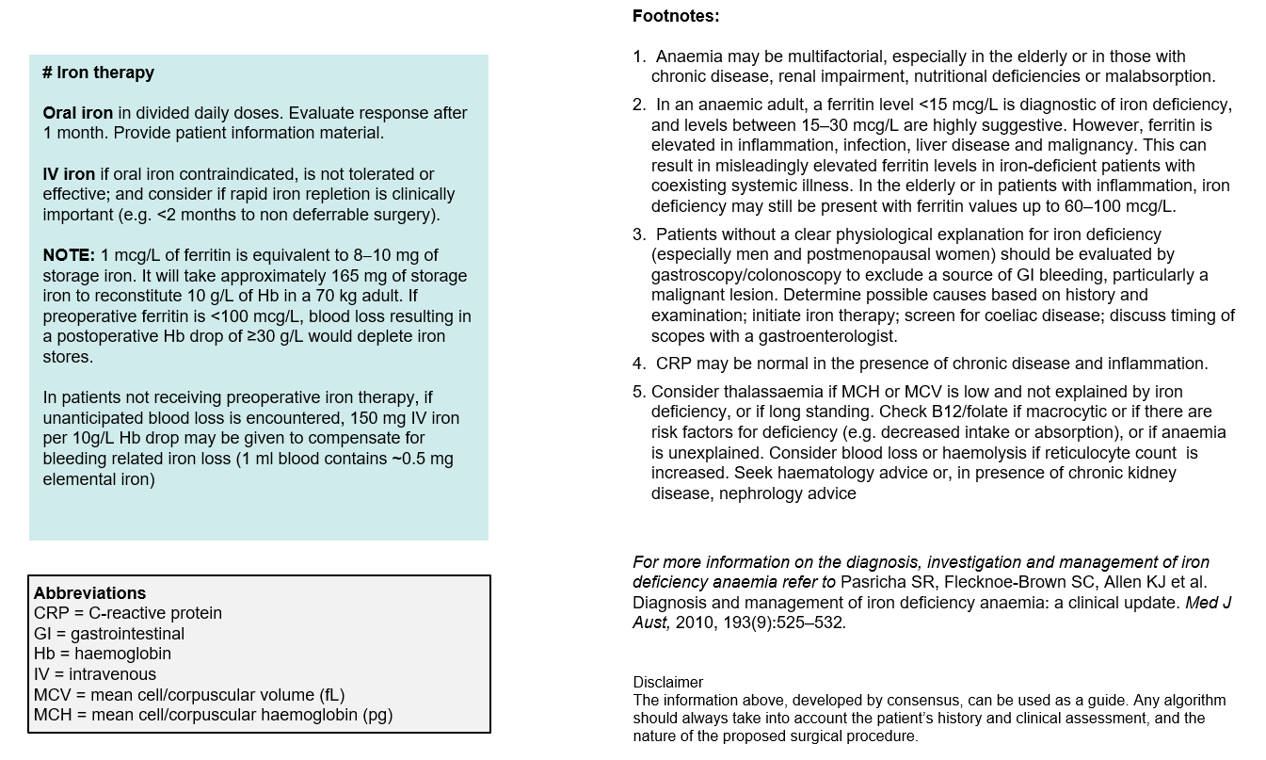
This template comes from www.nba.gov.au and The National Blood Authority’s Patient Blood Management Guideline: Module 2 – Perioperative and which is licensed under the Creative Commons AttributionNonCommercial-ShareAlike 3.0 Australia licence.

