Procedure | Canberra Health Services
Electroconvulsive Therapy (ECT)/Neurostimulation (NS)
CHS25/261
Contents
Purpose 3
Alerts 3
Scope 4
Section 1 Governance 4
Section 2 – Roles and Responsibilities 5
Section 3 – Clinical Training, Credentialing and Scope of Practice 12
Section 4 – Clinical Indications and Special Populations 14
Section 5 – Consent for ECT 16
Section 6 – Electroconvulsive Therapy Orders 18
Section 7 – Preparation of a Consumer for ECT 20
Section 8 – Administering ECT 21
Section 9 – Continuation and Maintenance ECT 23
Section 10 – Referral of outpatients for ECT 23
Section 11 – Post ECT follow- up and monitoring 24
Section 12 – Adverse Incidents and Critical Events 24
Section 13 – DHR Business Continuity Plan 25
Evaluation 25
Related policies, procedures, guidelines and legislation 25
References 26
Definition of terms 27
Search terms 29
Attachments 30
Attachment 1: Prescription and Administration of ECT Flow Chart for an Adult 32
Attachment 2: Prescription and Administration of ECT Flow Chart for a Young Person at least 12 years of age but under 18 years of age 33
Attachment 3: ECT Electrode Placement 34
Attachment 4: Method of ECT Dose Titration and Treatment Schedule for Brief Pulse Thymatron Series IV 37
Attachment 5: Method of ECT Dose Titration and Treatment Schedule for Brief Pulse Thymatron Series IV ultra-brief pulse (0.3 ms and 0.5 ms) 39
Attachment 6: RANZCP guidelines considerations for ECT electrode placements, pulse width and seizure threshold. 40

Purpose
The purpose of this procedure is to provide information on the safe and effective administration of Electroconvulsive Therapy (ECT), also known as Neurostimulation (NS) to consumers being treated in Canberra Health Services (CHS) as either voluntary or involuntary under the Mental Health Act 2015.
This procedure provides clinicians with best practice information for the assessment, prescription, administration, and monitoring of consumers undergoing ECT as well as follow-up after a course of ECT.
ECT is an evidence-based treatment for severe depressive illness. There is also evidence to support the use of ECT in the treatment of acute mania, catatonia, and schizophrenia and as a long-term maintenance treatment (M–ECT) for the same indications as for acute treatment. It is an available treatment option at many specialist mental health facilities in Australia. Several organisations in Australia and internationally have produced guidelines to promote best practice and optimal outcomes in terms of efficacy and safety. This Procedure includes select material from multiple sources, with those of Australian origin being acknowledged⁻³.
Back to Contents

Alerts
Staff should always refer to the Mental Health Act 2015 (hereafter referred to as “the Act”) and Chief Psychiatrist Guidelines for the most definitive understanding, interpretation, and explanation of the Act itself, particularly when making any decisions in relation to the Act.
ECT must never be given to children under 12 years of age.
An Emergency ECT order may only be made for a young person who is at least 16 years of age.
ECT should be administered in accordance with the Royal Australian and New Zealand College of Psychiatrists professional practice guidelines for the administration of ECT¹. Where new evidence emerges, this should be incorporated in clinical practice only after due consideration within the organisational governance framework of ECT.
A person commits an offence against the Act if they are not a medical officer, and they administer ECT to a consumer. A doctor commits an offence if they administer ECT to a consumer without meeting the requirements to the Act.
Guardians and Attorneys are not authorised to consent to the administration of ECT.
Use of Restraints
The use of restraints may be necessary for a consumer while being transported from an adult mental health inpatient facility or Dhulwa Mental Health Unit (DMHU) to the treatment room, if extreme safety concerns exist. The Chief Psychiatrist or a delegated Psychiatrist can authorise the use of restraint.
The authorisation of restraints must be documented by the Consultant Psychiatrist on Digital Health Record (DHR) or if DHR downtime refer to the Clinical Risk Assessment and Management form (see Restraint of a Person Detained under the Mental Health Act 2015 Procedure).
Back to Contents

Scope
This procedure applies to adults and young people 12 years of age and over being treated by CHS. People treated by CHS can receive ECT as an inpatient, or day procedure as an outpatient.
In the Australian Capital Territory (ACT) ECT may only be performed in an approved Mental Health Facility. This procedure provides information for all CHS employees (permanent, temporary, and casual) and all organisations and individuals acting as its agents (including visiting medical officers [VMOs]) and other partners, contractors, consultants, and volunteers) involved in the delivery of ECT.
This document applies to the following staff working within their scope of practice:
- Medical Officers
- Registered Nurses
- ECT Co-ordinator
- Allied Health Professionals
- Enrolled Nurses
- Assistants in Nursing
- Wardspersons
- Students under direct supervision.
Back to Contents

Section 1 Governance

ECT Services
The provision of ECT services at CHS occur within an organisational framework of an ECT service under the direct leadership of a consultant psychiatrist who is the Clinical Director of ECT.
The Clinical Director’s role includes responsibility for ensuring that standards of ECT practice are maintained including:
- adequate orientation of new medical staff
- training for credentialing purposes
- Investigate and respond to complains about the prescription or administration of ECT
- documentation
- data collection
- auditing.
CHS also has a senior Registered Nurse appointed as the senior clinical nurse for ECT.

ACT–wide ECT Committee
The ACT-wide ECT committee reports to Mental Health, Justice Health and Alcohol and Drug Service (MHJHADS) governance committee.
Back to Contents

Section 2 – Roles and Responsibilities
Staff involved in the therapeutic administration of ECT have a key role in educating other parties in understanding and de-mystifying ECT as a treatment modality. For the consumer receiving ECT and their nominated person, family, carer, or other supports, education focuses on generating an informed understanding of ECT.

2.1 Medical Officers
The consumers clinical treating team (medical officers) are directly responsible for the consumers ongoing treatment, care, and support including follow-up of the consumer receiving ECT treatment. Medical officers should ensure that, with consent from the consumer receiving treatment, nominated person, family, carer, or other supports are provided with clear information about the ECT process and given the opportunity to ask questions or raise concerns.
The clinical team is comprised of:
- a consultant psychiatrist (the prescribing consultant psychiatrist),
- psychiatric registrar
- registered medical officer or junior medical officer.

2.2 Treating Consultant Psychiatrist/Psychiatric Registrar
The Treating Consultant Psychiatrist/Psychiatric Registrar will:
- Explain the potential benefits and risks of ECT, alternate treatments and the clinical prognosis of not having any treatment to the consumer being considered for ECT and with the consumers consent, their nominated person, family, carer, or other supports.
- A plain language summary of the treatment plan and potential risks should be offered to the nominated person, family, carer, or other supports where appropriate and consented. Nominated person, family, carer, or other supports should also be informed of how to report side effects post treatment.
- Consider the cessation of benzodiazepines and anticonvulsants (when used as mood stabilisers) prior to ECT treatment, as these can decrease seizure duration and ECT efficiency particularly in Right Unilateral (RUL) ECT.
- Arrange for any diagnostic assessments where applicable i.e., Electrocardiogram (ECG), MRI
- Arrange a specialist consultation for consumers with complex comorbid conditions and ensure a specialist management plan is documented in the consumers DHR.

2.2.1 DHR Documentation Process
Open Consumer’s File for ECT:
- Open ‘Schedule’ from the DHR toolbar
  - For North Canberra Hospital (NCH): Change ‘Dept:’ to “NCH MAIN THEATRE” by typing: ‘nch main’ and pressing Enter
  - For Canberra Hospital (TCH): Change ‘Dept:’ to “TCH NEUROSTIMULATION” by typing: ‘neurostimulation’ and pressing Enter
- Double Click to open consumer file
Sight and Review Consumer’s Consent:
- Open: Mental Health Tab
- Open: Pre and Post ECT tab
- Select: ‘Consents’ from side bar
- Select: ‘Preview Document’ This will allow you to sight and review the consent form
  - If under the Act, select ‘Decision’ on sidebar and click on the relevant order
- Select ‘Report’ to review document
Review ECT Therapy Plan: (this is the prescription for ECT)
- Within the Pre and Post ECT tab, select: ‘Plan Summary’ on sidebar
- Select: ‘Edit Plan’ tab and select ‘review plan’ review ECT Therapy Plan
- Select: ‘Treatment #’ tab and click on ‘Begin Treatment #’
- Check all boxes and select ‘Release’
ECT Authorisation:
- Within the Pre and Post ECT tab select: ‘ECT Authorisation’ on sidebar
- Complete ECT Authorisation checklist to verify that you’ve sighted and reviewed both the consent and prescription
- Select ‘Close’ to complete and save this entry
ECT Documentation:
- Within the Pre and Post ECT tab select: ‘Procedure Notes’ on sidebar
  - Click on the blue hyperlink ‘Electroconvulsive therapy’ for today’s treatment to open a note
- Complete/Fill in template to document treatment details - Select ‘Number of stimulations’ (i.e. 1-4) to expand the form
- Document time for induction and stimulation (use shortcut ‘n’ for current time ‘t’ for today’s date)
- In the ‘comments’ section of the note, type ‘.ECT’ to generate smart phrase template and document staff present, consent, anaesthetic agents, and trace comments.
- To complete documentation, click into the note under the Edit Note tab on the right side of the screen and then select sign.
- Complete ECT register
- Sign EEG trace
- Post ECT/Miscellaneous:
- ECT Nurse or Ward Clerk will upload traces. These can be viewed on the DHR via the Media Manager or via Notes under procedure

2.3 ECT Coordinator
The ECT Coordinator is responsible for numerous tasks at various stages of treatment. These include:
- Coordinating nursing staff training for the delivery of ECT, including ensuring training is recorded on HRIMS Learning
- Coordinating the daily procedure treatment lists
- Stocking consumables such as ECT paper, gels, and other items
- The maintenance of ECT equipment, including arranging regular maintenance of the Thymatron by the Biomedical department as indicated.
Prior to commencing first treatment of the day:
- Confirming the ECT Trolley is stocked, and all required equipment is available
- Running the safety alarm test of the ECT apparatus (Thymatron IV)
- Ensuring the appropriate consents, prescription and orders have been completed.
- Creating the consumer ECT folder and including ECT consent and prescription (when appropriate to include a copy of ECT order and Psychiatric Treatment Order)
- Maintain the consumer’s head in Supine position, to ensure adequate airway and comfort
- Place a warm blanket/sheet over the consumer receiving treatment and remove their shoes and socks.

2.4 Nursing Staff
Nursing staff have a significant role in the care of people prior to and after the administration of ECT. Nursing staff have the following specific roles and responsibilities:

2.4.1 Night before procedure
The nurse assigned to care for the consumer overnight will:
- Ensure that the consumer is fasting for a minimum for 6 hours prior to ECT. In exceptional cases small amounts of clear fluids can be consumed up until 2 hours before their procedure time, (refer to the Fasting Guidelines for Patients Requiring Sedation or Anaesthesia on the Policy and Guidance Documents Register).
- Where treating team have instructed to withhold medications, as documented in the consumer’s DHR, withhold medications that may affect the quality of the seizure, i.e. benzodiazepines, mood stabilisers or cholinesterase inhibitors
- If the consumer requires antihypertensives or medications to reduce oesophageal reflux, administer these at least two hours prior to ECT procedure with a small sip of water.
Note: people requiring medications can be placed on the end of the ECT list to ensure gastric emptying.
- Booking transportation the evening prior for inpatients requiring transportation to ECT Treatment Suite.

2.4.2 Day of procedure
On the day of treatment, the consumer’s assigned nurse will:
- Check that the consumer:
  - has a short-sleeved top on - they may wear a long-sleeved top over this
  - is not wearing a bra
  - has removed all jewellery or it is covered with tape
  - has an ID band/allergy bracelet visible.
- Complete the ECT Treatment in the DHR.
- Complete a set of clinical observations and record in the flowsheets tab of the DHR. If the consumer has any cold or flu symptoms, notify the ECT Co-ordinator and Treating team.
- Verify the correct identity of the consumer who has been prescribed ECT prior to transport, refer to Patient Identification and Healthcare Activity Matching Procedure
- Inpatients being transported will need to have the transport checklist form completed.
Ensure the following documents have been completed prior to leaving for theatre:
- Electroconvulsive Therapy Consent and Prescription form completed by the treating psychiatrist including the last page showing treatment number, date for treatment, voltage, and pulse width.
- Signed consent form (if consent can be provided). Where consent cannot be provided by the consumer receiving treatment, a valid Psychiatric Treatment Order (PTO) or Forensic Psychiatric Treatment Order (FPTO) and Electroconvulsive Therapy Order is available.
Note: If the treatment plan has not been documented, call the consumer’s Prescribing Consultant Psychiatrist, and ensure a decision has been made about treatment for the day. If unable to contact the Prescribing Consultant Psychiatrist, the ECT cannot be administered.
For NCH theatre:
- Check the ECT Consent and Check ECT plan to ensure that the consent is current, and that the consumer is receiving the correct dose of ECT and inform the Consultant Psychiatrist if they have any concerns.
- Verify the correct identity of the consumer who has been prescribed ECT, refer to Patient Identification and Healthcare Activity Matching Procedure.
- Stay with the consumer before and after the administration of medication to provide them with reassurance.
- Uncover the consumer’s feet to monitor for seizure activity after ECT has been administered.
- When the consumer has been sedated ensure that the mouth guard is placed correctly - wide end at the back to protect the consumer’s back teeth.
- After the procedure has been completed the recovery nurse will monitor the consumer for up to 1 hour.
- Receive a handover from the recovery nurse and accompany the consumer back to the ward and return all belongings back to the consumer.
- Complete a progress note in consumer’s DHR.
For TCH Neurostimulation Therapy Suite (NTS):
- For inpatients the ECT support nurse will receive an ISBAR handover from the ward nurse, for outpatients go to step 2.
- Verify the correct identity of the consumer who has been prescribed ECT, refer to Patient Identification and Healthcare Activity Matching Procedure.
- Check the ECT Consent and Check ECT plan to ensure that the consent is current, and that the consumer is receiving the correct dose of ECT and inform the Consultant Psychiatrist if they have any concerns
- Complete baseline vitals, preoperative checklist and Subject Assessment of own Memory Impairment (SAMI) on DHR.
- Offer the consumer a warm blanket and encourage to use the bathroom prior to procedure.
- Notify the ECT coordinator that the consumer is ready for their procedure.
- Receive a handover from the recovery nurse post procedure and assist the consumer to the second stage recovery area.
- Complete the ECT orientation on DHR.
- Complete a full set of vital signs, then half hourly for two (2) hours. For inpatients, complete the initial set of vitals then contact the inpatient ward for collection.
- Offer regular paracetamol and ibuprofen and fluids for muscle soreness.
- Contact the consumers next of kin to arrange pick up time.
- Give discharge information
- Complete a progress note on the consumers DHR.

2.4.3 Post Treatment Nursing Care
On return to ward (for inpatients):
- Orientate the consumer to the ward and provide the consumer with a meal as they have been fasting.
- Complete a full set of vital signs, then half hourly for two (2) hours (30 mins x 2 hours) and 1 hourly for four (4) hours.
- Offer regular paracetamol and ibuprofen and fluids for muscle soreness.

2.5 Psychiatrist Administering ECT
ECT will be delivered by a consultant psychiatrist or supervised psychiatric registrar who is credentialed by the Medical Dental Advisory and Appointments Committee (MDAAC).
The ECT Consultant Psychiatrist or Psychiatric Registrar is responsible for:
- Checking relevant documentation prior to procedure to ensure that ECT may be lawfully administered, including:
  - citing the completed ECT Consent and Prescription form, any relevant advanced care directive/goals of care, ECT order, emergency ECT order, PTO or FPTO
  - checking for any recommended changes to treatment as made by the treating team
- Liaising with the Anaesthetist regarding treatment for the consumer
- Preparing the treating site, such as skin and scalp area, and attaching the ECT tracing electrodes and treating electrodes, see Attachment 3: ECT electrodes
- Performing a time out (Refer to the Surgical Safety Checklist Procedure). Verifying the correct identity of the consumer who has been prescribed ECT, and ensuring that the Team ‘Time Out’ is called - before the consumer has been anaesthetised, stopping and conducting a final verification that the procedure is being conducted on the correct consumer, with the correct electrode placement and the charge dose
- Overseeing the delivery of ECT, including checking the prescribed electrode placement and charge dose for the consumer
- Reviewing the consumer’s EEG tracings following the delivery of ECT
- Documenting the effects of treatment, including seizure quality and any complications or side effects present on the ECT Treatment Table on the procedure note located on DHR
- Recording the administration of the ECT in the ECT Register
- Document the procedure in the consumer’s progress notes in DHR. The information in the progress notes should include making further recommendations for future treatment or the need for a review by the treating team.
- Ensuring that all documentation is complete within the DHR procedure note.

2.6 Anaesthetist
The Anaesthetist is responsible for the administration of the anaesthetic and the maintenance of the consumer’s airway during the administration of ECT (ANZCA Guidelines on Sedation and/or Analgesia for Diagnostic and Interventional Medical, Dental or Surgical Procedures Background Paper).
Specific responsibilities include:
- Conducting a pre-anaesthetic assessment of the consumer prior to the commencement of a course of ECT, this should be documented in the consumer’s DHR.
- Verifying the correct identity of the consumer who has been prescribed ECT, as per Patient Identification and Healthcare Activity Matching Procedure
- Use Propofol/thiopentone, sparing agents such as Remifentanil, Alfentanil or Ketamine and skeletal muscle relaxant medication such as suxamethonium, vecuronium and rocuronium, as clinically appropriate.
- Consider adequate time lag between sparing agents and Propofol/Thiopentone (minimum 30 seconds); and between induction and delivery of stimulus (minimum of 120 seconds).
- Ensuring that the consumer has a mouthguard in place during the procedure.
- In the event of a prolonged seizure (i.e. a seizure lasting more than 120 seconds) use an appropriate agent to terminate the seizure (e.g. Propofol or a benzodiazepine), and
- Conducting a further anaesthetic consult if there are concerns about the consumer’s ongoing fitness for anaesthesia during the course of ECT.
- Make anaesthetics recommendations for future treatment as clinically necessary.

2.7 Peri-operative Recovery Nurse
The Recovery Nurse is responsible for the care and monitoring of the consumer immediately following the procedure, including:
- Undertaking clinical observations of the consumer including:
  - blood pressure,
  - pulse,
  - respiratory rate,
  - oxygen saturation level
  - alertness (level of consciousness)
  - at five-minute intervals for an unconscious consumer or 15 minute intervals for a conscious consumer, unless alternate directions are provided by the anaesthetist or are clinically indicated.
- Administer ECT orientation questionnaire to the consumer 30 minutes after ECT located on DHR.
- Recording observations on the Post-Anaesthetic Observation Chart (DHR flowsheet).
Note: All consumers receiving ECT will be in recovery for a minimum of 30 minutes, or as directed by the Anaesthetist.

2.8 Administration Officer
The Administration officer will:
- Print consumer identification labels.
- Ensure that the consumer’s EEG tracings are cut into sections, mounted in sequence on a page and entered into the ECT paper file so that they may be scanned into the consumer’s DHR record for future reference.
- Complete the Consultant and Registrar roster.
Note: If paper clinical records are to be kept, the mounted tracings may need to be photocopied as the originals are likely to fade with time.
Back to Contents

Section 3 – Clinical Training, Credentialing and Scope of Practice
All consultant psychiatrists, and psychiatric registrars involved in the prescription and administration of ECT must:
- Meet the standard outlined in The Royal Australian and New Zealand College of Psychiatrists (RANZCP) Entrustable professional activity (EPA) (2012), and
- Be credentialed by the Medical and Dental Appointment Advisory Committee (MDAAC) Credentialing and Defining the of Scope of Clinical Practice for Senior Medical and Dental Practitioners Procedure.

3.1 Prescribing Medical Practitioners
Maintaining Credentials
Any Psychiatrist credentialled by MDAAC can prescribe ECT as treatment modality for consumers fulfilling the indications to receive ECT as treatment.
Psychiatrist’s must fulfil requirements of Continued Professional Development (CPD) stipulated by RANZCP.

3.2 Rostered ECT Consultant Psychiatrist or Psychiatric Registrar
Credentialing
To be granted clinical privileges as a psychiatrist or an advanced psychiatric trainee who can administer ECT at CHS, the psychiatrist or advanced psychiatric trainee must be credentialed by CHS and must demonstrate that they have achieved competence by having completed the following:
- a formal training course for psychiatrists in ECT within the last five years, and
- be assessed by the Director of ECT (or another psychiatrist who is currently credentialled by the service and has recent experience in ECT) for necessary knowledge and skills for the procedure. The supervising psychiatrist must be able to confirm in writing to the Director of Clinical Services and ACT Chief Psychiatrist, that the psychiatrist or advanced psychiatric trainee fulfills requirements of being Credentialed to perform ECT without supervision.
Maintaining Credentials
To maintain ECT credentials consultant psychiatrists and psychiatric registrars must:
- demonstrate maintenance of knowledge and practical skills through ongoing continuing education and practice improvement activities in ECT (including recognised ECT courses, conferences, peer review groups and quality improvement activities)
- Participate regularly in local ECT roster and administer minimum number of ECTs as per re-credentialling requirements.
- Participate regularly in ECT review committee meetings.

3.3 Trainees
As per the RANZCP 2012 Fellowship Program Regulations, Policies and Procedure, under Education Training Regulation 9.2, Stage 2 Mandatory Rotations 4.9.6, Mandatory Stage 2 General Psychiatry EPAs:
- Trainees must be assessed as competent with the ECT Entrustable Professional Activity (EPA) ST2- EXP-EPA1 demonstrating proficiency in all the expected tasks associated with prescription, administration, and monitoring of ECT before they can administer ECT without direct supervision in the ECT delivery suite (RANZCP 2012). The clinical director of ECT should prescribe a consistent approach to supervisor approval of the EPA.

3.4 Anaesthetists
The Anaesthetist must:
- Be registered by the Australian Health Practitioner Regulation Agency (AHPRA)
- Demonstrate knowledge of the ECT procedure
- Have been provided with an orientation to ECT and the ECT suite.

3.5 Nursing training requirements

ECT Nurse/ECT Coordinator
The ECT nurse must:
- Be registered by AHPRA as a Registered Nurse
- Have completed formal training in ECT within a 5-year period or completed a refresher course if they completed the formal training prior to 5-years ago.
- Demonstrate knowledge of the ECT procedure
- Participate regularly in ECT treatments

Assigned Nurse
The nurse assigned to each consumer will have:
- Registration by AHPRA
- An understanding of this procedure
- Received annual competency training and been assessed as competent in basic life support and ward MET Call or resuscitation procedures.
- Been provided with an orientation to ECT and the ECT suite.

Recovery Nurse
The Recovery Nurse must have:
- Registration by AHPRA
- Received annual competency training and been assessed as competent in recovery, basic life support/and or advanced life support, ward MET call guidelines and resuscitation procedures
- Been provided with an orientation to ECT and the ECT suite.
Back to Contents

Section 4 – Clinical Indications and Special Populations
In considering the prescription of ECT, the treating team should take into consideration the views and considerations of the consumer, including those documented in an Advance Consent Direction. Refer to Advance Agreements, Advance Consent Directions and Nominated Persons under the Mental Health Act 2015 Procedure.
The decision to recommend and implement ECT lies with the consumer’s prescribing consulting psychiatrist and the treating team and should be based on a careful assessment of the potential benefits and risks of ECT, alternate treatments and no treatment.
The ECT Consent and Prescription Form is to be completed by the prescribing consultant psychiatrist or psychiatric registrar.

4.1 Clinical Indications
Electroconvulsive therapy (ECT) is a therapeutic medical procedure for the treatment of severe psychiatric disorders. Its primary purpose is to rapidly relieve psychiatric symptoms. ECT involves the delivery of a small electrical current to the brain sufficient to induce a seizure for therapeutic purposes while the patient is under anaesthetic. (Weiss, Hussain, Ng, Sarma, Tiller, Waite, Loo, 2019).
ECT has a strong evidence base in adults and is used for a range of psychiatric conditions including:
- Major Depressive Episodes or severe melancholic depression with or without psychotic features
- Mania or a manic episode
- Schizophrenia and related disorders (schizophreniform disorder, schizoaffective disorder), especially when the condition is acute or chronic and treatment resistant
- Puerperal psychosis
- Psychosis
- Catatonia.
When considering the prescription of ECT, a second opinion may be obtained when clinically indicated. Support from a second Consultant Psychiatrist must be obtained when applying for an Emergency ECT Order and when applying for an ECT Order or for a consumer under 18 years of age.
ECT may have a role in treating certain medical conditions when standard management practices have failed. These include:
- Neuroleptic Malignant Syndrome
- Intractable Seizure Disorder
- Parkinson’s Disease
- Autism, specifically the treatment of severe and repetitive self-injurious behaviour
- Dementia, specifically the treatment of agitated and aggressive consumers.

4.2 Special Populations

Children and adolescents
ECT is very rarely administered to children and adolescents. The Act prohibits the administration of ECT to children under 12 years of age.
For issues of consent and prescription of ECT for children and adolescents, see Section 5.

Pregnancy and the post-partum period
ECT is considered a low-risk and effective treatment in all stages of pregnancy and during the post-partum period. The decision to prescribe ECT needs to take into account:
- the potential benefits and risks of ECT
- alternate treatments and no treatment
- the risks to the mother
- foetus and baby of having an untreated illness
- any complications which may increase the risks of ECT or the anaesthetic.
Careful monitoring of maternal physiologic parameters is necessary and ECT induced hypertension needs to be managed.
Depending on the trimester of pregnancy, adjustments may be required to anaesthetic management to ensure the consumer has adequate oxygenation and avoids hyperventilation.
Consultation and close collaboration with the obstetrician and anaesthetist is recommended.
Close monitoring of mother and foetus is essential. This may include the use of a doppler or cardiotocography to monitor foetal heart rate.

Older Adults
Older adults are consumers over the age of 65 years in the general population, or over the age of 50 years in the Aboriginal and Torres Strait Islander population.
ECT is a safe and well tolerated treatment for older adults and is frequently the treatment of choice for those with a depressive illness.
As older adults are more likely to have comorbid medical conditions, it is imperative that appropriate clinical assessments are undertaken prior to the administration of ECT to ensure that comorbid conditions are stable prior to the commencement of a course of ECT.
Regular assessment is required, during the course of ECT to detect any changes in physical or mental state so that appropriate alterations in treatment can be made.
Additional attention may be required when assessing decision-making capacity for consent, due to the increased fluctuating nature of capacity in older adults with some comorbid condition, i.e., dementia or delirium. Where decision-making capacity fluctuates, an application to the ACAT for an ECT Order should be considered. Refer to Advance Agreement, Advance Consent Direction and Nominated Person Procedure and Section 5.
Back to Contents

Section 5 – Consent for ECT
The Mental Health Act 2015 sets out when ECT may be delivered for each of the following groups of people:

5.1 Adults with decision-making capacity
ECT may be administered to an adult with decision-making capacity if the consumer:
- has given consent to the administration of ECT, and
- has not withdrawn their consent, either orally or in writing, and
- Has not had ECT administered:
  - more than nine (9) times since the consent was given, or
  - if the consent was given for less than nine (9) treatments, then only that number of treatments.
Refer to Attachment 1: Prescription and Administration of ECT Flow Chart for an Adult.
NOTE: A consumer is assumed to have decision-making capacity unless it is determined, via assessment, that they lack decision-making capacity, refer to Assessment of Decision making capacity and supported decision making for people being treated under the Mental health Act 2015 procedure, Informed Consent – Clinical Policy for more information.

5.2 Adults without decision-making capacity

5.2.1 ECT can be administered to an adult without decision-making capacity to consent if:
- Consent to ECT is documented in their Advance Consent Direction (see Advance Agreement, Advance Consent Direction and Nominated Person Procedure)

5.2.2 ECT may also be administered to an adult without decision-making capacity:
- In accordance with an ECT Order or Emergency ECT Order (see definitions) in relation to the consumer, with a PTO/FPTO.
Refer to Attachment 1: Prescription and Administration of ECT Flow Chart for an Adult.

5.3 Young People

5.3.1 ECT may be administered to a young person(see definition) who:
- Consents to ECT, or
- Has an ECT/Emergency ECT order is in place

5.3.2 ECT may be administrated to a young person:
- In accordance with an ECT Order or Emergency ECT Order in relation to the consumer, with a PTO/ FPTO
NOTE: A young person 12 to15 years is not eligible for an emergency ECT order.
Refer to Attachment 2: Prescription and Administration of ECT Flow Chart for a Young Person at least 12 years of age but under 18 years of age

5.4 Obtaining Consent
Both verbal and written information should be provided to the consumer, in a language and way of communicating that the consumer is most likely to understand. The treating team must involve the family, carer, or nominated person (if this is the consumer’s wish) in the discussion about the potential administration of a course of ECT. Use of interpreters, where identified, is imperative. Family, carers or staff who share a native language with the consumer are not to be used for obtaining consent or providing formal information about the proposed treatment. Further information is provided in the Language Services- Interpreters and Translated Materials for Adults and Children Procedure.
Responsibility for obtaining and documenting consent rests with the consumer’s prescribing Consultant Psychiatrist and treating team. Refer to Informed Consent – Clinical Policy
The Rostered Consultant Psychiatrist for ECT is responsible for verifying the accuracy of relevant documentation, including the:
- ECT Consent and Prescription form
- Advance Consent Direction
- ECT Order or Emergency ECT Order, and
- PTO or FPTO.
Consent is not required if the ACAT has made an ECT Order or an Emergency ECT Order and the consumer also has a PTO or FPTO in place. Details of the ECT Order or Emergency ECT Order and the PTO or FPTO must be provided on the Electroconvulsive Therapy Consent and Prescription form, with a copy of each attached to the form.
A new Electroconvulsive Therapy Consent and Prescription form is required if a course of ECT is required beyond nine treatments as specified within the Act.
If ECT has previously been administered via an ECT Order, a new application for an ECT Order must be made to the ACAT if treatment is required beyond the number of sessions specified in the original order.
Note: An application to ACAT for a further ECT Order can be made prior to the administration of the final ECT treatment.

5.5 Documentation of consent to ECT
The Electroconvulsive Therapy Consent and Prescription form, located on DHR, must be used to document the authorisation of all ECT.
The following documentation must be completed on the consumer’s DHR:
- a file note headed Consent for ECT, including the following information:
  - discussion with the consumer (and their family, carer, and/or Nominated Person, where relevant), including the information provided about ECT i.e., verbal information from the prescribing consultant psychiatrist and written material about the treatment, its reasons for use, its course and potential benefits and side effects, and
  - details of the assessment of the consumer’s decision-making capacity
  - the Electroconvulsive Therapy Consent and Prescription, and
  - any advanced care directive (ACD)/goal of care (GOC) (where relevant)
- a copy of the ECT/Emergency ECT Order authorising the administration of ECT (if a consumer is receiving ECT as a result of an ECT Order or an Emergency ECT Order)
- a copy of the PTO or FPTO, (if a consumer is receiving ECT as a result of an ECT Order or an Emergency ECT Order)
  - Detailed documentation if the consumer in refusing or resisting the administration of ECT.
Back to Contents

Section 6 – Electroconvulsive Therapy Orders
The Act sets out the legislative requirements for the administration of ECT to adults and children over 12 years of age. There are two (2) types of orders, an ECT Order and an Emergency ECT Order.

6.1 Applying for ECT Order

Adults and Young People
The Prescribing Consultant Psychiatrist may apply to the ACAT for an ECT Order, using the Electroconvulsive Therapy (ECT) Application Form, available on DHR, if they are satisfied that the consumer has a mental illness and:
- The consumer lacks decision-making capacity to consent to the administration of ECT, and
- The consumer does not have an Advance Consent Direction (see Advance Agreement, Advance Consent Direction and Nominated Person Procedure) refusing consent to ECT, and
- The administration of ECT is likely to result in substantial benefit to the consumer, and either:
  - all other reasonable forms of treatment available have been tried but have not been successful, or
  - the treatment is the most appropriate treatment reasonably available.
Note: For a consumer under 18 years of age, the application must be supported by another Consultant Psychiatrist. At least one of the Psychiatrists must be a Child and Adolescent Psychiatrist.

Submission of application for ECT Orders
A copy of the completed ECT application is automatically sent to the Tribunal Liaison Officer’s (TLO) in-basket once signed by a Delegate.
If the application is for emergency ECT, the TLO will send to the Chief Psychiatrist for endorsement (s160 MH Act). If seeking an emergency ECT order, the Application to Waive the 3-day notice requirement (only for emergency ECT order) must be completed and provided to the TLO, with the ECT and mental health order applications.
If a current mental health order is not in place, an application for a mental health order is also required, if the consumer does not consent (consent not included in ACD), refuses or resists the ECT, s149(3)(b)(i) & s151(2)(b)(i) of the MH Act. (see process outlined in Care of persons subject to a Psychiatric Treatment Order (PTO) with or without a Restriction Order (RO) procedure.

6.2 Content of an ECT Order or an Emergency ECT Order

ECT Orders
The ECT Order must state:
- the reasons that the ACAT believes that an ECT Order is justifiable, and
- the maximum number of times ECT may be administered under the Order (no more than nine).

Emergency ECT Orders
The Emergency ECT Order must state:
- that ECT may be administered to the consumer a stated number of times (not more than three), and
- the order expires in a stated number of days (not more than seven).
Note: If an ECT Order is granted while an Emergency ECT Order is in place, the Emergency ECT Order ceases to be in force.
Back to Contents

Section 7 – Preparation of a Consumer for ECT

7.1 Pre – ECT work up
The treating team is responsible for preparing the consumer for ECT. This includes ensuring that a comprehensive psychiatric and physical health assessment is carried out and thein the DHR, is completed by the Prescribing Consultant Psychiatrist or Psychiatric Registrar.

Comprehensive physical examination
A comprehensive physical examination of the consumer must be conducted and documented in the consumer’s DHR.
Attention should be given to the consumer’s current medications, particular medications that may affect seizure threshold, i.e. benzodiazepines, mood stabilisers, Lithium antipsychotics, antidepressants and cholinesterase inhibitors. These medications interfere with seizure threshold, seizure propagation and alter the neuro-behavioural effects of ECT. Treating Psychiatrist should review medication regime before and during the course of ECT.
Vigilance should be paid to the following high-risk comorbidities:
- Bradycardia and bradyarrhythmia’s
- Poorly controlled hypertension
- Myocardial ischemia especially recent myocardial infarction
- Cerebrovascular accident (CVA) (depression associated with severe stroke may respond to ECT)
- Raised intracranial pressure
- Epilepsy
- Addison’s disease
- Phaeochromocytoma
- Thyroid disease
- Diabetes
- Electrolyte abnormalities, and
- Obstructive airways disease.
Clinical investigations should be considered as individually appropriate. Investigations that may routinely be performed prior to ECT include:
- A full blood count
- Urea and /electrolytes test
- Electrocardiogram (ECG)
- Chest X-ray and Neuroimaging may be undertaken if clinically indicated.
NOTE: An ECG and serum potassium test provide important information on the risk of cardiac arrhythmias that is not always available from the consumer’s history and examination.

Cognitive Assessment
An appropriate rating scale should be used to conduct a baseline cognitive examination. Appropriate examinations include the:
- Montreal Cognitive Assessment (MOCA)
- Rowland Universal Dementia Assessment Scale (RUDAS) – a Multicultural Cognitive Assessment Scale,
- Kimberly Indigenous Cognitive Assessment Scale (KICA).
Back to Contents

Section 8 – Administering ECT
There are multiple safe and effective protocols for the administration of ECT. The prescription of ECT should be individualised for the consumer and their condition. Electrode placement, dose, pulse width, session frequency, other medications and anaesthetic approaches should be chosen to balance possible cognitive impairment, efficacy and speed of recovery.

Reviews During Treatment
Over an acute course of treatment, the consumer’s treating team will monitor the consumer at least weekly, or, where clinically indicated, review more frequently. The treating team will review the effects of ECT on psychiatric symptoms (such as mood and psychotic symptoms), side-effects (both cognitive and non-cognitive), and if indicated, arrange for a specialist consultation, prior to the next scheduled ECT treatment.
At a minimum, this should include:
- completing a cognitive assessment weekly through the treatment course and at end of the course of treatment, and
- updating the ECT Prescription and Consent form and in the consumers DHR.

8.1 Electrode Placement
The most commonly used electrode placements being Right Unilateral (RUL), Bitemporal (BT), and Bifrontal (BF). The choice of electrode placement should aim at reducing cognitive side-effects. Unilateral placement is preferred over Bilateral placement (BL), Bitemporal (BT) electrode placement is not the first line of treatment due to its increased risk of retrograde amnesia but may be considered if an urgent and rapid response is required or if a poor response is experienced after unilateral placement.
Bifrontal (BF) placement has been demonstrated to have less impact on cardiac rhythms, so may be considered when treating people at risk of ECT induced arrhythmias.
The Prescribing Consultant Psychiatrist will state the desired electrode placement on the Electroconvulsive Therapy Consent and Prescription form at the time of prescription. Refer to Attachment 3: ECT Electrode Placement for diagrams of frequently prescribed electrode placement options.

8.2 Pulse Width
- A brief pulse width of 1.0 milliseconds (ms) is traditionally used for ECT.
- Ultrabrief ECT uses a pulse width of 0.3 ms or below.
The advantage of Ultrabrief pulse width is fewer cognitive side effects, but it is less effective than brief pulse form ECT and treatment benefits can be slower.
Ultrabrief pulse-width should be considered where consumers are overly concerned about cognitive side effects, consumers with past history of significant cognitive impairment with/without ECT, consumers with poor cognitive reserve etc. In such situations, a formal rating scale for symptom severity and cognitive functions should be used to track the track the changes before, during and after the ECT course.
If the consumer shows unsatisfactory improvement, a change in pulse-width or electrode placement should be considered and the rationale documented in the consumer’s clinical record. There is limited evidence for the effectiveness of Bilateral Ultrabrief ECT.
The individual seizure threshold should be established using the stimulus dose titration protocol during the first treatment. Refer to Attachment 4 for stimulus dosage titration as appropriate.
The rostered ECT Consultant Psychiatrist administering subsequent treatments should ensure that treatment is administered at above threshold doses by choosing at least three levels up on dosing chart for right unilateral ECT and at least one level up on the dosing chart for Bitemporal (BT) and Bifrontal (BF) ECT.
NOTE: the main disadvantage of the titration procedure is that the consumer will usually receive one, two or three sub convulsive stimuli, with the risk of bradycardia or asystole. In people with significant cardiac risk factors, this can be prevented by premedication with atropine or glycopyrrolate.

Stimulus Dose Titration
If a seizure (defined as a generalised motor seizure or definite EEG seizure of any length or quality, with or without visible motor seizure) does not occur, the dose should be increased as per protocol, and the consumer re-stimulated after 15 seconds. Refer to Attachment 4: Titration Chart – a Method of ECT Dose Titration

Changing the Stimulus Dose
- In order to ensure that the dose remains supra-threshold, it is usually necessary to increase the dose during the treatment course, when there is lack of clinical improvement and poor-quality EEG seizure morphology. Refer to Attachments 4 and 5 for stimulus dosage titration as appropriate.
- Prior to each treatment, the Prescribing Consultant Psychiatrist will refer to comments from the previous ECT treating psychiatrist with regard to stimulus dose. Where this is not available, the treating psychiatrist will examine the previous treatment records to determine the best treatment dose.
- A number of factors affect the quality of seizures such as dose of anaesthetic agent, time to stimulate from induction and sometimes a rising seizure threshold, especially in the elderly. After completion of each ECT treatment, the ECT Consultant psychiatrist should consider making recommendations for the subsequent treatment.

8.3 Frequency of Treatment
- The Prescribing Consultant Psychiatrist will state the desired frequency of administration (usually two or three times a week) on the Electroconvulsive Therapy Consent and Prescription form.
Back to Contents

Section 9 – Continuation and Maintenance ECT
Continuation ECT (cECT) or Maintenance ECT (mECT) (see definition of terms) is the further administration of ECT treatments following remission of symptoms⁵.
cECT may be administered following a successful course of ECT, weekly up to monthly, for up to six months after remission from acute illness is achieved. A dynamic schedule of treatment, tailored to observations of the consumer’s mental state at clinical review, may be more appropriate than a fixed schedule.
mECT may be administered at weekly to monthly intervals (and occasionally less frequently) more than six months after treatment of the acute illness.
The Prescribing Consultant Psychiatrist must individually tailor the scheduling of cECT or mECT to maintain wellbeing while minimising potential side effects, particularly cognitive impairment and conduct periodic assessment of the consumer as clinically necessary.
Individually tailored monitoring of physical health should be undertaken for people receiving both cECT and mECT. This should be completed every three months at minimum.
Back to Contents

Section 10 – Referral of outpatients for ECT

10.1 Referrals
The Canberra Hospital Neurostimulation Suite (NTS) is the only site that administers outpatient ECT and will require the referring Psychiatrist to email a referral letter to CHSECT@act.gov.au, addressed to ECT director. The referral will be triaged by the ECT director and then discussed with the ECT committee.

10.2 Admissions
Outpatients who attend ECT at the Neurostimulation Therapy Suite are admitted on DHR by the NTS Administration (same day only admission).

10.3 Discharges
At NTS the outpatients administration team will:
- Discharge the consumer on DHR
- Maintain the outpatient ECT file until the completion of the course of treatment.
NOTE: Outpatient ECT files will stay in NTS until the consumer has completed the prescribed number of treatments. All completed files are to be sent to Clinical Records.
Back to Contents

Section 11 – Post ECT follow- up and monitoring
Consumers receiving ECT treatment should be advised for a minimum of 24 hours after receiving ECT not to:
- drive a vehicle
- operate machinery
- sign any legal documents
- make financial decisions or
- have sole responsibility for children
It is recommended that the consumer receiving ECT:
- be monitored regularly by their prescribing consultant psychiatrist and community treatment team in conjunction with their general practitioner for a period of time based on their clinical needs.
- the consumer should also be monitored for any return of symptoms in order to detect any relapse at an early stage.
- assess the consumer for any ECT-related cognitive impairment.
- Where the consumer receiving ECT consents, nominated person, family, carers and other supports can be invited to participate in post ECT follow up discussions to provide insight into recovery progress.
Back to Contents

Section 12 – Adverse Incidents and Critical Events
All adverse incidents and critical events must be documented in the consumer’s DHR and a Clinical incident report completed in Riskman. Refer to Incident Management Clinical Policy and Procedure).
All clinical incidents reports will be reviewed by the Mental Health, Justice Health, Alcohol and Drug Clinical Review Committee.
Back to Contents

Section 13 – DHR Business Continuity Plan

Refer to the Business Continuity Plan Folder.
Back to Contents

Evaluation
Outcome
- Consumers requiring ECT therapy will have care delivered as per this procedure
- CHS staff delivering ECT therapy will meet the training and credentialing requirements of this procedure
Measures
- Fortnightly review of all ECT treatments by ECT Committee.
- Site specific clinical governance meetings held each month/quarter.
- Review of clinical incident reports related to ECT
- Review of consumer feedback related to ECT
- Review of carer feedback related to ECT
- Annual review of staff meeting training and credentialing requirements.
Back to Contents

Related policies, procedures, guidelines and legislation
Policies
- Nursing and Midwifery Board of Australia Requirements to Practice
- Incident Management (Clinical)
Procedures
- Infection Prevention and Control
- Patient Identification and Healthcare Activity Matching
- Advance Agreement, Advance Consent Directive and Nominated Persons under the Mental Health Act 2015
- Clinical Handover
- Credentialing and Definition of Scope of Clinical Practice for Senior Medical and Dental Practitioners
- Adult Acute Mental Health Services (AAMHS) Operational procedure
- Restraint of a Person detained under the Mental Health Act 2015
- Clinical Records Management
- Patient Escort and Transport within Canberra Hospital Campus
- Dhulwa Mental Health Unit Operational Procedure
- University of Canberra Hospital (UCH) – Patient Escort and Transport
- Non-urgent Escort and Transport of Consumers of Mental Health, Justice Health, Alcohol and Drug Services
Guidelines
- Fasting Guidelines for patients Requiring Sedation or Anaesthesia
- Consent for Healthcare Treatment
Legislation
- Health Act 1993 (ACT)
- Health Practitioner Regulation National Law 2010 (ACT)
- Mental Health Act 2015
- Children and Young Persons Act 2008
- Information Privacy Act 2014 (ACT)
- Health Records (Privacy and Access) Act 1997 (ACT)
- Human Rights Act 2004
- Guardianship and management of Property Act 1991
- Powers of Attorney Act 2006
- Carers Recognition Act 2021
Other
- Australian Charter of Health Care Rights
- National Safety and Quality Health Service Standards
- National standards for Mental Health Services
- Mental Health Statement of Rights and Responsibilities
- Australian and New Zealand College of Anaesthesia (ANZCA) Policy on Supervision of Clinical Experience for Vocational Trainees in Anaesthesia
- Royal Australian and New Zealand College of Psychiatrists (RANZCP) Training and Assessment Regulation
- RANZCP Electroconvulsive Therapy and Neuro-Stimulation regulations
- RANZCP Electroconvulsive Therapy (ECT) Entrustable Professional Activity (EPA)
- RANZCP Electroconvulsive Therapy (ECT) Position Statement 74, 2014.
Back to Contents

References
- Weiss, A., Hussain, S., Ng, B., Sarma, S., Tiller, J., Waite, S., & Loo, C. (2019). Royal Australian and New Zealand College of Psychiatrists professional practice guidelines for the administration of electroconvulsive therapy. Australian & New Zealand Journal of Psychiatry, 53(7), 609–623. https://doi.org/10.1177/0004867419839139Tor, P. C., Bautovich, A., Wang, M. J., Martin, D., Harvey, S. B., & Loo, C. (2015). A Systematic Review and Meta-Analysis of Brief Versus Ultrabrief Right Unilateral Electroconvulsive Therapy for Depression. The Journal of clinical psychiatry, 76(9), e1092–e1098. https://doi.org/10.4088/JCP.14r09145Australian and New Zealand College of Anaesthetists (ANZCA, 2012) Recommendations for minimum facilities for safe administration of anaesthesia in operating suites and other anaesthetising locations http://www.google.com/url?sa=t&rct=j&q=&esrc=s&source=web&cd=1&cad=rj a&uact=8&ved=2ahUKEwj0vIfGtNDfAhUCOrwKHSf3A8gQFjAAegQIChAC&url=ht tp%3A%2F%2Fwww.anzca.edu.au%2Fdocuments%2Fps55-2012- recommendations-on-minimum-facilities- fo.pdf&usg=AOvVaw1d3kaonXT0vtoW9Bgob9X5
- Australian and New Zealand College of Anaesthetists (ANZCA) Post-Anaesthesia Recovery Room. http://www.anzca.edu.au/documents/ps04-2006- recommendations-for-the-post-anaesthesia.pdf
- Lisanby SH, Sampson S, Husain MM, Petrides G, Knapp RG, McCall WV, Young RC, Prudic J, Kellner CH. Toward individualized post-electroconvulsive therapy care: piloting the Symptom-Titrated, Algorithm-Based Longitudinal ECT (STABLE) intervention. Journal of ECT. 2008; 24: 179–182.
- Weiner RD & Irving MR (2017). Key updates in the clinical application of electroconvulsive therapy, International Review of Psychiatry, 29:2, 54-62, DOI: 10.1080/09540261.2017.1309362
- Gill SP & Kellner CH. Clinical Practice Recommendations for Continuation and Maintenance Electroconvulsive Therapy for Depression: outcomes From a Review of the Evidence and a Consensus Workshop Held in Australia in May 2017. Journal of ECT. Feb 2018. DOI: 10.1097/YCT.0000000000000484
- American Psychiatric Association (APS, 2001). The Practice of Electroconvulsive Therapy: Recommendations for Treatment, Training and Privileging: A Task Force Report, 2nd edition. Washington, DC: American Psychiatric Association.
- The Royal Australian & New Zealand College of Psychiatrists (RANZCP 2014). The Royal Australian & New Zealand College of Psychiatrists 2014, Position Statement 74 Electroconvulsive Therapy (ECT). Melbourne RANZCP.
- The Royal Australian & New Zealand College of Psychiatrists (RANZCP 2012). Stage 2 Mandatory Rotations Education Training Regulation. Melbourne. RANZCP.
- Australian and New Zealand College of Anaesthetics (ANZCA, 2016). Australian and New Zealand College of Anaesthetics (ANZCA) Statement on the Assistant for the Anaesthetist (ANZCA, 2016). http://www.anzca.edu.au/documents/ps08-2015-statement-on-the- assistant-for-the-anaes
Back to Contents

Definition of terms
ACT Civil and Administrative Tribunal (ACAT) – is the tribunal established under the ACT Civil and Administrative Tribunal Act 2008. The ACAT is tasked with making a range of decisions under the Mental Health Act 2015 in regard to a person’s mental health treatment, care or support.
Advance Consent Direction – a written document made by a person, while they have decision-making capacity to do so, to record their consent or non-consent to receiving treatment, care or support, or specific medications and procedures, if they do not have decision-making capacity.
Chief Psychiatrist – is appointed by the Minister for Mental Health under the Mental Health Act 2015 , has responsibility for the treatment, care, and support of people on PTOs and FPTOs.
Continuation ECT (cECT) – is defined as treatment administered following a successful course of ECT, weekly up to monthly, for up to six months after remission from acute illness is achieved. Each ECT prescription is for nine treatments, the treatment can occur over weeks or months.
Credentialing – means the formal process used to verify the qualifications, experience, professional standing and other relevant professional attributes of a doctor or dentist for the purpose of forming a view about the competence, performance and professional suitability of the doctor or dentist to provide safe, high quality health care services within a specific organisational environment.
Doctor – refers to a person employed at the facility as a Consultant Psychiatrist, a Psychiatry Registrar in consultation with a Consultant Psychiatrist, or another doctor (e.g. Emergency Department Registrar) in consultation with a Consultant Psychiatrist (s. 84 Mental Health Act 2015).
Electroconvulsive Therapy – means a procedure for the induction of an epileptiform convulsion in a person (s. 145 Mental Health Act 2015)
Emergency Electroconvulsive Therapy Order - an order under section 162 of the Mental Health Act 2015 for the emergency administration of electroconvulsive therapy to a person.
Forensic Community Care Order (FCCO) – an order made by ACAT authorising involuntary treatment, care, and support for persons with a mental disorder involved with the criminal justice system.
Forensic Psychiatric Treatment Order (FPTO) – an order made by ACAT authorising involuntary treatment, care, and support for persons with a mental illness involved with the criminal justice system.
Involuntary person – a person who is subject to a mental health order under the Mental Health Act 2015.
Maintenance ECT (mECT) – is administered at weekly to monthly intervals (and occasionally less frequently) more than six months after treatment of the acute illness and sometimes up to two years.
Mental disorder – is defined as a disturbance or defect, to a substantially disabling degree, of perceptual interpretation, comprehension, reasoning, learning, judgment, memory, motivation, or emotion, but does not include a condition that is a mental illness (s. 9 Mental Health Act 2015).
Mental illness – is defined as a condition that seriously impairs (either temporarily or permanently) the mental functioning of a person in 1 or more areas of thought, mood, volition, perception, orientation, or memory and is characterised by:
- at least 1 or more of the following symptoms:
- delusions
- hallucinations
- serious disorders of streams of thought
- serious disorders of thought form, or
- serious disturbance of mood, or
- sustained or repeated irrational behaviour that may be taken to indicate the presence of at least 1 of the above symptoms (s. 10 Mental Health Act 2015).
Nominated person – a person appointed by a person with a mental disorder or mental illness, when they have decision-making capacity, to help the person by ensuring that their interests are respected if they require treatment, care or support for a mental illness or mental disorder. Examples are a close relative or close friend, a carer, the person’s neighbour.

Person in charge of the facility – means:
- Whilst in the Emergency Department at the Canberra Hospital, under an Emergency Apprehension, the person is charge is the senior emergency department doctor (Registrar or Consultant) allocated to the area in which the person is placed
- In the Emergency Department when the person has been placed on an Emergency Detention 3 days (ED3), the person is under the care of Mental Health, Justice Health, Alcohol and Drug Services (MHJHADS). The person is charge is the Consultant Psychiatrist (Business Hours) or Consultant Psychiatrist on-call (After Hours)
- On an inpatient approved mental health facility – the Assistant Director of Nursing (Business Hours) or most senior nurse on the unit (After Hours), and
- On an inpatient surgical or medical unit – the Clinical Director (Business Hours) or Consultant on Call (After Hours).
Phrase – Nominated person, carer, family, or other supports is used, and includes but is not limited to:
- Parent, guardian, health attorney, friend, spouse.
Psychiatric Treatment Order (PTO) – is an order made by ACAT under authorising involuntary treatment, care or support for persons with a mental illness.
Young Person – a person who is 12 years or older, but not yet 18 years (Children and Young People Act 2008).
Back to Contents

Search terms
Electroconvulsive Therapy, ECT, ECT Order, Emergency ECT Order
Back to Contents

Attachments

Attachment 1: Prescribing and Administration of ECT Flow Chart for an Adult

Attachment 2: Prescribing and Administration of ECT Flow Chart for a Young Person at least 12 years of age but under 18 years of age

Attachment 3: ECT Electrode Placement

Attachment 4: Method of ECT Dose Titration and Treatment Schedule for Brief Pulse Thymatron Series IV

Attachment 5: Method of ECT Dose Titration and Treatment Schedule for Brief Pulse Thymatron Series IV ultra-brief pulse (0.3 ms and 0.5 ms)

Attachment 6: RANZCP guidelines considerations for ECT electrode placements, pulse width and seizure threshold.
Back to Contents

For Policy Team to complete:
Date amended | Section amended | Divisional approval | Final approval
29/07/2025 | Complete review | Bruno Aloisi, General Manager MHJHADS | CHS Policy Document Review Panel
This document supersedes the following:
Document number | Document name
CHS22/214 | Electroconvulsive Therapy (ECT) Neurostimulation (NS) - Adults and Children 12 years of age and over
Disclaimer
This document has been developed by Canberra Health Services specifically for its own use. Use of this document and any reliance on the information contained therein by any third party is at his or her own risk and Canberra Health Services assumes no responsibility whatsoever.
Back to Contents

Acknowledgement of Country  Canberra Health Services acknowledges the Ngunnawal people as traditional custodians of the ACT and recognises any other people or families with connection to the lands of the ACT and region. We acknowledge and respect their continuing culture and contribution to the life of this region.  © Australian Capital Territory, Canberra 2024 | Accessibility  call (02) 5124 0000   Interpreter call 131 450  canberrahealthservices.act.gov.au/accessibility  

Attachment 1: Prescription and Administration of ECT Flow Chart for an Adult
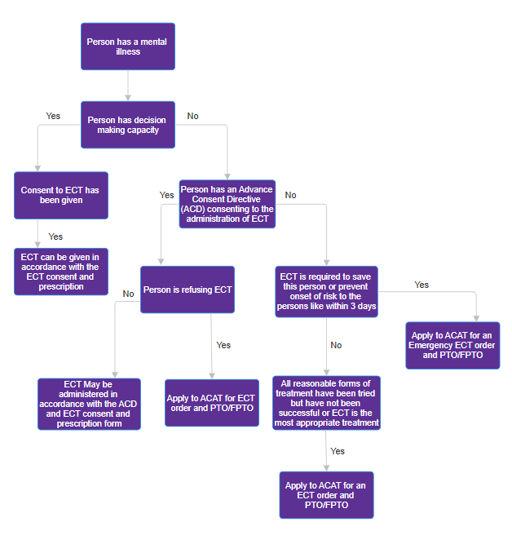
Back to Contents

Attachment 2: Prescription and Administration of ECT Flow Chart for a Young Person at least 12 years of age but under 18 years of age

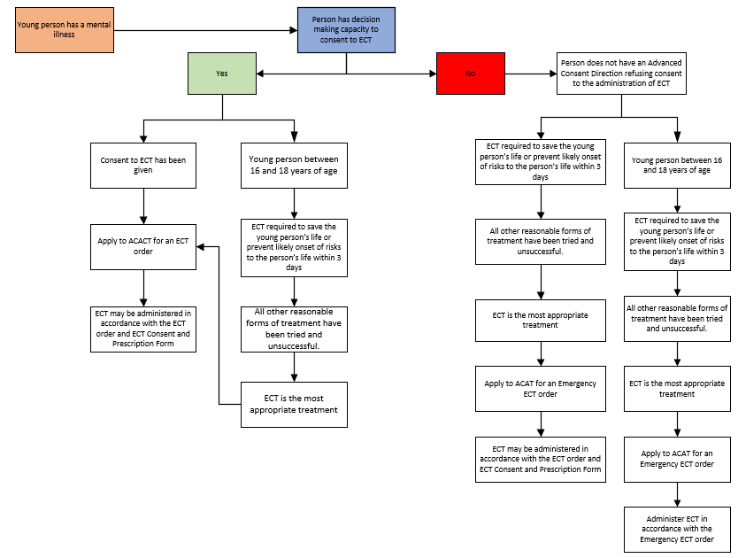

Back to Contents

Attachment 3: ECT Electrode Placement

Right Unilateral (RUL) Electrode Placement
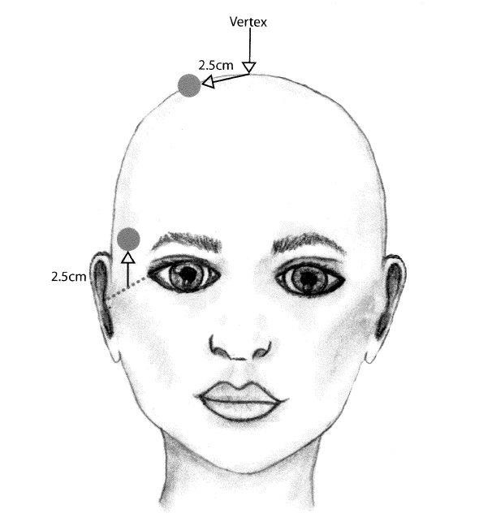
When using Right Unilateral (RUL) electrode placement, the centre of treatment electrode is placed 2.5 centimetres to the right of the vertex midpoint between external auditory meati in a coronal plane, and 2.5 centimetres above a line between outer canthus and external auditory meatus.
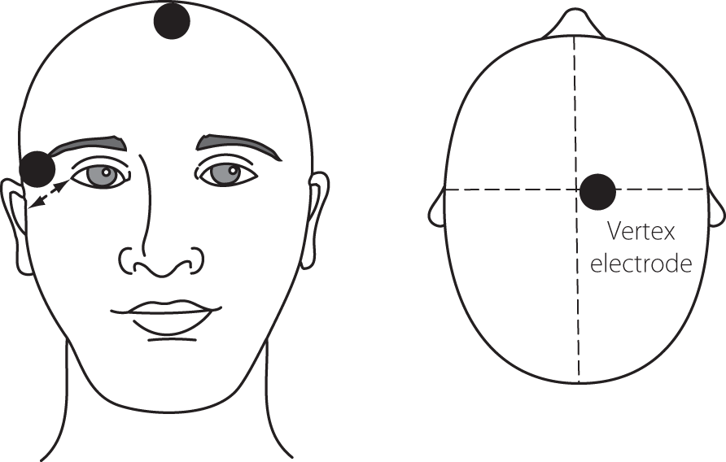

Figure 1 Right Unilateral Electrode Placement (Weiss 2018)

Bifrontal Electrode Placement
For Bifrontal (BF) electrode placement, the centre of treatment electrodes are placed 5.0 centimetres above the outer canthus of each eye.

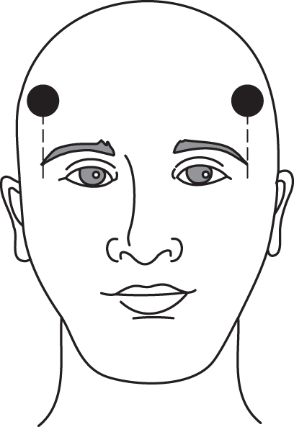
5 cm
5 cm
Figure 2 Bifrontal Electrode Placement

Bitemporal Electrode Placement
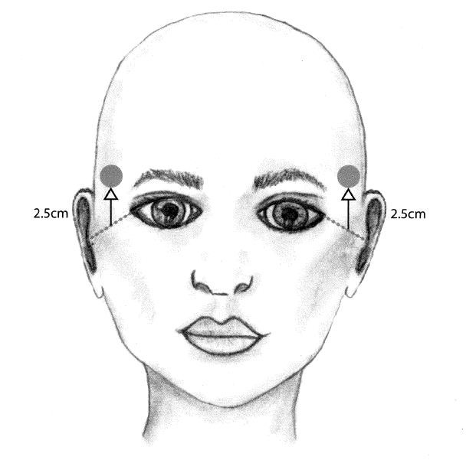
Using Bitemporal (BT) electrode placement, the centre of treatment electrodes are placed 2.5 centimetres above line between the outer canthus and external auditory meatus bilaterally.

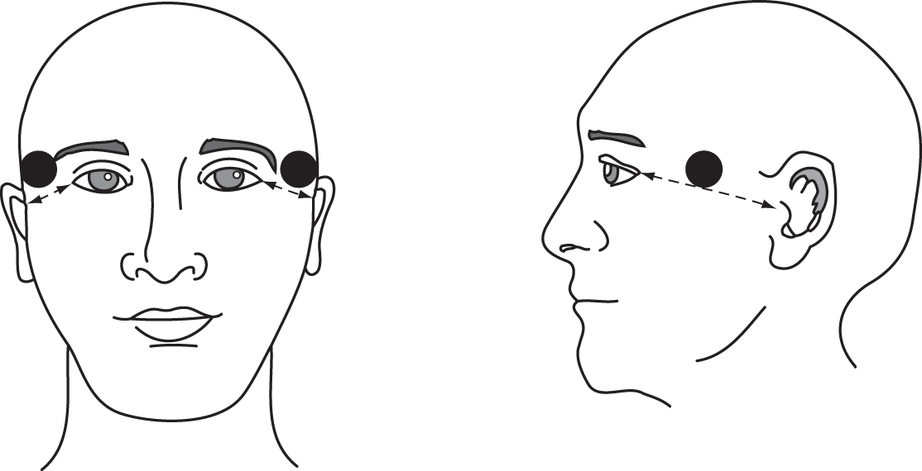
Figure 3 Bitemporal Electrode Placement (Weiss 2018)

Back to Contents

Attachment 4: Method of ECT Dose Titration and Treatment Schedule for Brief Pulse Thymatron Series IV
Note: Start titration at level 1 for consumers aged less than 50 years old, Level 2 for consumers aged at or above 50 years old.

Level | % | mC | Frequency  (Hz) | Duration in seconds
1 | 5% | 25 | 30 | 0.5
2 | 10% | 50 | 30 | 0.9
3 | 15% | 76 | 30 | 1.4
4 | 20% | 101 | 30 | 1.9
5 | 25% | 126 | 30 | 2.3
6 | 35% | 176 | 50 | 2.0
7 | 45% | 227 | 50 | 2.5
8 | 65% | 328 | 70 | 2.6
9 | 90% | 454 | 70 | 3.6
10 | 120% | 605 | 70 | 4.8
11 | 160% | 806 | 70 | 6.4
12 | 200% | 1008 | 70 | 8.0

Brief Pulse (1 ms, DGX program) DOSE CHART (12 levels)
Increase by one level if restimulation is necessary.
If there is no generalised seizure after 3 stimulations increase two levels for the fourth stimuli, and if successful drop one level for the first stimulus at the next treatment session to continue titration, before proceeding to treatment dose.
If no seizure after four stimuli, abort session and increase by one level for first stimulus at next session to continue titration.
Presence of a motor seizure is useful in determining if seizure has generalised. Cuffed limb technique should be used in titration sessions.

Successive Treatments
After establishing lowest level needed to produce a generalised seizure (ST- Seizure Threshold) increase by:
- For High dose UL (approx. 5 x ST) increase 5 levels (exception: L1 ‒› L5)
- Moderate dose UL (approx. 3.5 x ST) increase 4 levels (exception: L1 ‒› L4)
- Low dose BL (approx. 1.5 x ST) increase by 1 level
Whenever there is inadequate seizure, increase the stimulus by 50% of previous dose for either UL or BL electrode placement.
ST- Seizure Threshold
UL- Unilateral Electrode placement
BL- Bilateral Electrode placement
Back to Contents

Attachment 5: Method of ECT Dose Titration and Treatment Schedule for Brief Pulse Thymatron Series IV ultra-brief pulse (0.3 ms and 0.5 ms)
Titration levels  LEVEL | Titration levels  STIMULUS SETTINGS | Treatment levels (6x Threshold)  LEVEL | Treatment levels (6x Threshold)  STIMULUS SETTINGS
RU 1 Titration < 50 years | 2% ‒› | RU 9 | 10%
 |  | RU 9.5 | 15%
RU 2 Titration ≥ 50 years | 4% ‒› | RU 10 | 25%
 |  | RU 10.5 | 35%
RU 3 | 8% ‒› | RU 11 | 50%
 |  | RU 11.5 | 70%
RU 4 | 15% ‒› | RU 12 | 100%
RU 5 | 25% ‒› | RU 13 | 140%
RU 6 | 35% ‒› | RU 14 | 200%

Back to Contents

Attachment 6: RANZCP guidelines considerations for ECT electrode placements, pulse width and seizure threshold.
Electrode Placement | Recommended parameters for pulse width and threshold
For right unilateral (RUL) ECT | Ultra brief pulse width (0.3 ms) at 6 X ST 1.0-ms pulse width at 5-6X ST  0.5-ms pulse width at 5-6 X ST is recommended, noting lower level of evidence
For bifrontal (BF) ECT | 1.0-ms pulse width at 1.5 X ST  0.5-ms pulse width at 1.5-2.5 X ST
For bitemporal (BT) ECT | 1.0-ms pulse width at 1.5 X ST  0.5-ms pulse width at 1.5-2.5 X ST

Back to Contents

