Canberra Health Services
Clinical Procedure
Early Onset Group B Streptococcus Disease (EOGBSD) (Maternity)

Contents

Contents 1
Purpose 2
Alerts 2
Scope 2
Section 1 – Background 2
Section 2 – Routine Antepartum Screening 3
Section 3 – Intrapartum Management Recommendations 4
Section 4 – Postpartum 6
Evaluation 8
Related Policies, Procedures, Guidelines and Legislation 8
References 9
Search Terms 10
Attachments 10

Purpose

The purpose of this procedure is to facilitate a consistent approach to the prevention and early detection of Early Onset Group B Streptococcal Disease (EOGBSD) in babies.

Back to Table of Contents

Alerts

- Women with risk factors for EOGBSD or with Group B Strepococcal (GBS) positive screening should be offered induction of labour and intrapartum antibiotic prophylaxis without delay after a diagnosis of ruptured membranes.
- For women with known penicillin allergy, the clinician must request clindamycin sensitivity testing on pathology form at time of screening culture.
- Babies with a sibling affected by EOGBSD should be commenced on GBS specific intravenous (IV) antibiotics regardless of intrapartum antibiotic administration or clinical status.

Back to Table of Contents

Scope

This document pertains to women and babies in the antepartum, intrapartum and postpartum periods who have risk factors for developing EOGBSD or who have been found to be positive for GBS after culture-based screening and for whom intrapartum chemoprophylaxis is recommended. This document also pertains to babies of mothers who have risk factors for EOGBSD.

This document applies to the following Canberra Health Services (CHS) Network staff working within their scope of practice (CHS Network includes the inpatient facilities at Canberra Hospital, Clare Holland House, North Canberra Hospital, and University of Canberra Hospital and community based-services.):
- Midwives and Nurses
- Medical Officers
- Students under direct supervision.

Back to Table of Contents

Section 1 – Background

GBS is a common bacterium found in the gastrointestinal tract, vagina and urethra. Approximately 20-24% of Australian women will be asymptomatic carriers of GBS. Colonisation rates vary and may be transient, intermittent or persistent. Administration of Intrapartum antibiotic prophylaxis to women at risk of transmitting GBS to their baby does not prevent late onset GBS disease but substantially reduces the rate of early onset GBS disease (EOGBSD). Prophylactic intrapartum antibiotic administration is recommended for women with identified risk factors and to those who test culture positive for GBS (in the routine antenatal culture-based screening). Prophylactic intrapartum antibiotic is associated with infant gut microbiota dysbiosis, breastfeeding modifies some of these effects, however long-term outcomes require further research.

- In the absence of antibiotic prophylaxis approximately 40-50% of colonised women will transmit GBS to their babies. Approximately 1-2% of these babies will go on to develop early onset sepsis, neonatal pneumonia and meningitis
- Approximately 90- 95% of neonates with EOGBS sepsis, irrespective of whether the mother received intrapartum chemoprophylaxis or not, manifest within the first 24 hours of life
- About 5% of cases may manifest within the following 24 hours and rarely, up to 6 days of life
- Preterm babies are four times more likely to develop EOGBSD than full-term babies as they are immunologically more prone to sepsis. The mortality rate for EOGBS in preterm babies is about 20% which is ten times more compared to term infants
- Women who decline screening or are known to be GBS negative are managed in a risk-based approach.

Clinical risk indicators for development of neonatal EOGBS

Women with the following risk factors should receive Intravenous Antibiotic Prophylaxis:
- A positive maternal swab culture for GBS in current pregnancy
- GBS bacteriuria during the current pregnancy
- A previous neonate with early or late onset GBS disease
- Clinical diagnosis of chorioamnionitis
- If any of the following are present irrespective of GBS status –
- the onset of premature labour < 37 weeks gestation
- rupture membranes for ≥ 18 hours
- intrapartum fever of ≥ 38° C.

Back to Table of Contents

Section 2 – Routine Antepartum Screening

Routine antepartum screening recommends all pregnant women between 35+0 and 37+0 weeks’ gestation are offered a routine antenatal culture for GBS colonisation.

- Discuss risk factors with the pregnant woman:
- Discuss rationale behind screening
- Explain the treatment offered during labour for women with known colonised GBS or who have risk factors for transmission of GBS during labour.
- Offer testing and give information about the test:
- If the woman declines GBS swab, recommend treatment with intrapartum intravenous antibiotic prophylaxis if any risk factors develop, as per Pre-labour Rupture of Membranes (PROM) guideline. Offer of GBS screening to be documented in DHR regardless of whether the woman chooses to accept

Practice Note
Recommend intrapartum intravenous antibiotic prophylaxis for women with GBS Urinary Tract Infection (UTI) during current pregnancy or to women with a previous GBS affected baby.

- Collecting swabs for GBS screening:

Discuss procedure to collect vaginal/rectal culture to screen for GBS:
(Offer information handout GROUP B STREPTOCOCCUS SCREENING TEST)
- Between 35 and 37 weeks’ gestation
- With preterm pre-labour ruptured membranes
- If known penicillin allergy, request clindamycin sensitivity testing on pathology form at time of screening culture.

Women may collect their own GBS swabs following verbal and/or written instruction
Culture results have been shown to be less predictive of carrier status if more than 5 weeks have elapsed since sample collection

- Document and follow-up

Confirm results of screening with the woman and document the GBS status in the antenatal handheld record and on DHR

Discuss intravenous antibiotic prophylaxis where necessary and offer the GBS Information sheet from Royal Australian and New Zealand College of Obstericians and Gynaecologists (RANZCOG). This can be found on the Policy Register or RANZCOG - Group B Streptococcus.

Women who have returned a positive GBS culture in pregnancy will be advised to contact Birth Suite or Continuity Midwife when they commence regular/established labour contractions if membranes remain intact OR if membranes rupture spontaneously

Back to Table of Contents

Section 3 – Intrapartum Management Recommendations

Premature pre-labour rupture of membranes, GBS positive or clinical risk factors:
- If GBS+ and ≥34 weeks offer immediate Induction of labour (IOL) with Intrapartum antibiotics
- If GBS+ and < 34 weeks manage as per Preterm Pre-labour Rupture of Membranes (PPROM).

Pre-labour rupture of membranes at term
All women with risk factors for GBS or with GBS positive screening should be offered an induction of labour and prophylactic intravenous antibiotics without delay after a diagnosis of ruptured membranes

For planned inductions, if a woman has a GBS positive culture, commence antibiotic treatment with regular painful contractions or upon rupture of membranes.

Practice Note
Antibiotic administration is unnecessary prior to active labour irrespective of GBS status, however antibiotics should be initiated immediately prior to commencement oxytocin IOL.

If a woman’s GBS status is unknown at onset of labour, treatment according to clinical risk factors is appropriate.

Recommend GBS antibiotic prophylaxis once rupture of membranes > 18 hours, regardless of GBS status.

Water birth and water immersion
Waterbirth and water immersion are not contraindicated in women known to have GBS if they receive intravenous antibiotic prophylaxis and follow water immersion guidelines for risk factors for birth in water.

If a woman is known to be GBS positive, or has clinical risk factors and declines immediate induction the decision for recommended timing of an induction is based on risk factors and the individual clinical situation.
- Discuss the evidence behind the recommendations for intrapartum antibiotics (as per Section 1) to allow a woman to make an informed decision
- Explain to the woman that the risk of their baby developing EOGBS is significantly higher than if they had received intrapartum antibiotics
- Explain that development of infection or other complications is an indication for delivery by the most appropriate method for the clinical situation
- Discuss and set a time limit for expectant management
- Document all discussion in the woman’s clinical record.
Practice Note:
- Women awaiting elective cesarean (GBS+ve or risk factors for EOGBSD) with ruptured membranes or in active labour should be administered prophylactic intravenous antibiotics.
- Elective cesarean (not in labour, no rupture of membranes) no additional prophylaxis is recommended, irrespective of risk factors.

Intrapartum Intravenous Antibiotic Prophylaxis - See Attachment 1

GBS prophylaxis is aimed at achieving adequate levels in the fetal circulation and amniotic fluid rapidly, while avoiding potentially neurotoxic serum levels in the mother or fetus

MEDICATION | DOSE | ROUTE | FREQUENCY | DURATION
Benzylpenicillin ³ | 3.0gram stat  then 1.8gram | Intravenous | 4 hourly | Intrapartum
Clindamycin (if anaphylaxis to penicillin) | 600mg in 100mls | Intravenous | 8 hourly | Intrapartum
Cephazolin (if non-anaphylaxis to penicillin) | 2gram stat  then 1 gram | Intravenous | 8 hourly | Intrapartum

If evidence of chorioamnionitis ADD:

MEDICATION | DOSE | ROUTE | FREQUENCY
Gentamicin | 4-6mg/kg | Intravenous | Daily
Metronidazole | 500mg | Intravenous | 12 hourly

Back to Table of Contents

Section 4 – Postpartum

Management of Term babies – See Attachment 2

Signs of EOGBSD are non-specific and can include respiratory distress, temperature instability, tachycardia, lethargy and poor feeding. They are most likely to arise within 24 hours of birth.

Practice Note:
Babies whose mothers were not screened for GBS will follow the Neonatal Early Warning pathway (NEWS) normal care if there are no risk factors and no signs of infection

All babies will have a risk assessment done within 1 hour of birth. Observations to be commenced per Neonatal Vital signs and Early Warning scores. Treat all babies with signs and symptoms of sepsis with IV antibiotics, irrespective of maternal GBS status or adequate administration of intravenous antibiotics.

RISK FACTOR 1:
Adequate intrapartum antibiotic prophylaxis
Babies of women testing positive for GBS in the antenatal period who are well and for whom there was adequate intrapartum antibiotic prophylaxis (>4 hours before birth) are observed for 24 hours with 4 hourly observations as per NEWS. If the mother remains an inpatient, 8 hourly observations until discharge is recommended.

RISK FACTOR 2:
Inadequate intrapartum antibiotic prophylaxis
- Well babies for whom there was inadequate intrapartum antibiotic prophylaxis (<4 hours before birth) are observed in hospital for at least 36-48 hours with 4 hourly observations as per NEWS. If the mother remains an inpatient 8 hourly observations until discharge is recommended.
- Well babies born to a mother with suspected chorioamnionitis should be observed in hospital for at least 36-48 hours with 4 hourly observations as per NEWS regardless of intrapartum antibiotic prophylaxis.

RISK FACTOR 3:
Additional risk factors
- Babies born to GBS positive mothers with other risk factors (i.e. ROM >18 hours, intrapartum fever >=38 °C or <37 weeks’ gestation) are managed as per Sepsis Calculator (https://neonatalsepsiscalculator.kaiserpermanente.org) (refer to Neonatal bacterial sepsis Guideline).
- Babies born <34 weeks with risk factors or who are symptomatic, should be investigated and treated as per Neonatal bacterial sepsis Guideline.
- Well babies born to GBS positive mothers and with additional risk factors for EOGBSD, should be observed in hospital for at least 36-48 hours with 4 hourly observations as per NEWS regardless of intrapartum antibiotic prophylaxis.

Practice Note:
Babies with a sibling affected by EOGBSD should be commenced on GBS specific IV antibiotics regardless of intrapartum antibiotic administration or clinical status. Antibiotics could be ceased at 36 hours if cultures are negative and baby remains clinically well.

If proven GBS blood culture: treat with 5-7 days of IV benzyl penicillin. If proven GBS meningitis on lumbar puncture treat with 14-21 days of IV antibiotics.

Practice Note:
If there are any changes in neonatal clinical signs, inform the neonatal registrar.

If the family wishes to go home before the recommended observation period has passed the midwife needs to clearly explain the risks as below and arrange for a neonatal review prior to discharge.

For all parents of babies with risk factors for infection before the observation period has passed the treating midwife should:
- inform the parents about the potential risks and complications of GBS infection
- provide the EOGBSD parent information sheet and discuss the instructions
- discuss with the parents the signs of illness to look out for, and advise the parents to re-present immediately if the baby shows signs of infection
- ensure access to a thermometer, discuss ongoing monitoring of baby at home as per the attached observation chart
- give clear education on number to contact if any concerns
- ensure follow up by the midwife who is visiting the family at home.

The treating team should clearly document their consultation in the patient record and ensure that the family understands the instructions on the factsheet.

Bloods in the asymptomatic infant in the absence of maternal chorioamnionitis do not offer benefit over observation and should not be recommended as an alternative to 36-48 hours of inpatient observation.

Back to Table of Contents

Evaluation

Outcome
- Women at risk of developing EOGBSD are provided with safe, effective care as per this procedure. This procedure will aim to reduce the incidence of maternal and neonatal morbidity and mortality.

Measures
- Incidence of early onset neonatal sepsis (Including EOGBSD) to be presented at three-monthly Neonatal Morbidity and Mortality meetings.
- Incidence of suspected maternal sepsis will be discussed at the Maternity Morbidity and Mortality meetings to ensure appropriate intrapartum management has occurred.

Back to Table of Contents

Related Policies, Procedures, Guidelines and Legislation

Policies
- Informed Consent (Clinical)

Procedures
- Infection Prevention and Control (for your facility)
- Labour and Birth: Care during First, Second, Third and Fourth Stage
- Medication Administration for Infants and Paediatric Patients
- Monitoring Infants in the Special Care Nursery (SCN)
- Neonatal Lumbar Puncture Procedure
- Patient Identification and Procedure Matching
- Pre-labour Rupture of Membranes (PROM) Management at Term
- Preterm Pre-labour Ruptured Membranes (PPROM)
- Stabilisation of an Infant Retrieval by NETS
- Vital Signs & Early Warning Scores – Canberra Hospital
- Vital Signs & Early Warnign Scores – North Canberra Hospital
- Water immersion in Labour & Birth

Guidelines
- Fetal Surveillance Practice Guideline
- Neonatal bacterial sepsis Guideline

Legislation
- Health Records (Privacy and Access) Act 1997
- Human Rights Act 2004
- Work Health and Safety Act 2011

Other
- Australian Charter of Health Care Rights

Back to Table of Contents

References

- streptococcus. 2019. In: Clinical Practice Guidelines: Pregnancy Care [Internet]. Canberra: Australian Government Department of Health. Available from: https://www.health.gov.au/resources/pregnancy-care-guidelines/part-f-routine-maternal-health-tests/group-b-streptococcus
- The Royal Australian and New Zealand College of Obstetricians and Gynaecologists (RANZCOG). Maternal Group B Streptococcus in pregnancy: Screening and management: C-Obs 19. RANZCOG. 2019. Available from: https://ranzcog.edu.au
- American College of Obstetricians and Gynaecologists. Prevention of group B streptococcal early-onset disease in newborns: ACOG committee opinion. Obstet Gynecol. 2020;135(2):e51-72. Prevention of Group B Streptococcal Early-Onset Disease in Newborns | ACOG
- Filkins Laura, Hauser Jocelyn, Robinson-Dunn Barbara, Tibbetts Robert, Boyanton Bobby, Revell Paula. Guidelines for the Detection and Identification of Group B Streptococcus. American Society for Microbiology. March 10. 2020. Guidelines for the Detection and Identification of Group B Streptococcus | ASM.org
- Puopolo, Karen M, Lynfield, Ruth, Cummings, James J. Management of Infants at Risk for Group B Streptococcal Disease. Pediatrics. August 2019, 144 (2) e20191881; DOI: https://doi.org/10.1542/peds.2019-1881.
- Puopolo, K.M, Edwards, M.S & Wilkie, L (2022). Management of Neonates at risk for early-onset group B streptococcal infection. Up-to-date https://www.uptodate.com/contents/management-of-neonates-at-risk-for-early-onset-group-b-streptococcal-infection?topicRef=438&source=see_link
- Group B streptococcus (GBS) – screening and management. Safer Care Victoria. 2019. Group B streptococcus (GBS) – screening and management | Better Safer Care
- Early onset Group B Streptococcal disease-Queensland Clinical Guidelines. April 2020
Maternity and Neonatal Clinical Guidelines | Queensland Clinical Guidelines | Queensland Health
- Group B Streptococcal disease. North Metropolitan Health Service 2021
https://www.kemh.health.wa.gov.au/~/media/Files/Hospitals/WNHS/For%20health%20professionals/Clinical%20guidelines/OG/WNHS.OG.GroupBStreptococcalDisease.pdf
- Hasperhoven GF, Al-Nasiry S, Bekker V, Villamor E, Kramer BWW. Universal screening versus risk-based protocols for antibiotic prophylaxis during early-onset group B streptococcal disease: A systematic review and meta-analysis. BJOG. 2020;127:680-91.
- Feng-Ying C. Assessment of Intrapartum Antibiotic Prophylaxis for the Prevention of Early-onset Group B Streptococcal Disease. Paediatric Infect Dis J. 2011 September; 30(9): 759-763.
- The Prevention of Early-onset Neonatal Group B Streptococcal Disease. RCOG Green-top Guideline No. 36
- Kurz, E and Davis, D 2015, ‘Routine culture based screening versus risk based management for the prevention of early onset group B streptococcus disease in the neonate: a systematic review’. DOI: 10.11124/jbisrir-2015-1876. Routine culture-based screening versus risk-based management for the prevention of early-onset group B streptococcus disease in the neonate: a systematic review - PubMed (nih.gov)
- Dare MR, Middleton P, Crowther CA, et al. Planned early birth versus expectant management (waiting) for prelabour rupture of membranes at term (37 weeks or more). Cochrane Database Syst Rev 2006; CD005302
- Azad,M.B, Konya,T , Persaud,R.R, Guttman,D.S, Charli, R.S, Field, C.J, Sears, M.R,Mndane, S.E, Turvey, S.E, Subbarao, P, Becker, A.B, Scott, J.A & Kozyrskyj A.L (2016). Impact of maternal intrapartum antibiotics, method of birth and breastfeeding on gut microbiota during the first year of life: a prospective cohort study. BJOG 2016;123:983–93
- Homer C.S.E, Scarf V, Catling C, & Davis D. Culture‐based versus risk‐based screening for the prevention of group B streptococcal disease in newborns: a review of national guidelines. Women and Birth 2014; 27: 46– 51.
- Ohlsson A, Shah VS. Intrapartum antibiotics for known maternal Group B streptococcal colonization. Cochrane Database Syst Rev 2014;( 6): CD007467
- Therapeutic Guidelines, May 2022: https://tgldcdp.tg.org.au Australian Therapeutic Guidelines. Antibiotic guidelines. Version 17 2020 viewed via eTG complete

Back to Table of Contents

Search Terms

Group B Streptococcus, Group B Strep, GBS, early onset group B strep disease, EOGBSD

Back to Table of Contents

Attachments

Attachment 1 – Maternal management for reduction of EOGBSD
Attachment 2 – Group B Streptococcal Management of the Neonate

Back to Table of Contents

Disclaimer: This document has been developed by Canberra Health Services specifically for its own use. Use of this document and any reliance on the information contained therein by any third party is at his or her own risk and Canberra Health Services assumes no responsibility whatsoever.

Policy Team ONLY to complete the following:
Date Amended | Section Amended | Divisional Approval | Final Approval
07 December 2021 | Complete Review | Boon Lim, ED-WY&C | CHS Policy Committee

This document supersedes the following:
Document Number | Document Name
CHHS17/196 | Early Onset Group B Streptococcus Disease (EOGSBD)

Attachment 1 – Maternal management for reduction of EOGBSD
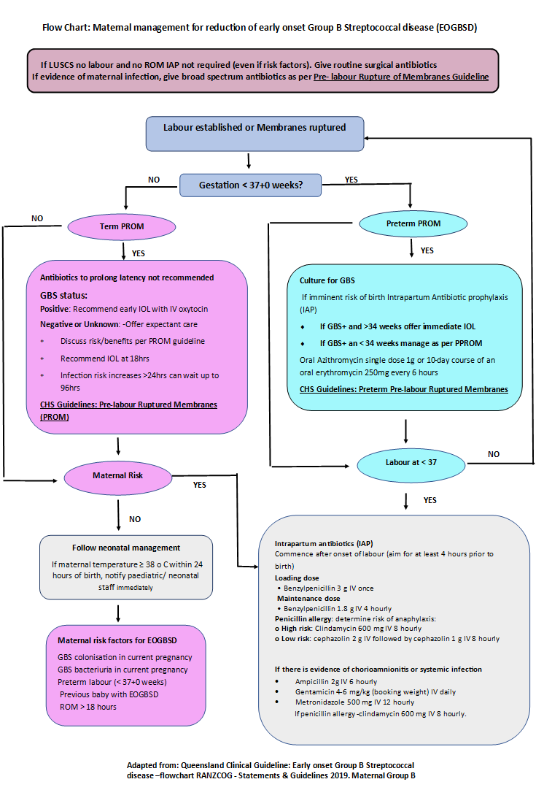

Attachment 2 – Group B Streptococcal Management of the Neonate
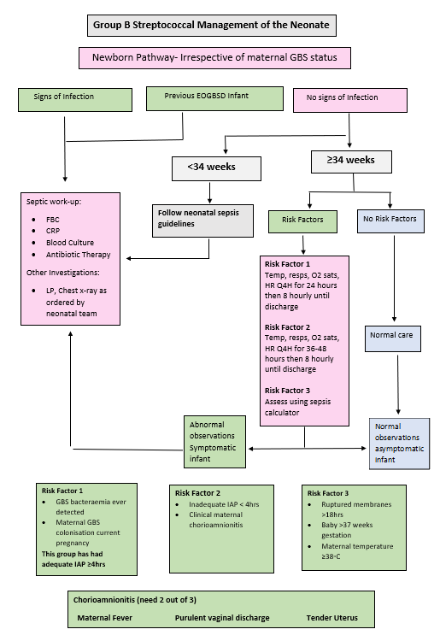

These could include any supporting information that would be useful to staff such as information sheets or flow charts

