Canberra Health Services
Guideline
Developmental Care in the Neonatal Intensive Care Unit and Special Care Nursery

Contents

Contents 1
Guideline Statement 3
Background 3
Key Objective 3
Scope 3
Section 1 – Environment 3
Limiting noise 4
Limiting light 4
Other Noxious Stimuli 4
Section 2 – Minimizing stress and pain 5
Section 3 – Safeguarding sleep 5
Section 4 – Protecting skin 6
To reduce the incidence of skin injury: 6
Humidity 6
Neonatal Skin Risk Assessment Scale (NSRAS) 6
Nappy Care 6
Section 5 – Feeding and nutrition 7
Supportive practices 7
Introduction of oral feeding 8
Section 6 – Positioning/handling and cue based care 9
Section 7 - NICUCAM 9
The NICUCAM service is available for: 9
Confidentiality and safety 10
Admission to the NICUCAM service and documentation 10
Logging into NICUCAM 10
Using the wall plate 10
Transferring or discharging Infants 11
Section 8 – Family centred care/Partnering with parents/Developmental care ward rounds 11
Section 9 – Growth and Development Clinic Criteria 11
Evaluation 12
Related Policies, Procedures, Guidelines and Legislation 12
References 13
Definition of Terms 14
Search Terms 14
Attachments 14
Attachment 1 – The Premature Infant Pain Score: Revised 15
Attachment 2 – Neonatal Skin Risk Assessment Form 18
Attachment 3 – Preventative and Management Strategies for Diaper Dermatitis 20
Attachment 4 – NEW NICU Growth and Development Clinic Criteria 21

Guideline Statement

Developmental care protects the rights of the infant to be protected from stress and pain, not to be separated from the mother and family, and to have mother’s breast milk whenever possible.

Background
This document outlines strategies to provide care for infants that will support their development and is family centred.

Developmental care refers to interventions that:
- Support the behavioural organisation of the individual infant
- Enhance physiological stability
- Protect sleep rhythms
- Promote growth and maturation

Key Objective
Infants cared for in the Department of Neonatology will receive care that is family centred, creates an environment that reduces stress to the infant, is neuro-developmentally appropriate and is individualised for each infant and family.

Back to Table of Contents

Scope

This document applies to all infants cared for in the Neonatal Intensive Care Unit (NICU) and Special Care Nursery (SCN).

This document applies to the following Canberra Health Services (CHS) team members working within their scope of practice:
- Medical Officers and Medical students
- Nurses and Midwives
- Nursing and Midwifery students
- Allied health professionals that work in NICU & SCN.

Back to Table of Contents

Section 1 – Environment

Consideration must be given to space and privacy in the NICU and SCN in order to provide a healing environment. The healing environment includes the physical environment of space, privacy and safety and the sensory environment of temperature and touch, proprioception, smell, taste, sound and light.

In NICU and SCN, most rooms allow the setup of two patient bedspaces. Within each bedspace in NICU and SCN, there is an allocated parent and clinician’s side. The parent side, which is situated close to the parent’s cupboard, provides a small, private area for parents to relax and interact with their infant.

Limiting noise
Keeping noise levels to a minimum should be encouraged. For adults, the threshold for cochlear damage is 80-85 decibels. The infant will have a lower threshold than this as the immature cochlear is more sensitive. Restricting sound levels can help facilitate infant sleep and allow infants to hear human voices in normal conversation.

Noise reduction strategies
- Avoid tapping or writing on isolettes.
- Close port holes gently.
- Decrease voice volume of conversation at the bedside.
- Set monitor alarm limits and tone at low levels. Try to silence them as soon as possible.
- Turn suction off following use.
- Prevent water build-up in Continuous Positive Airway Pressure (CPAP) and ventilator circuits.
- Use ear muffs on infants when needed.
- A quiet time is designated each afternoon between 1pm and 3pm.

Limiting light
Constant bright light in the nursery should be avoided as it can interfere with natural diurnal rhythms and overstimulate the infant.

Light reduction strategies
- Maintain appropriate individualised lighting.
- Use adjustable light levels within each cot bay plus procedure light for observation and procedures.
- Shield infants from bright light with cot covers, eye covers and dim the lights.
- Full black-out cot covers should be used for infants less than 32 weeks corrected gestation. These infants are unable to regulate pupil dilatation and therefore control the amount of light entering the eye. Infants greater than 32 weeks do not require the isolette to be completely covered.
- The visual system is not developmentally ready for external visual stimuli before term gestation so the use of mobiles or other visual stimuli is not recommended until the infant’s corrected gestational age is term or beyond.

Other Noxious Stimuli
- Discourage use of strong fragrances, cleaning products and cleansers.
- Minimise painful procedures and provide appropriate pain relief measures including comfort measures.

Back to Table of Contents

Section 2 – Minimizing stress and pain

The preterm or unwell term infant is exposed to multiple stressful and painful events in NICU and SCN together with separation from family. Intensive care exposes the infant to stressors and painful interventions that interfere with neuroplastic reorganisation and therefore disturb memory and learning of motor skills. Exposure to painful procedures can have negative short and long-term consequences for brain organisation.

Self-regulation and neurodevelopmental organisation can be facilitated by:
- Completing a pain score using the Premature Infant Pain Profile-Revised (PIPP-R, see Attachment 1). A pain score should be recorded routinely each shift for infants in the SCN and 4 to 6 hourly with cares for all infants nursed in the NICU. Infants who are receiving pharmacological pain relief or are undergoing multiple painful procedures may require more frequent pain scores to evaluate the effectiveness of pain relief measures.
- Providing non-pharmacological support for all minor interventions. This includes the use of positioning, containment, swaddling, dummies and sucrose.
- Provide pharmacological measures to support infant comfort as determined by the PIPP-R.
- Involve parents in supporting their infant during painful procedures if they choose, by assisting with containment or by providing skin-to-skin care.
- Educate parents to recognise their infant’s behavioural cues related to stress and pain and to respond to these cues by providing comfort interventions.

Back to Table of Contents

Section 3 – Safeguarding sleep

Both Rapid eye movement (REM) and non-REM sleep phases are essential for early neurosensory development, learning, memory, and preservation of brain plasticity.

- Protect sleep cycles. Avoid sleep interruptions, bright lights, loud noises, and unnecessary disturbing activities. Infant sleep cycles should be assessed before caregiving activities.
- Individualize all caregiving activities by clustering cares based on infant sleep-wake cycles. If it is necessary to wake a sleeping infant, approach slowly using a soft voice followed by gentle touch.
- Protect eyes from direct light exposure and maintain low levels of ambient light when bright light is not needed for care and procedures. Cover isolettes.
- For infants greater than 32 weeks gestation, provide some daily exposure to light, preferably including shorter wavelengths, for entrainment of the circadian rhythm.
- Encourage prolonged skin- to- skin care to promote normal sleep patterns.
- Ensure the infant is able to maintain normal sleep pattern during back-to-sleep before discharge and ensure this behaviour is role modelled in the unit.
- Educate parents about the importance of adherence to safe sleeping guidelines, back to sleep and tummy time.

Back to Table of Contents

Section 4 – Protecting skin

A preterm infant’s skin is very different in structure to a term infant. The extremely preterm infant’s skin has very little stratum corneum and by 32 weeks gestation has only a few layers, increasing the risk of skin injury. Infants admitted to NICU are at high risk of skin injury with 25-50% of infants sustaining an injury during admission.

To reduce the incidence of skin injury:
- Reduce the use of adhesives and tapes used on the infant’s skin.
- Use an adhesive removing wipe (Niltac wipe) when removing tapes from the infant’s skin.
- Apply a silicone barrier (Cavillon wipe) to the skin prior to applying tape to the infant’s skin.
- Epaderm cream may be used as a general moisturiser/emollient to prevent dry skin and may also be used to bath infants.
- Baths should be attended by parents when the infant’s medical condition permits and when they can maintain body temperature out of the isolette.
- Educate parents with regard to skin care and bathing.

Humidity
Preterm infants are at risk of increased transepidermal water loss (TEWL) as a result of the under developed stratum corneum. The large surface to body weight ratio also increases TEWL and heat loss.

- For infants <1000g and <28 weeks gestation, provide 85% humidity via the isolette for the first week of life. Reduce humidity by 5% daily from day 7 to 14 as epidermal maturation occurs. Continue to wean humidity until humidity level reaches 40% and then cease. Change isolette after humidity is ceased.

Neonatal Skin Risk Assessment Scale (NSRAS)
- A score using the NSRAS must be completed each shift (see Attachment 2).
- See the reverse side of the form for details of management of skin injury.

Nappy Care
- Follow directions as per Prevention & Management of Nappy Rash protocol (see Attachment 3).

Back to Table of Contents

Section 5 – Feeding and nutrition

Breastfeeding is the optimal method of infant feeding and should be promoted to ensure optimal nutrition for all infants.

Feeding should be a pleasant experience for the infant and an opportunity for positive parent interaction. In the neonatal unit environment, many of the infants’ early oral experiences are uncomfortable.

Supportive practices
Kangaroo Care
Kangaroo care involves holding a nappy-clad infant prone and upright, enclosed in the parents clothing in skin-to-skin contact on the chest of the parent. Kangaroo care has been shown to improve an infant’s ability to maintain his/her autonomic stability in the presence of environmental disturbances, reduce parental and infant stress and improve motor regulation. Kangaroo care is a safe practice and should be offered to every parent, every day, irrespective of weight and gestational age of the infant.

Benefits of Kangaroo care include:
- Improved physiological stability and oxygen saturation.
- Better weight gain.
- Longer periods of quiet sleep.
- Increased breastfeeding.
- Reduced pain and stress for the infant.
- Enhanced parent-infant attachment.
- Reduced incidence of post-natal depression.
- Increased maternal milk supply.

Immuno-supportive oral care
Providing the scent and taste of the mother’s milk facilitates mouthing, sucking, arousal and calms the infant. This can be provided by introduction of the “wombat” cloth and use of breast milk for mouth care. All infants should receive breast milk and/or immune-supportive oral care with available colostrum, as soon as possible after birth. Preferably within four hours.

Use of dummies/pacifiers for non-nutritive sucking
Non-nutritive sucking is a self-soothing behaviour that promotes quiet sleep and has been found to reduce activity and pain. Before offering an infant a dummy, staff should explain to parents the benefits of non-nutritive sucking and ask for consent.

Non-nutritive sucking may be encouraged by:
- Positioning the infant to encourage hand to mouth to allow the infant to suck their own fingers/thumb.
- Offer a dummy to preterm infants for about five minutes before tube or oral feeds as this assists with state organisation and calming of the infant.

Offering support during tube feeding
- Encourage Kangaroo care during feeds.
- Offer infant the opportunity to suck. Either on a dummy or at the breast.
- Provide the taste and smell of breastmilk with tube feeds by using breastmilk for mouth care. Use ‘wombat’ cloth.
- Give the tube feed slowly over 20-25minutes.
- Elevate the head of the cot if required.

Supporting production of breastmilk
- Promote frequent expression of breastmilk, every 3 hours, even at night.
- Ensure the mother is using a hospital grade pump.
- Initiate expressing breastmilk as soon as possible after birth. Preferable within 1-3 hours.
- Teach the mother how to collect and store the expressed milk.
- Refer to CHS Breastfeeding Guideline on the Policy and Guidance Documents Register for further guidance.

Introduction of oral feeding
Breastfeeding is the preferred method of feeding for all infants. Breastfeeding supports the mother-infant interaction and bonding.

Readiness to feed:
Feeding should be safe, nurturing and developmentally appropriate. Factors to consider when assessing an infant’s readiness to feed include:
- Hemodynamic stability of the infant.
- The infant is weaned from ventilation or on minimal CPAP/high flow.
- Ability to co-ordinate suck/swallow/breathe during feeding.
- Observe behavioural cues of the infant. Vigorous sucking, rooting and crying are recognised as appropriate feeding reflexes or hunger cues.
- When feeding orally the focus must be on the quality of feeding experience rather than the quantity of feed taken.
- Promote side-lying position close to the parent/caregiver when bottle feeding, or other appropriate position recommended by speech pathologist to support feeding development and physiological stability.

Back to Table of Contents

Section 6 – Positioning/handling and cue based care

Infants should be provided with developmentally supportive positioning to optimize musculoskeletal development and behavioral organization. The primary goals of positioning should include:
- Support and anticipate the infant’s individualized needs during every caregiving interaction to minimize stressors known to interfere with normal development.
- A variety of symmetrical postures (supine/prone/side lying).
- When prone, provide appropriate prone support to ensure flexed shoulders and hips.
- Trunk flexion, shoulder and hip flexion and adduction.
- Shoulder protraction, hands near face.
- Neutral alignment of ankles and hips.
- Neutral alignment of head and neck whenever possible.
- The use of swaddling or nesting to provide boundaries whilst ensuring a safe sleeping environment.
- Regular position changes aligning with handling and sleep/wake states.
- Reposition the infant 4 to 6 hourly with cares.
- Provide containment care during painful procedures.
- Educate parents about the principles and techniques of positioning, containment and handling.

As infants approach term, they are no longer monitored and are preparing for discharge to home, the Red Nose safe sleeping guidelines (https://rednose.org.au/) must be implemented. Note this is a CHS approved site for downloading and printing handouts for patents (for more details refer to Approved external websites for downloading and printing handouts for consumers on the Policy and Guidance Documents Register).

Cue based care
Caregiving based on infant cues is an integral part of providing developmentally appropriate care. Infant cues rather than clustered care is best used for optimal care-giving practices.

Back to Table of Contents

Section 7 - NICUCAM

NICUCAM is a video streaming service that allows families and relatives to see live images of their infant via the internet.

The NICUCAM service is available for:
- Infants nursed in the SCN and selected bedspaces in the NICU.
- Infants who are nursed in an open cot. At times NICUCAM may be available for infants nursed in isolettes.
- If infants are in the care of Child Youth Protection services (CYPS), CYPS encourages the use of this service as it allows the family to have safe access to the infant. If the infant is under the care of the Director General, permission to access the service must be sought from CYPS not from the parents. Two staff members call CYPS and gain consent over the phone. Both staff members sign the consent form and document in the patient’s notes.

Confidentiality and safety
- It is the responsibility of the nurse caring for the infant on NICUCAM to move or discharge infants as soon as possible after the infant is moved.
- Not doing so could result in a breach of privacy.
- The green “stop” button on the wall plate behind the infant may be pressed at any time if the video stream needs to be halted for any reason (e.g. procedures, tests or resuscitation).

Admission to the NICUCAM service and documentation
- Provide parents with a copy of the NICUCAM consumer handout, located on the Policy and Guidance Document Register, prior to signing the consent form.
- Parent must sign the image transfer consent form.
- The nurse may sign as a witness.
- Place the completed form in the medical notes.
- The NICUCAM service form must be completed each shift.
- It is the responsibility of the nurse on shift to check the correct infant is in the correct camera space, modify the camera numbers if the infant moves bed spaces or is discharged.
- A ward map is kept with the team leader and filled out each shift.
- Place a NICUCAM service sticker in the Patient notes and complete on admission and discharge.
- Place a NICUCAM sign on the infant’s cot to indicate that the NICUCAM is active.

Logging into NICUCAM
- Log into NICUCAM via the icon on the desktops in SCN.
- Click on “Manage Users’ and click on “enrol infant” and fill out the information.

Using the wall plate
- Touch the screen to activate.
- Enter your PIN.
- Press the magnifying glass icon and scroll down to the name of the infant that is to be enrolled in that bedspace and press the tick icon.
- Press the Green tick icon and the infant has now been entered into the bedspace.
- Press the camera icon to start or stop the live stream.
- The movie clapboard icon indicates that there is a current live stream.

Transferring or discharging Infants
- Before moving the infant to another bedspace, press the green halt button to stop the video streaming.

Back to Table of Contents

Section 8 – Family centred care/Partnering with parents/Developmental care ward rounds

Parents are involved in decisions about interventions where possible. This promotes their understanding of their infant’s behaviour and allows them also to practice cue based care. This allows them to experience positive interactions with their infant and empowers them to recognise behavioural cues and become more confident caring for their infant.

The goals of developmental care for the family are:
- For parents to become vital members of the caregiving team and work in partnership with the multidisciplinary team.
- For parents to be supported in their role as the most important care givers for their infant to facilitate secure attachment between infants and parents.

Interventions include the following:
- Encourage and support parents in the primary caregiver role. Educate parents on how they can care for their infant at the level they are comfortable with to assist them in becoming competent in caring for their infant.
- Enhance family emotional and social wellbeing.

Developmental care ward rounds in the Canberra NICU and SCN:
- The goals of developmental care rounds are to support parents and staff in recognising the individual needs and cues of their infant and to provide developmentally supportive care based on infant cues and needs.
- A multi-disciplinary team ward round may occur of appropriate infants comprising medical, nursing and allied health team members. Families and staff discuss the individual progress of the infant with the team. The team will decide when the infant is next reviewed.
- An infant’s developmental care goals for the fortnight are provided on a laminated developmental care card at the bedside for families and nursing staff to follow.

Back to Table of Contents

Section 9 – Growth and Development Clinic Criteria

Infant admitted to NICU and SCN are at risk of developmental and behavioural issues. The NICU Growth and Development Clinic aims to identify the concerns early and refer infants to the appropriate services. Formal developmental assessments are undertaken during the first formative years of life by a multidisciplinary team that includes registered nurse and doctors from the Department of Neonatology, speech pathologist and physiotherapist.

Infants who meet the Growth and Development Clinic criteria (see Attachment 4) and their families from the NICU and SCN are invited to participate in the follow-up program. Information regarding the program is provided before the infant’s discharge or transfer.

After each clinic visit families are given feedback and a formal report is sent to the infant’s parents, Pediatrician, GP and any other health professionals involved in the care.

Back to Table of Contents

Evaluation

Outcome
Neonates admitted to the NICU and SCN receive the highest quality care consistent with their developmental care needs.

Measure
Incidents related to developmental care (such as skin injuries, feeding recommendations and family-integrated care issues) will be reviewed annually by the Department of Neonatology Quality and Safety Committee, Family Centred Care Committee, and Developmental Care Team.

Back to Table of Contents

Related Policies, Procedures, Guidelines and Legislation

Policies
- Nursing and Midwifery Continuing Competence
- Consent and Treatment
- Approved external websites for downloading and printing handouts for consumers

Procedures
- Healthcare Associated Infections Clinical Procedure

Guidelines
- Breastfeeding Clinical Guideline
- Neonatal Nutrition Guide
- Neonatal Routine Care
- Safe Sleeping Guidelines – Neonates and Infants up to 12 months of age

Legislation
- Health Records (Privacy and Access) Act 1997

Back to Table of Contents

References

- Hurst NM, Engebreton J, Mahoney JS. Providing mother’s own milk in the context of the NICU: a paradoxical experience. Journal of Human Lactation. 2013 29:3 366-73.
- ACT Health Directorate (2011) Consumer and Carer Participation. Australian Capital Territory, Canberra.
- ACT Health Directorate (2011) Towards a Patient and Family-Centred Care Model in the ACT Australian Capital Territory, Canberra.
- Almadhoob A & Ohlsson A (2015) Sound reduction management in the neonatal intensive care unit for preterm or very low birth weight infants. Cochrane Database Syst Rev. 30;1:CD010333.
- Altimer L, Phillips RM. The integrative developmental care model: Seven neuroprotective core measures for family-centred developmental care. Newborn and Infant Nursing Reviews. 2013:13(1):9-22
- Blackburn ST (2012) Maternal, Fetal, & Neonatal Physiology 4th Edition: Elsevier.
- Byrne E & Garber J (2013)Physical Therapy Intervention in the Neonatal Intensive Care Unit. Physical & Occupational Therapy in Pediatrics 33 (1):75-110
- Caskey M, et al (2014) Adult talk in the NICU with preterm infants and developmental outcomes. Pediatrics 133(3):578-84.
- Creger PJ (Ed) (1989) Developmental Interventions for Preterm and High-Risk Infants. Therapy Skill Builders
- Graven SN (2011) Early visual development: implications for the neonatal intensive care unit and care. Clin Perinatol. 38(4):671-83
- Kenner C & McGrath J (Eds.) (2010) Developmental Care of Newborns & Infants, 2nd Edition.
- Kenner C & Lott JW (Eds) (2007) Comprehensive Neonatal Nursing: A Physiologic Perspective 4th Edition. Mosby.
- Lipchock SV et al (2011) The gustatory and olfactory systems during infancy: implications for development of feeding behaviors in the high-risk neonate. Clin Perinatol. 38(4):627-41.
- McCulloch DL1, Fulton AB. (2013) Introduction to the special issue: vision after premature birth.
- SumnerG & Spietz A (Eds). (2004) Caregiver/Parent-Child Interaction Feeding Manual. NCAST-AVENUW Publications
- VandenBerg, K A (2007) State Systems Development in High-risk Newborns in the Neonatal Intensive Care Unit: Identification and Management of Sleep, Alertness, and Crying. J Perinat Neonatal Nurs. 21(2): 130–139
- Vergara E (1993) Foundations for Practice in the Neonatal Intensive Care Unit and Early Intervention Volume 1. The American Occupational Therapy Association Inc.
- Warren I, Bond C (2010) A Guide to Infant Development in the Newborn Nursery. Positive Touch.

Back to Table of Contents

Definition of Terms

Wombat cloth-A soft cloth that is transferred between mother and infant, impregnated with both maternal scent and infant scent to facilitate bonding and attachment and to assist with lactation. Providing the scent and taste of the mother’s milk facilitates mouthing, sucking, arousal and calms the infant.

Back to Table of Contents

Search Terms

NICU, SCN, Developmental Care, Neurodevelopmental care, PIPP-R, Pain, NSRAS, Kangaroo care, NICUCAM, Growth and Development.

Back to Table of Contents

Attachments

Attachment 1 – The Premature Infant Pain Score: Revised
Attachment 2 – Neonatal Skin Risk Assessment Form
Attachment 3 – Preventative and Management Strategies for Diaper Dermatitis
Attachment 4 – NEW NICU Growth and Development Clinic Criteria

Disclaimer: This document has been developed by Canberra Health Services specifically for its own use. Use of this document and any reliance on the information contained therein by any third party is at his or her own risk and Canberra Health Services assumes no responsibility whatsoever.

Policy Team ONLY to complete the following:
Date Amended | Section Amended | Divisional Approval | Final Approval
15/07/2020 | Complete Review | Tina Bracher, ED WYC | CHS Policy Committee

This document supersedes the following:
Document Number | Document Name
CHHS12/079 | Department of Neonatology – Positioning of the Infant
CHHS12/096 | Developmental Care for Neonates
 | NICUCAM Video Streaming Service

Attachment 1 – The Premature Infant Pain Score: Revised

Infant Indicator | Indicator Score |  |  |  | Infant indicator Score
Infant Indicator | 0 | +1 | +2 | +3 | Infant indicator Score
Change in Heart Rate (bpm)  Baseline:_______ | 0-4 | 5-14 | 15-24 | >24
Decrease in Oxygen Saturation (%)  Baseline:_______ | 0-2 | 3-5 | 6-8 | >8 or increase in O2
Brow bulge  (sec) | None  (<3) | Minimal  (3-10) | Moderate  (11-20) | Maximal  (>20)
Eye Squeeze  (Sec) | None  (<3) | Minimal  (3-10) | Moderate  (11-20) | Maximal  (>20)
Naso-Labial Furrow  (sec) | None  (<3) | Minimal  (3-10) | Moderate  (11-20) | Maximal  (>20)
*Sub-total Score:
If sub-score is 0 do not score gestational age or behavioural state-pain score =0
Gestational Age  (Wks + days) | >36 weeks | 32wks-35wks, 6d | 28wks-31wks,6d | <28wks
Baseline Behavioural State | Normal for infant’s gestation Normal sleep/wake cycle | Disturbs easily  Sleeps for short periods | Restless, unsettled sleep | Exhausted, Hypersensitive to changes in environment, touch and handling
*Sub-total for physiological and facial indicators. If Sub-total score>0, add GA and BS indicator scores.
**Total Score: Sub-total Score + GA Score + BS Score

Scoring Instructions
Step 1: Observe infants for 15 seconds at rest and assess vital sign indicators
(highest heart rate (HR) and lowest O2 saturation (O2 SAT) and behavioural state.
Step 2: Observe infant for 30 seconds after procedure and assess change in vital sign indicators (maximal HR, lowest O2 SAT and duration of facial actions observed).*If infant requires an increase in oxygen at any point before or during procedure, they receive a score of 3 for the O2 for the O2 SAT indicator
Step 3: Score for corrected gestational age (GA) and behavioural state (BS) if the sub-total score >0.
Step 4: Calculate total score by adding Sub-total Score +BS Score
Premature Infant Pain Profile-Revised (PIPP-R). *Subtotal for physiological and facial indicators. If subtotal score > 0, add GA and BS indicator scores. **Total score: subtotal score + GA score + BS score. BS indicates behavioural state; GA gestational age.

Scoring instructions
Step 1: Observe infant for 15 seconds at rest and assess vital sign indicators
(highest heart rate (HR) and lowest O2 Saturation (O2 SAT) and behavioural state
Step 2: Observe infant for 30 seconds after procedure and assess change in vital sign indicators
(Maximal HR, lowest O2 SAT and duration of facial actions observed).
Step 3: Score for corrected gestational age (GA) and behavioural state (BS)if the sub-total score >0
Step 4: Calculate total score by adding Sub-total Score + BS Score

Premature Infant Pain Profile-Revised (PIPP-R). *Subtotal for physiological and facial indicators. If subtotal score > 0, add GA
And BS indicator scores. **Total score: subtotal score + GA score + BS score. BS indicates behavioural state; GA, gestational age

PROCEDURE
PROCESS | RATIONALE
Using the Pain Score Chart  - Score < or = 5 indicates no acute pain  - Score >10 indicates moderate to severe pain | A score of < or = indicates that the infant is not experiencing acute pain. Continue to assess trends and act appropriately to changes. Ballantyne et.al. (1999), Stevens et.al. (1996)
ACTION PLAN:
- A: Score < or = 5 No action required

- B-C: Score 6-10  Rationalise the number of painful procedures  Assess and provide comfort measures  - Modify the environment (e.g. Reduce noise and light)  - Swaddling  - Non-nutritive sucking  - Oral sucrose +/- pacifier  - Containment  - Breastfeeding | Oral sucrose ameliorates the pain response in infants by, encouraging endogenous endorphin release. Research continues on the cumulative effect of sucrose on the neuro-development of pre-term infants. American Academy of Pediatrics (2006). Holsti and Grunau (2010)  Non-pharmacological measures have been demonstrated to reduce pain, encourage self-soothing ability and assist state control in pre-term and term infants and work best when combined (e.g. Sucrose and pacifier, sucrose and containment) American Academy of Pediatrics (2006), Holsti and Grunau (2010) NSW Department of Health (2006).
- D: Score >10  Assess  Consult with medical staff  Consider pharmacological treatment  Consider increasing medication dose, if prescribed | Judicious use of narcotics is recommended, as research continues on both the short term and long term, risk/benefit to infants. American Academy of Pediatrics (2006), Bellu, de Waal and Zanini (2007). Whit-Hall, Boyle and Young (2007).

Attachment 2 – Neonatal Skin Risk Assessment Form

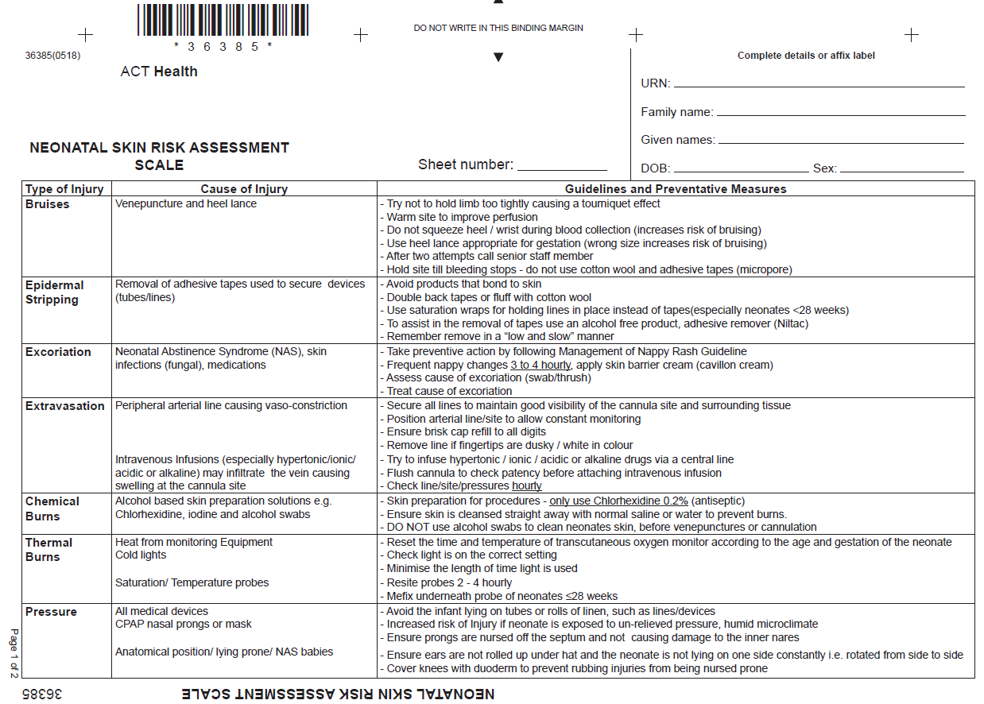
Sample

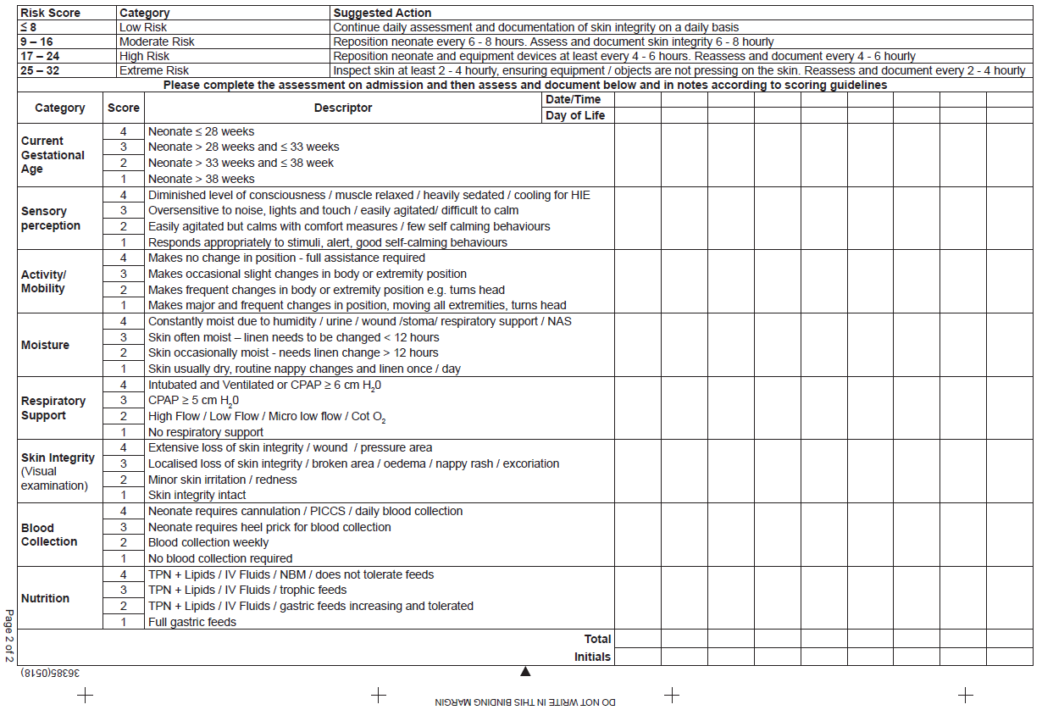
Sample

Attachment 3 – Preventative and Management Strategies for Diaper Dermatitis

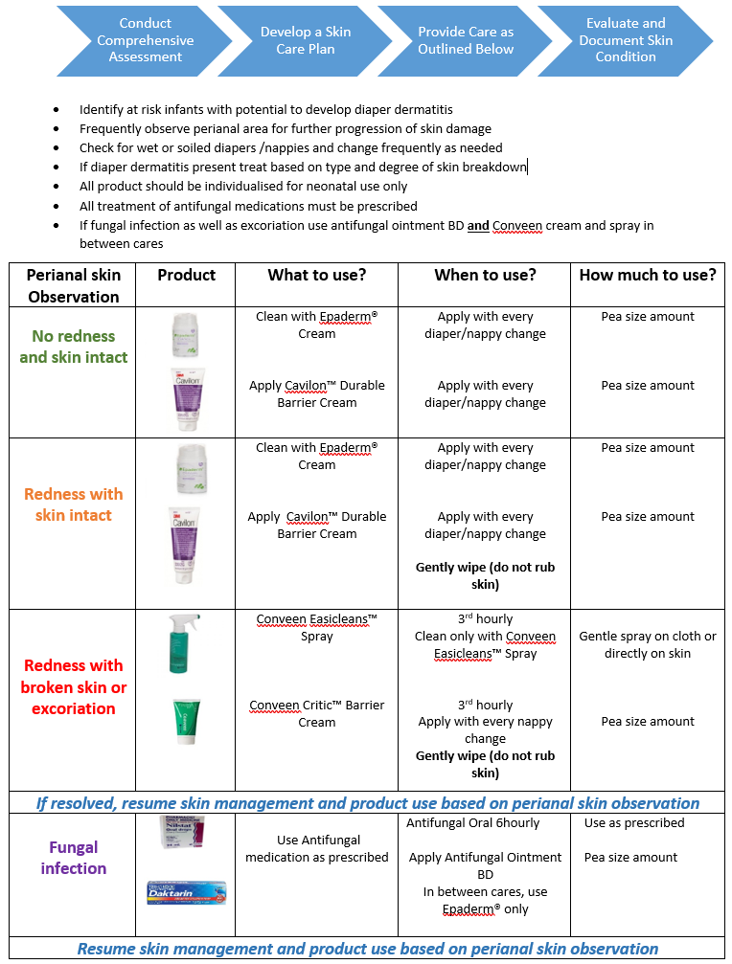

Attachment 4 – NEW NICU Growth and Development Clinic Criteria

Age for Review | < 30/40 or < 1150 grams | 30-32/40 or < 1500 grams | Term Criteria | Surgical babies
4/12 | Request | Request | Request | Request
8/12 | P S M | Request | P S M | P S M
12/12 | P S M/ B if <29/40 | A + S Questionnaire | P S M | P S M
2 y.o. | M B | Nil | M B | M B
3 y.o. | A + S Questionnaire? | Nil | A + S Questionnaire? | A + S Questionnaire?
5 y.o. | WPSII? | Nil | Nil | Nil

P = Physio S = speech M = medical B = Bayley’s A + S = Ages and Stages Questionnaire

Term Criteria
Confirmed seizures
Peri ventricular Leucomalacia Persistent peri ventricular flare and /cysts
Persistent Pulmonary Hypertension Requiring Ventilation and NO
Meconium Aspiration Requiring Ventilation

