Canberra Health Services
Procedure
Cancer Multidisciplinary Meeting (Adults Only)

Contents

Contents 1
Purpose 2
Scope 2
Section 1 – Cancer Multidisciplinary Care 2
Section 2 – Cancer Multidisciplinary Meeting Members 3
Section 3 – Requirements of Cancer Multidisciplinary Meetings – Meeting Structure and Guideline for Participation by Team Members 4
Section 4 – Criteria, Documentation and Meeting Process for Cancer Multidisciplinary Meetings 5
Section 5 – Meeting with the patient 9
Section 6 – Medico Legal 9
Section 7 – Educational Opportunities at the Meeting 10
Section 8 – Evaluation 10
Related Policies, Procedures, Guidelines and Legislation 11
References 12
Search Terms 12
Attachments 12
Attachment A – Terms of Reference - 14
Attachment B – GP Letter Template 17
Attachment C – Lung Cancer and Mesothelioma Multi-Disciplinary Team Clinical Record Referral 18
Attachment D – Multidisciplinary Cancer Care Consumer Handout 20

Purpose

The purpose of this procedure is to outline the clinical and administrative processes involved in the safe and effective management of a Cancer Multidisciplinary Meeting (Cancer MDM) at Canberra Health Services (CHS). The Cancer MDM is a forum for discussion and review of cancer patients and to facilitate effective treatment planning within appropriate timeframes.

This procedure aligns with the Multidisciplinary Care Principles for Advanced Disease: A Guide for Cancer Health Professionals for best practice in the assessment and management of patients who require multidisciplinary input, and for staff training, education and support. All staff involved in the management of cancer patients will practice in accordance with the Cancer Australia National Guideline recommendations.
Back to Table of Contents

Scope

This procedure applies to all clinical staff, including students who participate and contribute to the Cancer MDMs noted below where patients are presented/discussed:
- Breast Cancer
- Gastrointestinal Cancer
- Gynae -Tumour Board
- Head and Neck Cancer
- Lung Cancer and Mesothelioma
- Lymphoma
- Melanoma and Skin Cancer
- Neuro-Oncology Cancer
- Uro-Oncology Cancer
- Sarcoma Cancer
- Thyroid Cancer.
Back to Table of Contents

Section 1 – Cancer Multidisciplinary Care

Cancer Multidisciplinary Care is an integrated and collaborative team approach to health care in which medical, nursing and allied health care professionals from a range of specialties consider all relevant evidence-based treatment options when developing a treatment plan with each patient.

Cancer Multidisciplinary Care includes presentations of cases at Cancer MDMs, and has been demonstrated to:

- Improve patient care through the development of an agreed treatment plan
- Provide best practice care through the adoption of evidence-based guidelines
- Improve patient satisfaction with treatment
- Improve mental well-being of health professionals
- Streamline treatment pathways
- Reduce duplication of services
- Improve access to possible clinical trials of new therapies
- Increase the timeliness of appropriate consultation and surgery and a shorter timeframe from diagnosis to treatment
- Cancer MDMs are considered best practice in cancer care.

Within this document reference to:
- MDM is Multidisciplinary Team Meeting
- MDT is Multidisciplinary Team
- MDM are also referred to as cancer care multidisciplinary care conferences as per the MBS Schedule.
Back to Table of Contents

Section 2 – Cancer Multidisciplinary Meeting Members

The MDM members will comprise the core disciplines integral to the provision of care for the particular cancer type and will reflect both clinical and psychosocial aspects of care.

The disciplines represented at the core Cancer MDMs will minimally include
- Surgery
- Oncology (Radiation and Medical Oncology)
- Pathology
- Radiology
- Nursing
- Palliative Care
- Allied health
- The patient’s general practitioner (GP) may be a team member.

To ensure that the patient has access to the full range of therapeutic options, the core team may be expanded as required, including but not limited to genetics, psychiatry and nuclear medicine. Members do not have to be physically present to participate and may do so through digital connection to the meeting or through the provision of specific information/advice to be tabled at the meeting.
Back to Table of Contents

Section 3 – Requirements of Cancer Multidisciplinary Meetings – Meeting Structure and Guideline for Participation by Team Members

The Team Members will appoint a Chairperson for each meeting. The Chairperson, along with the treating doctor and meeting co-ordinator, will:
- Ensure all appropriate clinical information is available for presentation at the meeting
- Ensure outcomes of cases are recorded in the Cancer MDM Clinical Record form (referred to in Section 4)
- Inform the treating clinician and/or the patient’s general practitioner of the meeting outcomes.

Cancer MDMs at CHS must have:
- Standard Terms of Reference for use by each MDM (See Attachment A) which include specific criteria for presentation for that tumour group. This may include tabling new straightforward cases, identifying cases for in-depth discussion and for those whose treatment/plans should be reviewed
- Accurate record keeping which facilitate prompt communication, on-referral and a means for auditing
- Where patients are referred from non CHS facilities they will need to be registered within ACT Patient Administration System (ACTPAS) in order to have accurate record keeping. MDM administration will ensure that the referrer provides sufficient information provided to complete this step
- Educational opportunities for team members and trainees including peer support and mentoring.

Conduct of Participants at the Cancer MDM

Team members must conduct themselves in a professional and respectful manner and value the role and function of each team member. If differences of opinion arise, all positive efforts must be made to address these differences to ensure the patient’s needs continue to be met. Interactive participation is required from all team members.

Meeting Venue, Costs and Catering
The meeting venue must have access to power points for use of projectors (radiology/pathology/meeting template), information technology equipment, and access to pathology/radiology results, slides and a microscope. When setting up the meetings it will be a consideration to share equipment with other departments or groups to minimise costs.

The Cancer MDM Administration Support will ensure:
- An attendance register is provided to the meeting
- All recommendations for ACT/Southern Health District patients are:
- Uploaded onto Clinical Patient Folder (CPF)
- Uploaded onto the Cancer Information Management System known as CHARM
- Sent to Radiation Oncology New Patient Officer to upload to the Radiation Oncology Information Management System known as ARIA, if applicable, and
- Sent to the patient’s GP/referrer.

The thyroid cancer MDM is organised by the endocrinology department. Endocrinology prepare the agenda and upload the recommendations to the patient’s current medical record.

The gynaecology MDMs are received for uploading to EMR for current patients.

Back to Table of Contents

Section 4 – Criteria, Documentation and Meeting Process for Cancer Multidisciplinary Meetings

Criteria for nomination of a patient case for discussion at the cancer MDM, can be:
- By any member of the patient’s treating team, or
- By any member of the MDT.

Patient Criteria:
As per agreed terms of reference each cancer MDM may include cases with:
- A new diagnosis
- Changes in patient’s diagnosis
- An unclear diagnosis
- Uncertain staging
- Discrepancies between clinical, radiological, pathological findings
- Integrated care required beyond normal pathways.

Required Patient information:
- Complete patient demographics
- Relevant medical history details
- Pathology reports and slides
- Imaging films and scans. Where possible view online, particularly for ACT results
- Results of diagnostic examinations. Utilise online facilities for real time access
- Blood test results
- Previous treatment plans, if relevant, access via the CPF.

The treatment plan for the patient will consider individual patient circumstances and wishes. Discussion and decisions about treatment options will only be considered when all relevant results and information are available.

MDM Clinical Record Form
A Cancer MDM Clinical Record Form will be completed by the referring health professional (treating specialist or registrar, cancer specialist nurse or social worker). The clinician who completes the form must attend the Cancer MDM to present the case.

The patient’s general practitioner cannot complete the form and must pass on patient information/discuss the patient with a specialist who will present the case at the MDM.

The person (specialist/registrar/ specialist Nurse or Social Worker) presenting the case at the MDM will complete and incorporate on the Cancer MDM Clinical Record Form:
- Patient’s details- name, date of birth (DOB), sex, address and phone number
- Unit Record Number (URN) (if known) must be provided
- Meeting date
- Referring clinician
- Whether patient consent has been obtained (preferable in all cases, mandatory for any case where a Medicare Benefits Schedule (MBS) item is to be raised)
- Patient history
- Reason for referral
- Presenting symptoms
- Medication
- Allergies
- Social history
- Review of patient functional status through the Eastern Cooperative Oncology Group (ECOG) performance status assessment.

The Cancer MDM Clinical Record Form will be emailed to the MDM administration support in Cancer Services who will:
- Ensure Clinical Record Form is completed correctly
- Complete patient case list agenda
- Enter patient’s details onto ACTPAS
- Advise pathology and radiology that scans/slides/test results are required as noted on the referral form
- Distribute the agenda for the MDM to all members two (2) days prior to the meeting
- Liaise with the chair to ensure appropriate number of referrals are listed as per terms of reference
- Ensure venue is booked with all equipment/supplies necessary (laptop, leads, attendance list, teleconferencing equipment) and required security to ensure privacy and confidentiality.

The Chair will:
- Introduce new members
- Appoint the minute taker from the medical staff attending
- Keep the meeting to the case list agenda in a timely manner
- Discuss and promote a full range of input from all members
- Summarise the discussion ensuring all members have provided input and that the actions are agreed and documented in the MDM Clinical Record Form
- Promote respectful resolution of any differing opinions about the best treatment pathway for the patient in order to achieve the best possible outcomes.

The meeting discussion should include:
- A discussion of all potential treatment options
- Review and discussion of imaging and pathology results
- The extent of the tumour should be determined by using the appropriate staging system.
- A discussion on the psychosocial needs of the patient and family
- Communication strategies to inform the patient of prognosis, treatment options and plan will be discussed, and a responsible person allocated
- Ensuring all team members are aware of any changes and final decisions
- Clear allocation of the person responsible to follow up on outcomes for all cases.

Determining and completing referrals to appropriate specialists/services:
The general practitioner (GP) is critical in the care of any person with cancer and may participate in a number of stages in the disease process, including diagnosis, referral, treatment, coordination and continuity of care as well as provision of information and support to the patient and his/her family. It is essential that the GP is kept informed in a timely manner about treatment decisions from the treating specialist.

The MDT administration support team will ensure the recommendations from the MDM team meetings are forwarded within two (2) working days following the meeting to members.

The MDM will work with relevant regional services to ensure Southern Health District patients receive timely access to multidisciplinary care.

Patient Eligibility for Medicare billing:
Patients who are eligible for Cancer MDM (termed “cancer care multidisciplinary case conference” under the MBS Schedule) are:
- Public and private patients, in public or private hospitals, or the community, with a malignancy of a solid organ or tissue or a systemic cancer, with the exception of patients whose only cancer is a non-melanoma skin cancer
- Patients who have given consent to be presented at the Cancer MDM
- With a valid referral from a clinician to the MDM for the purpose of the care pathway discussion, treatment, surgery or other/further tests
- Case discussion is of at least 10 minutes duration at the MDM.

Medicare Billing:
- Patients eligible for Medicare rebates for cancer care multidisciplinary care conferences as per the MBS Schedule may be billed
- The billing clinician, specialist or consultant physician may be from any area of medical practice and must be a treating doctor of the patient discussed at the case conference and have rights to private practice
- Only one practitioner, usually the Chair, is eligible to claim item 871 for each patient case conference. All other medical practitioners who participate in the MDM are eligible to claim under item 872
- MBS defines item 871 as: “Attendance by a general practitioner, specialist or consultant physician as a member of a case conference team, to lead and coordinate a multidisciplinary case conference on a patient with cancer to develop a multidisciplinary treatment plan, if the case conference is of at least 10 minutes, with a multidisciplinary team of at least 3 other medical practitioners from different areas of medical practice (which may include general practice), and, in addition, allied health providers”
- MBS defines item 872 as: “Attendance by a general practitioner, specialist or consultant physician as a member of a case conference team, to participate in a multidisciplinary case conference on a patient with cancer to develop a multidisciplinary treatment plan, if the case conference is of at least 10 minutes, with a multidisciplinary team of at least 4 medical practitioners from different areas of medical practice (which may include general practice), and, in addition, allied health providers”
- Each billing clinician must ensure that his or her patient is informed that a charge will be incurred for the case conference for which a Medicare rebate will be payable and that there will be no out of pocket expenses for the patient. This information can be provided as part of the consent process
    - Participants must be in communication with each other throughout the case conference, either face-to-face, by telephone or video link
- In general, it is expected that no more than two case conferences per patient per year will be billed by a practitioner.

The cancer multidisciplinary administrative support team will identify eligible patients for billing on review of the completed record and issue the patient with the appropriate Medicare Billing form and DB4 forms for signing and will process the billing.

Where appropriate, MDM billing revenue will be re-directed to Cancer Services, in order to further support the effective functioning of the MDM.

Post meeting:
- On – Referrals determined at the MDM and documented on the MDM Clinical Record Form should be completed by the referring medical practitioner and sent to the specialist/department within 2 business days
- MDM Administration support team must send patient treatment recommendations from MDM within 24 hours to the selected specialist
- A Treatment Plan with a cover letter will be sent to the GP by the treating specialist/registrar. (See GP letter template at Attachment B with an “example only” Lung Cancer and Mesothelioma Multi-Disciplinary Team Clinical Record)
- The doctor who assumes responsibility for presenting the case at the MDM ensures that records are kept, and that the outcome is discussed with the patient. In most cases this will be the lead treating doctor.

Back to Table of Contents

Section 5 – Meeting with the Patient

Meeting with the patient pre Cancer MDM
Explaining the multidisciplinary care concept is an important part of introducing this type of care to the patient. This is usually done by the clinician who has seen the patient in the lead up to a cancer diagnosis. It is important to explain to the patient how the meetings work, the meeting structure, whether or not patient names are used in the meeting, and issues relating to confidentiality.

All patients will be provided with written information about the members of their Cancer MDM team, what and how information is shared between team members and the treatment plan as outlined in the Consumer Handout (Attachment C).

To ensure that patient preferences are considered in developing the plan, these should be discussed with the patient prior to the meeting.

Patients should be informed that the outcomes of the meeting will be discussed with them and that they will be involved in the agreeing to the final treatment plan.

Patient Consent
The patient must be informed that treatment and care planning by the Cancer MDT is part of their care and that their case may be discussed with health professionals whom they may not have met.

Consent from patients prior to any case discussion must be obtained prior to any case conference if the intention is to bill the client through Medicare. The treating specialist, registrar, cancer specialist nurse and social worker must indicate on the MDT Clinical Record Form that patient has been informed and/or consented prior to the patient being discussed at a meeting. It is sufficient to record on the MDT Clinical Record Form that patient consent has been obtained, including when and by whom.
Back to Table of Contents

Section 6 – Medico Legal

Medico Legal issues to consider:
- Patient consent
- Documentation of the multidisciplinary team recommendations
- Patient’s decision on treatment.

If there is no intention to claim a Medicare rebate for the case conference, then obtaining patient consent prior to the case conference is not essential.

While a recommended treatment plan is discussed and decided by the members of an MDM, the final decision of treatment is decided by the patient and their treating clinician after the MDM. The MDM form has a disclaimer: The meeting discussion is based on the information presented therefore the summary of discussion is a proposal for treatment. Final decision of treatment will be discussed with the patient by the treating specialist.

The patient’s MDM recommendations are recorded in the patient’s medical record in the Clinical Patient Folder (CPF) and CHARM. All appointments are documented in ACTPAS. Any treatment plan for a patient that is recorded as part of the MDM is a health record for the purpose of Health Records (Privacy and Access) Act, 1997. As such the patient has a right of access to that record.

Note:
As MDMs are now considered standard best practice in cancer care any clinical review or coronial review will include a review of the role of the MDM in that patient’s care and it is therefore critical that cases discussed and those not discussed are justifiable and that record keeping is comprehensive.

Back to Table of Contents

Section 7 – Educational Opportunities at the Meeting

The Multidisciplinary meeting can provide important education to all members of the team through:
- Peer discussion
- Knowledge sharing on best practice
- Providing best practice guidelines to all cancer care
- Following International and National Guidelines
- Encouraging the presentation of cases.

Back to Table of Contents

Section 8 – Evaluation

Outcome
- MDM agenda is finalised and circulated a minimum of 2 days prior to the meeting
- All referrals are to be registered on the day they are received
- All Recommendations will be uploaded to CHARM and CPF within 2 business days of the meeting
- All email communications received via the MDM Mailbox must be actioned by close of business on the day the email is received
- An ACTPAS appointment will be booked by MDM Administration Support prior to the MDM, to allow for tracking of deferred patients.
- All MDM post meeting actions will be completed by MDM Administration Support. When these are completed is dependent on the time taken for documentation return.

Measures
Cancer MDMs will be evaluated on an annual basis and will include:
- Satisfaction of the members
- Referral process to the Cancer MDM is followed and an estimate of the proportion of incident cases presented
- Cancer MDM Forms are completed accurately
- Pathology is advised of cases to be discussed prior to the meeting, as per cut-off dates and times supplied by ACT Pathology/Capital Pathology. Results are provided to the meeting
- Recommendation summaries are:
- Completed during the meeting
- Filed in the patient’s medical record and distributed to the membership and to the GP within 2 business days
- On – Referrals determined at the MDM should be completed by the referring medical practitioner and sent to the specialist/department within 2 business days
- Attendance records are summarised and filed within 2 business days.

Back to Table of Contents

Related Policies, Procedures, Guidelines and Legislation

Policies
- Consumer Privacy
- Informed Consent (clinical)
- Clinical Record Management

Procedures
- Patient Identification and Procedure Matching
- Clinical Handover
- Clinical Record Management

Legislation
- Health Records (Privacy and Access) Act 1997
- Human Rights Act 2004
- Work Health and Safety Act 2011.

Guidelines
- Multidisciplinary Care Principles for Advanced Disease: a Guide for Cancer Health Professionals.

Back to Table of Contents

References
- https://canceraustralia.gov.au/clinical-best-practice/multidisciplinary-care/all-about-multidisciplinary-care/principles-multidisciplinary-care
- Cancer Australia lung cancer guides and resources:
- Investigating symptoms of lung cancer: a guide for GPs
- Risk factors for lung cancer: an overview of the evidence
- Best practice approaches to the management of lung cancer in Australia
- A systematic review of the impact of stigma and nihilism on lung cancer
- https://canceraustralia.gov.au/sites/default/files/mdc_-_checklist_for_principles_of_mdc.docx
- Checklist for communication with the patient (DOC 35 KB)
- MDC information sheet (DOC 33KB)
- https://canceraustralia.gov.au/system/tdf/guidelines/all_about_multidisciplinary_care.pdf?file=1&type=node&id=3551

Back to Table of Contents

Search Terms

Multidisciplinary Team, Multidisciplinary Care, Multidisciplinary Meeting, MDT, MDM, Cancer, Cancer MDM
Back to Table of Contents

Attachments

Attachment A – Terms of Reference
Attachment B – GP Letter Template
Attachment C – Lung Cancer and Mesothelioma Multi-Disciplinary Team Clinical Record Referral
Attachment D – Multidisciplinary Cancer Care Consumer Handout

Disclaimer: This document has been developed by Canberra Health Services specifically for its own use. Use of this document and any reliance on the information contained therein by any third party is at his or her own risk and Canberra Health Services assumes no responsibility whatsoever.

Policy Team ONLY to complete the following:
Date Amended | Section Amended | Divisional Approval | Final Approval
4/10/2022 | Full review | Melissa O’Brien ED CAS | CHS Policy Committee

This document supersedes the following:
Document Number | Document Name
CHS19/165 | Cancer Multidisciplinary Meeting

Attachment A – Terms of Reference -

XXXXX
Multidisciplinary Team Meeting
Cancer and Ambulatory Support | TERMS OF REFERENCE
Role
The role of the Cancer and Ambulatory Support (CAS) XXXXX Multidisciplinary Meeting (MDM) is to enable a formal mechanism for multidisciplinary input into treatment planning and ongoing management of patients with cancer.

Reports
The MDT reports through the Chair to the Clinical Director, CAS, as required.

Functions
The MDT will:
- provide an opportunity for multidisciplinary discussion of newly diagnosed and review cases of cancer presenting to the medical, surgical or oncology team
- ensure patients presenting with a malignancy have an opportunity for their case to be discussed
- identify, in the light of available information and evidence, appropriate treatment recommendations
- Provide educational opportunities to senior and junior medical, nursing and allied health staff.

Cases to be presented:
The XXXXX MDT will review the following case types:
(To be specified and agreed by the MDM – this may include cases tabled and cases discussed).

Frequency of Meetings
The XXXXX MDT will meet (insert frequency).

Agenda
Agenda items and referrals for case discussion must be sent to the MDT Administration Officer at least three days prior to the meeting by email to mdtreferrals@act.gov.au. The agenda will be circulated two days prior to the meeting. The Chair will have the discretion to add late cases to the agenda.

Membership
MDTs have “core” and “non-core” members.

Core members may include:
- Clinical members: medical, surgical, pathology, radiology, nursing and allied health staff.
- Support staff: administrative support.

Non-Core members may include:
- General practitioners: of referred patients
- Invitees: observers such as health care profession students who are in attendance but are non-contributory to the final decision.

NB: an attendance register will be documented and retained.

Meeting Quorum
50% +1 of Core Members

Chair Responsibilities:
- Keeping meetings to the agenda
- Allocating a medical officer to take minutes
- Ensuring all visiting members are appropriate to the meeting
- Ensuring appropriate representation in the meeting to enable a comprehensive discussion and associated recommendations
- Commencing and facilitating discussions
- Prompting the full range of input into discussions if it is not forthcoming including relevant social and psychosocial issues
- Summarising the discussion
- Negotiating resolution of conflict
- Endorsing the final Recommendation Report for each case presented
- Chair will be responsible for ensuring that sponsors have left the room prior to the discussion of cases.

Core Members Responsibilities:
- Providing appropriate information about patients they have referred to the MDT including relevant pathology and imaging reports
- Participating in the case discussion
- Contributing to the formulation of referral and treatment recommendations
- Communicating recommendations back to patients they have referred to the MDT.

Non – Core Members Responsibilities: if appropriate
- Providing appropriate information about patients they have referred to the MDT including relevant pathology and imaging reports
- Participating in the case discussion
- Contributing to the formulation of referral and treatment recommendations
- Communicating recommendations back to patients they have referred to the MDT
- If attending as an observer obey all privacy and confidentiality guidelines with respect to the patients discussed
- Observers are not able to comment on clinical cases
- To leave the meeting when directed by the Chair.

Meeting Documentation
The cases presented will each be documented on the XXXXX MDT Clinical Record. Once endorsed by the MDT Chair, this form is part of the patient’s medical record and will be stored in the electronic medical record system – CHARM and CPF.

Approved by:
xxx, Executive Director, Cancer and Ambulatory Support

Last reviewed
xx/xx/xxxx

Attachment B – GP Letter Template



To
Address

Dear GP

I understand (Patient’s Name) ……………………………………………………is known to you . They have been discussed at the XXXXX Cancer Multidisciplinary Team Meeting on …………………dd/mm/yy.

Please find attached:
- A summary of the patient’s details, including the treating specialist’s details, diagnosis, management and treatment
- The referral
- The team’s recommendations.

The treating specialist will discuss diagnosis and treatment options at the time of the next specialist appointment. You may receive this letter before there has been an opportunity to discuss with the patient and therefore is for your information only at this stage.

Cancer Multidisciplinary Team Support
Phone:

Date

Attachment C – Lung Cancer and Mesothelioma Multi-Disciplinary Team Clinical Record Referral
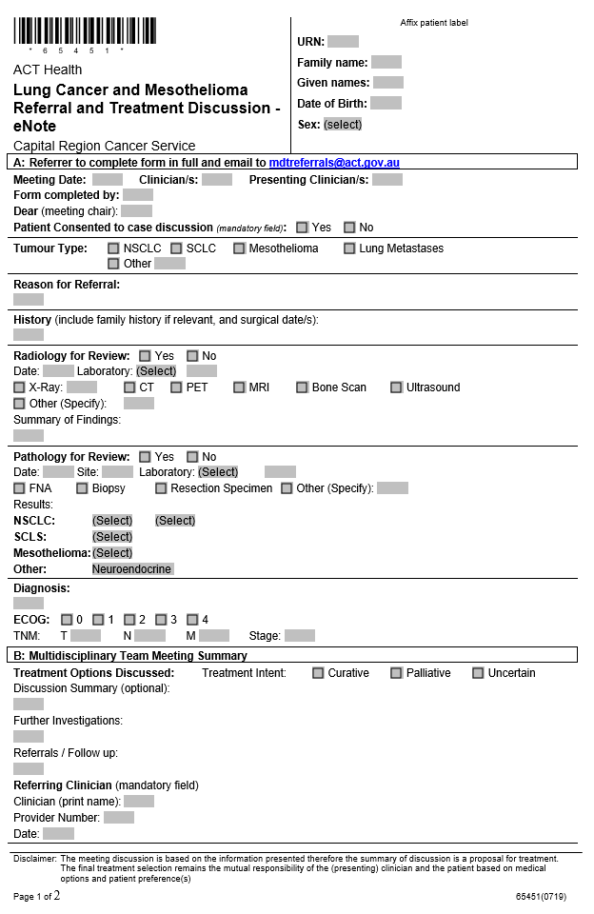
Sample
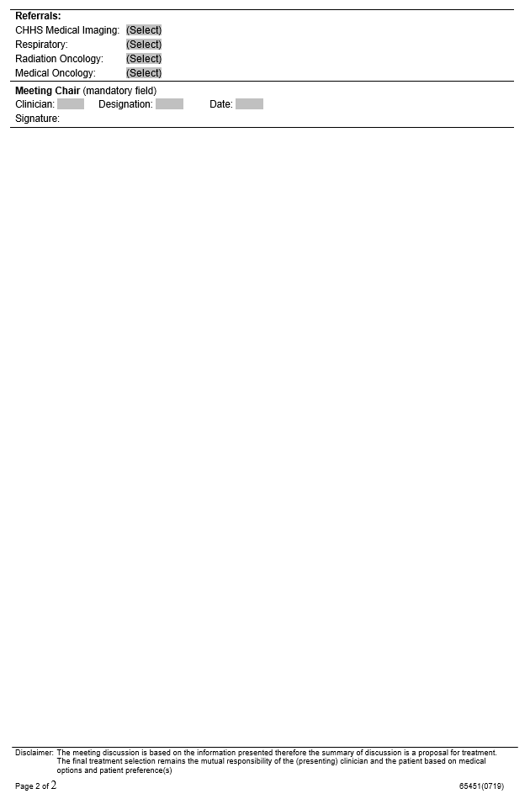
Sample


Attachment D – Multidisciplinary Cancer Care Consumer Handout

INFORMATION

