Canberra Health Services
Guideline
Assessment of the Newborn

Contents

Contents 1
Guideline Statement 2
Scope 2
Section 1 – Qualification status of Newborn Infants 3
Section 2 – Physical examination 4
Section 3 – Elements of Newborn Assessment that Require Consideration 10
Section 4– Referral and Documentation 11
Section 5 – Discharge Planning 11
Evaluation 11
Related Policies, Procedures, Guidelines and Legislation 12
References 13
Definition of Terms 13
Search Terms 14
Attachments 15

Guideline Statement
This clinical guideline describes the parameters of an uncomplicated newborn assessment and the process of escalation if assessment deviates form expected parameters. It does not describe management if the newborn assessment parameters, as per this guideline deviate from normal.

This guideline applies to well newborns born >37 weeks gestation and/or > 2.0 kg who remain under the care of maternity services.

Background
Every newborn baby requires a physical examination within the first few hours after birth to detect birth injuries, cardiorespiratory disorders and significant abnormalities that may compromise transition to extra uterine life. This should be followed by a full and detailed assessment within the next 48 hours prior to discharge from hospital.

It is accepted and good practice that this assessment is performed with the mother/ parents present, this provides an opportunity to discuss parameters of baby wellness, how to recognise an unwell baby and to convey information on relevant community support services including how to access them after discharge from primary care.

Key Objectives
To ensure safe discharge planning for newborn baby’s at Canberra Health Services (CHS).
- Determination of appropriate clinician for newborn assessment will be guided by this guideline.
- Family centred care will be safeguarded through inclusion of parents during newborn assessment and options for newborn care in the community will be discussed during discharge planning.

Alerts
Newborn examination for discharge can only be attended by a Registered Medical Officer or a Registered Midwife/Nurse who has completed all the requirements of Canberra Health Services (CHS) Newborn Assessment training.
Back to Table of Contents

Scope
This document applies to the following CHS staff working within their scope of practice:
- Medical officers
- Registered midwives
- Registered nurses
- Midwifery and medical students under direct supervision.
Back to Table of Contents

Section 1 – Qualification status of Newborn Infants

Qualification status of Newborn Infants
A newborn qualification status is assigned to each patient day within a newborn episode of care. The newborn baby's qualified days are eligible for health insurance benefits under the Australian Health Care Agreements. In this context, newborn qualified days are equivalent to acute days.
A newborn patient day is qualified if the baby meets at least one of the following criteria:
- Is admitted to an intensive care facility in a hospital, being a facility approved by the Commonwealth Minister for the purpose of the provision of special care.
- Is the second or subsequent live born baby of a multiple birth, whose mother is currently an admitted patient
- Is admitted to or remains in hospital without its mother.

A newborn patient day is unqualified if the baby does not meet any of the above criteria.
Qualified babies can receive care on the postnatal/antenatal ward. They are classified as either administrative or clinical qualification depending on qualification status.

If receiving care away from the neonatal unit a qualified baby will:
- Receive a formal admission with a diagnosis under the care of a neonatologist
- Be reviewed by the neonatal registrar daily, or as clinically indicated
- Have a newborn assessment and discharge summary completed by the neonatal medical team.
Administrative and Clinical Qualification

Administrative Qualified babies
Babies who are identified as administrative qualified are newborns less than 10 days old in the maternity unit with their mothers cared within the mother/baby dyad and do not require additional midwifery/nursing resources.
Administrative Qualified Baby Criteria
• Second or subsequent liveborn infant from a multiple birth
• Baby not born at CHS but transferred with mother >10 days old

Clinically Qualified Baby
A clinically qualified newborn is any newborn baby less than 10 days old and who meets one of the following criteria:

Clinically Qualified Baby Criteria
- Preterm Infant (<37 weeks of gestation at birth)
- Babies that were admitted in NICU or SCN at any stage
- Babies requiring gavage feeding and needing two or more NGT/OGT feeds in 24 hours
- Babies with hypoglycaemia
- Babies with jaundice requiring phototherapy
- Babies receiving IV antibiotic treatment who are otherwise well
- Babies receiving palliative/comfort care
- Babies re-admitted to maternity unit with a medical condition, under 14 days of age, not requiring admission to the NICU/SCN, and accompanied by the mother as a border
- Baby who remains in hospital with a medical condition and whose mother accompanies the baby as a boarder.

Back to Table of Contents

Section 2 – Physical examination

For guidance on which practitioner should perform newborn assessment see Attachment 1.

Newborn assessment of clinically qualified babies is to be performed by the neonatal medical team. The discharge summary of clinically qualified babies is performed by the neonatal medical team.

Well babies and babies with Administrative Qualification
Well babies and babies who are administratively qualified can have newborn assessment performed and documented by midwives/nurses who are competent to perform newborn assessment.
- If normal variance is identified during newborn assessment the baby must be checked by midwifery team leader before discharge. Record of variance must be documented in the baby’s clinical record, health record (blue book) and midwifery discharge summary
- If any clinical concerns are identified by the midwife/nurse during newborn assessment this should be escalated to the appropriate neonatal medical team for review (see attachment 1 for guidance).

Provision of family centred care
- Seek parental consent before examining the newborn
- Wherever possible perform the examination with at least one parent present
- Respect family values, beliefs and culture (consider an interpreter)
- Ask the parents about any concerns that they may have about the newborn
- Ensure information is shared in a complete, unbiased and timely manner to ensure parents effectively participate in care and decision making.

Equipment
- Stethoscope –paediatric
- Ophthalmoscope
- Documentation- Newborn Assessment form, Personal Health Record (blue book), Midwifery discharge summary.

Procedure
Review Maternal History including:
- Maternal medical history (including relevant immediate family history e.g., hip dysplasia, congenital heart conditions, thyroid disease)
- Antenatal history, ultrasounds, obstetric history
- Medication/substance use
- Labour history.

Review Newborn History including:
- Gestational age
- Type of Birth
- Neonatal Resuscitation and Apgar’s
- Identified neonatal risk factors per Neonatal early warning score (NEWS)
- ABO incompatibility risk assessment
- Biometric measurements
- Feeding and output.

Physical examination
- Ensure hand hygiene is performed prior to performing the physical exam.
- Ensure environment is warm with adequate lighting and newborn is completely undressed (nappy may be left insitu for elements of assessment)
- Prior to performing assessment complete and document a full set of neonatal observations.

General wellness of baby’s should be assessed and escalated as per The Royal Australasian College of Physicians Examination of the newborn as below.

Also see Attachment 2 Routine Newborn Assessment flowchart.

GENERAL  APPEARANCE | NORMAL | ABNORMAL
Colour | Pink, transient acrocyanosis | Cyanosis, pallor, jaundice, plethoric, ecchymoses (bruising), multiple petechiae
Position | Flexion of extremities | Floppy with “frog posture”, high tone or abnormal posture, adduction of thumbs
Activity while awake | Spontaneous movement | Decreased or absent spontaneous movement, asymmetry of movement
Cry | Vigorous and sustained after stimulation | Weak, high pitched, hoarseness, aphonia
Skin appearance | Mild peeling, vernix | Massive peeling in post-term and congenital ichthyosis
Pigmentation and lesions | Congenital dermal melanocytosis (blue spots), lanugo, naevus simples (salmon patch/stork mark), milia, erythema toxicum, | Naevus flammeus (port wine stain) haemangioma (strawberry naevi), pigmented genitalia, large dermal melanocytosis, petechiae, multiple cafe´ au lait macules
Face | Familial variation | Dysmorphism- epicanthic folds, flattened nasal bridge, asymmetrical position of eyes and ears
HEAD | NORMAL | ABNORMAL
Shape/size | Moulded, caput succedaneum | Cephalohaematoma, Subgaleal haematoma, hydrocephalus, microcephaly, plagiocephaly (flattened area of skull), scaphocephaly (narrow long head)
Fontanelles | Soft, flat, open anterior and posterior fontanelle. | Bulging: increased intracranial pressure  Small: craniosynostosis (ridged suture lines)  Large: hypothyroidism/vitamin D deficiency.  Third: Trisomy 21
EYES | NORMAL | ABNORMAL
Site | Symmetrically placed | Hypertelorism (wide spaced), hypotelorism (decreased spacing).
Conjunctiva | Clear, subconjunctival haemorrhage, sticky eye (non-purulent) | Conjunctivitis
Cornea and iris | Clear with normal red eye reflex. | Opaque with absent red-light reflex (congenital cataracts), coloboma (structural defect of eyelid or eye tissue)
EARS | NORMAL | ABNORMAL
Shape | Familial variation | Preauricular skin tag or sinus. Large, small or malformed ear. Microtia
Site | Pinna above horizontal line between inner and outer canthi | Low-set ears (present in some genetic syndromes)
NOSE | NORMAL | ABNORMAL
Patency | Bilateral patency of nares | Choanal atresia (bilateral or unilateral)
MOUTH | NORMAL | ABNORMAL
Lips | Familial variation | Cleft lip; prominent philtrum, and thin vermillion border in fetal alcohol syndrome
Palate | Epstein’s pearls - small inclusion cysts in midline of hard palate | Cleft or high-arched palate, bifid uvula, palatal insufficiency
Tongue and jaw | Familial variation | Large tongue: Trisomy 21, Beckwith Wiederman syndrome  Small jaw (retrognathia): Pierre Robin syndrome
Teeth | None | Natal teeth
Mucous membrane | Epithelial pearls (inclusion cysts) | Creamy/white lesions (Thrush)
Saliva | Moist mucous membranes | Excessive secretions: oesophageal atresia, tracheo-oesophageal fistula,  dry mucous membranes (dehydration)
NECK | NORMAL | ABNORMAL
Shape | Short (head seems to sit on neck) | Torticollis, excessive tissue back of neck (Turner’s syndrome/Trisomy 21), asymmetry, palpable masses
Hair | Soft | Low hair line: Turner’s syndrome. Coarse hair: Hypothyroidism
Masses | No palpable mass | Cystic hygroma, ectopic thyroid, sternomastoid tumour, fractured clavicle
THORAX | NORMAL | ABNORMAL
Shape | Symmetric | Pectus excavatum (funnel chest), pectus carinatum (pigeon chest)
Breast | Up to 1cm palpable glandular breast tissue | Neonatal mastitis, supernumerary nipples
LUNGS | NORMAL | ABNORMAL
Respiratory rate | Normal 40-60 breaths per minute | Tachypnoea >60 breaths per minute  Bradypnea< 20 breaths per minute  Gasping/ apnoeic
Retractions/recessions | Not present | If present indicate respiratory distress
Sounds | Symmetrical breath sounds | Grunt, stridor (noisy breathing), unilateral absence of breath sounds
HEART | NORMAL | ABNORMAL
Femoral Pulses | These should be felt when baby is quiet | Weak or absent: Aortic coarctation, hypoplastic left heart syndrome, shock.  Bounding: Patent ductus arteriosus
Apex beat | Fourth intercostal space in left mid-clavicular line | Shifted right/ left or displaced Hyperdynamic (dextrocardia, diaphragmatic hernia)
Murmurs | Grade I-II (soft) systolic murmur is common in the first 24 hours in a well-baby (without abnormal saturations/pulses) | Check saturations, pulses and precordial examination.  If murmur sounds pathological or the baby is unwell, immediate review by senior neonatal registrar is necessary. If murmur is soft in first day of age in a well-baby, repeat examination in 24 hours
KIDNEY | NORMAL | ABNORMAL
Kidney | May be palpable bilaterally | Enlarged: Hydronephrosis, renal vein thrombosis, horseshoe kidneys, Wilm’s tumour, cystic or dysplastic kidneys
ANUS | NORMAL | ABNORMAL
Anus | Patent | Imperforate anus with or without fistula, fissure
UMBILICUS | NORMAL | ABNORMAL
Vessels | Two arteries and one vein | Single umbilical artery: may be associated with growth restriction, renal congenital anomalies and clinical syndromes
Colour | Translucent: Wharton’s jelly | Green- yellow meconium staining resulting from fetal distress. Bilirubin staining.
Umbilical cord stump | Falls off day 10-14  Slight discharge/mild odour (shouldn’t be large volumes of ongoing discharge) | Periumbilical flare (erythema surrounding stump/cellulitis)  Significant bleeding or discharge  Umbilical hernia (common but requires review)
 | GENITALIA | NORMAL | ABNORMAL
 | MALE  Testes | Descended to scrotum | Undescended (ectopic or arrested in line of normal descent). Should be present in the inguinal canal if not needs further investigation.  Baby with bilateral undescended testes always need medical review
 | Penis and urethra | Urethral opening at centre of glans - foreskin non-retractile. | Hypospadias: urethral opening on ventral surface of penis at various positions. Epispadias: urethral opening on dorsal surface of penis.  Micropenis <2.5cm at term
 | Scrotum | Transient hydrocele (GP review for resolution) | Inguinal hernia, swollen and discoloured foreskin (may be testicular torsion and these babies need review by surgical team)
FEMALE  Hymen |  | Hymenal tag | Bulging imperforated hymen or labial adhesions
Clitoris |  | Variable in size | Large clitoris >9mm length or >6 mm width
Vagina and vulva |  | Mucoid vaginal discharge or bleeding caused by maternal hormones | Fusion of the labia majora  Single urogenital sinus (urethra and vagina should be seen separately)  Pigmented labia
EXTREMITIES |  | NORMAL | ABNORMAL
Feet |  | Movement, mild postural talipes positional needs physiotherapy exercise handout and GP review | Talipes equinovarus, calcaneovalgus, metatarsus adductus
Hips |  | Full abduction of flexed hip. | Congenital subluxation or dislocation of hip (Ortolani and Barlow signs)
Upper Limbs |  | Full range of movement of arm and hand. Symmetrical Moro. | Asymmetrical limb movement and/or Moro reflex (Brachial plexus injury, clavicle or humerus fracture)
Spine |  | All spinus processes palpable, sacral dimple <0.5cm, clearly visualised base and positioned below gluteal fold | Dense tufts of hair/birthmarks in midline/ sacral dimple >0.5cm wide >2.5 mm from anal verge (may be indicative of neural tube defect)

Neurological screening examination
A simple screening examination should be done in all newborn babies. It consists essentially of assessment of muscle tone and primitive reflexes. Absence or abnormality indicates pathology, and a more detailed neurological examination will be indicated.

 | NORMAL | ABNORMAL
Primitive Reflexes | Moro, sucking, rooting, grasping, walking, pupillary | Absence of appropriate reflexes.
Movement/Tone | Spontaneous symmetrical movement, flexion of limbs | Flaccidity, rigidity, convulsions, tremors, asymmetrical movement

Recommended reflexes to review are:
(1) Moro reflex - elicited by placing one hand under the baby’s shoulders and the other under his/her head and then suddenly dropping the baby’s head in relation to the trunk. A full response consists of fast abduction and extension of the arms followed by slow adduction and flexion. An asymmetry could suggest brachial plexus palsy or a bone injury. This reflex should disappear by 2 to 6 months of age.

(2) Palmar grasp - elicited by applying pressure to the palm of the hand resulting in flexion of fingers and a firm grasp of the object. If traction is applied the baby should lift his/her head off the bed and head lag can be assessed. This reflex should disappear by 12 weeks of age as the baby begins to reach for objects.

(3) Stepping reflex – is obtained by holding the baby in a vertical position with the feet in contact with a flat surface. This initiates a slow alternate stepping action of flexion and extension of the legs. This reflex usually disappears by 4 to 8 weeks of age.

(4) Rooting reflex - as the cheek of the baby is touched, the head turns to the stimulus and mouthing movements commence.
Back to Table of Contents

Section 3 – Elements of Newborn Assessment that Require Consideration

Jaundice Assessment
Alert: All clinically jaundiced babies should have a transcutaneous bilirubin performed and managed as per the CHS Jaundice in the Newborn Guideline.

Risk factors for neonatal jaundice are outlined in the CHS Jaundice in the Newborn Guideline. Per this guideline, all newborn babies will have a jaundice risk assessment at birth. Babies with identified risk factors for development of pathological jaundice must have a full jaundice screening completed and be reviewed by the neonatal medical team BEFORE discharge.

Neonatal Hypoglycaemia
Routine blood glucose measurement is not necessary in NORMAL well-grown babies after a normal birth. Please refer to CHS Guideline - Neonatal Hypoglycaemia for determination of risk factors and appropriate management.

Risk of Developmental Dysplasia of the Hip
If baby has identified risk factors for developmental dysplasia of the hip (DDH) prior to newborn assessment or has a confirmed dislocatable hip on examination, please refer to CHS Guideline -Developmental Dysplasia of the Hip guideline for appropriate management and referrals.

Baby of a mother with Thyroid conditions
Babies of a mother with any of the following conditions require review by neonatal medical team prior to discharge:
- Any thyroid disease with positive TSH receptor antibodies (TRABS)
- Grave’s disease
- Thyrotoxicosis (including those treated with anti-thyroid drugs, radioactive iodine or surgery)
- History of congenital thyroid disorders in previous offspring
- Antenatal concerns regarding foetal thyrotoxicosis.

Risk of neonatal sepsis
Babies who require extended admission due to risk for developing sepsis should have newborn assessment completed by the neonatal medical team. Observations and treatment will occur as per CHS Neonatal Bacterial Sepsis Guideline.

Babies with antenatal renal hydronephrosis
Babies with evidence of hydronephrosis in antenatal ultrasound need to be referred to the neonatal medical team for review, further investigations and follow up.

Babies with Subgaleal bleed
Newborn assessment of these babies is to be performed by the medical neonatal team. Observations occur as per CHS Neonatal Neurology Procedure.

Risk of neonatal abstinence syndrome
These babies are usually identified antenatally. Newborn assessment for discharge will be attended by the neonatal medical team.
Back to Table of Contents

Section 4– Referral and Documentation

Alert: Any abnormal features identified during newborn assessment are to be referred to the neonatal registrar/SRMO for review before discharge. Urgency of referral will be based on clinical presentation and severity of symptoms.

Notable features detected during the newborn assessment (e.g., positional talipes/tongue tie), may not need immediate referral but require a plan of care. Referrals should be organised per clinical need with appropriate service e.g. (physiotherapy/surgical/paediatric review/tongue tie clinic), communicated with the parents and documented in the baby’s clinical record, health record (blue book) and electronic midwifery birthing summary.

Back to Table of Contents

Section 5 – Discharge Planning

Evaluate each mother-baby dyad individually and involve the family when determining optimal time of discharge. Criteria for newborn baby discharge includes physiological stability, family preparedness to provide care for the baby at home, and knowledge regarding access to community health care resources for new parents and babies. This should include discussion regarding follow up at six weeks of age for the baby with general practitioner or Maternal and Child Health services.

Newborn bloodspot screening test (NBST)
If baby is discharged before 48 hours of age discuss collection options with parents, this can occur through midcall or ACT Pathology services. Please refer to CHS Procedure - Newborn Bloodspot Screening Guidelines to guide discussion with the parents on when and why this this test is performed, provide appropriate literature and screening card/pathology forms. This discussion should be documented in the clinical record of the mother and the baby.
Back to Table of Contents

Evaluation

Outcome
- All newborn babies will receive examination at birth and prior to discharge from Canberra Health Services inpatient care by an appropriate practitioner as per this guideline.
- Newborn babies who require additional assessments, as identified from birth or discharge assessment, will be referred for review by an appropriately skilled neonatal medical practitioner per this guideline.

Measures
- Unexpected outcomes in neonatal care that were not identified during Assessment of the Newborn, will be reported in Riskman and case reviewed at monthly Neonatal Mortality and Morbidity meeting.
- Where assessment of the newborn at birth or on discharge, identifies significant unexpected morbidity or mortality, the case will be reviewed at monthly Neonatal Mortality and Morbidity meeting.
- Consumer feedback related to Newborn Assessment will be reviewed via relevant reporting processes.
Back to Table of Contents

Related Policies, Procedures, Guidelines and Legislation

Policies
- Nursing and Midwifery Board of Australia Requirements for Practice
- Informed Consent (Clinical)

Procedures
- Infection Prevention and Control
- Midcall Early Discharge Service
- Neonatal Neurology
- Newborn Bloodspot Screening Test
- Patient Identification and Procedure Matching
- Vital Signs & Early Warning Scores

Guidelines
- Developmental Dysplasia of the Hip
- Early Onset Group B Streptococcal Disease
- Neonatal Bacterial Sepsis
- Neonatal Hypoglycaemia
- Neonatal Resuscitation and Airway Management Guideline
- Jaundice in Newborn
- Pre-labour Rupture of Membranes (PROM) Management at Term
- Preterm Pre-labour Ruptured Membranes (PPROM)
- Developmental Care in the Neonatal Intensive Care Unit and Special Care Nursery

Legislation
- Health Records (Privacy and Access) Act 1997
- Human Rights Act 2004
- Work Health and Safety Act 2011

Other
- Australian Charter of Health Care Rights

Back to Table of Contents

References

- Australian College of Midwives. National midwifery guidelines for consultation and referral 4th edition. 2021. Available from: https://www.midwives.org.au
- The Royal Australasian College of Physicians (RACP): Paediatrics and Child Health Division. Examination of the newborn. 2009. Available from: https://www.racp.edu.au
- Gantan EF, Wiedrich L. Neonatal Evaluation. Updated 2021. StatPearls [Internet]. StatPearls Publishing. Available from Neonatal Evaluation - StatPearls - NCBI Bookshelf (nih.gov)
- Australian Institute of Health and Welfare. Meteor Report, Version 2. Tasmania. 2021 Newborn qualification status. Available from Newborn qualification status (aihw.gov.au)
- Queensland Department of Health, Queensland Clinical Guidelines. Newborn baby assessment (routine) 2021. Available from: Guideline: Newborn baby assessment (routine) (health.qld.gov.au)
- South Australian Perinatal Practice Guideline. 2021. Postnatal Care: Routine care of the well woman neonate. Available from: Postnatal Care. Routine care of the well woman and neonate (sahealth.sa.gov.au)
- Southern Health, Neonatal Assessment and Discharge Examination in the Term Newborn- Guideline for Midwives and Obstetric Staff, 2009.
- Tappero. E, and Honeyfield.M, (2014) Physical assessment of the Newborn: A comprehensive Approach to the Art of Physical Examination. NICUINK California

Back to Table of Contents

Definition of Terms
- Achondroplasia: genetic disorder disturbing normal growth of cartilage, resulting in a form of dwarfism characterized by a usually normal torso and shortened limbs
- Calcaneovalgus: a condition where the foot and ankle are excessively bent up, where the toes may be touching the shin
- Cephalohematoma: a subperiosteal haematoma that occurs underneath the skin, in the periosteum of the newborn's skull bone
- Choanal atresia is a congenital disorder where the back of the nasal passage (choana) is blocked, usually by abnormal bony or soft tissue (membranous) due to failed recanalization of the nasal fossae during fetal development
- Craniosynostosis: premature fusion of the sutures of the skull
- Dextrocardia: a cardiac condition in which the heart is situated on the right side of the chest and the great blood vessels of the right and left sides are reversed
- Epicanthal fold is skin of the upper eyelid that covers the inner corner of the eye. The fold runs from nose to the inner side of the eyebrow
- Glossopteris: a condition which involves the downward displacement or retraction of the tongue
- Hydrocephalus: is an abnormal build-up of cerebrospinal fluid (CSF) in the ventricles of the brain. The fluid is often under increased pressure and can compress and damage the brain
- Hydrometrocolpos: an accumulation of watery fluid in the uterus and vagina
- Hypertelorism: excessive width between the eyes
- Kyphosis: exaggerated outward curvature of the thoracic region of the spine resulting in a rounded upper back
- Metatarsus adductus: a condition of the foot that causes the front half of the foot, or forefoot, to turn inward
- Micrognathia: a condition in which the jaw is undersized. Micrognathia may interfere with a child's feeding and breathing
- Philtrum: the vertical groove on the median line of the upper lip
- Plagiocephaly: a malformation of the head marked by an oblique slant to the main axis of the skull and usually caused by closure of half of the coronal suture
- Scaphocephaly: a congenital deformity of the skull in which the vault is narrow, elongated, and boat-shaped caused by premature ossification of the sagittal suture
- Subgaleal haemorrhage: accumulation of blood between the epicranial aponeurosis of the scalp and the periosteum caused by rupture of the emissary veins, which are connections between the dural sinuses and the scalp veins
- Syndactyly: a union of two or more digits and is marked by webbing of two or more fingers or toes
- Talipes equinovarus: a congenital condition of the foot in which both talipes equinus and talipes varus occur so that walking is done on the toes and outer side of the sole
- Torticollis: condition characterized by involuntary intermittent or sustained contraction of the muscles of the neck (such as the sternocleidomastoid or trapezius) that causes the head to tilt or turn sideways.

Back to Table of Contents

Search Terms

Newborn Assessment, Well baby Assessment, Newborn qualification status
Back to Table of Contents

Attachments

Attachment 1: Who performs Well Baby Assessment
Attachment 2 Routine Newborn Assessment Flowchart

Disclaimer: This document has been developed by Canberra Health Services specifically for its own use. Use of this document and any reliance on the information contained therein by any third party is at his or her own risk and Canberra Health Services assumes no responsibility whatsoever.

Policy Team ONLY to complete the following:
Date Amended | Section Amended | Divisional Approval | Final Approval
4/10/2022 | Full review | Susan Freiburg ED WYC | CHS Policy Committee

This document supersedes the following:
Document Number | Document Name
CHSS17/267 | Assessment of the Newborn

Attachment 1 Who performs Newborn Assessment
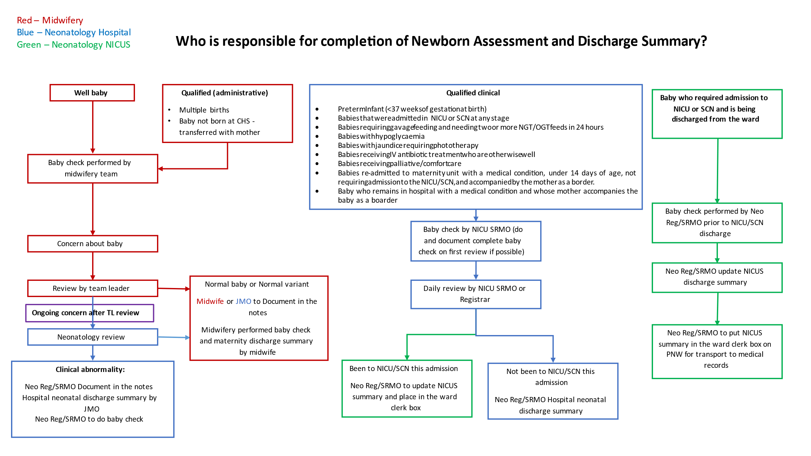

Attachment 2 Routine Newborn Assessment Flowchart
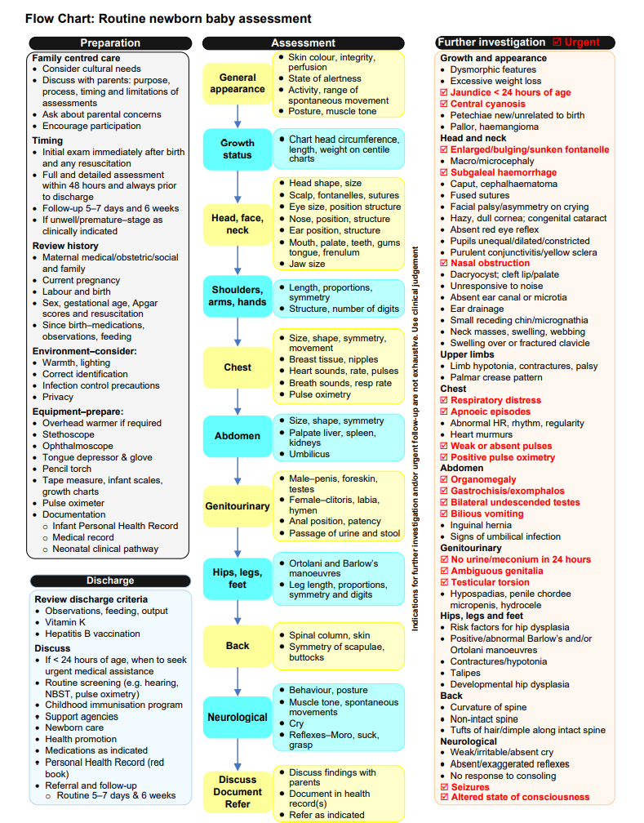
Sourced from: Queensland Clinical Guideline: Newborn baby assessment 2021

