Canberra Health Services
Guideline
Billing for outpatient or non-admitted patient activity

Contents
Contents 1
Guideline Statement 3
Scope 3
Section 1 – Non-Admitted (Outpatient Billing in a Public Health Facility) 3
Billable status 4
Department of Veterans Affairs cards 5
Section 2 – Outpatient Bulk Bill and DVA Billing 6
Section 3 – Referral Requirements for Medicare Bulk Billing/DVA Billing 7
What is a referral? 7
Named referral requirements 8
Referrals not to a named Specialist (NTANS) 8
Referral validity periods 8
Indefinite referrals 8
Transferred referrals. 9
Requesting new referrals 10
Services that do not require referrals 10
Diagnostic Imaging – ‘Self-determined’ Services 12
Bulk Billing for Locum Tenens and Staff Specialist Leave Cover 12
Section 4 – Consultations and Other Professional Attendances for Medicare/DVA Billing 13
When to bill an initial consultation verses a review/follow-up consultation 13
Billing for multiple services provided on the same day 14
Specialist Trainees 15
Public health services for Medicare Non-Eligible Patients during the COVID-19 period. 16
MBS Specialist Telehealth Services 16
What is the ‘30/20 rule'? 16
Section 5 – Other Billed Non-Admitted Categories 16
Defence Personnel 16
Compensable Patient 17
Workers Compensation/Third Party/Public Liability Patient 17
Lifetime Care and Support Scheme (LCSS) 18
Medicare Non-Eligible/Ineligible 18
Non-MBS Billable Items 19
National Disability Insurance Scheme (NDIS) 19
Asylum Seeker in Community Detention 20
Section 6 – Other Non-Billed Non-Admitted Categories 20
Public Non-Admitted Services 20
Reciprocal Health Care Agreement Patients 20
Countries with Reciprocal Health Care Agreements with Australia 21
Asylum Seeker with ACT Access Card 22
Correctional Facility/Incarcerated Patient 22
Non-Eligible Exemptions 22
Section 7 – Admission Category Workflow 24
Section 8 – Frequently Asked Questions 25
Section 9 – Billing for Services/Items via Shared Services 28
Section 10 – Patient Accounts, Revenue Data 29
Section 11 – Support Using DHR 29
Section 12 – For Further Information 29
Related Policies, Procedures, Guidelines and Legislation 30
Definition of Terms 30
Search Terms 31
Attachments 31
Attachment 1 – Provider Digital Access (PRODA) and Health Professional Online Service (HPOS) Information Sheet 32
Attachment 2 – Health Professional Online Service (HPOS) How To Access 34
Attachment 3 – Case Conference Billing 37
Attachment 4 – Defence Personnel Billing Letter 40
Attachment 5 – Compensable Patient Billing Letter 41
Attachment 6 – Non-Eligible Billing Slip 42
Attachment 7 – Asylum Seeker in Community Detention 43

Guideline Statement

Background
This billing manual has been developed in line with the billing team and referencing applicable legislation to provide a straightforward guide for staff engaging in billing activities.

Key Objective
The key objective of this document is to aid staff engaging in billing activities in entering correct data for billing purposes.

Alerts
Note: this billing manual is aimed at both clinical and administrative staff engaging in billing activities.

Back to Table of Contents

Scope

The Billing Guideline applies to clinical and non-clinical or administrative staff engaged in billable activities for outpatients or non-admitted patients on behalf of Canberra Health Services (CHS).

For the purposes of this document, billable activities refer to any action undertaken that when recorded appropriately in the Digital Health Record (DHR) or other appropriate CHS system results in the production of a charge. Billing activities refers to any action taken to record items that are considered for billing including but not limited to patient status and financial classes, health fund details, MBS item numbers and completed admission documents. This applies to data entered for all patients, regardless of age.

Back to Table of Contents

Section 1 – Non-Admitted (Outpatient Billing in a Public Health Facility)

Standard: For every non-admitted occasion of service the correct billing status will be determined and recorded in the appropriate source system.
Revenue to Canberra Health Services (CHS) can be generated by billing patients or third parties for eligible attendances. Processes must be efficient, accurate, legal, and timely to increase the revenue received. While it is the responsibility of the treating clinician to determine the relevant Medicare Benefits Schedule (MBS) code for the services provided, it is the administrative processes that facilitate billing.
All administrative staff involved in any aspect of non-admitted services must understand their role and the correct processes to follow in billing. Substantial penalties apply for fraud – even if unintentional.
Billing in a public health facility is governed by the following:
- The National Health Care Agreement 2012 (NHCA) 2020–25 National Health Reform Agreement (NHRA) | Australian Government Department of Health and Aged Care
- The National Health Reform Agreement (NHRA) The National Health Reform Agreement | Federal Financial Relations
- The Medicare Benefits Schedule (MBS) http://www.mbsonline.gov.au/internet/mbsonline/publishing.nsf/Content/Home
- The Health Insurance Act 1973 (HIA) Health Insurance Act 1973 (legislation.gov.au)
- Health (fees) Determination (DoF) Health (Fees) Determination 2022 (No 1) | Disallowable instruments (act.gov.au)

Billable status
The billable status is determined by the:
- Patient’s Medicare status
- Service being provided
- Referral status
- Status of the clinician providing the service.
This is determined and set by the administration support staff. Once the billable status has been determined, administration staff will need to assign the appropriate administration category to the patient’s occasion of service in the Digital Health Record (DHR).
Administrative Category (previously known as financial class)
For each non-admitted occasion of service, an administrative category or ad cat will need to be assigned to every occasion of service. It is important that staff ensure the ad cat is correct as this will determine the appropriate funding to be received and ensure revenue is captured.
If it is unclear which ad cat to select for a particular patient and/or occasion of service, staff should confirm with their team leader or the treating clinician.
You can also refer to the workflow, found here in this document to help determine the appropriate ad cat.
Medicare cards
Below are examples of the different Medicare cards which indicate that the client is eligible to be charged under Medicare. There are three Medicare cards:
- Green Medicare card - people permanently in Australia. Cards may be issued for individuals or families.
- Blue Medicare card - with the words "Interim Card" are for people who have applied for permanent residence.
- Yellow Medicare card - with the words “Reciprocal Health Care” are for people from countries with Reciprocal Health Care Agreements with Australia.
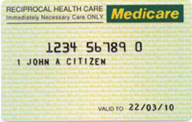
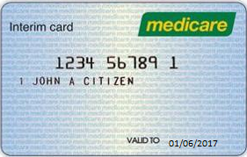
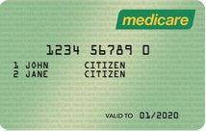

Green Blue Yellow

Note: Federal and State/Territory Governments fund health services to provide patient care services.
Accurate collection of Medicare numbers and funding source information by the Department of Health will enable CHS to meet its obligations regarding:
- National reporting requirements
- Internal billing requirements
- Australian Digital Health Agency requirements to contribute to individuals My Health Record (more information can be found here: https://www.digitalhealth.gov.au/).

Department of Veterans Affairs cards
Below are examples of the different Department of Veterans Affairs (DVA) health cards – each health card has a different level of cover and are issued to veterans, their widows/widowers and dependants ensuring they have access to health (and other) care services.

There are three DVA cards:
- Gold card – DVA accepts financial responsibility for all services.
- White card – entitles the veteran to treatment for their accepted war-caused disabilities, and for a few general disabilities including:
- cancer (malignant neoplasia)
- pulmonary tuberculosis
- any mental health conditions.
- Orange card – entitles the veteran to pharmaceutical items only.

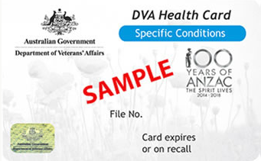
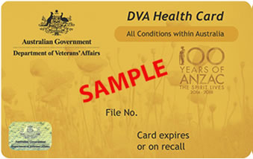

Gold White Orange
Health Professional Online Service (HPOS)
CHS has access to check a patient’s Medicare eligibility (with the patient’s permission) online through the Health Professional Online System (HPOS). HPOS is accessed via staff’s individual PRODA (Provider Digital Access) account. Please see Attachment 1: Health Professional Online Service (HPOS) patient verification access. Once your account has been created you can use Attachment 2: How to Access Health Professional Online Service (HPOS).

Note: Ensure you are actively checking the patients Medicare card details upon every visit to CHS and correcting any discrepancies (such as correcting dates generated by the source systems, reference numbers, etc.). Do not assume the registered card number or accompanying details are correct – it is the last two digits that change.

Back to Table of Contents

Section 2 – Outpatient Bulk Bill and DVA Billing

Standard: All eligible persons have the right to choose to be treated as either a public or a private patient.
In an outpatient setting Medicare defines outpatient bulk billed services as private and public as true public services. Nurse, Allied Health and Registrar appointments should be placed through as public and CHS receives activity-based funding for these services.
For the service to be an eligible private non-admitted (known as “outpatient bulk billed”) or DVA billed service:
- The patient needs to be Medicare/DVA eligible and choose to be treated as a private (outpatient bulk bill) or DVA patient, and
- The service is provided by a Medicare eligible staff specialist (with a valid provider number) who is exercising their right of private practice, and
- The service provided must comply with the rules outlined in the National Health Reform Agreement (NHRA) and Medicare Benefits Schedule (MBS).
This means eligible Medicare/DVA patients have a choice between being treated publicly (free of charge) or privately (bulk billed through Medicare/DVA with no out of pocket expenses).
Note: As per the National Health Reform Agreement if a patient chooses to be treated as a public patient (free of charge – Public), all components of that public service (such as pathology and diagnostic imaging) are a part of the patient’s treatment and will also be provided free of charge. This means, if from a public clinic attendance, the patient is referred to imaging for a scan and pathology for blood tests, the scan and blood tests will also be public.
If they choose to be treated privately, services provided by Nurses, Allied Health, Registrars (or similar) and Visiting Medical Officers (VMOs)/ cannot be claimed through Medicare. These services are provided publicly and receive activity-based funding.
Where the patient and service meet the criteria outlined above, the patient will need to give consent for CHS to bill Medicare/DVA directly for the services provided – this consent is obtained when a Medicare patient signs a “Bulk Bill Assignment Advice” form (referred to as a “DB4”) or a DVA patient signs a “Health Practitioner Service Voucher” (referred to as a “DVA voucher”). This may be signed electronically.
Staff should ensure they properly inform patients what they are signing, and why, and reassure the patient there is no cost to them. This is part of providing Informed Financial Consent (IFC) to the patient or their representative.
What is Bulk Billing in a public health facility?
Bulk billing in a public health facility is when a service is invoiced to Medicare directly for any eligible medical services the patient receives.

When a provider and a patient enter a bulk billing arrangement:
- The provider accepts the relevant Medicare benefit as full payment for the service; and
- The patient assigns their right to a Medicare benefit to the service provider, allowing the benefit to be paid directly to the provider.

When a provider bulk bills for a service they undertake, they accept the relevant Medicare benefit as full payment for the service – this means additional charges for that service cannot be raised.
Back to Table of Contents

Section 3 – Referral Requirements for Medicare Bulk Billing/DVA Billing

Standard: For certain services provided by Specialists and Consultant Physicians, the Medicare benefit payable is dependent on acceptable evidence that the service has been provided following referral from another practitioner.

What is a referral?
For Medicare/DVA purposes a referral is a request to a Specialist or Consultant Physician for investigation, opinion, treatment and/or management of a condition/problem or, for the performance of a specific examination or test.
For a valid "referral" to take place the:
- Referring practitioner must have undertaken a professional attendance with the patient and then communicate relevant patient information to the Specialist/Consultant Physician;
- Referral must be in writing; this can include but is not limited to a letter, a note, an electronic request including via DHR; to a named Specialist/Consultant Physician;
- Referral must be signed and dated by the referring practitioner and cannot be written on behalf of someone else; and
- Specialist/Consultant Physician to whom the patient is referred must have received the referral on or prior to the occasion of service to which the referral relates.

Named referral requirements
The NHRA states that to bill an outpatient attendance in a public hospital, a patient must be referred to one named Specialist.
Named referral requirements are for billing purposes only. Referral pathways cannot be controlled to deny access to free public hospital services or so that a referral to a named Specialist is a prerequisite for access to outpatient services.
As a public hospital, all patients will be treated regardless of their billable status. Treatment is not to be denied to any patient based on whether their referral is billable or not.
Note: Once a referral has been used and billed by a service provider, the referral cannot be used by other service providers, except where Locum Tenens applies, or non-referred items are billed for Staff Specialist Leave Cover.

Referrals not to a named Specialist (NTANS)
Referrals received addressed to a department/specialty or ‘Dear Doctor’ are known as referrals ‘Not To A Named Specialist’ (NTANS). These referrals are not valid for billing purposes and services should be processed as public (correct ad cat to use is ‘Public’).
Once an appointment has been made, administrative staff can contact the referrer’s practice and request a named referral to the consulting doctor, however the referring practitioner is under no obligation to do so.

Referral validity periods
A referral’s validity period starts from the first billed occasion of service covered by that referral.
The exception to this is when the referral is for an admitted patient, the referral is valid for the length of the admission.
Referrals received from a Medicare eligible Specialist/Consultant Physician (with provider number):
- Are valid for 3 months from the first occasion of service covered by that referral.
- Specialists and Consultant Physicians CANNOT refer indefinitely.

Referrals received from Medicare eligible General Practitioner (GP), Registrars, Junior Medical Staff, Dentist, Optometrist, participating Midwife or participating Nurse Practitioner (with provider number):
- Are valid for 12 months from the first occasion of service covered by that referral unless stated otherwise (e.g., 3, 6 or 18 months or indefinitely).

Indefinite referrals
Indefinite referrals are open ended referrals that cover the length of treatment required for the condition stated.
The MBS uses the word ‘indefinitely” to describe continued or ongoing management of a patient’s condition, however the word “indefinite” is not a specific requirement. A referring practitioner can use a term commonly understood by the profession to describe an indefinite referral or that the referring practitioner wishes for the specialist/consultant physician to treat/manage the patient’s specified condition.
The referring practitioner can use terms like:
- referring indefinitely
- ongoing referral
- please consider this an indefinite referral
- referring for ongoing management
- referring for continual/continuing management
- referring for further management
- referring for opinion and management.

Note: This is not a complete list of terms. Staff should seek clarification from a team leader (or equivalent) if the referral validity is unclear and where necessary should contact the referring practitioner for further clarification.

Indefinite referrals are only valid for the stated condition – if the patient presents with an unrelated illness/condition a new referral to the specialist/consultant physician is required.
Indefinite referrals should not affect the Patient/GP relationship, it just means a new referral won’t be required for the specified condition (or single course of treatment).
Indefinite referrals should also not be affected by closure of practices or movement of referring practitioners between practices.

Transferred referrals.
Where a referral is received to a named Specialist/Consultant Physician, but the patient is seen by a second/different Specialist, the referral can be transferred to the second/different specialist - this is still considered a valid named referral for billing purposes as long as:
- The referral has not been used to bill for any other servicing provider before
- The referral meets all other referral requirements, and
- The second Specialist has the rights to private practice (Staff Specialist) and has the appropriate qualifications to treat the patient for the referred condition, the referral can be transferred.

Where a referral is received to a named Specialist/Consultant Physician who is no longer employed by CHS (referred to as an NTACS referral - “Not To A Current Specialist”), the referral is still considered valid for billing purposes and can be transferred to another Specialist/Consultant Physician, as long as standard transferred rules apply.

Requesting new referrals
Staff should ensure that if a new referral is required, this is requested at the time of booking the appointment and received prior to that appointment. The request can be made to the patient’s General Practitioner or directly to the patient/guardian.
Should you need to make the request in writing a letter can be sourced from Community Health Intake (CHI).
CHI Phone: 02 5124 9977
CHI Admin Group Email: #CHSCHIBookingsAdmin@act.gov.au

Services that do not require referrals
The following services do not require a referral to be billed under Medicare:
Diagnostic Respiratory Items 11503 - 11512
Cardiac Holter Monitor & Exercise Stress Test Items 11707 - 11715
Pre-anaesthesia consultation by a Specialist Anaesthetist Items 17610 - 17625
Antenatal attendance with Specialist Item 16500
Non-Referred Consultation Items Items 00052 – 00057
- 00052: Brief Consultation (less than 5 minutes)
- 00053: Standard Consultation (5 to 25 minutes)
- 00054: Long Consultation (25 to 45 minutes)
- 00057: Prolonged Consultation (more than 45 minutes)

While non-referred consultation items do not require a valid referral at the time of service to bill, certain criteria still need to be met.
There are three scenarios of outpatient services that are valid for billing non-referred consultation items listed below and shown on the following diagram.
Scenario 1: Outpatient services with expired referrals, where the previous service with the same Specialist had a valid referral and was billed as a private (outpatient bulk bill) or DVA non-admitted patient.
Scenario 2: Outpatient services provided by a Staff Specialist covering leave for another Staff Specialist of the same specialty.
Scenario 3: Outpatient services after discharge, where the patient was admitted as a private patient under the same Specialist.
Note: Where an outpatient referral has expired, follow up of a new referral is still required. Non-referred items should only be used where the new referral could not be obtained prior to the occasion of service.

Workflow for Scenario 1 - Previously referred outpatient

Workflow for Scenario 2 - Staff Specialist covering leave in the same specialty

Workflow for Scenario 3 - Discharged Private patients

Items from Category 2 & 3 of the Medicare Benefits Schedule

Diagnostic Procedures and Investigation items 11000 to 12533 and Therapeutic Procedure items 13015 to 51318
Items in category 2 and 3 of the MBS generally do not require a referral if the below conditions are met (unless the MBS item descriptor specifically states one is required e.g., 12203):
- the patient has previously been referred to the same Specialist and was eligible for and billed to Medicare/DVA; or
- the patient was previously admitted as a private patient under the same Specialist.

Diagnostic Imaging – ‘Self-determined’ Services
Where a diagnostic imaging service has been provided following a valid written referral/request, and the providing practitioner determines that based on results of the requested service/s, that additionally services are necessary, a new written request is not required. These services are billed without referrals but as a “self-determined” or “self-deemed” service, where the item descriptor specifically states a referral is required
However, the following services cannot be self-determined/self-deemed as additional services:
- MRI services; and
- services not otherwise able to be requested by the original referrer.

Note: Individual MBS item descriptors should be checked via MBS Online or by contacting the Revenue Data team for further clarification.

Bulk Billing for Locum Tenens and Staff Specialist Leave Cover

Locum Tenens
A locum is a practitioner who replaces a provider during a period of absence or leave. The replacement practitioner can be external or internal to CHS. If the replacement is internal to CHS then there must be a confirmed agreement between the provider on leave and the replacement, it must also be recorded on the consumers appointment and clinic letter that the replacement is a Locum or LT for the practitioner who is on leave.
Billing for external locums, also known as true locums, depends on their specific employment contract. Administrative staff of units employing locums should contact the Revenue Data team for clarification prior to the locum starting wherever possible.
New referrals are not required for a locum to enable billing - referrals addressed to practitioner on leave that the locum is covering can be used.
Locums can also hold clinics and accept new referrals. Any referrals made to the locum over the period of cover can continue to be used by original practitioner when they return from leave.

Staff Specialist Leave Cover
Leave Cover is when a Specialist/Consultant Physician is covering another staff Specialist/Consultant Physicians’ period of leave, who are both employed by the same practice/hospital.
In this circumstance the covering practitioner will require new named referrals to follow standard billing rules, unless the covering practitioner bills any items listed in “Services that do not require referrals”. Please also refer to the Scenario 2 Workflow above for non-referred consultation billing.
Any referrals made to the covering practitioner over the period of leave CANNOT be used by the original practitioner when they return.
Should you need any further information or clarification on locum/leave cover please contact Revenue Data.
Email: CHS.revenuedata@act.gov.au

Back to Table of Contents

Section 4 – Consultations and Other Professional Attendances for Medicare/DVA Billing

Standard: Personal attendance by the medical practitioner under whose name the service is billed, is necessary, before a "consultation" may be billed and the practitioner should record the clinical details of the service(s) provided to the patient.

When to bill an initial consultation verses a review/follow-up consultation
A single course of treatment by a Specialist/Consultant Physician involves only one initial consultation and then any continuing/follow-up consultations and treatment, until the patient is discharged (referred) back to the care of the referring practitioner.
Initial and follow up consultations have different item numbers/descriptors listed in the MBS and will attract different rebates where criteria are met to enable billing.
Receiving an updated/new referral following the expiration of a previous referral for the same condition does not indicate a new course of treatment or another initial consultation.
A new referral for the same condition only initiates a new course of treatment/initial consultation where the following criteria is met:
- the patient had been discharged back to the referring practitioner, and
- the referring practitioner deems it necessary for the patient's condition to be reviewed, and
- the patient is seen by the Specialist/Consultant Physician outside the validity of the last referral, and
- the patient was last seen by the Specialist/Consultant Physician more than 9 months earlier.
Presentation of a new referral for an unrelated/new illness or condition does initiate a new course of treatment/initial consultation.
If you are unsure if the new referral is for an unrelated illness you must confirm with the treating Specialist/Consultant Physician.
Where the service is eligible (details below) a Consultant Physician can bill for the creation of and review of a patient treatment and management plan. As there are a lot of rules and criteria to be met for management plans, staff should only bill these items when the criteria are met.

Billing for multiple services provided on the same day

Multiple Consultations
Multiple consultations for the same patient with the same Specialist/Consultant Physician can be billed on the same day if they are distinct services with a reasonable lapse of time between each attendance.
Separate attendances must be recorded as such in DHR.
A patient can attend appointments with different Specialists/Consultant Physicians for different conditions on the same day.

Consultation and Procedures:
During an occasion of service, where a consultation and another medical service (such as a procedure or imaging service) are provided at the same time both can be billed, except for the following:
- anaesthetics items 17609 - 17690,
- assistance at and Operation items 51300 - 51318
- any other item that states, “each attendance”, “attendance at which” or “including associated attendances/consultations” in its description.

Note: Individual MBS item descriptors should be checked via MBS Online or by contacting the Revenue Data team for further clarification.

Consultations and Radiotherapy/Treatment verification items
Benefits for consultations provided on the same day as treatment and/or planning services are only payable where they are clinically relevant. A clinically relevant service is one that is generally accepted by treating Specialist as being necessary for the appropriate treatment of the patient.
Treatment verification items (15700-15710) can be claimed once per attendance for radiotherapy but only where prescribed and reported by the Specialist.

Multidisciplinary Team Meetings (MDTs)/ Case Conferences
A case conference or multidisciplinary team (MDT) meeting is when a patient, who suffers from a minimum of one medical condition and who also has complex needs requiring a combined team of multiple specialities, is discussed in detail. The patient’s medical condition must have been or will likely be present for at least 6 months or be terminal.
MDTs are for patients in the community, a residential facility or due to be released from hospital back into the community.
The chair (or leader) of the MDT should bill the organising and coordinating MBS item and all other eligible Staff Specialists/Consultant Physician should bill the participant MBS items.
No more than 5 MDTs should be claimed per patient in a 12-month period, noting that Non-Eligible patients are not to be charged for MDTs.

Referral Requirements:
A specific referral for an MDT is not required however the patient must have either:
- a valid referral to the billing doctor, or
- have been previously billed (with a valid referral) by the billing doctor, or
- have been admitted under the billing doctor as a private patient.

Basic Guidelines for Organiser (chair or leader) of an MDT:
- arranged in advance
- explain what an MDT is and obtain consent from the patient (or patients agent/guardian)
- minimum of 4 care providers present, either in person, by phone or video link, for the duration including the organiser
- record the MDT in the patients record including the following details:
- participants
- date and begin and end times
- content
- outcome.
- provide (or make available) a copy of the notes to participants and patients GP
- discuss outcome/s with patient (or patient’s agent/guardian).

Basic Guidelines for participants in an MDT:
- recorded date/time MDT was held
- record content and outcomes related to their participation in patient’s notes.

Note: The patient is required to sign a DB4 for each staff specialist/consultant physician claiming for the MDT service to enable billing through Medicare/DVA. This can be done at the same time the consent is obtained from the patient (or agent/guardian) or after the service is provided.
Attachment 3 contains more comprehensive billing rules and MDT item numbers for billing.

Specialist Trainees
Generally, Therapeutic Procedures listed in the MBS between 13015 to 51318 (excluding items listed below) performed by a Specialist trainee (medical practitioner undertaking an Australian Medical Council accredited Medical College Training Program) will still be eligible for billing purposes under the Staff Specialist/Consultant Physician’s name, IF the Consultant has provided direct supervision – this means personal and continuous attendance for the duration of the service.
Exceptions:
- 13209 - Assisted Reproduction Therapy planning and management
- 16400 to 16500 - Obstetrics and Gynaecology consultation items
- 16590 & 16591 -Planning and managements of pregnancy
- 17610 to 17690 - Pre anaesthetic consultations, and
- 18350 to 18373 - Botulinum Toxin injections.

Public health services for Medicare Non-Eligible Patients during the COVID-19 period.
When a Covid positive Non-Eligible patient presents to CHS for treatment of Covid or related to Covid their financial category should be ‘Non-Eligible COVID’ in DHR.

No out-of-pocket fees will be charged to Medicare non-eligible patients for treatment for COVID-19 or public health services relating to COVID-19 during the COVID-19 period.

Any services not relating to Covid treatment will still be charged as per the non-eligible criteria and rules.

MBS Specialist Telehealth Services
From 1 July 2022, ongoing MBS telehealth arrangements remain in place and provide for a wide range of telephone and video services by qualified health practitioners and support safe and equitable telehealth services which are informed by the MBS Review Taskforce Principles. Previous temporary arrangements ceased on 30 June 2022.
MBS telehealth items are available to GPs, Medical Practitioners, Specialists, Consultant Physicians, Nurse Practitioners, participating Midwives, Allied Health providers and Dental Practitioners in the practice of oral and maxillofacial surgery.

What is the ‘30/20 rule'?
From 1 July 2022, a new prescribed pattern of service (a ‘30/20 rule’) was applied to telephone attendances provided by Consultant Physicians and GPs.

The 30/20 rule means that on 20 or more days, within 1 year, if the Doctor has conducted (and claimed) 30 or more phone consults they would be referred to the Professional Services Review (PSR).

The PSR will only consider exceptional circumstances if a practitioner exceeds these numbers in the 30/20 rule. If a Specialist feels they could reach this number, then they should monitor and flag this with Revenue Data so we are able to keep a record of what the “exceptional circumstance” was leading to the requirements for so many phone consults as this information will be required for Medicare.

Back to Table of Contents

Section 5 – Other Billed Non-Admitted Categories

Defence Personnel
For any person who is an active serving member of the Australian Defence Force, CHS services are funded by Department of Defence.
Additional information for a defence patient should be recorded in the appropriate source system. This should include their Defence Approval Number (referred to as DAN) and their Entitled Personnel Employee ID (EP ID).
As revenue is captured from the Department of Defence and not Medicare/DVA, referral criteria and practitioner eligibility rules do not apply for billing purposes. The appropriate ad cat to use when billing for Defence Personnel is “Defence Shared”.
Billing should be captured for all Specialist/Consultant Physician occasions of services as well as registrar and nursing attendances – billing should not occur for VMOs.
When billing for Specialists and Consultant Physicians ensure you are using the relevant MBS item/s. When billing for Registrar attendances you are required to use Non-MBS Billable (below).
For each billable occasion of service, the Defence Personnel Billing Slip in Attachment 4 should be completed/signed and uploaded/recorded in DHR.

Compensable Patient

Workers Compensation/Third Party/Public Liability Patient
A compensable patient is someone who may have a right to recover compensation or damages from another person or third-party including costs of services provided by CHS. These services can also be provided in respect of the injury, illness, or disease.
There are three main kinds of compensable patients:, which are also the ADCATs they are to be entered into DHR under:
- Workers Compensation
- Whereby an employer must pay or provide insurance to pay medical expenses of an employee who is injured at work.
- Third Party
- Compensation for a loss to a party other than the insured for which the insured is liable. Relates to Motor Vehicle accidents.
- Public Liability
- Protection for businesses and business owners against the financial risk of being found liable to a third party for death or injury, loss or damage of property or economic loss resulting from their negligence.

As revenue is captured from a third-party provider and not Medicare/DVA, referral criteria and practitioner eligibility rules do not apply for billing purposes. The appropriate ad cat to use when billing for a compensable patient will be dependent on the type of claim they are making.
Billing should be captured for all Specialist/Consultant Physician occasions of services as well as Registrar, Nursing, and Allied Health attendances – billing should not occur for VMOs.
All attendances should be billed using the appropriate Non-MBS Billable Items (below), or in the absence of a Non-MBS item, the appropriate MBS item.
Revenue generated for a compensable patient is much higher than that of a Medicare/DVA patient. The fees for these services can be found in the Health (fees) Determination.
For each billed occasion of service, the Compensable Patient Billing Slip in Attachment 5 should be completed, this will issue an invoice to the third party for payment.

Note: If a compensable patient chooses not to go ahead with a claim or the claim is not accepted, if the patient is Medicare eligible, services can be reverted back to public (ad cat Public), or bulk billed through Medicare where possible.

Lifetime Care and Support Scheme (LCSS)
Lifetime Care and Support Scheme is a no-fault insurance scheme, to ensure Canberrans who are catastrophically injured in a motor vehicle accident, can manage their ongoing care needs into the future.
Under this scheme, which has previously not existed in the ACT, Canberran motorists needing lifetime care because of a catastrophic injury can access the scheme, which is targeted at providing long-term care and support. Patients will need to meet certain eligibility criteria to be accepted by the scheme.
As revenue is captured via the scheme and not from Medicare/DVA, referral criteria and practitioner eligibility rules do not apply for billing purposes. The appropriate ad cat to use when billing for a LCSS patient is “Lifetime Care & Support Scheme”.
Billing should be captured for all Specialist/Consultant Physician occasions of services as well as Registrar, Nursing and Allied Health attendances – billing should not occur for VMOs.
All attendances should be billed using the appropriate Non-MBS Billable Items (below), or in the absence of a Non-MBS item the appropriate MBS item.

Medicare Non-Eligible/Ineligible
A Medicare Non-Eligible or Ineligible patient is defined as persons who:
- are not an Australian citizen, or
- do not hold a current valid Medicare card.

These patients are most likely overseas visitors, foreign embassy staff or international students and who are not covered by Reciprocal Health Care Agreements (information below).
Non-eligible patients are not entitled to receive free public hospital/health care services and are therefore liable to meet the full costs of their health treatment.
It is a requirement for an overseas visitor/student to have private health insurance before entering Australia. This is to ensure adequate safety measures in case of any required debt recovery actions or if the patient is not able to cover the full cost of treatment on their own.
As revenue is captured from the patient or partially from the patients’ health fund not Medicare/DVA, referral criteria and practitioner eligibility rules do not apply for billing purposes.
Billing should be captured for all Specialist/Consultant Physician occasions of services as well as VMO, Registrar, Nursing and Allied Health attendances (however not for services provided at CHS Walk in Centres). These attendances should be billed using the appropriate Non-MBS Billable Items (below), or in the absence of a Non-MBS item, the relevant MBS item.
Revenue generated for a Non-Eligible patient are much higher than that of a Medicare/DVA patient. In some circumstances however, a Non-Eligible patient can be exempt from charges for services they are provided. These fees are listed in the Health (Fees) Determination.
The appropriate ad cat to use when billing for a Medicare Non-Eligible/Ineligible patient will be “Non-Eligible”. For each billed occasion of service, the Non-Eligible Outpatient Form at Attachment 6 should be completed and signed. This replaces the Non-Eligible Patient Billing Slip.
Non-Eligible patients need to be advised that they will receive an invoice for the services provided to them and to contact Patient Accounts on 6207 6131 (Option 2) if they have questions. This should be done when the patient presents for their appointment to reception or over the phone when the patients appointment is confirmed. Non-Eligible patient fee sheets are available through Share Point on the intranet, patients will need to be advised that fees will change on July 1st each year. CHS has long and short-term payment options available for patients experiencing financial hardship.

Non-MBS Billable Items
Non-MBS Billable Items
Items for Defence, Compensable and Non-Eligible patients where an MBS item doesn’t apply
Item | Description | Medical Practitioner
C1 | Initial Consultation | Specialist/Consultant Physician, Registrar, VMO
C2 | Follow-up Consultation | Specialist/Consultant Physician, Registrar, VMO
NAH1 | Attendance 30 minutes or less | Nursing/Midwifery/Allied Health Professional
NAH2 | Attendance 30 to 60 minutes | Nursing/Midwifery/Allied Health Professional
NAH3 | Attendance 60 minutes or more | Nursing/Midwifery/Allied Health Professional
NAH4 | Group Education Service | Nursing/Midwifery/Allied Health Professional
NAH6 | Community Based Rehabilitation Services - 60 mins | Nursing/Allied Health Professional
NAH7 | Community Based Rehabilitation Services - Maintenance Exercise Therapy Session | Nursing/Allied Health Professional
PAIN1 | Pain Management Service - Multidisciplinary Assessment | Medical Staff
PAIN2 | Pain Management Service - Cognitive Behavioural Therapy Program (2-week program) | Medical Staff
PAIN3 | Pain Management Service - One-Day Education Program for Chronic Pain (JUMP) | Medical Staff
PAIN4 | Pain Management Service - Psychology Assessment | Medical Staff
PAIN5 | Pain Management Service - Group Psychology Session | Medical Staff
PAIN6 | Pain Management Service – Initial Medical Assessment | Medical Staff
PAIN7 | Pain Management Service – Follow-up Medical Assessment | Medical Staff

National Disability Insurance Scheme (NDIS)
The National Disability Insurance Scheme (NDIS) provides support to people with disability, their families, and carers. The main component of the NDIS is individualised packages of support to eligible people with disability.
Under the scheme, CHS is a registered NDIS provider and can provide through a range of RACS Nursing and Allied Health (podiatry, nutrition etc.) and/or assistive technology to NDIS participants when the care they receive is related to their NDIS recognised disability. Billing can be raised for eligible services listed in the signed service agreement between the participant and NDIS.
NDIS numbers should be recorded within the patient’s demographics in DHR, clinicians are responsible for recording the services rendered in line with the participants agreement. There are only limited units that are registered as NDIS providers so not all areas are able to bill NDIS.
The NDIS is not a funding source for hospital care or consultation/procedures provided by Specialists, Consultant Physicians or VMO’s.
For detailed division specific operational guidelines see your team leader or equivalent.

Asylum Seeker in Community Detention
An Asylum seeker is an individual who is seeking international protection. Not every asylum seeker will ultimately be recognised as a refugee, but every refugee is first an asylum seeker.
The ACT Government is committed to providing the fairest society possible for all Canberra residents, and that is no less the case for asylum seekers.
Asylum seekers who enter Australia unlawfully and who do not hold a valid visa are placed in immigration/community detention.
An agreement between the Department of Home Affairs and CHS via International Health and Medical Services (IHMS) exists to ensure adequate health care services are provided for those in challenging environments often requiring targeted and tailored solutions.
Under this agreement CHS invoices Department of Home Affairs directly for services provided to these patients – the patient will not be invoiced for the service.
To enable billing for these services, the patient must be pre-approved by the Department of Home Affairs, an authorisation letter should be supplied as proof (example in Attachment 7).
The appropriate ad cat to use for an Asylum Seeker in Community Detention is “Asylum Seeker Community Detention”. Ensure a copy of the authorisation letter is attached to the clinic schedule and then emailed to Patient Accounts (CHSBilling@act.gov.au).

Back to Table of Contents

Section 6 – Other Non-Billed Non-Admitted Categories

Public Non-Admitted Services
Standard: All Medicare eligible persons have rights to choose to be treated as either a public or a private patient.
Where a Medicare/DVA eligible patient has elected to be treated publicly or the service provided doesn’t meet the rules and criteria to be billed privately (above), no charges are to be raised.
The appropriate ad cat to use for a public patient/a service that does not meet the necessary billable criteria is “Public”.
The only charges that can be raised for a service provided to a public non-admitted patient are those listed in the Health (Fees) Determination.

Reciprocal Health Care Agreement Patients
A Reciprocal Health Care Agreement (RHCA) is an agreement between two countries offering medically necessary, publicly funded care to overseas visitors.
This means overseas visitors travelling from countries where such an agreement exists, can receive medically necessary treatment while they are in Australia, including public hospital care. However, people visiting Australia for the purpose of receiving treatment are not covered and will be billed as a Non-Eligible person. There may be some costs associated with accessing care under the reciprocal agreements. Further information on the individual agreements can be found here: When Reciprocal health care agreements apply and you visit Australia - Reciprocal Health Care Agreements - Services Australia

Generally, ‘medically necessary treatment’ means any episode of illness or injury which requires attention before the visitor returns home. This covers not only ‘emergency’ treatment but any ill health or injury that arises during the visitors stay. Any decisions around the patient’s health/injury should be referred to the treating clinician.
The appropriate ad cat to use for a RHCA patient is “Reciprocal Health Care Agreement” and are treated as public patients, meaning no charges are to be raised.
A passport is sufficient evidence to receive public hospital care and PBS (The Pharmaceutical Benefits Scheme) prescriptions, or the patient may hold a Yellow Medicare Card bearing the words "RECIPROCAL HEALTH CARE".

Countries with Reciprocal Health Care Agreements with Australia
- Belgium
- Finland
- Italy
- Malta
- New Zealand
- Norway
- Republic of Ireland
- Slovenia
- Sweden
- The Netherlands
- The United Kingdom – Including Scotland, Wales and Northern Island.

Period of cover
Residents from Belgium, Finland, the Netherlands, Norway, Slovenia, Sweden, and the United Kingdom are covered from the first day they arrive in Australia until either their private health insurance or visa expires (whichever expires first).

Residents from New Zealand are covered for the entire length of their stay in Australia.

Residents from Republic of Ireland are covered from the day they arrive in Australia until their visa ends.

Residents from Italy and Malta are covered from the first day they arrive in Australia for a period of 6 months unless their visa expires first.

Students
Visitors to Australia on a student visa from Belgium, Italy, The Netherlands, New Zealand, Slovenia, Sweden, and The United Kingdom are covered under RHCA.
However, visitors on student visas from Finland, Malta, Norway and Republic of Ireland are not covered and should be billed as Non-Eligible.

Asylum Seeker with ACT Access Card
As mentioned above an asylum seeker is an individual who is seeking international protection. Not every asylum seeker will ultimately be recognised as a refugee, but every refugee is first an asylum seeker.
In Australia, an asylum seeker is a Protection Visa (PV) applicant who has not yet received a final decision on their application from the Department of Home Affairs and are instead issues with an ACT Access Card.



Asylum seekers can feel extremely vulnerable because they have an uncertain future. By showing their ACT Services Access Card, asylum seekers can decrease the stress or trauma of retelling their story again.
This card entities the asylum seeker to free public health care including pathology, diagnostic imaging, pharmaceutical and outpatient services in ACT public hospitals.
The appropriate ad cat to use for an Asylum Seeker with an ACT Access Card is “Public” – no charges are to be raised.

Correctional Facility/Incarcerated Patient
Any person who is incarcerated is excluded from Medicare and PBS under section 19(2) of the Health Insurance Act 1973. This means an incarcerated patient attending CHS for services, should be treated as a public patient and the funding we receive is generated outside of Medicare. The appropriate ad cat to use for an incarcerated patient is “Correctional Facility” – therefore no charges are to be raised.
When correcting patient demographics for an incarcerated patient, ensure their address and “next of kin” is listed as the name of the correctional facility the patient is in. Incarcerated patients will have their correctional facility visit listed in DHR so the demographic details should be available for reference.

Non-Eligible Exemptions
Generally, Non-Eligible patients will be charged for services provided by CHS.
However, under certain circumstances outlined in the Health (Fees) Determination (below), services will be provided to the patient, free of charge at the discretion of CHS and or the state/territory.
- Investigation, Treatment and Medication for Eligible Tuberculosis and Latent Tuberculosis Patients.
- HIV Medication for Medicare Ineligible Patients.
- Victims of family, domestic, and sexual violence.
- Involuntary Admissions.
- Public health services for Medicare Non-Eligible Patients during the COVID 19 period.
The appropriate ad cat to use when billing for a Medicare Non-Eligible/Ineligible patient who is exempt from charges will be “No Charge Raised Due to Hospital Decision”.
Note: Please ensure you seek clarification from the Clinician and/or supporting treatment team if you believe a patient is exempt.

Back to Table of Contents

Section 7 – Admission Category Workflow
The following flow chart shows how to identify which financial class a non-admitted patient falls under.
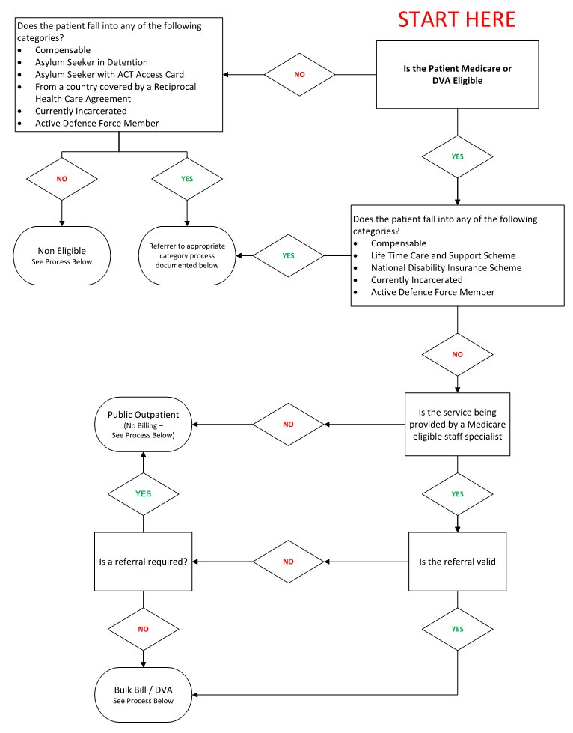
Back to Table of Contents

Section 8 – Frequently Asked Questions

Email chs.revenuedata@act.gov.au

Q: Can I still book the patient’s appointment if the referral isn’t named?
A: Yes.
The National Health Reform Agreement states, Business Rule G17:
a. except where there is a third-party payment arrangement with the hospital or the State, emergency department patients cannot be referred to an outpatient department to receive services from a Medical Specialist exercising a right of private practice under the terms of employment or a contract with a hospital which provides public hospital services;
b. referral pathways must not be controlled so as to deny access to free public hospital services; and
c. referral pathways must not be controlled so that a referral to a named Specialist is a prerequisite for access to outpatient services.
A named referral can be requested; however, the referring practitioner isn’t obligated to address the referral to anyone specifically and services cannot be refused if a named referral isn’t obtained.

Q: Are referrals location specific?

A: No.
A named referral is intended for the treating practitioner, not a specific practice location, and is valid for a single course of treatment, including attendances and procedures performed by the treating practitioner.
Medicare benefits are payable for a subsequent consultation provided by the specialist/consultant physician at another location (second site) within the referral period.
Therefore, CHS can request named referrals written to our Specialists/Consultant Physicians from their private rooms to use for billing purposes.

Q. Can a referral that states “Electronically Signed” be used in the absence of a physical signature?
A. If we ensure the electronic referral received meets the following criteria around acceptance of an ‘electronic signature’ then we can accept these as valid and process billing accordingly:
- The person making the ‘signature’ is identifiable and the persons intent in respect of the information communicated is clear,
- Identification through a statement ‘Electronically signed by XXXXX’ or similar, or
- Confirmation of Identification through the means of the electronic transaction, e.g. CHS email address, fax, or feeder system user account information
- Intent will be met by the information contained in the referral indicating the reason for referral, etc.
- The method of electronic communication is appropriate for the given circumstances;
- i.e. transmission of documentation over an un-encrypted medium, etc.

Q: Can a medical practitioner refer themselves?
A: Yes
Medical practitioners can refer themselves to a Specialist or Consultant Physician and Medicare benefits are payable at the referred rate.

Q: The referral letter was dated prior to the patient’s attendance; however, it wasn’t received until days after the occasion of service – can we still bill for that appointment?
A: No.
The referral must be received prior to or at the service to which the referral relates. We are unable to backdate referrals.

Q: Can I use a Discharge Summary to bill for the first post inpatient follow up? Is it a billable referral?
A: Generally, no.
There is a misconception that Discharge Summaries can be used to claim through Medicare/DVA for the first outpatient attendance after the patient was admitted. This is not the case as most Discharge Summaries do not comply with billing requirements (such as to a named Specialist).

A Discharge Summary can serve as a referral to book an appointment for a patient, however it’s unlikely it can be used as a billable referral.

If you’re unsure you can seek clarification from your team leader or the Revenue Data team.

Q: Can I bill the first appointment after a patient has been discharged from hospital?
A: Billing for an attendance post inpatient admission will depend on the type of patient and admission.
Please see table below to determine billable status:
Post Inpatient Billing Guide
Type of Admission | Billable | Comment
Private Inpatient | Yes | If the service meets MBS/NHRA requirements and the patient elects to be treated as a private “Outpatient Bulk Bill” outpatient
Public Inpatient:  Surgical admission with post-operative follow-up | No | If the service is the first attendance as an outpatient directly related to post-operative/post-discharge care
Public Inpatient:  Surgical admission with non-surgical appointment (different speciality) | Yes | If the service meets MBS/NHRA requirements and the patient elects to be treated as a private “Outpatient Bulk Bill” outpatient
Public Inpatient:  Non-surgical admission | Yes | If the service meets MBS/NHRA requirements and the patient elects to be treated as a private “Outpatient Bulk Bill” outpatient

Q: What criteria needs to be met to bill treatment and management MBS items (00132 & 00133)?
A: It is the responsibility of the treating Consultant Physician to ensure the service meets all necessary criteria.
A Consultant Physician can bill a treatment and management plan (00132 – initial or 00133 – review), if:
- item 132 has not been claimed within the last 12 months, and
- item 133 is not billed more than twice, within the first 12 months of a 132, and
- the patient is referred, and
- the patient has at least two morbidities, and
- the consultation for 00132 is 45 minutes or more and 00133 more than 20 minutes, and
- a written copy of the management plan is provided to the patient (where appropriate), the referring medical practitioner and maintained in the patient’s Medical Record.

Q: Can I bill for contacts?
A: Yes.
Contacts are billable, where they meet the criteria listed for any of the above types of services. The source system should contain all necessary information such as the treating clinician, referrals details (when necessary) and the appropriate items.
For each billed occasion of service, a DB4 or the appropriate above-mentioned Non-Eligible Outpatient Form should be completed.

Q: When should a patient sign the Bulk Bill Assignment Advice (DB4) form?
A: Best practice is before the service is provided when the consumer presents to reception, however the DB4 can be printed/presented before or after the service is provided and signed physically or digitally at any point. However, if any of the details were changed after the initial signature (e.g. item numbers, referral details) a new, corrected form must be printed / presented for the patient to resign.
Any necessary changes can be handwritten on the printed form if this is done before the patient signs.

Back to Table of Contents

Section 9 – Billing for Services/Items via Shared Services

For non NDIS patients consumables and non-medical services are billed through Shared Services rather than the Patient Accounts Office. This includes but is not limited to:
- equipment repairs / modifications
- prosthesis and orthotics
- consumables (e.g. dressings, plaster casts, foot files)
- some driving assessments
- medical reports.
A complete list of chargeable items can be found in the Health (Fees) Determination.
NDIS consumables and equipment is invoiced through Patient Accounts in line with the participants service agreement.
If you are unsure if the item/service should be billed through Patient Accounts or Shared Services confirm with your team leader or equivalent.
All requests to raise invoices are to be made in writing, can be electronic, by the Clinician or manager who provided the service and need to include at a minimum, the following information:
- who the invoice is to be sent to
- description of service provided
- amount to be invoiced
- name of requesting clinician/manager.
If there is information missing or you are unsure about the information provided on the invoice request, you should return it to the requestor or seek advice from your team leader or equivalent.
To raise an invoice through Shared Services follow the steps in the link below:
https://actss.service-now.com/sharedservices/finance?id=sc_cat_item&sys_id=2911b4e3e14daa006f09c7b1cb1f3ec0
Back to Table of Contents

Section 10 – Patient Accounts, Revenue Data

Patient Accounts is responsible for the billing and debt recovery of patient, Medicare and Health Fund invoices raised for CHS. This includes, but is not limited to, accommodation, diagnostic services, and admitted/non-admitted services.
Our dedicated teams provide support to patients, internal and external stakeholders, as well as clinical and administrative staff members ensuring timely and accurate information is available to assist with both the patient experience and enhancing CHS revenue.
Revenue Data provides administrative support, training and advice to the CHS divisions on billing processes and guidelines in a public health facility. We provide billing data reports to the divisions, these include missed revenue reports and billing process insights on request, noting these are available in DHR. For CHS staff members seeking advice on billing rules or billing training please contact CHS.revenuedata@act.gov.au
For divisions seeking support or advice on behalf of patients wishing to discuss their accounts, please contact Patient Accounts via phone (02) 6207 6131 (option 2) or via e-mail CHSBilling@act.gov.au.

Back to Table of Contents

Section 11 – Support Using DHR

Staff requiring support and training to use DHR, including coding patient encounters for billing, should contact Digital Solutions Support

Back to Table of Contents

Section 12 – For Further Information

Please ensure that if you require further information or have any questions about billing, speak to your team leader (or equivalent) first, who should escalate to Revenue Data if required.

Any clarification required from Medicare and/or other legislation about billing MUST be sought through Revenue Data. Individual teams should not contact Medicare directly.

Back to Table of Contents

Related Policies, Procedures, Guidelines and Legislation

Policies
- Patient Debt Write Off

Procedures
- Admission to Discharge (adults and children)
- Inpatient Revenue Collection
- Charges for Medicare Ineligible – Non-Eligible patients presenting for non-emergent treatment and or procedures
- Telehealth Consultation

Legislation
- Health Records (Privacy and Access) Act 1997
- Human Rights Act 2004
  - Health Insurance Act 1973
  - Health (fees) Determination

Other
- Australian Charter of Healthcare Rights
- National Health Care Agreement 2012 (NHCA)
  - National Health Reform Agreement (NHRA)
  - Medicare Benefits Schedule (MBS)
Back to Table of Contents

Definition of Terms

ADCAT – Admission Category
Billing Activities – refers to any action taken to record items that are considered for billing including but not limited to patient status and financial classes, health fund details, MBS item numbers and completed admission documents.
CHS – Canberra Health Services
DAN – Defence Approval Number
DB4 – Bulk Bill Assignment Form
DHR – Digital Health Record
DOF – Determination of Fees
DVA – Department of Veterans Affairs
EP ID – Entitle Person Employee Identification, applies to Defence Personnel
Fin Class – Financial Class, now known as ADCAT
HIA – Health Insurance Act (1973)
HPOS – Health Professional Online Services
IFC – Informed Financial Consent
LCSS – Lifetime Care and Support Scheme
MBS – Medicare Benefits Schedule
MDTs – Multidisciplinary Team Meetings
NAH – Nursing and Allied Health
NDIS – National Disability Insurance Scheme
NHCA – National Health Care Agreement
NHRA – National Health Reform Agreement
NTACS – A referral issued ‘Not To A Current Specialist’
NTANS – A referral issued ‘Not To A Named Specialist’
OBB – Outpatient Bulk Bill
OOS – Occasion Of Service
PBRC – Power Billing & Revenue Collection – invoicing and collection system used by CHS
PRODA – Provider Digital Access
VMO – Visiting Medical Officer

Back to Table of Contents

Search Terms
ADCAT, Admission Category, Billing, Billing Guideline, Billing Manual, Bulk Bill, DVA, Fin Class, Finance, Inpatient, Locum, MBS Item, MDT, Medicare, NDIS, Outpatient, Patient Accounts, PRODA, Reciprocal, Referral, Revenue Data, Shared Services

Back to Table of Contents

Attachments
Attachment 1 – PRODA and HPOS Information Sheet
Attachment 2 – HPOS How To
Attachment 3 – Case Conference Billing
Attachment 4 – Defence Personnel Billing Letter
Attachment 5 – Compensable Patient Billing Letter
Attachment 6 – Non-Eligible Billing Slip
Attachment 7 – Asylum Seeker in Community Detention

Disclaimer: This document has been developed by Canberra Health Services specifically for its own use. Use of this document and any reliance on the information contained therein by any third party is at his or her own risk and Canberra Health Services assumes no responsibility whatsoever.

Policy Team ONLY to complete the following:
Date Amended | Section Amended | Divisional Approval | Final Approval
20/05/2024 | New Document | CHS Policy Team | CHS Policy Team

This document supersedes the following:
Document Number | Document Name

Attachment 1 – Provider Digital Access (PRODA) and Health Professional Online Service (HPOS) Information Sheet
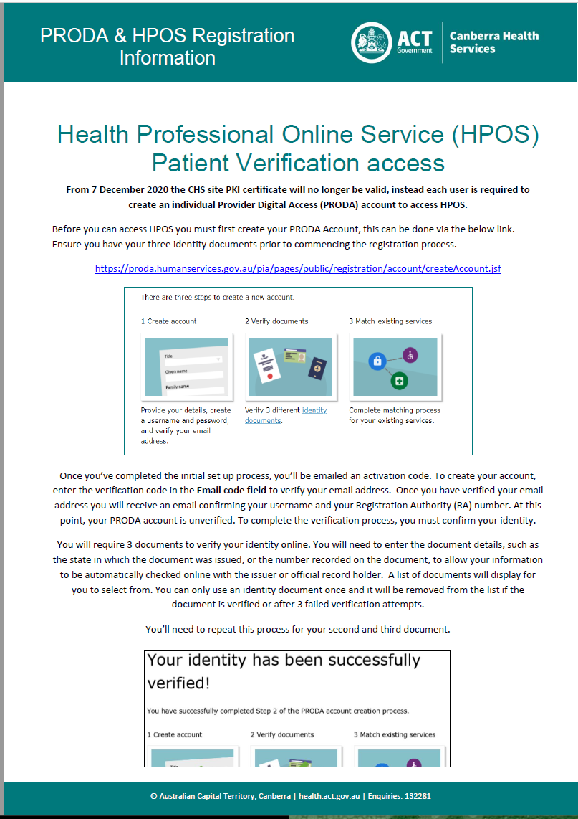
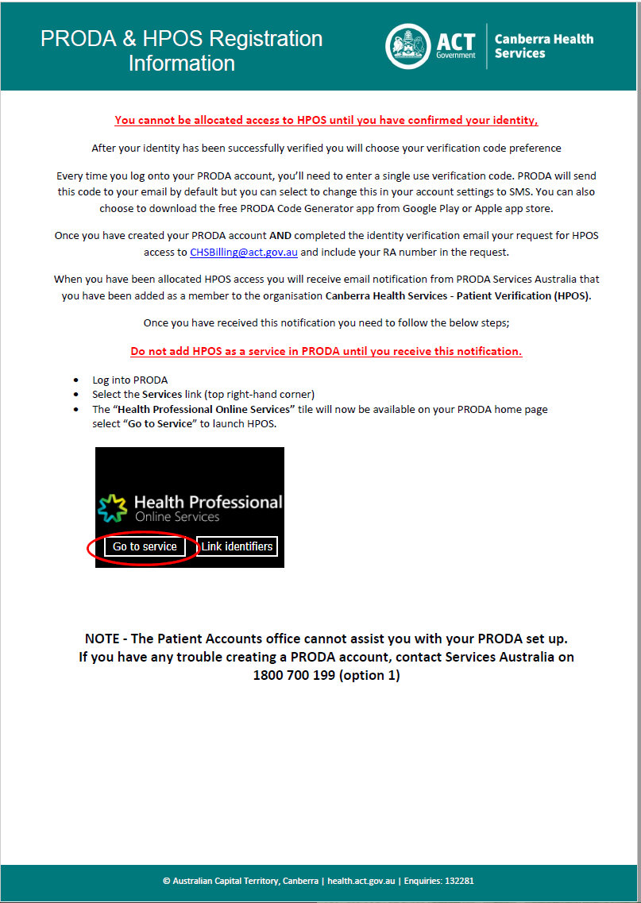

Attachment 2 – Health Professional Online Service (HPOS) How To Access
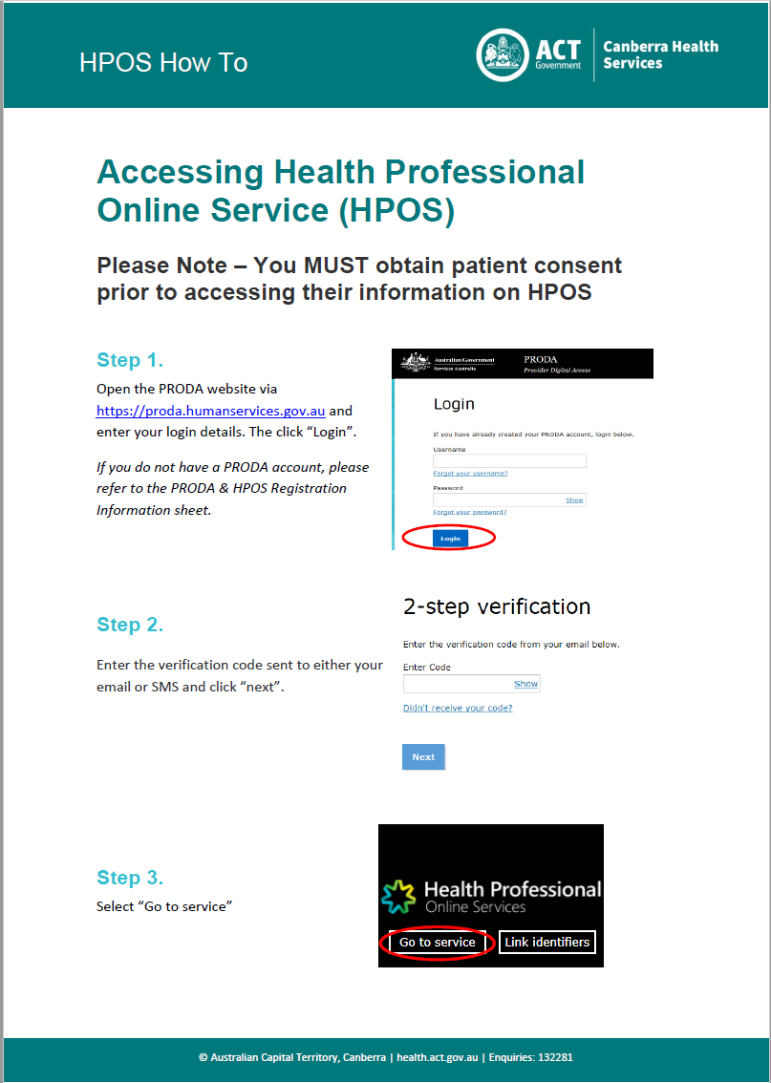

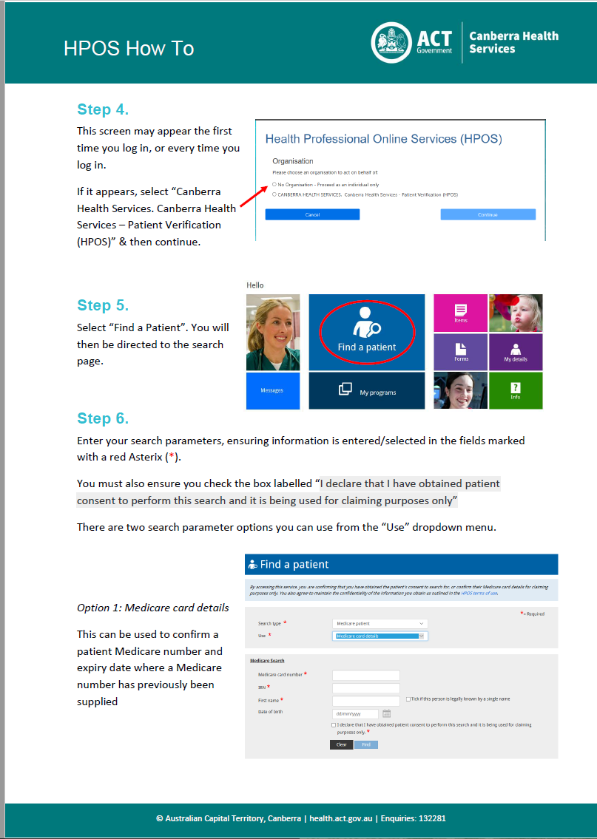
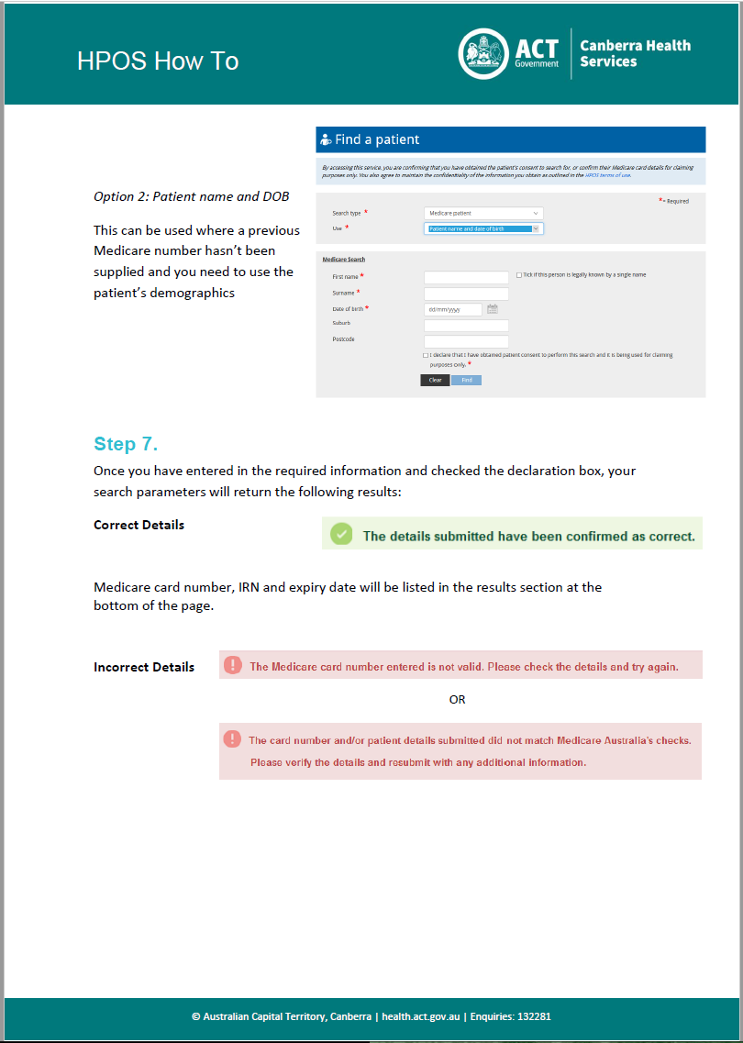

Attachment 3 – Case Conference Billing
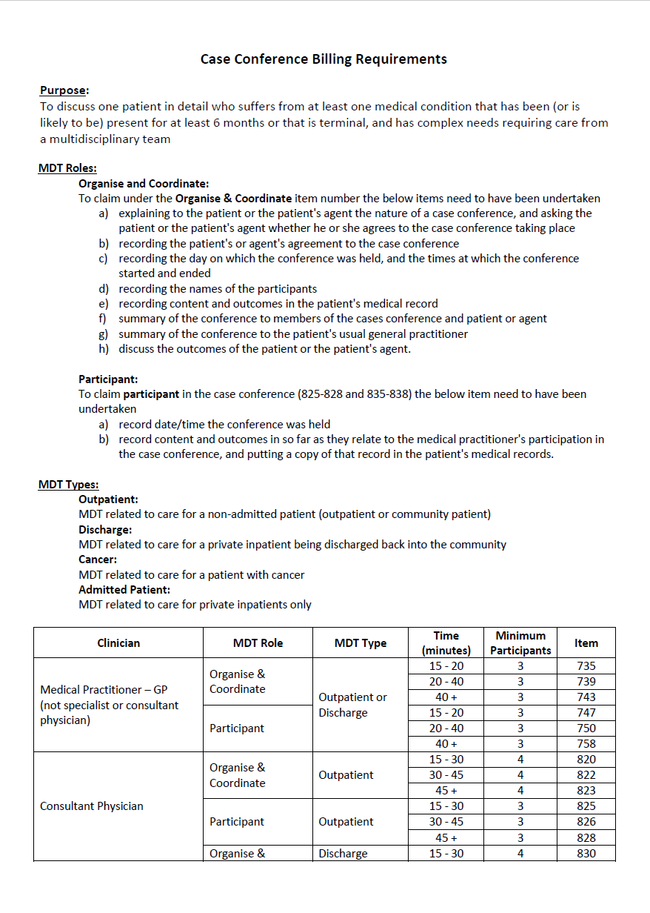

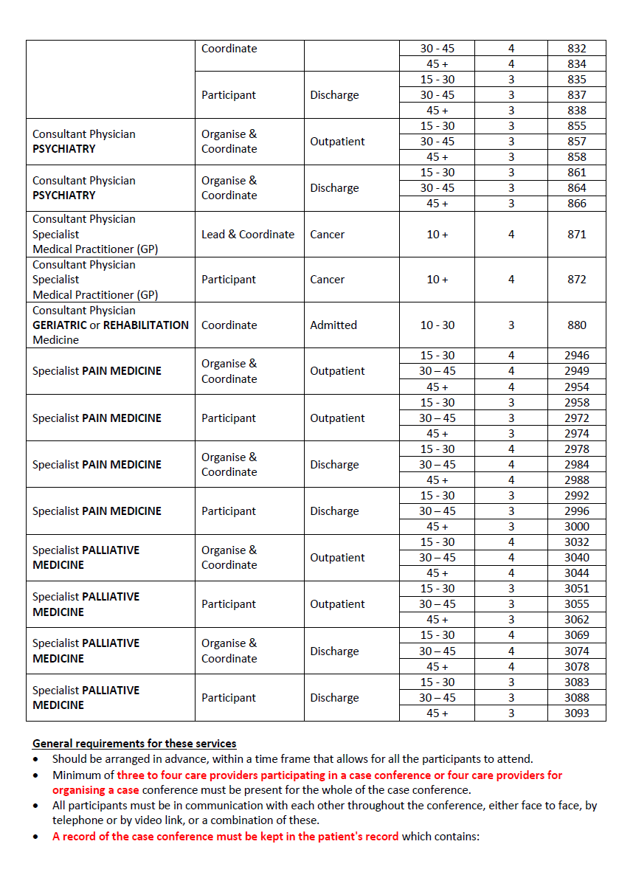

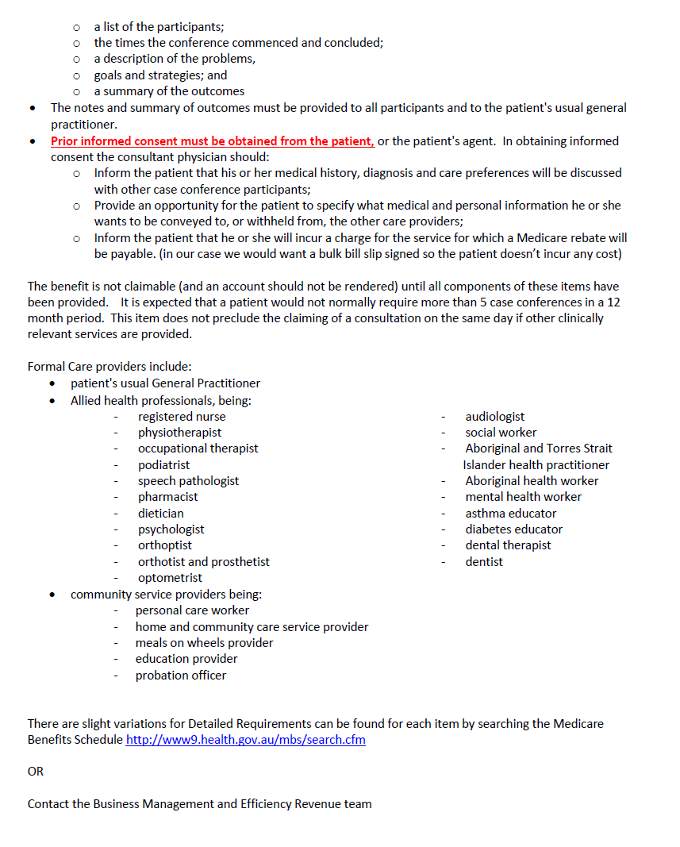

Attachment 4 – Defence Personnel Billing Letter
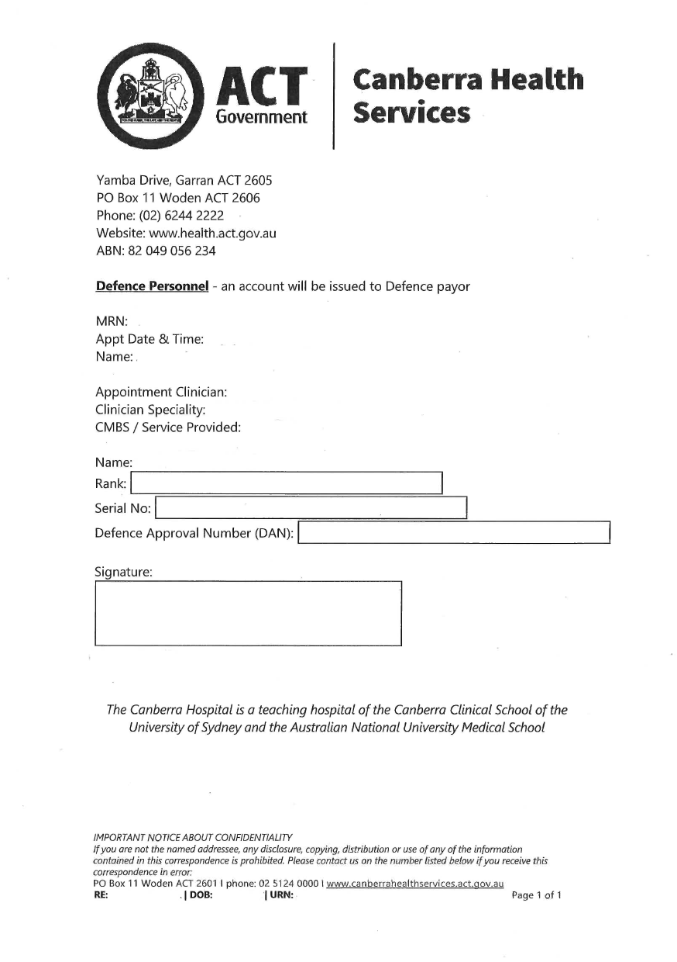

Attachment 5 – Compensable Patient Billing Letter
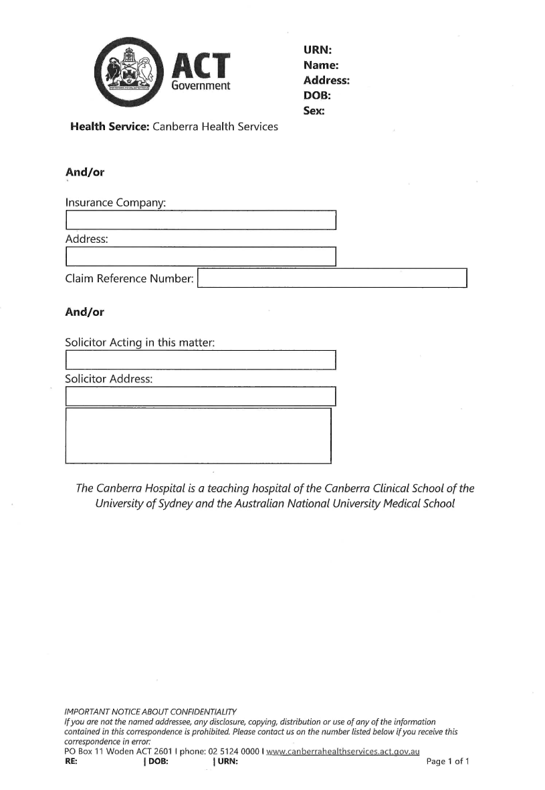

Attachment 6 – Non-Eligible Billing Slip
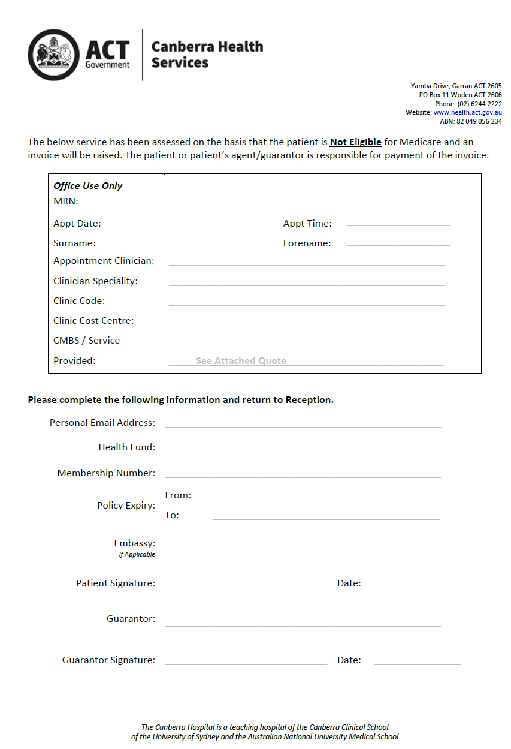

Attachment 7 – Asylum Seeker in Community Detention
