Canberra Health Services
Procedure
Medication Fridge Temperature Monitoring – North Canberra Hospital

Contents

Contents 1
Purpose 2
Alerts 2
Scope 2
Section 1 – Importance of Maintaining Cold Chain 3
Section 2 - Procurement and Maintenance of Medication Fridges 3
Section 3 – Transportation of Refrigerated Medicines 4
Section 4 – Storing Refrigerated Medicines in Patient Care Areas 5
Section 5 – Central Monitoring of Medication Fridges 5
Section 6 – Manual Medication Fridge Monitoring 9
Section 7 – Health Protection Service Vaccines 10
Section 8 – Reporting Requirements 10
Section 9 – Useful Contacts 11
Evaluation 11
Related Policies, Procedures, Guidelines and Legislation 12
Definition of Terms 12
Search Terms 12
Attachments 12

Purpose

This document outlines the procedure to be followed for:
- monitoring the temperature of medication fridges across North Canberra Hospital (NCH) and Clare Holland House (CHH).
- identifying and managing a temperature excursion to prevent harm caused to patients and to minimise economic losses for the organisation.
- procuring a new medication fridge for a patient care area.

Back to Table of Contents

Alerts

- All medication fridges in NCH are monitored centrally via the building maintenance system (BMS). Information is stored on a server and accessed via a software program called BACNET (Automated Logic).
- In patient care areas where fridges are wired into the BMS, there is no need for staff to manually monitor medication fridges or reset the temperature display of the fridge using the buttons on the controller at the front of the fridge.
Note: Special requirements apply where vaccinations provided by Health Protection Services are stored in the fridge – see Section 7 - Health Protection Service Vaccines.
- If monitoring via the BMS is interrupted, Information Communication Team (ICT) will communicate outages to the facilities team who will notify patient care areas, the Pharmacy Department or the NCH After Hours Hospital Managers (AHHMs). In this instance manual monitoring is to resume using the Medication Fridge Manual Monitoring Recording Form – Appendix 1.
- In the event of a temperature excursion, a Riskman is to be completed by the Clinical Nurse Consultant (CNC), Clinical Midwife Consultant (CMC) or team leader of the patient care area.
- Medication Fridge Temperature Excursion Pack replacement kits can be obtained from the Medication Safety Team by emailing CHSNCH.dispensary@act.gov.au or ext. 6265 8.30am to 5pm Monday to Friday.

Back to Table of Contents

Scope

This document relates to temperature monitoring of medicines in medication fridges across NCH and CHH.

This document applies to all NCH staff involved in:
- supply, storage and administration of medicines which need to be stored under refrigerated conditions (e.g., pharmacists, pharmacy staff, nursing and midwifery staff)
- transportation of refrigerated medicines from pharmacy to patient care areas
- maintenance of medication fridges and freezers (e.g., Facilities and Asset Management)
- maintenance of the technical features of the BMS monitoring of medication fridges.
Back to Table of Contents

Section 1 – Importance of Maintaining Cold Chain

A significant proportion of medicines need to be stored between 2 and 8 degrees Celsius to ensure they maintain clinical efficacy, to preserve shelf life, or to prevent degradation into potentially toxic breakdown products.

To guarantee the integrity of these refrigerated items and ensure patient safety, storage temperatures must be monitored at all stages of the cold chain. When storage conditions fall outside of the recommended range, it is important that appropriate action is taken to confirm the viability of the stock and dispose of non-viable stock to prevent it from being administered to a patient. Maintaining the cold chain supports NCH to provide safe and effective treatment to patients.

Acknowledging the importance of maintaining cold chain in the provision of safe and effective treatment to patients, the Medication Safety Committee has oversight of the monitoring of medication fridges across NCH.
Back to Table of Contents

Section 2 - Procurement and Maintenance of Medication Fridges

Purpose built medication grade fridges of a suitable size to accommodate the anticipated volume of stock should be used across NCH. Wherever possible, a medication fridge with a glass, self-closing door and illumination is preferred to allow for easier stock selection prior to opening the medication fridge door. Consultation with the NCH Maintenance and Asset Manager regarding selection of an appropriate fridge is suggested.

Medication fridges are to be stored in a space with security appropriate for medication storage as per the NCH Medication Handling procedure – section 4.2

To ensure that new medication fridges are accounted for and monitored via the BMS, new medication fridges must:
- be purchased via NCH Facilities
- be asset tagged
  - This will be co-ordinated by the Asset Manager on procurement of the fridge.
  - Fridges will also be added to the asset register for monitoring and depreciation purposes.
- be wired into the BMS when installed in the patient care area
- have a Medication Fridge Temperature Excursion Pack (Appendix 2) placed on the front or side of the fridge.

Maintenance of Medication Fridges
Medication fridges have routine maintenance every three months. This maintenance is co-ordinated by the Facilities Manager work order system PM project.

If unplanned maintenance is required, this can be organised with the Facilities Manager during business hours.

Inside Business hours (Monday – Friday 9am to 5pm)
A work order is to be submitted in FMI works for action by the facilities team

Outside Business hours
A work order is to be submitted in FMI works for action by the facilities team
If urgent maintenance or replacement is necessary, the AHHM is to contact the on-call Facilities Manager.

If urgent replacement of a medication fridge is required, a spare medication fridge is kept cold in the equipment bay outside biomed, ready to be swapped into clinical areas.
Back to Table of Contents

Section 3 – Transportation of Refrigerated Medicines

Cold chain must be maintained for medicines that are transported from the Pharmacy Department to patient care areas.

Dispensed medicines
Refrigerated medicines that have been dispensed to individual patients will have a blue alert sticker (see image below for sample) placed on the product near the dispensing label to alert staff that the medicine is to be stored in the fridge.

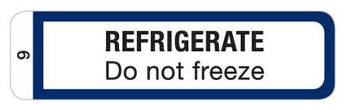

When the dispensed medicine is released by the pharmacist in the dispensary, it will be stored in the fridge prior to delivery to the ward.

All refrigerated medicines will be stored in a fridge within pharmacy until delivery rounds.

For delivery to CHH
At delivery rounds the central equipment and courier service will accept the refrigerated medicines for transport to CHH. The medicines will be placed in an esky with an ice brick just prior to leaving the pharmacy department.

For delivery across NCH campus
At delivery rounds, pharmacy technicians will identify wards that have fridge items for delivery with blue “fridge item”” labels (see image below for sample). If the medication will be out of the fridge for more than 5 minutes an esky with an ice brick will be used to deliver the medication to the ward.
FRIDGE ITEM

Imprest medicines
Imprest medicines are delivered from the pharmacy to the patient care area by pharmacy technicians. To maintain the cold chain, these medicines will be transported from the pharmacy to patient care areas in an esky containing an ice brick and unpacked into the medication fridge in the medication room. Empty eskies and ice bricks are then returned to the pharmacy by the technician.
Back to Table of Contents

Section 4 – Storing Refrigerated Medicines in Patient Care Areas

To reduce the risk of selection error, medicines are to be stored inside the fridge in manufacturers’ packaging or the packaging provided by the Pharmacy Department. Loose strips of tablets or individual ampoules or vials are not to be stored.

Note: Food, nutritional supplements, and blood products must not be stored in medication fridges. They are to be stored in a separate fridge.

Blood and blood products must only be stored in a NATA (AS 364.2-2012) accredited fridge. Refer to ‘Fresh Blood Products Administration – Adults, Paediatrics, and Neonates Procedure’ for more detail.
Back to Table of Contents

Section 5 – Central Monitoring of Medication Fridges

Scope of BMS
All medication fridges in NCH and CHH are monitored centrally via the BMS. Information is stored on a server and accessed via a software program called BACNET (Automated Logic).

In patient care areas where fridges are wired into the BMS, there is no need for staff to manually monitor medication fridges or reset the temperature display of the fridge using the buttons on the controller at the front of the fridge.

Note: Medication fridges that contain vaccines belonging to the Health Protection Service must have the temperature checked and recorded manually twice daily – refer to Section 7.1 - Monitoring the temperature of Health Protections Service Stock.

If the BMS system is interrupted the facilities manager will be notified by automated logic and will notify the Pharmacy Department and AHHMs. In this instance, the patient care areas affected will be contacted and asked to revert to manual monitoring of their medication fridge until it is rectified. Refer to Section 6 for details on manual monitoring.

The ICT department are actively monitoring the servers which sit behind the BMS.
- If a server goes offline in ICT hours – ICT will work to rectify the issue immediately. If there will be ongoing interruption to the BMS ICT will notify the facilities manager of the server being offline
Note: The facilities manager will then notify the Pharmacy Department. In this instance, the patient care areas affected will be contacted and asked to revert to manual monitoring of their medication fridge until it is rectified. Refer to Section 6 for details on manual monitoring.
- If a server goes offline out of ICT hours – ICT on call will be notified and work to rectify the issue immediately. If there will be ongoing interruption to the BMS ICT will notify the facilities manager of the server being offline
Note: The facilities manager will then notify the AHHMs. In this instance, the patient care areas affected will be contacted and asked to revert to manual monitoring of their medication fridge until it is rectified. Refer to Section 6 for details on manual monitoring.
- When server patching for the BMS is scheduled the ICT department will notify all staff via email the day before. Patching will impact the sending of messages but should not impact the temperature monitoring – if temperature monitoring will be interrupted affected areas will be notified.

Monitoring Medication Fridges via BMS
The BMS enables central, real-time, and consistent monitoring of medication fridge temperatures via the BACNET System. This monitoring system measures product temperature (by a temperature probe immersed in a gas filled vial) and is a better reflection of medicine temperature than air temperature (which is reported on the front of the fridge).

With the central monitoring of NCH fridges on the BMS, real-time remediation of potential (or actual) temperature excursions is possible. The BMS provides a dashboard of data for all medication fridges, generates alerts sent to a pager and/or email of impending and actual temperature excursions.

Responsibilities for responding to alerts from the BMS
The Pharmacy Department and the AHHMs at NCH share responsibility for monitoring medication fridges and ensuring that alerts generated by the BMS are appropriately responded to.
- The NCH Pharmacy Department (Business Hours: 830am to 5pm Monday to Friday) and
- The NCH AHHMs (all other times)

When the Pharmacy Department do not have capacity to manage the fridge pager the AHHM will be advised in morning DOP.

Process for BMS Monitoring of Medication Fridges by Pharmacy Department/AHHMs
For a quick reference, refer to Appendix 3: Flow sheet for management of medication fridge alert – AHHMs and Pharmacy

Materials required
- BMS http://192.168.80.103 or http://prdbms01 and log on credentials
Note: Pharmacy and Facilities Management have log on capabilities
- Pharmacy Fridge Pager, or AHHM Pager/AHHM email
- Medication Fridge Temperature Excursion Pack attached to medication fridge, containing:
  - CNC Flow Chart for Responding to a medication fridge alert
  - “Medication Fridge Out of Order” signage
  - stickers to mark stock affected by temperature excursion
  - quarantine signage to segregate affected stock
  - Medication Fridge Temperature Excursions Standard Recording Form to record details of medicines affected by a temperature excursion so that pharmacy can investigate if the medicines are safe to be used
  - useful contact numbers and contact people
  - Medication Fridge Manual Monitoring Recording Form to use if BMS monitoring is not available (Appendix 1).

Medication Fridge Temperature Excursion Pack replacement kits can be obtained from the Medication Safety Pharmacist by emailing CHSNCH.dispensary@act.gov.au or calling pharmacy on (X6265) during business hours.

The monitoring of medication fridge temperatures and documentation of the response to alerts and events is shared between:
- The NCH Pharmacy Department (Business Hours: 830am to 5pm Monday to Friday) and
- The NCH AHHMs (all other times)

Alerts of impending temperature excursions identified via the BMS
When a medication fridge temperature reaches 2.5 or 7 degrees Celsius (before it is out of range) a message is sent to the Pharmacy Fridge Pager, the AHHM’s Pager and the AHHM’s email. The time of day (see above) will dictate who responds to the pager message. An example of the message is as follows:

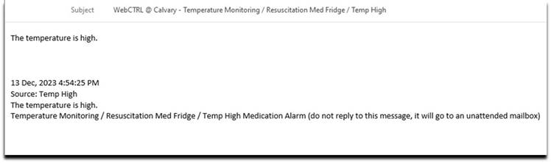
When a message is received, the pharmacist or pharmacy technician contacts the patient care area to see if the situation can be rectified to prevent a temperature excursion (for example, closing the door of the fridge and leaving it closed for half an hour)
In Business hours:
  - After speaking with staff of the patient care area, the pharmacist or pharmacy technician will monitor the temperature of the fridge to ensure that it does trend down and does not continue to move out of range.
  - The pharmacist or pharmacy technician will log the event in the fridge temperature alert recording tool
  - The Pharmacist or pharmacy technician will monitor the data in the BMS to ensure that the temperature is trending back to being in range.
  - Once the Pharmacist or pharmacy technician is satisfied that a temperature excursion has been avoided, they will complete documentation in the recording tool and delete the message from the pager.
Outside business hours:
  - After speaking with staff of the patient care area, the AHHM will forward the email alert to CHSNCH.dispensary@act.gov.au with details of actions taken.
  - The pharmacist or pharmacy technician will log the event in the fridge temperature alert recording tool in business hours

- All alerts are to be actioned at the end of the shift, and handover to occur between Pharmacy and AHHM if anything needs to be followed up.
Note: that a RiskMan entry is not required in this instance, as a temperature excursion has not occurred (i.e. did not exceed 8 degrees C).

Response to actual temperature excursions identified via the BMS
- If the medication fridge temperature continues to move out of range (greater than 8 or below 2 degrees Celsius) cold chain has been breached.
- When this SMS is received, the pharmacist, pharmacy technician or AHHM contacts the CNC, CMC or team leader of the patient care area to advise of the temperature excursion.

In Business hours (830am to 5pm Monday to Friday);
  - The pharmacist or pharmacy technician will notify the CNC, CMC or team leader of the patient care area to advise of the temperature excursion.
Note: If the CNC, CMC, or other person-in-charge of the area be unavailable, the pharmacist or pharmacy technician will escalate to the relevant Assistant Director of Nursing (ADON) or Director of Nursing (DON) until a responsible officer is identified
  - The pharmacist or pharmacy technician will ask the team leader or CNC to follow the CNC/CMC/Team leader Flow Chart for responding to the Medication Fridge Alert found in the Medication Fridge Temperature Excursion Pack (Appendix 4)
  - The pharmacist or pharmacy technician will log the event in the fridge temperature alert recording tool
Outside business hours (all other times);
  - The AHHM will notify the CNC, CMC or team leader of the patient care area to advise of the temperature excursion.
Note: If the CNC, CMC, or other person-in-charge of the area be unavailable, the AHHM will escalate to the relevant Assistant Director of Nursing (ADON) or Director of Nursing (DON) until a responsible officer is identified
  - The AHHM will ask the team leader or CNC to follow the CNC/CMC/Team leader Flow Chart for responding to the Medication Fridge Alert found in the Medication Fridge Temperature Excursion Pack (Appendix 4)
  - The AHHM will forward the email alert to CHSNCH.dispensary@act.gov.au with details of actions taken.
  - The pharmacist or pharmacy technician will log the event in the fridge temperature alert recording tool in business hours

Professional judgment and temperature excursions
Depending on the nature of the temperature excursion, the medicines in the fridge and professional judgment of the pharmacist assessing the situation, the pharmacist monitoring the fridge may be able to provide advice to the team leader on date adjustment of stock which still may be safe to use. This is dependent on the medicines affected, how extreme the excursion is, information available in the medicines’ product information, extended stability data, advice provided from the relevant pharmaceutical manufacturer(s) and the clinical judgment of the pharmacist.
Out of pharmacy opening hours if a medication from an affected fridge is required, the on-call pharmacist is to be contacted for clinical guidance and if necessary to resupply the medication.
Pharmacy opening hours are:
830 am to 530pm Monday to Friday, and
830am to 430pm Weekends and Public Holidays

Nurse in Charge Process to follow when advised of temperature excursion
When the Nurse in charge of the Patient Care Area is advised by Pharmacy or the AHHM that there has been a temperature excursion, the most important action is to protect patients from receiving potentially damaged and unsafe medicines.

For step-by-step guidance on the process to follow, refer to the flow sheet in Appendix 4
Back to Table of Contents

Section 6 – Manual Medication Fridge Monitoring

All medication fridges in NCH are monitored centrally via the BMS. If the server running the BMS fails, patient care areas impact will be notified (see section 5.1 for more details) and be required to temporarily monitor their fridge manually. In these instances, data loggers will be supplied by pharmacy to affected Fridges.

Areas that require manual monitoring (see section 7) require a new form to be started every month. Manual Monitoring Recording Forms can be found in Appendix 1 or Strive for 5

Procedure for Manual Monitoring and Recording of Fridge Temperatures
- The medication fridge temperature is to be checked twice daily at approximately the same time each day and the details recorded on the Medication Fridge Manual Monitoring Recording Form (Appendix 1).
- To complete manual temperature monitoring of a medication fridge:
  - In the box corresponding to today’s date, document the current temperature displayed on the front panel of the medication fridge using a ● to indicate the current temperature
  - Using the buttons on the front of the fridge, check the minimum and maximum temperature recorded by the fridge’s temperature display and document using an X to indicate the temperatures the fridge has experienced over the last 24 hours (or since last check):
    - If the maximum temperature was greater than 8 degrees Celsius or the minimum temperature was below 2 degrees Celsius, report this immediately to the nurse in charge of the area and contact Pharmacy in business hours or the AHHMs.
    - If the values are within 2 and 8 degrees Celsius, reset the fridge thermometer. No further action is required.
Back to Table of Contents

Section 7 – Health Protection Service Vaccines
Vaccines supplied by the Health Protection Service (HPS), ACT Health for immunisation in
accordance with the National Immunisation Schedule are to be monitored according to
Strive for 5 monitoring and recording requirements.

Monitoring the temperature of Health Protections Service Stock
Health Protection Service requires medication fridges holding vaccinations be monitored
according to Strive for 5; that is, the temperature of the fridge is monitored and recorded
twice a day manually on a vaccine refrigerator temperature chart.

The Medication Safety Pharmacist or Operations Pharmacist will notify HPS as soon as possible within business hours if the real time BMS monitoring system detects an excursion in a fridge containing HPS vaccines that would not be detected in real time by the current monitoring system.

Managing a temperature excursion that involves Health Protection stock
If Health Protection Service Vaccines are affected by a temperature excursion, quarantine
the stock using the signage in the Medication Fridge Temperature Excursion Kit and contact
the immunisation section of the Health Protection Service Vaccine Management Unit on (02) 5124 9800 for advice on management of the temperature excursion.

Locations of Health Protection stock
Patient care areas that hold HPS vaccines include:
- NCH Antenatal Unit
- NCH Birth Suite
- NCH Emergency Department – Wait See & Treat
- NCH Pharmacy
- NCH Staff Health
Back to Table of Contents

Section 8 – Reporting Requirements
Acknowledging the importance of maintaining cold chain in the provision of safe and effective treatment to patients, the Medication Safety Committee has oversight of the monitoring of medication fridges across NCH, including monitoring of medication fridges containing vaccines provided by HPS that are administered to NCH patients.

The Medication Safety Pharmacist will provide a Quarterly report to the Medication Safety Committee for their consideration. This report will:
- summarise all temperature excursions that have been notified through the BMS
- provide details of the action taken in response to the temperature excursion (as documented in the fridge temperature alert recording tool)
- provide the number of near misses where an alert regarding an impending temperature excursion had been generated, but temperature excursion was avoided
- Provide a Summary of adherence to manual medication fridge monitoring for relevant areas

If HPS detect a cold chain breach, details of this must be sent through to the Medication Safety Pharmacist CHSNCH.dispensary@act.gov.au
Back to Table of Contents

Section 9 – Useful Contacts

After Hours Hospital Manager
- For advice or specific details of temperature excursions that occur overnight between the hours of 5pm and 830am each day:
Contact the After-Hours Hospital Manager via Switchboard
Facilities Management
- To organise fridge repair or service:
Contact Maintenance Manager on 02 6201 6936 or Facilities Administration on 02 6201 6153
- Maintenance on-call via switchboard
Pharmacy
- For replacement of medicines affected by a temperature excursion between hours of 8:30am and 4:30pm each day:
Imprest medicines: scan an imprest request form to the pharmacy
Medicines dispensed to individual patients: request resupply via DHR ( EPIC)
- For assessment of whether medicines are safe to use following a temperature excursion:
Scan and e-mail a completed Medication Fridge Temperature Excursion Medicine Recording form (Appendix 5) to CHSNCH.dispensary@act.gov.au – Please note that this service takes time, and research will need to be conducted to determine if medicines are safe to use

- For advice or specific details of temperature excursions that occur between the hours of 8.30am and 4:30pm each day
Contact the Pharmacy department on ext. 6265

- For replacement of items in Medication Fridge Temperature Excursion Packs (Date adjustment stickers, quarantine sign etc.):
Contact the Medication Safety Pharmacist on ext. 6265 or via email CHSNCH.dispensary@act.gov.au
Back to Table of Contents

Evaluation
Outcome
Medication fridges at NCH CHH are monitored as per this procedure and overseen by the NCH Medication Safety Committee

Measures
- Compliance with manual monitoring and recording of fridge temperatures
- Number of temperature excursions that have been notified through the BMS which are appropriately documented in the recording tool
- Number of near misses where an alert regarding an impending temperature excursion had been generated, but temperature excursion was avoided
Back to Table of Contents

Related Policies, Procedures, Guidelines and Legislation

Procedures
- NCH Medication Handling procedure
- Vaccine Cold Chain Management
- Fresh Blood Products Administration – Adults, Paediatrics, and Neonates procedure

Legislation
- Medicines, Poisons and Therapeutic Goods Act 2008
- Medicines, Poisons and Therapeutic Goods Regulation 2008
- Therapeutic Goods Act 1989
- Therapeutic Goods Regulation 1990

Back to Table of Contents

Definition of Terms

Alert: An alert is a pager message advising of an impending temperature excursion. At this point the medication fridge temperature has reached either 2.5 or 7 degrees.

Business Hours: 830am to 5pm Monday to Friday

Cold Chain: The 'cold chain' is a system of storing and transporting vaccines at recommended temperatures from the point of manufacture to the point of use.

DOP: Daily Operation Plan meeting held each morning to discuss hospital bed status and issues

Temperature excursion: When the temperature of a medication fridge exceeds 8 degrees Celsius or less than 2 degrees Celsius.
Back to Table of Contents

Search Terms

Medication Fridges, fridges, refrigerator, manual monitoring, Wi-Fi, BMS, Building maintenance, temperature excursion, fridge reporting, cold chain, vaccines, temperature monitoring, fridge, cold chain breach, refrigeration, temperature-sensitive medicine, cold chain management, cool room, temperature alarm, fridge alarm.

Back to Table of Contents

Attachments

Appendix 1 - Medication Fridge Manual Monitoring Recording Form
Appendix 2 - Medication Fridge Temperature Excursion Pack Contents Page
Appendix 3 - Flow sheet for management of medication fridge alert – AHHMs and Pharmacy
Appendix 4 - CNC Flow Chart for responding to Medication Fridge Alert
Appendix 5 - Medication Fridge Temperature Excursion Standard Recording Form

Disclaimer: This document has been developed by Canberra Health Services specifically for its own use. Use of this document and any reliance on the information contained therein by any third party is at his or her own risk and Canberra Health Services assumes no responsibility whatsoever.

Policy Team ONLY to complete the following:
Date Amended | Section Amended | Divisional Approval | Final Approval
22/05/2024 | Document created | Allied Health | CHS Policy Team

This document supersedes the following:
Document Number | Document Name
CCID825782 | Refrigerated storage of medications and vaccines on wards

Appendix 1 - Strive for 5 Medication Fridge Manual Monitoring Recording Form

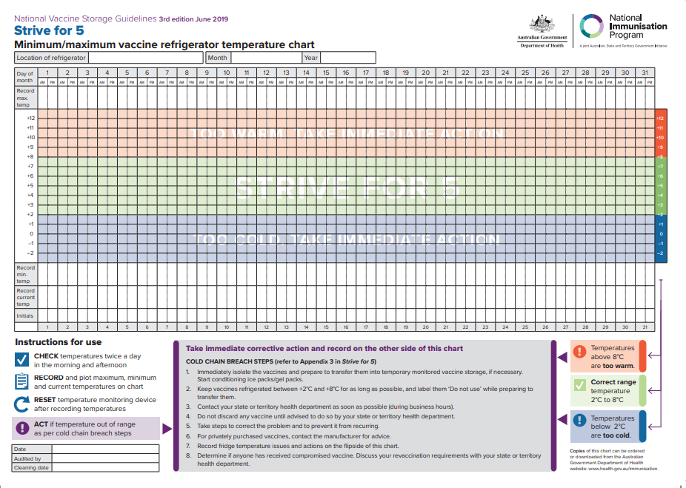

Appendix 2 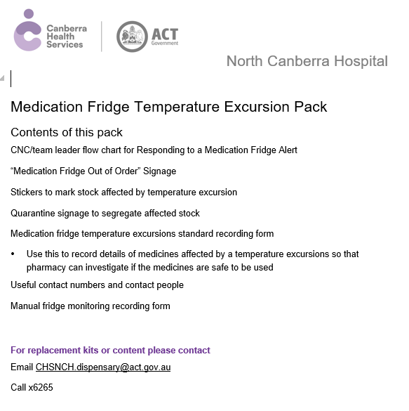

Appendix 3

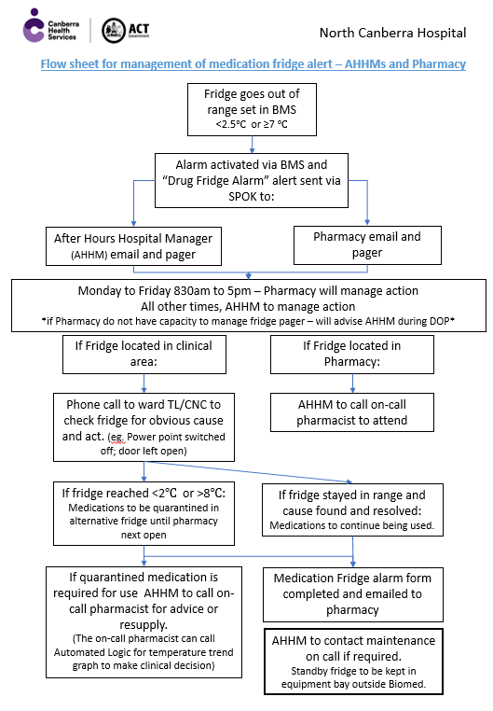

Appendix 4
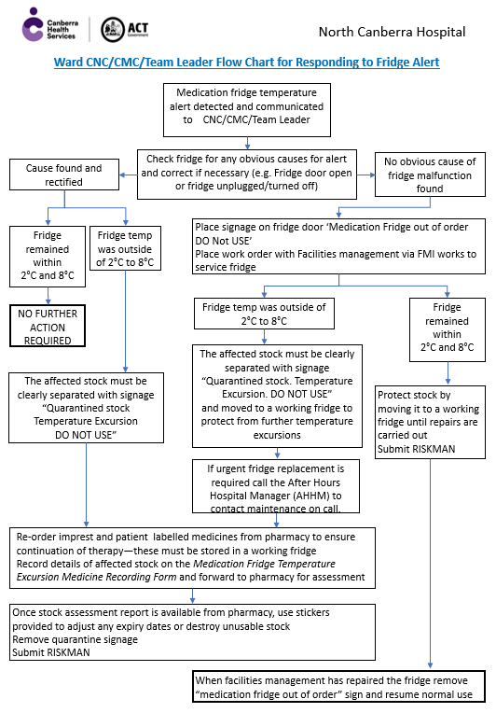

Appendix 5


