Canberra Health Services
Procedure
Nitrous Oxide for Painful Procedures in Paediatrics

Contents

Contents 1
Purpose 2
Scope 2
Section 1 – Selection of nitrous oxide as an appropriate therapy 2
Section 2 – Procedural Safety 5
Section 3 – Preparation 7
Section 4 – Procedure 7
Section 5 – Effects of Prolonged Use of Nitrous Oxide 10
Evaluation 11
Related Policies, Procedures, Guidelines and Legislation 11
References 12
Definition of Terms 12
Search Terms 13
Attachments 13
Attachment A: Matrx digital Mixer Set Up 14

Purpose

The purpose of this procedure is to guide the safe and effective administration of nitrous oxide to paediatric patients, with the goal of reducing the pain and anxiety associated with some clinical procedures.

This procedure provides a safe and standardised approach to the use of nitrous oxide for paediatric patients across Canberra Health Services (CHS).

Back to Table of Contents

Scope

The document applies to Registered Nurses (RN) and Junior Medical Officers, working within their scope of practice, caring for paediatric patients in Paediatric settings and in the Emergency Department (ED) at Canberra Hospital. In order to administer nitrous oxide, the clinician must:
- have at least 2 years of clinical experience (RNs)
- have either successfully completed CHS – Paediatric Life Support (available through HRIMS), or show evidence of having completed Advanced Paediatric Life Support, within the previous 5 years
- be up to date with CHS - Resus 4 Kids and CHS - Basic Life Support (both available through HRIMS)
- participate in ‘Nitrous Oxide for Painful Procedures in Paediatrics’ training (available through HRIMS)
- have read this Procedure
- have been assessed by a CHS accredited assessor as competent to administer nitrous oxide
- complete yearly re-assessment (with a clinical case as available or in a simulation) or maintain a logbook with 5 cases a year.

Medical Officers in the Proceduralist role should complete the training in order to be able to assist the sedationist in the event of an emergency.

Back to Table of Contents

Section 1 – Selection of nitrous oxide as an appropriate therapy

Background
Nitrous oxide is a colourless, gas with a slightly sweet odour and taste. It has analgesic, sedative and anxiolytic effects. Nitrous oxide is absorbed rapidly via the lungs, taking effect within 2-5 minutes and wearing off within 3-5 minutes post-administration.^{1,2} Nitrous oxide is excreted unchanged from the body almost entirely via the lungs, with minimal loss via the skin.³

Indications
Nitrous oxide is safe and effective for use in paediatric patients to reduce the pain and anxiety associated with mild to moderately painful procedures^{1,2,4} of less than 30 minutes duration. This may include:
- dressing changes, including burns dressings
- injections
- venepuncture
- intravenous (IV) cannula insertion
- removal of foreign bodies
- fracture reduction
- chest physiotherapy
- splint/plaster application or removal
- urinary catheterisation
- lumbar puncture
- suturing of minor wounds
- Peripherally Inserted Central Catheter (PICC) insertion.

Contraindications
Contraindications to nitrous oxide administration in the Paediatric or ED settings include:
- Increased risk of airway loss in patients:
- younger than 12 months of age or less than 10kg
- with significant respiratory disease, respiratory trauma or predisposition to airway obstruction due to underlying co-morbidity
- with airway obstruction or history of difficult airway management
- with acute altered level of consciousness, neurological deficits and/or intoxication with alcohol or drugs.
- Risk of expansion of air-filled closed spaces in:
- chest injury with a suspicion of pneumothorax or lung cyst
- bowel obstruction
- abdominal distension
- recent head injury with neurological deficit, cerebral oedema or neurosurgery
- decompression sickness or air embolism
- middle ear disease, including recent otitis media or middle ear surgery due to potential for tympanic membrane rupture
- maxillofacial injuries, sinus obstruction, intraocular surgery or penetrating injury to the globe.
- Increase in pulmonary vascular pressure and pulmonary hypertension.
- Any child to whom the sedationist does not feel comfortable administering nitrous oxide.

Use with other agents
Nitrous oxide can safely be used in combination with simple analgesia, such as paracetamol or ibuprofen. In procedures where the skin will be punctured, topical anaesthetic cream should also be used.⁴ Topical wound anaesthetic gel (e.g. Laceraine) should be considered for broken skin. Other agents such as intranasal fentanyl (ED only) or oral/buccal midazolam may be considered if a greater level of analgesia is required, the appropriately trained staff are available, and senior medical staff are notified.

Dosing and administration
Nitrous oxide is administered in combination with oxygen to a maximum concentration of 70%. It is delivered through a continuous flow system via a mask or mouthpiece.

Adverse effects
Serious adverse events are rare when nitrous oxide is delivered as outlined in this procedure (<0.5% occurrence) however may include:
- apnoea
- significant hypoxia. Diffusion hypoxia can occur due to nitrous oxide entering the alveoli faster than nitrogen can leave, causing dilution of oxygen (i.e. less oxygen and therefore hypoxia).
- bradycardia
- hypotension
- laryngo/bronchospasm in patients with underlying airway problems, acute respiratory infections or illnesses
- expansion of, or increased pressure within, air-filled spaces in the body. Nitrous oxide diffuses into air-filled spaces more rapidly than nitrogen can diffuse out.
- aspiration after vomiting when over-sedated. ¹⁻⁴

Side effects
Minor side effects are more common, occurring in up to 10% of paediatric patients and include:
- nausea and vomiting
- dysphoria or euphoria
- dizziness
- headache. ^{.1-4}

Adverse events and side effects are more common when nitrous oxide is administered for more than 15 minutes, or at higher concentrations.¹

Oversedation
Each child may respond differently to nitrous oxide, and oversedation can occur. While oversedation is rare when nitrous oxide is used as a single agent, it may occur with prolonged use of nitrous oxide, or when combined with opioids (such as fentanyl) or benzodiazepines (such as midazolam).

Alert:
Nitrous oxide in combination with opioids or benzodiazepines can lead to oversedation, increasing the risk of vomiting, aspiration and respiratory compromise.

Precautions
Discuss concomitant or recently administered medications (e.g. opioids, other sedating central nervous system depressant drugs, methotrexate, bleomycin) with treating Senior Medical Officer.

Back to Table of Contents

Section 2 – Procedural Safety

Pre-procedure requirements
Table 1: Pre-procedure requirements for administration of nitrous oxide in paediatric patients
 | Nitrous oxide +/- simple analgesia | Nitrous oxide + oral/buccal sedating agent#
Staff | Two staff:  - sedationist  - proceduralist  Senior Medical Officer aware | Three staff:  - sedationist  - proceduralist  - assistant  Senior Medical Officer must be present (this may be as part of the above team)
Location | Treatment/procedure room | Treatment/procedure room
Fasting | 2 hours* – fluids/solids | 2 hours* – clear fluids  4 hours* – milk/solids
Consent | Documented verbal consent | Documented verbal consent
*Fasting times may be individualised with consideration of the patient’s clinical condition and the clinical urgency of the procedure. Decisions to deviate from fasting times must be made in collaboration with the ED Consultant covering paediatrics/treating Paediatrician on the wards, and documented in the patient’s clinical record. Consider longer fasting time in patients with risk factors for delayed gastric emptying.

# Co-administration of nitrous oxide with opioids given in the previous 4 hours may occur in the ED only, with Senior Medical Officer notified and a Medical Officer present.

Patient Safety
A minimum of two staff members (a sedationist and a proceduralist) must be present for a procedure using nitrous oxide.
The sedationist is responsible for administering the nitrous oxide, monitoring the child and safety measures including:
- preprocedural assessment and planning
- documentation of verbal consent for nitrous oxide
- ensuring appropriate staff are present (as outlined above), and a Senior Medical Officer is on site and aware the nitrous oxide is being administered.
- ensuring appropriate fasting times (see Table 1)
- ensuring appropriate equipment is available, checked and tested (although rare, deaths have been associated with mechanical failure and inadvertent administration of 100% nitrous oxide)
- ensuring the paediatric resuscitation trolley is in close proximity
- obtaining pre-procedure baseline observations and recording in the ‘Sedation Documentation’ page in the patient’s Digital Health Record, including:
- weight
- heart rate (HR)
- respiratory rate (RR)
- oxygen saturation (SpO₂)
- temperature (T)
- blood pressure (BP)
- sedation score: Alert, Voice, Pain, Unresponsive (AVPU)
- the administration of the nitrous oxide
- ensuring both the patient and monitoring screen are in direct line of sight
- ensuring the patient is monitored until they have recovered adequately for discharge or transfer
- a comprehensive clinical handover if ongoing care is required
- ensuring nitrous oxide is charted on the Paediatric National Inpatient Medication Chart (NIMC) or the Medication Administration Record (MAR) in the patient’s clinical record by a Medical Officer. Nitrous oxide is a Schedule 4 medication and MUST be charted on a medication chart. The appropriate item in the MAR is ‘nitrous oxide gas’.

The proceduralist is responsible for:
- preparation of the patient
- preparation of equipment for the procedure
- documentation of consent for the procedure
- ensuring all procedural safety checks are conducted
- ensuring the procedure being performed can be safely completed within 30 minutes
- conducting the procedure.

Alert:
The sedationist will ONLY be responsible for the safe administration of nitrous oxide and CANNOT be asked to assist in the procedure.

Staff safety
Nitrous oxide can have adverse effects on staff. Occupational exposure should be minimised by ensuring the scavenging system is used, and a consistent and adequate mask seal on the patient’s face is maintained.^{1, 2} The scavenging system should be connected directly to piped wall suction only (never portable) and turned to full flow. Exposure to nitrous oxide should be avoided by pregnant staff as there is a small risk to the fetus.^{1, 4}

Back to Table of Contents

Section 3 – Preparation

Patient Preparation
- It is essential that the sedationist has discussed the use of nitrous oxide with the patient/parent/carer and provided written information (Sydney Children’s Hospital Network Factsheet – Nitrous oxide, available at: https://www.schn.health.nsw.gov.au/nitrous-oxide-therapy-factsheet), prior to seeking and documenting verbal consent for the nitrous oxide.
- Refer to the Placeholder ‘Caring for Infants, Children and Adolescents During Procedures’ available on the Policy and Guidance Documents Register for guidance.
- Patient selection and preparation is a major factor in achieving safe and effective use of nitrous oxide. Patients who, in the opinion of the sedationist, appear anxious or unable to tolerate the nitrous oxide procedure should be referred back to the treating medical team for consideration of alternative management.
- The patient and parent/carer should have sufficient time and support to become familiar with the administration equipment prior to its use.
- If any of the patient’s observations score a Paediatric Early Warning Score (PEWS) above 0 prior to the procedure commencing, a medical review is required before proceeding.

A pre-procedure planning time-out must be performed by the sedationist and proceduralist prior to the commencement of the procedure. This to clarify roles of all staff in attendance and agree on a primary and backup plan for the procedure.

Back to Table of Contents

Section 4 – Procedure

Equipment
Equipment required includes:
- documented medication order for nitrous oxide
- Personal Protective Equipment (PPE) as necessary
- Matrx Digital MDM Mixer - oxygen/nitrous oxide delivery system (must be checked prior to commencing sedation)
- disposable anaesthetic breathing circuit with scavenger connection and viral/bacterial filter system (must be checked prior to commencing sedation)
- mouthpiece or correct size mask to cover the patient’s nose and mouth
- Yankauer sucker connected to wall suction
- continuous pulse oximetry monitoring with audible alarm in the line of sight of the sedationist
- two sources of high flow oxygen in the room. One for the nitrous oxide delivery system and one for resuscitation
- paediatric resuscitation trolley in close proximity
- appropriate size bag, valve and mask connected to oxygen outlet, checked and ready for use.

Pre-procedure Steps
- Ensure medication order is documented on a Paediatric NIMC or in the patient’s Digital Health Record.
- Gain verbal consent.
- Commence pre-procedural planning, time-out and documentation (‘Sedation Documentation’ in the Digital Health Record).
- Ensure appropriate fasting time has occurred.
- Check oxygen and nitrous oxide hoses are connected to the correct wall outlets.
- Check the circuit is correctly connected, functioning and that the reservoir bag inflates.
- Select the appropriate face mask or mouthpiece.
- Check the scavenging system is connected to the wall suction.
- Set up continuous pulse oximetry.
- Complete and document pre-procedure observations, including the sedation score in the patient’s clinical record.

During procedure
- Turn on gas flow to 100% oxygen at a rate of 6L/min for patients <20kg, 8L/min for patients 20-50kg and 10L/min for patients >50Kg.
- Turn on scavenger system.
- Apply the face mask or mouthpiece ensuring adequate seal. Aim for the child to hold the mask or mouthpiece if possible.
- The reservoir bag should be inflated enough so there is a continuous supply of gas for the child to breathe, but not over expanded, as this makes it difficult for the child to breathe against. Ensure the bag is inflating and deflating with each breath throughout the procedure.
- Adjust the ratio of oxygen/nitrous oxide to 50% and administer for 3 minutes² prior to commencing the procedure. If the analgesic level is inadequate at this stage, the nitrous oxide ratio can be increased in increments over 2-3 minutes up to a maximum of 70% nitrous oxide, until the desired effect is achieved.
- The child should continue to breathe the nitrous oxide/oxygen mix throughout the procedure.
- Continuously monitor HR, RR, SpO₂, AVPU, pain score and nausea/vomiting, and document every 15 minutes in the patient’s clinical record. Monitor and document the duration and dose of nitrous oxide used.
- Aim to maintain a sedation score between ‘Alert’(A) and ‘Voice’ on the AVPU scale, throughout procedure.
- Adjust ratio of nitrous oxide/oxygen as required, aiming for the minimum dose required to achieve analgesia. 70% nitrous oxide should be used for as short a time as possible.

Alert:
If nitrous oxide 70% is reached without achievement of adequate analgesia, the procedure should be stopped, and alternative options should be considered.

Alert:
If the child’s AVPU sedation score is ‘Pain’ or ‘Unresponsive’, verbalise the score to the proceduralist and change gas flow to 100% oxygen.
Call for help.
Stop the procedure.
Continue to closely observe sedation and consider calling for a Medical Emergency Team (MET) if the child does not rapidly return to ‘Voice’ or ‘Alert’ sedation score.

Post procedure
- Administer 100% oxygen for 3 minutes^{1, 2} to reduce the risk of diffusion hypoxia and nausea.
- Assist the patient to roll onto their side or to a supported sitting position.
- Document the cessation time of nitrous oxide in the patient’s clinical record.
- Turn off the scavenger system suction.
- The sedationist must ensure the patient is monitored (in line of sight)⁵ for a minimum of 15 minutes post-nitrous oxide administration, and until they return to their pre-procedure state and score an ‘A’ on the AVPU scale (procedure ends at this point).
- Record post-procedure observations in the patient’s clinical record until the patient reaches baseline.
- Sign the use of nitrous oxide on the NIMC/MAR and document outcomes of the procedure in the patient’s clinical record.
- Discard all single use equipment.
- Ensure all documentation is complete.

Potential Adverse Events
Adverse events are to be reported via the clinical incident reporting system and, if relevant, the adverse drug reactions navigator in the Digital Health Record.

Management of Vomiting
If the child shows signs of nausea, complains of nausea or is actively retching or vomiting:
- position the child on their side to reduce aspiration risk
- stop the procedure
- stop nitrous oxide delivery and administer 100% oxygen for 3 minutes
- utilise suction where required.

Alert:
If the child deteriorates during the procedure, the proceduralist will press the emergency button and ask for a MET.
The sedationist will maintain the child’s airway and breathing. The sedationist should never be left alone.
The proceduralist will assist the sedationist and escalate care for the child.

Discharge criteria
The following criteria should be met for discharge:
- The patient is at their pre-procedure state and scores an ‘A’ on the AVPU scale.
- The parent/carer is satisfied that the patient is at their baseline state, including behaviour/consciousness, ability to ambulate, general wellness and pain level.
- The patient does not show any signs or symptoms of adverse effects.
- The parent/carer is able to accompany the patient home.
- Post procedure care has been discussed with the parent/carer and the discussion documented in the clinical record. Safety and injury prevention are highlighted during this discussion and written information provided (SCHN Factsheet – Nitrous oxide therapy: https://www.schn.health.nsw.gov.au/nitrous-oxide-therapy-factsheet.
If the patient is to remain an inpatient, the sedationist is to provide clinical handover to staff providing ongoing care.⁶

Back to Table of Contents

Section 5 – Effects of Prolonged Use of Nitrous Oxide

Prolonged or repeated exposure to nitrous oxide can affect folate metabolism and cause bone marrow, as well as other, changes.^{2, 4} Paediatric patients requiring nitrous oxide on more than five occasions within a four-week period should be considered for supplemental Folinic acid and Vitamin B₁₂. The risk of these effects is increased when there is:
- history of Vitamin B₁₂ or folate deficiency, or nutritional compromise (including resection of the distal ileum)
- treatment with H₂ blockers or proton pump inhibitors
- concurrent underlying serious illness
- metabolic diseases associated with homocysteine metabolism (methionine synthetase deficiency, homocystinuria and methylmalonic acidaemia).

Back to Table of Contents

Evaluation

Outcome
- The administration of nitrous oxide for painful procedures in paediatric patients is managed safely and effectively.
- Adverse events related to nitrous oxide administration are closely monitored for and managed promptly.

Measures
- Ongoing monitoring and discussion among Paediatric and ED nursing and medical teams.
- Regular assessment and monitoring of all clinical incident reports and Adverse Drug Reaction incident reports related to nitrous oxide administration, with particular attention to adverse events leading to activation of MET response.

Back to Table of Contents

Related Policies, Procedures, Guidelines and Legislation

Policies
- Nursing and Midwifery Board of Australia (NMBA) Requirements for Practice
- Informed Consent – Clinical

Procedures
- Patient Identification and Procedure Matching
- Vital Signs & Early Warning Scores
- Infection Prevention and Control
- Clinical Handover

Guidelines
- ANZCA Sedation and/or Analgesia for Diagnostic and Interventional Medical, Dental or Surgical Procedures Guidelines (PS09) 2014 in Adults, Adolescents and Children
- Australian Guidelines for the Prevention and Control of Infection in Healthcare
- Caring for Infants, Children and Adolescents During Procedures

Legislation
- Health Records (Privacy and Access) Act 1997
- Human Rights Act 2004
- Work Health and Safety Act 2011
- Carers Recognition Act 2021

Other
- Australian Charter of Health Care Rights

Back to Table of Contents

References

- Pedersen, R.S., Bayat, A., Steen, N.P., Jacobsson, M.L. (2013). Nitrous oxide provides safe and effective analgesia for minor paediatric procedures--a systematic review. Dan Med J. 60(6):A4627. PMID: 23743110.
- Tobias, J.D. (2013). Applications of Nitrous Oxide for Procedural Sedation in the Pediatric Population. Pediatric Emergency Care. 29(2) doi: 10.1097/PEC.0b013e318280d824
- Frampton, A., Browne, G.J., Lam, L.T., et al. (2003). Nurse administered relative analgesia using high concentration nitrous oxide to facilitate minor procedures in children in an emergency department. Emergency Medicine Journal. 20:410–13.
- Schug, S.A., Palmer, G.M., Scott, D.A., Alcock, M., Halliwell, R., Mott, J.F. (2020) APM:SE Working Group of the Australian and New Zealand College of Anaesthetists and Faculty of Pain Medicine, Acute Pain Management: Scientific Evidence (5th edition), ANZCA & FPM, Melbourne.
- Sydney Children’s Hospital Network (2018). Procedural Sedation (paediatric ward, clinic and imaging areas) Practice Guideline.
- Australian and New Zealand College of Anaesthetists (ANZCA). (2014). PS09 “Guidelines on Sedation and/or Analgesia for Diagnostic and Interventional Medical, Dental or Surgical Procedures (https://www.anzca.edu.au/getattachment/c64aef58-e188-494a-b471-3c07b7149f0c/PG09(G)-Guideline-on-procedural-sedation).

Back to Table of Contents

Definition of Terms

Alert, Voice, Pain, Unresponsive (AVPU) score – a sedation score/level of consciousness assessment where the patient is assessed as:
- A – Awake and alert
- V – Responds to voice
- P – Responds to pain or
- U – Unconscious.

Matrx Digital MDM Mixer – a nitrous oxide digital delivery system which allows for the continuous flow of a mixture of nitrous oxide and oxygen. The device contains a fail-safe system that stops the flow of nitrous oxide if the oxygen supply discontinues.

Paediatric Early Warning Score (PEWS) - a system for identifying paediatric patients at risk of clinical deterioration.

Proceduralist – the clinician performing and responsible for the procedure.

Sedationist - the clinician responsible for administering the nitrous oxide and monitoring the patient.

Back to Table of Contents

Search Terms

Nitrous oxide, nitrous, procedure, sedation, paediatric, child, gas

Back to Table of Contents

Attachments

Attachment A: Matrx digital Mixer Set Up

Disclaimer: This document has been developed by Canberra Health Services specifically for its own use. Use of this document and any reliance on the information contained therein by any third party is at his or her own risk and Canberra Health Services assumes no responsibility whatsoever.

Policy Team ONLY to complete the following:
Date Amended | Section Amended | Divisional Approval | Final Approval
13/05/2024 | New Document | CHS Policy Team | CHS Policy Team

This document supersedes the following:
Document Number | Document Name

Attachment A: Matrx digital Mixer Set Up

- Check oxygen (white) and nitrous oxide (blue) hoses are connected to their corresponding wall outlets. | 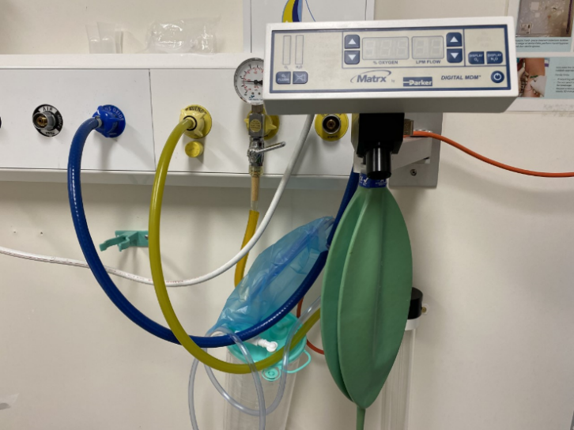
- Check machine is plugged in and working.
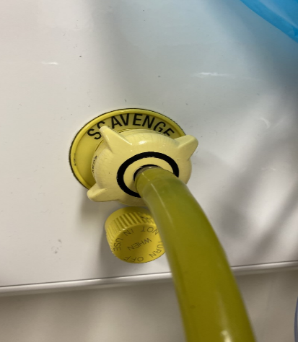 | - Check emergency suction and Yankauer nozzle is set up and ready for use.
 | - Check scavenging (yellow) hose is connected to the ‘scavenge’ wall outlet and is working.
- Check scavenging tube (pink) is connected to the scavenging unit, with the other end attached to the bacterial/viral filter in front of the mask/mouthpiece. | 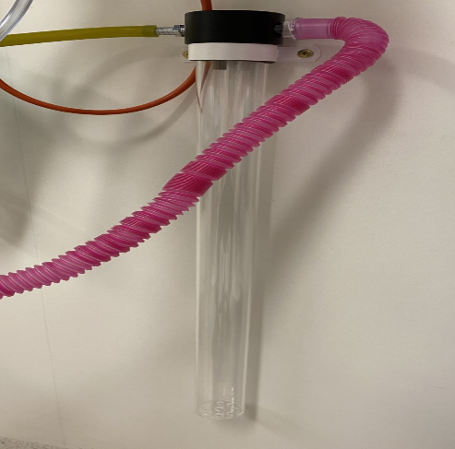
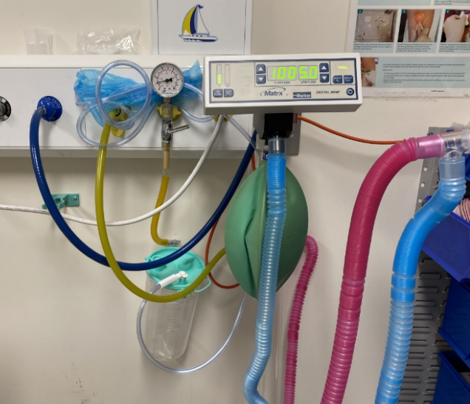 | - Check gas reservoir bag is connected to the black port on the underside of the Matrx Digital MDM Mixer machine (bag is not disposable).
- Set up the ‘Analgesic Disposable Breathing Circuit’, connecting one end of the blue flexible tubing to the front black outlet of the Matrx Digital MDM Mixer machine and the other end to the bacterial/viral filter in front of the mask/mouthpiece. | 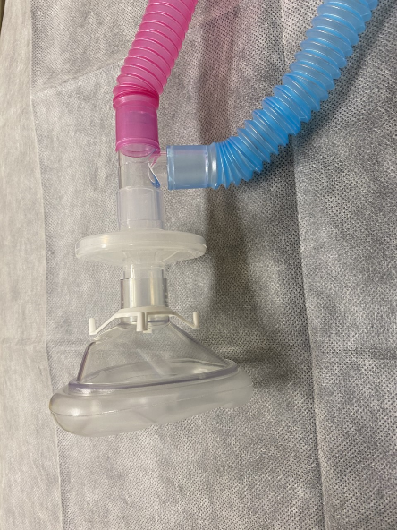
- Select the appropriate face mask or mouthpiece. Consider applying scented lip balm on the inside of the mask.
- Turn mixer on – default setting will provide 100% oxygen and a 5.0L flow rate.
- Check for leaks by turning the flow rate to 8.0L and occluding the circuit.
- Set initial flow rate of oxygen depending on the patient’s weight: 6L/min for patients under 20kg, 8L/min for patients 20-50kg and 10L/min for patients over 50kg.
- Observe the reservoir bag during the patient’s breathing to ensure the bag is not under or over inflating. Adjust the oxygen flow rate accordingly to ensure an adequate supply of gas.
- Begin titrating nitrous oxide and oxygen (as described in Section 4).
- After the procedure discard disposable circuit, bacterial/viral filter and mask/mouthpiece.
- Change scavenger tube and reservoir bag as required.

