Canberra Health Services
Procedure
Venous Thromboembolism (VTE) Prevention (Adults and Children)

Contents

Contents 1
Purpose 5
Alerts 5
Scope 5
Section 1 – VTE Risk Assessment 5
Section 2 – Prophylaxis Prescribing 6
Section 3 – VTE Prevention in Children 9
Section 4 – VTE Prevention in Pregnancy 10
Section 5 – VTE Prevention in Trauma 13
Section 6 – VTE Prevention in the Perioperative Period 15
Evaluation 16
Related Policies, Procedures, Guidelines and Legislation 16
References 17
Definition of Terms 17
Search Terms 18
Attachments 18
Attachment 5 “Preventing Blood Clots in pregnancy and after birth” Patient Brochure 18
Attachment 1: Venous Thromboembolism Risk Assessment and Prophylaxis Guidelines 19
Attachment 2: Procedure Guide sizing and application for T.E.D Anti Embolism Stockings 25
Attachment 3: “Preventing Blood Clots” Patient Brochure 26
26
Attachment 4 “Preventing Blood Clots following leg injury” Patient Brochure 29
https://www.cec.health.nsw.gov.au/__data/assets/pdf_file/0007/647062/Preventing-blood-clots-following-a-lower-leg-injury.PDF 29
Attachment 5 “Preventing Blood Clots in pregnancy and after birth” Patient Brochure 29
https://www.cec.health.nsw.gov.au/__data/assets/pdf_file/0007/362167/Preventing-Blood-Clots-in-Pregnancy-and-After-Birth.pdf 29
Attachment 5: Maternity Thromboprophylaxis Risk Assessment Tool 30
30

Purpose

To provide guidance to clinicians to support the identification of patients in need of thromboprophylaxis, and the appropriate use of prophylactic measures in the prevention of venous thromboembolism (VTE). This guidance is aligned with the Venous Thromboembolism Prevention Clinical Care Standard published by the Australian Commission on Safety and Quality in Healthcare.

Back to Table of Contents

Alerts

- VTE is a serious risk to acutely unwell patients, being a well-recognised cause for morbidity and mortality related to hospitalisation, immobilisation, medical illness or surgical procedures. This risk can be reduced with the use of prophylactic measures in accordance with an identified risk assessment (Attachment 1)
- Mechanical thromboembolism prophylaxis is not recommended for children.

Back to Table of Contents

Scope

This procedure applies to all staff working within Canberra Health Services (CHS) for patients admitted to the Canberra Hospital and University of Canberra Hospital.

For information on Anticoagulation medications and management, see the Anticoagulation Procedure on the CHS Policy Register.

Back to Table of Contents

Section 1 – VTE Risk Assessment

All patients must have a VTE risk assessment by a medical officer within 24 hours of hospital admission and the risk assessment must be carried out in accordance with the VTE Risk Assessment and Prophylaxis Guidelines (Attachment 1). As detailed in Attachment 1, the decision to prescribe should be based on a risk assessment of the patient’s risk of thrombosis, balanced against their bleeding risk. Any contraindications to VTE prevention methods should be assessed (Attachment 1).

More detailed prophylaxis guidelines for obstetric patients (both inpatient and outpatient) are provided in the Anticoagulation Management Clinical Procedure on the CHS Policy Register and are summarised in Attachment 4.

The Medical Officer who conducts the risk assessment must document the risk assessment outcome, and any contraindications identified to either pharmacological or mechanical prophylaxis, on the VTE Prophylaxis section of the National Inpatient Medication Chart (NIMC).

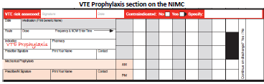

If the NIMC is not used and the patient is being managed via the Electronic Medication Management system (EMM), other medications may not be prescribed until VTE risk is assessed.

VTE risk must be assessed and documented weekly, or when the patient’s condition changes, goals of care change, and on discharge from hospital. The patient must also be monitored for VTE-related complications each time risk is reassessed.

Any changes to prescribing must be documented on the NIMC or EMM. Any discrepancies between medical officers’ risk assessments must be discussed with the managing team.

Back to Table of Contents

Section 2 – Prophylaxis Prescribing

- General Principles of VTE Prevention
As part of a comprehensive VTE prevention care plan, patients should be encouraged to remain well hydrated and mobilise regularly, unless clinical contraindications exist.

- Pharmacological Prophylaxis
Medical Officers will prescribe appropriate VTE Prophylaxis using the VTE Risk Assessment and Prophylaxis Guidelines and risk assessment results. Pharmacological prophylaxis will be prescribed on the ‘Medication’ field of the VTE Prophylaxis section on the patient’s medication chart, or under the ‘Protocol’ section of the EMM.

If pharmacological prophylaxis is contraindicated, clear documentation on the VTE prophylaxis section on the patient’s medication chart or EMM, and in the patient’s medical record, is required along with the reason for the contraindication.

Pharmacists will review the prophylaxis prescription using the VTE Risk Assessment, Prophylaxis Guidelines and medical officer’s risk assessment results and ensure any discrepancies are discussed and resolved with the managing team.

- Mechanical Prophylaxis
Medical Officers will assess the need for mechanical prophylaxis using the VTE Risk Assessment and Prophylaxis Guidelines and risk assessment results.

Mechanical prophylaxis requirements will be documented on the ‘Mechanical Prophylaxis’ field of the VTE Prophylaxis section on the patient’s medication chart. If mechanical prophylaxis is contraindicated, clear documentation is required on the VTE Prophylaxis section of the patient’s medication chart or EMM and in the patient’s medical record, along with the reason for the contraindication.

3.1 Use of Anti-Embolism Stockings (T.E.D.TM) as a mechanical prophylaxis
Anti-embolism stockings can be applied to patients to provide graduated compression and increase venous blood flow in all conditions where this is indicated, including venous disorders and varicose veins. T.E.D. TM stockings have been clinically proven to prevent the damaging effects of venous distension that occurs during surgery and hospitalisation.

The T.E.D. TM anti-embolism stockings apply the clinically proven graduated pressure pattern of:

Ankle | 18 mmHg
Calf | 14 mmHg
Popliteal | 8 mmHg
Lower thigh | 10 mmHg
Upper thigh | 8 mmHg

It is important to measure the patient’s leg sizes to assure that the appropriate pressure pattern is applied.

Contraindications
Stockings are not recommended for patients with the following:
- Any local leg condition in which stockings would interfere, such as dermatitis, vein ligation, gangrene, or recent skin graft
- Severe arteriosclerosis or other ischemic vascular disease
- Massive edema of legs or pulmonary edema from congestive heart failure
- Extreme deformity of leg.

For further information on the sizing and application of T.E.D. TM stockings see Attachment 2

Note that VTE prophylaxis needs to be ceased at least 24 hours before an interventional radiology-guided procedure such as insertion of drain, deep organ biopsy, lumbar puncture.

- Prophylaxis Administration by Nursing Staff
Nursing staff will:
- Administer pharmacological prophylaxis according to the medication prescription on the VTE Prophylaxis section on the patient’s medication chart/EMM and document the administration
- Apply appropriate mechanical prophylaxis and document the application and checking (twice daily, once in the AM and once in the PM) on the VTE Prophylaxis section of the patient’s medication chart/EMM.

- Patient Education
Nursing staff, Pharmacists and Medical Officers will provide education to patients and carers to help raise awareness of the importance of VTE prevention, describe the treatments to prevent VTE and outline what patients should do to reduce risk both during admission and upon discharge. This includes education at the time prophylaxis is initiated, of relevant risks and benefits, how prophylaxis is used, possible side effects and management strategies. Patients should also be educated about general means of preventing VTE, including remaining well hydrated and mobilising regularly, where clinically appropriate.

A patient information brochure “Preventing Blood Clots: Information for Patients and Carers” (Attachment 3) is available from the NSW Clinical Excellence Commission website. A dedicated patient information brochure also exists for maternity patients: “Preventing Blood Clots in Pregnancy and After Birth: Information for Women and Their Families” on the same website. These brochures are available in 7 languages.

- Reassessing Risk at Discharge and Continuity of Care
Patients who have been identified as being at risk of VTE during their admission are required to be reassessed at the point of discharge to determine if there is a need for extended prophylaxis. The recommended duration of pharmacological prophylaxis depends on the patient’s medical and mobility status as per the VTE Prophylaxis Guidelines.

Patients who require extended prophylaxis should have a thorough plan handed over from the assessing medical officer to the patient’s continuing care provider, and this should be explained to patients and carers. Handover should include details of VTE prophylaxis used in hospital, whether it is required on discharge and relevant monitoring requirements. Further information on appropriate clinical handover can be found in the Clinical Handover Procedure.

Prior to discharge home or to another care facility, an ongoing supply of required prophylaxis should be organised to ensure uninterrupted treatment. Plans relating to the continued supply of prophylaxis should be clearly communicated to patients and carers upon discharge. The patient should understand the reason for and importance of continued prophylaxis and the plan for its continuation.

Back to Table of Contents

Section 3 – VTE Prevention in Children

In general, children are at extremely low risk of VTE. Specific prophylaxis is rarely required in the paediatric population. Early mobilisation and adequate hydration should be routinely practiced minimising the risk of VTE, and mechanical thromboembolism prophylaxis is not recommended.

Low molecular weight heparin (LMWH) is recommended for VTE prophylaxis for high-risk paediatric patients.

Guideline for the Identification of Paediatric Patients at High Risk of VTE
Paediatric patients at high risk of VTE should be identified using the following guidelines:
High risk paediatric surgical patients
- A prior history of VTE not related to an intravenous line
- Paediatric patients with four out of the nine identified risk factors below:
- Age less than 3 months, or older than 15 years, or post-pubertal
- Significant co-morbidities such as infection, inflammatory disease (example, inflammatory bowel disease, connective tissue diseases, Kawasaki disease, nephrotic syndrome) or congenital heart disease
- Presence of cancer which includes haematological cancer such as leukaemia
- Severe injury, including chest injury, abdominal injury, limb fractures (particularly lower limb), head injury and multiple injuries
- Major surgery, for example, chest, abdominal, spinal, lower limb orthopaedic, craniotomy
- The presence of a central venous catheter
- A previous line related VTE, that is, thrombosis at the site of a central venous catheter or PICC line
- “Oestrogenic states” such as pregnancy, use of the oral contraceptive, or miscarriage or termination in the last 3 months
- Known (or strongly suspected to have) inherited thrombophilia (factor V Leiden gene mutation, prothrombin gene mutation, protein C deficiency, protein S deficiency, antithrombin deficiency, raised plasma factor VIII, raised plasma homocysteine) or antiphospholipid syndrome.
- Obesity with BMI >95th centile

High risk paediatric patients should be administered LMWH prophylaxis starting 6-12 hours post operatively, where there is adequate haemostasis.

Enoxaparin is recommended in high risk patients at the following doses:
- 0.5mg/kg/dose bd (to a maximum of 20mg bd) if ≥ 2 months old
- 0.75mg/kg/dose bd if < 2 months old

It should be ceased when the patient is mobile or upon discharge.
For paediatric patients, it is recommended that pharmacological prophylaxis is not administered whilst an epidural catheter is in situ.

Back to Table of Contents

Section 4 – VTE Prevention in Pregnancy

VTE is uncommon in pregnancy or in the first 6 weeks postnatally and the absolute risk is around 1 in 1000 pregnancies. It can occur at any stage in pregnancy but the first 6 weeks following birth is the time of highest risk, with the risk increasing by 20-fold. Pregnant women are 4-5 times more likely to suffer from VTE than non-pregnant women of the same age.

Maternity Risk Assessment Tool
- All VTE risk assessments undertaken during pregnancy and/or within the first 6 weeks postpartum should be performed using the maternity thromboprophylaxis risk assessment tool with numerical scoring (Attachment 4)
- The VTE risk assessment result should be discussed with patients and carers and the reasons for individual recommendations explained.

Timing of Risk assessments for pregnant women:
- An assessment of risk factors for VTE in early pregnancy should occur at the initial visit and if the clinical condition alters during pregnancy.
- The assessment should be recorded in Birthing Outcomes System An assessment of risk factors for VTE should occur if there is a hospital admission for any reason during pregnancy/postpartum. Additional risk assessments should be performed if intercurrent problems are developed during a postpartum stay. The assessment should be recorded on the Maternal Venous Thromboembolism (VTE) Risk Assessment Tool, as well as in the VTE risk assessment box on the National Inpatient Medication Chart or EMM.
- An assessment of risk factors for VTE postpartum following birth. Additional risk assessments should be performed if intercurrent problems are developed during her postpartum stay. The assessment should be recorded on the Maternal Venous Thromboembolism (VTE) Risk Assessment Tool and entered in the NIMC or EMM.
- On discharge the resulting identified VTE risk (low/moderate/high) should be recorded in the electronic medical record. The duration of VTE prophylaxis should be documented in the discharge notes.

Thromboprophylaxis Recommendations for Pregnancy
The presence of any of the following risk factors places the woman at higher risk of obstetric VTE.
- Personal history of unprovoked VTE
- Personal history of VTE with hormonal risk factor
- Antithrombin deficiency AND family history of VTE in a first-degree relative
- Homozygous Factor V Leiden OR more than one thrombophilia (regardless of family history of VTE in a first-degree relative)
- Ovarian hyperstimulation syndrome requiring admission (up to 14 weeks)
- Postpartum: any woman requiring antenatal LMWH for maternal VTE prophylaxis.

Higher risk women require pharmacological prophylaxis with low-molecular-weight heparin (LMWH) throughout the antenatal period and for 6 weeks postnatally. For women with OHSS not pregnant, cease prophylaxis 4 weeks after resolution of OHSS and for pregnant women with OHSS as their only risk factor, cease pharmacological prophylaxis after 13 weeks.
Women with one or more of the following risk factors are deemed to be at intermediate risk:
- Personal history of unprovoked VTE with non-hormonal risk factor
- Protein C or Protein S deficiency (regardless of family history of VTE in a first-degree relative)
- Homozygous Prothrombin G20210A (PT) (regardless of family history of VTE in a first-degree relative)
- Current medical condition e.g. heart or lung disease, SLE, cancer, systemic inflammatory condition, nephrotic syndrome, sickle cell disease, pre-existing diabetes with vascular complication
- Obesity (BMI ≥ 40kg/m2)
- Non-obstetric surgery during pregnancy (requiring general or regional anaesthesia)
- Current sepsis (requiring IV antibiotics)
- Postpartum: Any surgical procedure including caesarean section in labour (except immediate repair of the perineum).

Intermediate risk women may be considered for prophylactic LMWH in the antenatal period and will require prophylactic LMWH at least 7 days postnatally.
In addition, the presence of three or more of the following risk factors places a woman at intermediate risk of obstetric VTE:
- Antithrombin deficiency with NO family history of VTE in a first-degree relative
- Heterozygous Factor V Leiden or Heterozygous Prothrombin G20210A (regardless of family history of VTE in a first-degree relative)
- Stillbirth in the current pregnancy
- Age > 40 years
- Obesity (BMI ≥30kg/m2)
- Parity ≥3
- Smoker
- Extensive varicose veins
- Prolonged restricted immobility e.g. Antenatal bed rest, paraplegia, long distance travel
- Family history of VTE in a first-degree relative (with no known thrombophilia)
- Pre-eclampsia in current pregnancy
- Dehydration/hyperemesis
- Multiple pregnancy
- Abruption
- Premature pre-labour rupture of membranes (PPROM)
- Elective Caesarean section
- PPH >1 litre or blood transfusion.

If 2 or fewer of these risk factors are present (lower risk), this does not meet criteria for thromboprophylaxis with LMWH.
When admitted to hospital, patients should be offered thromboprophylaxis with LMWH unless there is a specific contraindication such as risk of labour or active bleeding.
Those with mechanical heart valves require therapeutic anticoagulation to be maintained throughout pregnancy. Management of these rare situations should be based on a multidisciplinary approach involving Haematologists, Cardiothoracic Surgeons, Cardiologists, Anaesthetists and Maternal Fetal Medicine Specialists.
Doses of LMWH are based on weight. The following weight-adjusted doses are not evidence-based and are suggested doses only (5). For thromboprophylaxis the booking or most recent weight can be used to guide dosing.

Weight | Enoxaparin (Clexane) dose
< 50 kg | 20 mg
50-90 kg | 40 mg
91 – 130 kg | 60 mg
131 – 170 kg | 80 mg
>170 kg | 0.6mg/kg/day

Direct acting oral anticoagulants are contraindicated in pregnancy.
If receiving antenatal LMWH, no further LMWH should be injected if there is any vaginal bleeding or once labour begins. They should present to hospital and be reassessed on admission. Further doses should be prescribed by medical staff.

Intrapartum considerations for pregnancy
- If anticoagulation is required during pregnancy, there must be a plan in place to manage the birth
- If receiving antenatal LMWH and having an elective caesarean section LMWH should be omitted on the day before planned surgery
- Regional analgesia is contraindicated for at least 12 – 24 hours after the most recent injection of LMWH. Duration is dependent on dose of LMWH being taken
- For obstetric patients only, LMWH should not be given for 4-6 hours after use of spinal anaesthesia or after the epidural catheter has been removed. The epidural catheter should not be removed within 12 hours of the most recent injection.
- Those at high risk of haemorrhage with risk factors, including:
- major antepartum haemorrhage
- coagulopathy
- progressive wound haematoma
- suspected intra-abdominal bleeding
- postpartum haemorrhage.

- May be managed with anti-embolism stockings (AES), foot impulse devices or intermittent pneumatic compression devices. Unfractionated heparin (UFH) may also be considered
- Those needing therapeutic doses LMWH, or those who are on Warfarin, may need intrapartum intravenous Heparin and should be assessed by medical staff on admission
- Early mobilisation and adequate hydration should be routinely practiced to minimise the risk of VTE.

Postpartum Considerations
- Postpartum thromboprophylaxis should be initiated within 6-12 hours after a normal vaginal birth or caesarean section, provided the Obstetric team have no concerns about bleeding at that time
- LMWH is safe in breastfeeding
- Those receiving long-term anticoagulation with warfarin can be converted from LMWH to warfarin postpartum when the risk of haemorrhage is reduced, usually 5–7 days after delivery.
- Warfarin is safe in breastfeeding
- Direct acting oral anticoagulants should not be commenced or recommenced while breastfeeding.

Back to Table of Contents

Section 5 – VTE Prevention in Trauma

All trauma patients are at high risk of thromboembolic events and require prompt evaluation of thromboembolic risk/benefit and initiation where appropriate. Risk increases with injury severity.
Most trauma patients should have chemical thromboprophylaxis initiated within 24-72hrs, with this approach shown to reduce VTE rates in spinal cord injury and traumatic brain injury, without major increase in bleeding risk. Mechanical prophylaxis alone is not sufficient to protect against VTE in this high-risk cohort. Once chemical prophylaxis is initiated, it should only be held or stopped for significant or potentially significant bleeding events, or development of heparin-induced thrombocytopenia.
Absolute indications for holding chemoprophylaxis include active haemorrhage and recent spine or intracranial surgery.

Special Patient Groups (Contraindication for Chemical VTE Prophylaxis)
Inter-speciality communication in high-risk trauma is essential, with clear plans and timing of imaging such as MRI, surgeries and procedures allowing for minimisation of logistical barriers to optimal care. Examples of such high-risk conditions include severe head injury plus long bone fractures, head injury plus spinal cord injury, multiple long bone fractures, severe pelvic fracture plus long bone fractures and/or medical conditions that predispose to bleeding. These patient-specific high-impact risks may not be well represented in clinical trials.
If chemical thromboprophylaxis is NOT planned to be initiated at, or before, 72hr after admission, there must be a risk/benefit discussion involving the consultant of the speciality team documented in the medical record at the earliest opportunity. This should include:
- Reason for withholding chemical VTE prophylaxis
- Likely duration of withholding
- When decision to be reviewed and additional investigations required e.g. MRI, US lower limbs
- Consultant responsible for decision

Regional Local Anaesthetic Blocks
Epidural/Paravertebral Block
- Allow a 12hr interval between prophylactic LMWH administration and placement/removal of an epidural or paravertebral catheter (24hrs if higher than standard dosing is used or if the patient has impaired renal function*)
- Resume LMWH 12hrs post placement/removal of epidural catheter
- *Impaired renal function is defined as eGFR < 30mL/min

Erector Spinae Block
- No interruption to LMWH dosing is required around placement/removal of an ESB catheter

Chemical VTE Prophylaxis
LMWH are the preferred chemical thromboprophylaxis for trauma patients. If renal impairment is present, unfractionated heparin may be used instead.
- If eGFR >30 mL/min
- Enoxaparin 40mg OD SC OR
- Dalteparin 5000U OD SC OR
- UFH 5000U BD/TDS SC
- If eGFR <30 mL/min
- UFH 5000U BD/TDS SC

Mechanical VTE Prophylaxis
All trauma patients should receive a sequential calf compression device (SCCD) until fully mobile. If one lower limb is inaccessible due to injury/prostheses, the SCCD should be applied to the contralateral lower limb.
Graduated compression stockings may be considered until patient is fully mobile. Specialist vascular advice should be sought if prescribing graduated compression stockings in patients with peripheral arterial disease (or if suspected).

IVC Filter
The utility of IVC filters in major trauma patients is controversial. Prophylactic IVC filters should only be considered in high-risk patients with contraindications to chemoprophylaxis due to ongoing risk of life-threatening bleeding. It is essential that IVC filters be removed as soon as protection is no longer needed or when the patient can safely have chemoprophylaxis or therapeutic anticoagulation, to avoid long-term complications related to their presence. If a patient with an IVC filter is later able to start anticoagulation, it should be initiated while the filter is still in place and the filter removed as soon as feasible.
IVC filters require a removal date to be planned at time of insertion. Patients must not be discharged without the removal date booked. Removal date should be brought forward when a patient's clinical condition allows chemical prophylaxis to be commenced earlier.

Back to Table of Contents

Section 6 – VTE Prevention in the Perioperative Period

In the perioperative setting it is important to establish the risks of bleeding and thromboembolism.

For patients receiving low molecular weight heparin thromboprophylaxis prior to surgery, the last dose should be administered between 12 to 24 hours before the beginning of the procedure. Evening administration is preferred in perioperative patients, to ensure thromboprophylaxis is administered if surgery is delayed. If neuraxial anaesthesia is planned, anaesthetic consultation should be sought, but typically a 12-hour gap is required for patients receiving enoxaparin 40mg SC daily, and 24 hour gap for patients on higher doses. Urgent surgery should not be delayed due to recent administration of pharmacological thromboprophylaxis.

For patients receiving unfractionated heparin thromboprophylaxis, the last dose is typically administered the evening before surgery. There is evidence supporting the safety of prophylactic unfractionated heparin up to 2 hours pre-procedure (9). There will be clinical situations where prophylactic unfractionated heparin may be administered around the time of the procedure, at the discretion of the surgeon/proceduralist.

In the post-operative period, individualised VTE risk assessment should be made and VTE prophylaxis commenced at the discretion of the proceduralist. Recommended post-operative prophylaxis regimens are detailed in Attachment 1, Table 2. If postoperative anticoagulation is contraindicated, the reasons should be clearly documented.

Back to Table of Contents

Evaluation

Evaluation
Monitoring and reporting will include:

METEOR statistic: Proportion of patients admitted to hospital who were assessed for VTE risk within 24 hours of admission, using the risk assessment tool, and had the outcome of the risk assessment documented in their medical record

Annual VTE HAC audit including;
- VTE assessment undertaken
- VTE reassessment within 7 days
- Patient included in care planning
- VTE prevention plan on file
- Appropriate VTE prevention provided
- VTE information included in discharge information

Back to Table of Contents

Related Policies, Procedures, Guidelines and Legislation

Policies
- Informed Consent- Clinical
- Medication Handling Policy

Procedures
- Infection Prevention Control and Healthcare Associated Infections Clinical Procedure
- Patient Identification and Procedure Matching
- Anticoagulation Management procedure
- Clinical Handover procedure

Guidelines
- National Health and Medical Research Council “Blood Clots: Reducing your Risk” Brochure
- Venous Thromboembolism Prevention Clinical Care Standard, Australian Commission of Safety and Quality in Health Care, January 2020

Legislation
- Health Records (Privacy and Access) Act 1997
- Human Rights Act 2004
- Work Health and Safety Act 2011

Other
- Australian Charter of Healthcare Rights 2019

Back to Table of Contents

References

- Stein PD, Kayali F, Olson RE: Incidence of venous thromboembolism in infants and children: data from the National Hospital Discharge Survey. J Pediatr 145:563-5, 2004
- Westmead TCsHa: Thromboprophylaxis in surgical and trauma paediatric patients practice guideline, in Health n (ed), NSW health, 2010
- Vavilala MS, Nathens AB, Jurkovich GJ, et al: Risk factors for venous thromboembolism in pediatric trauma. J Trauma 52:922-7, 2002
- Jackson PC, Morgan JM: Perioperative thromboprophylaxis in children: development of a guideline for management. Paediatr Anaesth 18:478-87, 2008
- Royal College of Obstetricians and Gynaecologists. Reducing the Risk of Venous Thromboembolism during Pregnancy and the Puerperium. 2015
- Venous thromboembolism prophylaxis in the trauma intensive care unit: an American Association for the Surgery of Trauma Critical Care Committee Clinical Consensus Document. Rappold JF, et al. Trauma Surg Acute Care Open 2021.
- Queensland Health Guideline for the Prevention of Venous Thromboprophylaxis https://www.health.qld.gov.au/__data/assets/pdf_file/0031/812938/vte-prevention-guideline.pdf. Accessed June 2021.
- Royal Perth Bentley Group Clinical Practice Standard for Venous Thromboembolism (VTE) Risk Assessment and Management for Adult Inpatients 2020.
- O’Donnell M, Weitz JI. Thromboprophylaxis in surgical patients. Can J Surg 2003; 46(2): 129-135.

Back to Table of Contents

Definition of Terms

BD (b.i.d.) Bis in die. Twice a day
eGFR Estimated glomerular filtration rate (CKD-EPI formula per ACT pathology)
ESB Erector spinae block
IVC Inferior vena cava
LMWH Low molecular weight heparin
MRI Magnetic resonance imaging
NIMC National Inpatient Medication Char
OD Omnie die. Once a day
SC Subcutaneous
SCCD Sequential calf compression device
SCI Spinal cord injury
TBI Traumatic brain injury
TDS (t.i.d.) Ter in die. Three times a day
UFH Unfractionated heparin
US Ultrasound
VTE Venous thromboembolism

Back to Table of Contents

Search Terms

Venous thrombosis, Pulmonary embolism, Venous thromboembolism, Anticoagulation

Back to Table of Contents

Attachments

Attachment 1: Venous Thromboembolism Risk Assessment and Prophylaxis Guidelines
Attachment 2: Procedure Guide sizing and application for T.E.D Anti Embolism Stockings
Attachment 3: “Preventing Blood Clots” Patient Brochure”
Attachment 4 “Preventing Blood Clots following leg injury” Patient Brochure

Attachment 5 “Preventing Blood Clots in pregnancy and after birth” Patient Brochure
Attachment 6: Maternity Thromboprophylaxis Risk Assessment Tool

Disclaimer: This document has been developed by Canberra Health Services specifically for its own use. Use of this document and any reliance on the information contained therein by any third party is at his or her own risk and Canberra Health Services assumes no responsibility whatsoever.

Policy Team ONLY to complete the following:
Date Amended | Section Amended | Divisional Approval | Final Approval
27 June 2022 | Complete Review | Melissa O’Brien, A/g ED-CAS | CHS Policy Committee

This document supersedes the following:
Document Number | Document Name
CHS20/142 | Venous Thromboembolism (VTE) Prevention (Adults and Children)

Attachment 1: Venous Thromboembolism Risk Assessment and Prophylaxis Guidelines
VENOUS THROMBOEMBOLISM (VTE) RISK ASSESSMENT AND PROPHYLAXIS GUIDE
STEP 1
The following surgical procedures or injury carry a high risk of VTE
Some form of thromboprophylaxis is warranted (see Tables 1 and 2) unless absolute contraindications exist
- Any surgical procedure, but especially abdominal, pelvic, thoracic, or orthopaedic surgery.
- Major joint surgery and curative surgery for cancer carry very high VTE risk
- Leg injury requiring surgery or prolonged immobilisation
- Prolonged surgery and/or prolonged immobilisation
STEP 2
Assess other VTE risk factors (patient and condition based)
A tick of any of these risk factors or conditions may warrant VTE prophylaxis for any hospital admission
- Any relevant medical condition described in Table 1 – VTE Prophylaxis for Medical Patients
- Previous VTE
- Older age (increased risk with each decade over 40)
- Prolonged immobility
- Obesity (BMI of 25 – 29.9 is classified as overweight and BMI > 30 is classified as obese NHMRC, Clinical practice guidelines for the Management of overweight and obesity in adults, adolescents and children in Australia 2013)
- Pregnancy, current or within 6 weeks or oestrogen-containing hormone replacement therapy (HRT) or oral contraceptive
- medications associated with risk of clotting including but not limited to oestrogen containing oral contraceptives, hormone replacement therapy, tamoxifen and antipsychotics.
- Certain types of thrombophilia
- General (versus regional) anaesthesia
- Current malignancy and/or chemotherapy
STEP 3a
Assess the risk of bleeding / contraindications to pharmacological prophylaxis
A tick of any of the following factors may contraindicate pharmacological prophylaxis
If pharmacological prophylaxis is contraindicated, consider mechanical prophylaxis if appropriate
- Significant renal impairment
- Current active major bleeding (i.e. at least 2 units of blood/blood products transfused in 24 hours)
- Current chronic, clinically significant and measurable bleeding over 48 hours
- Inherited or acquired bleeding disorders e.g. haemophilia or other coagulation factor abnormality, coagulopathy or disseminated intravascular coagulation (DIC)
- Severe platelet function disorder or thrombocytopenia (pharmacological prophylaxis not recommended with platelet count < 50 x 109/L
- Recent central nervous system bleeding
- Intracranial or spinal lesion
- Recent major surgical procedure of high bleeding risk
- Active peptic ulcer or active ulcerative gastrointestinal disease
- Liver failure or prolonged obstructive jaundice
- Concurrent use of anticoagulants known to increase the risk of bleeding**
- Neuraxial block or recent lumbar puncture
STEP 3b
Assess any contraindications to mechanical prophylaxis
A tick of any of the following factors may contraindicate mechanical prophylaxis
Graduated Compression Stockings (GCS) may cause reduced blood flow, pressure ulcers or increase the risk of falls, so are contraindicated with:
- Any factor that prevents correct fitting of stockings (e.g. obesity)
- Inflammatory conditions of the lower leg
- Severe peripheral artery disease
- Diabetic neuropathy
- Severe oedema of the legs
- Severe lower limb deformity or inability to correctly fit stockings
- Intermittent pneumatic compression (IPC) or foot pumps can exacerbate peripheral arterial disease or arterial ulcers
**Note: For steps 3a and 3b if patient is already receiving full anticoagulant therapy (for example warfarin or a heparin infusion), no additional pharmacological or mechanical VTE prophylaxis is required
STEP 4
Assess the results of the risk assessment - is thromboprophylaxis required?
YES
On the VTE Prophylaxis section of the medication chart or EMM:
- Sign for completion of the risk assessment
- Refer to Tables 1 and 2 for VTE prophylaxis recommendations
- If required, discuss risk assessment with the treating team e.g. if patient is at risk of VTE but also has contraindications to prophylaxis; or if risk assessment results differ from another clinician’s risk assessment. Document outcome in medical record.
Ensure appropriate pharmacological and/or mechanical prophylaxis is ordered if indicated.
NB see renal impairment / low body weight, obesity, paediatric and adolescent patients, and heparin-induced thrombocytopenia notes below

NO
On the VTE Prophylaxis section of the medication chart or EMM:
- Sign for completion of the risk assessment, and document any contraindications identified to either pharmacological or mechanical prophylaxis, in the ‘Specify’ field. If complex, document ‘complex, see medical record’
- If required, discuss risk assessment with the treating team e.g. if patient has a contraindication to
- prophylaxis, but prophylaxis is prescribed; or if risk assessment results differ from another clinician’s risk
- assessment
- Document reason for not ordering thromboprophylaxis in the patient’s medical record
RENAL IMPAIRMENT / LOW BODY WEIGHT
In renal impairment (estimated creatinine clearance < 30mL/min) or low body weight, reduced doses of enoxaparin are required (usually 20mg subcut once daily). In extremes of bodyweight and/or age, rena l function may need to be calculated using an equation such as Cockcroft-Gault. Dose adjustments are recommended in the ACT Health Anticoagulation Policy.
OBESITY
Altered pharmacokinetics in the obese population results in increased clearance of enoxaparin, and potentially inadequate anti- factor Xa levels with once daily dosing. There is evidence that heavier builds (beyond 120kg) are associated with lower enoxaparin levels at standard prophylactic doses. Higher doses (0.6mg/kg/day or 0.5mg/kg BD) should be considered in this group.
PAEDIATRIC AND ADOLESCENT PATIENTS
This guideline does not provide recommendations for prevention of VTE in patients under the age of 18 years. Prophylaxis may be required in a number of high-risk paediatric patients. For further information refer to the paediatric section of the full ACT Health VTE Prophylaxis Guidelines.
HEPARIN-INDUCED THROMBOCYTOPAENIA
For patients with previous heparin-induced thrombocytopenia (HIT), the risk of HIT may persist for several years and heparins, including low molecular weight heparins, should be used with extreme caution. Expert advice and close monitoring of platelets is required. Consult Haematology for advice.

Table 1 – VTE Prophylaxis for Medical Patients
* See renal impairment / low body weight, obesity, paediatric and adolescent patients, and HIT notes
Medical Condition | Prophylaxis Recommendations
Medical Condition | Pharmacological | Mechanical
Cancer (non-surgical) | Enoxaparin 40mg* subcut once daily OR Unfractionated heparin 5000 units subcut bd or tds based on VTE and bleeding risk  From admission until discharge | Use GCS if pharmacological prophylaxis is contraindicated
General Medical:  Acute / Acute-on-Chronic Chest  Acute /Acute-on-chronic inflammatory conditions  Acute Inflammatory Bowel Disease  Heart Failure Infection  Infarction Stroke Immobility Myocardial with  Some forms of Cancer Chemotherapy  (refer to protocol for advice) | Use thromboprophylaxis based on an assessment of the patients risk of VTE and bleeding, where appropriate use: Enoxaparin 40mg* subcut once daily OR Unfractionated heparin 5000 units subcut bd or tds | Insufficient evidence to make recommendation
Haemorrhagic Stroke | Do not use any pharmacological prophylaxis due to the risk of intracranial bleeding | Insufficient evidence to make recommendation
Ischaemic Stroke | Enoxaparin 40mg* subcut once daily based on degree of immobility and bleeding risk OR if contra-indicated or not available, use Unfractionated heparin 5000 units subcut bd or tds | Insufficient evidence to make recommendation
Myocardial Infarction | Where full anti-coagulation is not in use Unfractionated heparin 5000 units subcut bd or tds | Insufficient evidence to make recommendation
Pregnancy and Childbirth (non-  caesarean) | Minimise immobilisation and ensure adequate hydration during pregnancy, labour and the puerperium. See dedicated maternity VTE risk assessment tool (attachment 4). | Consider using GCS if pharmacological  prophylaxis is contraindicated or not used

Table 2 – VTE Prophylaxis for Surgical Patients
* See renal impairment / low body weight, obesity, paediatric and adolescent patients, and HIT notes

Anaesthesia | - Consider neuraxial block as an alternative to general anaesthesia if feasible  - Discuss timing of pharmacological prophylaxis in advance with the anaesthetist

Type of Surgery | Prophylaxis Recommendations
Type of Surgery | Pharmacological | Mechanical
Abdominal Surgery | Enoxaparin 40mg* subcut once daily  For 5 – 9 days | Use GCS whether or not pharmacological prophylaxis is used  Until fully mobile
Caesarean Section | Mobilise promptly after surgery. Where appropriate, use: Enoxaparin 40mg* subcut once daily  For 5 – 7 days post-caesarean or until fully mobile, extend enoxaparin to six weeks for women with additional risk factors | Consider using IPC during and 24 hours  after caesarean  Consider using GCS If pharmacological thromboprophylaxis contraindicated
Cancer Patients having General,  Abdominal, Pelvic or Neurosurgery | Enoxaparin 40mg* subcut once daily OR Unfractionated heparin 5000 units subcut bd or tds  For at least 7 – 10 days post-surgery but consider extending to 28 days for patients having major abdominal or pelvic surgery for cancer, especially if obese, slow to mobilise or history of VTE | Use GCS if pharmacological thromboprophylaxis is contraindicated  Until fully mobile
Cardiac, Thoracic and Vascular Surgery | Enoxaparin 40mg* subcut once daily OR Unfractionated heparin 5000 units bd or tds  For up to one week or until fully mobile | Use GCS or IPC, whether or not pharmacological prophylaxis is used Until fully mobile
General Surgery | Enoxaparin 40mg* subcut once daily OR  Unfractionated heparin 5000 units subcut bd or tds  For up to one week or until fully mobile | Use GCS whether or not pharmacological prophylaxis is used  Until fully mobile
Gynaecological Surgery | Enoxaparin 40mg* subcut once daily OR Unfractionated heparin 5000 units subcut bd or tds  For up to one week or until fully mobile | GCS or foot pump or IPC, especially if pharmacological prophylaxis is contraindicated  Until fully mobile
Head and Neck Cancer Patients having  Head and Neck Surgery | Use pharmacological thromboprophylaxis with extreme caution as high risk of haematoma. If appropriate use: Enoxaparin 40mg* subcut once daily OR Unfractionated heparin 5000 units subcut bd or tds | Insufficient evidence to make  recommendation
Hip Fracture Surgery | Enoxaparin 40mg* subcut once daily +/- low dose aspirin  For up to 35 days  OR  Fondaparinux 2.5mg subcut once daily  For up to 28 days | If pharmacological prophylaxis is contraindicated use: Foot Pump or IPC Until fully mobile
Knee Arthroscopy | Routine prophylaxis not recommended. Consider Enoxaparin 40mg* subcut once daily if patient has additional VTE risk. | Insufficient evidence to make recommendation
Lower Leg Fractures / Injuries with  Immobilisation in a Brace or Plaster Cast | Enoxaparin 40mg* subcut once daily  For the entire period of immobilisation | Insufficient evidence to make recommendation
Neurosurgery or Spinal Surgery | Use pharmacological thromboprophylaxis with extreme caution as high risk of bleeding. If appropriate use: Enoxaparin 40mg* subcut once daily OR Unfractionated heparin 5000 units subcut bd or tds | Use IPC whether or not pharmacological  prophylaxis is used Consider use of GCS Until fully mobile
Total Hip Replacement | Enoxaparin 40mg* subcut once daily For up to 35 days  OR  Apixaban 2.5mg oral twice daily, rivaroxaban 10mg oral once daily, or dabigatran 150-220mg oral once daily For up to 35 days  OR  Aspirin 100 mg oral once or twice daily + mechanical compression is a recently endorsed but controversial alternative strategy for patients with no major risk factors for VTE/bleeding (ACSQHC VT Prevention Clinical Care Standard) For up to 42 days | Use GCS or IPC or foot pump whether or not pharmacological prophylaxis is used If pharmacological prophylaxis is contraindicated, use GCS and foot pump Until fully mobile
Total Knee Replacement | Enoxaparin 40mg* subcut once daily For up to 14 days  OR  Apixaban 2.5mg oral twice daily, rivaroxaban 10mg oral once daily, or dabigatran 150-220mg oral once daily For up to 14 days  OR  Aspirin 100 mg oral once or twice daily + mechanical compression is a recently endorsed but controversial alternative strategy for patients with no major risk factors for VTE/bleeding (ACSQHC VT Prevention Clinical Care Standard) For up to 28 days | Use foot pump or IPC whether or not  pharmacological prophylaxis is used  Until fully mobile
Urological Surgery | Consider thromboprophylaxis based on an assessment of the patient’s risk of VTE and bleeding. Use Unfractionated heparin 5000 units subcut bd or tds OR Enoxaparin 40mg* subcut once daily | Insufficient evidence to make recommendation GCS or IPC

Reference: National Health and Medical Research Council. Clinical Practice Guideline For the Prevention of Venous Thromboembolism in Patients Admitted to Australian Hospitals. November 2009; and ACSQHC VT Prevention Clinical Care Standard January 2020

Attachment 2: Procedure Guide sizing and application for T.E.D Anti Embolism Stockings

Double click on the picture below to open the procedure guide

Attachment 3: “Preventing Blood Clots” Patient Brochure

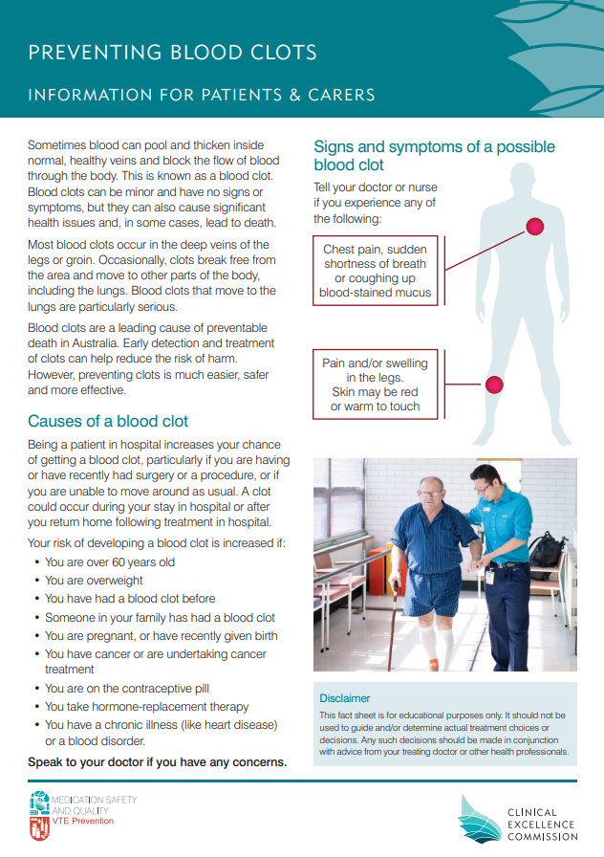
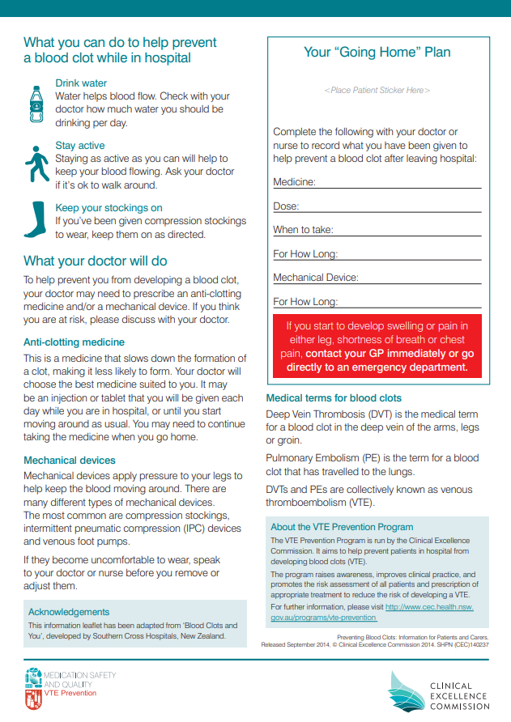

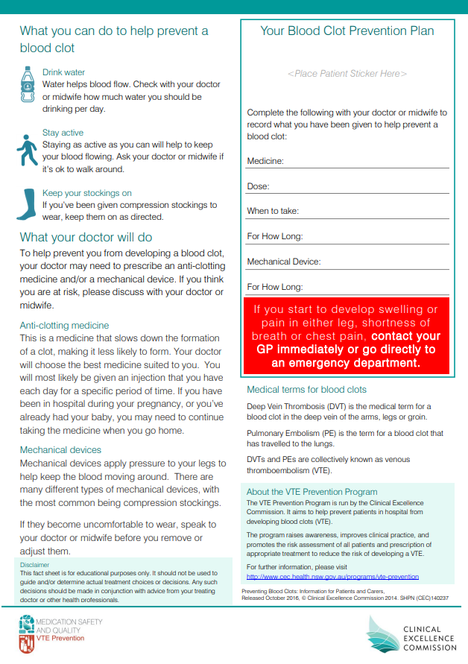

Attachment 4 “Preventing Blood Clots following leg injury” Patient Brochure

https://www.cec.health.nsw.gov.au/__data/assets/pdf_file/0007/647062/Preventing-blood-clots-following-a-lower-leg-injury.PDF

Attachment 5 “Preventing Blood Clots in pregnancy and after birth” Patient Brochure

https://www.cec.health.nsw.gov.au/__data/assets/pdf_file/0007/362167/Preventing-Blood-Clots-in-Pregnancy-and-After-Birth.pdf

Attachment 5: Maternity Thromboprophylaxis Risk Assessment Tool

Link to Clinical Form once approved

