Canberra Health Services
Procedure
Subcutaneous Medication Management in the Care of the Palliative Patient – Adults Only

Contents

Contents 1
Purpose 2
Scope 2
Alerts 2
Section 1 – Requirements for Procedure for NIKI T34 Syringe Driver 2
Section 2 – Guidelines for Practice in the Inpatient Setting 3
Section 3 – Day 1: Preparing Syringe Driver Infusion and Priming the Line using NIKI T34 5
Section 4 - Changing a Syringe Only (If Not Priming) 6
Section 5 – Inserting the Safety Intima Cannula 6
Section 6 - Observations while using the Syringe Driver 8
Section 7- – Breakthrough Medication Management 9
Section 8- Patient and Family/Carer Education 10
Section 9 - Community Nursing 11
Section 10- Requirements for Procedure for an Elastomeric Device (Neria Guard) 11
Evaluation 12
Related Policies, Procedures, Guidelines and Legislation 12
References 13
Definition of Terms 13
Search Terms 14
Attachments 14

Purpose

This procedure sets out the process for the administration of subcutaneous medication via a subcutaneous infusion as well as subcutaneous breakthrough medication in accordance with legislative, statutory and regulatory requirements, at Canberra Health Service (CHS) including the community for patient with palliative care needs.

Back to Table of Contents

Scope

This procedure applies to all CHS nursing staff who have received the necessary training to administer medications using subcutaneous infusions as well as those who are monitoring the continuous administration of the infusion.

Back to Table of Contents

Alerts
- Cyclizine should only be mixed with water for injection¹
- Cyclizine, clonazepam, methadone, morphine tartrate, levomepromazine, and promethazine should be diluted to a maximum infusible volume to minimise stability problems and to reduce the risk of local skin irritation¹
- Chlorpromazine, Diazepam and Prochlorperazine are contraindicated for use in subcutaneous infusions due to severe localised reactions
- Sodium chloride 0.9% is recommended for use as a diluent for ketamine, levomepromazine and ondansatron¹
- For all infusions involving the administration of an S8 medication a “lock box” is to be
used with syringe drivers
- Under the Medication Handling Policy all infusion devices and sites are required to be checked four hourly by the nurse caring for the patient and at the end of each shift at handover from shift nurse to shift nurse. This does not apply in the community setting
- On completion of the infusion, accredited nursing staff must dispose of the unused portion of the syringe in the presence of a witness and in a way that makes the drug unrecoverable in accordance with the Medication Handling Policy. The discarded amount must be entered into the Discard Register for S8 infusions
- From 7:30 am to 9 pm call Central Equipment Store for collection of syringe driver on extension 47171, outside these hours contact the Afterhours Clinical Nurse Consultant via Switch.
Back to Table of Contents

Section 1 – Requirements for Procedure for NIKI T34 Syringe Driver

- NIKI T34 Syringe Driver and lockable case
- BD Safe-T-Intima- 24 gauge safety system with Y adapter
- 20mL Luer lock syringe
- Drawing up needle
- Transparent dressing or non allergenic tape if indicated
- Disposable 9V battery
- Medication label
- Subcutaneous line label
- 100cm extension set
- Antiseptic/alcohol wipe
- Prescribed medications
- Compatible bung
- Disposable gloves
- Hand washing facilities or antimicrobial hand rub.
Back to Table of Contents

Section 2 – Guidelines for Practice in the Inpatient Setting

Subcutaneous syringe driver infusions are used to administer medications to maximise symptom management. Approved devices in the inpatient setting are NIKI T34 (preferred) and disposable elastomeric devices (Section 10) and if neither are available, start continuous opioid infusion via an IVAC® PCAM (refer to Acute Pain Services – Adult and Paediatric Procedure)
- The main indication for the use of a syringe driver is that a patient has persistent and unstable symptoms (usually pain and nausea) and does not have the ability to swallow or absorb medications via the oral route and/or if there is no oral drug substitute to alleviate the symptoms
- Medications for the syringe driver are prescribed by an authorised prescriber on an inpatient Medication Chart or Electronic Medication Management (EMM) over a 24 hour period
- Only registered nurses who have been educated and trained in the use of subcutaneous infusion sets and the device may administer infusions
- Student nurses, under the direct supervision of a Registered Nurse, in accordance with the protocol of their educational institution may also administer infusions
- When trained staff prepare and administer a syringe driver infusion to a patient another staff member must be present to witness the procedure. The witness may be a:
  - Medical or Nurse Practitioner
  - Registered Nurse
  - Credentialed Enrolled Nurse.

Medication Combinations
- It is recommended that no more than three (3) medications be combined in a syringe driver. Check compatibility at time of prescription and prior to administration
- Monitor contents of syringe and tubing four hourly for evidence of physical incompatibility demonstrated by precipitation, colour change, crystallisation etc. If this occurs, stop infusion and discard the medications
- All syringe driver infusions should be prepared in a 20mL Luer lock syringe to a volume of 17mL with prescribed medication/s and appropriate compatible diluent.

NOTE: Incompatible medications are loaded into separate syringes and infused into separate subcutaneous sites

Commencing Dose
- Calculate the patient’s intake of opioid over the past 24hrs and and convert to the oral morphine equivalent
- Calculate for the chosen opioid E.g. If wanting to use hydromorphone, divide the 24hour oral morphine equivalent by 5
- A third of the 24 hour oral dose should be the commencement dose of subcutaneous opioid over 24 hours
- If a different opioid is being use, 50-75% of the dose should be done for as a cross tolerance reduction

Example
Mrs T has had her usual 10mg Oxycontin BD and an additional 30mg in oxycodone IR breakthroughs in the last 24 hours. She has uncontrolled pain and a SD is being ordered to stabilise. Her renal function is impaired and she has no known allergies so a hydromorphone subcutaneous infusion is to be ordered. Here is the calculation for the infusion
- 50mg oxycodone x 1.5 to find the oral morphine equivalent = 75mg oral morphine
- 75mg oral morphine / 3 = 25mg parenteral morphine
- 25mg parenteral morphine / 5= 5mg hydromorphone
- 5mg hydromorphone x 75% = 3.75mg hydromorphone
Syringe driver commenced at 4mg hydromorphone over 24 hours

- Authorised prescribers, or those in consultation with the specialist palliative care team, may prefer to use a larger starting dose where appropriate
- Consideration should be given to the opioid naive patient, the elderly and those with renal or hepatic impairmen.
- The EVIQ opioid calculator https://www.eviq.org.au/opioidcalculator.aspx can be used to assist with dosing
- Specialist palliative care medical officer or nurse practitioner should be consulted for dose equal to or above 100mg equivalent of oral morphine in 24hrs
- Care should be taken when converting opioids when the patient’s response has been suboptimal, as this may relate to the individual rather than the dose and morphine equivalents may be higher than the patient was truly exposed to. E.g. poor response to Codeine or Tramadol may relate to patients’ liver enzyme metabolism due to a genetic lack of CYP2D6.

Back to Table of Contents

Section 3 – Day 1: Preparing Syringe Driver Infusion and Priming the Line using NIKI T34

- Obtain Syringe Driver from Central Equipment Store through Smart Page
- Attend moments of handhygiene as appropriate
- Prepare prescribed medications and compatible dilutant in 20mL Luer-lock syringe ensure up to 17mL volume
- Label syringe with patient information, date, time, medication, dose, volume and sign
- Connect extension line and safety intima subcutaneous cannula line to the syringe.
- Insert battery into NIKI T34 Syringe driver
- Raise clamp and turn to back of unit (push down again so it is not sticking up)
- Turn on NIKI T34
- Measure syringe against NIKI T34 and press either FF or Back to align actuator to syringe plunger. Actuator will re-set to previous syringe size, so if same syringe size, no need to alter
- Load syringe and raise clamp to turn and fit over syringe
- Use  to select correct syringe brand, press YES
- Check and review data on screen: volume, duration, rate (e.g. 24mL, 24hrs or mL/hr).
- DO NOT start infusion
- Press FF to purge line and safety intima cannula line (it will ask you to press YES to confirm the patient is not attached)
- Hold down the FF key until the line and safety intima cannula line are primed (approx 1mL)
- Syringe driver will revert to original screen
- Again press YES to confirm size and brand of syringe
- Press YES to Resume
- Display will now read new volume (load minus prime amount) and new duration (e.g. 23 hours) however, the Rate will remain constant (e.g. mL/hr)
- To confirm press YES
- Insert safety intima cannula into patient (see Section 5)
- When “Start Infusion?” is displayed, press YES to commence
- Lock Keypad by holding down the blue key until the black rectangle is completely marked
- Place unit in lock box, lock and place in bag next to patient
- Document on syringe driver checklist form medications in syringe, date, time, volume and rate. Document in patient notes and include placement of safety intima cannula details.
Back to Table of Contents

Section 4 - Changing a Syringe Only (If Not Priming)

- Attend moments of handhygiene as appropriate
- Draw up medication and compatible diluents in relevant syringe and label.
- Unlock keypad (by holding down the blue key until the rectangle is unmarked)
- Press STOP
- Raise clamp and turn away from screen (push down so it is not sticking up)
- Remove old syringe
- Attach new syringe to infusion line. Measure syringe against NIKI T34 and press either FF or Back to align actuator to syringe plunger. Actuator will re-set to previous syringe size, so if same syringe size, no need to alter
- Pull clamp up and over new syringe
- Use   to Select syringe brand, press YES
- Check data on screen, Volume, Duration, Rate (e.g. 24mL, 24 hours, 1mL/hr, battery life)
- To confirm press YES
- When “Start Infusion?” is displayed, to commence press YES
- Lock Keypad by holding down the blue key until the black rectangle is completely marked out
- Place unit in lockable case, lock and place in bag next to patient
- Document on syringe driver checklist form medications in syringe, date, time, volume and rate. Document syringe change in patient’s notes.
Back to Table of Contents

Section 5 – Inserting the Safety Intima Cannula

Possible Sites for Subcutaneous Needle (See diagram below)
- Upper outer thigh
- Upper outer arm
- Upper chest
- Back upper shoulders
- Abdomen
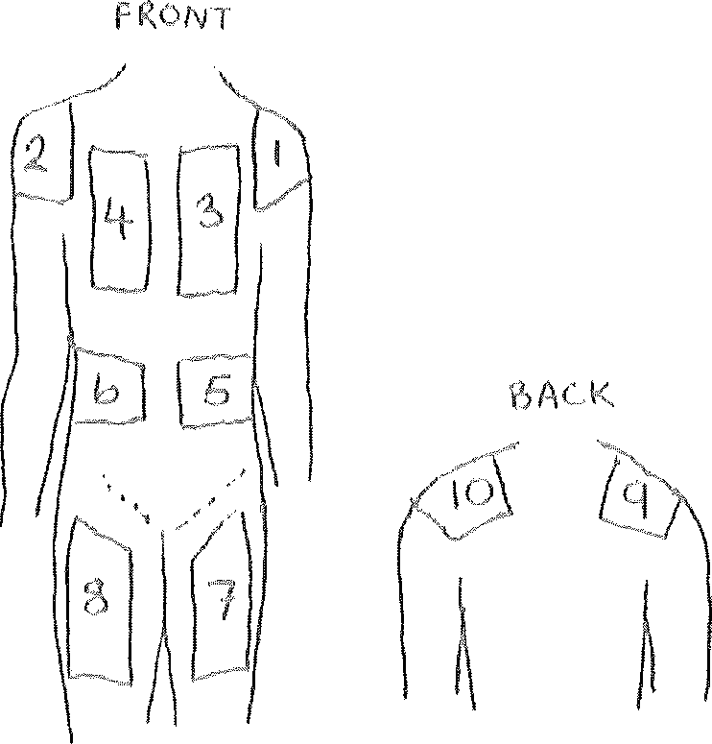

Areas to Avoid
- Porta Cath or central line site
- Pace maker site
- Tumours
- Mastectomy site or arm on mastectomy side
- Areas of local irritation, stoma site or areas with oedema.

Note: Consider site in relation to ease of mobilisation if patient is ambulant.

Procedure
The insertion of a Safety intima cannula for a subcutaneous infusion or breakthrough administration is a standard aseptic technique procedure. All appropriate moments of hand hygiene should be performed pre, during as needed and post procedure.
- Gather equipment needed ie primed Safety intima and infusion set (see Section 3), bung, alcohol swap, clear occlusive dressing (see Section 7 for more details)
- Clean insertion site with alcohol swab and allow to dry
- Insert primed infusion set cannula through the skin at a 30-45 degree angle into the subcutaneous tissue. Hold wings together during insertion for stability with bubbled surface of the wings facing the patient’s skin, the cannula should be attached to a primed subcutaneous infusion set
- Remove guide wire while stabilising the wings with the other hand
- Replace bung with a compatible bung if the side arm is to be used (using second breakthrough site preferable)
- Cover the insertion site with clear occlusive dressing (check for allergies; use Mefix if no other choice)
- Write the date and time of insertion of the cannula on the sticker provided
- Document in patient’s clinical record the date time and site of insertion of the cannula.

Clinical Indications for Site Change Include
- Redness at insertion site
- Pain at site
- Swelling
- Line obstruction
- Itchiness at site
- Hardened or engorged tissue

Nursing Considerations
- Rotate the sites of insertion to minimise complications.
- Check the insertion site four hourly and at change of shift in the hospital setting and check insertion site daily in the community settings
- Change the injection site if indicated or at least every 7 days. Document change of insertion site on Syringe Driver Checklist form and in patient’s notes.

Back to Table of Contents

Section 6 - Observations while using the Syringe Driver

Additional Observations to be Carried out While Using the Syringe Driver
- Document the following every 4 hours and at change of shift on the Syringe Driver Checklist form (In the community, observations occur daily or when the infusion is changed)
- Correct rate
- Volume in syringe is reducing appropriately
- Light is flashing in the Syringe Driver (change battery if not flashing)
- Site is not inflamed or leaking
- Co- sign the syringe driver order and observation chart at change of every shift (not necessary in community)

Note:
A syringe driver locked box is to be use in all settings (not appropriate for elastomeric as a closed system device)

- Report any side effects or any issues relating to the syringe driver to the hospital treating team/ Palliative and Supportive Care as well as Central Equipment- consider Riskman reporting if appropriate
- Monitor the appropriateness of the syringe driver on a regular basis and discuss the need for change or cessation with the Medical officer, Nurse practitioner and/orPalliative and Supportive Care team.
Back to Table of Contents

Section 7- – Breakthrough Medication Management

- Breakthrough subcutanous doses should be anticipated and will need to use a second dedicated subcutaneous cannula
- Breakthrough doses should have an ongoing order and have unrestricted time limits
- Breakthrough doses normally are one sixth of the required 24 hour opioid dose and should be available to the patient hourly
- In the community setting, it is advised that if a patient is requiring 2 doses in 1-2 hours, the community palliative care team should be notified for further advice
- If three or more subcutaneous breakthrough injections are required within 24 hours, the analgesic regime should be reassessed. Additionally, if no breakthroughs are required in a 24 hour period, the analgesic regime should be reassessed
- Ensure that an anti-emetic is considered for any patient commencing a subcutaneous opioid infusion
- Amount of breakthrough lines should be limited for patient comfort with dedicated breakthroughs for compatible medication combinations only
- If one breakthrough line is being used for more than one medication, a normal saline flush of 1mL should be use after medication is delivered.

Process for Inserting Breakthrough Safety Intima Cannula
- Attend moments of hand hygiene
- Attach a bung to the safety intima line
- Check breakthrough drug compatibility with 0.9% sodium chloride and/or water for injections via the Safer Care Victoria guidance document Syringe driver compatibility (bettersafercare.vic.gov.au)
- Prepare compatible solution in syringe, attach to bung and prime
- Clean selected site with alcohol wipe and allow to dry
- Insert primed infusion set cannula through the skin at a 30-45 degree angle into the subcutaneous tissue. Hold wings together during insertion for stability with bubbled surface of the wings facing the patient’s skin
- Remove guide wire while stabilising the wings with the other hand
- Cover the insertion site with clear occlusive dressing (check for allergies; use Mefix if no other choice)
- Write the date and time of insertion of the cannula on the sticker provided
- Administer breakthrough dose
- If line is to be used for more than one compatible breakthrough medication, flush with 1mL of compatible diluent
- Document date, time and site of insertion in patients clinical notes.

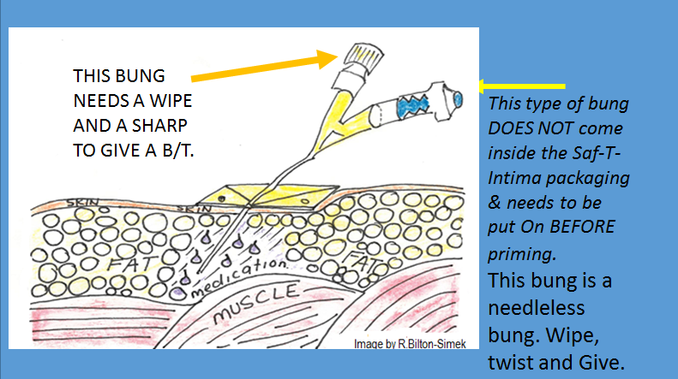

Back to Table of Contents

Section 8- Patient and Family/Carer Education

The prescriber ordering the subcutaneous should discuss with the patient, family/carer about why the device is required and ensure informed consent prior to prescribing. This education would include, but is not limited to;
- What the device will do and its advantages and possible disadvantages?
- Breakthrough dose administration
- Safety aspects on mobilising with the device and performing activities of daily living without risk of pulling the safety intima line out
- How not to get the syringe driver wet and how to manage the device when having a shower
- The keypad and that it has a locking mechanism which prevents unintentional power off
- Ongoing management and assessment of the goals of the subcutaneous infusion for symptom control and comfort measures.

If there are any concerns, consultation with the specialist palliative care team should be sought.

Back to Table of Contents

Section 9 - Community Nursing

- Community Nursing work under a shared care arrangement with the Community Specialist Palliative Care Service to provide subcutaneous infusion and breakthrough management to patients of the service. CHS staff should be aware of the policies and procedures used by Community Specialist Palliative Care Service of Calvary Health Care (Bruce).
- To facilitate the shared care arrangement, clear documentation of current orders and administration history must be available to both the CHS Community Nursing team and the Community Specialist Palliative Care Service via digital health record and/or Community Nursing clinical file refer to Community Based Clinical Records Procedure.
- Additionally patients receiving community palliative care can be managed by CHS Hospital in the Home in liaison with the CHS Specialist Palliative Care team.
- Breakthrough medications may be drawn up in the home by Community Nursing in keeping with the prescribed orders
- It is important to note that a patient’s own medication is their property and any use, disposal or destruction of that medicine must be done with their consent
- Discarding of any unused, unwanted or out of date medication should be done through the community pharmacy safe disposal program by the patient or carer in keeping with the Medication Safety Policy. For unused portions of a S4D or S8 medication, these should be ejected from syringe in the sharps container or household waste and documented in the clinical file
- A witness is not required for either the drawing up of or destruction of, a prescribed medication including S4D and S8s, by a community registered nurse due to the unique setting of community care
- Clear written instructions should be given to the patient and carer on how to mobilise and perform activities of daily living with the syringe driver including disconnection procedure for showering, bag for carrying, what to do and who to contact if it alarms or there are any concerns etc
Back to Table of Contents

Section 10- Requirements for Procedure for an Elastomeric Device (Neria Guard)

Elastomeric devices are available as a clinical option to deliver a subcutaneous infusion within CHS for both inpatients and the community. They are often used when there is no NIKI T34 syringe drivers are available and when patient requires transport to another health service or for infection control reasons.

Procedure
- Attend moments of handhygiene as appropriate
- Identify the correct patient as per Patient Identification and Procedure Matching Procedure
- Gather equipment
- Neria guard accufuser 100mL volume at 1.0mL/hr flow rate
- Neria guard infusion set
- Drawing up needle
- Transparent or non allergenic tape if indicated
- 20mL luer lock syringe - the Accufuser should be made up to 50mL volume as a minimum to deliver the dosage calculated for 50 hours as prescribed i.e. divide 24 hour dosage by 24 then times by 50
- Medication label
- Subcutaneous line label
- Antiseptic wipe
- Prescribe medication/s with compatible diluent
- Disposible gloves
- Please refer to product information for further guidance on filling Accufuser, priming and insertion of Neria guard infusion set
- Seek advice from Specialist Palliative Care team as appropriate.

Back to Table of Contents

Evaluation

Outcome
- Consistency in the use of subcutaneous medications and infusions across CHS for patients with palliative care needs
- Reduction in errors and complications secondary to subcutaneous medication prescribing and use
- Decrease of the length of time on the waitlist

Measures
- Regular review of Riskman data related to the prescribing and use of subcutaneous medications
- Clinical and quality outcomes are evaluated through patient experience questionnaires and consumer feedback data

Back to Table of Contents

Related Policies, Procedures, Guidelines and Legislation

Policies
- Informed Consent- Clinical
- Canberra Health Services Guideline Comfort Care Pathway Guidelines (Adults Only)
- Subcutaneous Fluids Policy (RACS)
- Medication Safety Policy.

Procedures
- Infection Prevention Control and Healthcare Associated Infections
- Patient Identification and Procedure Matching
- Acute Pain Services- Adult and Paediatric.
Legislation
- Health Records (Privacy and Access) Act 1997
- Human Rights Act 2004
- Work Health and Safety Act 2011

Other
- Calvary Public Hospital Bruce Syringe Driver Subcutaneous Infusions of Opioids and Breakthrough Dose
- Australian Charter of Healthcare Rights.
Back to Table of Contents

References

- eTG March 2021 edition, Therapeutic Guidelines Ltd
- Australian Pharmaceutical Advisory Council Guiding Principles for Medication Management in the Community 2006 (under review as of 2022)
- Safer Care Victoria; Syringe Driver Compatibility Guidance Document February 2021 Syringe driver compatibility (bettersafercare.vic.gov.au)
- Centre for Palliative Care Research and Education, Department of Health 2021 Guidelines for Subcutaneous Infusion Device Management in Palliative Care and other settings. 3rd Ed. Guidelines for Subcutaneous Infusion in Palliative Care (health.qld.gov.au)
- Caesarea Medical Electronics Ltd, NIKI T 34 Syringe Pump Instruction Manual December 2020.
Back to Table of Contents

Definition of Terms

Breakthrough medication an extra dose of the patient’s prescribed opioid given in response to pain.

Direct supervision is provided when the registered nurse is present, observes, works with and directs the person who is being supervised.

Lock Box-a secured box to place the syringe driver into to prevent unauthorised access.

Precipitation- a substance that has separated from or settled out of a solution.

Purged (primed)- a syringe driver infusion line is loaded with the contents of the syringe driver combination.

Scope of practice- covers the activities and responsibilities that a health professional is educated, trained, authorised and competent to perform.

Back to Table of Contents

Search Terms

Syringe driver, subcutaneous medication infusion, subcutaneous infusion, pain management, palliative care, symptom management.

Back to Table of Contents

Attachments

Disclaimer: This document has been developed by Canberra Health Services specifically for its own use. Use of this document and any reliance on the information contained therein by any third party is at his or her own risk and Canberra Health Services assumes no responsibility whatsoever.

Policy Team ONLY to complete the following:
Date Amended | Section Amended | Divisional Approval | Final Approval
29/07/2022 | Full Review | Melissa O’Brien ED CAS | CHS Policy Committee

This document supersedes the following:
Document Number | Document Name
CHHS17/105 | Subcutaneous Medication Management in the Care of the Palliative Patient – Adults Only

