Canberra Health Services
Procedure
Spinal Injury Management of the Adult Patient

Contents

Contents 1
Purpose 3
Scope 3
Section 1 – Initial Assessment and Management of Patients with Suspected Traumatic Spinal Injury 4
1.1 Emergency Spinal Immobilisation 4
1.2 Spinal Injury Assessment 5
1.2.1 Cervical Spine Clearance in the Trauma Patient 5
1.2.2 Thoracolumbar spinal clearance in the trauma patient 10
Section 2 – Management of the Confirmed Spinal Injury 14
2.1 Spinal Precautions 14
2.1.1 Logrolling 17
2.1.2 Head Immobilisation 18
2.2 Spinal Injury Management Plan 20
2.3 Traumatic Spinal Injury and Spinal Surgery Observations 20
2.4 Spinal Orthosis 26
2.4.1 Cervical Collar 27
2.4.2 Thoracic, Lumbar and Sacral Rigid Spinal Bracing 30
2.5 Spinal Traction (Canberra Hospital Only) 32
2.6 Crown Halo and Vest 34
Section 3 – Spinal Surgery Management 37
3.1 Pre-operative 37
3.2 Post-operative 38
3.3 Anterior Cervical Discectomy and Fusion (ACDF) 39
Section 4 - Discharge and Community Management of a Patient with a Cervical Collar 39
4.1 Discharge of a Patient with a Cervical Collar 39
4.2 Discharge Planning and Referral to Rehabilitation, Aged and Community Services (RACS) Community Care Program (CCP) Community Nursing for Cervical Collar Management 40
4.3 Community Nursing Procedure to Organise a Community Nursing Manual Handling Powered Hospital Bed For a Resident of the ACT 41
Evaluation 42
Related Policies, Procedures, Guidelines and Legislation 42
References 43
Definition of Terms 44
Search Terms 44
Attachments 45

Purpose

The purpose of this procedure is to outline the process for optimal care and management of known or suspected spinal injuries and disorders at all levels of the spinal column, in adult patients (>16 years of age) at Canberra Health Services (CHS).

This procedure provides information for any CHS staff who care for patients with a spinal injury or who require spinal surgery in the acute hospital and follow up in the community setting.

Standardisation of practice means delivery of best practice, continuity of care and optimal clinical outcomes for CHS patients.

Back to Table of Contents

Scope

This clinical procedure is applicable to all CHS adult patients (>16 years of age) who have presented with a suspected spinal injury, those who have had radiological confirmation of a spinal injury and patients admitted for surgical management of a spinal injury or disorder.

Paediatric patients should be discussed directly with The Westmead Children’s Hospital Spinal Service (for Westmead switchboard ph. 02 9845 0000).

The document applies to staff working within their scope of practice including:
- medical officers
- registered and enrolled nurses
- allied health professionals
- wardspersons
- tertiary students under direct supervision.

Consultants responsible for clearance of the cervical spine (c-spine) following review and reporting of the appropriate cervical spine imaging by a consultant radiologist or senior radiology registrar include:
- neurosurgeons (or senior neurosurgical registrar/fellow)
- general/trauma surgeons
- intensive care physicians
- emergency physicians
- orthopaedic spine surgeons
- registrars from the above specialties after discussion with their senior consultant.

Alert:
In the consideration of spinal precautions and logrolling, head immobilisation should only be performed by medical officers or registered nurses, on completion of the appropriate training. Enrolled nurses, student nurses, medical students and wardspersons may assist under strict guidance and supervision.

Back to Table of Contents

Section 1 – Initial Assessment and Management of Patients with Suspected Traumatic Spinal Injury

1.1 Emergency Spinal Immobilisation
Spinal immobilisation is required in all trauma patients when the mechanism of injury has the potential for causing spinal injury, the patient presents with signs or symptoms of a spinal injury and for all unconscious trauma patients. On arrival to a CHS site, patients with a collar in situ must be managed with full spinal precautions until their cervical spine has either been cleared of injury, at which time they should have their collar removed and precautions lifted; or an injury has been diagnosed and the protocol has been followed for longer term immobilisation. The following emergency immobilisation strategies are appropriate for all acute trauma patients with suspected spine trauma (with or without neurological concerns) whilst awaiting radiological or clinical clearance:
- For conscious or fully unconscious patient apply soft collar +/- sandbags.
- For conscious but confused or uncooperative patients apply a Miami J collar or equivalent if tolerated.
- For all patients:
- maintain supine position
- immobilise head (see Section 2)
- logroll with inline stabilisation for all turns (see Section 2)
- remove all metal (jewellery and clothing including bra) to prepare for medical imaging
- Immobilisation principles applied in the Emergency Department (ED) should continue throughout the patient journey, including in the Medical Imaging Department, until a diagnosis is made and specific care indicated.

Flowchart 1: Initial Management of Adult Patients with Potential Spinal Injuries

1.2 Spinal Injury Assessment

1.2.1 Cervical Spine Clearance in the Trauma Patient
Patients with altered conscious state or cognition: Full spinal precautions should be followed as above for patients with an altered conscious state or cognition (including unconscious patients) until whole spine Computer Tomography (CT) is performed. If the CT imaging is normal and the c-spine is cleared, once this has been documented in the patient’s clinical record the soft collar may be removed and spinal precautions ceased (see Flowchart 2: C-spine Clearance in Patients with Altered Conscious state or Cognition below).

If the CT imaging is abnormal, the scan must be reviewed by both an appropriate consultant (see Scope) and a radiologist, and Magnetic Resonance Imaging (MRI) may be scheduled (see Flowchart 2).

Flowchart 2: C-Spine clearance in Patients with Altered Conscious State or Cognition

*Refer to Scope for consultants who may be responsible for clearance of the c-spine.

Conscious and alert patients: In alert (Glasgow Coma Scale (GCS) 15) trauma patients with a suspected cervical spine injury, clinical exam should follow the Canadian C-Spine Rule (see Flowchart 3: C-spine Clearance in Conscious Trauma Patients).

- For patients cleared following clinical exam, no further cervical imaging is required unless new symptoms or concerns are reported.
- Where clinical exam is unreliable or where radiographic assessment is required, Flowchart 3: C-spine Clearance in Conscious Trauma Patients should be followed for radiological clearance.

Flowchart 3: C-spine Clearance in Conscious Trauma Patients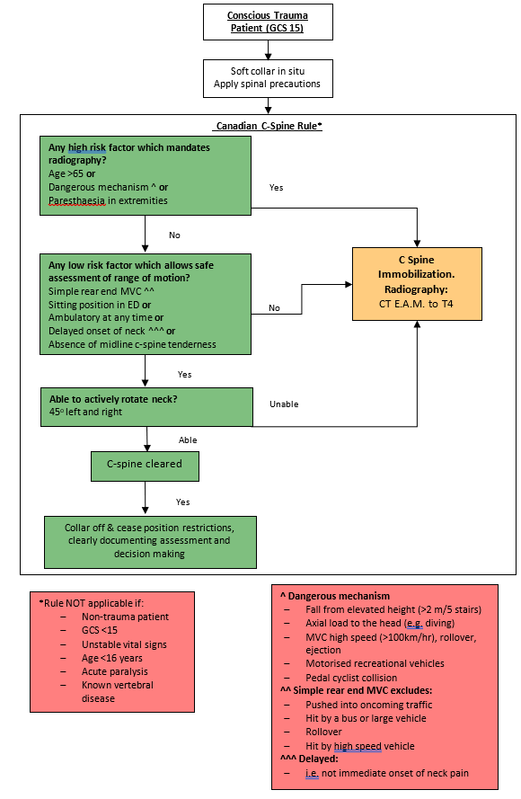

All patients following appropriate cervical spine assessment:
- If a cervical spine injury is identified, then the thoracolumbar spine should also be imaged with CT if not already done.
- Magnetic Resonance Imaging (MRI) may be required if CT images are abnormal or if neurological signs are present. Indications for the use of MRI are as follows:

Flowchart 4: MRI Indications

*Refer to Scope for consultants who may be responsible for clearance of the c-spine.
- Clinically insignificant injury, as deemed by the Emergency, Trauma or Neurosurgical teams, may result in c-spine clearance.
- There is no role for flexion extension x-rays in a patient who has already had CT of the cervical spine.
- Only once c-spine clearance is clearly documented in the patient’s clinical record by one of the following may the spinal precautions be lifted and collar removed:
- neurosurgeon (or senior neurosurgical registrar/fellow)
- general/trauma surgeon
- intensive care physician
- emergency physician
- orthopaedic spine surgeons
- registrars from the above specialties, only after discussion with their senior consultant.
- If imaging is abnormal, clinically significant or an unstable injury exists, the patient will be referred for consultation by Neurosurgery.
- A Spinal Injury Management Plan on the Digital Health Record (DHR) system should be completed by a neurosurgical registrar or consultant, by the Neurosurgery Clinical Nurse Consultant (CNC) or by the shock/trauma team in consultation with neurosurgery, outlining appropriate management and restrictions.

1.2.2 Thoracolumbar spinal clearance in the trauma patient
The Thoracic and Lumbar (TL) spine is the most rigid and strong of all the vertebrae and to disrupt the column at this level requires great force. The incidence of TL injuries in level 1 (major trauma) centres is 4-5%. Injuries to the TL spine are commonly the result of high velocity deceleration mechanisms such as motor vehicle crashes, high falls, pedestrians stuck by motor vehicles and motorcycle accidents. The frequent use of CT scanning of patients with trauma has resulted in an improved sensitivity in the diagnosis of TL spine injury.

Compression and burst fractures are the most common TL fractures, accounting for 35% of all TL spine injuries. In major trauma patients, isolated thoracic and lumbar region transverse process (TP) fractures are a commonly occult diagnoses on CT scan. Whilst a TP fracture may be an indicator of injury to adjacent structures, the injury itself is benign and requires only symptomatic management. Commonly, the incidental finding of isolated TP fractures triggers a request for neurosurgical unit consultation. The result is often no change in management but a delay in patient mobilisation, acceptance for admission under an appropriate inpatient team and therefore timely patient care.

Trauma patients with CT findings of spinal injury and neurological deficit should be maintained on spinal precautions and referred to the neurosurgical service at the time of diagnosis. These patients require imaging of the entire spine to identify additional spinal fractures at other spinal levels.

Patients with isolated thoraco-lumbar vertebral injuries are assessed and managed based on the ‘Thoraco-Lumbar Injury Classification and Severity Score (TLICS)’. This score assesses three components:
- Fracture morphology
- Integrity of the posterior longitudinal ligamentous complex (PLC) (see Box 1)
- Neurological deficit
For the purposes of triaging referral for neurosurgical consultation the TLICS has been simplified to direct appropriateness and timing of referral (Algorithm 1).

Algorithm 1: Simplified TLICS
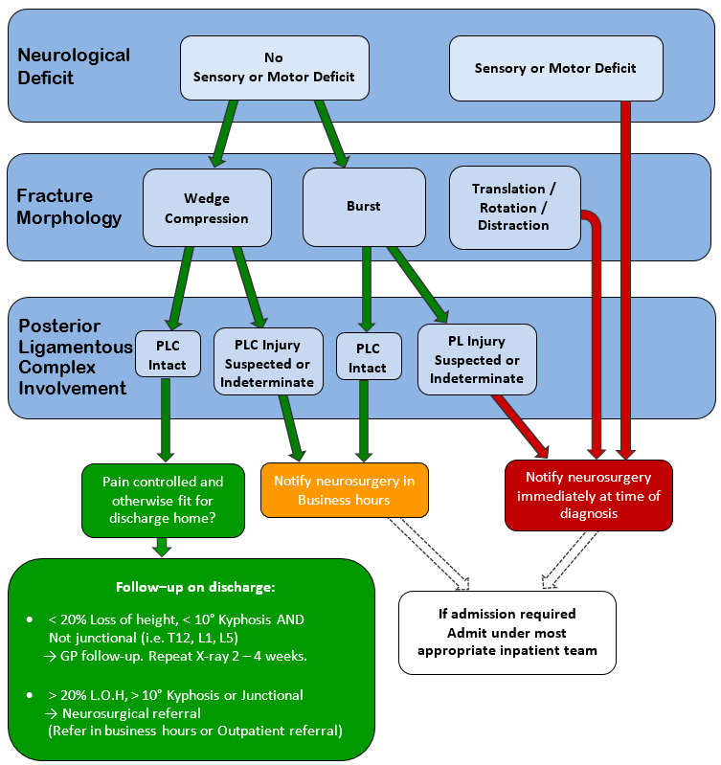

Box 1. Posterior Longitudinal Ligamentous Complex
The PLC is a major stabilising element of the spine. The components of the PLC are:
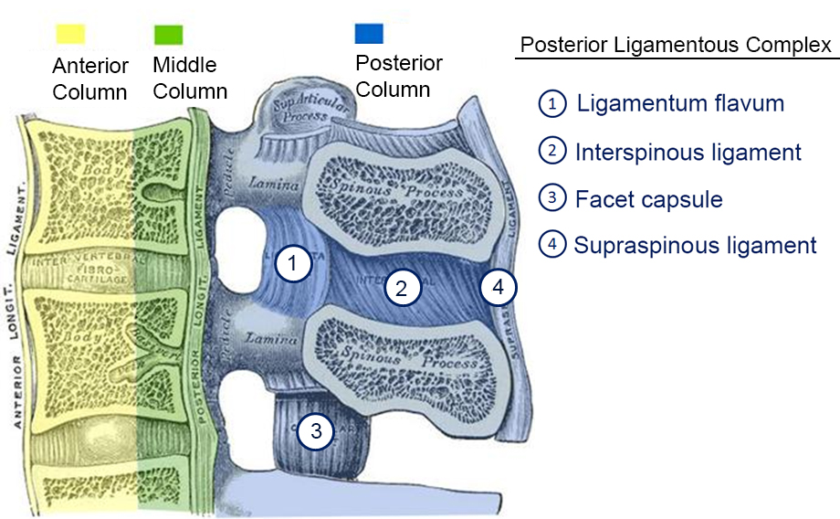
Injury and potential instability of the PLC should be suspected in following circumstances:
- clinically, if there is a palpable gap between spinous processes
- x-ray or CT imaging findings of interspinous widening (location 2 in the above picture)
- absence of posterior ligamentous hyperintensity on fat-suppressed T2-weighted MRI images.

Thoraco-lumbar Transverse Process Fractures
Patients with isolated TL region transverse process fractures, with a few exceptions, do not require neurosurgical consultation. These patients can be managed without a need for intervention or immobilisation. Isolated TL transverse process fractures can be triaged using Algorithm 2.

Uncomplicated TL transverse process fractures meet the following criteria:
- TP fractures of T2 to L5 levels (i.e., excluding the 1st thoracic vertebra [T1])
- numbering less than three (3) fractures
- no additional bony or disc related spinal injury on CT scan
- no acute neurological findings on clinical examination.

These injuries do not require neurosurgical consultation, regardless of degree of displacement. These injuries are neurologically stable fractures that do not require surgery or immobilisation.
Potentially complicated transverse process fractures that require neurosurgical consultation are listed below. These patients may be admitted under the most appropriate team depending as per TCH admission guidelines.
- Cervical region transverse process fractures. These fractures may involve the vertebral foramen with consequent vertebral artery injury. There patients require a CT angiogram of the neck to exclude vascular injury and a neurosurgical opinion.
- 1st thoracic Vertebra (T1) fractures are associated with additional injuries including subclavian artery and brachial plexus injury and should be consulted on by neurosurgery.
- Non-isolated thoracic and lumber transverse process fractures. Associated bony and disco-ligamentous injuries may require a neurosurgical management plan.
- More than 3 contiguous transverse process fractures. This injury pattern is usually the result of a high-energy mechanism. There is an increased likelihood of associated bony and disco-ligamentous injury. These patients may require further radiological imaging to exclude spinal column instability.
- Spinous process fractures at any vertebral level. These injuries whilst stable in themselves may involve additional bony or disc related injuries that may require a neurosurgical management plan.
- Patients with acute neurological deficit following trauma thought to be of traumatic origin and suspected to be due to spinal cord injury (i.e., not due to a cerebrovascular accident or a peripheral nerve injury). These patients may require MRI to exclude a spinal cord injury without bony injury (e.g., central cord syndrome).

Vertebral and disc injuries not mentioned above should be discussed with the Neurosurgery unit.
Back to Table of Contents

Section 2 – Management of the Confirmed Spinal Injury

2.1 Spinal Precautions
If a spinal injury has been diagnosed following appropriate imaging and either the cervical or thoracolumbar spine are not cleared, the spinal precautions then required while awaiting a definitive plan for stabilisation to be enacted can be assessed using the three Protocol Groups outlined below. The protocols apply to both conscious patients and patients with altered conscious state or cognition (refer to Flowchart 5: Spinal Injury Protocols).

Protocol 1
If following appropriate whole spine clearance or imaging, the patient has no identified spinal injury or has a stable injury then there is no requirement for spinal precautions. This should be documented in the notes by the treating team or senior clinician authorising the spinal clearance.

Protocol 2
Following CT imaging of the whole spine and a radiological injury of unknown significance involving the cervical spine only has been identified then spinal position restrictions are as follows:
- Soft collar changed to Miami J collar or equivalent
- Appropriate mattress option – meeting pressure care requirements
- May sit up to 30 degrees supported
- Logroll with inline stabilisation for all turns.

Protocol 3
For patients with a radiologically or clinically unstable spinal injury OR a thoracolumbar spine injury with cervical spine injury the following full spinal precautions are required:
- Soft collar changed to Miami J collar or equivalent
- Appropriate mattress option – meeting pressure management requirements
- Lie flat with logroll with inline stabilisation for all turns.

Position requirements may vary from the protocol. These need to be documented in the clinical notes with the specific restrictions and the rationale for the alteration.
Note that the cervical spine should be maintain in a neutral position, adjusting and allowing for anatomy such as kyphosis. How this is achieved should be guided by the neurosurgical consultant.

Flowchart 5: Spinal Injury Protocols

2.1.1 Logrolling
Logrolling is performed to provide pressure area care, examine skin integrity, assess for further injury, during thoracolumbar spinal clearance and to protect the airway in the instance of vomiting etc. The main aim of this technique is to support and maintain the natural anatomical alignment of the spine.

The number of staff required and the technique itself is dependent on the level of injury. This should be identified from medical documentation in the patient’s clinical record, or in the instance of potential spinal injury then full spinal precautions should be maintained until cervical spine cleared.
- Cervical (full) spinal precautions – 3 staff members for logroll (+ staff performing the planned activity, e.g., pressure area care).
- Thoracic and Lumbar precautions (head hold not required) - 2 staff members for logroll (+ staff performing the planned activity).
Note these are a guide only and manual handling procedures should be adhered to.

- The patient should be supine and anatomically aligned prior to commencement of the logrolling procedure.
- Explain the procedure to the patient, asking them to lie still, cross their arms across their chest to prevent twisting motion and refrain from assisting.
- Ensure any lines or medical devices i.e., indwelling catheters, intercostal catheters, are clear and reposition them where necessary to avoid dislodgement.
- If the patient is intubated or has a tracheostomy tube, airway suctioning prior to logrolling is recommended to prevent coughing and anatomical misalignment.
- Position the bed at a suitable height for staff. If cervical precautions are required the height should be suitable for the ‘head holder’.
- Assistant 1, the assistant supporting the upper body, places one hand over the patient’s shoulder to support the posterior chest area, and the other hand around the patient’s hips.
- Assistant 2, the assistant supporting the patient’s abdomen and lower limbs, overlaps with assistant 1 to place one hand under the patient’s back, and the other hand over the patient’s thigh (see image below).
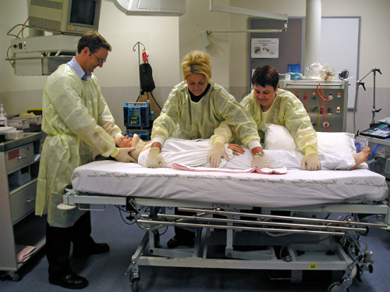
- The ‘head holder’, the clinician who leads the roll, directs assistants 1 and 2 when the roll will be initiated (on the count of three).
- Again, on direction from the ‘head holder’, the patient is turned in anatomical alignment in one smooth action.
- Assistant 3 completes the planned activity (pressure area care etc.).
- The head holder will direct the assistants to either return the patient to the supine position (on the count of three) or to support the patient in a lateral position with wedge pillows. The patient should be left in correct anatomical alignment.
- Consider whether the intubated patient or patient with a tracheostomy requires further suctioning post roll.

2.1.2 Head Immobilisation
Prior to cervical spine clearance or when a cervical injury has been diagnosed, a patient’s head should be immobilised during a logroll, position change or when a cervical collar is removed.

The main aim is to maintain the patient’s head in neutral position and prevent flexion, extension and lateral tilting. The patient’s head is always held from the top of the bed, however there are different techniques including head and trapezius holds, which may be used depending on clinician preference and environmental constraints.

- If a collar is in situ, ensure that it is well fitted prior to commencement of roll.
- Head Hold: The thumb and forefingers of both hands are extended allowing the rest of the fingers to shrug the occiput. The forefingers are folded along the line of the sternocleidomastoid muscle and the thumbs provide support along the angle of the jaw.

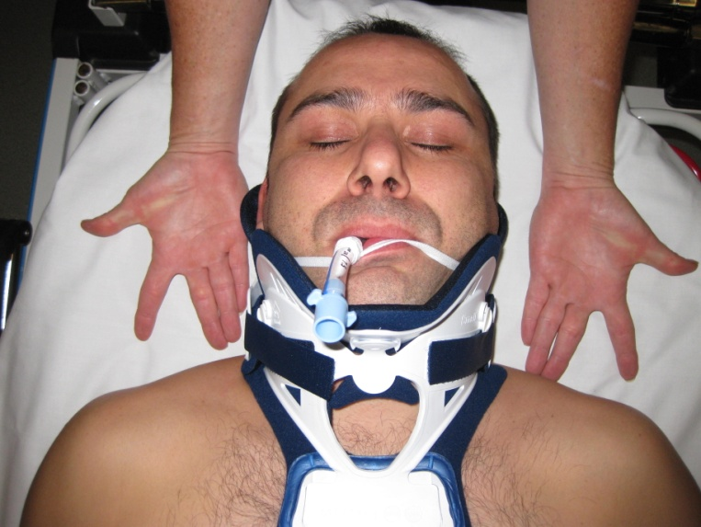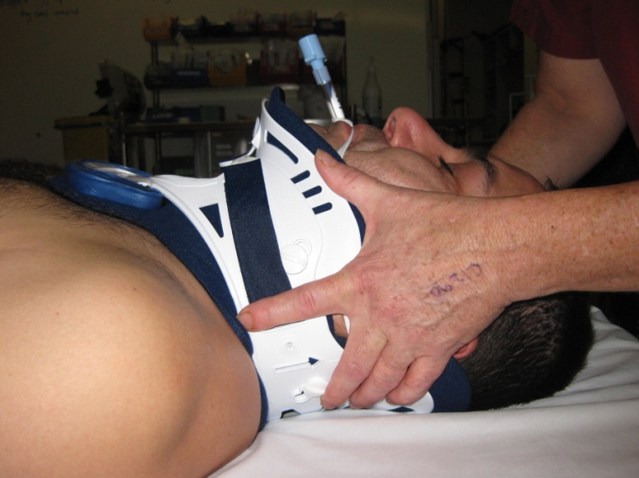

If the patient is intubated the hand which is supporting the opposite side to the side which is being rolled on, can support the endotracheal tube.

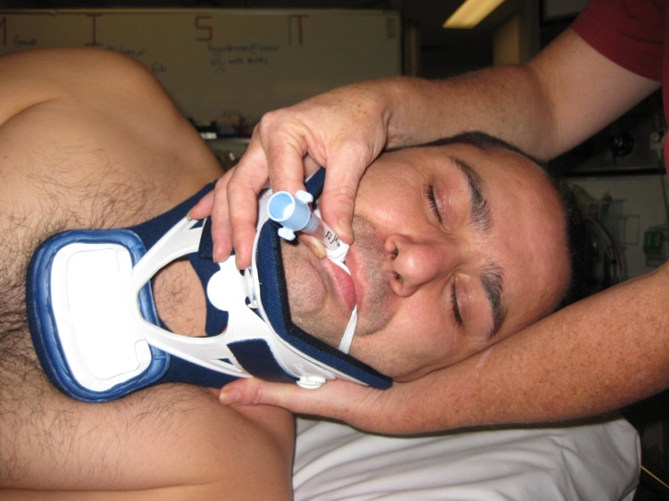

Trapezius Hold: With the forearms in a supinated position and with the thumbs extended, slide the fingers under the trapezius muscles bilaterally with thumbs resting over the clavicles (and alongside the collar if in situ). In this hold, the forearms are used to immobilise/support the patient’s head during the logroll.

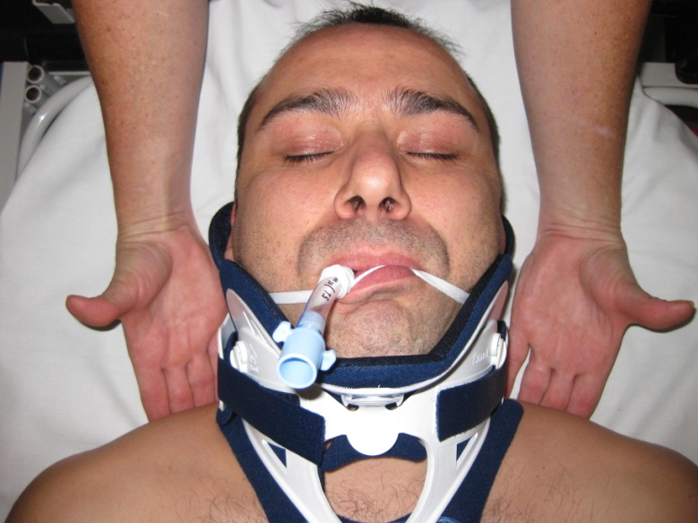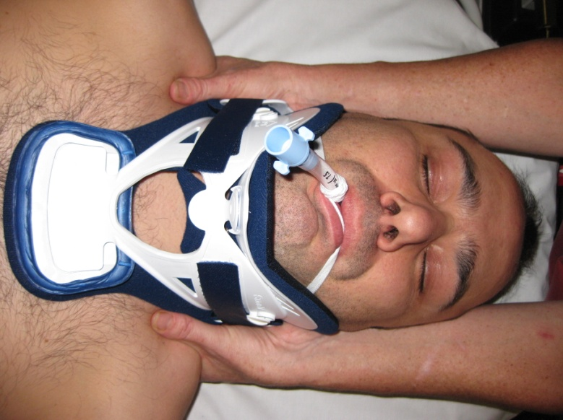

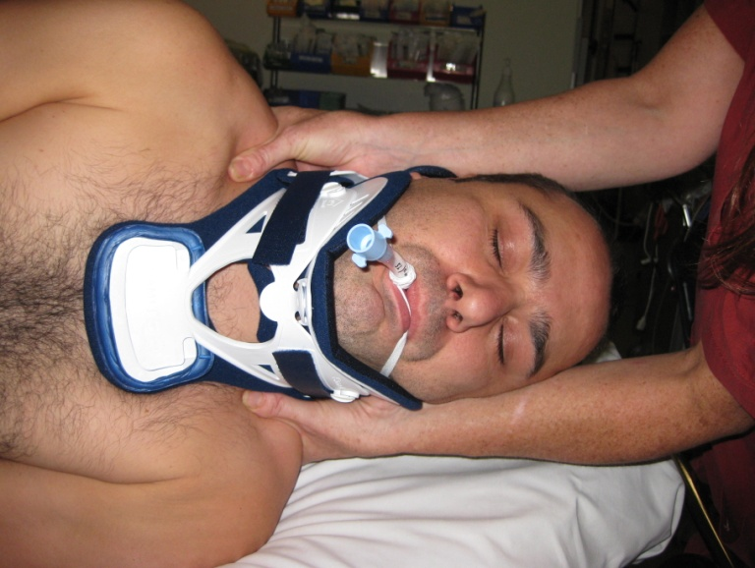

- The ‘head holder’ is the team leader throughout the process of logrolling. They must ensure that all assistants are in correct position and ready to commence.
- Once assured that all assistants are ready, call ‘on my count of three: one, two, three’, and roll should occur on three.
- This process repeats on return to resting position – ‘back on my count of three; one, two, three’.
- The ‘head holder’ must continue to support the head until completion of the procedure or for as long as the patient is being repositioned (e.g., slide sheet up the bed).

Alert:
Clinicians should always be aware of the risk of neurogenic shock in severe acute spinal injury with possible cord involvement. Neurogenic shock is defined as vascular hypotension with associated bradycardia usually resulting from traumatic disruption of the sympathetic outflow between (T) 1 and Lumbar (L) 2 and the subsequent unopposed vagal tone. The degree of risk is related to the severity of neurological injury, but clinicians should be vigilant as neurogenic shock can progress to cardiac arrest.

2.2 Spinal Injury Management Plan
The Spinal Injury Management Plan (available in the DHR) was developed to provide appropriate, safe and consistent care to patients with a spinal injury. This tool, which aids clinical handover, outlines restrictions placed on patient’s mobility, orthosis prescribed, donning and doffing orders and progress with patient education for discharge planning. This flowsheet is a clinical order and restrictions documented should be strictly adhered to.
- The Nursing Team Leader may complete the form only when restrictions have already been documented by the neurosurgical team in the patient’s notes.
- The form should be completed within 4 hours of admission to the inpatient setting.
- The form should be updated as soon as the patient’s condition changes and restrictions are lifted or further restrictions are placed on mobility.

2.3 Traumatic Spinal Injury and Spinal Surgery Observations
The Spinal Injury – Surgery Observations (available in the DHR) is designed to objectively assess motor and sensory nerve function in patients with a spinal injury or who have undergone a spinal surgery. The aim is to identify any neurological compromise as a complication or deterioration in the patient’s condition, to provide documented baseline function prior to a spinal procedure and to confirm stability or improvement.

Procedure
- To be commenced on admission to the Emergency Department, Post Anaesthetic Recovery Unit (PACU) or inpatient unit.
- For traumatic spinal injury - performed hourly until surgical fixation or treatment plan documented. If for conservative management/orthosis, perform at time of first mobilised then after a further hour, continue four hourly (Q4/24) until standing x-ray reviewed and cleared by neurosurgical team.
- Pre-operative elective spinal surgery – perform one baseline assessment.
- Post-operative – ½ hourly for 2 hours, hourly for 4 hours then Q4/24 hourly until stable for 72 hours or ceased with clarification from the Neurosurgical team or Nursing Team Leader.
- Begin with documenting level of injury or levels of surgery in the space provided together with the need for traction or orthosis.
- If injury level is T3 or above, both upper and lower motor and sensory assessments required. If injury level is below T3, only lower limb motor and sensory assessment is required, the upper limb section does not need to be completed.

Motor Assessment
The following exercises must be performed to test motor function in the upper and lower limbs. After each exercise, a numerical score should be recorded for each muscle group using the Motor Grading Scale (0-5).

Upper Limbs:
Shoulder Abduction | Place supporting hand on the patient’s shoulder and resisting hand on the wrist/forearm. Ask patient to lift arm out from body, and as they lift arm apply resistance downward. Assessing the deltoid muscle and axillary nerve (nerve root C5/C6). | 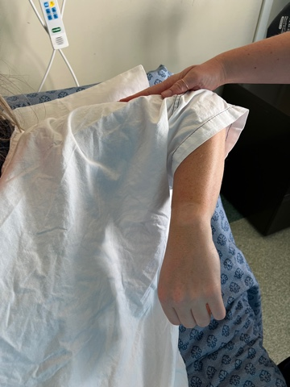
Elbow Flexion | Place supporting hand on patients bent elbow and resisting hand on anterior wrist. Ask patient to flex arm towards the face and apply resistance downward. Assessing biceps brachii muscle and musculocutaneous nerve (nerve root C5/C6). | 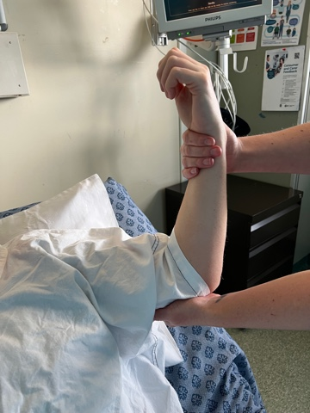
Elbow Extension | Place supporting hand on patient’s bent elbow and resisting hand on anterior. Ask patient to straighten arm and apply resistance in opposite direction. Assessing tricep muscle and radial nerve (nerve root C5/C6/C7). | 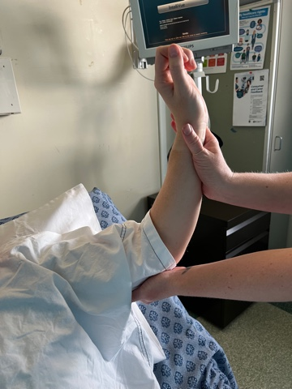
Wrist Flexion | Support patient’s forearm and ask them to make a fist and flex wrist downwards. Apply resistance upwards in attempt to keep wrist straight. Assessing flexor carpi radialis, flexor carpi ulnaris and radial nerve (nerve root C7/C8). | 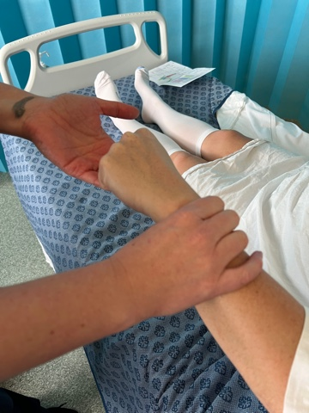
Wrist Extension | Support patient’s forearm and ask them to make a fist and extend wrist upwards. Apply resistance downwards. Assessing extensor carpi ulnaris/ radialis and biceps plus radial nerve (nerve root C8/T1). | 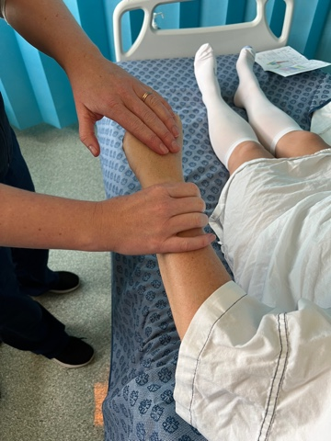
Finger Flexion | Curl the patient’s finger around yours (in a ‘monkey grip’) and ask the patient to resist you straightening their fingers. Pull gently in attempt to straighten fingers. Assessing flexor digitorum superficialis and profundus muscles and median and ulnar nerve (nerve root C8). | 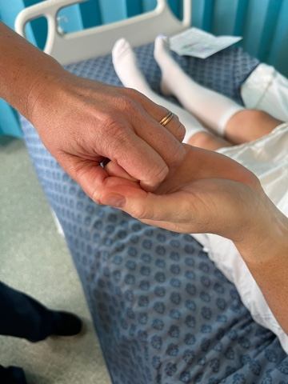
Finger Abduction | Support patient’s wrist, ask patient to place their palm down and spread the fingers. Apply resistance on index and little finger attempting to bring them together. Assessing first dorsal interosseous muscles and ulnar nerve (nerve root T1). | 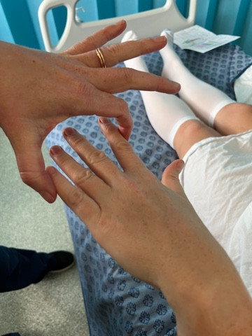
Lower Limbs:
Hip Flexion | Ask patient to bend their knee and apply resistance downwards through lower thigh/knee asking patient to bring knee up towards face. Assessing iliopsoas muscle and lumbar sacral plexus (nerve root L1/L2). | 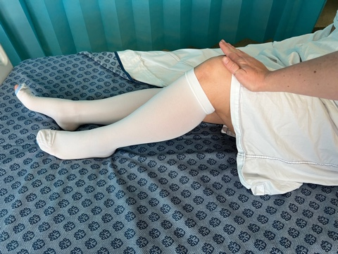
Knee Flexion | Ask patient to bend their knee, place supporting hand on lower thigh/knee, asking the patient to bend their knee further (bring heel to buttocks) and apply opposing force. Assessing hamstring muscle and sciatic nerve (nerve roots L5/S1). | 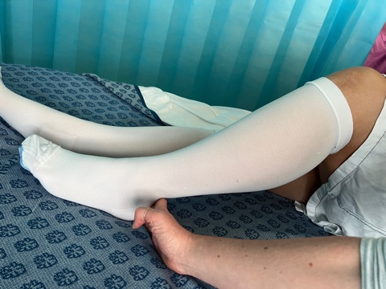
Knee Extension | Ask patient to bend their knee, place supporting hand underneath knee and ask them to kick lower leg up straightening knee, apply opposite force. Assessing quadricep femoris and femoral nerve (nerve root L3/L4). | 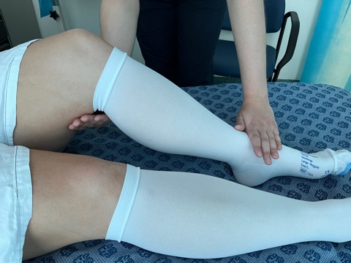
Ankle Dorsiflexion | Place supporting hand on lower leg, ask patient to flex foot up, toes towards face and apply opposing resistance. Assessing anterior tibialis muscle and deep peroneal nerve (nerve roots L4/L5). | 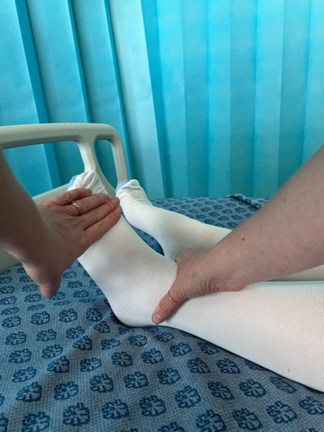
Ankle Plantar Flexion | Place supporting hand on ankle, ask patient point toes downwards, apply opposite resistance on ball of foot. Assessing gastrocnemius muscle and posterior tibial nerve (nerve root S1/S2) | 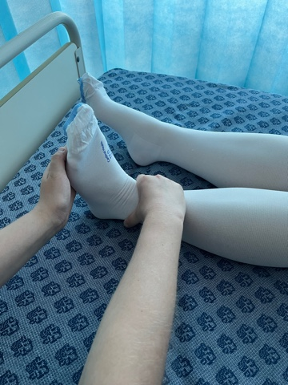
Ankle Inversion | Ask patient to place feet hip width apart. Place your hands on the medial feet bilaterally and ask patient to bring big toes towards the midline keeping legs still, inverting the ankle. Assessing tibialis posterior muscle and tibial nerve (nerve roots L4/L5) | 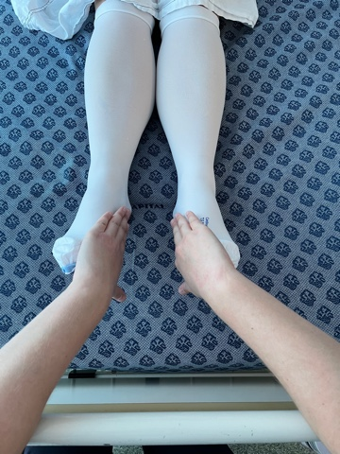
Ankle Eversion | Ask patient to place feet hip width apart. Place your hands on the lateral feet bilaterally and ask patient to push feet away from the midline keeping legs still, everting the ankle. Assessing tibialis posterior muscle and tibial nerve (nerve roots L4/L5) | 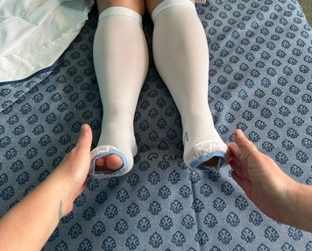

Sensory Assessment
- Gain patient consent.
- Using hand touch, assess both medial and lateral limb and gain patient feedback.
- Examiner should assess bilateral limbs simultaneously to identify subtle differences or deficits.
- Observations should be documented as ‘present’, ‘tingling/pins and needles’ or ‘no sensation/numb’.
- Specifics should be then documented on the DHR in ‘Flowsheets’.

2.4 Spinal Orthosis
Spinal orthoses (braces, splints, or other artificial external devices serving to support the spine) are prescribed to patients as an immobilisation device during the diagnostic phase (in the instance of possible cervical injury) and for stabilisation and management of a confirmed fracture. Appropriate orthoses are prescribed by Neurosurgical or Shock/Trauma registrars or consultants and should be suitably fitted by qualified physiotherapists, medical officers or registered nurses who have been assessed as competent to do so by their relevant work areas.

2.4.1 Cervical Collar
Suspected and confirmed cervical injuries are managed with the application of a cervical collar.
- For a conscious and cooperative patient, a soft collar with the alert sticker “C-spine Not Cleared” will be applied in the pre-hospital setting. This is used to consciously and physically acknowledge a potential c-spine injury and to prompt the use of spinal precautions when repositioning, but not to immobilise. It is felt that a fully awake and alert patient will stabilise their own spine, with muscle spasm and pain providing adequate immobilisation and the risks associated with rigid trauma collars eliminated. These soft collars remain in situ until the c-spine has been cleared, in which case they can be removed, or until an injury has been confirmed.
- For a patient with an altered state of consciousness or cognition or who is uncooperative, a rigid trauma collar will be fitted in the pre-hospital setting.
- If an injury has been radiographically confirmed, or a patient has had a rigid trauma collar on within 4 hours of admission, a Miami J collar or an Aspen collar (NCH) should be fitted. Extended application of rigid collars can cause pressure injuries, increase intracranial pressure, restrict venous return, and increase patient discomfort and aspiration risk.

Initially, a cervical collar (routinely, a Miami J collar or Aspen collar (NCH)) should be fitted by the physiotherapist, medical officer or registered nurse, and worn for the time prescribed by the treating/consulting neurosurgeon.

Note, it is reasonable, with consultation from Neurosurgery, to remove Miami J collars or Aspen collar from patients who are intubated and heavily sedated whilst they are lying with no interventions, to reduce the risk of pressure injures. The Miami J collar / Aspen collar should be reapplied when suctioning, rolling, for transport or when sedation is reduced.

To fit a Miami J collar

- Size it up: Use fingers to observe and determine the vertical distance between the highest point of the trapezius and the top of the chin when the head is in the desired treatment alignment.
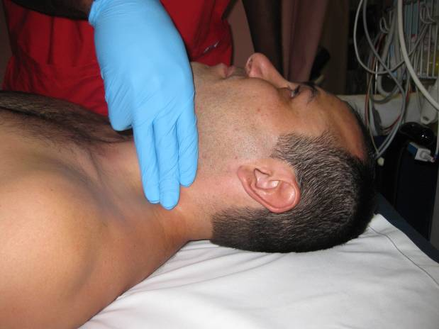
- Select appropriate collar size by using the distance observed in step 1 and corresponding it to the distance from the top of the Velcro strap to the bottom edge of the collar plastic.
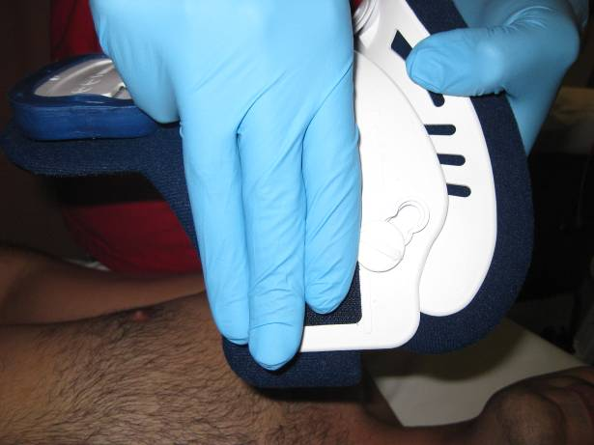

- Miami J sizes are phenotype-driven according to sizing silhouettes and come in Adult Tall, Regular, Short as well as specialty sizes Stout, Super Short and Extra Small.

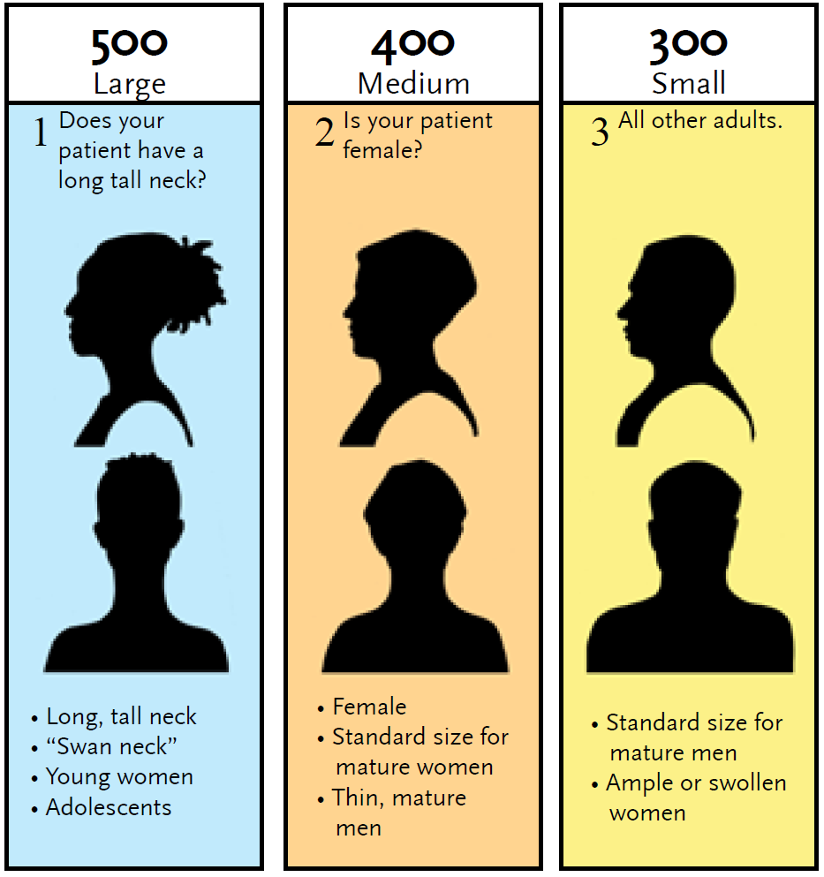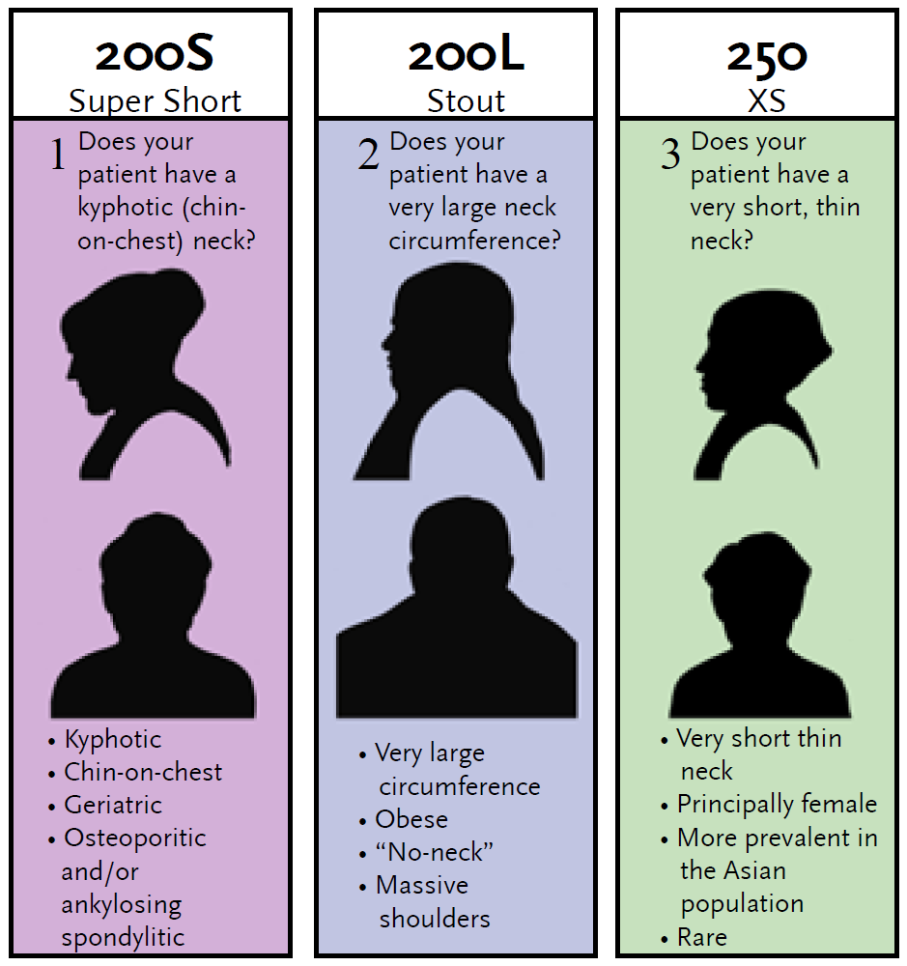

- Two persons are needed for initial collar placement: one to maintain the patient’s head and neck in proper alignment, the second to fit the collar.
- Position patient with arms to the side, shoulders down and head centrally aligned.
- Slide the Back Piece behind the patient’s neck and centre it. To avoid pushing/pulling on the patient, push down into the mattress during slide and avoid towels or other materials which will increase friction. Ensure the blue Sorbatex™ padding extends beyond the edge of the hard plastic.
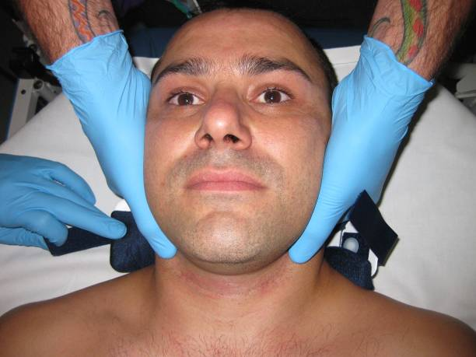
- To apply the front, flare the sides out, slide it up the chest wall and ‘scoop’ up to achieve a neat fit under the chin. Caution must be taken to ensure that the head is not extended during this process.
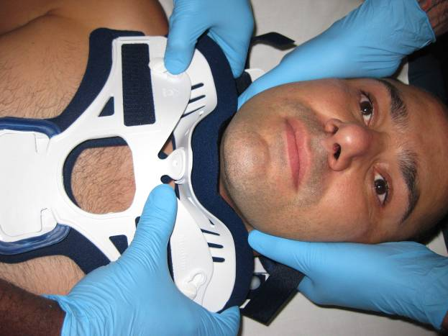
- Orient the sides of the collar up, away from the trapezius, and toward the ears.
- Place the front of collar inside the back, lining the blue Velcro straps up with the ‘buddy’ Velcro on the collar.
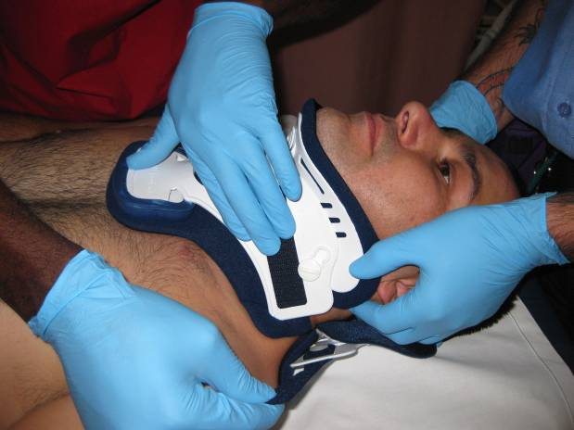
- Tighten straps alternately, one at a time, ensuring that they finish up equal in length (an indication that both the front and back are centred to the midline).If the patient can slip their chin inside the collar, it is clear indication that it is not snug enough and proper alignment is not being maintained.
- Miami J collars should be removed daily at a minimum, to inspect skin integrity and change the blue Sorbatex padding. Each patient should have 2 sets of padding to be interchangeable, when removed they should be washed in warm soapy water, rinsed and air dried (a mechanical dryer will shrink the pads) ready to use the next day.
- Any removal of the collar should be in keeping with the precautions required and outlined in the Spinal Injury Management Plan and performed by staff who have undergone appropriate training and assessment.

Pressure injuries can easily occur underneath the Miami J collar, especially on bony prominences such as the sternum, clavicles and occiput as well as trapezius. Underlying skin should be inspected for redness or signs of pressure injury when the collar is removed or if the patient reports any irritation. Any areas of redness should have management strategies applied as soon as they are observed.
- Check blue Sorbatex padding is covering rigid plastic edges.
- Ensure Velcro straps are aligned with buddy Velcro so ensuring appropriate fit.
- Apply Mepilex border dressings to reddened or irritated areas to offload pressure. Bulkier dressings such as combine will increase pressure and should be avoided.
- If a pressure injury is noted, follow normal procedure including referral to the Tissue Viability Unit and completing a report in the clinical incident reporting system.

To fit an Aspen collar (NCH)
Prior to applying a collar, all clothing and jewellery should be removed, to prevent potential pressure areas. (Aspen Collar In-service Training): https://www.youtube.com/watch?v=jgxv4L9CZbg)

Staff should be trained in the fitting and application of the specific collar used in the emergency department (e.g. Aspen collar) prior to using them.

2.4.2 Thoracic, Lumbar and Sacral Rigid Spinal Bracing
For management of confirmed thoracic, lumbar and sacral fractures, a rigid spinal brace, also known as orthoses may be prescribed.

The referral for the measurement, supply and fitting of rigid spinal braces to the Physiotherapy Department will only be accepted upon referral from the relevant medical team and after an appropriate review by a Neurosurgical Registrar or Consultant.

For patients assessed by a Neurosurgical Registrar or Consultant as having a non-complex fracture between the spinal levels of T8 and S1 requiring rigid spinal bracing (TLSO and/or LSO) that would otherwise be managed as per a usual medical admission (i.e. not in a specialised neurosurgical setting), the relevant brace will be measured, supplied and fitted through the Physiotherapy Department. Please see Attachment 1 for spinal orthoses indication guide.

NCH Only:
For patients assessed as having complex and/or unstable fractures or fractures between the level of C7 and T8 that require neurosurgical intervention, nursing and/or specialised bracing (Halo traction; Cervical-Thoracic orthosis (CTO); Cervical-Thoracic-Lumbar-Sacral orthosis (CTLSO)) patients will require transfer to Canberra Hospital for specialised management. The determination of the required management will be based on appropriate neurosurgical consultation and take into consideration the level and type of fracture. The NCH Physiotherapy Department is unable to measure, supply or fit the above braces due to their specialised nature.

On referral it will be the responsibility of the treating medical team to liaise with the Neurosurgical Registrar and/or Consultant to determine the following:
- Type of bracing requested (LSO, TLSO etc)
- Length of time bracing required
- Suitability to apply brace in lying and seated position
- Spinal precautions – log roll, mobility etc
- Functional restrictions – able to sleep with brace on/off; able to mobilise or shower brace on/off.

The above information will be required to be documented and relayed to the physiotherapist upon referral for a rigid spinal brace.

On receipt of the above information it will be the responsibility of the Physiotherapy Department to measure, supply and fit the appropriate spinal brace as requested. It is also the responsibility of the Physiotherapy Department to ensure credentialed and competent practitioners are available for the above process.

Measurement:
LSO/TLSO
See Attachment 1 and 2 for details.

Supply:
The supply of standard LSO and TLSO braces will be managed by the Physiotherapy Department and will be sourced by:
- Utilisation of the limited stock kept by the Physiotherapy Department. Any braces utilised will be cross charged to the relevant home ward of the patient requiring the brace.
- Through the ordering of new stock (approximately 3 days delivery time). The ordering of the stock will be the responsibility of the Physiotherapy Department and will again be cross charged to the relevant home ward.

Please note that the supply of a rigid spinal brace can only be completed upon approval from the ward CNC to accept the cost of the supplied brace.

It will be the responsibility of the Physiotherapy Department to maintain a small stock of commonly used LSO and TLSO sizes to allow for an efficient response to any request for LSO and TLSO braces. Please note that if ordering of a brace is required the patient will have to remain on bed rest and spinal precautions until the appropriate brace has been sourced.

2.5 Spinal Traction (Canberra Hospital Only)
Gardner Wells Tongs
Applied either in the neurosurgical acute care unit or in the operating theatre by the neurosurgical Consultant, Gardner Wells Tongs are indicated in cases of facet subluxation or dislocation, and in burst-type fractures. Gardner Wells Tongs immobilise the cervical vertebrae, reduce a fracture and/or dislocation, reduce pressure on the spinal cord in the instance of a burst fracture and provide relief from the pain associated with malalignment.

Equipment
- traction bed with head bar and pulley
- Gardner Wells Tongs
- double cord
- local anaesthetic
- antiseptic
- blue under pads
- clippers
- syringes and needles
- tap water
- Leukoplast strapping
- weight bag and S hook
- sterile gloves and gown
- sandbags x 2

Procedures
- Consent is obtained by the attending registrar or consultant (as per the Informed Consent - Clinical Policy, available on the Policy and Guidance Documents Register).
- Assess the patient’s level of understanding and educate the patient and significant others about the immobilisation process.
- Administer premedication/analgesia as prescribed.

If being applied in the Operating Theatres
- Follow preoperative spinal procedure (as per Section 3.1)
- Post procedure observations as per points 6-13 below.

If being applied in the Neurosurgical Acute Care Unit (NACU) or Intensive Care Unit (ICU):
- Position the patient in the supine position in centre of the bed to ensure the line of pull will be correctly set up.
- The scalp may be clipped in the temporal region superior to the ear depending on preference. The scalp is prepared with antiseptic and the insertion sites are infiltrated with local anaesthetic. The tongs are positioned by the consultant with the sterile points contacting the skin at the predetermined sites of placement. The points are then advanced until the position of the spring-loaded points shows that the proper pressure is being exerted. An assistant may be necessary to hold the metal ring of the tong. Weights are applied via a double cord to reduce the fracture-dislocation. A cervical spine x-ray may be obtained to evaluate vertebrae alignment.
- Position either head bar or pulley at the head of the traction bed ensuring the line of pull will be in alignment with the cervical spine.
- Apply traction by tying a double cord (two separate cords) to the tongs and passing it straight over the pulley. Tie double cord to S-hook and attach weight. Ensure the correct weight is applied and that the weight hangs freely if the height of the bed is adjusted.
- Secure knots by taping the loose end to the main body of the rope as taping the actual knot will make observation and adjustments difficult.
- The consultant may request that the bed be tilted with the foot down to maintain counter traction.
- Monitor neurological status including spinal injury-surgery observations and vital signs hourly for 4 hours and then Q4/24 for duration (or more frequently if prescribed and documented in the patient’s clinical record)
- Inspect pin sites each shift. Clean with normal saline, monitor for any signs of infection and report these to the medical officer.
- The consultant should document specific instructions for patient logroll. Ensure Q4/24 turns for pressure injury prevention following spinal precautions outlined in Section 2.1.

Note:
Traction is not to be removed when rolling patient. Attend normal c-spine precautions including head hold whilst maintaining traction.

- Apply anti-embolic stockings and sequential compression devices, encourage deep breathing and leg exercises. Educate patient on the signs and symptoms of venous thromboembolism (VTE) and pressure injuries.
- Administer low dose heparin, analgesia, aperients and antispasmodics as prescribed by the medical officer.
- Patients with Gardner Wells tongs will have progressive cervical spine x-rays which can be done on the ward with a mobile x-ray. If patient is required to move anywhere within the hospital, they require a registered nurse escort, and traction should never be removed without specific documentation from a consultant or registrar and even then, manual traction must be applied.
- If patient has cervical surgery, ensure all relevant equipment for Gardner Wells tongs is returned to the Neurosurgical ward from the Operating Theatre.

Alert:
With proper placement of the tongs and continuous traction, the patient should have minimal pain which should be relieved by medication. Notify neurosurgical registrar immediately if the patient experiences undue discomfort or change in neurological status. Muscle spasms are a common discomfort rather than pain –consider diazepam.

2.6 Crown Halo and Vest
A crown halo and vest are utilised as an external stabilisation of unstable high cervical spine fractures or significant cervical ligamentous injury. They provide precise positional control of the cervical spine while allowing for early mobilisation and a shorter hospital stay for the patient. A crown halo and vest can either be applied within the NACU or in the operating theatres.

Determining Appropriate Size of Crown Halo and Vest
- Measure the greatest circumference of the skull (about ½” above the ears)

- Choose the appropriate size halo ring as per manufacturers advice.
- Measure the patient’s chest circumference at the xyphoid process.

- If patient has a pendulous abdomen, measure around the widest part of the costal margin and the sternal length to ensure appropriate fit.

- Choose applicable vest size as per the manufacturer’s advice.

Equipment
- Pre-packaged halo ring (measured for size as per below), including bolts and halo clamps
- Pre-packaged vest with synthetic liner (measured for size as per below) including transverse bars, connectors and bolts
- Tape measure and sizing chart
- Positioning spoon
- Titanium skull pins with locking nuts x 5 (1 pack)
- Hair clippers
- Local anaesthetic, drawing up needle and syringes
- Basic dressing pack with extra gauze squares
- Sterile gloves
- Torque pin driver and wrench (kept in neurosurgical registrar’s office)
- Manufacturers ‘Patient Information Manual’.

Pre-Operative Procedure
- Explain the procedure to the patient and identify patient as per the Patient Identification and Procedure Matching Procedure (available on the Policy and Guidance Document Register).
- Maintain positional restrictions in accordance with Spinal Injury Management Plan documented by registrar or consultant.
- Ensure consent is signed – re consent will have to be completed if original was signed >24 hours previously.
- Check and record full set of vital sign observations and baseline Spinal Injury – Surgery Observations. Note any pre-existing neurological deficit.
- Keep nil by mouth as per the Fasting Guidelines for Patients Requiring Sedation or Anaesthesia Guideline (available on the Policy and Guidance Documents register). Ensure IVC is in situ and appropriate intravenous therapy is prescribed.
- Perform pre-operative patient wash and dress in inpatient gown.
- Complete Preoperative Checklist.

Post Operative
- Patient to remain resting in bed with restrictions as documented by the medical officer until a post-procedure x-ray has been performed to confirm correct alignment.
- Monitor spinal observations and vital sign observations 1/24 for 4 hours then 4/24 for 24 hours if stable, unless otherwise requested by Neurosurgical consultant.
- Ensure the patient is aware of the need to report pain and sensory changes post procedure.
- Await documented clearance from Neurosurgical consultant before mobilising the patient. Once cleared patients should get out of bed by rolling onto their side at the edge of the bed, dropping their legs off the edge and pushing sideways with their elbow and hand at the same time. This method puts less stress on the front pins. Refer to physiotherapy for formal assessment.
- Pin sites are cleaned daily using normal saline and gauze swabs or may be cleaned with shampoo on hair washing days (conditioner should not be used). Provide patient education on performing this daily at home once discharged. If the patient is unable to do this, refer to Community Nursing on discharge or educate family members/carers.
- Observe pin sites and educate the patient on reporting any of the following:
- inflammation, swelling and/or discharge
- tracking (open area where the skin has pulled away from the pin)
- pain or tenderness around the pin site
- clicking noises.
- It is important to keep the patient’s skin and fleece liner as clean as possible because the liner should not be changed unless it is medically necessary. No soap, lotion or powder should be used under the vest because it cannot be adequately removed and may irritate the skin. To wash the skin under the vest, use a wipe that has been wrung out in warm water. Pull it back and forth in a drying motion beneath both front and back portions of the vest. The skin under the vest should be inspected daily with a torch in order to detect pressure areas. Extra fleece or foam may be inserted to relieve pressure points that may occur when the patient assumes certain positions. Try to keep the synthetic vest liner dry at all times, however if the lining gets wet, dry it with a hair dryer on a cool setting.
- If the vest liner should get soiled it may have to be changed as per the manufacturer’s instructions.
- The patient can clean the rest of their body via sponge bath. If the patient is mobile, they can have a shallow bath, ensuring that the bottom of the vest is protected with plastic.
- Provide the patient with the manufacturer’s Patient Information Manual.

Alert
In the event that cardiopulmonary resuscitation is required, each brand of crown halo and vests have specifications on how to release front plate of the vest to gain direct access to the chest. On application of the halo, all staff should familiarise themselves with these specifications and it should be documented as a clinical alert. Any equipment provided from the manufacturer which is required for this process should be kept on the patient at all times.

Back to Table of Contents

Section 3 – Spinal Surgery Management

The following pre- and post-operative procedures should be followed for the management of patients who are undergoing elective surgery for a disorder of the spine and following surgical management of an acute spinal injury.

3.1 Pre-operative
- Explain the procedure to the patient and identify patient as per the Patient Identification and Procedure Matching Procedure.
- Follow positional restrictions in accordance with Spinal Injury Management Plan documented by registrar or consultant and assist with logrolling as required.
- Ensure consent is signed – re-consent will have to be completed if the original was signed >24 hours previously.
- If not already collected in pre-admission clinic, ensure that the following routine bloods have been collected and that results are available prior to the patient going to theatre:
- Full blood count (FBC), urea, electrolytes and creatinine (UEC), full coagulation profile (FCP), Group & Hold.
- Check bowels have opened recently, if not, consider aperients prior to theatre and commence bowel chart.
- Check and record full set of vital sign observations and baseline Spinal Injury - Surgery Observations. Note any pre-existing neurological deficit.
- Give pre-operative education as well as instructions regarding deep breathing and coughing exercises, VTE and pressure injury prevention.
- Nil by mouth from midnight (or as per the Fasting Guidelines for Patients Requiring Sedation or Anaesthesia Guideline). Ensure intravenous catheter (IVC) is in situ and appropriate intravenous therapy is prescribed.
- Perform pre-operative patient wash and dress in inpatient gown.
- Measure patient for anti-embolism socks (TEDs) and apply.
- Complete Pre-operative Checklist.

3.2 Post-operative
Follow the general post-operative care outlined in the Post-operative Handover and Observations – Adult Patients (First 24 Hours) Procedure (available on the Policy and Guidance Documents register) and in addition:

- Attend Spinal Observations:
- ½ hourly for 2 hours, Q1/24 for 4 hours, then Q4/24 if stable. Continue Q4/24 until mobilising.

Alert:
Progressive neurological deterioration resulting from cord compression is an emergency. Notify medical officer if there is any deterioration in limb movement, power or sensation.

- Nurse the patient resting in bed with positional restrictions as directed by the surgeon. Post-operative spinal patients are not to have an alternating air mattress unless approved by the neurosurgical team.
- If staples are in situ, replace the dressing on day 2 with a dressing of surgeon’s choice.

Note:
If Dermabond is in situ, do not apply adhesive secondary dressings.

Alert:
If a dural breach has occurred intra operatively, patient may need to rest in bed lying flat for ≥48hrs or as specified by surgeon. Strict hourly wound site checks and monitoring for cerebrospinal fluid leak is required, with escalation to Neurosurgery team if any leak is suspected.

- Surgical drains are generally removed on Day 1 unless high output post operatively or specified otherwise by neurosurgical team. Remove drain when ordered in accordance with the Drain Management Procedure (available on the Policy and Guidance Documents register).
- Encourage deep breathing, coughing and leg exercises, ensure TED stockings and sequential compression devices (SCD) in situ and source SCD pump from Central Equipment Store.
- If the patient cannot move themselves in bed, ensure appropriate pressure injury prevention management strategies have been implemented.
- Routine post-op bloods – Day 1 – FBC, UEC.
- Mobilisation – as per surgeon’s orders in ‘Post-operative Instructions’.
- Record bowels daily and respond early to concurrent days of bowels not open.
- Remove any stitches or staples Day 7-14, as directed by neurosurgeon.
- Patient will follow up with consultant in 6 weeks post discharge.

3.3 Anterior Cervical Discectomy and Fusion (ACDF)
In addition to the post-operative risks and management of spinal surgery outlined in section 3.2, patients who have undergone a Cervical Discectomy and Fusion with an anterior approach are at risk of localised oedema or haematoma which may cause difficulty swallowing and potentially obstruction of airway resulting in a medical emergency.

First 12 hours post operation
- Supervise patient during oral intake, observing for any signs of dysphagia or possible aspiration. If any concerning signs cease oral intake, report to surgical team immediately for review and consider speech pathology.
- Closely assess airway patency and escalate any dyspnoea or stridor to surgical team immediately or consider activating a MET in accordance with the Vital Signs and Early Warning Scores – The Canberra Hospital Procedure (available on the Policy and guidance Documents Register).
- Report any new or increasing hoarseness of voice or visible swelling to the medical officer immediately.
- Monitor Exudrain hourly. Ensuring patency of drainage will reduce the risk of haematoma formation. Report sudden large volumes of frank blood drainage to the surgical team and otherwise manage as per the Drain Management Procedure. Refer to post operative instructions for guidance on requirement of suction and only place suction on Exudrain if specifically documented.

Alert:
Airway obstruction from haemorrhage or oedema has rapidity of onset and requires immediate activation of a Code Blue as per Vital Signs and Early Warning Scores Procedure for your facility.

Back to Table of Contents

Section 4 - Discharge and Community Management of a Patient with a Cervical Collar

4.1 Discharge of a Patient with a Cervical Collar
As per best practice guidelines, patients who are discharged with a cervical collar must have a plan for safely removing collar, assessing skin integrity and changing collar pads daily or every second day. This reduces the risk of pressure injuries, allows optimal personal hygiene practices and improves the patient’s quality of life.

- The consulting Neurosurgery team must document in the patient’s clinical record, using the Spinal Injury Management Plan, how the patient must be immobilised during collar pad changes (supine or sitting position) and the number of assistants required.
- The patient and/or their family/carers should be provided collar education by a physiotherapist with cervical orthosis competency.
- Consider referring to Occupational Therapy if equipment is needed.

If the patient is unable to perform collar pad changes themselves and does not have family or a carer who can perform this for them daily or every second day on discharge, referral to Community Nursing services should be attended as below.

4.2 Discharge Planning and Referral to Rehabilitation, Aged and Community Services (RACS) Community Care Program (CCP) Community Nursing for Cervical Collar Management
Canberra Hospital uses the Miami J® Cervical Collar and North Canberra Hospital uses the Miami J® Cervical Collar and the Aspen® Cervical Collar.

For referral of a patient for Community Nursing cervical collar management:
- Contact the CNC Post Acute Care (PAC) (T: 02 5124 7958 / 0475 840 873) or the relevant Community Nursing Team Leader (if the CNC PAC is not available) prior to Central Health Intake (CHI) referral. This ensures appropriate equipment, community nursing education and adequate, timely support.
Community Nursing Teams Team Leaders:
Belconnen T: 5124 1439
Central T: 5124 1591
Phillip T: 5124 1278
Tuggeranong T: 5124 1384
- Provide handover of patient using ISBAR including how the cervical spine must be immobilised during padding change (supine or sitting) to ensure appropriate equipment can be coordinated (e.g., community nursing manual handling powered hospital bed must be used if collar is to be changed in supine position).
- For both ACT residents and residents from other local area health services refer to Discharge Liaison Nurse to assist coordination of discharge with cervical collar.
- In addition to this, ACT residents should be referred to community nursing through the Order tab of the DHR as follows:
- Orders > Future Outpatients > Place new discharge order.
- Type ‘community’ in text box and click ‘new’ search.
- Select ‘Outpatient referral to Community Care Nursing and CNC’
- Referral will be highlighted in green, double click to open referral.
- Complete all fields of referral (ignoring PROVIDER text box with hazard icon).
- In ‘Type of Care’ select ‘Home Care’ as well as ‘CNC’ (note: if it is the weekend, public holiday or after hours also select LINK). In the CNC options that then appear, select ‘Post Acute Care CNC’.
- When all fields are completed, click Accept and then Sign.
If the collar care is to be done with the patient lying supine for daily skin check and changing of padding as per the medical order, a community nursing manual handling powered height adjustable hospital bed with standard hospital mattress will be required in the home for community nurses to provide the collar care. If the patient is unable to immobilise their cervical spine and a second person is required to ‘head hold’ as per the medical order, then the adjustable hospital bed must also have a removal headboard. Note that this bed is for manual handling and the patient is not required to sleep in it in their home.

4.3 Community Nursing Procedure to Organise a Community Nursing Manual Handling Powered Hospital Bed For a Resident of the ACT
Community nursing (usually the CNC or Nurse Manager) telephones the RACS Coordinator of Oxygen & Equipment Services (T: 5124 1065, M: 0438 286 944) to discuss the availability of the following bed types:
- community nursing manual handling powered height adjustable hospital bed with standard hospital mattress
- community nursing manual handling powered height adjustable hospital bed with standard hospital mattress with a removable headboard.

Hospital beds are available in one piece or a pull apart configuration to allow for the bed to be dismantled for delivery to the patient’s home. The requirement for a removable headboard and the ability for the bed to be dismantled for delivery must be known to ensure the correct hospital bed is delivered to the patient’s home.

The requirement for a community nursing manual handling powered hospital bed (for manual handling not for sleeping) will need to be discussed with the patient, for patient consent and to gather the information required for community nursing to complete all the fields in the DHR order “ELS Equipment Referral” after discussion with the relevant Nurse Manager.

If the appropriate community nursing manual handling powered hospital bed is not available, the CNC PAC is to liaise with hospital ward CNC and hospital occupational therapist (OT) for advice.

Other Contacts
The Equipment Loan Service (ELS) T: 5124 1057
Location: Village Creek Health Centre, 37 Kingsmill Street Kambah ACT 2902
E: EquipmentLoanService@act.gov.au

Central Health Intake (CHI)
T: (02) 5124-9977
CHI Clinician only phone line to speak with CHI nursing team T: 5124 0870. It is manned Mon- Fri 08:30 – 17:00, no message bank (closed Wednesday 1530 for education). This number is only for internal clinicians. Please do not share this contact number with consumers or external stakeholders.
Back to Table of Contents

Evaluation

Outcome
- All patients with spinal injuries (suspected or confirmed) are managed as per this procedure.

Measures
- Completion of observations and adherence to management plans outlined in this document will be reported and reviewed in Clinical Handover and case reviews.

Back to Table of Contents

Related Policies, Procedures, Guidelines and Legislation

Policies
- Nurse and Midwifery Board of Australia (NMBA) requirements for practice Informed Consent- Clinical
- Patient Identification and Procedure Matching
- Informed Consent - Clinical

Procedures
- Vital Signs and Early Warning Scores – The Canberra Hospital
- Acute Pain Service – adults and children
- Infection Prevention and Control
- Drain Management
- Aseptic Technique
- Venous Thromboembolism (VTE) Prevention (Adults and Children)
- Patient Identification and Procedure Matching
- NCH Spinal Immobilisation – Emergency Department Clinical Procedure

Guidelines
- Fasting Guidelines for Patients Requiring Sedation or Anaesthesia
- Post-operative Handover and Observations – Adult Patients (First 24 Hours)

Legislation
- Health Records (Privacy and Access) Act 1997
- Human Rights Act 2004
- Work Health and Safety Act 2011
- Carers Recognition Act 2021

Back to Table of Contents

References

- Kwan I, Bunn F & Roberts I (2001) Spinal immobilisation for trauma patients (Review), The Cochrane Collaboration, 4:1-15
- Hoffman JR, Mower WR, Wolfson AB et al (2000) Validity of a set of clinical criteria to rule out injury to the cervical spine with blunt trauma, New England Journal of Medicine, 343:94-99
- Stiell IG, Clement CM, McKnight RD, Wells GA, Brison R, Schull M, Rowe B, Worthington J, Eisenhauer M, Cass D, Greenberg G, MacPhail I, Dreyer J, Lee J, Bandiera G, Reardon M, Holroyd B, Lesiuk H. (2003) Comparative Validation of the Canadian C-Spine Rule and the NEXUS Low-Risk Criteria in Alert and Stable Trauma Patients. New Engl J Med, 349:2510-8
- Clinical Quality and Patient Safety Unit, Queensland Ambulance Service (2016). Clinical Practice Procedures: Trauma/Cervical Collar. Accessed from http://ambulance.qld.gov.au/clinical.html
- Michaleff ZA, Maher CG, Verhagen AP, Rebbeck T, Lin CW. Accuracy of the Canadian C-spine rule and NEXUS to screen for clinically important cervical spine injury in patients following blunt trauma: a systematic review. CMAJ. 2012 Nov 6;184(16):E867-76. doi: 10.1503/cmaj.120675. Epub 2012 Oct 9. PMID: 23048086; PMCID: PMC3494329.
- Badhiwala JH, Lai CK, Alhazzani W, Farrokhyar F, Nassiri F, Meade M, Mansouri A, Sne N, Aref M, Murty N, Witiw C, Singh S, Yarascavitch B, Reddy K, Almenawer SA. Cervical spine clearance in obtunded patients after blunt traumatic injury: a systematic review. Ann Intern Med. 2015 Mar 17;162(6):429-37. doi: 10.7326/M14-2351. PMID: 25775316.
- Oh JJ, Asha SE. Utility of flexion-extension radiography for the detection of ligamentous cervical spine injury and its current role in the clearance of the cervical spine. Emerg Med Australas. 2016 Apr;28(2):216-23. doi: 10.1111/1742-6723.12525. Epub 2015 Dec 20. PMID: 26685877.
- Slaar A, Fockens MM, Wang J, Maas M, Wilson DJ, Goslings JC, Schep NWL, van Rijn RR. Triage tools for detecting cervical spine injury in pediatric trauma patients. Cochrane Database of Systematic Reviews 2017, Issue 12. Art. No.: CD011686. DOI: 10.1002/14651858.CD011686.pub2. Accessed 29 August 2021.
- Boulter JH, Lovasik BP, Baum GR, Frerich JM, Allen JW, Grossberg JA, Pradilla G, Ahmad FU. Implications of Isolated Transverse Process Fractures: Is Spine Service Consultation Necessary? World Neurosurg. Elsevier 2016 Nov; 95:285-291.
- Nagasawa DT, Bui TT, Lagman C, Lee SJ, Chung LK, Niu T, Tucker A, Gaonkar B, Yang I, Macyszyn L. Isolated Transverse Process Fractures: A Systematic Analysis. World Neurosurg. Elsevier 2017 Apr; 100:336-341.
- Alijanipour, P., Greif, D., Lebwohl, N.H. et al. Isolated multiple lumbar transverse process fractures with spinal instability: an uncommon yet serious association. Eur Spine J (2019).
- The Royal Melbourne Hospital Thorcolumbar Spine Guideline. (TRM 04.03) K. Gumm et al. V3.0 June 2015, V 2.0 June 2012. https://www.thermh.org.au/sites/default/files/media/documents/clinical/TRM04.03_0.pdf accessed 1st Dec. 2020
- Lee, JY et Al. Thoracolumbar injury classification and severity score: a new paradigm for the treatment of thoracolumbar spine trauma
Journal of Orthopaedic Science. 2005 Nov. 10:6:671-675
- Image of Posterior Ligament Complex. https://www.orthobullets.com/spine/2003/spine-biomechanics. Accessed 17th Sep.
Back to Table of Contents

Definition of Terms

- ACDF – A herniated disc in the cervical spine can be removed through an anterior approach (the front of the neck) to relieve spinal cord or nerve root pressure and alleviate corresponding pain, weakness, numbness, and tingling. A bone graft, which is usually taken from the iliac crest, is then inserted to stabilise. Indications for this procedure are: herniated disc, degenerative disease, bone spurs, cervical stenosis and spondylosis.
- Discectomy – A discectomy is the surgical removal of herniated disc material that is pressing on a nerve root or the spinal cord.
- Disco-ligamentous –intervertebral disc and ligamentous tissues connecting adjacent bony Vertebrae
- Dysphagia – swallowing deficit
- E.A.M – External Auditory Meatus
- Immobilisation: either logroll or mechanical bracing for spinal injury
- Isolated transverse process fracture: A fracture of the vertebrae only involving the transverse process with no extension into other bony elements of adjacent disco-ligamentous structures
- LSO – Lumbar-Sacral orthosis
- MSCT – multi slice computer tomography
- Neurological deficit – clinical examination findings of acute motor or sensory abnormality
- Spinal Fusion – performed by a neurosurgeon in the operating theatre and involves the fixation of an unstable segment of the spine, using bone grafts and/or metal plates and screws. Fusion is performed to limit movement and/or stabilise the spine at a particular level in the cases of Spondylolisthesis, fractures, lesions or deformity.
- TLSO –Thoracic-Lumbar-Sacral orthosis
Back to Table of Contents

Search Terms

Spine, brace, orthosis, traction, trauma, vertebrae, halo, cervical, logroll, Gardner-wells, fracture, spinal, precaution, head hold, observations, c-spine, ACDF, collar, Miami J, spinal injury, neurosurgery, transverse process, TP

Back to Table of Contents

Attachments

Attachment 1: Aspen Product Indication Guide
Attachment 2: Measuring the ASPEN® Contour LSO & TLSO and application videos

Back to Table of Contents

Disclaimer: This document has been developed by Canberra Health Services specifically for its own use. Use of this document and any reliance on the information contained therein by any third party is at his or her own risk and Canberra Health Services assumes no responsibility whatsoever.

Policy Team ONLY to complete the following:
Date Amended | Section Amended | Divisional Approval | Final Approval
21/06/2023 | Complete review | Lisa Gilmore, ED of Surgery | CHS Policy Committee

This document supersedes the following:
Document Number | Document Name
CHHS18/110 | Spinal Injury Management of the Adult

Attachment 1: Aspen Product Indication Guide

Attachment 2: Measuring the ASPEN® Contour LSO & TLSO and application videos
ASPEN® Contour LSO & TLSO Application Guides:
Therapist Video: https://www.youtube.com/watch?v=8h3B44sol7w
Patient Video: https://www.youtube.com/watch?v=3lGZQxoJWbs

