Canberra Health Services
Clinical Guideline (and associated procedures)
Respiratory support – Invasive and Non-Invasive (Neonates and Infants)

Contents

Contents 1
Guideline Statement 4
Scope 4
Alerts 4
Section 1: Introduction to Neonatal Respiratory Support 5
1.1: Respiratory Distress in Neonates and Infants 5
Section 2: General care of neonate requiring respiratory support 6
2.1: Nursing Care and Assessment 6
2.2: Care of an Intubated and Ventilated Neonate 7
2.3: Kangaroo or Skin-To-Skin Care of Neonate on Respiratory Support 8
Section 3: Oxygen saturation targeting 10
Section 4: Continuous Non-Invasive Carbon Dioxide Monitoring 11
4.1: Transcutaneous Carbon Dioxide Monitoring (TCM) 11
4.2: End Tidal Carbon Dioxide Monitoring (ETCO₂) 13
Section 5 – Conventional Mechanical Ventilation (CMV) 15
5.1: Ventilator Set Up Procedure 16
5.2: Usual Range for Ventilation Settings 17
5.3: Assessing Infant and Adjusting Ventilation 18
5.4: Trouble Shooting Conventional Mechanical Ventilation 19
Section 6 – High Frequency Oscillatory Ventilation (HFOV) 20
6.1 HFOV Ventilator Set-Up 21
6.2: Oxygenation and CO₂ Clearance/Ventilation Adjustments with HFOV and DCO₂ Levels 21
6.3: Usual Range of HFOV Settings 22
6.4: Using HFOV in the Clinical Setting 23
6.5: Trouble shooting HFOV 25
Section 7 - Care of an Infant receiving Muscle Relaxants 25
Section 8 - Suctioning 27
8.1: Oropharyngeal and Nasopharyngeal Suctioning 28
8.2: Endotracheal Suctioning – Closed (In-Line) System 29
8.3: Attaching Closed (In-Line) Suction to ETT 30
8.4: Endotracheal Suctioning – Open Suctioning 33
8.5: Suction for Endotracheal Aspirate 35
Section 9: Extubation 36
Section 10 - Neurally Adjusted Ventilatory Assist (NAVA) in Neonates 37
10.1: Principles of Non-Invasive NAVA ventilation (NIV-NAVA) using SERVO-n Ventilator 38
10.2: NAVA Terminologies 39
10.3: Getinge SERVO-n (NAVA) Ventilator and Patient Set-Up 40
10.4: Guide to initial NIV NAVA Settings 43
10.5: Troubleshooting Edi Catheter position 43
10.6: Determining appropriate NAVA Settings 45
10.7: Monitoring and optimisation of NIV-NAVA 45
10.8: Weaning from NIV-NAVA 46
10.9 - Troubleshooting on NIV-NAVA 47
10.10: Invasive Nava 47
Section 11 – Non-Invasive Positive Pressure Ventilation (NIPPV) 48
Section 12 - Bubble Continuous Positive Airway Pressure (CPAP) 48
12.1: Guide to ceasing chronic CPAP 51
12.2: Guide to recommence CPAP 51
Section 13 – Continuous Positive Airway Pressure (CPAP) via Nasopharyngeal Tube 52
Section 14 – Humidified High Flow Nasal Prong Therapy 54
Section 15 - Low Flow Nasal Cannula Oxygen Therapy 57
Section 16 - Respiratory Physiotherapy 58
16.1: Contraindications, Precautions, and Risks of Chest Physiotherapy 60
16.2: Physiotherapy Procedures 62
Section 17: Chronic Lung Disease (CLD) or Bronchopulmonary Dysplasia (BPD) 63
Section 18 – Neonatal Lung Function Assessment - Shift Test and Modified Walsh Oxygen Reduction Trial 65
18.1: Shift Test Procedure 66
18.2: Modified Walsh Oxygen Reduction Air Trail 67
Evaluation 67
Related Policies, Procedures, Guidelines and Legislation 68
References 69
Search Terms 74
Attachments 75
Attachment A: NIV-NAVA Quick Guide 76
Attachment B: Information on Credentialing, Simulator, and Chest Physiotherapy Competency 77
Attachment C: Sentec Digital Monitoring (SDM) Device Troubleshooting 79
Attachment D: Australian & New Zealand Neonatal Network (AZNN) Flowchart for Shift Test for Physiological Chronic Lung Disease 80
Attachment E: Australian & New Zealand Neonatal Network (ANZNN) Shift Test Form 81
Attachment F: Modified Walsh Oxygen Reduction Air Trail 84
Attachment G: Australian and New Zealand Neonatal Network Parent Information Sheet Neonatal Lung Function Assessment (Shift Test) 85

Guideline Statement

This guideline outlines the safe and effective management of neonates and infants requiring respiratory support while being cared for by the Department of Neonatology (Neonatal Intensive Care Unit (NICU) and Special Care Nursery (SCN) at Canberra Health Services. This document outlines the pathophysiology and principles of care involved in providing respiratory support as well as detailing the equipment required and its use and nursing care and physiotherapy that may assist these infants.

Back to Table of Contents

Scope

The document pertains to neonates and infants nursed in the Neonatal Intensive Care and Special Care Nursery.
This document applies to:
- Medical Officers
- Nurses and Midwives who are working within their scope of practice (Refer to Scope of Practice for Nurses and Midwives Policy)
- Physiotherapists
- Medical, Physiotherapy and Nursing Students under direct supervision

Back to Table of Contents

Alerts

- The paediatric patient (2 years or less) requiring Intensive Care may be admitted to NICU after consultation with the Neonatologist on service and in accordance with the admissions policy. The decision whether to transfer to a tertiary Paediatric Intensive Care Unit (PICU) is made by the Neonatologist who will initiate a consultation with Neonatal Emergency and Transport Service New South Wales (NETS NSW). These patients may require different management strategies than usual neonatal patients. Please refer to the Paediatric Patient (Under 2 Years) Requiring Intensive Care and Deteriorating Paediatric Inpatient Management and Planning for the Complex Paediatric Surgical Patient Guideline for additional guidance.
- The Pain Tool PIPP-R is used for all neonates who are intubated, on Continuous Positive Airway Pressure (CPAP) or who are suspected of being in pain. For older infants and paediatric patients, the Comfort B score is used (refer to “Paediatric patient (under 2 years) requiring intensive care”). Appropriate pain management such as positioning, or administration of medication should be implemented according to the patient’s PIPP-R or Comfort B score.
- When providing care as described in this guideline staff should adhere to clinical guidelines for the use of personal protective equipment, hand hygiene and aseptic technique as appropriate to the situation.
- Patient identification procedures must also be followed prior to any procedures. Parents should be informed and where appropriate provide written or verbal consent for treatment.
Back to Table of Contents

Section 1: Introduction to Neonatal Respiratory Support

Introduction
Respiratory distress is the manifestation of a variety of respiratory and non-respiratory conditions in the neonate and infant and usually presents with some or all of the following:
- Increased effort of breathing
- Tachypnoea
- Reduced oxygenation/increased requirement for supplemental oxygen
- Elevated blood CO2
- Apnoea
Alert:
Significant respiratory compromise is a medical emergency and needs urgent attention from clinical staff. Lower levels of compromise also require a response.

A range of conditions can lead to respiratory distress in neonates (and additional conditions affect infants and young children who are occasionally admitted to NICU for higher levels of care than available on paediatric high care ward) and while there are commonalities in the way we provide respiratory support to these patients the underlying pathophysiology should drive decision making around the type of support and the settings of that support. Each situation needs to be assessed individually, as ‘one size does not fit all’. See also the “Paediatric Patient (under 2 years) Requiring Intensive Care” guideline for further discussion on management of these patients.

1.1: Respiratory Distress in Neonates and Infants
Common respiratory conditions in neonates include:
- NEONATAL RESPIRATORY DISTRESS SYNDROME- a disease of underdeveloped and/or surfactant deficient lungs. This incorporates a wide spectrum of disease from an extremely premature infant with primitive alveoli and surfactant deficiency to a term/near term infant with well-developed alveoli but surfactant deficiency due to the circumstances of their birth. Some preterm infants have minimal surfactant deficiency due to maternal steroid or exogenous surfactant administration but will still have immature lung development consistent with the degree of prematurity.
- PNEUMONIA- a heterogenous group of infants with lung disease characterised by usually patchy consolidation and inflammation in the setting of infection/suspected infection. Occasionally infants have more confluent consolidation of one or more lung lobes.
- ASPIRATION SYNDROMES- Meconium, amniotic fluid, maternal (usually) blood or bath water (waterbirth) may all be aspirated before during or immediately after birth and result in patchy collapse/consolidation and inflammatory responses. Meconium tends to cause the most severe disease due to its viscosity with severe meconium aspiration syndrome characterised by patches of lung collapse and adjacent hyperinflation and is associated with severe persistent pulmonary hypertension of the newborn (PPHN).
- TRANSIENT TACHYPNOEA OF THE NEWBORN is generally a disease of late preterm and term infants associated with delayed transition/fetal lung fluid clearance and generally resolves within hours after birth.
- PERSISTENT PULMONARY HYPERTENSION (PPHN) is usually secondary to an underlying lung disease or perinatal events such as asphyxia which impact on the cardiorespiratory transition leading to persistently elevated pulmonary blood pressure and hypoxaemia. 5-10% of PPHN may have minimal or no underlying lung disease and is termed primary or idiopathic PPHN.
- CONGENITAL ANOMALIES. Various congenital anomalies of the airway, lungs and other thoracic structures (oesophagus, diaphragm, heart and vasculature, etc.) may cause respiratory distress.
- Some infants need respiratory support in the context of non-respiratory conditions. The goal in this case is to maintain normal gas exchange and minimise lung injury. Sepsis, metabolic and neurological conditions may also initially present with signs of respiratory distress such as work of breathing, tachypnoea or grunting. It is important to identify the underlying condition and direct treatment appropriately.

Back to Table of Contents

Section 2: General care of neonate requiring respiratory support

2.1: Nursing Care and Assessment
- Neonates and infants on respiratory support should generally have cares 4-6hrly (more frequently in specific circumstances). Cares should pay particular attention to the effective delivery of the respiratory support and the developmental care needs of neonates. Refer to Neonatal Routine Care and Developmental Care in the Neonatal Intensive Care Unit and Special Care Nursery guideline. The following is additional information specific to those requiring respiratory support:
- ensuring bubble Continuous Positive Airway Pressure (CPAP) is effectively providing patient support as per Section 12.
- clearing upper airway and tracheal secretions with suction as appropriate
- ensuring nasal prong fit and positioning is appropriate
- checking ET tube position is appropriate
- Between cares, staff should respond to changes in the infant including desaturations, bradycardias, and vomiting with measures to reposition or clear the airway, adjust medical equipment, and escalate any concerns about a deteriorating patient appropriately
- Respiratory support also has potential to contribute to pressure injuries and the skin integrity should be assessed with each cares as per Neonatal Routine Care guideline. For example, CPAP may cause nasal septal and nasal bridge injuries and occasionally ears may be affected by pressure from the CPAP hat.

Positioning
- Infants should be positioned comfortably and in accordance with developmental care principles. Refer to Developmental Care in the Neonatal Intensive Care and Special Care Nursery and Neonatal Routine Care guideline.
- Positioning may assist with lung recruitment and work of breathing, but care should be taken to change the neonate’s position throughout the day for developmental reasons as well as pressure area prevention.
- Prone positioning particularly helps to recruit lung bases, side-lying may assist recruitment of the lung on the upper side. In neonates where these positions cannot be achieved (e.g., intercostal catheters, umbilical lines) one quarter off supine (alternating left and right) can be beneficial to respiratory status

Suctioning
- Suction should aim to be minimally invasive while still being effective as part of developmental care, and in an effort to avoid oral aversion and other consequences of repeated unpleasant procedures. Refer to Section 8 of this document – Suctioning for procedure.

Observations and Monitoring
- Neonates on respiratory support or oxygen therapy require hourly observations and monitoring. Refer to Neonatal Routine Care Guideline on how to perform observation and monitoring. Consider the need for blood gas and transcutaneous carbon dioxide monitoring (TCM).
- Documentation of the type of respiratory support, parameters related to the type of respiratory support, indicators that determine efficacy of the support e.g., bubbling for CPAP or chest wiggle factor and Diffusion Coefficient of Carbon Dioxide (DCO₂) for High Frequency Oscillatory Ventilation (HFOV) must be recorded in the appropriate observation monitoring record.

2.2: Care of an Intubated and Ventilated Neonate
Nursing care of ventilated infants should be carried out by specifically trained staff or staff who are upskilling with supervision. Many aspects of care are similar to general infant nursing care but with special attention specifically to:

- Infants may be unstable particularly when handled and procedures and such events should be planned and minimised to reduce instability (usually 4-6 hourly routine cares). Refer to the Neonatal Routine Care Guideline on how to perform cares and the Developmental Care in the Neonatal Intensive Care Unit and Special Care Nursery for developmental strategies to minimise stress in the neonate.
- Assessment of the infant and management of respiratory secretions and maintenance of ET tube patency and position with suction and regular assessments.
- Care of a sedated infant (when medications used) with regular pain/sedation assessment every 4 hourly as per Pain Assessment and Management in Neonates in Routine Care guideline, attention to positioning and pressure area care. Weaning of sedation with the goal of extubation may pose additional challenges to ensure patient comfort as well as maximising potential for successful extubation.
- A muscle relaxed infant requires additional attention to multiple aspects of care (see Section 7).
- Increased monitoring including need for blood gas sampling and/or carbon dioxide monitoring (See Section 4).
- Increased preparedness for medical emergencies (set up and regular checking of bedside equipment) as infant may be dependent on medical equipment for basic physiological function(s). Refer to Neonatal Resuscitation and Airway Management guideline.
- Management of the ventilator and humidifier including checking circuit integrity and clearing condensation (water) as required, monitoring humidifier temperature and flow, pressure, and volume loops on the ventilator.
- Planning equipment changes- ventilator circuit every 7 days, Inline (closed) suction system every 3 days; and ensuring appropriate labelling with changeover date.
- Teamwork- many tasks require a second person when managing a ventilated infant to reduce risk of unplanned extubations.
- Increased documentation of observations and assessments and communication with medical and other staff as required.
- Increased communication with and support for parents/family including facilitating appropriate involvement in the infant’s care.
- Nursing staff must check and verify that the endotracheal tube (ETT) placement is correct and secure at commencement of shift, during very hourly observations, and during handover of patient to next staff member.
- As such handover of ventilated patients requires a greater level of detail and review of a greater number of parameters on charts.
- As with any patient, resuscitation equipment, monitoring, alarm limits, and equipment settings should be reviewed each shift. Differences between written orders or the verbal handover from actual management should be assessed and discussed with senior nursing and/or medical staff to clarify.

2.3: Kangaroo or Skin-To-Skin Care of Neonate on Respiratory Support

Introduction
Kangaroo or Skin-to-skin care is placing a neonate on the bare chest of a parent or guardian for the purpose of developmental care. Kangaroo care provides emotional and physiological benefits to the neonate and their caregivers. Refer to Developmental Care in the Neonatal Intensive Care Unit and Special Care Nursery.

CRITERIA FOR EARLY RETURN OF INFANT TO INCUBATOR/COT
If despite repositioning and other supportive measures (as appropriate):
- Increased O₂ requirement of >10%
- Infant shows persistent or repeated signs of compromise i.e., apnoea/ bradycardia/ desaturation/ colour change
- Hypothermia
- Infant remains unsettled and/or distressed

Equipment
- Recliner Chair
- Pillows
- Foot Stool
- Tapes
- Adult Gown
- Warm Blankets and Beanie (unless CPAP hat already in place)

Procedure
- The infant should be dressed in a nappy and beanie/CPAP hat
- Observe baseline observations of temperature, heart rate and respiratory rate
- Ask parent to remove clothes from waist up and don gown so it opens to the front
- Parent to sit in low chair or recliner chair and offer a foot stool and pillows
- Check they are seated comfortably and in a draft free area
- Obtain assistance from second nurse (more if required)
  - One nurse holds the infant, and the other nurse supports ETT /ventilator tubing or CPAP circuit/ lines/monitoring leads
- Check and clear ventilator tubes of condensation
- Auscultate chest and make sure that ETT is clear of secretions prior to moving infant. (Suction, if necessary)
- More stable infants may be briefly disconnected from the ventilator/CPAP
- Both nurses transfer the infant and connections at the same time
- Place infant vertically on the mother/father’s chest
- Secure ventilator/CPAP tubing to parent’s gown at shoulder using tape
- Position the infant comfortably with legs and arms flexed and head on the side once placed on parent’s chest
- Cover infant with a warmed blanket and close parent’s gown around the infant
- Monitor cardio-respiratory status throughout transfer and regularly assess infant’s stability throughout cuddle
- Inform parents how to recognize changes in their infant’s colour
- Encourage the parent or guardian to cuddle their infant for a prolonged period of time, over 1 hour ideally to avoid two transfers within a short time
- When returning infant to cot (minimum) two nurses are required.

Back to Table of Contents

Section 3: Oxygen saturation targeting

Introduction
Oxygen saturation targeting is a fundamental part of modern neonatology following validation in large randomised controlled trials. Preterm infants are at increased risk of morbidity and mortality if exposed to hyperoxia or hypoxia. This includes retinopathy of prematurity, chronic lung disease, neurodevelopmental disability, and death.

Oxygen Saturation Targeting
To maximize preterm infants’ outcomes oxygen saturation targeting in the range of 90-95% for all preterm infants receiving supplemental oxygen is the standard of care. This is achieved using histogram technology in patient monitors to assess oxygen requirement based on both the second-to-second changes but also the average saturations over the preceding hours.
- In general, the target for the histogram is <10% of saturations <90% and (for those infants receiving supplemental oxygen) <10% of saturations >95%.
- In infants who have very labile saturations these targets may be unachievable and <20% (each above and below target range) may be more appropriate.
- The Canberra NICU targets saturations of 90-95% in all infants receiving supplemental oxygen unless otherwise specified by the senior medical staff. Common exceptions to this are congenital heart disease (who may have lower saturations based on shunts or mixing lesions) and term infants with persistent pulmonary hypertension of the newborn (who often benefit from the pulmonary vasodilatory effects of oxygen and in whom a target of 95-98% may be appropriate).
Alert:
- Oxygen saturation lower and upper alarm limits should be set at 90 and 95% respectively in all infants receiving supplemental oxygen to ensure targets are met.
- In infants not receiving oxygen, limits may be set at 90% and 100% to avoid inappropriate alarms and alarm fatigue.

- All infants also undergo lower limb oxygen saturation screening prior to discharge and lower limb saturations of ≤94% are considered abnormal in well infants who are being discharged home. Refer to Pulse Oximetry Screening - Neonates. Infants with chronic lung disease/bronchopulmonary dysplasia or congenital heart disease may have different targets for pulse oximetry screening.

Back to Table of Contents

Section 4: Continuous Non-Invasive Carbon Dioxide Monitoring

Continuous Non-Invasive Carbon Dioxide (CNICO₂) monitoring can assist staff in NICU to assess the efficacy of ventilation and is used in conjunction with blood gas monitoring. CNICO₂ monitoring can be achieved in two ways, end tidal carbon dioxide monitoring (ETCO2) and transcutaneous CO₂ monitoring (TCM). Blood gas sampling provides a more accurate and comprehensive assessment of blood gas and acid- base status for that moment in time but relies on an invasive line or repeated sampling. Non-invasive monitoring provides a continuous measurement of the patient’s partial pressure of CO₂ (pCO₂) levels.
Alert
- CNICO₂ monitoring doesn't replace arterial blood gas (ABG) measurements but may allow clinicians to monitor trends over time and potentially reduce episodes of blood sampling. Randomised control trials are still required to determine the beneficial effect of CNICO₂ monitoring in neonates and specifically the extremely premature infant.
- Any significant clinical change/concern should be managed with the aid of a blood gas and inform medical staff.

4.1: Transcutaneous Carbon Dioxide Monitoring (TCM)

Introduction
Transcutaneous Carbon Dioxide Monitoring (TCM) uses a heated sensor to “arterialize” subcutaneous capillaries which then allows the rapid diffusion of carbon dioxide (tPCO₂) through the skin and this is measured by the sensor. The TCM displays the current reading and a trendline on the monitor screen continuously but there is often a short delay before changes are reflected in the readout. After stabilisation, the TCM reading is usually correlated by taking a new ABG to determine accuracy with subsequent trends used to guide management ideally reducing the number of blood sampling events.

Indications
- Infants with significant respiratory illness
- High frequency oscillatory ventilation (TCM monitoring is standard care)
- Muscle relaxation (TCM monitoring is standard care)

Relative Contraindications
- Fragile skin
- Body cooling, poor perfusion or vasoconstricting inotropic support (often lead to inaccuracy)
Note
The TCM Monitoring Device used in NICU is the Sentec Digital Monitoring System.
For Troubleshooting Information and Videos, visit: https://www.sentec.com/neonatal-pediatric-intensive-care/.
Refer to Attachment C – Sentec Digital Monitoring Device Troubleshooting for common troubleshooting issues.

Equipment
- Alcohol-Based Hand Rub (ABHR)
- TCM monitoring device with sensor and mounting equipment
- Skin attachment rings
- Contact Gel / fluid
- Alcohol swab (Isopropanol 70%)
- Optional: sterile saline solution

Preparation of TCM monitor
- Ensure the TCM temperature is 41⁰C
- Site time is set to 4 hours

Procedure
- Identify correct patient and inform parents of procedure
- Gather, prepare, and inspect equipment
- Mount TCM monitoring device to appropriate location for easy viewing with patient’s other cardio-respiratory monitoring
- Prepare infant taking into consideration their developmental care needs.
- Choose site to place attachment ring. Refer to Image 1 on application sites, avoid bony areas.

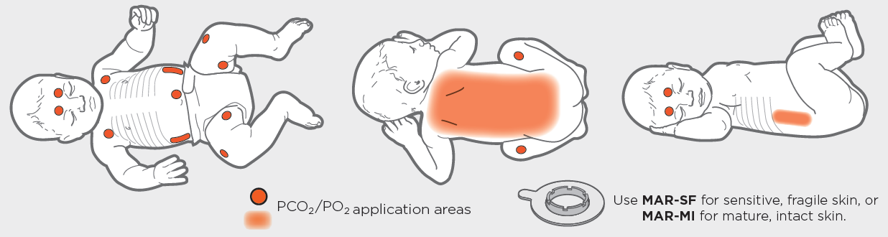
IMAGE 1
- Apply one drop of contact gel or sterile saline solution to the skin in the centre of the attachment ring
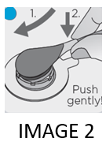
- Hold sensor by cable. Insert nose of sensor at an angle and apply light downward pressure with forefinger to snap into place. See Image 2.
- After sensor applied, verify that TCM monitoring device detects “Sensor-On-Patient” and monitoring is initiated, and parameters have stabilised.
  - tPCO₂ usually stabilised within 2 – 10 minutes and the display value should turn from grey to green.
  - Readjust sensor as necessary
- Perform ABG as needed or medically ordered after stabilisation, to assist in determining pCO2 correlation and trend
  - Document ABG and TCM results in Respiratory Care Flow Chart and NICU flow chart as appropriate
- Inform medical team of abnormal result or trend.
- When monitoring completed or monitoring time has lapsed (site time is 4 hours), remove sensor from patient, and clean and inspect site.
- Clean sensor with alcohol swab and inspect condition of membrane before inserting in docking station in TCM monitoring device
  - If membrane needs to be changed. Refer to Attachment C – Sentec Digital Monitoring Device Troubleshooting
- Insert sensor into docking station to calibrate (red light will be visible) and display will read “calibration in progress”
  - Calibration lasts up to 12 hours and once this interval has lapsed re-calibration is recommended.
- Once calibration is finished, display will read “ready for use”
- Re-site attachment ring and sensor to a different application site as per image 1.
- Document procedure in patient’s progress notes and record calibration and change of sensor position in patient’s observation chart/records.

4.2: End Tidal Carbon Dioxide Monitoring (ETCO₂)

Introduction
End-tidal carbon dioxide (ETCO₂₎ monitoring determines the carbon dioxide concentration in exhaled gas and is used to provide information about the patient’s ventilation status, perfusion, and metabolism, and is displayed numerically and with a waveform on a monitor. Unfortunately, in the neonatal population ETCO2 measurement is only practical in intubated patients and is often inaccurate due to low tidal volume and dilution with fresh gas (reading significantly lower than PaCO2). The device also adds dead space to the ventilation circuit.
In the Canberra NICU it is most commonly used in paediatric patients requiring ventilation. A rise in ETCO₂ may indicate sepsis/fever (increased CO₂ production), poor ventilation (CO2 retention) or partial airway obstruction (CO₂ retention). A decrease in ETCO₂ may indicate apnoea/severe respiratory depression (low volume of expiratory gas delivered to sensor), excess ventilation (CO₂ washout), and low cardiac output (low CO2 delivery to lungs for exhalation). A sudden loss of ETCO₂ waveform may indicate cardiac arrest, apnoea, or disconnection/malfunction of mechanical ventilation.
Note:
ETCO₂ monitoring does not work when using high frequency oscillatory ventilation

Normal Capnogram
The waveform of continuous ETCO₂ monitoring depicts the different phases of the respiratory cycle. It consists of several segments that reflect various stages of inhalation and exhalation. See Diagram 1 – Capnogram Waveform.

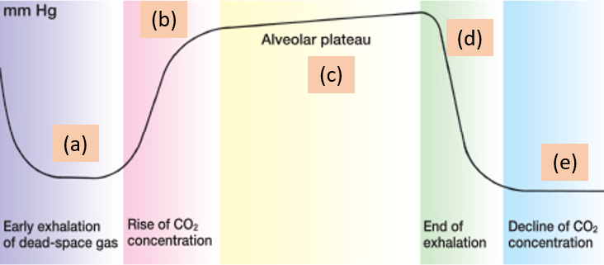

DIAGRAM 1 – CAPNOGRAM WAVEFORM
(a): Gas eliminated during early exhalation is dead-space gas and does not contain CO₂
(b): As exhalation continues, CO₂ concentration rises rapidly and sharply
(c): The Alveolar plateau phase is the CO₂ rises gradually as alveolar emptying is constant.
(d): The digital CO₂ value is derived from the point at the end of exhalation.
(e): During inhalation, CO₂ concentration will decline sharply and rapidly to zero.

Equipment
- Hand hygiene and PPE as appropriate
- ETCO₂ detector tubing
- ETCO2 module
- Cardio-respiratory monitoring device with ETCO₂ monitoring capabilities
- Stethoscope

Procedure

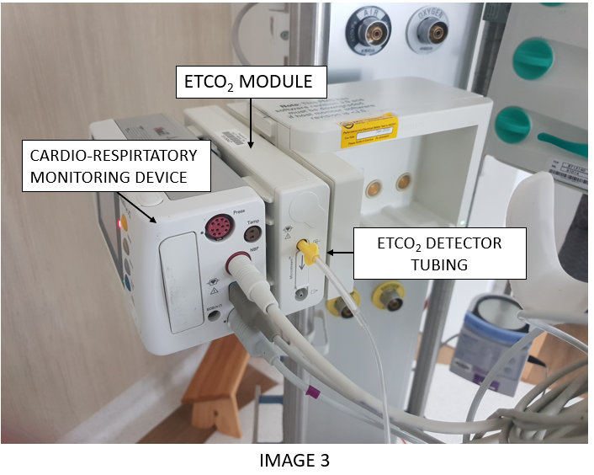
- Identify correct patient and inform parents of procedure
- Perform hand hygiene (HH) and don PPE as required
- Prepare equipment and connect ETCO₂ detector tubing to cardio-respiratory monitoring device using CO₂ module. See Image 3.
- Ensure patient stable enough to cope with brief disconnection of ventilation
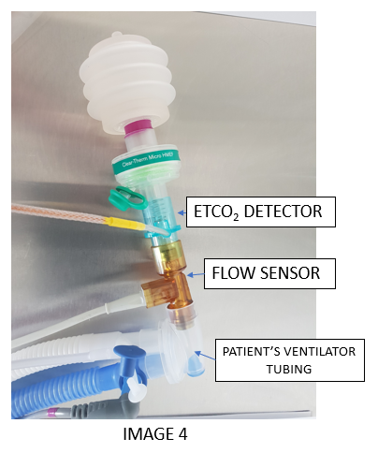
- Attach ETCO₂ detector between flow sensor and ventilation circuit. See Image 4
  - To reduce the risk of condensation obstructing ETCO₂ detector keep tubing connection upright
- Observe the capnograph waveform for quality.
- Set alarm limits appropriately with consultation from medical team and alarms turned on
- Remove PPE and perform HH
- Document procedure in patient’s notes
- Monitor patient and document hourly observations
- Attend to ABG as per medical order to determine measurement correlations.

Section 5 – Conventional Mechanical Ventilation (CMV)

Introduction
Invasive ventilation allows staff to provide a higher level of respiratory support to infants as required. It utilizes an endotracheal tube (ETT) and mechanical ventilator to deliver support directly into the trachea, large airways, and lungs. This guideline covers management of ventilation and procedures associated with maintenance of an ETT.

Conventional mechanical ventilation aims to replicate normal breathing patterns by providing assistance to spontaneous breathing or replacing spontaneous breathes with mechanical breaths if the patient’s own breathing is inadequate.
- The usual mode of ventilation in the NICU is Synchronized Intermittent Positive Pressure Ventilation (SIPPV) which supports every breath taken by the infant and gives a mandatory minimum respiratory rate in the event of apnoea.
- Synchronized Intermittent Mandatory Ventilation (SIMV) is occasionally used in larger infants during the weaning phase especially if there are issues with over-ventilation. This mode only supports the set rate of respiration and any additional breaths are unsupported, which may impose a significant increase in work of breathing due to the small ETT used in our infants.

Indications
- In most cases indications refer to a situation occurring “Despite appropriate lower levels of respiratory support”
- Inadequate respiratory effort or fatigue from work of breathing
- Inadequate gas exchange (Oxygen or carbon dioxide)
- Need for medication/other treatment that will impair effectiveness of breathing (e.g., Surgery, analgesia)

Contraindications
- Advanced care plan indicating intubation/ventilation is not part of parent/guardian’s wishes

5.1: Ventilator Set Up Procedure

Equipment
- Alcohol Based HandRub (ABHR)
- Ventilator Machine
- Humidifier base/chamber
- Ventilator Circuit
- Flow sensor and cable
- Water for injection (WFI) Fluid Bag
- 2 x Grey Wires – short and long
- Sterile Gloves
- Closed (in-line) suction system (highly recommended) See Section 8.2.

Procedure
- Perform HH and gather equipment.
- Don sterile gloves and procedure to be done as clean as possible to minimise contamination.
- Set up ventilator with circuit, humidifier including grey wires, sterile expiratory valve, WFI fluid bag and flow sensor as per equipment set-up procedure.
  - If already set up, visual check to ensure complete
- Connect ventilator oxygen and air tubing to wall supply and plug machine to power.
- Turn on humidifier base and set to intubation mode.
- Turn ventilator on- ventilator will automatically go through a Self-test and when complete will display Self-test OK OR an error message.
  - If error occurs, troubleshoot ventilator circuit connections for leak, and ventilator machine oxygen and air tubing and power are all connected to wall supply
  - If all troubleshooting rectified and error remains, do not use and report ventilator to biomedical engineering for maintenance
- Calibrate the flow sensor
  - Select calibration menu on the start screen
  - In flow sensor calibration window press calibrate
  - When prompted make sure there is no flow by disconnecting flow sensor and holding still, press next
  - When done status appears press close to exit
- Select start button or Ventilation on the screen to move to the ventilation screen and set ventilation parameters

5.2: Usual Range for Ventilation Settings

MODE |  | SIPPV
PRESSURES | PEAK INSPIRATORY PRESSURE (PIP) | 15-25cm H2O (occasionally up to 30-35 but need to consider HFOV in such scenarios) Aim to use a pressure that generates tidal volumes of 4-7mL/kg (ideal 4-6mL/kg especially in preterm infants)
PRESSURES | POSITIVE END-EXPIRATORY PRESSURE (PEEP) | 5-8cm H2O
RATE |  | 30-60
INSPIRATORY TIME (IT or I time) |  | 0.3- 0.5 seconds (secs) (occasionally higher in term infants) Should be set based on respiratory pathology and analysis of flow and volume loops on the ventilator screen. HMD- 0.3-0.4, Meconium aspiration, severe pneumonia and chronic lung disease may need longer. Consider I:E ratio when setting I time and rate; target 1:2
VOLUME GUARANTEE (VG)  MODE ADDED TO SIPPV |  | Has increasing evidence to support its use especially in preterm infants who are susceptible to lung injury. (However, our current Leoni ventilators do not perform as well as desired in VG mode hence it is not often used currently. VG allows user to set a target tidal volume and the ventilator will adjust the PIP to achieve that target which often helps avoid under and over ventilation associated with secretions or changes in lung mechanics. The user also sets a maximum pressure limit (Pmax) to ensure patient safety. This should be set at a level that allows the desired tidal volume (TV) to be achieved with a margin of approx. 5cm H₂O to allow for variability. If the ventilator repeatedly alarms “Tidal volume not reached” the Pmax limit or mode of ventilation should be reassessed.
Alert:
Alarm limits should always be set to provide meaningful information regarding changes in the ventilator or infant. Do not set so high or low that they never alarm but also not so narrow that the user receives a constant barrage of alarms (alarm fatigue) and therefore may ignore an important alarm.

5.3: Assessing Infant and Adjusting Ventilation
Ventilation aims to maintain adequate gas exchange (CO₂ removal and oxygenation) while minimising risks of ventilator induced lung injury and maximising patient comfort. Lung injury may be induced by excess respiratory support (high tidal volumes and high pressures) or inadequate support where collapse or atelectasis occurs. Both processes induce inflammatory changes in the lung which may lead to chronic lung disease especially in extreme preterm infants who are the most susceptible.

Patient comfort is generally achieved by having the ventilator supporting a spontaneously breathing infant rather than taking over ventilation from the infant but in the sickest infants the latter may be necessary. Ventilator synchrony and settings which match an infant’s breathing pattern (appropriate I time and rate for example) assist with patient comfort and many infants also benefit from use of medications for analgesia and sedation to facilitate comfort and patient-ventilator synchrony. Morphine is usual first line agent and midazolam added when necessary although the latter is often avoided in preterm infants.

When assessing a ventilated infant consider:
- The patient’s:
- Chest movement, air entry
- Clinical observations
- Comfort (including but not limited to the pain score)
- The ventilator’s:
- Set and measured parameters
- Flow, volume and pressure graphs and loops
- Blood gas or other measures of gas exchange (pCO2 and oxygen saturations (SPO2))

The basics of adjusting respiratory support in response to blood gas results or other measures of gas exchange are as follows:
- CO₂ removal is proportional to minute ventilation (tidal volume (TV) x respiratory rate)

High CO₂
- TV <6mL/kg increase PIP until TV 6mL/kg then increase rate (if necessary). If VG mode is being used increase VG target volume rather than PIP.
- TV ≥6mL/kg increase rate

Low CO₂
- TV >4mL/kg decrease PIP until TV 4mL/kg then decrease rate if necessary. If VG mode is being used decrease VG target volume rather than PIP.
- TV ≤4mL/kg decrease rate (if spontaneous respiratory rate is faster than the ventilator rate other strategies may be required)
- When adjusting rate 5 breaths/min intervals usually appropriate
- When adjusting PIP 2mmHg intervals are usually appropriate
- When adjusting VG 0.5mL/kg intervals are usually appropriate
- If CO₂ significantly abnormal larger increments may be necessary
- Oxygenation is proportional to lung recruitment (which usually correlates with Mean Airway Pressure (MAP)) and _{FiO2}. PEEP is the greatest contributor to MAP in conventional ventilation with smaller contributions made by changes in PIP and IT.
- Poor oxygenation- increase _{FiO2} and/or PEEP and consider appropriateness of PIP and I time settings. Do the opposite for good oxygenation. Clinical and radiological assessment of lung recruitment may be useful to avoid overdistention or under-recruitment.

If unsure seek senior assistance/guidance. Consider alternative ventilation modes if approaching the limits of “normal/usual” settings on current mode.

5.4: Trouble Shooting Conventional Mechanical Ventilation

If persistent failure to achieve adequate gas exchange (hypoxia or hypercapnia) consider:
- Displaced ETT
- Obstructed ETT
- Pneumothorax (urgent transillumination)
- Equipment failure
- Urgent chest x-ray- assess ETT, under or over distension of lung, collapse, or pneumothorax
- Increased airway resistance (Meconium Aspiration Syndrome (MAS), Bronchopulmonary Dysplasia (BPD)) or non-homogenous lung disease-are the current mode and settings the most appropriate. Consider:
- Would HFOV work better?
- Would a longer I time, slower rate strategy overcome airway resistance or ventilate more “hard to get” alveoli?
- Is there cardiovascular compromise from excessive ventilation pressure, is weaning the answer? Assess BP, perfusion, metabolic acidosis

Back to Table of Contents

Section 6 – High Frequency Oscillatory Ventilation (HFOV)

Introduction
High Frequency Oscillatory Ventilation (HFOV) is an alternative mode of invasive ventilation. It is not inherently superior to conventional ventilation and studies comparing routine use of HFOV to conventional ventilation as a primary mode of respiratory support for neonatal respiratory distress syndrome showed no clear benefit (9).

However, HFOV has advantages in specific clinical scenarios especially when higher pressures and higher tidal volumes are required on conventional ventilation as it reduces the exposure of the lung to the forces which induce lung injury (volutrauma and barotrauma). As such HFOV is primarily used as a “rescue” mode when conventional ventilation is failing or using higher than recommended pressures or volumes. HFOV may also be used after lung injury (as evidenced by pneumothorax/other air leak or pulmonary interstitial emphysema) has occurred to reduce further injury.

The physics and physiology of HFOV is complex but it delivers a waveform (oscillation of pressure) above and below a continuously applied mean airway pressure (MAP) to deliver tidal volumes that may be less than or equal to the anatomical dead space volume. The waveform has an amplitude which is proportional to pressure and volume changes and a frequency (measured in Hertz, cycles per second).
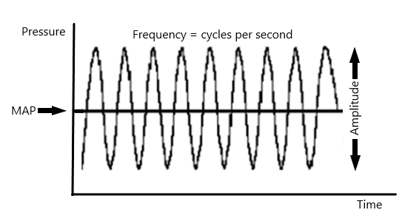
The result of HFOV is a higher end expiratory lung volume in HFOV and fresh gas is delivered to the alveolar spaces (despite the tidal volume often being less than dead space) due to a variety of mechanisms (flow patterns and mixing of gas) occurring throughout the bronchial tree and alveoli. Unlike conventional ventilation both inspiration and expiration are active with ventilation being delivered by a vibrating diaphragm.

The Leoni ventilator is used to deliver HFOV and requires a filter to be added to the expiratory limb. The maximum patient weight for the HFOV mode is 12kg (per manufacturers guidance) however there is concern in the literature regarding effectiveness of ventilation for patients greater than 4-5kg if frequencies of greater than 10Hz are used.
Indications
- Severe lung disease that is unresponsive to or requiring high pressures on conventional ventilation - “rescue therapy”
- Pulmonary air leaks, pulmonary interstitial emphysema, pneumothorax, bronchopleural fistulas and pneumopericardium
- Hypoplastic lung, diaphragmatic hernia

Contraindications
- No absolute contraindications, however, use with trachea-oesophageal fistula may lead to significant gaseous distention of the gastrointestinal tract due to higher MAP and an inability to vent the stomach via a nasogastric tube
- High MAP may reduce venous return to the heart and cause cardiovascular compromise
- High MAP may reduce venous return from the brain which may contribute to raised intracranial pressure

6.1 HFOV Ventilator Set-Up

Equipment
- Ventilator Machine
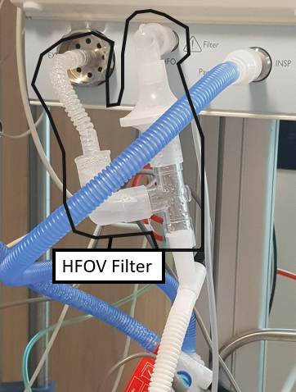
- Humidifier base/chamber
- Ventilator Circuit
- HFOV filter to be added to the expiratory limb of circuit
- Flow sensor and cable
- Water for injection
- 2 x Grey Wires – short and long
- Closed (in-line) suction system (mandatory for HFOV) See Section 8.2.
- TCM monitoring (standard care with HFOV)

Procedure
- Follow Section 5.1: Ventilation Set-Up Procedure except for addition of HFVO filter on expiratory limb on Leoni Ventilator machine. See Image 5.
Image 5

6.2: Oxygenation and CO₂ Clearance/Ventilation Adjustments with HFOV and DCO₂ Levels

Oxygenation
- Is controlled by MAP and FiO₂
- Higher MAP leads to greater alveolar recruitment and better oxygenation (up until the point of overdistention)
- Clinical assessment and CXR may be used to assess recruitment (and avoid overdistention); target 8-9 posterior ribs above diaphragm

CO₂ Clearance/Ventilation
- Is controlled by Frequency and amplitude
- Higher frequency causes higher CO₂ (higher frequency = less time per cycle = lower tidal volume = less CO2 clearance)
- Higher amplitude causes lower CO₂ (higher amplitude = higher tidal volume)
- Clinical assessment (how much does the chest “wiggle” or “wobble”) and tidal volume measured by the ventilator can help you assess appropriateness of current amplitude.
Note:
In general Registrars are expected to change amplitude and MAP in accordance with a treatment plan or changes in the infant’s condition. Large changes in MAP or amplitude or any change in frequency should always be discussed with the fellow/consultant on call.

Carbon Dioxide Diffusion Coefficient (DCO₂)
DCO₂ is a measure of CO₂ clearance displayed on the ventilator screen. Changes in DCO₂ usually reflect a change in lung mechanics and a resultant under or over ventilation. The DCO₂ is unique to the individual patient (no standard target range) but can be used as a trend over time to identify changes in the patient such as secretions in the ET tube.
If unsure about making changes always seek senior advice/guidance.

6.3: Usual Range of HFOV Settings
FREQUENCY- 8-12HZ (CYCLES PER SECOND) | - Preterm HMD – 10-12Hz  - Meconium aspiration 6-10Hz  - Term 8-10Hz  - PIE/Air leak higher frequencies may help  - Severe CO2 retention 6-8Hz  - In general, larger bodyweight lower frequency
MEAN AIRWAY PRESSURE (MAP) | - 10-20cm H₂O most commonly 12-18cm H₂O  - Initial MAP is usually set 2cm H₂O above MAP on conventional ventilation
AMPLITUDE | 20-60cm H₂O (usual starting point approx. 30cm H₂O)
Inspiratory: Expiratory (I: E) RATIO | Usually 1:2
TIDAL VOLUME  (Vt) | 1-3mL/kg
RECRUITMENT BREATHS | - Recruitment “breaths” are short increases in MAP which may assist in recruiting additional alveoli or prevent de-recruitment when weaning MAP. They are optional  - The user sets the number of “breaths” (“Freq (Rec)” usual 30 per hour to 4 per minute), the duration of each “breath” (usual 0.5-5secs) and the pressure of the “breath” (“P (Rec)”-usually approx. 5cm H₂O above MAP)
HFOV WITH VOLUME GUARANTEE | - Volume guarantee allows the user to set a target tidal volume and the ventilator continually adjusts amplitude (up to a user set maximum), in order to maintain a stable tidal volume (and theoretically a more stable CO2 with less changes due to positioning, secretions, etc). The DCO₂ will be more stable in HFOV with VG.  - Using volume guarantee negates the usual changes in CO2 clearance caused by changes in frequency because the target tidal volume remains the same (NOTE- amplitude used to generate that tidal volume will be higher and the max amplitude limit may need to be changed). If wishing to increase CO₂ clearance- usual first step is to increase target tidal volume up until 3mL/kg, then increase frequency if further increase is required (increased Max Amplitude limit may also be required).

6.4: Using HFOV in the Clinical Setting
ALERT
Due to the risks of hypercarbia, strongly consider transcutaneous CO₂ monitoring (TCM).
- Ensure appropriate size ETT (minimal Leak)
- Use transcutaneous pCO₂ monitoring as well as invasive blood pressure (BP) monitoring, if possible. Refer to Venous and Arterial Access and Management for invasive blood pressure monitoring and Neonatal Routine Care Guideline for neonatal blood pressure observation and monitoring
- Optimise systemic blood flow (Volume bolus, Inotropes as required)
- Optimal analgesia, sedation, consider muscle relaxation
- After starting HFOV assess chest “wiggle” and measured tidal volume and adjust amplitude
- Monitor tCO₂ and consider adjusting parameters or an early blood gas if outside desired range
- After starting HFOV it is usual to perform a lung recruitment manoeuvre which should only be performed with a neonatal advanced trainee or Consultant present
- From the initial Mean Airway Pressure (MAP also known as P mean) increase MAP in steps of 1-2 cm/H2O every 5-10 minutes (may be longer in conditions like MAS or BPD where recruitment of collapsed alveoli is more difficult). When SpO₂ >94% lower Fi0₂ in steps of 5-10%
- Continue recruitment until Fi02< 30% or no improvement in saturations after 3 steps (this is the recruitment strategy)
- Decrease MAP in steps of 1cm H₂O every 2-3 minutes until saturations deteriorate at a constant Fi02. This is the closing pressure. At this point re-recruit and drop the MAP back to 2cm H20 above the closing pressure. Be aware of high MAP which may cause cardiovascular or other compromise (Maximum MAP 20-25cm H₂0)
- Arrange for a chest X-ray and blood gases once settings are stable (usually approx. 30mins to 1hour later)
- It is useful to conceptualise HFOV as ventilating the lung around one sustained pressure volume hysteresis loop (Diagram 2)

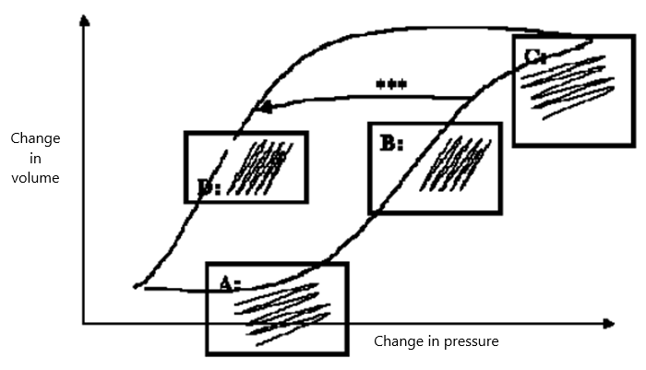

DIAGRAM 2 – PRESSURE VOLUME HYSTERESIS LOOP

Point A: | Underinflated with high oxygen requirements
Point B: | Well inflated. The lung has ‘opened up’. Good chest wobble. Fi0₂ starts to decrease. Any further rise in pressure results in little extra volume recruitment
Point C: | Overinflated Fi0₂ may remain unchanged for a while. Chest wobble decreases. CXR >9 posterior ribs above diaphragm
Point D: | Ventilation on the expiratory limb, achieving maximum inflations with minimal pressure. The ideal “place” to ventilate.
Alerts:
Medical Officer (usually consultant or neonatal advanced trainee to be present at bedside when HFOV commences. Amplitude needs to be adjusted by observing the infant’s chest until there is an appropriate wiggle. If SpO₂ poor/does not improve recruitment to be done by senior medical officer.
- Open suction may be used in circumstances where secretions are causing tube blockage and cannot be removed with in-line suction. Open suction often results in greater de-recruitment than closed suction and should be avoided where possible. Recruitment may be required after suction if significant deterioration in oxygenation.

6.5: Trouble shooting HFOV
If persistent failure to achieve adequate gas exchange (hypoxia or hypercapnia) consider:
- Displaced tube
- Obstructed tube
- Pneumothorax
- Equipment failure
- Urgent chest x-ray-alter MAP based on over distension or under distension/ other complication
- Increased airway resistance (MAS, BPD) or non-homogenous lung disease-is HFOV appropriate?
- If all of the above appears adequate, but hypercapnia remains an issue try reducing frequency (discuss with consultant on call before changing frequency); the effect of lung impedance and airway resistance reduces as there is more time per respiratory cycle, leading to increased Vt
- Is there cardiovascular compromise from excessive ventilation pressure, is weaning MAP the answer? Assess BP, perfusion, metabolic acidosis

Back to table of contents

Section 7 - Care of an Infant receiving Muscle Relaxants

Introduction
Muscle relaxation is a medical treatment which may be used to facilitate other treatments including mechanical ventilation and surgery. Muscle relaxation eliminates spontaneous movement including respiratory effort therefore the infant must have artificial respiratory support prior to administration of medication. The drugs used for prolonged muscle relaxation are the non-depolarising agents such as Vecuronium and Rocuronium, which block the binding of acetylcholine at the neuro-muscular junction preventing muscle cell depolarisation and therefore muscle contraction does not occur.

Important aspects of care(see also mechanical ventilation and HFOV sections above)
- When the initial dose of muscle relaxant is given, the infant’s respiratory support requirements may change significantly as the infant’s spontaneous respiratory effort is removed and the compliance of the chest wall changes.
  - This may lead to under or over ventilation and a medical officer should be present to assess vital signs, chest movement and tidal volume and adjust settings.
  - A blood gas may be required 30-60minutes later to confirm settings are appropriate. Transcutaneous CO2 monitoring recommended.
- The infant must receive appropriate analgesia and sedation and regular pain scoring. Muscle relaxants do not relieve pain but mask some of the clinical signs of pain as the infant will be unable to move or have facial expression.
  - The Premature Infant Pain Profile- Revised (PIPP-R) Pain score should be revised to use heart rate and saturation only. Refer to Neonatal Routine Care guideline for pain management and scoring.
- Increased attention to secretion management from ETT as well as nasal and oropharyngeal secretions which may require suction as infant cannot swallow. Refer to Section 8 – Suctioning.
- In event of ventilation equipment malfunction the infant will be completely dependent on staff effectively using manual devices (Neopuff and Laerdal bag with appropriately sized mask) which should be set up ready for use. The infant will have staff available to immediately respond at all times.
- Position infant with appropriate body alignment and support all limbs. Alternate body positioning (e.g., side to side) if not contraindicated and check skin for early signs of pressure injury with each care.
- Use pressure relieving devices such as gel mattress and pay extra attention to appropriate nesting as infant cannot move to relieve any pressure area.
- Keep infant’s eyes closed, regularly clean with saline, and lubricate with artificial tears to prevent corneal drying and ulceration.
- Mucous membrane care- Lanoline ointment to lips (do not use if under radiant heater) and sterile water or EBM mouth care (gently applied with swab sticks).
- Artificial tears or ophthalmic lubricant, cotton swabs and sterile saline.
- Hearing protection with earmuffs (mini muffs) to protect ears from loud noises as middle ear muscles are also relaxed and unable to protect inner ear. Avoid excessive noise.
- Urinary catheter as bladder contraction (emptying) impaired and may lead to retention.
- Monitor for returning muscle activity and notify medical staff as appropriate. If ongoing muscle relaxation is required a repeat bolus dose or change in infusion rate may be required.
  - Movement of diaphragm including spontaneous respiratory effort or hiccup.
  - Movement of limbs, eyelids, or digits.
  - Increase in jaw tone.
- Minimise handling by clustering care activities together and ensure adequate analgesia before procedures.
- Prolonged muscle relaxation can have adverse effects and duration should be minimised
  - Peripheral oedema- pay careful attention to fluid balance
  - Muscle atrophy/weakness
  - Joint contractures- implement gentle extension and flexion of the joints if not contraindicated and maintain joints in the position of function.
- Seizures will not manifest with abnormal movement if muscle relaxed. Consider a EEG monitoring for infants who are muscle relaxed if there is a risk for seizures. Refer to Neonatal Neurology on bedside a EEG monitoring and seizure management.

Back to Table of Contents

Section 8 - Suctioning

Introduction
Suction should be used to clear secretions from the oropharynx and nasal passages (and trachea and ETT in intubated patients) to maintain a clear airway to minimise work of breathing. Suctioning should be based on clinical assessment with consideration of the patient’s physiological stability. While intubated infants may require regular suctioning to avoid ETT related complications, not all infants on lower levels of support need suctioning with every set of cares. It is important for staff to suction only as clinically indicated to access the airway patency and the infants’ ability to clear their own secretions. Monitoring of the infant before, during, and after procedure to assess the baseline and efficacy of procedure is important when suctioning. Clinical observations and ventilator parameters and graphics should be observed.
Alert
- All procedures should be done after hand hygiene and with appropriate PPE and aseptic technique
- Standard Precautions are appropriate for oropharyngeal suctioning unless sterile technique or airborne precautions are medically indicated
- Nasal and oropharyngeal suction and any procedure with an open ETT are aerosol generating procedures

Indications
- Desaturations/increased oxygen requirement
- Bradycardia/tachycardia
- Absent/decreased chest movement, Decreased Tidal Volumes on ventilator
- Increased work of breathing
- Visible secretions in ETT
- Audible rales/rhonchi (crackles/wheeze) on auscultation
- Irritability/agitation
- Increased carbon dioxide (blood gas, ETCO₂, TCM)
- History of large amounts of secretions
- Decreased chest wiggle or decreased DCO₂ (on HFOV)
- Flattening or less smooth loops/waves on ventilator graphics (indicates reduced flow or vibrations caused by secretions or condensation in ventilatory tubing)

8.1: Oropharyngeal and Nasopharyngeal Suctioning
Alert
- Oropharyngeal suctioning may induce a vagal response with resultant bradycardia and hypoxaemia
- Oropharyngeal suctioning may cause mucosal trauma especially after recent surgery or during healing of past trauma
- Painful procedures may induce vital sign instability and altered cerebral blood flow, consider appropriate analgesia

Oropharyngeal suctioning is the removal of secretions from the neonate’s oropharynx via suction catheter that is inserted through the nose and/or mouth. The aim of the procedure is to assist the neonate in maintaining a clear airway. This procedure should only be performed when necessary, to prevent mucosal trauma, pain/distress/oral aversion (from repeated unpleasant procedures) and apnoea and bradycardia episodes.

Equipment
- PPE
- Sterile 0.9% Saline
- Suction Catheters (Size 6F, 8F, or 10F)
- Wall suction or portable suction with connection tubing
- Stethoscope
- Resuscitation equipment- gas supply/flow meter, Neopuff and mask
- Optional: Swaddling Blanket, Sucrose

Procedure
- Assess patient’s respiratory status and determine if suctioning is necessary as per indications.
Note
- Avoid suctioning for 30 minutes to 1 hour after feeding, unless it’s necessary for airway patency
- Oropharyngeal suctioning is stressful, use developmental care technique to minimise stress and discomfort
- Change unit canister and connection tubing once weekly, and record with date and time.

- Determine need for second staff member to assist with respiratory support during procedure
- Gather and inspect all equipment and supplies
- Prepare resuscitation equipment for use in event of apnoea and bradycardia
- Select appropriate suction catheter size and type
- Attach suction catheter to connection tubing from wall suction or portable suction
  - Suction should be set to 100 mmHg or 13kpa
  - Ensure equipment functioning normally.
- Use PPE as appropriate
- Confirm patient’s identity, communicate with parents as appropriate
- Comfort the neonate as per developmental care principles and providing comfort through sucrose and swaddling
- Using no-touch technique throughout, open sterile saline ampule, open the suction catheter and attach it to connection tubing
- Maintain appropriate respiratory support and oxygenation throughout the procedure
- Without applying suction, gently insert the suction catheter into the side of the patient’s mouth (avoiding the midline of the tongue) for oropharynx clearance.
  - For nasopharynx clearance, determine nasopharynx distance (length is determined by measuring from ear tragus and to nares) and gently insert into the patient’s nares to nasopharynx distance. Dip suction catheter into sterile solution or lubricate with patient’s saliva, if needed.
  - Using your non-dominant hand to control the suction valve while dominant hand manipulates suction catheter tip
- Occlude the suction port to apply negative pressure and clear the oropharynx and nasopharynx of sections, while withdrawing slowly and rotating the suction catheter gently between thumb and forefinger
  - Limit suctioning to 15 seconds
- Clear the lumen of the suction catheter by dipping into sterile normal saline solution and applying suction
- Provide respiratory support/oxygen as required to allow the patient to recover.
- Reassess patient’s clinical condition and repeat the procedure as necessary for further secretions
- Assess the volume, colour, consistency, and odour of suctioned secretions
- Discard used supplies appropriately, clean reusable items (e.g., stethoscope)
- Remove and discard PPE
- Perform HH
- Document procedure and characteristics of secretions in the patient’s progress notes and observation records.

8.2: Endotracheal Suctioning – Closed (In-Line) System

Introduction
Suctioning of ETT is vital for their ongoing functioning (prevention of tube obstruction and prevention of secretion build up in the airways) which may cause airway/alveolar collapse and contribute to ventilator associated pneumonia. The presence of the ETT prevents the continued action of normal muco-ciliary clearance which clears secretions from an un-intubated airway. A closed (in-line) suction system enables clearance of secretions without disconnecting the ventilator circuit. The advantages are:
- Infection prevention
  - Protection of the health care staff from against aerosol and air-borne pathogens
  - Protection of the patient against introduction of pathogenic agents from the environment into the airway
- Physiological benefits
  - Ventilation is continued (although interrupted by presence of suction catheter in ETT)
  - Return to normal ventilation between and after suctioning is immediate and loss of FRC may be less resulting in less physiologic instability (desaturation, etc)

8.3: Attaching Closed (In-Line) Suction to ETT
Note:
An appropriately sized closed (in-line) suction system is attached to the ETT, as soon as practicable and patient stability allows.

Equipment
- ABHR and PPE including Sterile Gloves
- Trache Care closed (in-line) suction system (Size 5, 6, 8) with assortment of Y connectors (2.0, 2.5, 3.0, 3.5, 4.0)
- Sterile Scissors
- Stethoscope
- Resuscitation Equipment (Neopuff and Suction)

Procedure
- Perform Hand Hygiene (HH)
- Identify Correct Patient
- Prepare resuscitation equipment
  - Check and turn on suction equipment. Wall suction should be set to 100mm Hg (or 13 kpa)
  - Check and turn on Neopuff to PIP 25/ Peep 5 or to patient’s pressure requirements
  - Make sure that neonatal resuscitation trolley with intubation equipment nearby and prepared
- Perform HH, don sterile gloves and/or PPE
- Prepare closed (in-line) suction system by attaching appropriate Y connector (Y connector size should be the same size of ETT)
  - Place inside packet to maintain micro critical field
- Two competent or experienced staff members are required to be present for this procedure. Roles need to be allocated and procedure needs to be done quickly and simultaneously
  - One staff to shorten and/or cut ETT and attach the prepared closed suction system securely.
  - Other staff member will disconnect cut portion of ETT from ventilator circuit and connect to secured closed suction system attached to patient’s ETT.
Note:
- The ETT is often shortened at this time if clinically appropriate to minimise resistance and dead space.
- If shortening the ET tube, it is best to cut on a 30⁰ angle (approx.) for ease of connection

- Staff to recheck closed suction system Y connector and ETT connection is secure, and patient is ventilating appropriately, has equal air entry on both sides of chest, and vital signs are stable.
- Doff glove and/or PPE
- Perform HH
- Dispose of equipment appropriately
- Place sticker on closed suction system with due date of change.
  - Closed suction system to be changed every 3 days
- Document procedure in patient’s notes.

8.4: Using the Closed Suction System for Suctioning

Equipment
- ABHR
- Wall suction
- 2ml syringe
- 10 ml Normal Saline Ampoule
- Stethoscope
- Optional: Suction Catheter (if oral suction required)
Preparation for procedure
Note:
For Halyard Trache Care Closed Suction System, the distance between (a) and the window (b) is 4 cm. See Figure 3 below
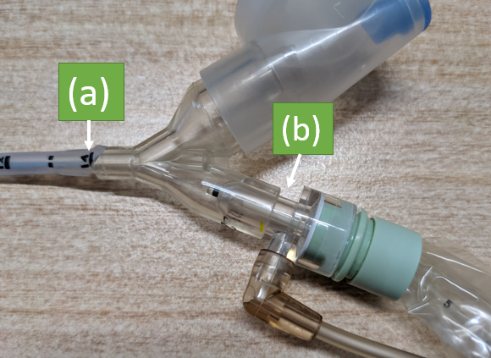

- Determine distance to advance the closed (in-line) suction catheter (c) (See Figure 4):
1. Identify the length at which the ETT connects to the Y connector at point (a).
2. Add 4 cm to this number, which should equal (c)
3. Match this number (c) to the corresponding colour to the left of that number on the closed (in-line) suction catheter.

For example, if (a) is 12cm then (c) should be 16cm. See Figure 4.
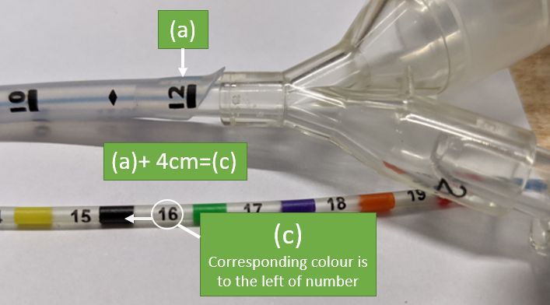
FIGURE 4
- Adjust suction regulator of the wall suction unit until gauge reads 100 mmHg or 13 kpa when tubing occluded
- Remove protective cap and connect tubing from low wall suction unit to suction device
- Prepare 2ml syringe with sterile normal saline and connect to irrigation port
- Stethoscope available

Procedures
- Perform HH
- Don Gloves and PPE
- Unlock the in-line suction valve by turning the suction thumb valve to open
- Stabilize catheter with non-dominant hand and advance the catheter in its plastic sleeve to the premeasured distance (colour coded)
- Withdraw the catheter over 5 seconds whilst depressing the suction control valve, until the black tip is visible in the window dome
- Observe amount, colour, and consistency in the window near control valve prior to releasing suction
- Allow the infant to recover before repeat suctioning (if required)
- Reassess the infant to evaluate the effectiveness of the procedure
- Flush the catheter by instilling normal saline into the irrigation port while applying continuous suctioning via control valve to clear catheter
- Rotate suction thumb valve to locked “off” position
- Disconnect suction tubing and replace protective cap
- Ensure the irrigation port is free of normal saline by withdrawing plunger of syringe prior to removal of syringe
- Close irrigation port and discard syringe
- Proceed to oropharyngeal suction as required
- Settle the infant
- Document colour consistency and amount of secretions on the patient’s observation records and progress note
- Closed suction units are changed every 3 days or earlier if required

8.4: Endotracheal Suctioning – Open Suctioning
Open suction may be required, prior to the connection of a closed suction device or when in-line suction has not effectively removed secretions. Open suctioning will lead to greater loss of PEEP and potentially Functional Residual Capacity (FRC) and should be minimised.

Equipment
- Sterile Gloves
- Alcohol/chlorhexidine swab
- Sterile Normal Saline Solution
- Suction Catheters (Size 6F, 8F, or 10F)
- Wall suction or portable suction with connection tubing
- Stethoscope
- Oxygen Flowmeter
- Oxygen delivery device
- Neopuff
- Optional: Mask, Googles, Swaddling Blanket, Sucrose

Preparation for procedure
- Wall suction checked adjusted to 100 mmHg/13 kpa
- Suction catheters (size 6 or 8, depending on size of ET tube)
- Measure required depth for insertion of the suction catheter (length of the ETT plus the connector)
- Saline to clear suction tubing
- Handwashing and equipment to maintain an aseptic technique
- Two staff required to be present for this procedure (primary staff and assistant)

Procedure
- Perform HH and identify correct patient
- Explain to parents of procedure
- Collect and inspect equipment, and determine suction catheter size
- Perform HH and don sterile gloves
- Protect key parts, the primary staff attaches suction catheter to suction tubing. Ensure that the suction catheter does not touch anything that could contaminate
- Observer pre-suction physiological parameters
- When primary staff and assistant are ready, assistant to disconnect the ventilator tubing from the ETT
- Without applying suction, primary staff to insert the catheter to the predetermined length, whilst the assistant supports the endotracheal tube and restrains the infant’s head
- Apply suction by occluding the “Y” connection and withdraw slowly ensuring disconnection from the ventilator does not exceed ten seconds
- Observe secretions at the ‘Y’ connection
- Reconnect the ventilator to the endotracheal tube
- Reassess the infant to evaluate the effectiveness of the procedure
- Repeat the suctioning steps two more times if required or until the endotracheal tube is clear - taking into account the patient’s tolerance to the procedure
- Proceed to oropharyngeal suction as required
- Clear the suction tubing with normal saline
- Turn off the suction
- Settle the infant
- Document the amount and characteristics of the secretions, and the patient’s tolerance to the procedure on the flow chart
- Any clinical concerns regarding suctioning (such as plugs, blood stained or yellow secretions or difficulty with insertion of the suction catheter to the predetermined depth) or deterioration of the infant during and/or after the procedure must be reported to the Team Leader and/or Medical Officer
Note:
Suction tubing is changed daily and labelled with date and time of change.

8.5: Suction for Endotracheal Aspirate
Endotracheal aspirate is done to obtain samples for microscopy, culture, and sensitivities for suspected or known lower respiratory tract infection. Some microorganisms detected may represent colonisation rather than infection.

Equipment
- ABHR
- Gloves
- Sterile Specimen Trap
- Laboratory Biohazard Transport Bag
- Laboratory Request/Order
- As per open or closed suction above. All laboratory samples should be collected with a new sterile suction catheter to minimise risk of sample contamination
- Optional: Mask, Googles, Sterile 10ml Normal Saline Ampoule.

Procedure
- Perform HH
- Identify correct patient against laboratory request/order
- Inform parents of procedure
- Perform HH
- Open and prepare suction catheter and sterile specimen trap taking care to keep key parts clean
- Attach sterile in-line specimen trap to the connection tubing first, then attach suction catheter to in-line specimen trap.
- Perform endotracheal suction as per procedures above
- If specimen is collected, detach the suction catheter from the in-line specimen trap and dispose of catheter appropriately
  - If specimen is minimal, use normal saline to flush through specimen into specimen trap
- Detach the in-line specimen trap from the connection tubing and seal the specimen trap tightly. Label as per Patient identification - Pathology Specimen Labelling
- Place specimen in laboratory biohazard transport bag and immediately send to pathology lab
- Discard used supplies into appropriate receptacles
- Remove and discard gloves and/or other personal protective equipment
- Perform HH
- Document in patient’s progress notes and observation record.

Back to Table of Contents

Section 9: Extubation

Introduction
Extubation is the removal of an endotracheal tube (ETT) from a previously ventilated patient. This procedure is planned in advance by medical staff in consultation with beside nurse when mechanical ventilator support is considered to no longer be required and procedure is planned to maximise likelihood of success. The requirement for alternative modes of respiratory support i.e., CPAP, low flow oxygen, is assessed and prepared prior to the procedure. Occasionally an unplanned extubation happens in which case the care team determines whether re-intubation is required, or an alternative mode of respiratory support may be appropriate, and the team responds and provides care as appropriate.

Equipment
- PPE such as Gloves, Masks, and Goggles
- Neopuff with appropriate mask
- IV Access
- Suction Unit with appropriately sized suction catheters
- Resuscitation Trolley
- Stethoscope
- Step down respiratory support equipment prepared, if required
- Adhesive remover
- Cardiorespiratory monitoring

Preparation for procedure
- Ensure appropriate staff availability- 2 nursing staff members present and appropriate medical staff available in the unit in case of the need for re-intubation (registrar/fellow/consultant)
- Enteral feeds should be withheld and/or aspiration of the stomach contents should be performed prior to the extubation. Intravenous fluids may be required/ increased for this period
- Consider prophylactic Caffeine medication prior to extubation, as required
- Emergency/Intubation trolley available in event of the need for reintubation
- Suction equipment prepared for use (Section 8)
- Neopuff and appropriate size mask set up and ready for use
- Tape removal wipes
- Equipment for alternative mode of respiratory support ready for use
- Ensure appropriate monitoring, recalibrate, and reapply tcCO₂ sensor as required prior to extubation.

Procedure
- Perform HH
- Don Gloves and PPE
- Consider removing orogastric or nasogastric tube
- Suction oropharynx/ETT only if necessary. Avoid ETT suction if surfactant given within the last 6 hours unless absolutely necessary
- Remove ETT strapping or Neobar strapping followed by the ETT
- Suction mouth and oropharynx prior to ETT removal
- Position comfortably ensuring airway patency is maintained
- Doff gloves and perform HH
- Assess and closely monitor respiratory status- work of breathing, stridor, oxygen requirements and tCO₂
  - Adjust oxygen and report deterioration to medical staff if required
- Document procedure in patient’s progress notes and observation record.
- Perform blood gas (arterial or capillary) 1 hour post extubation if requested by medical team, to assess respiratory status
- Post extubation enteral feeds may be recommenced after 1‐2 hours if condition permits

Back to Table of Contents

Section 10 - Neurally Adjusted Ventilatory Assist (NAVA) in Neonates

Background
Neurally Adjusted Ventilatory Assist (NAVA) is a mode of mechanical ventilation intended for use in spontaneously breathing patients. It delivers ventilation in synchrony with and in proportion to the infant’s efforts. The patient's own electrical diaphragmatic activity (Edi) waveform is used to trigger-on and cycle-off each assisted breath. The pressure delivered depends on the size of the Edi signal, thus providing well synchronized proportional assist ventilation. The Edi waveform is recorded with an “Edi catheter”, a standard-sized naso-or orogastric feeding tube with miniaturized sensors embedded within. When correctly placed at the level of the gastroesophageal junction, the Edi signals are detected from the crural portion of the diaphragm.

Alerts
This guideline applies for non-invasive NAVA (NIV-NAVA) only.

Indications for NAVA
In the NICU the Getinge SERVO-n NAVA ventilator (refer to equipment section 2) is used as a non-invasive mode of ventilation for the following:
- Post-extubation as a weaning mode from invasive ventilation
- As an escalation mode from nasal CPAP to avoid intubation
- Alternative to nasal IPPV to treat apnoea

Contraindications for using NAVA are:
- MRI scanning: Edi catheter must be removed before MRI scanning
- Congenital Anomaly: oesophageal atresia, diaphragmatic hernia
- Weak diaphragm: Phrenic nerve injury, congenital myopathy
- Insufficient/absent respiratory effort: brain anomaly, medication

10.1: Principles of Non-Invasive NAVA ventilation (NIV-NAVA) using SERVO-n Ventilator

Difference between Conventional and NAVA ventilation

In contrast to conventional ventilator which use either flow or pressure as trigger, NAVA ventilation uses a neural trigger (diaphragmatic EMG) to deliver mechanical breaths that are synchronised to initiation, size, and termination with each patient’s breath. The flow chart below explains the principle behind NAVA.
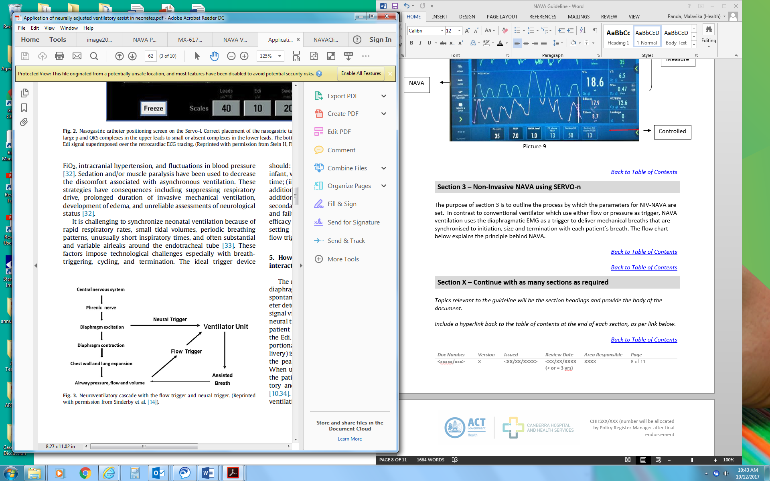

CONTROLS | CONVENTIONAL VENTILATION | NAVA VENTILATION
TRIGGER | Flow trigger | Neural diaphragm (Edi) Trigger
VENTILATOR CONTROLS | - PEEP  - FiO2  - Peak pressure or tidal volume  - Inspiratory Time  - Minimum Rate  - Breath termination | - PEEP  - FiO2  - NAVA level  - Apnoea time  - Peak pressure limit
SYNCHRONY | Initiation of breath | Initiation of breath  Size of breath  Termination of breath

10.2: NAVA Terminologies

The electrical activity of the diaphragm is detected by electrodes embedded in a special nasogastric tube positioned in the lower oesophagus at the level of crural diaphragm and transmitted electrically via the nasogastric tube to the ventilator. The peak inspiratory pressure delivered is proportional to amount of electric activity generated by the diaphragm. Inspiration (pressure delivery) is maintained until the electrical activity decreases by 30% of the peak activity generated and the breath is then terminated. The terminologies used in NAVA and their significance are:

Edi | It is the electrical activity of the diaphragm and can be thought of as a respiratory vital sign. The electrical nerve signal from the crural part of diaphragm is summated, filtered, and processed to give the Edi signal. The Servo-n ventilator displays Edi as a waveform as well as numerically on a breath-by-breath basis. It is measured in microvolts (µV). When using the Edi to control all aspects of the ventilator breath, the patient’s effort determines inspiratory pressure (or volume), inspiratory and expiratory time and respiratory rate for each breath.
Edi peak (µV): | It is the peak of the Edi waveform. It represents the work the diaphragm performs for each breath and is responsible for the size and duration of the breath. Edi peak is higher while awake than during sleep and lower in the post-prandial state than pre-prandial and feeding states. The reference range for Edi peak is 10.8±3.7 µV (Stein 2013).
Edi min (µV): | It is the nadir of the Edi waveform. It represents the spontaneous tonic activity of the diaphragm which prevents de-recruitment of alveoli during expiration. Edi minimum is higher while awake than during sleep but similar among feeding states. The reference range for Edi min is 2.8±1.1 µV (Stein 2013).
Edi trigger (µV): | It is the minimum increase in electrical activity from the previous trough that triggers the ventilator to recognize the increase in electrical activity as a breath, not just baseline noise. It is generally set at 0.5µV.
NAVA Level | NAVA level is a conversion factor that converts the Edi signal into a proportional pressure. The units of the NAVA level are cmH₂0/µV. The Edi is multiplied by this NAVA level to determine airway pressure delivered by the ventilator for each breath. The peak pressure is determined on an ongoing basis every 60 msec, and continues to increase as long as the instantaneous Edi increases, as determined by the formula:  Peak pressure = NAVA level x Edi (peak-min) + PEEP
Apnoea time | This represents the maximum amount of time the infant can be apnoeic before the ventilator initiates backup ventilation. This provides a minimum guaranteed rate which is different from the backup rate. For e.g., setting apnoea time at 2 seconds guarantees minimum rate of 30 breaths/min.

10.3: Getinge SERVO-n (NAVA) Ventilator and Patient Set-Up

Equipment
- Getinge SERVO-n ventilator
- Grey set up tubing (from storage box on ventilator)
- Fisher Paykel RT266 ventilator tubing
- MR850 humidifier base with grey wires
- Sterile water bag
- Edi catheter
- 6FR-49 cm, weight 0.5-1kg, length<55cm
- 6FR-50cm, weight 1-2kg, length<55cm
- 8FR-50cm, weight 1-2kg, length<55cm
- 8FR-100cm, weight >2kg, length 45-85cm
Notes
- Refer to Attachment A - NIV-NAVA Quick Guide
- The EDI catheter can be difficult to aspirate but placement can be reliably ascertained when Edi monitoring is commenced
- Once a circuit is wet, it must be used on a patient within 24 hours
- The expiratory block needs to be changed and sent to pre-rinse after use
- The patient circuit check can only be reliably completed on a wet circuit, so should be performed immediately prior to use. All other pre-use checks can, however, be completed beforehand
- Catheter should be changed every 7 days with ventilator circuit

Procedure
- In most cases ventilators will be set up in advance and clinician just need to add water to humidifier chamber, do pre use checks and ensure all connections are complete  - Collect all equipment on a clean trolley  - Connect ventilator to oxygen and air wall gas supply  - Connect ventilator and humidifier base to blue UPS power points  - Ensure expiratory block is in situ (picture 1). This is sent to pre-rinse for sterilization between patients. The spare blocks are kept with the other expiratory blocks in the clean utility room, in the cupboard above the bench  - Turn on the ventilator. The on/off button can be found at the back of the ventilator, behind a hinged door. To turn on/off the button must be pulled down and then across (picture 2)  - Perform pre-use checks following the prompts on the ventilator. The thick grey or white tubing will be required for this. The tubing can be found in the white drawer on the base of the ventilator. Attach as indicated in picture 3. This will take approximately 4 minutes.  - Patient circuit checks require the circuit to be wet  - Attach humidifier chamber to base and water bag to humidifier. Turn on humidifier base to commence warming  - Attach blue inspiratory tubing to ventilator’s inspiratory gas port and the other end to the humidifier as per picture 4 and 5. Attach white expiratory tubing to the expiratory block (picture 4)  - Attach second blue tubing to the second humidifier post (picture 5)  - Attach Bubble CPAP patient interface(snorkel) to ventilator circuit (70mm or 100mm) with appropriately sized nasal prongs  - No flow sensor is required  - Select non-invasive or invasive ventilation option on ventilator screen  - Perform Edi module function check with Edi cable  - Plug cable into the module (Should be plugged in already) and the other end into the port on the cable itself as indicated in picture 6)  - Perform Edi cable test prior to commencing ventilation  - Assess correct Edi catheter size for patient and measure length from nose/mouth to ear to xiphisternum (nose- first preference to avoid movement of the catheter) and use the calculation and positioning tool on the ventilator (picture 7)  - Wet Edi catheter using sterile water. Pass Edi catheter to measured depth  - Connect Edi catheter to cable from the ventilator  - Adjust catheter position by looking for a diminishing ECG waveform progression from the 1st to the 4th waveform (Lead 4-No P wave &small QRS wave) and the presence of a purple colour in the 2nd and 3rd waveforms. Record the optimal insertion depth of the catheter. Refer to Section10.5  - Secure the Edi catheter to the face as per standard NG or OG tube procedures ensuring the catheter is not kinked. | 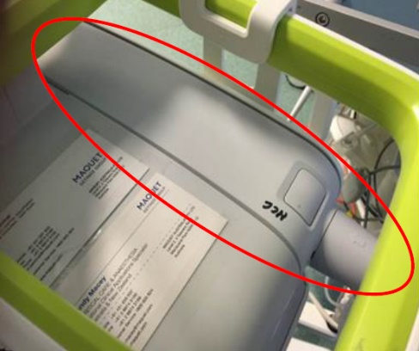  PICTURE 1
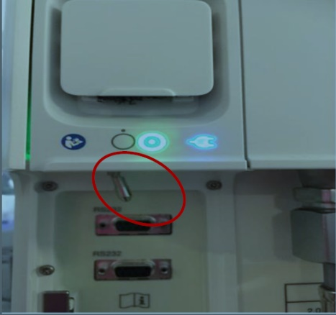
PICTURE 2
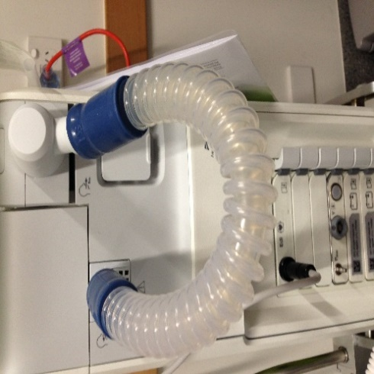
PICTURE 3
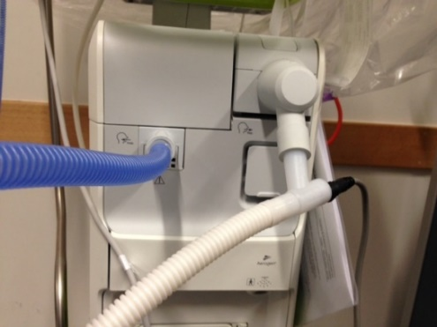
PICTURE 4
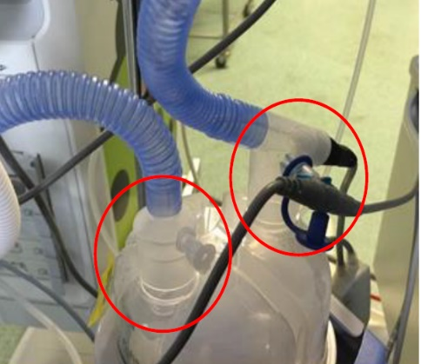
PICTURE 5
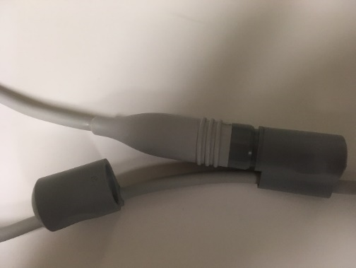
PICTURE 6
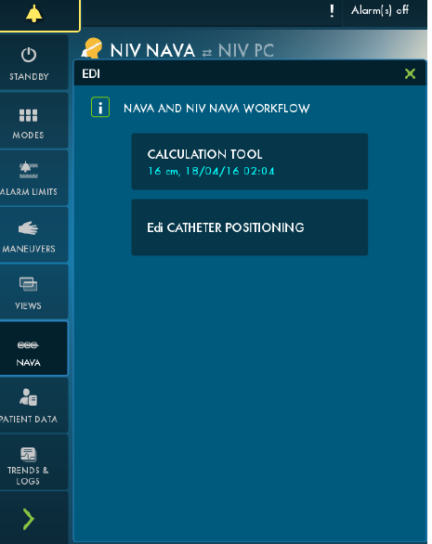
PICTURE 7

- Select ventilation mode and adjust settings. Controlled/Set values can be found along the bottom of the screen. Measured Values are down the right-hand side of the screen as you face it (Picture 8).
- Check and adjust alarm limits.
  - The pressure alarm is limited to 5 cmH2O below the set upper pressure limit which restricts volume delivery.
  - Ppeak alarm is set at 40cm H₂O for non-invasive ventilation unless fellow/consultant decision to reduce this
- Start ventilation and apply bubble CPAP interface to patient with “duoderm nose” to improve seal and reduce risk of nasal pressure injury
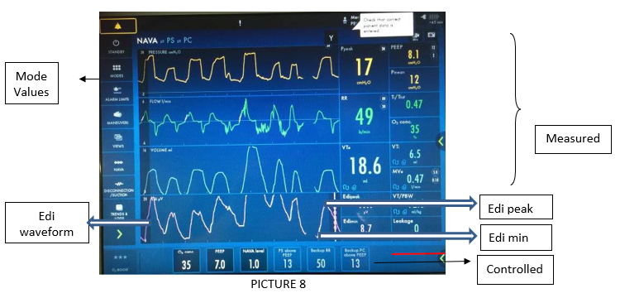

10.4: Guide to initial NIV NAVA Settings
To facilitate synchronised non-invasive ventilation, prevent de-recruitment and avoid increased work of breathing and apnoea.

Initial settings based on indications:
NAVA SETTINGS | POST-EXTUBATION | ESCALATION MODE FROM CPAP | BACKUP MODE TO TREAT APNOEA
NAVA Level | 1.0-1.5 | 1.5-2.0 | 0
PEEP | 6-8 | 6-8 | 6-8
PC above PEEP | 10 | 10 | 10
IT | 0.40 | 0.40 | 0.40
Apnoea Time | 2-3 sec | 2-3 sec | 2 sec
Back up rate | 40-50 | 50 | 40-50
Comments  (All settings to be tailored according to individual patient requirements) | Usually, NAVA level that generates PIP of 16-18 cmH20 provides adequate support | Usually, NAVA level that generates PIP of 16-18 cmH20 provides adequate support | For nasal CPAP therapy with backup, choose NIV-NAVA mode and set NAVA to zero. Do not choose nCPAP mode.

10.5: Troubleshooting Edi Catheter position

Procedure
- Insert the Edi catheter after measuring length from nose/mouth to ear to xiphisternum.
- When the Edi catheter is in a good position the following ECG landmarks will be seen (refer to Picture 9).
  - The Edi catheter is in good position the Purple circles to the left of ECG signals should be seen on Leads 2 &3 as well as superimposed on waveforms on Lead 2&3.
- Read from the top of the screen downwards where it reads mV
- Lead 1-Tall P wave (the first peak before QRS wave)
- Lead 2-Smalller P wave
- Lead 3- No or very small P wave
- Lead 4- No P wave &small QRS wave
- When Edi catheter is in incorrect position:
  - If Purple circles are on Lead 1- Pull catheter out (1cm at a time) until purple circles are seen on lead 2 & 3
  - If Purple circles are on Lead 4- Push catheter in (1cm at a time) until purple circles are seen on lead 2 & 3
  - If ECG amplitudes are in reverse order (small P waves and QRS complexes in lead 1 and then tall P and QRS waves in lead 4): Push catheter in (often by 3 cm or so).
  - If tall P wave and QRS waves are seen in Lead 1 and Lead 4- Catheter is curled back forming a loop therefore reposition catheter.

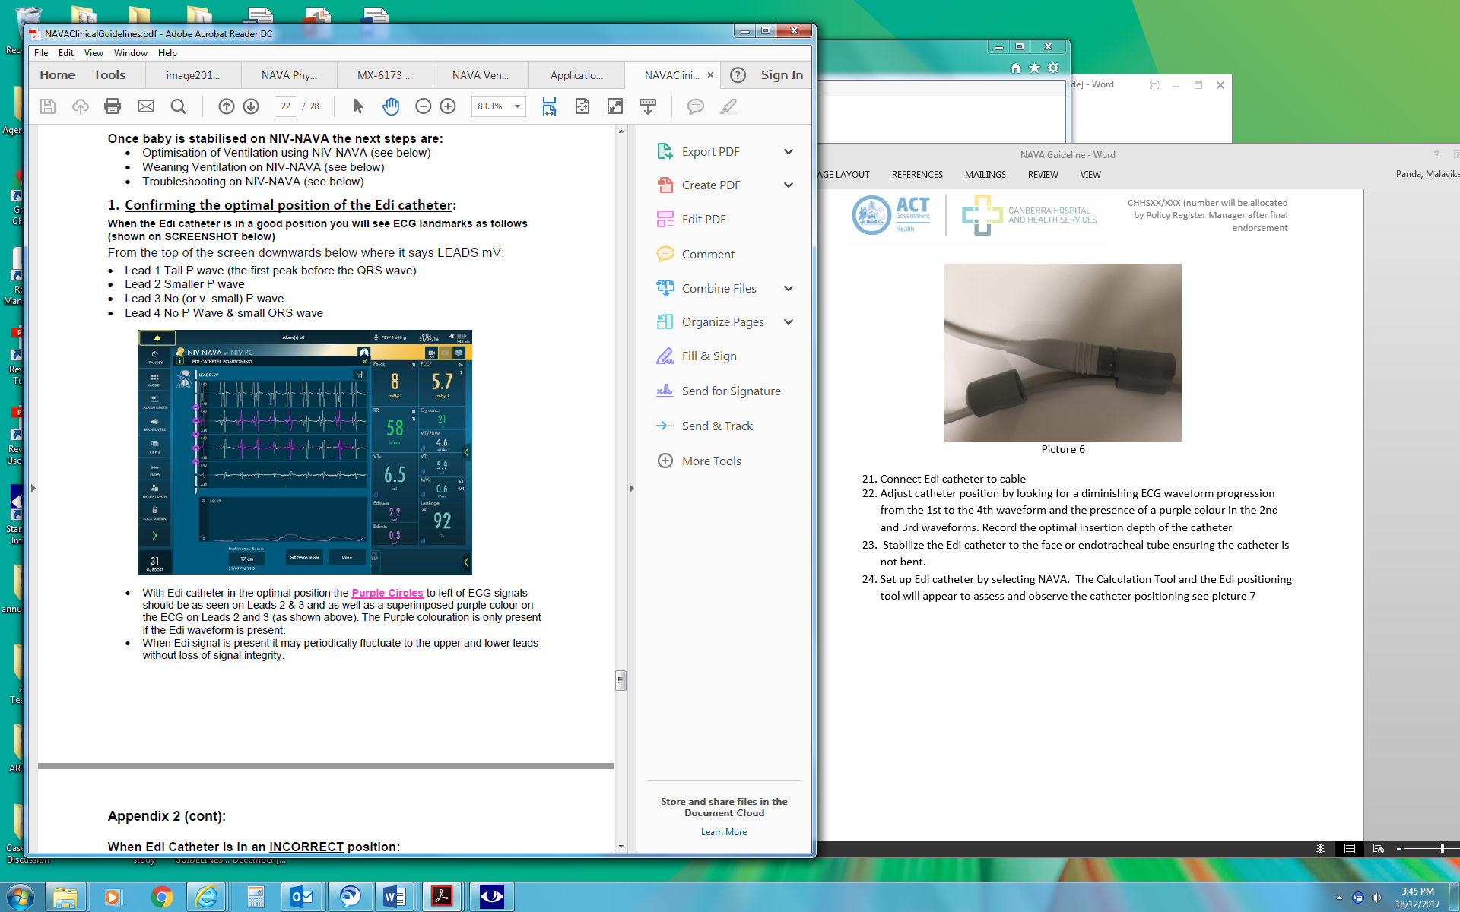
PICTURE 9

10.6: Determining appropriate NAVA Settings

The Edi, in conjunction with the NAVA level, controls the NAVA ventilator support. The delivered pressure during NAVA is continually adjusted based on the neural feedback from respiratory centres. Increasing the NAVA level results in unloading of the respiratory muscles and is followed by an increase in inspiratory pressure, mean airway pressure and tidal volume while Edi remains constant. This is termed as first response wherein the respiratory muscles are unloaded insufficiently. Further increase in NAVA level results in reaching a ‘breakpoint’ where the respiratory muscle unloading becomes sufficient, and the Edi signals starts decreasing and the inspiratory pressure reaches a plateau despite a further increase in NAVA level. This breakpoint is the appropriate NAVA level and is unique in each individual. Above a certain NAVA support level, the Edi signal becomes erratic, indicating over-assistance. The NAVA level is fluid and should be adjusted to clinical picture as the respiratory disease evolves. Example of breakpoint.
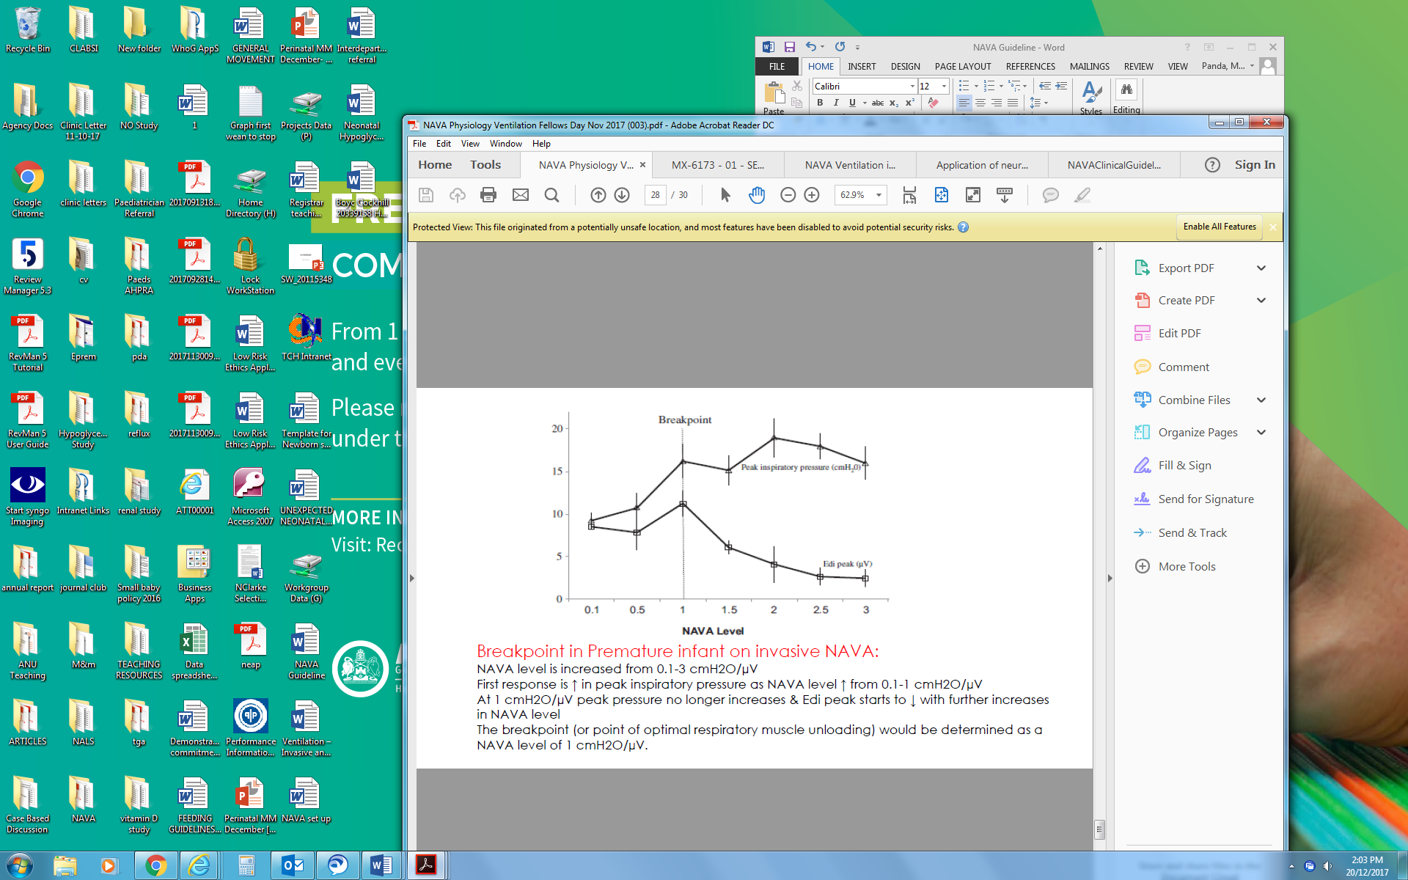

10.7: Monitoring and optimisation of NIV-NAVA
- Ensure Edi catheter is well positioned (refer to picture 9). Nasally inserted Edi catheter is more secure and easier to look after in comparison to oral Edi catheter. Nasal Edi catheter can be used with prongs and mask.
- Edi catheter malposition:
- P wave on all lines and increasing P wave progressing from 1st to 4th lead- Push in catheter
- No P wave and dampened QRS on all 4 leads-Pull out catheter
- Larger P and QRS on 1st and 4th waveforms-Catheter curled in-Reinsert
- No signal- No respiratory drive
- Review regularly and look at the efficiency of seal with the infant’s nose. Note the NAVA level and PIP and Edi’s generated, infant’s breathing effort, spontaneous. respiratory rate, percentage back-up assist and any gaseous distention of abdomen.
- Regularly review Edi peak (target range 5-15 µV), Edi min (target range <3µV) and percentage backup assist to avoid under or over- support.
- If Edi peak is >20 µV consistently- Ensure common causes are addressed e.g., secretions blocking nose or prongs wrongly positioned. Otherwise indicates increase work of breathing. Please increase NAVA level in increments of 0.2 until Edi is persistently below 15 µV and infant is comfortable.
- If Edi peak is <5 µV consistently- indicates work of breathing is low. Please decrease NAVA level by 0.1 to 0.2.
- Discuss changes with medical staff.
- If desaturations & periods of apnoea are worsening do a blood gas and review apnoea time. This may need to be decreased. Please consider change in infant’s condition like RDS worsening, sepsis, IVH, Pneumothorax, abdomen distention, etc.
- If Edi peak & _{FiO2} is increasing and work of breathing worsening- It indicates under-support, increase NAVA level. Other changes could be: Increasing PEEP if Edi min is high and increasing FiO₂ or reassessing the infants need for invasive respiratory support
- If Edi peak and Edi min are low, FiO₂ is decreasing, and work of breathing is improving- decrease NAVA level. Other proposed changes can be reducing PEEP (if Edi min is low)
- If there is abdominal distention or feed intolerance place another gastric tube (largest size appropriate) into the stomach to vent air out. Use the Edi catheter for feeding and keep the spare gastric tube open.

10.8: Weaning from NIV-NAVA
- Infant can be transferred to bubble CPAP or High Flow Therapy once the NAVA level is <0.5 and FiO₂ <0.30 with Edi peak< 15 µV and Edi min <3 µV.
- Review frequency of backup ventilation (Back up PC %) on the trends page and time spent in back up/min. If back-up is frequent, consider increasing apnoea time and reducing back up PC rate &/or pressure control to encourage an increase in spontaneous respiratory drive.
- There is no recommended weaning of NAVA level and it is based on individual experience. Once infant’s respiratory distress improves, weaning of NAVA level can be quicker. Usually, NAVA level is weaned by 0.1-0.2 at a time. If infant does not tolerate weaning return to previous settings.

10.9 - Troubleshooting on NIV-NAVA

PROBLEM/ALARM | RESPONSE
EDI CATHETER WON’T ASPIRATE | Aspirating Edi catheter may collapse the lumen. They are however designed to be aspirated so gentle adjustment should allow aspiration in case of aspirate measurement.
EDI CATHETER BLOCKED | As the Edi catheter is incorporated with an electrical probe, the lumen is smaller than a usual nasogastric tube. Therefore, it can get blocked by thick viscous medications or thickened feeds. In this case it may be necessary to pass a second nasogastric or orogastric tube.
EXCESSIVE LEAK/LOW PEEP DISCONNECTION ALARM | Means the leak is >15L/min. Review circuit for disconnections, interface and connections to interface. (Most common cause being mouth open, inadequate interface seal and secretions)
VOLUME DELIVERY RESTRICTED | It means that upper high pressure alarm limit is set low. The pressure is limited to 5cmH2O below the set upper pressure limit, which restricts the volume delivery. Check the Ppeak alarm pressure setting which might need to be increased.
NO PATIENT EFFORT | Ensure Edi is correctly positioned, if so then patient may be apnoeic in which case back up rate will begin. Consider reducing apnoea time if patient is not adequately supported in back up mode. Both oversedation and overventilation can lead to this alarm. After assessment consider reducing sedation or backup rate
DESATURATIONS/BRADYCARDIA | Consider:  - Suitability of mode of ventilation  - Changing NAVA level (increase)  - Insufficient Back Up Ventilation seen in extreme prems: may see reduced Edi activity-> can reduce Apnoea time down as low as 1 sec in 0.2 sec increments to give more Backup PC & Resp. Rate  - Air in stomach (Aspirate Edi Catheter/OG tube & check positions are correct)  - Clinical change in infant’s condition- RDS, Sepsis, IVH, Pneumothorax

10.10: Invasive Nava
While the NAVA ventilators are usually used in non-invasive mode, invasive NAVA may be appropriate for some patients. The ventilator works similarly but the respiratory support is delivered through an alternative interface (ET tube). The key differences are as follows
- Invasive mode is chosen during set up
- Both NAVA catheter and flow sensor are used.
  - Ventilation synchrony is determined by the Edi signal (same as NIV-NAVA)
  - Flow sensor allows accurate measures of tidal volume and leak
- Peak pressure alarm is set lower to avoid excessive pressure and volume delivery directly to the airway via the ET tube as the “protective” leak of the non-invasive interface is no longer present.
- NAVA levels and targets for Edi min and peak are the same
- The NAVA ventilator can ventilate in non-NAVA modes using just a flow sensor however these infants would usually be changed to a Leoni
- Backup ventilation is identical to SIPPV in an apnoeic patient (spontaneous effort will reengage NAVA ventilation) with set pressures, I time and rate.

Section 11 – Non-Invasive Positive Pressure Ventilation (NIPPV)
Note:
In infants, where non-invasive ventilation is appropriate our preference is to use the NAVA ventilators to deliver this. However, if NAVA is unavailable, NIPPV may be considered as per the Neonatologist.

In the absence of NAVA availability, the Leoni ventilators can deliver non-invasive ventilation via a nasal interface. Non-Invasive Positive Pressure Ventilation (NIPPV) is selected as the ventilatory mode and nasal prongs and snorkel are used as the patient interface. No external flow sensor is used. The duoderm nose, CPAP hat and chin strap are used to secure the patient interface similar to CPAP and non-invasive NAVA. The key difference with NIPPV from non-invasive NAVA is the lack of patient synchrony which may limit its effectiveness. Leak either at the nasal prongs or via the mouth may also limit effectiveness and the ability to deliver higher pressures. The following is a guide to setting parameters:
- PIP - As appropriate to the patient noting leak may limit actual peak pressure delivery
- PEEP- As appropriate to patient (usually 7-10 in NIPPV)
- Rate - Usually 30-40 (higher rates often lead to neonate “fighting” the ventilator)
- I time - Usually 0.5sec (0.4-1sec)
- FiO₂ - As appropriate

Back to Table of Contents

Section 12 - Bubble Continuous Positive Airway Pressure (CPAP)

Introduction
Nasal CPAP delivers a continuous positive pressure to the airway via a nasal interface and is the first line respiratory support for most neonatal conditions. The continuous pressure can:
- Assist an infant to establish their functional residual capacity (FRC) or assist an older infant to maintain FRC by preventing alveolar collapse and atelectasis. FRC is a key parameter determining oxygenation
- Reduce work of breathing by maintaining small and/or large airway patency and preventing airway/alveolar collapse in expiration
- Prevent apnoea via feedback from stretch receptors in the lung to the respiratory centre
- Prevent or reduce desaturation during apnoea

The key to effective CPAP is maintaining a pressure “continuously” as when pressure reduces the process of collapse and de-recruitment of lungs often beings immediately. Bubble CPAP is delivered by continuous flow through a circuit with inspiratory and expiratory limbs. A bubble chamber acts as a valve to control the pressure and nasal prongs (or a nasal mask) deliver the pressure to the upper airway. Pressure may be lost by loss of flow, a break/disconnection in the circuit or issues at the patient interface (incorrect prong size, open mouth, etc). If the chamber is bubbling, pressure is maintained but clinical staff still need to regularly check that the patient interface is applied correctly as obstructed prongs will bubble normally.

Clinical judgement is required but the general approach for most infants on CPAP should have PEEP increased progressively until either in air or PEEP reaches 8cmH₂O unless clinically or radiologically hyperinflated or other contraindication.
Note
- All infants with ongoing CPAP requirement, beyond 4 hours of age or older infants with a new requirement for Peep, should have a chest x ray.
- Infants who have <4hrs of CPAP where there is doubt about the respiratory diagnosis (eg. possible congenital pneumonia), or an atypical course (eg. onset of respiratory distress after initially appearing well) or oxygen requirement persisting beyond the initial postnatal transition (>1hr of age) should also have a chest x ray at 4hrs of age
- Those with higher oxygen requirements or significant work of breathing an earlier chest x-ray may assist with management.

Once an infant is established on CPAP it is usual practice to wean FiO₂ first and when the infant is in air start weaning PEEP.
- Term and near-term infants who are rapidly improving can be weaned quickly and CPAP removed when in air with PEEP 5 or 6cm H₂O and no increased work of breathing.
- Preterm infants <28wks usually are maintained on CPAP until at least 32 and those requiring oxygen usually continue CPAP until 34-36wks. CPAP weaning usually occurs more slowly in preterm infants, often 24-48hrly weans of PEEP if remaining in air (or low _{FiO2}) and no increased work of breathing results from the previous wean.

Equipment
- ABHR and PPE
- CPAP circuit and heater wire (Grey and blue)
- CPAP cap and accessories
- Nasal prongs (preferred) or mask appropriate for the size of the infant
- Duoderm Nose appropriately sized for patient and nasal prongs
- Oxygen/Air blender
- Humidifier base and water
- Suction equipment

Procedure
- Collect all equipment
- Set up circuit as per directions on CPAP trolley, set PEEP at bubble chamber (usual range 5-8cm H2O) as prescribed by medical staff
- Set up humidifier base set on intubation mode.
- Turn the oxygen flow meter to 8L/min and check for leaks
- Prepare patient ensuring ongoing respiratory support with Neopuff as required
- Suction the oropharynx and nares prior to application of the nasal prongs
- Place CPAP cap and duoderm nose on infant
- Attach nasal prongs to snorkel and connect snorkel to circuit
- Insert prongs gently into infant’s nares and attach snorkel to cap

Ongoing care
- Maintain an orogastric tube on free drainage throughout treatment with CPAP
- Release the CPAP cap as per manufacturers guidelines and Neonatal Routine Care Guideline every 4-6 hourly and massage the infants head and ears
- Change the nasal prongs and perform suction as required
- Document procedures (i.e., cares, suction, and gastric tube aspirates), clinical observations (as per routine care guideline), treatment settings (i.e., flow, PEEP, humidifier temperature and bubbling status) and clinical status (i.e., work of breathing and apnoeas) on the observation chart as indicated
- Troubleshoot CPAP if it is not bubbling consistently. Refer to table below.
- When attending CPAP cares maintain developmental care principles as per Developmental Care in the Neonatal Intensive Care Unit and Special Care Nursery.

TROUBLESHOOTING CPAP
CPAP BUBBLE CHAMBER NOT BUBBLING
EQUIPMENT ISSUES | Patient interface issues
ADEQUATE FLOW? USUALLY 8L/MIN | Leak around prongs  - Correct size prongs- should fill nares completely but not stretch skin  - Duoderm nose appropriate size and correctly applied
ALL CONNECTIONS SECURE/ALL UNUSED PORTS CAPPED
CHECK CIRCUIT FOR CRACKS AND LEAKS
EXCESSIVE CONDENSATION IN CIRCUIT | Prongs securely attached to snorkel
CPAP PROBE CORRECT DEPTH IN BUBBLE CHAMBER | CPAP hat snug fitting to minimise movement of snorkel and prongs
BUBBLE CHAMBER FILLED TO APPROPRIATE LEVEL | Pressure leak from mouth requiring Chin strap

Infants who are stable on CPAP (with minimal tachypnoea or work of breathing and PEEP 6cm or less and less than 30% oxygen) and who are at an appropriate gestational age to attempt suck feeds (breast or bottle) may do so after discussion with neonatologist on service. This should be done in the presence of an experienced neonatal nurse (+/- speech pathologist if required) who should not leave the room while the feed is in progress. Breastfeeding mothers should be educated regarding the signs their infant may show if their breathing is being compromised by feeding.

Daily management
- Management of neonates requiring CPAP should be directed by medical staff in consultation with the treating Consultant Neonatologist/Fellow
- A nasal mask may be used instead of prongs, if the prongs have caused nasal trauma being aware that nasal masks can cause pressure injury to the bridge of the nose
- Neonates requiring CPAP ≥ 6cm H2O should have PEEP maintained during their cares with Neopuff. This is important to maintain alveolar expansion
- When caring for a neonate on CPAP please document if the neonate is meeting the following criteria for “Guide to cease CPAP”, as this will assist in decision making for cessation of CPAP
- In general, weaning CPAP pressure to a PEEP of 5cm H2O then ceasing is the preferred method. Alternative methods of weaning may be used for individual neonates as directed

12.1: Guide to ceasing chronic CPAP
ALL 6 NEED TO BE PRESENT:
- CPAP 5cm H2O
- Oxygen requirement <30% and not increasing (or as directed by treating Consultant Neonatologist). Infants less than 34wks corrected gestation should be in air prior to ceasing CPAP
- Average respiratory rate (RR) <60 bpm
- No apnoeas or bradycardias requiring tactile stimulation over 24 hours (feeding related episodes may be excluded on advice from consultant/fellow).
- Saturation histogram within target range (<10% saturation <90% and >95% (if in supplemental oxygen))
- Tolerate 15-30 mins off CPAP with appropriate oxygen provided during several care sessions over a 24-hour period

12.2: Guide to recommence CPAP
2 OR MORE NEED TO BE PRESENT:
- Increased work of breathing (Recessions or other signs of increased respiratory effort and/or average RR >75 for 4-6 hours)
- Apnoeas requiring tactile stimulation ≥2 episodes over 6 hours
- Major apnoea and/or bradycardia requiring resuscitation
- Increase in oxygen requirement >10% above the level when CPAP ceased
- Neonate has non-specific clinical deterioration
- Infants less than 32wks corrected gestation should have lower thresholds for recommencing CPAP (any oxygen requirement or increased work of breathing)

If the neonate has two or more of the above criteria, then the neonate should be:
- Placed back on CPAP
- Reviewed by the registrar
- The timing of next cessation of CPAP will be decided by the neonatal advanced trainee or consultant on service (Minimum of 48 hours) and when criteria to “cease CPAP” are present

Back to Table of Contents

Section 13 – Continuous Positive Airway Pressure (CPAP) via Nasopharyngeal Tube
Alert
- This system is usually used during transport following delivery/resuscitation of an infant and should only be used where an infant is stable on CPAP.
- Where possible use the shuttle, which can deliver usual bubble CPAP during transfers from theatre or birthing especially for smaller preterm neonates.

Introduction
CPAP may be delivered via a nasopharyngeal tube (NPT) (usually a shortened ET tube inserted to appropriate depth) as a short-term measure when bubble CPAP is unavailable or inappropriate. The distance of nasopharyngeal tube is measured from lateral edge of nares to the tragus and the tip of the tube should be visible through the mouth and sit just below the level of the uvula. It is attached to a ventilator/Neopuff circuit to deliver a required level of peak end expiratory pressure (PEEP).

Equipment
- Resuscitation and suction equipment, ready to use
- ETT - refer to table below (x2 - one spare)
- Taping- Barrier wipes, Duoderm®, 1cm wide leucoplast and Scissors
- Gastric tube
- Oral sucrose for analgesia as appropriate- refer to SOP sucrose Pain relief
Note
Oral sucrose may be used during procedure as required/appropriate but will increase oral secretions

ENDOTRACHEAL TUBE SIZE
TUBE SIZE (mm)  (INSIDE DIAMETER) | WEIGHT (g) | GESTATIONAL AGE (week)
2.5 | <1000 | <28
3.0 | 1000-2000 | 28-34
3.0-3.5 | 2000-3000 | 34-38
3.5-4.0 | >3000 | >38
Procedure
- Neopuff set to appropriate FiO₂, flow, and PEEP
- Continue to provide CPAP via mask and Neopuff prior to NPT insertion
- Apply barrier wipe - cheeks (avoiding the eyes and lips) and allow to dry
- Prepare tapes and duoderm – see diagram below (Option A and B)
- Shorten ETT to approx. 6-8cms to reduce dead space
- Suction the oropharynx and nares prior to insertion of nasal tube
- Gently insert nasal tube 3-5cm directly backwards (not upwards) into infant's nares
  - Ensure blue line on tube is towards the septum, i.e., bevel of nasal tube pointed away from the septum; prevent occlusion
- Check nasal tube is correct size - if blanching of nares occurs try a smaller size
- Secure the nasal tube in place using either taping option A or B
- Check nasal tube and taping is secure, and not traumatising the nose or face
- Connect to Neopuff circuit and ensure settings are still appropriate
- Monitor heart rate, resp rate and saturations (minimum required)
- Ensure adequate cylinder gas supply prior to disconnecting from wall gas and transport via resuscitaire with neopuff
  - NPT CPAP may also be delivered by the transport ventilator. Set up ventilator circuit and ventilator settings as appropriate
- Nasopharyngeal tube should be changed to usual bubble CPAP after arrival in the NICU
- Document on observation chart and progress notes
Alert
- Do not irrigate nasal – tube, remove the tube if blocked.
- Suction the nares and replace tube in other nare. If the infant is CPAP dependant a second staff member should apply PEEP via the Neopuff throughout the procedure.

OPTION A: STRAPPING USING X2 TROUSER LEGS
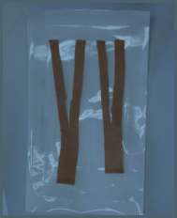 | 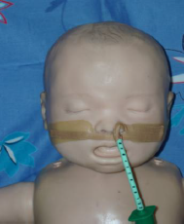 | 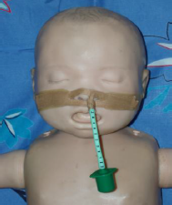
STEP 1 | STEP 2 | STEP 3

OPTION B: STRAPPING USING 1X TROUSER LEG
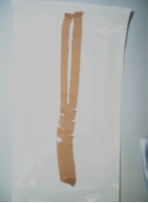 | 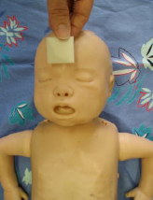 | 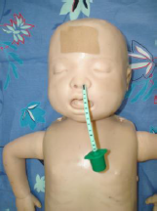 | 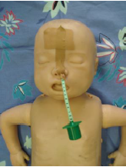
STEP 1 | STEP 2 | STEP 3 | STEP 4

Back to Table of Contents

Section 14 – Humidified High Flow Nasal Prong Therapy

Introduction
Humidified high flow nasal prongs (HHFNP) are a device to deliver blended air and oxygen and potentially PEEP to a patient. The PEEP is unmeasured and variable and depends on several factors including flow rate, patient size, fit of nasal prongs in the nares and degree of mouth opening. Unlike CPAP there is no safety mechanism (valve or bubble chamber) to prevent unintended delivery of very high pressures. Conversely the PEEP delivered may be very low especially if flow is less than 2L/kg or the prongs are significantly smaller than the nares or the mouth open.

HHFNP is not used as a primary respiratory support mode for neonates at Canberra Hospital. When used as primary respiratory support for neonatal respiratory distress syndrome it is associated with longer times on respiratory support and may have higher rates of treatment failure. There is very limited evidence regarding use of HHFNP in extremely preterm infants <28wks (Wilkinson 2016, Manley 2019).

Usual indications
- Term or near term corrected infant requiring ongoing respiratory support for chronic lung disease at a weight and age where it is developmentally appropriate to be establishing suck feeds (Usually following prematurity or low birth weight)
- Nasal trauma or other complication of CPAP where consultant considers use of high flow as beneficial for the infant

Contraindications
- Cardiovascular or Respiratory instability
- Gastrointestinal obstruction before or immediately after repair e.g., Tracheo oesophageal fistula (TOF), Duodenal Atresia or Volvulus or functional obstruction e.g., suspected ileus

Equipment
- Fisher and Paykel (F&P) high flow circuit (packaged with pressure manifold) plus heater wire and temperature probe
- Air/oxygen blender and attached flow meter
- Water for irrigation (1 litre bag)
- Humidifier base
- Oxygen tubing
- F&P High Flow Nasal Cannula. See size guide below.

F&P HIGH FLOW CANNULA SIZE GUIDE
CANNULA SIZE | WEIGHT | GESTATION | FLOW RATE
 | 0.5-2.5 kg | 23-35 weeks GA | 0.5-8L/min
 | 0.9- 4 kg | 27-42.5 weeks GA | 0.5-9L/min
 | 1-8kgs | 28-31 weeks GA | 0.5-10L/min
 | 3 – 3.5 kgs | 37.5-40 weeks GA | 0.5-23L/min
 | 5-7kg | 47.5 weeks GA – 4.7 months | 0.5-25L/min
 | 8 kg | 6.4 months | 1-50L/min

Set up and starting HHFNP
- Slide the chamber onto the humidifier, remove the blue caps, connect the bag of water for irrigation
- Connect the pressure manifold to the chamber and attach to gas source with oxygen tubing from flow meter to manifold
- Set desired flow and FiO2
- Connect the elbow of the blue inspiratory limb to the chamber
- Connect the blue temperature probe- electrical plug into the blue socket on the side of the humidifier, the blue twin probe into the side of breathing circuit elbow above the chamber and single probe into the port at the patient end of the circuit
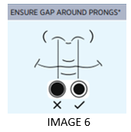
- Connect the yellow heater wire- plug into the yellow socket on the side of the humidifier and the clover leaf end into the socket on the breathing circuit elbow above the chamber
- Attach appropriately sized prongs to circuit
- Turn on the humidifier
- Secure prongs to both cheeks using wiggle pads and ensure prongs are positioned in the nares. Prongs should not completely fill the nares, there should be space around the prongs and the prongs should not put pressure on the nasal septum. See Image 6.
Alert
Do Not use the unheated extension line included in the RT329 kit.

Clinical use
- Usual starting flow is 2-3L/kg/min with the same _{FiO2} as previously being received
- If after starting HHFNP there is a significant increase in _{FiO2} or work of breathing, consider increasing flow in 1L/min increments to a maximum 8 L/min
- Titrate the _{FiO2} to maintain oxygen saturation within target range. In neonates _{FiO2} exceeding 40% (or 10% greater than baseline) or other respiratory concerns notify medical team and consider higher level of respiratory support
- Ensure appropriate clinical assessment and monitoring and gastrointestinal decompression with NGT/OGT
- Infants may be offered breast or bottle feeds whilst on high flow therapy, but regular respiratory assessment is essential throughout the feed

APPROXIMATE PEEP PRESSURES DELIVERED BY HHFNP IN IDEAL CONDITIONS- FLOW (L/MIN) VS WEIGHT
WT (KG) | 1L/min | 2L/min | 3L/min | 4L/min | 5L/min | 6L/min | 7L/min | 8L/min
1-1.5 | 1.3-2.0 | 2.1-2.8 | 2.9-3.6 | 3.7-4.4 | 4.5-5.2 | 5.3-6.0 | 6.1-6.8 | 6.9-7.6
1.6-2.0 | 0.6-1.2 | 1.4-1.9 | 2.2-2.8 | 3.0-3.6 | 3.8-4.4 | 4.6-5.2 | 5.4-6.0 | 6.2-6.8
2.1-2.5 | 0-0.5 | 0.7-1.2 | 1.5-2.1 | 2.3-2.9 | 3.1-3.7 | 3.9-4.5 | 4.7-5.3 | 5.5-6.1
2.6-3.0 | 0 | 0 | 0.8-1.4 | 1.6-2.2 | 2.4-3.0 | 3.2-3.8 | 4.0-4.6 | 4.8-5.4
3.1-3.5 | 0 | 0 | 0.1-0.7 | 0.9-1.5 | 1.7-2.3 | 2.5-3.1 | 3.3-3.9 | 4.1-4.7
3.6-4.0 | 0 | 0 | 0 | 0.2-0.8 | 1.0-1.6 | 1.8-2.4 | 2.6-3.2 | 3.4-4.0
Note
Pressure delivered may be highly variable in real world clinical situations
Weaning from High Flow
- Ensure stable oxygen requirement and appropriate saturations for 48 hours
- Reduce flow by 1L/min 24-48hrly or as clinically appropriate. Cease when flow is 3L/min or at the discretion of the Consultant
- If ongoing oxygen requirement transfer to low flow oxygen when ceasing HHFNP. Otherwise allow the infant to self-ventilate in room air and monitor clinical status

Complications
- Inadequate support requiring escalation to a higher level of support
- Unintended exposure to excessive PEEP causing lung hyperinflation and potentially air leak/lung injury
- Gaseous distention of GIT leading to feed intolerance, respiratory compromise and rarely GIT perforation

Back to Table of Contents

Section 15 - Low Flow Nasal Cannula Oxygen Therapy

Introduction
Low flow oxygen is appropriate for infants requiring supplemental oxygen but do not need additional support in the form of pressure (PEEP). It is most commonly used in infants with established chronic lung disease in the final stages of respiratory support weaning. Low flow oxygen is usually not appropriate for infants <32weeks corrected gestation and most infants <36weeks corrected gestation will benefit from PEEP, if still requiring additional oxygen.

Equipment
- ABHR and PPE
- Low flow (0.1 to 1L/min) or micro low flow (0-0.2L/min) oxygen meter
- Appropriate size nasal prongs (neonate and infant sizes)
- Sterile Water Pack (water pack is not mandatory <40mL/min but is often used in case flow needs to change)
- Skin protection tape / tape to secure prongs to face
- Pulse oximetry is minimum monitoring when starting low flow oxygen however those infants where preparations are being made for discharge on home oxygen may cease continuous monitoring as per senior medical staff
Alert
Micro low flow & Low flow meters should be attached to the wall oxygen outlet only (to deliver 100% oxygen at low rates), do not attach to the blender.

Procedure
- Perform HH and use appropriate PPE throughout
- Identify correct patient and inform parents of procedure
- Collect and prepare equipment
- Attach flow meter to an oxygen outlet
- Attach sterile water pack to the flow meter to allow humidification, (if required as stated above)
- Attach nasal cannula to the water pack (or flow meter)
- Prepare the neonate’s skin with no sting barrier and duoderm
- Tape the appropriate size nasal cannula, ensuring there is no pressure on the nares or septum
- Start flow and adjust oxygen flow rate to maintain target saturations (usual 90-95%)
- Notify neonatal registrar/neonatologist of significant changes in oxygen administration
- Settle infant as per developmental care guidelines
- For long term oxygen therapy, provide education to the parents and allow them ample opportunity to practice changing the nasal cannula and observing changes in infants condition prior to discharge

APPROXIMATE FIO₂ BASED ON FLOW RATE AND PATIENT WEIGHT AND CAN BE USED AS A GUIDE WHEN STARTING LOW FLOW OXYGEN.
Please note this table is a guide only and individual patient’s requirement should be based on their oxygen saturations.
Flow (100% O₂) | Infant weight
Flow (100% O₂) | 1.5kg | 2kg | 2.5kg | 3kg | 3.5kg | 4kg
30mL/min | 0.23 | 0.23 | 0.22 | 0.22 | 0.22 | 0.22
60mL/min | 0.24 | 0.23 | 0.23 | 0.23 | 0.23 | 0.23
125mL/min | 0.27 | 0.26 | 0.24 | 0.24 | 0.24 | 0.24
150mL/min | 0.29 | 0.27 | 0.26 | 0.25 | 0.24 | 0.24
0.25L/min | 0.34 | 0.31 | 0.29 | 0.27 | 0.27 | 0.26
0.5L/min | 0.47 | 0.41 | 0.37 | 0.34 | 0.32 | 0.31
0.75L/min | 0.6 | 0.51 | 0.45 | 0.41 | 0.38 | 0.36
1L/min | 0.74 | 0.6 | 0.53 | 0.47 | 0.44 | 0.41
1.25L/min | 0.87 | 0.71 | 0.6 | 0.54 | 0.49 | 0.47
1.5L/min | 1.0 | 0.8 | 0.68 | 0.6 | 0.55 | 0.51
2.0L/min | 1.0 | 1.0 | 0.84 | 0.74 | 0.66 | 0.6

Shaded area = Consider other modes of respiratory support

Back to Table of Contents

Section 16 - Respiratory Physiotherapy

This section outlines standard practice and educates staff regarding the correct procedure and evidence-based indications for Respiratory Physiotherapy techniques for infants in NICU.
Alerts
- Chest physiotherapy in the Neonatal Unit is a potentially high-risk activity and a specialised clinical area. It requires advanced clinical reasoning skills, knowledge of neonatal respiratory physiology, complications associated with prematurity, neurodevelopment, and the philosophy of developmental care. Refer to Attachment B – Information on Credentialing, Simulator, and Chest Physiotherapy Competency
- Respiratory physiotherapy must only be performed by physiotherapists who have undergone training and supervision and been deemed competent by an experienced Neonatal/Paediatric physiotherapist. This service is available 7 days per week. Registered Midwives and Registered Nurses may be required to follow instructions for treatments overnight after patient assessment by a physiotherapist. These staff must be credentialed by the Senior Physiotherapist in NICU. A respiratory positioning plan should also cover the 24-hour period.

Rationale
The on-service neonatologist may refer for a physiotherapy respiratory assessment seven days a week. On assessment the physiotherapist will determine if the infant requires any physiotherapy treatment to assist with breathing or secretion clearance. This will include assessment via auscultation, palpation and suctioning to assess the secretion’s tenacity, ease of clearance and amount, as well as assessment of their oxygen requirements, suctioning requirements, and ventilator requirements. Contraindications or precautions to physiotherapy intervention will be identified.

Indications
- CXR changes – collapse, consolidation and/or atelectasis
- Copious secretions not cleared by suctioning alone
- Increasing O2 requirements/respiratory instability due to above
- Preventative: Infants with cystic fibrosis/other conditions where active techniques are beneficial/ infant deteriorates when active techniques are ceased

Aims of chest physiotherapy
- Facilitate removal of accumulated secretions
- Re-expand areas of collapse/consolidation caused by retained secretions (also known as mucus plugging)
- Improve respiratory function
- Maintain adequate oxygenation
- Reduce need for suctioning

Treatment
- Positioning program for increasing lung volume
- Chest percussions with neo puff mask, vibrations (rarely indicated in the neonate/premature infant) and suction as required.
- Treatment frequency will be determined by the physiotherapist.

Chest Physiotherapy
Chest physiotherapy has shown to have some effect in decreasing airway resistance and improving lung compliance in preterm infants, although sample sizes are small and effect duration is short (up to 2-4hrs depending on techniques used). Chest physiotherapy should not be used routinely for chronic lung disease or post extubation (Bagley et al. 2005; Bloomfield et al. 1998). Therefore, chest physiotherapy should be used for the indications outlined above and objective measures should be taken before and after treatments to assess the benefits and closely monitor the infant.
Alert
Treatments not to be used in preterm infants include manual hyperinflation and head down tilt (Price & Ronan 2014).

Positioning
Positioning can be used to optimise lung function and prevent pooling of secretions and areas of lung collapse in preterm infants (Dunn 1973; Wagaman 1979; Crane 1981; Gouna et al. 2013).
- Benefits of prone position include ventilation improvements, maximised diaphragmatic involvement, reduced risk of reflux and aspiration, increased time in quiet sleep, lower metabolic rate, and reduction in apnoea of prematurity (Wagaman 1979). The musculoskeletal complications of prone can be alleviated with quarter off prone while maintaining the respiratory benefits (Montgomery et al. 2014).
- Other positions include lateral positioning and quarter off supine.
- Supine positioning can lead to increased; work of breathing, central apnoeas and risk of reflux, and contributes to postural asymmetries. Positioning needs to be regularly changed as lung function peaks at two hours post position change and then drops off (Hough et al. 2016).

Suctioning
Suctioning is used as required for assessment as previously mentioned and as indicated. Suction can lead to decruitment and reduction in lung volume so should only be performed as indicated (Hough et al. 2014).

16.1: Contraindications, Precautions, and Risks of Chest Physiotherapy
Contraindications to any treatment (Price & Ronan 2014)
- Infants <1500grams in the first 2-4 days of life
- Rib fractures or severe bone pathology/osteopenia/Metabolic bone disease
- Within 48 hours of known IVH
Additional Contraindication to Percussions and Vibrations:
- First 48 hours after birth (premature infants)
- <24 hours from surfactant dose
- Recent pulmonary haemorrhage
- Undrained pneumothorax
- Platelets <50
- Significant pulmonary hypertension
- Hypothermia

Precautions:
- Extreme prematurity (<26/40 in first week after birth)
- Ventilated with HFOV mode
- Platelets <100
- Pulmonary interstitial emphysema (PIE)
- Chest drains
- Poor tolerance to handling
- Poor skin integrity/Bruising/Severe oedema
- Reflux
- Wounds/Stomas/drains/central lines
- Recent thoracic, abdominal, cranial or eye surgery (incl. ROP laser)
- Raised intracranial pressure
- Heart failure/PDA
- Seizure activity

Risks of Chest Physiotherapy
Neonatal chest physiotherapy is a highly specialised area of respiratory care. A preterm infant may be extremely fragile. They have fragile bones, thin skin and reduced postural control due to hypotonia and lax ligaments. The preterm infant has an unstable cardiovascular system, immature central nervous system, and sensory systems. They have reduced immunity and are very susceptible to stress. Therefore, the likely benefits must outweigh the potential risks and thus physiotherapy should only be done after careful assessment and when clinical symptoms are present. Physiotherapy has been shown not to be beneficial when used routinely or for a prophylactic effect post extubation (Bagley et al 2005).

Chest physiotherapy has been associated with a range of neurological sequelae, however if best practice recommendations (Cull et al. 1999) are followed, evidence showed no increase in neurological sequelae for infants who received chest physiotherapy (Bagley et al. 2005). An evidence review did not show any evidence of harm for infants receiving a short course of chest physiotherapy (Flenady & Gray 2002). Given the past associations with neurological injury (although cause and effect are not well established) physiotherapy should be done by appropriately trained staff with care taken to avoid prolonged or overly vigorous treatments. Cardiovascular and respiratory stability should be monitored, and the head stabilised throughout. Other adverse events related to chest physiotherapy in neonates include episodes of hypoxaemia (Fox 1978), bruising and rib fractures (Purohit 1975, Dabezies 1997).

Risks should be minimised by: (Price & Ronan 2014; Cull et al. 1999)
- Careful monitoring and maintenance of physiological stability
- Temporary adjustments to respiratory support, e.g., increased ventilator pressures/rate where necessary
- When used, saline volume for lavage should not exceed 0.5mls
- Closed suction is preferred
- Stress responses should be monitored and minimised throughout treatment.
- Ensure safety of manual techniques
- No head down during treatment
- Head support provided at all times during manual treatments
- See competency for further information

16.2: Physiotherapy Procedures

Equipment
- Appropriate hand hygiene and PPE (Gloves, Gown as required)
- Syringe and Saline
- Suction equipment
- Appropriately sized Neopuff mask
- Appropriate monitoring and resuscitation equipment (Vital signs, neopuff, suction, oxygen).
- Stethoscope

Procedure
The Physiotherapist will:
- Employ universal precautions when handling the neonate as per Infection Control policy.
- Establish relevant information from the medical record, referring doctor and nurse looking after the infant.
- Written referral/patient notes
- CXR
- Secretions over 24 hours prior to referral
- Oxygen requirement and stability of SaO2
- Gestation and neurological status
- Identify contraindications and precautions (see section X above)
- Complete initial assessment, provide treatment, demonstrate competent respiratory assessment and reassessment, chest percussion, respiratory positioning and suctioning during their period of orientation and then annually after that. See Credentialing Document attached.
- Demonstrate clinical reasoning in line with evidence-based practice for this population and clinical presentation.
- Explain the procedure to the parents as able.
- Position the neonate as indicated.
- Provide percussion (careful consideration for indication of vibrations of appropriate strength. Do not treat in more than two positions per treatment session Head support MUST be provided during manual techniques.
- Continually monitor the neonate throughout the procedure and cease treatment if physiologically unstable.

Clinical Outcome
1. The neonate’s airway has been cleared of retained secretions as evidenced by:
- Improved breath sounds on auscultation
- Reduced oxygen requirements or improved saturations
- CXR improved (e.g., re expansion of collapsed areas)
- Less suction required subsequently
2. The neonate is positioned comfortably.
3. The parents understand the need for physiotherapy and suction.

Weekend physiotherapy service
There are physiotherapists trained in the respiratory management of neonates on call over the weekend. A NICU trained physiotherapist will call the team leader in the morning and check if any infants have been referred for chest physiotherapy. The physiotherapist will then leave a phone number to be contacted on, for referrals over the weekend.

Back to Table of Contents

Section 17: Chronic Lung Disease (CLD) or Bronchopulmonary Dysplasia (BPD)

Introduction
Neonatal Chronic lung disease (CLD) is a clinical diagnosis and is usually associated with prematurity and is usually defined as a need for chronic respiratory support at 36wks corrected gestation. Bronchopulmonary dysplasia (BPD) describes the pathophysiological process that underlies CLD in preterm infants which is abnormal development of airways and alveoli in response to lung injury, inflammation, and prematurity. Other patients with pulmonary hypoplasia as a result of a variety of in utero insults may have a similar condition.

Key Considerations
The key consideration for infants with severe CLD/BPD is that their lung physiology has changed (is different from when they had neonatal respiratory distress syndrome) and their treatment (especially when mechanically ventilated) may also need to change to meet their needs. Lungs affected by BPD are often heterogenous and are characterised by one or more of three main characteristics:
- parenchymal lung disease with simplified alveoli and cystic areas and areas of atelectasis and collapse
- small and/or large airway disease leading to increased airway resistance and sometimes airways which collapse in expiration leading to air trapping
- pulmonary vascular changes leading to pulmonary hypertension and possibly intrapulmonary shunting.

These changes lead to lung regions that are easy to recruit and ventilate and others which are harder. It may also lead to V/Q (ventilation/perfusion) mismatch. Settings for mechanical ventilation, need to take these unique pathophysiological features into account in order to achieve adequate ventilation.

When mechanical ventilation is required for severe BPD a long inspiratory time (>0.6sec), long expiratory time and slow rate (<30/min) may be required to overcome airway resistance but also to allow the hard to recruit alveoli to be adequately ventilated. To maintain minute ventilation with the slower rate and due to increased dead space larger tidal volumes may be used (8-12mL/kg). Adequate PEEP is also an important consideration in order to maintain recruitment of areas of lung which have a tendency towards atelectasis and also to maintain patency of large and small airways in expiration which may otherwise collapse leading to air trapping and hyperinflation.

Severe Bronchopulmonary Dysplasia
Severe BPD (sBPD also known as severe CLD) patients benefit from consistency of approach over time and generally weaning should proceed slowly with changes made after confirming stability on current level of support. Reductions in support can occur when lung growth or development has occurred allowing the infant to breathe adequately on reduced support. Infants should be assessed for work of breathing including tachypnoea prior to and after weaning. Work of breathing and tachypnoea may impact the infants’ ability to feed orally and the increased energy demand from breathing may cause growth failure therefore particular attention should be paid to growth and nutrition and controlling energy demand from work of breathing. Length growth correlates better with lung growth than weight and infants with sBPD should be weighed and measured regularly. For infants with apparent “CPAP dependence” consideration should be given to initiating careful oral feeds for a stable infant on CPAP rather than weaning to HHFNP or low flow oxygen, in order to attempt oral feeding as the respiratory support decrease may actually be counterproductive.

Respiratory support should be weaned progressively as clinically indicated and if there is an ongoing need for oxygen, consideration given to home oxygen if the infant is appropriately stable. Those patients with ongoing requirement for pressure support (in addition to oxygen) beyond 4 weeks corrected age should be considered for a referral to a children’s hospital for initiation of home-based respiratory support on a device suitable for this purpose.

Routine imaging of sBPD is with chest x ray although there may be a role for chest CT in the most severe cases. All infants with sBPD (on mechanical ventilation, CPAP, HHFNP or >30% oxygen at 36wks CGA) should be screened for BPD associated pulmonary hypertension with clinician performed cardiac ultrasound and severe or atypical findings referred for formal echocardiography with a paediatric cardiologist. Screening may also occur earlier at the discretion of the on-service consultant for infants with clinical features of “evolving” BPD.

Pharmacotherapy in established severe BPD is difficult with limited evidence for many therapies and adverse effects common. Corticosteroids, diuretics, and pulmonary vasodilators may be used with careful consideration of risks and benefits. Acid suppression (for symptomatic reflux) may also be considered. There is no evidence to support long term use of inhaled corticosteroids (i.e., Flixitide or Pulmicort inhalers) or long or short acting beta 2 agonists (e.g., salbutamol) in chronic lung disease. Refer to the Neonatal Intensive Care Drug Manual for further information on medications.

Back to Table of Contents

Section 18 – Neonatal Lung Function Assessment - Shift Test and Modified Walsh Oxygen Reduction Trial
Alerts:
- Infant’s Saturations to remain 90 -94 % (Set alarm limits 89-95%)
- Cease shift test if infant has an apnoea for more than 20 seconds or if infant has a bradycardia
- Check with medical staff for infant with congenital heart disease and patent ductus arteriosus (PDA)

Introduction
Infants born prematurely have immature lungs and lung injuries early in life may cause chronic lung disease (CLD [1]). This procedure (The Shift Test [2]) is to test the lung function of neonates born before 29 weeks gestation. It is performed on infants at 35 weeks 0 days to 36 weeks 6 days corrected gestation. Infants in this gestation range may be breathing room air, be on low flow air/oxygen via nasal prongs or be on respiratory support via continuous positive airway pressure (CPAP), ventilated or high flow via nasal prongs ≥ 2L min. The “Shift Test” determines the amount of oxygen required to maintain the infant’s oxygen saturations via pulse oximetry at 90% – 94%. A strict criterion determines if the testing needs to be halted. A further procedure (The Modified Walsh Oxygen Reduction Air Trial [3]) will performed if infants who need low level supplemental oxygen or flow can reach room air and maintain oxygen saturations (SpO₂) ≥ 90%

18.1: Shift Test Procedure
Note:
Refer to
- Attachment D: AZNN Flowchart for Shift Test for physiological chronic lung disease
- Attachment E: Australian & New Zealand Neonatal Network (ANZNN) Shift Test Form
- Attachment G: Australian and New Zealand Neonatal Network Parent Information Sheet Neonatal Lung Function Assessment (Shift Test)

Equipment
- Alcohol based hand rub (ABHR)
- Documentation to record results
- Oxygen blender
- Respiratory support equipment required by infant if on CPAP, Nasal Prong (NP) O₂, Ventilator
- Comfeel
- Isolette able to deliver measured oxygen levels

Procedure
Note:
SpO2 must be maintained at 90-94% for 15 minutes

1. Perform test when infant stable about 30 minutes after a feed or most suitable quiet time
2. Position infant in optimal supine position to achieve best SpO₂
3. Record respiratory support immediately prior to Shift test
4. Set low SpO₂ alarm limits at 89% and high alarm limits at 95% SpO₂
5. Infants on CMV/HFOV/CPAP/Hi Flow Maintain respiratory support and adjust oxygen requirements to maintain SpO₂ at 90-94%
6. For Infants on low flow (LF) oxygen/air Transfer infant to isolette:
- Prior to transfer:
  - Ensure isolette at appropriate temperature
  - Calibrate oxygen sensor
- Titrate oxygen in the isolette to maintain infant’s SpO2 90-94%
7. Infants in Room Air Perform test in room air
8. Maintain SpO2 90-94% for 15 minutes (post ductal usually on foot)
9. Record respiratory support during Shift test (see form in NICU/SCN work room and as per Attachment E)
10. Every minute for 15 minutes record oxygen required to maintain SpO2 90-94%. If oxygen needs to be adjusted during trial to maintain SpO2 in desired range record average oxygen requirement (See Attachment E)
11. Record if the infant initially in room air drops below 90% during the test
12. Continue to Modified Walsh Oxygen Reduction Air Trial if infant:
a) Initially in LF oxygen/air and
b) The Oxygen required to maintain SpO2 90-94% over 15-minute Shift test was ˂ 30%

18.2: Modified Walsh Oxygen Reduction Air Trail

Equipment
As for Shift Test

Procedure
1. Leave infant in isolette
2. Wean oxygen slowly by reducing by 2% every 5 minutes until in air
3. If infant SpO₂ ≥ 90 for 5 minutes then record SpO₂ for 15 minutes as per Modified Walsh Oxygen Reduction Air Trial (Attachment F)
4. Discontinue test if SpO₂ dips below 90% for more than 5 minutes or below 80% for 15 seconds
5. Complete required documentation (Attachment F)

Evaluation

Outcomes
- The procedures and protocols highlighted in this document are easily accessible to staff working in NICU and SCN
- The document will assist staff in providing quality and safe care to their patients in NICU and SCN
- This policy will assist in the education and training to clinical staff.

Measures
- Audit of reported incidences via risk management system (Riskman) related to neonatal respiratory support, physiotherapy, and neonatal lung function assessments.
- Review of case reports via clinical meetings that evaluate patient outcomes and quality and safety.
- Compliance with this policy will be monitored and communicated by inclusion in relevant clinical area orientation (new staff), relevant HP3 staff providing individual feedback to rotating and weekend staff regarding compliance, and inclusion of this policy in weekend staff update sessions

Back to Table of Contents

Related Policies, Procedures, Guidelines and Legislation

Policies
- Nursing and Midwifery Continuing Competence Policy
- Patient identification and procedure matching
- Informed Consent (Clinical)

Manual
- Neonatal Intensive Care Drug Manual

Guideline
- Neonatal Routine Care
- Developmental Care in the Neonatal Intensive Care and Special Care Nursery
- Neonatal Resuscitation and Airway Management Guideline
- Oxygen Therapy and/or Non-Invasive Ventilation (Paediatrics 0-16yrs)

Procedure
- Infection Prevention and Control - Healthcare Associated Infections Clinical Procedure
- Central Venous Access Device (CVAD) Management – Children, Adolescents and Adults (NOT Neonates)
- Patient Identification - Pathology Specimen Handling
- Pathology Specimen Handling
- Patient identification and procedure matching
- Neonatal Neurology
- Venous and Arterial Access and Management in the Department of Neonatology
- Pulse Oximetry Screening - Neonates

Legislation
- Health Records (Privacy and Access) Act 1997
- Human Rights Act 2004
- Work Health and Safety Act 2011

Forms
- Neonatal Intensive Care Unit Fluid Balance and Flow Chart
- Respiratory Care Flow Chart

Back to Table of Contents

References

- Askie, L., Henderson-Smart, D., Inwig, L., Simpson, J.M. (2003) Oxygen Saturation Targets in Extremely Preterm Infants. New England Journal of Medicine 349 959-967
- Barrington, K. & Finer, N. (2007) Inhaled Nitric Oxide for Preterm Infants: A Systematic Review. Pediatrics. 120(5):1088-1099.
- Berends, S.k. (2001) Nasopharyngeal CPAP: A Nursing Art. Neonatal Network 20(6):7-16
- Brander L, Leong-Poi H, Beck J, Brunet F, Hutchison SJ, Slutsky AS, Sinderby C. Titration and implementation of neurally adjusted ventilatory assist in critically ill patients Chest. 2009 Mar; 135(3):695-703.
- Broom M., Shadbolt B., Wright A., Chauhan M., Cameron C., Todd D.A. (2010) CPAP weaning: Impact on length of stay. J Paediatric Child Health; 46 (supp 1) A144
- Bullock, S., Manias, E, & Galbraith, A. (2007). Fundamentals of Pharmocology (5th ed.). Frenchs Forest, NSW: Pearson Education Australia.
- Burton, S., Alexander, E. (2006). Avoiding the pitfalls and ensuring the safety of sustained neuromuscular blockade. AACN Advanced Critical Care, 17 (3), 239-245.
- Clark, R.H. Auten R.L. & Peabody, J. (2001). A comparison of the outcomes of neonates treated with two different natural surfactants. Pediatrix Medical Group, Inc, Florida. Mosby Inc.
- Cools, F. & Offringa, M. (2009) Neuromuscular paralysis for newborn infants receiving mechanical ventilation (Cochrane Review), The Cochrane Collaboration.
- Cools F, Offringa M, Askie LM. Elective high frequency oscillatory ventilation versus conventional ventilation for acute pulmonary dysfunction in preterm infants. Cochrane Database of Systematic Reviews 2015, Issue 3. Art. No.: CD000104. DOI: 10.1002/14651858.CD000104.pub4. Accessed 15 July 2021
- Corso, L. (2008) Train-of-four results and observed muscle movement in children during continuous neuromuscular blockade. Critical Care Nurse, 28 (3), 30-39.
- Cunningham, M GomellaT (2004) Neonatology: Management, Procedures, On-call Problems, Diseases, and Drugs, St Louis McGraw-Hill
- Davis, P., Davies, M., Faber, B. (2001) A randomised controlled trial of two methods of delivering nasal continuous positive airway pressure after extubation of infants weighing less than 1000g: binasal (Hudson) versus single nasal prong. Archives of Disease in Childhood - Fetal and Neonatal Edition 85: F82-F85.
- De Paoli, A.G., Morley, C. & Davis, P.G. (2003) “Nasal CPAP for neonates: what do we know in 2003.” Archives of Diseases in Childhood 88 F168
- Firestone KS, Fisher S, Reddy S, White DB, Stein HM. Effect of changing NAVA levels on peak inspiratory pressures and electrical activity of the diaphragm in premature neonates. J Perinatol. 2015; 35(8):612-6.
- Gardner, D., Shirland, L. (2009)Evidence-Based Guideline for Suctioning the Intubated Neonate and Infant. Neonatal Network. 2 8( 5) 281-3
- Goldsmith, J. P., & Karotkin, E. H. (2010). Assisted ventilation of the neonate (4th ed.) Philadelphia: Saunders.
- Hoellering, A. B., Copnell, B., Dargaville, P.A., Mills, J. F. (2008) Lung volume and cardiorespiratory changes during open and closed endotracheal suction in ventilated newborn infants Arch Dis Child Fetal Neonatal Ed;93:F436-F441
- http://www.indianpediatrics.net/may2004/may-459-469.htm
- Hudak, L. Martin, D.J. Egan, E.A. & Matherson. E.J. (1997). Comparison of surfactants for Prevention of RDS. PEDIATRICS (ISSN 0031 4005).
- John Hunter Children’s Hospital Surfactant Guideline
- Kalyn, A., Blatz, S., Feuerstake, S., Paes, B. & Bautista, C. (2003) Closed Suctioning of Intubated Neonates Maintains Better Physiologic Stability: A Randomized Trial. Journal of Perinatology 23, 218–222. doi:10.1038/sj.jp.7210883
- Lal, M. & Kotecha, S. (2000). Surfactant Therapy. Journal of Neonatal Nursing, Vol 6 Issue 2, 2000.
- Longhini F, Ferrero F, De Luca D, Cosi G, Alemani M, Colombo D, Cammarota G, Berni P, Conti G, Bona G, Della Corte F, Navalesi P. Neurally adjusted ventilatory assist in preterm neonates with acute respiratory failure. Neonatology. 2015; 107(1):60-7.
- Manley BJ, Arnolda GRB, Wright IMR, Owen LS, Foster JP, Huang L, Roberts CT, Clark TL, Fan WQ, Fang AYW, Marshall IR, Pszczola RJ, Davis PG, Buckmaster AG; HUNTER Trial Investigators. Nasal High-Flow Therapy for Newborn Infants in Special Care Nurseries. N Engl J Med. 2019 May 23;380(21):2031-2040.
- Maquet Getinge Group (2016) SERVO-n Self-Guided Education Presentations. Maquet Rastatt (Germany)
- Martin, L. D., Bratton, S., & O’Rourke, P. P. (1999). Clinical uses and controversies of neuromuscular blocking agents in infants and children. Critical Care Medicine. Official Journal of the Society of Critical Care Medicine, 27 (70) 1358-1368.
- Merenstein, G. B., & Gardiner, S. L. (2011). Handbook of Neonatal Intensive Care (6th ed.). St. Louis: Mosby Elsevier.
- Morley, C.J. & Soll, R.F. (2001). Prophylactic versus selective use of surfactant in preventing morbidity and mortality in preterm infants (Cochrane Review). The Cochrane library, Issue 1, 2002.
- National Women's Newborn Services Clinical Guideline (2006) Nasopharyngeal CPAP http:www.adhb.govt.nz/newborn/Guidelines/Respiratory/CPAP/CPAPNasopharyng…
- Nava in neonates using Maquet SERVO-n. Clinical guidelines of Royal Hospital for Women. (Accessed 17/12/17)
- Neonatology Clinical Guidelines, King Edward Memorial/Princess Margaret Hospitals
- Neotech products, inc. http://www.bamsalute.com/neotech/neobar_inst.pdf
- Niermeyer, S. and Clarke,S.B. (2006) Delivery Room Care in Merenstein, G.B. and Gardner, S.L. (eds) Handbook of Neonatal Intensive Care (6th Edition). Missouri: Mosby.
- Pfister RH1, Soll RF. Initial respiratory support of preterm infants: the role of CPAP, the INSURE method, and noninvasive ventilation. Clin Perinatol. 2012 Sep;39(3):459-81..
- Quinn, W., Sandifer, L., Goldsmith, J. (2005) Pulmonary Care In Goldsmith, J., Karotkin, J. Assisted Ventilation of the Infant. W.B. Saunders. Philadelphia.
- Rennie, J.M., Roberton N.R.C. (2002) A Manual of Neonatal Intensive Care 4th Ed Hodder Headline Group, Great Britain
- Rojas-Reyes MX, Morley CJ, Soll R. Prophylactic versus selective use of surfactant in preventing morbidity and mortality in preterm infants. Cochrane Database Syst Rev. 2012 Mar 14;3:CD000510. doi: 10.1002/14651858.CD000510.pub2. Review.
- Rowley, S. & Cooper, D. S (1998). Surfactant Administration. Newborn Services Drug Protocol.
- Rozé H, Lafrikh A, Perrier V, Germain A, Dewitte A, Gomez F, Janvier G, Ouattara A. Daily titration of neurally adjusted ventilatory assist using the diaphragm electrical activity. Intensive Care Med. 2011; 37(7):1087-94.
- Saslow, J., Aghai, Z., Nakhla, T., Hart, J., Lawrysh, R., Stahl, G. & Pyon, K. (2006) Work of breathing using high-flow nasal cannula in preterm infants. Journal of Perinatology. 26, 476-480
- Shoemaker, M.T., Pierce, M.R., Yoder, B.A. DiGeronimo, R.J. (2007) High flow nasal cannula versus nasal CPAP for neonatal respiratory disease: a retrospective study. Journal of Perinatology.: 27 85-91.
- Soll, R.F. (1999). Multiple versus single dose natural surfactant extract for severe neonatal respiratory distress syndrome. The Cochrane Library, Issue 1, 2002. Oxford.
- Sorce, L. R., Hamilton, S. M., Gauvreau, K., Mets, M. B., Hunter, D. G., Rahmani, B., Wu, C., & Curley, M. A. (2009). Preventing corneal abrasions in critically ill children receiving neuromuscular blockade: A randomized, controlled trial. Pediatric Critical Care Medicine, 10 (2), 171-175.
- Stein H, Beck j, Dunn M. Non-invasive ventilation with neutrally adjusted ventilatory assist in newborns. Seminars in Fetal & Neonatal Medicine; 2016; 21(3): 154-61
- Stein H, Firestone K. Application of neurally adjusted ventilatory assist in neonates. Sem Fetal Neonatal Med; 2014 Feb; 19(1):60-9
- Stein H, Howard D. Neurally adjusted ventilatory assist in neonates weighing <1500 grams: a retrospective analysis. J Pediatr. 2012 May; 160(5):786-9.e1.
- Stein, H.M, Firestone, K.S, Dunn, D, Howard, D Bringing NAVA to the NICU. Advance for Respiratory Care and Sleep Medicine. 2010; 19:28–32.
- Stein, H.M., Firestone, K.S. NAVA ventilation in neonates: clinical guidelines and management strategies. Neonatology Today. 2012; 7:1–8.
- Stephens, C & Fawcett, T. (2007) Nitric Oxide and Nursing: A Review. Journal of Clinical Nursing.
- Suresh, G.K. & Soll, R.F. (2001). Current Surfactant use in Premature Infants. Clinics in Perinatology, Vol 28, Number 3. Pages 671-698. W.B. Saunders Company, Philadelphia.
- Szymankiew, M., Vidyasagar, D. & Gadinowski, J (2005). Predictors of successful extubation of preterm low‐birth‐weight infants with respiratory distress syndrome Pediatric Critical Care Medicine, 6(1):44‐49.
- Todd D.A., Shadbolt B., Wright A., Chauhan M., Cameron C., Broom M. (2010) CPAP weaning: Impact on time of CPAP and oxygen duration. J Paediatric Child Health; 46 (supp 1) A143
- Upadhayay, A. and Deorari. A.K. (2004) Continuous positive airway pressure – a gentler approach to ventilation. Indian Pediatrics 41(4): 456-69.
- Verklan M. T. (2004) Adaptation to Extrauterine Life. In Verklan, M.T. & Walden, M. Core Curriculum for Neonatal Intensive Care Nursing. St Louis, Elsevier.
- Walker, L. (1993). Synthetic Surfactant. Seminars in Perinatology, Vol 17 No 4, pages 275-284. W.B. Saunders Company. Philadelphia.
- Weaver, T.E. (2000). Surfactant Proteins and Chronic Lung Disease. Biol Neonate 2000; pages 247-248.
- Westwell, T.E. & Courtney, S.E. (2011) Noninvasive Respiratory Support. In Goldsmith, J.P. & Karotokin, E.H. Assisted Ventilation of the Newborn 5th Ed. St Louis, Elsevier.
- Wilkinson, D., Andersen, C., Smith, K. & Holberton, J (2008) Pharyngeal pressure with high-flow nasal cannulae in premature infants. Journal of Perinatology.: 28(1), 42-47.
- Wilkinson D, Andersen C, O'Donnell CPF, De Paoli AG, Manley BJ. High flow nasal cannula for respiratory support in preterm infants. Cochrane Database of Systematic Reviews 2016, Issue 2. Art. No.: CD006405. DOI: 10.1002/14651858.CD006405.pub3. Accessed 15 July 2021.
- Williams, L., Shaffer, T. & Greenspan, J. (2004) Inhaled Nitric Oxide Therapy in the Near-Term or Term Neonate with Hypoxic Respiratory failure. Neonatal Network. 23(1):5-13.
- Wis ell, T.E. and Srinivasan, P. (2011) Continuous Positive Airway Pressure in Goldsmith, J.P. and Karotkin, E.H. (eds) Assisted Ventilation of the Neonate (5th Edition) Philadelphia: Saunders Elsevier. Inc
- Wratney, A.T. & Cheifetz, I.M. American Association for Respiratory Care (2007). AARC Clinical Practice Guidelines: Removal of the Endotracheal Tube in the Neonate. Respiratory Care, 52(1): 89‐93.
- Yost,C.C. & Soll, R.F. (1999). Early versus delayed selective surfactant treatment for neonatal respiratory distress syndrome. The Cochrane Library, Issue 1, 2002. Oxford.
- Bertone, N. (1988). The role of physiotherapy in a neonatal intensive care unit. Australian journal of physiotherapy, 34(1), 27-34.
- Bloomfield, F. H., Teele, R. L., Voss, M., Knight, D. B., & Harding, J. E. (1998). The role of neonatal chest physiotherapy in preventing postextubation atelectasis. The Journal of pediatrics, 133(2), 269-271.
- Crane, L. (1981). Physical therapy for neonates with respiratory dysfunction. Physical therapy, 61(12), 1764-1773.
- Cull, H., Weston, P., & Adams, J. (1999). Inquiry Into the Provision of Chest Physiotherapy Treatment Provided to Pre-Term Babies at National Women’s Hospital Between April, 1993 and December, 1994. Ministry of Health, Wellington.
- Dunn, D., & Lewis, A. T. (1973). Some important aspects of neonatal nursing related to pulmonary disease and family involvement. Pediatric Clinics of North America, 20(2), 481-498.
- Flenady, V., & Gray, P. H. (2002). Chest physiotherapy for preventing morbidity in babies being extubated from mechanical ventilation. Cochrane Database of Systematic Reviews, (2).
- Gouna, G., Rakza, T., Kuissi, E., Pennaforte, T., Mur, S., & Storme, L. (2013). Positioning effects on lung function and breathing pattern in premature newborns. The Journal of pediatrics, 162(6), 1133-1137.
- Harding, J. E., Miles, F. K., Becroft, D. M., Allen, B. C., & Knight, D. B. (1998). Chest physiotherapy may be associated with brain damage in extremely premature infants. The Journal of pediatrics, 132(3), 440-444.
- Hough, J. L., Flenady, V., Johnston, L., & Woodgate, P. G. (2010). Cochrane review: Chest physiotherapy for reducing respiratory morbidity in infants requiring ventilatory support. Evidence‐Based Child Health: A Cochrane Review Journal, 5(1), 54-79.
- Hough, J., Trojman, A., & Schibler, A. (2016). Effect of time and body position on ventilation in premature infants. Pediatric research, 80(4), 499-504.
- Hough, J. L., Shearman, A. D., Liley, H., Grant, C. A., & Schibler, A. (2014). Lung recruitment and endotracheal suction in ventilated preterm infants measured with electrical impedance tomography. Journal of paediatrics and child health, 50(11), 884-889.
- Knight, D. B., Bevan, C. J., Harding, J. E., Teele, R. L., Kuschel, C. A., Battin, M. R., & Rowley, R. S. H. (2001). Chest physiotherapy and porencephalic brain lesions in very preterm infants. Journal of paediatrics and child health, 37(6), 554-558.
- Lewis, J. A., Lacey, J. L., & Henderson‐Smart, D. J. (1992). A review of chest physiotherapy in neonatal intensive care units in Australia. Journal of paediatrics and child health, 28(4), 297-300.
- Montgomery, K., Choy, N. L., Steele, M., & Hough, J. (2014). The effectiveness of quarter turn from prone in maintaining respiratory function in premature infants. Journal of paediatrics and child health, 50(12), 972-977.
- Price, F. Ronan, C. (2014) on behalf of the Association of Paediatric Chartered Physiotherapists, A competence based Framework and Evidence Based Practice Guidance for Physiotherapists providing Respiratory Intervention for preterm infants in the United Kingdom.
- Santos, M. L. D. M. D., Souza, L. A. D., Batiston, A. P., & Palhares, D. B. (2009). Results of airway clearance techniques in respiratory mechanics of preterm neonates under mechanical ventilation. Revista Brasileira de terapia intensiva, 21(2), 183-189.
- Wagaman, M. J., Shutack, J. G., Moomjian, A. S., Schwartz, J. G., Shaffer, T. H., & Fox, W. W. (1979). Improved oxygenation and lung compliance with prone positioning of neonates. The Journal of pediatrics, 94(5), 787-791.
- Wong, I., & Fok, T. F. (2003). Randomized comparison of two physiotherapy regimens for correcting atelectasis in ventilated pre-term neonates. Hong Kong Physiotherapy Journal, 21(1), 43-50.
- Wong, I., & Fok, T. F. (2006). Effects of lung squeezing technique on lung mechanics in mechanically ventilated preterm infants with respiratory distress syndrome. Hong Kong Physiotherapy Journal, 24(1), 39-46.
- Protocols from Mater Mothers Hospital, Brisbane, Liverpool Hospital and Sydney children’s network.
- Lippincott. Oropharyngeal suctioning, neonatal [Internet]. Lippincott Procedures. Wolters Kluwer; 2020 [cited 26 June 2021]. Available from: https://procedures.lww.com/lnp/view.do?pId=3434915&hits=suctioning,suction,suctioned&a=true&ad=false&q=suctioning
- Lippincott. Endotracheal suctioning, intubated patient, neonatal [Internet]. Lippincott Procedures. Wolter Kluwer; 2021 [cited 26 June 2021]. Available from: https://procedures.lww.com/lnp/view.do?pId=3435261&hits=suctioning,suction&a=true&ad=false&q=suctioning
- Lippincott. End-tidal carbon dioxide (ETCO2) monitoring, AU [Internet]. Lippincott Procedures. Wolters Kluwer; 2021 [cited 26 June 2021]. Available from: https://procedures.lww.com/lnp/view.do?pId=6021857&hits=monitoring,dioxide,carbon,monitor&a=true&ad=false&q=carbon%20dioxide%20monitoring
- Lippincott. Transcutaneous blood gas monitoring, pediatric [Internet]. Lippincott Procedures. Wolters Kluwer; 2021 [cited 26 June 2021]. Available from: https://procedures.lww.com/lnp/view.do?pId=3435028&hits=monitoring,monitor,dioxide,carbon,monitors&a=true&ad=false&q=carbon%20dioxide%20monitoring
- Neonatal & Pediatric Intensive Care | Sentec [Internet]. Sentec. 2021 [cited 26 June 2021]. Available from: https://www.sentec.com/neonatal-pediatric-intensive-care/
- Chronic Lung Disease after Premature Birth, Eugenio Baraldi, M.D., and Marco Filippone, M.D. N Engl J Med 2007; 357:1946-1955November 8, 2007DOI: 10.1056/NEJMra067279
- Non-invasive measurement of reduced ventilation: perfusion ratio and shunt in infants with bronchopulmonary dysplasia: a physiological definition of the disease. D Quine, C M Wong, E M Boyle, J G Jones, B J Stenson, Arch Dis Child Fetal Neonatal Ed 2006; 91:F409–F414. doi: 10.1136/adc.2006.095406
- Oxygen Delivery Through Nasal Cannulae to Preterm Infants: Can Practice Be Improved? Michele Walsh, William Engle, Abbot Laptook, S. Nadya J. Kazzi, Susie Buchter, Maynard Rasmussen, Qing Yao and for the National Institute of Child Health and Human Development Neonatal Research Network. Pediatrics 2005; 116; 857-861
- ANZNN flow chart for shift test for physiological chronic lung disease, www.slhd.nsw.gov.au/rpa/neonatal%5Ccontent/pdf/guideline/SHIFT%20Test20Protocolpdf

Search Terms
Neonate, Isolette, Chronic Lung Disease, Shift Test, Modified Walsh Oxygen, Reduction Air Trial, Shift Test Parent Information Sheet, Neonatal Lung Function Assessment Parent Information Sheet, Neonatal, Neonatal Intensive Care Unit, NICU, Respiratory Support Neonates, Ventilation Neonate, ETT Strapping, Neobar, Nasal ETT, Ventilation, Ventilated Infant, ETT Suction, Suction, HFOV, High Frequency, Ventilating muscle relaxed Infant, ETT Aspirate, Extubations, Extubation, CPAP, Continuous Positive Airway Pressure, Highflow, High Flow, Low Flow, Micro Low Flow, Micro Lowflow, Lowflow, Nasal Prong Oxygen, NAVA, NIV-NAVA, Edi, Edi catheter placement, SIPPV, Neurally Adjusted Ventilatory Assist, NIPPV, Non-Invasive Positive Pressure Ventilation, High Frequency, High Frequency Oscillatory Ventilation, SIMV, Synchronised Intermittent Mandatory Ventilation, Synchronised Intermitted Positive Pressure Ventilation, End Tidal Carbon Dioxide Monitoring, End Tidal CO2 monitoring, ETCO2, Carbon Dioxide Monitoring, Transcutaneous CO2 monitoring, Transcutaneous Carbon Dioxide Monitoring, tCO2, oropharyngeal suctioning, nasopharyngeal suctioning, endotracheal suctioning, closed system suctioning, in-line suctioning, closed in-line suctioning, Trache care

Back to Table of Contents

Attachments

Attachment A: NIV-NAVA Quick Guide
Attachment B: Information on Credentialing, Simulator, and Chest Physiotherapy Competency
Attachment C: Sentec Digital Monitoring (SDM) Device Troubleshooting
Attachment D: Australian & New Zealand Neonatal Network (AZNN)
Attachment E: Australian & New Zealand Neonatal Network (ANZNN) Shift Test Form
Attachment F: Modified Walsh Oxygen Reduction Air Trail
Attachment G: Australian and New Zealand Neonatal Network Parent Information Sheet Neonatal Lung Function Assessment (Shift Test)

Back to Table of Contents

Disclaimer: This document has been developed by Canberra Health Services specifically for its own use. Use of this document and any reliance on the information contained therein by any third party is at his or her own risk and Canberra Health Services assumes no responsibility whatsoever.

Policy Team ONLY to complete the following:
Date Amended | Section Amended | Divisional Approval | Final Approval
05 November 2021 | Complete Review | Boon Lim, ED-WYC | CHS Policy Committee

This document supersedes the following:
Document Number | Document Name
CHHS14/032 | Ventilation – Invasive and Non-Invasive (Neonates and Infants)

Attachment A: NIV-NAVA Quick Guide
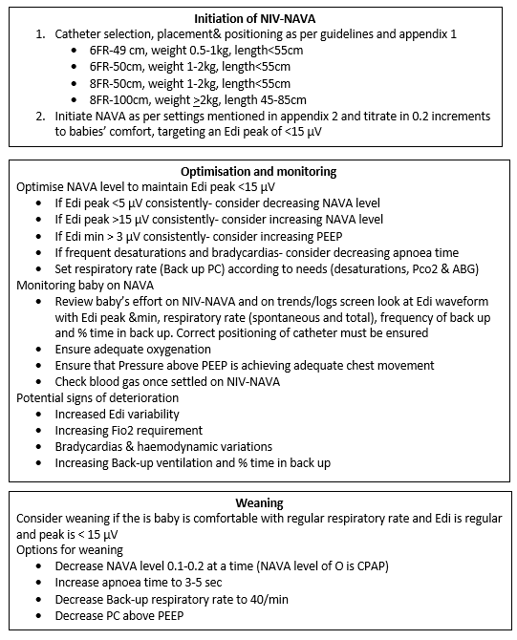

Attachment B: Information on Credentialing, Simulator, and Chest Physiotherapy Competency

Credentialing
All staff performing respiratory physiotherapy techniques on infants in the Department of Neonatology at Canberra Hospital will be credentialed. New staff will not be permitted to perform respiratory physiotherapy until they have been credentialed by the Senior Physiotherapist in CNC.

Simulator:
Connect anaesthetic bag with manometer up to oxygen outlet. Turn oxygen on (flow rate of 4 l/min) inflate the bag up to a pressure of 10 cm/H2O by adjusting the outlet of the bag. Staff simulate chest percussion on the bag - the manometer should move between 10 – 15 cm/H2O during the technique, indicating a percussion pressure of 5 cmH2O.

Records:
Staff participation at these sessions will be recorded and kept for accreditation and staff development purposes.
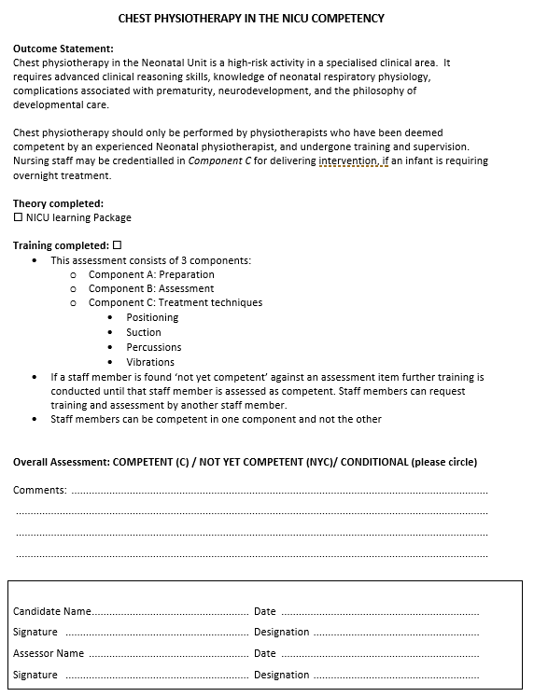

Attachment C: Sentec Digital Monitoring (SDM) Device Troubleshooting

REFERENCE WEBSITE FOR SDM DEVICE:
https://www.sentec.com/neonatal-pediatric-intensive-care/

THE tcpCO₂ AND /OR tcpO₂ READING DON'T STABILISE WITHIN 10 MIN:
- Check if attachment ring is attached properly
- Check if contact gel was used
- Check local or general perfusion of patient

CHANGING SENSOR MEMBRANE
When SDM displays the message “Change Sensor Membrane” and marks pCO₂ values invalid. Attend to sensor membrane change. Refer to Sentec Video link: www.sentec.ch/tv/v0

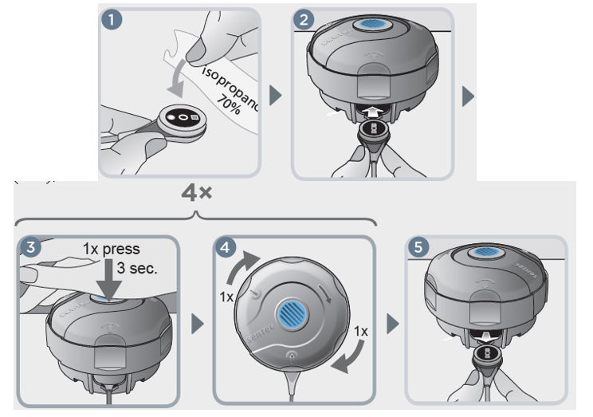

Attachment D: Australian & New Zealand Neonatal Network (AZNN) Flowchart for Shift Test for Physiological Chronic Lung Disease

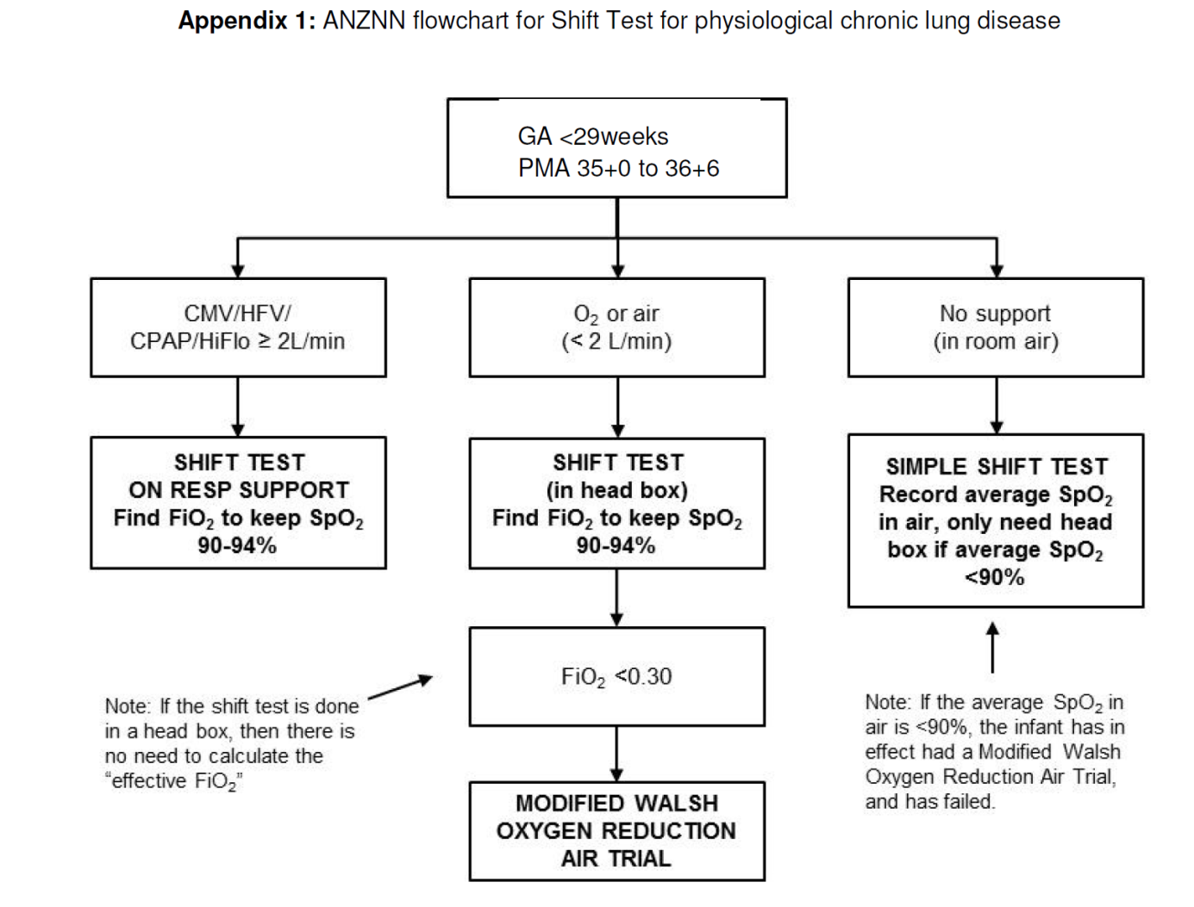

Attachment E: Australian & New Zealand Neonatal Network (ANZNN) Shift Test Form
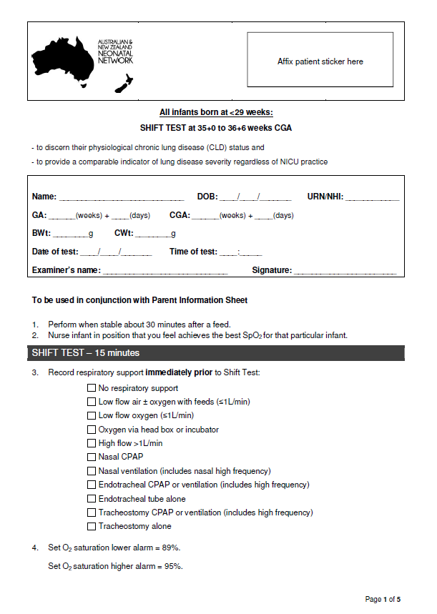

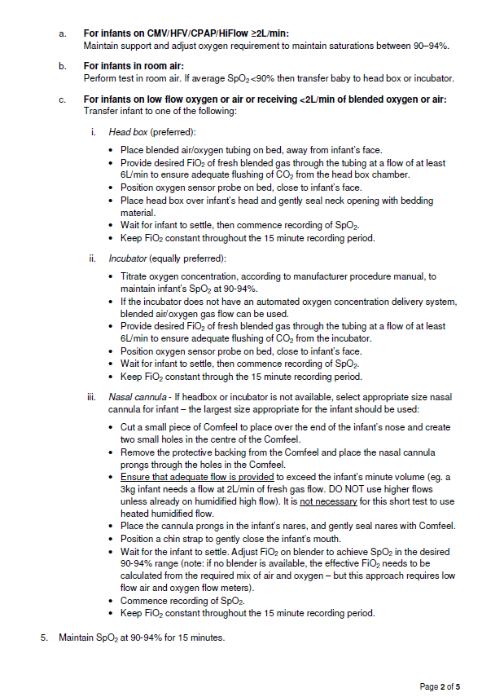

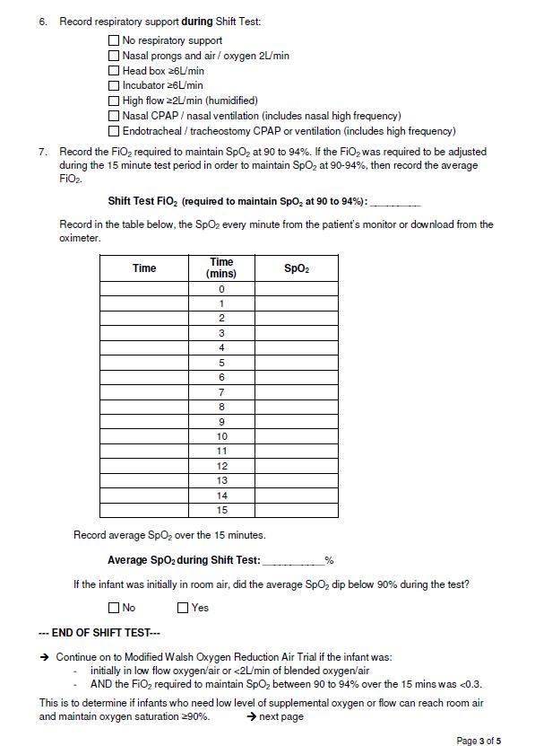

Attachment F: Modified Walsh Oxygen Reduction Air Trail
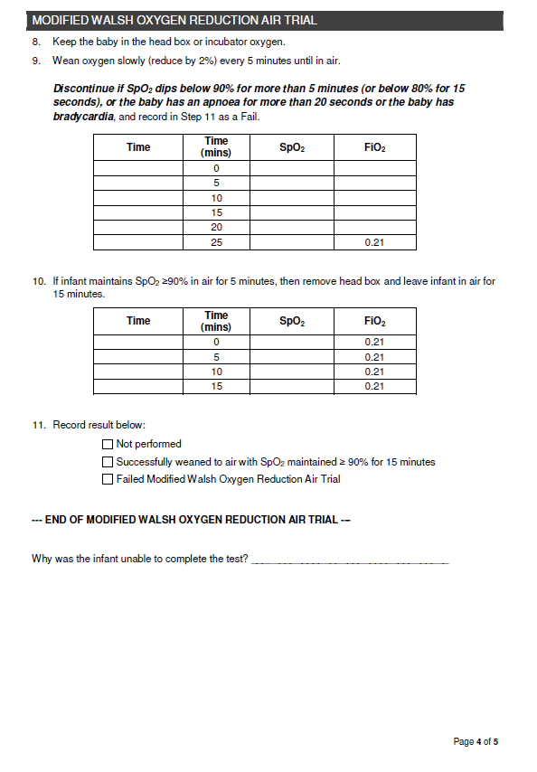

Attachment G: Australian and New Zealand Neonatal Network Parent Information Sheet Neonatal Lung Function Assessment (Shift Test)

