Canberra Health Services
Procedure
Professional Development Support for Health Professionals

Contents

Contents 1
Purpose 2
Scope 2
Background 2
Section 1 – Eligibility criteria 3
Section 2 – Eligible expenditure 3
Section 3 – Finance process 4
Section 4 – Administrative process 5
Section 5 – General considerations 6
Section 6 – Roles and Responsibilities 7
Evaluation 8
Related Policies, Procedures, Guidelines and Legislation 8
References 9
Search Terms 9
Attachments 9
Attachment 1: Application Process Flowchart 11
Attachment 2: Calculations of PD Support for Health Professional Classification 2021-2022 12
Attachment 3: Electronic application form 14
Attachment 4: Printable/PDF application form 17

Purpose

The purpose of this procedure is to outline a clear and consistent Professional Development (PD) support process for Canberra Health Services (CHS) Health Professionals which aligns with Clause N3 of the ACT Public Sector Health Professional Enterprise Agreement 2018-2021 (Enterprise Agreement).

Section N of the Enterprise Agreement applies to employees from any directorate who occupy a position having a classification of Health Professional as listed in Annex A of the Agreement. In accordance with Clause N3 of the Enterprise Agreement, CHS employees with a minimum of 12 months of service who occupy a casual, temporary, or permanent Health Professional position are eligible for PD support, subject to meeting all other eligibility requirements.

Note: This procedure should be read in conjunction with Clause N3 of the Enterprise Agreement. In the event of any inconsistency between this procedure and the Enterprise Agreement, the Enterprise Agreement will prevail.

Back to Table of Contents

Scope

This procedure applies to staff working at Canberra Hospital, University of Canberra Hospital and in the community. It does not apply to North Canberra Hospital or Clare Holland House staff, they should refer to Allied Health Professional Development Support North Canberra Hospital Procedure.

This procedure applies to the following CHS staff working within their scope of practice:
- Health Professionals employed under the classification of Health Professional, Medical Imaging, Medical Physics, Perfusionists, Pharmacist or Radiation Therapists.
- Staff responsible for managing, governing, or leading CHS staff employed under a Health Professional classification.

Back to Table of Contents

Background

CHS is committed to providing funding support to enable Health Professionals to undertake professional development training and educational activities (PD activities) through a range of schemes and programs, for example:
- PD support (as outlined in this procedure)
- Professional Development leave
- In-house training within CHS
- Studies Assistance
- Private Practice Fund
- CHS grants.

It is important that Health Professionals first discuss their PD activities with their line manager to determine which scheme(s) or program(s) may best suit their individual circumstances.

Health Professionals should have an annual CHS performance agreement capturing their learning and development needs.
Back to Table of Contents

Section 1 – Eligibility criteria

In accordance with Section N, Clause N3 of the Enterprise Agreement, PD support will be granted to an employee with a minimum of 12 months continuous service to undertake professional development training and educational activities subject to meeting all of the following criteria:
- the application is relevant to the employee’s field of practice (where relevance is disputed, the matter will be referred to the employee’s Profession Lead for the employee’s discipline)
- operational requirements permit the absence of the employee
- the training or educational activities to be funded are relevant to the employee’s professional development and the achievement of objectives as set out in the employee’s performance agreement
- the employee’s mandatory training is up to date or will be at the time the professional development is to be undertaken.

If an application for PD support does not meet all of the above criteria at the time of application, the application is ineligible at that point in time. Where applicable, an applicant may be asked to resubmit the application at a time that will ensure all criteria are met, for example, when operational requirements will support the applicant’s absence.

Where a Health Professional is ineligible to apply, they are encouraged to identify other PD Support options, many of which are outlined in the Studies Assistance Procedure available on the CHS Policy and Guidance Documents Register.
Back to Table of Contents

Section 2 – Eligible expenditure

Professional development activities that are eligible for PD support include, but are not limited to:
- course/conference registration fees
- online educational events including workshops, masterclasses, forums etc
- relevant post-graduate tuition where alternative funding has not been accessed or covers only part of the associated costs
- PD associated travel costs
- PD associated accommodation.

In-House Training Time
As per clause N3.3 of the Enterprise Agreement, PD Support includes “…all professional development time provided or to be provided in-house within the current year as agreed with the employee, but not including an employee’s mandatory training.” It is the responsibility of the Division or Department to support the delivery of In-House Training.

Examples of in-house training include:
- In-services
- Journal Clubs
- Allied Health New Graduate Program
- Teaching on the Run
- Workshops/Staff Development sessions run by CHS.

Pooling funds
Eligible applicants may elect to pool their individual PD support for the purpose of combining funds to support a group professional development activity. For example, it may be agreed by a group of eligible Health Professionals to fund an external speaker to present to a whole department rather than sending multiple individuals to an individual course conducted by that speaker. If funding is to be pooled, each applicant must submit an individual application form that reflects the amount of funding the individual is applying for. With such events, the department/profession may consider supporting staff who are ineligible for PD support (i.e., temporary staff <12mo service) in attending at no charge.

Items not eligible for funding under PD support include, but are not limited to:
- Professional registration or professional association membership fees
- Training required to ensure continuity of a clinical service
- Professional indemnity insurance
- Computers (including laptops), portable electronic devices, mobile and smart phones
- Textbooks and professional trade journal subscriptions
- Coaching or mentoring activities
- Externally provided clinical supervision
- Area/profession training activities that are mandated by legislation or National Safety and Quality Health Service (NSQHS) Standards.

Back to Table of Contents

Section 3 – Finance process

In any financial year, eligible Health Professionals are entitled to receive PD support funding equivalent to 2% of their base rate of pay (refer to the Enterprise Agreement for current base pay rates).

Attachment 2 provides further details of base rates of pay. If an employee is part-time, this will be calculated pro rata.
Each financial year, PD support funding will be allocated to the Office of the Executive Director Allied Health (OEDAH). The OEDAH is responsible for processing approved requests and administrating payment via reimbursement of costs.

An individual’s unused PD support funding is not able to be paid out or accrued. There is no requirement to fully expend each employee’s PD support entitlement. Individuals are able to self-fund any gaps between their PD support and the total cost of a PD activity.

The OEDAH will be responsible for monitoring and reporting to CHS’ Chief Executive Officer, Chief Operating Officer, Chief Finance Officer, Executive Directors and Directors of Allied Health each financial year on how the PD support has been delivered.

Back to Table of Contents

Section 4 – Administrative process

The employee is responsible for:
- Reviewing their eligibility
- Ensuring their mandatory training is up-to-date
- Discussing their learning needs with their manager/delegate
- Ensuring they have a current Performance Agreement
- Completing the PD Support Application Form (Attachments 5 & 6 for samples) and submitting it to their manager/delegate. Application forms are available at the Allied Health HealthHub page: Professional Development support application form.pdf
- Uploading their PD log for the applicable financial year onto the relevant Credential Platform
- Communicating promptly with the OEDAH in relation to any information required to process payment
- Providing timely notice to the OEDAH if they are subsequently unable to attend the funded activity.

The PD Support Application form must be accompanied by a copy of any Division specific learning and development/professional development form(s) to ensure that PD support is provided for the identified items.

Reimbursement of approved applications will be administered via the OEDAH. The applicant will need to pay for all expenditures themselves and then forward the receipt/s of the approved component/s to the OEDAH for reimbursement. To ensure prompt reimbursement receipts should be forwarded to the OEDAH no later than 30 days following the PD activity occurring.

Assessing relevance of PD activity
The manager/delegate is responsible for reviewing applications and for approval, consistent with the criteria outlined in Section 1.

If the manager/delegate is unsure if the requested PD activity is relevant to the applicant’s field of practice but the applicant believes it is, the applicant may discuss the relevance with their Profession Lead. Based upon the Profession Lead’s advice, the manager must re-assess the relevance of the PD activity to the applicant’s field of practice.

In instances where the individual’s manager is also their Profession Lead or where a decision cannot be reached on eligibility for funding, the manager may forward the application to the OEDAH requesting a decision.

Once an application has been reviewed by the manager/delegate and a decision made regarding approval, the manager/delegate is then responsible for submitting the approved application package to the Office of Executive Director of Allied Health at CHS.ExecutiveDirectorofAlliedHealthOffice@act.gov.au.

Processing Approved PD Support Applications
The OEDAH will contact the applicant and confirm the level of support endorsed and any further information needed to facilitate the required payments.

Mandatory training
For the purposes of PD support, ‘mandatory training’ is taken to mean ‘must complete’ and is detailed as the first pillar of training required in the Education and Training – Governance Processes and Staff Requirements Procedure.

Monitoring, tracking, and reporting on PD support activities
The OEDAH is responsible for processing all PD support applications. The OEDAH will maintain a record of applications and total payments each financial year. Records will be used to enable reporting to provide both a Division and CHS record of PD support applications and funding provided.

Time
The employee is required to gain approval to attend a professional development activity on a paid workday. If the activity occurs outside of the employee’s core hours, time in lieu is at the discretion of the employee’s manager.

Back to Table of Contents

Section 5 – General considerations

Professional Development leave
PD support does not replace Professional Development Leave (PDL). Further information on PDL is available on the HealthHub (intranet) HR Fact Sheet page. All PDL applications must be submitted through the Shared Services website by applying for ‘Other leave’.

Considerations for Health Professionals
Health Professionals are encouraged to share the learnings from PD accessed through the PD support scheme with members of their team and profession.

Consideration for Divisions
Divisions, with guidance from the OEDAH, should consider ways to gain the maximum benefit for Health Professionals undertaking PD activities. For example, it may be more cost effective to engage a speaker to deliver a PD activity to a group of staff both within and across Divisions, than to send individual employees away to attend a PD activity. PD activities such as webinars and online courses may also be cost effective.
Back to Table of Contents

Section 6 – Roles and Responsibilities

Position | Responsibilities
Executive Director Allied Health | - Supporting Health Professionals, managers/delegates and Directors of Allied Health to be aware of their responsibilities in relation to this procedure.  - Financial management and approval of requests.  - Processing, monitoring, tracking, and reporting on PD Support activities.
Directors of Allied Health | - Supporting Health Professionals and managers/delegates of Health Professional staff to be aware of their responsibilities in relation to this procedure.  - Encouraging staff to consider the full range of PD training and educational supports available
Profession Leads | - Advising the manager/delegate whether the PD activity is (or is not) considered reasonably relevant to the applicant’s field of practice when agreement cannot be reached between employee and manager/delegate.
Managers/Delegates | - Assessing PD support application in accordance with this procedure.  - Advising applicant of PD support decision.  - Encouraging staff to consider the full range of professional development training and educational supports available.  - Submitting the application.
Health Professionals | - Considering the full range of PD training and educational supports available and discussing with their line manager/delegate to determine which option(s) may best suit their individual circumstances.  - Submitting PD support application to manager/delegate and providing all requested information.  - Seeking advice from their Profession Lead if agreement regarding the relevance of the PD activity cannot be reached between employee and manager/delegate.  - Self-funding and/or seeking other funding sources (e.g., from the Divisional budget) to meet any gaps between the PD support payment and total cost of the PD activity.

Back to Table of Contents

Evaluation

Outcomes
All Eligible Health Professionals utilise the PD support scheme to access relevant learning and development opportunities.
All Health Professionals have equitable and fair access to the scheme.

Measures
- Annual report detailing:
- Total amount of PD Support budget spent
- Number of CHS Health Professionals undertaking PD activities via the PD Support Scheme
- Number of PD Support applications received by the OEDAH for processing.
- Total number of applications referred to Profession Leads.
- Breakdown of PD Support provided to Health Professionals across each Division.

Back to Table of Contents

Related Policies, Procedures, Guidelines and Legislation

Policies
- Interprofessional Education and Collaboration
- Leave Management

Procedures
- Education and Training – Governance Processes and Staff Requirements
- Studies Assistance
- Travel for Official Purposes

Enterprise Agreement
- Health Professionals Enterprise Agreement 2018-2021

Legislation
- Health Practitioner Regulation National Law (ACT) 2010
- Health Practitioner Regulation National Law Act 2009
- Public Sector Management Act 1994
- Financial Management Act 1996

Other
- Australian Charter of Healthcare Rights

Back to Table of Contents

References

- Government of South Australia, SA Health Allied Health Professionals + Professional Development Reimbursement Program Policy Directive, version no. V10, Approval date June 2018
- Office of the Commissioner for Public Employment, Northern Territory Government Professional Development Allowance Guidelines, Published January 2014.
Back to Table of Contents

Search Terms

Professional development, PD, PD Support, allied health, allied health professionals, health professional, health professionals, HP support, AHP support, AHP, AH, HPs, HP, Enterprise Agreement, Clause N3, Clause N

Back to Table of Contents

Attachments

Attachment 1: Application Process Flowchart
Attachment 2: Calculations of PD Support for Health Professional Classification 2020-2021
Attachment 3: Electronic application form
Attachment 4: Printable/PDF application form

Disclaimer: This document has been developed by Canberra Health Services specifically for its own use. Use of this document and any reliance on the information contained therein by any third party is at his or her own risk and Canberra Health Services assumes no responsibility whatsoever.

Policy Team ONLY to complete the following:
Date Amended | Section Amended | Divisional Approval | Final Approval
20 June 2022 | Complete Review | Jo Morris, ED-Allied Health | CHS Policy Committee
9/4/24 | Updated Scope and made minor editing amendments where needed

This document supersedes the following:
Document Number | Document Name
CHS20/326 | Professional Development Support for Health Professionals

Attachment 1: Application Process Flowchart

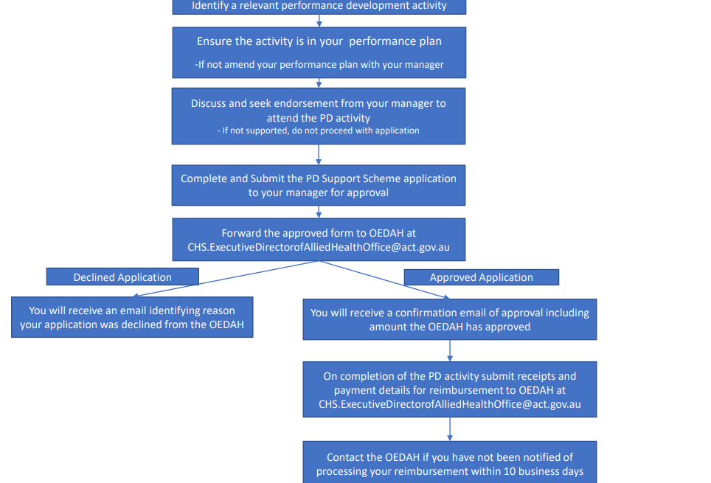

Attachment 2: Calculations of PD Support for Health Professional Classification 2021-2022
Refer to ACT PUBLIC SECTOR HEALTH PROFESSIONAL ENTERPRISE AGREEMENT 2021-2021 for rates of pay for other in scope classifications.
CLASSIFICATION – HEALTH PROFESSIONAL | Base rate of pay | 9/12/21 (2%) | Base rate of pay | 9/6/22 onwards (2%)
HP 1.1 | $65,402 | $1,308.04 | $66,285 | $1,327.70
HP 1.2 | $69,738 | $1,387.56 | $70,679 | $1,413.58
HP 1.3 | $74,225 | $1,484.50 | $75,227 | $1,504.54
HP 1.4 | $79,233 | $1,584.66 | $80,303 | $1,606.06
HP 1.5 | $83,327 | $1,666.54 | $84,452 | $1,689.04
HP 1.6 | $85,685 | $1,713.70 | $86,842 | $1,736.84
HP 2.1 | $69,738 | $1,394.76 | $70,679 | $1,413.58
HP 2.2 | $74,225 | $1,484.50 | $75,227 | $1,504.54
HP 2.3 | $79,233 | $1,584.66 | $80,303 | $1,606.06
HP 2.4 | $83,327 | $1,666.54 | $84,452 | $1,689.04
HP 2.5 | $85,685 | $1,713.70 | $86,842 | $1,736.84
HP 2.6 | $88,150 | $1,763.00 | $89,340 | $1,786.80
HP 2.7 | $90,459 | $1,809.18 | $91,680 | $1,833.60
HP 2.8 | $92,934 | $1,858.68 | $94,189 | $1,883.78
HP 2.9 | $95,736 | $1,914.72 | $97,028 | $1,940.56
HP 3.1 | $98,489 | $1,969.78 | $99,819 | $1,943.54
HP 3.2 | $100,844 | $2,016.88 | $102,205 | $2,044.10
HP 3.3 | $103,779 | $2,075.58 | $105,180 | $2,103.60
HP 3.5 | $108,927 | $2,178.54 | $110,398 | $2,207.96
HP 4.1 | $113,397 | $2,267.94 | $114,928 | $2,298.56
HP 4.2 | $122,062 | $2,441.24 | $123,710 | $2,474.20
HP 5.1 | $133,552 | $2,671.04 | $135,355 | $2,707.10
HP 5.2 | $140,456 | $2,809.12 | $142,352 | $2,847.04
HP 5.3 | $150,347 | $3006.94 | $152,377 | $3047.54
HP 6.1 | $155,107 | $3,102.14 | $157,201 | $3,144.02

Attachment 3: Electronic application form
Health Professional - Professional Development (PD) Support Application
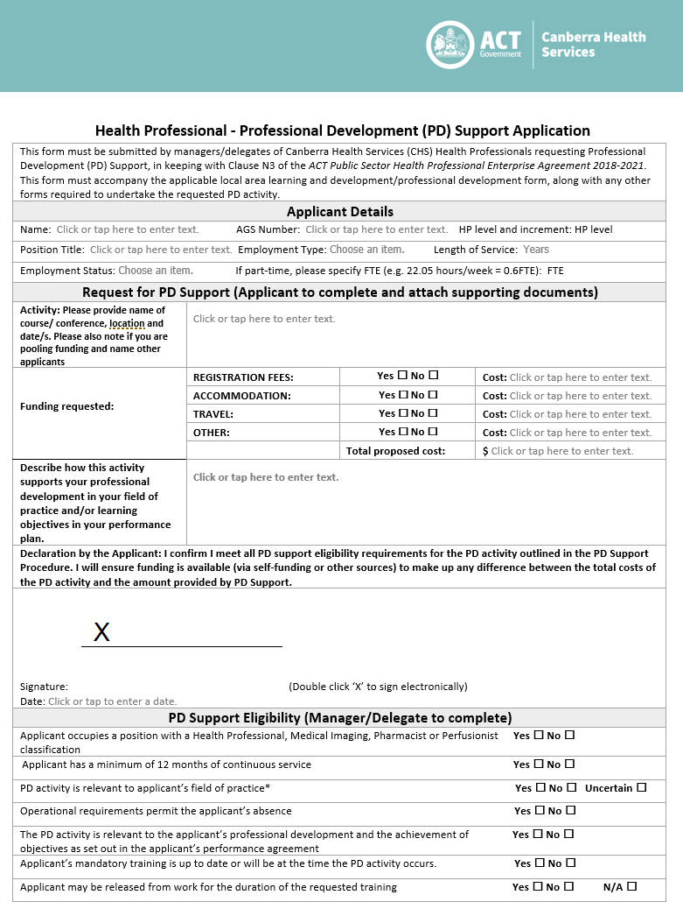

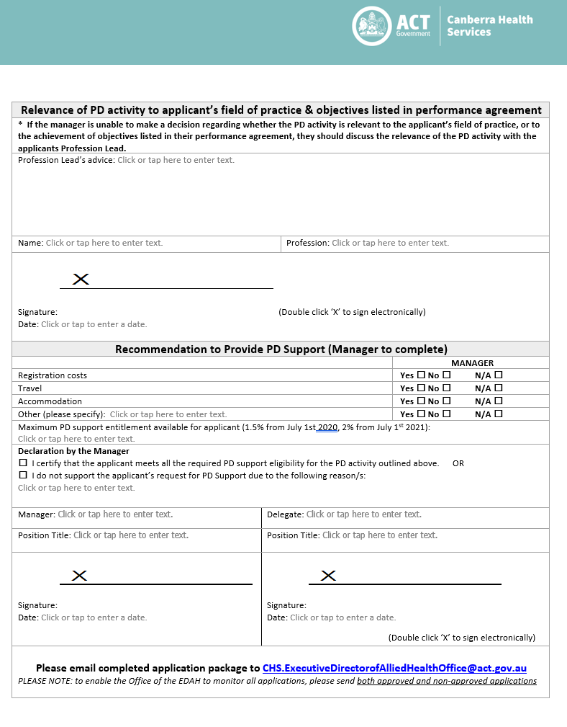


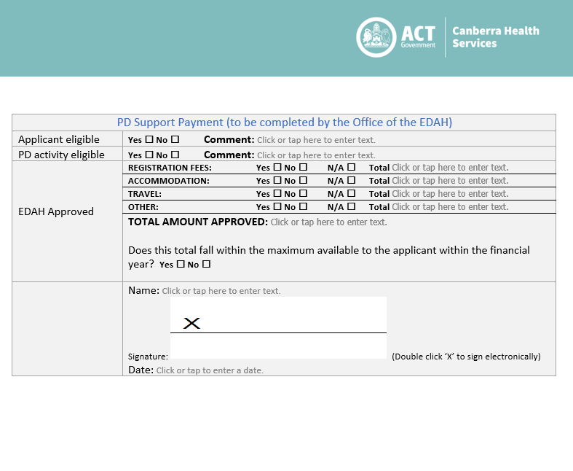

Attachment 4: Printable/PDF application form
