Procedure | Canberra Health Services

Policy Document Development and Review
CHS26/029
Contents
Purpose – Policy Statement 2
Alerts 2
Scope 2
Section 1 – Governance 3
Section 2 – Roles and Responsibilities 4
Section 3 – Getting started 5
Section 4 – Getting approval 6
Section 5 – Considerations when drafting and updating Policy documents 8
Section 6 – Evaluation requirements 11
Section 7 – Policy document consultation 12
Section 8 – Submission and endorsement of policy documents 14
Section 9 – Extension of review date 16
Section 10 – Amendments 16
Evaluation 17
Related policies, procedures, guidelines and legislation 17
Definition of terms 18
Search terms 20
Attachments 20
Attachment 1 - CHS policy development and review process 22
Attachment 2 - Policy document impacts which need to be considered 24

Purpose – Policy Statement
This document outlines the Canberra Health Services (CHS) policy governance processes for initiation, development, monitoring and evaluation of policy documents, including regular review. This process ensures the organisation has current, comprehensive, and effective policy documents developed in ways that are person-centred, culturally safe, and inclusive of diverse community needs.
The CHS policy governance process addresses key safety and quality risks. It exceeds the requirements of Action 1.07 of the National Safety and Quality Health Service Standards (NSQHSS) (Second Edition): Clinical Governance Standard.
Policy documents (i.e. policies, procedures, guidelines, and placeholders) provide a consistent approach for work undertaken by CHS team members that align with the CHS vision, role, and values.
A document must be classified as a policy document if it includes one or more of the following:
- high risk processes or procedures
- information to ensure consistency of practice across CHS
- processes required for legislation compliance, governance or accreditation requirements
- processes required to ensure consumer safety where there is no other suitable control for the safety risk.
Back to Contents

Alerts
If CHS team members are directly contacted by ACT Directorates (e.g., Health and Community Services Directorate, Justice and Community Safety Directorate) or external organisations to provide policy document feedback, they must confirm with the CHS Policy and Consumer Handouts Team the appropriate CHS internal approval process required, prior to providing any feedback. This internal process will vary depending upon the request made.
Back to Contents

Scope
This procedure applies to all staff at CHS.
CHS includes inpatient and outpatient facilities at Canberra Hospital, Clare Holland House (CHH), North Canberra Hospital (NCH), Mental Health Justice Health and Alcohol and Drug Services (MHJHADS), University of Canberra Hospital (UCH) and community based services.
For the purposes of this document policy documents include:
- policies
- procedures
- guidelines
- placeholders.

Out of Scope
Policy documents do not include frameworks, plans, strategies, business rules/local area protocols, clinical pathways, clinical forms, or consumer handouts. Please see Definition of Terms for further information. Refer to the following as relevant:
- Organisational Plans, Guidance and Patient Care Documents Management Procedure located on the Policy and Guidance Documents Register
- Consumer Handout - Development and Review Guideline located on the Policy and Guidance Documents Register
- Clinical Forms Register SharePoint site: Pages - Clinical Forms Register.
Back to Contents

Section 1 – Governance
The CHS Policy Document Review Panel is responsible for CHS policy governance. All policy documents must be endorsed by the CHS Policy Document Review Panel. The CHS Policy Document Review Panel reports to the CHS Network Clinical Governance Committee.
Endorsed policy documents are available to all CHS team members via the Policy and Guidance Documents Register. Policy documents are also publicly available from the ACT Open Access Portal and CHS public website, unless otherwise indicated i.e., due to posing significant risk to staff or consumer safety or copyright agreements. Please see Section 7 for further details.

Ownership
Policy documents are owned by a single division, even if it affects multiple divisions. They’re owned by the most senior Executive responsible for the subject matter or its operationalisation. To request a change of ownership:
- The current owner is required to email the proposed owner with the document details and reason for transfer of ownership.
- If ownership is agreed, forward the email agreeing to the change to PolicyAtHealth@act.gov.au.
- If document ownership is contested, the CHS Policy Document Review Panel Chair or Deputy Chair will provide a recommendation and facilitate discussion to reach an agreement.

Support for Policy Development and Review
The CHS Policy and Consumer Handouts Team, within the Quality, Safety and Governance Division, provide support to all CHS team members on how to navigate the policy document governance process. The Team can be contacted by email at: PolicyAtHealth@act.gov.au.
A summary of the CHS policy development and review process (as detailed in Sections 3-8) is presented as a flow chart in Attachment 1. This includes approximate indicative timelines.
Note: In special circumstances timeframes may be shortened. Please contact the CHS Policy and Consumer Handouts Team if there is an urgent need for the document to progress.
Back to Contents

Section 2 – Roles and Responsibilities

CHS Policy Document Review Panel
- Overarching governance, oversight and guidance in the development, review and monitoring of all policy and guidance documents developed for CHS.
- Incorporate a risk management approach which is fit for purpose, meets the needs of CHS and is aligned with Action 1.07 of the National Safety and Quality Health Service Standards: Clinical Governance Standard.
- Review policy documents to ensure person-centred language and approaches, cultural appropriateness (including Aboriginal and Torres Strait Islander cultural safety) and equity and inclusion principles.
- Endorsement of policy documents.
Document Owner (Divisional Executives who are responsible for overseeing the development and review of documents)
- Supervise development and review of policy documents assigned to them.
- Ensure their policy documents are up to date, document current practice, based on current evidence and comply with legislation, regulation, and jurisdictional requirements.
- Ensure all policy documents are appropriately implemented and evaluated.
- Ensure their action officers have the necessary skills, experience, and time to follow the governance process outlined in this procedure.
Action Officer (the content expert, co-ordinating team member or committee who writes, develops or reviews a document. The action officer reports to the document owner)
- Lead the development or review of the policy document.
- Ensure the document reflects person-centred care principles and culturally appropriate approaches relevant to its subject.
- Ensure document is appropriately consulted with all the relevant stakeholders (both internal and external).
- Collate all the feedback received and actions taken in response to feedback.
- Ensure document is evidence based, risk rated, succinct, reflects current practice, does not duplicate other available documents, is referenced, and has evaluation criteria.
- Follow the policy development and review process outlined in this procedure.

CHS Policy and Consumer Handouts Team
- Provide support for all CHS team members to navigate the policy document governance process. This includes:
  - assisting the CHS Policy Document Review Panel with governance insights (e.g. policy status updates and alignment to legislation and other requirements (e.g. National Safety and Quality Health Service Standards), and provide policy updates
  - providing regular reports to relevant stakeholders.

Medication Safety Committee
- Review documents with medication prescription and administration information to ensure its appropriate and safe.

CHS team members
- Follow relevant CHS policy documents when working at CHS facilities, services, and representing CHS externally.
- Apply CHS policy documents in ways that respect individual’s needs, cultural identity, and human rights.
Back to Contents

Section 3 – Getting started
Prior to commencing policy development or review, it is recommended that action officers complete the CHS – Policy and Guidance Documents Development and Review e-Learning available on HRIMS Learning accessible via the home page of the HealthHub.

Is a policy document required?
When determining whether a policy document may be required (or is still required), the following questions need to be considered.

Will the policy document:
- help control real or perceived risks?
- support a consistent approach to introducing a new clinical treatment, a clinical treatment in a new setting or change in clinical practice, i.e. beyond standard clinical practice?
- support compliance with legislation, regulation, or jurisdictional requirements?
- aid alignment with ACT Public Sector or Commonwealth Government policies or initiatives?
- need to be accessed beyond the document owner’s work area, e.g. by other CHS teams?
- support team members to meet CHS priorities, vision, role, and values?
- support delivery of person-centred, safe and culturally responsive care?
- address an unmet need or a current problem for CHS?
If the answer is ‘yes’ to any of the above questions, a policy document is required.

Local area protocols, business processes or business rules
If a policy document is not required, areas can consider business rules which are a local operational protocol that describes a low-risk activity specific to a work area. This document should be endorsed by the Division Safety and Quality Committee, an equivalent committee, or the DON/Assistant Director of Nursing (ADON)/Clinical Lead of the area. Divisions need to have a regular review process for these documents, which can be kept in hardcopy or in a central electronic location. More information and an electronic copy of the template to document local area protocols, business processes or business rules can be found on the HealthHub: New Business Rule template now available to capture low-risk activities

Searching the Policy and Guidance Documents Register
To minimise unnecessary duplication of information, action officers must check there are no existing CHS policy documents covering the same topic, practice, treatment, or risk.
If action officers identify an existing document could be added to or altered to more comprehensively address the identified concern, they should contact the CHS Policy and Consumer Handouts Team by emailing policyathealth@act.gov.au.

Using or adapting an external guidance document
Action officers are encouraged to first check there are no existing external (international, national or jurisdictional/interstate) guidance documents which cover the same topic, practice, treatment, or risk.
If an external document exists that could be used or adapted for CHS, a placeholder can be used to direct CHS team members to this resource from the Policy and Guidance Documents Register. See Section 4 for next steps.
Back to Contents

Section 4 – Getting approval

New policy document
If a new policy document (including a placeholder) is needed, the action officer is required to complete an Initiation Request Form and return to policyathealth@act.gov.au. The team will review and may contact the action officer for more detail, before a decision on approval is made by the Director of Policy and Consumer Handouts. An electronic copy of the Initiation Request form can be found on the Policy and guidance documents page on the Health Hub.

Review of an existing policy document
The review of an existing policy document may be prompted by:
- it being close to its review date
- its evaluation as part of ongoing monitoring/quality improvement
- recommendation to change an existing policy document following a completed investigation of a reported incident
- a change in infrastructure, work, or evidence-based practices, e.g. due to new information technology systems or new research findings
- a change to legislation, regulation, jurisdictional or best practice requirements
- response to consumer feedback or trend in negative outcomes.

Note: When reviewing policies, if they have associated procedures, please consider whether they could be combined into a single procedure document.

Note: Action officers should email the CHS Policy and Consumer Handouts Team when they start reviewing an existing policy document. This allows timely support and consolidation of documents where possible.

NCH policy documents
Wherever possible, NCH information is incorporated into existing CHS documents. The purpose of harmonising policy processes is to reduce duplication of documents and ensure clarity of advice to staff.

Reviewing an existing NCH-specific document
- The CHS Policy and Consumer Handouts Team will notify the NCH Divisional owner when a document is due for review.
- If the document is no longer required, refer to the archiving process in this section.
- If the content is required, consider:
  - Are the processes described in the CHS wide and NCH documents similar/the same or align but there are minor differences?
If yes, amend the scope of the CHS document to incorporate and/or add NCH-specific information, such as phone number, team to contact, etc. or content (such as a new section) to the CHS document to guide staff around the site-specific requirements. The NCH-specific document is archived when the updates are endorsed.
If no to the above, the NCH-specific document may be appropriate to review, noting the following criteria (NCH-specific documents must meet at least one of the following criteria):
    - the process(es) described are specific to the NCH/CHH facilities
    - the process(es) are specific to equipment only used at NCH
    - NCH has limited or no capacity to support the process/es described, i.e., the CHS team supporting the process(es) does not currently support NCH and there is limited or no team to support the process at NCH
    - the process(es) described are vastly different for CHS and adoption of the CHS process requires implementation of a new process at NCH.
If the document is required and meets one or more of the criteria above, an NCH-specific document can be created/reviewed.

Archiving
If the existing policy document is no longer required, a completed Archive Request Form should be sent to policyathealth@act.gov.au to allow the policy document to be removed from the Policy and Guidance Document Register. An electronic copy of the Archive Form can be found in the Policy and Consumer Handout Development Resources on the Health Hub.
Alternatively, an email to the CHS Policy and Consumer Handouts Team will be accepted if it includes the details of the document, the reason for archival, and approval from the Divisional Executive (Executive Director (ED)/ Executive Group Manager (EGM)/Executive Branch Manager (EBM)).
Note: If a request to archive is received due to development of a new document, it will not be actioned until the new document is endorsed by the Policy Document Review Panel and uploaded to the Policy and Guidance Document Register. Exceptions may apply if a document is unsafe or not fit for purpose.
Back to Contents

Section 5 – Considerations when drafting and updating Policy documents
When the Initiation Request has been approved for new documents, or the review of an existing document is commencing, the action officer will draft or update the document.
Action officers working on a new, or updating an existing policy document are encouraged to contact the:
- CHS Policy and Consumer Handouts Team
- divisional policy support (where available), and/or
- team members within their respective Division who are experienced policy writers/reviewers.
This helps to identify whether a working group of key stakeholders should be convened and what research should be undertaken to ensure that the policy document is evidence based.
CHS policy documents need to consider any potential economic, social, equity, diversity, cultural and environmental impacts. Please refer to Attachment 2 for further details and who to contact to ensure these impacts, where appropriate, are adequately considered.
Action officers should familiarise themselves with the appropriate policy document templates. These are regularly updated and can be found on the Policy and Consumer Handout Development Resources on the Health Hub.
The CHS Tone of Voice Guide and CHS Writing Style Guide are available on the Communications, Media and Brand HealthHub page: Communications, media and brand.

Accessibility
In line with legal requirements and the organisation’s commitment through the CHS current Disability Inclusion Plan, CHS has an obligation as a health service to ensure our documents are accessible to people with disability and those who use screen readers.

Alternative text
Alternative (Alt) text is a written alternative to an image (image, infographic, diagram and chart). It is a short description of an image that will improve accessibility for users relying on screen readers and ensure the content is fully comprehensible to all users i.e., people with visual impairment. Alternative text can also be changed into other formats that some people may require, such as large print, Braille, speech, symbols or other languages. The action officer is required to add alternative text to all images within a policy document. This is completed in MS Word by right clicking the image, selecting ‘View Alt Text’ and entering text into the box. For example, ‘Infographic detailing the steps on how to put on and remove personal protective equipment’, ‘a drawing of a person's head showing bitemporal electrode placement’. Any graphics or icons that are not required to understand the content can be ticked ‘Mark as decorative’.

Tables
Use tables for tabular information only. Avoid using tables for layout, or aesthetics. Keep tables simple with no merged or empty cells. Make sure tables always have a header row or column. Accessibility of tables can be checked using the Microsoft Accessibility Checker found under the “Review” tab.

Colours
CHS policy document templates are pre-set with CHS Colours. Colour combinations should be checked to make sure they are accessible for people with low vision. Text and colour contrast is required to meet CHS accessibility standards, refer to the CHS Brand Cheat Sheet for more information. This is located on the Communications, Media and Brand HealthHub site: Communications, media and brand.

Microsoft Accessibility Checker
Action Officers can test their documents to see if they meet accessibility requirements with the Microsoft Accessibility Checker found under the “Review” tab.

Aboriginal and Torres Strait Islander Impact Statement and Declaration (ISD)
All CHS policies are required to have a completed Aboriginal and Torres Strait Islander ISD.
CHS procedures, guidelines and placeholders may require a completed Aboriginal and Torres Strait Islander ISD.
Refer to the Aboriginal and Torres Strait Islander Impact Statement and Declaration Procedure available on the Policy and Guidance Documents Register for further details. When considering whether a document requires an ISD, team members are encouraged to speak to the CHS Policy and Consumer Handouts Team or one of the following services:
- Canberra Hospital and UCH Aboriginal and Torres Strait Islander Liaison Services, by phone 5124 2055 or email ALOService@act.gov.au.
- NCH Aboriginal Liaison, by phone 6264 7097 or 6201 6289
- MHJHADS Aboriginal and Torres Strait Islander Service, by phone 5124 6790.

Risk management of policy documents
When a policy document is endorsed by the CHS Policy Document Review Panel, a review date between 12 months and five years will be determined, based on its risk rating.
Policy documents are risk rated based upon the overall likelihood and most common consequence of an adverse outcome if the document did not exist, was not current or was not followed. When risk rating, action officers should use the CHS Risk Matrix available on the Risk Management HealthHub page: Risk Management.
For advice on risk rating policy documents, CHS Policy and Consumer Handouts Team by emailing PolicyAtHealth@act.gov.au.

Implementation of policy documents
During planning for implementation, action officers and owners are to consider who will be affected by the new or revised policy document. They should then determine the most appropriate, effective, and efficient way of informing them.
Action officers and owners are encouraged to identify and consider:
- those with responsibility for implementing the policy document
- the resources needed to implement the policy document, including time and budget
- the need for education or training. Any policy documents requiring changes to established practice may need to be supported by information sessions, training or workshops. In addition, the change may need to be communicated through executive structure, leadership groups and existing committees to inform team members across and within CHS that the change must be adopted.
- any changes to practice needed and how this will be managed across and within CHS and by whom
- how team members are going to know about the new or revised policy or guidance document, so they can follow it. For example, communication by the action officer and/or Executive in addition to the Policy and Consumer Handout Team’s CHS wide communication regarding policy document changes i.e., Policy Alerts.
Communication activities might include:
- all team members emails at CHS/branch/division level
- face-to-face meetings/discussions e.g. information sessions and/or team members forums
- team briefings by managers
- team members bulletins or newsletters
- communication books used by specific work areas.
Some policy documents may need more comprehensive communication strategies, such as media release or launch, and advice to stakeholders in the form of brochures/information sheets, advertising, training sessions and community announcements. For further assistance, please contact the CHS Strategic Communications Team by emailing chscomms@act.gov.au.
If the policy document requires a consumer handout to inform consumers and the wider public about the service, please contact Consumer Handouts via Consumer.Handouts@act.gov.au and refer to Consumer Handouts Development and Review Guideline

Related Policies, Procedures, Guidelines and Legislation mentioned in policy documents
Each document should include appropriate references to other documents. Examples are included in policy document templates.

Policy document record keeping
Action officers are to maintain official files relating to development of new or process of review for policy documents. Approval emails, iterations or drafts of the document and working papers are required to be kept with the final version of the policy document. These can be kept in official hard copy files or electronic record keeping system. All records are to be maintained in accordance with the Territory Records Act 2002.
Back to Contents

Section 6 – Evaluation requirements
The Evaluation section details what the document is wanting to achieve (outcome) and what information the action officer will look at to assess if the document has achieved its purpose and is effective (measure).
Measures should directly relate to the identified outcomes. That is, what specific qualitative and/or quantitative measures (e.g., percentage of compliance with a specific element) can be used to determine if the policy document is effective?
Consider:
- What is being evaluated? ie. what is the policy document seeking to achieve, and how is success measured?
- How often does the document need to be evaluated? For example, if low risk, monitoring might only need to occur on review of the document. If high risk, more frequent monitoring may be required, inclusive of reporting to a suitable Committee or Executive.
- What data is available to understand if the policy document is being used as intended, meeting consumer-centred care outcomes and/or culturally safe care? E.g. from audit of consumer’s clinical records, feedback from staff or users observational surveys.
- Is a direct measure required, or can indirect measures be used? Indirect measures include information such as survey responses, and stakeholder feedback.

Evaluation of existing policy documents
As a part of the review process the action officer must complete an Evaluation of the version already on the Policy and Guidance Documents Register.
This involves a review of the measures outlined in the Evaluation section of the existing document to assess if the outcomes were achieved. This is to be documented on the Consultation Feedback Form, see Section 7.
Through this process it may be identified that the outcomes and measures need to be revised in the reviewed version, to ensure the document achieves its purpose.
Back to Contents

Section 7 – Policy document consultation

Seeking consultation feedback
Each document will require a different level of engagement, if you are unsure of who to consult for your document, please contact the CHS Policy and Consumer Handouts Team.

Internal consultation
All reasonable attempts must be made by the action officers to seek feedback from staff that are listed in the scope or have responsibility in the document.
Note: Existing placeholders are not required to go through consultation. The final updated version and completed Submission for Approval Form can be submitted to PolicyAtHealth@act.gov.au
Action officers seeking the CHS Policy and Consumer Handouts Team’s feedback on a policy document can contact PolicyAtHealth@act.gov.au.
For broader internal consultation, a clean copy of the document and consultation feedback form can be emailed to the CHS Policy and Consumer Handouts Team for uploading to a central Consultation page on SharePoint. This allows key stakeholders within CHS to provide feedback via tracked changes on a single version of the document. This is recommended as this typically makes version control, consolidation and consideration of feedback easier for the action officer.

External consultation

External feedback – when to seek, and how?
CHS requires consumer feedback being sought for policy documents where consumers will be directly impacted or where they relate to a topic with a high public profile and/or expectations. A minimum of six weeks is required for feedback from consumer organisations.
To obtain consumer and carer input, email a draft document and consultation feedback form to relevant stakeholders:
- Health Care Consumers Association (HCCA) by emailing adminofficer@hcca.org.au
- ACT Mental Health Consumer Network by emailing policy@actmhcn.org.au
- ACT Disability, Aged and Carer Advocacy Service by emailing adacas@adacas.org.au)
- Carer’s ACT by emailing carers@carersact.org.au
- Mental Health Carers by emailing mhcarers@carersact.org.au
Where a document includes or applies to specific cohorts of consumers, the consultation should include organisations and groups that represent them. For example, a document that specifically relates to a service for people with disability should include consultation with disability organisations, or a document that includes people from multicultural background should be consulted with multicultural organisations or groups.
When considering whether consumers may need to be consulted, CHS team members are encouraged to speak with the Divisional dedicated policy support (where available) or the CHS Policy and Consumer Handouts Team.
Note: This procedure focusses on policy documents which are routinely developed by CHS team members and does not preclude action officers from working with consumers and consumer organisations using a co-design approach when developing policy documents. For further information on co-design, please refer to the Partnering with Consumers and Carers Policy.

Additional consultation which may be required
- If an Aboriginal and Torres Strait Islander ISD is required then action officers must include Aboriginal and Torres Strait Islander groups in consultation
- Health Safety Representatives (HSRs) for the work group affected. HSRs represent employees regarding Work Health Safety matters in the workplace. HSRs must be included in any consultation which may impact CHS team members health and safety.
- Relevant unions and employee representatives, for any draft documents relating to enterprise agreements or other industrial matters. For advice contact the Workforce Relations team via email CHSHRAdvisory@act.gov.au.
- Other Divisional and CHS wide committees may also need to be included in consultation depending on the policy document e.g. CHS National Safety and Quality Health Service Standard Committees. For more information and contacts please see National Standards and Reaccreditation - Home page available via the National Standards HealthHub site.
- If the policy document contains specific references to medications, it will need the relevant Divisional pharmacist(s) to provide feedback regarding medication information. For Canberra Hospital, University of Canberra Hospital and Alexandar Maconochie Centre please contact medication safety pharmacist at Medicationsafetypharmacist@act.gov.au. For North Canberra Hospital and Clare Holland House please contact Lead Pharmacist miriam.lawrence@act.gov.au .

Review of consultation feedback
Action officers are to review and consider whether consultation feedback should be accepted and incorporated, or not accepted, and document the rationale for this. This information should be recorded on the Consultation Feedback Form to support policy document endorsement. An electronic copy of the Consultation Feedback Form can be found on the Policy and guidance documents page of the HealthHub. The Consultation Feedback Form should list everyone/all groups the document was provided to for feedback, even if no feedback was received.
It is recommended for consumer and external stakeholder consultation that the action officer confirms the feedback received and any related actions and changes to the document. This can be summarised in an email or consultation feedback form provided.
Back to Contents

Section 8 – Submission and endorsement of policy documents

Submission of new and reviewed policy documents
To submit a new or reviewed policy document for endorsement by CHS Policy Document Review Panel the following are to be emailed to policyathealth@act.gov.au:
- clean copy of the policy document
- completed Consultation Feedback Form
- signed Submission for Approval Form
- completed Aboriginal and Torres Strait Islander Impact Statement Declaration, if applicable.
An electronic copy of the Submission for Approval Form and Aboriginal and Torres Strait Islander Impact Statement Declaration can be found in the Policy and Consumer Handout Development Resources available from the Policy and Guidance Document Register: Policy and Guidance Documents Register - Policy and Consumer Handout Development Resources - Policy and Consumer Handout Development Forms - All Documents
Note: Under the Freedom of Information Act 2016, all CHS policy documents are made publicly available on the CHS website and the ACT Government Open Access website. The only exceptions to this are where the content might pose a risk to security or safety of staff, consumers or the public, or if the document contains copyrighted third-party material. If the document should not be available on the internet, the action officer should discuss this with their responsible Executive and the decision should be reflected in the FOI Open Access Scheme section of the Submission for Approval Form. This section may only be completed and signed by the responsible Executive.
The CHS Policy and Consumer Handouts Team can assist action officers to seek any necessary approvals from other CHS wide governance committees. This includes the Medication Safety Committee, Clinical Forms Committee, and Consumer Handouts Committee. For example, documents that have been submitted to the Policy Document Review Panel for endorsement that contain medication dosage and administration will be identified by the CHS Policy and Consumer Handouts Team and submitted to the Medication Safety Committee.
Divisional approval processes, where relevant, should be completed prior to submission (e.g. Quality and Safety Meeting).

Endorsement
Following review of the document by the CHS Policy Document Review Panel, the action officer will be provided with an Endorsement Report including a decision about endorsement. This will include any required changes that need to be made prior to upload to the CHS Policy and Guidance Documents Register. Possible outcomes from the meeting include:
- Endorsed
- Endorsed pending minor changes
- Requires minor or moderate changes and resubmission to the chair for endorsement, or
- Requires significant changes and must be resubmitted to the Panel.
It is the action officer’s responsibility to update the document and meet the requirements set out in the Endorsement Report. Once this has been completed the action officer should provide the updated policy or supporting documents to policyathealth@act.gov.au. Once the document meets the requirements of the Endorsement Report it will be uploaded to the CHS Policy and Guidance Documents Register.
Back to Contents

Section 9 – Extension of review date
To seek an extension of the review date of a policy document, the document owner should contact the CHS Policy and Consumer Handouts Team by email at policyathealth@act.gov.au. They should include the reason and desired timeframe for extension.
The requirements for extensions being considered by the Director of Policy and Consumer Handouts include:
- The document must be in date, not already overdue.
- The document needs to be safe for staff to use and reflective of current practice. If this is not the case an amendment can be processed to update it accordingly.
- An extension will only be granted when there is an incoming major change to practice – such as review of model of care/service, or implementation/change of technology such as DHR or new equipment that will affect process.
- Only one extension will be granted. Extensions can be for three to six months.
Back to Contents

Section 10 – Amendments
Management for documents requiring amendments will depend on how much change is required.

Major Change
A major change occurs when the document requires updates to the purpose, scope or majority of the processes. This needs to be completed as a full review and update of the document.

Moderate Change
A moderate change occurs when all/most processes documented will be altered but not changed completely and the purpose and scope of the document remain the same. To progress:
- Email PolicyAtHealth@act.gov.au with the name of the document and staff member leading the update with a summary of the changes required
- Download the current version of the document from the Policy and Guidance Document Register
- Turn tracked changes on and make the amendments to the document
- Seek approval for the amendments from your Director/Clinical Director/Director of Nursing/Director of Midwifery/Director of Allied Health
- Return the document with tracked changes and evidence of approval to PolicyAtHealth@act.gov.au

Minor Change
A minor change is an addition or removal of small amounts of information that doesn’t alter the purpose or scope and is not applicable to all processes within the document. For example, formatting or grammatical changes, updates to contact details, hyperlinks or attachments, or incorporating minor feedback from internal areas or external stakeholders.
To progress:
- Download the current version of the document from the Policy and Guidance Document Register.
- Turn tracked changes on and make the amendment to the document.
- Seek approval for the amendments from your Clinical Nurse Consultant/Clinical Midwifery Consultant/Nurse Unit Manager/Director of Allied Health/Director – this can be done via email.
- Return the document (still containing tracked changes) and evidence of approval to PolicyAtHealth@act.gov.au.
Back to Contents

Evaluation

Outcome
- CHS policy documents are developed and reviewed in line with this procedure.
- 10 percent or less policy documents on the Policy and Guidance Documents Register are overdue for review.

Measures
- Percentage of policy documents overdue for review on the CHS Policy and Guidance Documents Register is communicated monthly to all divisions and facilities.
- Percentage of CHS policy documents overdue for review reported from the CHS Policy and Consumer Handouts Team to Network Clinical Governance Committee monthly.
- Annual survey of action officers and Policy Document Review Panel Members.
Back to Contents

Related policies, procedures, guidelines and legislation

Policies
- Risk Management
- Clinical Governance

Procedures
- Aboriginal and Torres Strait Islander Impact Statement and Declaration
- Organisational Plans, Guidance and Patient Care Document Management

Guidelines
- Consumer Handouts – Development and Review Guideline

Legislation
- Freedom of Information Act 2016
- Human Rights Act 2004
- Territory Records Act 2002
- Multiculturalism Act 2023
- Carers recognition Act 2021
- Disability Inclusion Act 2024

Other
- National Safety and Quality Health Service Standards (NSQHSS) (Second Edition): Clinical Governance Standard
- Australian Charter of Healthcare Rights
- Charter of Children and Young People’s Rights in Health Care Services in Australia
- ACT Charter of Rights for People who experience mental health issues
- CHS Disability Action and Inclusion Plan 2022-2025.
Back to Contents

Definition of terms
Action Officer - is the content expert, co-ordinating team member or committee who writes, develops or reviews a document. The action officer reports to the document owner.
Approval – An Executive supports the content of a document and accepts it as accurate and appropriate for use at CHS.
Archived – when a document is no longer required or has been incorporated into another document it can be removed from the CHS Policy and Guidance Documents Register or CHS Clinical Forms Register with a copy saved in an archive folder.
Business rule/local area protocols (non-policy document) – a local operational procedure that describes a low risk activity specific to a work area. This document should be endorsed by the Division Safety and Quality committee, an equivalent committee, or the Director of Nursing /Assistant Director of Nursing /Clinical Lead of the area. Divisions need to have a regular review process for these documents, which can be kept in hardcopy or in a central electronic location.
Clinical Form (non-policy document) – logically structured document designed for entering, extracting, or communicating required information about a consumer and their care. Endorsed by the Clinical Record Forms Committee. Email clinicalRecordsFormsOfficer@act.gov.au for further details or visit the Clinical Forms Register available via the HealthHub homepage: Pages - Clinical Forms Register (sharepoint.com).
Clinical Pathway (non-policy document) – standardised, evidence-based map which identifies sequence of clinical interventions, timeframes, milestones and expected outcomes for a similar consumer group. The content may be sourced from external expertise or developed internally. CHS development of an evidence-based practice clinical pathway is written by clinicians who are appropriately skilled and qualified in the relevant field of practice or by broad consensus. Clinical Pathways are endorsed by an executive level committee. A clinical pathway is supported by a procedure or guideline, which must be endorsed by the CHS Policy Document Review Panel.
Consumer Handout (non-policy document) – a written document which is consumer focussed and follows health literacy principles. Consumer Handouts ensure that consumers have relevant, reliable, health literate and accessible handouts which meet their needs, and supports safe care and positive consumer experiences. Endorsed by the Consumer Handouts Committee. Email consumer.handouts@act.gov.au or refer to the Consumer Handout - Development and Review Guideline located on the Policy and Guidance Documents Register for further details.
Document Owner – the Divisional Executives who are responsible for overseeing the development and review of a document.
Endorsement – A committee with appropriate authorisation formally makes the final decision to accept a document on behalf of CHS. Endorsement is granted when the committee is satisfied that the appropriate processes of development, consultation and approval have been completed.
Guideline – detail the recommended practice to be followed by CHS team members but allow some discretion or autonomy in its implementation or use. Guidelines are written when more than one option is available under a given set of circumstances, and the appropriate action requires a judgement decision. Guidelines may also be used when the supporting evidence for one or other course of action is ambiguous.
Manual – These documents collate a range of clinical and operational policies, procedures, guidelines for a particular unit or work area. The purpose of a manual is to enable ease of use/location/compliance of key information for a specific team. A manual containing clinical information or high-risk operational information is endorsed by the CHS Policy Document Review Panel. A manual containing low risk operational information is endorsed by the Division Safety and Quality Committee or an equivalent committee.
Placeholder – a short document that states CHS endorsement of, and where applicable, compliance with, an international, national, or state guideline or standard and provides a weblink to the external document for team members to refer to. The placeholder identifies any exceptions to the use of the external document or includes further information on CHS process, if required. Placeholders can also be used where internal documents have been developed but are held on other platforms e.g., SharePoint, HealthHub, HCSD, Policy Register.
Policy – is an overarching, organisational wide directive about how CHS team members are to act in defined circumstances or regarding a particular situation. Policies are documents based on evidence, legislation, Standards, regulations and/or ACT Government requirements and compliance is mandatory. A policy can be supported by a procedure or guideline.
Procedure – details specific methods or actions team members must undertake to complete required processes within CHS. Procedures inform team members about how to complete clinical or administrative actions consistently across the organisation. Non-compliance with a clinical procedure must be clearly documented in the consumer’s clinical record.
Back to Contents

Search terms
Policy, Procedure, Guideline, placeholder, Register, Manual, Policy, Review, Panel, Committee, document, consultation, evaluation, Policy Team, business rule, local area protocols, clinical pathway, clinical form, north
Back to Contents

Attachments

Attachment 1 - CHS policy development and review process

Attachment 2 - Policy document impacts which need to be considered
Back to Contents

For Policy Team to complete:
Date amended | Section amended | Divisional approval | Final approval
2 January 2026 | Complete review | Josephine Smith, Executive Group Manager, Quality, Safety and Governance | CHS Policy Document Review Panel
This document supersedes the following:
Document number | Document name
CHS23/346 | Policy Document (Policies, Procedures, Guidelines, and Placeholders) Development and Review
Disclaimer
This document has been developed by Canberra Health Services specifically for its own use. Use of this document and any reliance on the information contained therein by any third party is at his or her own risk and Canberra Health Services assumes no responsibility whatsoever.
Back to Contents

Acknowledgement of Country  Canberra Health Services acknowledges the Ngunnawal people as traditional custodians of the ACT and recognises any other people or families with connection to the lands of the ACT and region. We acknowledge and respect their continuing culture and contribution to the life of this region.  © Australian Capital Territory, Canberra 2026 | Accessibility  call (02) 5124 0000   Interpreter call 131 450  canberrahealthservices.act.gov.au/accessibility  

Attachment 1 - CHS policy development and review process
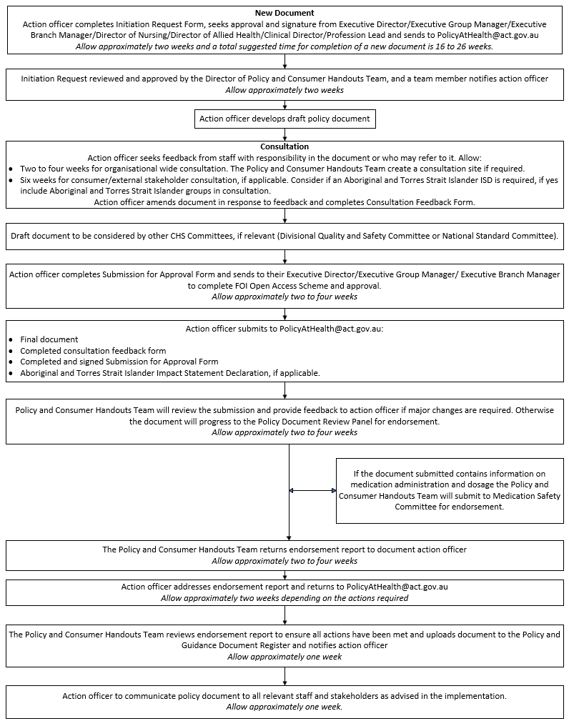
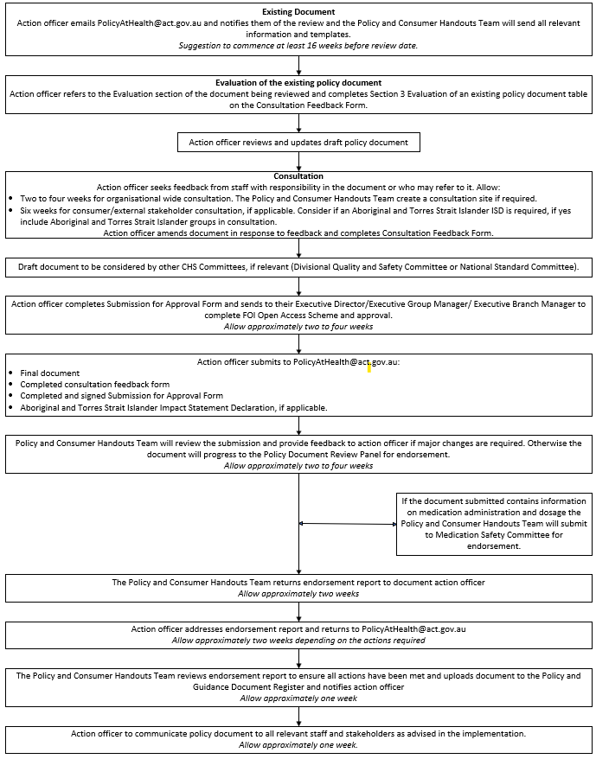
Back to Contents

Attachment 2 - Policy document impacts which need to be considered
Carers recognition impact – It is strongly recommended carers appear before family in the standard order of text. This recognises that the role of a carer in supporting consumers is above and beyond the typical responsibilities of a family or friend, as outlined in the Carers Recognition Act 2021 (Carers Recognition Act 2021 | Acts). CHS policy documents including carers should be reviewed by Carers ACT to ensure the rights and recognition of Carers are supported.
Child sexual abuse victim and survivor impact – CHS policy document content should be underpinned by promotion of a trauma-informed approach. For further assistance, please contact the HCSD Health Policy and Strategy Branch by emailing HCSDPolicyPartnerships-Programs@act.gov.au
Disability impact –In line with the organisation’s commitment through the Disability Inclusion Act 2024, CHS policy documents should be underpinned by inclusion, accessibility and universal design. For further assistance, please contact the CHS Policy and Consumer Handouts Team by emailing policyathealth@act.gov.au
LGBTIQA+ impact – including consideration of the Capital of Equality: An ACT Government Strategy, Capital of Equality (act.gov.au). For further assistance, please contact the Office for LGBTIQ+ Affairs by emailing LGBTIQOffice@act.gov.au
Multicultural impact – consistent with the Multiculturalism Act 2023 Charter: CHS policy documents should be underpinned by consideration and respect of the diverse background and experiences of individuals. For further assistance, please contact the Multicultural Health Unit by emailing multiculturalhealth@act.gov.au
Impact on team members - The CHS Manager of Workforce Inclusion (phone 5124 9900 or email CHS.WorkforceInclusion@act.gov.au) may be able to provide further assistance if the policy document potentially has implications for team members, including those who identify as Aboriginal and Torres Strait Islander, are LGBTQIA+, come from a multicultural background or have lived experience of disability.
Back to Contents

