Canberra Health Services
Procedure
Management of Accountable Items Used during Surgery in the Perioperative Unit

Contents

Contents 1
Purpose 3
Scope 3
Section 1 – Responsibilities 4
Section 2 – Accountable Items 5
2.1 Instructions for absorbent and accountable items. 6
Section 3–Management of the count 8
3.1 Principles of the count 8
3.2 Documentation of the count 9
3.3 Counting techniques 10
3.4 Progressive count technique 10
3.5 Responsibility for counts 11
3.7 Anaesthetic procedures (e.g., insertion of central line or long line) 12
Section 4 – Counting of instruments with instrument tray lists 12
Section 5 – Special Circumstances 14
5.1 Count not completed in extenuating circumstances (emergency) 14
5.2 Items removed from OR before the final count 14
5.3 Simultaneous surgical procedures 15
5.4 Sequential surgical procedures 15
5.5 When a second RNTRC sheet is required 15
5.6 Accountable items deliberately left in a patient 15
5.7 Dropped or contaminated accountable items 16
5.8 Incorrect packaging of accountable items 16
Section 6 – Procedure where doubt exists about the accuracy of the count 16
Evaluation 17
Related Policies, Procedures, Guidelines and Legislation 17
References 18
Definition of Terms 18
Search Terms 19
Attachments 19
Attachment 1: Example of Registered Nurses Theatre Report Count 20
Attachment 2: Example of Registered Nurses Theatre Report Count with Ribbon Gauze left insitu 22
Attachment 3: Example Registered Nurse Theatre Report Count with items not visualised 24
Attachment 4: Example of DHR Procedural Navigation “Counts” tab 26
Attachment 5: Example of DHR “Final” count with “Intentionally Retained Foreign Object” 27
Attachment 6: Example of DHR Avatar “Intentionally Retained Foreign Object” 28

Purpose

The aim of this procedure is to ensure that any items, as defined by this document, used during the course of a surgical procedure are removed from the patient prior to the completion of the surgical procedure, unless retained intentionally as part of the procedure.

Accountable items are instruments and other items which by their nature, are at risk of being retained in the patient and require additional risk management.

The surgical and anaesthetic teams shall not hinder the process of accounting for all items opened onto the aseptic field at the beginning, during and at the completion of the surgical procedure. Due to the rapidly changing technology in this environment, items accounted for should not be limited to those outlined in this document.

Back to Table of Contents

Scope

This procedure applies to all surgical procedures performed at Canberra Health Services (CHS). This procedure is applicable to all locations at CHS where surgical procedures are performed by nursing staff from the Perioperative Unit. Examples of locations include but are not limited to:
- Perioperative Unit
- Neonatal Intensive Care Unit
- Medical Imaging
- Brachytherapy Unit
- Emergency Department
- Intensive Care Unit
- Women’s and Children’s Hospital

All members of the surgical and anaesthetic teams must follow this procedure and must cooperate fully with this procedure, especially in the circumstances where a discrepancy is identified.

This document applies to the following staff working within their scope of practice:
- Medical Officers
- Nurses (Enrolled and Registered Nurses) and Midwives
- Students working under direct supervision.

Back to Table of Contents

Section 1 – Responsibilities

CHS Responsibilities
- CHS will provide the mandatory requirements, standards and tools to support implementation of this procedure.
- This procedure must be made readily available to all workers employed within the perioperative environment and displayed within Operating Rooms (OR).
- Upon employment within the Perioperative Unit, all nurses shall be provided with an electronic copy of this procedure and acknowledge receipt in writing.
- The contents of this document shall be brought to the attention of all medical staff who have operating and anaesthetic privileges.
- This document shall be included in perioperative nursing orientation programs and form part of ongoing education for all nursing and medical staff working within the Perioperative Unit.

Nurse Responsibilities
- The instrument and circulating nurse shall have primary responsibility for the management of accountable items used during surgery. It is their responsibility, when necessary, to liaise with other members of the surgical team to ensure that all items are retrieved at completion of surgery including any Anaesthetic items such as sutures etc.
- Documentation of all accountable items (see Section 2) used during surgery is required. Any instrument, accountable item or other item intentionally retained at the end of the procedure shall be documented on the Registered Nurses Theatre Report Count (RNTRC) (see Attachment 1) and documented on DHR in the Procedural Navigation under the “Counts” tab (see attachment 4).
- Two nurses perform the surgical count, one of whom must be a Registered Nurse (RN) and whenever possible the same two nurses shall be present and responsible for all counts during the surgery.
- All nurses have the duty to open only the minimum number of items deemed necessary for the surgery.

Surgeon responsibilities
- The surgeon will collaborate with all other members of the surgical team to ensure that all instruments, accountable items and equipment used during surgery are retrieved at the conclusion of surgery.
- The surgeon shall be responsible for a thorough manual and visual search of the operative field, as is possible and compatible with the safety and welfare of the patient.
- Surgeons shall at all times, prior to the surgical wound closure ensure adequate time is allowed for the counting procedures, including the checking of all trays, and accounting for all other items. Furthermore, the surgeon shall cooperate fully should the nursing staff report a discrepancy in the count by retrieving/searching for the missing accountable items, instruments or equipment.

Anaesthetic Team Responsibilities
- Anaesthetists will collaborate with other members of the surgical team to ensure that all accountable items such as sutures used during anaesthesia or surgery are retrieved, accounted for and appropriately documented at the completion of surgery.

- Theatre Pack tray used by Anaesthetic team is to be counted by anaesthetic nurse. The anaesthetic nurse is responsible for checking the tray list supplied with the tray, filling in the tray list, checking the tray at the end of the theatre list and making sure the tray list is returned to pre-rinse with the tray.
- When a member of the anaesthetic team opens an accountable item for use during the procedure, that person shall inform the instrument and circulating nurse for inclusion of the item on the RNTRC.
- The Anaesthetist shall be responsible for a thorough manual and visual search to ensure all anaesthetic instruments, pharyngeal packs and equipment used during administration of the anaesthetic are retrieved at the conclusion of the anaesthetic or recorded on the patient’s anaesthetic record as being left in situ. Furthermore, the anaesthetist shall cooperate fully should the nursing staff report a discrepancy in the retrieval of accountable items, instruments or equipment.

Back to Table of Contents

Section 2 – Accountable Items

Accountable items are items which, by their nature, are at risk of being retained in the patient and require additional risk management. Accountable items requiring mandatory documentation include but are not limited to:
- Instruments – all instruments including reusable and loan sets
- Absorbent items - such as: Raytecs, sponges, neuro patties, peanuts, eye swabs (strolls and cotton buds), gauze strips, cotton wool balls, speed ball
- Sharps - such as: needles (ordinary and atraumatic), hypodermic needles, detachable scalpel blades, diathermy tips, drill bits
- Vascular items - such as: bulldog clamps, vessel loops (ligaloops), snuggers, snares, tapes, liga reels, ligaboots (rubber boots/shods)
- Retraction devices - such as: fishhooks, visceral retractors (‘fish’), lone star retractor elastic stays
- Miscellaneous items - such as: rubber bands, finger (glove) tourniquets, corneal protectors, backgrounds used for microsurgery, diathermy scratch pads, Anti- fogging agent (FRED), sponge, and specimen retrieval bags
- Other Items:
- Other items are any items which have the potential to be retained at the site of the surgery and which are not already classified in this document as an accountable item or instrument
- Other items shall be counted and recorded at the discretion of the nurses performing the count and/or surgeon
- Other items may include, but are not limited to: saw blades, pins, retractor nuts, stealth balls and K-wires.

2.1 Instructions for absorbent and accountable items.

Sponges/Raytec (gauze) swabs
- Must be x-ray detectable
- Must never be cut
- Are not used as dressings on wounds
- Are not used for wrapping articles for sterilisation, under any circumstances.

Note: Non x-ray detectable gauze such as kerlix must only be used for dressings and may only be opened once the final count has been done

Note: Green gauze swabs may only be used for anaesthetic purposes, except in the following circumstances:
- Due to the image artefact generated by the indicator strip contained in Raytecs, green gauze may be used in the special circumstance of protecting the brain during Intra-operative MRI (iMRI) surgery when clearly documented on the RNTRC and on the whiteboard with the time placed, and the time it was removed.
- It is recognised that Green gauze swabs may be used for a bolster after nasal surgery at the completion of the surgery

Pharyngeal packs
- Must be x-ray detectable
- Must be documented on the RNTRC
- Must have their placement and removal communicated to the entire surgical team.

Note:
When the Anaesthetist is responsible for the insertion of the pharyngeal pack, the insertion and removal of the pharyngeal pack must be documented on the anaesthetic record and RNTRC. All members of the surgical team are responsible for ensuring the pharyngeal pack is removed at the end of the surgery.

Ribbon Gauze/strips
- Must be x-ray detectable and must contain an x-ray detectable marker when used for the packing of wounds or cavities.
- If cut, the extra pieces shall be documented on page 1 of the RNTRC
- Must not be used as dressings on surface dressing on wounds, however if used for wound packing, this must be documented on the RNTRC. This is documented by the final count having an asterisk (*) next to the count and specified in the “particulars of gauze, drains and catheters left in situ:” on page 4 of the RNTRC (see Attachment 2).
- Intentionally retained ribbon gauze/strips must also be documented on DHR Procedural Navigation in the “Final Count” section of the “Counts” tab (see Attachment 5) as well as on the Avatar as a “Intentionally Retained Foreign Object” (see Attachment 6).

Small dissecting swabs and cotton wool
- On rare occasions when small dissecting swabs (e.g., patties or eye strolls) require division, this must be recorded on page 1 of the RNTRC.
- When small segments of cotton wool (‘speed balls’) are used during surgery, they must be counted and recorded on page 1 of the RNTRC.
- Cotton wool must not be used for skin preparation.

Tapes and vessel loops
- If cut, the extra pieces shall be documented on the RNTRC on page one (1) of the count. If left insitu this is documented by the final count having an asterisk (*) next to the count and specified in the RNTRC comments found on page four (4) that gauzes are left insitu such as peri-anal abscess packing, see Attachment 2
- Intentionally retained tapes and vessel loops must also be documented on DHR Procedural Navigation in the “Final Count” section of the “Counts” tab (see Attachment 5) as well as on the Avatar as a “Intentionally Retained Foreign Object” (see Attachment 6).

Back to Table of Contents

Section 3–Management of the count

3.1 Principles of the count
- The count must be carried out by two nurses, one of whom must be an RN.
- A minimum of two counts will be performed whenever accountable items, including instruments, are used, and documented on the RNTRC and on DHR Procedural Navigation tab under “Counts”.
- When performed, the count must equal the number from the previous count, in addition to any items that have been given to the instrument nurse since the time the previous count was performed.
- Accountable items added during the procedure shall be counted and documented on the RNTRC and on DHR Procedural Navigation tab under “Counts”.
- Where a body cavity is entered during a procedure, an additional count of accountable items and instruments shall be performed on closure of each cavity. This includes minimally invasive surgical procedures
- An additional count may also be performed at any time at the discretion of the instrument or circulating nurse, taking into consideration any surgery or procedure where there is a possibility of accountable items, instruments or other items being retained
- A count shall be performed and recorded at the commencement of the closure of any cavity or wound
- The final count must be performed and recorded at the commencement of skin or equivalent closure
- Following the initial count, all articles shall remain in the OR until the surgical procedure is completed, and all counts have been performed and deemed correct
- Between patients, all used instruments and accountable items are cleared from the OR and processed or discarded appropriately. Waste, recycling bins and linen skips are also emptied.

3.2 Documentation of the count
- Accountable items must be recorded on a paper-based system (RNTRC) and on DHR Procedural Navigation tab under “Counts” for all surgical procedures with perioperative nursing staff in attendance.
- Documentation of each count should be shown to the instrument nurse for visualisation.
- All accountable items that are added to the aseptic field during the procedure are counted, then documented by the circulating nurse. This documentation should be communicated to the instrument nurse, either by visual sighting or by a verbal message
- The count must be documented starting from the top of the page to the bottom as it is a sequential process and documentation must reflect the progression of the procedure and the accountable items used. Items should be counted in a progressive order, for example, originally counted 5 Raytec and add another 5 Raytec throughout the procedure to progressively equating to 10 Raytec.
- Document any items deliberately retained in the patient in section “particulars of gauze, drains and catheters left insitu” located on RNTRC page 4 (Attachment 2). The item (packing gauze, drainage tubes or catheters), their location and/or modification must be documented in this section. They must also be documented on DHR Procedural Navigation in the “Final Count” section of the “Counts” tab (see Attachment 5) as well as on the Avatar as a “Intentionally Retained Foreign Object” (see Attachment 6).
- If a mistake is made on the RNTRC, a single line is placed through the mistake and initialled.
- The RNTRC must be signed by the instrument and circulating nurses responsible for the count.
- Extra counts must be documented on the RNTRC in the count columns provided, with the reason for the extra count also documented (e.g., handover or cavity closure). In this instance, it may be necessary to continue documentation on a second RNTRC. This is stapled to the first sheet and labelled as Sheet 2 of 2. All items and the last count of Sheet 1 are carried over to the first count column of Sheet 2, see Attachment 1. For any additional counts, document as “Other” under the “Counts” tab on DHR Procedural Navigation.
- While documentation is primarily completed by the circulating nurse, the instrument nurse must ensure completion and accuracy of all documentation relating to the surgery. If the instrument nurse is an Enrolled Nurse (EN), then the responsibility is that of the circulating RN.
- The instrument nurse shall inform the surgeon the outcome of each count with a verbal acknowledgment required from the surgeon, in order to avoid any misunderstanding.
- All instruments (including retractors with removable screws and parts) shall be accounted for and documented initially and at the final closure count.
- In procedures where no accountable items are used, and no count is performed, "NO COUNT REQUIRED" is written on the RNTRC, which is signed by the nurse, but it will not be necessary for the Medical Officer to sign the RNTRC. In this instance, the Perioperative Unit Instrument Tracking form on pages two (2) and Three (3) of the RNTRC still needs to be completed by the nurse in collaboration with all staff if any anaesthetic items need to be tracked.
- The surgeon shall sign the RNTRC (page 4) at the conclusion of the procedure following notification of a correct count.
- The RNTRC must be included in the patient's clinical record.

3.3 Counting techniques
- The initial count must be performed immediately prior to the commencement of the surgery.
- Ensure items remain intact in their inner packaging, or as originally secured, so they do not become separated prior to counting
- While counting, open, count and separate multiple like items as per their original packaging e.g. 5 or 10
- During the initial count if there is a large quantity of a specific accountable item (i.e. Raytec or sponges) they should be separated into the counting bundles to allow efficiency.
- Each accountable item must be separated during the counting procedure, showing the x-ray detectable marker if applicable.
- Check the integrity of the item and the x-ray detectable marker if present.
- Recommence the count if an interruption occurs.
- Ensure that both nurses count aloud, simultaneously, and visualise all accountable items. Only visualised items should be recorded (nil assumptions) with the number. An asterisk (*) is placed beside the number, (see Attachment 3) to indicate accountable items that have been retained and haven’t been visualised. Items that are retained, MUST be visualised, removed, and counted in the final count.
- Instruments and accountable items should be counted in the same sequence each time to allow consistency and accuracy. This should be done by starting with off field, dirty bowl/bowl stand, instrument nurse trolley and then surgical field. Counting from outside the surgical site and ending at the surgical site reduces missed items.

3.4 Progressive count technique
- Counting away of any accountable item should be handed off the aseptic field using technique compliant with standard precautions. Circulating nurse wears eye protection and gloves and prepares a clear plastic bag to receive the items being counted off. Instrument nurse counts 5 items e.g., sponges, making sure it is clearly visible to the scout nurse. The scrub nurse repeats this process a second time, then passes them in a bundle to the scout nurse who then seals them in the clear bag.
- Raytec and sponges shall be separated and opened during the progressive counting procedures to ensure adequate checking by both Nurses
- Raytec swabs, sponges, peanuts, neuro patties, etc shall be managed within a separate receptacle on the sterile field until they can be counted away and bagged in multiples as per their original packaging (either packs of five or ten) and written on clear plastic bag, example “5 Raytec” or “3 peanuts” outside of bag.
- In some surgical procedures, it may be necessary to count away atraumatic needles or other sharps. In this instance, the needles must be placed on a magnetic needle mat, counted twice, then the needle mat is closed. This is then passed off by the instrument nurse using aseptic technique (as described above) then placed in a clear plastic bag, cable tied closed, with the number of sutures written on the bag by the circulating nurse. Items ‘counted away’ must be placed in a clear bag by the instrument nurse, then the circulating nurse will seal the bag. The bag will then be labelled with the item and quantity, so they are readily visible by both Nurses throughout the entire surgery.
- For any item, two consecutive counts must be performed prior to bagging
- Bags must remain in the OR until the completion of the final count
- Open bags if a discrepancy occurs and recount the contents

Responsibility for counts
- An RN shall be nominated as in charge for each particular surgical procedure. Being in charge will include supervision of an EN. When the instrument nurse role is performed by an EN, the circulating nurse must be an RN
- A fatigue management plan shall be identified prior to commencing the case of extended duration.
- Whenever possible, the same two nurses shall be present and responsible for all counts during a surgical procedure
- The instrument nurse responsible for the counts of accountable items should not be required to act as a surgical first assistant in operations where a body cavity is opened. If in special circumstances it becomes vital to do so, the surgeon shall allow time for the instrument nurse to complete the count and instrument checks.
- All present instrument/ circulating registered Nurses involved in the surgery should sign the RNTRC sheet. The RNTRC also needs to be signed by a registrar or consultant surgeon to indicate that they acknowledge that the count is correct.

3.6 Changeover count
- Should it become necessary to replace either the instrument and circulating nurse permanently during the procedure, a complete count of all accountable items and instruments shall be conducted, recorded, and signed by the incoming and outgoing nurse. An additional count sheet may be required for this purpose. The changeover count totals will reflect any items that are inaccessible for counting purposes, and these items must be documented
- A complete ‘change over count’ must be completed of the instrument and accountable items. This should be documented as “change over count correct” with the time in the count column on page 1 (near the bottom of page) and in the comment section on page 4. This should also be signed by all responsible nurses involved (changeover instrument nurse and circulating nurse) on the allocated section on page 4. A change over count should also be documented on DHR Procedural Navigation as “Other”.
- If there is a discrepancy, follow the guidelines in Section 6.
- The instrument nurse shall not be replaced on a temporary basis, except under exceptional circumstances. This addresses patient safety and fatigue management.
- The surgeon is to be notified when the instrument nurse is to be replaced and a count is to be conducted. This should occur during a suitable time determined in collaboration with the surgeon and should not occur during a critical point in the surgical procedure.
- The names and times of all replacement or relieving Nurses shall be legibly recorded on the RNTRC

3.7 Anaesthetic procedures (e.g., insertion of central line or long line)
- If an anaesthetic procedure is performed in an anaesthetic bay, the anaesthetist and anaesthetic nurse shall be responsible in ensuring that any accountable item used is disposed of and not brought into the OR. Documentation will be completed using the Anaesthetic Nurses’ Procedure Report only if it is a once off procedure performed in the anaesthetic bay, such as a CVC/ PICC line insertion.

If a patient is subsequently transferred into the OR and an accountable item is retained (e.g., pharyngeal pack), the anaesthetist must communicate this to the surgeon and the instrument and circulating nurses. The accountable item is then documented on the RNTRC.
- Certain anaesthetic procedures performed in the OR may require the use of accountable items. If the item is a suture and/or blade, it will be secured within a clear rigid container, e.g. a small Specimen Container, where it can be visualised by the instrument and circulating Nurses, added to the count in progress and documented on the RNTRC. Such as a blade and a suture when used for securing a CVC.
- Reprocessed equipment used by the anaesthetic staff is not accounted for by the Instrument and circulating nurses, but the tracking sticker is placed on the RNTRC consumable section (page 4) for tracking purposes. Items may include laryngoscopy blades, C-MAC laryngoscope blade, Magill’s Forceps, and fibre scopes.

Back to Table of Contents

Section 4 – Counting of instruments with instrument tray lists

The use of instrument tray lists assists in the counting and documenting of instruments prior to:
- Sterilisation
- Commencement of surgery
- During surgery
- Closure of body cavities
- Completion of surgery
- Decontamination

- A list shall be used for every instrument tray and shall be signed off as correct by ACT Sterilising Services (ACTHSS) personnel or an authorised person prior to sterilisation.
- Prior to the commencement of the surgical procedure, the instrument and circulating nurses shall account for each individual instrument utilising the instrument tray list to establish the baseline record. This is recorded on the RNTRC as “correct as per tray list”. Examples of such trays are Major General instrument tray and Plastic Surgery instrument tray.
- If there are items missing from the tray (not documented by sterilising services as missing), then this should be documented on the RNTRC to reflect “correct as per amended tray list”. For example: “correct as per tray list” *Kocher missing. An incident notification through Riskman also needs to be completed for the missing item and documented on the tray list to notify PRSU.
- Each instrument shall be ticked off on the tray list when identified, for instrument trays counted in this manner.
- It is also acknowledged that some trays are counted as per number of instruments. The number of instruments on that tray will be documented on the RNTRC, and on the tray list for checking by Pre-Rinse Sterilising Unit (PRSU) staff.
- Stickers from all instruments must be placed on the RNTRC (page 2-3) as a means of tracking the instruments.
- All trays and instruments are counted during each count and recorded on the RNTRC.
- Prior to the commencement of the surgical procedure, if an instrument nurse deems an instrument tray incorrect, this is noted on the instrument tray list and a hospital approved incident form (RiskMan) must be completed.
- All instruments, particularly those that require assembling or have removable parts, must be checked by the instrument nurse for completeness prior to being handed to the surgeon and again at the completion of the surgery. Retractors with multiple detachable blades and attachments that are packaged as a separate item shall be accompanied by an instrument tray list. When included in a tray of instruments, the retractor shall be identified as having multiple parts e.g. Parkes anal retractor, 5 parts.
- Initials of the instrument nurse and circulating nurse, the date, OR number, and the patient’s medical record number is documented on the instrument tray list and returned with the instrument/s for processing with due consideration of infection control procedures, as per Healthcare Associated Infections procedure.
- It is the responsibility of the Instrument nurse to ensure that all items must be returned to the appropriate tray as listed by the tray list. This is to prevent confusion and risk of counting mistakes.
- As a quality check, prior to reprocessing, the instrument tray shall be checked for completeness by PRSU personnel. It is not necessary to retain the instrument tray list; however, for auditing purposes the instrument tray list may be retained until final processing is correct and complete.
- When an instrument tray is deemed incorrect, the PRSU personnel shall notify the Patient Flow Co-ordinator (PFC) or the Team Leader (TL) of theatres and complete the missing instrument internal communication form. The PFC or TL will initiate an immediate investigation. In this circumstance, the instrument tray list shall be retained to aid investigation.
- When separate instruments are opened during an operation a tracking sticker shall be placed on both the RNTRC and a tray list to account for these items.

Loan sets from medical companies and/or instrument sets from other hospitals
- Loan sets from medical companies will have illustrated tray lists. One will be processed with the tray so that nursing staff and ACTHSS personnel can complete the baseline and subsequent record checks of the trays as described above.
- Instrument trays or sets from other hospitals must contain a tray list supplied by the lending facility. This will be used by nursing staff and ACTHSS personnel to perform the baseline and subsequent record checks of that item as described above.
- If there is no signing box for staff initials, staff can write the number on the tray list then initial below just to help pre rinse confirm the tray is complete.

Back to Table of Contents

Section 5 – Special Circumstances

5.1 Count not completed in extenuating circumstances (emergency)
- When a count is not performed at any stage of a surgical procedure, as the patient is critically ill, unexpectedly deteriorates, or has profuse bleeding so that normal procedures cannot be followed, the following steps must be undertaken:
- The instrument nurse must inform the surgeon, at an appropriate time that the count was not able to be completed
- If possible, when receiving items from the circulating nurse, the scrub counts any non-x-ray detectable accountable items for example: Raney clips, Liga boots, vessel lops, ligareels
- The instrument and circulating nurses must attempt to perform a complete count, when appropriate, and ensure that this is documented on the RNTRC and on DHR.
- A post-operative x-ray must be performed as soon as practicable. The outcome shall be documented in the patient’s Progress Notes, as well as the RNTRC and the Operation record. A copy of the x-ray shall be made available in the Radiology Information Systems/Picture Archive Communication Systems (RISPACS) system.

5.2 Items removed from OR before the final count
- Attaching specimens to Raytec gauze should not occur. However, in exceptional circumstances if a Raytec is removed from the OR during the course of the operation this shall be recorded on the RNTRC. This needs to be reflected in the second and final count columns.
- If a single instrument or tray is removed from the OR prior to the final count, e.g., it is required for another surgical procedure so is taken to PRSU for reprocessing, then this must be accounted for as per the instrument tray list. This is documented on the RNTRC by a complete tray count performed by the instrument and circulating nurse.

5.3 Simultaneous surgical procedures
Where simultaneous surgery or procedures are undertaken:
- When more than one surgical team is involved with only one instrument and circulating nurse, one RNTRC shall be used for the count
- When more than one surgical team is involved with additional instrument and circulating Nurses, separate RNTRCs shall be used by each circulating nurse
- If the proximity of the surgical sites makes it difficult to ensure separation of the two teams’ accountable items, then one RNTRC shall be used for the count. One instrument nurse is designated as being in charge of the count.
- Any additional counts may be recorded on DHR Procedural Navigation as “Other” under the “Counts” tab. Document in the comments section ‘Change Over’ or other as required.

5.4 Sequential surgical procedures
- Should two or more procedures be carried out sequentially on the same patient and the OR is totally cleared between procedures, with different ‘set-ups’ being used, a separate RNTRC shall be used for each procedure. The RNTRCs shall be labelled, ‘Sheet 1 of 2’ etc.
- Should two or more completed procedures be carried out sequentially on the same patient and the OR is not cleared between procedures, with the same ‘setup’ being used, it may be necessary to use separate RNTRCs for each procedure. The final count of the first procedure shall be carried over as the first count of the second procedure and so on. The RNTRCs shall be labelled, ‘Sheet 1 of 2’, see Attachment A.

5.5 When a second RNTRC sheet is required
- When a second RNTRC is required for the continuation of a count, the second sheet shall be labelled with patient details, "COUNT CONTINUED" written on it, and it shall be stapled to the first RNTRC. The pages shall be labelled as Sheet 2 of 2. All items and the last count of Sheet 1 are carried over to the first count column of Sheet 2, see Attachment1.

5.6 Accountable items deliberately left in a patient
- When accountable items are deliberately left in a patient (e.g., sponges for haemostasis, gauze strip for packing), these items and their location shall be recorded on the RNTRC, under comments (page 4). The number recorded in the count columns shall reflect the number of accountable items visualised at the count e.g., the totals in the final count are minus the number left in the patient. An asterisk shall be used to link the reason for the discrepancy in both the count columns and the comments section of the RNTRC (page 4).
- When the accountable items deliberately left in a patient are later removed, the previous RNTRC shall be available at the subsequent surgical procedure. The item's removal shall be recorded on the new RNTRC. The number recorded in the count columns will demonstrate the addition of the items recovered. An asterisk shall be used to link the reason for the discrepancy in both the count columns and the comments section of the RNTRC (page 4).
- When accountable items deliberately left in a patient, who is transferred from another area to the OR, are removed from that patient the item and number must be added to the RNTRC, for example sponges left insitu for a patient with post-partum haemorrhage who is transferred from Delivery Suite to OR. The total will demonstrate the addition of the items recovered. It is the responsibility of the nurse or Registered Midwife (RM) transferring care of the patient to the instrument nurse, to document and inform the perioperative nursing team that the patient has accountable items insitu.
- Intentionally retained accountable items must also be documented on DHR Procedural Navigation in the “Final Count” section of the “Counts” tab (see Attachment 5) as well as on the Avatar as a “Intentionally Retained Foreign Object” (see Attachment 6).

5.7 Dropped or contaminated accountable items
- If any accountable items are dropped or contaminated prior to the initial count, these items are immediately removed with their packaging from the OR. In this situation these items are not considered to be part of the count.
- After completion of the first count, if an accountable item is dropped or contaminated, the item/s shall be included in the count and remain in the OR.

5.8 Incorrect packaging of accountable items
- In the event there is an incorrect number of items in a newly opened packet, ensure the entire packet is removed from the surgical field. The items should be bagged and marked with the actual number of items. If the procedure has already commenced, then the item is not removed from the theatre. This should not be included in the count; the bag must be labelled clearly with “NOT INCLUDED ON COUNT”. The product must be given to the Perioperative Resource Officer for action with a clinical incident report Riskman notification attached.

Back to Table of Contents

Section 6 – Procedure where doubt exists about the accuracy of the count

- The count is repeated by the instrument and circulating nurses.
- Any discrepancy in the count shall be reported immediately to the surgeon, anaesthetist and the PFC or the TL if the PFC is not on duty in the unit.
- The instrument nurse checks the aseptic field, and the surgeon performs a thorough check of the surgical site.
- The circulating nurse must thoroughly search the rubbish, linen skip and room.
- The circulating nurse must open all bags of used accountable items and recount their contents ensuring each item is individually visualised by both the circulating and instrument nurses. If the count is still incorrect the surgeon is again notified.
- If after a thorough search the count is still incorrect and the missing item is:
- An x-ray detectable item (this includes a consumable such as a sponge or a metal item such as an instrument) then an x-ray of the surgical/procedure site must occur prior to the patient leaving the OR, unless contraindicated by the condition of the patient. In this circumstance, the x-ray shall be carried out as soon as practicable. The outcome shall be documented in the patient’s Progress Notes, as well as the RNTRC and the Operation Record. A copy of the x-ray shall be made available in the RISPACS system.
- If a micro suture needle is not x-ray detectable (size 7/0 or smaller), then an x-ray is not appropriate. In this case it may be necessary to utilise a microscope and/or magnet to locate the needle within the aseptic field. The outcome shall be documented and a clinical incident report in Riskman completed.
- For a non-x-ray detectable item an appropriate thorough visual and manual search is required and the outcome documented.
- The discrepancy in the count, subsequent action and outcome shall be reported to the PFC if on duty, or the TL, and shall be recorded on a clinical incident report in Riskman. This includes discrepancies identified retrospectively.

Back to Table of Contents

Evaluation

Outcome
- Accountable items used during surgery in operating theatres at CHS are managed as directed by this this procedure.

Measures
- Review of clinical incident reports related to items retained during surgical procedure.

Back to Table of Contents

Related Policies, Procedures, Guidelines and Legislation

Policies
Nursing and Midwifery Board of Australia (NMBA)Requirements for Practice
Work Health and Safety
Informed Consent (Clinical)

Procedures
Infection Prevention and Control - Healthcare Associated Infections
Management of Occupational Blood and Body Fluid Exposures
Pathology Specimen Handling
Patient Identification – Pathology Specimen Labelling
Patient Identification and Procedure Matching
Clinical Handover

National Guidelines
Australian College of Operating Room Nurses Ltd (ACORN). Standards for Perioperative Nursing in Australia 16thEd. Adelaide, South Australia: ACORN; 2020.

Legislation
Health Records (Privacy and Access) Act 1997
Human Rights Act 2004
Work Health and Safety Act 2011

Other
Australian Charter of Healthcare Rights
Back to Table of Contents

References

- Australian College of Operating Room Nurses Ltd (ACORN). Standards for Perioperative Nursing in Australia 16th Ed. Adelaide, South Australia: ACORN; 2020.
- NSW Government Policy Directive. Management of Instruments, Accountable items and Other items used for Surgery and Procedures. PD2013_054; Sydney: Ministry of Health, NSW; 2013.
- Australian Commission on Safety and Quality in Health Care. Reprocessing of reusable medical devices in health service organisations. AS 18/07:2019 version 3. Sydney: SAI Global Limited: 2019.

Back to Table of Contents

Definition of Terms

Word | Definition
Accountable | Answerable to self, patient, profession and employer for nursing care given in the perioperative environment
Body cavity | Refers to any space in the human body that contains internal organs, or is of a size that an instrument, accountable item or other item may be unintentionally retained, e.g. hip joint.
Must | Indicates a mandatory action requiring compliance.
Should | Indicates a recommended action that should be followed unless there are sound reasons for taking a different course of action.
Tray | A set of assorted instruments.

Back to Table of Contents

Search Terms

Accountable items, perioperative unit, operating theatre, counting, count, instruments, sponges, Raytec, sharps

Back to Table of Contents

Attachments

Attachment 1: Example of Registered Nurses Theatre Report Count
Attachment 2: Example of Registered Nurses Theatre Report Count with Ribbon Gauze left insitu
Attachment 3: Example Registered Nurse Theatre Report Count with items not visualised
Attachment 4: Example of DHR Procedural Navigation “Counts” tab
Attachment 5: Example of DHR “Final” count with “Intentionally Retained Foreign Object”
Attachment 6: Example of DHR Avatar “Intentionally Retained Foreign Object”

Disclaimer: This document has been developed by Canberra Health Services specifically for its own use. Use of this document and any reliance on the information contained therein by any third party is at his or her own risk and Canberra Health Services assumes no responsibility whatsoever.

Policy Team ONLY to complete the following:
Date Amended | Section Amended | Divisional Approval | Final Approval
24 June 2022 | Complete Review | Lisa Gilmore, ED-Surgery | CHS Policy Committee
22 July 2024 | Additional Attachments, Minor amendments | Lynda Schwass, A/g CNC Perioperative Services | CHS Policy Team

This document supersedes the following:
Document Number | Document Name
CHS19/022 | Management of Accountable Items used during Surgery in the Perioperative Unit

Attachment 1: Example of Registered Nurses Theatre Report Count
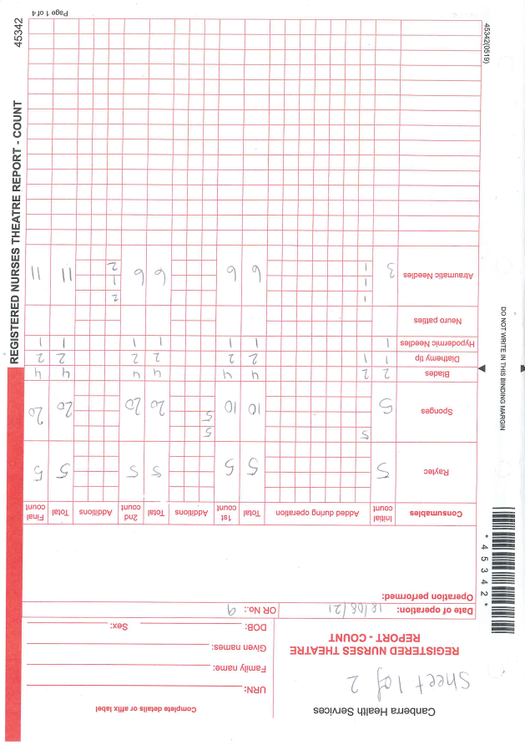

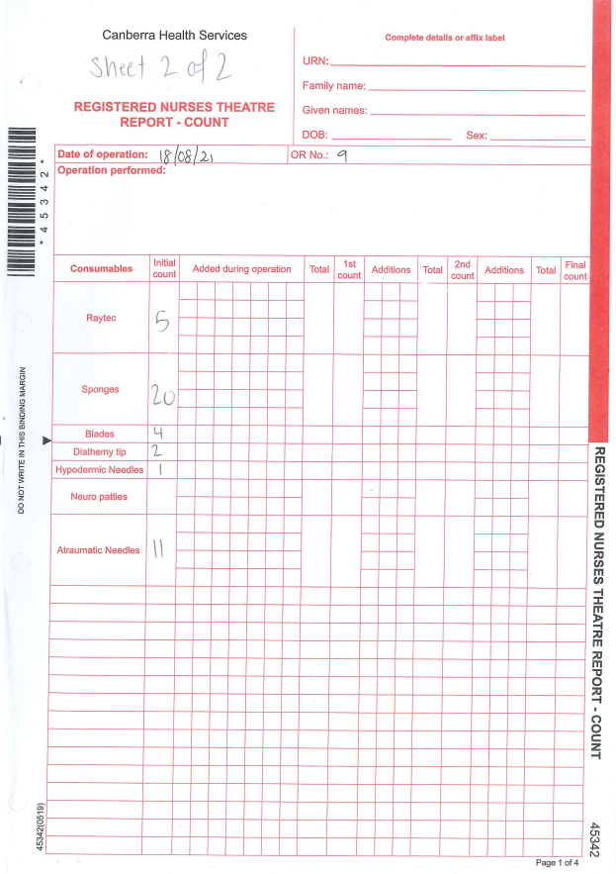
COUNT CONTINUED

Attachment 2: Example of Registered Nurses Theatre Report Count with Ribbon Gauze left insitu
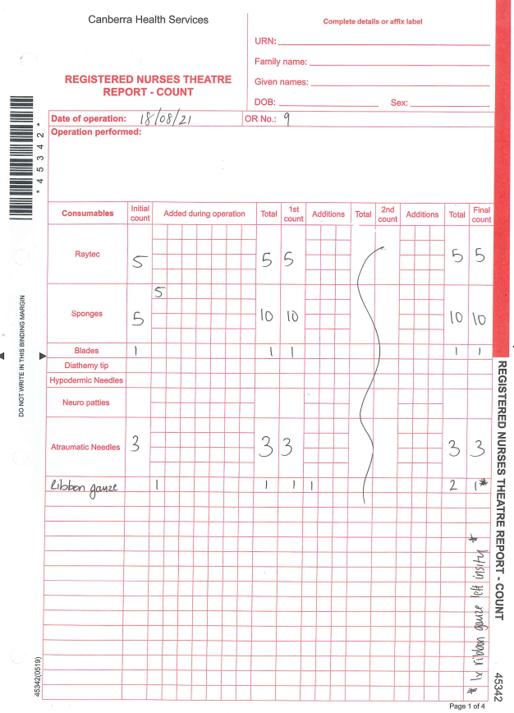
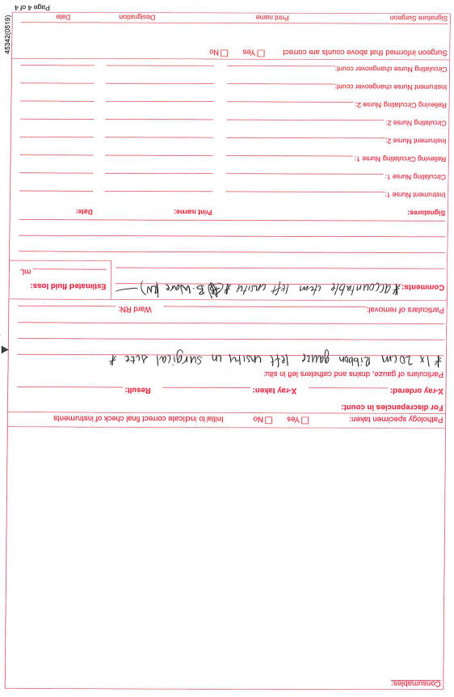

Attachment 3: Example Registered Nurse Theatre Report Count with items not visualised
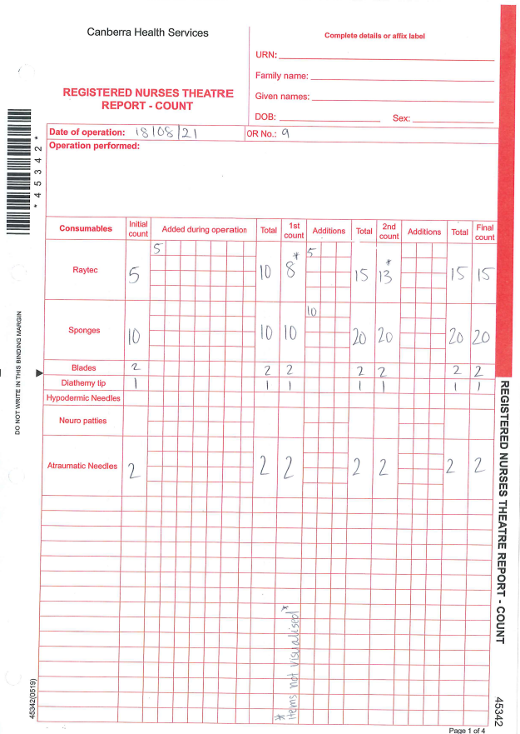
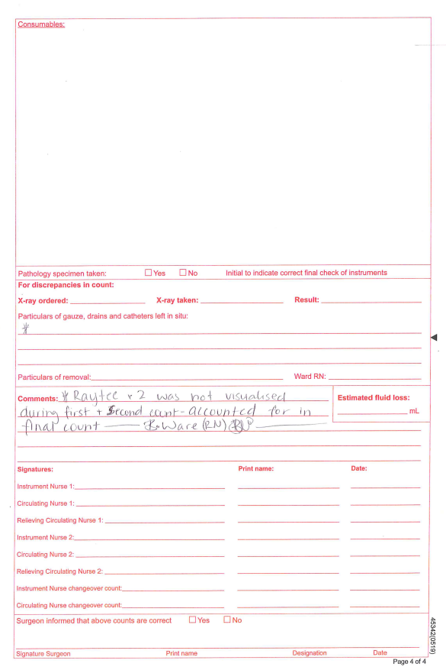

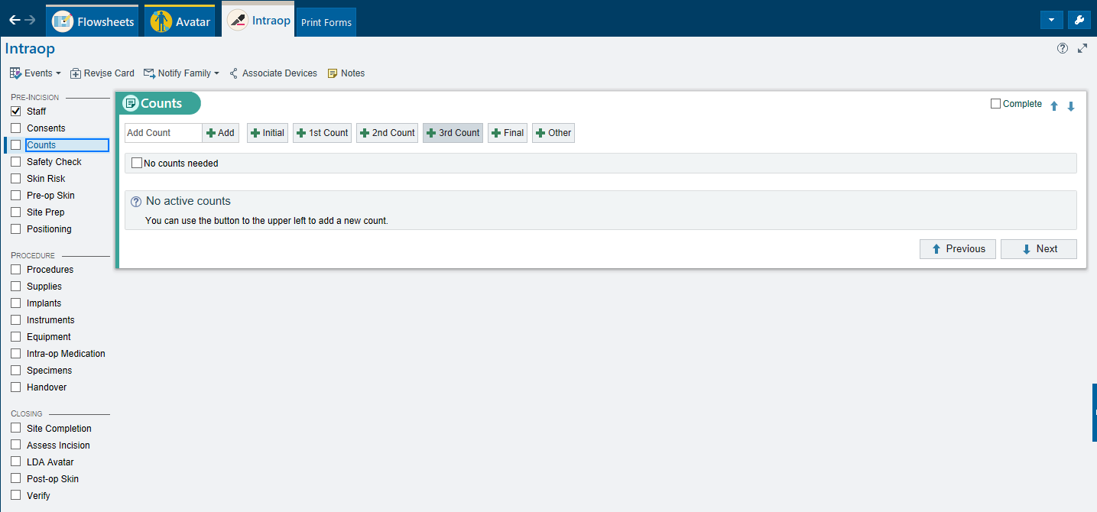
Attachment 4: Example of DHR Procedural Navigation “Counts” tab

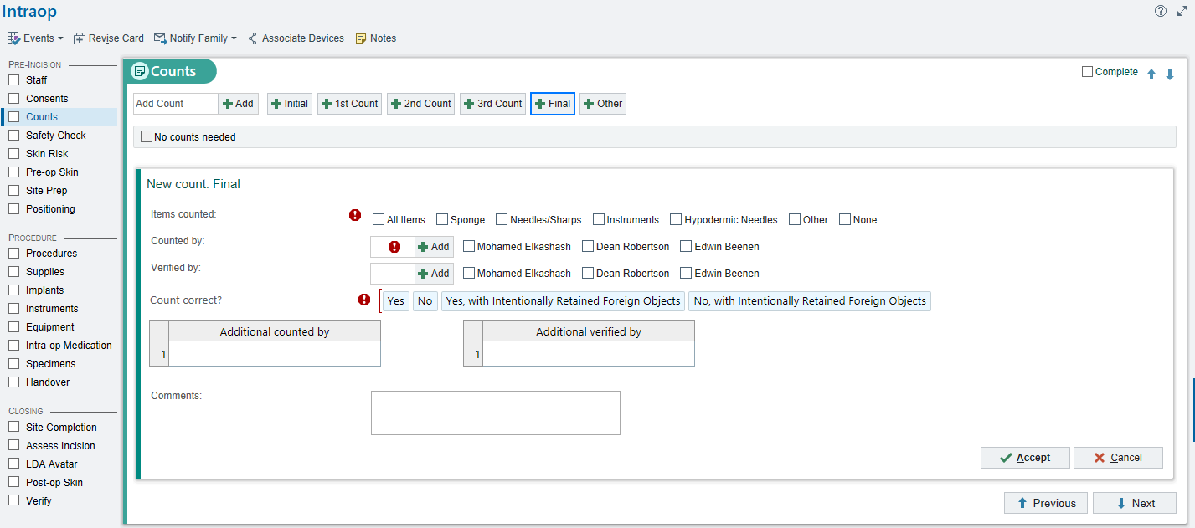
Attachment 5: Example of DHR “Final” count with “Intentionally Retained Foreign Object”

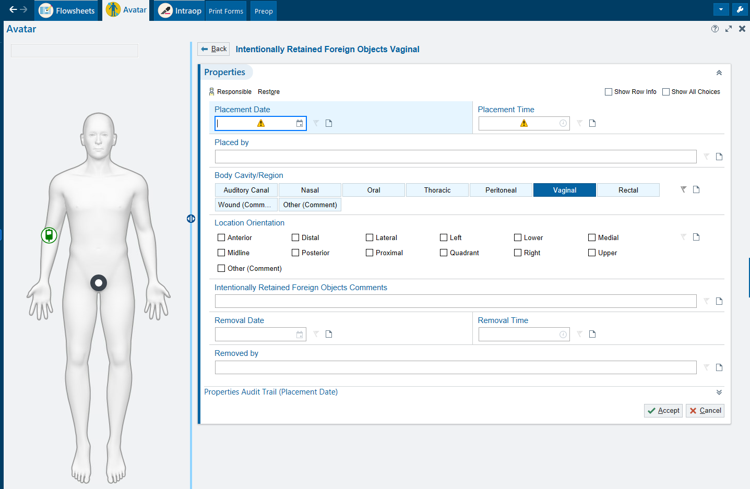
Attachment 6: Example of DHR Avatar “Intentionally Retained Foreign Object”

