Canberra Health Services
Procedure
Intra-Aortic Balloon Pump Insertion and Management

Contents

Contents 1
Purpose 3
Alerts 3
Scope 3
Section 1 – General principles of IABP Catheter 4
1.1 General principles 4
1.2 Timing 4
1.3 Indications for IABP therapy 6
1.4 Contraindications of IABP therapy 6
1.5 Complications of IABP therapy 6
Section 2 – Insertion of IABP Catheter 6
2.1 Patient Assessment and Preparation 6
2.2 Balloon pump preparation using AutoCAT2WAVE® IABP pump and AC3 Optimus™ Intra-Aortic Balloon Pump 7
2.3 IABP catheter (Arrow® FiberOptix® Catheter) preparation 9
2.4 Insertion Equipment 10
2.5 Insertion procedure 11
Section 3 – Timing of IABP 14
3.1 Normal inflation/deflation 14
3.2. Timing Errors- Early inflation 15
3.3. Timing Errors - Early deflation 16
3.4. Timing Errors - Late inflation 16
3.5. Timing Errors - Late deflation 17
3.6 Adjusting inflation and deflation timing in Operator mode 18
Section 4 – Nursing and medical management during IABP Therapy 19
Section 5 – Balloon Pressure Waveform analysis 20
5.1 Normal Balloon Pressure Waveform 20
5.2 Relationship between arterial blood pressure waveform and BPW 21
Section 6 – Weaning of IABP 21
6.1 Weaning of IABP 21
Section 7 – Removal of IABP catheter 22
Section 8 – IABP Alarms and Troubleshooting 23
Alarms: HELIUM LOSS 24
Balloon Rupture 24
IABP during Cardiac Arrest 24
IABP During Standby 25
ALARM- Trigger Loss 25
ALARM- Purge Failure 26
Changing The Helium Tank 26
IABP Training Requirements 26
Evaluation 27
Related Policies, Procedures, Guidelines and Legislation 27
References 28
Definition of Terms 29
Search Terms 30
Attachments 30
Attachment 1: Arrow Intra-Aortic Balloon Catheter Kit 31

Purpose

The purpose of the Intra-Aortic Balloon Pump (IABP) Management procedure is to outline the safe and effective management of IABP therapy for patients at Canberra Health Services (CHS).

Back to Table of Contents

Alerts

- Only Arrow AutoCAT2WAVE® IABP pump and AC3 Optimus™ Intra-Aortic Balloon Pump are used in the CHS for IABP therapy. Please refer to the specific operators manual.
- The Arrow® FiberOptix® Catheter is used by CHS as a unique component of the AutoCAT2WAVE® and AC3 Optimus™ IABP systems, to deliver ProActive CounterPulsation® Technology. The catheter is to be zeroed prior to insertion.
- Catheter rupture is a rare complication, but requires immediate medical action. In the event of balloon rupture, IABP therapy must be stopped immediately by turning the whole console off. The balloon catheter and the sheath need to be removed/exchanged within 30 minutes of cessation of therapy.
- Continuous cardiac monitoring (ECG) and arterial pressure monitoring must be maintained whilst the patient is on IABP therapy for proper timing and triggering.
- The central lumen of the IABP Catheter is to be maintained and continually transduced via the rigid pressure monitoring tubing provided in the Catheter Tray.
- Ensure the pressure bag is always pumped above 300 mmHg to ensure patency, as a good arterial trace is essential for proper triggering and timing of IABP therapy.
- Never pressure inject, administer medications or withdraw blood from the central lumen of the IABP catheter. Flushing can be done by pulling the pigtail/squeezing the light blue flush valve on the transducer.
- The IABP catheter must not remain deflated for longer than 30 minutes, as this will increase the likelihood of thrombus formation on the balloon membrane.

Back to Table of Contents

Scope

This document applies to CHS staff, working within their scope of practice, involved in the care and management of adult patients with an IABP including:
- Medical Officers
- Nurses and Midwives
- Physiotherapists
- Medical/Nursing/Physiotherapy Students under supervision.

Back to Table of Contents

Section 1 – General principles of IABP Catheter

1.1 General principles
The IABP is composed of two principal parts:
- A flexible catheter with a trifurcating lumen that includes:
- A fluid filled central lumen as a ‘back up’ trigger for arterial pressure monitoring.
- A helium port that permits delivery and removal of helium to the balloon, via a pressurized pneumatic system.
- A fiberoptix pressure cable connected to a slide connector and calibration key.
- A console that contains a pneumatic system for helium transfer as well as computer control of the inflation and deflation cycle.

The catheter is usually inserted through the patients’ common femoral artery and advanced until the distal end is positioned in the proximal descending aorta, about two centimetres distal to the left subclavian artery.

The IABP works using the principle of counter-pulsation. This refers to the alternation of inflation and deflation of the balloon, during diastole and systole. The mechanical pump uses the R-wave on the ECG or the arterial systolic pressure waveform to identify the cardiac cycle and the correct points for inflation and deflation of the balloon. Helium is used to inflate the balloon. The ballon is rapidly inflated and deflated depending on the cardiac cycle. Acurate timing is required to provide maximum benefit to the patient.

1.2 Indications for IABP therapy
- Refractory Unstable Angina
- Acute or impending myocardial infarction
- Cardiogenic Shock
- Cardiac support for non-cardiac surgery
- Weaning from bypass machine
- Prophylactic support in preparation for cardiac surgery
- Mechanical bridge to other assist devices or transplant
- Cardiac support following correction of anatomical defects
- Ischemia related intractable ventricular arrhythmias
- Support for diagnostic, percutaneous revascularization, and interventional procedures
- Prophylactic support or adjunct therapy in high risk Percutaneous Coronary Intervention (PCI) procedures.

1.3 Contraindications of IABP therapy
- Severe aortic incompetence or regurgitation
- Abdominal, aortic or thoracic aneurysm or dissection
- Severe calcified aorta-iliac disease or peripheral vascular disease
- Sheathless insertion with severe obesity, scarring of the groin
- Uncontrolled bleeding disorder
- Uncontrolled sepsis.

1.4 Timing
- Refers to the exact points of IABP inflation and deflation in relationship to systolic and diastolic events of the cardiac cycle.
- See below, arterial pressure waveform displaying normal timing, in a 1:2 assist ratio.

- Inflation of the IABP should commence just prior to the onset of diastole, which is identified by the dicrotic notch on the arterial pressure waveform.
- Deflation should occur prior to systole and isovolumetric ejection, on completion of assisted diastole.
- Inflation and deflation of the balloon has two major effects:
- Blood is displaced to the proximal aorta by inflation of the balloon during diastole.
- Aortic volume (and thus afterload) is reduced during systole through a vacuum effect created by rapid balloon deflation.
- The IABP inflation has the following effects:
- Increases coronary artery perfusion.
- Increases myocardial oxygen supply.
- Decreases myocardial oxygen demand.
- The systemic effects are:
- Increased cerebral perfusion.
- Increased renal perfusion.
- The IABP deflation has the following effects:
- Decreased myocardial work by reducing Left Ventricular afterload.
- Increased blood pressure.
- Decreases pulmonary artery pressure.
- Decreases Systemic Vascular Resistance.
- Increases cardiac output and cardiac index.

These effects may be quite variable, and they depend upon the volume of the balloon, its position in the aorta, heart rate, rhythm, the compliance of the aorta, and systemic resistance.

1.5 Complications of IABP therapy
- Limb ischemia.
- Bleeding at the insertion site.
- Thrombosis.
- Aortic perforation and/or dissection.
- Balloon rupture and catheter entrapment.
- Renal failure and bowel ischemia.
- Neuro complication.
- Infection.
- Heparin-Induced Thrombotic Thrombocytopaenia Syndrome (HITSS) from anticoagulation therapy.

Back to Table of Contents

Section 2 – Insertion of IABP Catheter

Insertion of an IABP catheter occurs in the Cardiac Catheter Lab (CCL) or theatres, and must be performed by an appropriately accredited medical officer. This procedure may be pre-planned before cardiac surgery, or as an emergency. Preparation in a peri-operative or emergency setting may be different due to the nature of the environment.

2.1 Patient Assessment and Preparation
- Gather and prepare the necessary equipment and supplies.
- Conduct a pre-procedure verification to make sure that all relevant documentation, related information, and equipment are available and correctly match the patient's identifiers as per Patient Identification and Procedure Matching Procedure.
- Confirm that the patient has given informed consent and that the signed consent form is in the patient's clinical record as per Informed Consent Policy.
- Consider the need for anticoagulation therapy for the patient. The risk of thrombus, thromboembolism or limb ischemia increases with time on the IABP. The decision for the patient to commence anticoagulation therapy is made by the team responsible for insertion of the IABP, and in consultation with the patient’s treating team. Refer to the Anticoagulation Therapeutic Management procedure and the Venous Thromboembolism Prevention procedure.
- Pre-insertion patient assessment:
- Review the patient’s clinical record for their history, specifically related to aortic valve competence, aortic disease and peripheral vascular disease and identify any contraindications to IAB therapy.
- Ideally, patient should have invasive and continual blood pressure monitoring through an arterial line. Level and zero the arterial line. If patient does not have invasive pressure monitoring, ensure the patient has a non-invasive blood pressure cuff in situ.
- Obtain a full blood count, coagulation profile and kidney function tests for the patient.
- Consider arterial blood gas (ABG) and Lactate tests for the patient.
- Check if the patient has any conditions that increase the risk of bleeding.
- Complete baseline hemodynamic assessment of the patient- Heart Rate (HR), cardiac rhythm, 12-lead Electrocardiogram (ECG), blood pressure, Mean Arterial Pressure (MAP) and Central Venous Pressure (CVP).
- Complete neurological assessment of the patient, including neurovascular observations of their left arm.
- Complete neurovascular assessment of the pateint’s lower legs, including peripheral pulses, colour, warmth, sensation and movement.
- Place an oxygen saturation (SaO₂) probe on the patient’s left finger and administer supplemental oxygen to the patient as indicated.
- Assess the patient’s ankle/brachial index to evaluate peripheral circulation status.
- Explain procedure to the patient, emphasising the importance of keeping affected leg straight at all times.
- Inform the patient that the head of the bed/ position of their head is to be no greater than 30 degrees.
- The medical officer responsible for insertion of the IABP must provide patient education regarding the benefits and risks of IABP therapy, the process of the procedure and post-procedure care.

Pre procedure preparation
- Ensure patient privacy will be maintained throughout the procedure.
- Ensure intravenous access either peripherally or centrally.
- Insert indwelling urinary catheter (IDC) to monitor urine output.
- Place the patient in a supine position and adjust the bed.
- Remove the patient’s hair from their groin to above knee using disposable-head surgical clippers, rather than a razor. Microabrasions caused by shaving with a razor can increase the risk of infection.
- Clean both sides of the patient’s groin with soap and water if visibly soiled.
- Prepare the patient’s skin using Triclosan pre-procedural body wash.
- Administer sedatives or analgesics as prescribed.

2.2 Balloon pump preparation using AutoCAT2WAVE® IABP pump and AC3 Optimus™ Intra-Aortic Balloon Pump
- Obtain IABP pump. They are stored in Intensive Care, CCL and Theatres. One IABP console must always be available in CCL for emergent procedures.
- Provide AC power and turn on the pump at the bottom of the console.
- Confirm battery indicator and AC power icons are illuminated at bottom of console. This confirms battery is more than 80% charged and AC power is available.
- Verify Helium (He) supply is available- turn helium tap to ‘open’ position.
- Confirm > 125 PSI (Pounds per Square Inch) helium supply is available via helium icon on control head. Ensure spare helium tank is available in IABP blue bag (extra cylinders are in ICU equipment room).

Initial pump settings for AutoCAT2WAVE® IABP will be:
- Default Operation Mode: AUTOPILOT.
- 1:1 Assist Ratio
- Full Volume on Balloon.
- Auto Gain.
- Auto Scale.
- Automatic Lead Selection.
- Automatic Trigger Selection.
- Arrhythmia Detection and Arrhythmia Timing.
- Gas alarms turned on and available at all heart rates.

Initial pump settings for AC3 Optimus™ IABP will be:
- Mode: AutoPilot
- Timing: 50-85%
- Trigger: ECG
- Ratio: 1:1
- Attach IABP ECG electrodes to patients’ chest.

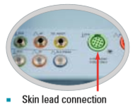

- IABP ECG electrodes to be covered by tape or clear film dressing and labelled as ‘IABP’ to ensure easy identification.
- Autopilot will identify the lead with the most suitable R-wave for triggering.
- Prepare arterial pressure transducer and 500mL 0.9% sodium chloride and pressure bag and connect to IAB pump via arterial pressure cable.

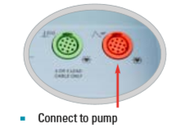

2.3 IABP catheter (Arrow® FiberOptix® Catheter) preparation
IAB Size selection

Table 1: Guide for Arrow® FiberOptix® Catheter sizes

- Open IABP Insertion Tray first and place on sterile field. Do not tip contents out of tray. IAB Catheter will be opened after sheath insertion.
- Physician to prepare for femoral arterial puncture as per Section 2.5-Insertion Procedure.
- Scrub staff to pass Fiberoptix (FOS) Slide Connector to assist staff to connect to console prior to removal of IAB from tray and prior to flushing/ wetting IAB catheter.
- Insert Black CAL Key into slot first.
- Gently insert Blue Slide Connector into FOS connection plate. Avoid contact with the light bulb on the tip of FOS Slide Connector.
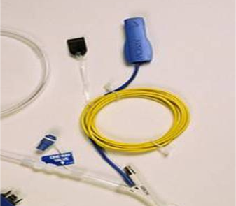
Slide Connector
CAL Key
Using the AutoCAT 2 WAVE:

- Listen for four audible tones to confirm auto zero has occurred. Verify presence of green light bulb. Autozero should take approximately 15 seconds.
- Otherwise the FOS should be manually zeroed (refer to user manual).

Using the AC3 Optimus:
- Insert Black CAL Key into slot first. Insertion can be either way.
- Gently insert Blue Slide Connector into FOS connection plate. Avoid contact with the light bulb on the tip of FOS Slide Connector.
- FOS Zero is complete when four green check marks appear and four beat tone is heard.
- When all steps are complete the message will read: Insert IAB.

2.4 Insertion Equipment
- Appropriately sized Arrow Intra-Aortic Balloon Catheter Kit.
- Antiseptic solution, such as ChloraPrep™.
- 1% Lignocaine 5 mL x2 ampoules.
- 20 mL syringe.
- 5 mL syringe.
- 0.9% sodium chloride 10 mL x 4.
- Major procedure pack.
- Sterile gowns and proper sized sterile gloves.
- Surgical mask and theatre cap.
- Sterile drape.
- Suture material.
- Scalpel blade handle (optional).
- Occlusive dressings.
- Gauze.

Ensure that relevant emergency equipment, suction and temporary pacemaker are readily available, set up and properly functioning.

2.5 Insertion procedure
Preparation of the Insertion Site
- Insertion of an IAB Catheter is a sterile procedure using a full body sterile drape.
- Fluroscopy or Transoesophageal Echocardiogram (TOE) may be utilized for IAB Catheter insertion.
- Environmental considerations to ensure sterility are necessary– set up must occur immediately prior to insertion. Ensure the sterile area is positioned away from traffic areas, curtains, areas undergoing cleaning or any other activity that may increase the likelihood of contamination.
- Adhere to manual handling principles for on-bed tasks.
- Wash hands or apply Alcohol Based Hand Rub (ABHR).
- Conduct Patient Identification as per Patient Identification and Procedure Matching Clinical Procedure.
- Don safety glasses, shield or goggles, theatre cap and mask.
- Perform surgical scrub, don sterile gown and gloves as per Aseptic Technique.
- Ensure patient comfort during the procedure. Offer reassurance as required.
- Prepare site with Chlorhexidine 2% in alcohol (ChloraPrep™) prior to sterile draping. Allow time for solution to dry.

Preparation and Insertion of IAB sheath. To be performed by Senior ICU Specialist or Interventional Radiologist. Senior ICU or Cardiac Catheter Lab nursing staff to assist.
- Administer local anaesthetic to insertion site.
- Flush the Arrow sheath sidearm with normal saline and insert backloaded dilator through haemostasis valve. Tighten luer lock connection.
- Insert the angiographic needle into the common femoral artery at a 45 degree angle or less.
- Insert the J-tip end of the 0.025” guide wire through the angiographic needle and advance into the femoral artery.
- Advance the guidewire into the thoracic aorta.
- Keeping the guidewire in place, remove and discard the needle.
- Wipe the guidewire with a wet, lint free sponge.
- Make a small incision at the exit of the guidewire to facilitate inserting the sheath. introducer through the skin. Do not cut the wire.
- Insert the pre-dilator over the guidewire with a gentle rotating motion.
- Remove the pre-dilator.
- Insert the pre-flushed dilator/ sheath assembly over the 0.025” guidewire and advance with a gentle rotating motion into the arterial lumen.
- Remove the dilator from the sheath. Leave the 0.025” guidewire in place.
- Secure the sheath.

Preparation and Insertion of IAB Catheter
- Confirm FOS auto-zero is complete.
- Open the IABP Catheter tray (refer to Attachment 1: Arrow Intra-Aortic Balloon Catheter Kit) and place on sterile field.
- Attach one-way valve to helium lumen. Attach 60ml syringe and apply negative pressure to the balloon.
- Leave one-way valve insitu.
- Withdraw IAB Catheter from tray horizontally. Avoid bending catheter.
- Remove blue packaging stylet.
- Flush central lumen of catheter with normal saline.
- Flush 15cm extension tubing with stopcock and pressure monitoring tubing with normal saline.
- Activate hydrophilic coating on balloon by wetting with syringe of normal saline. Minimize handling to avoid unravelling of the balloon.
- Snap and remove the peel-away haemostasis device if doing a sheathed insertion.

- Insert catheter over the in place 0.025” guidewire and through sheath haemostasis valve.
- Hold catheter close to haemostasis valve.
- Gently rotate balloon clockwise while inserting through sheath to avoid balloon unravelling.

- Position IAB catheter tip 2cm distal to the left subclavian artery.
- Confirm catheter tip position on fluoroscopy.
- Push catheter suture wing onto hub of sheath and ensure a secure connection.
- Remove the guidewire.
- Attach 15cm extension tubing with stopcock to central lumen. Aspirate 5mL of blood and then flush with 10mL of normal saline.
- Connect the 15cm extension tubing to the pressure monitoring tubing.
- Connect to pressure transducer, AP cable and IAB console.
- The arterial pressure waveform will default to Fiberoptix if the signal is detected.
- Remove one-way valve from helium lumen.
- Connect the gas drive line tubing and tighten the white rotating adapter.
- Attach the balloon connector to the IAB console.
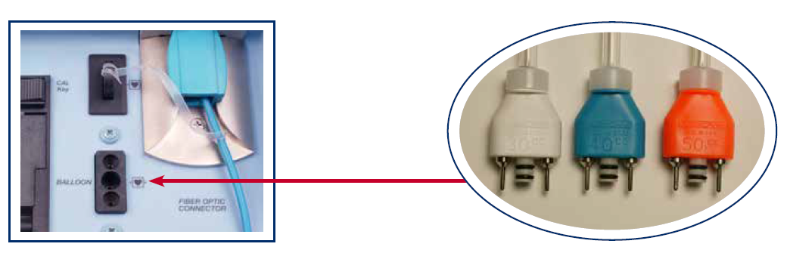
- The IABP will automatically detect balloon size, via the balloon connector.
- Secure and apply a sterile occlusive dressing to the insertion site.
- Arrange for a chest X-ray (if insertion is not guided by fluoroscopy), to confirm the position of IAB catheter.
- Initate pumping by pressing ‘Start Pump’ on AC3 Optimus and Pump Status ‘ON’ on the AutoCAT 2 WAVE.
AC3 Optimus | AutoCAT 2 WAVE
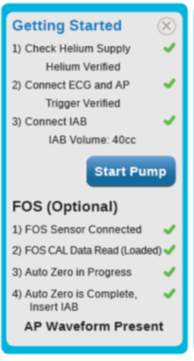 | 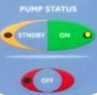

Back to Table of Contents

Section 3 – Timing of IABP

- The balloon pump console uses the aortic pressure waveform and the ECG to determine when the balloon should inflate, the duration of inflation and the timing for deflation.
- Inflation occurs at the closure of the aortic valve, at the onset of diastole and deflates during isovolumetric contraction i.e. prior to rapid ventricular ejection.
- Recognizing a timing error is important because improper timing may fail to achieve the full benefit of augmentation or worse, cause clinical deterioration.
- Timing of inflation and deflation is assessed by comparing the arterial pressure waveform on assisted and unassisted beats. To analyse the timing, print an arterial waveform of counterpulsation at a 1:2 assist ratio.

3.1 Normal inflation/deflation
- Balloon inflation occurs at the onset of diastole, after closure of aortic valve.
- Deflation occurs during isovolumetric contraction, just before the arterial pressure upstroke and opening of the aortic valve.

Rules of inflation
- Inflation commences just prior to aortic valve closure.
- A sharp ‘V’ is present on inflation (as shown below)
- Augmented diastolic pressure > systolic pressure.
- Goal of therapy is to produce a rapid rise in aortic pressure, thereby increasing oxygen supply to coronary circulation.
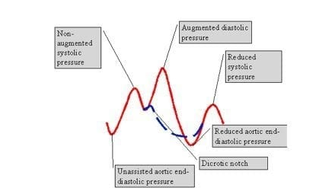
Look for U
Sharp ‘v’

Rules of deflation
- Deflation occurs just prior to the systolic upstroke.
- A sharp ‘V’ is present on deflation (as shown above)
- Assisted diastole < unassisted diastole.
- Assisted systole is up to 15mmHg lower than unassisted systole.
- Goal is to reduce aortic end diastolic pressure (afterload), thereby decreasing myocardial oxygen consumption while improving the cardiac output.

3.2 Timing Errors- Early inflation
In early inflation, the inflation point occurs before the dicrotic notch (as shown below). Early inflation dangerously increases myocardial workload and decreases cardiac output.

Alert: Early inflation is the most potentially dangerous timing error.
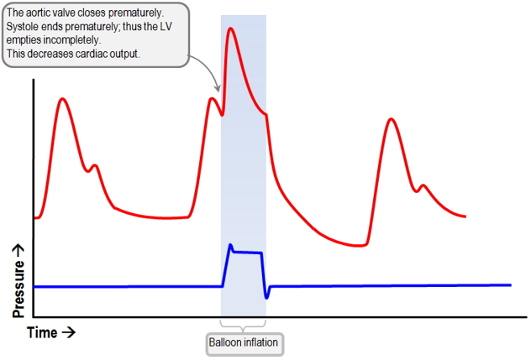
Waveform Characteristics:
- Inflation of IABP more than 50 msec prior to dicrotic notch.
- Diastolic augmentation occurs during reduced systolic ejection (may be unable to distinguish).
- Physiologic Effects:
- Premature closure of aortic valve.
- Reduced stroke volume.
- Potential increase in left ventricular end diastolic volume.
- Increased left ventricular wall stress or afterload.
- Increased myocardial oxygen delivery (MVO2) demand.

3.3 Timing Errors - Early deflation
Early deflation results in a U-shape at the end of deflation on the arterial pressure waveform (as shown below). Assisted systole may be equal to unassisted systole. Early deflation doesn't help decrease afterload or myocardial oxygen consumption.

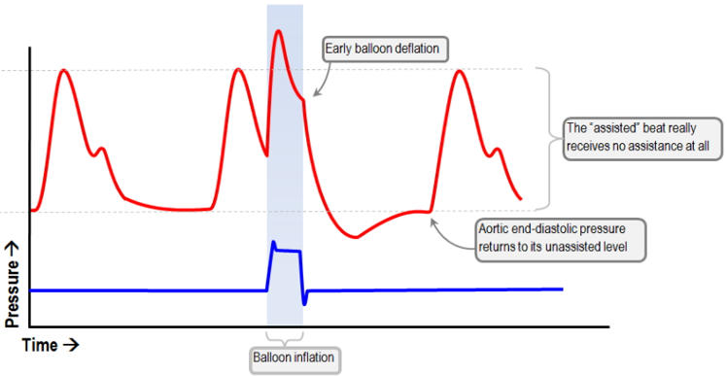

Waveform Characteristics:
- Deflation of IAB is seen as a sharp drop following diastolic augmentation.
- Assisted systolic pressure may be equal to or less than unassisted systolic pressure.
- No afterload reduction.

3.4 Timing Errors - Late inflation
Inflation occurs after the diacrotic notch, exposing it. Late inflation can lead to a reduction in augmented diastolic pressure, coronary and systemic perfusion augmentation time, and augmented coronary perfusion pressure.
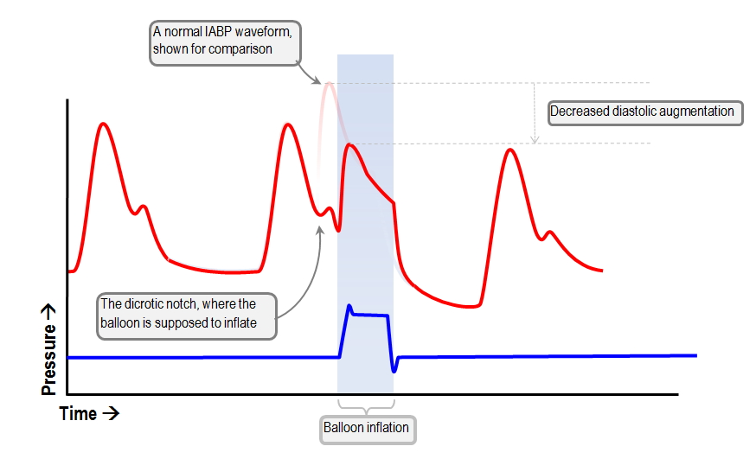

Waveform Characteristics:
- Inflation of the IAB catheter after the dicrotic notch.
- Absence of sharp ‘V’ – refered to as a ‘W’.
- Sub-optimal diastolic augmentation.

3.5 Timing Errors - Late deflation
In late deflation, the balloon remains inflated during systolic ejection. This results in an increase in afterload and can subsequently cause assisted systole to drop more than 15mmHg lower than unassisted systole. Late deflation can be seen to have a clinical impact when this occurs. There may also be more time taken for systolic ejection on the assisted systolic beat. This can be seen if the slope of assisted systole is not parallel/ is lower, than the slop for unassisted systole.

Late deflation may also increase myocardial oxygen consumption, cardiac workload, and preload.

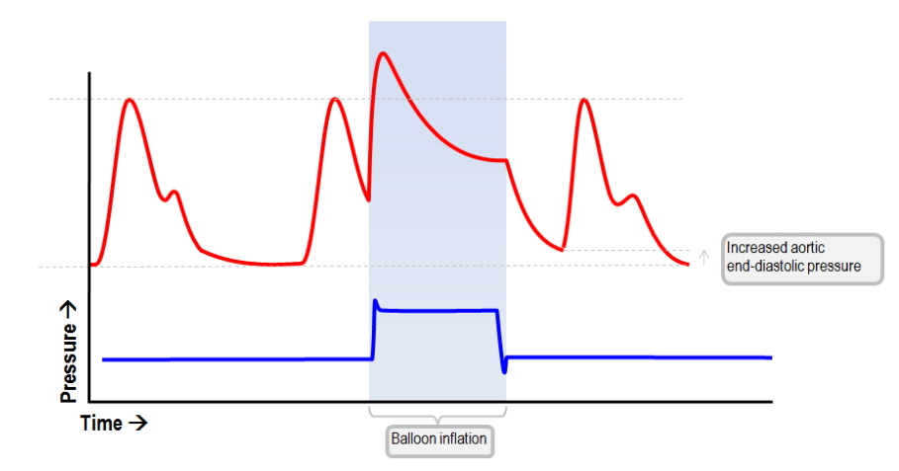

Waveform Characteristics:
- Assisted diastole may be equal to/ or higher than unassisted diastole.
- Rate of rise of assisted systole is prolonged.
- Diastolic augmentation may appear widened.
- Assisted systole >15mmHg lower than unassisted systole.

3.6 Adjusting inflation and deflation timing in Operator mode
- The inflation point is moved to the right until the dicrotic notch is revealed. Inflation timing is moved progressively earlier, until the dicrotic notch just disaapears.
- The deflation point is moved to the left (earlier) until there is a loss of the sharp ‘V’. It is then moved progressively later, until a sharp V appears, while maintaining assisted diastolic (ADIA) less than unassisted diastolic.

Note: In AUTOPILOT mode, AutoCAT2 WAVE® IABP and AC3 Optimus™ IABPs both automatically select the best possible trigger source/ mode and provide intrabeat timing. You are unable to manually adjust the trigger or timing in Autopilot mode.

In OPERATOR mode, when the trigger is changed, timing of the balloon must also be adjusted accordingly.

DO NOT adjust the timing of the balloon in OPERATOR mode unless the surgeon, Registrar, Cardiologist or ICU specialist has been consulted and is present at the bed side.

Back to Table of Contents

Section 4 – Nursing and medical management during IABP Therapy

Nursing and medical management during IABP Therapy
- The patient is supine with the head of the bed ≤ 30° and with the affected limb immobilised.
- Check the Helium level on the IABP console.
- Check all ECG electrodes are secured and covered with opsite and labelled on the patient’s chest.
- Check for recognition of triggering, by the presence of the flashing ♥ symbol, on the right hand side of the IABP screen.
- Check the arterial pressure bag is maintained to 300 mmHg, level the transducer to the phlebostatic axis. Zero transducer once per shift and PRN. Flush the arterial line by pulling the pigtail/squeezing light blue flush valve of the transducer. Ensure 0.9% sodium chloride in pressure bag is replaced every 24 hours.
- The patient’s Oxygen saturations must be monitored continuously on their left hand.
- Assess the ECG trace for optimal augmentation on the arterial pressure waveform.
- Assess the balloon pressure waveform, make sure the plateau pressure is within ± 25 mmHg of the augmented peak diastolic pressure.
- Assess pump timing once per shift and after any rate or rhythm changes. To do this, set pump ratio to 1:2 and print arterial waveform. For patients on a 1:1 ratio, this should only be performed if they are haemodynamically stable. Return to a 1:1 ratio immediately after check complete. This can be done by appropriately trained medical or nursing staff.
- Please note that the unaugmented blood pressure (the bottom blood pressure reading which flashes on and off) will only record reliably when the IABP is in 1:2 mode.
- Inspect the IAB catheter insertion site, verify that the catheter is secured to the patient’s skin, assess for signs of infection, change the dressing according to protocol. Document hourly groin and neurovascular observations of the patient.
- The patient is to have a daily chest xray to confirm IAB catheter position. Medical staff to review chest x-ray.
- Monitor the patient for signs that the IAB catheter has migrated:
- Decreased urine output may indicate the balloon has migrated down and is impeding flow of renal artery.
- Cool left arm may indicate the balloon has migrated up and is impeding blood flow of subclavian artery. An early sign of this may be decreased oxygen saturations.
  - In the event of possible catheter migration, the managing medical team must be notified immediately. Position of catheter must be reconfirmed by chest x-ray.
- Assess the patient for bleeding at the insertion site or from other sites (e.g., blood in urine or stools, bleeding gums, petechiae, increased lower abdomen or lower back pain).
- Bedside nurse to perform a full physical assessment of the patient at the start of every shift and after any significant haemodyamic event. Document all findings of the assessment in the patient’s clinical notes. A physical or head to toe assessment should include assessing the patient for:
- Hypotension and/or pain in the abdomen, flank or back, which can indicate retroperitoneal bleeding.
- A blood pressure differential between the left and right sides of the body, pallor, dyspnea, syncope, diaphoresis, and pain in the chest, abdomen, or back as these can indicate dissecting aortic aneurysm.
- Cardiac rate and rhythm; auscultate heart sounds and assess cardiac output. If the patient is hemodynamically stable, the IABP can be placed on standby briefly so that heart sounds can be more easily auscultated.
- Respiratory status, including ventilator settings if applicable, and pulse oximetry.
- Pedal and tibial pulses distal to the IAB catheter insertion site; assess for changes in capillary refill, color, temperature, and sensation of the affected limb. Use a Doppler to assess pulses, as needed and document all findings.
- Radial and ulnar pulses and changes in capillary refill, color, temperature, movement and sensation in the left arm.
- Urine output. Decrease in urinary output may indicate that the balloon is displaced downward and is occluding the renal arteries.
- Neurologic changes, changes in level of consciousness may indicate reduced cerebral blood flow.
- Bowel sounds via ascultation and palpitation of the patient’s abdomen for distention or tenderness, which may indicate thrombus, internal bleeding, or mesenteric ischemia.
- Daily chest x-ray to ensure catheter has not migrated. This is also to be reviewed by the medical team.
- Bedside nurse to perform systematic cardiovascular, peripheral vascular and haemodynamic assessment of the patient every 15-60 minutes as required or prescribed. Hourly documentation of the patient’s level of consciousness, vital signs, arterial and balloon pressures, cardiac output, neurovascular observations and urine output.
- If patient is haemodynamically stable, pressure area care should be done every 2 hours by log-rolling patient. Use pressure relieving bed and dressing to prevent pressure injuries. Medical staff must be informed of plan to log-roll patient.
- Monitor laboratory test results daily or as prescribed, including:
- PT/APTT to assess bleeding risk and effects of anticoagulation therapy if appliable.
- Electrolytes (e.g., potassium) as abnormalities can increase risk for arrhythmia.
- Serum urea and creatinine to assess renal function.
- Full blood count to monitor risk of haemorrhage, infection and thrombocytopenia.
- Document patient care and observations on MetaVision or appropriate paper observation forms included in the patient’s clinical record.
- ABGs are routinely performed 6 hourly or when clinically indicated to evaluate the effectiveness of the IABP and the patient’s oxygenation, respiration and circulation status.

Back to Table of Contents

Section 5 – Balloon Pressure Waveform analysis

The Balloon Pressure Waveform (BPW) represents the pressure within the closed pressurised pneumatic system, including the IAB catheter and console.

The plateau pressure on the BPW, reflects the pressure in the pneumatics when the balloon is fully inflated. This corresponds with Augmented Diastolic Pressure on the AP trace. The plateau pressure on the BPW should be within ±25 mmHg of the Peak AUG pressure.

The BPW width represents the duration in which the balloon is inflated.

5.1 Normal Balloon Pressure Waveform
- Zero Baseline.  - Balloon Pressure Baseline.  - Rapid Inflation.  - Peak Inflation Artifact.  - Balloon Pressure Plateau (IAB fully inflated).  - Rapid Deflation.  - Balloon Deflation (return to baseline).  - Return to Baseline.  - Duration of Balloon Cycle. | 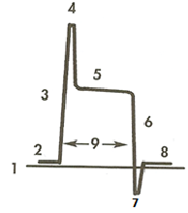  (Arrow, 2005, pg 74)

A Normal balloon pressure waveform should have:
- A base pressure of 2.5mmHg (waveform 2 baseline pressure).
- A sharp upstroke (waveform 3 Rapid Inflation).
- Plateau Pressure (waveform 5 Plateau Pressure).
- A rapid deflation (Waveform 6 Rapid Deflation).
- Has a negative deflection below baseline (Waveform 7 Balloon Deflation).
- Return to baseline of 2.5mmHg (Waveform 9 Return to Baseline).

5.2 Relationship between arterial blood pressure waveform and BPW
The Figure below shows the arterial pressure waveform (top) and balloon pump waveform (bottom).

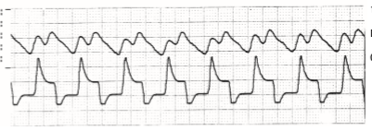
Back to Table of Contents

Section 6 – Weaning of IABP

6.1 Weaning of IABP
- When the haemodynamic and clinical state of the patient has improved to the point where assistance is no longer required, the IABP can be weaned and removed. This must be ordered by the ICU or Cardiology consultant or registrar and documented in MetaVision or the patients’ notes.
- Before IABP removal, assess patient’s haemodynamics to establish a baseline for analysis of response to weaning. Carefully monitor the patient’s haemodynamics during and immediately after weaning through continual blood pressure, ECG and oxygen saturation monitoring.
- Change the assist ratio from 1:1 to 1:2, and monitor patients response for 1-6 hours.
- Observe the patient’s vital signs including, but not limited to ECG, heart rate, blood pressure, urine output, mentation, distal perfusion, cardiac output/index .
- It is suggested that IABP support may be discontinued if the the patient has the following clinical picture:
- Signs of hypoperfusion due to low cardiac output syndrome are absent.
- Urine output is > 30mL per hour.
- The need for positive inotropic agents is minimal.
- Heart rate is less than 100 beats per minute.
- Ventricular ectopic beats are fewer than 6 per minute, not coupled and unifocal.
- Cardiac index remains equal to or greater than 2.0 L/min/m² and does not decrease by more than 20%.
- The index of Left Ventricular End-Diastolic Pressure (LVEDP) (Pulmorary Capillary Wedge Pressure (PCWP), Pulmonary Artery Diastolic Pressure (PADP)) does not increase to greater than 20% above pre-weaning level.
- Absence of angina.

Back to Table of Contents

Section 7 – Removal of IABP catheter

The removal of an IABP catheter must be performed by an appropriately accredited ICU specialist or senior registrar or interventional radiologist. For IABPs placed in the femoral or proximal aorta, removal needs to be done in the operating theatre.

Equipment
- Dressing pack.
- Stitch cutter.
- Chlorhexidine 0.5% & alcohol 70%.
- Femstop dome and arch clamp (if appliable).
- Gauze and combines.
- Gloves gown and protective eyewear.
- Transparent occlusive dressing.

Procedure
- Ensure patient is haemodynamically stable through consultation with bedside nurse and medical team.
- Check the patient’s INR and APPT are within normal range.
- Explain the catheter and sheath removal procedure to the patient. Obtain and record consent. The patient will need to lie flat on their back for 6-8 hours and tolerate compression of the insertion site after the catheter is removed.
- Ensure the patient is lying flat on their back in a straight body alignment to enable the visualisation of the anatomical structures prior to catheter and sheath removal.
- Turn IABP to OFF position on screen and then turn off the whole console at the ON/ OFF switch on the bottom of the pump. This will allow for venting of the pneumatics and deflation of the balloon.
- Position the patient’s bed at a comfortable height for the clinician who will apply the manual pressure to ensure that adequate pressure can be exerted to achieve haemostasis.
- Disconnect gas driveline tubing from IAB to pump.
- Wash hands and apply Personal Protective Equipment.
- Clean the insertion site using aseptic technique.
- Remove the catheter securement.
- Withdraw the balloon until the proximal end of balloon makes contact with the distal end of the introducer sheath.
- While applying pressure 2-3 cm proximal to the puncture site, remove the balloon and introducer sheath as a single unit, slowly at the same angle at which it was inserted, allowing a few seconds of free bleeding to prevent thrombus formation.
- DO NOT pull the balloon through the sheath.
- Assess the integrity of the balloon and presence of blood clots after removal.
- Apply firm pressure over the arteriotomy site.
- Initial pressure should be occlusive, but this should be decreased gradually after the first 2-5 minutes such that distal pulses can be felt.
- Hold direct manual pressure to the site for 20 to 30 minutes or until bleeding stops.
- Apply a sterile pressure dressing to the insertion site for 2-4 hours or as prescribed. Allow visibility of femoral insertion site once haemostasis is established. FemoStop Compression device may be utilised to avoid haematoma.
- A sand bag may be used to maintain pressure on the insertion site if necessary.
- Attend neurovascular observations, femoral site checks and vital signs on the patient every 15 minutes for the first 2 hours, then half hourly for the following 2 hours and then hourly for 24 hours.
- Maintain patient in supine position with affected leg extended for 6-8 hours.
- Patient should avoid vigorous straining or exertion for for 24 hours post removal.
- Instruct the patient to inform the nurse immediately of any obvious bleeding, or sensation of wetness, burning, tearing, tingling and numbness, either at the puncture site or in the affected limb.

Using FemoStop Femoral Compression System
- Position the FemoStop belt under patient’s hips in line with the puncture site.
- Position FemoStop arch clamp.
- Post IABP catheter and sheath removal, apply digital pressure for 2-3 minutes.
- Pump up FemoStop device and ensure in proper position over the insertion site.
- Inflate dome to 20mmHg above the patient’s Systolic Blood Pressure after removing catheter and sheath.
- Maintain initial pressure for 2-3 minutes when artery is occluded and pedal pulses are absent. Do not exceed 3 minutes of occlusion.
- Reduce pressure to attain strong pedal pulse.
- Maintain that pressure for 30 minutes.
- Lower pressure by 15mmHg every 15 minutes until pressure of 40mmHg is reached.
- Maintain 40mmHg pressure for 30 minutes, and then completely deflate the dome.
- Ask patient to cough and observe for bleeding at the insertion site.
- If not bleeding, remove the FemoStop pressure device. If bleeding observed continue to apply pressure until bleeding stops.

Alert: Digital compression remains the gold standard for IABP catheter removal. The FemoStop™ device is only to be used by a practitioner trained to perform this procedure.

Back to Table of Contents

Section 8 – IABP Alarms and Troubleshooting

Alarms: HELIUM LOSS
- Criteria- unable to fill pneumatics to 2.5mmHg within a prescribed interval:
- 3x refill cycles requested within 2 minutes.
- BPW Base Pneumatic Pressure <-10mmHg for 3 consecutive beats.

- Troubleshooting:
- Check for leak in tubing and connections.
- Check for blood in tubing- if blood present- STOP PUMPING.
- Check for kinked catheter.
- Check for ectopic beats.
- Assess for increased HR with short time for deflation.

Balloon Rupture:
Check for the presence of blood in the gas driveline tubing, which is a hallmark of balloon rupture and is considered a medical emergency. Please note, due to the size of the tear in the balloon, blood may not be present or observed.

If a balloon rupture is suspected, a ‘helium loss’ alarm will cause the pump to turn OFF, vent the pneumatics, freeze the screen, print a strip and record the alarm message in ‘HISTORY’. After this happens:
- Ensure the IABP remains OFF.
- Clamp the IAB catheter to prevent blood backflow to the IAB console.
- Disconnect the gas driveline tubing from IABP console.
- If blood reaches the balloon connector, it is assumed to have contaminated the pump.
- Notify the treating clinician.
- Prepare for immediate removal/replacement of the IAB catheter and sheath.
- Do not leave the balloon idle for more than 30 minutes.
- Assess for entrapment of the catheter on removal of the balloon, as a surgical cutdown may be required.
- Discontinue anticoagulant therapy for the patient as ordered.

IABP during Cardiac Arrest
- Follow Advanced Life Support (ALS) protocols.
- Leave the pump in AUTOPILOT MODE.
- AUTOPILOT mode will detect noise on the ECG, poor or absent ECG waveform (e.g. ventricular tachycardia/asystole), and switch to AP trigger. In Pulseless Electrical Activity (PEA), it will use the R-wave as a trigger source, and switch to AP trigger once CPR commences and artefact is detected.
- If in OPERATOR mode- select AP trigger.
- If CPR generates a perfusion pressure of 3-5mmHg, the IABP will have sufficient trigger to inflate the balloon. The IABP may improve perfusion to coronary and carotid arteries.
- A TRIGGER LOSS alarm will sound during assessment for return of spontaneous circulation, if there is no detectable ECG/AP waveform. This alarm will stop once CPR generates a pulse pressure of 3-5mmHg.
- Ensure staff and patient are not in contact with the IABP machine or it’s connections during defibrillation.

Internal Trigger
- If the CPR cannot generate a consistent and reliable trigger, change the mode to Operator mode, select Triggers and then, select the Internal trigger source. The Internal trigger key must be depressed TWICE.
- This trigger will maintain movement of the catheter and therefore reduce the risk of thrombus formation.

WARNING: The use of INTERNAL TRIGGER will produce fixed rate counterpulsation which may be asynchronous with the cardiac cycle. DO NOT USE if an intrinsic ECG/ AP waveform is present.

- Once an intrinsic R-wave/ AP upstroke is detected, the trigger mode must be changed from INTERNAL to an acceptable patient trigger.
- In most instances, it is recommended to leave the pump in AUTOPILOT during cardiac arrest.

IABP During Standby
- IABP must not be put on standby for longer than 30 minutes as this will increase the risk of thrombus formation on the balloon.
- Manual inflation of the balloon should be done once every 5 minutes while the balloon pump is on standy mode to open the balloon membrane:
  - Apply the one-way valve to helium port.
  - Aspirate with 60mL luer lock syringe provided in kit, to check for blood.
  - Check ALARM HISTORY to ensure there is no record of prior helium loss alarms that may indicate a ruptured balloon.
  - Disconnect the one-way valve.
  - Inject 10mL of air less than the total balloon volume (i.e. 30 mL for a 40 mL IAB) into the balloon connector and aspirate it immediately.

ALARM- Trigger Loss:
- Check patient.
- Check ECG trace.
- Replace ECG electrodes.
- Check ECG cable and connections.
- Choose an alternate ECG lead.
- Check pressure trace and troubleshoot accordingly.

ALARM- Purge Failure:
- Check for leaks in the tubing and connections.
- Check helium cylinder is connected.
- Check helium regulator is turned to OPEN position.
- Check for a loss of trigger signal.

Changing The Helium Cylinder
The helium cylinder should be replaced whenever tank volume drops below 125 PSI, as indicated by the LOW HELIUM TANK message.

There is no need to interrupt IABP therapy to change the cylinder.
- The cylinder should be replaced as soon as practicable.
- Replacement of the Helium Cylinder:
- Close helium cylinder valve to CLOSE position.
- Do not open yoke retaining handling.
- Lift latch lever up and angle tank upwards.
- Rotate cylinder to the left to remove.
- There will be an alarm message on disconnection of tank ‘LOW HELIUM TANK PRESSURE’.
- Take cap off new cylinder and screw into yoke.
- Angle tank downwards and secure latch.

Note: An extra helium cylinder is located in the ICU store room.

Back to Table of Contents

Section 9 - IABP Training Requirements

Managing a patient with an IABP requires specialised training and a strong foundation of critical care skills, including knowledge of and demonstrated competence in the following critical care/nursing skills:
Essential
- How the IABP functions and provides hemodynamic support.
- How to assess the IABP augmented arterial pressure waveform and the balloon pressure waveform.

Important
- How the IABP console functions and how to respond to alarms.
- Potential complications of IABP therapy.
- How to contact the IABP technician or perfusionist, if available, to assist with the IABP console if difficulties arise.

Prerequisite training for managing IABP patients
- Current ALS
- For ICU staff: Blue Coloured step
- Completed IABP self-learning package
- Attended IABP workshop
- Pass the IABP skills competency

Back to Table of Contents

Evaluation

Outcome Measures
- The outcome measures for the Intra-Aortic Balloon Pump therapy to be considered in terms of improved performance in the domains of safe practice and prevention/reduction of potential complications.
- This includes:
- >95% Compliance against Clinical Procedural guidelines.
- Reduced compliations related to IABP therapy.
- Improved Benchmarking performance against similarly delineated facilities.

Method
- Clinical Audits of compliance against Clinical procedural guidelines as conducted by Clinical Support/Development Nurses (CDNs) and reported on at Staff Unit Meetings.
- Any mechanical patient incidence or complication related to IABP as reported via incident management system.

Back to Table of Contents

Related Policies, Procedures, Guidelines and Legislation

Policies
- Informed Consent - Clinical
- Nursing and Midwifery Continuing Competence
- Clinical Supervision
- Incident management

Procedures
- Radial and Femoral Arterial Sheaths removal following Cardiac Catheterisation Management and Care of Adult Patients
- Infection Prevention and Control - Healthcare Associated Infections
- Aseptic Technique
- Incident Management
- Vital Signs and Early Warning Scores
- Patient Identification and Procedure Matching
- Non-invasive Electrocardiography (ECG) in Adults
- Patient Identification – Pathology Specimen Labelling
- Anticoagulation Therapeutic Management
- Venous Thromboembolism Prevention

Legislation
- Health Practitioner Regulation National Law (ACT) Act 2010
- Health Records (Privacy and Access) Act 1997
- Human Rights Act 2004
- Privacy Act 1988
- Guardianship and Management of Property Act 1991
- Medical Treatment (Health Directions) Act 2006
- Powers of Attorney Act 2006

Back to Table of Contents

References

- Unverzagt S, Buerke M, de Waha A, Haerting J, Pietzner D, Seyfarth M, et al. Intra-aortic balloon pump counterpulsation (IABP) for myocardial infarction complicated by cardiogenic shock. Cochrane Database Syst Rev. 2015;3, CD007398.
- Harper PJ. (2017). Proceduer 52 Intraaortic Balloon Pump Management, in Wiegand, D. L. AACN Procedure Manual for High Acuity, Progeressive and Critical Care (7th ed.). St. Louis, MO: Elsevier.
- Liverpool Hospital ICU Guideline: Intra-Aortic Balloon Pump Management 2015. Accessed on 18th June 2020.
https://www.aci.health.nsw.gov.au/__data/assets/pdf_file/0006/380229/Intra-Aortic_Balloon_Pump.pdf
- Intra-aortic balloon, fiber-optic, insertion, assisting. Revised: May 15, 2020. Lippincott Procedures. Accessed on 18th June 2020.
https://procedures.lww.com/lnp/view.do?pId=3436321&hits=iabp&a=true&ad=false
- Intra-aortic balloon management. Revised: August 16, 2019. Lippincott Procedures. Accessed on 18th June 2020. https://procedures.lww.com/lnp/view.do?pId=3435989&hits=management,iab&a=true&ad=false
- Gerardina Bueti and Kelly Watson. (2016) Chapter 17, The Intra-aortic Balloon Pump, in Taylor et al. (eds.), Interventional Critical Care, DOI 10.1007/978-3-319-25286-5_17. © Springer International Publishing Switzerland 2016 D.A.
- Arrow (2005) Counterpulsation Applied – An Introduction to Intra-Aortic Balloon Pumping. Arrow International Inc.

Back to Table of Contents

Definition of Terms

Assisted Aortic End-diastolic Pressure (AOEDP): the diastolic pressure in the aorta just prior to the onset of systole, which is affected by deflation of the IAB.

Assisted Systole: systolic pressure, which follows an assisted aortic end diastolic pressure. On arterial pressure balloon waveform it should be lower than the unassisted systolic pressure

Augmentation: Inflation of the balloon, which displaces blood volume into the coronary sinus and systemic circulation. Augmentation IAB refers to the ability of the balloon to be fully expanded and contain the full amount of helium in the catheter. During normal pumping it should be maintained on full to prevent clots forming on the end of the catheter.

Auto fill: IABP automatically refills the closed gas system with a preset volume of helium when the IAB auto fill button is pressed.

Cardiac Index (CI): Cardiac output divided by the patient’s body surface area (BSA) expressed in liters/minute/m².

Counterpulsation: Alternating inflation and deflation of the intra-aortic balloon during diastole and systole respectively.

Dicrotic Notch: Indentation in the arterial waveform that signals aortic valve closure.

FemoStop: FemoStop system is a femoral compression system for hemostasis management. It provides a comfortable and efficient "hands off method of compressing the femoral artery and vein after diagnostic and interventional procedures. When used properly, it can objectively achieve the fine balance of hemostasis with preservation of distal perfusion.

IAB: Intra Aortic Balloon. Polyurethane balloon attached to a vascular catheter which is put into the aorta for counterpulsation.

Intra-Aortic Balloon Pump (IABP): Circulatory assist device that improves left ventricular function by increasing myocardial oxygen supply and reducing myocardial oxygen demand.

Myocardial Infarction (MI): Commonly known as a “heart attack”. Blood supply to a section of the heart muscle is blocked due to a clot in the artery supplying that region. This results in the death if the heart tissue if not treated immediately to reinstitute blood supply.

Systemic Vascular Resistance: resistance to blood flow offered by the systemic vascular, excluding pulmonary vasculature. This term is not commonly used.

Timing: Inflation and deflation of the IABP in synchrony with the mechanical cardiac cycle.

Trigger: Signal used by the IABP to identify the beginning of the next cardiac cycle (R wave) and deflate the IAB (if not already deflated).

Back to Table of Contents

Search Terms

Intra Aortic Ballon Pump, IABP, timing and triggering, pressure, cardiac, heart, ECG, ICU, femoral, insertion, removal, troubleshooting, arterial, catheter, CCL

Attachments

Attachment 1: Arrow Intra-Aortic Balloon Catheter Kit

Disclaimer: This document has been developed by Canberra Health Services specifically for its own use. Use of this document and any reliance on the information contained therein by any third party is at his or her own risk and Canberra Health Services assumes no responsibility whatsoever.

Policy Team ONLY to complete the following:
Date Amended | Section Amended | Divisional Approval | Final Approval
18 Dec 2020 | Complete Review | Lisa Gilmore, ED Surgery | CHS Policy Committee

This document supersedes the following:
Document Number | Document Name

Attachment 1: Arrow Intra-Aortic Balloon Catheter Kit

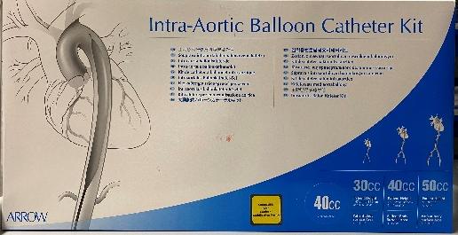 | Each balloon catheter is packaged with  - Insertion tray  - Balloon catheter tray  - Two Separately packaged driveline tubing for TransAct® and Datascope® pump consoles.
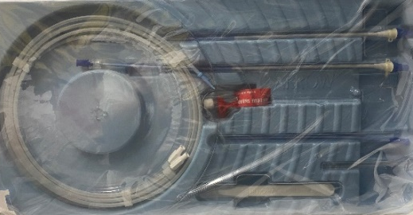 | Insertion Tray  - 18-gauge arterial needle  - size 11 blade scalpel with handle  - French size 8 pre-dilator  - 2 X 175cm 0.025 guidewires  - 2 X sheaths - one with side port and one without side port  *Note: both sheaths have dilators back-loaded to the end of the sheath and these need to be assembled prior to insertion (pre-mounted peel-away hemostasis device)
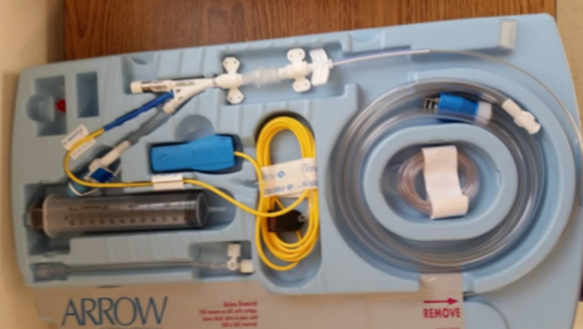  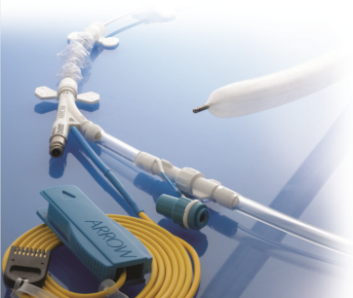 | Balloon Catheter Tray  - Arrow® FiberOptix® Catheter  - Drive line tubing for Arrow IABP consoles (attaches the balloon to the console)  - 6 inch arterial extension tubing for connecting the central lumen arterial line of balloon catheter (has a stopcock at one end)  - 36 inch piece of arterial extension tubing for attachment to transducer  - Fiberoptic yellow cable  - Blue fiberoptic connector  - Black cal key  - 60mL syringe

