Canberra Health Services
Clinical Procedure
Community Based Clinical Records

Contents

Contents 1
Purpose 3
Scope 3
Section 1 – Community Based Clinical Record Requests 3
Section 2 – Archiving Community-Based Clinical Records 5
Searching / registering consumers in ACTPAS 5
Document Tracking 5
Labelling the archive box 5
Storing the archive box 6
Section 3 – Order of Filing 6
Order of Filing 6
Section 4 – Filing Community-based Clinical Records 7
Section 5 – Filing Loose Clinical Record Documents in Community-based Health Centres 8
Section 6 – Managing Community Nursing Clinical Records 9
Procedures 9
Community Nursing staff providing an ambulatory or home-based service 9
Procedures 12
Health Centre Administration staff 12
Section 7– Managing Missing Community-based Clinical Records 15
Procedures 15
Section 8 – Management for Late or Closely Booked Appointments 17
Evaluation 19
Related Policies, Procedures, Guidelines and Legislation 20
Policies 20
References 20
Definition of Terms 20
Search Terms 21
Attachments 21
Attachment A: Community-Based Services Clinical Record Request Form 23
Attachment B: Document Tracking 24
Attachment C: Document Tracking Archived Documents 28
Attachment D: ACTPAS Document Types 33
Attachment E: Labelling Archive Boxes 35
Attachment F: Labelling Hard Copy Clinical Records 36
Attachment G: Creating a CN Volume 37
Attachment H: Searching for consumer documents 45

Purpose

To ensure clinical records are available to clinicians at the point of care (see definition of terms) by assisting members of the interdisciplinary and multi-disciplinary teams locate the records efficiently and effectively.

To ensure that there is a consistent filing and archiving system for all hardcopy community-based clinical records and that all documents are accurately catalogued and recorded in the ACT Patient Administration System (ACTPAS) using the document tracking function, enabling record identification, tracking and retrieval as required.

To ensure all Community Nursing clinical records held in the consumer’s home or the Ambulatory Clinic can be tracked and located. The aim of document tracking for Community Nursing clinical records is to enable these records to be accurately tracked between service delivery sites (including the consumer’s home) and to identify records that have not been returned to a central storage location (Health Centre Administration or Clinical Records Unit).

To ensure clinical records are managed in compliance with legislative requirements.

Back to Table of Contents

Scope

This procedure applies to all staff (including the, Release of Information and Medico-Legal Officers) who:-
- request clinical records from a community-based service or clinical record storage facility for the purposes of providing or reviewing clinical care or responding to subpoena or release of information requests,
- create, file, track, store & archive community-based clinical records.

Back to Table of Contents

Section 1 – Community Based Clinical Record Requests

NOTE: For the purposes of this section community based clinical record storage facilities may include:
- The Clinical Records Unit, 1 Moore Street
- Community Health Centres
- Mitchell (Essington Street) clinical record storage facility
- Building 7, Palmer Street, The Canberra Hospital

EXCLUSIONS: Women’s Health Service, Maternal and Child Health and Child Health Targeted Support Services.

Requesting Clinical Records
- Staff requesting a clinical record from a community-based clinical record storage facility must complete all fields of the ‘Community-Based Services Clinical Record Request’ form (Attachment A).
- Completed clinical record request forms are to be sent via email to the generic email inbox of the relevant area listed below. All requests from clinicians should be directed to the relevant health centre. All requests for clinical records stored at Mitchell and requests from health centre administration staff, Release of Information and Medico-legal Officers should be sent to the Clinical Records Unit.
ACTHC Belconnen – Belconnen Community Health Centre
ACTHC City – City Health Centre
ACTHC Dickson – Dickson Health Centre
ACTHC Gungahlin – Gungahlin Community Health Centre
ACTHC Phillip – Phillip Health Centre
ACTHC Tuggeranong – Tuggeranong Community Health Centre
CHS HIS.CRU – Clinical Records Unit

NOTE: Incomplete clinical record request forms may not be able to be actioned. When this is the case, phone or email contact will be made with the requestor, seeking further information. Actioning of the request may be delayed as a result.

NOTE: Unless otherwise specified clinical record requests received by the Clinical Records Unit (CRU) will be scanned onto the Clinical Patient Folder System (CPF) within 48 hours. Hard copy records will only be made available on request, where the hard copy record still exists.

NOTE: Requests for clinical records are considered urgent if required within 24 hours. If the request is urgent the box must be checked. Unless otherwise specified CRU will scan the clinical record into CPF, or scan and email a copy, as required, within 24hrs for requests identified as urgent. Clinical records required in a shorter time frame can be requested however the exact notes required need to be specified and those notes only will be scanned and emailed, or faxed to the requestor. Notes must be stamped ‘copy’ if printed. When the record becomes available in CPF, or on receipt of the hard copy record as appropriate, the requestor will place the notes stamped ‘copy’ into the classified waste bin.

Processing Clinical Records Requests
The following procedures relate to Clinical Records Unit or Health Centre Administration staff processing clinical record requests:
- Staff at the relevant location will action the request upon receipt.

NOTE: Court Order or clinical record release of information requests received by CRU will be processed according to procedures outlined in the Clinical Records Management l Procedures.

NOTE: In the event that the record is unavailable (e.g. currently being used by another clinician) health centre administration staff will notify the requestor via phone or email, and liaise with the clinician using the record to obtain the record, or a copy of the relevant notes, and forward these to the requestor. All photocopied notes must be stamped ‘copy’. It is the responsibility of the receiver to place these notes into classified waste when they are no longer required.

- Any movement of the clinical record will be tracked in ACTPAS (as per Attachment B).
- Any hard copy clinical records that have been requested will have the requestor’s form attached and be securely placed in a locked clinical record transport case / satchel prior to being addressed to the relevant location and delivered to the secure collection point for the mail courier.

Back to Table of Contents

Section 2 – Archiving Community-Based Clinical Records

Searching / registering consumers in ACTPAS
- Search for the consumer on ACTPAS. If the consumer is registered on ACTPAS but the address that appears is different to the address in the hard copy record, ensure three common points of identification are available (e.g. full name, date of birth, Medicare number). Refer to ACTPAS Registration & Alerts User Guide
- If consumer is not registered on ACTPAS complete registration using the consumer details that are in the clinical record. Refer to ACTPAS Registration & Alerts User Guide if required.
  - Old Medicare numbers
    - Some clinical documents have Medicare numbers that will not be accepted by ACTPAS. Enter these as ‘CU’ (card unknown).

Document Tracking
- Using the ACTPAS document tracking function, determine if there is an ACTPAS ‘document’ for the clinical record (See Attachment C).
- If there is already an ACTPAS ‘document’ created, ensure that the ‘current location’ reflects the correct archive storage location (e.g. Mitchell). Update the ‘current location’ if required. In the comments box, enter the box number of the archive box the file is in e.g. ‘Box 155’ (See Attachment C).
- If there is not an ACTPAS ‘document’, create a new ‘document’ (See Attachment C). Select the document type from the drop down box that relates to the paper based file (e.g. CYWHP, IHCP). (See Attachment D).

Labelling the archive box
- The archive box must be labelled appropriately to correspond with the Program records it contains and only those records should go in that archive box.
- The box numbers should follow in sequence e.g. 1, 2, 3……….410, 411, 412…….898, 899, 900 etc for each Program.
- Labels on the box should correspond with the Division, Program and where necessary, Service/ Document type. (See Attachment E)

Storing the archive box
- The archive box should be taken to the relevant storage facility and stored chronologically in the area designated to the relevant Program and service (where applicable).

Back to Table of Contents

Section 3 – Order of Filing

Order of Filing
Staff will file consumer related documentation in community-based clinical records according to the following directory:

At the front of the record
- Consumer labels
- Referral summary
- Community Health Intake (CHI) referral and/ or other referral documents

NOTE: If fax cover sheets and / or additional documents are attached to a referral place all documents at the front of the record

- Off campus/ home visit pre-assessment form (if applicable)
- Overview of Client Services
- Non response to a scheduled visit
- Consent forms

Care Plan Divider
- Discharge plan(s)
- Care plans(s)
- Family intervention plans(s)

Record of Care Divider
- Treatment sheets
- Medication orders/ charts
- Observation charts
- Assessments
- Clinical pathways
- Admission
- History
- Case closure summaries

Progress Notes Divider
- Progress notes

NOTE: Progress notes should be filed in date order, with oldest notes on top and subsequent notes following (i.e. notes should read ‘like a book’)

Reports/ Results Divider
- Laboratory results
- Imaging
- Other diagnostic results

Correspondence Divider
- Emails
- Letters

NOTE: If referral letters/ documents are attached to a referral place both documents at the front of the record

- Fax cover sheets

NOTE: If fax cover sheets are attached to a referral place both documents at the front of the record

- Requests for release of information/ subpoena
- Detainee requests
- Interpreter request(s)

NOTE: Where possible all documentation under a divider that relates to the same discipline should be kept together (e.g. all physiotherapy correspondence including letters and emails should be grouped together under the Correspondence divider).

NOTE: Clinical records (files) should not be more than approximately 2.5cm thick If clinicians identify that a record is greater than 2.5cm thickhey should report this to administration staff for a second volume of the record to be created.

Back to Table of Contents

Section 4 – Filing Community-based Clinical Records

- There will be a clinical record created and maintained for every consumer receiving health care by Canberra Health Services (CHS).
- ACTPAS will be used to generate a Unit Record Number (URN) for every CHS consumer registered within ACTPAS.
- In the event that a consumer has more than one Unit Record Number (URN), the lowest number will be used. A Suspected Duplicate Record Request will be completed to identify and rectify this situation Suspected Duplicate Record Request Form
- A document-tracking label will be printed from ACTPAS (refer to ACTPAS Document Tracking User Guide and placed on the front cover of the record in the top right hand corner.
- The ACTPAS URN will be placed on the outside cover of the clinical record using numerical stickers within the following parameters (See Attachment F):
  - The URN has a minimum of six numbers and a maximum of eight
  - The last two digits indicate the bay (full sized numbers)
  - The next two digits indicate the bay sub-section (full sized numbers)
  - The last two to four digits are for numerical filing within the bay and bay sub-section
  - If the URN is six digits long the two digits at the top should be full size labels
  - If the URN is eight digits long then the six digits below should be full sized labels and the top two digits should be half size.

NOTE: Clinical record (file) covers and coloured number stickers are currently purchased from ‘Filing Systems International’. Further information about ordering supplies can be obtained from the Clinical Records Unit Supervisor.

- Records will be stored within a lateral filing system, using terminal digit filing. In a terminal digit filing records are filed by the last two digits, then the middle two digits, and finally in numerical order by the remaining digits. Further information can be obtained from the ‘Clinical Records Management Procedure (CHHS18/085)
- When not in use by a clinician all hardcopy clinical records from the program areas within the scope of this procedure will be stored in the compactus of the relevant storage facility:
  - All inactive clinical records are stored in their default location in the lateral filing compactus located in the Clinical Records Unit, lower ground floor, 1 Moore Street.
  - All active clinical records are stored at the health centre or facility where treatment is occurring.

Back to Table of Contents

Section 5 – Filing Loose Clinical Record Documents in Community-based Health Centres

Clinicians will file loose clinical record documents directly into the official clinical record when they have access to the record. When the official clinical record is not accessible clinicians will follow these procedures:

- All documents for loose filing must be placed into a plastic sleeve
- Only documents relating to one consumer per plastic sleeve
- A maximum number of ten clinical record documents per sleeve
- All documents must be marked with at least three points of identification: Name, date of birth (DOB), address and/or unit record number (URN) in the vicinity of the top right hand corner
- All documents must be marked to indicate the appropriate section / divider heading that the clinician wants the document to be filed into e.g.: Consent; Care Plan; Record of Care; Progress Notes; Reports/ Results; Correspondence.
- No paper clips are to be included
- Loose filing documents in plastic sleeves are to be placed in the tray nominated for loose filing by health centre administration.

Health centre administration staff will return any loose documents submitted for filing that do not comply with the above procedures, to the relevant clinical service / clinician. The clinical service / clinician may then either resubmit the documents once they comply with the above procedure or submit a request for the clinical record and file the documents themselves.

No clinical records, including loose clinical record documents or official clinical records, are to be stored in clinical areas, unless this has been approved by Clinical Records Unit. All clinical records must be resubmitted to the health centre administration area for secure storage.

Two typical examples of appropriate handling of clinical records:
- The clinician has the clinical record (file) in their clinic during service, completes their clinical entries and returns the clinical record to the administration area at the completion of their daily / sessional clinic.
- The consumer contacts the clinician by phone and there is a discussion regarding clinical care. The clinician must create contemporaneous clinical notes on a loose progress note sheet. The clinician must ensure the progress note contains three points of patient identification to ensure the note is filed in the correct patient’s clinical record. The progress note is placed in a plastic sleeve and submitted to health centre administration before leaving the site that day.

Back to Table of Contents

Section 6 – Managing Community Nursing Clinical Records

Procedures

Community Nursing staff providing an ambulatory or home-based service

Community Nursing staff, when providing an ambulatory or home-based service, are required to:
- Manage Referrals:
  - Print a copy of the referral from ACTPAS and retain as a master copy in the relevant Community Nursing office.
  - Use this master copy referral when processing a new consumer and whenever extra labels are required.

NOTE: If an open Community Nursing referral exists and a new referral is received (e.g. for management of a different issue) the new referral should be closed by the Community Nurse and care continued under the original referral, leaving only one open Community Nursing referral for a consumer at any time. A copy of each new referral should be placed in the clinical record and in the relevant folder in the Community Nursing office.

  - Indicate on the master referral with a hand written note the date of the request, whether the consumer is ‘Home’ or ‘Ambulatory’, or if existing consumer indicate ‘Extra Labels’ and number of sheets required. This will facilitate Health Centre Administration staff with preparing the file and correctly recording the file location.
  - Deliver appropriately prepared referrals to the ‘Health Centre Administration’ identified tray/ pigeon hole in the Health Centre Administration area by 3pm each day.

NOTE: If referrals are placed in the tray/pigeon hole after 4pm labels may not be available until the following day.

  - Collect labels from Health Centre Administration as they become available.

NOTE: Health Centre Administration staff will print labels for Community Nursing files held in ‘Patient Care’ that have been created by LINK nurses over a weekend. Community Nursing staff are responsible for ensuring these labels are appropriately placed on the file.

  - Create a paper based Community Nursing file for all consumers as follows:
    - Write the consumer’s URN in a clear manner down the edge of the file using black texta only (See Attachment F). Do not use pen or pencil
    - Place one label (without the consumer’s name) from the top right hand corner of the label sheet on the front of the file cover over the ‘Bar Code ID’.
    - Place one label (with the consumer’s name) inside the front cover of the file.
    - Place one label on every page of the hard copy record in the consumer’s file.
    - Place remaining labels inside at the front of the file.

NOTE: If labels are not available from Health Centre Administration at the time the file is made up a minimum of three points of identification must be clearly hand written in black pen in the designated identification box in the top right hand corner of the page. This identification must include full name (given name and family name), date of birth and URN. Labels must not be placed over any hand written notes. The consumer must be clearly identified on all documents for inclusion in the clinical record.

NOTE: All copies of referrals should be disposed of into classified waste bins when the consumer is discharged from the service.

- Report any change in file location

NOTE: Community Nursing staff must notify Health Centre Administration of any movement of the nursing file (including transfer to Clare Holland House).

  - When a consumer accesses the Ambulatory Clinic in a health centre throughout the week, and requires a home visit over the weekend the Community Nurse must:
    - Indicate ‘Home Visit’ against the consumer’s name on the daily clinic list; and
    - Deliver the list to health centre admin by 4:30pm, so the file location can be changed to ‘Patient’s Care’.
  - When the consumer returns to the Ambulatory Clinic for appointments the following week, the Community Nurse will take the file from the consumer and return it to Health Centre Administration at the conclusion of the clinic so the file can be scanned back in and the location updated.

- Manage home nursing files
Community Nursing staff will remove clinical record documentation that is not relevant to current care from the home nursing file on a three monthly basis. This documentation will be returned to Health Centre Administration staff and married with the main Community Care clinical record. Home nursing files should not be more than 3.5cm thick.

NOTE: To avoid the creation of duplicate home files clinical record documentation must be culled from the file as per the above process, rather than a subsequent community nursing home file being created.

- Close referrals at the conclusion of care
  - At the conclusion of an episode of care Community Nursing staff will close the Community Nursing referral in ACTPAS and return the Community Nursing file to Health Centre Administration to be married with the main Community Care clinical record.
  - In the event that no direct care is provided to the consumer (e.g. due to changes in the consumer’s circumstances) a brief entry should be made on a progress note outlining why care is not being provided and this, along with the identification labels, should be returned to Health Centre Administration in a plastic sleeve with a note indicating ‘Referral closed; no file’. This will be married with the main Community Care clinical record.

- Report any lost community nursing files via Riskman
  - If the nursing file is unable to be located after one month the Community Nurse will ask Health Centre Administration staff to check ‘document tracking’ on ACTPAS to determine if the file has been returned.
  - If a nursing file that has been located in the consumer’s home is unable to be found a notification should be completed by the relevant Community Nurse or Nursing Manager via the relevant incident reporting register in Riskman as per ‘Retrieval of the Clinical Home Files – Community Nursing’ Procedure. The Clinical Records Unit (CRU) Manager should be included in the incident distribution list.
  - The file location will be updated on ACTPAS by the CRU Manager by documenting in the ‘Comments’ column that the file is unable to be found, and an incident has been submitted via Riskman. The Riskman incident number should be included where possible.

Procedures

Health Centre Administration staff
Health Centre Administration staff are required to:
- Process Referrals
  - Collect the printed referrals that are placed in the tray/ pigeon hole on a regular basis throughout the day. Final collection is to be undertaken by 4:00pm. If referral is marked ‘Home’ or ‘Ambulatory’:
    - Search ACTPAS to determine the location of the current main Community Care (‘IHCP’) file

NOTE: IHCP is the abbreviation for Integrated Health Care Program which was a previous name for the current Health Directorate Community Care program. The Integrated Health Care Program name is no longer used however the abbreviation still exists in ACTPAS and therefore the abbreviation will be used when referring to the Community Care file in ACTPAS.

    - Search for the consumer in ACTPAS. When the relevant consumer is identified right click and select ‘Patient Documents’.
- If no Community Care file exists, create a new ‘IHCP’ volume in ACTPAS, print 1 sheet of ‘IHCP’ labels and prepare a new main file. This file should contain the Community Nursing Referral and the remainder of the ‘IHCP’ labels. No dividers are required at this stage. Dividers and documents are only placed in file when the consumer is referred to another service. The file is to be stored in the compactus until the consumer has been discharged.
- If the Community Care file is located in the Clinical Records Unit process a file request, and create a subsequent ‘IHCP’ volume in ACTPAS. Print 1 sheet of ‘IHCP’ labels and prepare a new volume of the main file. This file should then be stored in the compactus with a copy of the Community Nursing referral attached until the consumer has been discharged (no dividers are required for the file). The previous volume of the record will be available electronically on the Clinical Record Information System (CPF) within 48hours of the request.
- If the Community Care file is located at another health centre as the consumer has another open referral and is receiving services at that health centre, the main file will remain at that health centre until the referral is closed. Forward the Community Nursing referral to the relevant health centre for placement on the Community Care file. Once all referrals are closed to the listed services, leaving Community Nursing as the only open referral, the file should be transferred to the appropriate health centre for storage in their compactus.

NOTE: Referrals for ‘Continence’, ‘Footcare’, ‘Stoma’ and ‘Wounds’ only require Community Care (‘IHCP’) files. They do not use Community Nursing files.

- Using the ‘Patient Documents’ screen determine if a Community Nursing file already exists

NOTE: In the event that an open Community Nursing volume already exists in ACTPAS notify the Nurse Manager at the relevant health centre for continuation of that file.

        - If an inactive nursing file appears a subsequent nursing volume needs to be created e.g. if volume one has been made inactive then volume two is the next nursing volume that needs to be created.
        - If no Community Nursing volume exists, or a subsequent Community Nursing volume is required, create a temporary Community Nursing volume in ACTPAS noting the location as ‘Patient’s Care’, or the relevant health centre for an ambulatory consumer or where a ‘shared care’ arrangement exists with Home Based Palliative Care. For ‘shared care’ consumers any loose filing received by Health Centre Administration staff will be placed in the Community Nursing record held in the health centre compactus.

NOTE: For every new nursing referral a new volume of the nursing file should be created (with the exception of consumers with concurrent open referrals). If a new referral is received and the file that was created under a previous referral has not been returned, and a Riskman number is not entered in the ‘Comments’ against the document on ACTPAS, the Administration staff will request the file is returned and Community Nursing staff will physically create a new home file. Health Centre Coordinators will type ‘Requested return of file’ in the ‘Comments’ field in ACTPAS. Health Centre Managers will retain a list of files that have been requested for return to Health Centre Administration and conduct a monthly audit to ensure files are returned.

        - Print two sheets of Community Nursing labels, unless otherwise specified, and place in the ‘Community Nursing’ tray/ pigeon hole.

NOTE: In the event that a consumer has more than one Community Nursing volume open, labels should always be printed from the first open Community Nursing volume.

Procedure for Extra Labels
- If a referral is provided with a note requesting ‘extra labels’ enter the consumer URN in ACTPAS and select ‘Patient Documents’.
- Under the ‘Volume Id’ column find the active ‘CN’ volume and right click. A side box will appear with ‘Volume Label’. Proceed to print, selecting ‘XTRA Community Patient Labels’ under the template dropdown box. This will print a sheet of labels with document labels only. If an active ‘CN’ volume does not appear (this occurs when there is an open referral prior to December 2008) create new ‘CN’ volume as per instructions (See Attachment G).
- Print number of copies requested by clicking on the ‘no. of copies’ located at the top right of the screen and, using the up and down arrows, select the appropriate number required.

NOTE: When Community Nursing staff request labels for a consumer where a ‘shared care’ arrangement exists with the Home Based Palliative Care service only one sheet of Community Nursing labels are required.

- Manage any change in file location
  - Print daily clinic list for any Community Nursing Ambulatory Clinics and scan files out (in ACTPAS) to the professional carer for that clinic.
  - Place a reminder label on the printed clinic list indicating ‘Admin staff to be advised of files location’.
  - Scan files back in (in ACTPAS) at the conclusion of the Community Nursing Ambulatory Clinic.

NOTE: If a nursing file is received by admin staff at a health centre from a consumer with an open referral the file must be electronically tracked in ACTPAS by receiving in and dispatching the file to the relevant clinician as per instructions (See Attachment G). The clinician will review the file and document in the progress notes accordingly. If the consumer is discharged the file will be returned to the discharge basket/ tray in the administration area.

NOTE: If a discharged nursing file is received by admin staff at a health centre from a consumer or a clinician the file must be electronically tracked in ACTPAS by receiving in and dispatching to the main file as per instructions (See Attachment G)

NOTE: If a CN file does not appear create a new CN file and dispatch to the main file as per instructions (See Attachment G).

- Process discharged files
  - When the consumer is discharged from the Community Nursing episode of care, and the file is returned to Health Centre Administration, Health Centre Administration staff must physically merge the nursing file with the main Community Care file in a segment directly behind all current paperwork, and on top of any previously discharged segmented paperwork. The nursing file should then be made inactive on ACTPAS by the receiving health centre with a note indicating the ‘IHCP’ volume the nursing file was merged with, as per instructions (See Attachment G).
  - The file will then be dispatched to CRU.
  - If the Community Care file is located at another health centre as there is an open referral for service at that health centre, the nursing file should be dispatched in ACTPAS to that health centre, and physically sent to the health centre. The nursing file must be physically merged with the main Community Care file in a segment directly behind all current paperwork, and on top of any previously discharged segmented paperwork, and made inactive on ACTPAS by the receiving health centre.

- Managing deceased files

NOTE: Management of deceased files is a responsibility shared between Community Nursing and Health Centre Administration staff. Whoever is notified of the death of the consumer is to complete the ACTPAS “Patient Death Notification Form” as follows:

  - Complete the Client Death Notification Form
  - Complete mandatory fields and submit.

  - When Health Centre Administration staff are notified of the death of a Community Nursing consumer, or if CRU is requesting a deceased file, Health Centre Administration staff are to dispatch the main Community Care (‘IHCP’) file to CRU with a note attached stating that the Community Nursing file is to follow. The Health Centre Coordinator is to liaise with the Community Nurse to recover the file and Health Centre Administration staff are to dispatch the nursing file to CRU in a timely manner.
  - The Community Nurse must recover the nursing file from the consumer’s home and return to Health Centre Administration staff as early as practical.

Back to Table of Contents

Section 7– Managing Missing Community-based Clinical Records

Procedures
When a community-based clinical record is unable to be located, Health Centre Administration staff will:
- Search the area compactus for the record
- Check for misfiles (transposed terminal digits, middle digits and primary digits)
- Check in the un-processed incoming mail
- Check in the discharge box
- Check in pulled clinic files
- Check activity on the record and the last recorded location of the record, and contact the user to determine if the file was actually returned but tracking information was not completed on ACTPAS
- Email the generic inbox of other community-based health centres, requesting administrative staff search each facility for the record, including misfile searches.

If the record is still unable to be located relevant staff (as outlined in the ‘note’ below) will complete a RiskMan incident notification, in accordance with the Incident Management Procedure

NOTE: Administration staff who are unable to locate a clinical record where the last known location of the record in ACTPAS is the relevant clinical record storage facility (e.g. health centre compactus) or where the record is unable to be located after being transferred between clinical record storage facilities, are responsible for completing the Riskman incident notification for the record.

NOTE: Program based staff that are unable to locate a clinical record where the last known location of the record in ACTPAS is the relevant program or clinician, are responsible for completing the Riskman incident notification for the record.

- Alerts used by the relevant incident reporting register in RiskMan will notify the relevant Manager when there has been an incident regarding community-based clinical records submitted.

NOTE: Incidents relating to Justice Health records are notified to the Operational Manager (Justice Health); incidents relating to Alcohol and Drug Services records are notified to the Manager of Clinical Services (Alcohol and Drug Services). All other incidents relating to community-based clinical records covered under the scope of this procedure are notified to the Clinical Records Unit Manager.

- Upon receipt of a RiskMan notification the Clinical Records Unit Manager will undertake an additional search for the record including:
  - Searching the Clinical Records Unit compactus for the record
  - Checking for misfiles (transposed terminal digits, middle digits and primary digits)
  - Checking in the un-processed incoming mail
- If the record is unable to be located:
  - Enter a comment against the specific record on ACTPAS under ‘Patient Documents’ indicating that the record is unable to be located and include the RiskMan incident number (See Attachment H)
  - Document in the relevant RiskMan incident report that the record has been unable to be located and has been noted as missing on ACTPAS.
- If the record is located:
  - Update the location of the specific record on ACTPAS under ‘Patient Documents’
  - Document in the relevant RiskMan incident report that the record has been located and the location updated on ACTPAS

Back to Table of Contents

Section 8 – Management for Late or Closely Booked Appointments

Notification
All staff involved in the booking of appointments will:
- upon processing a late or second appointment, immediately complete and email a Community Based Services Clinical Record Request to the generic email inbox of the relevant health centre specifying notes required:
- ACTHC Belconnen – Belconnen Community Health Centre
- ACTHC City – City Health Centre
- ACTHC Dickson – Dickson Health Centre
- ACTHC Phillip – Phillip Health Centre
- ACTHC Tuggeranong – Tuggeranong Community Health Centre
- ACTHC Gungahlin – Gungahlin Community Health Centre

The following information needs to be included:
- Clinic Code, Clinic type, Consumer’s name, Consumer’s date of birth and Unit Record Number (URN).

Response
Upon receipt of the notification of a late appointment Health Centre administration staff will:
- inform the relevant clinician of the additional consumer booked into their clinic, by email with a cc to their Team Leader. As not all clinicians have access to a computer administration staff will also call to notify the clinician and leave a message if they are unavailable. It is imperative that any changes made on the day of the clinic are notified to the clinician.

NOTE: Clinicians should also be monitoring their ACTPAS clinic regularly and refreshing to see if any changes have been made.

- check on ACTPAS for the appointment and clinical record location
- if the clinical record is at another Health Centre, immediately contact that Health Centre clinical records area (also known as medical records) and request the following information be scanned and emailed:
- Overview of Client Services
- Service/Care Plan – with Consent
- Progress Notes (relevant to the service being accessed by the appointment)
- Any Assessments
- scan required notes and forward via email to the generic inbox of the requesting health centre. The receiving health centre will stamp “COPY” on all notes received
- prepare a ‘holding file’ (cardboard envelope), place a blank label on the top right hand corner. In black permanent marker, document briefly why a ‘holding file’ has been prepared (i.e. late or conflicting appointment); include the date and administration staff initials. The ‘holding file’ must contain:
- A new page of Labels
- A copy of the Referral
- All faxed documents
- A blank Progress Notes sheet
- Note: no file dividers are required
- deliver ‘holding file’ to clinician
- complete and send an urgent clinical record request to the relevant Health Centre in accordance with the Community-Based Clinical Record Requests Procedure.

Upon becoming aware of a conflicting appointment in ACTPAS Health Centre administration staff will:
- determine which appointment should receive the clinical record or a ‘holding file’ based on the following:
- New appointment – this type of appointment can use a ‘holding file’ as there have been no previous contacts and no progress notes.
- Review appointment – if the two appointments are review, then one Health Centre has to prepare a ‘holding file’. Health Centre Management staff to contact the other Health Centre clinical records (medical records) area by phone, advising the Consumer’s name, date of birth, URN and clinic type, and request the following documentation to be immediately scanned and emailed:
- Overview of Client Services
- Service/Care Plan – with Consent
- Progress Notes
- Any Assessments relating to the clinic
- scan required notes and forward via email to generic inbox of requesting health centre. The receiving health centre to stamp “COPY” on all notes received
- prepare a ‘holding file’; place a blank label on the top right hand corner. In black permanent marker, document briefly why a ‘holding file’ has been prepared (i.e. late or conflicting appointment); include the date and administration staff initials. The ‘holding file’ must contain:
- A new page of Labels
- A copy of the Referral
- All faxed documents
- A blank Progress Notes sheet
- Note: no dividers are required
- deliver ‘holding file’ to clinician

Upon determining this is a new appointment and the clinical record is located in the Clinical Records Unit (CRU) Health Centre administration staff will:

- complete and send an urgent clinical record request to CRU in accordance with the Community-Based Clinical Record Requests Procedure.
- generate a new record on ACTPAS (previous volume will be scanned onto the Clinical Record Information System
- (CPF) by CRU) and print two sets of labels
- create a new hard copy record in accordance with training guidelines
- deliver the ‘holding file’ to the clinician

When the clinician returns the clinical record Health Centre administration staff will check ACTPAS to determine the consumer’s next appointment and either
- forward the new clinical record to the Health Centre where the next appointment is scheduled or
- complete and send a clinical record request in accordance with the Community-Based Clinical Record Requests Procedure and place new documents on the record in accordance with the Community-Based Clinical Records Order of Filing Procedure.

NOTE: It is the responsibility of the clinician to place the documents stamped “copy” into the classified waste when they are no longer required.

Health Centre Administration staff will check the health centre generic email inbox by 4.00pm each day to confirm all urgent clinical record requests have been actioned.

Back to Table of Contents

Evaluation

Outcome
- The management of hard copy clinical records meets relevant legislation and standards
- Clinical records are available to clinicians at the point of care

Measures
- Evidence of appropriately tracked records through file audits
- Reduction in lost hard copy clinical records

Back to Table of Contents

Related Policies, Procedures, Guidelines and Legislation

Policies
- Clinical Records Management Policy
- Incident Management Policy

Procedures
- Clinical Records Management Procedures
- Incident Management Procedure

Guidelines
- Clinical Audit Program Guideline

Standards
- Australian Standard (AS2828.1) Health records Paper-based health records
- Australian Standard (AS2828.2) Health records Digitized (scanned) health records
- The National Safety and Quality Health Service (NSQHS) Standards
- Territory Records Office Standard for Records, Information and Data

Legislation
- Territory Records (Records Disposal Schedule – Health Treatment and Care Records) Approval 2013 (No 1):
- Health Records (Privacy and Access) Act 1997
- Territory Records Act 2002
- Human Rights Act

Back to Table of Contents

References

¹ Australian Commission on Safety and Quality in Health Care. National Safety and Quality Health Service Standards guide for hospitals. Sydney: ACSQHC; 2017.

Standards Australia 2019, Health records AS 2828.1:2019, Standards Australia, NSW.
Standards Australia 2019, Digitzed health records AS 2828.2:2019, Standards Australia, NSW.

Back to Table of Contents

Definition of Terms

ACTPAS: ACT Patient Administration System
Bay: Section located within the compactus
Clinical record: May also be known as health record, file, clinical file or medical record
CN: Abbreviation for Community Nursing as used in ACTPAS.
CPF: Clinical Patient Folder – scanned clinical record solution
IHCP: Abbreviation for Integrated Health Care Program which was a previous name for the current Health Directorate Community Care program. The Integrated Health Care Program name is no longer used however the abbreviation still exists in ACTPAS and therefore the abbreviation is used when referring to the Community Care file in ACTPAS.
Point of Care¹
The time and location of an interaction between a patient and a clinician for the purpose of delivering care
URN: Unit record number/ patient identification number / ACTPAS number / Medical Record Number (MRN)

Back to Table of Contents

Search Terms

Archiving, Audit, Clinical record(s), Community, Community Nursing, Documentation, File(s), Filing, Health record(s), Order, Riskman, Point of Care

Back to Table of Contents

Attachments

Attachment A: Community-Based Services Clinical Record Request Form
Attachment B: Document Tracking
Attachment C: Document Tracking Archived Documents
Attachment D: ACTPAS Document Types
Attachment E: Labelling Archive Boxes
Attachment F: Labelling Hard Copy Clinical Records
Attachment G: Creating a CN Volume
Attachment H: Searching for Consumer Documents

Disclaimer: This document has been developed by Canberra Health Services specifically for its own use. Use of this document and any reliance on the information contained therein by any third party is at his or her own risk and Canberra Health Services assumes no responsibility whatsoever.

Policy Team ONLY to complete the following:
Date Amended | Section Amended | Divisional Approval | Final Approval
03/09/2021 | Complete Review | Paul Ogden – CFO, FBI | CHS Policy Committee
14/10/2021 | Added definition of Point of Care, reference to NSQHS and minor updates. | Director Health Information Services | Senior Director, Policy Planning and Government Relations.

This document supersedes the following:
Document Number | Document Name
CHS15/081 | Community Based Clinical Records

Attachment A: Community-Based Services Clinical Record Request Form

The following “Community-Based Services Clinical Record Request” form can be obtained from the Clinical Records Unit.

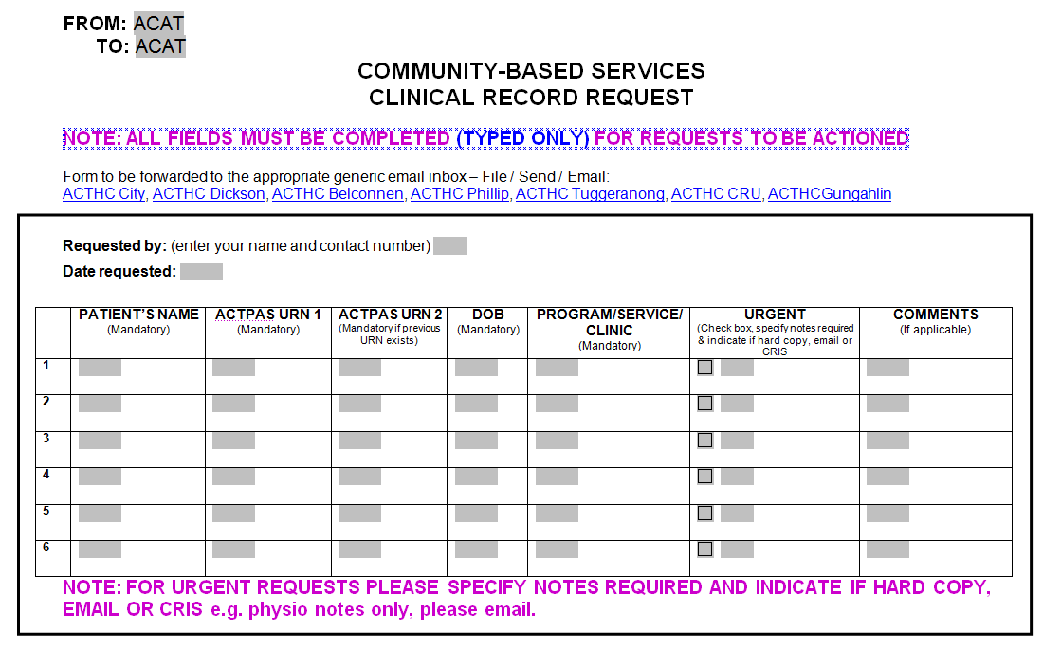

Attachment B: Document Tracking
Dispatching clinical records using the hand held scanner

Click on the ‘Patient Document Transfer’ icon on the right hand end of the ACTPAS tool bar to bring up the ‘Patient Document Transfer View’ screen

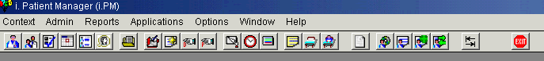

Right mouse click and select ‘Build Transfer’ and then ‘Add’
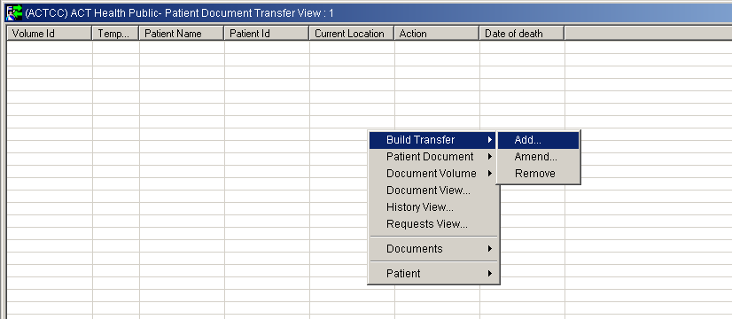

The ‘Patient Document Transfer Add’ screen will appear. Click ‘Dispatch’.

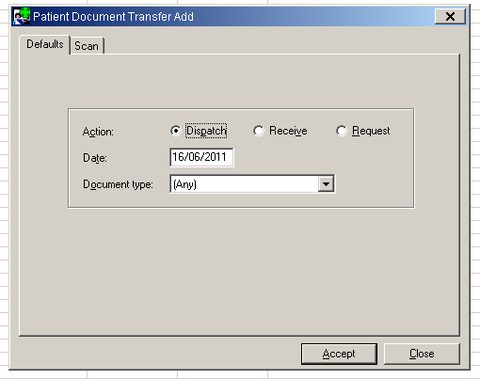
Select the ‘Scan’ tab and click on the ‘Set’ box next to ‘Location Code’
Click in the box next to ‘Description’ and type the location to which the file is being sent e.g. BHC-HCA = Belconnen Health Centre; CHC-HCA = City Health Centre; DHC-HCA = Dickson Health Centre; PHC-HCA = Phillip Health Centre; THC-HCA = Tuggeranong Health Centre

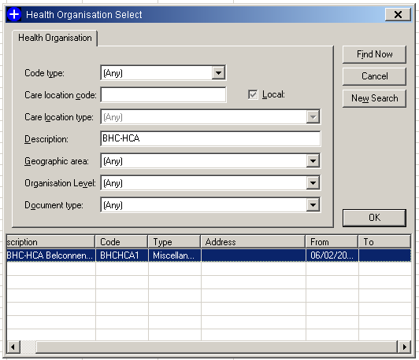

Click ‘Find Now’
Select the correct location and click ‘OK’
Click on the ‘Set’ box beside ‘Prof. carer code’ and type the surname of the specified professional carer for the relevant health centre, or the surname of the specific health professional if the file is being dispatched to a specific clinician. A list of professional carers is available from the CRU supervisor. Click ‘Find Now’ and select the relevant name from the list. Click ‘OK’

Place cursor into the box beside ‘Identifier’ and begin scanning the bar codes on the front cover of each file that is being dispatched to the nominated health centre using the hand held scanner. When finished click ‘Close’. Ensure that all files scanned appear on the list and then click ‘Process’

If you are dispatching the files to the Clinical records Unit when the message appears ‘Do you wish to print a summary copy?’ click ‘Yes’ and attach the batch list to the hard copy files. If you are dispatching files to other areas click ‘No’
Receiving clinical records using the hand held scanner when there is no ‘batch list’ attached
Click on the ‘Patient Document Transfer’ icon on the right hand end of the ACTPAS tool bar to bring up the ‘Patient Document Transfer View’ screen

Right mouse click and select ‘Build Transfer’ and then ‘Add’

The ‘Patient Document Transfer Add’ screen will appear. Click ‘Receive’

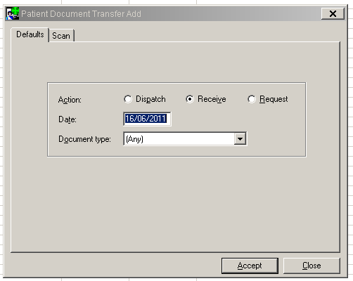
Click on the ‘Scan’ tab
Click on the ‘Set’ box beside ‘Prof. carer code’ and type the surname ‘Mackenzie’. Click ‘Find Now’ and select the relevant name from the list. Click ‘OK’

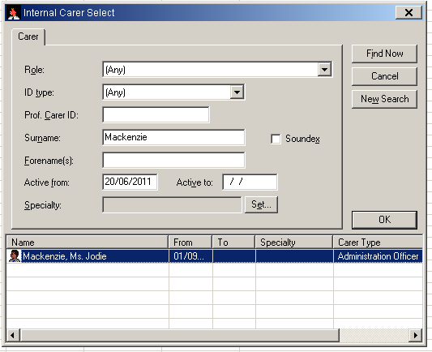

Place cursor into the box beside ‘Identifier’ and begin scanning the bar codes on the front cover of each file using the hand held scanner. When finished click ‘Close’. Check that all files scanned appear on the list and then click ‘Process’. When the message appears ‘Do you wish to print a summary copy?’ click ‘No’

Attachment C: Document Tracking Archived Documents

Search for consumer documents
- Search for the consumer – 3x3 search (See Attachment H)
- Select the relevant consumer
- To view all consumer documents, Right click and select ‘Patient Documents’

To create a new consumer document
- Right click and select ‘Patient Document’ then ‘New’
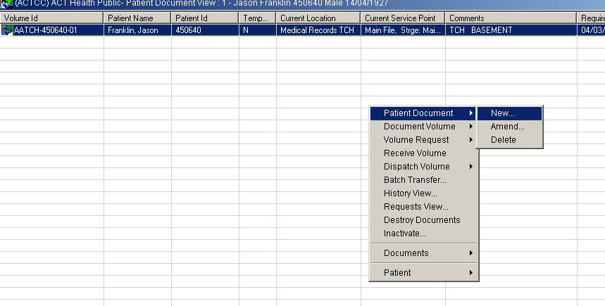

- Click on the ‘Set’ button next to the ‘Storage location’ field
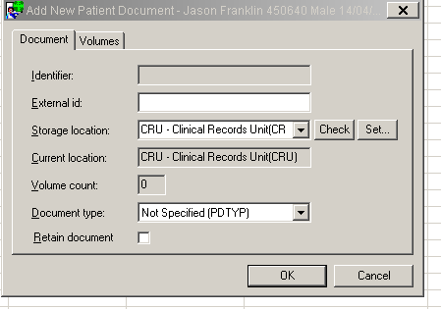

- Type the location where the file is held e.g. ‘THC’ (Tuggeranong Health Centre) in the description field
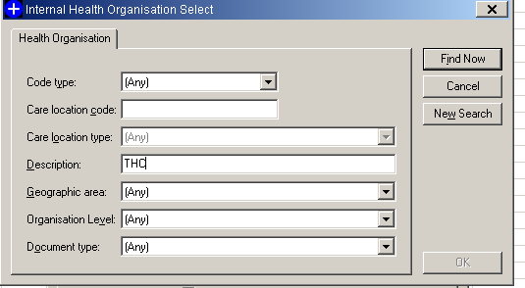

- Select ‘Find Now’ and choose the correct location from the description list and click ‘OK’
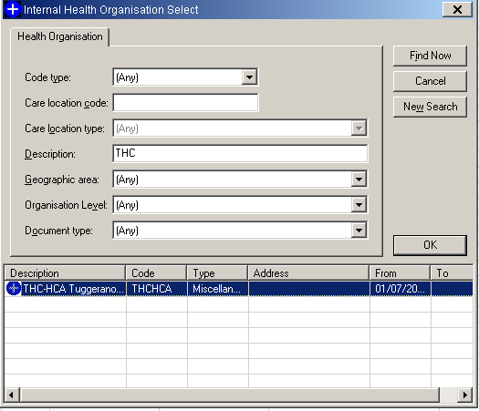

- From the ‘Document type’ drop down box select the correct document type e.g. IHCP, CY&WHP Record
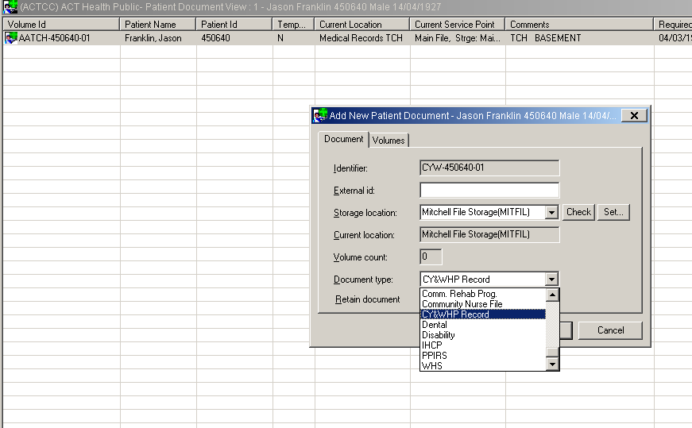

- Click on the ‘Volumes’ tab and click ‘Add’
- In the comments section enter the box number
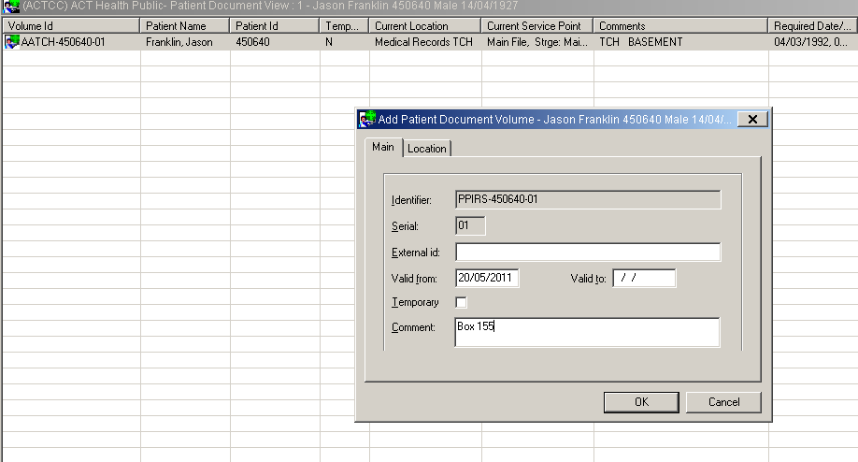

- Click on the ‘Location’ tab and click on the ‘Set’ button next to the ‘Current Location’ field
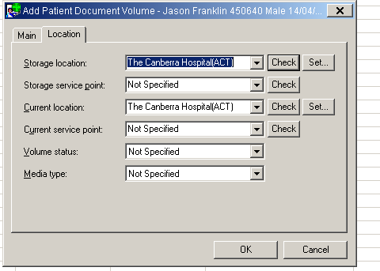

- Type the archive to which the file is being sent e.g. ‘Mitchell’
- Select ‘Find Now’ and choose the correct location from the description list and click ‘OK’
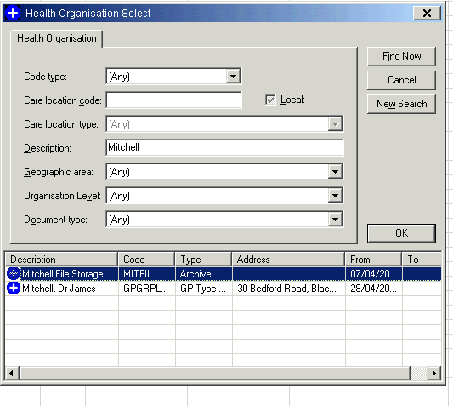
- The following screen will show the storage location where the file is being held, and the current location where the file will be archived
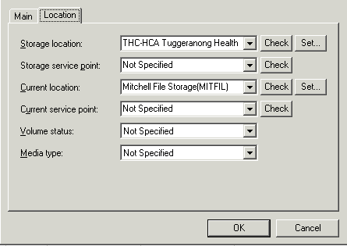

- Click ‘OK’ again
- When the screen appears asking if you wish to print labels select ‘No’
- Click ‘OK’ again to the ‘Add New Patient Document’ window
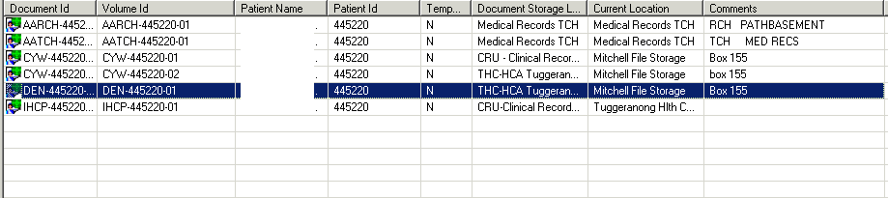

- The document will now be visible along with any other document types the consumer may have. The Document Storage Location will be the location where the file is held and the current location will show that the file is archived e.g. in Mitchell

Attachment D: ACTPAS Document Types

Community Based Services, Division of Women, Youth and Children
The following services should have the document type as ‘CY&WHP Record’:
- Social-work
- Audiometry
- Physiotherapy
- Asthma
- Nutrition
- Day Stay
- Sleep Group
- PEPs (Parenting Enhancement Program)
- Additional Support
- School files
- Caring for Kids

The following services should have the document type as ‘Child Health Record’:
- Child Health Clinics (baby cards)

The following services should have the document type as ‘CPCHS’:
- Community Paediatric and Child Health Services

Community Care Program, Division of Rehabilitation, Aged and Community Care
The following services should have the document type as ‘IHCP’:
- Physiotherapy
- Continence
- Diabetes
- Nutrition
- Podiatry
- Social Work
- Occupational Therapy
- GP (when located in Health Centres)

The following services should have the document type as ‘Community Nursing File’:
- Ambulatory
- Community Nursing
- LINK

Justice Health
All Justice Health clinical records should have the document type as ‘CHP’. Prior to 21 March 2011, Justice Health was known as ‘Corrections Health Program’ hence the ‘CHP’ abbreviation.

Alcohol and Drug
All Alcohol and Drug services should have the document type as ‘ads’. Prior to 1 September 2011, Alcohol and Drug Services document types were as follows:
- AD - B7: Withdrawal Services and OTS
- AD – CTS: Counselling and Treatment Service
- AD – PED: Diversion Services
- AD – CADAS: Court Alcohol and Drug Assessment Service
- AD – TRP: Treatment Referral Program
- AD – ALO: Aboriginal Liaison Officer

Attachment E: Labelling Archive Boxes

Label type: OfficeMax Premium L7169 Laser Labels
Size: 100 sheets per pack, 4 labels to a sheet, 99.1 x 139mm
Colour: Bright White
Purchased from OfficeMax, Code: 1950819
Labelling the box
- Labels are to be typed, not handwritten, with the following information:
  - Division
  - Program
  - Service/ Document Type (where applicable)
  - Box number
    - e.g.
Division of Women, Youth and Children
Community Based Services
Baby Health Cards
Box 5

Or

Division of Rehabilitation, Aged and Community Care
Community Care Program
Box 490
Division of Women, Youth and Children
Community Based Services
Baby Health Cards

Box 5
Division of Rehabilitation, Aged and Community Care
Community Care Program

Box 490

Attachment F: Labelling Hard Copy Clinical Records
URN 12345678
Label without name
Lateral Tab File | 1  2  3  4  5  6  7  8

Diagram showing correct positioning of URN on a clinical record
Community Nursing files must have numbers hand written in black texta down the side.
Numbers must NOT be written in pen or pencil.
Numbers must be legibly written.

Attachment G: Creating a CN Volume

Search for consumer documents
- Search for the consumer – using the first three letters of surname and first name (3x3 search) (See Attachment H)
- Confirm details – date of birth and address
- Select the relevant consumer
- To view all documents, Right click and select ‘Patient Documents’

Creating an ‘IHCP’ document
For every new community nursing referral a Community Care (‘IHCP’) document must exist in ACTPAS.
- If an electronic ‘IHCP’ document already exists in ACTPAS skip to the following section: ‘To create a new Community Nursing patient document’.
- If there is no ‘IHCP’ document in ACTPAS then a ‘IHCP’ document must be created electronically (using the instructions below) and physically:
  - Right click and select ‘Patient Document’ and then ‘New’
  - Select the document type as ‘IHCP’
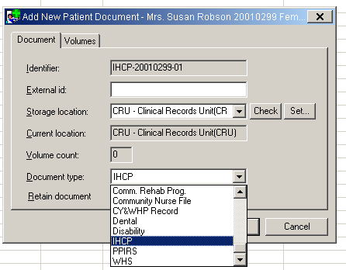
  - Select the ‘Volumes’ tab and click ‘Add’
  - Click on the ‘Location’ tab and click on the ‘Set’ button next to the ‘Storage location’ field Click in the ‘Description’ field of the ‘Health Organisation Select’ window and type ‘CRU’
  - Click ‘Find Now’
  - Select the CRU location with the code ‘CRUHCA’
  - Click ‘OK’
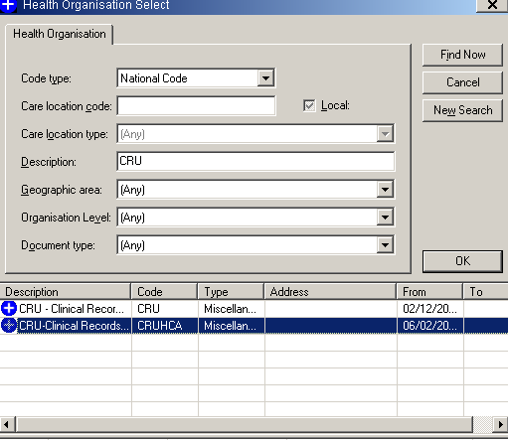
  - Click on the “Set” button next to the “Current Location” field and in the “Description” field type the relevant health centre where the file will be located e.g. BHC-HCA = Belconnen Health Centre; CHC-HCA = City Health Centre; DHC-HCA = Dickson Health Centre; PHC-HCA = Phillip Health Centre; THC-HCA = Tuggeranong Health Centre
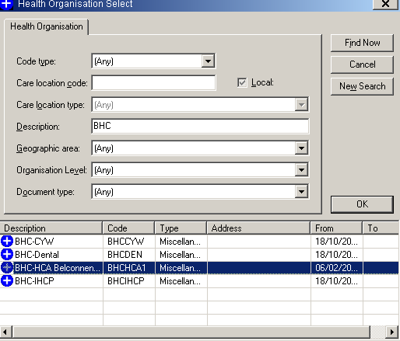
  - Click ‘OK’ and ‘OK’ again
  - Click ‘Yes’ to the message “Do you wish to print a document volume label?”
  - Click ‘OK’ to the warning message that follow
  - Select the relevant printer and printer tray to print from
  - Click ‘OK’ and click ‘Yes’ to the warning message that follow
  - Clock ‘OK’ again and the relevant ‘IHCP’ document will appear in the ‘Patient Document’
  - View window
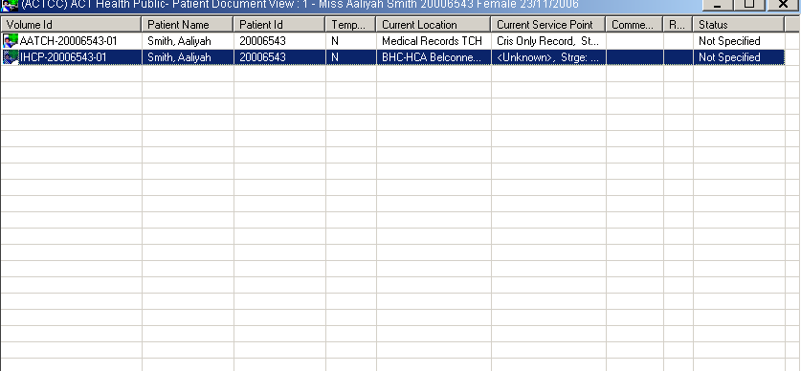

To create a new Community Nursing document

NOTE: If a Community Nursing document already exists in ACTPAS and the consumer has an open referral, and a new referral is received (e.g. for management of a different issue) a new document does not need to be created.

- Right click and select “Patient Document” and then “New”
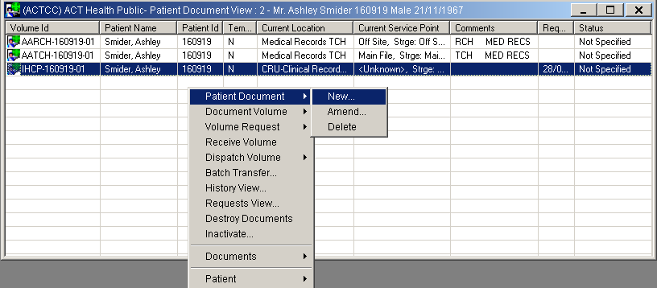

- Click on the ‘Set’ button next to the ‘Storage location’ field and search for your health centre site e.g. type ‘BHC’ in the description field of the Internal Health Organisation window, click ‘Find Now’, and select the correct health centre description from the list, click ‘OK’
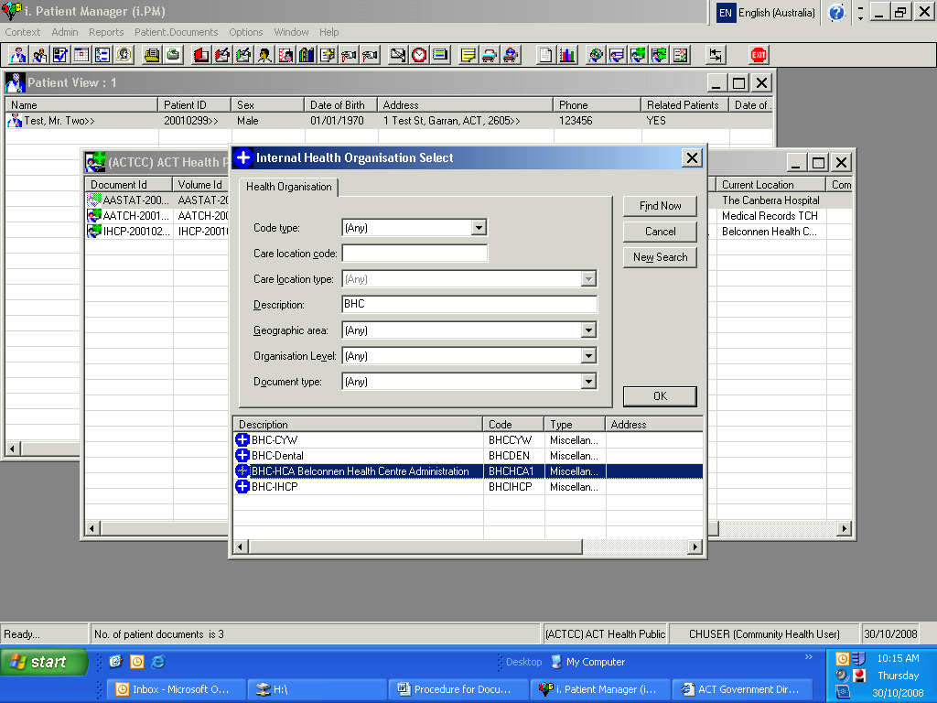

- From the ‘Document type’ drop down box select ‘Community Nurse File’
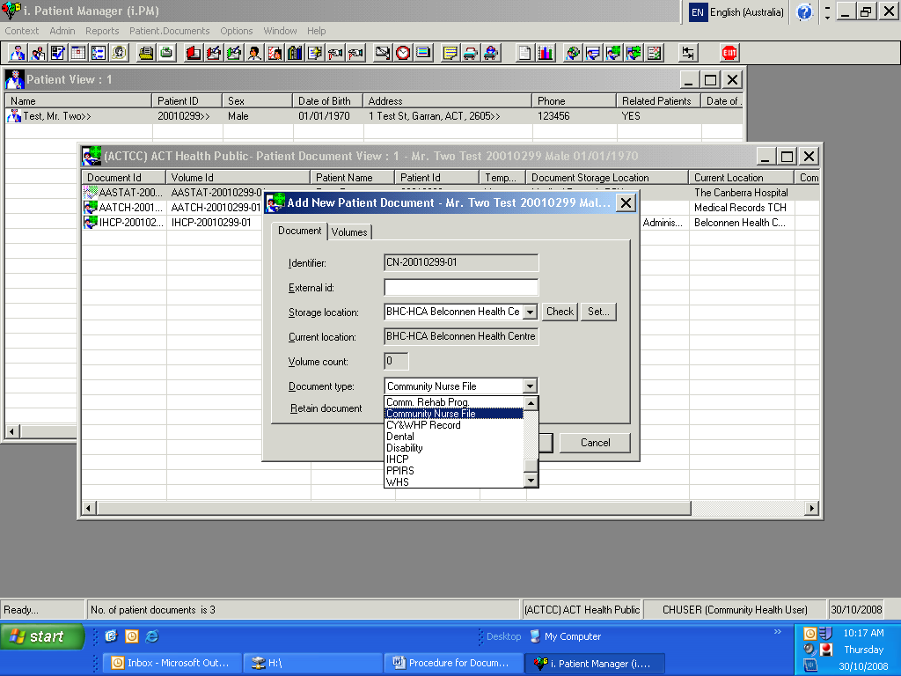

- Click on the ‘Volumes’ tab and click ‘Add’
- Select the tick box next to ‘Temporary’
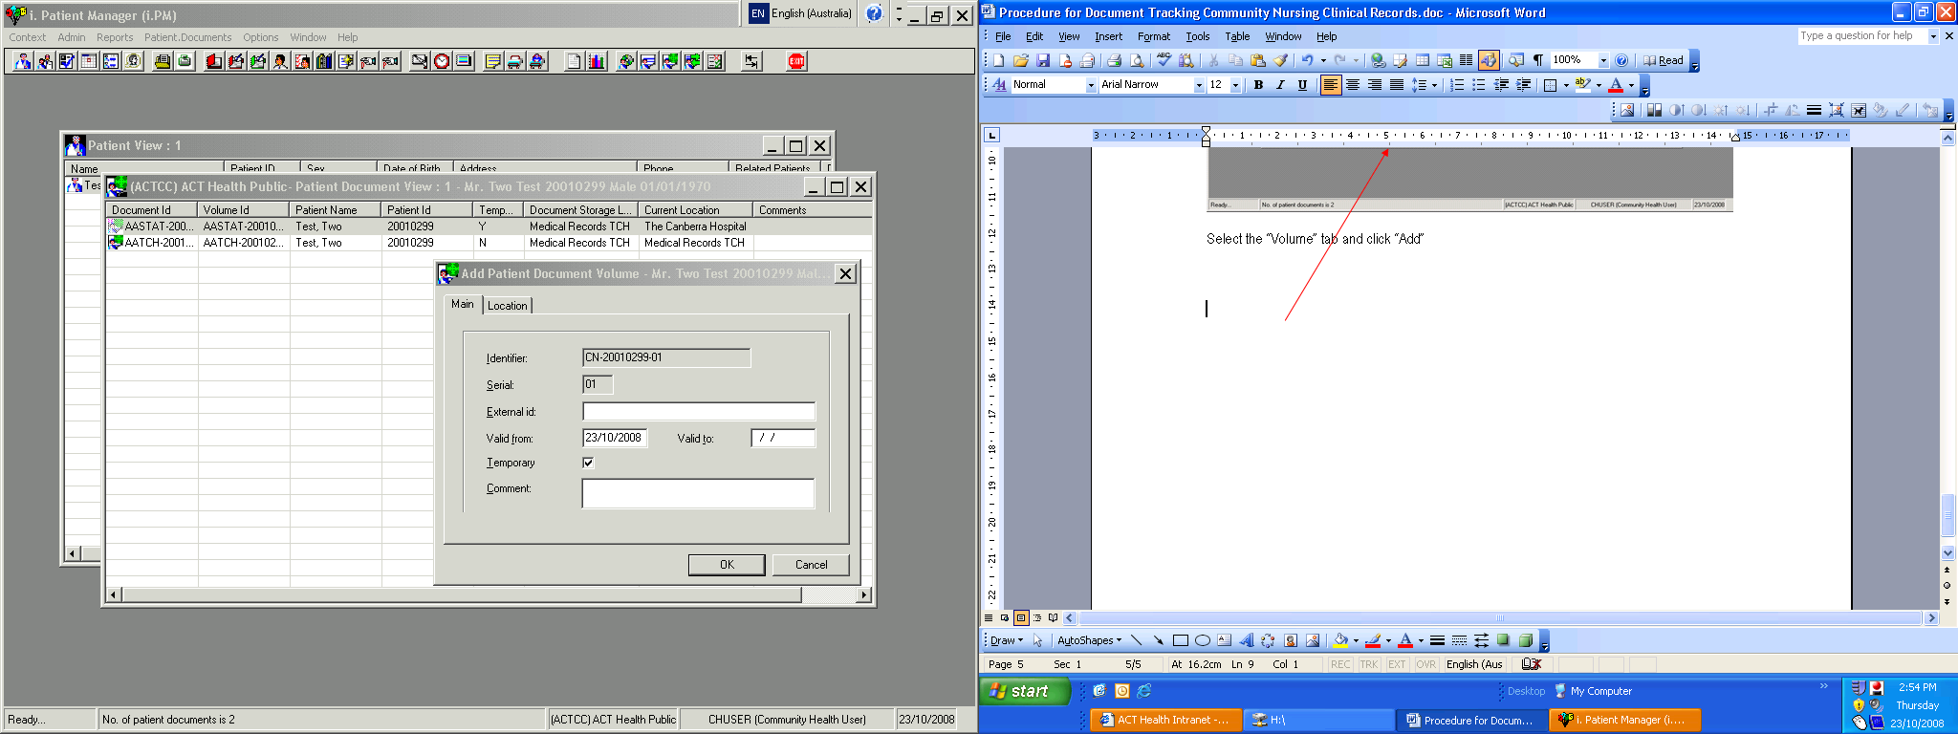
- Click on the ‘Location’ tab
- Click on the ‘Set’ button next to the ‘Current Location’ field
- Type the word ‘Patient’ or the relevant health centre name (e.g. BHC-HCA = Belconnen Health Centre; CHC-HCA = City Health Centre; DHC-HCA = Dickson Health Centre; PHC-HCA = Phillip Health Centre; THC-HCA = Tuggeranong Health Centre) in the description field and then select ‘Find Now’
- Select “Patients care” or the relevant health centre name and click “OK”
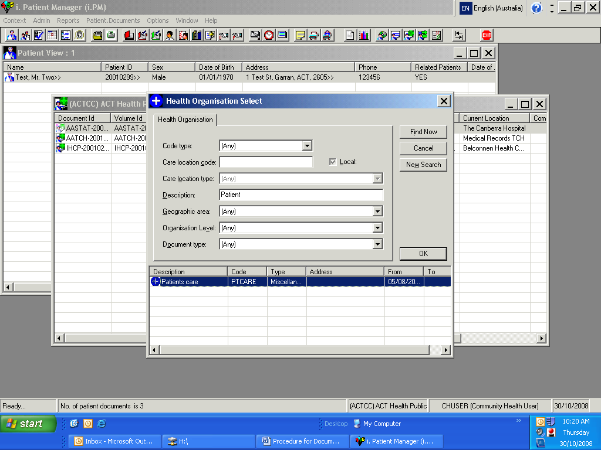
- Select “OK” again
- Follow the prompts to print the labels

The Community Nursing document will now be visible along with any other document types the consumer may have. The Community Nursing document will appear with the prefix ‘CN’ and will be marked with a ‘Y’ in the ‘Temp’ field. The Document Storage Location will be the health centre where the temporary file was created and the Current Location will show that the file is in the ‘Patient Care’ or the relevant health centre as appropriate.
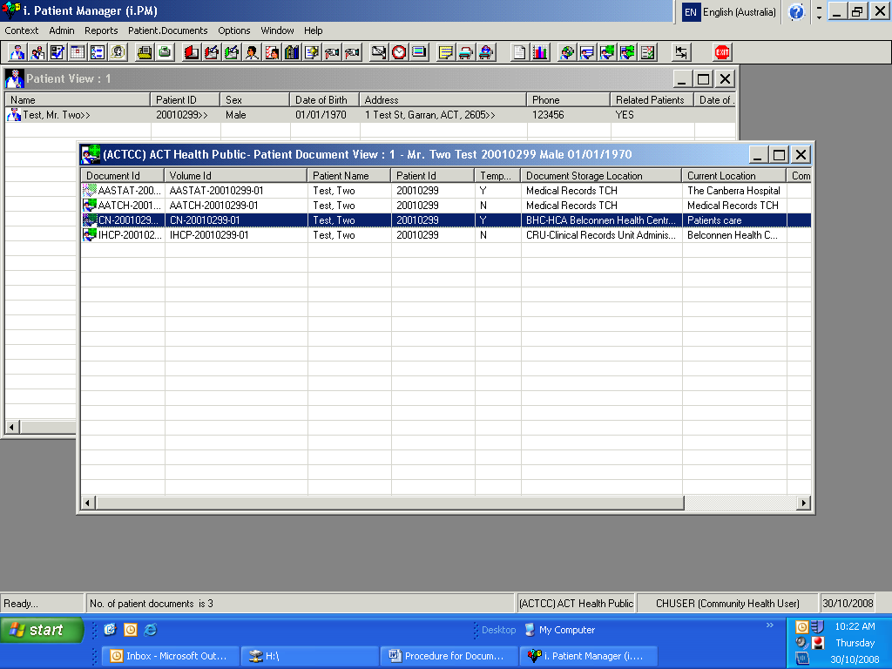

To close a Community Nursing document
When the temporary nursing file is returned:
- If the Community Care file is located at the relevant health centre, the nursing file must be received electronically in ACTPAS and merged physically and electronically, making the nursing file inactive in ACTPAS.
- If the main file is located at another health centre the nursing file must be dispatched in ACTPAS and sent to the appropriate health centre and the receiving health centre must merge the nursing file physically and electronically, making the nursing file inactive in ACTPAS.
- Select ‘Dispatch Volume’ and ‘New’
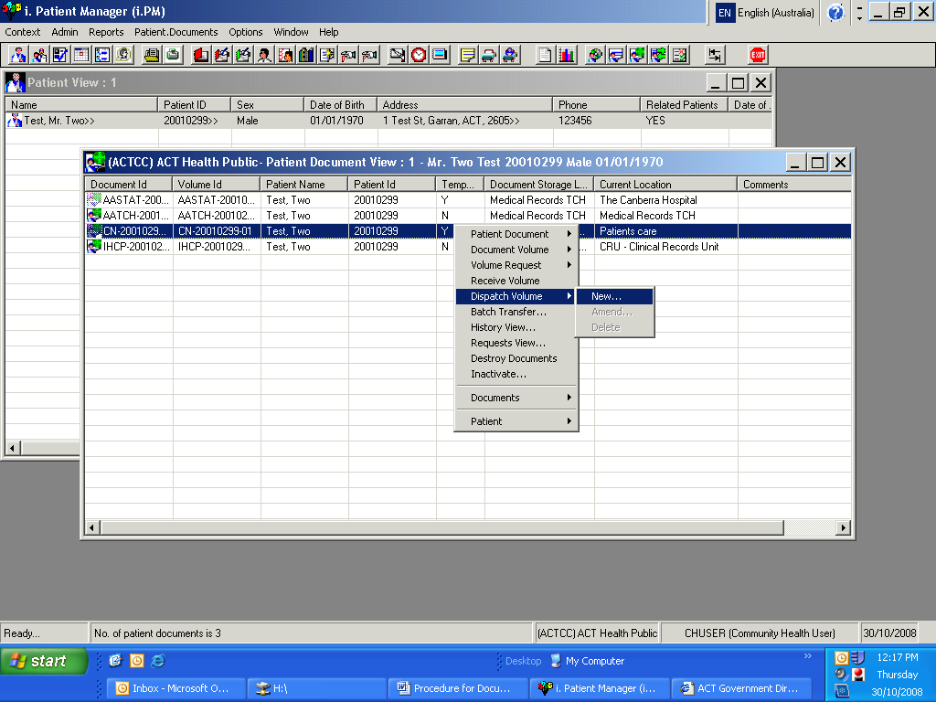

- A message will appear ‘Please note that the patient document volume selected is temporary’.
- Indicate ‘Yes’ to ‘Do you wish to continue’
- When the ‘Add Patient Document – Dispatch’ window appears click on the ‘Set’ button next to the ‘Location’ field
- Enter ‘CRU’ in the ‘Description’ field and click ‘Find Now’
- Select ‘CRU-Clinical Records Unit Administration’ from the drop down box
- Click ‘OK’
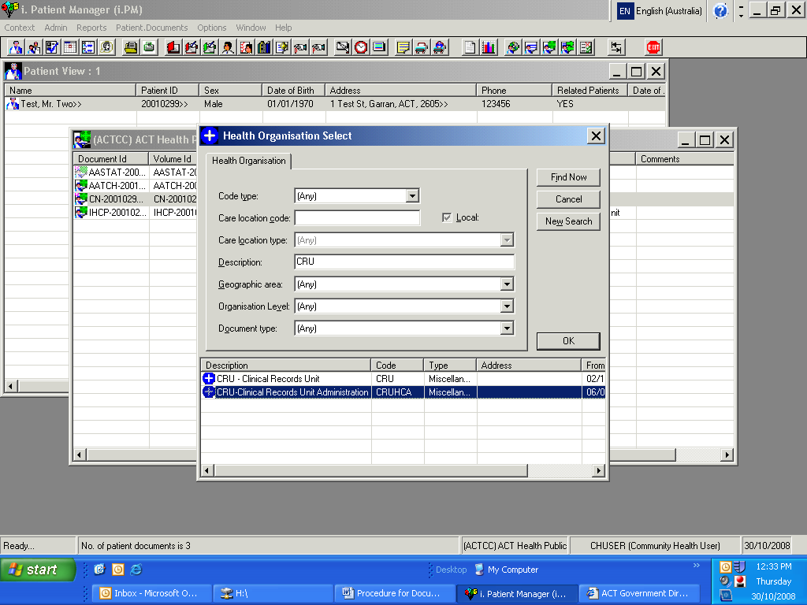

- Once the correct location is selected click on ‘Set’ next to ‘Professional Carer’ and type the surname ‘Mackenzie’ for files being dispatched to CRU.
- Click ‘Find Now’ and select the relevant name from the list.
- Click ‘OK’
- The file is now dispatched and shows the current location as the Clinical Records Unit but the storage location will show the health centre where the file was created
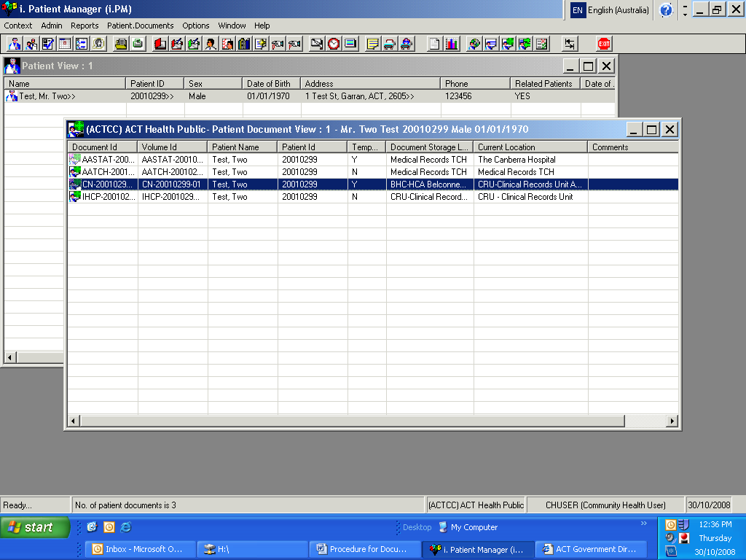

- Select the ‘CN’ document from the Patient Document View and double click
- Enter the date the file has been returned in the ‘Valid to’ field
- In the ‘Comment’ section type ‘merged with IHCP’ and specify the ‘IHCP’ volume that the ‘CN’ document has been merged with.

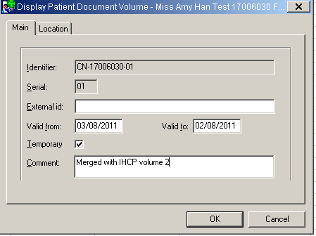

- Select the ‘Location’ tab
- Go to the ‘Volume Status’ field and select ‘Inactive’ and click ‘OK’
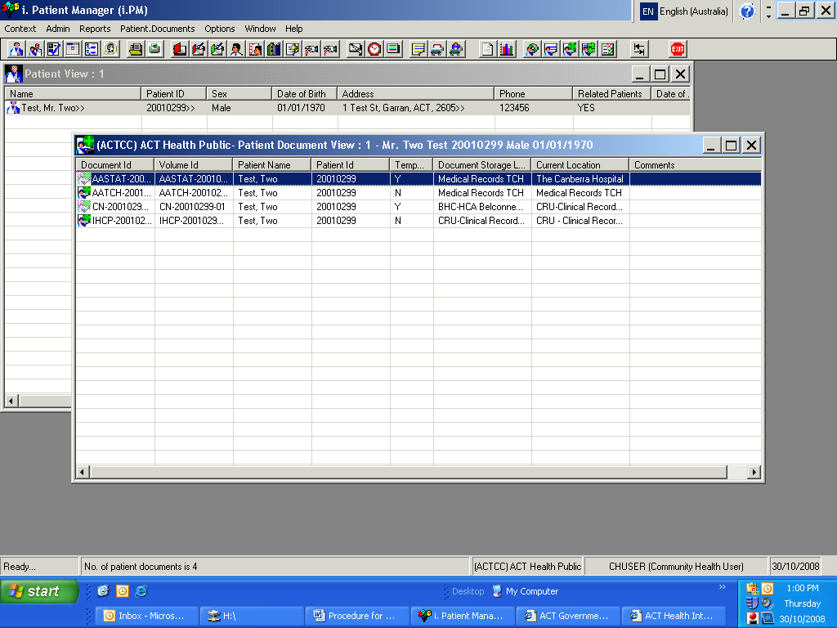

- You will now notice that the Icon for the nursing file in the Patient Document View is ‘greyed out’.
- The physical paper record must now be merged with the Community Care (‘IHCP’) file.
- The Community Care file must now be dispatched and returned to CRU if the consumer’s care is now completed or located in the health centre compactus/ forwarded to another health centre until discharged from other services.
- If a consumer requires another Community Nursing service (where the previous ‘CN’ volume has been discharged), a subsequent ‘CN’ volume must be created in ACTPAS. A subsequent ‘CN’ volume must be created for every new Community Nursing referral; an inactive ‘CN’ volume cannot be reactivated and used again. For consumers with more than one ‘CN’ volume the Community Nurse should request the previous notes through health centre admin staff if required prior to the home visit or clinic appointment.

Attachment H: Searching for consumer documents

- Search for the consumer – using the first three letters of surname and first name (3x3 search)
- Confirm details – date of birth and address
- Select the relevant consumer
- To view all documents - Right click and select ‘Patient Documents’
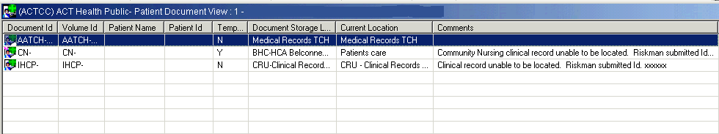
- The ‘Current Location’ column will indicate the last known location of the record, and the ‘Comments’ will indicate if the record is unable to be found at that location and include the relevant Riskman number. For further details regarding the missing record, refer to the Riskman incident.

