Procedure | Canberra Health Services

Immunisation Service Delivery in Schools and Early Childhood Health Clinics
CHS25/129
Contents
Purpose 2
Alerts 2
Scope 2
Section 1 – Background 3
Section 2 – Early Childhood Immunisation 3
Section 3 – School Immunisation Program 9
Section 4 – Contact Prophylaxis Immunisation Clinics 17
Section 5 – Management of Adverse Events Following Immunisation 18
Section 6 – Competency Assessment for Registered Nurse Immunisers Procedure 19
Evaluation 20
Related policies, procedures, guidelines and legislation 21
References 21
Definition of terms 22
Search terms 22
Attachments 22
Attachment 1 – Immunisation record for children 24
Attachment 2 – Minimum/maximum vaccine refrigerator temperature chart 25
Attachment 3 – Basic Life Support flow chart 26
Attachment 4 – Ambulance information chart 27
Attachment 5 – Year 10 student consent process – Gillick Consent 28
Attachment 6 – Work, Health and Safety checklist for immunisation for schools 29
Attachment 7 – Team Leader duties 30
Attachment 8 – School Health Team pre-vaccination checklist 33
Attachment 8 – Anaphylaxis Information 34
Attachment 10 – WYCCP Immunisation Clinical Competency Assessment 35

Purpose
To guide the practice of Registered Nurses (RNs) and Registered Midwives (RMs) who provide immunisation services to children aged zero to six (0-6) years and adolescents within the Women Youth and Children Community Health Program (WYCCHP). This procedure is to be read in conjunction with The Australian Immunisation Handbook and the ACT Medicines, Poisons and Therapeutic Goods Regulation, 2008.
Note Canberra Health Services (CHS) endorses the use of the Australian Immunisation Handbook per The Australian Immunisation Handbook.
Back to Contents

Alerts
Under the ACT Medicines, Poisons and Therapeutic Goods (Nurse and Midwife Immunisers) Direction 2020 (No 1) a registered nurse or midwife is authorised to administer a vaccine to a person without a supply authority (prescription or standing order) if the nurse or midwife administers the vaccine in accordance with the ACT Registered Nurse and Midwife Vaccinations Standards as set out in Schedule 1 of the instrument.
Back to Contents

Scope
This document pertains to children zero to six (0-6) years and adolescents who are clients of WYCCHP. It applies to WYCCHP RNs and RMs working within their scope of practice.
Vaccine administration should always adhere to standards as per Medication Handling Policy located on the Policy and Guidance Documents Register.
Vaccines must be administered in accordance with the recommendations of the current edition of The Australian Immunisation Handbook and under the legislative framework of the ACT Medicines, Poisons and Therapeutic Goods Regulation (2008).
Strict Hand Hygiene should always be adhered to when performing all clinical procedures as per Infection Prevention and Control Procedure located on the Policy and Guidance Documents Register.
For vaccination requirements for CHS staff, please refer to Occupational Assessment, Screening and Vaccination Procedure on the Policy and Guidance Documents Register.
Back to Contents

Section 1 – Background

Procedure
The National Immunisation Program (NIP) Schedule outlines a series of immunisations given at specific times throughout a person’s life. The age of immunisations range from birth through to adulthood. In the ACT the schedule for children aged zero to six (0-6) years and for adolescents is provided through the WYCCHP Early Childhood Immunisation Clinics and High School Immunisation Program.
The following sections detail procedures for service provision including pre-vaccination, vaccine administration, post vaccination and management of Adverse Event Following Immunisation (AEFI) for the Early Childhood Immunisation Clinics and High School Immunisation Program.
Back to Contents

Section 2 – Early Childhood Immunisation

2.1 Eligible Clients
- Subject to consent, the service will provide NIP funded vaccines to children from zero to six (0-6) years. Vaccines are only to be administered to children up to their sixth birthday.
- For the most up to date NIP schedule refer to link: https://www.health.gov.au/health-topics/immunisation/immunisation-throughout-life/national-immunisation-program-schedule
Alert:
Early Childhood Immunisation RNs and RMs are only permitted to administer NIP vaccines supplied by ACT Health, Vaccine Management Unit. Vaccines supplied by the client or any other third party cannot be administered by Early Childhood Immunisation RNs and RMs.

2.2 Early Childhood Immunisation Clinic Appointments
- Parents/guardians can book a 20-minute appointment through the Central Health Intake (CHI) phone 5124 9977 or by booking directly through MyDHR.

2.3 Consent
The administering RN/RM will obtain valid consent prior to every immunisation encounter obtains.
Parents/guardians shall be provided with sufficient information, including risks and benefits, to allow informed consent to be given as per Consent for Healthcare Treatment Guideline located on the Policy and Guidance Documents Register.

Procedure for Written Consent
The administering RN/RM will:
- ensure pre vaccination screening is completed with parent/legal guardian prior to every vaccination (see Section 2.5.1)
- provide a written copy of WYCCHP ‘After Your Child Has Been Immunised’ health information sheet located on the Policy and Guidance Documents Register to the consenting adult and explain the schedule, post immunisation care of the child and reporting process for adverse reactions
- inform the consenting adult that the immunised child needs to remain in the clinical observation area for 15 minutes post-vaccination
- ensure the consent form, agreeing to the NIP, is signed and dated by the parent/guardian at the first immunisation encounter in the child’s Personal Health Record (Attachment 1)
- document consent at subsequent immunisation encounters by the parent/guardian signing in the space provided on the child’s Personal Health Record immunisation record (See example in Attachment 1)
In the event the child is brought to the clinic by an adult other than the parent/guardian, they must have a signed letter from the parent/guardian stating permission for the immunisation to occur as per Patient Identification and Health Care Activity Matching Procedure located on the Policy and Guidance Documents Register.

Procedure for Phone Consent
Where a child requires vaccination without a parent or legal guardian present, and the carer does not have written permission, phone consent may be obtained by:
- initial verification of the parent/guardian status on the phone. This is completed by asking the person to state the child's full name, date of birth, address, and their full name to confirm they are the parent or legal guardian of the child, as per the Patient Identification and Health Care Activity Matching Procedure located on the Policy and Guidance Documents Register.
- ensuring the parent/guardian has enough information to make an informed verbal consent.
Two RNs/RMs must listen to the call and co-sign that consent has been obtained. This is completed on the vaccination record and in the Digital Health Record (DHR) as per the Consent for Healthcare Treatment Guideline located on the Policy and Guidance Documents Register.

2.4 Documentation at Child Immunisation Clinics
Documentation is required on the following three locations, as further outlined below:
- Immunisation Record in the Child’s Personal Health Record
- Client record on DHR
- Australian Immunisation Register (AIR).

Immunisation Record in the Child’s Personal Health Record
At first the immunisation service the following information is to be recorded:
- parent/guardian consent for the childhood NIP, as obtained by the immunising RN/RM
- child’s details including:
  - Medicare number (if available)
  - surname and given name
  - date of birth (DOB)
  - sex
  - address
  - Aboriginal and /or Torres Strait Islander status.
At all immunisation encounters the following information is to be recorded:
- initials of the parent/guardian providing consent on the day in the consent column
- name of vaccines administered
- vaccine batch numbers/by writing or by using stickers provided by vaccine company
- site where the vaccine was administered if multiple vaccinations were given
- date the vaccine was administered
- signature of the RN/RM administering the vaccine next to each vaccine given
- Canberra Health Services stamp
- date the next immunisation is due.

Client record on DHR
- ensure client is registered correctly on DHR, and update details if required
- ensure Medicare number (if available) is recorded
- ensure the appropriate vaccines have been selected
- document consent
- document administration of vaccines (vaccine, batch number, expiry date, dose, number and site of administration)
- complete reason for visit
- select visit outcome

Australian Immunisation Register (AIR)
Each encounter will be entered onto the AIR website directly via DHR. Clinicians are required to view the client’s AIR record prior to vaccination to ensure immunisations given at the encounter are those due.
Birth doses of Hepatitis B vaccine should be added to AIR if evidence is available and they are not already listed on the AIR record.

Each clinician requires individual access to AIR via PRODA (Provider Digital Access).
- Clinicians who need to gain access to PRODA can register here: How to register for an individual PRODA account - PRODA (Provider Digital Access) - Services Australia (https://www.servicesaustralia.gov.au/how-to-register-for-individual-proda-account?context=33786)
- Once a clinician received their individual number, they are to email this to the CAIT Coordinator to approve and finalise their PRODA access.
The following information is entered on the AIR register by the immunisation provider:
- Medicare number and reference number
  - If Medicare number is unavailable, record name, address, DOB, and postcode.
- Aboriginal/Torres Strait Islander status
- ‘Who performed this encounter’
- Date
- Hepatitis B birth dose and date.

Staff are to await confirmation from AIR and then record the confirmation number on DHR.
Alert
AIR should be notified of a deceased child to prevent a Child History Statement being sent to bereaved parents. The RN/RM can contact AIR on 1800 653 809 and provide details of the child’s name, address, and date of birth, Medicare number and date of death.

2.5 Vaccination at Child Immunisation Centres
- Check the viability of vaccines by close monitoring of the cold chain and record on Minimum/Maximum vaccine refrigerator temperature chart (Attachment 2). This is to be completed at the beginning and end of the morning session, and at the end of the afternoon immunisation session. Refer to the Vaccine Cold Chain Management Procedure, available on the CHS Policy and Guidance Documents Register.
- Two RNs/RMs are to count and record stock levels at the beginning and end of the morning session and at the end of the afternoon immunisation session.
- Any discrepancies are to be reported to the Clinical Nurse Coordinator or CAIT Manager.

Procedure

2.5.1 Child Vaccination Safety
- The Triage RN/RM will:
  - welcome client
  - ascertain child’s name/identity and relationship to adult
  - confirm booking against appointment list
  - ascertain age of child and immunisation status
  - work through a pre-vaccination checklist to assess child wellness and any contraindications to immunisation. This is to include asking parent/guardian to advise if their child:
    - is unwell at time attending for immunisation
    - has ever had a reaction after an immunisation or a serious allergic reaction to anything
    - identifies as an Aboriginal or Torres Strait Islander person*
    - was born weighing less than 2000g*
    - was born early (before 32 weeks)*
    - has a medical condition
    - has a bleeding disorder
    - has had any immunisations in the four weeks prior to attending for immunisation
    - has ever had a blockage of their bowel (intussusception)
    - received immunoglobulin, blood products or whole blood transfusions in the past 12 months prior to attending for immunisation
    - has low immunity or someone at home has low immunity
    - is likely to travel overseas.
    - *note nurse to discuss with parent/guardian that the child may require extra immunisations
  - encourage parent/guardian to discuss any further questions or concerns they might have about immunising their child before the immunisations are given
  - advise parent/guardian to wait for 15 minutes after immunisation in case their child has a reaction.
  - manage the clinic flow for the administrating immunisers, and ensure safe recovery of clients
  - reassure and respond to parental concerns whilst observing child for 15 minutes post vaccination.

2.5.2 Prepare clinic environment
The administrating RN/RM will ensure that:
- the vaccine administration area is clean ensuring infection control principles are met
- table, chairs, and benches meet Work Health Safety standards
- there is adequate lighting, heating, and cooling.

2.5.3 Emergency Equipment
All RN/RMs conducting the clinic will check to ensure the following equipment is available each day:
- Laerdal resuscitator – age appropriate and clean
- adrenaline 1:1000 (2 vials) per Australian Immunization handbook – check expiry date, and that 1ml syringe and 23g needle are present
- Basic Life Support Flow Chart and Ambulance Information Chart identifying clinic location (See Attachments 4 & 5)
- Access to a landline phone.

2.5.4 Documentation & Client Information
Ensure documentation is available including:
- Pre-vaccination check list in clinic folder to support nursing staff in discussion (see Section 2.5.1)
- Consent form in Personal Health Record (Attachment 1)
- Adverse Event Following Immunisation (AEFI) online form available at via ACT Health website: Immunisation Adverse Event (vaccination reaction) Reporting Form (https://www.act.gov.au/health/providing-health-care-in-the-act/treatment-and-clinical-information/vaccination/adverse-events-after-immunisation)
- Translated immunisation resources, for use as individually appropriate for culturally and linguistically diverse families, available via the Australian Government Department of Health and Aged Care website: www.health.gov.au/resources/translated?f%5B0%5D=field_related_health_topics%3A1476
- ‘After Your Child Has Been Immunised’ health information sheet available on the Policy and Guidance Documents Register.

2.5.5 Vaccination Procedure in Immunisation Clinics
In preparation for vaccination administration, the administrating RN/RM will:
- obtain informed consent from parent/guardian accompanying child
- ensure parent/guardian has completed pre-vaccination checklist with nursing staff
- provide an explanation of the vaccines to be administered, possible side effects, care advice and emergency numbers for post vaccination concern
- use interpreter services as required to ensure parent/guardian can provide informed consent (see Language Services – Interpreters and Translated Materials Procedure located on the Policy and Guidance Documents Register)
- provide an explanation of the procedure including sites for administration
- inform parent/guardian of 15-minute recovery supervised by triage RN/RM in a designated recovery area
- confirm client details on AIR and check the client’s immunisation history recorded on AIR.
When administering the vaccine, the administrating RN/RM will:
- remove vaccines from fridge
- prepare vaccine according to the Australian Immunisation Handbook

- ensure the vaccine/s is checked by two RN/RMs (includes the drawing up and mixing of all multi component vaccines)
  - right client
  - right vaccine
  - right dose
  - right route
  - right timeframe according to schedule.
- store individual vaccines in separate dishes prior to vaccination
- confirm if any known allergies and contraindications have been identified and appropriate action taken. They will seek further advice, if necessary, from Clinical Nurse Coordinator, CAIT Manager or ACT Health Immunisation Unit on 5124 9800.
- confirm vaccine to be administered by showing vaccine name and expiry date to consenting parent/guardian, and asking parent/carer to initial the Personal Health Record (Attachment 1)
- discuss and explain the ‘After Your Child Has Been Immunised’ health information sheet available on the Policy and Guidance Documents Register. As part of this:
  - remind parent/guardian of 15-minute recovery time and possible side effects
  - advise parent/guardian when next scheduled vaccine is due.
- complete all required documentation, including the child’s vaccination record card (Attachment 1)
- complete the medical record on DHR
- dispose of clinical waste, including sharps at the point of use.
Alert
When immunising more than one client (such as when a family has appointments for two or more children) ensure each Personal Health Record and respective vaccines required are drawn up and kept separate from each other in the workspace.
Back to Contents

Section 3 – School Immunisation Program

3.1 Eligible Clients
All Year 7 and Year 10 students attending ACT government and non-government schools are eligible for NIP funded vaccines. International students with valid consent are eligible for vaccination.

3.2 Consent

Written Consent
Immunisations provided to high schools are completed as two cohorts. High school immunisation consent forms which include a pre-vaccination checklist are sent to all high schools at the start of the school year for cohort one, and in the middle of the year for the other cohort. They are distributed to parents/guardians via the students. The consent form includes information regarding the vaccines, the diseases they prevent, common and rarer side effects and where to access further information. Parents are requested to complete a pre-vaccination checklist, sign the consent form, and return it to the school.
Consent is valid if the following elements have been satisfied:
- parent and/or legal guardian gives consent on the appropriate form
- full information on risks, benefits and alternatives has been provided
- consent is signed in ink
- all required information is completed on the consent form
- consent is specific to the vaccine being offered as part of the high school immunisation program.
Note
If a student is under the care of Children Youth and Families (CYF), consent will need to be obtained from their CYF case manager as the person with legal parental responsibility. WYCCHP staff will need to contact the CYF team on 1300 556 728.

Note
If there are any conflicts of consent between parents, refer to the Consent for Health Care Treatment Guideline located on the Policy and Guidance Documents Register. In this document see Section 10.1 Parenting and Consent Orders.
Completed consent forms are collected from the school and processed by the School Health Team (The team). The team will check that the form has been completed correctly by parent/guardian and note details that require follow up.
The consent forms are divided into three groups. These include:
- those giving consent ‘yes’
  - All the ‘yes’ completed consent forms are organised into alphabetical order prior to the team visiting each school. These are then checked against the school class list. Any students who have not returned a card will be followed up by the RN2 immunisation coordinator and the school.
- those who may have indicated ‘yes’ but the consent is invalid
  - Where an invalid consent is identified the parent/guardian are phoned to obtain ‘phone consent’ (See Phone Consent below)
- those not giving consent.
  - The ‘No consent’ forms are placed into a red folder. These are filed separately under the relevant school in the filing cabinet drawer marked ‘NO.’ The relevant filing cabinet is located within the School Health Team office.
  - The student’s name is added to a ‘No’ list stored on Q drive. Access is provided to WYCCHP staff on orientation, please contact CAIT clinical coordinator for further details. This list is physically taken to the school when immunisations are being completed so the team are aware which students have returned a consent card, and if their parents have consented ‘no’ to the vaccines.
If a parent has consented ‘yes’ to one vaccine and ‘no’ to another, the team are to:
- place a blue dot for consent to dTpa only
- place a green dot for consent to HPV only.
The consent form is processed for the relevant consented vaccine.

Phone Consent
If a Year 7 student presents for vaccination on the day but does not have a consent form, or if the Year 7 or Year 10 consent form does not satisfy all the requirements above, phone consent may be obtained in line with the Consent for Health Care Treatment Guideline located on the Policy and Guidance Documents Register.

Procedure
To obtain verbal consent the RN phones the parent/guardian using the phone numbers listed on the consent form, or the numbers given by the student on the day. To ensure informed consent the parent/guardian must have read the relevant consent card. If a parent/guardian has not seen the consent card, direct them to view this at: https://health.act.gov.au/services/immunisation
The RN should then ask the parent/guardian to:
- confirm their full name and their contact number
- confirm they have legal parental responsibility for the child
- confirm their child’s full name and date of birth
- confirm their address
- confirm the parent has read the consent form and understands what they are consenting to
- confirm the name of the vaccine they wish to consent
- if they have any questions
- confirm their child does not have any medical conditions listed on the pre-vaccination checklist, and if any are noted, RN to document on consent form,
- This information will then be repeated by the parent to a second RN to confirm the details as per the Patient Identification and Health Care Activity Matching Procedure located on the Policy and Guidance Documents Register.
- Both RNs will complete a ‘phone consent’ sticker, to include which vaccine the parent/guardian consented to, the name of the parent, date, time and both RNs will sign and print name with their designation. This label is then placed over the ‘Yes’ consent box on the relevant consent form.
Note: Any concerns about the ability to obtain valid consent must be discussed with the Clinical Nurse Coordinator and/or CAIT Manager. Where the health status of the student or validity of consent provided is unable to be determined vaccination must be deferred.

Withdrawal of Consent by Phone
Parents/guardians can withdraw consent at any time prior to the vaccination.
A ‘Withdrawal of Consent’ should not proceed under any circumstances without the immunisation consent form being to hand.

Procedure
If a parent wishes to withdraw consent the RN will:
- confirm the parent/guardian withdrawing consent is the same parent that provided the original consent. If the parent’s name is different, the parent who provided the original consent will need to withdraw the consent.
- confirm the student’s full name and date of birth
- confirm their full address
- ask the parent/guardian to state which vaccine/s they wish to withdraw consent for
- ask the parent/guardian to repeat their withdrawal of consent, confirming the above details with another RN
- Both RNs will complete a ‘withdrawn consent’ label. This includes documenting the vaccine name, parents name, date, time and the RN’s signature, name, and designation.
- The withdrawn consent label is placed over the ‘No’ box on the consent form.
- If consent for all vaccinations has been withdrawn this card should then be placed with the other ‘no consent’ forms and processed as under ‘Written Consent’ above.
- RN to document in DHR the reason for withdrawal of consent.

Year 10 student self-consent
In the absence of a consent card for a Year 10 student (only), a student can self-consent to vaccination if they actively seek the immunisation and are assessed to be Gillick competent (Attachment 5). That is, they are found by the RN to have sufficient understanding and intelligence to enable him or her to fully understand what is involved in vaccination and be capable of giving consent. This is in line with the Consent for Healthcare Treatment Guideline located on the Policy and Guidance Documents Register. In this case the RN must follow the Year 10 student consent card process (Attachment 5).
Note: There is no obligation for the RN or the student to inform the parent/guardian of the vaccination, as doing so would breach the obligation of confidentiality.

3.3 Vaccine Administration for School Immunisation Program

Team Leader’s Role
The Team Leader role is rotated amongst the RNs in the team. The overall responsibility for decision making at the school is the responsibility of RN2 immunisation coordinator and Clinical Nurse Coordinator and CAIT Manager.
The Team Leader is responsible for being the point of contact on the day for the school staff and will provide the coordination & delegation of duties at the school. This includes cold chain management and vaccine supply/release of vaccines to staff (Attachment 7).

Prepare Environment
The RNs will:
- complete the Work, Health, and Safety checklist for immunisation in school’s checklist (Attachment 6). If the school is unable to meet any of these requirements the Team Leader will contact the Clinical Nurse Coordinator and/or CAIT Manager immediately.
- clean and prepare the vaccination area in line with the Infection Prevention and Control Procedure located on the Policy and Guidance Documents Register
- log into the laptops and ensure connectivity to DHR is gained before leaving the central office and on arrival to the school
- set up their own work area with vaccines, needles, kidney dishes, cotton balls, gloves/hand hygiene solutions, pens, tissues, plastics/contaminated waste bags, sharps container, cooler bags/eskies, ice sheets / blocks and thermometers to manage the cold chain monitoring
- prepare vaccines in accordance with the Australian Immunisation Handbook. Two RNs will check the following before drawing up and giving vaccine:
- cold chain integrity
- correct vaccine
- batch number
- expiry date of vaccine and diluents
- correct dose
- patency of vaccine (colour, sealed or intact ampoule/syringe)
- the mixing of the Nimenrix vaccine ampoule with the prefilled diluents syringe (Year 10 program only).

Administering the vaccine
Each RN administering vaccines will:
- ensure the Pre-Vaccination Checklist has been read & understood by the student prior to every immunisation occasion of service
- verify the student’s identity – asking their name, date of birth, address and parent/guardian details and checking these correspond to what is written on the consent card, ensures details match with DHR profile and update as required, as per the Patient Identification and Health Care Activity Matching Procedure located on the Policy and Guidance Documents Register
- “Check in” each student on DHR
- confirm with the student that the signature on the consent form is indeed their parent or legal guardian’s signature
- provide information on which vaccine/s they will be receiving
- ask the student if they have any questions
- administer vaccine in accordance with the Australian Immunisation Handbook. This includes:
- right client
- right vaccine
- right dose
- right route
- right timeframe according to schedule.
- dispose of clinical waste, including sharps at the point of use
- cover the injection site quickly with a cotton ball and ask the student to hold this in place for a couple of minutes
- enter details of vaccine/s into DHR and click ‘Administer’ to ensure documentation has been recorded. The RN should then note in the side tab that the vaccine has been accurately recorded.
- the CHS high school post vaccination information sheet is given to the student to take home to parent/guardian
- If the student is feeling well, ask them to walk to the recovery area and advise them to wait 15 minutes. If the student is feeling unwell, RN is to escort the student to the recovery area.

Administering Multiple Vaccines
This process involves two RNs working together and each RN administering a different vaccine to the same student (Year 7 students only).
RN ‘A’ will:
- search student on DHR and bring up profile to confirm three points of identification. “check in” student on DHR.
- explain the process to the student
- check the student has read and understood the pre-vaccination check list and discuss any concerns with the student
- check for valid parent/guardian consent as per process outlined above
- administer the required vaccine in the right deltoid after RN ‘B’ has administered the first vaccine.
RN ‘B’ will:
- search student on DHR and bring up profile
- complete student identification check at same time as RN ‘A’
- listen to the RN ‘A’ check details for consent and visually check for written parental consent
- administer the first vaccine in the left deltoid.
The vaccine will be administered in the following order for Year 7 students:
- Human Papillomavirus (HPV) vaccine will be given in the left deltoid
- Diphtheria, Tetanus & Pertussis vaccine will be given in the right deltoid (unless the student specifically asks for both vaccines in the same arm and this will be assessed by the RN providing the immunisation/s).
Both RNs are to sign for administered vaccines on DHR, then complete the Post vaccination information with student name, time of immunisation and tick which arm vaccine was given and document. The Post vaccination information is given to the student to take home to parent/guardian. The consent form is retained by the team and filed in the relevant filing cabinet located in the School Health Team office until the end of the school year. See 3.4 for further detail.
The RNs must double check that vaccinations are documented as administered on DHR.
Note: A student can withdraw consent at any time. In this instance the parent is phoned and given information on catch up vaccination/s.

Note: RNs to ensure correct injection technique “underarm” is used, as this is the recommended position to reduce the risk of shoulder impingement for the immuniser and workplace injury.
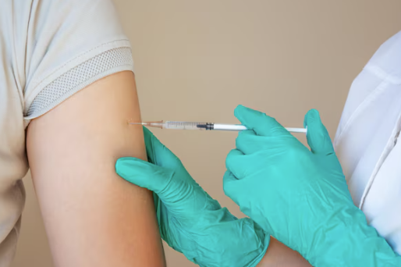

The Role of the RN in the post vaccination recovery area
Every student is to be directly observed for 15 minutes following the immunisation procedure. This is to ensure they do not experience an immediate adverse event and to provide rapid medical care if needed. A RN is always present in the recovery area post vaccination.
The RN in the recovery area will inspect the student recovery area and ensure that it:
- meets the minimum standard for safe immunisation in schools per the Guidelines for Safe Immunisation in Schools (See Attachment 6)
- is large enough to accommodate the number of students being immunised
- has adequate room for resuscitation should it be necessary
- adjoins or is screened off from the immunisation area
- is the same level as immunisation area e.g., not on the stage or in an upstairs room
- has carpet on the floor or gym mats for the students to sit or lie on
- check resuscitation equipment and set up in the recovery area prior to the immunisation session commencing
- remove adrenaline from esky, take to the recovery area and check expiry date
- complete the Ambulance Chart with the school address, post code and location of the immunisation area (See Attachment 4)
- inform team of emergency evacuation points
- ensure mobile phone is fully charged and is working
- ensure school staff member/s are present to manage student behaviour.

Post Vaccination Administration
The RN in recovery will:
- observe all students for at least 15 minutes post immunisation for unexpected and adverse events and provide care as and when required as per requirements in the Australian Immunisation Handbook
- contact RN2 Immunisation coordinator or Clinical Nurse Coordinator or CAIT Manager for support and advice following any unexpected and adverse events
- ensure the students have a record of immunisation and provide verbal aftercare information to students when they leave the recovery area
- ensure any student who remains unwell after observation period is taken to the school’s sickbay. The student is escorted by at least one nurse, carrying a mobile phone and one other person, and is left in the care of a designated person from the school.
- report and document adverse events as per management of Adverse Events Following Immunisation (AEFI) (See Section 9). This includes documenting in the DHR, completing an ACT Health AEFI form (available online) and a clinical incident report.
- At the end of the immunisation session and before leaving the school, the RN in recovery will check if any students who have been immunised are in the school sick bay and provide advice/information to school staff if required.
With the exception of the team leader, all CAIT RN staff will rotate roles on the day. All members will work as a team to provide effective services and reduce the risk of injuries with repetitive tasks.

3.4 School Immunisation Records

Student Vaccination Record
All students receive their vaccination record on leaving the recovery area. This record includes information for their parent/legal guardian on the vaccine/s given, site of injection, time given and advice on how to report an adverse reaction. These records are hard copies and taken out with the team each day.

Student Consent Form
The consent form remains the property of CHS and is retained by the team until the end of the school year. These are filed in filing cabinets located within the School Health Team Office.
All consent forms are securely held by the team and once the team have finished at the schools at the end of the year, these are processed ready to be scanned onto the DHR by the Clinical Records Unit (CRU).
At the end of each scheduled school program, students who have missed their vaccination/s are sent a letter advising them of the vaccines missed and how to access these vaccinations through their GP or immunisation provider by RNs on return to the office. These vaccines are provided free of charge under conditions specified by the NIP.

The Australian Immunisation Register
All vaccines administered by the team are automatically uploaded to AIR via DHR.
Back to Contents

Section 4 – Contact Prophylaxis Immunisation Clinics
Contact Prophylaxis Immunisation clinics are organised at short notice to manage contacts following exposure to a vaccine preventable disease e.g., measles.
Contact Prophylaxis Immunisation clinics will be managed between the Walk- in Centre (WiC) Belconnen Community Health and WYCCHP.

Notification
Health Protection Services (HPS) will notify:
- Assistant Director of Nursing (ADON) WiC for management of the contact clinic processes.
- ADON, WYCCHP will organise staff to vaccinate children under two (2) years of age, if required.

Clinic site: Belconnen Community Health Centre (BCHC) WiC only
This facility utilised for appropriate reception area with reception staff, on duty seven days a week from 7:30am to 10:00pm with suitable areas for post vaccination observation.

Staffing
Nursing staff from WiC are to administer vaccines for clients over one (1) year of age.
Credentialed immunising staff from WYCCHP are to administer vaccines to children less than one (1) year of age.
WiC staff are to organise access to BCHC level 3 (through Shared Services) for vaccines supplied by HPS, as the WiC vaccine fridge has limited storage capacity.

4.4 Equipment

WYCCHP to provide:
- needles, syringes (need 19g, 23 g and 25g needles and 2ml syringes)
- eskies (and ice sheets for vaccine decanting)
- thermometers to manage the cold chain monitoring
- resuscitation equipment i.e., Laerdal resuscitator for children under two (2) years of age,
- adrenaline in case of adverse event.

WiC to provide:
- resuscitation equipment i.e., bag and mask for clients over the age of two (2).

HPS to provide:
- vaccines (delivered to WYCCHP Maternal and Child Health (MACH) fridge, level 3 BCHC)
- pre and post vaccination information and generic consent forms
- medication standing orders
- prospective client names and dates of birth prior to client arrival, by phoning WiC BCHC Reception on (02) 5124 9977.
Back to Contents

Section 5 – Management of Adverse Events Following Immunisation
To be read in conjunction with the Management of Anaphylaxis in Adults and Children Guideline located on the Policy and Guidance Documents Register and the Australian Immunisation Handbook.

5.1 Equipment
The RN in recovery will ensure that emergency equipment is available as follows:
- phone, fully functioning (with mobile phone reception)
- Laerdal resuscitator age appropriate
- adrenaline 1:1000 (2 vials and 1ml syringes, 23g needles)
- Basic Life Support Flow Chart (See Attachment 3)
- Ambulance Information Chart (See Attachment 4)
- Management of Anaphylaxis information (See Attachment 9).

5.2 Procedure
To minimise the risk of an adverse event following immunisation, all persons prior to vaccination are screened using the pre-vaccination checklist.
All nurses must be able to distinguish between anaphylaxis, convulsions and a vasovagal episode. Refer to Australian Immunisation Handbook for further detail.
Alert:
Recipients of vaccines to remain under direct observation of an RN/RM for at least 15 minutes following immunisation.
For adverse events that include anaphylaxis, prolonged loss of consciousness or severe asthma, the RN/RM must:
- phone for an ambulance – 000 or 112 on mobile phone
- notify parents/guardian
- inform the school when an ambulance is called
- inform Immunisation Coordinator, Clinical Nurse Coordinator and/or CAIT Manager as soon as practical.

5.3 Documentation
All adverse events (AEFI) are reported to Health Protection via the online immunisation adverse event reporting form Immunisation Adverse Event (vaccination reaction) Reporting Form (https://www.act.gov.au/health/providing-health-care-in-the-act/treatment-and-clinical-information/vaccination/adverse-events-after-immunisation)
A copy will be sent to the documenter. This must be added to the client’s DHR profile with the clinical notes.
A clinical incident report is also lodged via the HealthHub or by phone when computer access is not available (Clinical Incidents RiskMan Helpdesk Number: 5124 5926).
Back to Contents

Section 6 – Competency Assessment for Registered Nurse Immunisers Procedure
All RNs/RMs who deliver vaccines are required to have completed a training course that meets the minimum requirements set out in the National Immunisation Education Framework for Health Professionals and completed the WYCCHP Immunisation Clinical competency Assessment (Attachment 10).
All new RN immunisers are required to:
- complete Basic Life Support (e-learning and assessment)
- complete Anaphylaxis recognition and management (e-learning)
- provide evidence of completion of a recognised training course that meets the requirements set out in the National Immunisation Education Framework for Health Professionals and have this documented into the CHS rostering system - PROACT
- have successfully completed the immunisation competency assessment (Attachment 10) within five business days of commencing immunisation practice. A minimum of two successful immunisation encounters are required to complete this assessment.
All existing nurse immunisers are required to annually:
- complete Basic Life Support (e-learning and assessment)
- complete Anaphylaxis recognition and management (e-learning)
- provide evidence of four hours of immunisation education
- successfully complete the immunisation competency assessment with a minimum of one successful immunisation encounter and showing evidence of one to three (as above).
Evidence of competency will be recorded by Clinical Nurse Coordinator/CAIT Manager /School Immunisation Coordinator on HRIMS, and a copy retained by the RN/RM for their own records.
Back to Contents

Evaluation

Outcome
- Compliance with the National Safety and Quality Health Service Standard 4 – Medication Safety.
- CHS are meeting the National Immunisation Strategy vaccine uptake rate targets.
- Scheduled vaccines are safely provided to children aged zero to six years and adolescents accessing CHS WYCCHP immunisation services.

Measures
- Regular reporting to ACT Health, Health Protection Services, with data collected by both the Early Childhood Immunisation Clinics and the High School Immunisation Programs.
- Review of rates of completed staff training and access to support as outlined in Section 6.
- Clinical and quality outcomes are evaluated through patient experience questionnaires, feedback from key stakeholders, clinical incident reports, clinical file audits, and data collection.
Back to Contents

Related policies, procedures, guidelines and legislation

Policies
- Nursing and Midwifery Board of Australia (NMBA) Requirements for Practice
- Work Health Safety
- Medication Handling

Procedures
- Infection Prevention and Control
- Patient Identification and Health Care Activity Matching
- Vaccine Cold Chain Management
- Occupational Assessment, Screening and Vaccination

Guidelines
- Consent for Healthcare Treatment
- Australian Immunisation Handbook
- Management of anaphylaxis in children and adults
- National Vaccine Storage Guidelines

Legislation
- Medicines, Poisons and Therapeutic Goods Regulation, 2008
- Medicines, Poisons and Therapeutic Goods Act, 2008
- Medicines, Poisons and Therapeutic Goods (Nurse and Midwife Immunisers) Direction 2020 (No. 1)
- Therapeutic Goods Act 1989
- Work, Health and Safety Regulation, 2011
- Public Sector Management Act 1994
- Health Records (Privacy and Access) Act 1997
- Human Rights Act 2004
- Work Health and Safety Act 2011
- Carers Recognition Act 2021

Other
- Australian Charter of Healthcare Rights
Back to Contents

References
- Australian Immunisation Handbook
- National Vaccine Storage Guidelines
Back to Contents

Definition of terms
- ADON – Assistant Director of Nursing
- AEFI – Adverse Event Following Immunisation that is an unwanted or unexpected event following immunisation
- CHS – Canberra Health Services
- CAIT – Child and Adolescent Immunisation Team
- DHR – Digital Health Record
- dTpa – Diphtheria, Tetanus, Pertussis
- HPS – Health Protection Service, Population Health Division of ACT Health
- HPV – Human Papillomavirus
- MACH – Maternal and Child Health
- NIP – National Immunisation Program
- RN – Registered Nurse
- RM – Registered Midwife
- WiC – Walk in Centre
- WHS – Workplace Health and Safety
- WYCCHP – Women Youth & Children Community Health Program
Back to Contents

Search terms
Diphtheria, HPV, Human Papillomavirus, Immunisation, Inoculation, Pertussis, School Health, School Immunisation, Tetanus, Vaccination, Varicella, Whooping cough, children, childhood immunisations, vaccinations, adolescent, infant.
Back to Contents

Attachments

Attachment 1 – Immunisation Record for Children

Attachment 2 – Minimum/Maximum vaccine refrigerator temperature chart

Attachment 3 – Basic Life Support Flow Chart

Attachment 4 – Ambulance Information Chart

Attachment 5 – Year 10 student consent process – Gillick Consent

Attachment 6 – Work, Health, and Safety Checklist for immunisation for schools

Attachment 7 – Team Leader duties

Attachment 8 – School Health Team pre-vaccination checklist

Attachment 9 – Anaphylaxis Information

Attachment 10 – WYCCP Immunisation Clinical Competency Assessment
Back to Contents

For Policy Team to complete:
Date amended | Section amended | Divisional approval | Final approval
04/03/2025 | Complete review | Sarah Watson, EBM WY&C | CHS Policy Document Review Panel
This document supersedes the following:
Document number | Document name
CHS21/338 | Immunisation Service Delivery in Schools and Early Childhood Health Clinics
Disclaimer
This document has been developed by Canberra Health Services specifically for its own use. Use of this document and any reliance on the information contained therein by any third party is at his or her own risk and Canberra Health Services assumes no responsibility whatsoever.
Back to Contents

Acknowledgement of Country  Canberra Health Services acknowledges the Ngunnawal people as traditional custodians of the ACT and recognises any other people or families with connection to the lands of the ACT and region. We acknowledge and respect their continuing culture and contribution to the life of this region.  © Australian Capital Territory, Canberra 2024 | Accessibility  call (02) 5124 0000   Interpreter call 131 450  canberrahealthservices.act.gov.au/accessibility  

Attachment 1 – Immunisation record for children
SAMPLE
SAMPLE
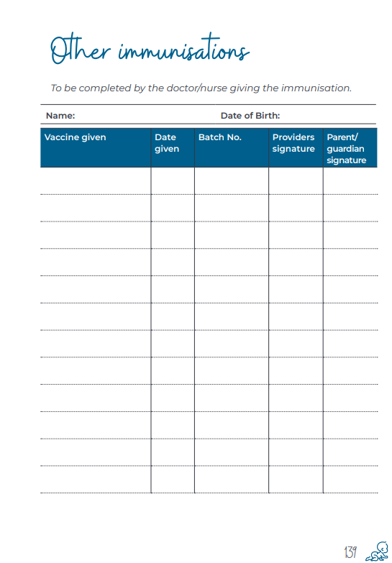
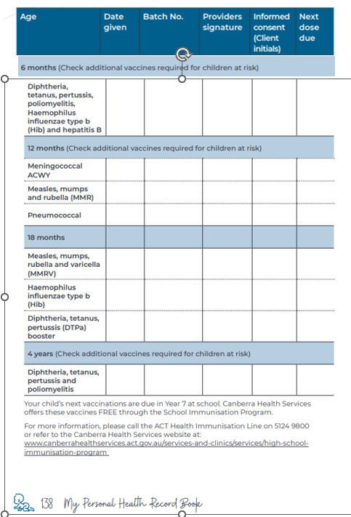

Back to Contents

Attachment 2 – Minimum/maximum vaccine refrigerator temperature chart
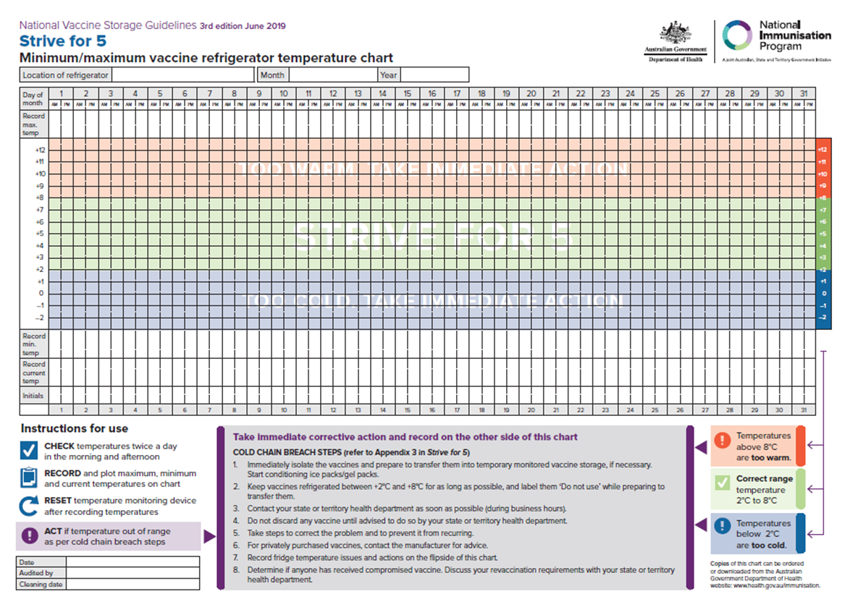
SAMPLE
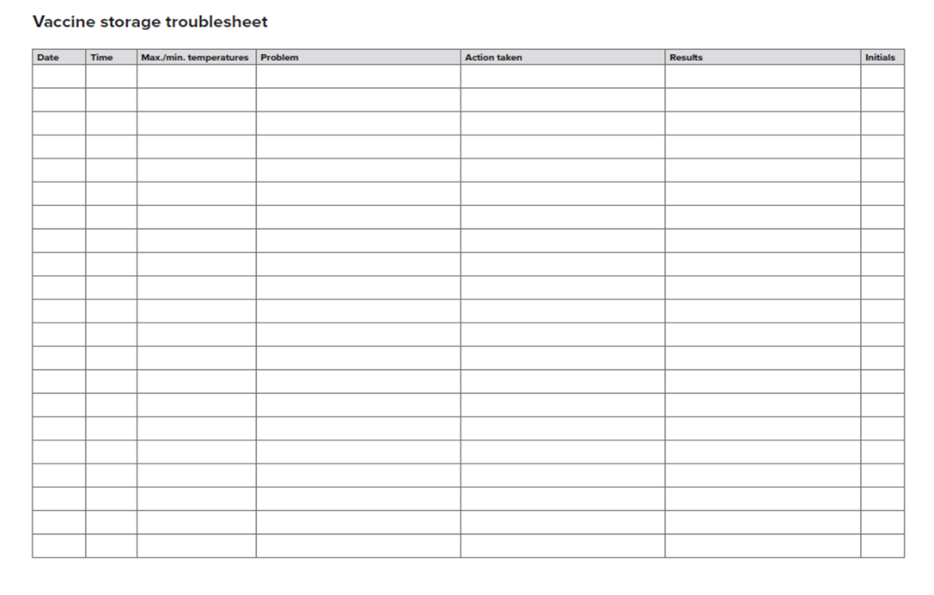
SAMPLE
Back to Contents

Attachment 3 – Basic Life Support flow chart

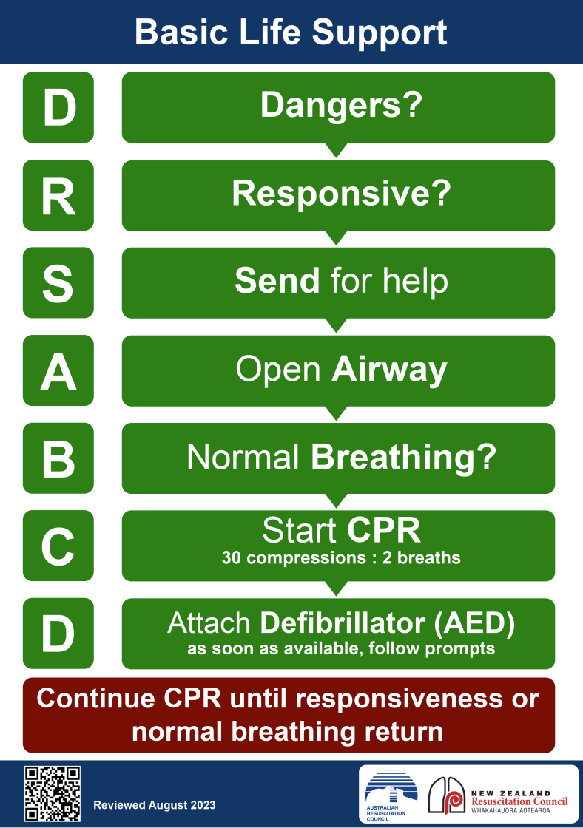

Back to Contents

Attachment 4 – Ambulance information chart

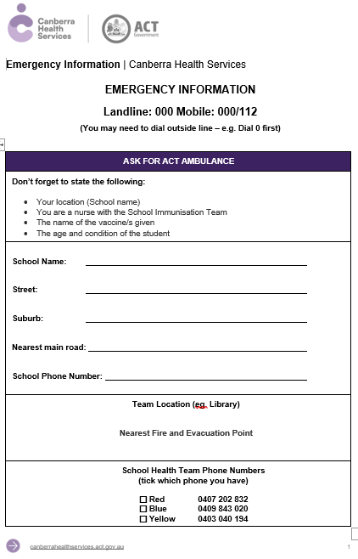
SAMPLE

Back to Contents

Attachment 5 – Year 10 student consent process – Gillick Consent

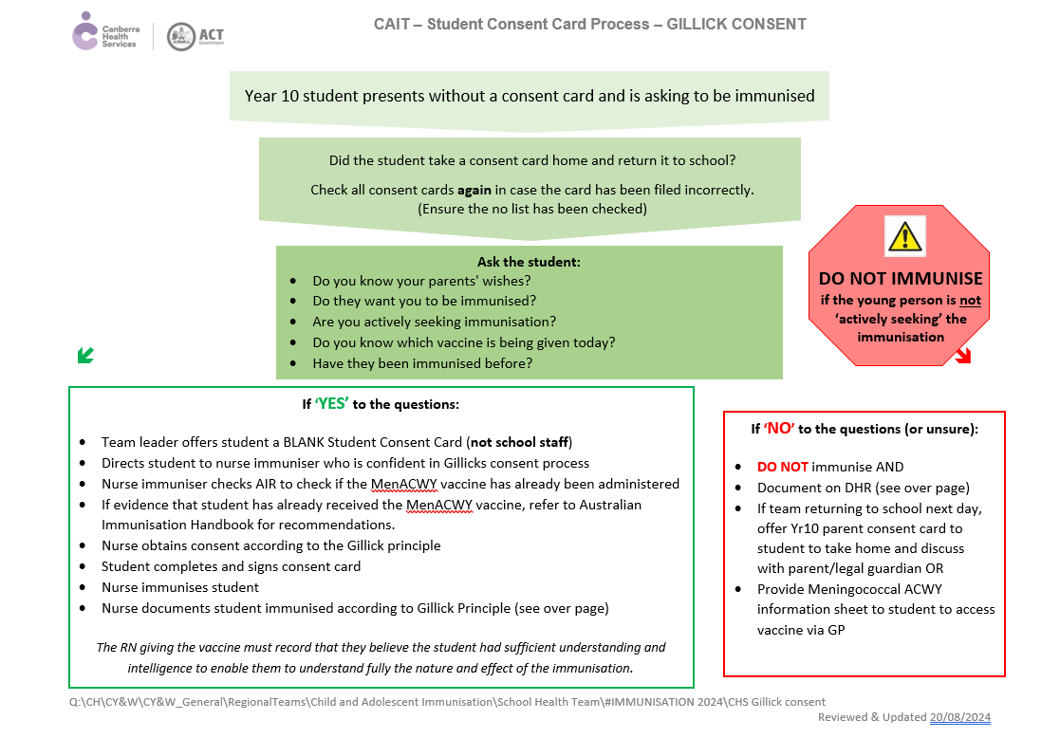
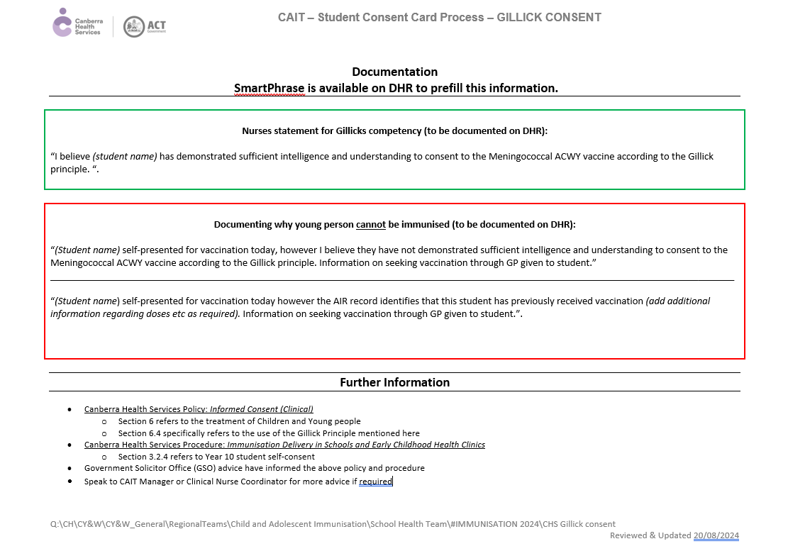
Back to Contents

Attachment 6 – Work, Health and Safety checklist for immunisation for schools
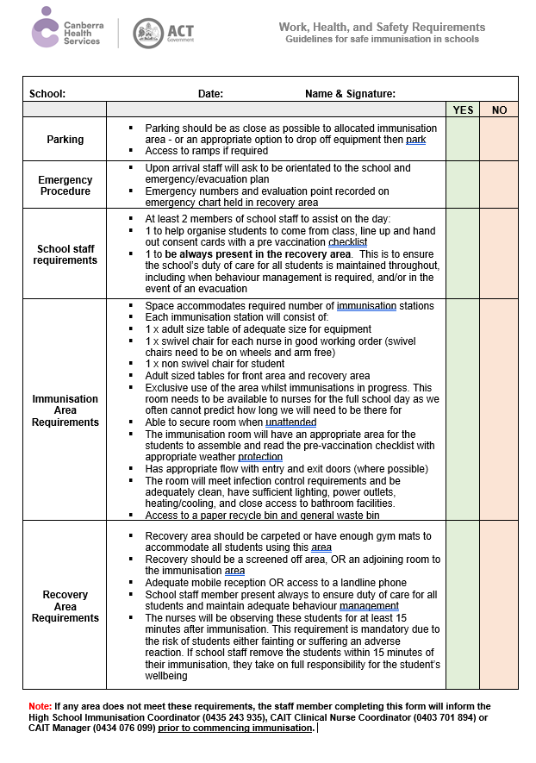
Back to Contents

Attachment 7 – Team Leader duties

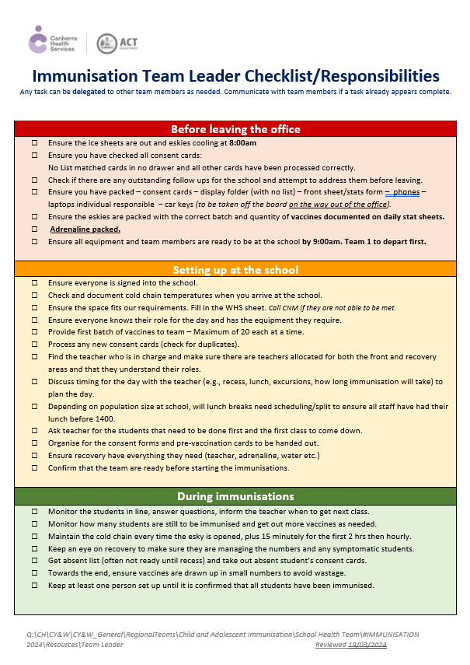
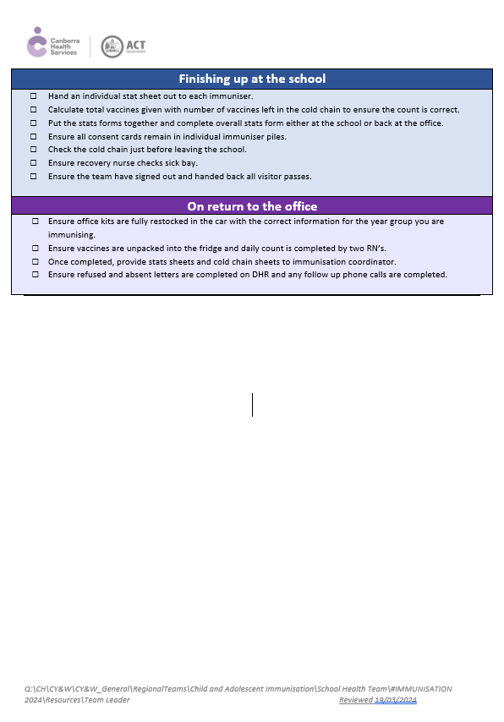

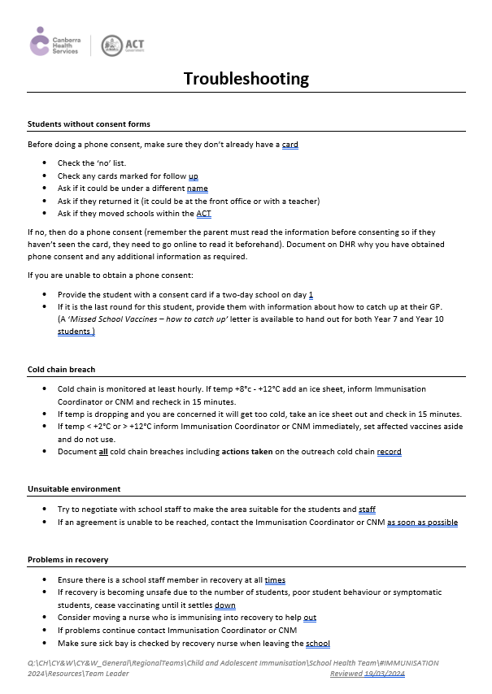

Back to Contents

Attachment 8 – School Health Team pre-vaccination checklist

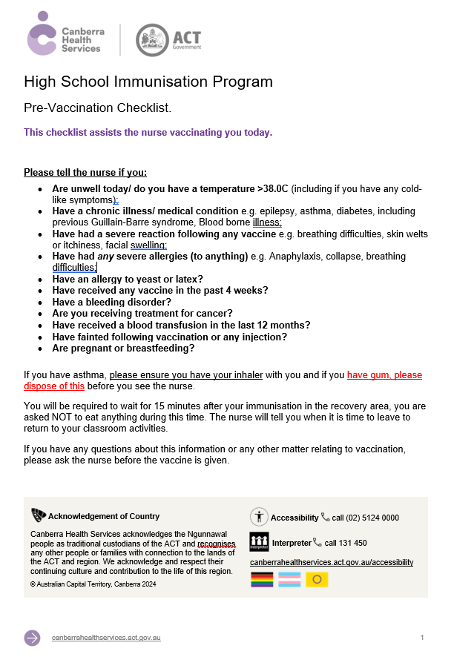

Back to Contents

Attachment 8 – Anaphylaxis Information

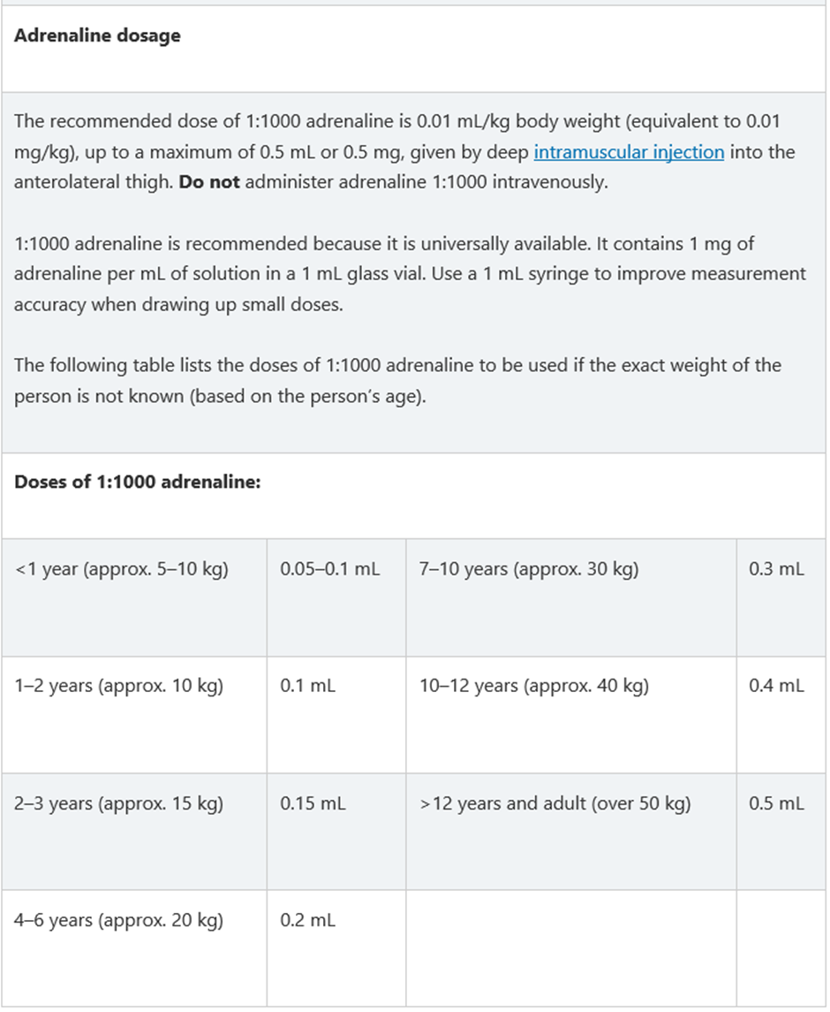

Back to Contents

Attachment 10 – WYCCP Immunisation Clinical Competency Assessment

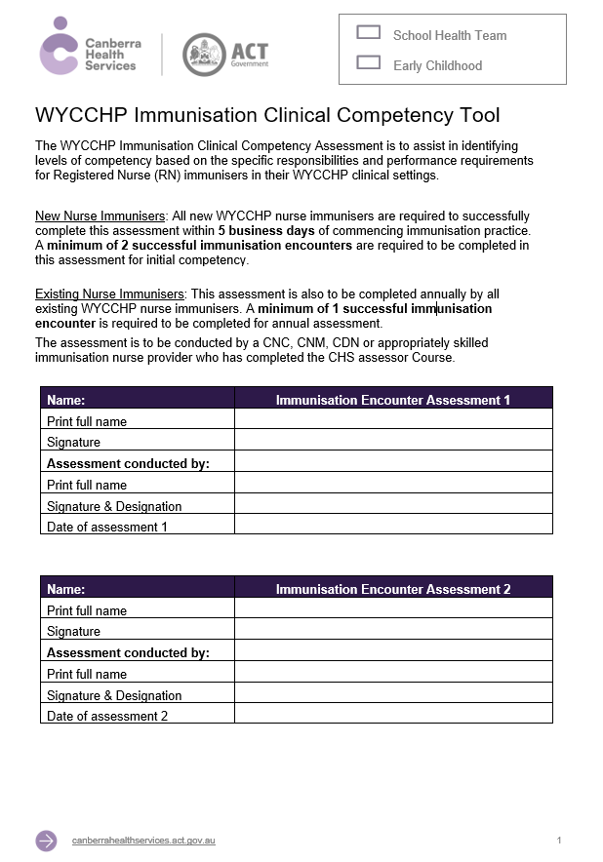
SAMPLE

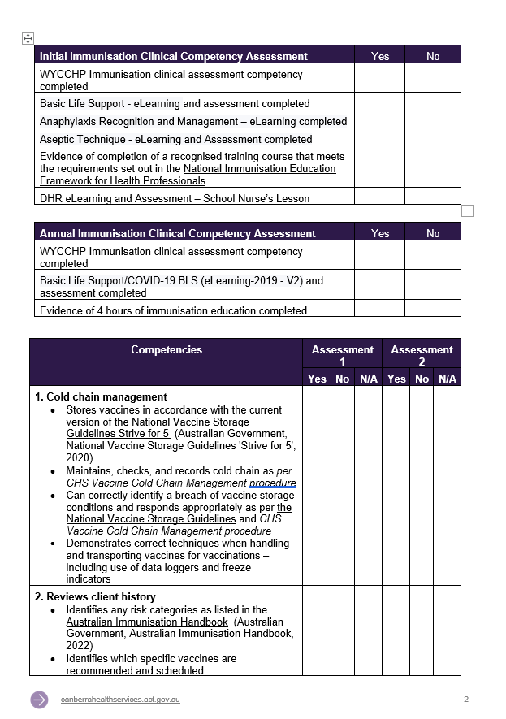
SAMPLE

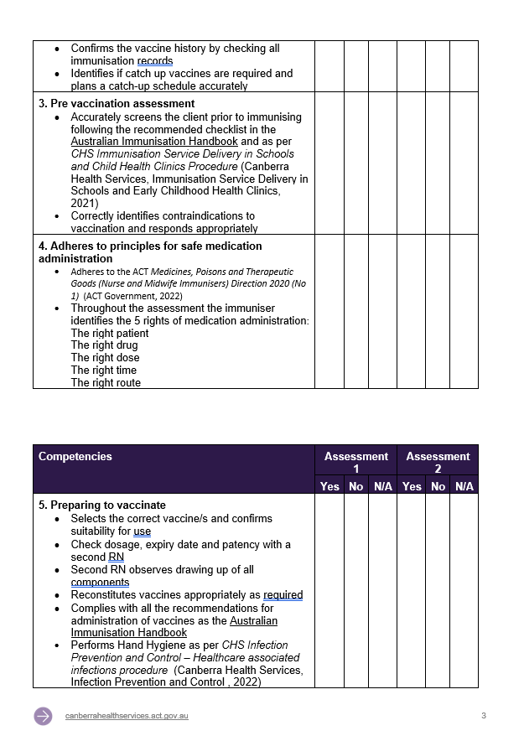
SAMPLE

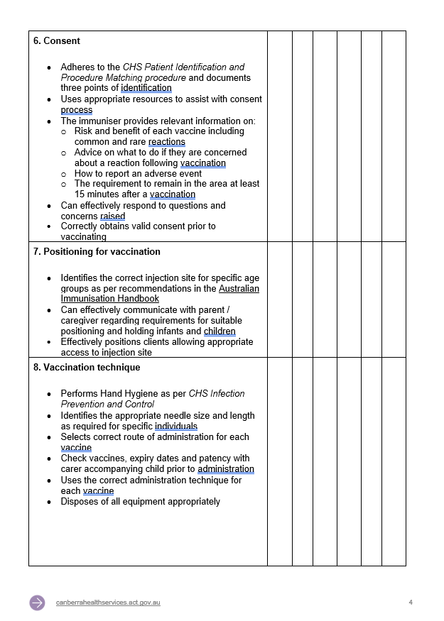
SAMPLE

Back to Contents

