Canberra Health Services
Procedure
Documentation Query Completion – Inpatients

Contents

Contents 1
Purpose 2
Scope 2
Section 1 – Situations in which queries to clinicians are necessary 2
Section 2 – How queries are posed 4
Section 3 – Responsibility when posing queries 6
Section 4 – Query templates 7
Section 5 – How clinicians can respond to queries 8
Section 6 – Query completion 9
Section 7 – Escalation of unanswered queries 10
Section 9 – Reporting and feedback 12
Evaluation 14
Related Policies, Procedures, Guidelines and Legislation 14
Definition of Terms 15
References 16
Search Terms 17
Attachments 17

Purpose
The purpose of the procedure is to provide team members with information and guidance on creating and responding to clinical documentation queries (‘queries’) for Clinical Documentation Improvement (CDI) and clinical coding purposes. This procedure emphasises the importance of generating clear, ethical, and non-leading queries, and provides guidance to ensure queries are adequately recorded and responded to.

Queries are an important means of clarifying documentation regarding diagnoses, conditions and/or procedures that are representative of a patient’s clinical picture, complexity, and resource consumption during an admitted episode of care. A robust and consistent query process will improve the accuracy and integrity of coded data and can improve the precision of documentation within the clinical record. This will ensure that Canberra Health Services (CHS) presents an accurate representation of the admitted patients we care for, and the care provided in data that is sent to government organisations, which subsequently informs research, funding, benchmarking, and health service decisions.
Back to Table of Contents

Scope
Queries are used by Clinical Documentation Specialists (CDSs), clinical coders and Health Information Managers (HIMs) (‘query professionals’) to ensure diagnoses and procedures derived from the documentation accurately represent a patient’s admitted episode of care. Queries are more commonly raised in relation to medical officer documentation. However, any member of the care team may be queried to clarify documented conditions or procedures that fall within their scope of practice.
This procedure applies to the following Canberra Health Services team members:
- Medical officers
- Nurses and midwives
- Allied health professionals
- CDSs
- Clinical coders
- HIMs.
Back to Table of Contents

Section 1 – Situations in which queries to clinicians are necessary
Queries to clinicians are necessary where documentation in an episode of care is insufficient to reflect the care provided, the clinical scenario (e.g. complications, condition onset), or where it may impact the accuracy of code assignment. This may include situations where documentation:
- is ambiguous (e.g. documentation of ‘multi trauma’ as a principal diagnosis)
- is conflicting (e.g. documentation of TIA and CVA in the same episode)
- is illegible (e.g. contains unknown/unsupported abbreviations)
- is incomplete (e.g. a patient admitted for a revision of an open reduction internal fixation [ORIF] with no indication provided for the procedure)
- includes clinical findings, diagnostic evaluation and/or treatment not related to a specific documented condition or intervention (e.g. E. coli positive blood culture not linked to a diagnosis of sepsis/bacteraemia)
- is unclear in distinguishing condition onset (e.g. documentation of hospital acquired pneumonia and community acquired pneumonia in the same episode).

Documentation which contains the above discrepancies often means that the principal diagnosis, additional diagnoses and/or procedures cannot be accurately coded in line with the classification system (i.e. ICD-10-AM/ACHI/ACS) (See Definition of Terms) used for admitted patient care. Queries may be used to clarify the following common scenarios:
- sequencing of the principal diagnosis (e.g. where a patient is admitted with multiple conditions requiring management such as Chronic Obstructive Pulmonary Disease (COPD), Congestive Cardiac Failure (CCF) and pneumonia, clarifying which should be sequenced as the principal diagnosis)
- causal links between manifestations/aetiology, conditions/diagnostic findings, and procedure/conditions (e.g. if adhesions are ‘due to’ prior surgery)
- diagnosis specificity (e.g. if a diagnosis of anaemia should be classified as iron deficiency anaemia or acute blood loss anaemia).

A clinician query may be sent on the basis of documentation in any part of the clinical record, including, but not limited to:
- progress notes
- consultation requests/reports
- operation reports
- anaesthetic reports
- flowsheets (including wound assessments, observation charts)
- orders for tests and treatment (including medication charts).

Queries will not be necessary for every discrepancy or unaddressed documentation issue. The query professional will consider the following when determining the need to query:
- If the Australian Coding Standards (ACS)² provides guidance for resolving the query
- if the query can be resolved by a review from a CDS (RN) or senior coder
- if the clinician can offer clarification based on the information available in the clinical record (e.g. if the patient been referred for further assessment)
- if the documentation issue is commonly occurring, whether it can be addressed through alternative avenues (e.g. the clinical record system workflows, education sessions).
Back to Table of Contents

Section 2 – How queries are posed

Queries may be posed retrospectively (after a patient has been discharged) or concurrently (whilst a patient is still an inpatient). Queries may be sent by a CDS, HIM or clinical coder. Clinical coders and HIMs may choose to send cases to a CDS (RN) for review, who will assume responsibility for querying the clinician, query escalation and query completion (See Attachment A: Flowchart 1 - Initial Query Process).

The following clinicians may be queried:
- Retrospective queries will be directed to the admitting consultant
- Concurrent queries (usually posed by a CDS) may be directed to the junior medical officer (JMO) in the first instance. The expectation is that the query can be discussed at ward rounds and shared with the treating team if required, including the consultant, prior to a response being provided.
- Where clinical record system functionality permits, multiple clinicians may be queried concurrently. Once the first appropriate response is received, the query will be completed.

Both retrospective and concurrent queries may be directed to other clinicians in the following circumstances (this is not an exhaustive list):
- Where multiple clinicians from different specialities are involved in care, the most appropriate provider related to the query subject will be queried
- Queries that pertain to documentation in the discharge summary (e.g. where the principal diagnosis conflicts with the documentation in the record) may be sent to the clinician responsible for completing the discharge summary
- Queries pertaining to procedures conducted by a clinician other than the admitting clinician may be sent to the clinician performing the procedure
- Where an admitting consultant is a visiting medical officer (VMO), the query may be sent to the senior registrar
- For VMOs who do not access their ACT Health email, the relevant division may be contacted to facilitate a response
- Queries pertaining to pressure injuries will be sent to the Tissue Viability Unit (TVU).
- Queries pertaining to Staphylococcus aureus bacteraemia will be sent to the Infection Prevention and Control Unit (IPCU)
- Queries pertaining to diagnoses for which allied health primarily manage (e.g. malnutrition, deconditioning, dysphagia) may be directed to allied health clinicians including the treating dietician, physiotherapist or speech pathologist.

The following query method will be used to query clinicians:
- Electronically, written via the electronic clinical record system: queries will be sent via the clinical record system to individual clinician In Baskets
- The query will be classified by the query professional as either a coding query or a CDI query (this does not affect the responding clinician)
- The query professional may send a message to the clinician via the clinical record system secure chat or email to advise that a query has been sent to their In Basket.

Tip Sheet available in the clinical record system for query professionals: Help (F1) " <Relevant Learning Home> " Secure Chat

- The query professional may need to provide instructions to assist clinicians to respond, particularly for disciplines that are not frequently queried (e.g. nursing, midwifery, and allied health).

In limited situations the below query methods may also be used:
- Electronically, written via email: appropriately formatted queries may be sent to individual clinicians via email. This includes in circumstances where:
- the patient episode in question pertains to an admission prior to the clinical record system implementation (i.e. if the record is located in clinical Patient Folder [CPF])
- the account has been closed in the clinical record system
- escalation is commenced by the query professional due to non-response. In this case a copy of the clinical record system query will be sent to clinicians via email
- Verbally: concurrent queries may be directed to the clinician verbally at the point of care.

The following query formats may be used:
- Open ended: this format will be employed in situations when the query pertains to a diagnosis or condition that has not been documented in the clinical record, but where there may have been evidence of management (e.g. antibiotics charted, but no condition documented)
- Multiple choice: this format can be employed when the multiple-choice options being provided have been documented, or when the multiple-choice options being provided can be substantiated and supported by clinical indicators in the clinical record.Generally, at least 3 options will be provided (including the option of ‘other’)
- Yes/no: this format can be employed when the query professional is seeking additional specificity for an already documented condition. This may include situations where the following requires clarification:
- causal relationship between documented conditions,
- condition onset flag assignment
- substantiating findings in pathology, radiology, and other diagnostic reports.
Back to Table of Contents

Section 3 – Responsibility when posing queries

Queries must contain the following information:
Query professionals must ensure that queries are ethical and non-leading and, at minimum, contain the following:
- Three patient identifiers
- The date of the episode
- The date of the query
- The name and credentials of the person posing the query
- An appropriately formatted and worded query that complies with this procedure, the Australian Coding Standards (ACS)², and the Clinical Coding Practice Framework.³
- Reference to the documentation/clinical indicators in question, including the page number of the entry (if applicable), and/or author of the entry and/or the date and time of the entry.

NOTE: The first four above points are auto populated for queries sent via the clinical record system.

Regardless of the format used (i.e. multiple choice, open ended, yes/no), the clinician must be given the opportunity to:
- elaborate or expand on any point and/or
- give context to a response and/or
- provide an alternative response and/or
- disagree with any point.

Choosing a query format:
The query professional must ensure the format used is appropriate for the query situation.
- Multiple choice options should only be provided where the diagnoses are already mentioned in the clinical record, or where there are clinical indicators documented which can be used to support the diagnosis. An option must always be provided to ensure the clinician can craft their own response (e.g. ‘other’, ‘please specify’).
- Yes/no queries should only be employed to clarify documented conditions that need further specification. They should not be used where there are clinical indicators of a condition, but the condition has not been documented.
- Where unsure, and where an approved template does not exist, the query professional should opt for an open-ended query.

Potential funding gains/losses
The query professional must not share potential funding gains or losses for individual queries.
Back to Table of Contents

Section 4 – Query templates

Query templates can offer a standardised means of querying clinicians about commonly identified discrepancies in the clinical documentation. Templates will generally include references to clinical indicators which need to be identified, which support the need for a query. Query templates will always provide an opportunity for clinicians to craft their own response. Currently HIS has the following templates available for use:
- Adhesions
- Asthma severity query template
- Microsurgery procedure
- Post operative complication
- Pneumonia
- Principal diagnosis
- Pressure injury
- Situational crisis.

Templates may not be appropriate for all query situations, and the use of a template will be at the discretion of the query professional.

Tip Sheet available in the clinical record system for query professionals: Help (F1) " <Relevant Learning Home> " Queries

Creating query templates
- Where there is an opportunity identified to create a query template to standardise the querying of a condition or a procedure, the query professional will seek feedback from relevant clinicians/specialities where appropriate.
- Opportunities may also be identified by clinicians, who can contact the CDS or clinical coding manager at HIS for advice.
- New templates need to be added to the clinical record system by Digital Solutions Division and requested by query professionals via a Jira ticket.

Review of query templates
Review of query templates will occur annually by the CDI or coding team, or when changes to processes occur. If changes are required, these need to be updated within the clinical record system by Digital Solutions Division.

Concerns about query templates
If clinicians or coders have concerns about a query template or wish to discuss the criteria used on any query template, they can do so by raising the matter with the CDS or the clinical coding manager.

Back to Table of Contents

Section 5 – How clinicians can respond to queries

NOTE: Reponses are expected within 7 days. If a response to a query is not received in this time, the query professional will commence follow up (see Section 7).

See Attachment B: Flowchart 2 – responding to queries (for clinicians)
Responding to queries via the clinical record system:
- after receiving a message via email or secure chat advising that a query has been received, clinicians should proceed to their In Basket (by clicking on the mail icon tab).
- Clinicians may also be alerted to unread queries in their In Basket when mail icons appear at the top of the clinical record system window (near the minimise/maximise/close buttons).
- Queries will be found under the ‘Chart Completion’ folder within the In Basket.

Tip Sheets available in the clinical record system for clinicians: Help (F1) " <Relevant Learning Home> " Secure Chat and In Basket Messaging

- Queries received via the clinical record system In Baskets are linked to the correct episode and clinicians can open the episode and review the documentation by double clicking on the query message. The query will remain accessible in the ‘To Do’ sidebar.
- Clinicians can respond to a query by creating a new note or with an addendum to an existing note, by selecting the ‘respond with note button’ in the query. The specific note type (e.g. progress notes) can then be selected.

Tip Sheet available in the clinical record system for clinicians: Help (F1) " <Relevant Learning Home> " Responding to a query
- Responses to verbal queries should be documented in the clinical record system in routine documentation or as an addendum as appropriate.

NOTE: For disciplines that are not frequently queried (e.g. nursing, midwifery, allied health), further instruction (including tip sheets where available) will be provided to individual clinicians if required.

Responding to queries outside of the clinical record system:
- Clinicians can respond to queries via email, by either using a query form (if provided) or within the body of the email. Both are considered valid responses, and email text may be transferred to a query form and scanned into the clinical record to support coding.
- Clinicians can respond verbally. Where the response has not been documented in the clinical record, follow up via email or with a query form is required.

NOTE: To avoid paper burden, risks to privacy and confidentiality and additional workflows associated with queries posed/answered outside of the clinical record system, electronic query completion via the clinical record system is encouraged whenever possible.
Requesting further information:
If a clinician has concerns about a query (including the format, why it was posed or the way it was posed), feels the query is outside their scope of practice, or requires clarification about a query they can do so by:
- requesting more information, by selecting the ‘request clarification’ button in response to a query sent via the clinical record system (replies sent in this way do not populate the progress notes),
- responding via secure messaging within the clinical record system,
- requesting further information from the query professional via email or phone call, regardless of how the query was sent.

Inappropriate queries:
- Inappropriate queries include those that may be:
- Leading (e.g. lack of clinical elements to support the diagnosis/procedure being queried)
- Limiting (e.g. do not provide the clinician the opportunity to craft their own response)
- The clinician can raise concerns with the CDS, clinical coding manager or senior director of HIS, via phone call or email.
Back to Table of Contents

Section 6 – Query completion

NOTE: The query professional who posed the query is responsible for completing and closing the query, commencing escalation, or referring the case for escalation.

Coding is to remain open until:
- a query response is received
- the query escalation process has been completed
- direction is provided to complete coding (e.g. to complete end of month coding).

The episode is to be flagged by the query professional, so it is clear that the case is awaiting a query, by either:
- changing the status in the coding activity to ‘Clinician Query’. Queries that have not received a response within 7 days are to be flagged with the CDS (see Section 7, Step 1)
- via the ‘CDI review needed’ account activity - the case will be monitored and followed up by a CDS
- When the query is complete, the CDS will return the case to the coder via an account activity of ‘CDI Review Complete’.

Tip Sheet available in the clinical record system for query professionals: Help (F1) " <Relevant Learning Home> " Code an Account (Change an Account’s Coding Status) and Routing Accounts for Review.
Completing a query on an open account in the clinical record system:
- Once a response is received complete the query in the clinical record system via the query sidebar.
- Update coding where necessary and complete the coding.

Completing a query on a completed (closed) account in the clinical record system:
- Reopen the account via the ‘open account’ activity.
- Update the outcome of the query by clicking on the pencil icon via the query sidebar.
- If coding needs to be updated, reopen the coding to update, and then complete the coding.

Query completion for queries posed or answered outside of the clinical record system:
- Where a clinician has responded to a query within the body of an email but has not updated the documentation in the clinical record, the email response will be transferred to a query form by the query professional.
- Where a clinician has responded to a query within the body of an email, but has updated the documentation in the clinical record, the query can be completed without a query form.
- Verbal responses must be authenticated by documentation within the clinical record or on a signed query form.
- Completed query forms are to be scanned into the clinical record by HIS.
- Clinicians may be asked to update documentation within the clinical record system in certain circumstances regardless of the above (e.g. where a diagnosis in question may impact continuity of care).
- Copies of email responses will be saved in HIS for auditing, monitoring and compliance using the format <coder initials, patient UR, discharge date>.
Back to Table of Contents

Section 7 – Escalation of unanswered queries

NOTE: Queries are important communication tools which support accurate documentation and coding. It is expected that clinicians will provide timely responses to queries. If a response is not received within 7 days, the following process will be commenced.
See Attachment C: Flowchart 3 – Escalation of Unanswered Queries.
Step 1. No response after 7 days:
Queries that have not received a response within 7 days are to be flagged with the CDS. This can be done by:
- assigning an account activity of ‘CDI Review Needed’ to the case in the clinical record system,
- notifying the CDS via email, who will locate the case and allocate it to the ‘CDI Review Needed’ work queue.

The CDS will conduct a review of all queries that have not received a response within 7 days and may:
- discuss with the clinical coding manager or clinical coding educator/auditor regarding further action,
- abandon/resolve the query,
- send an email to the initial clinician requesting a response with a copy of the query sent via the clinical record system, and instructions on how to respond,
- send the query to a different clinician (e.g. sending a query to the consultant where a query was initially sent to a JMO).

Consideration will be given to:
- whether coding can be completed,
- whether the query impacts patient complexity, procedural specificity, re-imbursement, or quality patient indicators.

Step 2. No response after 14 days:
- The query professional will send an email with a copy of the query to the unit director and may include the following people as Cc recipients:
- the original query recipient,
- the relevant divisional email,
- the clinical coding manager.
- If the unit director was the original query recipient and has already received a reminder as part of Step 1, proceed to step 3.

It is expected that the unit director will facilitate a response to the query with the appropriate clinician and/or raise any concerns about the query with the query professional.

Step 3. No response after 21 days:
- The query professional will send an email with a copy of the query to the clinical director and may include the following people as Cc recipients:
- the original query recipient and/or the unit director,
- the relevant divisional email,
- the clinical coding manager,
- the senior director of health information services (HIS).
- If the clinical director was the original query recipient, and has already received a reminder, proceed to Step 4.

It is expected that the clinical director will facilitate a response to the query with the appropriate clinician and/or raise any concerns about the query with the query professional.

Step 4. No response after 28 Days:
- The query professional will send an email and a copy of the query to the executive director of the relevant division and may include the following people as Cc recipients:
- The original query recipient and/or the unit director and/or the clinical director,
- The relevant divisional email,
- The clinical coding manager,
- The senior director of HIS.

Step 5: No response after 35 days
- The CDS will complete the query in the clinical record system as “no response”.
- The CDS will return the case to the coder via an account activity of ‘CDI Review Complete’.
- The coder will complete the coding for the case – the clinical coding manager or clinical coding auditor may need to provide advice on the most appropriate code/s.
- Responses received after 35 days will require the query professional/coder to re-open and update the coding (see Section 6: Query completion).
- Non-response and escalation outcomes will be collated for reporting purposes (see Section 9: Reporting and feedback).

If queries are frequently being escalated, query professionals may seek advice from unit directors and/or executive directors on delivering information to support query responses.

Inappropriate responses:
- Inappropriate responses include those that may be:
- disparaging,
- sarcastic,
- are not fit to be included in the clinical record for the above or other reason.
- Responses that are assessed as inappropriate by the query professional will be sent to the senior director of HIS for review.
- A chart correction may be submitted.
- The clinician responsible will be alerted through the clinical record system if a chart correction case has been submitted.

Privacy and confidentiality
Patient information that is sent via email will be sent using an appropriate email encryption.
Back to Table of Contents

Section 9 – Reporting and feedback

Monitoring and trending of query outcomes will be conducted to identify clinician engagement and patterns of concern. Query tracking and trending will be performed for both coder and CDS generated queries, including for the following key metrics and outcomes:
- Query response rate (%):
- number of queries
- number of responses.
- Queries and responses by:
- speciality
- division
- query subject.
- Type of response:
- agreed,
- disagreed (includes ‘unable to determine’).
- Query type:
- concurrent
- retrospective.
- Query method:
- clinical record system
- verbal
- email.
- Escalation required:
- stage 1 (Y/N)
- stage 2 (Y/N)
- stage 3 (Y/N)
- stage 4 (Y/N).
- Query impacts:
- National Weighted Activity Unit (NWAU) change (LOS adjusted)
- quality metrics,
- clinical handover
- diagnosis specificity.

Query outcomes will be reported via the following avenues:
- To the Health Records Advisory Committee
- To the Senior Director of Health Information Services
- To clinicians, unit directors, clinical directors, and executive directors
- To coders, health information team members and other query professionals.

Feedback to senior clinicians and Executive Directors will be provided regarding query responses for the relevant division. Data will be aggregated, and feedback may be provided to Executive Directors regarding query outcomes, including the potential impacts on quality metrics and funding.
Back to Table of Contents

Evaluation

Outcome
- To improve the accuracy, integrity, and quality of patient data, minimise variation in the query process, and improve the quality of clinician documentation within the body of the clinical record.
- To provide an accurate and comprehensive representation of a patient’s inpatient journey and to facilitate accurate clinical coding and Australian Refined Diagnosis Related Group (AR-DRG) assignment for funding, management, and quality purposes.

Measures
- Minimum 80% response rate
- A response includes any type of clinician response (i.e., agreed, disagreed, unable to determine) regardless of escalation required, and excludes responses deemed as inappropriate as defined in Section 7.
- Regular monitoring of key metrics outlined in Section 9 by the CDS/Clinical Coding Manager with reporting to:
- The Health Records Advisory Committee.
- The Senior Director of Health Information Services.
- Clinicians, unit directors, clinical directors, and executive directors.
- Health information team members and other query professionals.
Back to Table of Contents

Related Policies, Procedures, Guidelines and Legislation

Policies
- Clinical Governance
- Clinical Handover
- Clinical Records Management
- Comprehensive Care
- Privacy and confidentiality
- Risk Management

Procedures
- Clinical Records Management

Guidelines
- Australian Coding Standards

Legislation
- Health Records (Privacy and Access) Act 1997
- Human Rights Act 2004
- Work Health and Safety Act 2011

Other
- Approved Abbreviations and Symbols
- Australian Charter of Healthcare Rights
- Clinical Coding Practice Framework
- National Safety and Quality in Health Service Standards:
- Clinical Governance Standard
- Communicating for Safety
- Comprehensive Care
Back to Table of Contents

Definition of Terms

Additional diagnosis | A condition or complaint either coexisting with the principal diagnosis or arising during the admission that affects patient management in terms of requiring any of the following:  - commencement, alteration, or adjustment of therapeutic treatment  - diagnostic procedures  - increased clinical care and/or monitoring.⁴
Australian Refined- Diagnosis Related Group (AR-DRG) | A classification system which relates the number and type of patients treated in a hospital (known as hospital casemix) to the resources required by the hospital. Each AR-DRG represents a class of patients with similar clinical conditions requiring similar hospital services. Coded diagnoses and procedures in line with ICD-10-AM/ACHI/ACS influence the AR-DRG classification.⁵
Clinical coding | The process of classifying clinical information from clinical records into alphanumeric codes.
Clinical documentation improvement (CDI) | The process of reviewing, enhancing, and promoting the accuracy and completeness of clinical record documentation.
Clinical Record System | The Epic Digital Health Record (DHR) is the primary clinical record system in use across CHS.
Concurrent query | A query posed whilst a patient is an inpatient, prior to coding.
Condition onset | Refers to the timing of when conditions may arise.
Condition onset flag (COF) | A qualifier assigned to each coded diagnosis to differentiate between those conditions patients already have when entering hospital and those conditions that arise during the episode of admitted patient care.⁶ Hospital acquired complications (HACs) are identified through the use of the COF.
Episode of care | An episode of care refers to the “period of admitted patient care between a formal or statistical admission and a formal or statistical separation, characterised by only one care type”.⁷
ICD-10-AM/ACHI/ACS | The current classification system used for classifying admitted patient care in Australia¹ which comprises the following:  - International Statistical Classification of Diseases and Related Health Problems, Tenth Revision, Australian Modification (ICD-10-AM) – used to classify diseases, injuries, and related health problems,  - Australian Classification of Health Interventions (ACHI) – used to classify surgeries, therapies, and health interventions  - Australian Coding Standards (ACS) – guidelines designed for nationally consistent application of ICD-10-AM and ACHI.
Point of care | At the point where care is delivered (i.e. a clinical inpatient environment/ward)
Principal diagnosis | The diagnosis established after study to be chiefly responsible for occasioning an episode of admitted patient care. The phrase ‘after study’ should be interpreted as the evaluation of findings to establish the condition that was chiefly responsible for occasioning the episode of care. The condition established after study may or may not confirm the admitting diagnosis.^{2,8}
Procedure | A procedure is “a clinical intervention that:  - is surgical in nature and/or  - carries a procedural risk and/or  - carries an anaesthetic risk and/or  - requires specialised training and/or  - required specialised skills or equipment only available in an admitted patient care setting”⁹
Query | A question relating to documentation posed by a query professional, to assist with coding.
Query professional | A professional who may pose queries including health information managers, clinical coders, and clinical documentation specialists.
Retrospective query | A query posed for a patient who has been discharged, either prior to, or post coding.
Back to Table of Contents

References

- Independent Health and Aged Care Pricing Authority. ICD-10-AM/ACHI/ACS [Internet]. Sydney: IHAPA; 2023. https://www.ihacpa.gov.au/resources/icd-10-amachiacs-twelfth-edition
- Independent Hospital Pricing Authority. Australian Coding Standards For ICD-10-AM and ACHI, Twelfth Edition, July 2022. Sydney (AU). IHPA; 2022
- Health Information Management Association of Australia and the Clinical Coder Society of Australia. Clinical Coding Practice Framework [Internet]. 2019. Clinical Coding Practice Framework | Resources | IHACPA
- Australian Institute of Health and Welfare. METeOR Metadata Online Registry - Additional Diagnosis [Internet]. Canberra: AIHW; 2021. https://meteor.aihw.gov.au/content/746667
- Independent Health and Aged Care Pricing Authority. AR-DRG Classification Fact Sheet [Internet]. Sydney: IHAPA; 2022. https://www.ihacpa.gov.au/resources
- Australian Institute of Health and Welfare. METeOR Metadata Online Registry -Condition Onset Flag [Internet]. Canberra: AIHW; 2018. https://meteor.aihw.gov.au/content/686100
- Australian Institute of Health and Welfare. METeOR Metadata Online Registry-Episode of Care [Internet]. Canberra: AIHW; 2005. https://meteor.aihw.gov.au/content/268956
- Australian Institute of Health and Welfare. METeOR Metadata Online Registry-Principal Diagnosis [Internet]. Canberra: AIHW; 2021. https://meteor.aihw.gov.au/content/746665
- Australian Institute of Health and Welfare. METeOR Metadata Online Registry – Intervention [Internet]. Canberra; AIHW; 2021. https://meteor.aihw.gov.au/content/746719
Back to Table of Contents

Search Terms

Documentation, Clinical Documentation Improvement, Coding, Funding, Query, Clinician Query, Clinical documentation, clinical record, medical record, digital health record, the clinical record system, DHR.
Back to Table of Contents

Attachments

Attachment A: Flowchart 1 - Initial query process
Attachment B: Flowchart 2 - Responding to queries (for clinicians)
Attachment C: Flowchart 3 – Escalation of Unanswered Queries
Disclaimer: This document has been developed by Canberra Health Services specifically for its own use. Use of this document and any reliance on the information contained therein by any third party is at his or her own risk and Canberra Health Services assumes no responsibility whatsoever.

Policy Team ONLY to complete the following:
Date Amended | Section Amended | Divisional Approval | Final Approval
20/05/2024 | New Document | CHS Policy Team | CH Policy Team

This document supersedes the following:
Document Number | Document Name

Attachment A: Flowchart - Initial Query Process
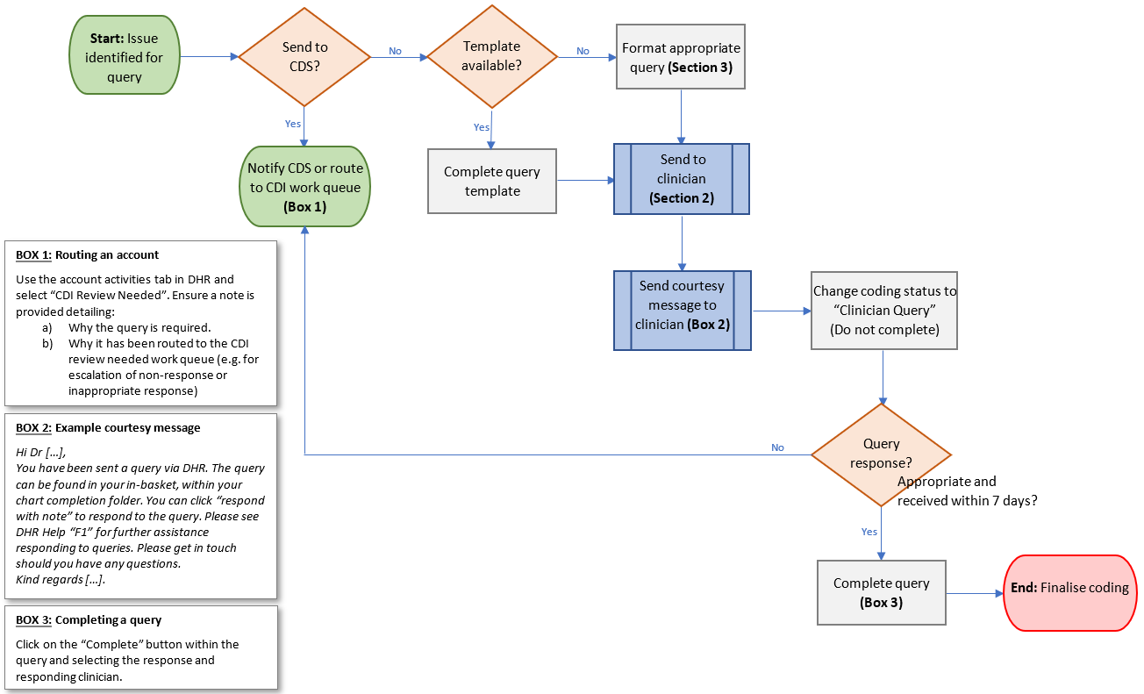
Attachment B: Flowchart 2 - Responding to Queries (For Clinicians)
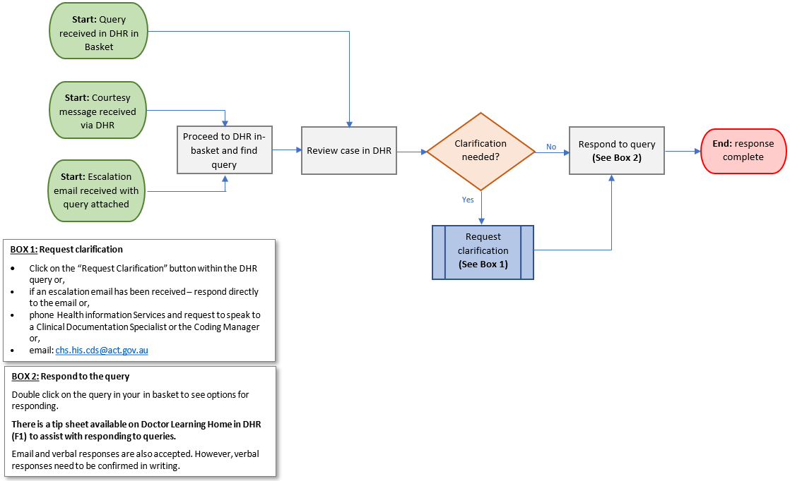
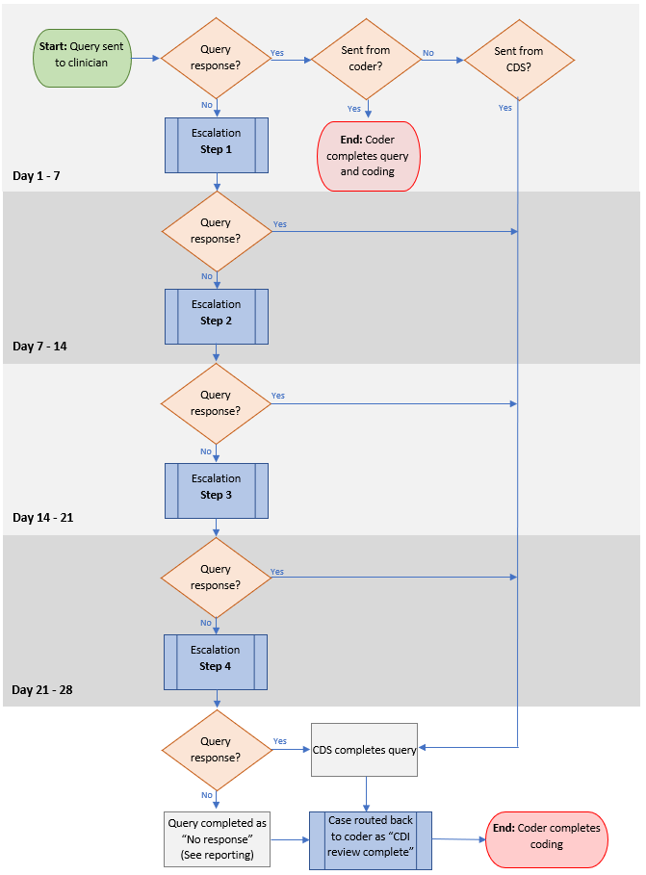
Attachment C: Flowchart 3 – Escalation of Unanswered Queries

