Canberra Hospital and Health Services
Procedure
Vaccine Cold Chain Management

Contents

Contents 1
Purpose 3
Alerts 3
Scope 3
Section 1 – Monitoring the temperature of refrigerators containing vaccine 4
Types of temperature monitoring devices include: 4
Equipment 4
Procedure 5
Section 2 – Identification and management of a possible cold chain breach 5
Equipment 6
Procedure 6
Section 3 – Vaccine stock management 7
Procedure 7
Section 4 – Maintenance of refrigerators and data loggers 8
Procedure 8
Section 5 – Child Immunisation Clinics 9
Procedure 10
Section 6 – School Immunisation Team 10
Procedure Transporting of vaccines 10
Evaluation 11
Related Policies, Procedures, Guidelines and Legislation 12
References 12
Definition of Terms 13
Search Terms 13
Attachments 13
Attachment 1 – Strive for 5 minimum/maximum vaccine refrigerator temperature chart 15
Attachment 2 – Reporting and Management of Cold Chain Breaches for CHS WYCCHP Staff 17
Attachment 3 – ACT Health vaccine order form 18
Attachment 4 – CHS WYCCHP Immunisation Clinical Competency Assessment 20
Attachment 5 – MACH vaccine register 25
Attachment 6 – SHT vaccine register 26
Attachment 7 – SHT outreach cold chain and vaccine wastage sheet 27

Purpose

The purpose of this procedure is to ensure that all Canberra Health Services (CHS) Network facilities within Women’s, Youth, Children’s Community Health Program (WYCCHP) adhere to mandatory vaccine storage and cold chain management to ensure vaccines are stored in accordance with best practice guidelines as outlined in the National vaccine Storage Guidelines: Strive for 5 3rd Edition. In addition, that vaccine cold chain breaches are identified and managed consistently and efficiently to ensure all patients and clients receive potent and effective vaccines.

The National Vaccine Storage Guidelines: Strive for 5 3rd Edition defines the cold chain as the system of transporting and storing vaccines within the safe temperature range of +2°C and +8°C. Vaccines must be stored between +2°C and +8°C to ensure efficacy and to minimise wastage. The cold chain begins from the time the vaccine is manufactured, delivered to the ACT, moves through Canberra Health Services Network facilities, and ends when the vaccine is administered. The success of the system involves three key elements: people, processes, and equipment (vaccine refrigerators and monitoring equipment).

Back to Table of Contents

Alerts

Vaccines are delicate biological substances that can become less effective or destroyed if they are frozen, allowed to get too warm or exposed to direct sunlight or ultraviolet (UV) light, including fluorescent light.

A ‘cold chain breach’ occurs when vaccine storage temperatures deviate outside the recommended range of +2°C and +8°C. Effective cold management ensures patients/clients are vaccinated with potent vaccines to reduce the risk of disease. If an ineffective vaccine is administered a patient/client may need to be recalled, counselled, and revaccinated. In addition, the total cost of a cold chain breach can be significant.

Back to Table of Contents

Scope

The procedure applies to all clinical and non-clinical CHS Network including the inpatient facilities at Canberra Hospital, Clare Holland House, North Canberra Hospital, and University of Canberra and community based services, staff involved in the handling, storage and/or administration of National Immunisation Program (NIP) and ACT funded vaccines within the WYCCHP.

Back to Table of Contents

Section 1 – Monitoring the temperature of refrigerators containing vaccine

Cold chain monitoring devices must be checked prior to administering vaccines and at least twice each day staff are present at the clinic, including at the commencement and completion of animmunisation session. This provides a better indication of any problems in the refrigerator’s function and temperature fluctuations over the course of the day. However, the temperature should be viewed and considered every time the refrigerator is opened.

Types of temperature monitoring devices include:
- Data logger
A data logger provided by the ACT Health, Health Protection Service (HPS), Immunisation Section must be used to continuously monitor all refrigerators that store vaccines and can be used to map ‘cold spots’ or investigate problems. A data logger can be used to monitor the current, minimum, and maximum temperatures within the refrigerator. They are electronic devices that measure temperature, recording the results over a period of time and:
- are programmed to record the temperature every 5 minutes
- continue to record until they are collected by HPS staff and connected to a computer for data reading
- are collected and replaced with regular deliveries or if there has been a cold chain breach
- cannot be manually reset by the immunisation provider
- an alarm will activate upon 2 consecutive readings outside of +2$°C$ to +8$°C$
- should be placed in the middle shelf of the fridge.

- Freeze Indicators (FreezewatchTM) are provided by HPS and:
- should be adhered to a clean, dry surface on each shelf of the fridge
- monitored for the expiry date on them
- require exposure to temperatures below 0$°C$ for one hour before they rupture
- when they rupture the glass bulb in the freeze indicator breaks to release a bluish/black dye which irreversibly stains the paper behind the glass bulb, providing a visual warning that the product may have been exposed to temperatures below 0$°C$.

Equipment
- Data logger
- Freeze indicator (FreezewatchTM)
- Temperature monitoring chart

Procedure
- Record on the Strive for 5 minimum/maximum vaccine refrigerator temperature chart (every refrigerator must have its own temperature chart) see Attachment 1. Information must include:
- The date, time, current minimum and maximum temperature and initial each time the temperature is checked
- Comments and any action taken every time the minimum and maximum temperature exceeds the recommended range of +2°C to +8°C, e.g., if restocking or defrosting the refrigerator
- If a freeze indicator has a stained background.
- Data Logger
  - Reading the Data Logger:
- Record the minimum and maximum temperatures of the Data Logger
- The LCD display will continuously display the current temperature
  - Check if the data logger is alarming by:
- Looking at the LCD display: a data logger that has recorded temperatures outside of +2°C to +8°C will either have a flashing current temperature reading or have AL-H (alarm high) or AL-L (alarm low) in the top right-hand corner of the display. (For Log Tag data loggers an X will appear in the top left corner).
- Observing the Freeze Indicator
Looking at staining of the paper behind the glass bulb may indicate possible exposure to temperature below 0$°C$.
- If a possible freezing event has been identified and the paper behind the FreezewatchTM does not appear stained remove the FreezewatchTM from the fridge and observe the background paper ten minutes later.

Note:
The Freeze indicators act as an additional measure and do not indicate if the vaccines are safe and viable. Please refer to the data logger for the temperature recordings and act as appropriate.

Back to Table of Contents

Section 2 – Identification and management of a possible cold chain breach

A cold chain breach occurs when vaccine storage temperatures deviate outside the recommended range of +2°C to +8°C. The optimal storage temperature for vaccines is +5°C.

A cold chain breach may have occurred if any one or more of the following has happened:
- The data logger is alarming or has a minimum temperature reading below +2°C or a maximum temperature reading above +8°C
- Any thermometers (including fridge temperature LED) have a minimum temperature reading below +2°C or a maximum temperature reading above +8°C
- A freeze indicator has broken – the paper behind the glass bulb has been stained.

If a possible cold chain breach has been identified refer to the Reporting and Management of Cold Chain Breaches for CHS WYCCHP staff flowchart at Attachment 2.

Equipment
- Data logger
- Freeze indicator (FreezewatchTM)

Procedure
Potential Breach
- Immediately isolate the vaccines and prepare to transfer them into temporary monitored vaccine storage, if necessary. Start conditioning ice packs/gel packs.
- Keep vaccines refrigerated between +2°C and +8°C for as long as possible and label them ‘Do not use’ while preparing to transfer them.
- Notify a Manager, Clinical Nurse Consultant (CNC), Clinical Midwifery Consultant (CMC), Clinical Nurse Manager (CNM) or person responsible for cold chain management.
- Contact the HPS Immunisation Unit to obtain advice by calling 5124 9800.
- Provide details of the possible cold chain breach, including minimum and maximum temperature reading from your data logger and/or thermometer, if freeze indicators are broken, and if there is any suspected cause for the breach (e.g., power failure).
- Information required to assess a cold chain breach includes:
  - Date and time of breach.
  - Length of time the vaccine was outside the +2°C and +8°C range.
  - Reason for the cold chain breach (if known) and if it has been rectified.
  - Brand and size of refrigerator in which the vaccines are stored.
  - What equipment was used to identify the breach and where was it located within the refrigerator.
  - What vaccine was involved and where was it located within the refrigerator.
  - If the vaccine has previously been exposed to temperatures outside the +2°C and +8°C range.
- HPS will assess every suspected vaccine cold chain breach and determine if the vaccines are suitable for use. If the vaccines are no longer viable and must not be used:
  - Do not discard any vaccine. HPS will arrange a time to collect it for disposal (keep vaccine at +2°C to +8°C until collected).
  - Leave the data logger with the affected vaccines. HPS will arrange a time to collect it to obtain more information about the cold chain breach.

Confirmed Breach
- A confirmed cold chain breach must be recorded on the Minimum/maximum vaccine refrigerator temperature chart (Attachment 1) and reported in an incident report on RISKMAN.
- In the event of a cold chain breach resulting in wastage, the Immunisation Coordinator at HPS advises the immunisation provider of revaccination recommendations & provides them with the Health Protection Services, Communicable Disease Control, Immunisation Unit Revaccination guidelines (Effective March 2014). Open disclosure & recall of patients remain the responsibility of the immunisation provider. The provider should be advised to consider the patient’s medical history and risk factors when reviewing the guidelines.
- A copy of the computerised data reading from the data logger may be supplied upon request.
- Recalling clients who have received compromised vaccine
- Once HPS has established that a cold chain breach has occurred and vaccine has been compromised, it is vital to determine if compromised vaccine has been administered to clients.
- The WYCCHP immunisation provider will compile a comprehensive list of any clients who may have been given compromised vaccine. HPS will advise on which clients will need revaccination. The client may require a repeat dose of the vaccine, to ensure they have received an effective dose.
- The client will be informed of the incident in line with the CHS Open Disclosure Procedure by a WYCCHP immunisation provider, this would include discussing the risks and benefits of revaccination.

Back to Table of Contents

Section 3 – Vaccine stock management

Procedure
- Ordering National Immunisation Program (NIP) or ACT Government funded vaccines:
- Keep vaccine stock to a minimum by ordering only the quantity of vaccine required until the next routine delivery. Take the vaccine stock already in the refrigerator into account before placing an order.
- The following formula can be used when calculating vaccine requirements:
- Quantity required until next routine delivery, minus quantity currently in refrigerator plus 10% of quantity used in last period as a buffer.
- Ensure the refrigerator capacity is appropriate to safely store the maximum volume of stock required, considering seasonal vaccination programs such as influenza.
- Refer to manufacturer guidelines for capacity recommendations for each refrigerator.
- Complete a vaccine order form available (Attachment 3) and email or fax to the Health Protection Service (HPS) Immunisation Section.
- All areas have designated delivery days. A calendar with the relevant dates is distributed by HPS annually.
- Email/Fax orders for routine deliveries at least two business days prior to the scheduled delivery date.
- Delivery of NIP or ACT Government funded vaccine:
- HPS staff will observe all cold chain monitors used during transportation to ensure cold chain integrity has been maintained:
- The refrigerator must be maintaining +2°C to +8°C before being stocked with vaccine.
- The vaccine will not be delivered if cold chain monitors indicate that vaccine has been exposed to temperatures outside of +2°C to +8°C.
- If all storage conditions have been met, vaccines should be unpacked and refrigerated as soon as possible upon delivery; and
- HPS staff will leave a delivery docket attached to vaccine for filing by section.
- Packing your fridge
- Do not overstock or overcrowd the refrigerator by overfilling shelves. Overstocking increases the likelihood of a cold chain breach and places all vaccine at risk.
- Allow space between vaccine to enable airflow to maintain constant ambient temperatures.
- Vaccine should be kept at least 4cm from refrigerator walls to reduce the risk of freezing.
- Be aware of cold spots in your refrigerator, commonly near air vents or cooling plates and regularly check for ice build-up.
- Always store vaccine in its original packaging to insulate it from temperature fluctuations and to protect it from light.
- Glass doors may not have ultraviolet (UV) filtering. This is another reason why vaccines must be stored in their original packaging. All vaccines are sensitive to UV light, including fluorescent lighting.
- Minimise the number of times the refrigerator door is opened.
- Stock rotation
- Regularly rotate your vaccine stock. Place stock with the shortest expiry dates at the front to be used first.
- Inform the HPS Immunisation Unit on 5124 9800 if you have NIP stock in your refrigerator that will expire within the next three months.
- Other temperature stability considerations
- Do not store food in your vaccine refrigerator.
- Ensure the refrigerator is labelled ‘for vaccine only’.
- Ensure the power source to the refrigerator is labelled clearly to prevent it from being accidentally unplugged or turned off. If the power source is exposed, a switch cover may be necessary. Strive for 5 Labels available here.
- Glass doors may cause the refrigerator to lose heat more rapidly during a power failure.
- Immunisation providers should ensure they have alternative provisions in place in the event of a power failure or refrigerator breakdown.
- Disposal of NIP or ACT Government funded vaccines
- Do not discard any vaccines. If vaccines are no longer required, damaged or expired call HPS Immunisation unit on 5124 9800 to arrange pickup.

Back to Table of Contents

Section 4 – Maintenance of refrigerators and data loggers

Procedure
- Position of fridge
- The refrigerator must be positioned away from external walls, out of direct sunlight and not against a heat source.
- The refrigerator must be in a well-ventilated room.
- Follow the manufacturer’s instructions about positioning the refrigerator to enable sufficient air circulation around it.
- Ensure that the refrigerator is in a secure area, only accessible to staff.
- The refrigerator must be positioned to ensure the door self-seals (closes) if the door is left accidentally ajar (ensure compliance with the manufacturer’s instructions about the refrigerator being level).
- Labelling
- Ensure the power source to the refrigerator is labelled clearly to prevent it from being accidentally unplugged or turned off. If the power source is exposed, a switch cover may be necessary. Labels available here.
- Ensure the refrigerator is clearly labelled ‘for vaccine only’.
- Maintenance of vaccine refrigerator
- Report refrigerator problems immediately to your manager or supervisor for maintenance follow up.
- The refrigerator door seals should be in a good condition to allow the door to close easily and securely. Check the door seals regularly, if brittle or torn, arrange for replacement.
- Check that the refrigerator is free of any water or coolant leaks.
- The refrigerator compressor should be quiet (an audible or noisy compressor may require attention).
- If there are exposed coils on the back of the refrigerator, keep them clean and dust free to improve operating efficiency.
- The refrigerator should be kept clean and tidy.
- Refrigerator to be serviced every 12 months and ensure it is in good working order.
- Maintain all documentation and records of refrigerator maintenance
- Refrigerator audits
- Complete the National Vaccine Storage Guidelines ‘Strive for Five’ 3rd Edition self-audit at least once every 12 months and more frequently if there has been problems with equipment or cold chain breaches. Documentation should be stored for future reference.
- Maintenance of data loggers
- Data loggers will be checked and replaced each time the HPS staff deliver vaccines. Battery life of data loggers to be regularly checked and replaced as necessary by HPS staff.
- Data loggers will be tested for accuracy and recalibrated annually and as necessary by an external provider via the HPS Immunisation Unit.

Back to Table of Contents

Section 5 – Child Immunisation Clinics
All staff involved in vaccine cold chain management will complete the WYCCHP Immunisation Clinical Competency Assessment (Attachment 4).

Procedure
- Monitoring
Monitoring the temperature of refrigerators containing vaccine and identifying, reporting, and managing cold chain breaches, the Registered Nurse will:
- Observe all temperature-monitoring devices
- Record on temperature on minimum/maximum vaccine refrigerator temperature chart at the start and end of the day and whenever the fridge door is opened (See Attachment 1)
- The area CNC/CNM will audit cold chain monthly and submit report to Q drive folder for review by WYCCHP Assistant Director of Nursing (ADON).
- In the event of an unreported cold chain breach, HPS and ADON to be contacted to progress action if required.
- Vaccine Stock Management
Follow National Vaccine Storage Guidelines, 2013-Strive for 5, 3rd Edition and
- Immunisation Clinic vaccine count recorded on vaccine register (Attachment 5)
- School Health Team (SHT) count recorded on Vaccine Register School Immunisation (Attachment 6).
- Storing and transporting Vaccine in Portable Coolers
Follow National Vaccine Storage Guidelines, 2013-Strive for 5, ^{3rd} Edition;
- Record on SHT outreach cold chain and vaccine wastage sheet (Attachment 7)
- All readings from a minimum/ maximum thermometer are recorded and signed by the Registered Nurse.
- Maintenance of Refrigerators containing Vaccine and Cold Chain Monitoring Devices
- Store copies of annual servicing, calibration, and maintenance reports in official team file for a 5-year period.

Back to Table of Contents

Section 6 – School Immunisation Team

This section refers to High School Immunisation Program and is to be read in conjunction with National Vaccine Storage Guidelines, 2013-Strive for 5, 3rd Edition.

All Registered Nurses involved in vaccine cold chain management will complete the WYCCHP Immunisation Clinical Competency Assessment (Attachment 4).

Procedure Transporting of vaccines
The Registered Nurse will:
- Cool the esky
- Place two (2) ice sheets straight from the freezer into each empty esky.
- Take out and sweat four (4) extra ice sheets per esky.
- Remove the thermometer and red probe box set (a probe box set is a thermometer probe well secured inside an empty red vaccine box) from the fridge and connect.
- Check the thermometer is reading the temperature from the probe (select ‘out’)
- Ensure the thermometer alarms are set at +2°C to +8°C.
- Reset the thermometer
- Place a probe box set and connected thermometer into each esky and zip closed.
- When the esky temperature reads between +2°C to +8°C remove the two (2) ice sheets.
- Pack the esky
- Pack the bottom of the esky with the sweated ice sheet and then bubble wrap.
- Pack the vaccines in the esky on top of the bubble wrap; making sure the vaccines are not in contact with the ice sheets to prevent freezing.
- Place ice sheets along the long sides of the esky.
- Place the probe box set in the middle/centre of the vaccine stock taking care that the probe is still firmly within the probe box.
- Place bubble wrap over the vaccines and then ice sheets on top.
- Pack extra ice sheets into a small esky; these are used to manage cold chain.
- Record the starting temperatures on the outreach cold chain and wastage record sheet (Attachment 7)
- Reset the thermometer
- Place the thermometer (still attached to the probe) just inside the esky on top of some bubble wrap during transport. The thermometer should be easily visualised by lifting the Velcro flap on the lid of the esky.
- Monitor at the school
- Take the thermometer out of the esky during the immunisation session and place it in the clear sleeve on the lid to monitor cold chain. If lid is opened frequently place thermometer on table in front of the esky to avoid damage to the thermometer.
- Always ensure the probe box set stays in the middle/centre of the vaccines
- Monitor the esky temperature every 15 mins for the first two hours and then at least hourly after that.
- Document when ice sheets are put in/taken out on the outreach cold chain and wastage record sheet (Attachment 7),
- If a cold chain breach occurs, please inform the Immunisation Coordinator immediately or CNC/CNM.
- Documentation
- The area CNM will audit cold chain monthly and submit report to Q drive folder for review by WYCCHP Assistant Director of Nursing (ADON).
- Maintenance of Refrigerators containing Vaccine and Cold Chain Monitoring Devices
- Store copies of annual servicing, calibration, and maintenance reports in official team file for a 5-year period.

Back to Table of Contents

Evaluation
Outcome
- Compliance with the National Safety and Quality Health Services Standard 4 – Medication Safety
- Compliance with the National Vaccine Storage Guidelines Strive for 5
- Ensuring every vaccine administered through the WYCCHP programs are viable and effective.

Measures
- Regular reporting to ACT Health, Health Protection Services, with data collected by both the Early Childhood Immunisation Clinics and the High School Immunisation Programs.
- Monthly cold chain reporting to the WYCCHP ADON
- Staff will be credentialled annually to perform immunisations within WYCCHP.
- Clinical and quality outcomes are evaluated through patient experience questionnaires, feedback from key stakeholders, Riskman reports, clinical file audits, and data collection.

Back to Table of Contents

Related Policies, Procedures, Guidelines and Legislation

Procedures
- Medication Handling Policy
- Medication Fridge Temperature Monitoring Procedure
- Nursing and Midwifery Continuing Competence Policy
- Australian Immunisation Handbook
- Immunisation Service Delivery in Schools and Child Health Clinics
- Open Disclosure Policy

Legislation
- Medicines, Poisons and Therapeutic Goods Regulation 2008
- Medicines, Poisons and Therapeutic Goods Act 2008
- Therapeutic Goods Act 1989
- Therapeutic Goods Regulation 1990
- Human Rights Act 2015
- Charter of Health Care Rights

Back to Table of Contents

References

- National Vaccine Storage Guidelines Strive for 5, Australian Government, ³rd edition

Back to Table of Contents

Definition of Terms

Adverse vaccine storage event | Exposure of vaccines to temperatures outside the recommended range of +2°C to +8°C (excludes fluctuations up to +12°C, lasting no longer than 15 minutes)).  An adverse vaccine storage event may be referred to as a ‘cold chain breach’.
Cold chain breach | Exposure of vaccines to temperatures outside the recommended range of +2°C to +8°C (excludes fluctuations up to +12°C, lasting no longer than 15 minutes).  A cold chain breach may be referred to as an ‘adverse vaccine storage event’.
Cold chain | The system of transporting and storing vaccines within the safe temperature range of +2°C to +8°C.
Cooler | This is a generic term used to describe portable solid-walled insulated containers such as Esky™/Willow™/Coleman™.
Data logger | A small electronic device that continuously measures temperatures and keeps a record of the results.
Ice Sheets packs | Commercial coolant products, commercial gel-packs, and other non-ice coolants.
Immunisation providers | These include any person that stores, monitors, or administers vaccine.
Refrigeration | Withdrawal of heat from a chamber to achieve a temperature below ambient temperature.

Back to Table of Contents

Search Terms

Immunisation, School Health, Vaccination, Vaccine, Inoculation, Cold Chain, Temperature, Fridge Management, Data Logger

Back to Table of Contents

Attachments

- Strive for 5 – Minimum/maximum vaccine refrigerator temperature chart available
- CHS WYCCHP staff flow chart for reporting and management of cold chain breaches
- ACT Health vaccine order form
- CHS WYCCHP Immunisation Clinical Competency Assessment
- MACH vaccine register
- SHT vaccine register
- SHT outreach cold chain and vaccine wastage sheet

Back to Table of Contents

Disclaimer: This document has been developed by Canberra Health Services specifically for its own use. Use of this document and any reliance on the information contained therein by any third party is at his or her own risk and Canberra Health Services assumes no responsibility whatsoever.

Policy Team ONLY to complete the following:
Date Amended | Section Amended | Divisional Approval | Final Approval
12/05/2021 | Complete Review | Boon Lim,ED,WYC | CHS Policy Committee

This document supersedes the following:
Document Number | Document Name
CHHS15/117 | Vaccine Cold Chain Management

Attachment 1 – Strive for 5 minimum/maximum vaccine refrigerator temperature chart
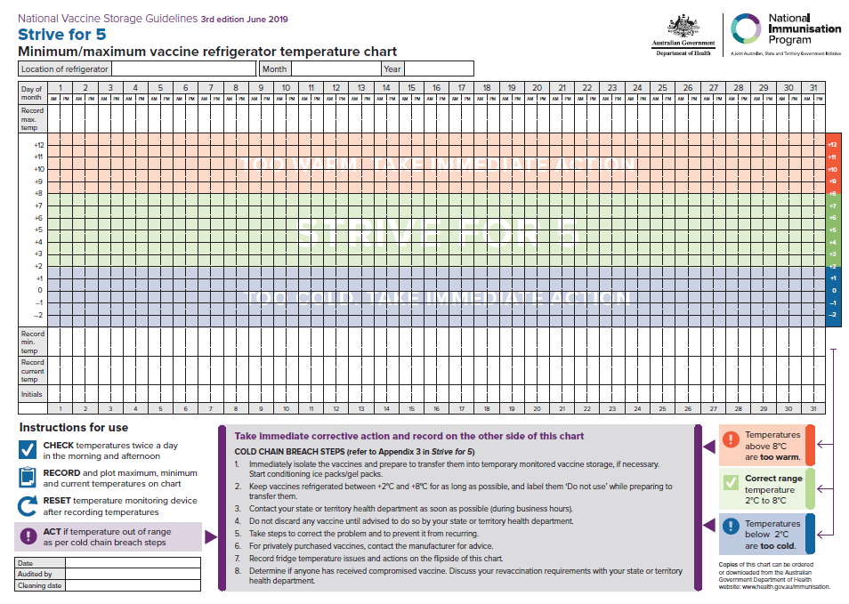

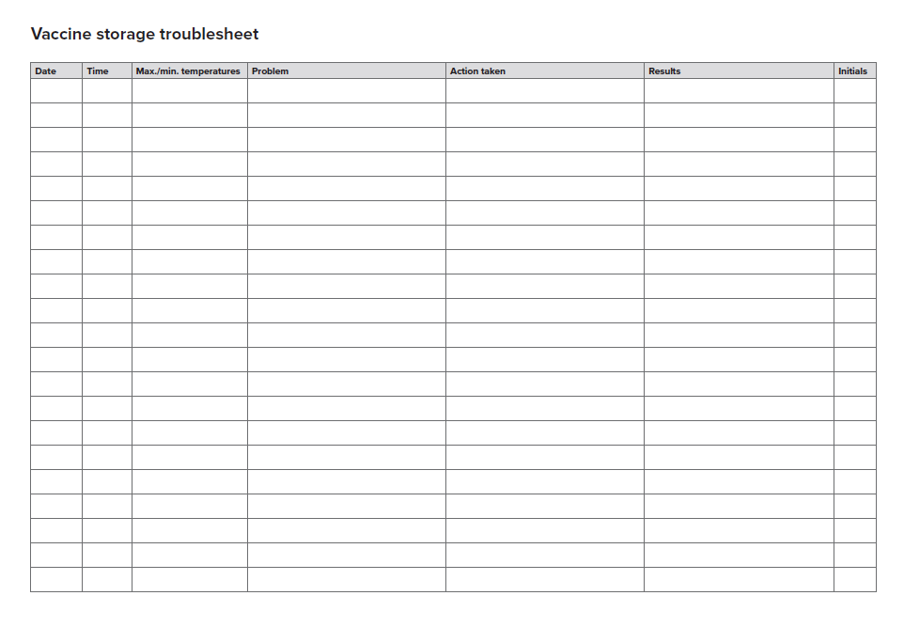

Attachment 2 – Reporting and Management of Cold Chain Breaches for CHS WYCCHP Staff

CHECK all tempertature monitoring devices at least twice daily and PRIOR to using vaccine
Contact Health Protection Services (HPS) on 5124 9800
Provide details of cold chain breach including min/max temp and duration of breach
Possible Cold Chain breach identified

DO NOT USE VACCINE
For more information refer to CHS Vaccine Cold Chain Management procedure or contact the HPS during business hours on 5124 9800
Document incident and actions on Strive for 5 temperature chart
Inform CNC/CMC or CNM of outcome and report on Riskman
The data logger may be collected to obtain additional information about storage conditions.
Continue using vaccine
The vaccine IS viable.
The vaccine and data logger will be collected, and replacement stock delivered by negotiation.
Keep affected vaccine at +2 - +8◦C until collected by HPS.
The vaccine IS NOT viable OR further investigation is required.
Notify Immunisation Coordinator, CNC/CMC or CNM
DO NOT USE VACCINE
Label the vaccines ‘DO NOT USE’, isolate the vaccine and keep at +2 - + 8◦C

Attachment 3 – ACT Health vaccine order form

Vaccine Management Unit

Vaccine Order Form
It is essential that this vaccine order is faxed or emailed to the Vaccine Management Unit
at least 2 working days prior to your next scheduled delivery. Urgent orders may take up to a week for delivery.
Immunisation providers are encouraged to keep vaccine stocks to a minimum by ordering only the number of vaccines required for the period until the next scheduled delivery. As a guide – note the number of vaccines used over the last month, plus 10%, then take away the amount of stock on hand.
Practice / Clinic:
Urgent Delivery Reason
Scheduled Delivery Date: ____ /____/____
Address:
Telephone No:
Vaccine | Current  Stock Numbers | Doses Required
Act-HIB® (Hib)
Adacel® / Boostrix® (dTpa) Adolescent
Adacel® / Boostrix® (dTpa) Antenatal from 20 weeks’ gestation or as soon as possible after this. Can be given up to delivery
Infanrix® / Tripacel® (DTPa)
Infanrix®-Hexa (DTPa, Hib, Polio, Hep B)
Infanrix®-IPV / Quadracel® (DTPa & Polio)
IPOL ® (IPV)
Neisvac-C® (MenCCV)
Nimenrix® (Meningococcal ACWY)
Pneumovax 23® (Pneumococcal)
Prevenar 13® (Paediatric) (Pneumococcal)
Prevenar 13® (Adult) (Pneumococcal)
Priorix® or MMR®II (MMR)
Priorix Tetra® / Proquad® (MMRV)
Rotarix® (Rotavirus)
Varilirix® / Varivax (Varicella)
Zostavax® (Herpes Zoster)
Other:
Please turn over for influenza, HPV, meningococcal B and hepatitis B vaccine orders.
Influenza Vaccine Orders (please note advice below)
Vaccine | Current  Stock Numbers | Doses Required
Influenza - 6 months to <5 years
Influenza - 5 years to 64 years
Influenza - 65 years and over
~ Before you administer an influenza vaccine check your patient’s age and check that you have the correct vaccine. The packaging and syringe have the age groups written on them ~

HPV Orders
Please use the HPV order form available from the Vaccine Management Unit or Website
https://www.health.act.gov.au/services/immunisation

Men B (Bexsero) Orders
Please use the Men B order form available from the Vaccine Management Unit or Website
https://www.health.act.gov.au/services/immunisation

HEP B
Please use the Hep B order form available from the Vaccine Management Unit or Website
https://www.health.act.gov.au/services/immunisation

Return form to Vaccine Management Unit by
Email: immunisation@act.gov.au (with Practice Name in subject) or Fax: 5124 9307
I agree that:
- All vaccines will be stored in accordance with the National Vaccine Storage Guidelines “Strive for 5”.
- Any temperature breaches outside of the recommended range of +2 to +8°C will be immediately notified to the Health Protection Service.
- All funded vaccines will only be administered to eligible persons. (National Immunisation Program or ACT Government Program)
- Data on recipients of influenza, adult pneumococcal and antenatal pertussis vaccine will be faxed to HPS fortnightly.
- All vaccines administered will be recorded on the Australian Immunisation Register.

Signature: Date: ___/___/___
(signature of staff member ordering vaccines)

Attachment 4 – CHS WYCCHP Immunisation Clinical Competency Assessment
The WYCCHP Immunisation Clinical Competency Assessment is to assist in identifying levels of competency based on the specific responsibilities and performance requirements for Registered Nurse (RN) immunisers in their WYCCHP clinical settings.

New Nurse Immunisers: All new WYCCHP nurse immunisers are required to successfully complete this assessment within 5 business days of commencing immunisation practice. A minimum of 2 successful immunisation encounters are required to be completed in this assessment for initial competency.

Existing Nurse Immunisers: This assessment is also to be completed annually by all existing WYCCHP nurse immunisers. A minimum of 1 successful immunisation encounter is required to be completed for annual assessment.
The assessment is to be conducted by a CNC, CNM, CDN or appropriately skilled immunisation nurse provider who has completed the CHS assessor Course.

Name: | Immunisation Encounter Assessment 1
Print full name
Signature
Assessment conducted by:
Print full name
Signature & Designation
Date of assessment 1

Name: | Immunisation Encounter Assessment 2
Print full name
Signature
Assessment conducted by:
Print full name
Signature & Designation
Date of assessment 2

Initial Immunisation Clinical Competency Assessment | Yes | No
WYCCHP Immunisation clinical assessment competency completed
Basic Life Support (eLearning-2019 - V2) and assessment completed
Anaphylaxis Recognition and Management (eLearning - 2020)
Evidence of enrolment in or completion of a recognised training course that meets the requirements set out in the National Immunisation Education Framework for Health Professionals

Annual Immunisation Clinical Competency Assessment | Yes | No
WYCCHP Immunisation clinical assessment competency completed
Basic Life Support (eLearning-2019 - V2) and assessment completed
Anaphylaxis Recognition and Management (eLearning - 2020)
Evidence of 4 hours of immunisation education completed

Competencies | Assessment 1 |  |  | Assessment 2
Competencies | Yes | No | N/A | Yes | No | N/A
1. Cold chain management
- Stores vaccines in accordance with the current version of the National Vaccine Storage Guidelines Strive for 5 .

- Maintains, checks, and records cold chain as per CHS vaccine cold chain management procedure

- Can correctly identify a breach of vaccine storage conditions and responds appropriately as per the National Vaccine Storage Guidelines and CHS Vaccine Cold Chain Management Procedure

- Demonstrates correct techniques when handling and transporting vaccines for vaccinations – including use of data loggers and freeze indicators
2. Review’s client history
- Identifies any risk categories as listed in the Australian Immunisation Handbook

- Identifies which specific vaccines are recommended and scheduled

- Confirms the vaccine history by checking all immunisation records

- Identifies if catch up vaccines are required and plans a catch-up schedule accurately
3. Pre vaccination assessment
- Accurately screens the client prior to immunising following the recommended checklist in the Australian Immunisation Handbook and as per CHS Immunisation Service Delivery in Schools and Child Health Clinics Procedure

- Correctly identifies contraindications to vaccination and responds appropriately
4. Adheres to principles for safe medication administration
- Adheres to the Standing Medication orders provided by Chief Medical Officer and the Medicines, Poisons and Therapeutic Goods (Nurse and Midwife Immunisers) Direction 2020 (No 1)

- Throughout the assessment the immuniser identifies the 5 rights of medication administration:
- The right patient
- The right drug
- The right dose
- The right time
- The right route

Competencies | Assessment 1 |  |  | Assessment 2
Competencies | Yes | No | N/A | Yes | No | N/A
5. Preparing to vaccinate
- Selects the correct vaccine/s and confirms suitability for use

- Check dosage, expiry date and patency with a second RN

- Second RN observes drawing up of all components

- Reconstitutes vaccines appropriately as required

- Complies with all the recommendations for administration of vaccines as the Australian Immunisation Handbook
6. Consent
- Adheres to the CHS Informed Consent – Clinical Policy and checks and documents three points of identification

- Uses appropriate resources to assist with consent process

- The immuniser provides relevant information on:
- Risk and benefit of each vaccine including common and rare reactions
- Advice on what to do if they are concerned about a reaction following vaccination
- How to report an adverse event
- The requirement to remain in the area at least 15 minutes after a vaccination

- Can effectively respond to questions and concerns raised

- Correctly obtains valid consent prior to vaccinating
7. Positioning for vaccination
- Identifies the correct injection site for specific age groups

- Can effectively communicate with parent / caregiver regarding requirements for suitable positioning and holding infants and children

- Effectively positions clients allowing appropriate access to injection site
8. Vaccination technique
- Identifies the appropriate needle size and length as required for specific individuals
- Selects correct route of administration for each vaccine
- Check vaccines, expiry dates and patency with carer accompanying child prior to administration
- Uses the correct administration technique for each vaccine
- Disposes of all equipment appropriately

Competencies | Assessment 1 |  |  | Assessment 2
Competencies | Yes | No | N/A | Yes | No | N/A
9. Post vaccination care
- Informs client when next vaccination due

- Reiterates what to do if they are concerned about a reaction following a vaccine (provides written information regarding common reactions post vaccination)

- Reiterates the requirement to remain in the area for 15 minutes

- Reiterates how to report an adverse event

10. Documentation
- Documents all necessary details in the appropriate records including injection site for each vaccine and batch number for each vaccine given

- Displays knowledge of specific documentation following Adverse Event Following Immunisation (AEFI), Riskman, CPF, Manager

- Maintains appropriate records for each vaccine given and ensures completion of the Australia Immunisation Register (AIR)

11. Anaphylaxis management
- Ensures appropriate availability of anaphylaxis equipment and emergency response equipment including knowledge of location and ambulance information

- Able to differentiate between a vasovagal, Hypotensive Hypotonic Episode (HHE) and anaphylaxis

- States the management of anaphylaxis:
- Describes when Adrenaline should be administered following an adverse event
- Identifies equipment required for rapid administration of Adrenaline
- States the recommended strength and dosage of Adrenaline
- Identifies correct anatomical site and route for administration of Adrenaline

- Documents and reports any Adverse Event Following Immunisation (AEFI) to ACT Health Protection Service on relevant form
P Immunisation Clinical Competency Assessment

Attachment 5 – MACH vaccine register

Attachment 6 – SHT vaccine register

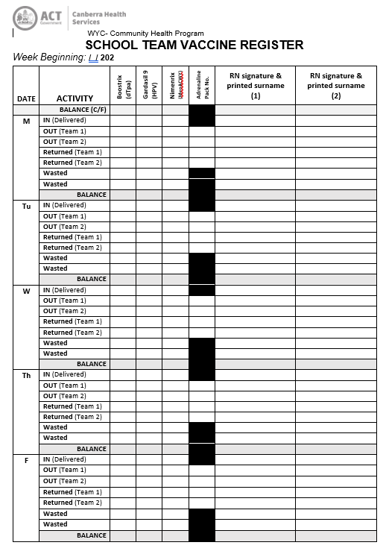

Attachment 7 – SHT outreach cold chain and vaccine wastage sheet

