Canberra Health Services
Procedure
Tongue Tie: Assessment, Management, and Division

Contents

Contents 1
Purpose 2
Scope 2
Section 1 – Care of the infant with a Tongue Tie 2
Section 2 – Identification of a Tongue Tie 3
Section 3 – Assessment of feeding 4
Section 4 – Referral Pathway 5
Section 5 – Feeding Evaluation Associated with Tongue Tie 7
Section 6 – Assessment of Tongue Appearance and Function - Hazelbaker Assessment Tool (HATLFF) 8
Section 7 – Safety assessment prior to Division of Tongue Tie 8
Section 8 – Tongue Tie Division Procedure 10
Section 9 – Care of the Infant in Paediatrics 12
Evaluation 12
Related Policies, Procedures, Guidelines and Legislation 12
Definition of terms 13
References 13
Search Terms 15
Attachment 15
Attachment 1: Tongue Tie Pathway 15

Purpose

This document outlines the process for the multidisciplinary team in the assessment and management of infants ≥ 37 weeks of corrected gestation age with ongoing feeding difficulties, ankyloglossia or a Tongue Tie (TT).

Scope

This document applies to the following Canberra Health Services (CHS) staff working within their scope of practice:
- Medical officers
- Nurses and midwives
- International Board-Certified Lactation Consultants (IBCLC)
- Speech Pathologists
- Students under direct supervision.
Back to Table of Contents

Section 1 – Care of the infant with a Tongue Tie

Tongue Tie (TT) or tight lingual frenulum may be identified during the newborn assessment or can be discovered when the newborn is having feeding difficulties. In the first instance all infants who present with an identified TT are to be managed as per the admitting department according to their processes and protocols. Refer to Attachment 1 to the Tongue Tie Pathway.

This includes:
- Infants who are assessed as being affected by maternal medication or condition in labour (i.e., caesarean section, anaesthetic, etc)
- Infants born during instrumental birth
- Preterm or unwell infants
- Infants with associated cleft lip and/or palate
- Infants with medical illness
- Maternal supply problems
- Mothers with flat or inverted nipples or affected by engorgement or oedema.

NOTE:
Frenotomy is not appropriate unless there is an associated feeding issue. Other reasons for feeding problems, as above, should be managed conservatively prior to consideration of frenotomy.

Back to Table of Contents

Section 2 – Identification of a Tongue Tie

Definition and Classification
The Tongue Tie (TT) is ‘an embryological remnant of tissue in the midline between the under surface of the tongue and the inferior alveolar ridge/floor of the mouth that restricts normal tongue movement’ (¹⁻⁴).

The classification of the TT has been based on the ‘Coryllos/Griffith’ classification and modified to include the sub-mucosal (SM) TT (¹⁻⁷ Figure 1).

A TT occurs in about 2-46% of the population and in up to 40%-50% of cases affects feeding but, depends on the definition used and the population (²⁻⁸). In a recent review of prevalence rates, Hill et al found that TT occurred in an average of 10% of the population (⁹) In the anterior or Types 1 and 2 TTs, feeding is affected in most cases especially when attached high on the inferior alveolar ridge. (Coryllos classification ¹⁻⁷)

Figure 1: Modified Coryllos classification for TT at <1 month
TYPE | SUPERIOR  ATTACHMENT TO UNDERSIDE OF TONGUE | INFERIOR ALVEOLAR RIDGE  ATTACHMENT | CHARACTERISTICS OF  FRENULUM
1 or 100%  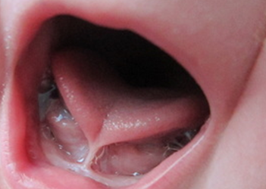 | Tip of tongue  (<2 mm from tip) | High to mid  alveolar ridge | Usually thin and  restrictive or less elastic
2 or 75%  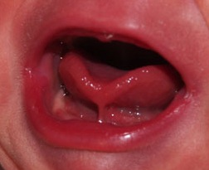 | Just behind tip  (2-4 mm from tip) | High to mid  alveolar ridge | Usually thin and  restrictive or less elastic
3 or 50%  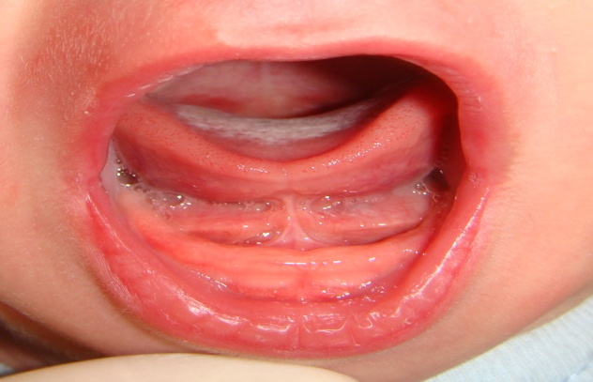 | Mid Tongue  (5-10 mm from tip) | High to base  alveolar ridge | May be thicker but less restrictive/more free tongue
4 or 25%  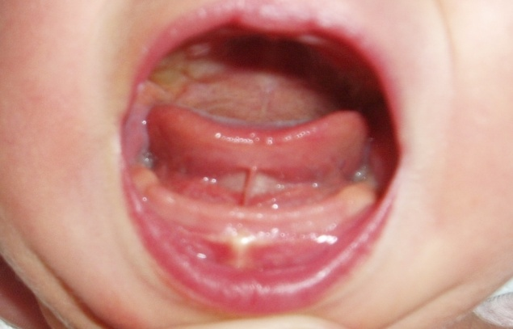 | Posterior tongue  (11-15mm from tip) | Mid to base  alveolar ridge | May be thicker but less restrictive/more free tongue
5 or SM  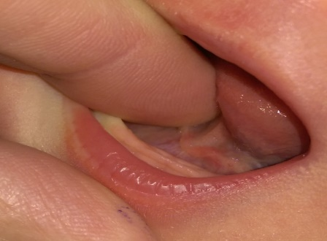 | Sub-mucosal  (>15mm from tip) | Mid to base  alveolar ridge | May look thinner with thicker base (sub-mucosal)

Back to Table of Contents

Section 3 – Assessment of feeding

Assessment
- All infants will be assessed as part of the newborn assessment. Refer to the Assessment of the Newborn Clinical Guideline
- If a TT is identified as per this procedure this must be documented in the patient’s progress notes and feeding observed and parents made aware.
- Infants with identified breastfeeding difficulties will be managed according to the processes and protocols of the admitting department. Refer to the Breastfeeding Clinical Guideline located on the CHS Policy and Guidance Documents Register. Those with TT will need further review.
- If there is a known TT and the infant is breastfeeding well, gaining weight and the mother has no significant concerns, no intervention is required. The mother should be provided with information about how to identify milk transfer and hydration in the infant. She should also know how to seek support if needed.
- If there is a known TT in an infant ≥37weeks corrected gestational age, and the infant is not breastfeeding well and having poor weight gain, or the mother has concerns about the breastfeeding, referral for assessment and consideration for intervention is recommended. Feeding assessment and support should occur prior to TT division (See Section 6 Assessment of Tongue Appearance and Function).
- If there is a known TT in a baby <37 weeks, then the referral process is the same, but the division of the TT may be delayed until the baby has more consistent breastfeeding that includes latch and attachment. This usually occurs after 36 weeks CGA but can be considered earlier in individual cases after discussion with the neonatologist on service.

Signs that the infant is feeding well include:
- Output: 6 heavily soaked wet nappies and several loose yellow stools per day by days 3-5 after birth
- Is gaining weight and has regained birthweight by day 10
- Sustained feeding
- Milk supply maintained

Signs that an infant is having feeding issues
Infant:
- Poor weight gain / failure to thrive
- Poor urine output (< 5 wet nappies by day 5)
- Hyperbilirubinaemia from dehydration resulting in high sodium
- Restlessness from hunger/ fussy feeder
- Gagging, excessive dribbling, vomiting
- Inability to sustain latch; frequently coming off the breast
- Hypoglycaemia from inadequate intake
Mother:
- Nipple pain and damage, including bleeding and/or infection
- A misshapen nipple / compression / stripe on nipple after breastfeeding
- Nipple vasospasm/engorgement/mastitis

Back to Table of Contents

Section 4 – Referral Pathway

Tongue Tie and No Feeding Problems
- Follow formal discharge pathway
- Attend newborn assessment
- Provide parent(s) with the Tongue Tie and Feeding your Baby health information sheet located on the CHS Policy Register
- Refer mother and infant to Maternal and Child Health (MACH) nurse / General Practitioner (GP)/ International Board Certified Lactation Consultant (IBCLC).
- The mother should be advised that after discharge from Women, Youth and Children (WY&C) services to seek advice from the MACH service or Lactation Consultant, if she believes her infant is not breastfeeding well.
- If further feeding issues are identified the MACH Nurse can offer the mother extended home visiting for 1:1 support or refer to the Early Pregnancy and Parenting Support line or the MACH breastfeeding clinic for feeding support (if the TT is not too problematic upon first assessment)

Note: Most infants with TT and subsequent feeding issues will be referred to MACH, where assessment of the TT and feeding issues can be attended by a MACH nurse.

Tongue Tie and Feeding Problems

Alert: All infants with a TT who have feeding difficulties are to be reviewed by a Medical Officer with experience in assessing TTs and feeding, IBCLC, or speech pathologist with relevant experience, prior to referral for consideration of frenotomy.

- Infants with a TT who have feeding difficulties and who are an inpatient of Centenary Hospital for Women and Children (CHWC) should be reviewed by Medical Officer with experience of TTs, Lactation Consultant, or by an Acute Support Speech Pathology who will offer further assessment, support, and management
- Infants who are outpatients and on Midcall or Continuity Programs of the Maternity Unit of the CHWC such as MACH who have a TT and breastfeeding difficulties can be referred to the CHWC Tongue Tie (CHWCTT) clinic for rapid further review and TT division
- Infants with TT and ongoing feeding problems should be prioritised to the MACH service for early review and ongoing care regardless of clinic referral
- Infants with TT who are in the care of the MACH service and having ongoing feeding problems or feeding problems which present later can be offered extended home visits, or referred to the Acute Support Speech Pathology outpatient clinic
- After assessment they can be referred to the CHWCTT Clinic if appropriate (under 4 weeks of age ONLY)
- All infants with TT and feeding problems who are in the MACH service including those who are > 28 days of age can be referred for review and possible frenotomy to GP/Paediatric Surgeon

Conservative Management
- A feeding management plan is to be developed by the treating team with the mother and documented in the medical record
- If frenotomy is being considered, a mother may decline frenotomy for her infant and opt for conservative management.
- Every effort needs to be made by a midwife, nurse, medical officer, or lactation consultant to support and manage the feeding problems. Supports include Lactation Consultant, MACH services, Acute Support Speech Pathology, or admission to Tresillian Queen Elizabeth II (QEII) Family Centre

Back to Table of Contents

Section 5 – Feeding Evaluation Associated with Tongue Tie

Feeding Assessment
Where a TT has been identified in an infant with a feeding problem, an experienced midwife, nurse, MACH nurse, speech pathologist, medical officer or Lactation Consultant will assess the infant using the Tongue Tie Assessment and Referral Form

Signs of Good Breastfeeding include:
- A deep latch at the breast
- No nipple trauma or nipple pain after lactation is established
- Good milk transfer-audible swallowing with no other sounds

Signs of Difficulty in Feeding Associated with Tongue Tie may include:
- Loss of ability to move tongue sideways or stick tongue out
- Loss of suction whilst feeding, a clicking sound while feeding and sucking in of air
- Upper lip blister
- Inability to clear milk from tongue with white marking on dorsal surface of tongue
- Longer feeds and or more frequent feeding
- Inability to sustain latch; frequently coming off the breast, or nipple pain after lactation is established
- Ridged and/or damaged nipple after breastfeeding

ALERT:
- In the first few days a TT may or may not influence breastfeeding and it is only when the milk has “come in” and the infant demands more milk beyond 48-72 hours that the problems may occur
- However, in a tight anterior 100% or 75% TT, the infant will poorly attach to the breast and will cause damage to the nipple early on day 1 or 2 and will need to be reviewed appropriately
- Not all infants with TTs will have feeding problems (especially the mid to posterior [≤ 50% TT]) and not all TTs will need to be snipped

If a TT is identified as part of a feeding problem, then a feeding plan is made by the midwife/IBCLC and the infant should be referred for a “Hazelbaker Assessment Tool for Lingual Frenulum Function” (HATLFF) assessment by an accredited IBCLC/trained Medical Officer ⁹⁻¹⁴.

Back to Table of Contents

Section 6 – Assessment of Tongue Appearance and Function - Hazelbaker Assessment Tool (HATLFF)

Note: The Hazelbaker “Assessment Tool for Lingual Frenulum Function” can be found in the Tongue Tie Assessment and Referral Form located on the Clinical Forms Register

The modified HATLFF (7-12: 2016 version is used)
- Assessment of the TT is by appearance and function using the HATLFF.
- The assessment of tongue appearance and function is undertaken by IBCLC, midwife, nurse or medical officer trained in HATLFF. HATLFF training is provided by Dr Alison Hazelbaker or medical officer /IBCLC trained by Dr Alison Hazelbaker. At the Centenary Hospital this can be performed by Associate Professor David Todd ⁷⁻¹⁴.

Evaluation and division of Tongue Tie:
- A well infant with ongoing associated feeding problems and with an HATLFF Function Score of <11 and or appearance score <8 will have management options discussed with the parents. Options include a TT release or conservative management
- The timing of division of a TT depends on the Type of TT and the functional problems
- An anterior TT (75-100% TT), and with an HATLFF Function Score of <11 and or Appearance score <8 a TT division is more likely to be necessary early on days 2-4.
- A posterior to mid to posterior TT (SM-50% TT), and with an HATLFF Function Score of <11 and or Appearance score <8, TT division is more likely to be necessary beyond day 4, and a conservative approach with a feeding plan may be more appropriate.
- Each case is individual and needs to be considered as such.
- The tongue tie division should not occur until there has been adequate assessment of the feeding, it has been established that there is a feeding problem and feeding support has been provided, commonly after day 5.

Back to Table of Contents

Section 7 – Safety assessment prior to Division of Tongue Tie

Prior to division of a TT, the infant will be assessed for the following:
If an infant has been referred for division of TT, then it is the responsibility of the clinician performing the TT division to ensure and document the following

In Infant:
- The infant has received Vitamin K – one dose intra-muscular injection (IMI) or two oral doses as per Maternity Standing Order, the infant has had no bleeding issues and there is no family history of bleeding disorders.
- The infant has had Hepatitis B vaccine or immunoglobulin if mother is Hep B positive.
- If there is poor feeding, has a BGL been checked and if >10% weight loss, has a BGL and NICP been performed?
- General clinical examination of the newborn.

In Mother:
- If the mother is systemically unwell with suspected infection, then the infection should be treated before TT division.
- Prior to consent for division of TT, ensure that the Hepatitis B & C, Cytomegalovirus (CMV), Herpes Zoster Virus (HZV), Varicella Zoster Virus (VZV) and Human Immunodeficiency Virus (HIV) status of the mother is determined and documented on the Tongue Tie Assessment and Referral Form

Note for potential infectious transmission:
- Hepatitis B virus: There has been no evidence of transmission of hepatitis B virus in breast milk, particularly when the neonate has been vaccinated and given hepatitis B immunoglobulin at birth, however there is lack of information in the setting of TT division. Hepatitis B is not a contraindication to breastfeeding, unless nipples are cracked and bleeding. The theoretical risk of transmission would be greatest in mothers who are Hepatitis B e antigen positive and/or Hepatitis B DNA positive. The mother who has active Hepatitis B infection (HBsAg positive) should be advised of the potential, but unproven, risk of infection, and advised not to breastfeed for 2 days following tongue tie division, to allow adequate wound healing. This is to be explained to the parents and they must sign the consent form with this knowledge.
- Hepatitis C virus: There has been no evidence of transmission of hepatitis C virus in breast milk, however there is lack of information in the setting of TT release. Hepatitis C is not a contraindication to breast feeding, unless nipples are cracked and bleeding. The mother who has active Hepatitis C infection (Hepatitis C PCR Positive) should be advised of the potential, but unproven, risk of infection, and advised not to breast feed for 2 days after the TT release procedure, to allow adequate wound healing. This must be explained to the parents, and they must sign the consent form with this knowledge.
- CMV: Transmission of CMV via breast milk has been demonstrated, however rarely causes problems in the full-term infant, particularly during maternal reactivation, due to the presence of maternal antibodies in the neonate. Disease has been reported in premature (<2000grams) or immunodeficient neonates/infants. Tongue tie division therefore should not pose a significant risk to otherwise well term infants. In the premature (Current Weight <2000grams) or immunodeficient neonate/infant further discussion with a microbiologist/infectious diseases specialist to discuss investigation and management of potential CMV may be undertaken prior to TT release. This must be explained to the parents, and they must sign the consent form with this knowledge.
- HSV or VZV: It is essential that mothers who have active lesions of HSV or VZV on their breast or a breast abscess should not breastfeed from that breast until it has been appropriately treated and resolved.
- HIV: Maternal infection with HIV is a contraindication to breastfeeding, and the mother should be counselled against breastfeeding. This must be explained to the parents, and they must sign the consent form with this knowledge.
References for infections: ¹⁹⁻³⁴

Back to Table of Contents

Section 8 – Tongue Tie Division Procedure

Equipment
- Alcohol Based Handrub (ABHR)
- Medical Grade Handwash Detergent
- Pain Relief: Sucrose, Swaddle
- Sterile Gloves
- Sterile Scissors (blunt ended and sharp)
- Sterile Dressing Pack
- Sterile Gauze

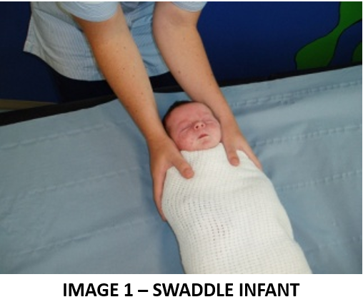
Procedure
- Attend Hand Hygiene
- Identify correct patient as per Patient Identification and Procedure Matching procedure
- Division of TT should only be performed by an IBCLC or Medical Officer accredited in frenotomy as per Staff Development Unit credentialing package.
- Prior to Division of TT informed consent must be obtained from the parents by the clinician performing the division. Informed consent should include complications including:
  - Bleeding
  - Pain relief
  - Infection
- Parents are offered to be present in room when the TT is released
- Swaddle the infant with the arms enclosed
  - The assistant stabilises the infant’s head and shoulders. See Image 1.
- The clinician performing the TT elevates the tongue with index finger and puts TT on stretch. See Image 2
  - The clinician divides the TT to the base with a sterile blunt ended sharp pair of sterile scissors
  - The clinician ensures that the TT is fully divided to base of tongue with blunt dissection to produce a diamond reveal
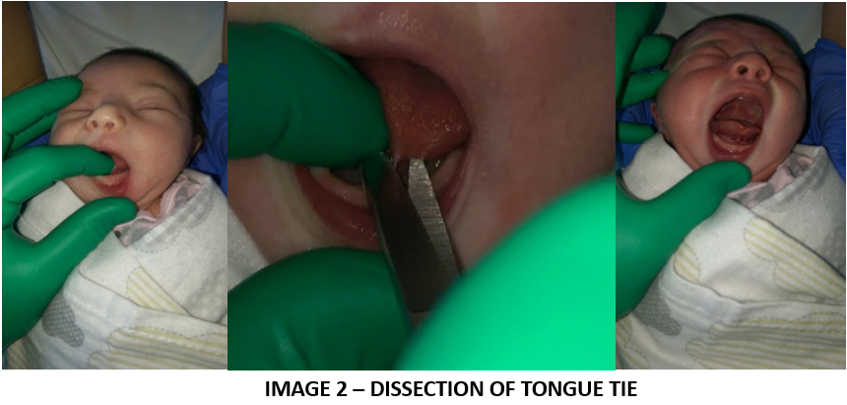
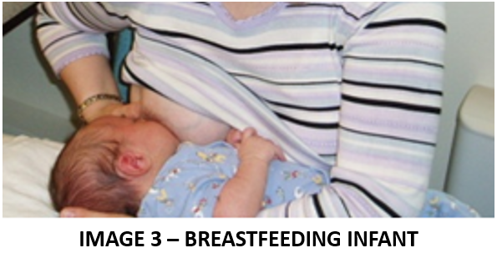
- Blood is removed with sterile gauze
- The infant is transferred to the mother for a breastfeed and the feed is assessed, with support to achieve good positioning and latch if required
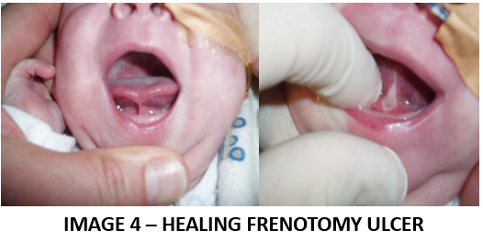
- Parents are advised there a healing ulcer will form in the next few days. See Image 4
- Following release of Tongue Tie the clinician performing the frenotomy will:
  - Arrange for evaluation of the woman and infant’s next feed if on the wards (NICU, SCN, PNW, ANW) for an inpatient; this assessment is to be recorded in the medical record. If TT division is performed in the CHWCTTC for outpatients, arrange for review by the Midwife, Lactation Consultant, or community nurse as soon as possible
  - Offer referral to MACH via Community Health Intake (CHI) as a high priority if they are not already being F/U by Midcall, CMP, MACH
  - Send a letter to the GP informing them of the procedure
  - Medical Officer (MO) to explain to the parents what mobilising exercises of the tongue are and that these should be performed for up 24 hours post procedure
  - Give the mother/parents 6 gloves for the mobilising exercises
  - Request the mother to text after the last of the tongue mobilising exercises and within 24 hours after the procedure to ensure all is well
Note: References for TT division: 2, 3, 5-9, 13, 14, 16, 18, 21, 27, 33, 36

Back to Table of Contents

Section 9 – Care of the Infant in Paediatrics

- Infants admitted to paediatrics with feeding difficulties or slow weight gain are to be checked for TT by a Lactation Consultant (LC)
- If a TT is evident and believed to be related to the feeding problems the infant should be referred for ongoing feeding assessment and support by a lactation consultant or Acute Support Speech Pathology
- If the infant is < 4 weeks of age and the TT has been shown to be related to feeding issues and growth delay in the infant, they can be referred to the CHWCTT clinic or GP/LC /paediatric surgeon for assessment, review and possible frenotomy
- If the infant is >4 weeks of age referral to the GP/LC/paediatric surgeon for review, assessment, and possible frenotomy.
Back to Table of Contents

Evaluation

Outcome
- The cause of poor feeding has been assessed and determined
- All parents of infants with un-resolved feeding difficulties related to TT are offered referral to a member of the neonatal/midwifery/nursing/GP team for assessment if the feeding support does not result in improvement
- The woman/parents demonstrate understanding of TT and division of TT
- The woman/parent’s consent to referral to have the infant reviewed and TT divided
- A well infant ≥37 weeks CGA is appropriately referred to an accredited practitioner for division of TT
- The woman has been referred for community follow up via Midcall, catch and MACH.

Measures
- Governance of this document/process is held jointly by the clinical director of neonatology and the Assistant Director of Midwifery (ADOM). Data will be presented twice yearly to the quality and safety meetings neonatology and maternity
- This document will be discussed in existing program of education, presented at the breastfeeding committee, emailed to staff, and placed in workrooms
Back to Table of Contents

Related Policies, Procedures, Guidelines and Legislation

Policies
- Nursing and Midwifery Board of Australia (NMBA) Requirements for practice
- Informed Consent – Clinical

Procedures
- Infection Prevention and Control
- Patient Identification and Procedure Matching
- Blood Collection using Heel Lance Device and/or venous collection (Neonates)
- Midcall – Early Discharge Service

Guidelines
- Breastfeeding
- Neonatal Routine Care
- Assessment of the Newborn
- Developmental Care in the Neonatal Intensive Care Unit and Special Care Nursery
- Eligibility for Birth Centre and Canberra Midwifery Program

Legislation
- Health Records (Privacy and Access) Act 1997
- Human Rights Act 2004
- Work Health and Safety Act 2011
- Carers Recognition Act 2021

Other
- Australian Charter of Health Care Rights

Forms
- Tongue Tie Assessment and Referral (*40311)
- Tongue Tie Assessment and Treatment (*40312)

Health Information Sheet
- Tongue Tie and Feeding your Baby

Back to Table of Contents

Definition of terms

- Frenotomy: Division of the lingual frenulum to release the tongue
- Tongue Tie (TT): ‘an embryological remnant of tissue in the midline between the under surface of the tongue and the inferior alveolar ridge/floor of the mouth that restricts normal tongue movement’ (^{1-4, 7})

Back to Table of Contents

References

- Coryllos E, Watson Genna C, Salloum A. Congenital tongue tie and its impact on breastfeeding. Breastfeeding: Best for Mother and Infant. American Academy of Pediatrics. 2004: Summer: 1–6
- Griffiths DM. Do tongue ties affect breastfeeding? Journal of Human Lactation 2004; 20(4): 409 – 414.
- Hogan M, Westcott C, Griffiths DM. A randomised controlled trial of division of tongue-tie in infants with feeding problems. Journal of Paediatrics and Child Health 2005; 41: 246-250
- International association of Tongue Tie professionals: Definition of TT, Toronto 2010
- Todd DA. Tongue Ties at the Centenary Hospital in 2008 and 2011. J Paediatr & Child Health: 2013: 46 (supp1); 74
- Todd DA. Tongue-tie in the newborn: what, when, who and how? Exploring tongue-tie division. Breastfeeding Review, 2014; 22: 7–10
- Todd DA, Hogan M. Tongue-tie in the newborn: early diagnosis and division prevents poor breastfeeding outcomes. Breastfeeding Review, 2015; 23: 11–16
- Maya-Enero Prevalence of neonatal ankyloglossia I a tertiary care hospital in Spain: a transversal cross-sectional study. European J Peds. 2021; 180:751-757
- Hill RR, Lee CS, Pados BF. The prevalence in children aged <1 year:a systematic review and meta-analysis. Ped Research 2021; 90 :259–266
- Hazelbaker AK: The assessment tool for lingual frenulum function (HATLFF): Use in a lactation consultant private practice. Pasadena, California, Pacific Oaks College; 1993.
- Hazelbaker AK. Newborn Tongue Tie and breastfeeding. Letter to editor. J Am Board FamPract 2005, 18:326.
- Amir LH, James JP, Donath SM. Reliability of the Hazelbaker assessment tool for lingual frenulum function. Inter Breastfeeding Journal. 2006 : 1; 1-6.
- Amir LH, James JP, Beatty J. Review of Tongue –Tie release at a tertiary maternity hospital. J Paediatr & Child Health 2005; 41: 243-245.
- LeFort Y et al: Academy of Breastfeeding Medicine Position Statement on Ankyloglossia in Breastfeeding Dyads. Breastfeeding Medicine; 2021; 16: 278-281 www.bfmed.org.
- Andre FE, Zuckerman AJ. Review: protective efficacy of hepatitis B vaccines in neonates. J Med Virol 1994;44:144-51
- Ballard JL et al. Ankyloglossia: assessment, incidence, and effect of frenuloplasty on the breastfeeding dyad. Pediatrics 2002. 110 (5): e63.
- Brook MG., Lever AML., Griffiths P., et al. Antenatal screening for hepatitis B is medically and economically effective in the prevention of vertical transmission: Three years experience in a London hospital. Quart.J.Med. 1989; 264:313-317.
- Brookes A and Bowley D. Tongue tie: The evidence for frenotomy. Early Human Development 90 (2014) 765–768
- Conte D, Fraquelli M, Prati D et al. Prevalence and clinical course of chronic hepatitis C virus (HCV) infection and rate of HCV vertical transmission in a cohort of 15,250 pregnant women. Hepatology 2000;31:751-5
- Dienstag JL. Sexual and perinatal transmission of hepatitis C. Hepatology 1997;26(suppl 1):66S-70S
- Francis DO, Krishnaswami S and McPheeters M. Treatment of ankyloglossia and breastfeeding outcomes: a systematic review. Pediatrics 2015;135:6 1458-1466
- Hale and Hartmann’s: Textbook of Human Lactation. 1st edition Hale Publishing 2007
- Hill JB, Sheffield JS, Kim MJ, Risk of hepatitis B transmission in breast-fed infants of chronic hepatitis B carriers. Obstet Gynecol 2002;99:1049-52
- Jones CA. Maternal transmission of infectious pathogens in breast milk. JPaediatr Child Health. 2001;37:576-582.
- Kiire CF. The epidemiology and prophylaxis of hepatitis B in sub-Saharan Africa: a view from tropical and sub-tropical Africa. Gut 1996;38(suppl 2):S5-12
- Kumar RM, Shahul S. Role of breast-feeding in transmission of hepatitis C virus to infants of HCV-infected mothers. J Hepatol 1998;29:191-7
- Lalakea ML, Messner AH. Ankyloglossia: does it matter? Pediatric Clinics of North Am 2003; 50(2):381-97.
- Lawrence RM, Lawrence RA. Breast milk and infection. Clin Perinatol. 2004;31:501-528.
- Numazaki K. Human CMV infection of breastmilk. FEMS Immunol Med Microbiol 1997;18: 91-98
- Papaevangelou V, Pollack H, Rochford G et al. Increased transmission of vertical hepatitis C virus (HCV) infection to human immunodeficiency virus (HIV)-infected infants of HIV- and HCV-coinfected women. J Infect Dis 1998;178:1047-52
- Polywka S, Schroter M, Feucht HH, Zollner B, Laufs R. Low risk of vertical transmission of hepatitis C virus by breast milk. Clin Infect Dis 1999;29:1327-9
- http://www.nice.org.uk/IPG149
- Power RF and Murphy JF. Tongue-tie and frenotomy in infants with breastfeeding difficulties: achieving a balance. Arch Dis Child 2015 100: 489-494
- Ricke LA, Baker NJ, Madlon-Kay DJ, DeFore TA: Newborn tongue tie: prevalence and effect on breast-feeding. J Am Board FamPract 2005, 18:1-7.
- Seeff LB. Natural history of hepatitis C. Hepatology 1997;26(suppl 1):21S-28S
- UNICEF UK Infant Friendly Initiative. Helping a infant with tongue tie. www.infantfriendly.org.uk/tonguetie.asp.
- Walker M. Breastfeeding Management for the Clinician: using the evidence. Boston, Jones and Bartlett. 2006. http://www.cdc.gov/breastfeeding/disease/hepatitis.htm

Back to Table of Contents

Search Terms

Tongue tie, frenotomy, frenulum, tongue tie snip, tongue tie division, Hazelbaker Assessment tool
Back to Table of Contents

Attachment

Attachment 1: Tongue Tie Pathway

Disclaimer: This document has been developed by Canberra Health Services specifically for its own use. Use of this document and any reliance on the information contained therein by any third party is at his or her own risk and Canberra Health Services assumes no responsibility whatsoever.

Policy Team ONLY to complete the following:
Date Amended | Section Amended | Divisional Approval | Final Approval
1/11/2022 | Full review | Susan Freiberg ED WYC | CHS Policy Committee

This document supersedes the following:
Document Number | Document Name
CHHS16/217 | Tongue Tie (TT): Assessment Management and Division

Attachment 1: Tongue Tie Pathway

