Canberra Health Services
Procedure -
Newborn Bloodspot Screening Test

Contents
Canberra Health Services 1
Contents 1
Purpose 2
Scope 2
Alerts 2
Scope 2
Section 1 – Introduction 2
Section 2 – Collection of Samples 4
Section 3 – Newborn Screening Test Procedure 5
Procedure 5
Section 4 – Decline of Test 7
Evaluation 7
Related Policies, Procedures, Guidelines and Legislation 8
References 8
Search Terms 9
Attachments 9
Attachment 1: NBST Quality Check (VCGS, 2021) 11
Attachment 2: NSW Newborn Screening Programme Suggested Disclaimer for Newborn Screening Test 12
Attachment 3: NBST Decline Questionnaire 13

Purpose

Newborn Bloodspot Screening Tests (NBST) are performed to diagnose a number of genetic and metabolic disorders in all newborns. The newborn screening blood sample is to be collected when the infant is 48-72 hours of age or as directed by the sampling times in Section 2. This guideline also aims to align with the NSW and ACT Newborn Screening Programme.
Back to Table of Contents

Scope

Alerts

A NBST must be taken prior to transfusion of any blood products.
Back to Table of Contents

Scope

The document pertains to neonates nursed in the Canberra Health Services (CHS) network, including inpatient facilities at Canberra Hospital, Centenary Hospital for Women and Children and North Canberra Hospital.

This document pertains to the following:
- Medical Officers
- Nurses and Midwives, who are working within their scope of practice (Refer to Scope of Practice for Nurses and Midwives Policy)
- Students under direct supervision.

Back to Table of Contents

Section 1 – Introduction

The Newborn Bloodspot Screening Test was commenced in 1966 in Victoria. The aim of this test is to screen babies nationwide and to save them from lifelong disability or death due to a range of disorders. The range of diseases the NBST investigates are not clinically obvious at birth, but may lead to death, permanent disability or poorer health outcomes if left untreated until they become clinically obvious. This highlights its importance. The first sample collection can indicate a problem may be present and repeat NBST testing +/- other tests are used to confirm whether the disorder is or is not present.

Some of the disorders it tests for and their descriptions are:
DISORDERS | DESCRIPTION
Congenital Hypothyroidism | Reduced production of the thyroxine caused by absence or improper functioning of the thyroid glad. Untreated can lead to severe intellectual disability, growth problems, and deafness.
Phenylketonuria | Inherited autosomal recessive disorder. Deficiency in the phenylalanine hydroxylase enzyme needed to convert phenylalanine to tyrosine. Increase phenylalanine levels in the blood can lead to brain damage. Untreated can cause severe progressive intellectual disability.
Cystic Fibrosis | Inherited autosomal recessive disorder causing increased thickening of mucous in the respiratory and digestive tract leading to susceptibility to respiratory infections and difficult digestion.
Galactosaemia | Inherited disorder that impairs the body’s ability to convert galactose to glucose due to a deficiency in an enzyme called galactose-1-phosphate uridylyl transferase. Untreated can lead to liver failure, intellectual disability.

Note:
For a more comprehensive list of disorders and further information on the NSW Newborn Screening Test processes, refer to the NSW and ACT Newborn Screening Programme.

Responsibility of the clinical team:
- It is important that the clinical staff are aware of the NBST collection sample times
- Medical Officers/Nursing/Midwifery/Medical staff are responsible to obtain parental consent and to document and submit the NBST at the specified sample times
- The NBST card must be filled out completely and correctly
- Consent must be obtained before NBST can be done.
- Verbal consent may be obtained and must be documented in the clinical notes (if NBST needs to be done urgently)
- Written consent must be documented on the NBST card before submission
- Parent/guardians are provided a parent information sheet from the NSW Government, “Newborn Bloodspot Screening – Tests to protect your baby”

Note:
- The “Newborn Bloodspot Screening – Tests to protect your baby” can be found in the NSW Government Health website and is available in different languages.
- Click on link: https://www.health.nsw.gov.au/kidsfamilies/MCFhealth/Pages/tests-newborn-bloodspot.aspx

- Parents are to be informed that if that test is negative, they will not hear anything about the result
- If the test is positive for a disorder, the laboratory staff will inform the medical team, who will arrange further testing and manage care specific to the condition
- Parents are informed that tests are stored and retained for 18 years after testing. After 2 years, the parent/guardian can request the NBST card to be returned to them or destroyed. Refer to NSW and ACT Newborn Screening Programme for further information on storage and reasons for storage
Back to Table of Contents

Section 2 – Collection of Samples

Alert:
For infants who meet multiple criteria for repeat sampling (e.g. birthweight <1500gms and transfusion), choose a repeat sampling time that meets the needs of all criteria to avoid unnecessary repeated sampling.

SAMPLE NUMBER | TIMING OF SAMPLE | CONSIDERATIONS
Routine NBST
1st | 48-72hrs of age | If timeframe missed, collect as soon as possible
SPECIAL CIRCUMSTANCES (REQUIRING ADDITIONAL TESTING)
Blood product or surgery <48hrs of age
1st | Before surgery or transfusion (Do not delay resuscitation) | If sample missed do follow up samples.  Some testing (minority) invalidated by previous blood transfusion for up to 6 months, but most remains possible.
2nd | >48hrs after transfusion | Date and time of transfusion to be documented on NBST card
3rd | >2wks after transfusion | In case of multiple transfusions, sample # 3 to be done 2 weeks after last transfusion but not later than 4-6 weeks of age
If patient having surgery <48hrs of age does not receive any blood products the 2nd sample may be taken as per the “routine” guideline and 3rd sample not required
Total parenteral nutrition
1st | 48-72hrs | Routine sample
2nd | >48hrs after TPN ceased
Birth weight <1500gms (or twin or triplet of baby <1500gms)
1st | 48-72hrs | Routine sample
2nd | 1 month old
EXPECTED (IMMINENT) NEONATAL DEATH
1st | As soon as possible | Not always clinically appropriate. Discuss with family. Important if considering a metabolic diagnosis as cause of death. Minimise patient discomfort especially if receiving comfort care (use arterial line where available)
2nd | 48-72hrs if baby still alive

Back to Table of Contents

Section 3 – Newborn Screening Test Procedure

Equipment
- Alcohol Based Hand Rub (ABHR)
- Newborn Screening Card
- Pathology Request
- Paper Envelope
- Blood collection equipment depends on patient’s access or lack of access.
- Follow Venous & Arterial Access: Management in the Department of Neonatology and Blood Collection using Heel Lance Device (Neonates)
- Optional: Sucrose, Alco-Prep Swab

Procedure
- Identify that neonate is due for NBST (48-72 after birth)
- Explain to parents why the neonate requires the test and provide parent information sheet. See Section 1
- Obtain written consent. Parents must sign and answer questions found at the back of the NBST card

Alert:
- If neonate requires an emergency blood transfusion before 48 hours of age and parents/guardians are not present, staff are allowed to obtain verbal consent, which must be documented in patient’s progress notes.
- After NBST is done, staff must keep card until parents can sign their written consent

- Attend to hand hygiene
- Administer pain relief e.g. sucrose or breast milk 2 minutes before procedure
- Collect and prepare equipment
- Staff including Nurses/Midwives to fill pathology request form with correct patient details and NBST test pathology request
- Complete identification details on NBST card IN BALLPOINT PEN.
- Ensure all fields are completed correctly on card
- Make sure to specify feed type
- Place patient’s pathology identification label on back of card (well clear of the blood spots)
- To be signed by nurse/midwife completing test
- Identify correct patient

Alert:
When completing card for multiple births, write Twin/Triplet 1, Twin/Triplet 2 or Triplet 3 and their name, even if a death of one or more sibling has occurred

- Obtain blood from arterial line or heel lance
- Refer Venous & Arterial Access: Management in the Department of Neonatology and Blood Collection using Heel Lance Device (Neonates) policy

Alert:
Avoiding sample contamination (and the need for repeat testing and/or delayed diagnosis)
- Use non-heparinised syringes and make sure that line is clear of heparinised blood or saline when collecting blood from arterial lines
- Do not layer blood (i.e. repeatedly add blood to the same area of the card)
- Ensure heel is completely dry prior to using the lance for sampling to avoid contamination with alcohol or other cleaning fluids
- Ensure the card is not contaminated with other body fluids or substances e.g. alcohol (hand rub), heparin, water, milk, urine or faeces
- Do not allow card to come into prolonged contact or be stored in plastic as plastics can contaminate the card
- Do not squeeze infant’s heels too hard as this may cause interstitial fluid to contaminate blood and the sample
- Ensure blood on card is completely dry prior to sending for testing

- Fill the circles from one side only. See Attachment 1: NBST Quality Check
- Comfort and settle the infant
- Dispose of used equipment according to WH&S guidelines
- Place completed NBST card in designated drying rack and allow to dry for 4 hours
- Once dry, NBST card and pathology request form to be placed in paper envelope and sent to pathology department (first floor)
- Must not go via pathology shute
- Document NBST in the following:

DEPARTMENT OF MATERNITY | DEPARTMENT OF NEONATOLOGY
- DHR Progress Notes  - Newborn Screening Test Flowsheet  - Personal Health Record (Blue Book) | - Progress Notes  - Neonatal Admission Assessment, Care Plan, and Discharge Planning Form  - Birth Register  - Personal Health Record (Blue Book)

- If repeat newborn screening is required then the date of repeat is to be documented in the patient progress notes and Neonatal Admission Assessment, Care Plan, and Discharge Planning Form
- When the repeat NBST is taken then the documentation is the same as above

Back to Table of Contents

Section 4 – Decline of Test

NBST is a voluntary program. While the test is highly recommended parents have the right to decline. The parent’s decision to decline must be an informed one. Staff must provide the relevant information to allow the parents/guardians enough time to make an informed decision. It is important to explore the reason for the decline.

Equipment
- Alcohol Based Hand Rub (ABHR
- NBST Parent Information Sheet
- NBST Card
- NBST Decline Questionnaire (Attachment 3)

Procedure
- Identify correct patient
- ABHR
- Explore reason for decline

Note:
Concerns around storage and access: Reassure parent/guardian that they can freely opt out of research use, and they can request their baby’s NBST back after 2 years.

- Medical Officer to consult and educate parents on importance of early screening
- Provide Patient Information Sheet
- If parent/guardian maintains decline for NBST
- Decline to be documented on patient’s progress notes
- Parent/guardian to complete and sign Disclaimer Form (Attachment 2) and to answer Decline Questionnaire (Attachment 3). Both forms can also be found in NSW and ACT Newborn Screening Programme Guideline
- “Refusal” to be documented in NBST card and sent to Pathology Department as per Step 6 in Section 3.
- Remind parents that they can change their mind at any time, but some disorders may not be detected if the NBST is not performed within the ideal time frame

Back to Table of Contents

Evaluation

Outcomes
- The procedures and protocols highlighted in this document are easily accessible to staff working in the Division of Women Youth and Children
- The procedure will assist staff in providing quality and safe care to their patients
- This procedure will assist in the education and training to clinical staff.
- Written consent from parents/guardians will be completed prior to all NBST
- NBST will be attended correctly and in a timely fashion

Measures
- Audit of reported incidences via risk management system (Riskman) related to NBST and its documentation
- Review of case reports via clinical meetings that evaluate patient outcomes and quality and safety.
Back to Table of Contents

Related Policies, Procedures, Guidelines and Legislation

Policies
- Nursing and Midwifery Board of Australia (NMBA) Requirements for Practice
- Informed Consent - Clinical

Procedures
- Infection Prevention control and Healthcare Associated Infections Clinical Procedure
- Patient Identification and Procedure Matching
- Blood Collection using Heel Lance Device (Neonates)
- Fresh Blood Products Administration – Adults, Paediatrics, and Neonates

Guidelines
- Venous & Arterial Access: Management in the Department of Neonatology
- Neonatal Routine Care
- Developmental Care in the Neonatal Intensive Care Unit and Special Care Nursery
- Total Parenteral Nutrition in Neonates

Legislation
- Health Records (Privacy and Access) Act 1997
- Human Rights Act 2004
- Work Health and Safety Act 2011

Other
- Australian Charter of Health Care Rights
Back to Table of Contents

References

- Matthews, A and Robin, N. (2006) “Genetic disorders, malformations, and inborn errors of metabolism.” In Merenstein G and Gardner, S Ed Handbook of Neonatal Intensive Care 6th Ed. Mosby Inc St Louis.
- Newborn Screening Guideline, NSW Policy Directive 24 March 2005
- Spiel JK. (1997) Capillary blood collection for neonatal screening tests should require a certificate of competence. Journal - Australian College of Midwives. 10(2) 8-13.
- Victoria Clinical Genetics Services. Newborn Bloodspot Screening Comprehensive Collection Guideline [Internet]. VCGS; 2021 [cited 15 November 2021]. Available from: https://www.vcgs.org.au/sites/default/files/downloads/NBS_collection_guidelines.pdf
- Neonatology. Newborn Screening Test [Internet]. Government of Western Australia. 2021 [cited 15 November 2021]. Available from: https://ww2.health.wa.gov.au/-/media/HSPs/CAHS/Documents/Health-Professionals/Neonatology-guidelines/Newborn-Screening-Test.pdf?thn=0
- NSW Newborn Screening Programme. NSW and ACT Newborn Screening Program [Internet]. 2015 [cited 19 December 2021]. Available from: http://www.schn.health.nsw.gov.au/files/attachments/newborn_screening_guidlines_2015.pdf
- Office of Kids and Families. Newborn Bloodspot Screening [Internet]. Sydney: NSW Government Health; 2016 [cited 19 December 2021]. Available from: https://www1.health.nsw.gov.au/pds/ActivePDSDocuments/PD2016_015.pdf
- Newborn Bloodspot Screening [Internet]. Australian Government - Department of Health. 2021 [cited 19 December 2021]. Available from: https://www.health.gov.au/initiatives-and-programs/newborn-bloodspot-screening
- Cross L. Clinical Guidelines (Nursing) : Newborn bloodspot screening [Internet]. The Royal Children's Hospital Melbourne. 2019 [cited 19 December 2021]. Available from: https://www.rch.org.au/rchcpg/hospital_clinical_guideline_index/Newborn_Screening_Test/
- Maternity, Child and Family. Newborn Bloodspot Screening - Tests to protect your baby [Internet]. NSW Government Health. 2018 [cited 19 December 2021]. Available from: https://www.health.nsw.gov.au/kidsfamilies/MCFhealth/Pages/tests-newborn-bloodspot.aspx

Back to Table of Contents

Search Terms

Neonate, neonatal, Newborn Screening Test, Newborn Bloodspot Screening Test, NST, NNS, NBST, Neonatal Screening Test, Neonatal Bloodspot Screening Test,

Back to Table of Contents

Attachments

Attachment 1: NBST Quality Check (VCGS, 2021)
Attachment 2: NSW Newborn Screening Programme Suggested Disclaimer for Newborn Screening Test
Attachment 3: NBST Decline Questionnaire

Disclaimer: This document has been developed by Canberra Health Services specifically for its own use. Use of this document and any reliance on the information contained therein by any third party is at his or her own risk and Canberra Health Services assumes no responsibility whatsoever.

Policy Team ONLY to complete the following:
Date Amended | Section Amended | Divisional Approval | Final Approval
14 April 2022 | Complete Review | Susan Freiberg, ED-WY&C | CHS Policy Committee
26 April 2022 | Section 3, Step 12: Removed three as there is four circles now and may increase in the future  Step 16: removed extra information about second floor |  | CHS Policy Team

This document supersedes the following:
Document Number | Document Name
CHHS15/145 | Newborn Screening Test

Attachment 1: NBST Quality Check (VCGS, 2021)
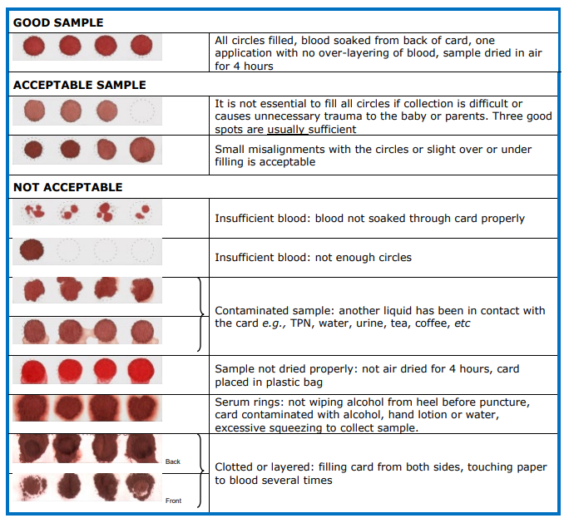

Attachment 2: NSW Newborn Screening Programme Suggested Disclaimer for Newborn Screening Test
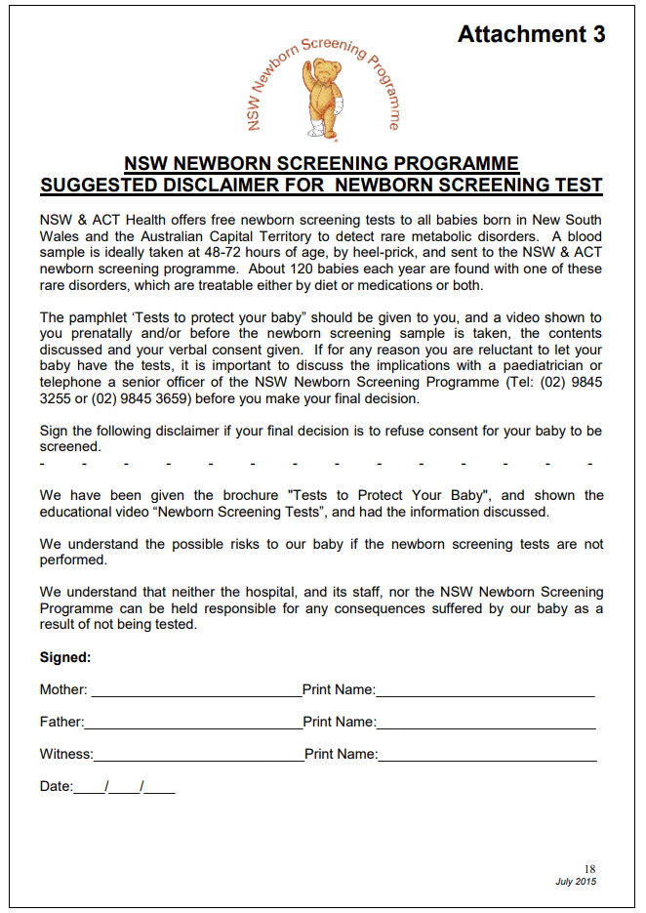

Attachment 3: NBST Decline Questionnaire

