Canberra Health Services
Guideline -
Neonatal Resuscitation and Airway Management Guideline

Contents

Contents 1
Guideline Statement 3
Background 3
Key Objective 3
Scope 4
Section 1 – Neonatal Resuscitation 5
1.1 – Delayed Cord Clamping Considerations during Neonatal Resuscitation 5
1.2 – Initial Assessment 6
1.3 – Breathing Assessment 7
1.4 – Circulation Assessment 9
1.5 – Fluid Resuscitation 11
Section 2 – Special Circumstances 11
2.1 – Meconium-Stained Liquor 11
2.2 – Prematurity 11
2.3 – Congenital Abnormalities 13
2.4 – Pulmonary Hypoplasia 13
Section 3 – Neonatal Versus Paediatric Resuscitation Algorithms 14
Section 4 – When Do We Stop Resuscitation? 14
Section 5 – Post-Resuscitation Care 15
Section 6 – Airway Management 16
6.1 – Basic Airway Skills 16
6.2 – MRSOPA 17
Section 7 – Alternative Airway - Advanced Airway Skills 17
7.1 – Elective/Semi-Elective Intubation 17
7.2 – Use of A Colorimetric Co₂ Detector 19
7.3 – Securing an Oral Endotracheal Tube With A NEOBAR 22
7.4 – Securing a Nasal Endotracheal Tube with Tape 24
7.5 – Laryngeal Mask Airways (LMA) 25
Section 8 – Difficult Airway Procedure 26
8.1 – Key Messages 26
8.2 – Options to Consider in Order to Achieve Effective Mask Ventilation 27
8.3 – Options to Consider in Order to Achieve Alternative Airway (In No Particular Order) 27
Section 9 – Pre-Oxygenation and Apnoeic Oxygenation 29
9.1 – Pre-Oxygenation 29
9.2 – Apnoeic Oxygenation 30
Evaluation 30
Related Policies, Procedures, Guidelines and Legislation 31
References 32
Search Terms 33
Attachments 33
Attachment 1: Neonatal Advanced Life Support Algorithm 34
Attachment 2: Neonatal Resuscitation Checklist 35
Attachment 3: Draft intubation checklist being used on a trial basis in the NICU 37

Guideline Statement

Background
Up to 10% of babies require some assistance at birth and up to 1% require significant resuscitative efforts. There are identifiable risk factors for many neonates who require assistance but neonates with an unexpected need for resuscitation remain a significant subgroup. Staff and equipment should be ready to provide assistance at every birth.

This document aims to support staff caring for neonates and/or their mothers before, during or after birth to perform appropriate neonatal resuscitation. It is to be used in conjunction with mandatory staff education programs as outlined below.

Key Objective
This guideline provides background information and supports what is taught in Neonatal Basic and Advanced Life Support education sessions. It provides a framework for airway management including management of the “difficult airway.”

Neonatal Resuscitation Team
Management of neonatal team attendance at birth is outlined in Birth Requiring The Presence Of A Neonatal Team Member guideline. The guideline outlines risk factors necessitating neonatal team attendance, referral processes and staff roles.

Additionally, neonatal resuscitation capability may be required within other areas of the hospital. The neonatal team (medical and nursing) provide a neonatal MET team response for neonates and infants up to one year of age (Canberra Hospital Emergency response Plan Code Blue).

All staff must be aware of how/who they need to call to get help. Consultant medical staff should be:
- in attendance at all births of an infant less than 28 weeks
- in attendance at all births where significant resuscitation is anticipated e.g. major congenital anomalies
- made aware of all category A Caesarean sections and Neonatal Code Blues

Consultant medical staff will attend at their discretion, based on assessment of the facts of the case. As required, the neonatal fellow and/or consultant on call will support the clinical team, to assist where:
- the clinical care requirements exceed the experience of the registrar on duty
- during multiple births
- where there is a risk of multiple simultaneous issues.
- At North Canberra Hospital (NCH) when Instrumental birth is required (in Birth Suite or OT), or at the discretion of the Obstetric registrar/SCN team leader

The Neonatal Intensive Care Unit (NICU) nursing team leader at CHWC or SCN team leader at NCH can be called at any time to facilitate additional nursing staff or equipment that may be required at a delivery/resuscitation.

Alert
- All staff should be aware of their mandatory neonatal life support education requirements and maintain up to date competencies.
- All neonates should have a post-natal risk assessment and minimum vital sign requirement as outlined in the guideline “Vital signs and early warning scores.”

Back to Table of Contents

Scope

Neonatal resuscitation is a core skill for all staff caring for neonates or their mothers before, during or after birth.

Mandatory education for staff who provide this care at Canberra Health Services is outlined in the Canberra Health Services Code Blue guideline. This includes the Neonatal Resuscitation e-learning education and assessed against Neonatal Advanced Life Support (NALS) yearly competencies. First responders to neonatal emergencies are required complete the Neonatal Advanced Life Support (NALS) advanced skills e-learning and face-to-face training program every five years.

This guideline is not intended to be an exhaustive document and is not an alternative to completion of the mandatory education appropriate to a staff members employment. Staff should refer to guidelines from various national and international bodies for an in-depth discussion of the evidence for various interventions as required; see References.

This document is applicable to clinicians working within their scope of practice:
- Medical Officers
- Nurses / Midwives
- Students under direct supervision.
Back to Table of Contents

Section 1 – Neonatal Resuscitation

Alert
Call for help from the consultant or fellow on call as soon as possible when a resuscitation requires significant intervention or difficulties are encountered.

Neonatal resuscitation follows a standard algorithm as shown in Attachment 1. Preparation is key to a successful resuscitation. All birthing rooms and ward areas should have basic resuscitation equipment ready for use at all times. Additional equipment should be prepared as required for cases with known risk factors prior to birth. In cases of an expected need for resuscitation at birth the resuscitation checklist should be utilised during preparation; See Attachment 2 – Resuscitation Checklist.

1.1 – Delayed Cord Clamping Considerations during Neonatal Resuscitation
Delayed cord clamping (DCC) may assist in the transition from fetal to neonatal life and should be planned in advance, in consultation with the birthing team. The procedure should be performed as per the Labour: Care During First, Second, Third and Fourth Stage guideline. Infants should be assessed throughout to ensure they are still breathing effectively. DCC should be stopped with immediate clamping of the cord in case of apnoea or ineffective breathing with inadequate/no response to stimulation. Both neonatal and obstetric/midwifery teams should be aware of the relative and absolute contraindications for delayed cord clamping.

Contraindicators for DCC:
- Apnoea/ineffective breathing despite stimulation
- Interruption of placental blood flow or oxygenation
- abruption
- significant maternal haemorrhage (e.g., bleeding placenta praevia)
- vasa praevia
- active maternal seizure or other cause of maternal hypoxia
- cord avulsion (snapped cord)
- Recipient twin in twin-to-twin transfusion syndrome (for donor twin- DCC is recommended)
- Hydrops fetalis due to any cause
- Selected congenital malformations
- congenital Diaphragmatic Hernia- immediate intubation recommended
- severe congenital heart disease such as Hypoplastic Left Heart Syndrome requiring immediate intubation/resuscitation
- Myelomeningocoele- to ensure exposed organs/tissues are rapidly covered and protected
- Gastroschisis- to ensure exposed organs are rapidly covered and protected

Possible contraindicators for DCC:
Clinical judgement of the team is required for the following non absolute contradictions for DCC:
- Severe fetal distress and Caesarean section under general anaesthesia are situations where the risk of apnoea or ineffective breathing are high
- Fetal Growth Restriction (FGR) with abnormal uterine artery Dopplers (these infants may already have polycythaemia and placental blood flow may be compromised).

1.2 – Initial Assessment
Initial Assessment Criteria
- Term Gestation?
- Good Tone?
- Breathing (Crying)?

If “yes” to all three criteria.
It is usually appropriate for the neonate to stay skin-to-skin with the mother with further assessments be performed there:
- dry the neonate, remove wet linen and position so that the airway remains in a neutral position
- in adequate light: assess the infant’s colour and effort of breathing
- in addition to skin-to-skin contact, warm towels or blankets may assist to keep the neonate warm
- regularly reassess the neonate to ensure fetal to neonatal transition has occurred and thermoregulation is being maintained e.g. assessment of tone, effort of breathing and temperature
- if required clear secretions by positioning (using gravity) or suction.
In all other cases the neonate should be assessed on a Resuscitaire:
- dry and stimulate the neonate, provide radiant heat and remove wet linen
- position airway in neutral position (See Figure 1) and clear secretions if required using gravity drainage or suction. Further assess breathing and heart rate
- assess the need to call for help.
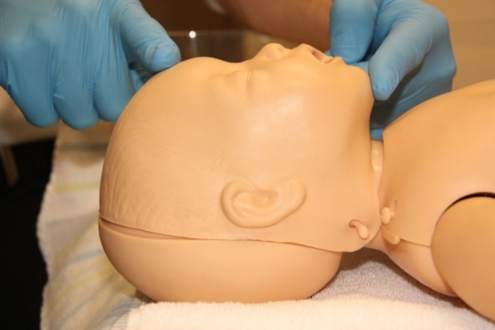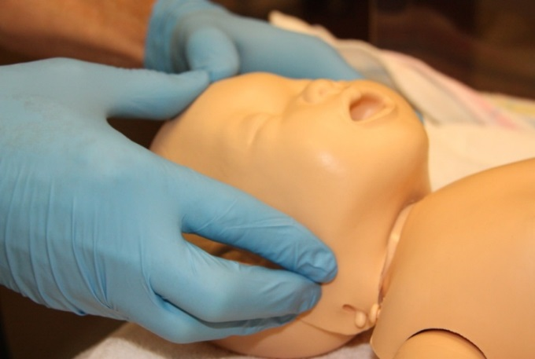
a). Neutral position with chin lift b). Neutral position with jaw thrust
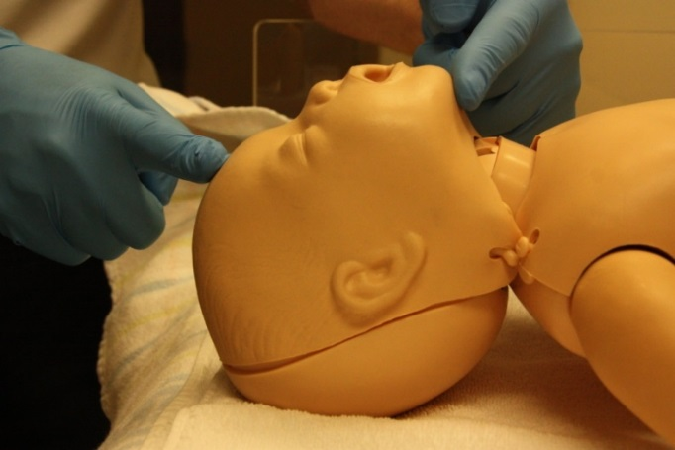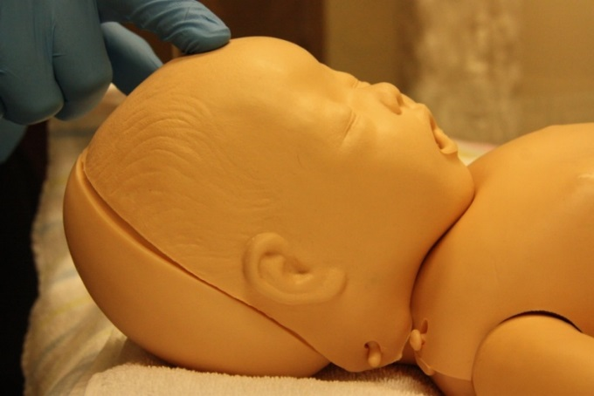
c). Hyperextended d). Flexed neck (chin on chest)
Figure 1: The neutral position maximises the patency of a neonate’s upper airway. Flexed and extended positions may cause upper airway obstruction. The neutral position should be maintained at all times. A towel behind the shoulders may assist with this in an infant with a large occiput (most infants).

1.3 – Breathing Assessment
Is breathing effective?
If “no” and neonate is apnoeic or gasping:
- apply intermittent positive pressure ventilation (IPPV) using a mask (See Figure 2- Mask Sizing) and neopuffing should commence
- establish monitoring (Oxygen saturation probe is minimum, three-lead electrocardiogram (ECG) also useful)
- arrange for heart rate to be checked by another team member. If the heart rate is below 100/min then IPPV should be given regardless of breathing
- ensure that IPPV is effective (chest moving, air entry, clinical improvement)
- If IPPV is not effective, troubleshoot for causes and solutions (see MRSOPA in Section 6 – Airway Management).

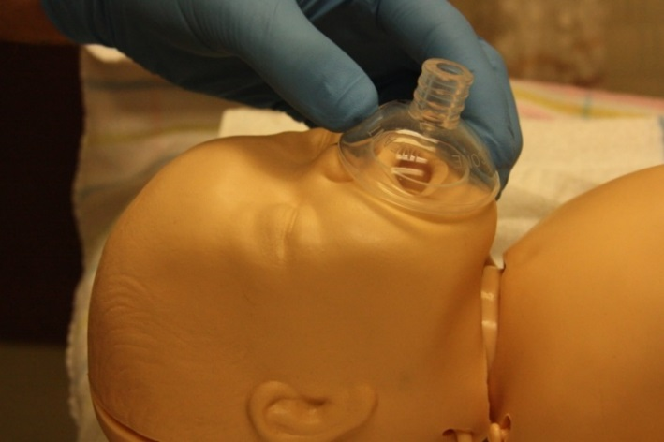 | 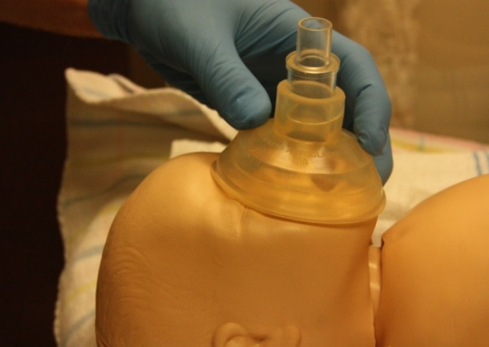
a). Too small | b). Too large
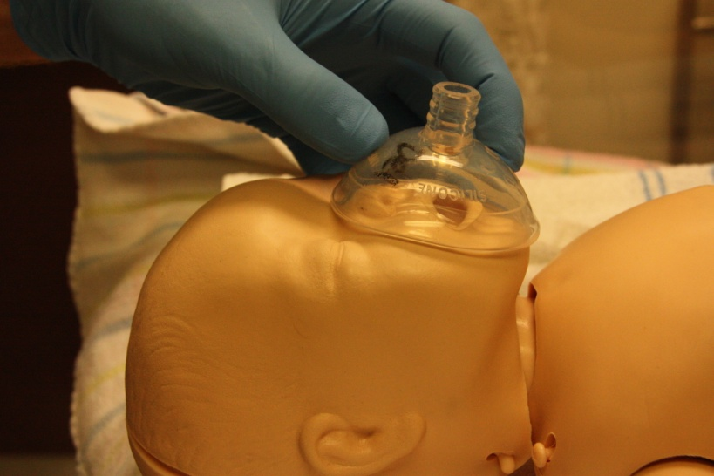
c). Just right
Figure 2: Mask sizing- should cross the bridge of the nose without impacting on the eyes and sit on the chin

All neonatal resuscitations should have blended air and oxygen available, and for term and near-term neonates, resuscitation should begin with air as the gas of choice. Oxygen should be blended in as required to achieve target oxygen saturations. Oxygen use during resuscitation of preterm neonates is further discussed below in Section 2.2 - Prematurity.

Target Oxygen saturations (regardless of prematurity) are as follows:
AGE AFTER BIRTH | TARGET SATURATION
1 min | 60-65%
2min | 65-70%
3min | 70-75%
4min | 75-80%
5min | 80-85%
10min | 85-95%

In the case of IPPV being required:
- Heart rate should be rechecked after 30 seconds of effective ventilation:
- if heart rate is less than 100/min, reassess the effectiveness of the IPPV- chest movement, air entry and work through the MRSOPA checklist (Section 6.2 - MRSOPA)
- if these steps are ineffective the final MRSOPA step is an alternative airway- intubation or Laryngeal Mask Airway (LMA). See Section 7.

Is breathing effective but with persistent cyanosis and/or laboured breathing?
- airway position as required
- Apply monitoring
- Commence mask/neopuff Continuous Positive Airway Pressure (CPAP) with supplemental oxygen as required
- Ensure constant attention to airway position (neutral +/- jaw thrust) and maintenance of continuous mask pressure (critical for effective CPAP)
- monitor the pressure being delivered and ensure minimal interruptions to pressure delivery
- every time the seal between the mask and the face is broken the neonate’s lungs will lose the additional functional residual capacity that was gained with CPAP and the recruitment of the lungs “starts again.”

1.4 – Circulation Assessment
Is circulation adequate?
The initial response to bradycardia during neonatal resuscitation is to establish effective ventilation as detailed above.

Where the heart rate remains less than 60/min after 30 seconds of effective IPPV, chest compressions are required:
- coordinate chest compressions with IPPV at a ratio of three compressions to one breath. See Figure 4, compression techniques
- deliver 100% oxygen
- apply saturation monitoring (and ECG if available).

Continued mask ventilation may be appropriate and avoids ventilation gap during intubation. However, if ineffective, intubation should be considered.

In the case of prolonged attempts to achieve effective ventilation it may be appropriate to start chest compressions prior to effective ventilation. Although there are no current specific guidelines, 90 seconds to two minutes of age is an appropriate time to start compressions if ventilation attempts have been ineffective.

The team should continue to take corrective measures to achieve effective ventilation while chest compressions are ongoing. Intubation is likely to be the most effective solution and should be done with minimal interruption to chest compressions.

All cases of prolonged chest compressions require intubation (although mask ventilation may continue until help arrives).

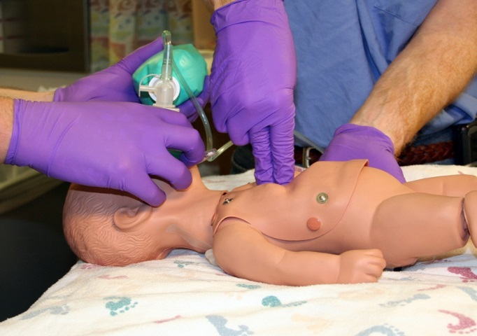 | 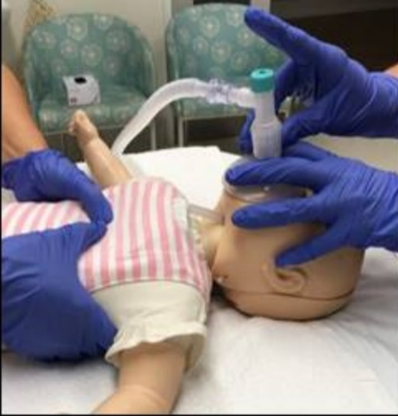

Figure 4. a). two-finger chest compression technique b). Encircling or two-thumb technique

Both techniques should compress the sternum 1/3 of the AP diameter of the infant’s chest.

Note
According to Australian and New Zealand Committee on Resuscitation (ANZCOR), the only circumstance where the two-finger technique should be considered is when there is only one resuscitator. The two-thumb technique is preferred as it has been shown to improve perfusion during chest compressions, however during the insertion of an emergency UVC this technique may interfere with the access of the other clinician and the two-finger method may be useful.

In all infants requiring chest compressions:
- The team should begin preparations for an emergency Umbilical Venous Catheter (UVC) to deliver adrenaline or fluid (O negative blood or 0.9% saline) as required
- Heart rate (HR) should be checked after approximately one minute of chest compression
- If HR is persistently less than 60/min then:
- a UVC should be inserted, (as per NALS advanced skills teaching)
- IV Adrenaline should be administered through the UVC (dose 0.1-0.3mL/kg of estimated birthweight of 1:10,000 adrenaline (=10-30mcg/kg of estimated birthweight)
- In line with standard resuscitation practice, minimising lapses in chest compressions is important in maintaining organ perfusion during asystole/profound bradycardia
- Adrenaline may also be given via an endotracheal (ET) tube at a dose of 0.5-1mL/kg of 1:10,000 (=50-100mcg/kg) (however IV is preferred).

Note
There is limited evidence to guide timing of repeated doses of IV adrenaline in neonatal resuscitation but a three to five minute cycle with heart rate/rhythm checks prior to each dose is what is generally practiced.

1.5 – Fluid Resuscitation
IV fluids have a limited role in neonatal resuscitation as most compromised infants are hypoxic and acidotic but not hypovolaemic. Types of IV fluids administered during resuscitation are O Negative blood or 0.9% saline.

O-Negative Blood
In cases of known bleeding (abruption, placenta praevia etc) the blood loss is usually primarily maternal. Notably small volume blood loss from a neonate may be haemodynamically significant (total blood volume of a term newborn 80mL/kg). In such cases 10-20mL/kg of blood is the preferred fluid as it replaces oxygen carrying capacity as well as volume.

0.9 % Saline
In the absence of known bleeding or clinical signs of anaemia e.g. extreme pallor (noting that severe acidosis also may lead to pallor secondary to poor skin perfusion) it is reasonable to treat a neonate requiring resuscitation with chest compressions with a fluid bolus of 10-20mL/kg of 0.9% saline. However repeated boluses are unlikely to benefit a neonate who is not hypovolaemic. If required please request “1 unit O negative, non-irradiated blood urgently” to your location from the transfusion laboratory (ext 42918).

Back to Table of Contents

Section 2 – Special Circumstances

2.1 – Meconium-Stained Liquor
Meconium-stained liquor is a risk factor for the need for resuscitation and in the past these infants were treated differently to others. More recent evidence suggests that this does not improve outcomes and therefore neonates with meconium-stained liquor should be resuscitated in the same way as any other. The only exception to this is in the rare case of ineffective ventilation with suspected airway obstruction, where intubation and use of a meconium aspirator to clear meconium from the trachea may be attempted prior to reintubation or further attempts at mask ventilation. Routine suctioning is no longer practiced and serves only to delay effective ventilation.

2.2 – Prematurity
Preterm infants have increased risk of lung disease, impaired transition to postnatal cardio respiratory function and difficulties with thermoregulation.

Note
For the retrieval and care of a less than 28 week and less than 1000 gram neonate, refer to the Care of the Extremely Preterm and Low Birth Weight Baby – the Golden Hour Guideline.

Cardio-Respiratory Care
The requirement for ongoing respiratory support in the Neonatal Intensive Care Unit (NICU) is much higher among premature neonates (approaching 100% if born less than 30 weeks gestation).

Evidence suggests resuscitation with blended air/oxygen reduces hypoxia and hyperoxia compared to resuscitation in air or high FiO2:
- for infants less than 28 weeks gestation, it is usual practice to take surfactant to the delivery room/theatre and administer it there if required. It may also be appropriate to have surfactant immediately available in cases of prolonged rupture of membranes from an early gestation or non-steroid covered infants up to a higher gestation
- for infants less than 32 weeks gestation:
- it is recommended to begin in 30% oxygen and adjust delivered oxygen to achieve target saturations
- most will require at least short-term respiratory support in the NICU with CPAP. The oxygen saturation targets after birth remain the same as term infants and oxygen should be titrated to achieve these targets
- for infants 32 to 35 weeks gestation clinical judgment is required as no firm recommendations are available. national and international guidelines recommend resuscitation in 21% to 30% oxygen.

In extreme prematurity, it may be appropriate to limit resuscitative efforts within the immediate post birth period to respiratory interventions only. If these infants do not respond to effective respiratory support (given that lung disease is most often the major pathology), chest compressions and other interventions are unlikely to lead to a different outcome. The antenatal consult should discuss these issues as appropriate.

Thermoregulation
Preterm neonates require optimal conditions for effective thermoregulation in the delivery room/theatre. The e-prem pathway/checklist found in the Care of the Extremely Premature and Low Birth Weight Neonate – The Golden Hour guideline can assist with this. Measures include:
- radiant heat
- raising delivery / theatre room temperature
- use of heated, humidified gas in the Neopuff
- minimising draughts
- wrapping undried neonates in plastic wrap
- transferring neonates in a prewarmed isolette with the shuttle.
- use of self-heating gel mattresses (chemical reaction) available from NICU for use at emergency deliveries.
Regardless of the measures used, regularly checking the infant’s temperature is crucial to allow appropriate adjustments and prevent hyperthermia or hypothermia.

2.3 – Congenital Abnormalities
Cardiac Anomalies
Infants with congenital cyanotic cardiac anomalies may have persistent cyanosis at birth but are otherwise usually initially well. Infants with antenatally known congenital heart disease whose birth is planned for a non-cardiac centre (such as Canberra), will usually achieve normal saturations in the immediate period after birth. These infants should have the same targets as other neonates.

Neonates with severe congenital heart lesions, either antenatally diagnosed (with planned delivery in cardiac centre) or postnatally diagnosed, may remain cyanosed. Management in these cases should be consultant led and in consultation with a cardiac centre. These neonates may require alternative oxygen saturation targets.

Non-Cardiac Anomalies
Several non-cardiac anomalies require special treatment at birth. Neonates with congenital diaphragmatic hernia require early intubation. Other forms of respiratory support should be avoided to prevent gaseous distention of bowel loops within the chest and the associated respiratory compromise. Babies with abdominal wall defects requiring respiratory support should also be intubated in preference to CPAP. This also prevents distention of extra-abdominal bowel. Those without the need for respiratory support may remain self-ventilating.

2.4 – Pulmonary Hypoplasia
“Dry lung” or significant pulmonary hypoplasia many require high levels of respiratory support after birth. Causes include:
- neonates born with some thoracic anomalies
- following prolonged pre-labour rupture of membranes
- other causes of severely reduced amniotic fluid volumes from an early gestation (usually prior to 24 weeks gestation).

Appropriate respiratory support measures include:
- mechanical ventilation
- inhaled nitric oxide or other vasodilators
- surfactant and cardiovascular support.

These resuscitations should be consultant led and appropriate preparation carried out prior to birth, including role allocation, equipment preparation and resuscitation planning.

Note:
Women presenting to North Canberra Hospital in threatened premature labour <34 weeks gestation should be considered for transfer to CHWC as per CHS Preterm Labour Clinical Guideline
Back to Table of Contents

Section 3 – Neonatal Versus Paediatric Resuscitation Algorithms

A key difference between the neonatal and paediatric resuscitation algorithms is the ventilation to chest compressions ratio (3:1 vs 15:2, respectively):
- neonates at birth should be resuscitated with the neonatal algorithm of 3:1 chest compression to ventilation ratio, regardless of patient location
- neonatal patients (less than 28 days of age or 44 weeks corrected age) within postnatal care areas, the NICU and Special Care Nursery (SCN) should be resuscitated with ratio of 3:1 for simplicity and consistency
- paediatric patients (greater than 28 days of age or 44 weeks corrected age) being cared for in the NICU, should be resuscitated using the paediatric algorithm of 15:2

Alert
NICU staff attending to assist with resuscitations in other parts of the hospital (responding to Neonatal MET calls on paediatric patients up to 1 year of age) are recommended to NOT change the ratio from 15:2 to 3:1 (even if the patient is less than 28 days old and would be resuscitated with 3:1 in the NICU).

This is for consistency and to avoid creating confusion of those already involved in the resuscitation, as teams within ED or the Paediatric unit are likely to be more familiar with the 15:2 ratio of a paediatric resuscitation.

Back to Table of Contents

Section 4 – When Do We Stop Resuscitation?

Current best practice states that neonatal resuscitation should stop after 10 minutes if there is no response to treatment. In practice, it is often 15-20 minutes after birth when all interventions which are likely to make a difference to the neonate have been attempted. For this reason, how long resuscitation should continue without a response, is situation dependent and the decision needs to be made by the senior clinician (usually neonatologist) involved at the time. Things to consider:
- it should be at least 10 minutes of resuscitation without a detectable heart rate and all interventions likely to make a difference should be utilised.
- resuscitation should not proceed beyond the point of futility. Good outcomes in patients requiring chest compressions beyond 20-30 minutes are very rare.

All decisions should be made with the family kept informed as far as is possible given the acuteness of the situation.

Note
The benefits to families of “getting a heart rate back”, thus allowing parents to spend a small amount of time with their loved one should not be underestimated.

This applies even if it is in intensive care prior to a withdrawal of intensive care and palliation for severe perinatal brain injury.

Back to Table of Contents

Section 5 – Post-Resuscitation Care

A successful resuscitation must be followed by effective post resuscitative care to facilitate the neonate’s transition to normal post-natal cardiovascular and respiratory function. An extensive discussion of this topic is beyond the scope of this document. The following key principles apply.

Follow an Airway, Breathing, Circulation, and Disability (neurological - ABCD) approach to assessment and treat problems as they are identified . Reassess as required and always consider blood glucose and temperature.

Airway
Maintain patency through positioning or airway devices as appropriate

Breathing
Support breathing as required to maintain normal gas exchange (oxygen saturations and PaCO2 (CO2 may be allowed to normalise over time), and also consider the effort of breathing:
- include management of increased work of breathing and apnoea
- target treatments to the specific problems identified
- significant respiratory compromise should always lead to investigation for infection. Treatment with antibiotics, as clinically indicated, until infection can be ruled out

Circulation
Circulatory compromise should be assessed comprehensively, and include history, examination and investigations. Note early blood gases in newborns largely reflect in utero oxygenation and perfusion, therefore a metabolic acidosis is not necessarily a reflection of current cardiovascular status:
- treatment may involve volume replacement and or myocardial support.
- specific treatments for an underlying cause such as a congenital heart disease or transitional problem should also be considered
- significant circulatory compromise should always lead to investigation for infection. Treatment with antibiotics is appropriate until infection can be ruled out

Disability (Neurological Assessment)
There is a well-established process (Neonatal Neurology guideline and Thompson score charts found within the form Neonatal Encephalopathy Charts located on the Clinical Forms Register) for assessing for encephalopathy in infants after birth which have required resuscitation, or those with significant acidosis:
- assess the criteria and discuss with the fellow and/or consultant on call prior to starting therapeutic hypothermia.
- avoid overheating the infant. The aEEG (Brainz) monitor can be used as an adjunct to this assessment in borderline cases. This takes time to record data and should not delay cooling in cases which meet criteria. Refer to Neonatal Neurology guideline.
- examine tone, tendon and primitive reflexes, movement patterns, alertness, fontanelle and pupils
- in all cases a thorough neurological examination should occur and be documented.

Thermoregulation and Glucose Management
Abnormal temperature or blood glucose may cause significant abnormalities in any or all of the above (ABCD). Ensure they are checked and treated appropriately and measures implemented to maintain normal thermoregulation and blood glucose.

Back to Table of Contents

Section 6 – Airway Management

6.1 – Basic Airway Skills
Key with the use of all basic airway manoeuvres is to establish and maintain effective ventilation as evidenced by chest movement, air entry on auscultation, improvement in oxygen saturations and heart rate and expired CO2 detection.

Neopuff And Face Mask
- Can be used to deliver intermittent positive pressure ventilation to patient with apnoea or ineffective breathing
- Can be used to deliver continuous positive airway pressure (CPAP or PEEP) to patient with effective breathing but who has increased work of breathing or hypoxia
- See Figure 3- Mask Sizing in Section 2.2.

Self-Inflating Bag (Laerdal^{tm}) And Face Mask
- Can be used to deliver intermittent positive pressure ventilation to patient with apnoea or ineffective breathing
- Does not deliver CPAP/PEEP
- Does not reliably deliver oxygen by flow alone. If used, the bag must be regularly squeezed in order to reliably deliver fresh gas flow to the patient

Nasopharyngeal Tube with Neopuff
- Can be used to deliver continuous positive airway pressure (CPAP or PEEP) to patient with effective breathing but who has increased work of breathing or hypoxia
- Is generally ineffective when delivering IPPV due to leak

6.2 – MRSOPA
Inability to achieve effective ventilation should prompt staff to work through the MRSOPA mnemonic of possible solutions to ineffective ventilation.

M | MASK | Correct size, correct positioning, adequate seal
R | REPOSITION AIRWAY | Correct flexion or extension back to a neutral airway position, provide jaw thrust
S | SUCTION | To clear secretions
O | OPEN MOUTH
P | PRESSURE INCREASE | - To help overcome surface tension/ initial resistance to small airway opening  - Consider Pneumothorax and treat if required  - An increased inspiratory time (longer slower breaths) may also assist with the initial opening of lungs
A | ALTERNATIVE AIRWAY | Intubate/Laryngeal mask Airway (LMA)
Back to Table of Contents

Section 7 – Alternative Airway - Advanced Airway Skills

7.1 – Elective/Semi-Elective Intubation
Intubation provides a definitive long-term airway for IPPV or mechanical ventilation with maximum protection against aspiration. The maximum benefit is obtained with a correctly sized endotracheal tube (ETT). An undersized tube, with significant leak, may not be sufficient to achieve effective ventilation in all cases and provides less protection against aspiration.
Intubation requires significant skill and practice to action safely and quickly. Intubation protects the gut from gas insufflation, which may be associated with other methods of assisted ventilation. All elective or semi elective intubations should utilise the intubation checklist to assist teamwork and patient safety. See Attachment 3 – Intubation

Note
Surfactant Administration is a key treatment in Neonatology, especially for preterm infants. See Surfactant therapy for newborns guideline.

For elective extubations refer to the Respiratory Support – Invasive and Non-Invasive (Neonates and Infants) Procedure

Checklist
Equipment
- Elective intubation checklist when appropriate
- Resuscitation trolley in room (or retrieval bag if outside NICU)
- Prepared ventilation device (Neopuff) +/- ventilator
- Suction prepared with 10-12 FG catheter, plus size 6-8 FG for suctioning the ET tube
- Appropriately sized face mask
- Endotracheal tube (ETT) (see table below for correct sizing) +/- Introducing stylet

Tube Size mm | Weight (grams) | Gestational Age (weeks)
2.5 | Below 1,000 | Below 28
2.5 – 3.0 | 1,000 – 2,000 | 28-34
3.0 – 3.5 | 2,000 – 3,000 | 34-38
3.5 – 4.0 | Above 3,000 | Above 38

- Laryngoscope (light checked), Blade 1 (term), Blade 0 (preterm), Blade 00 (<1000gms)
- Prepared tapes for securing endotracheal tube (see Appendix X) and Scissors
- Stethoscope
- Monitoring equipment
- CO₂ Colorimetric detector
- Drugs for premedication prepared- see the Neonatal Intensive Care Drug Manual

Procedure
For all procedures use appropriate PPE, hand hygiene and aseptic techniques
- Assemble and prepare all equipment using checklist
- Prepare medications using standard checking procedure
- Position the infant supine on a flat surface with the head in a midline position. If the infant is in an enclosed crib, ensure laryngoscope will be clear of obstruction from crib wall/roof during the procedure
- Suction nose and oropharynx as necessary
- Intubate (medical officer) and hold tube at recommended length

ETT LENGTH AT LIPS (CM) | CORRECTED GESTATION (WEEKS) | ACTUAL WEIGHT (KG)
5.5 | 23-34 | 0.5-0.6
6.0 | 25-26 | 0.7-0.8
6.5 | 27-29 | 0.9-1.0
7.0 | 30-32 | 1.1-1.4
7.5 | 33-34 | 1.5-1.8
8.0 | 35-37 | 1.9-2.4
8.5 | 38-40 | 2.5-3.1
9.0 | 41-43 | 3.2-4.2

- Monitor the heart rate, saturation and time taken during the procedure and alert medical officer of significant issues (as per thresholds on checklist)
- Assess tube position
- attach CO2 detector and ensure appropriate colour change (see below)
- clinically assess tube position- Auscultate for equal air entry, assess chest wall movement and clinical response (heart rate, oxygen saturations and colour)
- Secure ETT (see below)
- Attach to ventilator with preset parameters once ETT secure, monitor clinical and ventilator parameters and adjust as required
- Confirm position with chest x-ray – assist radiographer, ensure the infant not rotated
- ETT tip should be at the level of the T1-T2 vertebra on chest x ray
- Shortening the external part of the ETT may optimize ventilation by reducing dead space and tube resistance – this is a two-person procedure and the medical officer must be in the unit and aware this procedure is in progress. Refer to Respiratory Support – Invasive and Non-Invasive (Neonates and Infants)
- ETT position must be confirmed as correct prior to shortening
- infant must be settled and have stable cardiorespiratory status
- cut the ETT at a slight angle which makes it easier to reconnect afterwards
- Document the position of the tube in the nursing notes
- Vent the stomach by passing an orogastric tube
- Reposition the infant comfortably
- Update the parents and support them as necessary.

7.2 – Use of A Colorimetric Co₂ Detector

Procedure
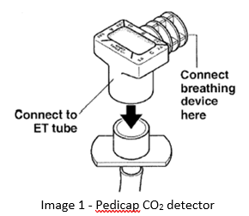
- The detector is connected between the outer end of the ETT and the manual ventilation device. (Image 1).
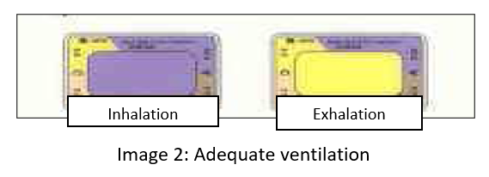
- The CO₂ detector changes from purple to yellow which verifies that exhaled CO₂ is being detected and returns to purple during inspiration of gas that is free of CO₂. (Image 2).
- It may take up to six breaths for the colour change to occur
- If colour remains purple or an intermediate tan colour (Image 3):
- the ETT may be in the esophagus (gastric distension with air prior to attempted intubation may introduce CO₂ levels as high as 4.5% into the detector, if the ETT is misplaced in the esophagus
- insufficient tidal volumes are being delivered (blocked tube, need to increase PIP or large leak around ETT) the infant is in circulatory arrest.
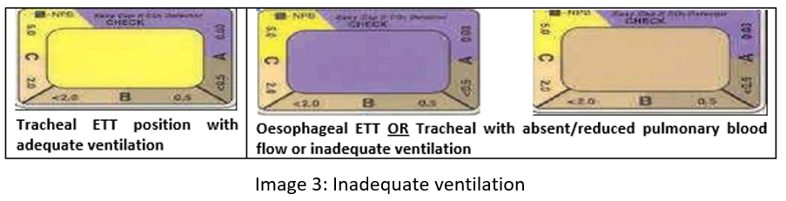

Note:
If the exhaled CO₂ detector window stays yellow on both inspiration and expiration, this indicates a damaged detector (Image 4). Reasons for damage may include:
- Contamination with Adrenaline
- Contamination with surfactant
- Exposure to gastric juices
- Prolonged exposure to high humidity
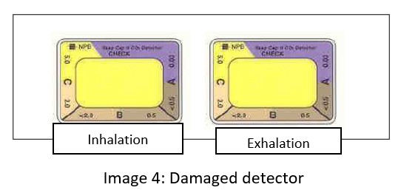

- The colorimetric CO₂ detector may provide constant visual feedback for up to two hours e.g., for transport.
- When a Heat and Moisture Exchanger (HME) is used:
  - Connect the HME to the ETT
  - Connect the exhaled CO₂ detector to the HME
  - Connect the breathing device to the detector
- If exhaled CO₂ detector results are not conclusive, the ETT should be immediately reinserted unless correct anatomic location can be confirmed with certainty by other means:
  - Improved vital signs (heart rate, saturation levels & colour, activity)
  - The CO₂ detector turned gold after 5 breaths
  - Breath sounds heard over both lung fields
  - Symmetrical chest movement with each breath
  - No gastric distension with ventilation
- The exhaled CO2 detector will respond to CO₂ in the presence of a main stem bronchial intubation. Standard clinical assessment should be used to confirm proper position of the ETT within the trachea: improved vital signs (heart rate, saturation levels & colour, activity), breath sounds heard over both lung fields, symmetrical chest movement with each breath, no gastric distension with ventilation

Alert:
- The exhaled CO₂ detector is labelled for use in infants > 1 kg birth weight.
- Large airway leaks may decrease tidal volume delivered to the detector which can limit the accuracy of the detector.
- Despite being correctly placed in the trachea, there are circumstances in which the detector may not change colour. This may occur when:
- Insufficient inflations are delivered
- Insufficient tidal volume is delivered
- There is significant air leak around the endotracheal tube
- The infant is in full circulatory arrest.
- The detector is not a substitute for observation of the infant. This device must not be relied upon as the sole indicator of resuscitation performance.
- A chest X-ray remains the gold standard to confirm correct endotracheal tube position in any infant who requires intubation.
- In cardiac arrest, re-establishment of cardiac output and pulmonary perfusion by adequate CPR is necessary to increase end tidal CO₂ to a level detectable by the exhaled CO₂ detector. Actions:
- Continue chest compressions and positive pressure ventilation at the ratio of 3:1
- Medical staff check that the ETT can be visualized passing through the vocal cords: re-intubate if it is not
- If the ETT is through the vocal cords, increase the Positive Inspiratory Pressure (PIP) to ensure a sufficient tidal volume is being delivered

7.3 – Securing an Oral Endotracheal Tube With A NEOBAR

Alert
Remove Neobar immediately if irritation occurs

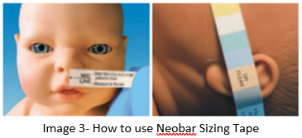
Equipment/preparation
- Skin protective wipe
- One centimetre wide leucoplast strip cut to approximately five centimetre long
- Select NeoBar size using sizing tape (see below) and trial fit to ensure correct size
- Sizing tape in packaging - align tip with middle of nasal septum as directed, wrap tape around face to ear, colour that aligns with external ear canal is correct size. See Image 3.
- Resuscitation equipment – Neopuff, Laerdal bag with correct mask size, resuscitation trolley

Procedure
- Ensure ETT is held securely by second staff member at all times
- Ensure skin is clean and dry
- Apply skin protective wipe to cheeks
- NeoBar should be positioned across center of mouth with ETT below NeoBar to reduce pressure on palate. NeoBar should not contact lips. (Image 4).
- Warm NeoBar tabs with hands or under radiant heater, remove clear liners and apply tabs in front of ear over bone ensuring ETT support platform midline.
- Hold in place for 60 seconds (Image 5).
- Secure ETT to NeoBar using one center meter brown tape
- Wrap tape completely around ET tube first (Image 6). Double check tub measurement at lip
- Continue taping around both ET tube & Platform. (Image 7).
- Place infant into comfortable position following procedure
- Document final position of tube
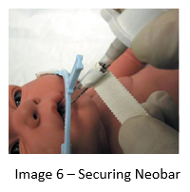
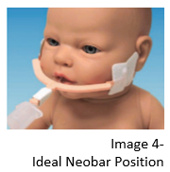
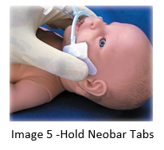
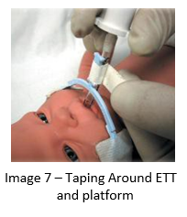

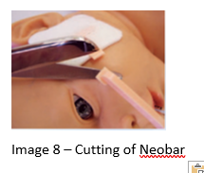
Alert
Emergency Removal of ETT with Neobar:
- Carefully cut thin portion of the NeoBar at the junction of the bar and the flaps on both sides (Image 8).
- Remove the ET tube attached to stabilizing platform.

7.4 – Securing a Nasal Endotracheal Tube with Tape
Equipment/preparation
- Skin protective wipe
- One centimetre wide leucoplast: Cut two strips eight to 15 centimetres in length and cut into trouser legs, cut one strip five to eight centimetres in length and cut into trouser legs
- Resuscitation equipment – Neopuff, Laerdal bag with correct mask size, resuscitation trolley

Procedure
- Ensure ETT is held securely by second staff member at all times
- Ensure skin is clean and dry
- Apply skin protective wipe to cheeks, above upper lip and to nose (down midline)
- Ensuring ETT is at correct measurement apply shorter tape from top of nose down midline and wrap each leg around tube (opposite directions). (Image 9).
- Apply one of the longer cross cheek to nose with one trouser leg across to other cheek above top lip and second over outside of nare and wrapped around ET tube (Image 10).
- Apply second trouser leg tape from opposite side again one leg above upper lip and second across nose and then around ET tube (Image 11).
- Document final position of tube
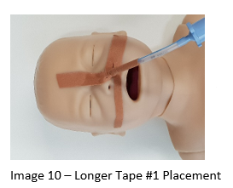
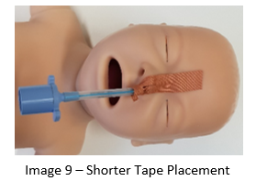
- Removal is done using adhesive dissolving wipes to loosen tape and to peel tape away gently before removing ET tube
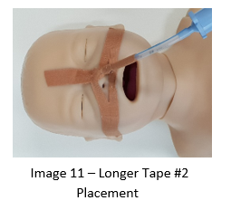

7.5 – Laryngeal Mask Airways (LMA)
LMA provides a short-term airway, allows IPPV or mechanical ventilation and provides some airway protection against aspiration:
- LMA has one neonatal size (size one) and is labelled with the appropriate patient weight range (two to five kilograms)
- The size 1.5 LMA is appropriate for Paediatric patients five to ten kilograms and is also stocked in the NICU resuscitation trolley

An LMA is usually easy to insert and requires less skill than intubation. It is therefore an option for less experienced staff and as an airway rescue device for senior staff in the case of a difficult airway. The following should be considered:
- LMA is not as effective as an ETT in protecting the gut from gas insufflation during ventilation support.. The size 1.5 iGel LMA has a NG tube “port” to thread a nasogastric tube through for gastric decompression. It is recommended to insert a gastric tube behind the LMA. This will usually enter the oesophagus and then stomach
- LMAs are generally used during anaesthesia and their presence in the upper airway may trigger airway reflexes and vagal responses. Therefore sedation is likely to be required, to maintain them beyond the initial period of resuscitation

NICU medical staff should be trained and familiar with the use of LMAs. NICU nurses and midwives should also be trained in their use so as to be competent assistants at the time of insertion. Staff should be familiar with methods for securing the LMA to avoid accidental dislodgement.

LMA AS FIRST LINE AIRWAY
There is scope for LMA to be used as a first line airway, these include:
- need for alternative airway (mask ventilation failed or prolonged in duration)
- where nursing and midwifery staff have received training and passed the LMA insertion competency, if unable to achieve effective ventilation. For example, Homebirth midwives who do not have medical help available
- where Senior Resident Medical Officer (SRMO) or Registrar present have limited intubation experience or intubation attempts have been unsuccessful. This approach may be particularly useful where effective mask ventilation has been unsuccessful and may be used prior to initiation of chest compressions
- where patient weight or estimated weight is approximately two kilogram or less (less than 32 to 34 weeks)

Relative contraindications
- Likely long term needs for ventilator support and or the likely need for surfactant treatment are relative contraindications. Patients expected to need ongoing ventilation or surfactant may benefit from an LMA while awaiting the arrival of a more skilled intubator. Effective oxygenation and ventilation must however, be the most important early goal. If an LMA is the most appropriate means to achieve that then it should be used.
- LMA remains a second line alternative airway to ETT in any resuscitation where intubation has been unsuccessful. It is usually the safest and quickest airway rescue technique after failed intubation especially if there is difficulty with a mask approach
- weight limitation excludes use of LMAs in smaller preterm infants and avoiding two airway procedures (LMA then later intubation/MIST for surfactant) is also preferable.
- late preterm infants, especially those without antenatal steroid coverage, may also need surfactant

- patients with congenital anomalies, where gas insufflation of the bowel may lead to difficulties (CDH, gastroschisis, etc), should be intubated in preference to use of an LMA. Patients with a history of CTG abnormality or fetal scalp lactate, which are suggestive of severe perinatal asphyxia, should also be intubated in preference to use of an LMA as longer-term respiratory support is often required.

Back to Table of Contents

Section 8 – Difficult Airway Procedure

Difficult airway is a spectrum from those in whom it is difficult to achieve effective mask ventilation through to a can’t intubate, can’t oxygenate scenario. Difficult airways are relatively infrequent in Neonatology and as such many units historically have not had policy or procedure developed to help deal with the issue.

8.1 – Key Messages
- Always have a plan B and C to establish an alternative airway if plan A fails. This may be as simple as returning to mask ventilation and waiting for help in a patient who you know can be successfully ventilated by mask.
- Call for help:
- Registrars and fellows who have had difficulty with airway management should ensure a consultant is aware, and on their way to help.
- Consultants who have had difficulty should consider calling the 2nd on call neonatologist, paediatric anaesthetist, or ENT surgeon on call
- Most experienced clinician to attempt all procedures in known difficult airways or after initial attempts have failed
- Repeatedly trying the same procedure without changes to optimise conditions for success risks airway trauma and further deterioration of an already difficult airway.
- Registrars and fellows should not have more than 2 attempts and consultants should seriously consider other options including calling for help prior to the third and each subsequent attempt. This applies to all airway procedures not just intubation.
- All attempts to “secure” an airway with any device that interrupts ventilation should be time limited to 30 seconds. A key pitfall of airway management is becoming too task focused and forgetting that oxygen delivery is the primary goal, not intubation:
- Always return to effective oxygen delivery as the primary goal
- Other team members should feel able to tell the proceduralist to stop and should be listened to
- It is good practice for the proceduralist to ask a team member to time the procedure and ask to be informed at 30 seconds at which time the procedure can be aborted or if almost complete (i.e. can see the cords), can be finished within the next 10-15 seconds maximum before a mandatory end to the procedure
- Communication during the procedure so the team is aware of any difficulties or “what you can see” can be helpful for the team to anticipate the next step. This is especially useful for trainees doing procedures under supervision so the supervisor can give guidance.

8.2 – Options to Consider in Order to Achieve Effective Mask Ventilation
- Redo “MRSOPA”. See Section 6.2.
- Consider airway adjuncts: nasopharyngeal or oropharyngeal (guedal) airways with the mask over the top. This may be especially useful with a large tongue and/or retrognathia
- Two-person technique- one maintaining seal and position of mask, neutral airway position and jaw thrust, second person using Neopuff/bag to deliver IPPV.

8.3 – Options to Consider in Order to Achieve Alternative Airway (In No Particular Order)
- Maximise favourable conditions for intubation. Refer to Section 7
- Carefully consider what drugs may be safely given for sedation and muscle relaxation. If no intravenous access, consider peripheral intravenous cannula, umbilical venous catheter, or intraosseous access in order to give drugs prior to another attempt
- Optimise patient position for operator comfort- Bed height, lighting, free from obstructions
- Optimise the shape and stiffness of the ETT with an introducing stylet
- Appropriate use of external laryngeal manipulation (commonly referred to as cricoid pressure) knowing that it may in some cases hinder not help and you can have too much
- Consider using video laryngoscope and using the screen for superior vision:
- The fibreoptic bronchoscope supplied with the video laryngoscope can be used as an intubating scope if the tube is prepositioned and the scope can be successfully introduced into the trachea
- Consider placing a bougie endotracheally as first line and then tube over the bougie. This is also a potentially safer technique if upsizing or changing an ET tube- bougie down current tube, remove tube leaving bougie in place followed by new tube over bougie
- LMA may be an effective alternative to intubation in the short term:
- We have 2 types of LMA available currently- “original” with inflatable cuff and the iGel type. If one is not effective’ try the other.
- In patients near the border of the weight limits of the size 1 and size 1.5 LMA it is appropriate to try the other size
- The iGel LMA is completely open at the patient end (inflatable type has fenestrations) and can serve as a means to introduce a bougie which can then be used to “railroad” an ETT into place. Direct vision may assist to ensure the bougie/ETT is correctly positioned prior to, during or immediately after the procedure. The inflatable type LMA should not (and cannot) be used to place a bougie

If having tried above options (as appropriate), there is a can’t intubate, can’t oxygenate (cico) scenario, front of neck access is the last resort option.
The two common techniques involve a needle or scalpel based approach to an emergency tracheotomy. These are rarely successful in untrained hands and are most difficult in small infants. This would ideally be done by an ENT surgeon however a neonatologist (who is familiar with the technique) may consider it as a last resort (live saving) option when ENT/anaesthetic help is not immediately available. In order to be effective it must be done without delay as hypoxia and ischaemia will rapidly progress during any delay.

Key Points of a CICO Scenario:
- Oxygen delivery is the number 1 priority. Intubation is a secondary goal. Task fixation (with prolonged or repeated attempts at a procedure that has already failed) is a key factor in many adverse outcomes
- Call for help
- Have a plan B and C
- Training in difficult airway courses can help with technical skills but also with the very important human factors which are frequently identified as key areas for improvement in reviews of adverse outcomes
- “The Vortex” which is an approach to difficult airway management is a useful tool to guide management through the procedure. It is widely used in anaesthesia, EDs and adult ICUs. Having a system (whether it is the Vortex or something else) to guide you through the stressful situation can take some of the cognitive load away from all team members. See References at the end of this Guideline

Resources for CICO
- An institutional approach to the management of the “Can’t Intubate, Can’t Oxygenate” emergency in children, Sabato and Long (RCH Melb); Pediatric Anesthesia 2016
- The Vortex: a universal ‘High-acuity implementation tool’ for emergency airway management. Chrimes; British Journal of Anaesthesia 2016
- www.vortexapproach.org
- Dr Andrew Heard Airway- Youtube channel- adult sized manikin based video demonstrations of the procedures
- “Just a routine operation” https://www.youtube.com/watch?v=JzlvgtPIof4

Back to Table of Contents

Section 9 – Pre-Oxygenation and Apnoeic Oxygenation

Recommendations for Practice in the Department of Neonatology:
- Pre-oxygenation should not be performed during routine intubation of Neonatal patients
- Pre-oxygenation should be used during all paediatric intubations which occur during the care of these patients in the NICU
- Pre-oxygenation may be considered in term and near term neonatal patients or “ex-prems” no longer at risk of ROP, especially in the case of anticipated difficult intubation.
- Apnoeic oxygenation may be used in conjunction with pre-oxygenation in paediatric patients and selected neonatal patients

9.1 – Pre-Oxygenation
Pre-oxygenation is not routinely practiced in neonatal intubation because of the risks of hyperoxic injury due to immature antioxidant systems and unique susceptibilities of the preterm population in particular (Retinopathy of Prematurity and Bronchopulmonary dysplasia). Pre-oxygenation is however standard practice in all other patient groups/specialities who perform airway management. It involves the patient breathing high percentage oxygen (close to 100%, within limitations of the device used) for at least three minutes prior to delivery of drugs for intubation. It may be delivered by face mask (with spontaneous or assisted breathing), Hudson mask with non- rebreather bag attached plus/minus nasal prongs (see also apnoeic oxygenation below). Pre-oxygenation maximises the oxygen being carried in the patient’s blood and within the functional residual capacity of the lungs and thus delays the onset of desaturation/hypoxia during the procedure as additional oxygen is available for ongoing metabolic needs.

9.2 – Apnoeic Oxygenation
Apnoeic oxygenation is also practiced during airway management by many units (anaesthesia, ED, ICU), including in paediatric patients and is becoming standard of care. It involves use of low flow or high flow nasal prongs to deliver 100% oxygen to the upper airway while the patient is apnoeic (following medication administration for the purposes of intubation). It is used in conjunction with pre-oxygenation. There are various protocols but a common one (advocated in RCH Melbourne guidelines) is 2L/kg/min of 100% oxygen via high flow nasal prongs.

During apnoea, oxygen is continuously absorbed from the functional residual capacity of the lungs into the circulation (and volume of oxygen absorbed is greater than that of CO2 excreted). This absorption creates a small but significant flow of gas into the alveoli from the upper airway if the airway remains patent. If oxygen is continuously delivered to the upper airway additional oxygen is therefore delivered to the alveoli despite apnoea. If the upper airway is obstructed absorption atelectasis will occur. Apnoeic oxygenation provides a further benefit beyond pre-oxygenation in further prolonging the time until critical desaturation occurs during an intubation attempt.

In “healthy” adult patients the combination of pre-oxygenation and apnoeic oxygenation can result in several minutes of normal oxygenation despite apnoea. In children and neonates this will be shorter and in critically unwell patients the time to critical desaturation may be very short despite adequate pre-oxygenation and apnoeic oxygenation.

Back to Table of Contents

Evaluation

Outcomes
- All neonatal resuscitations will follow the algorithm (Attachment 1)
- Where critical incidents have occurred cases are referred to CRC for investigation lead by people external to the department
- The Neonatal Resuscitation checklist will be used prior to all elective intubations/airway procedures.

Measures
- Clinical care of patients requiring resuscitation is reviewed routinely post event by the clinical team
- Formal reviews occur for all cases involving extreme preterm neonates (E prem departmental meeting) and MET calls via rapid response committee
- Where a case is identified as having significant morbidity or mortality, it will be reviewed in detail at a Neonatal Mortality and Morbidity meeting using CRC or RiskMan.

Back to Table of Contents

Related Policies, Procedures, Guidelines and Legislation

Policies
- Nursing and Midwifery Continuing Competence Policy
- Informed Consent (Clinical)

Procedures
- Infection Prevention and Control – Healthcare Associated Infections Clinical Procedure
- Labour and Birth: Care during First, Second, Third and Fourth Stage
- Patient Identification and Procedure Matching
- Aseptic Technique

Guidelines
- Care of the Extremely Preterm and Low Birth Weight Baby – the Golden Hour
- Paediatric patient (under 2 years) requiring intensive care
- Neonatal routine care
- Preterm labour clinical guideline

Manual
- Neonatal Intensive Care Drug Manual

Legislation
- Health Records (Privacy and Access) Act 1997
- Human Rights Act 2004
- Work Health and Safety Act 2011
- Australian Charter of Health Care Rights

Back to Table of Contents

References

- Australian Resuscitation Council <www.resus.org.au>
- European Resuscitation Council Guidelines for Resuscitation 2015 Section 7. Resuscitation and support of transition of babies at birth Wylliea J, Bruinenberg J, Roehr CC, Rüdiger M, Trevisanutoc D, Urlesberger B Resuscitation 95 (2015) 249–263
- 2015 American Heart Association Guidelines Update for Cardiopulmonary Resuscitation and Emergency Cardiovascular Care Part 13: Neonatal Resuscitation Wyckoff MH, Aziz K, Escobedo MB, Kapadia VS, Kattwinkel J, Perlman JM, Simon WM, Weiner GM, Zaichkin JG Circulation. 2015;132:S543–S560 <http://www.neoresus.org.au/wp-content/uploads/2015/01/Queensland-Maternity-and-Neonatal-Clinical-Guideline_Neonatal_Resuscitation.pdf)
- An institutional approach to the management of the “Can’t Intubate, Can’t Oxygenate” emergency in children, Sabato and Long (RCH Melb); Pediatric Anesthesia 2016
- The Vortex: a universal ‘High-acuity implementation tool’ for emergency airway management. Chrimes; British Journal of Anaesthesia 2016 <www.vortexapproach.org>
- Dr Andrew Heard Airway- Youtube channel- adult sized manikin based video demonstrations of the procedures, “Just a routine operation” <https://www.youtube.com/watch?v=JzlvgtPIof4>
- Endotracheal tube length for neonatal intubation Kempley ST, Moreiras JW, Petrone FL; Resuscitation 2008
- Gowda, H. Question 2 Should carbon dioxide detectors be used to check correct placement of endotracheal tubes in preterm and term neonates? Arch Dis Child. 2011 Dec 1; 96 (12): 1201-1203 29 http://www.ncbi.nlm.nih.gov/pmc/articles/PMC3223393/
- NellcorTM Pediatric Colorimetric CO2 detector instructions for use (2011) https://www.medtronic.com/covidien/en-us/products/intubation/nellcor-adult-pediatric-colorimetric-co2-detector.html
- The Victorian Newborn Resuscitation Project. PedicapTM CO₂ detector http://www.neoresus.org.au/wp-content/uploads/2015/01/Pedicap_CO2_detector_view_on_screen_March_2010.pdf

Back to Table of Contents

Search Terms

Nals, Neonatal Resuscitation, Neonatal, Neonate, Neonatal Advanced Life Support, Nals Algorithm, Intubation, Advanced Airway Skills, Difficult Airway, Lma, Ett Intuabtion, Endotracheal Tube, Neopuffing, Neopuff, Alternative Airway, Surfactant Administration, Mrsopa, Post Resuscitation Care Of Neonate, Department Of Neonatology, Nicu, Scn, Neonatal Intensive Care, T-piece resuscitator, delayed cord clamping, DCC, carbon dioxide detector, exhaled carbon dioxide, CO2

Back to Table of Contents

Attachments

Attachment 1: Neonatal Advanced Life Support Algorithm
Attachment 2: Neonatal Resuscitation Checklist
Attachment 3: Draft intubation checklist being used on a trial basis in the NICU

Back to Table of Contents

Disclaimer: This document has been developed by Canberra Health Services specifically for its own use. Use of this document and any reliance on the information contained therein by any third party is at his or her own risk and Canberra Health Services assumes no responsibility whatsoever.

Policy Team ONLY to complete the following:
Date Amended | Section Amended | Divisional Approval | Final Approval
29/9/2021 | New Document | Boon Lim, ED-WYC | CHS Policy Committee

This document supersedes the following:
Document Number | Document Name

Attachment 1: Neonatal Advanced Life Support Algorithm
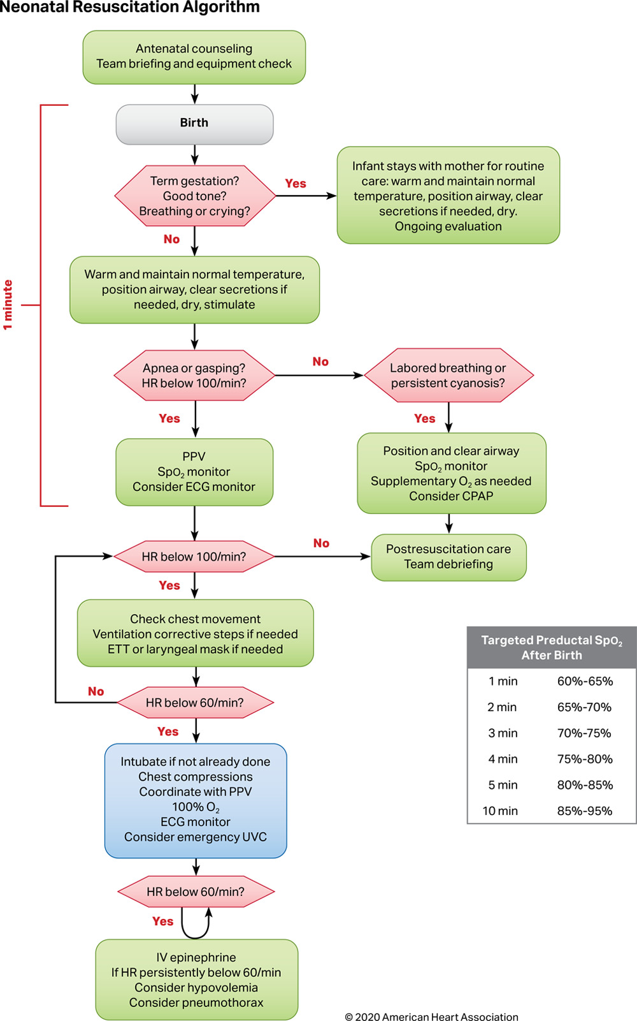

Attachment 2: Neonatal Resuscitation Checklist
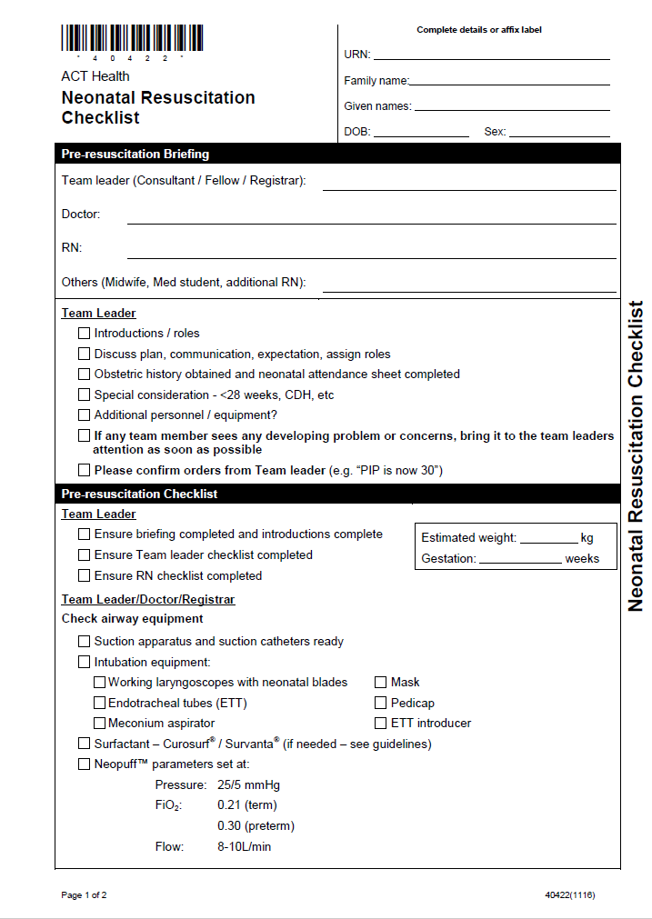
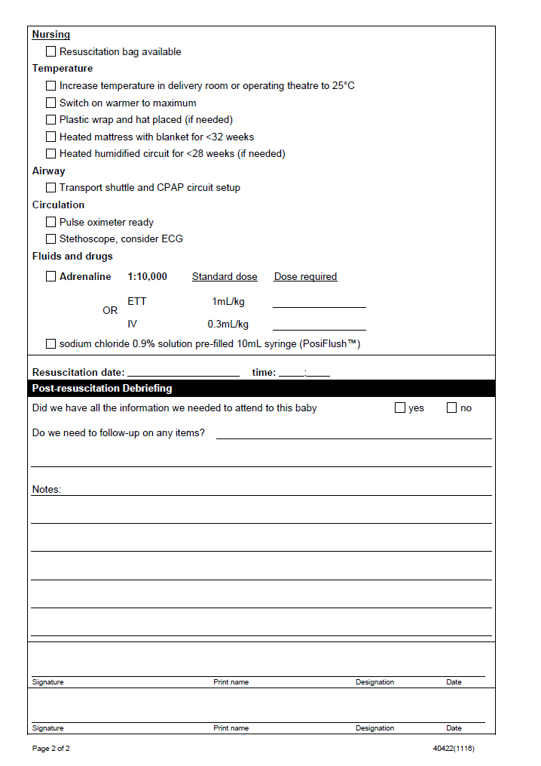

Attachment 3: Draft intubation checklist being used on a trial basis in the NICU

