Canberra Health Services
Procedure
Managing Nicotine Dependence

Contents

Contents 1
Purpose 2
Scope 2
Section 1 – What is Nicotine Dependence? 2
Section 2 – How is Nicotine Dependence Managed? 3
Section 3 – Smoking Cessation Clinical Pathway 3
Section 4 – Outpatient and Planned Admissions 5
Section 5 – Support 5
Free Nicotine Replacement Therapy (NRT) 5
Smoking Cessation Clinic 5
CHS Tobacco Treatment Specialists (TTS) 6
Cancer Council ACT 6
No More Boondah 6
General Practitioner (GP) 6
Quitline 6
Further rescources 6
Evaluation 6
Related Policies, Procedures, Guidelines and Legislation 7
References 7
Definition of Terms 8
Search Terms 9
Attachments 9
Attachment 1 – Smoking Cessation Clinical Pathway 11
Attachment 2 – Smoking and Drug Interactions 13
Attachment 3 – Special Considerations 15
Attachment 4 – International Classification of Disease (ICD) Codes for Smokers 19

Purpose

The purpose of this document is to provide an evidence-based procedure to support the Smoke Free Environment Policy within Canberra Health Services (CHS). This document will support people to become smoke free and help manage nicotine dependence in patients and staff.

There is no safe level of exposure to environmental tobacco smoke. Smoking and vaping exposes bystanders to nicotine and known carcinogens and may trigger asthma symptoms in vulnerable people. Smoking, including the use of e-cigarettes, herbal products or personal vaporisers is not permitted at any ACT Government owned and leased sites, facilities or vehicles at any time without exception.

Back to Table of Contents

Scope

This procedure is applicable to all staff within CHS.

It is a fundamental responsibility of all health professionals caring for patients who smoke or vape to offer support for smoking cessation including staff asking patients about their smoking status.

Back to Table of Contents

Section 1 – What is Nicotine Dependence?

People who are dependent on nicotine continue to vape or smoke because their brains are conditioned to the presence of nicotine. Craving for nicotine occurs when the level of nicotine drops and the receptors in the brain require replenishing. As time without a replenishment of nicotine continues, the person can feel increased cravings or withdrawal.

Prevalence rates in specific communities vary, with some as high as 70 – 80% (for people with mental health conditions and substance use disorders), compared to 13% in the general population.

Withdrawal symptoms may commence 2 hours after the last cigarette, hence the importance of completing the Smoking Cessation Clinical Pathway (“the Pathway”) to manage the nicotine dependence and control the withdrawal symptoms.

Back to Table of Contents

Section 2 – How is Nicotine Dependence Managed?

CHS staff who admit inpatients, are required to advise them on their arrival at the health service that CHS is smoke-free, and that they are not allowed to smoke while at our health-service, but that CHS staff are available to help manage their withdrawal.

CHS staff who admit inpatients should ask if they have smoked or vaped in the last 30 days. If the answer is “yes,” patients are to be screened using the Pathway (Attachment 1), (which can also be found on the Clinical Portal) to determine their nicotine dependence. The Pathway is an evidence-based, best practice, systematic approach used to support people to be smoke free while in hospital.

Patients who smoke can have their cravings and withdrawal managed by using combination nicotine replacement therapy (NRT) so they can be smoke free during their hospital stay.

Some people can stop smoking or vaping without support, however staff need to manage nicotine dependence in a sensitive manner and recognise that withdrawal from nicotine may cause distress. Patients may be stressed, anxious, grieving or aggravated which can present challenging behaviours, including violence and aggression. To manage patients’ cravings and withdrawal symptoms, fast-acting NRT, such as mouth spray, should be offered as soon as possible and as appropriate to the clinical circumstances. It may be beneficial to engage family / carers in the conversations so they can support the patient to be smoke free while in hospital.

Managing nicotine dependence with pharmacological treatment improves inpatient comfort, increases compliance with the hospital smoke-free policy and promotes smoking cessation after discharge.

Back to Table of Contents

Section 3 – Smoking Cessation Clinical Pathway

The Pathway uses the adapted Bittoun algorithm tool to provide treatment for nicotine dependence using NRT and encourages referral to Quitline and/or the patient’s GP for ongoing support after discharge. Clinical pathways never replace clinical judgement. Care outlined in the Pathway must be altered if it is not clinically appropriate for the individual patient.

Ask all patients
- Have you smoked or vaped in the last 30 days?
- Make them aware of the existence of the CHS Smoke Free Environment Policy.

Assess
- Nicotine dependence – does the patient
- smoke or vape more than 10 cigarettes in a typical day? or
- smoke or vape within 60 minutes of waking? or
- have a history of withdrawal symptoms or cravings from quitting smoking?
- Offer NRT
- If the patient is currently using NRT, Varenicline (Champix) or Bupropion (Zyban), this should be continued
- Titrate to achieve effect
- If declined, offer regularly during hospital stay.
- Record in patient notes.
Advise
- the patient that CHS can help them to manage any withdrawals
- the patient that providing the best care relies on the patient not leaving the hospital to smoke or vape
- To help with cravings the patient can use the “4 D’s”
- Delay – the craving usually passes within 5 minutes
- Deep breathe
- Do something else
- Drink water – sip slowly.
Assist
- Offer the patient free NRT (i.e. a combination of patch plus gum or spray or lozenges)
- Patients who stop smoking with or without NRT may require a medication change (e.g. opioids, antipsychotics, benzodiazepines, insulin and warfarin - Smoking and Drug Interactions (Attachment 2)
- The appropriate treatment is determined by the level of nicotine dependence, previous quit attempts, and patient suitability as per Special Considerations, contraindications and precautions (Attachment 3):
- Any local precautions/ protocols (eg microvascular surgery, skin grafts etc)
- Children under 12 years of age
- Pregnant/lactating
- Recent cardiovascular event, less than 48 hours
- Taking Clozapine
- Monitor patients for ongoing withdrawal symptoms and response to NRT
- If a patient is unable to be offered NRT the reason should be recorded in their clinical record
- The International Classification of Diseases (ICD) Codes for Smokers should be recorded in the patient’s clinical records and on their discharge summary (see Attachment 4).
Arrange
- Referral of the patient to Quitline, Smoking Cessation Clinic by emailing: ACTHealthCentralOutpatient-Referrals@act.gov.au
- Resources to be provided (e.g. “Smoking and Your Hospital Stay” flyer, Quitpack)
- Patient notes and 3 days discharge NRT, Continuing NRT at Home flyer
Back to Table of Contents

Section 4 – Outpatient and Planned Admissions

Prior to admission, all patients with appointments at outpatient clinics are to be sent, by the outpatient area, the CHS Smoke Free flyer “Do you have an appointment with CHS?”, advising them that CHS is smoke-free and the supports which are available.

Ideally, patients who smoke/vape should be provided with NRT by their GP 6 to 8 weeks prior to admissionto support them being smoke free while in hospital. Support is available for outpatients and visitors with Quitline (Phone 137 848) and No More Boondah [for Aboriginal and Torres Strait Islander people (Phone 6284 6222) providing free Quitpacks, advice, multi-lingual support and ongoing telephone counselling.

Back to Table of Contents

Section 5 – Support

Free Nicotine Replacement Therapy (NRT)
- Staff:
CHS provides an 8-week course of NRT patches to assist staff compliance with the policy and to maintain CHS workplaces as a non-smoking environment. Staff need to complete a registration form (available on the Smoke Free pages of the intranet) and get their cost centre delegate to sign it, then collect the NRT patches from Pharmacy at the Canberra Hospital.

Managers and Cost Centre delegates are to support staff by approving the NRT registration form and allowing staff to collect their NRT from Pharmacy at The Canberra Hospital.

- Patients:
Following assessment of nicotine dependence and completion of the Pathway, treatment can be initiated for 24 hours, by nursing staff, without prescription. Any ongoing nicotine replacement treatment beyond 24 hours must be prescribed by an authorised prescriber (medical officer, nurse practitioner or endorsed midwife). This applies to all forms of NRT, including long-acting therapy such as patches, as well as short-acting therapy such as gum and lozenges.

Nurse-initiated medication standing orders for NRT may be utilised for patients in the Alexander Maconochie Centre, Bimberi Youth Justice Centre and ACT Court Cells.

Smoking Cessation Clinic
This is a free CHS clinic for staff and patients, providing one on one appointments with a CHS Tobacco Treatment Specialist. To access this clinic a doctor’s referral is required to be sent to
ACTHealthCentralOutpatient-Referrals@act.gov.au

CHS Tobacco Treatment Specialists (TTS)
Email TTS from CHS Alcohol and Drug Services by sending a request to Smokinghelp@act.gov.au A TTS will answer staff queries via email, related to supporting patients with smoking cessation and NRT, usually within 24 hours Monday – Friday.

Cancer Council ACT
The Cancer Council offers a range of smoking cessation support services including free quit kits, one-on-one consultations, education seminars and group courses – phone 6257 9999. http://www.actcancer.org/prevention/smoking-and-tobacco/order-a-free-quit-pack/

No More Boondah
This is a quit smoking program run by Winnunga Nimmityjah Aboriginal Health and Community Services Ltd. This program assists Aboriginal and Torres Strait Islander people to identify why they smoke, what triggers their smoking and what strategies can help to avoid or delay their smoking - phone 6284 6222 .

General Practitioner (GP)
Staff may see their GP to obtain NRT or other treatments such as Varenicline (Champix), and/or counselling.

Quitline
Quitline offers a free confidential phone service (phone 137 848) to assist with quitting. Availablity: Monday to Friday 7am -10.30pm, Saturday, Sundays, Public Holidays 9am-5pm.

Further rescources
- Quit Coach. http://www.quitcoach.org.au/
- Quit Now website and the MyQuitBuddy – an interactive, free app with quit tips, motivational messages and countdown to quitting reminders. http://www.quitnow.gov.au
- I Can Quit website. https://www.icanquit.com.au/
- Smoke Free website. https://smokefree.gov/

Back to Table of Contents

Evaluation

Outcome
- All patients and staff who smoke or vape will be offered support for smoking cessation.

Measures
- Report to WHS Peak Committee annually on results of compliance monitoring and other activities to support smoke free environment. This report will include:
- Number of NRT dispensed by TCH Pharmacy
- Number of smoking related cautions issued by Security
- Number of complaints received by Consumer Feedback and Engagement Team, and how many have been resolved.

Back to Table of Contents

Related Policies, Procedures, Guidelines and Legislation

Policies
- ACT Government Real Estate Policy
- ACT Public Service Occupational Health and Safety Policy: Smoke Free Workplaces
- CHS Smoke Free Environment Policy
- CHS Occupational Violence Policy
- CHS Work Health Safety Policy
- Calvary Hospital Smoke-Free Workplace Policy

Procedures
- CHS Occupational Violence Procedure
- ACT Public Service Reasonable Adjustment Policy

Legislation
- ACT Emergencies Act 2004
- ACT Litter Act 2004
- ACT Public Sector Management Act 1994
- ACT Smoke-Free Public Places Act 2003
- ACT Tobacco and Other Smoking Products Act 1927
- ACT Work Health and Safety Act 2011
- Charter of Healthcare Rights 2019
- Human Rights Act 2004

Other
• Australian Charter of Healthcare Rights

Back to Table of Contents

References

- Carpenter, M.J et al Clinical Strategies to Enhance the Efficacy of Nicotine Replacement Therapy for Smoking Cessation: A Review of the Literature. Springer International Publishing, Switzerland, 2013.
- Government of Western Australia Department of Health: Clinical guidelines and procedures for the management of nicotine dependent inpatients. Perth, Smoke Free WA Health Working Party, 2011.
- Government of Western Australia Department of Health: Guidelines for the provision of assistance to nicotine dependent staff, January 2013.
- Lawn, S and Pols, R. 2005. Smoking bans in psychiatric inpatient settings? A review of the research. Australian and New Zealand Journal of Psychiatry. Vol. 36, pp. 866-885.
- Mendelsohn, C. 2013. Optimising Nicotine Replacement Therapy in Clinical Practice. Australian Family Physician Vol. 42, No. 5.
- Lawn, S. And Campion, J. Achieving Smoke-Free Mental Health Services; Lessons learned from the past decade of implementation research. International Journal of Environmental Research and Public Health, 10, 4224-4244, 2013.
- Mendelsohn, C. Up to date in the Pharmacy: Advocating Smoking Cessation. Scius Solutions P/L, NSW, 2013.
- Mendelsohn, C. Optimising Nicotine Replacement Therapy in Clinical Practice. Australian Family Physician Vol. 42, No. 5, May 2013.
- Mendelsohn. C. Management of Smoking in Pregnant Women. Australian Family Physician Vol. 43, No 1-2, Jan-Feb 2014.
- ACT Aboriginal and/or Torres Strait Islander Elected Body. Protocols for working with Aboriginal and/or Torres Strait Islander Peoples, September 2015
- Canberra Health Services, Guideline, Identification, Mitigation and Management of Aggression and Violence for Mental Health Justice Health Alcohol and Drug Services.
- Australian Capital Territory Tobacco and Other Smoking Products Act 1927
- CHS Guideline Clozapine Therapy

Back to Table of Contents

Definition of Terms

BGL: Blood Glucose Levels tests the amount of sugar in your blood.

Brief Tobacco Intervention: Providing people who smoke with advice and encouragement to quit, supporting behaviour change, recommending treatment and referring to support services.

Contractors: Any person employed by organisations with whom CHS has a contract for works or services.

E-cigarettes (also known as electronic cigarettes and vaporiser cigarettes): Battery operated devices that create a fine vapour which usually contains nicotine. The vapour is inhaled into the lungs and is exhaled as a visible mist.

International Classification of Disease (ICD) A standard diagnostic tool used for clinical purposes.

Inpatient: Refers to any patient admitted to any CHS facility.

INR: Measures the time for the blood to clot, also known as Prothrombin Time.

Nicotine Replacement Therapy (NRT): A type of treatment that uses special products to give small, steady doses of nicotine to help stop cravings and relieve symptoms that occur when a person is trying to quit smoking. Available in patches, gum, spray, lozenges.

Outpatient: Refers to any person who visits a CHS facility for a health service without being admitted.

Second-hand smoke: Smoke or vape inhaled by being near a person who is smoking or vaping.

Smoking products: A tobacco product, herbal product, personal vaporiser (e-cigarette) or personal vaporiser related product.

Special Considerations: There are a number of special considerations in applying Nicotene Replacement Therapy to special categories of patients, e.g. patients from CALD backgrounds, LGBTQ patients, patients receiving treatment for Cardiovascular disease. Attachment 3 provides detailed information.

Staff: Any person performing work for CHS, within ACT Government facilities, on a permanent, temporary or casual basis, including volunteers, contractors, visiting medical officers, students, consultants, and researchers .

Tenants: Any individual or organisation leasing an ACT Government-owned facility.

Third-hand smoke: Residual nicotine and other chemicals left on indoor surfaces by tobacco smoke.

Vaping: The action of inhaling and exhaling vapour containing nicotine and flavouring produced by a device designed for this purpose.

Visitors: Any non-staff person entering an ACT Government facility, for any purpose.

Back to Table of Contents

Search Terms

Smoke; Smoking; Smoke Free; SFE; Smoke Free Environment; Cigarettes; Electronic cigarettes; E-cigarettes; Nicotine; NRT; tobacco; vape; vaping

Back to Table of Contents

Attachments

Attachment 1 – Smoking Cessation Clinical Pathway
Attachment 2 – Smoking and Drug Interactions
Attachment 3 – Special Considerations
Attachment 4 – ICD Codes for Smokers

Back to Table of Contents

Disclaimer: This document has been developed by Canberra Health Services specifically for its own use. Use of this document and any reliance on the information contained therein by any third party is at his or her own risk and Canberra Health Services assumes no responsibility whatsoever.

Policy Team ONLY to complete the following:
Date Amended | Section Amended | Divisional Approval | Final Approval
03 December 2021 | Complete Review | Kalena Smitham, EGM-P&C | CHS Policy Committee
09 December 2021 | Attachment A – replaced sample form with watermark of “Unapproved Draft not for clinical use” with the approved document with “Sample” watermark. |  | CHS Policy Team

This document supersedes the following:
Document Number | Document Name
DGD18-013 | Managing Nicotine Dependence

Attachment 1 – Smoking Cessation Clinical Pathway
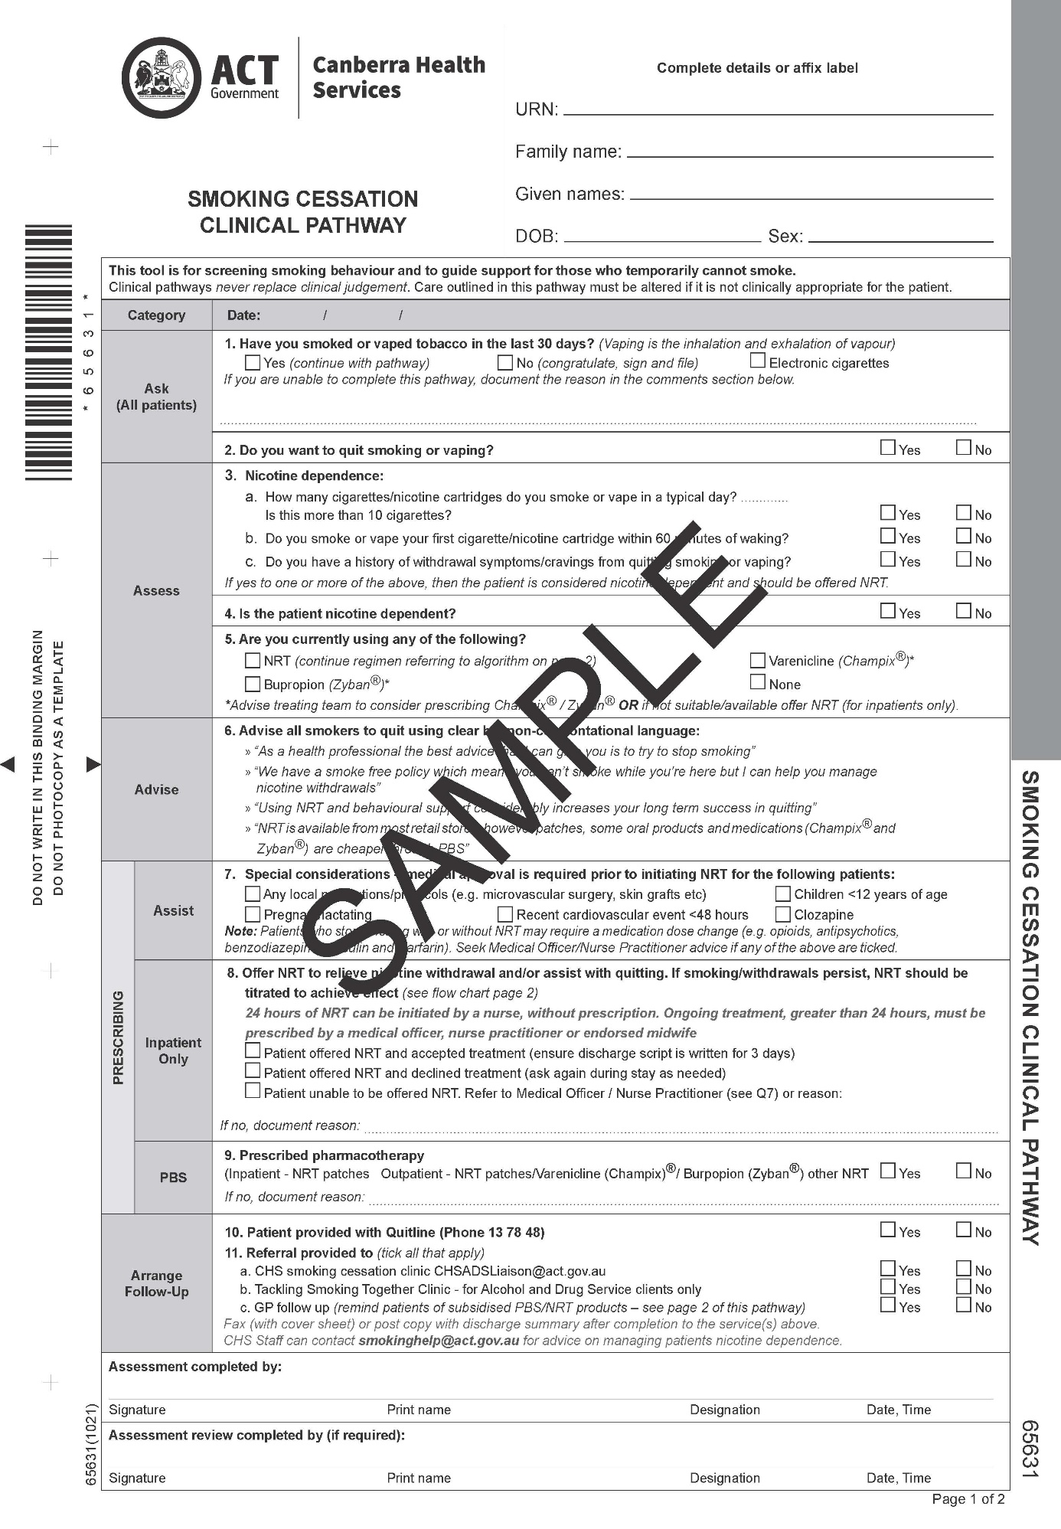
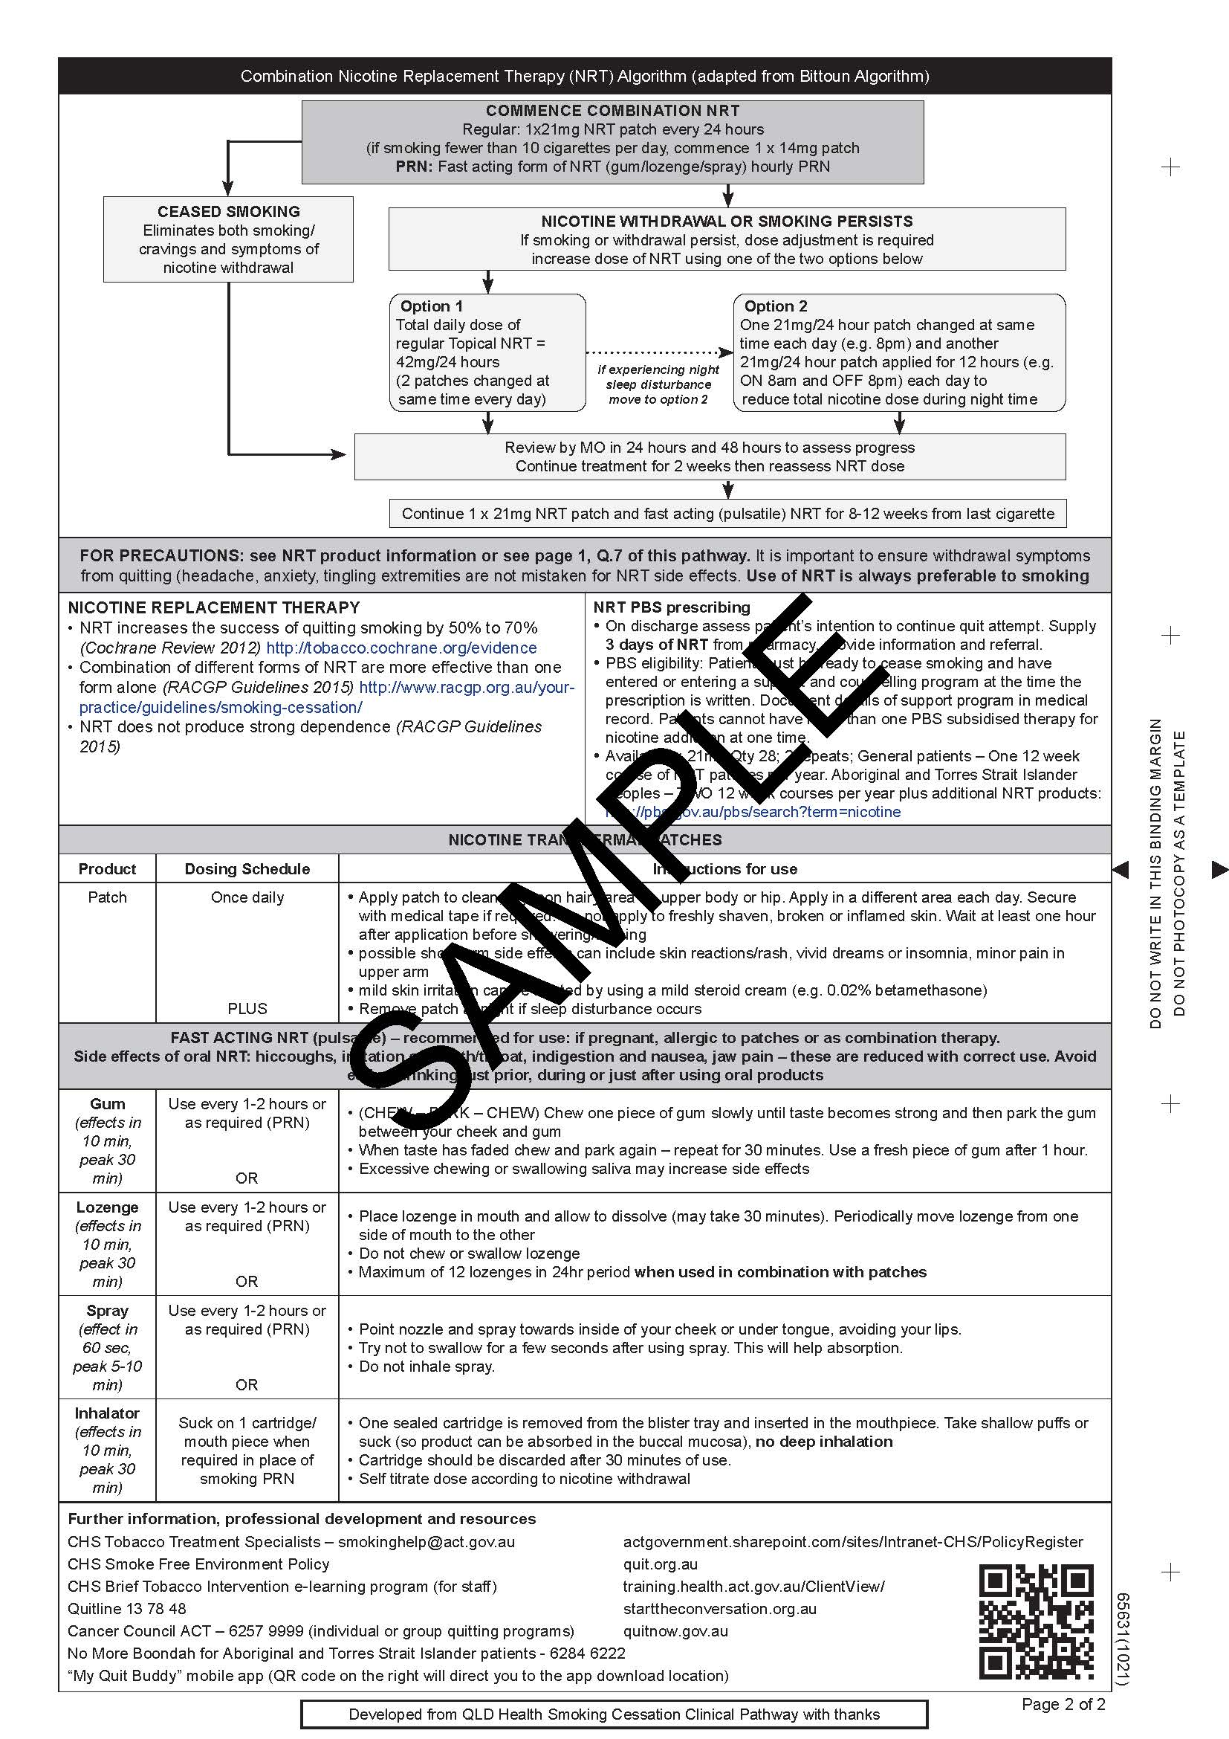

Attachment 2 – Smoking and Drug Interactions

When inpatients stop smoking (with or without NRT), clinical staff should carefully review prescribed medication and adjust or monitor drugs where metabolism is affected by smoking cessation.

All inpatients with contraindications to NRT should be assessed and prescribed appropriate alternatives. Medications for smoking cessation that are not NRT may only be prescribed to inpatients by a medical officer and should be done within 24 hours of admission. The two most effective non-nicotine medications are Bupropion and Varenicline. In most cases these medications will be initiated by the patient’s General Practitioner before admission. They may be considered as treatments for inpatients in hospital if nicotine therapy has failed or the inpatient has benefited from these options in the past.

Junior staff should seek assistance from more experienced staff members in treating smoking inpatients including GPs at the hospital and Psychiatrists and Tobacco Treatment Specialists in Mental Health Justice Health Alcohol and Drug Service Division.

Possible drug interactions with smoking cessation
Drug information sources contain varying reports of the effect of smoking and are unclear on the effect of vaping. The table below provides a list of common medications which may need a reduced dose upon smoking cessation. Many drug interactions have been identified with tobacco smoke. In most cases it is the tobacco smoke, not the nicotine, which causes the drug interactions. Products in tobacco smoke induce the hepatic cytochrome P450 enzymes and increase drug clearance in smokers. NRT does not contribute to the drug interactions through this affect. However, nicotine can counter the pharmacologic actions of certain drugs, because it activates the sympathetic nervous system.
Nicotine vaping products vary significantly in the flavourings and additives used. The food flavourings and additives commonly used have generally not been assessed for safety or drug interactions when inhaled. Many of these products are unlabelled or falsely labelled so the user may not know what is in their vape.

Alzheimer’s
Rivastigmine | Smoking increases clearance. Decreased dose may be needed.
Tacrine | Smoking increases clearance. Decreased dose may be needed.
Antidepressants
Fluvoxamine | Smoking increases clearance. Monitor for adverse events post smoking cessation.
Tricyclic antidepressants | Smoking may increase clearance. Monitor for adverse events post smoking cessation.
Antipsychotics
Clozapine  Olanzapine | Smoking increases clearance. Dose reduction may be needed to avoid toxicity.
Haloperidol | Smoking increases clearance. Monitor for adverse events post smoking cessation.
Benzodiazepines
Diazepam | Smoking increases clearance. Monitor for increased sedation post cessation of smoking.
Other benzodiazepines | Smoking may increase clearance. Monitor for increased sedation.
Cardiovascular drugs
Propranolol | Smoking increases clearance. Closely monitor for adverse events.
Verapamil | Smoking increases clearance. Closely monitor dose.
Warfarin | Dose reduction of 14-23% needed. Closely monitor INR.
Mexiletine, Flecainide, Lignocaine | Dosage may need to be decreased.
Hypoglycaemics
Insulin | Smoking may reduce subcutaneous insulin absorption. Post smoking cessation monitor BGLs. May need dose reduction.
Oral hypoglycaemics | Nicotine may increase plasma glucose. Monitor BGLs. May need dose reduction.
Respiratory
Theophylline | Decrease in clearance after smoking cessation. Closely monitor levels and adjust dose accordingly.
Other
Caffeine | Increased caffeine levels post smoking cessation. Recommend reduced caffeine intake post smoking cessation.

Attachment 3 – Special Considerations

Nicotine from NRT is much safer than from cigarettes and nicotine vaping products as it does not contain the harmful chemicals that cigarette smokes contain. Any amount of NRT is preferable to smoking. If patients are taking certain medicines and stop smoking the blood levels of some medications will change. Medical approval may be required for some groups of people on specified types of medication or NRT.*

Vaping products are not therapeutic products and it is therefore unclear how their use will interact with medications. Evidence-based treatments should always be used prior to use of e-cigarettes, and patients who vape should be monitored for any possible medication interactions.

*Psychiatric medication – Clozapine, Norclozapine
Smoking interacts with some medications by increasing their rate of metabolism, making medications pass through the system more quickly. Health professionals should carefully monitor and adjust prescribed medications during smoking cessation. Combination therapy for NRT should be offered. Cessation of smoking can increase the active metabolite of Clozapine, Norclozapine and may give rise to toxicity. Patients on Clozapine who start NRT should be carefully monitored for signs of Clozapine toxicity and a Clozapine level should be considered. Dose reduction may need to be considered to avoid Clozapine toxicity. (See Attachment 3: Smoking and drug interactions).

*Methadone
A decreased intake of cigarette smoke can lead to a reduction in methadone metabolism, resulting in higher serum concentrations which can lead to increased sedation. Patients on Methadone should be monitored for signs of Methadone toxicity upon the start of smoking cessation, and the dose of Methadone should be adjusted accordingly. The dose of Methadone may need to be reduced.

*Children and adolescents and NRT
The levels of nicotine in NRT are not suitable for children under 12. Children are likely to be affected by nicotine and it could cause severe toxicity, which can be fatal.
Contraindication: NRT should not be used for patients under 12 years of age.

NRT is safe for young people aged over 12 years and under 16 years, although the demand for cessation products and the motivation to quit is low.
Precaution: Patients younger than 16 years of age are excluded from nurse-initiated NRT and should be referred to a medical officer or nurse practitioner.

*Cardiovascular disease and NRT
NRT typically produces much lower peak arterial concentrations than smoking and therefore has less intense cardiovascular effects. Clinical trials of NRT in patients with underlying stable cardiovascular disease suggest that nicotine does not increase cardiovascular risk and can be used safely by smokers with less severe cardiovascular disease.
Precaution: Those with severe arrhythmias, refractory angina or recent (within 4 weeks) myocardial infarction or unstable angina are excluded from nurse- or midwife-initiated NRT and should be referred to a medical officer or nurse practitioner.

*Pregnancy and NRT Pregnant women should be encouraged to quit spontaneously. However, if unable to quit on their own, behavioural counselling, support and NRT can be offered, as the risk to the foetus is much lower than smoking or vaping.

During pregnancy, NRT taken intermittently (such as gum, lozenge, inhalator) is preferred to patches to minimise the exposure of nicotine to the unborn baby (24 hour patches are not first-line treatment in pregnancy). If the woman is unable to quit using intermittent dosing products, clinical staff can assess for the safe use of patches.

Use of intermittent NRT during labour should be monitored and supported as required.
Clinical staff should advise and support women who have quit smoking of the importance to remain smoke free in the postnatal period.

Smoking in pregnancy is the most preventable cause of a wide range of adverse pregnancy outcomes. Smoking causes obstetric and foetal complications and there is growing evidence of serious harm extending into childhood and even adulthood. Smoking during pregnancy is associated with risks such as unhealthy birth weight, premature birth or stillbirth. The antenatal phase provides opportunities for the early identification and assessment of smokers and smoking cessation advice and support. The earlier abstinence from smoking is achieved during pregnancy the better the outcome for mother and baby.

*Breastfeeding and NRT
The amount of nicotine that gets into breast milk is probably similar whether the mother smokes, vapes or uses NRT. Breast-feeding within one hour of smoking, vaping or taking an NRT product can significantly increase the levels of nicotine in breast milk. If NRT is used during breast-feeding NRT products that are taken intermittently (eg lozenge, gum and inhalators) are probably best.

The delivery of nicotine to infants via breast milk is unpredictable and depends upon the serum concentration of nicotine in the mother and rate of milk production. Staff shall be aware of the potential side effects of nicotine on infants and review the mother’s NRT treatment if symptoms attributable to NRT occur. Possible strategies to minimise the amount of nicotine in breast milk may be to prolong the duration between NRT administration and breastfeeding (ideally 2-3 hours). Avoid using NRT for at least one hour before breast-feeding.

Nicotine from both smoking and NRT is found in breast milk. However, the small amount of nicotine the infant receives from NRT is lower and less hazardous than that from smoking or vaping.

Diabetics and NRT
When NRT is initiated, patients with diabetes mellitus will require blood glucose levels (BGL) to be monitored a minimum of four times a day, as BGL’s generally fall after quitting. Depending on the BGL’s and clinical status of the patient, a consult with Endocrinology should be considered.

Aboriginal and Torres Strait Islander patients
Aboriginal and Torres Strait Islander people have a complex series of underlying historical and social issues to take into consideration when considering present day smoking and should be informed of the CHS Smoke Free Environment Policy in a culturally sensitive manner, with emphasis on why the hospital is smoke free. Additional time and resources may be required to ensure Aboriginal and Torres Strait Islander inpatients are informed of the policy and consent to NRT if required. English may not be the first language of many Aboriginal and Torres Strait Islander inpatients who may require access to interpreters where appropriate. It may be culturally appropriate to involve the family, or the CHS Aboriginal Liaison Officer in the process. Winnunga Nimmityjah Aboriginal Health and Community Services Ltd provides culturally appropriate Quit packs and trained smoking cessation counsellors through its “No More Boondah” Program. These counsellors offer an outreach service and can attend inpatients in hospital to provide support.

Culturally and Linguistically Diverse (CALD) patients
A CALD patient’s social, mental, physical and spiritual well-being factors need to be taken into account when addressing health related issues and CALD patients should be informed of the CHS Smoke Free Environment Policy in a culturally sensitive manner. Culturally appropriate visual imagery, DVD’s, information leaflets, pictures and symbol forms should be utilised to communicate the policy to CALD patients. Interpreters must be used at all times when communicating with CALD patients who are not able to understand the policy adequately on their inpatient stay. The Telephone Interpreter Service should be accessed via telephone on 131 450. A whole of family approach may be necessary to empower and engage the inpatient and maximise conformity to the policy. Clinical staff shall have clear knowledge of the policy for communication with CALD inpatients. Patients can be referred to the Quitline (phone 13 78 48). Quitline staff can offer multilingual support for smoking cessation and arrangements can be made for patients to be contacted by telephone to offer counselling.

Lesbian, Gay, Bisexual, Transgender, Queer or Intersex (LGBTQI) + patients
A person’s gender identity and sexual orientation can be fluid, and subject to change over time. A person may have different gender presentations for different situations. In a healthcare setting, it is important for healthcare professionals to respectfully find out the name, gender identity and gender pronouns of each person receiving care, to ensure they are correctly addressing them and meeting their core needs. LGBTQI+ patients shall be informed of the CHS Smoke Free Environment Policy in a sensitive manner. LGBTQI+ people come from all backgrounds and possess many varying abilities.

The main health issues and discrepancies for LGBTQI+ people may arise through stigma, stereotyping, discrimination, harassment, and exclusion. This includes reluctance to access health care and support due to a fear of not being understood and supported by medical professionals. This difference includes health impacts that result from mechanisms for coping with that discrimination and harassment, for example using alcohol and other drugs as self-medication.

Disability patients
Disability is part of human diversity. One in five people in Australia, almost four million people, have a disability and this proportion is increasing with the ageing population. Patients with a disability shall be informed of the CHS Smoke Free Environment Policy in a sensitive manner.

There are many kinds of disability and they can result from accidents, illness or genetic disorders. A disability may affect mobility, ability to learn things, or ability to communicate easily and some people may have more than one. A disability may be visible or hidden, may be permanent or temporary and may have minimal or substantial impact on a person’s abilities. Some people are born with disability or may acquire a disability because of an accident, as they age, or through a disease process. There is a strong relationship between age and disability; as people grow older there is a greater tendency to develop conditions which cause disability.

Parents or guardians of child and adolescent patients
Parents or guardians of child and adolescent inpatients shall be informed of the CHS Smoke Free Environment Policy. Parents or guardians who smoke or vape shall be provided with advice on how to manage their nicotine withdrawal or cravings whilst on CHS grounds. Further information on where to access smoking cessation support in the community shall be provided. This includes information on accessing NRT on the Pharmaceutical Benefits Scheme, through a GP and counselling support from Quit 137 848.

Personal world and physical environment
How people feel inside their own world makes a big difference to the risk they present. Like everyone else, they can have good days and bad days. This will affect how well people will engage with treatment, how connected they will feel with the service and their ability to take responsibility for their own actions (Gillespie, 2012). Some events can act as triggers for people. Understanding the person’s history and information from carers/others regarding triggers can help inform a person’s relapse prevention plan. Clinical staff can be responsive to the person’s internal world by understanding, recognising, and responding to the effects of trauma and lived experience of mental illness (Muskett, 2014).

Attachment 4 – International Classification of Disease (ICD) Codes for Smokers

F17.1 | Mental and behavioural disorders due to use of tobacco; harmful use
F17.2 | Mental and behavioural disorders due to use of tobacco; dependence syndrome.
F17.3 | Mental and behavioural disorders due to use of tobacco; behavioural state
P04.2 | Foetus and newborn affected by maternal use of tobacco may not need to be used in the cessation space.

