Canberra Health Services
Guideline
Management of Neonatal Pneumothorax

Contents

Contents 1
Guideline Statement 2
Background 2
Key Objective 2
Scope 2
Section 1 – Diagnosis of Neonatal Pneumothorax 2
Section 1.1 - Transillumination 3
Section 1.2 - Chest X-ray 3
Section 1.3 - Lung Ultrasound 4
Section 2 – Treatment and Management of a Pneumothorax 5
Section 2.1 - Conservative Treatment and Needle Aspiration 5
Section 2.2 - Chest Drain Insertion 8
Section 3 – Chest Drain Management 14
Evaluation 15
Related Policies, Procedures, Guidelines and Legislation 15
References 16
Definition of Terms 16
Search Terms 17

Guideline Statement

Background
A pneumothorax is a collection of air between the parietal and visceral pleura. The incidence of neonatal pneumothorax is reported to be between 6 and 23% depending on risk factors. ¹ Neonatal pneumothorax is associated with significant morbidity and mortality. It can be spontaneous or caused by various risk factors including:
- positive pressure ventilation (invasive ventilation or Continuous Positive Airway Pressure [CPAP])
- parenchymal lung disease including preterm respiratory distress syndrome, meconium aspiration syndrome, pneumonia or pulmonary hypoplasia.

Key Objective
This document will provide neonatal doctors and nurses with guidance related to:
- diagnosis of a pneumothorax
- management of a pneumothorax
- needle aspiration and chest drain insertion.

Back to Table of Contents

Scope

The document pertains to neonates nursed in the Canberra Health Services (CHS) network, including inpatient facilities at Canberra Hospital, Centenary Hospital for Women and Children and North Canberra Hospital.

For the purposes of this document, the term neonate is defined as from birth to 28 days old.

This document applies to the following clinicians working within their scope of practice:
- medical officers (MOs)
- nurses and midwives
- medical and nursing students working under direct supervision.

Back to Table of Contents

Section 1 – Diagnosis of Neonatal Pneumothorax

Diagnosis of pneumothorax
A pneumothorax should be suspected in a neonate with parenchymal lung disease who has a clinical deterioration exhibiting increased work of breathing and requiring increased FiO₂ (fractional concentration of inspired oxygen). Patients with unexplained respiratory distress could also have a pneumothorax. A suspected pneumothorax can be investigated using transillumination, chest X-ray (CXR) or lung ultrasound.

Section 1.1 – Transillumination
Transillumination can help confirm the presence of a clinically suspected pneumothorax. It cannot be used to definitively rule out a pneumothorax. The reported sensitivity of transillumination is 87-100% and specificity 95-100%.

Equipment
Equipment required for transillumination includes:
- alcohol based hand rub/soap
- disinfectant & detergent wipes
- fibreoptic cold light or pen torch.

Procedure
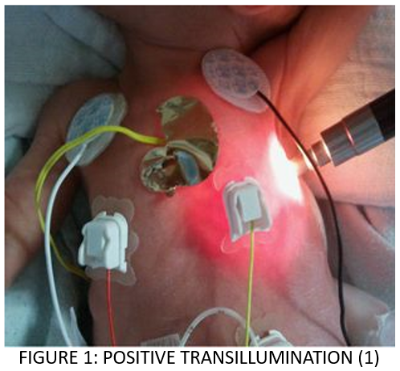
- Attend to hand hygiene.
- Inform the parent(s)/guardian(s) about the procedure if present and seek consent.
- Gather equipment.
- Position the patient supine.
- Dim the lights in the room.
- Using the cleaned fibreoptic cold light or pen torch, place the probe over the chest wall on both sides of the chest.
- Compare the two sides of the chest:
- a positive transillumination (suggesting the presence of a pneumothorax) will light up the whole hemithorax (see Figure 1) where a negative transillumination will only light up a ring of light around the cold light.
- Document findings in patient progress notes.
- Inform parent(s)/guardian(s) of findings.
- If pneumothorax is confirmed, manage as per protocol.

Section 1.2 – Chest X-ray
CXR is generally used to confirm or deny the presence of a clinically suspected pneumothorax (see Figure 2 for an example). In cases where the CXR is unclear, it may help to do a CXR with the patient in the lateral decubitus position. In this position, the patient lies on their side with the affected side up and the X-ray plate behind their back; the X-ray is shot from the patient’s front.

Note:
Clinical symptoms associated with pneumothorax are more important than size on CXR when deciding management.
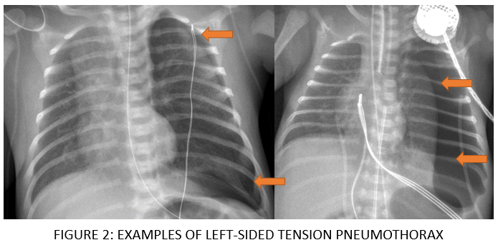

Section 1.3 – Lung Ultrasound
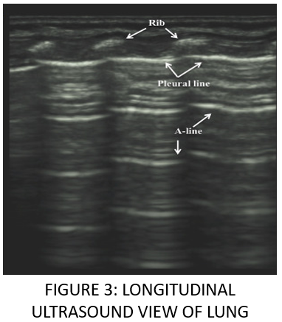
For clinicians with experience in using ultrasound, lung ultrasound has been shown to be a quick and effective method of diagnosing a pneumothorax. At CHS, this method should only be done by a consultant with a Certificate in Clinician Performed Ultrasound in Medicine from the Australian Society for Ultrasound in Medicine and as an adjunct to clinical assessment.

In a normal neonatal lung ultrasound (longitudinal view) (see Figure 3):
- The pleural lines are visible beneath the ribs. These slide over one another during normal breathing.
- A-lines are visible (parallel lines that represent reverberation artefact in healthy lung).
- You see drop out between the ribs (not always the case in preterm newborns).
- You may see B lines (vertical lines) which are thought to represent alveolar reverberation.
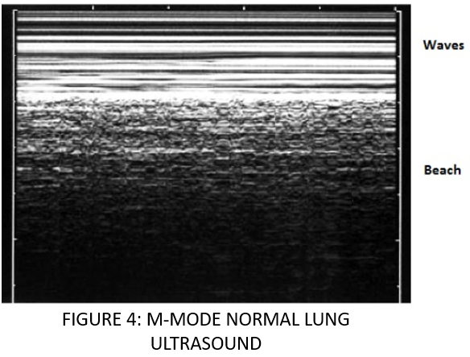
In an M mode normal lung ultrasound (see Figure 4):
- The ‘seashore sign’ (seen in Figure 4) is indicative of normal lung sliding (i.e., no pneumothorax).

Pneumothorax findings: In real time the ‘sliding’ of lung tissue is absent as are the ‘A lines’. In M-mode the seashore sign is absent and there are horizontal lines called the ‘barcode’ or ‘stratosphere’ sign. This is due to the absence of sliding and is consistent with a diagnosis of pneumothorax. The line between the ‘seashore’ and ‘stratosphere’ signs is the physical edge of the pneumothorax (lung point).

The presence of comet signs representing B lines rules out pneumothorax (see Figure 5).

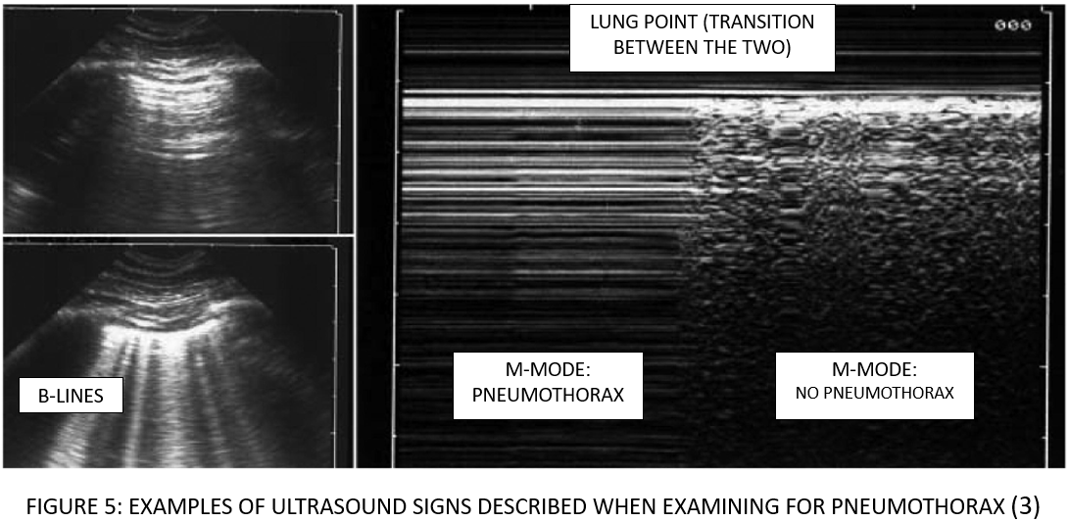

Signs described when examining for pneumothorax on lung ultrasound ^{2,3}
Ultrasound sign |  | Clinical utility
Sliding | Side to side horizontal movement of the parietal pleura | Presence of lung sliding has a sensitivity 95%, specificity 91-94% for absence of a pneumothorax³
B-lines | Vertical artefact that implies the presence of parietal pleura | Presence of a B-line or comet tail rules out pneumothorax (visceral pleura is present) NPV 99-100%³
Lung point | Point where lung sliding restarts on the border of a pneumothorax | Presence of lung point has a sensitivity 66%, specificity 100% for predicting pneumothorax
Lung pulse | Feature of atelectatic lung where the lung pulsates in time with the heartbeat | Presence implies complete atelectasis or a pneumothorax

Back to Table of Contents

Section 2 – Treatment and Management of a Pneumothorax

Section 2.1 – Conservative Treatment and Needle Aspiration
Pneumothoraces may spontaneously occur in term neonates. A term neonate without significant underlying lung disease is likely to remain well with supportive management.
- If a newborn is cardiovascularly compromised with a suspected tension pneumothorax, a needle aspiration should be performed prior to the insertion of a chest drain.
- Term newborns without underlying lung disease may have a needle aspiration performed as primary treatment for pneumothorax providing a medical officer that is skilled in drain insertion is available. Needle aspiration alone has been shown to be insufficient treatment for newborns <32 weeks 82% of the time and newborns >32 weeks 53% of the time. ²
- Only one needle aspiration should be performed as primary elective treatment for a pneumothorax.

In CHS, other criteria for draining pneumothoraces are:
- preterm symptomatic neonates <37 weeks gestation
- neonates with underlying lung disease
- any with a large pneumothorax who requires a significant amount of oxygen or respiratory support
- any showing evidence of a tension pneumothorax (tachycardia, hypotension, acidosis, poor perfusion)
- at consultant discretion.

Note:
Needle aspiration may be performed in birthing, Neonatal Intensive Care Unit or Special Care Nursery.

Needle Aspiration Procedure
Equipment
Equipment required includes:
- alcohol based hand rub/soap
- dressing Pack
- sterile gloves
- chlorhexidine Cleaning Solution
- 10ml, 20ml, or s30 ml syringe
- 3-Way Tap
- 23G/25G Butterfly Needle
- analgesia: sucrose, dummy, and swaddling blanket.

Procedure:
- Inform the parent(s)/guardian(s) about the procedure and seek consent.
- Attach patient cardiorespiratory monitoring.
- Gather and prepare equipment.
- Seek assistance from a nurse or a second clinician.
- Attend to hand hygiene.
- Don sterile gloves.
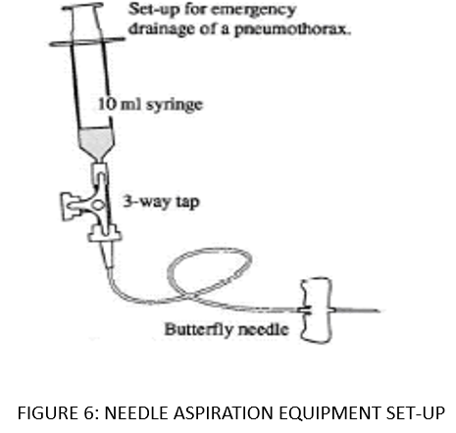
- Attach 10ml/20ml/30ml syringe and butterfly needle to the 3-way tap (see Figure 6):
- Make sure that 3-way tap is OPEN between syringe and needle and CLOSED to the side port.
- Assistant to position the patient as follows:
- The patient should be supine.
- Raise the arm of the affected side to a 90-degree angle.
- The affected side should be exposed and slightly elevated to ensure evacuation of air.
- Provide analgesia.
- Clean the neonate’s skin on the affected side with chlorhexidine.
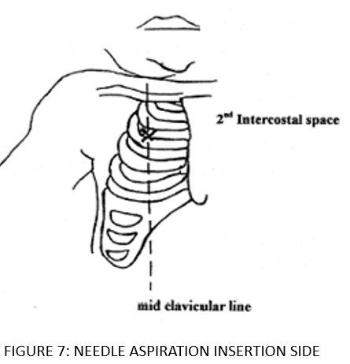
- Identify the needle insertion site, which is the 2nd intercostal space along the mid-clavicular line.
- Once the insertion site is determined, insert the needle by placing a finger on the neonate ’s 3rd rib and guide the needle along the finger and insert into the 2nd intercostal space just above the superior margin of the 3rd rib at an angle of 90 degrees (see Figure 7). Avoid the nipple and surrounding tissue.
- Securely hold on to the needle with the non-dominant hand (maintaining a 90-degree angle) and manipulate the 3-way tap and syringe with the dominant hand.
- Make sure that the 3-way tap is open from needle to syringe. Aspirate air from the chest using the syringe.
- Expel air collected from syringe by turning 3-way tap on from syringe to side port and push the air out.
- Make sure to communicate with the assistant regarding volume of air aspirated for documentation.
- Repeat Step 13-15 until resistance is met.
- Once resistance is met, remove needle.
- Settle the patient.
- Document the procedure in the patient’s clinical record including the amount of air removed in millilitres.
- Repeat the CXR to confirm drainage of the pneumothorax.
- Continue cardiorespiratory monitoring and observe for signs of deterioration.

Section 2.2 – Chest Drain Insertion
A chest drain should be inserted in any preterm neonate (<37 weeks) with significant pneumothorax and in any term neonate with significant underlying lung disease.

Note:
There is evidence that pigtail catheters are quicker to insert than traditional chest drains and work as effectively.³ There has been a suggestion in the literature that they are associated with fewer complications and less pain during insertion.⁴

Indication:
- Treatment of a pneumothorax or pleural effusion (see Definition of Terms).

Contraindication/Precaution:
- Avoid inserting a chest drain when there is untreated coagulopathy or thrombocytopenia (platelet count <80,000).

Insertion of Safe-T-Centesis (Pigtail) Drain Procedure
The Safe-T-Centesis is a soft flexible intercostal catheter that is introduced using a needle that is self-blunting.

Note:
Chest drain insertion is ideally completed in Neonatal Intensive Care Unit.

Equipment:
Equipment required includes:
- alcohol based hand rub/soap
- analgesia (sucrose (+/-dummy), morphine, and 1% lignocaine local anaesthetic)
- central line bundling equipment (refer to the Venous and Arterial Access Management in the Department of Neonatology Procedure, available on the Policy and Guidance Documents Register):
- hat
- mask
- sterile gown
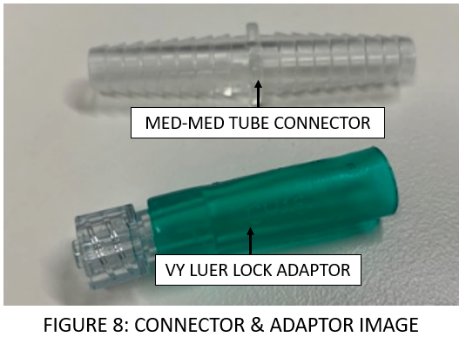
- sterile gloves
- sterile procedure stop sign
- sterile drapes
- sterile dressing pack
- underwater seal drain (UWSD) or Heimlich valve (temporary)
- X2 procedure trolleys
- wall suction
- chlorhexidine 0.2% Solution
- medium to medium tube connector (see Figure 8)
- VY Luer Lock Adaptor (see Figure 8)
- 20ml or 30ml Syringe
- Safe –T- Centesis (Pigtail) Catheter pack (see Figure 9) (preterm neonates Size 6Ch, term neonates Size 8Ch) containing:
- self-blunting Introducer with 10ml syringe attached
- pigtail catheter
- scalpel
- needle thoracentesis needle and tube (do not use).

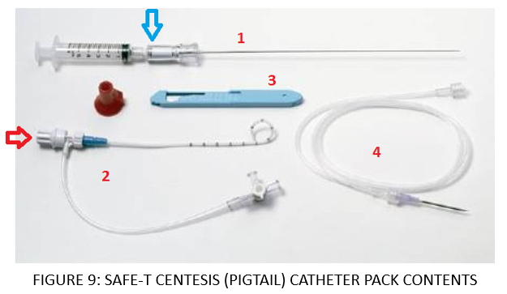
- Tegaderm dressing x4
- wound closure strips
- sterile scissors
- post-procedure securing & safety equipment:
- Duoderm
- 1 cm wide brown tape
- safety pin
- a pair of chest drain clamps.

Procedure:
- Identify the correct patient.
- Inform the parent(s)/guardian(s) about the procedure and seek consent.
- Seek assistance from a nurse or a second clinician.
- Attend to hand hygiene.
- If not already, attach cardiorespiratory monitoring to patient.
- Gather and prepare equipment:
- follow central line bundling requirements (see the Venous and Arterial Access Management in the Department of Neonatology Procedure) and aseptic procedure requirements (see the Aseptic Technique Procedure, available on the Policy and Guidance Documents Register).
- assistant to prepare the UWSD aseptically in a separate trolley.
- Don sterile gown and gloves. The assistant may also need sterile gloves if they need to access the sterile field during the procedure.
- Assistant to position the neonate supine with affected chest wall slightly elevated.
- Administer analgesia:
- provide sucrose and/or dummy
- if patient is on morphine infusion, consider increasing infusion medical order or consider commencing morphine infusion as per neonatologist
- administer local anaesthetic before the insertion of the needle.
- Assemble and check equipment (see Figure 10):
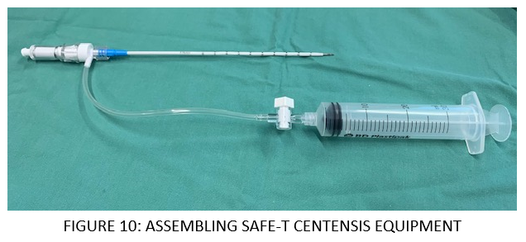
- insert self-blunting introducer with syringe attached into Safe-T-Centesis pigtail catheter
- attach a 30 ml syringe to the Safe-T-Centesis catheter 3-way tap
- make sure to open 3-way tap from catheter to syringe and turn off to the side port
- Clean the neonate’s affected chest area with Chlorhexidine 0.2%.
- Using the sterile drape, create aseptic field with cleaned affected area exposed.
- Identify the insertion site which is the 4th or 5th intercostal space along the mid to anterior axillary line making sure to avoid the nipple and any surrounding breast tissue.
- Administer local anaesthesia around insertion site and await effect.
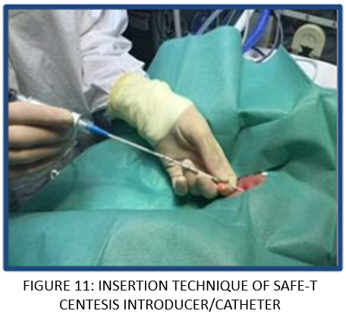
- When ready, use the scalpel to make a small 3-5mm incision (just through the skin) at the insertion site immediately above the lower rib (to avoid injuring the neurovascular bundle).
- Insert the assembled Safe-T-Centesis introducer with catheter gently through the intercostal space and pleura (see Figure 11).
- Apply firm pressure to get through the muscle and pleura.
- Guard the introducer with one of your hands by holding it approximately 2 cm from the tip to avoid advancing too far once there is a ‘give’ or a ‘pop’ when going through pleura.
- Make sure to watch the window of the Safe-T Centesis Introducer (see Figure 12).
- When inserting the introducer and the needle has a cutting edge, the window will be red.
- Once it has reached the pleura (when not in contact with tissue), the safety window will turn white, meaning it has a blunt edge.
- Gently insert introducer & catheter by 1-2 cm and position depending on type of contents aiming to empty. For example:
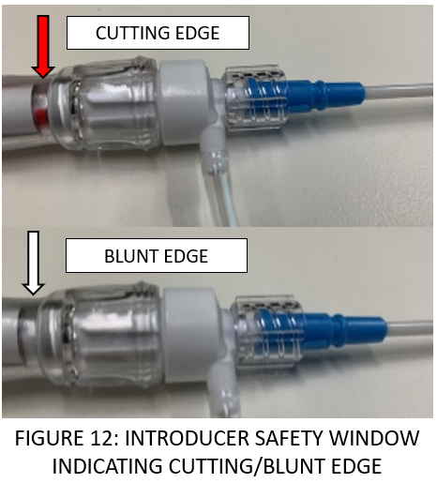
- pneumothorax: superiorly and anteriorly
- pleural effusion: inferiorly and posteriorly.
- Gently disconnect the introducer from the catheter.
- Begin threading the Safe-T Centesis catheter through whilst holding the introducer in place to desired depth, which should be at least 4 cm, making sure that the drain holes at the tip of the catheter are in the pleural space (approximately 5-7cm depending on size of the patient).
- Once desired depth is reached, remove the introducer from the catheter (the catheter has a self-sealing mechanism) (see Figure 13).
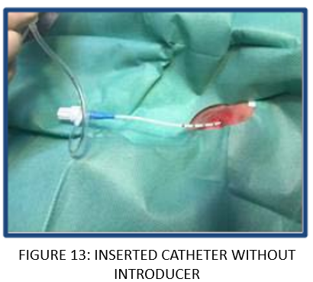
- Using the 3-way tap and syringe, aspirate any air/fluid from the pleural space until resistance is felt:
- To aspirate, turn 3-way tap open from catheter to syringe (off to side port)
- To expel contents, turn 3-way tap open from syringe to side port (off to catheter).
- Once resistance is met:
- Turn 3-way tap off to catheter to seal.
- Document the volume and/or appearance of aspirated contents in the patient’s clinical record (can be done after the procedure or done by the assistant).
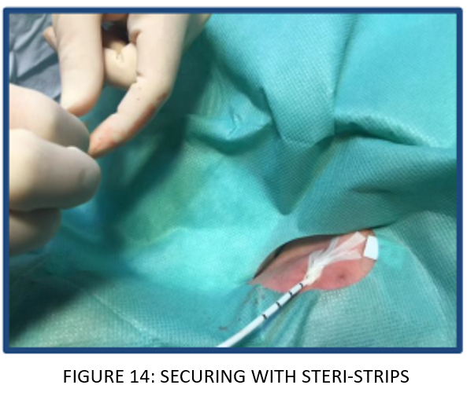
- Secure the drain to the skin using wound closure strips by crossing ends in a V-shape (see Figure 14)
- Create a ‘sandwich’ dressing technique using two Tegaderms (see Figure 15):
- Create additional security by placing Duoderm and brown tape (on top of the Duoderm) to anchor the drain to the abdomen or lower down the chest wall (see Figure 15).

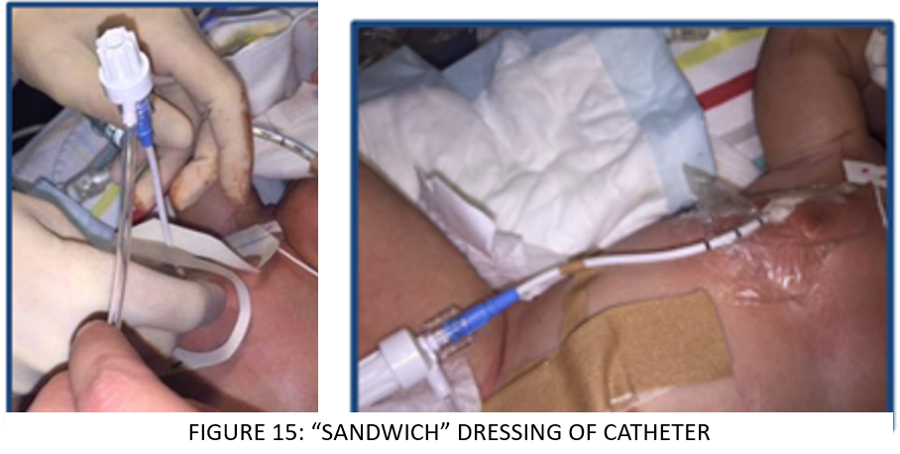
- Remove the 20ml/30ml syringe.
- Attach the VY Luer-lock adaptor to Medium-Medium Tube Connector and the 3-Way Tap (see Figure 16).
- The assistant is to attach the assembled UWSD to wall suction:
- To be attended cleanly as not an aseptic procedure
- Sterile MO to attend to Step 29
- Set wall suction as per the manufacturer’s recommendations (see Note below).

Note:
Oasis Atrium (Paediatric)
- fill Water Seal to 2cm line
- connect UWSD to wall suction
- wall suction to be set to -80mmHg
- UWSD suction regulator set to -20mmHg
Other UWSD without suction regulator (refer to manufacturer instructions)
- check the system is connected to low wall suction at between 5-10kpa if requested.
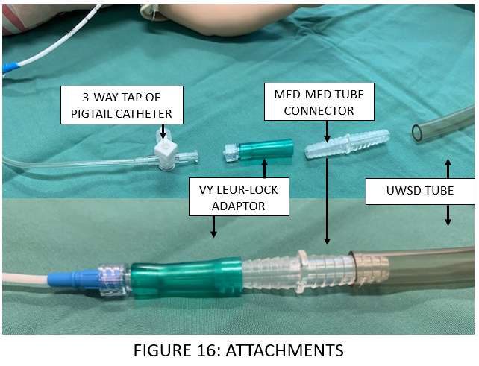
- Attach to UWSD tube or Heimlich Valve. See Figure 16.
- turn 3-way tap open from catheter to drain/valve (off to side port of 3-way tap)
- ensure that you can see swinging with respiration and/or bubbling (UWSD) or fluttering (Heimlich Valve) if there is ongoing drainage of intrathoracic air.
- Ensure that UWSD tube or Heimlich valve is below patient chest for effective draining.
- Apply Tegaderm between connections of VY Luer-lock adaptor, Medium-Medium Tube Connector, and UWSD tube/ Heimlich valve.
- Apply extra brown tape around UWSD tube with safety pin attached and secure to side of patient’s bed or nest for extra security.
- Place UWSD at end of patient’s bed, below patient’s chest.
- Confirm the position with a CXR and document the procedure in the patient’s clinical record.
- Position the patient supine.
- Settle the patient as per the Developmental Care in the Neonatal Intensive Care Unit and Special Care Nursery Guideline (available on the Policy and Guidance documents Register).
- Commence and document chest drain observations hourly (e.g., bubbling, swing, drain contents (appearance, volume, chest drain site, etc).
- Observe patient as per protocol in Neonatal Routine Care Guideline (available on the Policy and Guidance documents Register).
- Ensure chest drain clamps are readily available at patient’s bedside.
- Inform the medical team of any abnormal findings.

Alert:
- Pain associated with chest drain insertion may require pharmacological treatment.
- Drains may kink or fall out.
- Serious complications are rare. These include organ injury (particularly lung injury, although mediastinal or abdominal organ injuries can occur), bleeding, infection, and pneumothorax.

Back to Table of Contents

Section 3 – Chest Drain Management

Procedure
- Secure the tubing to the bed to ensure there is no pulling on the tube by encircling the tube with adhesive tape and pinning the tape to the bed.
- Check hourly for bubbling and swing (see Definition of Terms) in the chamber and document on patient observations.

Note:
- If a drain stops bubbling or swinging, particularly in the context of clinical deterioration, it’s important to suspect that it may be blocked/have dislodged.
- If a drain is bubbling excessively this may be a result of a ‘leak’ in the tubing or the drain being outside of the pleural space.

- Complete a pain score hourly and administer analgesia/sedation as ordered. Refer to the Neonatal Routine Care Guideline.
- Check dressing is intact and airtight at the insertion site; observe for any drainage or leaking from same. Do not change if dry and intact.
- Observe for signs of infection:
- drain site: erythema and purulent discharge around drain site
- drainage: purulent discharge.
- Check the system is connected to wall suction.
- Stabilise the UWSD tube when moving the patient by holding it close to their chest.
- Check that the UWSD is positioned below the level of the patient’s chest to prevent water from being drawn into the pleural space.
- Check UWSD clamps are available at the bedside
- To clamp tube if disconnected and during changing of the drainage system when necessary
- If disconnection occurs, immediately reconnect or use clamps to reseal and inform the MO immediately.
- Monitor and record the amount, colour, and consistency of the drainage hourly on the observation chart.

Back to Table of Contents

Evaluation

Outcome
- Staff are guided in the treatment and management of pneumothoraces.
- Staff can treat and care of patients requiring needle aspiration, chest drain insertion, and chest drain management.
- Patients have quality and timely care and treatment for pnuemothoraces.

Measures
- Incident data relating to pneumothoraces, chest drain insertion, infection, and needle aspiration will be tracked by Clinical Nurse Manager (NICU) weekly via the clinical incident reporting system. Any adverse events will be reported at the Neonatal Quality and Safety meeting.
- Review the drain observations attended with the assistance of DHR.

Back to Table of Contents

Related Policies, Procedures, Guidelines and Legislation

Policies
- Nursing and Midwifery Board of Australia Requirements for Practice
- Informed Consent
- Preventing and Controlling Healthcare Associated Infections

Manual
- Neonatal Intensive Care Drug Manual

Procedures
- Infection Prevention and Control
- Patient Identification and Procedure Matching
- Venous and Arterial Access Management in the Department of Neonatology

Guidelines
- Neonatal Routine Care
- Developmental Care in the Neonatal Intensive Care and Special Care Nursery
- Neonatal Resuscitation and Airway Management
- Respiratory Support – Invasive and Non-Invasive (Neonates and Infants)
- Surfactant Therapy for Newborns

Legislation
- Health Records (Privacy and Access) Act 1997
- Human Rights Act 2004
- Work Health and Safety Act 2011
- Carers Recognition Act 2021

Other
• Australian Charter of Healthcare Rights
Back to Table of Contents

References

- Waisman et al, Perinatal/Neonatal Case Presentation Chest dynamics asymmetry facilitates earlier detection of pneumothorax Journal of Perinatology volume 36, pages 157–159 (2016)
- Murphy et al, Effect of Needle Aspiration of Pneumothorax on Subsequent Chest Drain Insertion in s A Randomized Clinical Trial JAMA Pediatr. 2018;172(7):664-669.
- Wei et al, Pigtail Catheters Versus Traditional ChestTubes for Pneumothoraces in Premature Newborns Treated in a Neonatal Intensive Care Unit, Pediatrics & Neonatology, 2014-10-01, Volume 55, Issue 5, Pages 376-380.
- Cates, Pigtail catheters used in the treatment of pneumothoraces in the neonate, Adv Neonatal Care. 2009 Feb;9(1):7-16
- Jing Liu (2014) Lung ultrasonography for the diagnosis of neonatal lung disease, The Journal of Maternal-Fetal & Neonatal Medicine, 27:8, 856-861
- Hany Aly, An Massaro, Ceyda Acun & Maide Ozen (2014) Pneumothorax in the: clinical presentation, risk factors and outcomes, The Journal of Maternal-Fetal & Neonatal Medicine, 27:4, 402-406
- Sweet, David G et al. “European Consensus Guidelines on the Management of Respiratory Distress Syndrome – 2019 Update.” Neonatology (Basel, Switzerland) 115.4 (2019): 432–450. Web.
- Atrium Oasis dry suction chest drains, Instructions for use. (Accessed 13/12/2022 : mcv00033028_010395_rev_ab_oasis_wall_chart-en-us.pdf (getinge.com)
- Royal Prince Alfred Hospital (2022). Women’s and Babies : Management of Pneumothorax in Newborn infants. ( Accessed 13/12/2022 Women and Babies: Management of Pneumothorax in Newborn Infants (nsw.gov.au)

Back to Table of Contents

Definition of Terms

Bubbling (chest drain): While air is still draining from the intrapleural space, bubbles should be observed in the UWSD.

Pleural Effusion: an excessive collection of fluid in the pleural cavity

Self-Blunting Needle: A needle that is sharp when pressed into tissue and then covered by a blunt cover once the tip is in the thoracic cavity.

Swing (chest drain): When a chest drain is in the intrapleural space it should ‘swing’ with breathing (water level rising with inhalation and falling with exhalation).

M-mode: also known as motion mode, time motion display of ultrasound wave along a chosen ultrasound line.

Back to Table of Contents

Search Terms

Neonatology, Neonates, Infants, Pneumothorax, Pneumothoracies, Pleural Effusion, Pulmonary Haemorrhage, Chest Drain, Under Water Seal Drain, Underwater Seal Drain, UWSD, Needle Aspiration, NICU, Neonatal Intensive Care Unit, Special Care Nursery, SCN

Back to Table of Contents

Disclaimer: This document has been developed by Canberra Health Services specifically for its own use. Use of this document and any reliance on the information contained therein by any third party is at his or her own risk and Canberra Health Services assumes no responsibility whatsoever.

Policy Team ONLY to complete the following:
Date Amended | Section Amended | Divisional Approval | Final Approval
20/03/2023 | New Document | Susan Freiberg, ED WYC | CHS Policy Committee
12/04/2024 | CHS Network Included |  | CHS Policy Team

This document supersedes the following:
Document Number | Document Name
CHS19/096 | Management of Neonatal Pneumothorax - Guideline

