Canberra Health Services
Procedure
Electrical Safety Management (excluding medical electrical systems, equipment or devices)

Contents

Contents 1
Purpose 3
Alerts 3
Scope 3
Section 1 – Identified Risks 4
1.1 Identified hazards 4
1.2 Risk tolerances 4
1.3 Hierarchy of control 4
Section 2 – Responsibilities of CHS Team Membersand specialist Workers 5
Section 3 – Electrical Risk Management 6
Section 4 – Specific Electrical Risk Controls 7
4.1 Test and Tag of Electrical Equipment 7
4.2 Equipment brought from home into the work environment 7
4.3 Power boards 8
4.4 Double Adapters 8
4.5 Extension Leads 8
4.6 Use of Tools and Equipment 8
Section 5 – Responding to Electrical Incidents 9
5.1 What to do in an Electrical Emergency? 9
5.2 Facilities Management Actions 10
Section 6 – Contractors, Workers and Tradespersons with specific duties 11
6.1 Risk Management for Specific Electrical Tasks 12
6.2 Monitoring of Electrical Risks 15
6.3 Competency and Training for Specialised Trades 15
Related Policies, Procedures, Guidelines and Legislation 16
Definition of Terms 17
Search Terms 19
Attachments 20
Attachment 1 – Hierarchy of Control for Electrical Safety 21
Attachment 2 – Test & Tag New Portable Electric Equipment & Personal Computer Cabling 22

Purpose

This document describes the management requirements for:
- electrical works on Canberra Health Services (CHS) owned electrical infrastructure and grounds
- electrical energised equipment under the In-service Safety Inspection and Testing of Electrical Equipment Standard AS/NZS 3760
- work where a potential electrical hazard exists (i.e., ground excavation / drilling into a slab/wall)
- electrical equipment that connects to the mains supply by a flexible cord and plug.

This procedure relates to organisational obligations as part of Work Health and Safety (WHS) legislative compliance.
Back to Table of Contents

Alerts

This procedure relates to high-risk work where the consequence of control failure may be serious injury or death.

The following work is not permitted at any CHS premises or work sites:
- unauthorised or inadequately controlled electrical work
- working on or near live electrical equipment without required authorisation
- electrical work conducted by parties without required licence/competency
- improper use of electrical equipment
- isolation of any electrical circuit without required authorisation.

Back to Table of Contents

Scope

This procedure should be referenced by all workers. The document applies to:
- Section 1 - Tradespersons
- Section 2 – All workers
- Section 3 – Contractors, Workers and Tradespersons with specific duties.

For the purposes of this document:
- “Workers” means the same as in the Work Health and Safety Act 2011 and refers to contractors, volunteers, directly employed CHS Team Members etc. Further definitions can be found in the definitions section at the end of this document.
- “Tradespersons” means those workers who hold an electrical licence, restricted electrical licence, is an electrical inspector or electrical engineer.
- “Contractors” means those businesses and workers of those businesses as engaged to work on CHS facilities or grounds either directly by CHS or another ACT Government entity.

Exclusions:
- Where a Principal Contractor has a Disturbance or Interference with Services, Safety or Traffic (DISST) authorised site possession of a construction zone on CHS premises or lands, and the electrical activities or interruptions occur wholly within the site possession zone.
- Medical electrical equipment, including medical electrical systems and non-medical equipment connected to medical equipment as defined in Management Programs for Medical Equipment Standard AS/NZS 3551
- Medical electrical systems, equipment or devices which are managed by Health Care Technology Management (HTM) team.
- Work undertaken by the electrical supply authority on their owned infrastructure on or within CHS owned assets or lands.

Back to Table of Contents

Section 1 – Identified Risks

1.1 Identified hazards
For a current list of known hazards and risks, please contact your Health Project Representative (HPR) for the latest version of the Infrastructure & Health Support Services (IHSS) Risk Register or access it directly via the IHSS Sharepoint site.

1.2 Risk tolerances
A written risk assessment must be undertaken prior to any form of work where an electrical hazard may exist. After assessing the risk, work can proceed if the risk assessment is rated as Medium or below. The CHS Risk Assessment template can be found here - Risk assessment template.docx (sharepoint.com)
All electrical works rated as High risk or above must be passed on to your HPR for review and additional controls. Only with written consent from your HPR can high risk works proceed.
The risk assessment and authorisation documentation must be kept for 2 years from the date of works unless an incident occurred during the works and then paperwork must be kept for a minimum of 7 years.

1.3 Hierarchy of control
The hierarchy of risk controls can be found at Attachment 1. This shows the efficacy of control measures and the order in which they must be considered. It is good practice to include more than one level of controls to bring the risk to workers as low as reasonably practicable.
Back to Table of Contents

Section 2 – Responsibilities of CHS Team Membersand specialist Workers

This section contains general information to inform all workers of electrical safety responsibilities and risk management applicable to their place of work.
The following table defines roles with performance expectations related to electrical safety:

Position | Performance expectation and responsibility
Chief Executive Officer (CEO) CHS | - overall responsibility for electrical safety within CHS  - ensures the provision of appropriate resources to meet the requirements of this procedure
CHS WHS Team/ IHSS Safety and Risk Team | - provide workers with information on electrical safety, such as incident alerts and industry news  - assists with WorkSafe ACT Notifiable Incidents and support conducting investigations
Managers | - where relevant to performing safe work, managers will communicate the requirements of this procedure through orientation and induction and/or training to Workers  - ensure faulty equipment is tagged “Out of Service” and a My Facilities Management (MyFM) request is submitted.  - report and assist with investigating any electrical incidents and hazards through the CHS Incident Management Systems
Workers | Must:  - not use faulty equipment  - stop work if they believe the situation is unsafe or potential live electrical hazards exist and report to the supervisor or line manager  - report electrical incidents and hazards through a Staff Incident Report on the CHS Incident Management System follow instructions and contents of this procedure
Contractors | - attend CHS-mandated training and inductions in line with contractual agreements  - alert CHS to identified electrical risks or unsafe work environments  - comply with the WHS Act, Regulations and Codes of practice  - provide adequate supervision of engaged workers
Tradespersons | - comply with requirements of applicable AS/NZS Standards and Australian wiring rules  - perform work to a high standard

Back to Table of Contents

Section 3 – Electrical Risk Management

The following flowchart describes the steps that all CHS team members and workers should take when managing electrical risks:

Back to Table of Contents

Section 4 – Specific Electrical Risk Controls

4.1 Test and Tag of Electrical Equipment
During the life cycle of electrical equipment, the following must be considered:

Planning | - conduct a risk assessment of testing and tagging frequency dependent on the conditions of use of electrical equipment.  - consult with IHSS prior to commencing installation of new equipment so that the impact on the electrical supply load and maintenance requirements can be assessed.  - ensure that any electrical works required are carried out through IHSS with their knowledge and inclusive of the correct induction processes.
Prior to first use | - new equipment (including ICT equipment i.e., laptops, cords and monitors) to have the date of commissioning added to the device and cord at first use by supplier e.g., Shared Services Information and Communication Technology (SSICT).  - ensure all hired equipment has a current tag prior to receiving the hired equipment onsite.  - Refer to Attachment 2 – Test and Tag New Portable Electric Equipment & Personal Computer Cabling.
During Use | - equipment without a current test label should be tested & tagged as soon as reasonably practical. Unplug and visually inspect the item, electrical cable and the plug before further use. If any defect is noted the item must be removed from service, labelled “Do Not Use” and a MyFM request submitted.  - conduct regular visual inspections. In most cases defects are detectable by visual inspection.  - ensure routine testing and tagging of relevant plant / equipment / ICT (arranged through Facilities Management) is conducted.  - equipment that is faulty is immediately removed from service, labelled ‘Do Not Use’ and IHSS notified.
On repair of electrical equipment | - ensure all repaired and serviced equipment has a current tag when reintroduced to service.

4.2 Equipment brought from home into the work environment

Equipment brought from home into the work environment is subject to the same requirements as equipment owned and managed by CHS. Patients and consumers who are admitted for short durations are to, as far as is practical, use battery powered devices only.

Where a consumer is admitted for longer stays Facilities Management can test and tag the equipment for use at CHS inpatient units. The following electrical equipment are not permitted to be used at any CHS sites;
- Heaters
- Toasters
- Steam generators
- Electric blankets
- Irons
- Kettles
- Etc.

Where unsure, please contact Facilities Management on 51242215 to seek clarification.

Equipment that is identified as having damage to the device, cables or battery charges/plug packs will result in the item being removed from the premises.

4.3 Power boards
Power boards must not be used in clinical areas. Power boards may only be used for items such as computers and printers in non-clinical areas. Power boards should never be connected to another power board. Power boards must have overload protection. They must be tested and tagged by Facilities Maintenance prior to use.

4.4 Double Adapters
Double adaptors must not be used in CHS facilities. They may not sit securely in a wall outlet, may not be able to provide adequate earth protection and may cause overloading, overheating, fire or loss of electrical supply.

4.5 Extension Leads
Extension leads are not permitted in clinical areas of CHS facilities. They may cause high earth resistance and excessive earth leakage current. An extension lead can allow equipment to be powered from areas other than the relevant protected treatment area. The power from the other area may not be protected to the same level as the power in the treatment area.
As the connection between the extension lead and the equipment mains cable is often on the floor there is a high danger from fluid spills, tripping and damage to the cable by trolleys when an extension lead is used.
Outside clinical areas, extension cords may be used where no other reasonable alternative is available. Extension cords must not exceed 30 metres in total length and be connected to Residual Current Device (RCD) protected power. Extension leads must not be joined together.

4.6 Use of Tools and Equipment
- Always select the correct tool that has been designed to perform the task
- Use battery powered tools instead of mains-operated where possible
- When using electrical equipment with moving parts (saws, grinders etc.), guarding must be kept in place at all times.
- Frequently visually check each tool, lead and RCD (if applicable) for the following:
- evidence of physical damage (lead, connection, plug, switch)
- correct and in date tagging (refer to In-Service Safety Inspection and Testing of Electrical Equipment Standard AS/NZS 3760)
- “Out of Service” tag in place for untested/untagged items. Untested/untagged items must not be used, an ‘Out of Service’ tag applied, and item reported to supervisor.
Back to Table of Contents

Section 5 – Responding to Electrical Incidents

This section provides advice of the immediate actions to be taken following an electrical incident where a person has been or may have been exposed to contact with electricity involving any of the following: tingling, burns, arcing, shocks and/or electrocution.

5.1 What to do in an Electrical Emergency?
- Don’t touch someone receiving an electric shock
If someone receives a serious electric shock, your first reaction will likely be to go to their aid. But first, Do not touch, stop and think. The human body is an excellent conductor of electricity, meaning that the charge that just passed through the person could easily move into you if you make contact with them. Given that electricity has the capacity to kill or seriously injure, limiting the number of people exposed to the shock should be your number one priority.
In some cases, individuals can appear to be 'stuck' to electrical currents. What's actually happening here is that the voltage is sufficiently high to cause the victim's muscles to contract. This means they can't let go of the cable or object administering the shock, which is clearly very dangerous.
Additionally, be careful if there is water spilled on the site. Water conducts electricity, so until the power is turned off (see step 3), take precautions when moving around the area.
- Call emergency services
Ideally, you'll have someone with you so that steps two and three can happen at the same time. However, if you're alone, it's important that you phone emergency services as soon as possible. Victims of serious electric shocks will need treatment from medical professionals, so get the emergency crew on their way before you try and deal with anything further yourself.
When you call, give as much detail as possible on where you are and what's happened – this will allow the crew to prepare on route.
If you are in a clinical area, press the code blue button.
Help Numbers
Code Blue / Switchboard | 2222
Ambulance | 0 000

- Turn off the power
If it's safe to do so without putting yourself in danger, turn off the power – this makes the emergency site much safer to move around when the ambulance or other help arrives, and prevents further damage.
In situations where you can't turn the power off safely, try to separate the victim from the electricity source using a dry, non-conductive item such as a wooden broomstick, or the rescue crook from a low voltage rescue kit if one is readily available.
- Administer first aid
Only once the individual affected is away from the current can you approach them and begin first aid. Injuries from electric shocks can range from serious burns to cardiac arrest and death:
- If the individual isn't breathing – for unconscious victims who aren't breathing, perform cardiopulmonary resuscitation (CPR) until medical teams arrive to take over from you.
- If the individual is responsive – attend to their injuries, for example place burns under cold water for 20 minutes, and then cover with dressings. If you don't have a first-aid kit with you, kitchen glad wrap is suitable, as long as it's not applied too tightly (ensure circulation is maintained). Never put oils or ointments on burns.
Before professionals arrive, knowing how to treat an injured person can literally be the difference between life and death for those involved in electrical emergencies. This is why it's important to learn how to perform first aid.
- Alert your manager and organise attendance from Facilities Management (e.g. Electrician)
- Contact Facilities Management by phone and request urgent assistance – during business hours on 5124 2115 or after hours dial 9 (for customers on the Canberra Hospital campus or dial 0434 606 365). Be very clear on the nature of the electrical risk and the incident that has occurred
- Lodge a maintenance request on the MyFM system if instructed by Facilities Management.
- Lodge a staff incident report on the Incident Management Systems
- Ensure the incident is entered as a staff incident report on the Incident Management Systems

5.2 Facilities Management Actions
- Follow the IHSS Incident Process Flow
- If determined to be a ‘Notifiable Incident’ contact WorkSafe ACT immediately by phone on 6207 3000
- If a ‘Notifiable Incident’ is confirmed ensure, as far as reasonably practicable, that the site where the incident occurred is not disturbed until a WorkSafe ACT Inspector arrives or authorises this. Exceptions include to make the site safe and to minimise the risk of further injury
- If during business hours contact Infrastructure Safety on 42215 or 0402 962 508 or safetyandrisk@act.gov.au and Work Health Safety on 512 49410 and/or email CHS.WorkHealthSafety@act.gov.au
Back to Table of Contents

Section 6 – Contractors, Workers and Tradespersons with specific duties

This section relates to Contractors, Workers and Tradespersons with specific duties (as defined in the Scope of this procedure) who have duties under the Work Health and Safety Regulations 2011 in addition to those contained in Section 2. These may include:

- CHS team members who:
- are employed as electricians
- manage electrical infrastructure
- manage electrical contractors
and
- Contractors who:
- are engaged to work on CHS-owned or leased facilities
- hold a restricted electrical licence.
The following table defines roles with performance expectations related to electrical safety:

Position | Performance expectation and responsibility
Executive Group Manager  IHSS | - ensure that requirements of this procedure are met and adequate risk management is applied to electrical hazards.  - ensure the provision of appropriate resources to meet the requirements of this procedure.
Executive Branch Manager – Facilities Management (FM)  (in addition to above Executive Group Manager responsibilities) | - ensure that requirements of this procedure are met and adequate risk management is applied to electrical hazards.  - ensure electrical incidents reported in Incident Management Systems are responded to by the line manager and in accordance with WHS legislative requirements.  - Ensure contractors have safe systems in place to manage electrical risks.  - manage training matrix for electrical personnel.  - ensure electrical hazards are identified in planned activities and appropriate controls are in place.  - ensure electrical works have adequate resources (e.g. time, personnel) for work to be performed safely.  - nominate competent/qualified persons or contractors to undertake electrical inspection and testing of equipment.
Health Project Representatives (Project Managers) | - assess subcontractors through prequalification process and confirm compliance against legislation and regulations prior to engaging them to perform electrical work.  - conduct Task Observations to assess contractor compliance with electrical safety.  - review works once completed, where possible.  - ensure certificates of electrical safety and recertification of body and cardiac protect systems are received post works completion and are sent to Asset Management team.
Director, Infrastructure Safety and Risk | - conduct and/or assist in conducting Task Observations to assess contractor compliance with safety requirements.  - review provided DISST applications for adequacy of controls and provide sign off once satisfied.  - ensure Notifiable Incidents are communicated to Worksafe ACT and CHS Work Health Safety.  - investigate relevant electrical incidents reported to IHSS.  - review contractor WHS information at onboarding and contract review.
Director, Asset Management | - accept certificates of electrical safety, body protect and cardiac protect recertification certificates and add to building file.
Tradesperson | - remain up to date with training requirements.  - Follow all permit and safety procedures.  - submit certificates of electrical safety on completion of required works and forward a copy to nominated HPR.
Contractor | - provide suitably qualified tradespersons to undertake electrical works at CHS  - maintain minimum levels of insurance and provide evidence of same through Rapid Global system  - provide appropriate levels of supervision  - provide tradespersons with required PPE, tools and equipment and ensure they remain in good working condition

6.1 Risk Management for Specific Electrical Tasks
6.1.1 Use of Tools and Equipment
- always select the correct tool that has been designed to perform the task
- use battery powered tools instead of mains operated where possible
- when using electrical equipment with moving parts (saws, grinders etc.), guarding must be kept in place at all times
- RCDs should not be brought into the organisation without permission from IHSS
- frequently visually check each tool, lead and RCD (if applicable) for the following:
- evidence of physical damage (lead, connection, plug, switch)
- evidence of internal electrical damage
- sufficient electrical supply
- correct and in-date tagging (refer to In-Service Safety Inspection and Testing of Electrical Equipment Standard AS/NZS 3760)
- “Out of Service” tag in place for untested/untagged items. Untested/untagged items must not be used, ‘Out of Service’ tag applied, and item reported to supervisor
- electrical equipment being used in hazardous areas or used to exhaust/ventilate hazardous areas must be certified and intrinsically safe e.g., potentially flammable atmospheres
- the tools, testing equipment and Personal Protective Equipment for testing and fault finding must be suitable for the work, properly tested and maintained in good working order with evidence available on request to show last check/calibration and the results.
- insulated tools and equipment e.g., non-conductive ladders must be suitable for the work and be maintained in good working order
6.1.2 Safe Termination of Electrical Wires
Electrical hazards caused by unsafe termination of electrical wires include:
- exposed live electrical conductor / wiring
- unenclosed joints in conductors i.e., no connection boxes
- electrical connections where the condition of wiring has deteriorated
- unused wiring left in the roof space that could be connected to the switchboard
- past electrical work performed by an unqualified person and which could be substandard and unsafe.

Electrical Workers must ensure wires are terminated to comply with Electrical Installations (Wiring Rules) Standard AS/NZS 3000. If Workers have concerns about the condition of the electrical installation, they should stop and immediately advise CHS supervisors.
    - Body Protection in clinical areas
All body and cardiac protection are to follow the latest version of AS/NZS 3003. Any additions or deletions to circuits in these locations require the area to be re-certified to ensure the continued safety of the system.
6.1.4 Redundant Cabling
Redundant cabling must be removed back to the top of the switchboard and terminated in a Junction box. The junction box must be labelled with the circuit number. The circuit is to be tagged “Out of Service” with a note that it is terminated in the ceiling space above the board and the date the circuit was decommissioned.
6.1.5 Opening of Electrical Enclosures
Opening of enclosures while circuits remain energised is often required to facilitate inspections, troubleshooting and maintenance activities. However, consideration shall be given to the potential for hazardous atmospheres. This shall be considered in the risk assessment for the task and a gas test shall be conducted by a Competent Person for all such work in hazardous areas.

Opening of electrical enclosures or cabinets for purposes of inspecting or investigation, where the person is not coming into close proximity (closer than 500mm) with exposed electrical circuits, is not considered live electrical work under this local practice. However, whenever an escutcheon cover is removed, a second tradesperson must be in attendance and act as a spotter. The provisions for working on or near live electrics should be followed with the exception of holding an approved permit. Should works be needed that would require live electrical works or working near live electrics, the working on or near live electrics permit is to be sought.

Note: Opening of enclosures or cabinets where there is the presence of exposed voltage higher than 32Vac shall only be permitted by qualified persons. i.e. Electrical Engineer or Tradesperson.

While there is low risk for a Competent Person (as defined in the Definition of Terms Section) when opening a panel to observe the status of wiring or to inspect components as part of troubleshooting or maintenance activities, no part of the body or tools shall encroach within a distance of 500mm to exposed and live conductors.

Note: Placing hands or any part of the body within 500mm of live and exposed conductors shall be considered live work and additional safeguards shall be in place to protect the person from direct or indirect contact with energised conductors.
6.1.6 Electromagnetic Fields
Exposure to high electromagnetic fields may also present a potential hazard for workers with some medical conditions, for example pacemakers. Workers must inform all other persons at the workplace of any potential electromagnetic hazards at the workplace that may affect a medical condition. Managers must reduce risks to health and safety arising from electromagnetic hazards, including reducing the risk as low as reasonably practicable. Electromagnetic risks should be included in the Risk Assessment for the work being carried out.

At the hospital and other CHS medical imaging facilities, there are areas where exposure to high levels of electromagnetic fields can be experienced. Please check with your HPR for the locations of these areas as the operation of electrical equipment or having metal objects in these spaces can cause interference to sensitive medical equipment and impact on patient care.
6.1.7 Overhead and Buried Electrical wires
Workers and contractors must identify conditions and activities where there is potential for close proximity to overhead and buried electrical lines to occur. Where this risk has been identified, the DISST Application process must be followed.

The DISST Application form process ensures that risk assessments, procedures and instructions are in place to identify hazardous conditions and ensure that equipment, employees and workers do not come in contact with energized overhead lines with any unguarded points, or indirectly through conductive materials, tools or equipment.

Workers and contractors who are planning to do excavation work are to obtain copies of underground electricity cable plans through ‘Dial Before you Dig’(DBYD) (Phone 1100) and to make sure that the plans are no more than 30 days old when excavation commences. DBYD is the first step to excavating safely. DBYD should be used when undertaking (but not restricted to) the following:
- any excavation using machinery digging deeper than 150mm. This includes but is not restricted to backhoes, excavators, borers & kanga hammers (ploughing or ripping activities),
- any excavation using hand tools deeper than 300mm which includes shovels, spades and crow bars, or
- any vertical or horizontal boring.

For any excavation works, a survey utilising Ground Penetrating Radar (GPR) must be undertaken to identify and mark in-ground services. Any excavations occurring within 3 meters of any identified underground services must be performed using a Hydrovac.

All excavations work must follow the DISST Application process.

Note: The above examples are general and may not cover all situations where a DBYD would be required e.g. driving metal posts in the ground.

6.2 Monitoring of Electrical Risks
Contractors are ultimately responsible for monitoring electrical safety in the work that they perform. IHSS will monitor worker safety through Task Observations.

Electrical hazards will be monitored through routine Planned Inspection checklist of the workplace conducted by managers in conjunction with the Health and Safety Representative (HSR).

6.3 Competency and Training for Specialised Trades
The following table defines the expected competency by roles to implement the requirements of this procedure.

Competency | Who
ACT Electrical licence | For electrical work on energised electrical equipment or energised electrical installations (other than testing referred to in Regulations 150 and 165 of the Work Health and Safety Regulations 2011), a licensed or registered electrician or any other person permitted to carry out or supervise electrical work under Electrical Safety Act 1971 (e.g., electrical engineer, electrical apprentice).
Contractor Induction | For contractors conducting high risk construction work, maintenance, repairs, installations or alterations to CHS
Health Project Representative Training | Required by CHS Team Member with project management responsibility, coordinate construction activities/projects or who represent CHS as a client. This training is run by the Infrastructure Safety and Risk Section of IHSS.
Low Voltage Rescue and cardiopulmonary resuscitation training | Tradespersons and Contractors
Asbestos Awareness | Tradespersons and Contractors
Working on or near Asbestos Containing Products | Tradespersons and Contractors
Silica Awareness | Tradespersons and Contractors

Back to Table of Contents

Evaluation

Outcome
Electrical safety will be managed at CHS as per Regulation and Legislation.

Measure
- review of staff incident management reports related to electrical safety.

Related Policies, Procedures, Guidelines and Legislation

Policies
- Work Health and Safety Policy
- Work Health and Safety Management System (WHSMS)

Procedures & Forms
- DISST User Guide
- DISST Roles and Responsibilities
- DISST Application Form
- CHS Incident Report Form - Contractors
- Working on or Near Live Electrics Permit

Guidelines
- ACT Code of Practice “Managing Electrical Risks at the Workplace”
- CHS Electrical Standard inclusions
- CHS EV Charging Standard Inclusions
- CHS WHS and Risk Specifications
- CHS lighting Control Standard Inclusions
- CHS Number and Naming Convention
- CHS Rules for Adding Electrical Load
- CHS Infection Prevention and Control
- Escorting and Supervision of Tradespersons in AMHU and MHSSU
- Termination of electrical wires in ceiling spaces

Standards
Follow all applicable AS/NZS standards for electrical installations and safety including:
- Safety Inspection and Testing of Electrical Equipment Standard AS/NZS 3760

Legislation
- Work Health and Safety Act 2011
- Work Health and Safety Regulation 2011
- Electrical Safety Act 1971
- Electrical Safety Regulation 2004
- Human Rights Act 2004
- Machinery Act 1949

Other
- Work Health and Safety Management System (WHSMS)
- Australian Charter of Health Care Rights

Back to Table of Contents

Definition of Terms

Term | Definition
Competent Person | For electrical work on energised electrical equipment or energised electrical installations (other than testing referred to in Regulations 150 and 165 of the Work Health and Safety Regulation 2011), a licensed or registered electrician or any other person permitted to carry out or supervise electrical work under Electrical Safety Act 1971 (e.g. electrical engineer, electrical apprentice).  For any other case, a person who has acquired through training, qualification or experience and the knowledge and skills to carry out the task.
Electrical Installation | A group of items of electrical equipment that:  - are permanently electrically connected together  - can be supplied with electricity from an electricity supply authority or from a generating source (e.g. generator).  This includes fuse boxes and control panels.
Electrical Equipment | Devices which connect to an electricity supply. This includes but is not limited to workshop tools (drills, saws & welders), office equipment (computers, photocopies & faxes), and lunchroom items (refrigerators, microwaves & toasters).
Electrical Work | Includes connecting electricity supply wiring to electrical equipment or disconnecting electricity supply wiring from electrical equipment, and installing, removing, adding, testing, replacing, repairing, altering or maintaining electrical equipment or an electrical installation.
Exposed conductive part | A conductive part of electrical equipment that—  - can be touched with the standard test finger as specified in AS/NZS 3100; and  - is not a live part but can become live if basic insulation fails.  Exception: The term ‘exposed conductive part’ does not apply to the following:  - Conductive parts within an enclosure where the parts cannot be touched unless a key or a tool is required to remove the covers of the enclosure.  - Conductive parts within electrical equipment where the parts cannot be touched in normal use and movement of the electrical equipment, because of its configuration and size.  - Conductive parts that are effectively and permanently separated from live parts by—  - double insulation; or  - other conductive parts that are earthed.  - Conductive parts that are in the form of nameplates, screw heads, covers and similar attachments that cannot become live in the event of failure of insulation of live parts because of the manner in which they are supported and fixed.  - A removable or hinged conductive panel fitted to a switchboard or other enclosure containing conductors that are so located and/or restrained that, in the event of any conductor becoming detached from a terminal or mounting, the conductor is incapable of making contact with the panel.
Hazardous Areas | A hazardous area is an area (three-dimensional space) in which a flammable atmosphere is or may be expected to be present, and require special precautions for the construction, installation and use of equipment.
Health Project Representative | A CHS Officer, or who represent CHS as a client, responsible for providing assurance to Canberra Health Services that all duties and responsibilities are being appropriately managed and discharged by the Contractor.
Isolated | In this document, “isolated” means disconnected from all possible sources of electricity supply and rendered incapable of being made energised without premeditated and deliberate action.
Medical Equipment | Any instrument, apparatus or appliance, including software, whether used alone or in combination, which makes physical or electrical contact with the patient, or transfers energy from or to the patient, or detects such energy transfer to or from the patient, and is intended to diagnose, treat or monitor the patient
Medical Electrical System | Combination of either medical equipment or multiple medical devices which may also include other non-medical equipment, having a specified function and connected by either a physical connection or electrical interconnection
Personal Electrical Device | Personal electrical device: refers to any electrical device that is designed for portable personal use and is brought into CHS facilities for the personal use of patients and visitors. This may include but is not limited to:  - continuous positive airway pressure (CPAP) machines;  - portable televisions  - laptop computers (particularly with wireless network connection or modem)  - handheld wireless computers (tablets, Notebooks etc)  - audio players or similar  - radios or  - compact disc (CD) players  - mobile phone chargers.

Further definitions relevant to work, health and safety generally can be found in the WHSMS

Back to Table of Contents

Search Terms

SMS, WHS, Work Health and Safety, electrical, risk, compliance, test, tag, equipment, live work, testing, tagging, electrical work, electricity, WHSMS, WHS

Back to Table of Contents

Attachments

Attachment 1 – Hierarchy of Control for Electrical Safety
Attachment 2 – Test & Tag New Portable Electric Equipment & Personal Computer Cabling

Disclaimer: This document has been developed by Canberra Health Services specifically for its own use. Use of this document and any reliance on the information contained therein by any third party is at his or her own risk and Canberra Health Services assumes no responsibility whatsoever.

Date Amended | Section Amended | Divisional Approval | Final Approval
20/05/2024 | New Document | CHS Policy Team | CHS Policy Team
16/05/2025 | Update made to Section 4.2 Equipment brought from home into the work environment | Shannon Keevers, Director Infrastructure Safety and Risk | CHS Policy Team

This document supersedes the following:
Document Number | Document Name
CHS19/045 | Electrical Safety Management (excluding medical electrical systems, equipment or devices)
CHS20/179 | Electrical Safety Management (excluding medical electrical systems, equipment or devices)

Attachment 1 – Hierarchy of Control for Electrical Safety

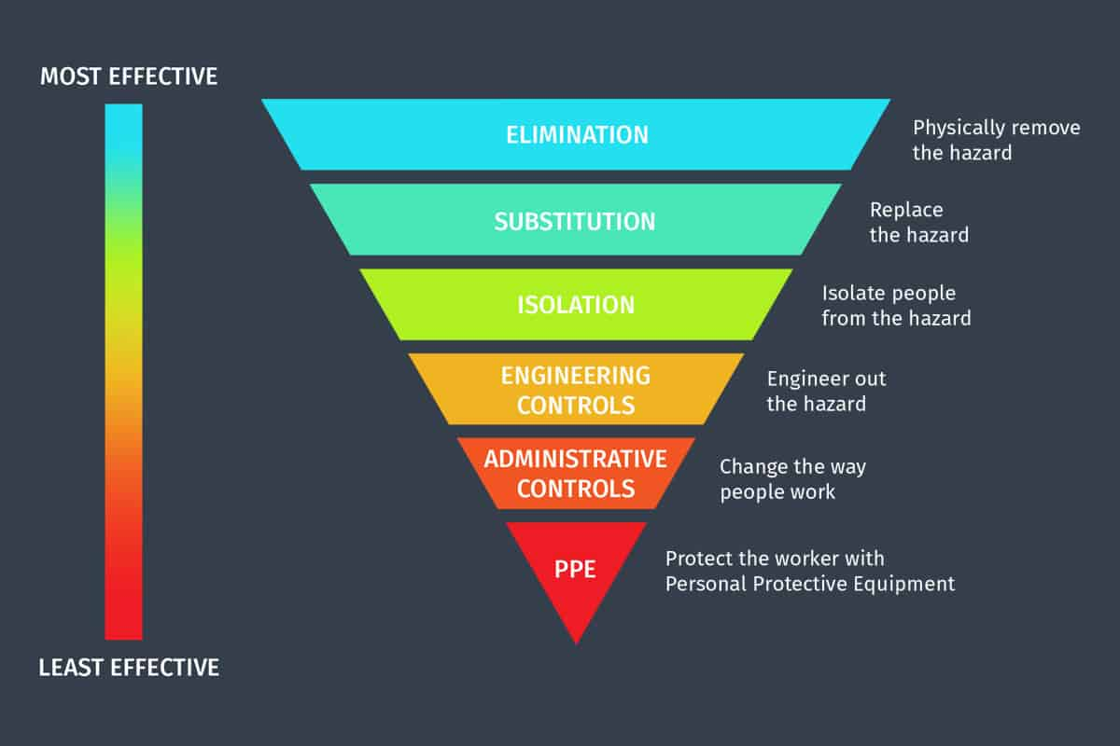

Attachment 2 – Test & Tag New Portable Electric Equipment & Personal Computer Cabling

New to Service Tags
A/S NZS 3760:2010 In- Service safety inspection and testing of electrical equipment. Part 2.4.2.1 c) of the AS/NZ Standard states:
“In Australia, when equipment is new, the supplier is deemed responsible for its initial electrical safety. New equipment need not be tested but shall be examined for obvious damage. Where deemed compliant the owner or responsible person shall ensure it is tagged.
In Australia, equipment that is new and entering into service for the first time but not tested and tagged shall have a tag applied that includes the following information:
- Wording “new to service”
- Date of entry to service
- Date when next test is due
- Statement: “This appliance has not been tested in accordance with AS/NZS 3760”
Note: Once the piece of equipment has been tested and tagged the ‘new to service’ tag can be removed.

Test and Tag
Test and Tag is a process of carefully visually inspecting each appliance for damage to flex, connections, guards, covers, and plug by a competent technician. Once the technician is assured the item is safe to electrically inspect, the item’s insulation, earthing and polarity may be tested to ensure it is electrically safe.
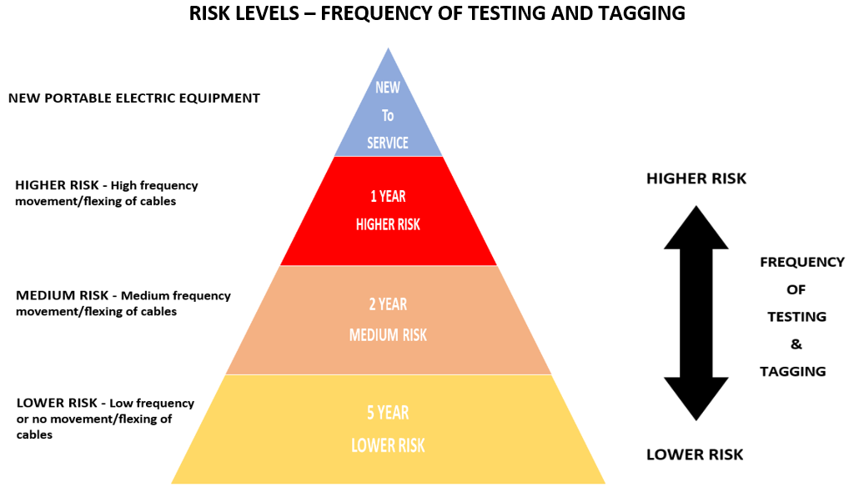
Please note: Testing and tagging according to the level of frequency of movement/flexing of cables and note the level of risk can change due to changes in way portable equipment is used. e.g., a worker based at hospital commences hybrid working arrangement (i.e., Work from home).

Risk Level | Frequency | Types of Portable Equipment | Responsibility
Risk Level | Frequency | Types of Portable Equipment | New to service | Routine Testing
HIGHER RISK  Higher frequency movement / flexing of cables | 1 Year | Community Nursing Team laptop | DSD / SSICT | FM Director of Maintenance CHS
HIGHER RISK  Higher frequency movement / flexing of cables | 1 Year | Team Member personal equipment and training equipment regularly moved | FM Director of Maintenance CHS | FM Director of Maintenance CHS
HIGHER RISK  Higher frequency movement / flexing of cables | 1 Year | Tradesperson tools | FM Director of Maintenance CHS | FM Director of Maintenance CHS
MEDIUM RISK  Medium frequency movement / flexing of cables | 2 Years | Laptop used under Flexible working arrangements e.g. work from home. | DSD / SSICT | FM Director of Maintenance CHS
MEDIUM RISK  Medium frequency movement / flexing of cables | 2 Years | Computer on Wheels (COWs) | DSD / SSICT | FM Director of Maintenance CHS
MEDIUM RISK  Medium frequency movement / flexing of cables | 2 Years | Kitchen equipment regularly unplugged e.g. not enough power outlets for kettles / sandwich press | FM Director of Maintenance CHS | FM Director of Maintenance CHS
MEDIUM RISK  Medium frequency movement / flexing of cables | 2 Years | Office equipment – laminators, electrical staplers etc | FM Director of Maintenance CHS | FM Director of Maintenance CHS
LOWER RISK  Lower frequency or no movement / flexing of cables | 5 Years | ICT equipment – monitors, printers, docking station  DHR equipment  Desktop - CPU | DSD / SSICT | FM Director of Maintenance CHS
 | 5 Years | Sit to stand desk | FM Director of Maintenance CHS | FM Director of Maintenance CHS

Note - Canberra Health Services uses the CHS Risk Management Framework and Risk Management Policy to manage risk effectively and efficiently. The Framework and Policy was applied to identify the risk levels of new portable equipment to confirm the frequency of testing and tagging.

