Canberra Health Services

Procedure
Dhulwa Mental Health Unit - operational

Contents

Contents 1
Purpose 3
Scope 3
Mental Health (Secure Facilities) Act 2016 3
Section 1 – Introduction 3
1.1 Dhulwa 3
1.2 Forensic Mental Health Inpatient Service Model of Care 5
1.3 Legislation 5
1.4 Role of security team 6
Section 2 – Mental Health Act 2015 provisions 6
2.1 Restraint and forcible giving of medication 6
2.2 Seclusion 7
2.3 Decision making capacity 7
2.4 Advance Agreement and Advance Consent Directions 7
2.5 Nominated person 7
2.6 Transfer of Custody 7
Section 3 – Referral 8
3.1 Role and function 8
3.2 Eligibility criteria 8
3.3 Exclusion criteria 9
3.4 How to make a referral 9
3.5 Referral assessment 9
3.6 Admission and Assessment Panel (AAP) 9
3.7 Urgent referrals 10
3.8 Referral outcomes 10
3.9 Appeals process 10
Section 4 – Admission 10
4.1 Role of staff during admission 10
4.2 Transfer of custody 12
4.3 Belongings 12
Section 5– Inpatient care 12
5.1 Clinical Care 13
5.2 Communication and care planning pathways 14
Section 6 - Risk assessment tools 19
6.1 Treatment, Placement, Restrictions, Implementation and Monitoring Plan (TPRIM) 20
6.2 Dangerousness, Understanding, Recovery and Urgency Manual (DUNDRUM) 21
6.3 Suicide Vulnerability Assessment Tool (SVAT) 21
6.4 Dynamic Appraisal of Situational Aggression (DASA) – IV 21
6.5 Historical Clinical Risk Management (HCR) – 20 22
6.6 Anamnestic Assessment (5Ws) 22
6.7 Dynamic Risk Assessment ISBAR 23
6.8 Clinical Risk Assessment (CRA) 24
6.9 Observation 24
Section 7 – Codes 26
7.1 Emergency codes 26
7.2 Code Black 26
7.3 Duress Alarms 27
Section 8 – Electronic devices for consumers 27
Section 9 – Food services 28
9.1 Cutlery 28
9.2 Supervision at servery area 28
9.3 Supervision in dining room 28
9.4 Searches for missing cutlery 29
9.5 Self-catered meals 29
Section 10 – Discharge 29
Section 11 – Partnering with consumers, carers, family, and other supports 30
Section 12 – Documentation 31
Section 13 – Dhulwa governance and meeting structure 32
Evaluation 33
Related Policies, Procedures, Guidelines and Legislation 33
Definition of Terms 35
Search Terms 35
Attachments 36
Attachment 1– Dhulwa Mental Health Unit Therapy Framework 37
Attachment 2 – Dhulwa Mental Health Unit meeting structure 38

Purpose

This document provides guidance on the operational procedures specific to the Dhulwa Mental Health Unit (Dhulwa). Adherence to this procedure is to ensure:
- Clinical practice supports the model of care (see 1.2)
- Compliance with statutory responsibilities
- Adoption of evidence-based practice principles
- Practice which supports overarching, Canberra Health Services (CHS) and Mental Health, Justice Health and Alcohol and Drug Services (MHJHADS) policy, procedures, and frameworks.
Back to Table of Contents

Scope

This document applies to all staff providing care to consumers at Dhulwa.

This document is to be followed in conjunction with all relevant, CHS and MHJHADS policies, procedures, and frameworks.
Back to Table of Contents

Mental Health (Secure Facilities) Act 2016

Dhulwa is a declared Secure Mental Health Facility (SMHF) in accordance with the Mental Health (Secure Facilities) Act 2016.

Section 60 of the Mental Health (Secure Facilities) Act 2016 requires the CHS Chief Executive Officer (CEO) to make a SMHF Direction. The following SMHF Directions have been made:
- Use of Force – see Use of force to conduct a search under the Mental Health (Secure Facilities) Act 2016 Procedure
- Strip Search – see Search (patient, personal property, bedroom, premises) under the Mental Health (Secure Facilities) Act 2016 Procedure
- Visitor Conditions – see Visitors to Dhulwa under the Mental Health (Secure Facilities) Act 2016 Procedure
- Prohibited Items – see Prohibited and Restricted Items under the Mental Health (Secure Facilities) Act 2016 Procedure
Back to Table of Contents

Section 1 – Introduction

1.1 Dhulwa
Dhulwa is a forensic inpatient unit with 25 beds for people with complex mental illness or people with mental illness who have or are likely to come into contact with the criminal justice system and are unable to be cared for in a less restrictive environment.

Dhulwa, as a forensic inpatient unit contributes to the care continuum of mental health services in the ACT provided by MHJHADS.

Dhulwa sits at the intersection between mental health and the justice systems to deliver specialised inpatient forensic services that address mental illness and offending behaviour. Forensic mental health is a speciality area primarily focused on providing clinical services that include assessment, treatment, and management of people with a mental illness or disorder who have offended or are at risk of offending.

The forensic therapeutic support framework at Dhulwa encompasses interventions and services that promote a consumer’s recovery and wellbeing across the domains of secure recovery:
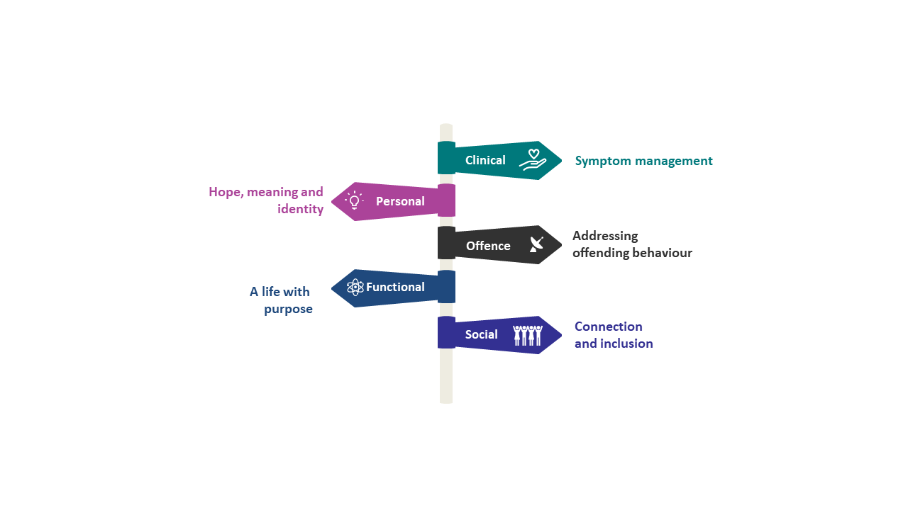

The therapeutic supports are delivered across the functions of assessment and stabilisation, rehabilitation and community reintegration and are aligned with the seven pillars of the DUNDRUM (see 6.2) to guide the delivery of services.

Risk assessment in a forensic mental health setting refers to harm individuals with a mental illness or disorder pose or have posed to others, where that risk is usually related to their mental illness or disorder. Risk assessment and management approaches are supported by clinical tools that are essential additions to clinical practice in conjunction with clinical judgement, multidisciplinary team review and other relevant factors.

Assessments of risk are to be structured using clinical tools underpinned by clinical expertise, to support responses to escalating risks through the implementation of proactive interventions to manage aggression risks effectively and balance safety with a consumer’s recovery journey.

The risk assessments used at Dhulwa (see section 6) are a continuous process that form an integral part of clinical care and informs the reliability of decisions regarding the management of risk.

Dhulwa has implemented the Safewards model and interventions for use in mental health inpatient units. The Safewards model is designed to reduce conflict and containment or restrictive practices by identifying and addressing the causes of behaviours in staff and consumer that may result in harm (conflict) and reduce the likelihood of this occurring. Staff are trained to use a range of direct and indirect strategies to manage consumer behaviours in a concerted effort to reduce restrictive or coercive interventions. This also requires staff to review their own behaviours and responses to conflict and the strategies used to manage challenging behaviours. Safeward strategies are included in the orientation and induction process for new Dhulwa staff which are audited for adherence.

Dhulwa has implemented a primary nurse model where consumers are allocated a primary nurse on admission. The primary nurse works with the multi-disciplinary team (MDT) to ensure all consumer needs are meet and is the consumer’s key contact regarding their health care. The MDT and primary nurse working together ensures consumers are supported in the provision of health care, including individual care planning and MDT meetings.

The primary nurse is responsible for the following tasks:
- Monthly outcome measures (HONOS, Phase of Care)
- Monthly Basis 32 and Relapse Prevention Plan 3
- Preparation of updates to the Multidisciplinary Team Meeting (MDT)
- Monthly review of Treatment, Placement, Restrictions, Implementation, Monitoring
- Preparation and attendance at Individual Care Planning (ICP) meetings
- Completion of admission requirements and discharge planning in collaboration with the treating team

1.2 Forensic Mental Health Inpatient Service Model of Care
The 2024 Model of Care sets out an evidence-based framework for practice and guides the delivery of the right care, at the right time, by the right person/ team and in the right location across the continuum of care.

A dedicated vision for Forensic Mental Health Inpatient Services is hope, healing and creating meaningful lives for a safer future together.

The vision and the six principles establish a standard against which actions can be assessed, guide and direct decision making to achieve the shared vision. The six principles are:

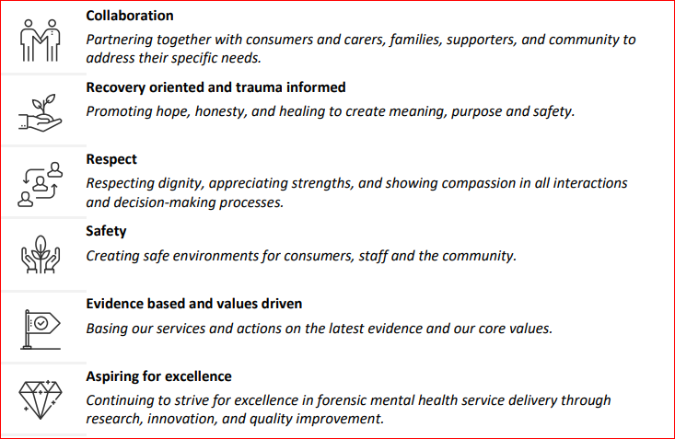

1.3 Legislation
Dhulwa staff are required to comply with overarching legislation, which collectively aims to ensure consumers admitted with mental health needs receive appropriate and compassionate care while protecting the rights and safety of consumers and the broader community.

The legislation governs the operation of mental health services, sets standards for assessment, treatment and detention while adhering to human rights principles and best practice in the mental health field.

The legislative foundation for the approach to care provision, recovery, treatment, security and a person’s requirements for privacy and dignity are considered the guiding principles of the Human Rights Act 2004, Mental Health Act 2015, and the Mental Health (Secure Facilities) Act 2016.

1.4 Role of security team
Security at Dhulwa has an important role in supporting the safety of consumers, carers, families, supporters, and staff. The security team at Dhulwa is responsible for the environmental security, this includes:
- Management of the entry of all persons into Dhulwa, the proof of identification requirements, registration into the security system and the condition of entry that people and their possessions be searched.
- Perimeter security consisting of the management of key and proximity card access and the storage system, the secure fence, Closed Circuit Television (CCTV), lighting and regular and random patrols.

Providing efficient, safe, and secure supervision of consumers during escorts.

The Security team do not have a role in the provision of treatment, care or support to consumers admitted to Dhulwa and are not authorised to do the following:
- Seclude or restrain a consumer under the Mental Health Act 2015.
- Search a consumer under the Mental Health (Secure Facilities) Act 2016, (unless requested by the Person in Charge of the facility (see definition of term).
- Be involved in a use of force for the purposes of a search of a consumer.
- Approve prohibited or restricted items to be brought into Dhulwa.
Back to Table of Contents

Section 2 – Mental Health Act 2015 provisions

See Office of the Chief Psychiatrist website for resources for clinicians and delegates, Rights of People experiencing mental illness or mental disorder, and Advisory notes on disclosure of information to carers and substitute decisions makers.

2.1 Restraint and forcible giving of medication
All Dhulwa staff are to comply with and refer to the CHS Restraint and/or forcible giving of medication to a person detained under the Mental Health Act 2015 procedure.

All incidents involving the use of restrictive practices under the Mental Health Act 2015 are reviewed at the Dhulwa Safe Practice Review Committee and the MHJHADS Restraint, Seclusion, Restrictive Practices Review Committee.

2.2 Seclusion
All Dhulwa staff are to comply with and refer to the CHS Seclusion of persons detained under the Mental Health Act 2015 procedure.

2.3 Decision making capacity
A consumer must be assumed to have decision making capacity unless established that they do not. Article 12 of the Convention on the Rights of Persons with Disabilities recognises that people have the right to make decisions and be supported in their decision making.

All Dhulwa staff are to comply with and refer to the CHS Assessment of decision making capacity and supported decision making for people being treated under the Mental Health Act 2015 procedure.

2.4 Advance Agreement and Advance Consent Directions
An Advance Agreement is a document stating a consumer’s preferences for future mental health treatment, care and support and any relevant information about practical support they may need.

An Advance Consent Direction is a document that records the consumer consent or non-consent to receiving treatment, care or support, or specific medications and procedures if they do not have decision making capacity in the future.

All Dhulwa staff are to comply with and refer to the CHS Advance Agreements, Advance Consent Directions and Nominated Persons under the Mental Health Act 2015 procedure.

2.5 Nominated person
A Nominated Person is a someone appointed by a consumer with a mental illness or mental disorder under the Mental Health Act 2015. A Nominated person is to be informed and consulted about the consumer’s treatment, care, and support to ensure that the consumers interests and rights are respected.

A Nominated person does not have the power to make treatment or other decisions on behalf of the consumer with a mental illness or mental disorder.

See CHS Advance Agreement, Advance Consent Direction and Nominated Person under the Mental Health Act 2015 procedure for further information.

2.6 Transfer of Custody
All Dhulwa staff are to be aware of the transfer of custody process of a consumer admitted who is a detainee or young people in court ordered detention.

See Transfer of custody of a detainee/ young detainee admitted to Dhulwa under the Mental Health Act 2015 procedure.
Back to Table of Contents

Section 3 – Referral

3.1 Role and function
To ensure transparency and governance of admissions to Dhulwa, the Admission and Assessment Panel (AAP) review each referral on an individual basis to determine if the consumer is suitable for admission.

The AAP serves as a single point of access to determine if a consumer requires rehabilitative care and/or care in a secure environment. The AAP meet weekly or as required to review referrals.

The AAP members include the following (or their delegates):
- Clinical Director, Forensic Mental Health Service (FMHS)
- Operational Director, FMHS
- Assistant Director of Nursing (ADON)
- FMHS Senior Manager
- Allied Health Manager / Therapy Manager
- Dhulwa Consultant Psychiatrist(s)
- Psychiatry Registrar(s)
- Clinical Nurse Consultant(s) (CNC)
- Administration Manager (secretariat)
Additional people who may be called to attend include:
- The referring team
- Aboriginal Liaison Officer (ALO)
- Nursing team representatives
- Allied Health team representatives
- Other people deemed relevant by the AAP Committee

3.2 Eligibility criteria
To be eligible for admission to Dhulwa, the consumer must be subject to a mental health order under the Mental Health Act 2015, and must meet one of the following inclusion criteria:
- Be sentenced or remanded to custody and have a mental illness or mental disorder with a need for treatment beyond what can safely be provided in a correctional setting
- Be subject to a conditional release order
- Be unable to receive treatment in a less secure non-forensic mental health services due to specialist forensic need as per Mental Health Act 2015 (i.e., pose a danger of serious harm to others)
- Be a correctional patient as defined in the Mental Health Act 2015.

3.3 Exclusion criteria
The exclusion criteria are:
- Those who can be assessed and treated in non-forensic mental health services
- Those who are assessed through a validated assessment tool as requiring a level of therapeutic security commensurate with a high secure service.

Note: If the admission assessment determines that the level of therapeutic security required is commensurate with a high secure service, a referral to a high security facility interstate may be considered.

3.4 How to make a referral
A referral to Dhulwa can be made by completing the Referral for Admission to Dhulwa and Gawanggal Form. This form can be obtained, by sending an email to DMHU@act.gov.au. The referring team is to email the completed referral form to DMHU@act.gov.au and save it in the consumer's clinical record.

The referral form is to be completed in collaboration with the consumer and their support systems, guardian, family, carer, nominated person (if have one) and have the support of the referring Multi-Disciplinary Team (MDT) prior to submission.

It is highly recommended the referring team consults with a member of the Dhulwa clinical team by telephone on 512 41851 prior to making a referral.

3.5 Referral assessment
Following the AAP’s review of a referral, a face-to-face clinical assessment will be arranged by the Dhulwa clinical team and documented in the consumer’s clinical record.
The DUNDRUM 1 and 2 assessments will be completed, and the outcome will be used by the AAP to inform the consideration of admission. The four-part validated structured tool provides a framework for the assessment and communication of:
- Admission triage - the appropriate level of therapeutic security for a consumer.
- Urgency - admission urgency, considering other consumers on a waiting list and consumer’s assigned level of security.
- Treatment completion - consumer’s progress in relation to treatment programs.
- Recovery assessment - levels of therapeutic security along the consumer’s recovery pathway.

3.6 Admission and Assessment Panel (AAP)
The outcome of the assessment and referral information will be discussed and considered by AAP, as well:
- If the admission criteria are met.
- If the consumer should be admitted to Dhulwa or if a less restrictive option should be considered.
- The urgency of the admission.
- What the consumer’s clinical assessment and treatment needs are.
- The mix of consumer’s currently admitted to Dhulwa.
- The triaged need of consumers awaiting admission.

3.7 Urgent referrals
In exceptional circumstances a consumer may require urgent admission to Dhulwa as clinically indicated. In those circumstances the AAP may convene as required to facilitate the review and clinical assessment.

3.8 Referral outcomes
All referral outcomes and /or any recommendations for alternative treatment options for consideration will be discussed with the referring team and documented in the consumers clinical record by the CNC or delegate.

3.9 Appeals process
If the referring team does not agree with the decision of the AAP, they may choose to appeal the decision. Firstly, the AAP will discuss the outcomes of the referral with the referring team and consider any additional relevant clinical information provided by the referring team. If admission is agreed, the AAP will advise the referring team and the admission will progress.

If disagreement regarding admission remain, AAP will formally offer the appeal process:
- A second assessment of the referral will be completed on the provision of additional information for clinical consideration.
- The second assessment will be discussed between stakeholders at a case conference and if agreement for admission to Dhulwa, the admission will progress as normal.
- If the second assessment determines the admission criteria is not met, the consumer will not be admitted to Dhulwa.
- If the referring team are still in disagreement regarding admission, they may raise their concerns with the Chief Psychiatrist for arbitration.

Back to Table of Contents

Section 4 – Admission

4.1 Role of staff during admission
4.1.1 Nursing
The admitting nurse is responsible for ensuring the admission process is complete, and will:
- Greet and orientate the consumer to Dhulwa, provide an explanation of the unit and a copy of the Welcome to Information Dhulwa Booklet
- Explain the admission documents to be completed, including conducting a search of the person’s belongings, allocation and access to their bedroom following registration into the electronic access control system
- Within 24 hours, or as soon as practicable, the in consultation with the CNC, undertaken and complete:
  - The Dhulwa Physical Appearance Form, available on the clinical forms register
  - Treatment, Placement, Restrictions, Implementation, Monitoring (TPRIM) risk management plan
  - Security Classification and Leave Entitlement (SCALE)
  - Suicide Vulnerability Assessment Tool (SVAT),
  - Behaviour and Symptom Identification Scale (BASIS-32)
  - Health of the Nation Outcome Scale for Users of Secure and Forensic Services (HoNOS–secure)
  - Fagerstrom Test for Nicotine Dependence (FTND, if not completed)
  - Personal safety / release prevention planning
  - Falls Assessment
  - Provide any dietary information to the kitchen
- Admit the person in the clinical record system to Dhulwa.

The nursing staff will seek the consumers consent to refer them to the Aboriginal Liaison Officer (ALO) for cultural support, if required.

4.1.2 Allied health
The Allied Health staff is responsible for providing information about the therapeutic groups and individual supports available at Dhulwa. Some of the individual responsibilities of the allied health team are outlined below:
- Social Worker - contact guardian, family, carer, nominated person or any other significant support person to introduce themselves and organise a family meeting
- Occupational Therapist - identify a suitable time(s) to undertake a functional assessment to inform functional needs of the therapy program
- Psychologist - identify a suitable time to conduct appropriate psychological and cognitive assessments to inform psychological and cognitive needs of therapy program.

4.1.3 Medical team
The psychiatry registrar will:
- Undertake a comprehensive assessment to identify critical elements of care and treatment
- Complete Clinical Risk Assessment (CRA) Initial form and medication charts including prescribing adequate PRN medication
- Complete physical health assessment and relevant medical examination of a consumer within 48 hours of their admission. If a medical examination is not possible at the time of admission (e.g., if it would be distressing to the person to undergo a physical examination due to mental state, or if a person refuses), the reason should be clearly stated in the consumers clinical record, including any relevant observations documented. Continued attempts should be made where possible to undertake the physical health assessment and examination.

4.1.4 Administration team
The Administration team will:
- Update the consumer’s clinical record indicating which room the consumer is allocated and the demographics such as guardian, nominated person, current General Practitioner, mobile telephone number and change of address to Dhulwa
- Ensure relevant admission forms are available and completed by all stakeholders
- Ensure property and valuable forms are completed and uploaded to the consumer's clinical record
- Provide the admitting nurse with an admission folder and patient identification labels.

4.2 Transfer of custody
See Transfer of custody of a detainee/ young detainee admitted to Dhulwa under the Mental Health Act 2015 procedure.

4.3 Belongings
On admission a consumer’s belongings will be recorded on the consumers clothing, property, and valuables form, following a search. See Dhulwa Search (patient, personal property, bedrooms, and premises) under the Mental Health (Secure Facilities) Act 2016 procedure.

Dhulwa has a holding room with storage for each bedroom where excessive belongings should be stored to avoid work health and safety or infection control issues in a consumer’s bedroom.

The MDT will monitor and liaise with the consumer about their belongings, including information on the items that can be kept in the consumers bedroom or be held in the holding room.
Back to Table of Contents

Section 5– Inpatient care

Inpatient care provided at Dhulwa is recovery focused, trauma informed specialist forensic mental health care. The MDT partners with the consumer, nominated person, carer, family and other supports to promote healing, recovery, and safety to meet the consumer’s needs and support their recovery goals.

The core functions of forensic mental health inpatient care are recovery oriented clinical assessment, co-planning, individualised treatment, capacity building and risk management. The Dhulwa Therapy Framework (Attachment 1) provides guidance on the activities and interventions that may be considered across the domains of secure recovery based on a consumer’s clinical progress as assessed by the DUNDRUM 3 and 4.

The Dhulwa Therapy Framework informs individual care plans and overall activity and intervention planning for the unit. Interventions aim to target individual and group clinical and rehabilitation needs within the seven pillars of health and wellbeing:
- Physical Health
- Mental Health
- Alcohol and Drugs
- Harmful Behaviours
- Activities of Daily Living
- Education and Occupation
- Social Networks

The clinical supports include behaviour change programs, other psychologist therapies and a full range of medical and psychosocial interventions. Individual Care Plans are used to identify and document programs and interventions recommended for the individual based on their individual DUNDRUM assessment and in collaboration with the consumer. Some programs may be required, while other activities may be optional.

5.1 Clinical Care
5.1.1 Medication
Medications prescribed by the medical team are done so with the expectation that they will be taken by the consumer.

Note: When a consumer does not follow the agreed medication treatment plan (including refusing medication or attempting to hide medication) the treating team must be informed as soon as possible.

Non-adherence with medication treatment by a consumer must be documented in the consumer’s clinical record and include a plan to manage the nonadherence. This must be included in the clinical hand over between shifts. Refer to CHS Clinical Handover procedure.

See CHS Medication Handling policy for more information about prescribing, administering, or managing consumer medications.

5.1.2 Therapeutic programs
Consumers at Dhulwa have access to a variety of activities and intervention programs such as:
- Social and recreational
- Skills based and self-help
- Pet therapy / assistance animals
- Mental health awareness
- Cognitive remediation
- Metacognitive and social skills training
- Problem behaviour interventions
- Community information
- Gym and actively living
- Managing physical health
- Psychoeducation relating to symptoms management, diagnosis and treatment choices and recovery
- Relapse prevention
- Alcohol and Drug programs
- Leisure activities
- Access to online and external education and training programs
- Community engagement activities.

The clinical interventions are provided in groups and individually to support consumers to understand their physical and mental health needs and make personal changes to manage their own risk of offending in the future. Dhulwa provides a minimum of 25 structured activity sessions per week. Activities and programs are scheduled in both on and off ward activity spaces and are reviewed every 3 months by the Allied Health team in consultation with the MDT and Senior Leadership Team.

5.1.3 Leave
Leave from Dhulwa is an essential component of care. Leave may be for medical, emergency, legal, or therapeutic purposes, and the access and type vary according to the legal status of the consumer. All consumers are allocated a leave rating (SCALE) which determines the security and leave entitlements including supervision and escort requirements.

All leave must be approved by the Dhulwa Leave Panel. Decisions about access to leave are informed by the consumers legal status, therapeutic security needs as assessed on the DUNDRUM 1, recent clinical presentation, risks as assessed by the HCR-20 or other structured risk assessments, and therapeutic recovery and program completion as assessed by the DUNDRUM 3 & 4.

All Dhulwa staff are to be aware of the process for consumer leave from Dhulwa, including if a consumer takes unauthorised leave, fails to return from leave or absconds during escorted leave, see Dhulwa and Gawanggal leave management procedure and CHS Missing patient procedure.

5.1.4 Visitors
Dhulwa promotes the importance of contact by consumers with family members, friends, and other people during their admission to promote successful recovery. Connection with families, friends, carers, and the community are encouraged to facilitate a supported transition back to the community. All visits are to be approved by the MDT and are to be scheduled by emailing the DMHU administration team at DMHU@act.gov.au.

See Visitors to Dhulwa under the Mental Health (Secure Facilities) Act 2016 procedure.

5.2 Communication and care planning pathways
5.2.1 Handover
Clinical handover is the communication of consumer care to ensure relevant, accurate and current information about the care transferred, actions undertaken (when necessary) and continuity of care is maintained. Standardised clinical handover optimises safe, high quality consumer care.

Handover may be delivered:
  - Face-to-face
  - Via telephone or telehealth,
  - Clinical documentation
  - Discharge summaries
  - Outpatient letters (e.g., by Medical Officers, Allied Health, Nurse Practitioners)
  - Electronic handover tools including e-Referrals.
CHS uses a structured handover process:
- ISBAR (Introduction, Situation, Background, Assessment, Recommendation/Read back) method for verbal clinical handover
- ISOAP (Identification, Subjective information, Objective information, Analysis/Action/Advice, and Plan) for written documentation and transfer of care depending on information to be communicated.
See CHS Clinical Handover procedure for further information.

5.2.2 Safety huddle
The safety huddle is a communication tool to maintain a safe working environment, by identifying and mitigating or managing safety issues that arise within the clinical environments of Dhulwa. Safety issues can be occupational, environmental, operational, or clinical.
The safety huddle does not replace a clinical handover or MDT meeting and not every consumer will be discussed during a safety huddle.
The safety huddle is an open and transparent forum for staff to identify, discuss and manage or resolve immediate safety issues and support a positive culture of workplace safety. The huddles take the form of a brief, focused and structured exchange of information about potential or existing safety issues which may affect consumer/s, staff and any person accessing the healthcare environment.
The safety huddle must be systematically organised to ensure that it is effective and sustainable, and is:
- Held at the beginning of the day, immediately following the MDT huddle
- Attended by staff involved in the care of consumers on shift, including the:
- ADON, Chair
- Consultant Psychiatrist or Clinical Director, Deputy Chair
- Psychiatry Registrar
- CNC
- NIC
- Nursing staff who are available
- Clinical Nurse Educator
- Therapy Manager
- Allied health staff that are available
- Health and Safety Representative
5.2.3 Multi-Disciplinary Team (MDT)
The MDT comprises of a range of health professionals working together to deliver comprehensive consumer care. An MDT approach is first and foremost centred on the needs of the consumer and to work collaboratively in the provision of best practice health care, resulting in improved and best clinical outcomes.

MDT meetings are a structured multi-disciplinary framework by which clinical decision making is made and is the primary clinical forum for a consumer’s treatment and care to be discussed. The meetings provide a structure for the varying disciplines to collaborate effectively to meet the needs of the consumer and provides a support function for clinical staff who work in Dhulwa.

MDT meetings are held weekly, and clinical discussions are to be documented in the consumer’s clinical record by the chair.
The CNC will appropriately triage and manage a list of consumers to be reviewed at an MDT.
A consumer’s care plan and ongoing treatment are to be discussed at MDT within the first two weeks of admission. The MDT may determine a review at a less frequent rate if the consumer’s presentation does not alter.
5.2.4 Deterioration of mental health or physical health
5.2.4.1 Mental health care
Mental health deterioration of the consumer may become evident through an increase in Dynamic Appraisal of Situational Aggression (DASA) scores or an acute episode of agitation and distress which requires immediate clinical intervention. In the instance a consumer exhibits an acute deterioration of their mental health or behaviour a management plan will be developed to effectively manage the deterioration, ensure consumer, and staff safety.

All staff are responsible to ensure the appropriate management and or an escalation of resources and clinical support to prevent potential episodes of consumer aggression or violence. The expertise of allied health, nursing and medical staff should be utilised through the MDT when seeking to address the complex issues relating to the prevention and management of aggression and violence of a consumer.

When staff are concerned a consumer’s behaviour is becoming increasingly disturbed or there are issues of clinical concern, it is an expectation that they be supported by their colleagues in escalating these concerns to other more senior members of the treating team. Their concerns must be proactively followed up in a timely manner by the implementation of an MDT review of the treatment plan as a priority.

ISBAR principles must be used in the verbal and documented hand over of any clinical concerns. In addition, details of risk assessment observations, the use of prescribed medications and clinical interventions for the consumer should also be outlined.

See Adult Acute Mental Health Services Operational procedure for process of direct admission.

5.2.4.2 Physical Health
People accessing MHJHADS will be supported with their physical health care needs. Physical health care will be delivered in a person-centred, respectful, non-judgemental, and culturally sensitive way, with information about the illness, physical condition and treatment options provided to enable people to make informed decisions.

Under section 74 of the Mental Health (Secure Facilities) Act 2016, CHS is required to ensure that consumers have access to specialist health services from health practitioners, including:
  - Regular health checks
  - Timely treatment where necessary, particularly in urgent circumstances
  - Hospital care, where necessary, and
  - As far as practicable, specialist health services and necessary health care programs (including rehabilitation programs).
Staff at Dhulwa will provide consistent evidence based physical health care to consumers to ensure their acute and ongoing physical health care needs are identified, assessed, and managed in a timely and effective way.

Nursing staff are to undertake a comprehensive physical health check and history within 7 days of admission and a General Practitioner (GP) review to be undertaken within 4 weeks. A medical physical health assessment will be undertaken annually.

See CHS Providing Physical Health Care across Mental Health, Justice Health and Alcohol and Drug Services Operational Procedure for more information.

5.2.4.3 Medical intervention
If urgent medical care is required, the consumer will be transported to an appropriate health facility in an ACT Government vehicle.

In an emergency, the consumer will be transported to an appropriate health facility via ACT Ambulance Services.

The escort level for urgent and emergency transports to another health facility is in accordance with the consumers SCALE rating. Detainees do not have a SCALE rating and the
minimum escort level is 2 CHS staff + 2 security staff and handcuffed.

SCALE is the clinical tool used to determine the security and leave entitlement of a consumer admitted to Dhulwa, see Dhulwa and Gawanggal leave management procedure.

All Dhulwa staff should comply with and refer to the Code Blue section contained in the Dhulwa Emergency Plan, a sub-plan of the CHS Emergency Management Plan for guidance on the escalation and management process for a medical condition that has the potential to be life threatening and / or cannot be managed at Dhulwa with the resources at hand.

Below outlined the afterhours clinical deterioration escalation pathway:
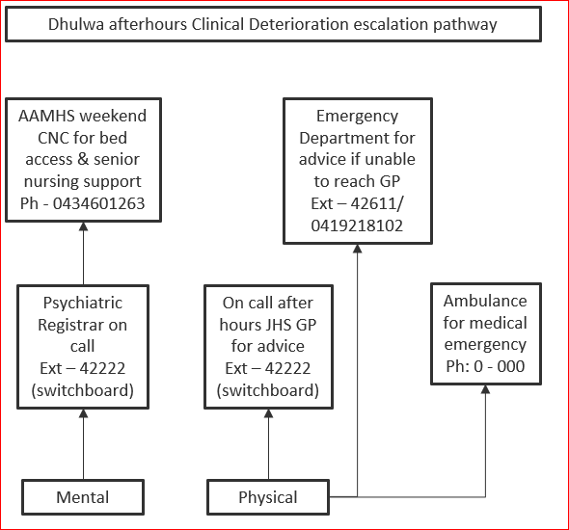

5.2.5 Individual Care Plan
Individual care plans (ICP) are used to actively engage the consumer in their care by the identification of their own individual recovery goals, including relapse prevention planning. The ICP is informed by the DUNDRUM 3 & 4, Health of the National Outcome Scale (HoNOS) outcome measures (3 monthly), and HCR-20 risk assessment (6 monthly).

A comprehensive multidisciplinary assessment conducted by the clinical lead of each discipline (nursing, allied health, medical) is presented at the consumers first ICP review, and then reviewed every 3 months.

Strategies and interventions will be clear, specify a target date for completion and identify a member of the MDT or service responsible for actioning clinically and therapy led items.

ICP’s will be guided by the MDT but will be led, developed, and maintained in collaboration with the consumer, nominated person, carers, family and other supports.

5.2.6 Environment safety check
The purpose of Environmental Safety Checks (ESC) is for staff to observe and assess for any items that could lead to self-harm and changes in the immediate environment that may increase potential for self-harm or suicide attempt.
ESCs at Dhulwa are not a premises search.

ESCs are completed on each shift. There may be occasions where opportunistic actions are taken by staff to manage items that can be used for self-harm.

Any risks identified during an ESC are to be notified to the CNC or the NIC. Information in ESCs is collated by the CNC and used as part of clinical governance, risk reporting systems and staff line management system.

Significant findings such weapons and suspected illicit substances etc must be reported to the ADON during business hours and after hours to the afterhours hospital manager/executive director on call.

Door pressure sensors are fitted on all bedrooms and all toilet doors in the common areas and laundry door. The sensors will be triggered when a weight greater than 15 kilograms is exerted. Dhulwa staff and a Security Officer are to respond to the activation of a door pressure sensor alarm.

All Dhulwa staff must ensure they are familiar with the CHS Clinical Procedure Ligature Risk Management for MHJHADS Inpatient Mental Health Units and CHS Clinical Procedure, ligature use in inpatient mental health units: response and management procedure.

Back to Table of Contents

Section 6 - Risk assessment tools

Below are the formalised risk assessments that are used for the identification and management of aggression and violence at Dhulwa. The completion of these assessments assists in the formulation of the management of risk and informs levels of observation and engagement for consumers.

Risk assessment tool | how often to be completed or reviewed
TPRIM | - admission  - monthly  - change in clinical presentation
DUNDRUM | - receipt of referral to Dhulwa (DUNDRUM 1&2)  - 3 monthly (DUNDRUM 3&4)  - change in mental state has been identified  - transition and discharge (DUNDRUM 1-4)
SVAT | - admission or change in treatment setting  - abrupt/significant change in clinical presentation  - 3 monthly  - transition and discharge
DASA - APP | - every shift
HCR-20 | - within 6-8 weeks of admission  - change in risk profile  - 6 monthly to accompany ICP reviews  - prior to transfer or discharge (“out” assessment)
5Ws | - after each incident of violence  - after any seclusion or restraint
Dynamic ISBAR | - prior to interventions that have potential to illicit aggressive response
CRA | - admission  - daily if change in risk / presentation  - align with any DASA rating increase  - if observations are unusual  - showing concerning behaviour  - MDT reviews  - deterioration in mental state

Other validated assessment tools may be used as clinically indicated within scope of practice.

6.1 Treatment, Placement, Restrictions, Implementation and Monitoring Plan (TPRIM)
TPRIM is the document used for the day-to-day communication of risk and risk management strategies for an individual consumer. It includes information on the bio-psychosocial and physical needs of the consumer including any behavioural risks, and the management plan for any risk. TPRIMS are developed in Dhulwa for each consumer and are working documents that are regularly updated and reviewed by the treating team.

A TPRIM reflects a consumer’s day-to-day treatment and management plan, and considers:
- Treatment – the biological, psychological, and social treatment interventions
- Placement – determining the location of treatment provision and decision making to ensure the least restrictive alternative is used and this is balanced with enabling safe delivery of care
- Restrictions – referring to any constraints that might be required to keep the consumer safe and reduce opportunity for harm to others. Restrictions may include or be influenced by:
- Legislation or legal orders
- Environmental factors
- Personal factors
- Implementation – identifying who is responsible for implementing the elements of the plan
- Monitoring – determining what needs to be monitored, by whom and when.
- Review – identify when, how and who will be involved in reviewing the plan

6.2 Dangerousness, Understanding, Recovery and Urgency Manual (DUNDRUM)
DUNDRUM is a four part (Triage, Urgency, Treatment completion and Recovery assessment), validated structured professional judgment instrument to support decision making regarding care environments, admission, leave and care transitions.

The DUNDRUM ratings are used to measure therapeutic engagement and progress and to inform the planning of activities, interventions, and therapeutic programs. The DUNDRUM informs the consumer’s progress towards discharge and their therapeutic security needs.

The DUNDRUM is to be completed collaboratively by the MDT. Where possible, every effort should be made to encourage the consumer to complete the self-assessment version with the support of a clinician familiar with the DUNDRUM.

6.3 Suicide Vulnerability Assessment Tool (SVAT)
SVAT is used to document the assessment of a consumer’s suicide vulnerability. The SVAT is used to formulate management strategies to mitigate the risk to the consumer.

SVAT is to be completed 3 monthly or if there is a change in clinical presentation and /or risk.

All Dhulwa staff must be familiar with the MHJHADS Initial Management, Assessment, and Intervention for People Vulnerable to Suicide Procedure and the Suicide Vulnerability Assessment Tool (SVAT) to assess a consumer’s suicide vulnerability.

6.4 Dynamic Appraisal of Situational Aggression (DASA) – IV
The DASA-IV is a seven-item risk assessment tool to assist clinicians in identifying a consumer’s potential for risk of aggression within the next 24 hours.

The DASA-IV is in the consumer's clinical record and must be completed by a clinician who has been trained in the use of the tool and who is familiar with the current presentation of the consumer being assessed.

The DASA -IV is to be completed during each shift by the consumers primary/ allocated nurse and documented in the clinical record. The consumers’ presentation and behaviour over the previous 24 hours should be considered when scoring the DASA-IV.

DASA forms part of the Aggression Prevention Protocol (APP) used at Dhulwa, to reduce aggression using appropriate nursing inventions based on the DASA rating.

The seven items of DASA are:
- Irritability
- Impulsivity
- Unwillingness to follow instructions
- Sensitive to perceived provocation
- Easily angered when requests are denied
- Negative attitudes
- Verbal threats

DASA -IV is to be used as a guide for assessing the short-term likelihood of inpatient aggression. It is used in conjunction with the APP to support early intervention strategies. The APP provides prompts for staff as to the types of interventions that should be considered based on an individual’s DASA-IV score. It aims to ensure the intervention is proportionate to the level of risk.
0 – Low risk
1:1 nursing, reassurance, distractions techniques

1-3 – Moderate Risk
1:1 nursing, talk down, distraction techniques

4-7 – High Risk
Limit setting, 1:1 nursing, increased observations, talk down, PRN, distraction techniques, reassurance

The assessments are not to be prescriptive in terms of dictating interventions, nor are they isolated from clinical judgement. The interventions are determined following consideration of available interventions and knowledge of what works for the individual consumer.

6.5 Historical Clinical Risk Management (HCR) – 20
The HCR-20 is a 20-item structured professional judgement tool used to assess an individual's risk for violence in clinical and forensic settings. HCR-20 assesses both static and dynamic risk factors associated with an increased risk of violent recidivism. The HCR-20 allow the assessors to utilise a range of clinical information sources to determine the presence of past, recent, or potential future problems with identified risk factors which may be a feature of their history, clinical presentation, or context/situation. The HCR-20 will be completed within six to eight weeks following the admission of a consumer and reviewed if there is a change in their risk profile, 6 monthly and prior to discharge. The HCR-20 informs the plan to manage the consumers risk of violence.

The HCR-20 must only be completed by a clinician who has been trained in the use of the HCR-20 tool or under the supervision of a clinician who has been trained in its use.

The use of the HCR-20 may be complemented by using other relevant structured professional judgment tools such as specialist assessment of personality, sexual offending risk, stalking risk, psychopathy, or arson risk. A decision will be made by the MDT about the use of additional assessments based on individual clinical need.

6.6 Anamnestic Assessment (5Ws)
Anamnestic assessment involves a detailed review of previous incidents of violence and aims to identify common factors and patterns. The analysis will assist in ensuring the risk management plan for each consumer addresses the person’s individual needs and vulnerabilities to assist in prevention in future incidents.

Documentation to support anamnestic assessment follows the 5W’s format completed after each incident of violence and or seclusion and restraint. A 5W’s report is to be completed by the clinician who witnessed the incident and documented in the consumer's clinical record.

For each episode of aggression consider:
- When the episode occurred
- Where it occurred
- Who the consumer/victim were (role, age, sex, and relationship)
- What behaviour they engaged in and what the consequences were
- Why they engaged in the behaviour

Following an incident a de-brief is to occur with the consumer to support ongoing and further safety planning. This de-brief involves obtaining the views and perspective of the consumer into their behaviour and what mitigation factors could be utilised in the future.

6.7 Dynamic Risk Assessment ISBAR
The short-term dynamic clinical and environmental risk assessment and management planning approach known as the ‘Dynamic ISBAR’ is utilised in Dhulwa to identify responses and plan interventions in a situation where it is anticipated that a consumer may respond aggressively. A situation may be, but not limited to, discussions relating to withdrawal of privileges, delivering bad news, enforcing treatment and/or episodes of restraint and seclusion.

The Dynamic ISBAR should be:
- Held before any planned intervention
- Attended by all staff involved in the care of the consumer
- Kept to a maximum of 10 minutes
- Held in a central location accessible to all team members, ensuring workflow is not obstructed and safety and confidentiality can be maintained
- Clinical and non-clinical staff are encouraged to participate, to speak up for safety and contribute to identified issues/risks and proposed management plan.

The NIC will lead the Dynamic ISBAR discussion and development of a management plan in consultation with the team present to address any identified safety issues.

The NIC or primary nurse is responsible for documenting the Dynamic ISBAR discussions and plan in the consumer’s clinical record as soon as practicable after the intervention. The notes should describe how effective the intervention was and the learnings.

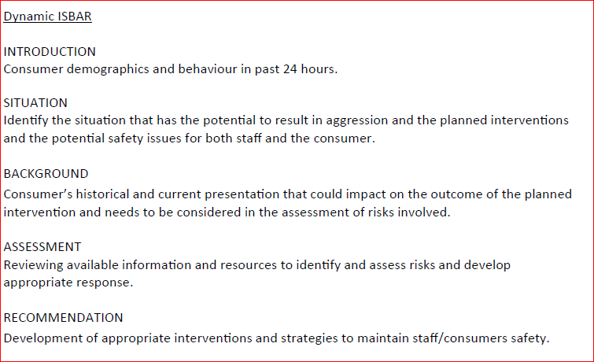

6.8 Clinical Risk Assessment (CRA)
A CRA is completed by the medical officer with the consumer and their support person(s) on admission to Dhulwa. If the medical officer is not available to participate in the initial assessment, the CNC or the NIC will review all relevant pre-admission information including the risk assessments completed by referring agency and complete the CRA. The medical officer will review the consumer and complete a CRA as soon as possible.

CRA’s are revised regularly throughout the consumer’s admission and should reflect any changes to risk according to their presentation. The risk can be revised by any member of the treating team in accordance with process outlined in section (e) Change of Risk Category on the form. These assessments should involve the consumer and when possible, family/ carer/ nominated person / advocate.

The CRA is reviewed and completed by the MDT:
- To inform the consumer’s level of observation
- If the consumer has been managed in the de-escalation area within the last 24 hours
- When observation rating of ARC 5 level (1:1 nursing)
- Following an increase in DASA rating
- When risk factors are perceived to have changed, including feedback or information from nominated persons, carers, family or other supports.

6.9 Observation
Observation through engagement is the purposeful gathering of information from consumers to inform clinical decision making and is the formal and objective assessment of a consumer’s physical, mental, and social condition.

A minimum of two nursing staff are to be on the clinical floor at all times, including during night shift.

Observations are not passive but requires nurses to be person centred and engage therapeutically with consumers. Observation through engagement is for safety, protection from harm and maintenance of wellbeing and provides opportunity to develop rapport and contribute to ongoing assessment and recovery.

The purpose of observation is to provide optimum care, to escalate and manage deterioration in a timely way and ensure safety of the environment where care is provided.

Observations enable engagement with consumers which actively contributes to comprehensive care. There are several principles that underlie the practice of observation:
- It is multifaceted
- Observation and assessment are interrelated
- Observation is grounded in therapeutic engagement with the consumer
- Appreciation of how Dhulwa environments influence behaviour
- Are communicated between staff
- There is a clear process of documentation that is timely and descriptive.

The consumer’s allocated nurse must always know the location of the consumer. Observation should be established as part of unit routine and performed regularly by the consumer’s allocated nurse as part of their everyday practice to maintain the safety of consumers.

The frequency of clinical documentation in a consumer’s clinical record is based on the consumers ARC level (see below). The documentation is to include:
- Mental state examination
- The location and activities of the consumer
- Any new behaviours i.e. symptom, aggression/risk attributes
- How the consumer is interacting with others

There are 5 levels of ARC observation:

ARC Level | Level of Risk | Description
Level 1 | Low risk | General engagement and observations every 2 hours
Level 2 | Low to Medium risk | Intermittent engagement and observation every 50-60 minutes
Level 3 | Medium risk | Frequent engagement and observation every 20- 30 minutes
Level 4 | Medium to High risk | Close engagement and observation every 10- 15 minutes
Level 5 | High risk | Continuous engagement and observation

ARC 1 - General Observation – 2 hourly
Minimum level of observation for a consumer at Dhulwa.

ARC 2 (Intermittent engagement and observations) – 50-60 Minutes
Consumer risk requiring observation higher than ARC 1.

ARC 3 (Frequent observations) – 20-30 Minutes
Consumer risk requiring observation higher than ARC 2, as assessed as posing a significant risk of:
- Suicide /Self harm
- Overt psychotic symptoms
- Harm to others
- Falls
- Severe self-neglect
- Violence, aggression, or physical harm

ARC 4 (Close observations) – 10-15 Minutes
Consumer risk requiring observation higher than ARC3 as assessed as posing a more severe risk than for ARC 3.

ARC 5 1:1 Engagement and observations or at arm’s length
Consumer risk requiring constant observation at arm’s length distance, as specified by the treating team, or when a person is in seclusion, as assessed as posing a serious, significant, and immediate risk as outlined for ARC 3 and 4.

Staff must not leave the consumer unsupervised under any circumstances or for any period of time. The consumer must be managed in a highly visible area. Staff providing continuous observation during normal sleeping hours will sit outside the consumer’s bedroom, with the bedroom door open. The MDT may recommend increasing the number to two staff, depending on the risk i.e., self-harm or risk of violence.
Nurses can increase an ARC level, but not decrease. All changes in ARC level are to be discussed at MDT and reflected in the consumers TRPIM.
Back to Table of Contents

Section 7 – Codes

7.1 Emergency codes
All Dhulwa staff should comply with and refer to the Dhulwa Emergency Plan, a sub-plan of the CHS Emergency Management Plan which provides guidance for emergency responses at Dhulwa, including security officer role in a code black.

7.2 Code Black
Dhulwa has Emergency Response Team (ERT) and Special Emergency Response Team (SERT) to ensure an appropriate first response of qualified personnel occurs to a code black.

7.2.1 ERT
To manage and deescalate the situation using least restrictive methods available, and is led by the NIC.

7.2.2 SERT
An extension of the code black emergency response where a situation has exceeded normal clinical response capabilities (i.e., extreme violence, use of non-bladed weapons or firearms, but not yet requiring intervention by police). SERT is led by the senior SERT operative.

7.3 Duress Alarms
All members of staff are required to wear a personal duress alarm. Duress alarms are kept in the Dhulwa key room and are to be collected by staff at the commencement of their shift. Duress alarms are registered to specific staff members for each shift.
Fixed duress alarms are located throughout Dhulwa and in the carpark. Staff are to make themselves familiar with their location.
Back to Table of Contents

Section 8 – Electronic devices for consumers

The Mental Health (Secure Facilities) Act 2016 enables people admitted to Dhulwa to use electronic communication as a form of contact. A specific area for electronic communication is to be provided where the consumer will always be supervised, and consumers are not to use the electronic communication device to capture visual data (see definitions of terms) of the consumer or another person.

To balance those considerations of contact, restrictions or limitations may be placed on the consumers access to an electronic communication device, as a form of contact. The restrictions or limitations will be applied in accordance with the Mental Health (Secure Facilities) Act 2016, see Dhulwa Visitors to Dhulwa under the Mental Health (Secure Facilities) Act 2016 Procedure for more information.

A room within the therapy space of Dhulwa has been identified as the electronic communication area. All consumers in the electronic communication area are to be always supervised by Dhulwa staff, as required by the Mental Health (Secure Facilities) Act 2016.

Detainees
While a detainee or young detainee transferred from a correctional centre or detention place, and their custody is transferred to CHS, their status as a detainee or young detainee remains while in Dhulwa.

Any restrictions or limitations applied to detainees or young detainee’s electronic communication while admitted to Dhulwa will be in line with either the:
- Corrections Management Act 2007 and ACT Corrective Services policies and procedures, or
- Children and Young People Act 2008 and Bimberi policies and procedures.

Forensic History
A consumer’s forensic history and offences will be considered when determining limitations and restrictions to an electronic communication profile.

Monitoring authorisation
Only a Delegated Officer (see definition of terms) may authorise a consumer’s communication be monitored. The authorisation may be made if the Delegated Officer believes on reasonable grounds that the monitoring is necessary and reasonable to avoid prejudicing the effectiveness of the patient’s treatment, care, or support.

Monitoring is defined in the Macquarie Dictionary as to check, observe or record the operation of (a machine) without interfering with the operation.

If a decision is made by the Delegated Officer the consumers communications are to be monitored, the parties to the communication are to be told:
- that their communication may be monitored, and
- If it is monitored, that it has been monitored.
Back to Table of Contents

Section 9 – Food services

All consumers eat their meals in the dining area and are to be supervised.

9.1 Cutlery
Each piece of cutlery is engraved with bedrooms numbers. Consumers are allocated the cutlery matching their bedroom number for each meal.

Each consumer is assessed by the MDT to determine if they can have cutlery at mealtimes. The assessment is informed by any risks to the consumers own safety or to others and the outcome is documented in the consumers TPRIM. If a consumer is accessed as not able to have cutlery, they will be provided with finger food.

9.1.1 Utensil and cutlery inventory
A utensil and cutlery inventory is to be maintained for the servery areas. The CHS food services staff are responsible for maintaining the inventory list.

9.2 Supervision of cutlery at servery area
- Two staff members must always be present at the servery area to supervise mealtimes.
- A cutlery count is to occur at the beginning and end of each mealtime by nursing staff.

9.3 Supervision in dining room
- Nursing staff are required to supervise consumers in the dining room for all meals and are encouraged to interact with consumers during mealtimes (i.e., sit at each table). This provides opportunity for general engagement and opportunistic de-escalation or response to issues of safety or security that may arise in the dining room.
- If one or more consumers are unsettled or have escalating behaviour, a clinical decision is made to determine appropriate strategies to mitigate risk i.e. access to finger food, separate dining times, sitting in another area.

9.4 Searches for missing cutlery
- In the event of missing cutlery, and reasonable grounds have been established for a search of the dining areas, a delegated officer may authorise a search. See Dhulwa Search (patients, personal property, bedrooms, premises) under the Mental Health (Secure Facilities) Act 2016.

The NIC is responsible for ensuring that a clinical incident report on Riskman is completed when:
- Cutlery or utensils cannot be found; or
- Any incident or near miss incident resulting from the misuse of cutlery or utensils.

9.5 Self-catered meals
The self-catering program at Dhulwa provides opportunities for recovery by providing occasions in a safe and supportive environment to address challenges and develop skills and resources that will promote community living and enhanced quality of life.

Consumer will be assessed by the MDT to identify the level of participation and supervision for self-catering their own meals. All practices are in line with safe food handling and storage requirements as outlined in the CHS Bringing Food into Canberra Health Services (Adults and Children) Procedure.
Back to Table of Contents

Section 10 – Discharge

All Dhulwa staff should comply with and refer to the CHS Admission to Discharge Procedure (Adults and Children) and the CHS Discharge Summary Completion – Inpatients.
All transfers and discharges from Dhulwa are referred to the AAP. Eligibility for discharge is considered with regard to the Dhulwa admission criteria, legal status, therapeutic security needs as assessed on the DUNDRUM 1, risks as assessed by the HCR-20 or other structured risk assessment, and therapeutic recovery and program completion as assessed by the DUNDRUM 3 & 4.
Discharge planning needs to be coordinated and comprehensive to support people on discharge in an optimal manner. As part of discharge planning, an expected discharge timeframe will be discussed with the consumer, nominated person, carer, family and other supports, and external services or networks. It will be noted if community supports, and housing options are needed to be arranged.
The Dhulwa team are required to involve relevant stakeholders including clinical managers, nominated person, carer, family and other supports, General Practitioners (GP), private psychiatrists and other treating specialists, private counsellors, and psychologists as a core element of discharge planning. For consumers subject to a Conditional Release Order being considered for discharge to a community placement, a referral must be made to the Forensic Consultation and Intervention Service (FoCIS) at least 3 months prior to discharge.
It is the responsibility of the CNC to invite the relevant people to discharge planning meetings.
Graduated leave and supported transition arrangements will be implemented to assist people to discharge safely and successfully from Dhulwa.
Guidance on the collection of discharge medications can be found in the CHS Medication Handling Policy.
Back to Table of Contents

Section 11 – Partnering with consumers, nominated person, carer, family, and other supports
CHS and Dhulwa are committed to partnering with consumers and carers as a foundation for exceptional care. Partnering with consumers supports a person-centred approach to individual care experiences and how Dhulwa staff deliver care. Dhulwa staff work alongside consumer and carers and listens and learns from their experience which is essential to achieving the CHS vision of creating exception health care together and the dedicated Dhulwa vision of hope, healing and creating meaningful lives for a safer future together.

Dhulwa is committed to the triangle of care to encourage and improve engagement between the consumer, carer and the health professionals providing care to the consumer.

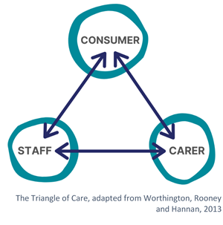

Dhulwa staff engage and partner with consumers through:

The Dhulwa Mutual Help meeting is held daily, led by the Nurse in Charge (NIC) or their delegate, to provide consumers and staff an opportunity to raise any issues, concerns, or questions, including:
- What’s on for the day?
- Any housekeeping issues, or if anything fixing?
- How are we all feeling?
- What are our goals are for the day?
- Any issues or incidents to be raised?
- Suggestions from consumers.
Dhulwa has processes to review and monitor consumer experience. Dhulwa undertakes regular surveys using tools that measures:
- The roles and relationship between staff and consumers
- How consumers feel about the ward environment and co-consumers
- How consumer feel personally safe on the ward
- Consumers experience of their care.

A Carer forum provides the opportunity to identify concerns and make improvements. The forum enables open communication about the process of Dhulwa and for carers to share their experiences. This is not a forum for individual consumer clinical care discussion, as that occurs in other clinical processes. Partnering with consumers and carers is supported by open communication between the consumer, carer and all Dhulwa staff, with consent from the consumer.

Communication enables the consumer, nominated person, carer, family, and other supports to be actively involved in their consumer journey and recovery.

Partnering with consumers are also supported by advocacy services, either individual or system support:
- ACT Disability, Aged and Carer Advocacy Service (ADACAS) an independent community organisation that provides free advocacy and information for people with disabilities, including psychiatric disability, and vulnerable older people, to assist consumers assert their rights or interests, or to have their needs met.

- Public Advocate advocates for people who may not be able to advocate for themselves, and monitors the services provided to people at Dhulwa to ensure their rights are protected, and their best interests are promoted.

- Official Visitors are independent of CHS to ensure inpatient mental health facilities in the ACT are providing the best possible care and visit Dhulwa monthly.

- ACT Mental Health Consumer Network (ACTMHCN) is an independent, consumer-lead organisation advocating for the interests of people with a mental illness in the ACT. The ACTMHCN does not provide individual advocacy, but trains and supports people to engage in systemic advocacy to improve metal health services based on the individual and collective experience of people with mental health issues.

- Carers ACT offers support, information and advice, counselling, respite, support groups, educational and social activities to family and friends caring for a loved one.

See CHS Partnering with Consumers Framework and CHS Partnering with Consumer policy for further information.
Back to Table of Contents

Section 12 – Documentation

Clinical documentation is an essential component of effective communication between the treating team and is one of the most important information sources available to a treating team.

The purpose of a clinical record is to communicate clinical information between members of the treating team. The clinical document provides accurate reflections of the assessment made, changes in clinical state, care provided and pertinent information to support the ongoing clinical care provided to the consumer.

Clinical records are multidisciplinary and are to contain sequential entries from all health professionals on the treating team. Clinical records are to document the engagement with the consumer at the time it occurs or as soon as practicable after.

The Digital Health Record (DHR) is to be used to record all interactions, assessments, and clinical tools between a consumer and CHS. The implementation of the DHR has meant paper risk assessment and templates are no longer used as they have been have built into the DHR clinical record.

See CHS Clinical Records Procedure for further information.

For consumers who are subject to involuntary treatment and care on a mental health order under the Mental Health Act 2015, or other orders granted by the ACT Civil and Administrative Tribunal (ACAT) staff are to be aware of the information contained in the orders, including expiry dates and obligations regarding the provision of reports to ACAT, which are to be included into the consumers’ clinical record.

Staff should make efforts to encourage consumers' engagement and attendance at ACAT hearings and in the process.

See CHS Care of Persons subject to Psychiatric Treatment Orders with or without a Restriction Order, CHS Care of Persons subject to Forensic Mental Health Orders, and CHS Care of Persons subject to a Conditional Release Order Procedure.
Back to Table of Contents

Section 13 – Dhulwa governance and meeting structure

Dhulwa governance is embedded within the existing MHJHADS and CHS corporate, clinical, and operational governance systems which provide a framework that draws together initiatives, process, systems, and ways of working.

The Forensic Mental Health Service Clinical and Operational Directors provide overarching leadership to ensure service delivery is in line with the strategic direction, organisational accountability targets and corporate governance processes. The Dhulwa clinical governance structure sits within a tiered hierarchy of organisational governances regarding decision making and endorsement of service activities.

See Attachment 2 for the Dhulwa Meeting Structure.
Back to Table of Contents

Evaluation

Outcome
- Dhulwa staff orientated and aware of the Dhulwa operational procedure.
- Dhulwa consumers receive safe, effective care, therapy, and treatment.

Measures
- The effectiveness of the procedure implementation will be evaluated through the collation and review of standardised key performance indicators and service data:
- Number of admissions to Dhulwa by referral location
- Percentage of consumers admitted to Dhulwa with a completed:
  - physical health assessment within 24 hours
  - psychiatric assessment within 24 hours
- 72 hrs between AAP referral and consumer assessment
- 7 days between admission accepted and admission date
- Percentage of consumers discharged from Dhulwa with a completed:
  - physical health assessment 48 hours prior
  - psychiatric assessment 48 hours prior
- Percentage of completed annual physical health assessments
- Discharge summaries completed within 48 hours
- Readmission to another mental health facility within 28 days of discharge
- Structured risk assessment completed every 6 months
- Comprehensive care/relapse prevention plans, reviewed every 3 months
- Consumer survey conducted annually
- 25 hours of structured activities offered each week.

Back to Table of Contents

Related Policies, Procedures, Guidelines and Legislation

Policies
- Informed Consent (Clinical)
- Medication Handling
- Occupational Violence
- Smoke Free Environment
- Work Health and Safety & Work Health and Safety Management System
- Partnering with Consumers

Procedures
- Incident Management- Clinical
- Clozapine Therapy
- Advance Agreements, Advance Consent Directions and Nominated Persons under the Mental Health Act 2015
- Assessment of Decision-making Capacity and Supported Decision-making for people being treated under the Mental Health Act 2015
- Care of Persons Subject to Psychiatric Treatment Orders (PTOs) with or without a Restriction Order (RO)
- CHS Searching of consumer of their property
- Ligature Use, Response and Risk Management in MHJHADS
- Clinical Handover
- Sharing Information with Carers – Mental Health Inpatient Units
- Dhulwa Mental Health Unit- Search (patients, personal property, bedrooms, premises) under the Mental Health (Secure Facilities) Act 2016
- Transfer of Custody of a detainee/ young person admitted to Dhulwa under the Mental Health Act 2015
- Dhulwa Mental Health Unit- Visitors to Dhulwa under the Mental Health (Secure Facilities) Act 2016
- Use of Force to search a consumer under Mental Health (Secure Facilities) Act 2016
- Dhulwa Mental Health Unit- Prohibited Items under the Mental Health (Secure Facilities) Act 2016 and restricted items at Dhulwa.
- Dhulwa and Gawanggal Leave Management
- Use of Mandatory National Outcome Measures – MHJHADS
- Infection Prevention and Control
- Information and Communication Technology Resources: Acceptable Use
- Initial Management, Assessment and Intervention for People Vulnerable to Suicide Managing
- Occupational Violence
- Patient Identification and Procedure Matching
- Seclusion of Persons Detained under the Mental Health Act 2015
- Providing Physical Health Care across MHJHADS
- Discharge Summary Completion – Inpatient
- Protective Security – Closed Circuit Television
- Care of Persons subject to Forensic Mental Health Orders
- Care of Persons subject to a Conditional Release Order (CRO)
- Missing Patient Procedure
- Adult Acute Mental Health Services (AAMHS)
- Bringing Food into Canberra Health Services (Adults and Children)
- Animal Visits Guideline

Standards
- National Standards for Mental Health Services 2010
- Forensic Mental Health Nursing Standards of Practice 2012
- Forensic Mental Health Standard Services 2016
- National Safety and Quality in Health Service (NSQHS) Standards 2021
- Clinical Governance
- Partnering with consumers
- Preventing and controlling infections
- Medical safety
- Comprehensive care
- Communication for safety
- Blood management
- Recognising and responding to Acute Deterioration
- Medication Safety

Legislation
- Mental Health Act 2015
- Mental Health (Secure Facilities) Act 2016
- Human Rights Act 2004
- Health Records (Privacy and Access) Act 1997
- Information Privacy Act 2014
- Carers Recognition Act 2021
- Work Health and Safety Act 2011

Other
- 2024 Forensic Mental Health Inpatient Services Model of Care
- Australian Charter of Healthcare Rights
- ACT Charter of rights for people who experience mental health illness
- Dhulwa Security Operational Framework
- Partnering with Consumers Framework
- Chief Psychiatrist Advisory Notes:
- AN23-15 - Access and disclosure of personal health information between members of a person’s treatment team
- AN23-14 Disclosure of health information to carers
- AN23-16 Disclosure of health information to Substitute Decision Makers
Back to Table of Contents

Definition of Terms

Person in Charge means the Assistant Director of Nursing (business hours), or most senior nurse (after hours).

Delegated officer for Section 8 - Electronic Communication, is the Operational Director, Forensic Mental Health Service, Clinical Director, Forensic Mental Health Services, Dhulwa Consultant Psychiatrists and On- Call, Assistant Director of Nursing (ADON), Director of Nursing, MHJHADS, CHS Executive on Call.

Capture Visual Data means a person captures visual data of another person if the person captures moving or still images of the other person by a camera or any other means.
Back to Table of Contents

Search Terms

Dhulwa, DMHU, secure, meals, cutlery, security, forensic, prohibited item, visitor, referral, admission, inpatient care, risk assessment, CRA, TRPIM, DUNDRUM, environment safety check, environment, medication, supervision, daily routine, therapy framework.

Back to Table of Contents

Attachments

Attachment 1 – Dhulwa Therapy Framework
Attachment 2 – Dhulwa Meeting Structure
Back to Table of Contents

Disclaimer: This document has been developed by Canberra Health Services specifically for its own use. Use of this document and any reliance on the information contained therein by any third party is at his or her own risk and Canberra Health Services assumes no responsibility whatsoever.

Policy Team ONLY to complete the following:
Date Amended | Section Amended | Divisional Approval | Final Approval
09/05/2024 | New Document | CHS Policy Team | CHS Policy Team

This document supersedes the following:
Document Number | Document Name

Attachment 1– Dhulwa Mental Health Unit Therapy Framework
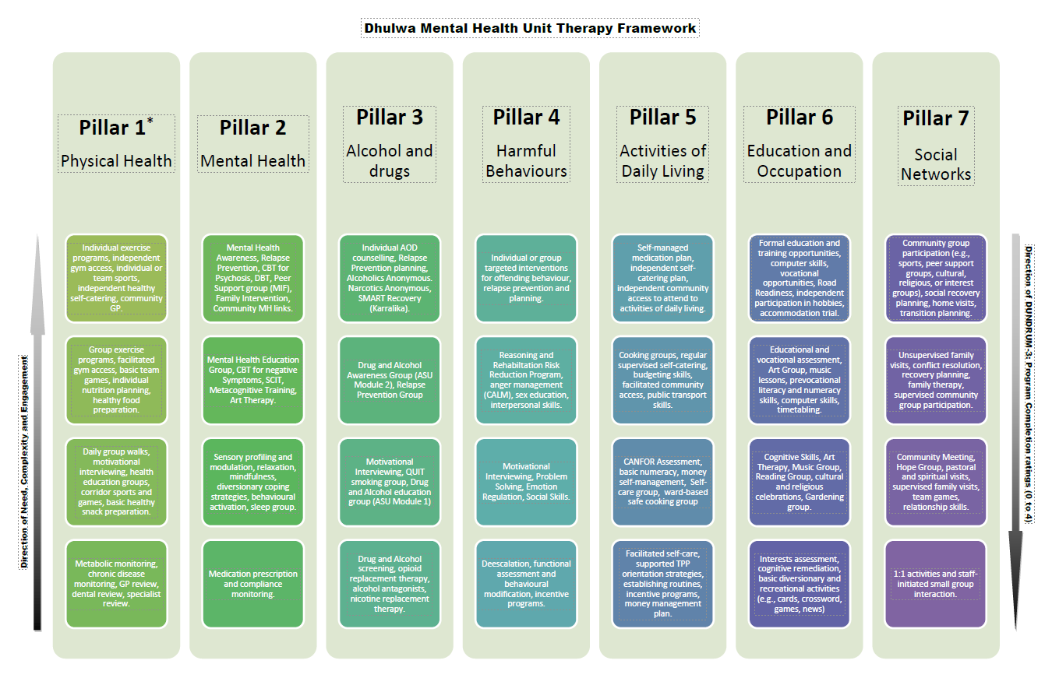

Attachment 2 – Dhulwa Mental Health Unit meeting structure

