Canberra Health Services
Procedure
Consumer Feedback Management

Contents

Contents 1
Purpose 2
Scope 2
Section 1 – Feedback Capture and Distribution 2
Section 2 – Feedback 3
Section 3 – Management of Feedback 4
Section 4 – Responding to feedback 5
Section 5 – Timeframe for Responding 9
Section 6 – Identification and Completion of Actions 9
Section 7 – Incident and ACT Insurance Agency (ACTIA) Notification 10
Section 8 – Reporting and Evaluation 10
Section 9 – Ministerial and Human Rights Commission 11
Evaluation 11
Related Policies, Procedures, Guidelines and Legislation 12
References 13
Definition of Terms 13
Search Terms 13
Attachments 14
Attachment A – CHS Consumer Feedback Process – Priority Three and Priority One 15
Attachment B – Managing Feedback at the time: B.L.A.S.T 17
Attachment C – Significant Incidents identified through Consumer Feedback 18
Attachment D – Consumers seeking compensation process 19

Purpose

This procedure and associated policy outline the Canberra Health Services (CHS) approach to managing consumer feedback and provide specific advice on systems in place to support consumers to provide feedback and to support staff in the management of feedback. This procedure also emphasises the importance of receiving, recording and responding to feedback promptly to ensure CHS engages with consumers in a proactive and coordinated manner to uphold our values of reliable, progressive, respectful and kind. The recorded feedback can be used to outline trending themes in feedback for CHS and individual divisions, this can be analysed so that quality improvements actions can be made by CHS.

Back to Table of Contents

Scope

Consumer feedback includes complaints, compliments and comments. All feedback provides valuable insight into the provision of health care from the perspective of those who use services provided by CHS. Feedback received from any consumer, their family, carers or other interested parties regarding services provided by CHS is covered in this procedure.

This procedure is specific to the management of consumer feedback and does not address:
- staff feedback on workplace issues;
- feedback from external service providers regarding service level interactions with CHS;
- feedback from advocacy groups regarding systemic issues;
- consultation feedback;
- external agencies who receive funding from CHS; and
- the broader aspects of consumer and carer engagement and support.

Back to Table of Contents

Section 1 – Feedback Capture and Distribution

Refer to Attachment A for an overview of the consumer feedback management process.

CHS encourages feedback from consumers to improve the healthcare experience. Feedback can be provided by:
- speaking to a staff member at the point of service;
- making contact with the Consumer Feedback and Engagement Team by:
- telephone;
- emailing;
- in writing;
- completing a consumer feedback form; or
- online.

CHS feedback forms and collection boxes are located throughout the hospitals and
community-based facilities.

In addition to making contact directly with CHS to provide feedback, consumers may contact:
- the Minister for Health and Wellbeing;
- the Minister for Mental Health; and the Health Services Commissioner (otherwise known at the Human Rights Commission HRC).

These agencies engage with CHS in the feedback process.

The Consumer Feedback and Engagement Team (CFET) records all feedback received in the Riskman Feedback Module for the purpose of tracking, trending and reporting.

Riskman has many mandatory fields when entering feedback including:
- complainant/consumer gender
- Aboriginal and/or Torres Strait Islander status
- mode
- received and due date
- summary of feedback
- referred to (complainant’s full name if available)
- Canberra Health Services Division
- acknowledgement required
- priority of the feedback. Please note: all CFET feedback is priority three (see definition of terms), Directorate Liaison Officer (DLO), Ministerial and Human Rights Commission feedback is priority one.
- feedback and response (on closing) should also be attached

The CFET member will ensure they enter as much information as available.

Feedback received from consumers directly by other areas of CHS must be forwarded to CFET for appropriate action and recording.

Back to Table of Contents

Section 2 – Feedback

Compliments, Comments and Complaints are recorded and distributed to the relevant areas for appropriate action and follow up.

Consumers who request a response to their feedback will be contacted by CFET to acknowledge receipt of their feedback within five business days. At this point, CFET may be able to resolve the concern with the consumer and will identify if a further response is required.

Feedback is generally submitted because people:
- want to acknowledge their positive experiences;
- do not want their experience to happen to anyone else;
- have had a negative experience with the health system;
- did not receive adequate information or explanation about the processes they encountered;
- have experienced poor communication between staff, health care consumers and their families and carers;
- seek to recover out of pocket expenses or believe they have an entitlement to compensation; and
- have had something go wrong or are concerned with their outcome

Communication and staff conduct are the most common reasons why consumers submit a complaint, noting that staff conduct is also the most common reason consumers submit a compliment. In order to prevent negative feedback of this nature staff should:
- introduce themselves and discuss the consumer’s expectations;
- involve the consumer and when appropriate their carer or family, in all aspects of their care;
- communicate effectively with consumers, families and carers about their health issues, treatment options and how care may be delivered; and
- connect with consumers by listening attentively.

Back to Table of Contents

Section 3 – Management of Feedback

Where possible feedback should be managed face to face with the consumer at the point of care. Frontline staff are encouraged to notify CFET of any concerns and actions taken, in addition to documenting in the patient’s clinical notes. All other feedback is kept separate from consumer clinical records to maintain privacy and confidentiality.

When engaging with consumers about their concerns, staff should:
- use the BLAST mnemonic – Believe, Listen, Apologise, Solve and Thank (see Attachment B);
- listen to the consumer with empathy;
- attempt to identify the problem and what outcome the consumer would like;
- provide factual information in relation to the concerns;
- take immediate action if required;
- identify and offer solutions that are acceptable to the consumer and within the staff member’s scope of practice;
- confirm with the consumer they are satisfied, and if not, escalate the matter to a higher authority;
- if the feedback relates to another area, assist the consumer to engage with the area, or put them in contact with CFET for assistance;
- forward documentation of feedback, actions and outcomes to CFET to be recorded in the feedback module of Riskman; and
- participate in open disclosure, either informal or formal, as soon as possible once an error has been identified (refer to CHS Open Disclosure Procedure).

When staff are engaging with another person on behalf of a consumer, they are to observe the usual consumer confidentiality requirements, ensuring that they have the permission of consumers with decision making capacity to discuss their personal health information with another identified person. Where the consumer does not have decision making capacity, permission must be obtained from the consumer’s legal guardian or substitute decision maker. Refer to Confidentiality of Consumers – Release of Information section below.

Where staff are unable to quickly resolve feedback, they should involve their immediate supervisor promptly, to assist in investigation and resolution of the issue. The consumer should also be provided with information on how to provide feedback through the Consumer Feedback and Engagement Team (CFET).

Consumers Seeking Compensation
In some circumstances, compensation may be appropriate in resolving a complaint about health services. It is critical to seek legal advice early in the complaint process where compensation is requested by the consumer or CHS form’s a view that a legal claim may be made in the future. No monetary offers can be made until the ACT Government Solicitor’s Office has recommended settlement on the basis of legal principle and practice requiring the existence of at least a meaningful prospect of liability being established. Refer to Attachments B and D for an overview of the feedback management process for consumers seeking compensation. Please refer to Consumers pursuing Compensation through Health Care Complaints procedure for more information and advice.

Back to Table of Contents

Section 4 – Responding to feedback

A diagram of the feedback process is provided at Attachment A.

Formal feedback is allocated by CFET to the office of the most appropriate Executive Director (ED), Executive Group Manager (EGM) or the Chief Operating Officer (COO), to investigate and provide a response if required. All feedback not received directly by CFET must be forwarded to CFET to be recorded in the feedback module of Riskman.

- In some circumstances, CHS may decide not to respond to feedback. Prior to declining to respond to feedback, CHS must ensure the concerns have been fully investigated. Examples where CHS may decide not to respond through the CFET process: Consumer is seeking compensation or a third-party claim has been received, the feedback has been addressed previously or a valid release of information has not been received.
- Feedback that requires a response is acknowledged by CFET within five business days, where adequate consumer contact details have been provided. The preferred method to acknowledge is by phone to gain further information if required as well as apologise to the consumer for their experience. If possible, the concerns should be discussed and resolved, and if so, may be closed at this point. However, if the consumer cannot be contacted an email or written automated acknowledgement (if submitted online or by email and automated response is provided) is acceptable. This acknowledgement should include information about the feedback process and the contact details of CFET for ongoing support.
- Information should be sought from the relevant divisions to respond to the issues raised in the feedback.
- Service areas may contact the consumer and respond to the feedback to promptly address concerns raised. If the consumer is satisfied with the response at this stage, a summary of the response is to be provided to CFET, after which the CFET member will call consumer to ensure they are happy with the outcome before feedback can be closed and no further response required.
- If feedback cannot be closed verbally, the responding area needs to provide a summary of the conversation to CFET so a written response can be drafted for the consumer based on the information provided and any investigations.
- All response letters to consumer feedback must:
- Be factually correct;
- Include an acknowledgement of the consumer’s experience and feelings;
- Address each of the points the consumer has raised with a full explanation and specific details about the investigation that was conducted, for example sources of information or what was discovered;
- Specify if an issue cannot be addressed and the reasons for this;
- Give details of action taken as a result of the feedback;
- Provide the full name, position and a contact telephone number of the contact person for further queries/discussion;
- Include details of further action available to the consumer, for example the Human Rights Commission (HRC); and
- Thank the consumer for taking the time to provide feedback.
Response letters will be drafted by CFET with information provided by the area investigating the feedback. Responses must be cleared and signed by the ED/EGM of the division responding to the feedback, or the Chief Executive Officer (CEO) or Chief Operational Officer (COO) if they have elected to take the lead due to the feedback being complex or involving multiple divisions.
- If the feedback is related to a service outside CHS, depending on mode of submission CFET will forward the feedback to the relevant service or Directorate to respond to the consumer and the consumer will be notified the feedback has been forwarded on to the appropriate area e.g. Calvary Hospital or ACT ambulance service. The accepted modes include Consumer and Carer Feedback Forms and online feedback submissions. For telephone and email submissions, please provide consumer with correct contact details for appropriate service.

The DLO may send an email to CFET, copying in the Chief Operating Officer (COO) when a consumer phone call has been received by the Minister for Health, Minister for Mental Health or Minister for Disability offices, that potentially can be dealt with quickly through a phone call to the consumer. CFET is to call the consumer within 24 hours (within business hours) and identify who they are and that they are calling on behalf of the Minister’s office. Once CFET has contacted the consumer an email confirmation is sent to the DLO and the COO to acknowledge that contact has been made. CFET will contact the Division, for them to coordinate the investigation of the issue and resolution if possible and report the resolution to the DLO and the COO. If the feedback is complex (not able to be managed with a phone call), particularly dealing with multiple concerns and/or requiring a written response, the COO will be required to manage the feedback directly through the Ministerial process.

If a consumer provides feedback about the same issue to more than one staff member or agency simultaneously, the areas involved will determine who is best to respond and inform the consumer about who their point of contact will be.

If the feedback relates to more than one division of CHS, CFET will assign a lead division to coordinate the response. CFET allocates the feedback to that area in the feedback module of Riskman.

Record Keeping
After the feedback management process has been completed and closed, operational areas must ensure documents relating to the feedback are sent to CFET for centralised filing (in Q drive, attached to Riskman episode and in Hewlett-Packard Enterprise Content Manager (HPE CM), also known as TRIM when a written response has been provided. Outcomes of telephone conversations should also be sent to CFET for closure of the feedback and attachment to the Riskman episode.

Documents relating to the investigation of staff conduct which arise from feedback are retained by the People and Culture Branch.

Confidentiality of Consumers – Release of Information
There are situations where feedback is received from someone other than the consumer involved in the case. For example, a family member may provide feedback with or without the consumer’s knowledge.

In accordance with the Health Records (Privacy and Access) Act 1997, no personal health information about the consumer is to be provided to another person without the patient’s or their substitute decision maker’s permission or a relevant legal document that proves legal grounds for accessing the information e.g. Enduring Power of Attorney (EPOA). When feedback is received by CFET on behalf of another person and the patient is over 18 years of age, the team will request a Release of Information (ROI) form during the entering and acknowledgement process. If a completed ROI form is not received the feedback will be investigated by the area although no response will be provided to the consumer. If there are concerns around sharing of information, advice can be sought from the CHS Medico Legal Team and Insurance and Legal Liaison Team.

Refer to Clinical Records Management Procedure.

Right of Reply for Staff
Any staff member identified in feedback must be given the opportunity to:
- review the feedback relating to them;
- provide a response to the feedback raised;
- be informed of any proposed actions and the reasons for this decision;
- ensure their manager only discusses the feedback with relevant staff, this may include but is not limited to
- COO;
- ED/EGM for the Division;
- Executive Officer for the Division; and
- People and Culture.
- be offered support and assistance from their manager; and
- be provided access to external support services as necessary.

Aboriginal and Torres Strait Islander Peoples
The paper and electronic feedback forms ask consumers if they identify as Aboriginal and/or Torres Strait Islander. With the consent of the consumer, the Aboriginal and Torres Strait Islander Liaison Service can participate in the feedback resolution process by providing advice and assistance to the consumer and staff. Staff should ensure that consumers are aware of this service.

Feedback requesting compensation
It is critical to seek legal advice early in the feedback process where compensation is requested by the consumer and/or if CFET forms a view that a claim may be made in the future. Advice should be sought from the ACT Government Solicitor’s Office (ACTGS), through the Insurance and Legal Liaison Unit, regarding appropriate settlement, including guidance on liability and financial compensation, if appropriate and regardless of the amount of compensation. No monetary offers can be made until the ACTGS has recommended settlement on the basis of legal principle and practice requiring the existence of at least a meaningful prospect of liability being established. Where a referral to ACTGS has been made, clinical divisions should stop their investigative process immediately to ensure that any documents created during the course of the investigation are free from disclosure in the event of a legal claim and protected under the client legal privilege of ACTGS. During their investigation, ACTGS may request the creation of documents such as statements or correspondence detailing the incident outcomes. Refer to Attachments B and D for an overview of the feedback management process for consumers seeking compensation. Please refer to Consumers pursuing Compensation through Health Care Complaints procedure for more information and advice.

Back to Table of Contents

Section 5 – Timeframe for Responding

Consumers who indicate they would like a response need to be contacted by CFET to acknowledge their feedback within five working days of receiving feedback.

The consumer must receive a response following an investigation within 35 calendar days. This might be a phone call or a written response.

It is acknowledged that some cases may be more complex and require more time to complete a thorough investigation. If it becomes apparent that the feedback will not be closed within the 35-day timeframe, CFET are to contact the consumer to advise and apologise for the delay. A copy of the final signed response should be forwarded to CFET so the feedback can be closed, and the response can be attached to the feedback module of Riskman.

If a staff member receives a request to comment on feedback but is unable to do so for any reason (e.g. conflict of interest, on leave and unable to access notes), they should notify their manager, CFET, or the Executive Officer for the division as soon as possible so this can be followed up appropriately.

Outstanding responses are monitored by CFET through reports generated from the Feedback Module of RiskMan. If CFET have not received a response by the identified date, the request for the response will be escalated to the relevant divisional ED/EGM or COO for action and completion.

Back to Table of Contents

Section 6 – Identification and Completion of Actions

The relevant area responding to feedback may identify quality improvement activities and /or corrective actions based on the feedback received or the investigation process. Responses should inform consumers about actions that have been taken as a result of their feedback.

The actions must be provided to CFET for recording in Riskman as an outcome of the feedback. If a response indicates any outstanding actions remain, the division is responsible for the action and should inform CFET of an expected completion date, as well as advise CFET when the action has been completed. CFET records outstanding and completed actions in the feedback module of Riskman.

Back to Table of Contents

Section 7 – Incident and ACT Insurance Agency (ACTIA) Notification

All clinical incidents should be recorded in the Incident module of Riskman as per the CHS Incident Management Policy and related procedure. CFET are responsible for identifying and linking related incidents that have been reported in the Incident module to feedback recorded on the Riskman feedback module. Where CFET identifies that an incident has not been entered, they will alert the appropriate Executive Director and Executive Officer when progressing the feedback to the division. Refer to Attachment C for a flow chart for feedback relating to significant incidents.

If CFET, the ED/EGM or EO of the relevant division or COO believes the feedback (whether CFET, DLO, MIN or HRC) may result in a claim for compensation against CHS, ACTIA must be notified of the feedback. This can be done by contacting the Medico Legal Coordination team directly or contacting CFET so they can ensure the relevant notification to the Medico Legal Coordination team occurs in the Riskman entry. It is the responsibility of the Medico Legal Coordination Team in QSII to notify ACTIA of the feedback.

Back to Table of Contents

Section 8 – Reporting and Evaluation

Data entered in the feedback module of Riskman is used to identify and support improvements in the quality and safety of the services we deliver. CFET can assist if an area requires a report of feedback received by CHS.

At the start of each month, CFET will distribute a data report to each individual division confirming their current open feedback and the due date. It is the responsibility of the ED/EGM of the division, or their delegate, to follow up on any outstanding feedback responses.

Data is analysed and trended by Quality, Safety, Innovation and Improvement and provided to the divisions and the National Standards Committees.

If an area or division would like to request data relating to feedback, a data request form will need to be completed and submitted to healthfeedback@act.gov.au for actioning and approval. This form is available on the intranet or CFET can be contacted to provide a copy.

Prior to all data requests being completed and distributed to the relevant person or division, it must be cleared by either the Consumer Participation Manager, the Patient Experience Senior Manager or the EGM for the division of Quality, Safety, Innovation and Improvement, depending on what data is being requested and how the recipient intends to use the data. Release of data outside of CHS must be cleared by the CEO.

Back to Table of Contents

Section 9 – Ministerial and Human Rights Commission

Feedback received by the Minister’s office and Human Rights Commission (HRC) are forwarded to CFET by the CEO/COO office for recording in the Riskman system. This information can be used for tracking, trending and reporting.

Note:
- Responses to feedback received via an ACT Government Minister are recorded on Riskman by CFET, however they are managed by the relevant division who will forward appropriate information or response letter to the Minister’s Office using TRIM.
- Responses to feedback received through the HRC are recorded on Riskman by CFET, however they are managed by the relevant division who will forward appropriate information or response letter to the HRC, who engages with the consumer.

Feedback received by either the Minister’s Office and/or HRC supersedes the CFET process. When CFET receive notification that the consumer’s feedback will be handled by another service, CFET are to close the feedback and record that on the Feedback module of Riskman and open a new priority one case in the Feedback module of Riskman, with the Ministerial or HRC number documented in the details section for easy reference.

Back to Table of Contents

Evaluation

Outcome:
- Target of 85% of feedback is closed within 35 days
- Consumer feedback is used to identify and implement opportunities for service improvement

Method:
- Divisional Key Performance Indicators (KPI) data for closure within 35 days is provided to the CEO on a monthly basis.
- Monthly themed data is provided to each division by the Quality Safety Business Partners (QDBP), this data is useful over time to compare the number of feedback broken down in to compliments, complaints and comments. The data can then be analysed by program areas to see trending themes.
- Improvement actions related to specific feedback matters are entered in and reviewed through Riskman to ensure ‘closing the loop’.

Back to Table of Contents

Related Policies, Procedures, Guidelines and Legislation

Policies
- Consumer Feedback Management Policy
- Consumer and Carer Participation Policy
- Consent and Treatment Policy
- Language Services Policy
- Information Privacy Policy
- Incident Management Policy
- Violence and Aggression by Patients, Consumers or Visitors Policy
- Clinical Governance Framework

Procedures
- Language Services- Interpreter Procedure
- Violence and Aggression by Patients, Consumers or Visitors Procedure
- Open Disclosure
- Incident Management Procedure
- Protocols for working with Aboriginal and/or Torres Strait Islander peoples
- Multicultural Coordinating Framework
- Clinical Records Management Procedure
- Consumer Compensation Claims Procedure

Legislation
- Health Act 1993
- Information Privacy Act 2014
- Health Records (Privacy and Access) Act 1997
- Human Rights Act 2004
- Human Rights Commission Act 2005
- Work Health and Safety Act 2011
- Health Practitioner Regulation National Law (ACT) Act 2010
- Discrimination Act 1991
- Freedom of Information Act 2016
- Territory Records Act 2002
- Public Interest Disclosure Act 2012
- Mental Health Act 2015
- Power of Attorney Act 2006
- Guardianship and Management of Property Act 1991

Standards
- Australian Commission on Safety and Quality in Health Care (ACSQHC) Standards
- Australian Charter of Healthcare Rights 2nd Edition
- Australian Standard on Complaint Handling (Consumer satisfaction – Guidelines for complaints handling in organizations) (AS ISO 10002:2004, MOD)

Back to Table of Contents

References

- Australian Commission on Safety and Quality in Health Care Australian Charter of Healthcare Rights
- Australian Commission on Safety and Quality in Health Care Patient Centred care: Improving quality and safety through partnerships with patient and consumers
- National Quality and Safety in Health Care Standards Second Edition

Back to Table of Contents

Definition of Terms

Consumer. Refers to any constituent, person, patient or client accessing services offered by CHS, and their associates including family, carers and people who have the legal authority to act on their behalf.

Consumer Feedback. Comments, compliments and complaints received from someone who has engaged with services provided by CHS, whether directly or indirectly.

Priority One (1): Used for feedback received via the Minister’s office, Directorate Liaison Officer or Human Rights Commission. Feedback must be responded to within 24 hours. Responses are managed by Divisions, and entered into the Feedback module of Riskman by CFET.

Priority Three (3): Used for all other feedback received, (other than priority one). Feedback must be acknowledged within five days and responded to within 35 days. Responses are managed by CFET.

Riskman. In this procedure, this term refers to the database used to record and track feedback received by CHS.

Back to Table of Contents

Search Terms

Feedback, Complaint, Compliment, Comment, Suggestion, Consumer, Engagement, Experience, CFET

Back to Table of Contents

Attachments

Attachment A – Consumer Feedback Process – Priority Three and Priority One
Attachment B –Managing Feedback at the time: B.L.A.S.T
Attachment C – Significant Incidents identified through Consumer Feedback
Attachment D – Consumers seeking compensation process

Disclaimer: This document has been developed by Canberra Health Services specifically for its own use. Use of this document and any reliance on the information contained therein by any third party is at his or her own risk and Canberra Health Services assumes no responsibility whatsoever.

Policy Team ONLY to complete the following:
Date Amended | Section Amended | Divisional Approval | Final Approval
15/07/2020 | Complete Review | Denise Patterson, EGM QSII | CHS Policy Committee

This document supersedes the following:
Document Number | Document Name
DGD18-021 | Consumer Feedback Management in ACT Health Procedure

Attachment A – CHS Consumer Feedback Process – Priority Three and Priority One

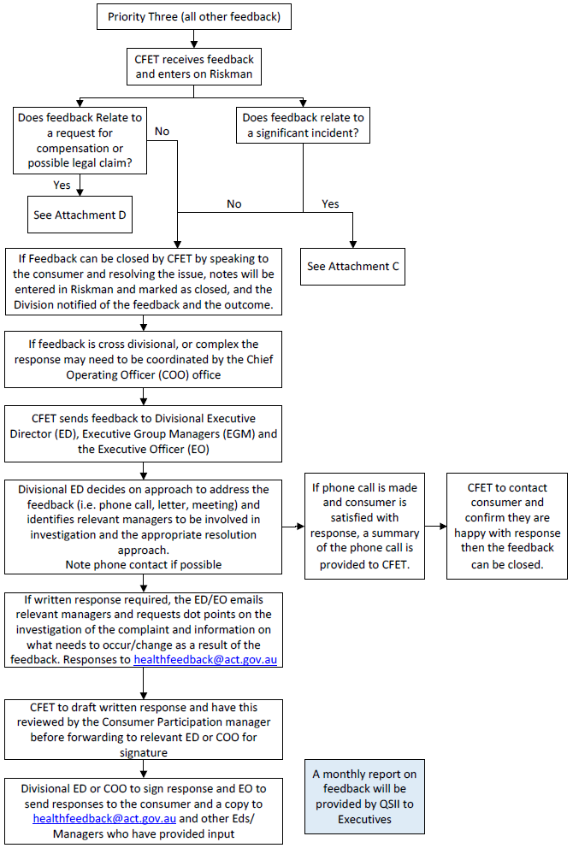
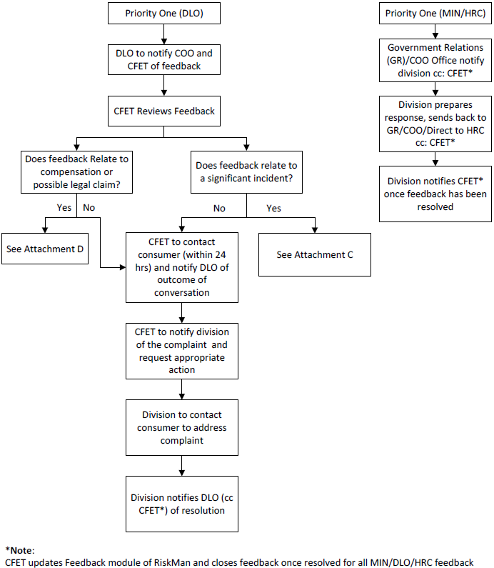

Attachment B – Managing Feedback at the time: B.L.A.S.T

- Believe
Take a moment to focus and believe. The perception of the issue for the consumer is real to them, even though you may think they have it wrong.

- Listen
We often start to think of how we will respond to the issue before we are done listening, and too often, already have the response ready. Take a second, relax, and listen. They may be very upset, it is important to understand it from their perspective. Let them talk until finished, then repeat back the main issues to ensure you understand them.

- Apologise
Always apologise. From your patient’s perspective, they have a legitimate issue. It could be as simple as “I’m sorry for the impact this has had on you” or “I’m sorry, I know how frustrating it is to have your surgery cancelled for the second day in a row” A sincere apology will often diffuse a lot of frustration that the consumer has.

- Solve
Make it right. Ask the customer “What can I do to make this right for you”?
If you can’t solve it, but someone else can, let the patient know what you are going to do. For example if the issue is about the food, “I will give the food services manager a call and have them come up to see you”.

If you feel you can’t manage the feedback or the feedback is about you personally, escalate to the next most senior person. “I will go and get the nurse in charge of the ward to come and assist you”. This shows you have taken it seriously. Attempt to resolve issues quickly in the local area.

If this is not possible, seek support from your manager or the Consumer Feedback and Engagement Team. You can contact the CFET on 6207 7627 or healthfeedback@act.gov.au

Always let the consumer know what you are going to do about the issue.

- Thank
At the beginning, at the end, in the middle; it doesn’t matter, thank the patient for providing their feedback. Why?- the consumer may highlight things we need to improve. They are giving you the opportunity to fix the problem and to assist them in lowering their level of fear and/or anxiety.

Attachment C – Significant Incidents identified through Consumer Feedback
Note: Refer to the Incident Management Policy for definitions of incidents that meet the definition of significant, and the process (including timeframes) for Significant Incident reporting.

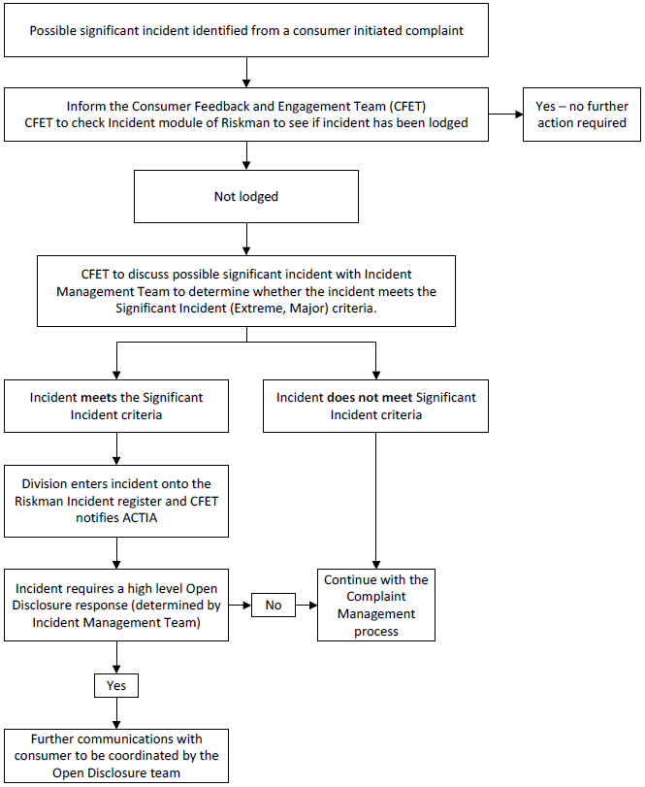

Attachment D – Consumers seeking compensation process

