Canberra Health Services
Guideline
Chest Injury Pathway (ChIP)

Contents

Contents 1
Guideline Statement 2
Scope 2
Overview 3
Section 1 – Initial Management and Chest Injury Page 4
Section 2 – Chest Injury Page (ChIP) Response Pathway 5
Section 3 – Ward Pathway 6
Section 4 – Intensive Pathway 7
Evaluation 8
Related Policies, Procedures, Guidelines and Legislation 8
References 9
Definition of Terms 9
Search Terms 10

Guideline Statement

This document aims to optimise the management of patients presenting with blunt chest wall trauma requiring coordination of multiple teams applying different, complex interventions which change in priority over the course of a hospital admission.

Background
Blunt chest-wall trauma accounted for over 15% of all trauma admissions to Emergency Departments (EDs) worldwide¹. Up to 50% of rib fractures may be undetected radiographically and reported associated mortality was as high as 29%, depending on risk factors². Risk factors for mortality include age over 65yrs, number of rib fractures, pre- existing disease and development of pneumonia³. Adequate analgesia is essential to preventing secondary respiratory complications from chest wall trauma². Modalities of analgesia to achieve this is controversial, but available guidelines recommend the use of epidural and multimodal analgesia over opioids alone⁴.
Surgical stabilisation of rib fractures may reduce the incidence of pneumonia, duration of mechanical ventilation, Intensive Care Unit (ICU) length of stay and hospital length of
stay⁵. Flail chest injuries carry a mortality rate between 11% and 40%⁶. In adult patients with flail chest, rib operative reduction and internal fixation is conditionally recommended (outlined in the Intensive Pathway – see Section 4) to decrease mortality, reduce duration of mechanical ventilation, ICU and hospital length of stay, incidence of pneumonia and need for tracheostomy ⁷.

Key Objective
The key objective of this guideline is to optimise management of patients with blunt chest- wall trauma at Canberra Health Services (CHS) and prevent deterioration and subsequent escalation of care.

Alerts
Patients presenting with blunt chest-wall trauma often have associated injuries. The pathways described in these guidelines are not intended to replace a coordinated trauma response by senior medical staff. Early resuscitation and management are the purview of the Emergency Medicine and Trauma Departments.
Back to Table of Contents

Scope

This document applies to Medical Officers, Nurses, Physiotherapists, and Medical, Nursing and Physiotherapy Students working within their scope of practice.

This document applies to adult patients over 18 years of age with blunt chest wall trauma presenting to the Canberra Hospital (CH). Application of aspects of this document to patients with multiple injuries including blunt chest-wall trauma and/or outside the specified age group are made by or under supervision of an experienced clinician.

Back to Table of Contents

Overview

This guideline is comprised of four flowcharts, henceforth Sections 1-4. Any reference to investigations or interventions are only to be performed by trained clinicians within their scope of practice. Patient care decisions should only be made by or under supervision of an experienced clinician.

Section 1 (Initial Management and Chest Injury Page) is primarily intended for use by nursing and medical staff of the Emergency Department but could be applied by nursing or medical staff for inpatients who suffer new traumatic injuries whilst admitted in Canberra Hospital.
Patient assessment at 30 minutes following monitoring and management will result in either consideration for discharge or escalation to a Chest Injury Page activation and progress to Section 2.

Section 2 (Chest Injury Page Response Pathway) describes the decision tree for respondents to the Chest Injury Page. Patient disposition is expected to be a collaboration between the Emergency Department, Trauma, and Intensive Care Unit (ICU) Outreach medical officers, with appropriate consultation to on-call senior medical staff as required. Based on factors including age, number of rib fractures and co-morbidities, patients will progress to Section 3 (Ward Pathway) or Section 4 (Intensive Pathway). This section also describes a series of risk factors which would prompt an early referral to the Trauma or Cardiothoracic surgical team to consider surgical rib fixation.

Section 3 (Ward Pathway) describes the monitoring and management for ward patients admitted with blunt chest wall injury. Patients who show signs of deterioration will be escalated to Section 4 (Intensive Pathway). Patients who improve will be considered for discharge from hospital.

Section 4 (Intensive Pathway) describes the monitoring and management for patients who are deteriorating or at a high risk of deteriorating. These patients should be reviewed by the ICU Outreach team. This is NOT a replacement for activating a MET (Medical Emergency Team) page via switchboard (internal phone 2222). The MET page should be activated if a patient meets criteria on the MEWS (Modified Early Warning Score) chart. Section 4 is intended to be commenced on the ward/ED but utilised by ICU medical and nursing staff. It is formatted to be consistent with local ICU guidelines (tiered responses). Patients may either be admitted to the ICU (continue to manage per Section 4) or stepped down to the Ward Pathway (manage per Section 3).
Back to Table of Contents

Section 1 – Initial Management and Chest Injury Page

Canberra Hospital Trauma Service
Chest Injury Pathway – Isolated Blunt Chest Wall Trauma

- Initial management and Chest Injury Page (ChIP) activation
Note: Drug doses are suggestions only. Patient care decision should only be made by or under supervision of an experienced clinician.
Risk Factors
Chronic respiratory disease Pulmonary contusion Cardiovascular disease Smoker
Low SpO₂ (<90% on RA)
Diabetes
Presence of distant injuries
Obesity (BMI)
Sleep apnoea
Blunt chest wall trauma with
confirmed or suspected rib fractures
Initial Assessment

Monitored in bed in ED
Assess deep breath and cough
Assess LOC/GCS Assess VAS
Assess risk factors
If ANY RISK FACTORS present, activate ChIP
Patient review 30 minutes post analgesia
If patient is:
- Unable to deep breathe or cough
- Is requiring FiO2>40% to maintain SpO2 90%
- Has a Respiratory Rate >20
Or
- Has an ongoing VAS
activate ChIP
Patient to be reviewed by Trauma team (in
hours) or surgical registrar (after hours)
Continue to monitor the patient Consider moving patient to ED resus bay Continue to provide analgesia to goal VAS 0-2

If able to deep breathe and cough AND not hypoxic/no oxygen requirement AND no underlying lung pathology THEN Patient may be suitable for discharge.
Discuss with senior ED medical officer. Patient/family education to include return to ED as required.

Activate ChIP

Call switchboard (phone 9)
Ask to activate the CHEST INJURY PAGE Provide patient location

This will alert:
Trauma team doctors Trauma case managers
Pain team/Anaesthetics Physiotherapy
ICU Outreach
Monitoring

Continuous pulse oximetry Continuous ECG monitoring
NIBP q15min
Action

Titrate FiO₂ to maintain SpO₂
Analgesia: Goal VAS 0-2

Initial
IV/PO paracetamol 1000mg QID
PO ibuprofen 200-400mg TDS

Intravenous opiates
Fentanyl 25mcg q5mins to goal VAS (0-2) Morphine 2.5-5mg q15mins to goal VAS (0-2)
PCA fentanyl/morphine

Consider
IV parecoxib 40mg one dose only
IV ketamine infusion
Investigations

CXR
FBC/EUC/LFTs/Coags/G&S
ECG
Consider CT chest with contrast
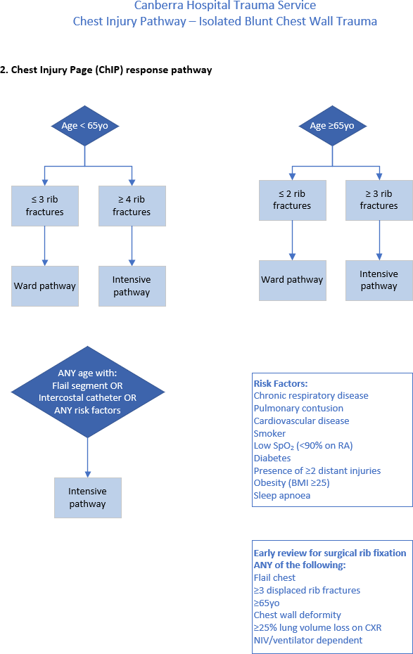
Back to Table of Contents

Section 2 – Chest Injury Page (ChIP) Response Pathway

Back to Table of Contents

Section 3 – Ward Pathway

Canberra Hospital Trauma Service
Chest Injury Pathway – Isolated Blunt Chest Wall Trauma

3. Ward pathway
These patients are considered suitable for general ward admission under the Trauma Service.
Note: Drug doses are suggestions only. Patient care decisions should only be made by or under the supervision of an experience clinician.

Start Here
Monitor
4hrly observations per CHS
MEWS chart
Pain: Visual Analogue Scale (VAS)
Within FIRST hour
Assess deep breath and cough
Assess LOC/GCS
Assess VAS
Referral to Acute Pain Service Referral to Physiotherapy Department
If ANY of the following:
SpO₂ falling (<90%)
FiO₂ rising to maintain SpO₂ RR increasing breaths/min
Vital capacity falling
Pain score increasing LOC falling
Escalate per MEWS
ICU Outreach review ph: 0401 691 565
Transition to INTENSIVE pathway
Care and rehabilitation
Early clearance for mobilisation Head up 30degrees when appropriate
Support/splint pillows
Chest physiotherapy
Scheduled time sitting out of bed
(eg. meals)
Scheduled mobilisation plan
Action
Initiate HFNP* at 30L/min flow
Titrate FiO₂ to maintain SpO₂

Chart and administer analgesia
Routine care and rehabilitation

*HFNP – if pneumothorax/ haemothorax present, discuss with senior medical officer
Analgesia
Titrate to goal VAS 0-2
Adjust dose for elderly/organ function

Examples:
IV/PO paracetamol 1000mg QID PO ibuprofen 200-400mg TDS PRN PO oxycodone 5-10mg q3hrly breakthrough

Consider:
Epidural or regional blockade IV opiate PCA
IV ketamine infusion
PO Docusate – sennosides ONE tablet BD
PO Movicol ONE sachet BD
PRN IV Ondansetron 4-8mg q4hrly
Discharge planning
Wean supplemental oxygen and analgesia. Patient/family education to include return to ED as required.

Consider referrals as required eg:
Rehabilitation, Geriatrics, Social Work.

Follow up after hospital discharge:
GP 3 days
Trauma clinic 1-2 weeks
Trauma case manager to follow up via phone
call

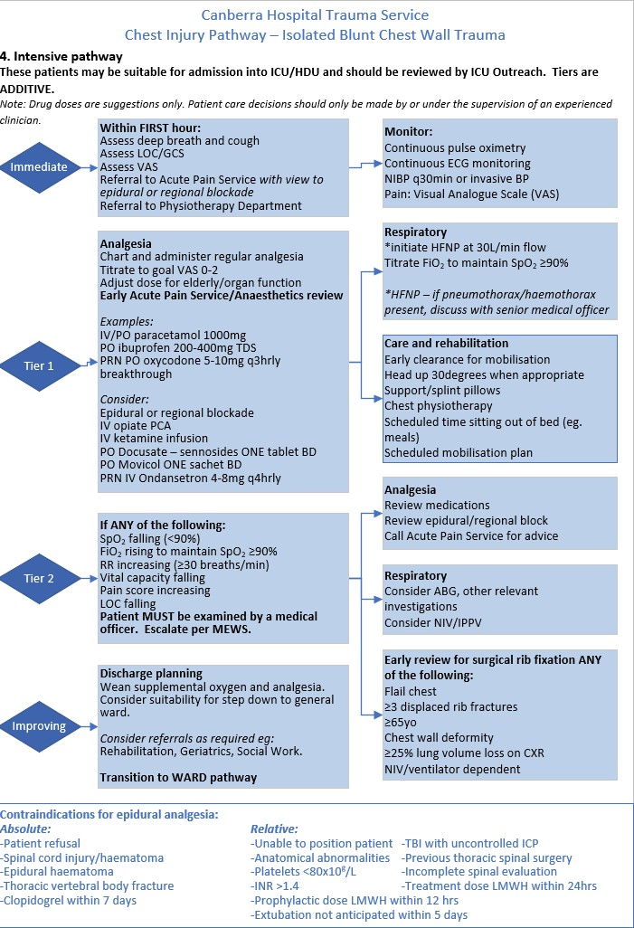
Back to Table of Contents

Section 4 – Intensive Pathway

Evaluation

Outcome
- Patients should be identified appropriately to be placed on the Chest injury pathway. Resulting in early identification, review and intervention by Trauma Service, Acute Pain Service, Physiotherapy and ICU Outreach.

Measures
- Data from the Trauma Data Registry and Quality and Safety will be analyzed to identify instances of MET calls and unplanned admissions to ICU or escalations of care. Processes will be reviewed through the ACT Trauma Service Quality Assurance process.

Back to Table of Contents

Related Policies, Procedures, Guidelines and Legislation

Policies
- Nursing and Midwifery Continuing Competence Policy
- Informed Consent (Clinical)
- Medication Handling

Procedures
- Infection Prevention and Control - Healthcare Associated Infections
- Patient Identification and Procedure Matching
- Orthopaedic Surgery – Pre and Post-Operative Management in Adults
- Vital Signs and Early Warning Scores
- Neurological Observations – for Adults and Paediatrics
- Non-invasive Electrocardiac (ECG) in Adults
- Trauma Team Roles and Responsibilities
- Trauma Team Activation
- Acute Pain Management Techniques

Guidelines
- Fasting Guidelines – Elective and Emergency Surgery

Legislation
- Health Records (Privacy and Access) Act 1997
- Human Rights Act 2004
- Work Health and Safety Act 2011

Other
- Australian Charter of Healthcare Rights
Back to Table of Contents

References

- Demirhan R, Onan B, Oz K, Halezeroglu S: Comprehensive analysis of 4205 patients with chest trauma: a 10-year experience. Interact Cardiovasc Thorac Surg 2009, 9: 450-453. 10.1510/icvts.2009.206599.
- Simon BJ, Cushman J, Barraco R, Lane V, Luchette FA, Miglietta M, Roccaforte DJ, Spector R; EAST Practice Management Guidelines Work Group. Pain management guidelines for blunt thoracic trauma. J Trauma. 2005 Nov;59(5):1256-67.
- Battle CE, Hutchings H, Evans PA: Risk factors that predict mortality in patients with blunt chest wall trauma: A systematic review and meta-analysis. Injury 2012, 43: 8-17. 10.1016/j.injury.2011.01.004
- Galvagno SM Jr, Smith CE, Varon AJ, Hasenboehler EA, Sultan S, Shaefer G, To KB, Fox AD, Alley DE, Ditillo M, Joseph BA, Robinson BR, Haut ER. Pain management for blunt thoracic trauma: A joint practice management guideline from the Eastern Association for the Surgery of Trauma and Trauma Anesthesiology Society. J Trauma Acute Care Surg. 2016 Nov;81(5):936-951.
- Coughlin TA, Ng JW, Rollins KE, Forward DP, Ollivere BJ. Management of rib fractures in traumatic flail chest: a meta-analysis of randomised controlled trials. . Bone Joint J. 2016 Aug;98-B(8):1119-25. doi: 10.1302/0301-620X.98B8.37282.
- Sirmali M, Türüt H, Topçu S, Gülhan E, Yazici U, Kaya S, Taştepe I. A comprehensive analysis of traumatic rib fractures: morbidity, mortality and management. Eur J Cardiothorac Surg. 2003 Jul;24(1):133-8.
- Kasotakis G1, Hasenboehler EA, Streib EW, Patel N, Patel MB, Alarcon L, Bosarge PL, Love J, Haut ER, Como JJ. Operative fixation of rib fractures after blunt trauma: A practice management guideline from the Eastern Association for the Surgery of Trauma. J Trauma Acute Care Surg. 2017 Mar;82(3):618-626. doi: 10.1097/TA.0000000000001350.
- Battle C, Hutchings H, Lovett S, Bouamra O, Jones S, Sen A, Gagg J, Robinson D, Hartford- Beynon J, Williams J, Evans A. Predicting outcomes after blunt chest wall trauma: development and external validation of a new prognostic model. Crit Care. 2014 May 14;18(3):R98. doi: 10.1186/cc13873.
Back to Table of Contents

Definition of Terms

ABG Arterial blood gas
BMI Body mass index
BD Twice daily
BP Blood pressure
ChIP Chest Injury Pathway
CHS Canberra Health Services
Coags Coagulation profile
CT Computed tomography
CXR Chest X-ray
ECG Electrocardiogram
ED Emergency Department
EUC Electrolytes, urea, and creatinine
FBC Full blood count
FiO2 Fraction of inspired oxygen
G&S Group and screen
GCS Glasgow Coma Scale
HFNP High flow nasal prongs
ICP Intracranial pressure
ICU Intensive Care Unit
INR International normalised ratio
IPPV Intermittent positive-pressure ventilation
IV Intravenous therapy
LFTs Liver function tests
LMWH Low-molecular-weight heparin
LOC Loss of consciousness
MEWS Modified Early Warning Score
NIBP Non-invasive blood pressure
NIV Non-invasive ventilation
PCA Patient controlled analgesia
PO Per oral
PRN IV ‘Pro re nata’ as needed intravenous
PRN PO ‘Pro re nata’ as needed orally
QID Four times a day
RA Room air
RR Respiratory rate
SpO2 Peripheral capillary oxygen saturation
TBI Traumatic brain injury
TCH The Canberra Hospital
TDS Three times a day
VAS Visual Analogue Scale
YO Years old.

Back to Table of Contents

Search Terms

Trauma, Emergency, Chest, Injury, Rib, Fracture, Flail, Chip, Pathway, ChIP

Back to Table of Contents

Disclaimer: This document has been developed by Canberra Health Services specifically for its own use. Use of this document and any reliance on the information contained therein by any third party is at his or her own risk and Canberra Health Services assumes no responsibility whatsoever.

Policy Team ONLY to complete the following:
Date Amended | Section Amended | Divisional Approval | Final Approval
30/11/2023 | Complete Review | Lisa Gilmore ED Surgery | CHS Policy Committee

This document supersedes the following:
Document Number | Document Name
CHS20/117 | Chest Injury Pathway (ChIP)

