Procedure | Canberra Health Services

Personal Ventilation Hoods – Adults only.
CHS25/254
Contents
Purpose 2
Alerts 2
Scope 2
Section 1 – Equipment 3
Section 2 – Patient suitability 4
Section 3 – Personal Ventilation Hood setup 5
Section 4 – Routine care and shift checks 7
Section 5 – Manual cleaning 9
Section 6 – Maintenance and HEPA filter replacement 9
Evaluation 9
Related policies, procedures, guidelines and legislation 10
References 10
Definition of terms 10
Search terms 11

Purpose
The purpose of this procedure is to provide clinicians with information on the safe patient use of personal ventilation hoods in hospital settings across the Canberra Health Services (CHS) Network.
This procedure provides clinicians with the following information about inpatient use of personal ventilation hoods:
- Patient suitability and exclusions
- Management and use
- cleaning and maintenance
Back to Contents

Alerts
- Personal ventilation hoods should not be routinely used. They should only be used when there are no single rooms available and no ability for patients with the same infectious organism to be cohorted’.
- Assessment of patient suitability requires nursing staff to discuss with the Medical Officer on shift if patient is suitable, in the absence of the appropriate engineering controls e.g. patient nursed in a single room.
- Consideration of patient needs, such as fall risk, level of cognition, and/or behaviours of concern, need to be considered when deciding if a patient is suitable to be in a personal ventilation hood due to safety risks
- Staff and visitors must adhere to the required transmission-based precautions when caring for a patient where a personal ventilation hood is being used and when cleaning the equipment after use.
Back to Contents

Scope
This procedure applies to adult patients (over the age of 16 years and not in a paediatric ward)in a inpatient setting at the following CHS Network facilities:
- Canberra Hospital
- Centenary Hospital for Women and Children
- North Canberra Hospital.
This document applies to the following staff working within their scope of practice:
- Medical Officers
- Nurses and Midwives
- Allied Health Workers
- Students under direct supervision
- All staff who are involved in the management, maintenance, and cleaning of personal ventilation hoods.
Back to Contents

Section 1 – Equipment

Equipment
The personal ventilation hoods used at CHS are the McMonty Patient Isolation Hoods by Medihood® (referred to in this procedure as Medihoods®). To request a Medihood® or the polyvinyl chloride (PVC) Medihood® covers, contact
- Canberra Hospital Facilities Management by placing a work order or phoning (02) 5124 2115.
- North Canberra Hospital Infection Prevention and Control team by phoning (02) 5103 6505, Monday to Friday 0800-1630hrs (excluding public holidays) OR the AHHM via switchboard.

Background
The Medihood® is a mobile, personal ventilation hood that has been designed to help reduce the risk of aerosol and droplet exposure, for patients and staff. The Medihood® provides both a physical barrier to contain droplet spread, and a ventilation system to reduce aerosol spread from an infectious patient. Data reports that the Medihood® can remove more than 99.7 per cent of particles larger than 0.5µm and more than 98.1 per cent of particles smaller than 0.5µm¹. See Image 1 below.

Image 1: Illustration depicting reduction of particles in air when Medihood delpoyed. Source: Medihoods Mcmonty
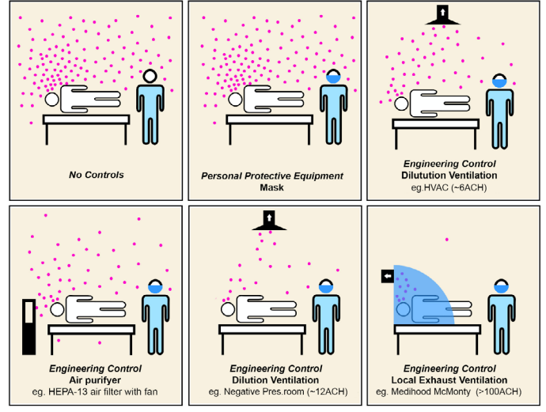
Back to Contents

Section 2 – Patient suitability

Patients suitable for Personal Ventilation Hood use
At CHS, a personal ventilation hood must be used for suspected or confirmed acute respiratory infections (ARI) when there are no appropriate engineering controls such as a single room or if the patient can’t be cohorted in a shared room with another patient with the same ARI organism infection.
Where cohorting of patient with the same identified ARI has occurred, a personal ventilation hood does not need to be used.
When the ability to cohort the patient in a room with the same identified ARI is not possible, patients may be cohorted with other patients (who are not immunocompromised or at significant risk of severe disease) and a personal ventilation hood must be used for the patient with the diagnosed or suspected ARI.

Exclusion Criteria
- Patients with known history of claustrophobia (fear of confined spaces), unless the patient consents to use.
- Patients experiencing delirium, or who have a history of dementia
- Patients who are agitated or displaying other Behaviours of Concern.
If the infected patient meets one or more of the exclusion criteria the patient must be prioritised for a single room.

Consent
Patients suitable for personal ventilation hood use must have the use of the personal ventilation hood explained to them and they must consent to the use of a personal ventilation hood. If the patient does not consent to the use of a personal ventilation hood, they are to be prioritised for s single room.

Ongoing use
If the patient consents to the use of a personal ventilation hood but are unable to tolerate the use of the personal ventilation hood, they are to be prioritised for single room.
Note:
- See allocation of single rooms in the Infection Prevention and Control Procedure, and the North Canberra Hospital - Infection Prevention and Control Procedure, available on the Policy and Guidance Documents Register.
- See the Acute Respiratory Infection (ARI): Infection Control Management in Adults, Paediatrics and Neonates Procedure, available on the Policy and Guidance Documents Register.
Back to Contents

Section 3 – Personal Ventilation Hood setup
The Medihood® frame and cover will be delivered to the requesting area by either Canberra Hospital Facilities Management or North Canberra Hospital Infection Prevention and Control team.
Ward staff must be appropriately trained in Medihood® set up, use and dismantling. Cleaning and disinfection protocols must be followed according to manufacturer guidelines.
Alert: Initial setup of the Medihood in the patient space has been assessed by CHS Work Health and Safety, and three staff are required to manually set the Medihood® up.

Initial Setup
- Pull up and lock the metal side arms into position; check they are thoroughly locked into place. See Image 2 below.
Image 2: Metal side are being locked into position.
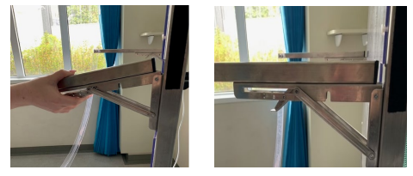
- Arrange the plastic cover so the long Velcro seam is at the top, and the vinyl tabs are exposed on the outside. Line up the centre with the middle of the metal frame, above the fan. Connect by pressing the Velcro along the edge of the top of the frame.
Image 3: Plastic cover being placed over metal frame.
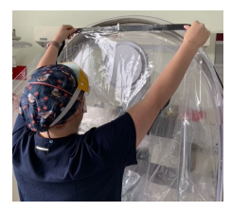
- Tuck the plastic inside, so entire PVC cover sits inside the metal side arms.
- There are two Perspex hoops:
  - Step back and extend the smaller hoop (hoop 1). Pull out the middle of the PVC cover and attach the first vinyl loop around the Perspex hoop. You can pull the Perspex a little to help achieve this if unable to comfortably reach. The Perspex is flexible and shouldn’t break.
  - Continue to loop all vinyl tabs into position along the hoop.
  - Step back again extending the larger hoop (hoop 2). Follow the same process of attaching the vinyl, starting with the centre vinyl tab
- Check the PVC cover is set up evenly along the hoops and check the integrity of the PVC cover by looking for holes, rips or tears.

Image 4 Staff checking PVC cover has been securely attached, as per manufacturer’s instructions for use.
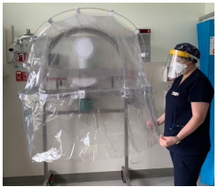
- Position the Medihood® frame behind the head of the patient’s bed. Lower the front section of the hood over the patient’s head and torso, draping the skirting of the hood over the sides of the bed. The hood is not designed to provide a complete airtight seal around the patient.
- Connect to power and turn the fan on once the hood is down.
- The fan must remain plugged into the essential (medical/emergency) power points for the duration of the patient is nursed under the Medihood®
- The Medihood is discontinued when:
- the patient has completed their isolation period
- appropriate engineering controls become available
- the patient cannot tolerate the Medihood®
- The Medihood® cover can be used for the duration of the use of the personal ventilation hood, unless it becomes visibly soiled or has rips, holes or tears, in which case it should be replaced.
Back to Contents

Section 4 – Routine care and shift checks
- Each shift Team Leaders and Clinical Nurse Coordinator (CNC) should assess if appropriate engineering controls are available such as:
  - negative pressure room
  - single room
  - appropriately cohorted bed space.
If available, in consultation with patient flow unit/bed management, the patient should, where possible, be moved to a space with engineering controls.

Nursing Shift Safety Checks
At the start of each shift the nurse caring for the patient:
- Assess the patient and determine if they are still a suitable candidate for the Medihood®.
- Check that the fan is switched on when the PVC cover is down.
- Check the PVC hood for integrity – make sure there are no holes, rips or tears. If there are any breaks in integrity replace the cover.
- Check the metal side arm – ensure the arms are firmly locked into position.
- Check there is enough room for staff to move around the bed and access to oxygen/suction and emergency equipment.

Care of Patient During Use
- Ensure the patient has access to their call bell at all times.
- The Medihood® design allows for prompt hood opening and patient access.
- The patient can be accessed from the side of the hood when the hood is in the closed position. There are two slits in the PVC, the healthcare worker can reach inside to the patient with the hood down to perform routine care, e.g. mouthcare, or observations.
- The hood must be opened to fully access a patient for care such as repositioning or mobilising the patient, performing a full wash, chest Xray, placing a tray table etc.
Note: When opening the hood cover staff must wear appropriate personal protective equipment(PPE) as per the Infection Prevention and Control and the Infection Prevention and Control – North Canberra Hospital (NCH) procedures.
- You can leave the fan on, even with the hood open.
- Close the hood when finished.
- If the PVC hood cover becomes visibly soiled during patient use, the PVC cover must be changed.
- Nursing staff should document each shift in the nursing notes of the patient’s clinical records that the safety check has been performed and that the patient is still able to tolerate the Medihood®.

Rapid Patient Access
If a patient rapidly deteriorates, and emergency access is required:
- Leave the fan running (the fan will still draw up and away from the healthcare worker) .
- Open the plastic hood cover.
- Unlock the wheel brakes (if deployed).
- Push the hood back out of the way to allow open access to the head of the bed and patient.
This may mean pushing the hood back to the wall, pulling the bed forward, or moving the hood back and to the side.
Back to Contents

Section 5 – Manual cleaning
- Always clean with full PPE as per the Infection Prevention and Control and the Infection Prevention and Control – North Canberra Hospital (NCH) procedures. PPE includes N95 mask, face shield, long sleeve gown and gloves.
- The PVC component of the Medihood® is single use. Remove the PVC hood and bag and place in infectious waste bins (yellow bin).
- Cleaning of personal ventilation hoods frame is the responsibility of the
  - Hospital Assistant (HA) team at Canberra Hospital.
  - Nursing Staff at NCH
- Perform a terminal clean of the frame at the patient bed area at the end of patient use (perform the clean when the bed has been vacated by the patient).Clean the frame as per the McMonty by Medihood® Instructions for Use, available on the Medihood® website at https://medihood.com.au/mcmonty-hospital-patient-hood-information/maintenance/.
- Contact Canberra Hospital Facilities Management or North Canberra Hospital Infection Prevention and Control team to arrange for the return of the frame to storage.
Back to Contents

Section 6 – Maintenance and HEPA filter replacement
Maintenance of the Medihoods®, including replacing the HEPA filter, is the responsibility of Facilities Management at Canberra and North Canberra Hospital. Please refer to the instructions for use, available on the Medihood® website - Home - Medihood - The McMonty.
Back to Contents

Evaluation

Outcome
- Reduction in healthcare associated infections for Acute Respiratory Infections(ARI)
- Personal ventilation hoods will be managed, cleaned and maintained safely and effectively for safe patient use.

Measures
- Regular review and reporting by the Infection Prevention and Control unit on healthcare associated infections.
Back to Contents

Related policies, procedures, guidelines and legislation

Procedures
- Acute Respiratory Infection (ARI): Infection control management in adults, paediatrics, and neonates
- Infection Prevention and Control – Canberra Hospital
- Infection Prevention and Control – North Canberra Hospital (NCH)
- Patient Identification and Healthcare Activity Matching

Guidelines
- Consent for Healthcare Treatment
- Infection Control – Cleaning (Shared) Patient Care Equipment

Legislation
- Health Records (Privacy and Access) Act 1997
- Human Rights Act 2004
- Work Health and Safety Act 2011
- Carers Recognition Act 2021

Other
- Australian Charter of Healthcare Rights
Back to Contents

References
- Lee, L., Landry, S., Jamriska, M., Subedi, S., et al. Quantifying the reduction of airborne infectious viral load using a ventilated patient hood. Journal of Hospital Infection, 2023;136:110-117
- McGain F, Humphries RS, Lee JH, Schofield R, French C, Keywood MD, et al. Aerosol generation related to respiratory interventions and the effectiveness of a personal ventilation hood. Critical Care and Resuscitation. 2020.
- Medihood® McMonty Instructions for Use March 2022. Available at: https://medihood.com.au/mcmonty-hospital-patient-hood-information/maintenance/
Back to Contents

Definition of terms
Personal ventilation hood: A personal ventilation hood consists of a mobile steel and plastic frame, a plastic canopy, an exhaust fan, and an H13 HEPA filter. The ventilation hood covers approximately half of a patient’s body and creates a negative pressure environment within the hood to reduce aerosol transmission.
Back to Contents

Search terms
Medihoods, McMonty, Personal Ventilation Hood, Acute Respiratory Illness, ARI, infection, infectious, airborne, north.
Back to Contents

For Policy Team to complete:
Date amended | Section amended | Divisional approval | Final approval
18/07/2025 | Complete review | Kellie Lang, CHS ED Nursing and Midwifery | CHS Policy Document Review Panel
This document supersedes the following:
Document number | Document name
CHS25/177 | Personal Ventilation Hoods - Maintenance
Disclaimer
This document has been developed by Canberra Health Services specifically for its own use. Use of this document and any reliance on the information contained therein by any third party is at his or her own risk and Canberra Health Services assumes no responsibility whatsoever.
Back to Contents

Acknowledgement of Country  Canberra Health Services acknowledges the Ngunnawal people as traditional custodians of the ACT and recognises any other people or families with connection to the lands of the ACT and region. We acknowledge and respect their continuing culture and contribution to the life of this region.  © Australian Capital Territory, Canberra 2024 | Accessibility  call (02) 5124 0000   Interpreter call 131 450  canberrahealthservices.act.gov.au/accessibility  

