Canberra Health Services
Guideline
Healthcare Access at School (HAAS) Program Guideline

Contents

Contents 1
Purpose 3
Scope 3
Background 4
Section 1 – Roles and Responsibilities 4
Section 2 – Health Care in ACT Public Schools 5
Section 3 – Healthcare in Catholic Education Archdiocese of Canberra & Goulburn (CECG) 7
Section 4 – The HAAS Program Process 8
Section 5 – HAAS Governance 8
Section 6 – HAAS Program Eligibility Criteria 9
Section 7 – Limitations of the HAAS Program 11
Section 8 – Referral and Initial Stakeholder Engagement 12
Section 9 – Initial Health Needs Assessment Meeting 13
Section 10 – Risk Management and Level of Support 15
Section 11 – Content of HAAS Individual Care Plans 19
Section 12 – Review and Approval of HAAS Individual Care Plans 20
Section 13 – The HAAS Folder 21
Section 14 – School Environmental Assessment 22
Section 15 – Appointment of School Staff for HAAS Training 23
Section 16 – Training and Competency Assessment for School Staff 25
Section 17 – Amendments to HAAS Individual Care Plan 29
Section 18 – Ongoing Support and Evaluation of Provision of Care 30
Section 19 – Reporting Errors and Near Misses to EDU/CECG 31
Section 20 – Discharge from the HAAS Program 32
Section 21 – Professional Development for HAAS RNs 34
Evaluation 37
Related Policies, Procedures, Guidelines and Legislation 37
References 38
Definition of Terms 39
Search Terms 39
Attachments 40

Purpose

The purpose of this document is to outline the operational elements, including limitations, of the Healthcare Access at School (HAAS) program. This document will provide guidance for the HAAS Registered Nurses (RNs).

For the purpose of this document:
- student refers to any child or young person enrolled or referred to the HAAS program
- parent/carer refers to a person who has parental responsibility for a child or young person under the Children and Young People Act 2008, including a carer under that Act
- Stakeholders refers to all interested parties, namely ACT Education Directorate (EDU), Canberra and Goulburn Education limited (CECG)school staff, parent(s)/carer(s), and the student’s health professional(s)/treating team.

Back to Table of Contents

Scope

This document applies to the following Canberra Health Services (CHS) staff practicing within their scope of practice and under the Memorandum of Understanding (MOU) between CHS and ACT Education Directorate (EDU), Deed of Grant Catholic Archdiocese of Canberra and Goulburn Education Limited (CECG) and other stakeholders, outlining the roles, function, and governance of the HAAS service:
- HAAS Registered Nurses
- Student nurses under direct supervision

This document may be used as a resource by appropriately trained EDU and CECG employees working under the MOU between EDU and CHS and under Deed of Grant between CECG and CHS, noting they are under employment of EDU and CECG and not under CHS governance.

This document does not apply to:
- The management of a paediatric inpatient
- The management of adult patients
- EDU employees who should refer to their own policies and procedures
- Children requiring healthcare tasks at school who are not on the HAAS program
- Non-government schools who do not have a Deed of Grant with CHS.

Back to Table of Contents

Background

HAAS is a collaborative program between CHS and EDU/CECG aimed at delivering equitable access to schooling for students (children and adolescents) who require complex or invasive health care interventions or management during school hours. This is achieved through the provision of health care tasks by appropriately trained school staff – the ‘HAAS Workers’. HAAS Workers are employees of EDU/CECG and are trained by HAAS RNs to deliver students’ clinical care in the school setting. Students can be referred to the HAAS program through schools, families and any other healthcare providers (see Healthcare Access at School Referral form on CHS Clinical Forms Register).

HAAS Individual Care Plans
HAAS RNs work collaboratively with the student’s family, school, and health professional(s) to develop an agreed HAAS Individual Care Plan, consistent with current, evidenced-based best practice, to be implemented in the school environment. This document can be found on the CHS clinical forms register and in the student’s CHS Digital Health Record (DHR). A hard copy of the HAAS Individual Care Plan can be found at the student’s school in the student’s HAAS folder which is kept with the student.

To maintain student safety at school, HAAS Workers are:
- trained by HAAS RNs to a specific task/procedure only and are required to follow steps that can be clearly outlined in a HAAS Individual Care Plan.
- not expected to employ clinical judgement/decision making - they are only permitted to perform the clinical tasks set out in the student’s HAAS Individual Care Plan.

HAAS Worker Training
HAAS Worker training consists of:
- initial theory and simulation training session with HAAS RN, specific to each student’s healthcare needs
- buddying sessions, where the HAAS RN works alongside the HAAS Worker completing the student’s tasks until the HAAS Worker is assessed by the HAAS RN as competent to perform the task without direct RN supervision
- initial competency assessment by the HAAS RN, followed by annual (minimum) reassessment of competency by the HAAS RN, as per the relevant approved and validated HAAS Competency Assessment Tool
- ongoing communication and support from the HAAS RN as needed.

Back to Table of Contents

Section 1 – Roles and Responsibilities

The HAAS Program is delivered in partnership between the following parties (also referred to as stakeholders):
- The HAAS team (HAAS RNs and HAAS Clinical Nurse Consultant (CNC)
- The HAAS paediatrician
- School Services Manager
- The student’s
  - Parent(s)/carer(s)
  - School
  - Health professional(s)/treating team
- The Education Directorate/Catholic Education

To ensure the delivery of safe health care at school, all parties have designated roles and responsibilities throughout the student’s enrolment on the HAAS Program. See
- Attachment 4: Roles and Responsibilities – HAAS Registered Nurses
- Attachment 5: Roles and Responsibilities – HAAS Paediatrician
- Attachment 6: Roles and Responsibilities – Parent(s)/Carer(s)
- Attachment 7: Roles and Responsibilities – Schools
- Attachment 8: Roles and Responsibilities – Health Professionals

Back to Table of Contents

Section 2 – Health Care in ACT Public Schools

Three-Tiered Approach
The ACT Education Directorate (EDU) employs a three-tiered approach to supporting the healthcare needs of all students in ACT Public Schools. This approach is detailed in the model and corresponding table below. The HAAS program forms tier three of the model.

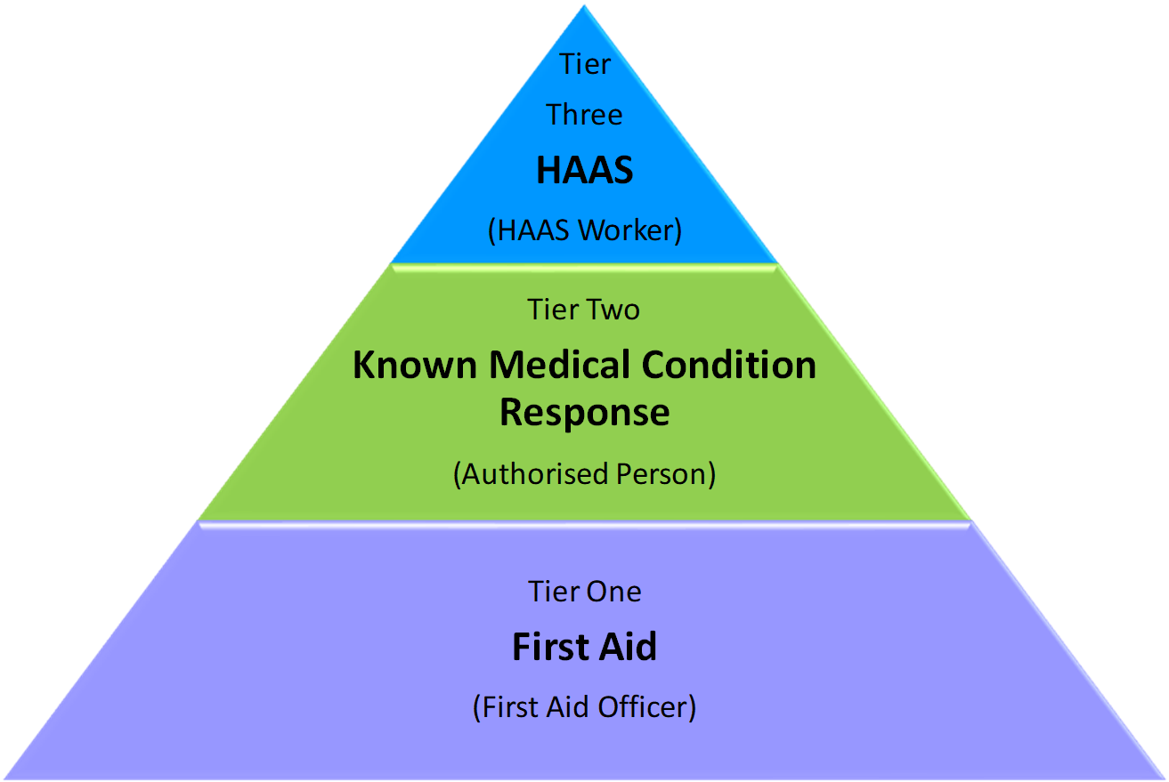

ACT Education Directorate
Three-Tiered Approach to Health Care in ACT Public Schools
Tier |  | One:  First Aid |  | Two:  Known Medical Condition Response |  | Three:  Healthcare Access at School (HAAS)
Description |  | For all students:  The immediate treatment or care given to a student suffering from an accident, injury or unexpected illness until more advanced care is provided or the student recovers. |  | For students with a known medical condition, short or long term, that:  - Requires intervention i.e. administration of medication or other support; and/or  - Could lead to a medical emergency. |  | For students with a known medical condition that requires staff to attend to complex or invasive health care procedures or management during school hours.
Provided by |  | EDU First Aid Officer |  | EDU Authorised Person |  | HAAS Worker
Training/ Knowledge Required | - Approved First Aid Course |  | - Approved First Aid Course  - Instructions from qualified health professional as per the student’s School Health Care Documentation  - Any specific instructions from the parent/carer |  | - Approved First Aid Course  - Instructions from qualified health professional as per the student’s School Health Care Documentation  - Specific training and competency assessment by a CHS HAAS Registered Nurse
Examples | - Headache  - Laceration  - Vomiting |  | - Asthma  - Epilepsy  - Student-managed type 1 diabetes |  | - Gastrostomy/ jejunostomy management  - Nasogastric tube management  - Oral suctioning  - Care of a Tracheostomy

School Health Care Documentation
To provide any level of health care, schools require a variety of documentation. Parent(s)/carer(s) are responsible for obtaining relevant School Health Care Documentation from their child’s health professional(s)/treating team and providing this to the school and the HAAS Program. The HAAS Program requires copies of this documentation to inform the HAAS Individual Care Plan. Where this Procedural Guideline refers to School Health Care Documentation, the following should be noted (also see Attachment 1: School Health Care Documentation):

Expired School Health Care Documentation
In accordance with EDU policy (Administration of Student Medication and Complex Health Care Procedures), health care at school (beyond basic first aid) cannot be provided without current School Health Care Documentation. It is important that Parent(s)/carer(s) are aware of this and are advised that HAAS Workers will not be permitted to provide health care at school without current (dated within the last 12 months) School Health Care Documentation.

The HAAS Program is Voluntary
Referral and enrolment to the HAAS Program is voluntary. Parent(s)/carer(s) of students who are eligible for, but do not wish to take part in the HAAS Program should contact the EDU Director of Healthcare Services in Schools to discuss the student’s health needs.

Likewise, if parent(s)/carer(s) do not provide consent for to the school to make a referral to the HAAS Program, the school executive team should advise the EDU Director of Healthcare Services in Schools healthcareservicesinschools@act.gov.au

Section 3 – Healthcare in Catholic Education Archdiocese of Canberra & Goulburn (CECG)

CECG ACT schools with a Deed of Grant in place are eligible for children to be enrolled in the HAAS program for the following Complex Healthcare Tasks:

- Enteral Feeding
- Enteral medications
- Tracheostomy Management
- Oral Suctioning
- Other complex tasks for example, blister management for students with Epidermolysis Bullosa (EB).

Exclusion
- Diabetes in Schools are the provider for Type 1 Diabetes Training for CECG
- First Aid Training
- Asthma, Anaphylaxis and Epilepsy Training
- Health Advice for students with Individual Medical Response Plan
- Non-Complex Health Task
- Healthcare Task requiring clinical judgement.

CECG School Health Care Documentation
- School Medication Authorisation-Healthcare Access At School
- Individual Response Plan
- HAAS Individualised Care Plan.

For students enrolled in HAAS program, two staff members are required to complete an independent second check before medication is administered to the student.

The Senior Officer: Disability, Wellbeing will assist CECG ACT schools to apply for assessment and training under the CHS HAAS program.
Back to Table of Contents

Section 4 – The HAAS Program Process

The process from referral to full commencement on the HAAS Program is outlined in the flowchart below. The following sections of this guideline provide detail on each aspect of the process. See Attachment 2 for a full-resolution version of The HAAS Program Process Flowchart.
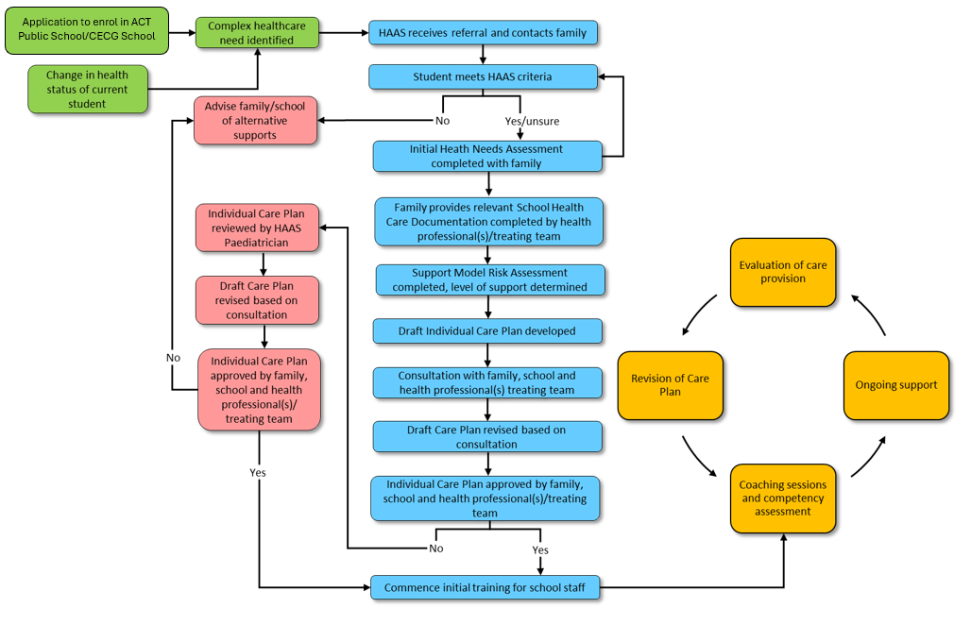
The HAAS Program Process Flowchart

Back to Table of Contents

Section 5 – HAAS Governance

The HAAS program is a student-centred initiative of the ACT Government to ensure all students in ACT Public Schools and non-government schools with a Deed of Grant to ensure equitable access to education.

The HAAS program sits under the governance of Community Health Programs within Women, Youth and Children (WYCCHP) and is delivered in accordance with a detailed MOU between CHS and EDU, Deed of Grant between CHS and CECG, and arrangements which may be specific to future stakeholders.

The HAAS Program MOU/Deed of Grant sets the service parameters, expectations of all parties, and governance relationship between the organisations. No services or activities which sit outside of this governance framework are permitted.

HAAS RNs use their health expertise in partnership with, or from the advice of the Subject Matter Experts (SMEs) and the student’s treating team, to lead the development of the HAAS Individual Care Plans and provide training and support to designated school staff to meet the healthcare needs of the individual student. EDU/CECG leads the care and education of the students involved.
Back to Table of Contents

Section 6 – HAAS Program Eligibility Criteria

To be eligible for enrolment to the HAAS Program, the student must meet all the following criteria:

- Attend an ACT Public School/or a school with a current HAAS MOU
- Attend a Catholic Education School with a current Deed of Grant
- Require a health care task and/or management during school hours
- See a medical specialist regarding their health care needs
- Have a current EDU Medical Condition Action and Management Plan or CECG Individual Medical Response Plan from their qualified health professional or a relevant association

And be determined by the HAAS program to fit within one or more of the following HAAS Eligibility Categories:

- Category A: The health care task and/or management cannot be managed through Tier One or Tier Two of the EDU Three-Tiered Approach to Health Care in Schools
- Category B: The health care task and/or management cannot be safely managed independently by the student under supervision of EDU/CECG staff
- Category C: Determinants of health are currently negatively impacting, or are likely to negatively impact, the student and/or family

The table below provides additional details on the HAAS Program Eligibility Categories.
Category | Description | Potential contributing factors
A | The health care task and/or management cannot be managed through Tier One or Tier Two of the EDU Three-Tiered Approach to Health Care in Schools. | The health care task is:  - Complex  - Invasive
B | The health care task cannot be safely managed independently by the student under supervision of EDU/CECG staff | - Student age or developmental level  - Student intellectual or physical capacity
C | Determinants of health are currently negatively impacting, or are likely to negatively impact, the student and/or family | - From an Aboriginal or Torres Strait Island, or culturally and linguistically diverse (CALD) background  - Living in poverty, or where parenting is affected by unemployment  - Low levels of literacy  - Parent who is socially isolated e.g. unsupported parent including fly-in fly-out arrangements  - Additional communication needs e.g. hearing, sight or speech impairment; and/or low English proficiency  - Adolescent parents  - Affected by chronic illness e.g., mental illness  - Parent/carer with disability  - Affected by substance abuse  - The student is living in out of home care  - Experiencing or at risk of homelessness

Re-referral to the HAAS Program
The HAAS Program welcomes re-referrals at any time for students who were not previously eligible for the HAAS Program. For example,
- The student’s health care needs at school or family circumstances have changed to meet eligibility criteria
- Their parent(s)/carer(s) previously declined enrolment to the HAAS Program but are now consenting to a referral.

Additional Support for Students who are ineligible for the HAAS Program
The HAAS program CNC or assigned RN will provide feedback to the referrer on the outcome of the referral to HAAS. The HAAS program will provide suggestions on additional support services or programs available for the student. For example, Epilepsy Australia.

School staff are also encouraged to contact the Director of EDU Healthcare Services in Schools or Senior Officer Disability Wellbeing & Inclusion for further information and assistance on alternative funding and support models.

Back to Table of Contents

Section 7 – Limitations of the HAAS Program

The provision of health care in a school setting by unregulated EDU/CECG staff must comply with strict parameters to ensure the safety of students and staff.

EDU/CECG employees assigned to attend to health care tasks and/or management for students in the HAAS program must undergo student specific training and competency assessment provided by the HAAS program. On completion of this training and competency assessment, EDU/CEGC employees, referred to as HAAS Workers, must always adhere to the approved HAAS Individual Care Plan.

Health care tasks or management that are beyond the limitations of the HAAS Program include, but are not limited to those that:

- requires clinical judgement and/or clinical decision making
- are not consistent with evidence-based best practice and/or CHS clinical practice guidelines and/or policy
- are deemed unsafe to attend in a school environment by the HAAS Risk Review Committee
- place the student at high risk of infection or trauma (for example catheterisation, TPN, Central or PICC line management)
- do not have a stable airway (cannot maintain by natural or mechanical means, adequate oxygenation, ventilation and/or a patent airway)
- are beyond the scope of practice for an RN Level 2 to teach to.

It may be determined at any stage during the student’s enrolment on the HAAS program that health care tasks(s) and/or management required at school are beyond the limitations of the HAAS program. For current students, this is most likely to occur if there has been a significant change in the student’s health care needs resulting in the health care task(s) and/or management progressing beyond the limitations of the HAAS Program.

The following HAAS Program Limitations – Review Process should be followed when determining if the health care task(s) and/or management is beyond the limitations of the HAAS Program. This process is not required for simple new referrals who do not meet HAAS Eligibility Criteria (see Section 5):

HAAS Program Limitations – Review Process
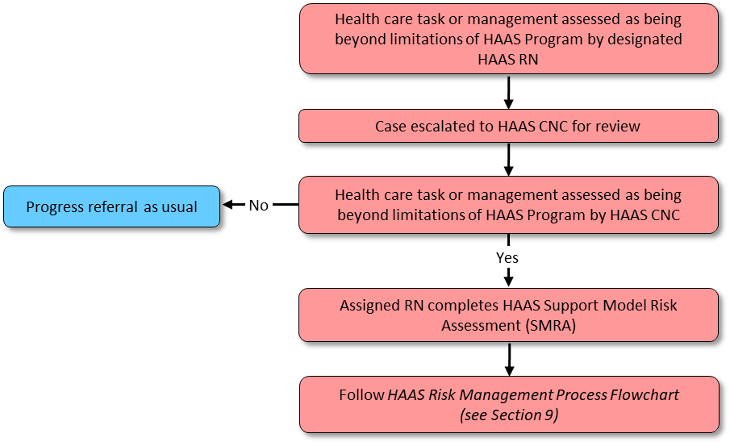

Back to Table of Contents

Section 8 – Referral and Initial Stakeholder Engagement

Referral to the HAAS Program
Schools, health professionals or the family themselves can make a referral to the HAAS program. A HAAS Program Referral Form (see Attachment 3) should be completed by the referring party and emailed to the HAAS program at HAAS@act.gov.au. CHS employees place a referral through the student’s Digital Health Record. They are encouraged to confirm receipt of their referral via email. Consent from parent/carer should be obtained by the referrer before a referral is made to the HAAS program.

Upon the receipt of a referral, the HAAS CNC will determine the allocation of the potential new client to the HAAS RNs, considering factors such as client load, acuity, and the student’s school.

Initial Stakeholder Engagement
Initial verbal consent is gained over the phone by the HAAS RN and documented in Digital Health Record (DHR)

- Consent to access the students Digital Health Record
- Consent to share information with regarding Healthcare Task with School
- Consent to share information with EDU/CECG for administration purposes
- Consent to share information with the students treating team

The assigned HAAS RN will then commence the initial engagement process with all stakeholders; the student’s family, school, health professionals, and treating team.

It is important to clearly communicate to all stakeholders, as per the HAAS Program Consent Form ACT EDU Education Directorate policy or CECG policy and parent(s)/carer(s) are required to meet the student’s health care needs at school (or they may choose to keep the student at home) until the HAAS Individual Care Plan has been approved for use and school staff have been appropriately trained (full commencement on HAAS Program).

The expected timeframe from initial referral of an eligible student to full commencement on the HAAS Program is 4-6 weeks. This timeframe may be extended during periods of high activity for the HAAS program.
Back to Table of Contents

Section 9 – Initial Health Needs Assessment Meeting

After the assigned HAAS RN has completed the initial stakeholder engagement process, they will arrange an Initial Health Needs Assessment meeting with the parent(s)/carer(s). The student is encouraged to be present and involved if appropriate.

Purpose of the Initial Health Needs Assessment Meeting
- Obtain written consent to commence on the HAAS Program
- Develop a therapeutic relationship with family and student
- Obtain additional contact details (family, health professional(s)/treating team)
- Obtain School Health Care Documentation completed by health professional/treating team (see Attachment 1)
- Complete HAAS Health Needs Assessment (a detailed description of the health care task(s) and/or management required in the school setting)
- Explain process for establishment of HAAS program support in school.

Safety Considerations
The initial meeting should be in accordance with the CHS Home Visiting Procedure available on the Policy and Guidance Document Register.
Key points:
- Staff are required to complete HRIMS modules:
- CHS Occupational Violence Modules 1-4
- CHS Home Visit Risk Assessment
- CHS SHEQSY Lone Worker Safety App Training
- CHS Code works or remote/isolated work (including home visits)
- The initial meeting can take place at a mutually convenient location such as the client's school, public meeting place or local ACT Community Health Centre.
- To maintain the safety of HAAS RNs, home visits are not always possible. If a home visit is indicated, a CHS Home Visit Pre – Assessment must be completed to assess risk.
- If a higher level of risk is determined, the visit should take place in a local ACT Community Health Centre.
- Home visits should be attended by two HAAS RNs and staff should bring a CHS SHEQSY lone worker app to raise the alarm in the event their personal safety is under threat. More information on the use of this is available in the HAAS Home Visiting Business Rules
Note: The device is considered a ‘Listening Device’ under the Listening Devices Act 1992. As such, the client's verbal consent for the use of device must be sought prior to the visit.

HAAS Occupational Violence Escalation pathway for new referrals

Back to Table of Contents

Section 10 – Risk Management and Level of Support

There is an expected level of risk when providing healthcare in a school-based setting. The HAAS program identifies and manages this risk via a three-tiered risk management process alongside the CHS risk management policy.

Alert: No training to commence prior to paediatrician approval of the Support Model Risk Assessment (SMRA).

Tier 1: Support Model Risk Assessment (SMRA)
The severity of the risk is assessed for each student, using the HAAS Support Model Risk Assessment (SMRA) template. The HAAS SMRA template is an adaption of the CHS Risk Assessment Template and should be used in conjunction with the CHS Risk Likelihood and Consequence Tables and the CHS Risk Matrix.

A HAAS SMRA is completed for new enrolments to the HAAS program and for current students if/when a significant change in health care requirements at school is identified. All SMRAs are approved by the HAAS RN, HAAS CNC and HAAS Paediatrician and stored on the student’s Digital Health Record. The training of school staff cannot commence until the SMRA has been signed by the HAAS paediatrician.

In accordance with the CHS Risk Management Process, the HAAS Support Model Risk Assessment serves to identify, analyse, and evaluate the risks to student and staff safety. The tool identifies current risk controls and determines if a risk is deemed acceptable.

Risks rated High or Extreme are deemed intolerable and managed according to the HAAS Program Risk Management Process Flowchart. Intolerable risks are subject to a Risk Treatment Action Plan (RTAP) and escalated to Tier 2: HAAS Program Risk Review Committee.

Tier 2: HAAS Program Risk Review Committee:
The SMRA identifies the risk as high/extreme
- The risk assessment, supporting documents and HAAS Individual Care Plan are reviewed in person by the HAAS Risk review Committee
  - the HAAS Consultant Paediatrician
  - HAAS CNC
  - School Services Manager
  - Identified HAAS RN2
to determine if the required health care can safely be delivered in the school environment, ensuring safety for the student and the HAAS Worker
- The outcome and rationale for this assessment is documented in the student’s Digital Health Record (DHR) by the CNC and HAAS consultant paediatrician
- If the risk can be mitigated, the risk assessment will be signed by the HAAS paediatrician and recorded as safe for HAAS training to commence.
- If the risk cannot be mitigated it will be escalated to Tier 3 Risk Review Committee
  - The family will be notified that a high risk was identified, and it will require referral to the HAAS independent Risk Review Committee
  - Following a committee outcome, results of the independent review will be communicated to the family.

Tier 3: The HAAS Program Independent Risk Review Committee:
The student will be escalated to the HAAS Program Independent Risk Review committee if:
- The student was assessed as unsafe to attend school at the level 2 risk assessment or
- There is dispute/disagreement regarding the HAAS Individual Care Plan.
The HAAS Program Independent Risk Review committee includes:
- Clinical Director of Paediatrics, Centenary Hospital for Women and Children (CHWC)
- Assistant Director of Nursing (ADON) CHWC Paediatrics
- ADON WYC Community Health Programs
- School Services Manager
- HAAS CNC
- Other subject matter expert/s where appropriate.
The HAAS Program Independent Risk Review committee are provided with all documents and the parent will be invited to provide a written/verbal statement putting forward their view if it is a dispute situation.
The committee will:
- Review all information and seek additional expert advice if required
- Make a decision
- Document the decision as a brief and/or ministerial.
Following the decision, the committee will concurrently:
- Write to HAAS informing them of the decision (included in the student’s Digital Health Record)
- Write to the parent informing them of the decision which may be:
- Asking the parent to sign the HAAS Individual Care Plan and return it to HAAS by X date - if not received by this date the referral will be closed
- Informing the parent that the student is unable to be safely supported at school (if so need to work with EDU/CECG on what their pathway is from this point)
- Write to the ACT EDU or CECG informing them of the decision.
All communication from the HAAS Program Independent Risk Review Committee, will be communicated from the Women Youth and Children Community Health Program (WYCCHP) inbox.
This process will ensure:
- There is a clear pathway to assess, escalate and document risk
- Individual circumstances and care requirements for students are independently reviewed
- Negotiation back and forth with families is minimised
- Outcomes are quickly determined
- There is clear documentation and communication to all parties of the final decision including dates etc
- The decision is adhered to and respected by all parties
- Should health needs/circumstances change a new referral to HAAS is implemented.

HAAS Program Risk Management Process Flowchart

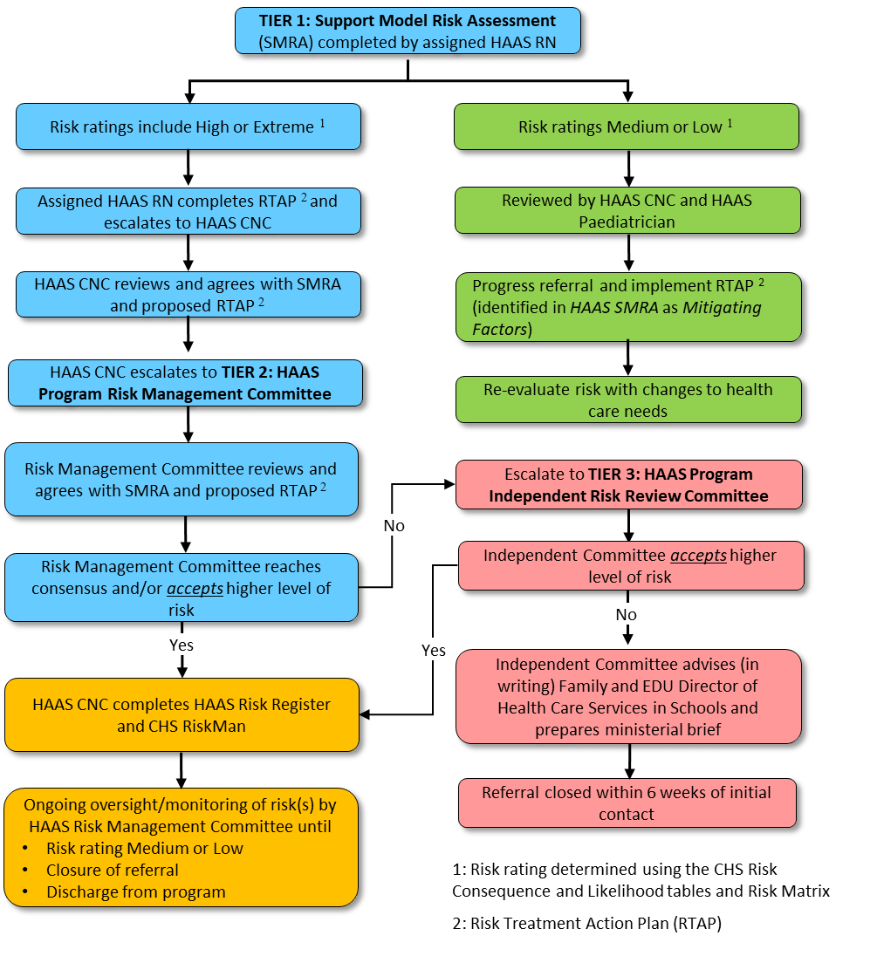

HAAS Program Levels of Support:
The HAAS Support Model Risk Assessment aids in determining the level of HAAS program support required by the student at school. The level of support is recommended by the assigned HAAS RN and endorsed by the HAAS CNC and HAAS Paediatrician as documented on the HAAS Support Model Risk Assessment form. HAAS can offer the following levels of support:

Intermittent – The HAAS Worker attend to one or more procedure during the school day, balanced with other assigned duties for their position.
1:1 Continuous Support – The HAAS Worker provides dedicated one to one support for the student. The HAAS worker can also provide learning support to the student as appropriate, however, they may not provide support for other students while the HAAS student is in their care.
Back to Table of Contents

Section 11 – Content of HAAS Individual Care Plans

The purpose of a HAAS Individual Care Plan is to provide the HAAS Workers with clear, stepped-out instructions to attend to the student’s health care needs in the school setting. HAAS Workers are obliged to always follow the approved HAAS Individual Care Plan.

The HAAS Individual Care Plan is reviewed by HAAS RNs in consultation with the student’s family and updated annually, or when there are changes to the student’s health care requirements at school.

Content of HAAS Individual Care Plans
Due to each student's unique health needs, the content of HAAS Individual Care Plans are specific to each student. However, all HAAS Individual Care Plans adhere to the following:

- Content of HAAS Individual Care Plans are informed by:
- Initial Health Needs Assessment
- Relevant School Health Care Documentation (see Attachment 1)
- Evidence-based best practice
- Relevant CHS Policies and Guidelines
- Relevant external policies (Education (EDU), CECG, Sydney Childrens Hospital Network (SCHN).

- HAAS Individual Care Plans include:
- Three forms of student identification
  - Name
  - Date of Birth
  - Medical Record Number (MRN)
  - Plus, current photograph of student (updated annually)
- Basic health background information
- Equipment required and provided by whom
- Medical emergency alerts for the student, with clear direction for HAAS Worker response and relation to EDU/CECG First Aid procedure
- All required HAAS health care task(s) and/or management, stepped out clearly and in simple English, including:
  - When to attend to task/management
  - Equipment required
  - Procedural steps
  - Required documentation
  - Who to contact if concerned or support required (parent/carer).
- Documented parent/carer approval of HAAS Individual Care Plan and date approved

- HAAS Individual Care Plans cannot include:
- Medical terminology or ‘jargon’
- Healthcare tasks and/or management that are not able to be regularly practiced due to infrequent requirement
  - E.g., If a student does not regularly remove their gastrostomy button, reinsertion may not need to be included
Note: Where HAAS Workers must be trained to a task that cannot be practiced regularly (eg: emergency management for tracheostomies), this task may be included in the HAAS Individual Care Plan. Such tasks are an exception and should be supported by more frequent simulation training. For example, once per school term.
- Procedures that are covered by standard EDU/CECG Policies and Procedures
- Practices not consistent with evidence-based best practice
- Practices not consistent with CHS Policies and Guidelines or relevant external policies
- Information that is over-complicated or difficult to interpret and increases the risk of error
- Other practices that are beyond the limitations of the HAAS Program (see Section 7: Limitations of the HAAS Program).

Draft HAAS Individual Care Plans are peer reviewed within the HAAS team to ensure consistency to the child’s parent/carer for approval via email. The reviewer is noted on Digital Health Record and email approval is uploaded to Digital Health Record. Prior to implementation of any HAAS Individual Care Plans parent review occurs and approval is documented via email and uploaded to DHR. No training will occur prior to the parent/s’ approval of the care plan.

Back to Table of Contents

Section 12 – Review and Approval of HAAS Individual Care Plans

The process for the review and approval of HAAS Individual Care Plans is outlined in Attachment 2: The HAAS Program Process Flowchart.

Consultation with Stakeholders
Following written consent by the family, draft HAAS Individual Care Plans are shared with the student's parent(s)/carer(s), and health professional(s)/treating team, seeking their feedback/input and approval.

Adherence with School Health Care Documentation
The HAAS Individual Care Plan must adhere to directions contained in the student’s School Health Care Documentation (see Attachment 1: School Health Care Documentation). Parent(s)/carer(s) should ensure that any requested changes to the HAAS Individual Care Plan are consistent with these documents. If not, changes will need to be approved by the student’s health professional/treating team. Updated signed documents will be provided to the school by the parent/carer and emailed to the HAAS team, HAAS@act.gov.au.

Alterations Beyond HAAS Program Limitations
HAAS Individual Care Plans cannot include health care tasks or management that are beyond the limitations of the HAAS Program (see Section 6: Limitations of the HAAS Program). During the consultation process, if any stakeholder requests a health care task(s) and/or management that exceeds the program limitations, the health care task(s) and/or management of concern should be assessed using the HAAS Support Model Risk Assessment Tool and the HAAS Risk Management Process should be followed (See Section 10: Risk Management and Level of support).

Approval of HAAS Individual Care Plans
Parents/carers should provide written approval (email is appropriate) of the HAAS Individual Care Plan, indicating that they agree with its contents and agree that nominated school staff can be trained to follow the directions therein. Copies of these emails are to be saved on the student’s Digital Health Record.

Commencement of Training and Interim Arrangements
Once the HAAS Individual Care Plan has been approved by all stakeholders and the HAAS team is satisfied that the content is within HAAS Program limitations, the HAAS team will commence the training of nominated school staff.
As per the HAAS Program Consent Form and ACT Education Directorate policy, CEGC Medical Welfare of Students policy), parent(s)/carer(s) are required to meet the student’s health care needs at school (or they may choose to keep the student at home) until the HAAS Individual Care Plan has been approved for use and school staff have been appropriately trained (full commencement on HAAS Program).

Back to Table of Contents

Section 13 – The HAAS Folder

The HAAS Program provides a HAAS Folder for each student, to always be kept with them at school. It must remain at school, students/families are not permitted to take the folder or any of its contents from the school site. The HAAS Folder is comprised of a suite of documents as indicated below.

Document | Description
Cover Sheet * | Indicates the purpose of the folder, includes student’s photo (updated annually) and three student identifiers:  - Name  - Date of Birth  - MRN
HAAS Individual Care Plan * | Agreed upon document including step by step procedure(s) for management of the student’s health care needs at school
HAAS Communication Pathway * | Flowchart with contact details and lines of communication, regarding the student’s health needs at school
School Health Care Documentation | See Attachment 1: EDU School Health Care Documentation  See Attachmen 1: CECG
HAAS Record of Tasks form * | CHS form to record all management/intervention by HAAS Workers. The form is uploaded to the student’s Digital health record once completed.

* Indicates that these are HAAS Program documents which remain the property of CHS and will be collected from the school intermittently as required and on discharge from the program.
Back to Table of Contents

Section 14 – School Environmental Assessment

The HAAS RN may need to complete an assessment of the school environment if indicated of where the health care tasks are to be performed. This may include recommendations to the school regarding equipment, storage of medication, or suitable space. Assessment and recommendations are in line with the Work Health and Safety Act 2011 and Disability Standards for Education 2005. It is EDU/CECG’s responsibly to ensure there is a suitable workspace for the healthcare task to be undertaken, ensure the students safety and dignity is maintained and that staff WHS requirements are met.

If an environmental assessment is required, the RN will:
- Complete the HAAS School Environmental Checklist
- Share the assessment and recommendations with the school Principal
- Send a copy of the completed checklist to the CHS Clinical Record Unit or upload directly to the student’s DHR

In the event of unresolved environmental concerns, training may not proceed. A RiskMan notification will be completed by the HAAS RN and the matter will be escalated by the HAAS CNC to the Director of EDU Healthcare Services in Schools and Senior Officer Disability wellbeing & Inclusion
Back to Table of Contents

Section 15 – Appointment of School Staff for HAAS Training

It is the responsibility of the school executive staff to identify suitable staff to commence training for the HAAS program. The school executive staff should access the EDU HAAS implementation guide for schools off the EDU portal or by contacting EDU Healthcare Services in Schools

Identifying Suitable Staff
- Staff training to be EDU/CECG HAAS Workers require the following:
  - Numeracy and English language proficiency (written and verbal)
  - Current First Aid certificate (as per EDU Administration of Student Medication and Complex Health Care Procedures policy and CEGC Medical Welfare of Students policy)
  - Willingness to perform the role and accept the responsibilities of required care (the EDU/CEGC HAAS worker role is voluntary).
- Staff with duty of care for groups of students (i.e. classroom teachers) are not suitable to be trained as HAAS Workers (*see note below)
  - The health care tasks, or management must take priority over the Worker’s other duties
  - Recommended staff include Learning Support Assistants (LSAs) and administration staff
  - If a student is in preschool, it is not recommended that only preschool assistants are trained as HAAS Workers as they will be required to follow the student to the wider school in subsequent years
- Staff who have a personal relationship with the student’s family are not suitable to be trained as HAAS Workers
  - For the safety and wellbeing of both the student and the staff member, staff must be able to maintain professional boundaries and engage in objective decision-making while working with the student and their family

HAAS Worker Ratios
- HAAS recommends schools train 2-3 Full Time Equivalent (FTE) HAAS Workers per full time student to ensure there is sufficient coverage and to account for staff leave, excursions etc. HAAS Workers can support more than one student on the HAAS program in their school if they have been deemed competent to attend each individual student’s healthcare needs (e.g two HAAS students does not require six HAAS Workers).
- HAAS Workers are required to maintain their competence by regularly engaging in the required health care task/management (minimum once/fortnight). For this reason, excessive numbers of HAAS Workers are not trained.
- Staff are not trained to be “back-up” HAAS Workers.

Funding for Schools
- School staff should be advised that any questions regarding funding or human resources should be directed to the EDU Healthcare Services in Schools team and Senior Officer Disability Wellbeing & Inclusion.
- The HAAS CNC meets monthly with the Director and Assistant Director of EDU Healthcare Services in Schools to provide an update of all HAAS students regarding time the HAAS tasks take for school funding purposes.
- When a student steps off the HAAS program or a HAAS worker is no longer doing the HAAS role, the HAAS CNC or assigned RN will send an email to EDU Healthcare Services in Schools so that the Assistant Director can follow up with relevant school to cease the HAAS worker’s allowance and HAAS funding for the school.
- The CECG Schools Enterprise Agreements provide allowances for school staff who perform healthcare procedures. Schools are required to contact CECG Senior Officer Disability Wellbeing & Inclusion to discuss funding.

HAAS Worker Time and Role Requirements
- School staff who will be trained to be HAAS Workers will need to be released from their normal duties to attend training sessions:
  - Initial training session: Usually 2 - 3 hours
  - Buddy sessions with the HAAS Worker and student: 30 – 60 mins. Typically, 3 -5 sessions required before the HAAS Worker is ready to undertake their competency assessment.

*Note: Executive staff, classroom teachers and any other staff who teach or supervise the student are encouraged to attend the first hour of the initial training session to understand their roles and responsibilities in supporting the student to participate in school safely.

- Whether a HAAS Worker can attend to other duties will depend on the level of HAAS Program support being provided for the student.

  - Intermittent – The HAAS Worker will be required to attend to one or more procedures during the school day. This can be balanced with other assigned duties for their position. However, the HAAS health care tasks and/or management must take priority over the Worker’s other duties.

  - 1:1 Continuous Support – The HAAS Worker will be required to provide dedicated one to one support for the student. The worker can also provide learning support to the student as appropriate however, they may not provide support for other students while the HAAS client is in their care.

Continuing Suitability of HAAS Workers
A staff member may be deemed unsuitable to continue in the HAAS Worker role should they:
- Demonstrate a limited ability to perform the health care task and/or management as required. This may be evidenced by:
      - Continued inability to comply with the HAAS Individual Care Plan
      - Extensive and continuous seeking of support from the HAAS team
      - Failure to achieve continued competency during subsequent competency reassessments
- Consistently demonstrate concerning behaviour toward the student, family, other HAAS Workers or HAAS team.

The following process should be followed if there are concerns regarding the continuing suitability of a HAAS Worker:
- HAAS RN provides the HAAS Worker with verbal feedback and strategies for improvement
- HAAS RN notifies the HAAS CNC and school Principal
- If issue resolves, HAAS RN should continue to monitor for further issues.

CHS HAAS RNs has the final decision in whether a Worker is suitable or not and will withdraw training support if needed.

If issue remains unresolved, the HAAS CNC will escalate the matter to:
- School Principal
- Director, EDU Healthcare Services in Schools/CECG.
- HAAS Program Risk Review Committee.
Back to Table of Contents

Section 16 – Training and Competency Assessment for School Staff

EDU/CEGC employees assigned to attend to health care tasks and/or management for students in the HAAS program must undergo student specific training and competency assessment provided by the HAAS program. On completion of this training and competency assessment, EDU/CEGC employees, referred to as HAAS Workers, must always adhere to the approved HAAS Individual Care Plan.

Arranging Initial Training
The assigned HAAS RN will liaise with the school staff to schedule the initial training session. This should include:
- Determining date, time, location
- Requesting a room with appropriate digital presentation technology
- Requesting participant names, positions, and email contacts
- Emailing participants advising of
  - Training day details
  - Pre-requisite training requirements (see below).

Pre-requisite Training Requirements for Potential HAAS Workers
- Participants are required to attend the following pre-requisite training and when requested, show evidence of completion/attainment prior to the initial training.
- All health conditions/procedures:
  - English proficiency (verbal and written) – initially determined by school executive staff member responsible for nominating staff for HAAS training
- Current First Aid certificate (as per EDU’s Administration of Student Medication and Complex Health Care Procedures/CECG Medical Welfare of Students Policy)
  - Australian Commission on Safety and Quality in Health Care Hand Hygiene Non-Clinical Online Learning Module
- Diabetes: Diabetes in Schools Online modules: Level 1 and 2
- Gastrostomy pump feeding: Enteral feeding using Nutricia Flocare Infinity II pump: videos and training simulator.

Initial Training Session:
The initial training session aims to:
- Explain the function of the HAAS program and the role of HAAS Workers and HAAS RNs
- Build on participant’s prerequisite knowledge of the student’s medical condition
- Provide a practical demonstration of required clinical skills
- Allow participants to engage in practical simulation of required clinical skills
- Introduce the student's specific HAAS Individual Care Plan
- Discuss health care management as per HAAS Individual Care Plan
- Introduce the relevant competency assessment tool
- Allow participants to demonstrate knowledge and understanding and/or competency (allowing the HAAS RN to record this on the competency assessment tool)
- Prepare participants for further training (buddy sessions) and continued competency assessment
- Answer any participant questions
- Seek feedback from participants (using the Digital HAAS Evaluation Survey)

Initial training sessions contain a balance of theoretical and practical content and employ multiple delivery methods to cater for different adult learning styles. Delivery methods include:
- PowerPoint Presentations
  - Developed by the HAAS team.
  - Based on current evidence-based practice and relevant CHS policies and procedures.
  - Include scenario-based questions to generate learning and group discussion.
- Practical Demonstration and Simulated Practice
  - Clinical equipment (both real and simulated) is provided so participants can observe the HAAS RN demonstrate clinical tasks and then can practice these in a simulated environment.
- Written Information
  - Participants are provided with a copy of the student's HAAS Individual Care Plan during the initial training which must be returned at the end of the training session.
  - Participants are emailed a PDF copy of the PowerPoint presentation which they may print and bring to the session if this supports their learning style.
  - Participants are provided with the opportunity to practice required HAAS documentation during the session.
- Discussion
  - The session is balanced with opportunities for participants to engage in discussion, questions and answers and clarify their understanding.

Buddying Sessions and Competency Assessment
Participants may be able to demonstrate partial competence during the initial training session. It is not expected that potential HAAS Workers will be able to demonstrate full competence until they have had the opportunity to practice in a variety of scenarios and situations, under direct supervision of the HAAS RN.

The HAAS RN will facilitate buddy sessions where they provide supervision, guidance, and support for the potential HAAS Worker, as well as the opportunity for assessment of competence.

To be assessed as competent, the potential HAAS Worker must demonstrate an ability to apply their knowledge and skills to attend to the student's health care needs in line with the requirements of the HAAS Individual Care Plan and relevant HAAS competency assessment tool.

Once a potential HAAS Worker is assessed as competent, they can attend to the student's health care unsupervised.

Currency of Competence
The principles of competency assessment¹ state that the learner is competent at the time the assessor makes the assessment decision. It is recognised that skills and knowledge degrade over time and ongoing competence is not guaranteed. For this reason, HAAS Workers are required to regularly engage in the required health care task/management at a recommended minimum of once per fortnight. School executive staff are also advised that:
Excessive numbers of HAAS Workers are not trained
Staff are not trained to be a “back-up” HAAS Worker

Where HAAS Workers are trained to a task that cannot be practiced regularly (eg: emergency management for tracheostomies or gastrostomy tube reinsertion), this task will be supported by more frequent simulation training.

To determine a HAAS Worker’s currency of competence, reassessment of competence is attended approximately every 12 months. HAAS Workers will be contacted via email at the beginning of the school Term by the HAAS RN to advise them that they are due for a reassessment.

Timeframe for Demonstration of Competence
Time to achieve competence can vary significantly between potential HAAS Workers. Regardless, all potential HAAS Workers should be able to demonstrate progression in line with the relevant competency assessment tool.

If a potential HAAS Worker fails to progress, they cannot be assessed as competent and therefore, cannot attend to the health care task(s) and/or management without the supervision of the HAAS RN.

Concerns regarding limited progression should be escalated to the HAAS CNC who will discuss them with the relevant school principal and/or executive staff and the EDU Healthcare Services in Schools Team Senior Officer Disability Wellbeing & Inclusion.

Advisement of Stakeholders of Assessment of Competence
Upon completion of the assessment of competence, the staff member will be referred to as a HAAS Worker. The HAAS RN should advise the following stakeholders of the assessment of competence.

- Initial training and training of additional HAAS Workers
  - The HAAS Worker: The HAAS RN provides them with a copy of the completed HAAS Competency Assessment Tool via email
  - The School Executive Team: The HAAS RN advises that the HAAS Worker is now able to attend to the student's health care needs without direct RN supervision and provides a copy of the completed HAAS Competency Assessment Tool via email. The executive staff will attend to the relevant EDU administration, including arranging for HAAS Worker financial allowance. Any queries regarding this should be directed to the EDU Healthcare Services in Schools Team.
  - EDU Healthcare Services in Schools Team: Provide details of HAAS Worker and school via email to enable allowances to be recorded within EDUs systems.
  - CECG: Provide details of HAAS Worker and school of the competence certification via email to the Senior Officer Disability Wellbeing and Inclusion and to the school principal, ensuring that the staff member receives the allowance.

Once all nominated staff have been deemed competent, the HAAS RN will email the relevant school executive staff to advise them of ongoing HAAS Program support and processes.

- Initial training only
  - The parent(s)/carer(s) (initial training only): Advise that, as school staff have been assessed as competent to attend to the student's health care needs, the responsibility for this during school hours can now be held by the HAAS Worker(s). The HAAS RN sends email to relevant school executive staff to advise of the ongoing support and process of the HAAS Program.
  - The HAAS CNC: Records that the student has formally commenced on the HAAS Program which is shared to EDU at the HAAS/EDU monthly meeting for funding/HAAS worker allowance purposes
  - The HAAC CNC: will communicate with Senior Officer Disability Wellbeing & Inclusion when a student formally commences on the HAAS program

Review of Competence
The HAAS RN attends the school (minimum once per term) to check in and review and collect the completed HAAS Record of Tasks form and associated HAAS paperwork.

The HAAS RN also facilitates competency reassessment and, if required, additional education:
- Annually
- Following significant changes to the student’s health care needs at school
- If there are concerns regarding HAAS Worker competence or compliance with the HAAS Individual Care Plan
- Following a long absence of a HAAS worker (longer than 12 weeks)
- If there are concerns regarding a HAAS Worker engaging in unsafe practice or there are concerns regarding their engagement in the HAAS program.
Back to Table of Contents

Section 17 – Amendments to HAAS Individual Care Plan

Trained school staff are obliged to always follow the approved HAAS Individual Care Plan. The parent(s)/carer(s) are requested to promptly advise the HAAS Team of any changes (current or anticipated) to the student’s health care needs or management in the school setting.
Repeated requests by parent(s)/carer(s) for school staff to provide care not consistent with the HAAS Individual Care Plan will be escalated to the school executive staff.
The HAAS Individual Care Plan must adhere to directions contained in the student’s School Health Care Documentation (see Attachment 1).

Minor Amendments
For minor amendment requests that are still consistent with the student’s current School Health Care Documentation, the HAAS RN should:
- amend the HAAS Individual Care Plan
- obtain HAAS RN peer review of the updated plan
- obtain confirmation of contents and approval for use of the updated HAAS Individual Care Plan from the parent(s)/carer(s) and school if necessary
- replace school copy of HAAS Individual Care Plan
- advise HAAS Workers of changes.

Significant Amendments
For significant amendment requests that are not consistent with the current School Health Care Documentation, the HAAS RN should:
- advise parent/carer of same
- advise parent/carer to discuss changes with student’s health professional/treating team
- obtain relevant updated signed School Health Care Documentation
- amend the HAAS Individual Care Plan
- obtain HAAS RN peer review of the updated plan
- obtain review by the student’s health professional/treating team as indicated
- obtain confirmation of contents and approval for use of the updated HAAS Individual Care Plan from the parent(s)/carer(s) and school if necessary
- replace school copy of HAAS Individual Care Plan
- advise HAAS Workers of changes and provide additional training if necessary.

Alterations Beyond HAAS Program Limitations
HAAS Individual Care Plans cannot include health care tasks or management that are beyond the limitations of the HAAS Program (see Section 7: Limitations of the HAAS Program). If any stakeholder stipulates health care task(s) and/or management that exceeds these limitations, the health care task(s) and/or management of concern should be assessed using the HAAS Support Model Risk Assessment Tool and the HAAS Risk Management Process should be followed (See Section 10: Risk Management and Level of Support).

Back to Table of Contents

Section 18 – Ongoing Support and Evaluation of Provision of Care

The HAAS team provide will provide ongoing support as needed for school staff and families. The HAAS team is available face to face, via phone or email, weekdays 0800 – 1630. This is inclusive of school holidays. However, the HAAS Program does not operate on public holidays.

Confirming a Student’s Identity
When receiving a phone call regarding a student or attending to the student in the school setting, in accordance with CHS Procedure: Patient Identification and Procedure Matching, HAAS RNs should request a minimum of three student identifiers to establish or confirm the student’s identity.
Additionally, when attending to the student in the school setting a current student photo is used to positively confirm student identity.

Note: The HAAS Program will request consent from caregivers to access the student’s annual school photo. This will be attached to the front page of the HAAS Individualised Care Plan and the EDU/CECG Medication Authorisation and Administration Record where in use.

To correctly identify a student, the HAAS RN/HAAS Worker and EDU/CECG staff, parents/carers and other health professionals will use a combination of identifiers including:
- The student’s full name
- Date of birth
- School the student is currently enrolled in
- Medical Record Number (MRN) (EDU/CECG staff and health professionals)
- Student’s photo (when present in the school setting).
Support Provided and Evaluation of Provision of Care
The HAAS Team provide the following:
- Support to navigate clinical issues as they arise in the school setting
- Revision of the HAAS Individual Care Plan annually and with changes to health needs or HAAS Worker and parent/carer feedback
- Intermittent observation of care provided by HAAS Workers
- Seek feedback on care provision from parent(s)/carer(s) intermittently and at annual review meeting
- Seek feedback on care provision from school executive staff
- Seek feedback from HAAS workers to determine they feel supported and confident in their role supporting HAAS students with their healthcare tasks
- Provide additional/refresher training for school staff as required
- Facilitate annual competency reassessment for HAAS Workers.
Back to Table of Contents

Section 19 – Reporting Errors and Near Misses to EDU/CECG

Purpose
To ensure timely, transparent, and systematic reporting and management of clinical errors or near misses involving students enrolled in the HAAS program by school staff.

Procedure
- Identification and Initial Reporting
  - Any error or near miss identified or reported to the HAAS RN must be escalated promptly
  - The HAAS RN initiates documentation in DHR and informs the HAAS CNC
- Notification to Education Leadership by HAAS CNC:
- The Principal of the affected school
- The Executive Teacher responsible for students enrolled in the HAAS program
- Notification to EDU Healthcare services in schools and CECG Senior Officer Disability Wellbeing & Inclusion.
- Recommendation to School Leadership by HAAS CNC:
- Undertake Open Disclosure to the student’s guardians, in accordance with CHS and EDU/CECG policy
- Follow the school’s internal documentation and incident reporting procedures.

- Clinical Documentation
- The HAAS RN will complete a formal incident report in CHS RiskMan noting nature of the error or near miss, immediate action will be taken and recommendations and follow up.

- Training and Risk mitigation. The HAAS CNC will:
- Co-ordinate additional face to face training for relevant school staff at the affected site
- Conduct a trend analysis of HAAS task administration errors or near misses
- Update training packages and protocols to address identified risks and prevent recurrence.

- Governance and Review
- All incidents will be reviewed as part of ongoing clinical governance
- Trends and outcomes will inform continuous improvement in HAAS training and service delivery
- Incidents are reported quarterly at WYCCHP Performance and Safety Meetings and reported to CHS Executive.

Back to Table of Contents

Section 20 – Discharge from the HAAS Program

Discussions about discharge from the HAAS program should occur with parents/carers when the student is enrolled on the HAAS program. When it is identified that a student is ready for discharge from the HAAS Program, the following process should be followed:

HAAS Transition to Discharge Flowchart

Student Progression
The HAAS Program recognises each student's health needs, abilities and experiences are unique to them. For this reason, the progression to discharge will be different for each student. The HAAS team monitor the student's progress over time through buddying with HAAS Workers, communication with schools’ staff, the student’s health professionals and parents/carers. When the HAAS team determines that a student meets the discharge criteria, they commence the transition to discharge.

HAAS Discharge Criteria
- The student no longer meets HAAS eligibility criteria (see Section 4: HAAS Program Eligibility Criteria)
- The health care task(s) and/or management have progressed beyond the limitations of the HAAS Program (see Section 6: Limitations of the HAAS Program).
When it is identified that a student is ready for discharge from the HAAS Program, the assigned HAAS RN should advise all stakeholders as indicated below:
- Parent(s)/Carer(s) - via phone call and email
- School principal and staff nominated by the principal - via phone call and email
- Health professional(s)/treating team – via email.
Transition Process
It is important to reassure families and school staff that discharge from the HAAS Program does not mean the student will receive less assistance with their health care needs at school. The school still have a duty of care to supervise the student with their healthcare tasks at school and supporting the student’s independence. As the student has developed their ability to manage their own health care needs at school, they will have been doing so safely under the supervision of school staff for some time.
After discharge from the HAAS Program, it is no longer exclusively HAAS Workers who are permitted to supervise the student with their healthcare needs. In accordance with EDU Administration of Student Medication and Complex Health Care Procedures policy, students who are attending to their own:
- Medication administration: must be supervised by a first aid officer or authorised staff member.
- Other health care task: must be supervised by a first aid officer or authorised staff member if a requirement for supervision is specified in the student’s School Health Care Documentation (see Attachment 1).
Discharge from HAAS
The assigned HAAS RN should advise all stakeholders when the transition process is complete via email including the HAAS CNC.
Funding for School Staff
School staff should be advised that any questions regarding funding or human resources should be directed to the EDU Healthcare Services in Schools Team
Back to Table of Contents

Section 21 – Professional Development for HAAS RNs

The HAAS Program recognises that their RNs come from diverse backgrounds and bring valuable knowledge and experience to the team. As per the Nursing and Midwifery Board of Australia (NMBA) Registered Nurse Standards for Practice (2016), RNs are responsible for their own continuing professional development.

CHS Mandatory Training:
Mandatory training forms one of the pillars of education and training within CHS and must be completed by all CHS employees. HAAS RNs should attend to their mandatory training as per their HRIMS profile. More information can be found on the CHS Procedure: Education and Training – Governance Processes and Staff Requirements.

HAAS Program Common Health Conditions
The common health conditions encountered in the HAAS Program are outlined below. HAAS RNs require a minimum level of knowledge regarding these conditions. As well as being familiar with the relevant CHS clinical guidelines, HAAS RNs should attend to the recommended learnings outlined below, both self-directed and facilitated, as soon as practicable. HAAS RNs are only able to train to conditions within their scope of practice.

Key clinical resource people/teams are also indicated. In addition to reviewing and endorsing the HAAS training packages, advice/information can be sought from these resources.

Condition | Policy/Guideline | Self-directed | Facilitated | Key resource(s)
Type 1 diabetes mellitus | CHS: Paediatric and Adolescent Diabetes–Management (not neonates) | Diabetes In Schools online modules Level 1 and 2 | Professional development experience: 1 – 2 days annually with the CHS Paediatric Diabetes Educator | CHS Paediatric Endocrine and Diabetes Service (PEDS)
Gastrostomy/ Jejunostomy | CHS: Gastrostomy, Gastric-Jejunal and Jejunostomy Tube – Nursing Management – Adults, Adolescents and Children (not Neonates) |  | Professional development experience: 1 day annually with Paediatric Outpatient Department | CHS Paediatric Outpatient Department and/or Paediatric Surgical Team
Nasogastric tube | CHS: Tube feeding for Infants, Children and Adolescents (Nasogastric, Orogastric, and Nasojejunal) |  | Professional development experience: 1 day annually with Paediatric Outpatient Department | CHS Paediatric Outpatient Department
Epidermolysis Bullosa | Not available | International consensus best practice guidelines skin and wound care in epidermolysis bullosa (2017): Skin and wound care in EB - Clinical Practice Guideline | DEBRA International (debra-international.org) | Professional development experience: Observe clinical practice of EB specialist nurse when available | SCHN: CNC of Paediatric Dermatology and Rare Diseases, Specialising in Epidermolysis Bullosa:
Tracheostomy | CHS: Tracheostomy Care and Management – infants, children and adolescents  CHS:  Paediatric Airway Management in ACT Public Schools  Sydney Children’s Hospital Network (SCHN): Tracheostomy Care Practice Guideline  Tracheostomy Care (nsw.gov.au) | Sydney Children’s Hospital Resus4Kids Paediatric Tracheostomy emergency management e-learning | - Tracheostomy theory presentation via live video conference from SCHN CNC  - 2-day clinical placement at SCHN hospital/ or annual peer review of learned clinical skills | CHW CNC  SCH CNC
Oral/Nasal Suctioning | CHS placeholder for Sydney Children's Hospitals Network (SCHN): Nasopharyngeal and Oropharyngeal Suctioning Procedure https://resources.schn.health.nsw.gov.au/policies/policies/pdf/2015-7023.pdf |  | Annual peer review of learned clinical skills

Peer Review
As per the WYCCHP Professional Practice Framework, there is an expectation that all nurses/midwives will have at least an annual peer review. The HAAS Program requires all RNs to attend to this once per school term.

HAAS RNs should have different aspects of their professional performance reviewed. These can include:
- Initial training sessions
- Buddy sessions
- Engaging with stakeholders including school executive staff, HAAS Workers, clients, health professionals (phone calls, meetings).

Peer reviews should be recorded on the WYCHP Peer Review Tool. Whilst the review is confidential and between peers, The HAAS CNC is to be informed when a review has been attended and the completed WYCHP Peer Review Tool is to be uploaded to HRIMS.

Back to Table of Contents

Evaluation

Outcome
- Children referred to the HAAS program are offered access to timely, best practice, evidence-based and safe care that is tailored to individual need.
- A consistent approach to risk management through actions of the HAAS Program Risk Review Committee.
- Reduction in consumer complaints.

Measures
- Clinical and quality outcomes are evaluated through patient experience and consumer feedback data.
- Regular review and reporting of clinical activity, referrals received, and any Riskman notifications.

Back to Table of Contents

Related Policies, Procedures, Guidelines and Legislation

Policies
- Risk Management Policy
- Risk Management Framework
- CHS WYCCHP NM&NP Professional Practice Framework January 2022

Procedures
- Home Visiting Procedure
- Community Duress Device Procedure
- Patient Identification and Procedure Matching
- Education and Training – Governance Processes and Staff Requirements.
- CHS Placeholder Nasopharyngeal and Oropharyngeal Suctioning Sydney Children’s Hospital Network
- CHS: Paediatric Airway Management in ACT Public Schools

Guidelines
- Paediatric and Adolescent Diabetes–Management (not neonates)
- Gastrostomy, Gastric-Jejunal and Jejunostomy Tube – Nursing Management – Adults, Adolescents and Children (not Neonates)
- Tube feeding for Infants, Children and Adolescents (Nasogastric, Orogastric, and Nasojejunal)
- CHS Placeholder Tracheostomy Care Practice Guidelines – Infants, Children and Adolescents Sydney Children’s Hospital Network

Legislation
- Children and Young People Act 2008
- Disability Standards for Education 2005.
- Listening Devices Act 1992
- Work Health and Safety Act 2011
- Health Records (Privacy and Access) Act 1997
- Human Rights Act 2004

ACT Education Directorate
- Memorandum of Understanding: CHS Women’s, Youth and Children’s Community Health Programs (WYCCHP) and the ACT Education Directorate
- Administration of Student Medication and Complex Health Care Procedures
- First Aid Policy
- First Aid General Procedure
- Diabetes Management Procedure

Catholic Education Archdioceses of Canberra & Goulburn
- Service Level Agreement: CHS Women’s Youth and Childrens’s Community Programs (WYCCHP) and Catholic Education Archdioceses of Canberra & Goulburn
- Medical Welfare of students Policy

Other
- Australian Charter of Healthcare Rights
Back to Table of Contents

References

- Accredited courses guide appendices. (n.d.). Australian Skills Quality Authority (ASQA). https://www.asqa.gov.au/course-accreditation/users-guide-standards-vet-accredited-courses/accredited-courses-guide-appendices
- Code of Conduct for Nurses. (2018, March 1). Nursing and Midwifery Board of Australia (NMBA). Retrieved March 9, 2023, from https://www.nursingmidwiferyboard.gov.au/Codes-Guidelines-Statements/Professional-standards.aspx
- Decision-making framework (DMF). (2020, February 3). The Nursing and Midwifery Board of Australia (NMBA). Retrieved March 10, 2023, from https://www.nursingmidwiferyboard.gov.au/Codes-Guidelines-Statements/Frameworks.aspx

Back to Table of Contents

Definition of Terms

- Student: Refers to any child or young person admitted, or seeking to be admitted to the HAAS Program
- Parent/carer: Refers to a person who has parental responsibility for a child or young person under the Children and Young People Act 2008, including a carer under that Act
- Stakeholders: Refers to all interested parties, namely the HAAS team, EDU and relevant school staff, CECG and relevant school staff, parent(s)/carer(s), and the student’s health professional(s)/treating team
- School Executive Staff: Executive officers, school principals, managers, and supervisors.
- HAAS Worker: An EDU employee or CECG employee who has received specific training and competency assessment by a CHS HAAS Registered Nurse
- Health care task/management: Provided by the HAAS program and is required by a student as a part of their normal activities of daily living and is required for them to safely attend school. This task/management is normally undertaken by the student’s parent/carer or person nominated by the parent/carer.
- Known Medical Condition Response Plan: An EDU management plan for a student with a known medical condition.
- Individual Response Plan: An CECG management plan for a student with a known medical response condition.
- Qualified health professional: A health professional with the skills and knowledge to assess, plan and evaluate care. This can be the student’s medical practitioner, specialist doctor or allied health professional.
Back to Table of Contents

Search Terms

Healthcare Access at School, HAAS, health care at school, healthcare at school, school support, HAAS Program Guidelines, Individual Care Plan, Care Plan, Learning Support Assistant, school staff

Back to Table of Contents

Attachments

Attachment 1: School Health Care Documentation
Attachment 2: The HAAS Process Flowchart
Attachment 3: HAAS Program Referral Form
Attachment 4: Roles and Responsibilities – HAAS Registered Nurses
Attachment 5: Roles and Responsibilities – HAAS Paediatrician
Attachment 6: Roles and Responsibilities – Parent(s)/Carer(s)
Attachment 7: Roles and Responsibilities – Schools
Attachment 8: Roles and Responsibilities – Health Professionals

Disclaimer: This document has been developed by Canberra Health Services specifically for its own use. Use of this document and any reliance on the information contained therein by any third party is at his or her own risk and Canberra Health Services assumes no responsibility whatsoever.

Policy Team ONLY to complete the following:
Date Amended | Section Amended | Divisional Approval | Final Approval
22/10/2024 | New Document Added | Donna Cleary, A/g EBM, WY&C | Policy Document Review Panel
29 September 2025 | Amendment to document to include information relating to HAAS in catholic schools | Louise Hawkins, A/g ADON WY&C Community Health | Policy and Consumer Handouts Team

This document supersedes the following:
Document Number | Document Name

Attachment 1: School Health Care Documentation

School Health Care Documentation is to be completed by the student’s qualified health professional(s)/treating team and includes:
Document | Owner | Tier 1 | Tier 2 | Tier 3  (HAAS)
Medical Information and Consent Form | ACT Education Directorate
Known Medical Condition Response Plan | ACT Education Directorate | 
Medical Action and Management Plan | HAAS Program or relevant association
HAAS Individual Care Plan (completed by HAAS) | HAAS Program
Medication Authorisation and Administration Record | ACT Education Directorate | If applicable | If applicable | If applicable
School Medication Authorisation-Healthcare Access At School | CECG | N/A | N/A | 
The Individual Response Plan | CECG | N/A | N/A

- All documents must be reviewed and updated annually (by the student’s treating team) and with any change to the student's health care management at school.
- Health care at school (beyond basic first aid) cannot be provided without current School Health Care Documentation.
- Examples of a Medical Action and Management Plan include:
  - School Diabetes Action and Management Plan (Diabetes -Diabetes NSW & ACT)
  - Asthma Action Plan (National Asthma Council Australia)
  - Anaphylaxis Plan (Australasian Society of Clinical Immunology and Allergy)
  - Epilepsy Management Plan (Epilepsy ACT)
  - Dietician approved feeding plan
Where no formal template exists:
  - Tier 2: Health professionals to complete Known Medical Condition Response Plan with the optional inclusion of additional letter/instructions
  - Tier 3: Health professionals should complete a Known Medical Condition Response Plan with the optional inclusion of additional letter/instructions
* The implementation of this plan is by written agreement with the school executive and authorised persons/HAAS Workers.

Back to Table of Contents

Attachment 2: The HAAS process flowchart

Back to Table of Contents

Attachment 3: HAAS Program Referral Form

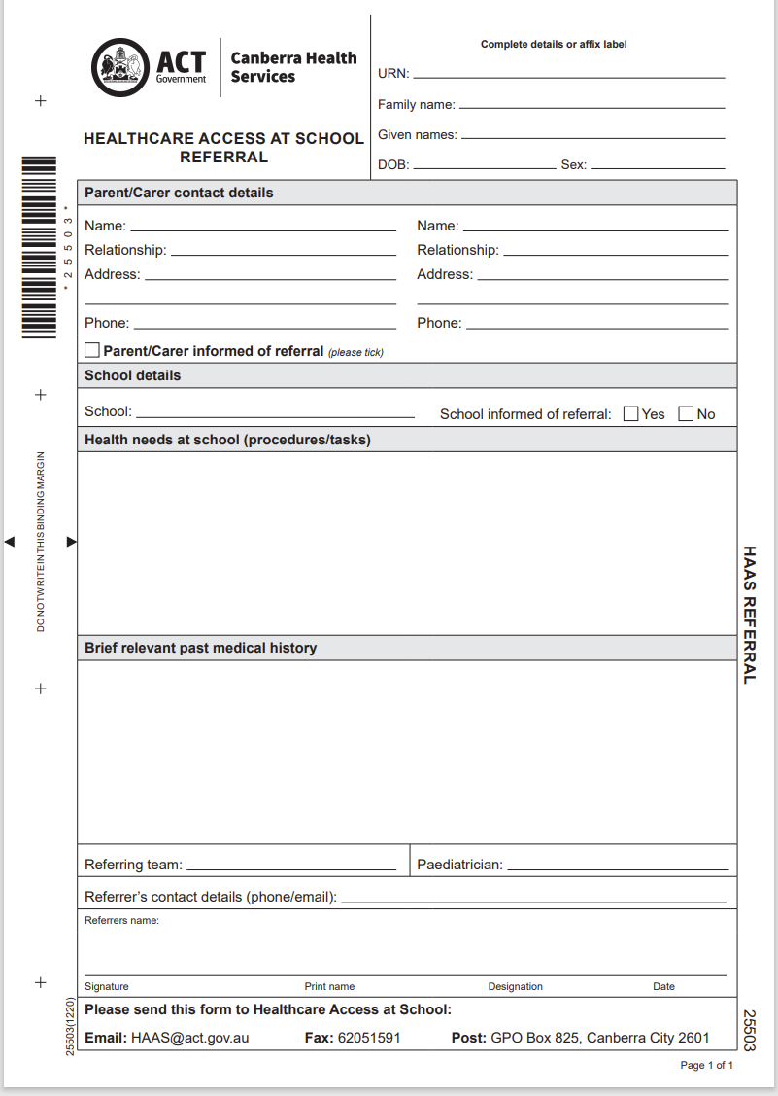
Back to Table of Contents
Attachment 4: Roles and Responsibilities – HAAS Registered Nurses (page 1 of 2)
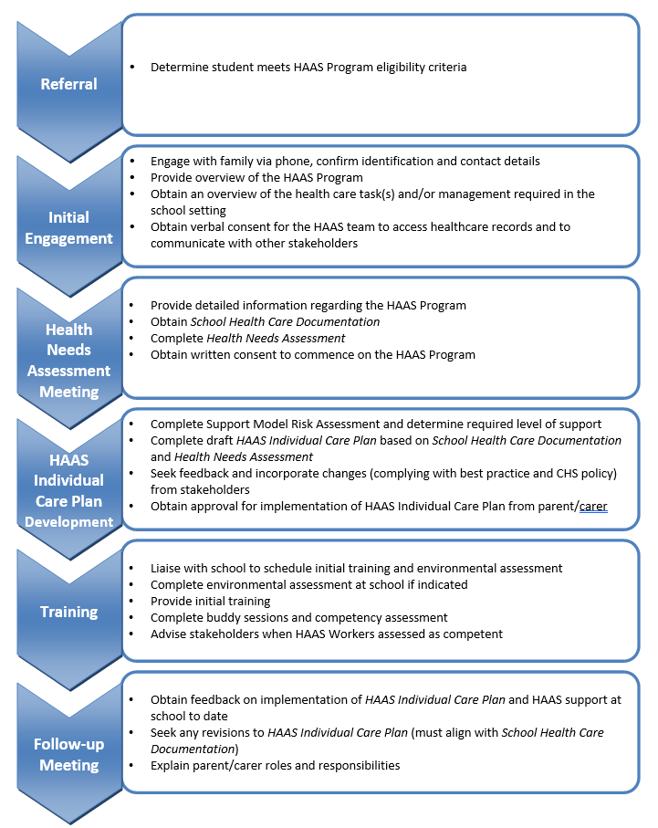
Back to Table of Contents

Attachment 4: Roles and Responsibilities – HAAS Registered Nurses (page 2 of 2)
Changes to HAAS Individual Care Plan
Discharge from HAAS
Evaluation of Provision of Care
Ongoing Support

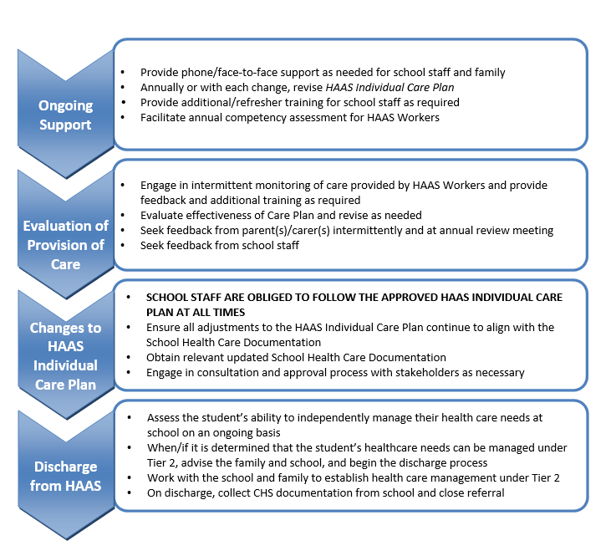
Back to Table of Contents

Attachment 5: Roles and Responsibilities – HAAS Paediatrician

Back to Table of Contents

Attachment 6: Roles and Responsibilities – Parent(s)/Carer(s) (page 1 of 2)

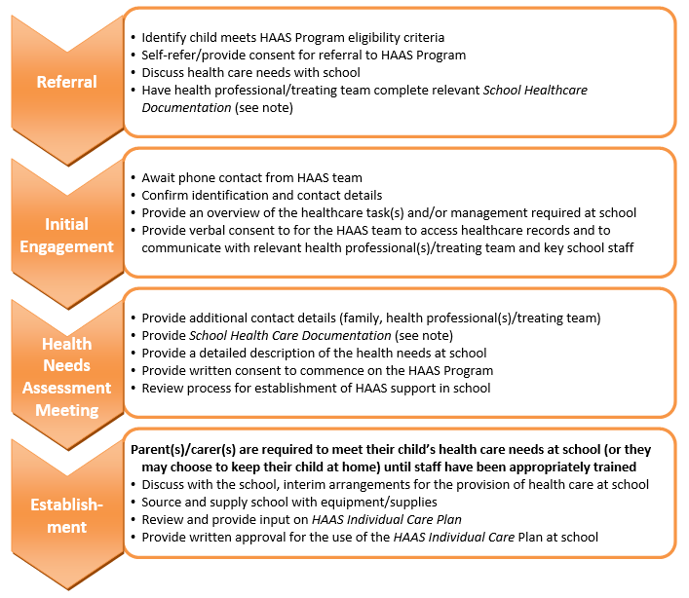

Back to Table of Contents

Attachment 6: Roles and Responsibilities – Parent(s)/Carer(s) (page 2 of 2)

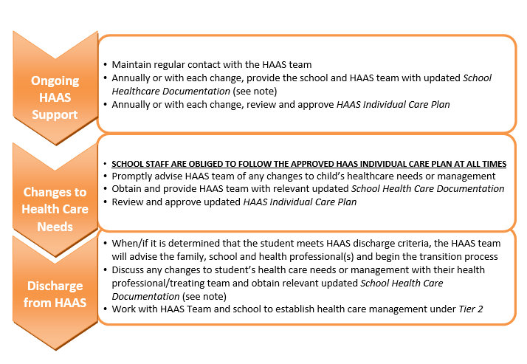
NOTE: School Health Care Documentation is to be completed by the student’s qualified health professional(s)/treating team and includes:
Document | Owner | Tier 1 | Tier 2 | Tier 3 (HAAS)
Medical Information and Consent Form | ACT Education Directorate | ü | ü | ü
Known Medical Condition Response Plan* | ACT Education Directorate |  | ü | ü
Medical Condition Action and Management Plan* | HAAS Program or relevant association |  | ü | ü
HAAS Individual Care Plan* (completed by HAAS) | HAAS Program |  |  | ü
Medication Authorisation and Administration Record | ACT Education Directorate | If applicable | If applicable | If applicable
School Medication Authorisation-Healthcare Access At School | CECG | N/A | N/A | ü
The Individual Response Plan | CECG | N/A | N/A | ü

- All documents must be reviewed and updated annually and with any change to the student's health care management at school.
- Health care at school (beyond basic first aid) cannot be provided without current School Health Care Documentation.
*The implementation of this plan is by written agreement with the school executive and authorised persons/HAAS Workers.

Back to Table of Contents

Attachment 7: Roles and Responsibilities – Schools
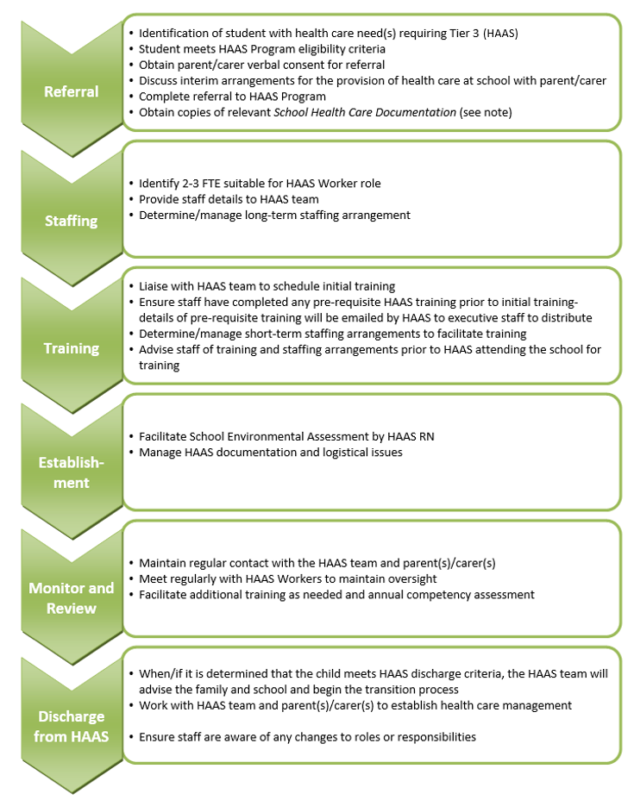
Back to Table of Contents
Attachment 8: Roles and Responsibilities – Health Professionals

Back to Table of Contents

