Canberra Health Services
Guideline
Fissure sealants and fissure protections for children and adolescents

Contents

Contents 1
Guideline Statement 2
Scope 3
Section 1 – Risk factors and case selection 3
Section 2 – Procedure for resin-based fissure sealant 4
Section 3 – Procedure for glass ionomer cement fissure sealant 5
Evaluation 5
Related Policies, Procedures, Guidelines and Legislation 6
References 6
Definition of Terms 8
Search Terms 8
Attachments 8
Attachment 1 - American Dental Association Caries Classification System 10
Attachment 2 - GIC usage guide 11

Guideline Statement

Key Objective
The purpose of this guideline is to provide dental practitioners with evidence-based information on the placement of fissure sealants and fissure protections on the molar teeth of children and adolescents. This guideline will help ensure a consistent approach to treatment recommendations and material selection amongst clinicians.

Nearly one quarter of 6 – 14-year-olds in Australia experience carious lesions in their newly erupted permanent dentition³. Pits and fissures are particularly susceptible to decay due to their retentive nature, rendering them prone to food and bacterial plaque accumulation and limiting effective cleaning⁵.

Background
Placing sealants for pits and fissures has been shown to be an effective method of preventing carious lesion development and progression^{1,5}. This is made evident in a study conducted in 2016 comparing the incidence of occlusal caries in molars that were sealed, against molars that were left unsealed. The results of the study revealed that sound permanent teeth that were protected by pit and fissure sealants were 76% less likely to develop occlusal caries compared to (initially sound) molars that were not sealed⁵.

It is important to note that the efficacy of fissure sealants largely depends on material retention. This means that choice of material and moisture control should be important factors to consider prior to placing a sealant. Cotton roll isolation and rubber dam isolation have been shown to be effective methods to maintain moisture control during the placement of sealants. One study has revealed that rubber dam isolation may increase the retention rate of sealants in comparison to cotton roll isolation, however, the results were of no statistical significance¹¹. Therefore, clinicians should consider their level of experience as well as patient compliance when deciding their method of moisture control during sealant placement.

Flowable composite resin and conventional resins are two popular materials utilised for fissure sealants. The superiority of one material over the other is still quite heavily debated⁶ with many studies failing to identify a significant difference between the two materials in their efficacy to prevent occlusal caries^{7, 8,9}. A similar conclusion was made when comparing filled and unfilled resin-based sealants however improved penetration of fissures has been observed with unfilled resin-based sealants^{4,9}.

Glass ionomer-based sealants are a suitable alternative to resin-based sealants when moisture control is difficult to maintain⁵. Although their retention has been shown to be lower compared to resin-based sealants, glass ionomer sealants have the benefit of high fluoride content and fluoride release which can continue despite visible loss of sealant. This makes it suitable for protecting pits and fissures on partially erupting molars and when sealing primary molars in high risk children³. Fuji VII is an ideal glass ionomer sealant material due to its superior fluoride release over other glass ionomers¹². In the initial stages of setting, glass ionomers are very susceptible to moisture from water or saliva and immediate application of emollients such as cocoa butter is a critical step to increase retention¹³.

Back to Table of Contents

Scope

The Clinical Guideline – Fissure sealants and fissure protections for children and adolescents applies to all dental practitioners (dentists, dental therapists, and oral health therapists) who provide fissure sealants for caries prevention and/or early intervention for children and adolescents accessing Oral Health Services.

For the purposes of this document, the term fissure refers to the entire pit and fissure system of a tooth. Occasionally, the palatal pits of anterior teeth and the fissures of premolar teeth also require sealants.

Back to Table of Contents

Section 1 – Risk factors and case selection

Due to the natural anatomy of teeth, effective cleaning of pits and fissures of the occlusal surfaces of posterior teeth is difficult². The fissures of teeth are the most susceptible areas to dental caries initiation as they cannot be adequately cleaned by most children and their parents².

Risk Factors:
- Poor oral hygiene and plaque retentive pits and/or fissures
- 1 or more new carious lesions
- 1 or more incipient carious lesions
- Hypomineralised molars
- Patients with special needs and/or poor manual dexterity

Case Selection:
- 1 or more risk factors
- Newly erupted at-risk molars
- Patient has had exam and x-rays in last 12 months, if this is not the case then the reason why must be documented and consider Orthopantomogram (OPG)
- Able to provide competent isolation

Back to Table of Contents

Section 2 – Procedure for resin-based fissure sealant

Equipment:
- Exam pack
- Disposable prophy brush (do not use any cleaning medium that contains oils or fluoride)
- Slow speed handpiece
- Rubber dam, hole punch, clamp and frame, and forceps (if rubber dam is achievable)
  - Otherwise: cotton rolls with/without Garmer’s clamps for lower teeth and dry tip/cotton rolls for upper teeth.
- Etch (34% - 37% phosphoric acid)
- Resin-based sealant e.g., Clinpro™ Sealant
- Dycal applicator or explorer
- Curing light
- Articulating paper
- High speed handpiece

Procedure:
- Isolate the tooth with rubber dam, if using.
- Dry brush the tooth to remove plaque and food debris.
- Thoroughly wash the tooth with water triplex and dry.
- Isolate the tooth with dry tip/cotton rolls/Garmer’s clamp.
- Apply etch to the pits/fissures and leave for 15 seconds.
- Wash off etch for 10 seconds and dry tooth thoroughly - until frosty-white appearance of enamel is visible.
- Replace cotton rolls if required, take care not to contaminate the tooth with water or saliva. You will need to re-etch if water/saliva contamination occurs. Note: with adequate suctioning this step may not be necessary.
- Place tip of applicator in the fissures and conservatively seal fissures. Due to the capillary action of the material into the fissure, a conservative amount is appropriate and will reduce the risk of the fissure sealant fracturing or dislodging.
- Use tip of applicator, dycal or explorer to create smooth margins and ensure that there are no bubbles.
- Light cure for 20 seconds.
- Check occlusion with articulating paper.
- Adjust occlusion with high-speed handpiece and polishing burs if required.

Back to Table of Contents

Section 3 – Procedure for glass ionomer cement fissure sealant

Equipment:
- Exam pack
- Disposable prophy brush
- Slow speed handpiece
- Cotton rolls
- Garmer’s clamps
- Dry tips
- Cavity conditioner (20% polyacrylic acid)
- Microbrush/s
- Amalgamator
- Glass Ionomer Cement (GIC) sealant e.g., Fuji™ VII/Fuji™ VII EP - pink or white
- GIC applicator/ketac gun
- Curing light (optional)
- Ball burnisher
- Cocoa butter
- Articulating paper
- Spoon excavator or slow speed polishing bur

Procedure:
- Dry brush the tooth to remove plaque and food debris.
- Wash the tooth with water triplex and gently dry, do not desiccate.
- Apply cavity conditioner (if using Fuji™ VII EP if extra adhesion is desired) for 10 seconds.
- Wash the tooth with water triplex and gently dry, do not desiccate.
- Isolate the tooth with Garmer’s clamps/cotton rolls/dry tips (single tooth isolation).
- Squeeze Fuji VII™ into the pits/fissures using GIC applicator/ketac gun.
- Use gentle pressure with your index finger and a thin layer of cocoa butter, or ball burnisher and/or microbrush, to ensure pits and fissures are well sealed and margins are smooth.
- Apply cocoa butter over the sealant, if not already used.
- Allow the GIC to dry. Use curing light if using Fuji™ VII and after a faster cure.
- Check high spots with articulating paper and remove excess with spoon excavator or slow speed polishing bur.

Back to Table of Contents

Evaluation

Outcome
- Cohesive approach to treatment planning amongst dental clinicians within Oral Health Services.
- Appropriate and consistent material selection based on clinical needs of the child or adolescent patient.
- Anticipated reduction in caries development in the pits and fissures of sealed teeth.

Measures
- Snapshot review and treatment plan auditing to ensure compliance with this guideline - reporting to relevant managers.
- Regular DHR auditing of permanent teeth requiring restorative procedure to assess if the tooth/teeth had been previously sealed, and if so, review whether case selection data, method used, and material selected was appropriate.

Back to Table of Contents

Related Policies, Procedures, Guidelines and Legislation

Policies
- Informed Consent (Clinical) Policy

Procedures
- Infection Prevention and Control Procedure
- Patient Identification and Procedure Matching Procedure
- Aseptic Technique Procedure
- Clinical Records Management Procedure

Guidelines
- Clinical Practice Guidelines – Updated September 2019
- Oral Health Services – Infection Prevention and Control Operational Guideline

Legislation
- ACT Health Records (Privacy and Access) Act 1997
- Human Rights Act 2004
- Work Health and Safety Act 2011

Other
• Australian Charter of Healthcare Rights

Back to Table of Contents

References

- Emmanuellie, B., et al. Dental caries prediction and the indication of pit and fissure sealant in children first permanent molars: A prospective study, JDent. 2003; 135:104557.
- Behroozian, A., et al. Evaluation of the success rate of pit and fissure sealants on first molars: 12 months follow-up study, Int J Dent hygiene. 2022;20:465-470.
- Do LG, Harford JE, Ha DH & Spencer AJ. Australian children’s general health behaviours. In: Do LG & Spencer AJ (eds). Oral health of Australian children: the National Child Oral Health Study 2012–14. Adelaide: University of Adelaide Press; 2016
- Naaman R, El-Housseiny A, Alamoudi N. The Use of Pit and Fissure Sealants- A Literature Review, Dent.J [Internet]. 2017 [cited 2021 Aug 26]; 5(4). Available from: https://www.mdpi.com/2304-6767/5/4/34/htm#B5-dentistry-05-00034
- Wright JT, Crall JJ, Fontana M, Gillette EJ, Novy BB, Dhar V, Donly K, Hewlett ER, Quinoez RB, Chaffin J, Crespin M, Iafolla T, Siegal MD, Tampi MP, Graham L, Estrich C, Carrasco-Labra A. Evidence-based clinical practice guideline for the use of pit-and-fissure sealants. JADA [Internet]. 2016 [cited 2021 Aug 30]; 147(8):672-82. Available from https://jada.ada.org/action/showPdf?pii=S0002-8177%2816%2930473-1
- Ahovuo‐Saloranta A, Forss H, Walsh T, Nordblad A, Mäkelä M, Worthington HV. Pit and fissure sealants for preventing dental decay in permanent teeth. Cochrane Database of Systematic Reviews [Internet]. 2017 [cited 2021 Aug 27]; 7. Available from https://doi.org/10.1002/14651858.CD001830.pub5
- Erdemir U, Sancakli HS, Yaman BC, Ozel S, Yucel T, Yildiz E. Clinical Comparison of a flowable composite and fissure sealant: A 24-month split-mouth randomised, and controlled study. Dent.J [Internet]. 2013 [cited 2021 Aug 27]; 42(2): 149-157. Available from: https://doi.org/10.1016/j.jdent.2013.11.015
- Jafarzadeh M, Malekafzali B, Tadayon N, Fallahi S. Retention of a Flowable Composite Resin in Comparison to a Conventional Resin-Based Sealant: One-year Follow-up. J Dent (Tehran). 2010;7(1):1-5. Available from: https://www.ncbi.nlm.nih.gov/pmc/articles/PMC3184721/
- Reddy VR, Chowdhary N, Mukunda KS, Kiran NK, Kavyarani BS, Pradeep MC. Retention of resin-based filled and unfilled pit and fissure sealants: A comparative clinical study. Contemp Clin Dent. 2015;6(Suppl 1):S18-S23. doi:10.4103/0976-237X.152932
- Hegde RJ, Coutinho RC. Comparison of different methods of cleaning and preparing occlusal fissure surface before placement of pit and fissure sealants: An in vivo study. J Indian Soc Pedod Prev Dent. [Internet]. 2016; 34(2): 111-4. doi: 10.4103/0970-4388.180403.
- Bandi M, Mallineni, SK, Nuvvula, S. Influence of Isolation Methods on Retention of Pit and Fissure Sealants in Young Permanent Teeth based on Simonsen’s Criteria: A Randomised Clinical Trial. J Clin Diagn Res. 2021; 15(4): 6-9. doi: 10.7860/JCDR/2021/44929.14734
- Kiran A, Hegde V. A short term comparative analysis of fluoride release from a newnly introduced glass ionomer cement in deionised water and lactic acid. J. Int Oral Health. 2010; 2(2):71-8.
- Ulusoy AT, Tunc ES & Bayrak S. Clinical performance of a glass ionomer sealant protected with two different resin-based agents over a 2-year follow-up period. Eur J Paediatr Dent. 2017;18(1):10-14.
- Young, D., et al. The American dental association caries classification system for clinical practice, JADA [internet]. 2015; 146(2):79-86. Available from: https://www.researchgate.net/publication/271648327_The_American_Dental_Association_Caries_Classification_System_for_Clinical_Practice
- GC Cavity Conditioner manufacturers instruction leaflet
- GC Dentine Conditioner manufacturers instruction leaflet
- 3M Clinpro Sealant instructions. Retrieved from https://multimedia.3m.com/mws/media/1393785O/anz-clinpro-sealant-sell-leaflet.pdf
- GC Fuji™ VII Capsule instructions for use. Retrieved from https://www.gcaustralasia.com/Upload/product/pdf/5/IFU_FUJI_VII.pdf
- GC Fuji™ VII EP Capsule instructions for use. Retrieved from https://www.gcaustralasia.com/Upload/product/pdf/6/IFU_FUJI_VII_EP.pdf

Back to Table of Contents

Definition of Terms

- Clinpro: Clinpro™ Sealant
- Cavity Conditioner: used to remove the smear layer and condition enamel and dentin and enhance the bond between GIC and tooth structure.
  - *Note: Dentin Conditioner is used to remove dentinal smear layer, condition dentin, and enhance bond between GIC and dentin. As such, is not suitable to use for fissure protections.
- Fuji VII: Fuji 7 – glass ionomer cement used for fissure protections, protection of root surfaces, endodontic access, and caries stabilisation.
- GIC: glass ionomer cement.
- OPG: panoramic or wide view x-ray of the lower face, which displays all the teeth of the upper and lower jaw on a single film.

Back to Table of Contents

Search Terms

Fissure sealant, seal, FS, Fuji, Clinpro.

Back to Table of Contents

Attachments

Attachment 1 – American Dental Association Caries Classification System
Attachment 2 - GIC usage guide

Disclaimer: This document has been developed by Canberra Health Services specifically for its own use. Use of this document and any reliance on the information contained therein by any third party is at his or her own risk and Canberra Health Services assumes no responsibility whatsoever.

Policy Team ONLY to complete the following:
Date Amended | Section Amended | Divisional Approval | Final Approval
10/05/2024 | New Document | CHS Policy Team | CHS Policy Team

This document supersedes the following:
Document Number | Document Name

Attachment 1 - American Dental Association Caries Classification System
Retrieved from https://www.researchgate.net/publication/271648327_The_American_Dental_Association_Caries_Classification_System_for_Clinical_Practice on 24 Aug 2023.

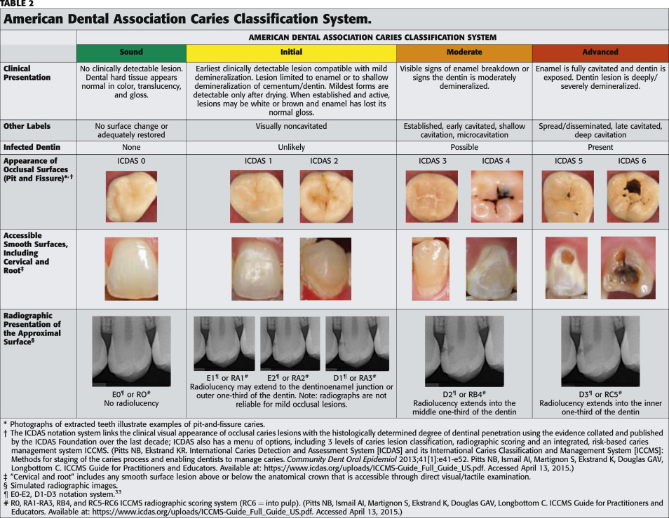

Attachment 2 - GIC usage guide
Retrieved from https://www.gcaustralasia.com/Upload/product/pdf/22/GC_AUS_GIC-Usage-Guide_18042019.pdf on 24 Aug 2023.

