Canberra Health Services
Procedure
Suicide Prevention and Intervention at the Alexander Maconochie Centre/ACT Court Cells

Contents

Contents 1
Scope 2
Section 1 – General Principles 2
Section 2 – Suicide and Self-Harm Rating 3
Section 3 – At-Risk Clinician’s Roles and Responsibilities 4
Section 4 – Initial At-Risk Referral and Assessment 5
Section 5 – Prisoner At-Risk (PAR) 8
Section 6 – High Risk Assessment Team (HRAT) Meeting 8
Section 7 – Changing the S Rating 8
Section 8 – Suicide and Self-harm Management 9
Section 9 – Release from Custody Whilst on a S Rating 10
Evaluation 10
Related Policies, Procedures, Guidelines and Legislation 11
References 12
Definition of Terms 12
Search Terms 14
Attachments 14

Scope

This procedure applies to all Custodial Mental Health (CMH) health professionals and relates to all persons accessing Forensic Mental Health Services (FMHS) within the Alexander Maconochie Centre (AMC) and persons in custody within the ACT Court cells. CMH also manage young people At-Risk of suicide and self-harm in the Bimberi Youth Justice Centre (BYJC). Refer to MHJHADS Suicide Prevention and Intervention Operational Procedure at the Bimberi Youth Justice Centre.

Back to Table of Contents

Section 1 – General Principles

Understanding Suicidal Behaviour
Suicidal behaviour is best understood as a continuum of behaviour including a person:

- Thinking about suicide (suicidal ideation)
- Expressing thoughts of suicide
- Self-inflicting an injury accompanied by an intention to die as a result of the action taken (suicidal act)
- Dying as a result of an injury inflicted with an intention to die as a result of the action taken, as determined by a coroner considering evidence (suicide)

Understanding Self-Harm
Suicide and self-harming behaviours are two separate but overlapping phenomena. An act of self-harm is not necessarily a suicide attempt. Rather than an attempt by a person to intentionally end their life, self-harm is most often used as a strategy to cope with life and deal with negative emotions such as anger, frustration, depression, anxiety or fear, hopelessness and loss. Identifying the purpose that self-harming behaviour serves for a person is significant in reducing the likelihood of further self-harming behaviour and associated risk of accidental death. It is acknowledged that self-harming behaviours significantly increase the risk of a person dying by suicide.

Self-harm is a significant health problem within correctional settings and requires specific strategies to minimise its frequency and impact.

Suicide Risk Assessment and Management
FMHS utilises the Mental Health, Justice Health and Alcohol & Drug Services (MHJHADS) approved approach for the assessment and response to an individual’s suicide risk. However, it is acknowledged that suicide risk is complex and dynamic.

The process of suicide risk assessment requires the application of structured professional judgement and thus the use of structured professional judgment tools can support this process. However, it is acknowledged that there are limitations to the use of even established suicide scales and tools, with no reliable method to reasonably predict suicide. This procedure is to provide guidance to staff within CMH on current best practice and local procedures for the application of their professional judgment.

Suicide risk management is a whole of community responsibility. It is not simply a health or corrections issue: FMHS, Justice Health Services (JHS), custodial officers, employees of all disciplines, and carers and other stakeholders work together to share information, knowledge, and skills in assessing and managing persons At-Risk of engaging in self-harming or suicidal behaviour. As such, a team approach leads to an improved quality of care for At-Risk persons.

Back to Table of Contents

Section 2 – Suicide and Self-Harm Rating

FMHS and ACT Corrective Services (ACTCS) operates a five-tier assessment and rating regime for risk of suicidal behaviour. The suicide and self-harm rating (S rating) given to a person denotes the acuity of current concerns and the appropriate intensity of care, treatment and management required for the person (see Attachment 1) and is primarily a communication tool. The S rating is not a clinical tool.

Rating S1: “Immediate risk of suicide or self-harm”
A S1 rating denotes that the person is assessed as at immediate risk of suicide and serious negative outcomes due to self-harm and requires intensive management and support. The person is assessed as having the potential to cause self-harm or attempt suicide if they are not supervised, for example, in their cell after lock-down or during out-of-cell hours; and/or the person may have an acute psychiatric illness where there is a high risk of self-harming behaviour.

Where it is assessed that someone is At-Risk of hanging/self-strangulation/use of ligature, this would indicate an S1 rating.

Rating S2: “Significant risk of suicide or self-harm”
A S2 rating denotes the person is assessed as significant risk of suicide or self-harm and they require intermediate management and support. This means:
- The person is assessed as being at significant (but not immediate) risk of suicide or self-harm; and/or
- the person is no longer at immediate risk but still requires intermediate management and support;
- where the risk is considered dynamic and unstable; and/or
- a person who was previously considered to be at lesser risk of suicide or self-harm whose risk has escalated.

Rating S3: “Potential risk of suicide or self-harm”
A S3 rating denotes the person is assessed as at potential risk of suicide or self-harm and requires follow-up management and support. This means the person is:
- assessed as having a number of risk factors where, without intervention, there is the potential for escalation of their risk, but who is not at high/moderate risk of suicide or self-harm; and/or
- there is some need for intervention to ensure their risk level does not escalate; and/or
- the person is no longer a moderate risk but still requires follow-up management and support; and/or
- the person has previously been categorised as having no current risk but a history of self-harm behaviour and whose risk has escalated
- the person has had a suicide attempt within the last 30 days, particularly at point of induction (on entry to custody).

Rating S4: “Previous history of suicide and/or self-harm behaviour”
A S4 rating denotes that the person has a previous history of suicide and/or self-harm behaviour. These persons are those considered not to be currently At-Risk, but given their history of suicide attempts or self-harming behaviour, the potential for suicide or self-harm may escalate.

Rating S Nil: “No evidence of current or historical suicide or self-harm behaviour”

Back to Table of Contents

Section 3 – At-Risk Clinician’s Roles and Responsibilities

- In collaboration with partner agencies, the Assertive Response Team (ART) clinicians within CMH are responsible for the clinical management of adults and young people who are identified as being At-Risk or at potential risk of suicide and/or self-harm (refer to Suicide Prevention and Intervention at the Bimberi Youth Justice Centre Procedure for processes specific to BYJC). At any point in time, during business hours, there will be an allocated At-Risk clinician.

- Each day, CMH are responsible for responding to At-Risk referrals during the below period:
- Monday – Friday 8:30 – 18:00
- Saturday, Sunday and Public Holidays 8:30 – 16:00.

The allocated clinician/s will respond to any At-Risk referrals and follow the process for assessment and notification as indicated below (Attachment 1).

- The At-Risk clinician will ensure they carry the At-Risk phone (0497 568 208) to respond to any At-Risk notifications that are received to the At-Risk inbox:
Custodial Mental Health Service At-Risk: CMHSATRISK@act.gov.au

CMH also monitor the below email for general referrals and enquiries:
Custodial Mental Health Service Alexander Maconochie Centre: CMHSAMC@act.gov.au

(Refer to Attachment 2 At-Risk and Induction workflow).

- The At-Risk clinician will liaise with the Area Managers, including Correctional Officer (CO) Level 3 and CO Level 4, to ensure clear lines of communication regarding any At-Risk referrals from overnight and throughout the day.
- The At-Risk clinician is responsible for co-ordinating clinical follow-up as per the daily handover each day.
- The At-Risk clinician will attend the ACTCS High Risk Assessment Team (HRAT) meeting and ensure any outcomes from this meeting are handed over to the CMH team and uploaded onto relevant systems.

Back to Table of Contents

Section 4 – Initial At-Risk Referral and Assessment

All staff/contractors/volunteers working within the AMC are responsible for reporting risk concerns regarding persons at AMC. All staff are to follow the ‘At-Risk’ process regarding notification (see Attachment 3). This includes the ACTCS Area Manager contacting CMH- Adult via the At-Risk mobile phone number and forwarding the completed “Referral for an At-Risk Assessment” notification form (see Attachment 4) to CMHSAtRisk@act.gov.au.

Referral Triage
The triage process is the process of initial brief assessment of the referral to determine the need for mental health services and the nature and urgency of the care required (Victorian Government Statewide mental health triage Scale: Guidelines 2010).

When an At-Risk referral is received, CMH staff are to use the MHJHADS Mental Health Triage Scales. This has been adapted from the United Kingdom Mental Health Triage Scales (MHTS). Refer to Canberra Health Services Procedure: Mental Health Triage Scales – Use within MHJHADS. Please see Attachment 5, for Mental Health Triage Scale, including local area actions.

Upon receipt of referral, within 2 hours during business hours (08:30-18:00 Monday to Friday and 08:30-16:00 Saturday, Sunday and public holidays), the At-Risk clinician will:

- Review the Digital Health Record (DHR), including any Advanced Agreements and/or Advanced Consent Directives that may be available
- Contact the Area Supervisor or initial referrer and seek further information regarding the referral in order to triage the appropriate clinical response
- Consider the available information with respect to the Mental Health Triage Scale (see attachment 5) and assign a triage category and response
- For referrals meeting criteria for triage category B, clinicians will assess the person within 2 hours (note, referrals considered triage category A would require an emergency response)
- For all other triage categories, the At-Risk clinician will make a plan for assessment as per the triage category.
- The referral will be uploaded onto the DHR.
- The plan for assessment will be documented on the daily handover.
- The triage timeframe recommendation and interim observations (see Table 1) recommended will be communicated to ACTCS, via reply email to the initial referral. The below template will be used. This will be copied into the DHR.

“Hi ACTCS,
The At-Risk referral for ________________ DOB ____________ has been received.
Based on the referral, a file review of the clinical information and information obtained from _________________________(yard/ Primary Health/ CO’s). A Risk assessment will take place within the next ________ hours.
Recommendations for interim obs from ACTCS are_____________________(constant/ hourly).
If the level of concern escalates, please consider re-referral and revert back to constant obs.

- The At-Risk clinician will enter the referral, including the outcome of the triage, into the ‘At-Risk Referral Register’ (green logbook), which is located in Building J of AMC (alongside other paper forms within the stationary area), as well as in the approved risk assessment tool, with additional inclusion of any relevant collateral. This provides a continuous record of all At-Risk referrals received and the outcomes.

Table 1: Triage and recommended observations
Recommended Triage Category | Recommended Observations | Assessment timeframe
Triage Category A | Constant observations | Emergency response required, as per relevant policies
Triage Category B | Constant observations | CMH- Adult Assessment within 2 hours
Triage Category C-G | 60-minute observations | CMH- Adult assessment as per triage category.

Note: If a clinician cannot meet the 2-hour triage timeframe, they must escalate this to the CMH team manager, Forensic Mental Health Services (FMHS) Senior Manager or Director on-call. If the 2-hour timeframe is not met, the clinician must document this in the clinical record and complete a Riskman in the Clinical Incident System.

(Refer to Attachment 6-Referral flow chart)

Assessment
- The At-Risk clinicians will undertake clinical assessment with the person as per the identified triage category. This may include seeking relevant family and carer input where appropriate. CMH recognises that assessing someone’s suicide risk should be treated as a therapeutic intervention, rather than just an information-gathering exercise. Compassion is the foundation of all interactions with someone in distress or At-Risk of suicide and CMH services approach all assessment of risk with sensitivity, empathy and non-judgement.
- Clinicians will document their assessment in the DHR, as well as completing the approved MHJHADS suicide assessment documentation and Outcome Measures on the DHR.
- Electronic Clinical Record (ECR) business rules have been established regarding document titles and are required to be used. The document titles specifically relate to the At-Risk process and must be followed by staff (see Attachment 7).
- Based on the assessment, the clinician will make recommendations regarding the appropriate S rating, as well as any ongoing follow up that is required, and recommendations regarding accommodation for clinical reasons, access to personal items, observations levels, current support services, daily activities (supported and not supported) and any significant issues. This will be communicated to ACTCS Area Managers/Unit Supervisors through a written Interim Risk Management Plan (IRMP) (see Attachment 8) as well as verbally to referring Officers. The IRMP will be completed even in the absence of an S rating (S Nil) being applied to the person.
- The clinician will enter the outcome of the assessment (i.e. S rating) into the ‘At-Risk Referral Register’ (green log book).
- Where risk concerns are identified on induction, CMH clinicians will inform ACTCS via the completion of an IRMP, in addition to the standard induction assessment notification form (ISBAR) (see Attachment 9. FMHS notification).
- At close of business each day, the At-Risk clinician will send the daily handover of clients on S-ratings or P1 and P2 (see CMH Operational Guide) via email to #chs-justicehealthservices_primarycare@act.gov.au

After Hours
For persons identified as ‘At-Risk’ outside of standard CMH- Adult business hours, ACTCS will transfer the person to the Crisis Support Unit (CSU) under a default S2 x 15 minute observation level. ACTCS will contact the JHS on call medical officer. The on-call medical officer and/ or ACTCS, consistent with ACTCS After Hours Procedure, may increase or decrease the observation level and also have the option of placing the person in a tear proof clothing and bedding if the risk indicates this mitigation strategy is required. The JHS on-call medical officer will also authorise an interim plan. A referral for an At-Risk assessment will be completed by ACTCS and emailed to CMHSAtRisk@act.gov.au. CMH- Adult will triage the referral as per the above process the following day within two hours of commencement of the shift.

Back to Table of Contents

Section 5 – Prisoner At-Risk (PAR)

- All new inductions entering custody on PAR status through the ACT Courts or Court Transport Unit (CTU) will automatically be placed on a S2 risk rating with 15-minute observations on arrival at the AMC by ACTCS. During core business hours, CMH- Adult clinicians will undertake an At-Risk assessment within two hours of the person arriving at the AMC.
- Persons returning to custody marked PAR will be managed as per any At-Risk referral. The referral will be triaged within two hours and a triage rating assigned.
- Persons entering custody marked PAR after hours will automatically transfer to S2 risk rating with 15-minute observation by ACTCS and will be accommodated in CSU until they are reviewed by CMH-Adult.
- ACTCS staff will contact the JHS on-call medical officer for those persons marked PAR entering custody after hours. The JHS on-call medical officer will authorise any interim management plans required and CMH- Adult will undertake a review of the person the following day within two hours of commencement of the shift.

Back to Table of Contents

Section 6 – High Risk Assessment Team (HRAT) Meeting

The HRAT is a multi-agency decision and intervention planning team involving ACTCS, FMHS and JHS to co-ordinate the management of At-Risk detainees, specifically S-rated detainees. The HRAT occurs each business day and is attended at a minimum by the CMH, ACTCS and Custodial Health Services.

All At-Risk triages and assessments are discussed at the HRAT meeting the following business day.

Recommendations from any IRMP will be discussed and a Modified Risk Management Plan (MRMP) will be completed once agreed by the HRAT.

Back to Table of Contents

Section 7 – Changing the S Rating

Any CMH- Adult clinician can increase an S rating (i.e. from S3 to S2) where the clinical presentation warrants this. This is done by immediately verbally advising the CO1 of the accommodation area of the concerns and subsequently completing an IRMP and providing it to the Area Managers.

When a person is assessed as being clinically suitable to have their S rating reduced (i.e. from S2 to S3) this is discussed at the next appropriate HRAT. If the clinical recommendation is supported by the HRAT, a MRMP will be completed by the HRAT and uploaded onto relevant systems (DHR and CORIS). S ratings can only be stepped down sequentially (i.e. from S2 to S3, and not from S2 to S4) and this includes the step down of observation level, with the exception of following receipt of an after-hours At-Risk referral.

Once a risk rating is given, it cannot be reduced until it is discussed at HRAT.

Back to Table of Contents

Section 8 – Suicide and Self-harm Management

CMH- Adult will undertake a Multi-Disciplinary Team (MDT) meeting to discuss presentation and treatment and management planning for any person referred At-Risk or made PAR and subject to an S rating (excluding S4). The treatment and management plan could include ongoing intervention provided by CMH, referral to an alternative pathway or a determination that no further engagement is currently required and may include consultation with carers and/or family where appropriate. In the absence of an MDT, this will be discussed with CMH Team Manager and/or Clinical Nurse Consultant (CNC) and documented on DHR.

Intervention will predominantly include brief psychosocial intervention to help the person manage their immediate needs and to provide tools and strategies to help the person prevent and better manage future crises and may include psychiatric reviews as required. Intervention could also include referral to the Brief Intervention Clinic (BIC – see below).

The S rating applied to persons denotes the acuity of the risk concerns and indicates the minimum level of contact required from CMH- Adult clinicians. Attachment 1 outlines the minimum required level of clinical contact for each S rating.

People supported by the CMH- Adult Clinical Management team who are assessed as requiring an S1, S2 or S3 rating following an At-Risk assessment will continue to be managed by their clinical manager, however, the ART clinician will assist with the acute management of the person.

Brief Intervention Clinic (BIC)
People referred to ART as At-Risk may be referred to the Brief Intervention Clinic (BIC). The BIC is a 4- session brief psychological intervention informed by the Gold Card Clinic model developed by the Project Air Strategy. The intervention is focused on understanding and containing crisis, empowering consumers to use and further their personal coping skills and identifying support options for future support both in the prison and in the community.

The four elements of the BIC include:
- Current risk assessment and development of an initial safety plan
- Psychoeducation and skills for self-management
- Carer plan and/or identification of supports
- Final safety plan and future directions for further support.

Once a referral has been accepted, an initial BIC session should occur within 7 days and the four sessions should be delivered within a maximum of four weeks. A copy of the collaborative safety plan is to be provided to the person and any persons identified in the safety plan as supports. The plan must be uploaded to the person’s DHR for future reference.

Back to Table of Contents

Section 9 – Release from Custody Whilst on a S Rating

When a person is released from custody while they are subject to an S1 or S2 rating, a referral must be made to Access Mental Health Services (Access MHS), or their existing community mental health team if a current client of one, for ongoing follow-up in the community.

When a person is released from custody while they are subject to an S3 rating, clinicians can use clinical judgement to determine whether a person should be referred directly to Access MHS or whether it would be suitable for CMH to provide a welfare call, reassess and re-triage their mental health and risk needs. For example, if someone came into custody for one night, presenting as distressed as it was their first time in custody and were released the following day, it may be more appropriate for CMH to make contact and re-triage. However, if CMH anticipate the person will require an episode of care in the community, a referral to Access MH would be more appropriate.

Back to Table of Contents

Evaluation

Outcome
At-Risk Assessment Completion
- All At-Risk referrals are triaged within two hours (as per CMH- Adult working hours).
- All At-Risk assessments are completed as per the identified triage category

Approved Risk Assessment Tool/Outcome Measure Completions
All persons reviewed by CMH- Adult at AMC will have the approved MHJHADS suicide assessment tool completed, as well as required Outcome Measures:
- at each new episode
- changes in presentation
- every three months when clinically managed by CMH- Adult
- when transferred from the care of the ART team to the Clinical Management team.

Performance Metrix
CMH- Adult will ensure compliance with both S performance metrics as per Attachment 1.

Measures
Monitoring by Team Leaders/Managers of triage and assessment completions outside of the 2-hour period or identified triage category, incident reports via Riskman and Consumer Feedback. This information may be reported on within monthly local team meetings, governance meetings, and work, health, and safety meetings.

Back to Table of Contents

Related Policies, Procedures, Guidelines and Legislation

Policies
- Informed Consent (Clinical)

Procedures
- Access, Triage and Health Induction Assessment (Justice Health Service)
- Initial Management, Assessment and Intervention for People Vulnerable to Suicide
- MHJHADS Suicide Prevention and Intervention
- MHJHADS Custodial Mental health – Child and Adolescent Operational Procedure
- Mental Health Triage Scales – Use within MHJHADS
- Suicidal Behaviour: Treatment and care of consumers who display suicidal behaviour.
- Use of Psychological Interventions in MHJHADS
- Advance Agreements, Advance Consent Directions, and Nominated Persons under the Mental Health Act 2015
- ACT Civil and Administrative Tribunal (ACAT) Ordered Mental Health Assessments
- Assessment of Decision-making Capacity and Supported Decision-making for people being treated under the Mental Health Act 2015
- Care of Persons subject to Psychiatric Treatment Orders with or without a Restriction Order
- Care of Persons subject to a Forensic Mental Health Orders
- Patient Identification and Procedure Matching
- Adult Community Mental Health Services (ACMHS) Community Recovery Services (CRS)
- Access, Triage and Health Induction Assessment (Justice Health Service)
- Use of Mandatory National Outcome Measures in Mental Health Service Delivery

Standards
- National Standards for Mental Health Services 2010
- National Safety and Quality in Health Service Standards
- National Standards for Forensic Mental Health Services 2007

Legislation
- Health Records (Privacy and Access) Act 1997
- Human Rights Act 2004
- Work Health and Safety Act 2011
- Carers Recognition Act 2021
- Mental Health Act (2015)
- Carers Recognition Act (2021)

Other
- Australian Charter of Healthcare Rights
- Partnering for Exceptional Care: Partnering with Consumers Framework 2020-2023
Back to Table of Contents

References

- Australian Institute of Health and Welfare (AIHW), 2018, The Health of Australian Prisoners 2018, AIHW, Canberra
- Belsher BE, Smolenski DJ, Pruitt LD, Bush NE, Beech EH, Workman DE, Morgan RL, Evatt DP,Tucker J, Skopp NA. (2019). Prediction Models for Suicide Attempts and Deaths: A Systematic Review and Simulation. JAMA Psychiatry. 1;76(6):642-651.
- Chan MK, Bhatti H, Meader N, Stockton S, Evans J, O'Connor RC, Kapur N, Kendall T. (2016). Predicting suicide following self-harm: systematic review of risk factors and risk scales. British Journal of Psychiatry, 209(4), 277-283.
- Carter G, Milner A, McGill K, Pirkis J, Kapur N, Spittal MJ. (2017). Predicting suicidal behaviours using clinical instruments: systematic review and meta-analysis of positive predictive values for risk scales. British Journal of Psychiatry, 210(6):387-395.
- Justice Health (2015). Correctional Suicide Prevention Framework. Working to prevent prisoner and offender suicides in Victorian correctional settings. www.corrections.vic.gov.au
- Klonsky, D. E., Victor, S. E., & Saffer, B. Y. (2014). Nonsuicidal self-injury: What we know, and what we need to know. Canadian Journal of Psychiatry, 59 (11), 565-568.
- Willis M et al. (2016). Self-inflicted deaths in Australian prisons. Trends & issues in crime and criminal justice no. 513. Canberra: Australian Institute of Criminology. https://www.aic.gov.au/publications/tandi/tandi513
- United Kingdom Mental Health Triage Scales (MHTS). adapted from Sands, N. Elsom, E, Colgate, R & Haylor, H. (2016) Development and inter-rater reliability of the UK Mental Health Triage Scale (In Press).

Back to Table of Contents

Definition of Terms

Acronym | Expanded Phrase | Details (If Relevant)
ACTCS | ACT Corrective Services | A business unit within the Justice and Community Safety Directorate that provides adult correctional services.
AMC | Alexander Maconochie Centre | Correctional facility located in the ACT accommodating detainees on minimal to maximum security of all genders.
ART | Assertive Response Team | The CMH team responsible for crisis assessment and intervention for people identified as at-risk of suicide or self-harm, and conducting a mental health screening for all people entering custody.
 | At-Risk Referral Register/Green Logbook | Located in Building J (alongside other paper forms within the stationary area) this book provides a continuous record of all At-Risk referrals received and the outcomes.
BIC | Brief Intervention Clinic | A 4-session brief psychological intervention offered by CMH for people who are at-risk of suicide or self-harm
CMH | Custodial Mental Health | The team that provides community equivalent mental health services to people in custody, including a crisis service and clinical management for people with serious mental health concerns.
CNC | Clinical Nurse Consultant | Senior nursing staff member responsible for oversight of clinical activities.
CTU | Court Transport Unit | A unit of ACTCS responsible for providing for the safe custody of people in Court cells and transport of persons between the Court and AMC.
EA | Emergency Apprehension | Process for transferring a detained person to a gazetted location
FMHS | Forensic Mental Health Services | Unit of JHS responsible for delivery of mental health care to clients who have a history of, are currently involved with, or are at risk of becoming involved with, the criminal justice system.
HRAT | High Risk Assessment Team | Committee that meets to coordinate management of people in custody who are considered at risk of suicide or self-harm.
IRMP | Interim Risk Management Plan | A tool for handover of assigned S and P-ratings to ACTCS and associated recommendations.
ISBAR | Identify, Situation, Background, Assessment and Recommendation | Mnemonic device to identify the key areas to address in the handover of clinical information
JACS | Justice and Community Safety Directorate | The ACT Government directorate that has oversight of the justice system and community safety.
JHS | Justice Health Services | A program within CHS that provides a range of health care programs and services to people in custody.
MDT | Multidisciplinary Team | A forum in which clinicians of various disciplines meet to discuss and make recommendations in relation to treatment, care planning, closure
MHJHADS | Mental Health Justice Health Alcohol and Drug Services | Division of Canberra Health Services encompassing Justice Health Services.
MHO | Mental Health Order | Orders made by the ACT Civil and Administrative Tribunal in relation to assessment, treatment and care of people with mental illnesses and disorders.
MSE | Mental State Examination | A structured tool to assess a person’s mental health and functioning
PAR | Prisoner At Risk | Persons identified as at-risk of suicide or self-harm by MHCALS, the Court, or the CTU prior to entering custody.
P-Rating | Psychiatric rating | A rating assigned to communicate the acuity of a person’s mental health needs.
+SS | Suicide and Self-Harm | Addendum to ISBAR, to include Suicide and Self-Harm risk assessment
S-Rating | Suicide and Self-Harm Risk rating | A rating assigned to communicate the acuity of a person’s suicide or self-harm risk.

Back to Table of Contents

Search Terms

Suicide, Self-Harm, At-Risk, Triage

Back to Table of Contents

Attachments

Attachment 1: Suicide and Self- Harm Rating Definitions and Parameters
Attachment 2: ART At-Risk Referral and Induction Workflow
Attachment 3: ACTCS At-Risk Notification Flowchart
Attachment 4: Referral for an At-Risk assessment
Attachment 5: Mental Health Triage Scale- CMH-Adult adaptation
Attachment 6: Referral triage flow chart
Attachment 7: Approved document titles on ECR
Attachment 8: Example Interim Risk Management Plan
Attachment 9: Example Modified Risk Management Plan
Attachment 10: CMH Notification Form

Disclaimer: This document has been developed by Canberra Health Services specifically for its own use. Use of this document and any reliance on the information contained therein by any third party is at his or her own risk and Canberra Health Services assumes no responsibility whatsoever.

Policy Team ONLY to complete the following:
Date Amended | Section Amended | Divisional Approval | Final Approval
26/08/2024 | New document | Katie McKenzie, ED, MHJHADS | PDRP

This document supersedes the following:
Document Number | Document Name

Attachment 1: Suicide and Self-Harm Rating Definitions and Parameters
Rating/Referral | Required Contact with the Person & Operational Restrictions | HRAT Requirements & Rating Definitions
At-Risk Referral | CMH- Adult to triage referral within two hours of being notified of an At-Risk during hours where service is operating. At-Risk referral to be triaged within two hours of beginning operating hours if received outside of hours | Discuss presentation HRAT within 24 hours on week days, and next business day if At-Risk occurs on weekend.
Prisoner At-Risk | Triage within two hours of arrival at Alexander Maconochie Centre during business hours, for persons returning to custody. For new inductions, PAR should be assessed within two hours. | Discuss presentation at HRAT within 24 hours on week days, and next business day if over weekend
S1  Immediate Risk of Suicide or Self-harm | Daily contact minimum  Twice daily contact desirable | Discuss presentation at HRAT within 24 hours on week days, and next business day if over weekend
 | Currently At-Risk and Requiring Intensive Management and Support  -15min observations  -Canvas gown  -Canvas blanket  -Camera cell  -Disposable cutlery  -Nil sharps or personal items  -CSU placement | - Are assessed as having the potential to cause self-harm or attempt suicide if they are not supervised, for example, in their cell after lock-down or during out-of-cell hours; and/or  - Have an acute psychiatric illness where there is a high risk of self-harming behaviour.
S2  Significant Risk of Suicide or Self-harm | Daily contact | Discuss presentation at HRAT within 24 hours on week days, and next business day if over weekend
 | Requiring Intermediate Management and Support  -15 or 30 min observations  -Normal clothing and bedding  -CSU  -Supervised access to sharps  -Limited access to personal belongings | - At significant (but not immediate) and/or chronic risk of suicide or self-harm; and/or  - No longer high risk but still requires intermediate management and support; and/or a person who was previously considered to be at Lesser Risk of suicide or self-harm whose risk has escalated.
S3  Potential Risk of Suicide or Self-harm | Once per week minimum  Bi-weekly desirable | Discuss at HRAT twice weekly
 | Requiring Follow-Up Management and Support  -60 min observations  -Normal clothing and bedding  -Normal unit placement  -Access to sharps and personal belongings | - Identified as having a number of risk factors where, without intervention, there is the potential for escalation of his / her risk, but who is not at high/moderate risk of suicide or self-harm; and/or  - In need of some intervention to ensure his or her risk level does not escalate; and/or  - No longer moderate risk but still requires follow-up management and support; and/or a person who has previously been categorised as having no current risk but a history of self-harm behaviour and whose risk has escalated.
S4  Previous History of Self-Harm Behaviour | Nil follow up unless clinically indicated | If following induction, then discuss next HRAT business day to finalise closure. Other S4’s not to be discussed unless indicated or requested
 | No follow up required  -Nil observations  -Normal unit placement  -Access to personal items and sharps | - These prisoners are those considered not to be currently At-Risk, but given their history of suicide attempts or self-harming behaviour, the potential for self-harm may escalate.

Attachment 2: ART At-Risk Referral and Induction Workflow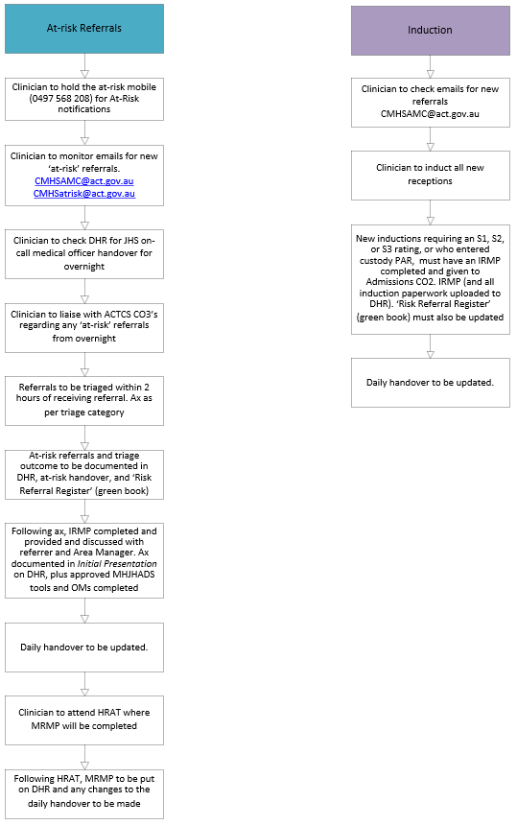
Attachment 3: ACTCS At-Risk Notification Flowchart

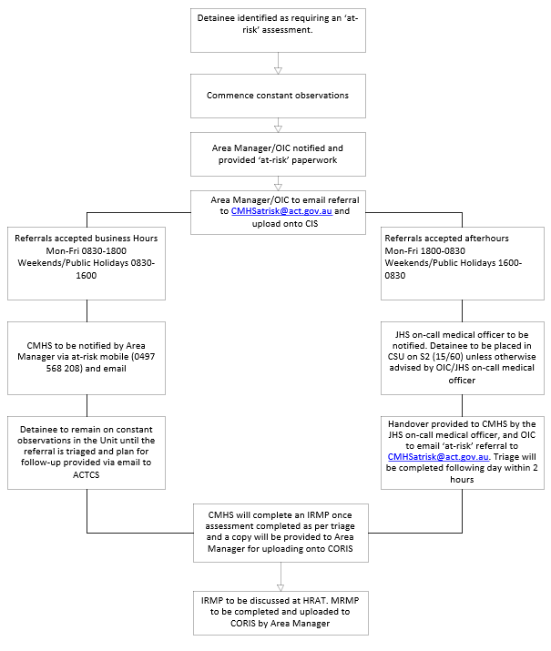

Attachment 4: Referral Form for At-Risk Assessment
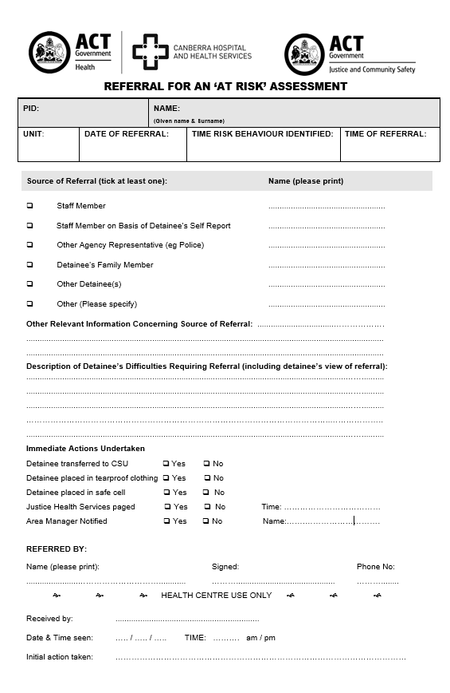
Sample
Canberra Health Services Triage ratings | Canberra Health Services Triage recommendations | TYPICAL PRESENTATIONS | ACTION/RESPONSE required at AMC | ACTCS Obs
A - EMERGENCY  Emergency service response | IMMEDIATE | - Time critical  - Overdose  - Suicide attempt/serious self-harm in progress  - Hanging attempt  - Violence/threats of violence related to major mental illness  - Delirium | Code blue  Fire brigade  Ambulance  Will require constant obs | Constant obs  If remains onsite will be reviewed by CMHS within 2 hours  If hosptialised will be reviewed by CMHS within 2 hours of returning to AMC
B - CRISIS  Very high risk of imminent harm to self or others | WITHIN 2  HOURS | - Acute suicidal ideation others with plan and/or intent  - Imminent risk of harm to self  - Imminent risk of harm to others with plan and/or intent (related to mental health)  - Engaged in serious deliberate self-harm  - Collateral information indicating the above  - Urgent assessment under Mental Health Act 2015 | Code blue IF medically compromised or requires urgent medical intervention  And then  FACE TO FACE mental health response within 2 hours of receiving referral | Constant obs  Will be reviewed by CMHS within 2 hours
C - PRIORITY  High risk of harm to self or others and/or high distress, especially in absence of capable supports | WITHIN 24  HOURS | - Information suggesting suicidal ideation or risk to others without plan and/or intent where level of suicide vulnerability or harm to others is unable be assessed.  - Required priority assessment to clarify risk needs however no evidence to indicate imminent risk  - Rapidly increasing symptoms of psychosis and/or severe mood disorder (and not receiving treatment/ treating team not aware)  - High risk behaviour associated with perceptual/thought disturbance, dementia, or impaired impulse control  - Known person requiring urgent intervention to mitigate risks to self or others (for mental health reasons) | Urgent mental Face to face response required within 24 hours  ACTCS to re-refer in the interim if the risk increases | Hourly obs after receiving notification from CO3.  Will be reviewed by CMHS within 24 hours
D SEMI-URGENT | WITHIN 72  HOURS | - Known person requiring priority review and/ or treatment  - Thoughts of self-harm or suicide without plan or intent (Chronic)  - Thoughts of self-harm in context of not having requests met (ie. Visit, phone call) however no imminent risks identified | Face to face contact within 72 hours  ACTCS to re-refer in the interim if the risk increases | Hourly obs after receiving notification from CO3.  Will be reviewed by CMHS within 72 hours
E – NON URGENT | WITHIN 14 DAYS | - Requires specialist mental health assessment but is stable and at low risk of harm in waiting period  - Other service providers able to manage the person Known person requiring non-urgent review follow-up | Despite being a 14 days non-urgent response, CMHS will still review triage category E’s within 72 hours | Hourly obs after receiving notification from CO3.  Will be reviewed by CMHS within 72 hours
F – REFERRAL | REFERRAL |  | Not applicable to CMHS at AMC | All referrals will be reviewed within 2 to 72 hours
G - ADVICE |  |  | Not applicable to CMHS at AMC | All referrals will be reviewed within 2 to 72 hours

Attachment 6: Referral Triage Flow Chart

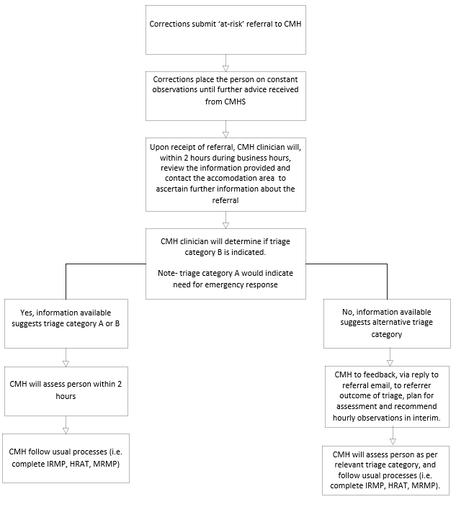
Attachment 7. Approved Document Titles on CHS ECR

Approved CMHS
CHS ECR Document Titles

At-Risk Referral (Date) = The At-Risk documentation received by CMHS from ACTCS dated

IRMP (Date and S-Rating) = The interim risk management plan (IRMP) completed by CMHS dated

MRMP (Date and S-Rating) = The modified risk management plan (MRMP) completed by CMHS dated

ART review = At-Risk review, S rating review, Prisoner At-Risk (PAR) review

Induction + ISBAR = Induction screening and ISBAR handover completed by CMHS dated

Clinical Discussion = Clinical discussion with no medical officer.

Attachment 8: Sample Interim Risk Management Plan (IRMP)
Note, this form is not owned by Canberra Health Services and may be subject to changes.

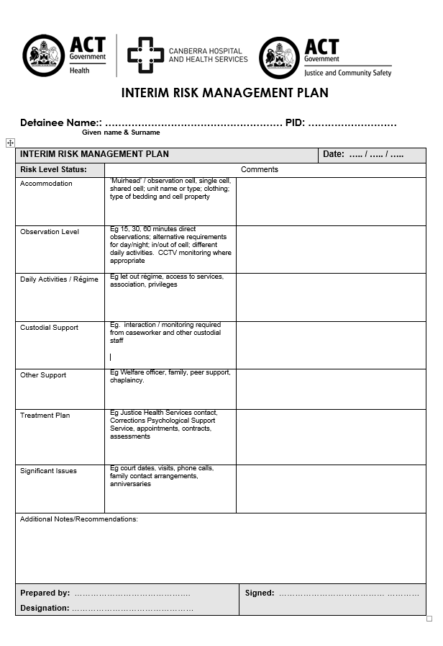
Sample
Attachment 9: Sample Modified Risk Management Plan (MRMP)

Note, this form is not owned by Canberra Health Services and may be subject to changes.
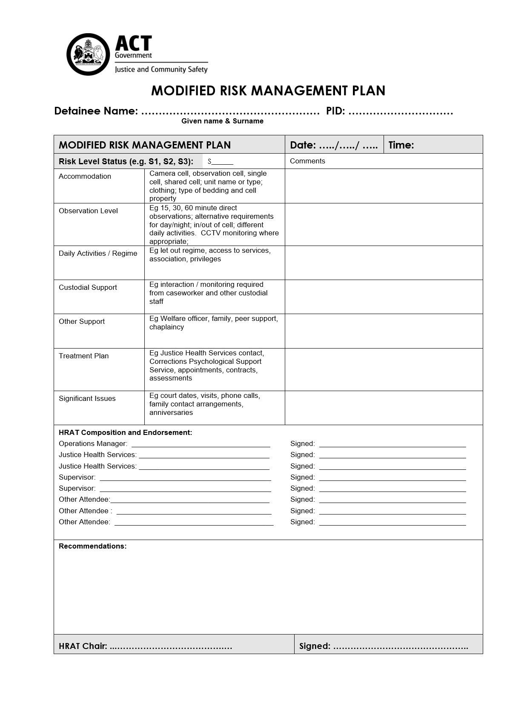
Sample
Attachment 10: CMH Notification Form
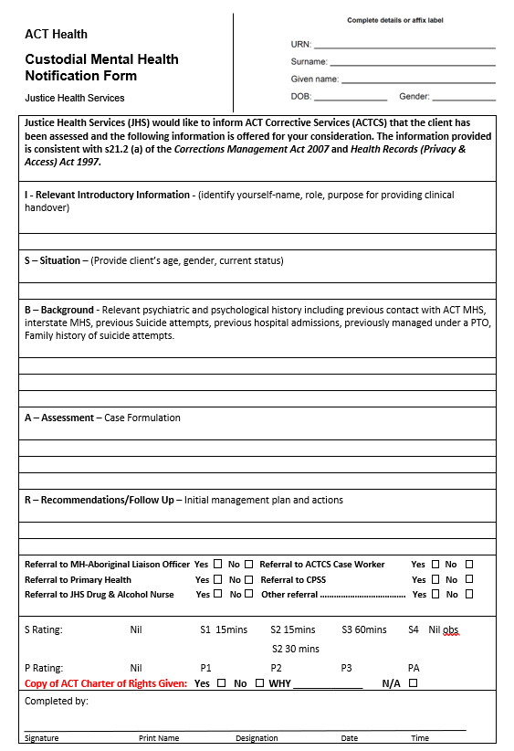
Sample

