Canberra Health Services
Guideline
Low Back Pain (LBP) Clinical Guideline - aged 16 years and over

Contents
Contents 1
Guideline Statement 3
Background 3
Key Objective 3
Alert 3
Scope 4
Section 1 – Initial assessment 4
1.1 Goals of assessment 4
1.2 History Taking 5
1.3 Physical Examination 6
1.4 Psychosocial Assessment 6
1.5 Laboratory tests 7
1.6 Imaging 7
Section 2 – Initial management 8
2.1 Specific spinal pathology 8
2.2 Non-specific low back pain +/- leg pain. 9
2.3 Pharmacological management 9
2.4 Role of Allied Health 10
2.5 Resources for patients 11
2.6 Certification, Referrals, Follow-up 11
Section 3 – Inpatient management 12
3.1 Considerations for admission to short stay units 12
3.2 Pain Management 13
Section 4 – Outpatient Management 18
Section 5 – Review and Referral 18
5.1 Safety-netting patients 19
5.2 Review and reassessment 19
5.3 Referral considerations 19
5.4 Continuity of Care 20
5.5 Referral options 23
Evaluation 26
Related Policies, Procedures, Guidelines and Legislation 26
References 27
Definition of Terms 28
Search Terms 29
Attachments 29
Attachment 1. Alerting features for serious pathologies in patients with low back pain. 30
Attachment 2 - Assessment Tools 32
Attachment 3 - Imaging decision flow chart for acute presentations of low back pain. 38
Attachment 4 - Advice to Stay active for people with acute low back pain. 39
Attachment 5 - Indications for Inpatient Management 40
Attachment 6 - Prescribing considerations for commonly used adjuvants in pain management in adults. 43
Attachment 7 – Characteristics of Pain Types 44

Guideline Statement

Background
Low back pain is the most common form of back problem and is a leading cause of disability worldwide. Back problems are the second most common reason Australians seek care from their general practitioner (GP) and a leading cause of presentation to emergency departments in Australia and throughout the world.

- The Australian Institute of Health and Welfare reports there were 192,000 hospitalisations with a principal diagnosis of back problems in 2020-2021(1).

The Australian Commission on Safety and Quality in Health Care (the Commission) launched the Low Back Pain Clinical Care Standard (LBP CCS) in September 2023. The LBP CCS helps support the delivery of evidence based clinical care and promote shared decision making between patients, carers, and clinicians.
- The LBP CCS defines Low Back Pain as LBP that does not have a diagnosed cause, but it is not considered to be associated with specific or serious pathology, based on either clinical assessment or investigations.
- The LBP CCS focuses on key areas of care, where the need for quality improvement is greatest.

Key Objective
- The guideline will provide Canberra Health Services (CHS) staff with an evidence-based standardised approach to the initial assessment and management, review and onwards referral of patients 16 years and over presenting with acute, acute-on-chronic, and chronic low back pain with or without leg pain, to Emergency Departments at Canberra Hospital (CH) and North Canberra Hospital (NCH), Walk-in Centres, Early Intervention Physiotherapy service and ambulatory care clinics across CHS Network.

Back to Table of Contents

Alert

This clinical care guideline does not cover:
- Delivery of surgical interventions or their indications for use (for example, fusion and disc replacement, discectomy, laminectomy
- Ongoing management of low back pain persisting longer more than 12 weeks, beyond the initial management of an acute exacerbation (although many of the principles of care described may still be relevant).
- Diagnosis or treatment of specific causes of low back pain, such as
- inflammatory conditions (for example, axial spondylarthritis)
- infections (for example, discitis, osteomyelitis, epidural abscess)
- fracture
- neoplasm
- metabolic bone disease (for example, osteoporotic fracture, Paget’s disease)
- non-spinal causes of back pain
- degenerative spinal disorders
Back to Table of Contents

Scope

This guideline applies to medical officers (MO), nurse practitioners (NP), advanced practice nurses, nurses, physiotherapists, allied health professionals, care co-ordination staff (e.g. Emergency Department Discharge Liaison Nurse), and supervised students working within the Emergency Departments, inpatient wards, Walk-In Centres, and ambulatory care clinics.

Back to Table of Contents

Section 1 – Initial assessment

1.1 Goals of assessment
In each new presentation of LBP, the clinician will complete a targeted history and clinical examination that will:
- Identify features that may indicate specific and/or serious pathology, including non-spinal causes of LBP (see Diagnostic Considerations, below).
- Identify the presence of a radicular syndrome with neurological impairment.
- Identify psychosocial contributing factors that may impact recovery.

Staff working in the Emergency Department may also wish to review Quick guide for emergency departments: Low Back Pain Clinical Care Standard 2022 (safetyandquality.gov.au)
Physiotherapists may also wish to review Quick guide for physiotherapists - Low Back Pain Clinical Care Standard

Table 1. Diagnostic Considerations:
Non-spinal causes for LBP | Specific Spinal Pathology* | Radicular Syndromes** | Non-Specific Low Back Pain (NSLBP)***
Example:  - Aortic aneurysm  - Artery occlusion  - Acute pancreatitis  - Acute pyelonephritis  - Renal colic, prostatitis  - Other visceral referred pain  - Shingles  - Hip joint or sacroiliac joint (SIJ) pathology. | Example:  - Cauda equina syndrome  - Spinal cord compression  - Fracture  - Abscess / Discitis  - Spinal metastases / Tumour  - Inflammatory spondyloarthropathy  * Estimated prevalence 1% in primary care (1), may be higher in secondary care (2) | Example:  - Radicular pain  - Radiculopathy  - Neurogenic claudication / spinal canal stenosis  ** 5-10% in primary care (1), may be higher in secondary care (2) | Presumed musculoskeletal origin.  Example:  - Sprain  - Strain  *** 95% in primary care(1), may be higher in secondary care (2).

1.2 History Taking
History taking should include questions that elicit information about:
- Pain onset (e.g. traumatic, insidious)
- Duration of symptoms
- Pain nature, location, distribution, aggravating and easing factors.
- Pain behaviour over a 24-hour period and relationship to activity
- Alerting features for specific spinal pathology and possible non-spinal causes for pain (see Attachment 1)
- Symptoms and signs of radicular syndromes (e.g. radicular pain, radiculopathy, neurogenic claudication/spinal canal stenosis)
- Past medical history +/- family history
- Medications
- Allergies
- Social history and occupation
- Psychological risk factors (e.g. worry, stress, depression)
- Beliefs and expectations
- Treatment goals

For a standardised assessment and monitoring of low back-related disability, the patient may be provided with the Oswestry Disability Index (See Attachment 2, also search 35770 in the Clinical Forms Register).

1.3 Physical Examination
The physical examination should be tailored to exclude or confirm a provisional diagnosis based on the subjective history and adapted according to clinical presentation. It may include:
Inspection/observation:
- Posture, alignment, presence of deformity
Palpation:
Spinous processes, soft tissues, sacro-iliac joints
Mobility and function:
- Gait, balance, gross motor coordination, transfers
Range of movement
- Lumbar spine (active), hip joint (active and passive)
Neurological examination
- Tone, myotome power, dermatome sensation (light touch +/- pin prick +/- temperature), tendon and plantar reflexes
- Where indicated, saddle anaesthesia, bladder scan
Neural Provocation
- Straight Leg Raise, Prone Knee Bend, and/or passive neck flexion and slump
Vascular examination, if indicated from the subjective examination
- Temperature, capillary refill, pulses, Buerger’s test
SIJ examination:
- if indicated from the clinical history

1.4 Psychosocial Assessment
Patients with low back pain, with or without leg pain or other neurological symptoms should be assessed for psychosocial factors that confer risk of chronicity. For a standardised psychosocial screening assessment, the patient should be provided with one of:
- Orebro Musculoskeletal Pain Questionnaire (Short Form)
- Örebro musculoskeletal pain screening questionnaire (Modified) (Linton & Hallden, 1998) (nsw.gov.au)
- OMPSQ-SF electronic complete (painHEALTH website)
- STartBack
- STarT Back Screening Tool (Printable)
- STarT Back Online Calculator

These forms can also be found in Attachment 2.
Questionnaires, together with qualitative information from history taking, should be used to identify patients who should be offered referral to a clinician with experience in pain management and/or psychological approaches:
- Recommendations from OMPSQ-SF Scores:
- <40 indicates low risk of poor outcomes, no referral indicated.
- 40-49 indicates moderate risk of poor outcomes, refer to physiotherapy.
- >50 indicates high risk of poor outcomes, refer to physiotherapy AND psychology.

- Recommendations from STarT Back Scores:
- ≤3 risk of poor prognosis is considered low, no referral indicated.
- ≥4 on combined overall score AND ≤3 on psychosocial subscale is considered medium risk of poor prognosis; refer to physiotherapy.
- ≥4 on psychosocial subscale is considered high risk for poor prognosis; refer to physiotherapy AND psychology.

See also Attachment 2 – ‘Psychosocial factors associated with delayed recovery’, for further information related to psychosocial screening.

1.5 Laboratory tests
Routine laboratory tests are not necessary in the evaluation of back pain unless there is concern for the possibility of malignancy, infection, or inflammatory arthritis. Note that for suspected inflammatory arthritis, the presence of normal inflammatory markers and/or HLAB27 negativity does not exclude the diagnosis (3).

1.6 Imaging
Most patients with LBP with or without leg pain do not routinely require imaging.
If there is a low level of suspicion for specific or non-spinal pathology, patients should be reassured that imaging is not required in the first instance but that it may be indicated if they do not improve as expected.

Imaging may be indicated for the following:
- Clinical evidence of nerve root compression with neurological weakness ≤3/5 (Oxford Scale), or signs and symptoms of spinal cord involvement. Imaging is relevant to confirm or identify pathology with a view to possible surgical intervention.
- A high level of suspicion for other specific or non-spinal pathology. Request imaging as appropriate for suspected pathology. The presence of multiple alerting features is associated with a higher likelihood of serious pathology compared with the presence of a single alerting feature (4).

Consider specialist involvement to obtain guidance on appropriate imaging studies, particularly if the patient requires inpatient admission. For example, Neurosurgeon where acute nerve compression is suspected; Rheumatologist where Inflammatory Spinal Pain is suspected. Refer also to Appendix 3 - ‘Imaging decision flow chart for acute presentations of LBP’.

Imaging requests must include:
- A clinical question
- Provisional diagnosis
- Relevant clinical details and family history
- Alerting features for serious pathology
- Signature and date of the requesting health professional.

Patients with unchanged symptoms should not repeated undergo imaging unless a diagnosis that was not considered previously is being contemplated.

Back to Table of Contents

Section 2 – Initial management

Initial management will depend on the diagnosis and can be provided by primary health care providers including:
- medical practitioners
- nursing staff and
- allied health professionals.

Initial management is usually provided in the Emergency Department (ED), or an outpatient setting if the patient has presented to an ambulatory service in the first instance. Inpatient management is covered in Section 3.

At multiple points throughout the implementation of initial management, patients must be provided with an opportunity to ask questions and to have their concerns addressed.

Note:
Staff working in the Emergency Department may also wish to review Quick guide for emergency departments: Low Back Pain Clinical Care Standard 2022 (safetyandquality.gov.au)

2.1 Specific spinal pathology
For patients with specific spinal pathology excluding radicular syndromes, initial management may include further investigations and/or referral for specialist consultation (inpatient or outpatient as appropriate to clinical urgency).

For patients with radicular syndromes that present with acute or progressive neurological deficit with ≤3/5 strength in one or more lower limb myotomes, initial management should be in consultation with a Spinal Surgeon (Neurosurgeon or Spinal Orthopaedic Surgeon).

Note: For patients with radicular syndromes with a mild or stable neurological deficit, initial management should follow the guidelines for Non-specific low back pain +/- leg pain.

2.2 Non-specific low back pain +/- leg pain.
Patients should be advised that their assessment (+/- imaging) indicates low probability of serious underlying disease.

Patients should be provided with information about their condition (i.e., ‘non-specific low back pain’, ‘low back pain with referred pain’, ‘low back pain with mild radiculopathy’), including:
- the positive natural history
- that a specific diagnosis may not be possible because there are many interacting factors that influence pain, and the lower back area has many structures that can become sensitive and difficult to isolate.
- the signs and symptoms that would indicate need for medical review (e.g., progressive weakness, bowel/bladder dysfunction). See also Section 5, Table 2 – ‘Safety-netting information for patients and clinicians’.

Patients should be educated about the general principles of management of LBP with/without leg pain, including:
- Movement is helpful and patients do not need to wait for all their pain to be gone before they start moving (refer to Attachment 4 – ‘Advice to stay active for people with acute low back pain’)
- Prolonged bed rest is not helpful and may be harmful.
- Heat packs or ice packs may provide short-term pain relief and can be an adjunct to other strategies.
- The importance of returning gradually to normal activity including work and social activities.
- ‘Active’ strategies (things you do yourself e.g. exercise, pacing your activity) are more helpful than ‘passive’ strategies (things that are done to you e.g. massage, acupuncture, surgery).
- The importance of good sleep habits and stress management where relevant.
- Pharmacological pain management is second line to the above strategies. There is evidence that opioid medication is not significantly more effective than other commonly used medicines such as NSAIDs. Opioids, where necessary should only be used for a short period (e.g. 3-5 days) after careful consideration of the risks and benefits.

2.3 Pharmacological management
- Published guidelines recommend pharmacological treatment as second line for low back pain, after physical and psychological strategies (5,6,12).
- If medication is needed, patients should be educated that the goal of pain medication is to support continuation of usual activity (including work and physical activity), not to eliminate pain.
- A trial of NSAIDs for short term use in acute low back pain is recommended first line pharmacological treatment for people at low risk of harm from NSAIDs (5).
- Acute low back pain usually gets better on its own and paracetamol has not been shown to improve the outcome beyond the natural course (5). However, individual patients may experience a benefit, and, because of its favourable safety profile, a trial of paracetamol may be considered if NSAIDs are contraindicated or not tolerated (6,7).
- Opioid medication may be considered appropriate in some circumstances (e.g. severe pain not relieved by other medication), and should be provided as an immediate release formulation, at the lowest effective does for the shortest possible duration.
- Evidence has shown that anticonvulsants (e.g., pregabalin and gabapentin), tricyclic antidepressants (e.g. amitriptyline), selective serotonin reuptake inhibitors (e.g., citalopram) and benzodiazepines have limited effectiveness in reducing low back pain or disability and have significant risks (8,9).
- Medications that are indicated for some types of neuropathic pain (e.g. amitriptyline, gabapentin, pregabalin) may be useful for radicular pain, however, evidence from high-quality randomised controlled trials is lacking (6).
- Clinicians prescribing medication for neuropathic (radicular) pain in the acute setting should be aware that some of these medications take longer to reach the therapeutic window than the duration of the Emergency Department or inpatient episode of care. Ongoing medications management including monitoring and up/down-titration as appropriate must be handed over to the GP on discharge.

See Attachment 6 – ‘Prescribing considerations for commonly used adjuvants in pain management in adults.

2.4 Role of Allied Health
In the Emergency Department settings:
- a referral to physiotherapy may be required if there is a concern over a patient’s ability to mobilise safely once pain is adequately controlled. A referral to physiotherapy is not required in the Emergency setting to provide advice and education or to make a referral to an outpatient or community-based service as these can be managed by other clinicians.
- involvement of the multi-disciplinary team (e.g., occupational therapy, social work) may also be required to adequately assess safety and function (such as ADLs) and social supports.

Patients presenting due to low back pain to Community Care Physiotherapy, the Early Intervention program (for CHS staff), and to the Emergency Department, may be assessed and managed by a physiotherapist without consulting a medical officer or nurse. In the Walk-In Centres (WiCs) patients are assessed and managed by a Nurse Practitioner or Advanced Practice Nurse.

Allied health referral options are listed in Section 5.

2.5 Resources for patients
- Patients should be provided with written and/or e-resources to supplement and support the verbal healthcare education and advice.
- Clinicians should consider the extent to which the patient will be able to absorb educational material in the acute pain stage and be familiar with the content of these resources to make suitable choice/s and format/s for their patient.

Table 1: Resource Options
Document Name | Document Type | Located At
Information for patients: Low Back Pain Clinical Care Standard 2022 - How to manage your low back pain safely | Printable PDF | Information for patients: Low Back Pain Clinical Care Standard 2022 – How to manage your low back pain (safetyandquality.gov.au)
Information for patients: Low Back Pain Clinical Care Standard 2022 – Common questions about low back pain | Printable PDF | Information for patients: Low Back Pain Clinical Care Standard 2022 – Common questions about low back pain (safetyandquality.gov.au)
Acute Low Back Pain - Patient Information Sheet | Printable PDF | CHS Sharepoint Policy Register
Low Back Pain – Pain Conditions | Website information | Low Back Pain - Pain Conditions - painHEALTH (uwa.edu.au)
Understand and manage your back pain website. | CHS approved website | Home (mybackpain.org.au)
Managing low back pain – Information for patients | Printable PDF | Managing low back pain - Information for patients (nsw.gov.au)

2.6 Certification, Referrals, Follow-up
- In the ED setting, it may be appropriate to provide an initial Medical Certificate or Workers Compensation form with a recommendation for GP follow-up, as part of the initial management and onward referral process.
- Detailed information on Referral options and Follow-up including ‘Safety-netting’ (in case of deterioration) and referral to the Early Back Review Clinic for patients presenting to ED, can be obtained in Section 5 – Review and Referral.

Back to Table of Contents

Section 3 – Inpatient management

This section offers guidance for the overall management of patients admitted to AMU or a CHS Network ward, via ED or transferred from a regional facility. It does not extend to include details of specific medical and surgical interventions for specific spinal pathologies, which would be the responsibility of the treating team/s as appropriate to the diagnosis and in accordance with evidence, patient preferences, and a shared decision-making model.

Indications for in-patient management include:
- Acute/worsening neurological deficit
- Cauda Equina Syndrome (CES)
- Spinal malignancy with/without spinal cord compression
- Suspected spinal infection
- Acute fracture
- Specific spinal or other pathology suspected but undiagnosed (requires further work-up) – consider transfer to Acute Medical Unit (AMU) at CH and Medical and Assessment Unit (MAPU) at NCH.
- Inability to mobilise independently/safely – consider transfer to Emergency Medical Unit (EMU) at CH and Short Stay Unit (SSU) at NCH
- Uncontrolled pain (consider EMU, AMU or other as appropriate)

For further details please refer to Attachment 5.

3.1 Considerations for admission to short stay units
The EMU (Emergency Medical Unit) at CH may be suitable for patients who are likely to require ED care beyond 4 hours but less than 12 hours. Examples include:
- patients who require time for analgesia to take effect to enable satisfactory mobilisation
- patients who are awaiting imaging but are unlikely to require admission.
At NCH, this unit is the Short Stay Unit (SSU) in the ED. Patients may stay here up to 24 hours.

The Acute Medical Unit at CH may be suitable for patients who require care beyond 12 hours, where an inpatient admission is deemed necessary. Patients with neurosurgical or orthopaedic conditions should receive surgical clearance prior to transfer to the AMU. Examples of patients who are likely to benefit from an AMU admission are:
- patients who are likely to be discharged home but who will take more than 24 hours to achieve satisfactory pain control and/or mobility.
- patients who require diagnostic work-up and disposition.

Note:
Patients suitable for EMU are identified by an ED Senior Medical Officer and are transferred accordingly.
Patients suitable for AMU are transferred as per standard ED-AMU referral pathways.

At NCH, admission to MAPU may be suitable for patients who require care between 24-72 hours. Patients accepted by MAPU from ED should be transferred to MAPU within 4 hours.

3.2 Pain Management
3.2.1. Pain types
Pain types include nociceptive (e.g. acute low back sprain), neuropathic (e.g. lumbar radicular syndromes), mixed nociceptive and neuropathic (e.g. lumbar disc herniation with radicular pain), or nociplastic (e.g. chronic non-specific low back pain, fibromyalgia) (10).
- Nociceptive - arises from activation of nociceptors due to actual or threatened tissue damage, integrated in the central nervous system with other information (eg previous experiences, expectations) to produce pain. Tissue damage is often also accompanied by local inflammation that causes peripheral sensitisation.
- Neuropathic - arises as a direct consequence of injury or disease of neural tissue. Pain is perceived throughout the innervation distribution of the injured nerve/s.
- Nociplastic - a diagnosis of exclusion, caused by altered or abnormal function of the nociceptive pathways in the absence of nociceptive stimulus or neuropathic lesion. Characterised by variable, non-specific and non-mechanical pain, may be localised or widespread.
- Mixed pain- any combination of the above.

See Attachment 7 – ‘Characteristics of Pain Types’.

3.2.2 General principles of acute pain management
Acute pain is managed by using non-pharmacological and pharmacological interventions. The management strategy depends on the cause of pain, pain type/s, pain intensity, and the available staff and resources for monitoring.

3.2.3 Non-pharmacological strategies
Non-pharmacological interventions for acute pain include psychological and physical techniques and are key components of good clinical care (10). Tailor the intervention to the individual and clinical context. Components include:
- Patient education. This is an important management strategy fundamental to patient-centred care, informed decision-making, and development of self-management capabilities. Explain the possible diagnoses, investigation plan, treatment options, ongoing care and likely outcomes (where known). Patient education helps with managing treatment expectations and can improve engagement with therapies.
- Psychological interventions. These assist with treatment adherence, management of painful procedures, earlier discharge and reduced analgesic use. Basic psychological techniques can be delivered by any health care provider, and include:
- distraction
- relaxation
- empathy/addressing concerns
- providing appropriate reassurance

Note
Formal psychological interventions may be required for highly distressed or anxious patients.

- Physical interventions. These are helpful to support functional recovery and build patient confidence, as well as reducing acute sensitivity to movement. Strategies include:
- breathing techniques
- gentle relaxed range of movement exercise
- mobilisation for position change (e.g. sit out of bed)
- walking with/without gait aid
- graduated mobility progression
- some patients may also have benefit from ice therapy.

Recommended resources for patients to support education, physical and psychological interventions include:

Home (mybackpain.org.au) | CHS approved website
Home | Pain Revolution | CHS approved website
Home - painHEALTH (uwa.edu.au) | CHS approved website

QR codes for these sites will be included on the CHS Low Back Pain Patient Information Sheet, currently in development.

3.2.4 Pharmacological interventions
The main aim of analgesia is to reduce pain enough to enable the patient to remain mobile, with considerations of mobility restrictions, e.g. in the case of unstable fracture.
- NSAIDs are recommended first-line analgesics for acute back pain.
- Paracetamol and topical NSAIDS such as diclofenac gel may be used as an adjunct second line therapy for patients who are unable to use NSAIDS (i.e. recent GI bleed, heart failure, renal impairment).
- Opioids and adjuvant medications should be avoided where possible due to limited benefit and risk of harm.

Note:
It is likely that a patient experiencing severe uncontrolled pain requiring hospital admission has had an inadequate response to first line analgesia (which may include intramuscular ketorolac) and will have been prescribed a low potency opiate +/- adjuvant medication.
Anticonvulsant medication or antidepressant medication, such as pregabalin or amitriptyline may be considered in the management of back pain with radicular pain as second line analgesia.

- On admission, review all medications. Provide the patient with information about the medicines and ensure that they understand the indications, risks, benefits, and expected duration.
- Prescribe the lowest effective analgesic dose for the shortest possible time, in line with current Therapeutic Guidelines.
- Monitor response to analgesia frequently to ensure effectiveness, to check for adverse effects, and to identify any potential misuse.
- Establish and document in the patients Digital Health Record (DHR) clear analgesia weaning and cessation plans.

Table 2: Formulary Options
Treatment Choice | Formulary Options Available | Comments
NSAIDs – 1st line | Ibuprofen 200-400mg Q4-6H | Shorter Duration of effect
NSAIDs – 1st line | Meloxicam 7.5-15mg Daily | Moderately COX-2 Selective
NSAIDs – 2nd line | Celecoxib 100-200mg BD | COX 2 Selective, Safest GI profile
NSAIDs – 2nd line | Naproxen Conventional Product 250-500mg BD  Naproxen Controlled Release Product 750-1000mg Daily | Caution using with patients with renal impairment or history of GI bleed.
NSAIDs – 2nd line | Ketorolac 10mg Q6H IM/IV while inpatient | Short-term therapy only
2nd Line: Paracetamol or Topical NSAIDs | Paracetamol 1000mg TDS-QID
2nd Line: Paracetamol or Topical NSAIDs | Diclofenac 1% gel 4g QID | <20% systemically absorbed
3rd line: Low potency Opioids  *only consider if patient unable to mobilise following use of 1st/2nd line agents*  Prescribe lowest dose for shortest possible duration with recorded review date | Tapentadol 50-100mg Q6H PRN | Per eTG, better safety profile than oxycodone
 | Oxycodone 2.5-5mg Q4H PRN
Adjuvant Options for radicular pain  *only in consultation with pain specialist, rheumatology or neurosurgical advice*  (There is little evidence to support the use of these medications, and have a significant side-effects profile) | Amitriptyline 10-100mg Nightly
 | Gabapentin 100-300mg 1-3x daily
 | Pregabalin initially 25-150/day up to 600mg/day

    - Role of Opioids
- There is high quality evidence that opioids for acute low back pain according to the definition of LBP in the Clinical Care Standard (5-10mg oxycodone MR, BD) have no benefit compared to placebo at short or long-term time points, with a small between groups difference at one year favouring placebo (11). This supports other guidelines which recommend that opioid analgesia should be avoided or limited to short term use such as 3-7 days but not more than 14 days, due to side effects such as constipation and somnolence, risk of overdose and dependency, respiratory depression, and prolonged recovery time (12, 13, 14).
- Prescribing opiates should be with full consideration of the Opioid Analgesic Stewardship in Acute Pain Clinical Care Standard.
- If opioids are used for severe acute pain immediate-release formulations are preferred, as part of an overall plan that considers the patients opioid status.

Note:
Modified-release opioid analgesics cannot be safely or rapidly titrated and their use in acute pain should be exceptional and not routine. The patient should be supported to cease any opioid analgesic use as their function and pain improve.

3.2.6 Role of adjuvant medications
- Adjuvant medications including amitriptyline, a tricyclic anti-depressant, and anticonvulsants (e.g. pregabalin and gabapentin) can be used to treat patients with radicular symptoms.
- These medications should be commenced in low doses and up titrated slowly. Consideration should be given to the risks associated with use of these medications and individualised. Patients should be referred to their GP on discharge for review of efficacy, monitoring, and adjustments as appropriate, and for a clear tapering/weaning plan as symptoms improve.
- Selective serotonin reuptake inhibitors and benzodiazepines have previously been utilised in the clinical setting to target neuropathic pain or muscle spasm. However, these medications have limited evidence of efficacy and significant risks and are not recommended as first line treatments (6).

3.2.7 Role of corticosteroid and other injection therapies
- Targeted transforaminal or epidural injections of local anaesthetic and steroid can be considered in patients with acute and severe radicular pain (12). There is moderate evidence of effectiveness for leg pain, and no evidence of benefit for back pain. The available evidence suggests that whether given transforaminal or inter-laminar, they offer short-term relief (e.g. a few weeks) for acute radicular pain (15).
- Epidural steroid injection is not recommended for patients with neurogenic claudication associated with spinal canal stenosis (6, 16).
- There is little evidence supporting facet joint or trigger point injections or prolotherapy (12, 17).
- A patient should not remain in hospital awaiting a guided corticosteroid injection if they are otherwise suitable for discharge.

3.2.8 Referral to the Acute Pain Service
- Referral to the Acute Pain Service (APS) may be appropriate for consideration of additional intervention for persistently uncontrolled pain despite optimal oral or intramuscular analgesia and non-medical strategies.
- Medical staff can refer to the APS via DHR. The APS request that medical staff please contact the APS Registered Nurse (during business hours 8am- 5pm) or APS Anaesthetist on call (after-hours) to discuss the situation and referral. These services can be contacted via Hospital Switchboard, dial 9.
Back to Table of Contents

Section 4 – Outpatient Management

- In Canberra Health Services Network, patients do not require a referral from a healthcare provider to receive care from Community Care Physiotherapy, Walk-in Centres, and Early Intervention Physiotherapy.
- Referrals are required for other outpatient services within CHS.
- For information on how consumers can access outpatient services, please refer to Section 5.4 – Referral Options.
- Patients presenting to all outpatient services with back pain will be assessed in accordance with Section 1 – Initial Assessment, within the scope of the attending healthcare professional, and appropriate to the setting and the patient’s presentation.
- Outpatient management will be informed by the diagnosis and clinical presentation (including co-morbidities) and will be based on evidence, clinical expertise, and patient preferences/expectations and goals.
- Where specific pathology is suspected (e.g. suspected fracture, inflammatory spinal pain) patients will be directed to seek medical follow-up (including attending an emergency Department where indicated) and referral to a more appropriate service (e.g. a Spinal Surgeon, Rheumatologist).
Back to Table of Contents

Section 5 – Review and Referral

Recovery from an episode of back pain is variable. For people who consult a healthcare provider, most will improve rapidly within the first 6 weeks (18). After 6 weeks, recovery is slower, but most people will have achieved minimal pain and disability at one year (18). For a small proportion of patients, symptoms will persist, progress, or recur. This section pertains to those patients.

5.1 Safety-netting patients
- As noted in Section 2 - Initial Management, it is important that patients are provided with information about how and when to seek care for symptoms that are not improving. This is referred to as ‘Safety-netting’.
- It is recommended that all patients be safety-netted, particularly if they are not referred on for follow-up care from the initial assessment, or if there is to be a delay. They should be provided with information about the need to seek follow-up care for:
- New or progressing neurological problems.
- Possible cauda equina syndrome.
- No improvement in pain and/or disability at 6 weeks from the acute presentation.

See Table 3 ‘Safety-netting information for patients and clinicians’ for recommended advice.

5.2 Review and reassessment
- At review, clinicians should listen carefully to the patients concerns to guide the reassessment and determine the need for escalation or modification of the current treatment plan.
- Reassess as appropriate. For example:
- a thorough neurological examination in the context of new weakness/numbness; an exploration of behavioural and psychosocial factors in the context of persisting disability without features of serious or significant pathology.
- As with the initial assessment, patient should be provided with an opportunity to express their concerns and have their questions answered.

5.3 Referral considerations
- Any new concerning features require urgent investigation or specialist assessment, for example:
- serious pathologies.
- neurological deficits.

Note: refer to Attachment 1 ‘Alerting features for serious pathologies in patients with low back pain’
- Patients with severe or progressively deteriorating neurological signs and symptoms should be immediately referred for urgent imaging and surgical review. Provide detailed information about the history, symptoms of concern, evolution of symptoms, and relevant background information (e.g. malignancy) on the referral.
- Many patients may be managed with GP care alone after initial presentation and exclusion of specific/serious pathology. Patients with recurrent or persistent low back pain, or any patient who has not recovered from the acute episode by 12 weeks, should be referred by their GP for specialist opinion or multidisciplinary care.
- Earlier referral or review may be warranted for patients with an acute exacerbation of chronic back pain, or when pain is persisting or worsening despite appropriate early intervention (19).

5.4 Continuity of Care
- For continuity of care, it is essential that for all referrals and handover, written clinical handover occurs in accordance with organisational guidelines for clinical handover, including any recommendations for ongoing management.
- For further information on Clinical Handover refer to the Clinical Handover Procedure. Where possible, patients who can access private services such as through workers compensation insurance, Department of Veterans Affairs (DVA), National Disability Insurance Scheme (NDIS), or individual private health insurance, should be encouraged to do so.
Table 3. Safety-netting information for patients and clinicians.
Possible problem | Symptoms | Advice to patient | Clinician action
Neurological compromise | New or progressive leg weakness or numbness | ‘If you develop any new or progressive leg weakness or numbness or difficulty walking, seek urgent medical attention e.g. same day GP appointment or present to Emergency Department’ | - On presentation, re-assess including neurological assessment  - Arrange MRI if new neurological compromise is suspected.  - Contact neurosurgical registrar on-call to discuss management.
Cauda equina syndrome | One or more of:  - Perineal or inner thigh paraesthesia  - Loss of ability to sense bladder fullness  - Inability to pass urine  - New bowel or bladder incontinence  - Altered sexual function | A rare but serious back condition ‘cauda equina syndrome’ can cause permanent damage. If you develop any of the following symptoms you should seek help immediately (attend an Emergency Department):  - Loss of feeling/pins and needles between your inner thighs or genitals  - Numbness in or around your back passage or buttocks  - Increasing difficulty starting, stopping, or controlling flow of urine  - Loss of sensation with passing urine or a bowel motion  - Not knowing if your bladder is full or empty  - Inability to stop a bowel movement or leaking  - Loss of sexual function.  - Note: CES Safety Cue-cards for patients can be found here in English and many other languages: Cauda Equina Information Cards | MACP (macpweb.org) | - On presentation, re-assess including neurological assessment  - Medical assessment of sacral nerve roots (perineal sensation, anal tone)  - Arrange post-void residual bladder scan  - Arrange MRI if CE compromise is suspected.  - Contact neurosurgical registrar on-call to discuss management.

Table 3. (continued). Safety-netting information for patients and clinicians.
Possible problem | Symptoms | Advice to patient | Clinician action
Physical or psychological factors affecting recovery with no improvement at 2-6 weeks. | Persisting or worsening pain, persisting, or progressing disability, increased worry. | ‘If there has been no change in your pain and/or no improvement in your abilities after 2-6 weeks, you should be reassessed to make sure the treatment plan is right for you. Make an appointment with your GP or physiotherapist’ | - Assess if the lack of improvement relates to incorrect diagnosis, progression of the condition, or physical, behavioural, or psychosocial factors.  - Review the initial assessment and current management program, including psychosocial factors that may delay recovery, medicines, and adherence to self-management strategies. Adjust the treatment plan accordingly.  - Consider compensation factors as there is an association between poorer physical and psychological status with compensation-related proceedings.  - Consider referral to a service with expertise in addressing functional limitations in the context of persistent pain.

5.5 Referral options
Early Back Review (EBR) Clinic
- A trial/pilot service in 2024, offering one-off review appointments with a physiotherapist following an initial presentation to CHS ED with back pain, within 1-2 weeks of presentation.
- The aim of this service is to re-screen for any serious/sinister pathology requiring medical review (an additional safety-net), assess for contributing factors including psychosocial factors, and provide tailored education and guidance for onward management.
- Free for ACT Residents.
- Referrals from ED/EMU/AMU/MAPU clinicians only.
- To refer:
- In DHR Orders, select Outpatient referral to Physiotherapy, Internal referral, CHS, AAHS, Early Back Review Clinic.
- Complete ISBAR into the Comments field.

Community Care Physiotherapy ACT (Public)
Community Care Physiotherapy – Canberra Health Services website
- Expertise in addressing functional limitations in the context of persistent pain.
- Individual and/or group-based exercise and education, with an emphasis on functional restoration.
- Free for ACT residents.
- To refer:
- In DHR Orders, select Outpatient referral to Physiotherapy, Internal referral, CHS, Rehabilitation Aged and Community Services, Community Care, Musculoskeletal General.
- Complete ISBAR into the Comments field.
- Patients can also self-refer by contacting Central Health Intake on 5124 9977.

North Canberra Hospital Physiotherapy (Public)
Musculoskeletal Physiotherapy at North Canberra Hospital – Canberra Health Services website
- To refer:
- In DHR, select Outpatient referral to Physiotherapy, Internal referral, NCH, Musculoskeletal.
- Complete ISBAR into the Comments field.
- Patients are not able to self-refer to this service.

Physiotherapy NSW (Public)
- Varied expertise and scope.
- Email referral to SNSWLHD-CommunityIntake@health.nsw.gov.au or MLHD-CCIS@health.nsw.gov.au.
- Include ISBAR in the body of the referral.
- Patients can also self-refer 1800 999 880 (Southern NSW LHD) or 1800 654 324 (Murrumbidgee LHD).

Private Physiotherapy
Find a physio - Choose physio | Australian Physiotherapy Association
- Recommend patients seek Australian Physiotherapy Association (APA) APA-titled ‘Pain’ or ‘Musculoskeletal’ physiotherapists who will have experience with persistent/complex presentations.
- Patients with chronic conditions can request GP referral to private physiotherapy for 5 Medicare-subsidised sessions, as part of a GP Management Plan or Team Care Arrangement.

Early Intervention Physiotherapy Service
- Early Intervention Physiotherapists can help staff with musculoskeletal injuries through treatment and advice.
- All full or part-time paid staff of Canberra Health Services are eligible for treatment for both work and non-work-related injuries. Additionally, treatment is offered for work-related injuries prior to workers compensation claim acceptance, as well as injuries to other areas of the body unrelated to a workers compensation claim.
- Patients may self-refer by calling (02) 5124 9038 or email to CHS.WorkHealthSafety@act.gov.au

Spinal Pain Service
Spinal Pain Service – Canberra Health Services website
- Physiotherapy-led assessment service with limited physiotherapy and psychology follow-up for patients referred to Outpatient Neurosurgery and/or seen by a Neurosurgery or Rheumatology Specialist. Patients can be referred if they are admitted to TCH under Rheumatology. Referrals are not accepted from other sources including GPs or Emergency Departments.
- To refer:
- In DHR Orders, select Outpatient referral to Physiotherapy, Internal referral, CHS, Acute Allied Health Services, Spinal Pain.
- Complete ISBAR into the Comments field.
- Patients are not able to self-refer to this service.

Pain Management Unit
Pain Management Unit (PMU) – Canberra Health Services website
- PMU offers medical and allied health assessment and interventions, based at the University of Canberra Hospital.
- PMU is preferred for severe/complex pain problems, indications for pain management procedures (e.g., facet joint blocks/RFA’s), and pain medication review.
- All allied health interventions for patients with back pain are group-based, with a high emphasis education and self-management and a limited exercise component.
- To refer:
- Detailed written referral from GP or specialist, see HealthPathways for detailed referral criteria and information Chronic Pain Management Referrals - Community HealthPathways ACT and SNSW

Psychological Services
Find a Psychologist | APS (psychology.org.au)
- Patients can request GP referral to Medicare-subsidised private psychology through a Mental Health Care Plan.
- Other support services for consideration include:
- Lifeline Canberra: 13 11 14 or www.lifelinecanberra.org.au
- Beyond Blue: 1300 224 636 or www.beyondblue.org.au
- MensLine Australia: 1300 789 978 or www.mensline.org.au
- Relationships Australia: 1300 364 277 or www.relationships.org.au
- Headspace Canberra: www.headspace.org.au
- MindSpot: www.mindspot.org.au
- eCentreClinic: www.ecentreclinic.org
- Head to Health: www.headtohealth.gov.au
- Black Dog Institute: www.blackdoginstitute.org.au
- ACT Mental Health Consumer Network: www.actmhcn.org.au
- Carers ACT: www.carersact.org.au

CHS Aquatic Therapy (Hydrotherapy)
UCH – Aquatic Therapy: Referral, Assessment and Service Delivery Procedure -Policy and Guideline Register.
- Supervised individualised aquatic exercise at the University of Canberra Hospital
- Patients must attend a land-based assessment with a physiotherapist from the Hydrotherapy service prior to commencement.
- Eligibility criteria includes acute exacerbations of chronic conditions, and chronic pain limiting ability to participate in land-based therapy.
- Referrals are accepted internally from CHS health professionals and externally from medical professionals.
- To refer:
- In DHR Orders, select Outpatient referral to Rehabilitation Medicine, Internal referral, CHS, Hydrotherapy.
- Complete ISBAR into the Comments field.

CHS Exercise Physiology
Exercise Physiology – Canberra Health Services website.
- Exercise Physiologists prescribe exercise as medicine for people with chronic disease and/or injury.
- The CHS Exercise Physiology service provides short term exercise therapy with clear goals, support with lifestyle modifications and behaviour change.
- Referrals are accepted internally from CHS health professionals and externally from medical professionals.
- To refer:
- In DHR Orders, select Outpatient referral to Exercise Physiology, Internal referral.
- Complete detailed ISBAR into the Comments field

Other
- For information about other services within CHS, e.g. Community Care Occupational Therapy or Social Work, please refer to Services and Clinics, Canberra Health Services website.
- Patients must provide consent for referrals. They are at liberty to decline suggested referrals and services and/or to engage with another health provider of their choosing.

Back to Table of Contents

Evaluation

Outcomes
Clinical staff will provide an evidence-based standardised approach to the initial assessment and management, review and onwards referral of patients 16 years and over presenting with acute, acute-on-chronic, and chronic low back pain, with or without leg pain, across inpatient and outpatient settings of Canberra Health Services.

Measures
- Audit relevant clinical areas’ (e.g., ED, AMU, Physiotherapy) orientation procedures to ensure the Guideline is provided to staff on commencement of work.
- Clinical documentation audit against 8 Quality Statements detailed in the ACSQH Low Back Pain Clinical Care Standard.
- Review of Patient experience survey/s.

Back to Table of Contents

Related Policies, Procedures, Guidelines and Legislation

Policies
- Informed Consent (Clinical)

Procedures
- Acute Pain Services – Adult and Paediatric
- Clinical Handover
- Community Care – Referral of patients for medical review
- Health Records Management
- Patient Identification and Procedure Matching
- NCH – Primary Contact Physiotherapy
- UCH – Aquatic Therapy: Referral, Assessment and Service Delivery

Guidelines
- Spinal Pain Service Operational Guideline
- Therapeutic Guidelines

Legislation
- Health Records (Privacy and Access) Act 1997
- Human Rights Act 2004
- Work Health and Safety Act 2011
- Carers Recognition Act 2021

Other
- Australian Charter of Healthcare Rights
- Therapeutic Guidelines
- Low Back Pain Clinical Care Standard | Australian Commission on Safety and Quality in Health Care
- Quick Guide for Emergency Departments: Low Back Pain Clinical Care Standard 2022 (safetyandquality.gov.au)
- Acute Low Back Pain |Emergency Care Institute (nsw.gov.au)
- Cauda Equina Information Cards

Back to Table of Contents

References

- https://www.aihw.gov.au/reports/chronic-musculoskeletal-conditions/back-problems
- Bardin LD, King P, Maher CG. Diagnostic triage for low back pain: a practical approach for primary care. Med J Aust. 2017 Apr 3;206(6):268-273
- Overview | Spondyloarthritis in over 16s: diagnosis and management | Guidance | NICE
- de Luca K, McLachlan AJ, Maher CG, Machado GCC. Australian emergency department care for older adults diagnosed with low back pain of lumbar spine origin: a retrospective analysis of electronic medical record system data (2016-2019). BMC Emerg Med. 2023 Feb 13;23(1):17. doi: 10.1186/s12873-023-00789-8. PMID: 36782123; PMCID: PMC9924838.
- Rheumatology Expert Group. Therapeutic guidelines: rheumatology, version 3. Melbourne: Therapeutic Guidelines Limited; 2017.
- Therapeutic Guidelines. Pharmacological management of low back pain. Accessed online 29/06/2023. Topic | Therapeutic Guidelines (tg.org.au)
- Saragiotto BT, Machado GC, Ferreira ML, Pinheiro MB, Abdel Shaheed C, Maher C. Paracetamol for low back pain. Cochrane Database of Systematic Reviews 2016, Issue 6
- Chou R, Deyo R, Friedly J, Skelly A, Weimer M, Fu R, et al. Systemic pharmacologic therapies for low back pain: a systematic review for an American College of Physicians clinical practice guideline. Ann Intern Med 2017 Apr 4;166(7):480–92.
- Enke O, New HA, New CH, Mathieson S, McLachlan AJ, Latimer J, et al. Anticonvulsants in the treatment of low back pain and lumbar radicular pain: a systematic review and meta-analysis. CMAJ 2018 Jul 3;190(26):E786–93.
- Pain and Analgesia [published 2020 Dec]. In: Therapeutic Guidelines. Melbourne: Therapeutic Guidelines Limited; accessed {accessed 01/01/2023}. https://www.tg.org.au
- Jones CM et al. Opioid analgesia for acute low back pain and neck pain (the OPAL trial): a randomised placebo controlled trial. The Lancet. 2023. 402 (10398): 304-312.
- National Institute for Health and Care Excellence. Low back pain and sciatica in over 16s [Internet]. United Kingdom: NICE; 2017 [cited 2021 Oct]. (Quality Standard QS155.) Available from: www.nice.org.uk/guidance/qs155
- Chou R, Deyo R, Friedly J, Skelly A, Weimer M, Fu R, et al. Systemic pharmacologic therapies for low back pain: a systematic review for an American College of Physicians clinical practice guideline. Ann Intern Med 2017 Apr 4;166(7):480–92.
- Petzke F, Klose P, Welsch P, Sommer C, Häuser W. Opioids for chronic low back pain: an updated systematic review and meta-analysis of efficacy, tolerability and safety in randomized placebo-controlled studies of at least 4 weeks of double-blind duration. Eur J Pain 2020 Mar;24(3):497–517.
- Pinto RZ, Maher CG, Ferreira ML et al. Epidural corticosteroid injections in the management of sciatica: a systematic review and meta-analysis. Ann Intern Med 2012; 157(12): 865-77.
- Friedly JL, Comstock BA, Turner JA et al. A randomized trial of epidural glucocorticoid injections for spinal stenosis. N Engl J Med 2014; 371(1): 11-21.
- NSW Agency for Clinical Innovation. Management of people with acute low back pain: model of care. Chatswood; NSW Health; 2016. p19.
- da C Menezes Costa L, Maher CG, Hancock MJ, McAuley JH, Herbert RD, Costa LO. The prognosis of acute and persistent low-back pain: a meta-analysis. CMAJ 2012 Aug 7;184(11):E613–24.
- NSW Agency for Clinical Innovation. ACI Pain Management Network: assessment [Internet]. Sydney: NSW Health; n.d. [cited 2021 Dec]. Available from: aci.health.nsw.gov.au/chronic-pain/health-professionals/assessment

Back to Table of Contents

Definition of Terms

LBP – Low Back Pain
APS – Acute Pain Service
CHS – Canberra Health Services
DHR – Digital Health Record
DVA – Department of Veterans Affairs
NDIS – National Disability Insurance Scheme

Back to Table of Contents

Search Terms

Back, Pain, Low back, Low back pain, Spine, Physiotherapy, Psychology, Neurosurgery, Rheumatology, Emergency Department, Guideline.

Back to Table of Contents

Attachments

Attachment 1 - Alerting features for serious pathologies in patients with low back pain
Attachment 2 - Assessment Tools
Attachment 3 - Imaging decision flow chart for acute presentations of low back pain.
Attachment 4 - Advice to Stay active for people with acute low back pain.
Attachment 5 - Indicators for inpatient management.
Attachment 6 - Prescribing considerations for commonly used adjuvants in pain management in adults
Attachment 7 – Characteristics of Pain Types

Disclaimer: This document has been developed by Canberra Health Services specifically for its own use. Use of this document and any reliance on the information contained therein by any third party is at his or her own risk and Canberra Health Services assumes no responsibility whatsoever.

Policy Team ONLY to complete the following:
Date Amended | Section Amended | Divisional Approval | Final Approval
05/08/2024 | New document | Felicity Martin, ED, Allied Health | Policy Document Review Panel

This document supersedes the following:
Document Number | Document Name

Attachment 1. Alerting features for serious pathologies in patients with low back pain.
Extracted from: Low Back Pain Clinical Care Standard 2022 (safetyandquality.gov.au) p15-16.

Serious pathology | Alerting features
Spinal infection (for example, osteomyelitis, epidural abscess) | - Symptoms and signs of infection (fever)  - Raised inflammatory markers (C-reactive protein, erythrocyte sedimentation rate)  - Risk factors for infection (underlying disease, immunosuppression, penetrating wound, history of intravenous drug use)
Vertebral fracture | - History of considerable trauma  - History of minor trauma if patient  - is older than 50 years  - has a history of osteoporosis or taking corticosteroids
Malignancy | - History of malignancy  - Age older than 50 years  - Failure to improve with treatment  - Unexplained weight loss  - Pain at multiple sites  - Pain while resting  - Symptoms in other body systems (e.g. cough, dysphagia)
Visceral disease (e.g. pancreatitis, aortic aneurysm) | - Sudden onset of pain  - Abdominal pain radiating to the back  - Associated collapse or hypotension  - Absence of aggravating features (such as pain not aggravated by spinal movement)
Suspected or threatened cauda equina compression | Early symptoms⁷³:  - Bilateral/alternating radiculopathy  - Subjective sphincteric problems  - Subjective perineal sensory changes  Established symptoms:  - Altered bladder and/or bowel function (urinary retention, faecal incontinence)  - Reduced sensation in the ‘saddle’ area  - Progressive bilateral foot or leg weakness
Spinal cord pathology (myelopathy) | - Sensory-level weakness  - Hyperreflexia or hyporeflexia  - Upgoing plantar responses  - Sensory loss  - Gait disturbance  - Reduced balance  - Reduced fine motor control  - Clonus
Axial Spondyloarthritis | - Age younger than 40 years  - Symptom duration of more than three months  - Prolonged morning stiffness  - Woken second half of night by back pain.  - Alternating buttock pain  - Improvement of symptoms with physical activity or exercise, and not improve with rest.  - Response to non-steroidal anti-inflammatory drugs  - Personal or family history psoriasis – skin or nail  - History inflammatory bowel disease – Crohn's disease or ulcerative colitis,  - History of uveitis  - Preceding infection (GIT or urogenital)  - Personal or family history of an inflammatory arthritis- peripheral or Axial Spondyloarthritis/AS
Based on Therapeutic Guidelines: Rheumatology (5)

Attachment 2 - Assessment Tools

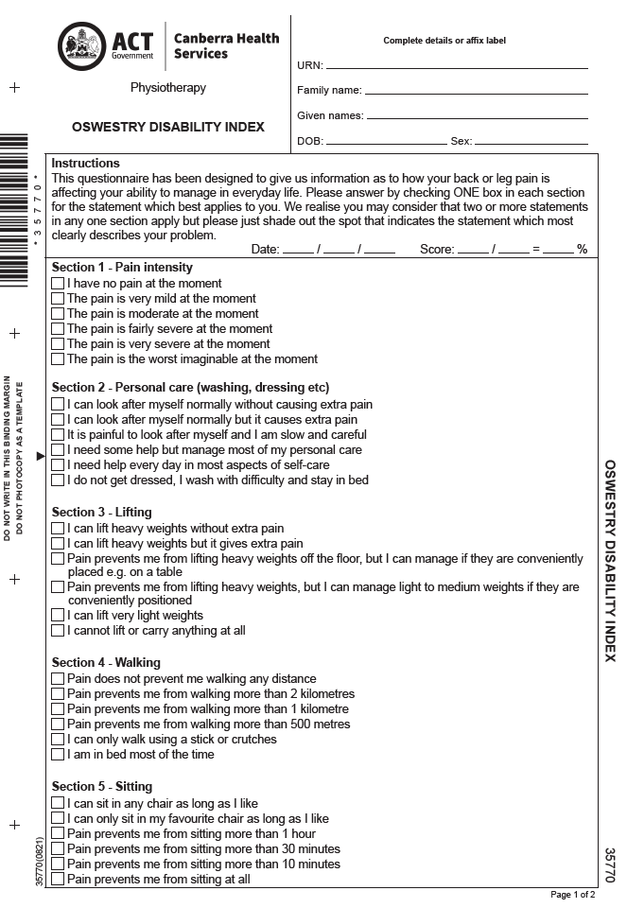
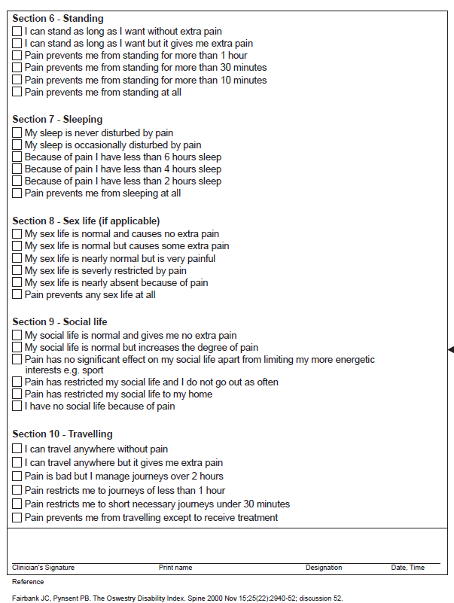

Psychosocial Assessment
Extracted from: Low Back Pain Clinical Care Standard 2022 (safetyandquality.gov.au) pp 26-27:

Factors associated with delayed recovery

- Belief that pain and activity are harmful
- ‘Sickness behaviours’ (such as extended rest)
- Low or negative moods, or social withdrawal
- Mental health comorbidities or trauma history
- Treatment that does not fit with best practice, but remains the focus of the patient’s requests
- Problems with the compensation system
- Previous history of back pain, time off work or other claims
- Problems at work or poor job satisfaction
- Financial hardship
- Overprotective family or lack of social support.
Source: Adapted from New South Wales Agency for Clinical Innovation.⁹

Sample questions to identify psychosocial issues

Do you think your pain will improve or become worse?
  - What to listen for: A belief that the back pain is damaging or potentially severely disabling
Do you think you would benefit from activity, movement or exercise?
  - What to listen for: Fear and avoidance of activity or movement-related pain
How are you coping emotionally with your back pain?
  - What to listen for: Signs of low mood, distress or withdrawal from social interaction
What treatments or activities do you think will help you recover?
  - What to listen for: Expectations of passive treatment, rather than expectations that active participation will help
Are you worried that something has been missed?
  - What to listen for: Concerns that there is serious pathology that has been missed.
Source: Adapted from Health Quality Ontario.⁴⁰

Attachment 3 - Imaging decision flow chart for acute presentations of low back pain.
Extracted from: Low Back Pain Clinical Care Standard 2022 (safetyandquality.gov.au) p 25.

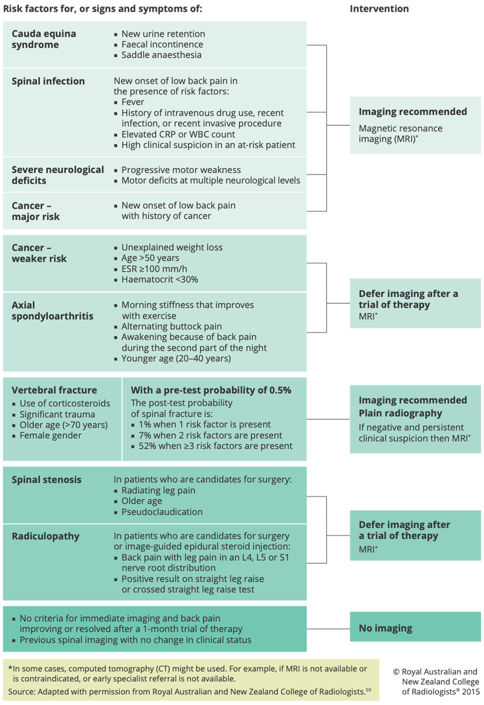

Attachment 4 - Advice to Stay active for people with acute low back pain.
Extracted from Low Back Pain Clinical Care Standard 2022 (safetyandquality.gov.au) p.40.

Box 4: Advice to stay active for people with acute low back pain

Indication
Staying active, instead of resting in bed, is recommended for a low back pain episode. It can improve pain relief and the ability to perform everyday activities (functional state), reduce sick leave and enable people to continue or return to work.

Precautions
Patients can be advised to reduce, alter or modify certain painful activities (for example, lifting) for a few days, as certain activities may exacerbate back pain. Patients need to be reassured that an exacerbation of pain is not an indication of damage, and fluctuations in pain can be expected during recovery from acute low back pain. Patients should feel confident to continue or get back to their normal everyday activities in days to weeks.

Description
Staying active means continuing with normal daily activities as much as possible, including going to work. It also means trying to reduce long periods of inactivity. No specific exercise(s) is needed at this stage.

People with low back pain who remain active, even when in pain, do better in the long term. In fact, it appears that the longer a person stays in bed because of low back pain, the worse their ability to work or return to work becomes.

Tips and challenges
Patients should be advised that it is important not to wait for all pain to be gone before they start moving. Having a strategy whereby they either reduce or alter certain painful activities (for example, lifting) for a few days, and then gradually build up these activities again can be recommended.

Patients often fear that pain is a sign of deterioration and/or further damage. They are often anxious about returning to physical work or activities that are high impact or involve bending, twisting or lifting. Patients may need to be reassured that the back is strong and, although they may need to reduce, alter or modify how they do these activities, they can still do them. They may also need reassurance that the pain is likely to subside and that ongoing pain is not an indication of further damage.

Source: RACGP.⁹⁰
Related patient resource: Staying Active for Acute Low Back Pain.

Attachment 5 - Indications for Inpatient Management
5.1 Acute / worsening neurological deficit.
Signs and symptoms | - Progressive motor weakness.  - Motor deficits at multiple neurological levels.
Investigations | - Whole or part spine MRI as clinically indicated.
Urgency | - Within 24 hours, contact Radiologist on-call to discuss.
Admission | - Neurosurgery, via Neurosurgery Consultation Team.
Intervention | - Pain management (see Section 3.8).  - Neurological observations as directed by Neurosurgery.  - Intervention may be non-surgical (e.g. ‘watch-and-wait’, guided corticosteroid injection) or surgical decompression +/- stabilisation.  - Interventions are determined using shared decision-making, as appropriate to diagnosis.  - Referrals to allied health as indicated.  - Discharge with plan for weaning short-term analgesia, referrals to relevant services, and Neurosurgery Outpatient Clinic follow-up.

5.2 Cauda Equina Syndrome
Signs and symptoms | - New urinary retention.  - Faecal incontinence.  - Saddle distribution anaesthesia.  - Bilateral leg pain/paraesthesia/weakness.
Investigations | - Lumbosacral MRI.
Urgency | - Without delay, contact Radiologist on-call to discuss.
Admission | - Neurosurgery via Neurosurgical Consultation Team.
Intervention | - Urinary catheterisation.  - Pain management (see Section 3.8).  - Neurological observations as directed by Neurosurgery.  - Surgical decompression as soon as possible.  - Referrals to allied health as indicated.  - Discharge with plan for weaning short-term analgesia, referrals to relevant services, and Neurosurgery Outpatient Clinic follow-up.

5.3 Spinal malignancy - no spinal cord compression
Risk Factors, signs and symptoms. | - History of cancer (particularly prostate, breast, lung, kidney).  - Unexplained weight loss.
Investigations | - Whole spine imaging CT followed by MRI
Urgency | - Within 48 hours
Admission | - Acute Medicine Unit (AMU) if no tissue diagnosis of malignancy and Oncology if known malignancy, or  - To the patient’s last Oncology Consultation Team (Medical or Radiation).
Intervention | - Pain management (see Section 3.8).  - Neurological observations as directed by Oncology.  - Medical interventions using shared decision-making, as appropriate to diagnosis.  - Referrals to allied health as indicated.  - Discharge with appropriate analgesia, referrals to relevant services, and specialist outpatient review as per team.

5.4 Spinal malignancy - spinal cord compression
Risk Factors, signs and symptoms | - History of cancer (particularly prostate, breast, lung, kidney).  - Unexplained weight loss.  - Acute neurological deficit consistent with cord or nerve compression.  - Acute CES.
Investigations | - Whole spine MRI +/- brain With and without contrast.
Urgency | - Without delay. Contact on-call Radiologist to discuss, and where relevant  - Discussion with Radiation Oncologist regarding imaging for semi-urgent radiation therapy if the patient is not an appropriate surgical candidate (this requires clarification).
Admission | - If known malignancy admit under last Oncological treating team with urgent Neurosurgery Consultation for potential neurosurgery intervention (this requires clarification).
Intervention | - Consider aspects of NG234 Visual summary on metastatic spinal cord compression: initial assessment and management (nice.org.uk) as applicable to the CHS context.  - Pain management (see Section 3.8).  - Neurological observations as directed by admitting team  - Medical and surgical interventions using shared decision-making, as appropriate to diagnosis.  - Referrals to allied health as indicated.  - Discharge with appropriate analgesia, referrals to relevant services, and specialist outpatient review as per team.

5.5 Spinal infection e.g. vertebral discitis, osteomyelitis, abscess.

Risk Factors, signs and symptoms | - Fevers.  - History of intravenous drug use.  - Recent infection or invasive procedure.  - High clinical suspicion in an at-risk patient e.g immunosuppressed.  - Inability to lie supine.
Investigations | - Blood cultures.  - MRI whole spine.
Urgency | - Without delay. Contact Radiologist on-call to discuss.
Admission | - Acute Medical Unit then to Infectious Diseases Team once diagnosis confirmed.
Management | - Pain management (see Section 3.8).  - Medical intervention using shared decision-making as appropriate to the diagnosis.  - Referral to allied health as indicated.  - Discharge with appropriate analgesia, referrals to relevant services, and specialist outpatient review as per team.

5.6 Acute fracture
Risk Factors, signs and symptoms | - Age >70.  - Prolonged use of corticosteroids.  - Acute onset pain in context of trauma or osteoporosis or ankylosing spondylitis.
Investigations | - Plain radiograph.  - CT spine, MRI if clinically indicated.
Urgency | - Within 24 hours
Admission | - Fracture unstable → Neurosurgery.  - Fracture stable → Rheumatology/General medicine/Geriatrics/Orthopaedics depending on the age and comorbidities of the patient (this requires input/clarification)
Intervention | - Pain management (see Section 3.8).  - Neurological observations as directed by Neurosurgery / Rheumatology.  - Medical or surgical intervention using shared decision-making as appropriate to the diagnosis, including management of contributing factors e.g. osteoporosis.  - Clear education regarding restrictions and precautions.  - Referrals to allied health as indicated.  - Discharge with appropriate analgesia, referrals to relevant services, and specialist outpatient review as per team/s.

Attachment 6 - Prescribing considerations for commonly used adjuvants in pain management in adults.
Extracted from Topic | Therapeutic Guidelines (tg.org.au)

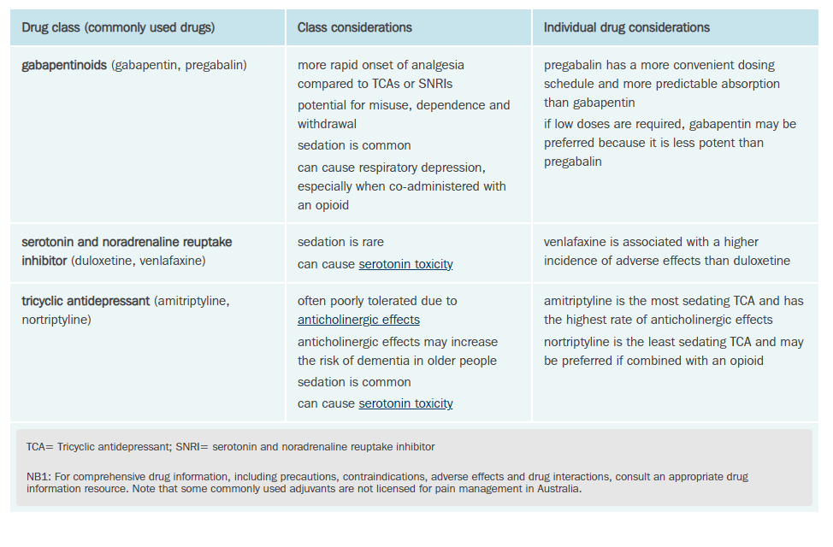

Attachment 7 – Characteristics of Pain Types
Source: Pain and Analgesia [published 2020 Dec]. In: Therapeutic Guidelines. Melbourne: Therapeutic Guidelines Limited; accessed {accessed 01/01/2023}. https://www.tg.org.au

